REPORT FORMAT: CL-1 | Version: 1.0_2018

FILE No.: VIS (2024-25)-PL406-356-480 Date: 15-10-2024

- REPORT NAME: Cost Verification Report for machines which are proposed to be installed at Khasra No.192/214, Salempur Rajputana, Roorkee, Haridwar, Uttarakhand.
- PREPARED FOR ORGANIZATION: State Bank of India, SME Branch, Roorkee, Haridwar, Uttarakhand
- BORROWER COMPANY’S NAME: M/s. Elbest Propack Pvt. Ltd.
- ASSET TYPE: Printing Machine and Cylinders.
- CURRENT LOCATION OF THE MACHINES: Proposed to be installed at Khasra No.192/214, Salempur Rajputana, Roorkee, Haridwar, Uttarakhand.
TO WHOM IT MAY CONCERN

S. NO. | PARTICULARS | DESCRIPTION
1. | Date of Survey | Not Applicable
2. | Date of Report | 15-10-2024
3. | Documents provided for perusal | Quotations of the machines
4. | Current Location of the Machines | Khasra No.192/214, Salempur Rajputana, Roorkee, Haridwar, Uttarakhand.
5. | Borrowing Company | M/s. Elbest Propack Pvt. Ltd.
6. | Type of Asset | Printing Machine and Cylinders
7. | Type of Assessment | Cost Verification
8. | Scope of Assessment | Cost Verification of the new equipment which are proposed to be purchased and installed by the company
9. | Year of Manufacturing | Yet to be purchased
10. | Total Project Cost | Rs.72.02 Lakhs. (Total project cost includes only the purchase cost as per the quotations / invoices / purchase orders provided by the company). Including G.S.T.
11. | Current Estimated Market Value | The range of current market rates of such type of machinery & equipment is verified from various suppliers and also from the public domain for the new machinery and equipment’s.  As per quotes received from market and online references, we are of the view that rate range for establishing the machinery of similar kind of machinery are available around Rs.65 Lakhs to Rs.75 Lakhs.  According to our observation, the rate as per the list of machinery and their total purchase price provided to us by the company/ bank are quite reasonable when compared to the rates of similar machines currently prevailing in the market.
12. | Condition of Machines | The machines are yet to be purchased / installed.

OBSERVATIONS:
- We have been provided with the copy of quotation mentioning cost of machines/ equipment by the borrower company.
- As per the information provided by the company officials these machines are proposed to be installed at Khasra No.192/214, Salempur Rajputana, Roorkee, Haridwar, Uttarakhand.
- We have contacted several suppliers for similar items and also did research on the public domain. Accordingly, we have got the quotation from the suppliers and found that the price given in the list of quotations provided to us is well within the price range of similar items available in the market and seems to be reasonable.
- In this report, there can be some difference in the cost of some of the machines due to the cost of some of the auxiliary equipment and accessories.
- Based on the information provided by the company (M/s. Elbest Propack Pvt. Ltd.) and enquiries made by us in the open market and references found on the public domain for similar machines/equipment, it is certified that the total market cost for the procurement of similar type of machines of similar specifications should be around Rs.65 Lakhs to Rs.75 Lakhs and therefore the total purchase price of Rs.72,02,720/- (Incl. GST) (as per the quotations provided to us by the company) appears to be satisfactory.

Disclaimer:
  - We can’t comment about the current status of machines whether these are purchased, installed or in transit. This cost vetting is done only on the basis of quotations provided to us by the company and we don’t recommend any sort of recommendation in our Report.
  - The estimated cost verification of item to item can’t exactly match as per our vetting due to several market consideration. In some of the items it is lower while in some of the item’s price comes to be higher but on an average the price as per list provided to us falls in the range as confirmed by us.
  - There can be variation in the estimated price if the specification & make of any items procured is different from the list provided to us during assessment.
  - The estimated cost verification is made based on the third-party information which has been replied upon in good faith.
  - The estimated price may vary at the time of actual procurement because of change in prices in the market for such kind of machinery/items for which we will not have any control. The cost vetting is only limited to the date of Report issued. We do not assume any responsibility in change of prices of the said machinery/items after this date.
  - This report doesn’t include any work related to drawing, design, sketch plan, procurement of the machines.
  - Ownership and other legal point of view in respect of the asset is not considered in this report as same is out of scope of this report.
  - This report is made at the request of the Bank.

For R.K Associates Valuers & Techno FOR INTERNAL USE Engineering Consultants (P) Ltd. TYPED BY: Manmohan REVIEWED BY: Abhinav Chaturvedi

ANNEXURE: - I (COMPARISON LIST)

S. No. | Name | Specifications | Vendor | QTY (in nos.) | Amount shown by company (Including GST) (INR) | Market Rate as per RKA (INR)
1 | Eaton Make 93 E- 60 KVA UPS | With all accessories and 12V 65 AH x 40 nos. Battery (Freight Insurance unloading Included) | Eaton Power Quality | 1 | 7,61,100 | 7,24,270
2 | HSM 320 Die Cutting Machine for Adhesive Label | (Freight, custom duty, clearance, Included) | Robus India Industries | 1 | 17,70,000 | 12,39,000
3 | WT LS 340 Label slitting and Rewinding Machine for Roll | Speed - 150 mtr. per minute, Precision 0.15 mm, Repeat range- 8" - 24" | Webtech International Machineries | 1 | 7,08,000 | 7,67,000
4 | Video Plate Mounter |  | Webtech International Machineries | 1 | 7,78,800 | 6,49,000
5 | PRINTING CYLINDER (250MM FLEXO PRINTING MACHINE) | PER CYLINDER 76T | Webtech International Machineries | 8 | 2,36,000 | 2,36,000
6 | PRINTING CYLINDER (250MM FLEXO PRINTING MACHINE) | PER CYLINDER 81T | Webtech International Machineries | 8 | 2,59,600 | 2,59,600
7 | PRINTING CYLINDER (250MM FLEXO PRINTING MACHINE) | PER CYLINDER 78T | Webtech International Machineries | 8 | 2,45,440 | 2,45,440
8 | PRINTING CYLINDER (250MM FLEXO PRINTING MACHINE) | PER CYLINDER 83T | Webtech International Machineries | 8 | 2,69,040 | 2,69,040
9 | PRINTING CYLINDER (250MM FLEXO PRINTING MACHINE) | PER CYLINDER 86T | Webtech International Machineries | 8 | 2,78,480 | 2,78,480
10 | PRINTING CYLINDER (250MM FLEXO PRINTING MACHINE) | PER CYLINDER 96T | Webtech International Machineries | 8 | 3,02,080 | 3,02,080
11 | PRINTING CYLINDER (250MM FLEXO PRINTING MACHINE) | PER CYLINDER 93T | Webtech International Machineries | 8 | 2,97,360 | 2,97,360
12 | MAGNETIC CYLINDER (250MM FLEXO PRINTING MACHINE) | PER CYLINDER 68T | Webtech International Machineries | 1 | 64,900 | 64,900
13 | MAGNETIC CYLINDER (250MM FLEXO PRINTING MACHINE) | PER CYLINDER 70T | Webtech International Machineries | 1 | 66,080 | 66,080
14 | MAGNETIC CYLINDER (250MM FLEXO PRINTING MACHINE) | PER CYLINDER 72T | Webtech International Machineries | 1 | 67,260 | 67,260
15 | MAGNETIC CYLINDER (250MM FLEXO PRINTING MACHINE) | PER CYLINDER 74T | Webtech International Machineries | 1 | 69,620 | 69,620
16 | MAGNETIC CYLINDER (250MM FLEXO PRINTING MACHINE) | PER CYLINDER 76T | Webtech International Machineries | 1 | 70,800 | 70,800
17 | MAGNETIC CYLINDER (250MM FLEXO PRINTING MACHINE) | PER CYLINDER 78T | Webtech International Machineries | 1 | 79,060 | 79,060
18 | MAGNETIC CYLINDER (250MM FLEXO PRINTING MACHINE) | PER CYLINDER 81T | Webtech International Machineries | 1 | 1,00,300 | 1,00,300
19 | MAGNETIC CYLINDER (250MM FLEXO PRINTING MACHINE) | PER CYLINDER 83T | Webtech International Machineries | 1 | 1,02,660 | 1,02,660
20 | MAGNETIC CYLINDER (250MM FLEXO PRINTING MACHINE) | PER CYLINDER 86T | Webtech International Machineries | 1 | 1,08,560 | 1,08,560
21 | MAGNETIC CYLINDER (250MM FLEXO PRINTING MACHINE) | PER CYLINDER 93T | Webtech International Machineries | 1 | 1,23,900 | 1,23,900
22 | MAGNETIC CYLINDER (250MM FLEXO PRINTING MACHINE) | PER CYLINDER 96T | Webtech International Machineries | 1 | 1,29,800 | 1,29,800
23 | MAGNETIC CYLINDER (250MM FLEXO PRINTING MACHINE) | PER CYLINDER 108T | Webtech International Machineries | 1 | 1,53,400 | 1,53,400
24 | MAGNETIC CYLINDER (250MM FLEXO PRINTING MACHINE) | PER CYLINDER 109T | Webtech International Machineries | 1 | 1,60,480 | 1,60,480
Total |  |  |  |  | 72,02,720 | 65,64,090

Note:
- The printing and magnetic cylinders are specially designed as per the drawing of the machine manufacturer and it is not feasible to draw any fair market rates without the availability of the drawing. But, as per discussion with the suppliers and market research it seems to be fine.
- For HSM 320 die cutting machine for adhesive label we have only calculated the Purchase cost inclusive of GST i.e. 18% and no freight, loading, unloading and installation charges are included in the rates provided by us.

ANNEXURE:- II (QUOTATIONS/ REFERENCES FROM MARKET)

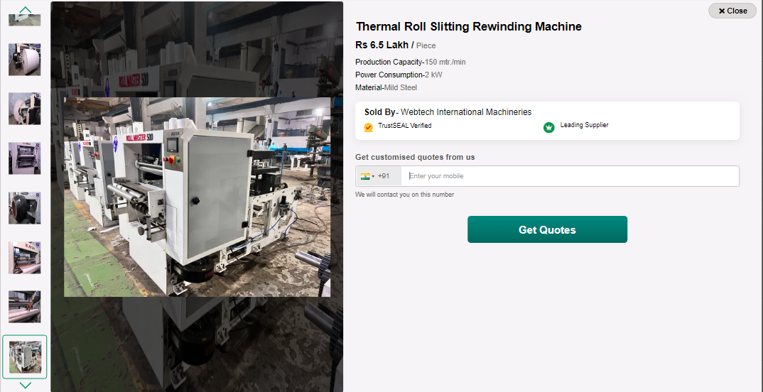
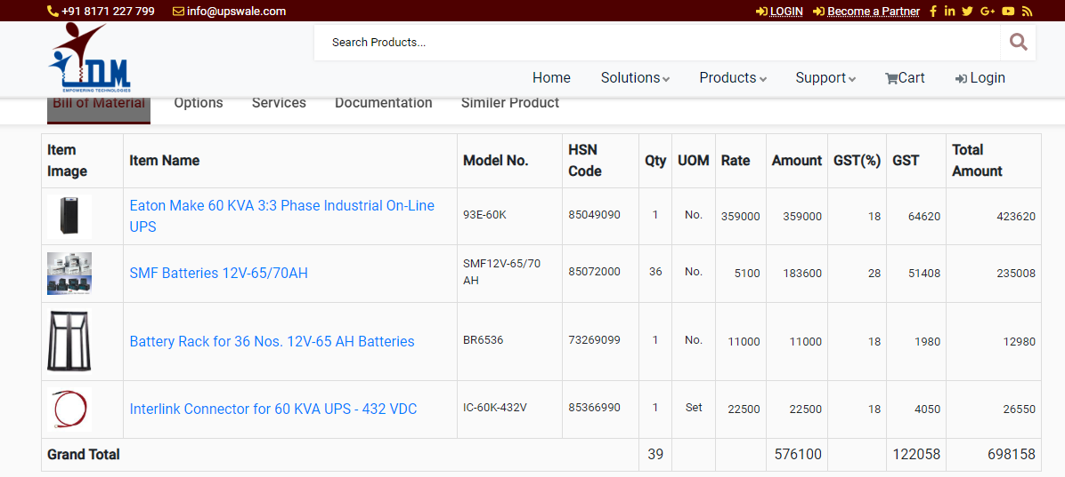

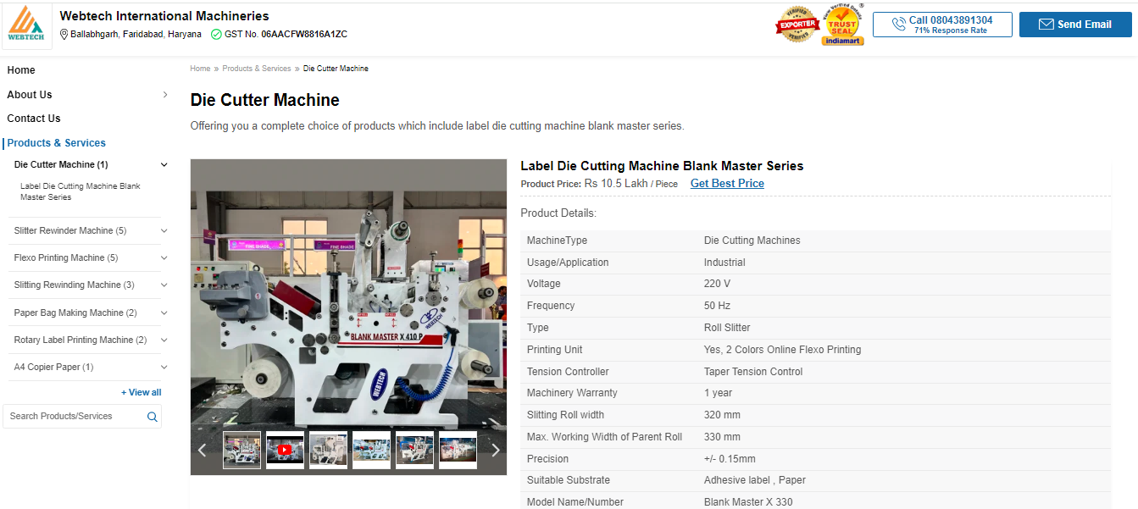
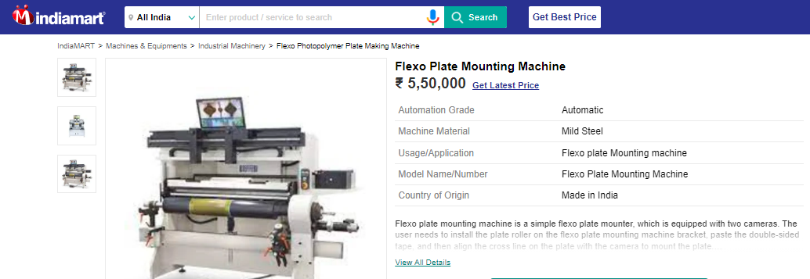
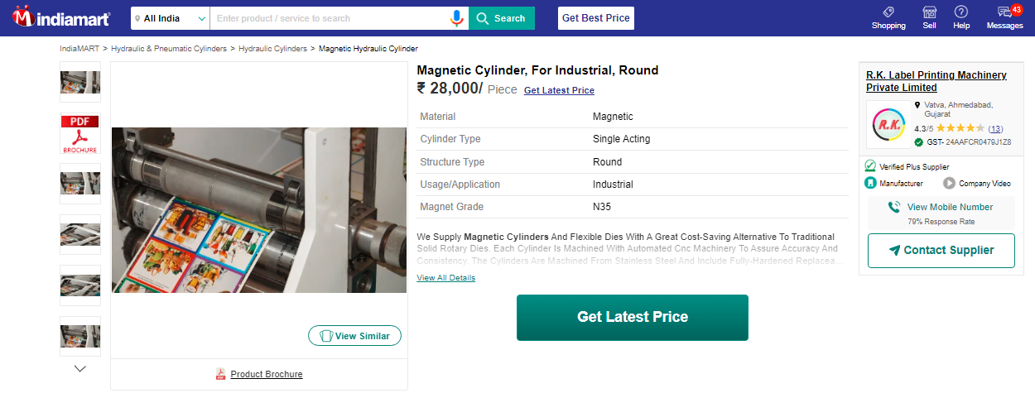

ANNEXURE: - III (DOCUMENTS PROVIDED BY CLIENT)

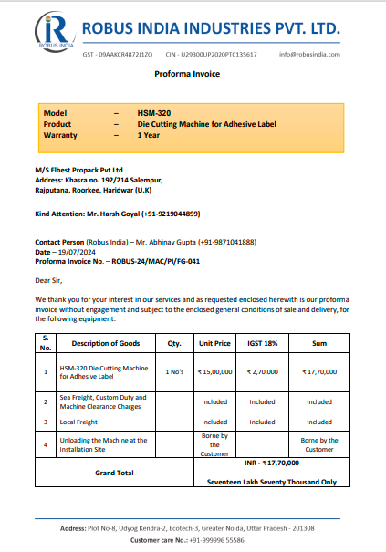

1