**File No.: VIS (2024-25)-PL411-361-468 Dated: 27.11.2024**

**LENDER’S INDEPENDENT ENGINEER REPORT (1ST)**

**(FOR QUARTER ENDING SEPTEMBER 2024)**

**OF**

**1,300 MTPA LITHIUM ION BATTERY RECYCLING UNIT**

****

**SITUATED AT**

**VILLAGE: RAIPUR, PARGANA & TEHSHIL: BHAGWANPUR, DISTRICT: HARIDWAR**

**IMPLEMENTED BY**

**M/S. ATTERO RECYCLING PRIVATE LIMITED (ARPL)**

**REPORT PREPARED FOR**

**STATE BANK OF INDIA, IFB, NEW DELHI**

***\*\*Important - In case of any query/ issue or escalation you may please contact Incident Manager at le@rkassociates.org. We will appreciate your feedback in order to improve our services.***

***NOTE: As per IBA Guidelines please provide your feedback on the report within 15 days of its submission after which report will be considered to be correct.***

|  |  |  |
| --- | --- | --- |
| **TABLE OF CONTENTS** | | |
| **SR. NO.** | **DESCRIPTION** | **PAGE NO.** |
| **PART A** | **Report Summary** | **03** |
| **PART B** | **Introduction** | **05** |
|  | 1. The Assignment | **05** |
|  | 1. Project Overview | **05** |
|  | 1. Project Location | **06** |
|  | 1. Scope of the Work During Assignment Duration | **07** |
|  | 1. Purpose of the Report | **07** |
|  | 1. Methodology Adopted | **07** |
| **PART C** | **Plant Infrastructure Sections & Facility Details with Actual Progress** | **08** |
|  | 1. Land and Land Development | **08** |
|  | 1. Building and Civil Works | **08** |
|  | 1. Plant Machinery and Equipment | **09** |
| **PART D** | **Project Consultants, Contractors & Suppliers** | **10** |
| **PART E** | **Project Cost and Means of Finance** | **12** |
|  | 1. Cost of Project | **12** |
|  | 1. Cost Expenditure Analysis | **13** |
|  | 1. Sources of Finance & Utilization of Funds | **15** |
| **PART F** | **Statutory & Regulatory Approvals, Clearances & NOC** | **16** |
| **PART G** | **Project Schedule & Current Status** | **17** |
| **PART H** | **Disclaimer** | **18** |
| **PART I** | **Enclosure** | **22** |
| **PART J** | **Photograph** | **28** |

# 

***IMPORTANT NOTICE***

***COPYRIGHT FORMAT:*** *This report is prepared on the copyright format of R.K Associates, to serve our clients with the best available information and analysis to facilitate them to take rational business decisions. Legally no one can copy or distribute this format without prior approval from R.K Associates. It is meant only for the advisory/ reference purpose for the organization/s as mentioned on the cover page of this report. Distribution or use of this format by any organization or individual other than R.K Associates will be seen as unlawful act and necessary legal action can be taken against the defaulters.*

*This report is intended for the sole use of the intended recipient/s and contain material that is STRICTLY CONFIDENTIAL AND PRIVATE.*

***DEFECT LIABILITY PERIOD:*** *- In case of any query/ issue or escalation you may please contact Incident Manager: le@rkassociates.org. We try our level best to ensure correctness in the calculations done, rates adopted and various other data points & information mentioned in the report but still can’t rule out typing, human errors or any other mistakes. In case you find any such mistake or inaccuracy in any data point of the report please help us by bringing all such points into our notice immediately or within 15 days of the report delivery in writing, to rectify these timely failing after which R.K Associates won’t be held responsible for any such inaccuracy in any manner. We would highly appreciate your feedback in order to improve our services.*

|  |  |
| --- | --- |
| **PART A** | **REPORT SUMMARY** |

|  |  |  |
| --- | --- | --- |
| **1.** | **Name of Project:** | Attero Recycling Private Limited (ARPL) is establishing a Lithium ion battery recycling plant with a total capacity of 1,300 Metric-Ton Per Annum (MTPA) in Village: Raipur, Pargana & Tehshil: Bhagwanpur, District: Haridwar, Uttarakhand. |
| **2.** | **Project Location:** | Village: Raipur, Pargana & Tehshil: Bhagwanpur, District: Haridwar, Uttarakhand |
| **3.** | **Name of the Borrower:** | M/s. Attero Recycling Private Limited. |
| **4.** | **Director’s/Partner’s:** | Mr. Rohan Gupta (Director) |
| **5.** | **Prepared for Bank:** | State Bank of India, IFB, New Delhi |
| **6.** | **LIE Consultant Firm:** | M/s. R.K. Associates Valuers & Techno Engineering Consultants (P) Ltd. |
| **7.** | **Date of Survey:** | 25th of October 2024 |
| **8.** | **Date of Report:** | 27th of November 2024 |
| **9.** | **Purpose of the Report:** | To provide fair detailed analysis report to the Bank based on the “in-scope points” mentioned below to know the current status of the Project. |
| **10.** | **Scope of the work provided by the Lender:** | 1. Periodic Project physical status review 2. Periodic review of expenditure of the Project based on the invoices/ bills submitted by the client |
| **11.** | **Documents perused for Proposal:** | 1. CA Certificate 2. TEV Report 3. Purchase order’s of the machine’s to be installed 4. Layout Plan 5. Property Title Documents 6. Invoices of machine’s found at site |
| **12.** | **Annexure with the report:** | 1. Copies of Project Statutory approvals 2. CA Certificate 3. Site/Plot Plan |

|  |  |
| --- | --- |
| **PART B** | **INTRODUCTION** |

1. **ABOUT THE ASSIGNMENT:**

1st LIE Report for the period (Quarter ending September 2024) of Lithium ion battery recycling plant being established at Village: Raipur, Pargana & Tehshil: Bhagwanpur, District: Haridwar, Uttarakhand. **M/s. Attero Recycling Private Limited (ARPL)** is establishing a Lithium ion battery recycling plant with a capacity of 1,300 Metric-Ton Per Annum (MTPA) which is an expansion to the present Lithium ion battery recycling plant at Roorkee. For this project bank has appointed M/s. R.K Associates Valuers & Techno Engineering Consultants (P) Ltd. for periodic review of physical & expenditure status of the project.

The physical status in the report is reported of the date of survey which is 25th of October 2024 but incurred expenses are considered till September 2024 ending.

1. **PROJECT OVERVIEW:**

**M/s. Attero Recycling Private Limited (APRL**) is establishing a Lithium ion battery recycling plant with a capacity of 1,300 Metric-Ton Per Annum (MTPA). Attero Recycling Private Limited (ARPL), incorporated on February 27, 2008, operates an e-waste recycling facility in Roorkee, Uttarakhand. The facility was upgraded in 2017 to include lithium-ion battery recycling in addition to e-waste processing. The current capacities of the e-waste recycling unit and the lithium-ion battery recycling unit are 1,44,000 MTPA and 700 MTPA respectively. ARPL proposes to expand its lithium-ion battery recycling facility by an additional 1,300 MTPA, enhancing the total recycling capacity to 2,000 MTPA.

As per the TEV Report the appraised Project cost considered is Rs. 39.41 Crore which includes Land, Project Planning & Designing, Building & Civil works and Advances of Plant & Machinery. Detailed breakup of the same is available in later section of the report. **This report covers only proposed plant with capacity of 1,300 MTPA.**

For the expansion and setting up new recycling Projects in the country, company has appointed Mr. Rajiv Banga as an Advisor- India & Global expansion & Mr. KV Rehani as an Automation Specialist. Mr. Rajiv Banga is assisting ARPL in finalizing the development/ management of capex plans across multiple sites. Mr. KV Rehani is working as a consultant regarding various aspects of plant machinery setup.

Major approvals of the Project is yet to be obtained. Company has applied for Building Sanction approval to SIDA already on 30.09.2024.

As per the current status of the project, the soil filling work is completed and construction work has not been started yet. In plant, machinery and equipment’s only D.G set and Forklift have arrived on site.

1. **PROJECT LOCATION:**

Details about Location of Unit is as below:

**Table No: 1**

|  |  |
| --- | --- |
| **Particulars** | **Description** |
| **Postal Address** | |
| Village: Raipur, Pargana & Tehshil: Bhagwanpur, District: Haridwar, Uttarakhand | |
| **Location** | |
| The project is situated on Dehradun- Roorkee Highway and nearby properties are used for Industrial purpose. | |
| **Google Coordinates** | |
| Latitude | 29°57'09.9"N |
| Longitude | 77°47'53.6"E |
| **Connectivity Systems** | |
| Road | Raipur is around 18-20 km from Roorkee city through SH 344. The project site is currently accessible through highway ~70-80 feet wide. |
| Rail | The Nearest Railway station to the subject locality is Roorkee Railway Station which is about approximately ~15 km from the subject project. |
| Air | The nearest airport to subject location is Jolly Grant Airport- Dehradun which is located ~75 km away. |
| **Geographical Conditions On The Site** | |
| Rainfall | The average annual rainfall of this area is about 960 mm. |
| Seismic Zone | The above plant site area falls in Seismic Zone III. |

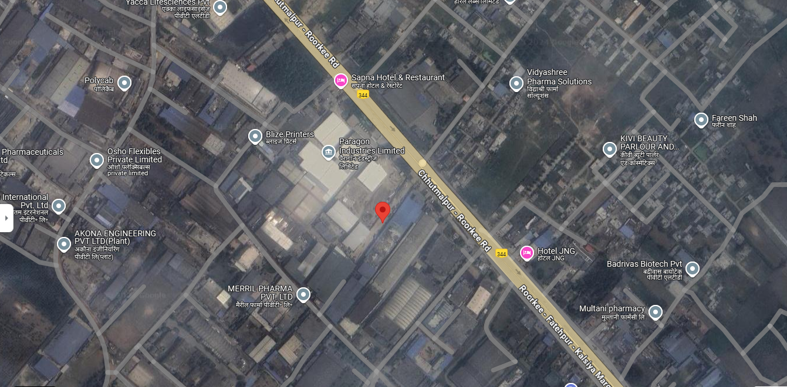

**Source: Google Map**

**Figure: Location of Recycling Plant**

1. **SCOPE OF WORK DURING PROJECT DURATION:**
2. Periodic Project physical status review
3. Periodic review of expenditure of the Project.
4. **PURPOSE OF THE REPORT:** To provide fair detailed analysis report to the Bank based on the “in-scope points” mentioned above for facilitating them to know the current status of the Project.
5. **METHODOLOGY ADOPTED:**
6. Study of Project Planning documents/ reports to know about the Project.
7. Additional information, data, documents collection from the borrower.
8. Site Inspection.
9. Review and analysis of the documents and information obtained from the borrower and corroborating it with the site inspection status.
10. Information compilation, analysis and reporting.
11. Expenditure assessment of the civil works has been done as per the physical observation during site survey and by taking benchmark cost of the respective items.

|  |  |
| --- | --- |
| **PART C** | **PLANT INFRASTRUCTURE SECTIONS & FACILITY DETAILS WITH**  **ACTUAL PROGRESS** |

1. **LAND:** For the purpose of the Project, company has purchased 2,541 sq.mtr (equivalent to 0.628 acres) of land at Khata No. 172, Village Raipur, Bhagwanpur Industrial Estate, Tehsil Roorkee. in Rs.2,35,20,000/- as per the sale deeds provided to us. The whole land parcel is demarcated properly and currently land levelling work is partially completed.

**Table No: 2**

|  |  |  |  |  |  |
| --- | --- | --- | --- | --- | --- |
| **S. No.** | **Khasra No.** | **Area in (sq.mtr.)** | **Sale Price**  **(In Rs.)** | **Stamp Duty**  **(In Rs.)** | **Total**  **(In Rs.)** |
| 1 | 172 | 1,540 | 1,36,00,000 | 6,80,000 | 1,42,80,000 |
| 2 | 172 | 1,001 | 88,00,000 | 4,40,000 | 92,40,000 |
| **Total** |  | **2,541** | **1,28,98,000** | **2,24,00,000** | **2,35,20,000** |

1. **BUILDING & CIVIL WORKS:** For the purpose of establishing the plant, Attero Recycling Private Limited planned to develop Shed structure along with necessary civil structure required for the expansion of Lithium-ion Recycling plant.

Based on the site survey, only the soil filling work and boundary wall work has been completed, while the building and civil work have not yet commenced. According to the schedule mentioned in TEV report, the building and structure were expected to be completed by June’24, indicating a delay in the project's progress.

As stated in the TEV report, the estimated cost for setting up the factory shed along with associated civil works is Rs. 399.8 lakhs, with expenses incurred to date amounting to Rs. 58.36 lakhs, as per the CA certificate provided.

As per the company they have already appointed Diamond Arch En Constructions for structural design analysis. Civil and PEB shed contractor is yet to be appointed.

**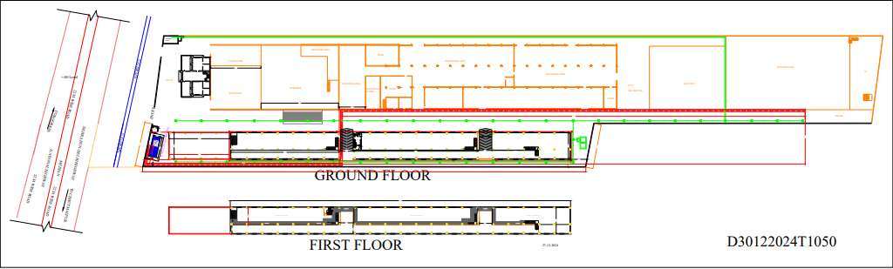**

1. **PLANTS/ MACHINERIES & OTHER EQUIPMENTS AND UTILITIES:** As per the TEV Report, company has estimatedRs. 31.07 crores which is equivalent to 79% of the total Project cost. Following is the proposed machinery & equipment list which company has planned to procure:

As per the CA Certificate dated: 28.08.2024, till date company has spent Rs.93.76 Lacs which is mostly advance paid to various suppliers/ manufacturers of which details are discussed in the later section of the report.

As of now no major machines have arrived at the site. Only one new forklift has arrived at the site which was parked at the present plant and also they have purchased one DG set which was supposed to be setup in the new Plant but now utilised in the existing Plant.

**Table No: 4**

|  |  |  |  |
| --- | --- | --- | --- |
| **S. No** | **Particulars** | **Supplier/Vendor** | **Status** |
|  | Godrej Diesel Forklift Truck | Prompt Packways | Arrived at the Existing plant |
|  | DG set | Gainwell Commosales Private Limited | Installed at the Existing Plant |

|  |  |
| --- | --- |
| **PART D** | **PROJECT CONSULTANTS, CONTRACTORS & SUPPLIERS** |

As of now mentioned below are the list of Contractors/ Suppliers/ Consultants which have been currently engaged in the Project.

**Table No: 5**

|  |  |
| --- | --- |
| *Contractors/ Suppliers/ Consultants* | *Nature of Work* |
| Soilex Consultant Pvt ltd | Soil Test Report & Conducting Dynamic Cone Penetration Tests |
| Diamond Arch En Constructions | Structural Engineering Report |
| Rajiv Banga | Project Consulting - EPC |
| Karam Rehani | Project Consulting - P&M |
| National Industries | Foam Waste Cursher Machine |
| M A Construction | Terrace reapiring work |
| Electro Vision Industries | 1600 KVA Oil Cooled Distribution Transformer & LT Panel |
| Unique Trading Co | Fire-fitting work |
| Apicon Electrical Engineer | PLC |
| YLEM Energy | --- |
| A R Engineers | For HT Panel |
| Aptech Industries | --- |
| Elektrocraft India Pvt Ltd | 70% Advance payment for Model-M 21D, Model-DS 25, Model-LS102 B & Model-LS 107.4B |
| Satvik Electrical & Electronics Engg. Solution | For Electric Item |
| Techno four | Technofour Advanced eddy Current Conductivity meter |
| Deep Hydraulic | Baling Chamber |
| Prompt Packways | Godrej Diesel Forklift Truck |
| Absolute Laboratory Solutions | Fume Hood & Work bench with sink |
| Taha Industries | Megnetic Pump |
| Aimil Ltd | --- |
| Sneha Analytical Services | AAS Gas Line work |
| Dimond Arch-EN-Construction | structure testing |
| Perfection Engineering Corporation | Vibro Feeder/Vibro Siever 3 stage /Scraper conveyor /Belt conveyor system /Scraper conveyor |
| Gainwell Commosales Private Limited | DG sets |
| Aye Bee Machinery Udyog | Electric Screw Driver machine |
| V.L. Scientific | Tray Dryer |
| Shamboo Scientific | Single Distilation water |
| Supertech Analytical | Moisture & Anlalytical Balance and Type II Water Purification System |
| SKU Engineering | SS 304 Mixur capacity-200 KG |
| Enviro Tech Industrial Products | --- |
| United Aluminium Fabricator | --- |
| Pharma Mix Engineering Works | --- |
| Mapple IT Solutions | 04 Qty. Lenovo Thinkcentre |
| Spectro Analytical | --- |
| Reliable Engineers | HCI, HNO3, H2SO4 Doasting Pump |
| Neo Instrumentation | --- |
| Agilent Technologies | UV spectotophotometer 190-1100 nm, AAS |
| Shambhoo Scientific | Rotary evaporator 5 lit |
| Shiglo Tech Private Limited | Motor Cutting Machine, Motor Inner Cell Cutting Machine, Motor Copper Pulling Machine, Radiator Recycling Machine, Scrap Wire Granulator |
| SAK INTERNATIONAL | Core cutting (compressor & Motor stator) |
| GLEAM TECH | --- |
| AQUAON ENGINEERS | --- |
| PATHAK MACHINE | --- |
| LABINDIA Analytical | --- |

Source: The above Information/Data is taken from the project progress report provided by the client.

|  |  |
| --- | --- |
| **PART E** | **PROJECT COST & MEANS OF FINANCE** |

1. **TOTAL PROJECT COST & STATUS OF EXPERNDITURE:** M/s Attero Recycling Private Limited has estimated the total Project Cost amounting to Rs. 39.412 Cr. and Rs. 6.1086 Cr. has been spent till 28th August 2024 as per CA Certificate with UDIN No. 24409160BKDPFX9276.

Tabular and chart representation of the same is shown below:

**Table No: 6**

***Amount in crores***

|  |  |  |
| --- | --- | --- |
| **Particulars** | **Project Cost as Budgeted**  ***(As per TEV report)*** | **Expenditure Incurred Till 28th August 2024**  ***(As per CA Certificate)*** |
| Land | 2.352 | 2.352 |
| Project Planning & Designing | 2.00 | 2.2355 |
| Building , Civil work & Other Expenses | 3.99 | 0.5836 |
| Plant Machinery (advances to vendors) | 31.07 | 0.9375 |
| **Total** | **39.412** | **6.109** |

1. **COST EXPENDITURE ANALYSIS:** A detailed comparison between the actual construction expenses and the company's reported costs, as certified by a Chartered Accountant (CA), is presented below. Alongside this, a cost assessment based on a site survey is also provided:

*In the below Table, amount is approved based on the actual work and invoice basis to give clear picture to the lending institution. Advances paid to vendors/ suppliers for which work has not begun yet is appended separately below this table.*

**Table No: 7**

***Amount in Cr.***

|  |  |  |  |  |
| --- | --- | --- | --- | --- |
| **PARTICULARS** | **ESTIMATED COST (Rs. In Cr.)** | **AMOUNT SHOWN BY THE COMPANY (UPTO 28.08.24)  (As Per C.A. Certificate)** | **AMOUNT APPROVED BY LIE (UPTO 30-09-2024)** | **REMARKS** |
| Land | 2.352 | 2.352 | ~2.352 | This includes cost of land with stamp duty (as per the value mentioned in the sale deed). |
| Project Planning & Designing | 2.00 | 2.2355 | - | 1. Breakup of expenses as per CA Certificate dated: 28.08.2024 is appended in Table no. 08 below. 2. In this respect company is yet to provide proper Invoices and details to us on our queries and therefore amount will be approved accordingly based on the receiving the same from the company. 3. No Bills/ Invoices have been received in respect to the expenses shown in this head. |
| Building & Civil Works | 3.99 | 0.5836 | ~0.4170 | 1. Breakup of expenses as per CA Certificate dated: 28.08.2024 is appended in Table no. 09 below. 2. Out of this amount we have approved Rs.25.67 Lacs incurred for soil filling work and front boundary wall work for which work is completed and we have been provided with the Invoices for the same. 3. Amount incurred to have shown on purchasing Transformer from Electro Vision will be transferred to P&M head as this is not part of Building & Civil works. 4. Advance Amount paid to MA Construction and Unique Trading Co. is mentioned in the Table no. 09 below. However in this respect company is yet to provide us the relevant PO and Performa Invoice and payment receipts for the amount paid. |
| Plant & Machinery | 31.07 | 0.9376 | ~1.1042 | 1. According to the CA certificate, the expenditure up to 28/08/2024 amounts to Rs. 0.9376 crore, which includes advances paid to vendors. 2. However, during the site survey conducted on 25/10/2024, no machine was observed to have arrived on the site except one new forklift has arrived at the site which was parked at the present plant. 3. They have purchased one DG set which was supposed to be setup in the new Plant but now utilised in the existing Plant. 4. List of various advances paid to different vendors as per CA Certificate is appended in Table 10 below. 5. For the same Purchase Orders/ Quotations have been provided by the company. Based on which this amount is taken into consideration. |
| **TOTAL** | | **6.1087** | **~3.8732** | Please see the comments above. |

**Table No: 8**

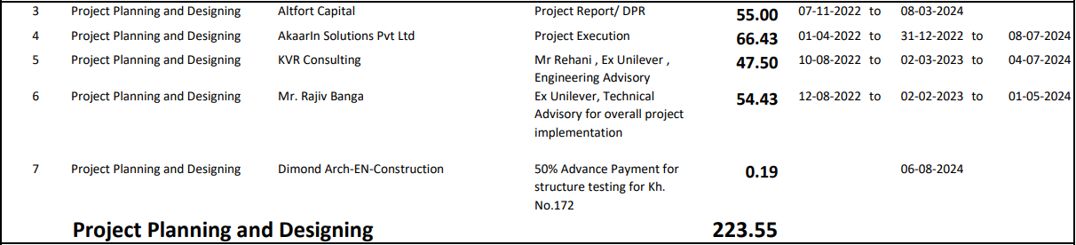

**Table No: 09**

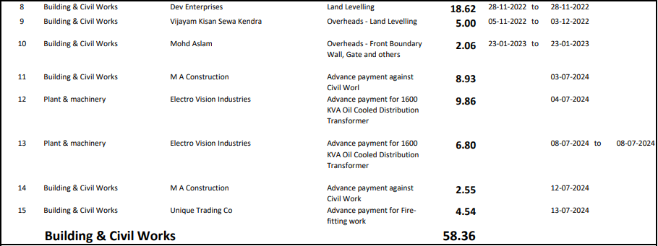

**Table No: 10**

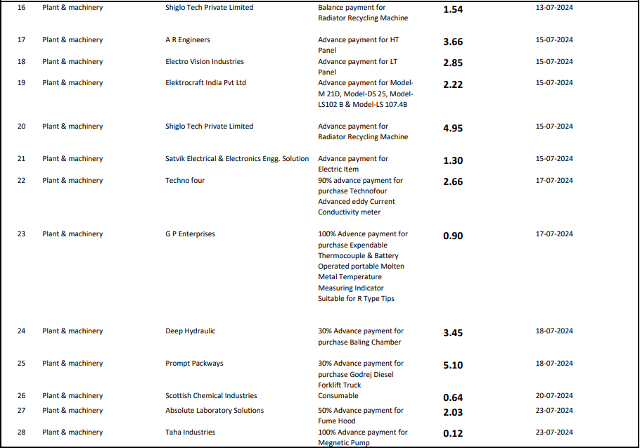

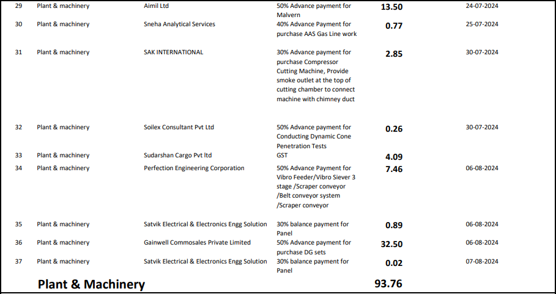

**Comment/ Note:**

1. We have given a general overview of the project based on expenses shown by chartered accountant in their CA certificate till 28th August 2024 with UDIN No. 24409160BKDPFX9276 based on the data/ information gathered from client and the observation made during the site survey.
2. **SOURCES OF FINANCE & UTILIZATION OF FUNDS:**

The Project cost mentioned above has been planned to be covered from following resources:

**Table No: 11**

|  |  |
| --- | --- |
| PARTICULARS | As per TEV Report |
| Promoter’s Contribution | 11.41 |
| Term Loan | 28.00 |
| TOTAL | **40.40** |

***Source:*** *As per CA Certificate*

|  |  |
| --- | --- |
| **PART F** | **STATUTORY & REGULATORY APPROVALS, CLEARANCES & NOC** |

**Table No: 12**

|  |  |  |  |  |
| --- | --- | --- | --- | --- |
| Sr. No. | NAME OF LICENSE/ REGISTRATION | PURPOSE | DATE OF ISSUE | CURRENT STATUS |
| **ISSUING AUTHORITY** | **LICENCE NO.** |
|  | Consent to Establish | --- | --- | --- |
|  | Importer Exporter Code | --- | --- | --- |
|  | Factory License | --- | --- | --- |
|  | NHAI NOC | NOC regarding proposed recycling plant | Dated: 06/06/2024 | Obtained |
|  | Building Construction permit | --- | --- | Application filed |
| 1. 2 | Environment Clearance/ Pollution NOC | --- | --- | --- |
|  | Consent to Operate | --- | --- | --- |
|  | Registration for Recycling and Processing of Plastic Waste | --- | --- | --- |
|  | Authorization for the Collection, transportation, reception, recycling and recovery of hazardous waste | --- | --- | --- |
|  | Membership Certificate for  disposing hazardous waste | --- | --- | --- |
|  | Fire NOC | --- | --- | --- |
|  | NOC for Ground Water  Abstraction | --- | --- | --- |
|  | NA Order | --- | --- | --- |
|  | Electricity Load Approval | --- | --- | --- |
|  | Boiler Certificate | --- | --- | --- |
|  | ISO 45001:2018 Certification | --- | --- | --- |
|  | ISO 14001:2015 Certification | --- | --- | --- |
|  | ISO 9001:2015 Certification | --- | --- | --- |
| *Observations & Comments:*  *Above mentioned are the preliminary approvals which are required for the Project. The status mentioned above is as per the documents provided by the client.* | | | | |

|  |  |
| --- | --- |
| **PART G** | **PROJECT SCHEDULE & CURRENT STATUS** |

The timeline and scheduling for the implementation of the plant is as follows:-

**Table No: 13**

|  |  |  |  |
| --- | --- | --- | --- |
| **Implementation and Schedule** | | | |
| **Activity** | **Commencement** | **Expected date of completion** | **Current Status** |
| Land Acquisition | --- | Purchased | Completed |
| Civil Construction | January 2024 | June 2024 | Soil filling work is completed |
| Plant & Machinery | December 2023 | September 2024 | D.G. set and forklift have arrived on site. |
| Installation & Commissioning | October 2024 | October 2024 | Not achieved |
| Trial Run | November 2024 | November 2024 | Not achieved |
| Commercial Production | --- | December 2024 | --- |

*Source: As per TEV report*

**Current Status:**

* During the recent site visit, it was observed that soil filling work is completed and building & civil works is not yet started.
* In plant, machinery and equiment’s only D.G set and Forklift is arrived on site.
* As per the timeline, the plant was expected to receive the required plant and machinery equipment at the site in September 2024. However, no major plant, machinery, or equipment was found on-site yet.
* The project has already missed the scheduled deadline.

|  |  |
| --- | --- |
| **PART H** | **DISCLAIMER** |

* + - 1. No employee or member of R.K Associates has any direct/ indirect interest in the Project.
      2. This report is prepared based on the copies of the documents/ information which the Bank/ Borrower has provided to us out of the standard checklist of documents sought from them and further based on our assumptions and limiting conditions. The client/owner and its management/representatives warranted to us that the information they supplied was complete, accurate and true and correct to the best of their knowledge. All such information provided to us has been relied upon in good faith and we have assumed that it is true and correct in all respect. I/We shall not be liable for any loss, damages, cost or expenses arising from fraudulent acts, misrepresentations, or wilful default on part of the owner, borrower, its directors, employee, representative or agents. Verification or cross checking of the documents provided to us from the originals or from any Govt. departments/ Record of Registrar has not been done at our end since this is beyond the scope of our work. If at any time in future, it is found or came to our knowledge that misrepresentation of facts or incomplete or distorted information has been provided to us then this report shall automatically become null & void.
      3. Legal aspects for eg. investigation of title, ownership rights, lien, charge, mortgage, lease, sanctioned maps, verification of documents, etc. have not been done at our end and same has to be taken care by legal expert/ Advocate. It is assumed that the concerned Lender/ Financial Institution has satisfied them with the authenticity of the documents, information given to us and for which the legal verification has been already taken and cleared by the competent Advocate before requesting for this report. I/ We assume no responsibility for the legal matters including, but not limited to, legal or title concerns.
      4. This report is a general analysis of the project based on the scope mentioned in the report. This is not an Audit report, Design document, DPR or Techno feasibility study. All the information gathered is based on the facts seen on the site during survey, verbal discussion & documentary evidence provided by the client and is believed that information given by the borrower is true best of their knowledge.
      5. All observations mentioned in the report is only based on the visual observation and the documents/ data/ information provided by the client. No mechanical/ technical tests, measurements or any design review have been performed or carried out from our side during Project assessment.
      6. Bank/FII should ONLY take this report as an Advisory document from the Financial/ Chartered Engineering firm and its specifically advised to the creditor to cross verify the original documents for the facts mentioned in the report which can be availed from the borrowing borrower directly.
      7. In case of any default in loans or the credit facility extended to the borrowing borrower, R.K Associates shall not be held responsible for whatsoever reason may be and any request for seeking any explanation from the employee/s of R.K Associates will not be entertained at any instance or situation.
      8. The documents, information, data provided to us during the course of this assessment by the client is reviewed only up to the extent required in relation to the scope of the work. No document has been reviewed beyond the scope of the work.
      9. This report only contains general assessment & opinion as per the scope of work evaluated as per the information given in the copy of documents, information, data provided to us and/ and confirmed by the owner/ owner representative to us at site which has been relied upon in good faith. It doesn’t contain any other recommendations of any sort including but not limited to express of any opinion on the suitability or otherwise of entering into any transaction with the borrower.
      10. We have relied on data from third party, external sources & information available on public domain also to conclude this report. These sources are believed to be reliable and therefore, we assume no liability for the truth or accuracy of any data, opinions or estimates furnished by others that have been used in this analysis. Where we have relied on data, opinions or estimates from external sources, reasonable care has been taken to ensure that such data has been correctly extracted from those sources and /or reproduced in its proper form and context, however still we can’t vouch its authenticity, correctness or accuracy.
      11. This Report is prepared by our competent technical team which includes Engineers and financial experts & analysts.
      12. This is just an opinion report and doesn’t hold any binding on anyone. It is requested from the concerned Financial Institution which is using this report for taking financial decision on the project that they should consider all the different associated relevant & related factors also before taking any business decision based on the content of this report.
      13. All Pages of the report including annexures are signed and stamped from our office. In case any paper in the report is without stamp & signature then this should not be considered a valid paper issued from this office.
      14. Though adequate care has been taken while preparing this report as per its scope, but still we can’t rule out typing, human errors, over sightedness of any information or any other mistakes. Therefore, the concerned organization is advised to satisfy themselves that the report is complete & satisfactory in all respect. Intimation regarding any discrepancy shall be brought into our notice immediately. If no intimation is received within 15 (Fifteen) days in writing from the date of issuance of the report, to rectify these timely, then it shall be considered that the report is complete in all respect and has been accepted by the client upto their satisfaction & use and further to which R.K Associates shall not be held responsible in any manner.
      15. Defect Liability Period is **15 DAYS**. We request the concerned authorized reader of this report to check the contents, data and calculations in the report within this period and intimate us in writing if any corrections are required or in case of any other concern with the contents or opinion mentioned in the report. Corrections only related to typographical, calculation, spelling mistakes, incorrect data/ figures/ statement will be entertained within the defect liability period. Any new changes for any additional information in already approved report will be regarded as additional work for which additional fees may be charged. No request for any illegitimate change in regard to any facts & figures will be entertained.
      16. R.K Associates encourages its customers to give feedback or inform concerns over its services through proper channel at valuers@rkassociates.org in writing within 15 days of report delivery. After this period no concern/ complaint/ proceedings in connection with the Financial Feasibility Study Services will be entertained due to possible change in situation and condition of the subject Project.
      17. Our Data retention policy is of **ONE YEAR**. After this period, we remove all the concerned records related to the assignment from our repository. No clarification or query can be answered after this period due to unavailability of the data.
      18. This Lender’s Independent Engineer report is governed by our (1) Internal Policies, Processes & Standard Operating Procedures, (2) Information/ Data/ Inputs given to us by the client and (3) Information/ Data/ Facts given to us by our field/ office technical team. Management of R.K Associates never gives acceptance to any unethical or unprofessional practice which may affect fair, correct & impartial assessment and which is against any prevailing law. In case of any indication of any negligence, default, incorrect, misleading, misrepresentation or distortion of facts in the report then it is the responsibility of the user of this report to immediately or at least within the defect liability period bring all such act into notice of R.K Associates management so that corrective measures can be taken instantly.
      19. R.K Associates never releases any report doing alterations or modifications from pen. In case any information/ figure of this report is found altered with pen then this report will automatically become null & void.

|  |  |  |
| --- | --- | --- |
| **SURVEY ANALYST** | **ENGINEERING ANALYST** | **L2 REVIEWER** |
| Yash Bhatnagar | Yash Bhatnagar | Sr. V.P. Projects |
|  |  |  |

**For**

**R.K. Associates Valuers and Techno Engineering Consultants Pvt. Ltd**

**Place: Noida**

**Date: 27th November 2024**

***DEFECT LIABILITY PERIOD - In case of any query/ issue or escalation you may please contact Incident Manager by writing at valuers@rkassociates.org. We ensure 100% accuracy in the Calculations done, Rates adopted and various other data points & information mentioned in the report but still can’t rule out typing, human errors or any other mistakes. In case you find any mistake, variation, discrepancy or inaccuracy in any data point of the report, please help us by bringing all such points into our notice in writing at valuers@rkassociates.org within 30 days of the report delivery, to get these rectified timely, failing which R.K Associates Valuers Techno Engineering Consultants (P) Ltd. won’t be held responsible for any inaccuracy in any manner. Also, if we will not hear back anything from you within 30 days, we will assume that report is correct in all respect and no further claim of any sort will be entertained thereafter. We would welcome and appreciate your feedback & suggestions in order to improve our services.***

***COPYRIGHT FORMAT - This report is prepared on the copyright format of R.K Associates Valuers Techno Engineering Consultants (P) Ltd. to serve our clients in the best possible way. Legally no one can copy or distribute this format without prior approval from R.K Associates. It is meant only for the organization as mentioned on the cover page of this report. Distribution or use of this format other than R.K Associates will be seen as unlawful act and necessary legal action can be taken against the defaulter***

**ENCLOSURE 1: IMPORTANT DOCUMENTS EXHIBIT**

**DOCUMENT-1: CA CERTIFICATE DATED 28/10/2024**

**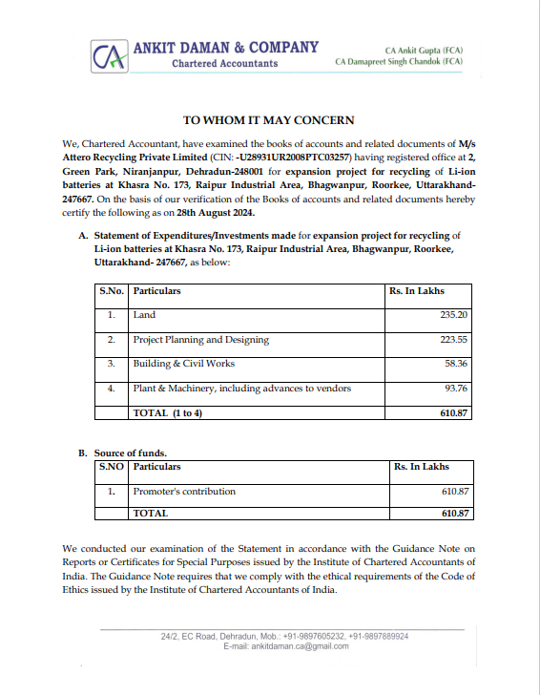**

**DOCUMENT-2: NOC FROM NHAI**

**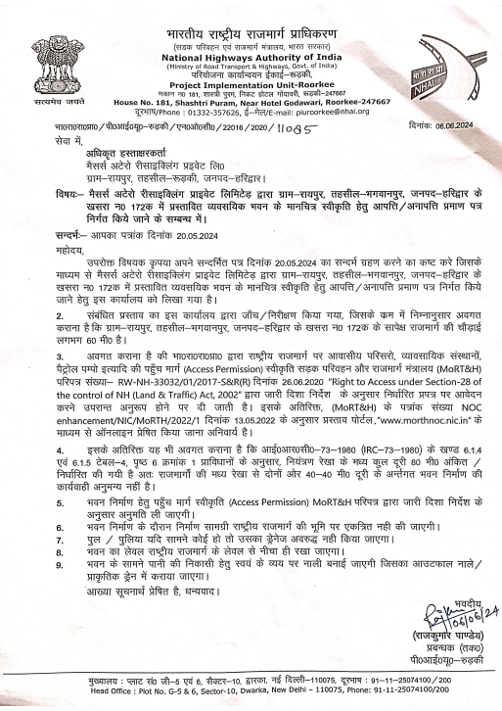**

**DOCUMENT 3: PLANT LAYOUT**

**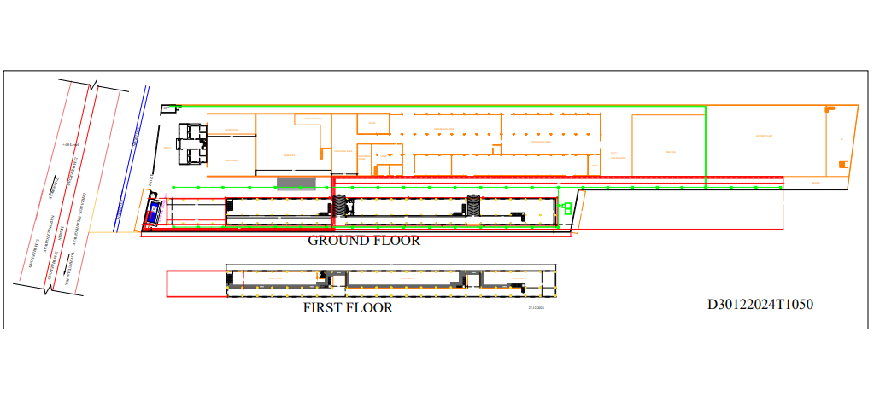**

**DOCUMENT 4: ONLINE APPLICATION FOR BUILDING CONSTRUCTION PERMIT**

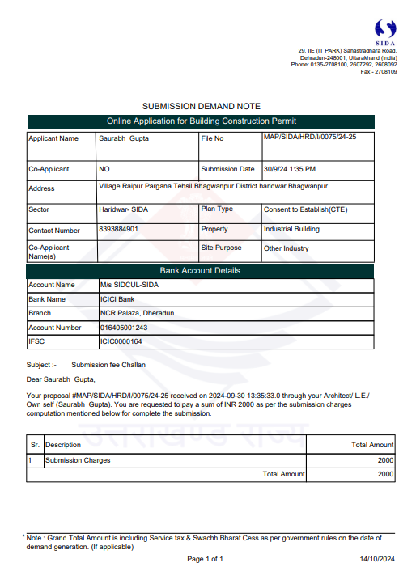

**DOCUMENT 5: COPY OF INVOICES FOR PLANT & MACHINERY**

**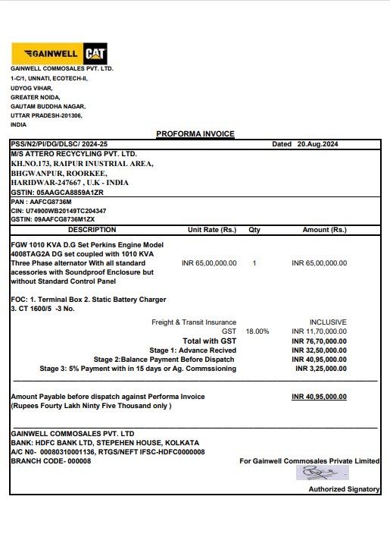**

**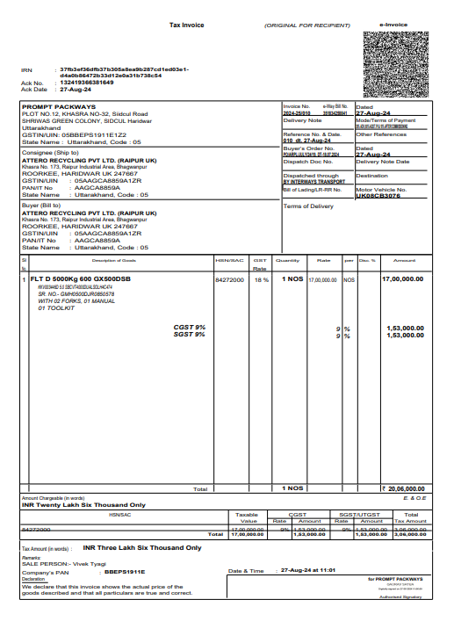**

**ENCLOSURE-2: - SITE PHOTOGRAPHS**

|  |  |
| --- | --- |
| W:\In Progress Files\Yash Bhatnagar\VIS(2024-25)-PL411-361-486 Attero Recycling\SiteImage\TimePhoto_20241025_114815.jpg | W:\In Progress Files\Yash Bhatnagar\VIS(2024-25)-PL411-361-486 Attero Recycling\SiteImage\TimePhoto_20241025_114915.jpg |
| W:\In Progress Files\Yash Bhatnagar\VIS(2024-25)-PL411-361-486 Attero Recycling\SiteImage\TimePhoto_20241025_115001.jpg | W:\In Progress Files\Yash Bhatnagar\VIS(2024-25)-PL411-361-486 Attero Recycling\SiteImage\TimePhoto_20241025_140243.jpg |
| W:\In Progress Files\Yash Bhatnagar\VIS(2024-25)-PL411-361-486 Attero Recycling\SiteImage\TimePhoto_20241025_140250.jpg | **W:\In Progress Files\Yash Bhatnagar\VIS(2024-25)-PL411-361-486 Attero Recycling\SiteImage\TimePhoto_20241025_115234.jpg** |

**Machines (Survey Dated:-25/10/2024)**

|  |  |
| --- | --- |
| W:\In Progress Files\Yash Bhatnagar\VIS(2024-25)-PL411-361-486 Attero Recycling\SiteImage\TimePhoto_20241025_113844.jpg | W:\In Progress Files\Yash Bhatnagar\VIS(2024-25)-PL411-361-486 Attero Recycling\SiteImage\TimePhoto_20241025_113913.jpg |
| W:\In Progress Files\Yash Bhatnagar\VIS(2024-25)-PL411-361-486 Attero Recycling\SiteImage\TimePhoto_20241025_140057.jpg | W:\In Progress Files\Yash Bhatnagar\VIS(2024-25)-PL411-361-486 Attero Recycling\SiteImage\TimePhoto_20241025_140114.jpg |

**Existing Plant**

