To,

Relationship Manager

HDFC Bank Limited, Emerging Corporates Group

15/46, Naveen market, Civil Lines,

Kanpur

**SUBJECT: REGARDING COMMENCEMENT OF GRINDING UNIT (GU) OF J.K CEMENT LTD., PRAYAGRAJ, UTTAR PRADESH.**

**Ref.: Quarter ending June 2024 LIE report and latest site inspection conducted on 17th March 2025.**

Dear Sir,

We refer to our appointment as Lender’s Independent Engineer (LIE), this is to inform that the Grinding Unit (GU) Of J.K Cement Limited located at Prayagraj, Uttar Pradesh has achieved the COD on 25th June 2024 as per the dispatch report and letter of commencement of commercial productions/operations submitted to The Bombay Stock Exchange Ltd.

As per the observation made during the latest site visit dated 17th March 2025, the unit was found operational and cement production was ongoing.

Thanks & regards,

For R.K Associates Valuers & Techno Engineering Consultants (P) Ltd.

Project Engineering Team

**Signature of Surveyor**

Name: Deepak Kumar Singh

Signatures:

Date: - 21.03.2025

Place: - Noida

|  |
| --- |
| **ENCLOSURE - DOCUMENT** |

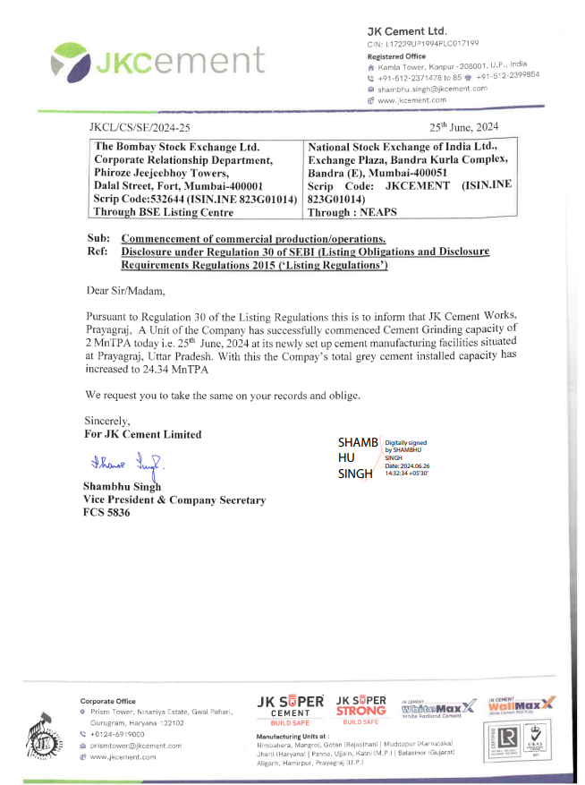

|  |
| --- |
| **SITE PHOTOGRAPHS** |

|  |  |
| --- | --- |
| X:\In Progress Files\Deepak Singh\Jan-Mar 2025\VIS(2024-25)-PL421-371-499 JK Cement\site images\TimePhoto_20250317_114107.jpg | X:\In Progress Files\Deepak Singh\Jan-Mar 2025\VIS(2024-25)-PL421-371-499 JK Cement\site images\TimePhoto_20250317_114452.jpg |
| X:\In Progress Files\Deepak Singh\Jan-Mar 2025\VIS(2024-25)-PL421-371-499 JK Cement\site images\TimePhoto_20250317_120336.jpg | X:\In Progress Files\Deepak Singh\Jan-Mar 2025\VIS(2024-25)-PL421-371-499 JK Cement\site images\TimePhoto_20250317_120930.jpg |
| X:\In Progress Files\Deepak Singh\Jan-Mar 2025\VIS(2024-25)-PL421-371-499 JK Cement\site images\TimePhoto_20250317_121131.jpg | X:\In Progress Files\Deepak Singh\Jan-Mar 2025\VIS(2024-25)-PL421-371-499 JK Cement\site images\TimePhoto_20250317_114133.jpg |