**Industrial Entrepreneur Memorandum**

**for**

**Manufacturing of Recycled Polyester Yarn/Chips from PET waste**

**(post-consumer & pre-consumer textile and bottle waste)**

**at**

**Block/Survey No. 87, (Old: 181-1), admeasuring 58643.00 sq.mt. at Village Koliyad, Tahsil Vagra**

**Distt. Bharuch, Gujarat.**

**Submitted by:**

|  |
| --- |
| **M/s TEXFIL PVT. LTD.**  **(a wholly owned subsidiary of M/s Filatex India Ltd.)**  **Regd. Office at 43 Community Centre,**  **New Friends Colony, New Delhi 110025.** |

**Summary of the Project**

|  |  |
| --- | --- |
| Name of Company/ Firm | M/s Texfil Private Limited  (a wholly owned subsidiary of M/s Filatex India Ltd.) |
| Date of Incorporation |  |
| Constitution | Private Limited Company |
| Company CIN | U17299DL2021PTC382764 |
| Industry | Textiles – (Technical) |
| Nature of Activity | Manufacturing of Recycled Polyester yarn/chips from PET waste  (post-consumer & pre-consumer textile and bottle waste) |
| Registered office | 43 Community Centre  New Friends Colony New Delhi 110025. |
| Factory Address | Block/Survey No. 87, (Old: 181-1), admeasuring 58643.00 sq.mt. at Village Koliyad, Tahsil Vagra Distt Bharuch Gujarat. |
| Pan No. | AAICT6905A |
| GST Reg. | 24AAICT6905A1ZN |
| Promoter | M/s Filatex India Limited |
| Directors | Sh. Madhu Sudhan Bhageria Sh. Purrshottam Bhaggeria Sh. Madhav Bhageria |
| Land Purchased | 58643.00 Sq. Mtrs |
| Power Requirement | 3 MW/hr |
| Water Requirement | 500 KL per day |
| Manpower Requirement | 250 |
| Estimated Project Cost | Rs. 300.00 crores |
| Production Capacity | 75 MT per day i.e. ~27000 MT p.a. |

**Project Overview**

The project aims to establish a sustainable manufacturing unit for the production of recycled polyester yarn/chips from both post-consumer and pre-consumer PET (polyethylene terephthalate) waste, specifically textile waste like yarn, fabric and garments along with PET bottle. This initiative will contribute to the global sustainability movement by reducing reliance on petroleum, lowering greenhouse gas emissions, reducing PET waste and promoting the circular economy.

**Key Highlights**:

* Recycled PET (r-PET) yarn/chips will be produced using a unique chemical recycling technology.
* Waste material, which otherwise ends up in landfills or incarcerated, will be converted into high-quality polyester yarn/chips with properties comparable to virgin polyester.
* The process will reduce greenhouse gas emissions and use of petroleum products along with reduction in PET waste, aligning with global environmental goals.

**Key Growth Drivers and Inhibitors**

**Growth Drivers:**

* **Global Sustainability Trends**: Increasing focus on eco-friendly products and sustainable manufacturing processes.
* **Government Initiatives**: Supportive policies for waste management and recycling industries.
* **Growing PET Demand**: Increasing global consumption of polyester for textiles, packaging, and other applications.
* **Environmental Concerns**: Rising awareness about the hazards of PET waste and its impact on ecosystems.

**Inhibitors:**

* **High Initial Investment**: Chemical recycling requires advanced technology, making initial setup costs high.
* **Technological Challenges**: Developing efficient processes for handling mixed PET waste from various sources.

**Current Recycled Polyester Market**

Polyester fiber production increased from 63 million tonnes in 2022 to 71 million tonnes in 2023, accounting for 57% of global fiber production, meaning that polyester continues to be the most widely produced fiber.

Globally, recycled polyester fiber production increased from around 8.6 million tonnes in 2022 to around 8.9 million tonnes in 2023. However, due to the increase in virgin polyester production, there was a decrease in the overall market share of recycled polyester from around 13.6% of global polyester production in 2022 to around 12.5% in 2023.

Systems for polyester textile-to-textile recycling are in development but are only estimated to account for around 2% of all recycled polyester. The interest in, and use of, ocean or ocean-bound plastic is increasing, but overall market shares remain very low and make up less than 0.01% of all recycled polyester.

Currently, recycled polyester is still primarily made from plastic bottles (98%). The key manufacturers of Recycled polyester in India are:

**Mechanical Recycling from PET bottles**

* Reliance Industries Ltd.
* Ganesha Ecosphere Pvt. Ltd.
* Nirmal Fibres
* KK Fibres
* Alliance Fibres Ltd.

**Chemical Recycling from PET bottles**

* Revalyu Recycling (India) Ltd. (formerly Polygenta)
* JB Ecotex Ltd.

**Details of Holding Company - M/s Filatex India Limited**

M/s Filatex India Ltd. (FIL) is promoted by the Bhageria family hailing from Dist. Jhunjhunu Rajasthan. This company was incorporated on 8th August 1990 and received its certificate of commencement of business on 5th September 1990. FIL is engaged in the business of manufacturing of polyester and polypropylene multifilament yarns (commonly known as PFY) at its exiting unit at Dadra UT of Dadra & Nagar Haveli through extruder based technology of manufacturing of yarns and backward Integration with installation of continuous polymerization plant with manufacturing of polyester chips and direct melt spinning of yarns at its existing unit at Dahej, Gujarat.

**Brief background of the Nanufacturing Units**

At Dadra, FIL, initially started with a small capacity for manufacture of POY of 5,000 MT p.a. in 1996 and gradually increased the same to 62,633 MT p.a. by the end of financial year 2013-14. FIL has also started manufacturing of Polypropylene Crimps and Textured Yarn which is a high value added product and now contributes 15% approximately to total turnover. FIL also added another value added product namely Fully Drawn Yarn (FDY) in its product range and the company is able to cater to diversified needs of its customers under one roof. The Dadra plant of the company is fully automated and ISO 9001/2015

Filatex India Limited (FIL) has put up a another unit for manufacture of 216,000 MTs/pa of poly-condensation and 108,000 MTs/pa of POY at Dahej Industrial Area, GIDC, Dist. Bharuch, Gujarat. The said plant has become fully operational during Sept 2012. The plant at Dahej, Bharuch has the locational advantage due to its proximity to market. Surat & Silvassa account for more than 45% of total demand of POY & more than 85% of total demand for chips in India. The company experienced various major gradual expansion in capacities and value-added products since inception to till date and has overall saleable capacity of over 410,000 MT per annum including in house captive thermal power plant of 30 MW/hr and ISO 14001/2015, ISO 45001/2018 and OEKO-TEX Standard 100

The company has experienced for completing various expansion projects well within the timeline and at the estimated cost all the time.

The company has been availing credit facilities under consortium arrangement led by Punjab National Bank with member banks viz. Bank of Baroda, IndusInd Bank Ltd and Yes Bank Ltd.

Presently, the company is enjoying various credit facilities with its consortium member banks as under:

(Rs./ Crores)

|  |  |  |  |  |  |
| --- | --- | --- | --- | --- | --- |
| **Facilities** | **PNB** | **BOB** | **IBL** | **YBL** | **Total** |
| Fund Base working capital limits | 50.00 | 35.00 | 28.00 | 35.00 | 198.00 |
| Non- Fund Base working capital limits | 275.00 | 200.00 | 175.00 | 200.00 | 850.00 |
| Term Loans | 24.01 | - | - | - | 24.01 |
| **Total** | **349.01** | **235.00** | **203.00** | **235.00** | **1022.01** |

Key Financial Indicators are under:

(Rs/Crore)

|  |  |  |  |  |
| --- | --- | --- | --- | --- |
| **Year Ending** | **2022-23** | **2023-24** | **2024-25** | **2025-26** |
| **Audited** | **Audited** | **Estimated** | **Projected** |
| **Capital Stream** |  |  |  |  |
| Tangible Net Worth | 1,241.27 | 1356.31 | 1579.94 | 1807.02 |
| Long Term Liabilities | 289.86 | 258.86 | 195.53 | 137.33 |
| Net Block | 1,348.97 | 1,347.56 | 1,341.98 | 1,334.33 |
| Net Working Capital | 160.05 | 245.71 | 316.07 | 292.60 |
| Current Assets | 742.17 | 728.19 | 1,007.12 | 987.60 |
| Current Liabilities | 582.12 | 482.48 | 691.05 | 695.00 |
| **Revenue Stream** |  |  |  |  |
| Net Sales | 4,303.87 | 4,285.90 | 4,344.56 | 4,348.38 |
| EBIDTA | 231.98 | 239.15 | 404.36 | 406.12 |
| Profit Before tax (PBT) | 122.08 | 150.43 | 311.68 | 313.44 |
| Net Profit After Tax (PAT) | 89.90 | 110.66 | 210.46 | 232.67 |
| Retained Profit | 70.37 | 104.00 | 201.58 | 223.79 |
| Cash Accruals | 135.65 | 186.82 | 298.75 | 302.81 |
| **Key Financial Ratios** |  |  |  |  |
| Debt Equity Ratio (DER) | 0.23 | 0.19 | 0.12 | 0.08 |
| Total Outside Liab/TNW | 0.74 | 0.57 | 0.60 | 0.49 |
| Fixed Asset Coverage Ratio | 4.65 | 5.21 | 6.86 | 9.72 |
| Current Ratio | 1.27 | 1.51 | 1.46 | 1.42 |
| Current Ratio (Adjusted) | 1.39 | 1.63 | 1.58 | 1.55 |

**Name of Directors & their Technical Background**

* Mr. Madhu Sudhan Bhageria, is a Commerce graduate from Shri Ram College of Commerce, Delhi University and has experience of more than three decades in Polyester Industry. He is also President of PTA users Association and holding directorship in various companies. He has over four decades of financial, operational and strategic planning experience in synthetic and polyester yarn, environment and energy conservation
* Mr. Purrshottam Bhaggeria, is a MBA from Cornell University, USA. He is a member of Managing Committee of PHD Chamber of Commerce & Industry. He has diverse experience in corporate affairs, policy perspective, investments, compliance and legal issues.
* Mr. Madhav Bhageria is a commerce graduate from Hindu College, Delhi University and looks after plant operations and marketing functions of the Company based at Surat & Mumbai. He is also a Promoter Director of Tapti Valley Education Foundation which is an International School in Surat. He has over 37 years of experience in marketing, operations, insurance and contracts.

**Need of Project**

1. **Global Sustainability:**

Sustainability consists of fulfilling the needs of current generations without compromising the needs of future generations, while ensuring a balance between economic growth, environmental care and social well-being. Other way, 5 pillars of sustainability are Human, social, Economic & environment. For achieving sustainability, rules are Rethink, Refuse, Reuse, Repair and Recycle.

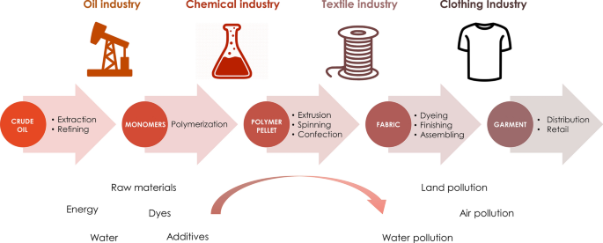

**b) PET is non-biodegradable**

Polyethylene terephthalate (PET) is a widely employed in various forms having several applications due to its high strength and its physical and chemical properties, particularly in Textiles and Packaging.

Industrially PET is obtained from two different raw materials via Pure Terephthalic acid (TPA) and Mono ethylene /Glycol (MEG) through polymerization process.

Clothing, upholstery, linen & rugs are one of the primary human needs & demand is met by the global increase in production of textile yarns/ fibres, fabrics & garments. Polyesters, specially PET is the major polymer used for clothing materials. Other major use of PET polymer is in bottle/ jars, such as mineral water, soft drinks, edible oils etc. The non- bottle & non- clothing end uses are PET packing, strapping etc.

PET during production creates pollution (GHG- Co2 gas emission) along its entire value chain – (virgin materials, power & heat). Its ever-increasing application and usages contribute to unsustainable depletion of resources. The continuous consumption of PET endangers environment & human health. Therefore, recycling is essential for reduction of effect on environment & human health.

With worldwide increase in population and increased per capita consumption of PET products, accumulation of its non-bio-degradable waste is generating a very big environmental and economic concern. Currently, 92 million tons of textile waste is generated annually.

Therefore, there is a growing interest in PET recycling technologies to reduce the growing quantity of PET waste is textile and packaging. Many international brands have now signed mandates for sourcing over 50% of their material through recycled sources by 2030.

1. **Lack of awareness leads to the mixing of all kind of waste.**

All sorts of PET waste are being either incinerated or are thrown into landfills or are spread in grounds, water, rivers, canals and seas damaging natural environment and creating a non-conducive atmosphere for habitation of Humans, animals and marine bio-diversities.

There is lack of awareness the waste collection system and about its re-use/ re-process of PET Plastic/Polyester waste for its re-utilization to manufacture yarns/fibres and other kinds of products.

Therefore, there is a growing interest in PET recycling technologies as PET & plastics can be recycled and reused.

1. **Recycling Technologies**

To make PET waste into re-useable products, recycling technologies can be grouped into two macro-categories: Mechanical and Chemical

**Mechanical recycling** refers to operations that aim to recover plastics via mechanical processes (grinding, washing, separating, drying, meting, re-granulating and compounding), thus producing recyclates that can be converted into plastics products, substituting virgin plastics.

This mechanical process often leads to thermo-oxidative and thermo-mechanical degradation, resulting in lower molecular and impure polymer formation. According to the Food Safety Authority, granulate from mechanical recycling cannot be used in food packaging.

Most importantly it limits the number of cycles the polymer can be subjected to further recycling process. **De facto, in mechanical recycling after maximum one recycle, polymer no longer can be recycled and must be discarded in landfills.**

**Chemical recycling** technologies are in accordance with sustainable development principles, bringing back waste to virgin PET raw materials, which of course are of much higher quality compared to mechanically recycled PET.

Chemical recycling involves depolymerization of the polyester by using reactants / solvents and reclaiming basic/intermediate raw materials from PET chains. Chemical recycling is a process to convert polymer into its original or intermediate monomer form so that it can eventually be repolymerized and remade into a virgin state polymer.

**Chemical recycling is the best way to achieve circular economy of PET as it does not limit number of recycling for the same product.**

Chemical recycling splits polymer chains into monomer which makes it possible to filter out fine particulate matters & purify the product better enabling production of high-quality product. It also provides possibility of feeding monomer that can be used in other applications of fossil-based alternatives. Chemical recycling provides utilization of wider range of waste PET than mechanical recycling.

Technology developed by **Texfil Pvt Ltd**. is a Chemical Recycling Process for producing r-PET. The developed process can handle the recycling of PET yarn waste & fabric waste along with bottle flakes waste.

# **Manufacturing Process**



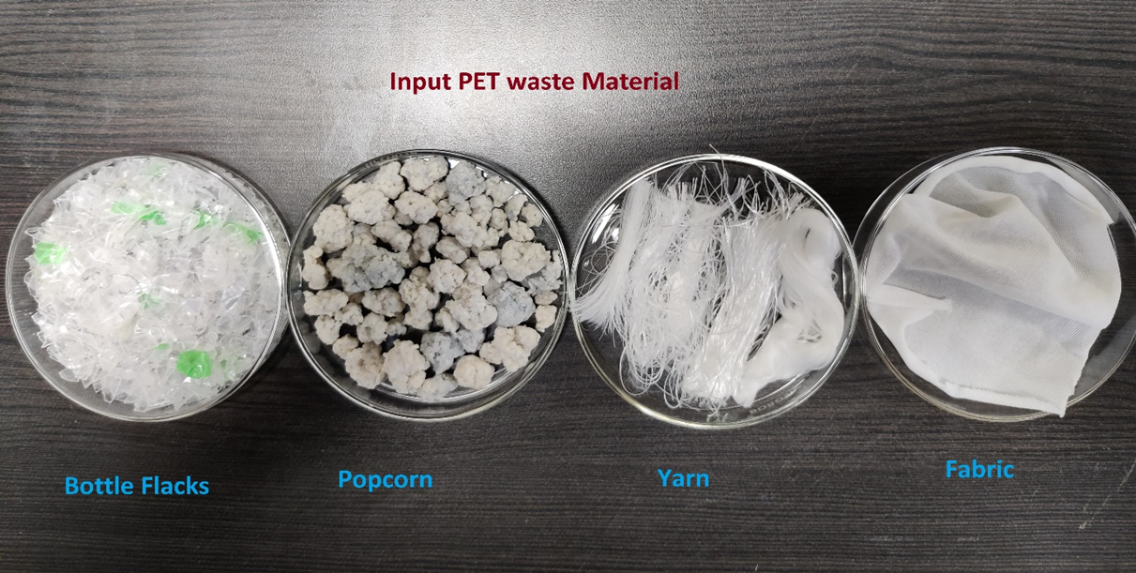

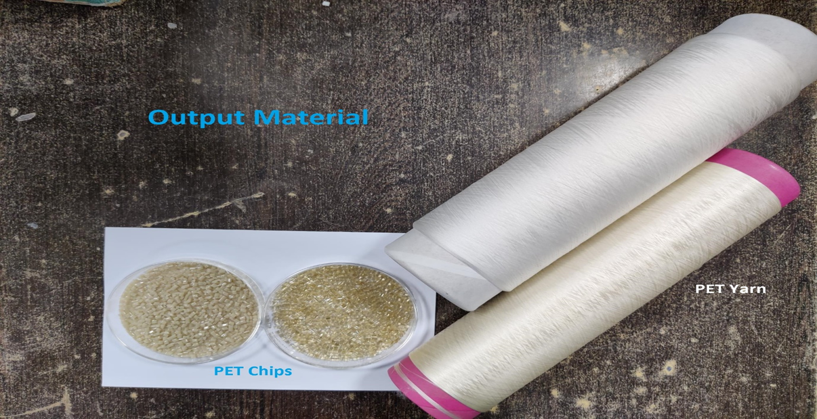

## **Process Flow**

**Waste Preparation**: The pre-consumer PET yarn / Fabric waste is sorted from highly contaminated portion or foreign matters & put into a conveyor for shredding**.** The shredded waste is passed through a conveyor with magnet and/or metal detector to remove metallic impurities.

**Glycolysis Process**: Since PET is formed through a reversible polycondensation reaction, the polymer can be transformed back to its monomer or oligomers by shifting the reaction to the opposite direction by adding EG. This reverse reaction, called glycolysis.

The waste is fed into the Glycolysis reactor having heating & agitation facility. The required quantity of Ethylene glycol (EG) is fed into reactor vessel & heated to attain required results with addition of catalyst. This completes the process of conversion of PET waste into monomer. The reacted liquid product is then transferred to cooling tank for further process of filtration.

Glycolysis of polyester waste generates polymerization intermediate BHET which is purified and repolymerized into polyester resin. It does not involve high handling of hazardous chemicals and is an energy saving process.

**Filtration & Purification**: The glycolyzed product has sub-micron impurities like Tio2, Baso4 & any other type of foreign particles. These submicron particles are removed in a series of filtration systems till the required quality is achieved as judged by product transparency. Filtration system is also capable of removing light organic coloring impurities developed during glycolysis process.

Finally, the product is washed with hot water, crystallized in a continuous manner & then filter pressed to separate solid monomer form liquid EG & water. The final monomer product is in the form of wet cake.

**Polymerization**: The polymerization of wet monomer cake is done by a series of polymerization reactors. After achieving the required polymer viscosity, melt from finisher is fed to granulator through polymer gear pump & continuous polymer viscometer for measuring polymer viscosity. The r-PET chips produced are packed for further use.

**Recycled Product Specifications**

|  |  |  |  |
| --- | --- | --- | --- |
| **FILATEX INDIA LTD, DAHEJ** | | | |
| **TECHNICAL SPECIFICATION** | | | |
| **Materials: POLYESTER (BRIGHT) CHIPS (r-PET)** | | | |
| Sr. No. | PROPERTIES | Specification | COA |
| 1 | I.V. ( dl / gm) * | 0.650 ± 0.01 | 0.645 |
| 2 | COOH End Group (MEG/kg) | ≤ 40 | 40 |
| 3 | DEG Content (wt %) | 1.40 ± 0.1 | 1.40 |
| 4 | Melting Point (Deg.C) DSC Peak Temp. | ≥ 255 ° C | 256.5 |
| 5 | Color Value L (Hunter) | > 42 | 42.00 |
| Color Value b (Hunter) | < 10.0 | 8.50 |
| 6 | Ash Content (Wt. %) | 0.040 ± 0.020 | 0.040 |
| 7 | Moisture (wt %) | ≤ 0.40 | 0.165 |
| 8 | Chips per gram | 60 +/-5 | 60 |

|  |  |
| --- | --- |
| **\*Solvent: Phenol: DCB = 60:40, at 25°C** |  |

|  |  |  |  |  |  |  |  |  |  |
| --- | --- | --- | --- | --- | --- | --- | --- | --- | --- |
| **POY Properties produced from r-PET chips** | | | | | |  |  |  |  |
| **Sr. no** | **Den/Fil** | **Denier** | **Tenacity (g/d)** | **% Elong.** | **D/F** | **DF cV%** | **%U(N)** | **%OPU** | **X-Sec** |
| **1** | **250/48** | **250.2** | **2.28** | **132.3** | **88.4** | **1.94** | **1.00** | **0.38** | **48-Cir** |
| **2** | **160/48** | **163.8** | **2.09** | **143.0** | **65.7** | **1.38** | **1.20** | **0.40** | **48-Cir** |
| **DTY yarn properties** | | | |  |  | | |  |  |
| **Sr. no** | **Den/Fil** | **Denier** | **Tenacity (g/d)** | **% Elong.** | **BWS %** | **CC %** | **OPU %** |  |  |
| **1** | **150/48 NIM** | **149.9** | **3.82** | **26.5** | **1.03** | **16.4** | **2.7** |  |  |
| **2** | **100/48 NIM** | **98.0** | **4.10** | **23.8** | **1.55** | **17.40** | **2.80** |  |  |

**Brief Technical Note on Existing Process and New Process**

In India, there are 2 companies Revalue Recycling (India) Ltd. (Formerly known as Polygenta), and J.B. Ecotex who are only running chemical PET recycling companies. All other PET recycling units in India are based on Mechanical recycling process technology. Mechanical recycling has got limitation of its life cycle as the same cannot be reprocessed.

It is necessary to mention here that both the above 2 chemical recycling plants are using BOTTLE FLAKES as their raw material which is not a sustainable circular operation as they are producing textile grade PET from Bottle grade PET.

Technology developed by Texfil Pvt Ltd. is a much-refined Chemical Recycling Process for producing r-PET. The developed process can handle the recycling of PET textile waste such as yarn waste, fabric waste and garment waste along with bottle waste. Only a few international chemical recycling processes (still in development stage) are designing such process which can handle textile waste along with bottle waste.

Advantage of this chemical recycling process is that one of the main ingredient chemical EG is used for recycling & monomer produced is part of the normal PET manufacturing process.

**Our R & D facility is registered with the Department of Scientific and Industrial research under the aegis of Ministry of Science & Technology.**

**Our company has already obtained Indian patent on “Chemical Recycling Technology” of PET. It has been also published in International PCT applications. We have also applied for patent recognition in US and European countries.**

As per the literature, virgin PET produces 2.15 – 2.35 kg CO2- equivalent per kilogram of PET. r-PET produces 0.45 -0.98 kg CO2-equivalent per kilogram of r-PET. So this process will also reduce CO2 emission contributing to global sustainability.

**Upcoming Textile to Textile Recycling Projects**

|  |  |  |  |
| --- | --- | --- | --- |
| **Company** | **Project Details** | **Capacity** | **Project Cost** |
| Loop Industries + Esther | Manufacturing 100% recycled virgin-quality DMT and MEG monomers using proprietary Infinite Loop technology | 70,000 MT of r-DMT  23,000 MT of r-MEG | USD 165 million |
| Carbios | Manufacturing 100% recycled PET using an enzymatic depolymerization process | 50,000 MT of r-PET | USD 250 million |
| Texfil Private Limited | Manufacturing 100% recycled polyester products using a unique textile to textile chemical recycling technology | 25,000 MT of r-PET | USD 36 million |

**Marketing Strategy**

**The Problem**

The global fashion, textile and apparel industry needs a paradigm shift. It can no longer continue business as usual under the guise of vague sustainability promises. Instead, companies must embrace the transition, transforming their business models on a large scale to address climate and nature impacts right from the start of their supply systems. Regulations relating to Extended Producer Responsibility (ERP) will come into force in 27 EU member states from December 2024 and will require manufacturers to take on significant responsibility for the treatment or disposal of post-consumer products. All reputed international brands have expressed firm commitments and readiness to establish a supply chain from recycled products and are willing to pay a substantial price premium for the same. Such global efforts all over the world will reduce the quantity of post-consumer textile waste being dumped in landfills or being burnt and help in creating truly a circular economy.

**The Solution**

In order to tackle this growing demand for recycled material, Texfil plans to market and sell their recycled material under the **Ecosis brand**.

Ecosis will offer a range of high-quality recycled polyester products, meticulously crafted to meet the needs of sustainable fashion and textile. The company plans to take a brand-first approach for selling Ecosis as brands under ERP have committed to . It has already started discussions with a few international brands who have given positive feedback regarding the process and recycled material.

Ecosis will be positioned as one of the first textile to textile polyester recycled product which it’s an urgent need for many brands as they are facing mounting pressure to improve the recyclability of their own products in order to move towards a circular economy. Mechanical recycling which uses PET bottles as their raw material does not tackle the problem of textile waste and is not a circular solution.

Ecosis will deliver the excellent characteristics of polyester while solving one  
of the biggest problems of waste handling. The production of Ecosis will be more energy efficient and can be carried out an infinite number of times achieving true circularity.

Currently, there is a big mismatch between the demand for recycled yarn versus the supply. This is especially true for recycled yarn manufactured via the chemical process which ensures better quality as well as circularity. Recycled yarn manufactured via the chemical route is currently selling at a premium of approximately USD 0.60 / INR 50 per kg based on both export as well as domestic data.

**Export Data**

|  |  |  |
| --- | --- | --- |
| **Month** | **Revalyu - Recycled Yarn Rate (USD)** | **Filatex - Virgin Yarn Rate (USD)** |
| August 2024 | 1.8 – 2.4 | 1.1 – 1.3 |
| July 2024 | 1.9 – 2.5 | 1.1 – 1.3 |

**Various Approvals & Permissions**

As the prevailing laws for establishment of new Industrial unit the following permissions and approval and its estimated timelines are as under:

1. Procurement of land- Already obtained and registered
2. Conversion of land- Application under process for conversion of agricultural land to Industrial land (NA process).
3. Building Plan - Shall be applied upon NA and expected to get 2 months post NA.
4. Electricity connections - Shall be applied temporary connections and after NA process for 66KV upon laying the required cables line from 66KV bay to factory substation in six months.
5. Factory License - Shall be applied
6. Pollution certificate – CTE shall be applied to GPCB before production and CCA shall be obtained before commencement of commercial production.













