File No.: VIS (2024-25)-PL436-386-531 Dated: XXXXXXX

TECHNO-ECONOMIC
VIABILITY (TEV) STUDY REPORT AND ENTERPRISE VALUATION (EV) REPORT

OF

M/S GUPTA POWER INFRASTRUCTURE LIMITED

REPORT PREPARED FOR

BOB CAPITAL MARKETS LTD, PARINEE CRESCENZO, 1704, B WING, 17TH FLOOR, BANDRA KURLA COMPLEX, G BLOCK, BANDRA EAST, MUMBAI-400 051

**Important - In case of any query/ issue or escalation you may please contact Incident Manager Valuers@rkassociates.org. We will appreciate your feedback in order to improve our services.

NOTE: As per IBA Guidelines please provide your feedback on the report within 15 days of its submission after which report will be considered to be correct.

IMPORTANT NOTICE

COPYRIGHT FORMAT: This report is prepared on the copyright format of R. K. Associates Valuers & Techno Engineering Consultants (P) Ltd. (R. K. Associates) to serve our clients with the best possible information and analysis to facilitate them to take rational business decisions. Legally no one can copy or distribute this format without prior approval from R. K. Associates. It is meant only for the advisory/ reference purpose for the organization/s as mentioned on the cover page of this report. Distribution or use of this format or report or any of its content/ information/ data by any organization or individual other than R.K Associates will be seen as an unlawful act and necessary legal action can be taken against the defaulters.
This report is intended for the sole use of the intended recipient/s and contains material that is STRICTLY CONFIDENTIAL AND PRIVATE.

DEFECT LIABILITY PERIOD: In case of any query/ issue or escalation you may please contact Incident Manager at valuers@rkassociates.org. Though adequate care has been taken while preparing this report as per its scope, but still, we can’t rule out typing, human errors, over sightedness of any information or any other mistakes. Therefore, the concerned organization is advised to satisfy themselves that the report is complete & satisfactory in all respect. Intimation regarding any discrepancy shall be brought into our notice immediately. If no intimation is received within 15 (Fifteen) days in writing from the date of issuance of the report, to rectify these timely, then it will be considered that the report is complete in all respect and has been accepted by the client up to their satisfaction & use and further to which R.K Associates shall not be held responsible in any manner.

Part L: R. K. Associates Important Disclaimer and Remarks are integral part of this report and Feasibility assessment is subject to this section. Reader of the report is advised to read all the points mentioned in these sections carefully.

TABLE OF CONTENTS
SECTIONS | PARTICULARS | PAGE NO.
Part A | REPORT SUMMARY | 4
Part B | INTRODUCTION
 | - About the Report | 6
 | - Executive Summary | 6
 | - Purpose of the Report | 10
 | - Scope of the Report | 10
 | - Methodology/ Model Adopted | 11
 | - Data Information received from | 12
 | - Documents/ Data Referred | 12
Part C | COMPANY PROFILE
 | - Company Overview | 13
 | - Debt Snapshot | 14
 | - Shareholding Details | 15
 | - Promoters/Directors Profile | 16
 | - Reasons for Financial Stress | 21
 | - Observations made during Survey/Site Visit | 22
PART D | INFRASTRUCTURE DETAILS
 | - Plant Location | 24
 | - Layout Plan | 26
 | - Location Map | 26
 | - Site pictures | 31
 | - Land Details | 43
 | - Building & Civil Works | 45
 | - Plant and Machinery/ Equipment details | 48
 | - Utilities | 50
PART E | TECHNICAL ASSESSMENT OF THE COMPANY
 | - Capacity of Manufacturing Facility | 52
 | - Process Flow Chart | 52
 | - Technical Specification/Technology Used | 54
 | - Testing Standards for Production | 58
 | - Manpower | 58
PART F | PRODUCT PROFILE
 | - Introduction | 59
 | - Product Category | 59
 | - Marketing, Selling & Distribution Plan | 62
 | - Raw Material Procurement | 62
PART G | INDUSTRY OVERVIEW & ANALYSIS | 64
PART H | SWOT ANALYSIS | 71
PART I | STATUTORY APPROVALS | LICENCES | NOC | 73
PART J | COMPANY’S FINANCIAL FEASIBILITY | 76
PART K | CONCLUSION | 94
PART L | DISCLAIMER | REMARKS | 96

PART A | REPORT SUMMARY

S. No. | PARTICULARS | DETAILS
 | Name of the Company: | M/s Gupta Power Infrastructure Limited
 | Registered Address: | EN-62, Sector-V, 7th Floor, Salt Lake City, Kolkata, West Bengal – 700091.
 | Administrative Address: | Cuttack-Puri Road, Infront of Budheswari Temple, Bhubaneswar, Odisha – 751006.
 | Project Name: | Two manufacturing plants in Khurda, Odisha and Kashipur, Uttarakhand, which makes both cables and conductors; and one near Chennai, dedicated towards manufacturing of conductors.
 | Project Location: | - Odisha: Plot No. F/9, IID Centre, Mukundaprasad, Khurda, Odisha - 752054  - Uttarakhand: Plot No. – 132 & 145, Nandanagar Industrial Estate Phase – II, Village Mahaukheraganj, Kashipur, Uttarakhand - 244713  - Chennai: D10/S1, SPCOT Industrial Complex, Gummidipoondi, Tiruvallur, Tamil Nādu - 601201
 | Project Type: | Manufacturing, Trading, and Marketing of Electrical Products
 | Project Industry: | Manufacturing – Cables and Wires
 | Product Type/ Deliverables: | Manufacturing of cables, conductors, wire rods, household wires and LED lighting alongwith EPC division which undertakes turnkey power infrastructure projects.
 | Report Prepared for Organization: | BOB Capital Markets Ltd, Parinee Crescenzo, 1704, B Wing, 17th Floor, Bandra Kurla Complex, G Block, Bandra East, Mumbai 400 051.
 | TEV Consultant Firm: | M/s. R.K Associates Valuers & Techno Engineering Consultants (P) Ltd.
 | Report type: | Techno-Economic Viability (TEV) and Enterprise Valuation (EV) Report
 | Purpose of the Report: | To assess Project’s Techno-Economic Viability and Enterprise Valuation to enable NARCL in making a decision regarding the acquisition of debt.
 | Scope of the Report: | To assess, evaluate & comment on Techno-Economic & Financial Viability of the Company and evaluate Enterprise Value of the company as per data information provided by the client, independent Industry research, data/ information available on public domain and our independent EIC research.
 | Date of Report: | 6th February 2024
 | Documents referred for the Project: | - Brief description about the company.  - Financial Model Shared by the client.  - Information provided by client.  - Consortium meeting minutes shared by the Company.  - Forensic Audit and ASM Audit Reports  - Last 4 financial year Audited Financial Statements of the company (FY 2019 to FY22).  - Documents regarding communications held with consortium bank members.
 | Key Financial Indicators: | Key Indicators Value  Average DSCR 1.36  Average EBITDA Margin 3.96%  Average EBIT Margin 1.98%

Note: Above financial indicators are based on the financial projections of M/s Gupta Power Infrastructure Limited provided by the company and assessment and analysis of the same done by us.

PART B | INTRODUCTION

- ABOUT THE REPORT:
Techno Economic Viability Study cum Enterprise Valuation Report of M/s Gupta Power Infrastructure Limited having registered office at EN-62, Sector-V, 7th Floor, Salt Lake City, Kolkata, West Bengal – 700091.

- EXECUTIVE SUMMARY:
M/s Gupta Power Infrastructure Limited was incorporated on 9th May, 1961 established for the purpose of manufacturing aluminium and alloy conductors and cables. The company is engaged in the Manufacture of HT Cables, LT Cables, FR/FRLS/ZHFR flexible cables, wire rods, complete range of overhead conductors (AAAC, ACSR, AAC, EHV and HTLS conductors, etc.) and complete range of high-quality end to end terrestrial optical fibre cables. The company also has an EPC division, which undertakes turnkey power infrastructure projects.
The Company was incorporated as ‘Gupta Cables Private Limited” in 1961. As per the information shared with us, Mr. MK Gupta and his family members, based in Odisha, acquired the business in 1970. Subsequently, the company changed its name from M/s Gupta Cables Private Limited to M/s Gupta Power Infrastructure Limited which is approved by the ROC, West Bengal vide Certification of Incorporation SRNA34284877 on 26th March 2008.The key milestones of the Company are listed in the below table:
Year | Milestones
2007 | - Awards for “Excellence in Entrepreneurship” by MSME Govt. of India and Govt. of Odisha in EXPO Odisha -2007.  - Developed the G- Power brand of different arrays of cables which includes HT Power Cables up to 66 KV, LT, XLPE/ PVC Power Cables 1.1 KV, Control cables, Instrumentation cable/Signalling cables, Thermocouple Extension Cables, House wires, Mining cables, Special cables
2008 | - Changed its name from M/s Gupta Cables Private Limited to M/s Gupta Power Infrastructure Limited  - Udyog Patra Award” from Institute of Trade & Industrial Development.
2009 | - Times of India "Leadership Award- 2009” for Business Leader 2009.  - MSME “Best MSME Unit” for Outstanding achievement of the year 2008, by MSME Govt. of India & Govt. of Odisha in EXPO Odisha -2009.  - MSME “National Award” for Outstanding efforts in Entrepreneurship in Micro & Small Enterprises (A Special Recognition Award) from Govt. of India and Govt. of Odisha.
2011 | - Installed CCV line procured from TROESTER Germany, at Kashipur, capable of producing cable up to 66 KV
2012 | - Installed Niehoff (German) high speed wire drawing on line annealing machine at Khurda, Odisha
2015 | - Started House wire production with Reelex pack technology capable of producing tangle-free wire
2016 | - Launched world class LED lighting with superior features using state-of-the-art technology for its domestic and international customers
2017 | - Produced a complete range of Optical Fiber Cable and Solar Cable for a variety of applications.
The company has two primary business activities and revenue streams viz:
- Manufacturing of insulated wire and cable [insulated (including enamelled or anodized) wire, cable (including coaxial cable) and other insulated conductors; insulated strip as is used in large capacity machines or control equipment; and optical fibre cables].
- EPC Division provides engineering services, procurement and construction services. Projects generally include Design, Planning Supply, Testing, Integrating and Commissioning of Transmission and Distribution lines, restoration, renovation and modernization of power sub-station, upgradation and augmentation of existing sub-station, project formulation for Rural Electrification.
M/s Gupta Power Infrastructure Limited, a flagship company of the JRG Group, is a known name in the electrical manufacturing industry since 1961. Its diverse product portfolio includes cables, conductors, wire rods, household wires, and LED lighting solutions. In the year 2016, Gupta Power entered the house wire market with its 'Rhino' brand and expanded its offerings to include a wide range of LED lighting products. In 2017, the company embraced the Digital India initiative by introducing a comprehensive range of terrestrial Optical Fiber Cables, further showcasing its commitment to innovation and quality.
EPC division was started with an objective of empowering lives by offering integrated turnkey solution. The division had a dedicated team of designers and engineers for successful project execution. To strengthen the EPC division work they had started manufacturing HTLS Conductor. The specialty of the conductor is it has high current carrying capacity and low sag-tension property. Apart from this, the installation of this conductor is easy and rapid.
It had established its distribution network of retailers for selling cables under the brand name of ‘Rhino’ under the franchisee model. As per the information available on the public domain and information shared with us, Rhino retail products were available through 500 registered dealers and distributors and over 5000 retail outlets across country.
There are 3 ultra-modern manufacturing facilities with latest technologies in its Strategic Business Units (SBUs). Plants at Khurda and Kashipur make both cables and conductors where as the one located near Chennai is dedicated towards manufacturing of conductors. For quality products Gupta Power has established in-house R&D division, hi-tech laboratory and quality assurance division. The carefully planned designs play a major role in providing the market with innovative, smart products. The details of all both plants along with their capacities are shown in the below table:
Particulars | Khurda Unit | Kashipur Unit | Chennai Plant | Total Capacity
Wire Rod, Conductors and Cables (Aluminium + Alloy + Copper) | 1,00,000 MT | 40,000 MT | 10,000 MT | 1,50,000 MT
Copper - Contact & Catenary Wire | 8,000 MT | 2,000 MT | - | 10,000 MT
Optic Fibre Cable | 60,000 KMs | - | - | 60,000 KMs
Source: Information provided by the client
As per the information shared with us and available on the public domain, M/s GPIL dealt with several reputed customers, such as PGCIL, KEC International Ltd, Odisha Power Transmission Corporation Limited, L&T Ltd, NTPC, Kalpataru Power Transmission Ltd, JSW, Lanco, Tata, Sail, PSPCL, and Areva, among others.
During the site visit, we have found the Chennai Plant (Dated 06.09.2024) and Khurda Plant (Dated 10.09.2024 & 11.09.2024) were closed and no manufacturing was in process. Although, the Kashipur Plant (Dated 11.09.2024) was operational and running in good stead. The plant located in Chennai, Tamil Nadu was closed prior to the classification of accounts as NPA and the same was recorded in the consortium minutes dated 24.02.2023.
Below is the graphical representation of the key historical financial metrics of the company:
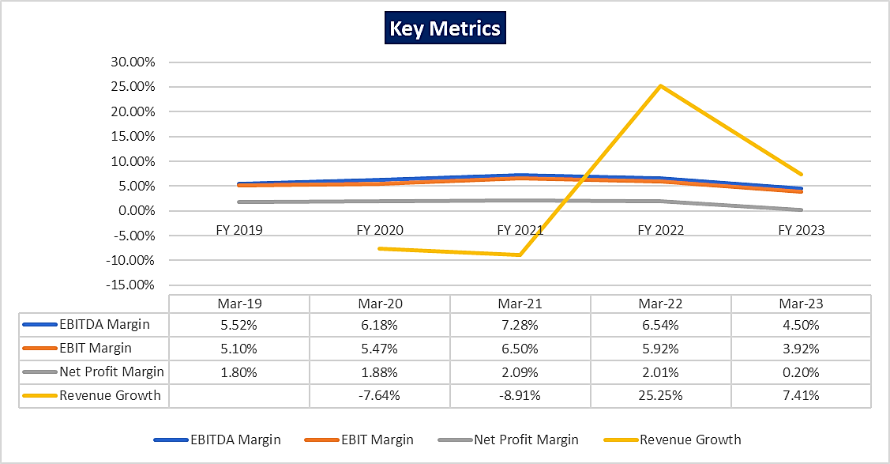
As per the previous years’ financials shared with us, the EBITDA Margin and Net Profit Margin of the company have decreased from 5.52% & 1.79% in FY 2018-19 respectively to 4.50% & 0.20% in FY 2022-23 respectively.
GPIL, has been reported to be in repeated default with its working capital lenders since January 2023. In a Joint Lenders' Meeting (JLM) held on September 15, 2023, GPIL presented a resolution plan aimed at clearing the overdue amounts to the banks by December 15, 2023. The plan projected an infusion of INR 160.00 Crores, along with cash flows from debtors and proceeds from the sale of other assets, to meet the lenders' dues. However, GPIL has failed to comply with any of the lenders' requirements, indicating that the company has not fulfilled the agreed terms or achieved the projected financial targets. As per the data/information available with us, the account is classified as NPA and all lenders have marked the account as Red Flagged. The status of the account with all lenders is shown in the table below:
S. No. | Name of the bank | Date of NPA | Date of Red Flagging
1 | Canara Bank | 30.09.2023 | 12.10.2023
2 | Bank of Maharashtra | 21.08.2023 | 14.09.2023
3 | Indian Bank | 24.09.2023 | 18.10.2023
4 | Bank of India | 25.09.2023 | 20.10.2023
5 | Union Bank of India | 29.09.2023 | 21.10.2023
6 | Punjab National Bank | 30.09.2023 | 27.10.2023
7 | UCO Bank | 16.10.2023 | 31.10.2023
8 | IDBI Bank | 12.10.2023 | 25.10.2023
9 | EXIM Bank | 19.12.2023 | 14.12.2023
10 | Karnataka Bank | 08.01.2024 | 17.10.2023
11 | Bank of Baroda | 29.01.2024 | 13.10.2023
12 | HDFC Bank | 07.02.2024 | 19.10.2023
Source: Data/Information provided by client
At present, the company is under financial stress and all the loan accounts of the company had been classified as Non-Performing Assets (NPA) in the month of August and September 2023. The operations were suspended but the Kashipur Plant was found operational at the time of our site visit. The Lead Bank of the consortium, i.e., Canara Bank had issued Demand Notice u/s 13(2) to the GPIL and the Personal Guarantors. The symbolic possession of all the properties is completed on 03.05.2024. Further, Online filing in DRT vide Diary No. 422/2024 completed on 13.05.2024 and physical filing for the same was completed on 23.05.2024 as per the information shared with us.
Further, a joint application vide case no. C.P. (IB)/37(KB)2024 has been filed by 7 banks (Canara Bank, Indian Bank, Punjab National Bank, Union Bank, UCO Bank, Bank of Maharashtra and Bank of India) for initiating CIRP u/s 7 of IBC on 08.07.2024. The physical filing of the case was completed on 27.02.2024. The case is pending before the tribunal and the next hearing is slated on 16.10.2024. All these allied factors resulted in squeezing of working capital funds which affected the facility to operate at lower capacity in Kashipur Plant, whereas Khurda and Chennai Plant became non-operational.
Therefore, to check and assess the Techno-Economic & Financial viability of the Company and to evaluate the Enterprise Valuation of the company to enable NARCL in making a decision regarding the acquisition of debt, BOB Capital Market Ltd. has appointed R K Associates as TEV consultant to review technical, commercial and financial viability of the company based on our independent EIC research and information/data provided to us about the company.
Hence, We R.K associate are performing the Techno-Economic Viability study and Enterprise Valuation of M/s Gupta Power Infrastructure Limited considering the Debt Acquisition Proposal.

- PURPOSE OF THE REPORT:
To assess Project’s Techno-Economic Viability and Enterprise Valuation to enable NARCL in making a decision regarding the acquisition of debt.

- SCOPE OF THE REPORT:
To assess, evaluate & comment on Techno-Economic & Financial Viability of the Company and evaluate Enterprise Value of the company based on Income Based Approach (Discounted Cash Flow) method as per data information provided by the client, independent Industry research, data/ information available on public domain and our independent EIC research.
NOTES:
- Project status is taken as per the information provided by the company officials/management.
- Site inspection has been carried out for all the existing units on 06.09.2024 (Chennai), 10.09.2024 & 11.09.2024 (Khurda) and 11.09.2024 (Kashipur). Operating details regarding the same is taken as per the information provided by the company which has been relied upon.
- Scrutiny about the company, background check, credibility, credit worthiness of the company or its promoters is out-of-scope of this report.
- This report is only an opinion in respect to Technical and Financial Feasibility of the project as per the future Projections provided by the firm and independent analysis done by us and doesn’t contain any recommendations including taking decision on the financial exposure.
- This is not an audit activity of any kind. We have relied upon the data/ information supplied by the company in good faith that it is true and without any fabrication.
- Existing units’ infrastructural details wherever mentioned has not been correlated with the documentary evidence such as title deeds, Building Map since the same was out of scope of work.
- This is not a Detailed Project Report or a detailed design or architecture document.
- Land and property details mentioned in the report is only for illustration purpose as per the information provided to us by the client. The same doesn’t tantamount for taking any responsibility regarding its legality, ownership and conforming to statutory norms.
- The enterprise valuation of the project is based on the Income generating capacity of the project in future years. This Valuation shall not be construed as the physical asset or should not be related directly to cost approach or Project cost.
- This Enterprise Valuation report doesn't cover vetting of the documents/ financial data/ projections or any other information provided to us by the client.
- This Valuation only covers the cash flow from operation of the company. It does not cover any transaction with the subject company’s subsidiary/ associate/ Joint Venture Companies, as per the requirement by the lender.
- This Valuation is prepared based on the current financial status and projections of the company, financial data/ model, future projections, other facts & information provided by the company/ lender/ Client in writing & verbal discussions held during the course of the assignment and based on independent assessment of certain assumptions which are specifically mentioned in the Valuation section of the Report.
- It doesn't contain the principles of physical asset valuation and is not based on the site inspection of the project.
- The Market and Industrial assessment of the given company’s industry/ sector has not been done at our end. So, this valuation doesn’t cover the market & industrial scenario in terms of the product demand & market potential.
- We have assumed that the information provided to us is correct and is not manipulated or distorted.

- METHODOLOGY/ MODEL ADOPTED:
- For TEV Report
- Data/ Information collection.
- Review of Data/ Information collected related to TEV study.
- Independent review & assessment of technology used and financial projections provided by the company/promoters.
- Review and analysis of the Projections as per the market trends and futuristic growth opportunity of the industry and company.
- Projections of Revenue, Expenses, P&L, Balance Sheet, fixed assets, COGS.
- Assessment of Key Financial Ratios.
- Final conclusion.
- For Enterprise Valuation Report:
Income-based Approach (Discounted Cash Flow Model) for the calculation of Enterprise Value of the Company.

- DATA/ INFORMATION RECEIVED FROM:
All the data/Information has been received from Mr. Puneet Bansal and the required details about him shown in the below table:
Particulars | Details
Name | Mr. Puneet Bansal
Company | BOB Capital Markets Limited
Email Address | puneet.bansal@bobcaps.in
Contact No. | +91 9769802131

- DOCUMENTS / DATA REFFERED:
- Financial Projections of the company for next 8 Years.
- Director’s Details.
- Details gathered during our site visit
- Brief description about the company.
- Financial Model Shared by the client.
- Consortium meeting minutes shared by the client.
- Forensic Audit Report, ASM Reports and Proposed Resolution Plan.
- Four years Audited Financial Statements of the company from FY 2018-19 to FY2021-22.

PART C | COMPANY PROFILE

- COMPANY OVERVIEW:
The Company was incorporated as Gupta Cables Pvt Ltd in 1961 to manufacture aluminium and alloy conductors and cables. Subsequently, the company was converted into a public limited company under the name “Gupta Power Infrastructure Limited” in 2008.
The company is established as a public (non-govt.) company limited by shares with Registration No. 025104 and Corporate Identification Number U31300WB1961PLC025104. GPIL has its Registered Office at EN-62, Sector-V, 7th Floor, Salt Lake City, Kolkata, West Bengal-700091, and Corporate Office at Cuttack-Puri Road, Infront of Budheswari Temple, Bhubaneswar, Odisha – 751006, under the directorship of Mr. Mahendra Kumar Gupta, Mr. Jitendra Mohan Gupta, Mr. Abhishek Gupta and Mr. Pravin Kumar Agarwal. Below table shows the incorporation details of the company:
Incorporation Details of the Company
Particular | Description
Company Name | M/s Gupta Power Infrastructure Limited
CIN | U31300WB1961PLC025104
Date of Incorporation | 9^{h} May 1961
Registration Number | 025104
ROC Name | ROC Kolkata
Company Category | Company limited by shares
Company Subcategory | Non-government company
Class of Company | Public
Registered Address | EN-62, Sector-V, 7th Floor, Salt Lake City, Kolkata, West Bengal, India-700091
Address at which the Books of Account are to be Maintained | Cuttack-Puri Road, Infront of Budheswari Temple, Bhubaneswar, Orissa, India-751006
Authorized Capital | INR 10,00,00,000
Paid up Capital | INR 9,54,35,600
Date of last AGM | 30/09/2022
Date of Balance Sheet | 31/03/2022
Company Status | Active
Source: Information extracted from MCA website & public domain
The certificate of incorporation of GPIL is shown below:
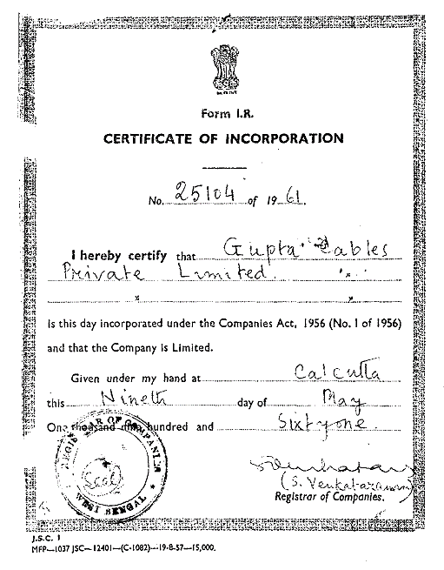
It is classified as Non-govt Company and is registered at Registrar of Companies, Kolkata. The company is having the authorised share capital of INR 10.00 Crores, and paid-up capital of INR 9.54 Crores as on 31st March 2022. Currently, GPIL has three plants, i.e., Khurda (Odisha), Chennai (Tamil Nadu) and Kashipur (Uttarakhand) with a combined installed capacity of 1,50,000 M. Ton. per annum.
The Directors of the company have multiple decades of experience in the electrical wires and cables manufacturing industry. As per the information available in the public domain about them and information provided by the company, they are holding the directorship in several other companies as well such as Utkal Chamber of Commerce and Industry Ltd, Ideas Activated Private Limited, Testec Power Products Private Limited, etc.
The company has also received various prestigious and coveted awards - Udyog Patra Award” from Institute of Trade & Industrial Development, Awards for “Excellence in Entrepreneurship” by MSME Govt. of India and Govt. of Odisha in EXPO Odisha -2007, Times of India "Leadership Award- 2009” for Business Leader 2009 and a host of others.

- DEBT SNAPSHOT: As per the information shared by the company/client, below table shows the Lender-wise and facility wise debt as on 31 March 2024.
S. No. | Name of the Bank | Limits FB | Limits  NFB | Total Limit | FB 0/s | NFB 0/s | Over-  dues | Total  liability | Sharing  Pattern
1 | Canara Bank | 367.50 | 806.28 | 1,173.78 | 1,079.29 | 31.92 | 1,079.29 | 1,170.24 | 32.87%
2 | Indian Bank | 210.00 | 362.30 | 572.30 | 569.90 | 12.57 | 569.90 | 582.47 | 16.03%
3 | UCO Bank | 51.79 | 141.35 | 193.14 | 115.84 | 52.00 | 115.84 | 167.84 | 5.41%
4 | Bank of India | 74.43 | 162.17 | 236.60 | 202.40 | 24.60 | 202.40 | 227.00 | 6.63%
5 | HDFC Bank | 81.60 | 73.80 | 155.40 | 155.08 | - | 155.08 | 155.08 | 4.35%
6 | IDBI Bank | 20.00 | 80.00 | 100.00 | 90.79 | - | 90.79 | 90.79 | 2.80%
7 | Punjab National Bank | 100.00 | 255.00 | 355.00 | 281.28 | 63.76 | 281.28 | 345.04 | 9.94%
8 | Bank of Baroda | 28.68 | 135.00 | 163.68 | 36.08 | 81.16 | - | 117.19 | 4.58%
9 | Union Bank of India | 100.00 | 130.00 | 230.00 | 223.50 | 4.81 | - | 228.31 | 6.44%
10 | Exim Bank | (50)  (Sublimit) | 100.00 | 100.00 | 49.00 | 15.33 | 49.00 | 64.33 | 2.80%
11 | Bank of Maharashtra | 50.00 | 190.00 | 240.00 | 176.99 | 16.68 | 176.99 | 193.67 | 6.72%
12 | Karnataka Bank | 6.00 | 45.00 | 51.00 | 48.96 | 0.96 | 48.96 | 49.92 | 1.43%
 | Unused Portion | - | 19.10 | 19.10
 | TOTAL | 1,090.00 | 2,500.00 | 3,590.00 | 3,029.11 | 303.79 | 2,769.53 | 3,391.88 | 100%
Source: Data/Information Provided by the Client.

- SHAREHOLDING DETAILS: As on 31st March 2022, the Company is having authorized share capital of Rs. 10.00 crores and the total subscribed and paid-up capital is ~ Rs 9.54 crores as per the latest audited financials shared by the client. The shareholding pattern of the company is mentioned below:
Table: Details of Equity Share Capital of the Company

Particulars | As at 31st March, 2022
 | No of Shares | INR Crore
Authorised Share Capital
Equity shares of Rs. 10/- each | 1,00,00,000 | 10.00
Subscribed & fully paid up
Equity Share of Re. 10/- each fully subscribed & paid up | 95,43,560 | 9.54
Source: Data/Information provided by the Client.

Promoter’s Shareholding as per ABS 2021-22

S. No. | Name of Shareholder | As at 31st March, 2022
 |  | No. of Shares | % of Holding
1 | Kiran Devi Gupta | 8,43,740 | 8.84%
2 | Adi Narayan Gupta | 4,22,500 | 4.43%
3 | Adi Narayan Gupta (HUF) | 3,90,310 | 4.09%
4 | Abhishek Gupta | 3,76,440 | 3.94%
5 | Sunita Gupta | 3,23,470 | 3.39%
6 | Mahendra Kumar Gupta (HUF) | 3,13,950 | 3.29%
7 | Padma Devi Gupta | 3,13,100 | 3.28%
8 | Mahendra Kumar Gupta | 2,93,980 | 3.08%
9 | Jitendra Mohan Gupta | 1,55,000 | 1.62%
10 | Ritu Gupta | 25,000 | 0.26%
11 | Pooja Gupta | 25,000 | 0.26%
12 | Kunj Gupta | 25,000 | 0.26%
 | Total | 35,07,490 | 36.75%
Source: Data/Information provided by the Client.
Overall, the promoters are holding 36.75% share of the company as on 31st March 2022.

- PROMOTERS/DIRECTORS PROFILE: Below table shows the details of Directors of M/s BHSL:
DIN | Name | Appointment Date | Qualifications/Experience
00492922 | Mr. Mahendra Kumar Gupta | 5th September 1997 | Mr. Mahendra Kumar Gupta is the Managing Director of GPIL. He has been accredited for making GPIL as one of the leading manufacturers of Power Conductors and cables in India.  He has been awarded with Best Entrepreneur Award for 3 Years consecutively. He was honoured with the Business Leadership Award by the then Chief Minister of Odisha, Shri Naveen Patnaik.  He is part of various delegates of bodies in India & abroad such as CII, IEEMA, ASSOCHAM, CACMAI, EEPC, FIEO, OSSIA, UCCI, etc. He has also been actively involved in various CSR activities. As the Vice President of the Bhubaneswar Club, he also sponsors major activities related to health and education to cater to the needs of society.  Under his guidance, GPIL extends financial assistance to 6 NGOs to carry forward social activities like the Plantation of Trees and Development of 200 Acres barren land.
00492662 | Mr. Jitendra Mohan Gupta | 5th September 1997 | Mr. Jitendra Mohan Gupta is a graduate by qualification and belongs to the second generation of Gupta Business Family living in Bhubaneswar. He has vast experience in field of manufacturing electrical products.  He has been looking after financial goals, hiring staff, and day-to-day operations of the company. He has a solid foundation of business acumen, technical skills, knowledge of basic bookkeeping and finance, strong knowledge of marketing and the ability to judge risk.
00492732 | Mr. Abhishek Gupta | 20 December 2006 | Mr. Abhishek Gupta has an MBA degree from Drexel University, USA. He has two-year industrial experience in the USA which equipped him with the technical know-how to handle a family business. He took over the reins of the family business in the year 2002.  Under his leadership, GPIL has made a strategic agreement with “Mercury Cables & Energy” of the USA for manufacturing HTLS conductors and has tied up with Business associates in South African and Latin American countries towards product supply. He was the man behind the launch of G-Power brand of cables & G-Trans brand of Power Conductor.  He was honoured with the Award for Excellence in Entrepreneurship by the then Chief Minister of Odisha, Shri Naveen Patnaik. He assisted in various projects taken up by Round Table India. He was honoured as the esteemed Chairman of Bhubaneshwar Round Table 53 and has also taken up various CSR activities.
06902513 | Mr. Parvin Kumar Agarwal | 5th July 2014 | No Data Available.
Source: Data/Information provided by the client
To give a brief overview of the background of Directors we have listed down the basic company information as found on public domain in general/ tertiary category research.
(MR. MAHENDRA KUMAR GUPTA)
S. No. | Company Name (CIN/FCRN) | Designation | Original Date of Appointment | Date Of Appointment at Current Designation | Date Of Cessation (If Applicable)
1 | Utkal Chamber of Commerce and Industry Ltd  (U91110OR1964GAP000468) | Additional Director | 02/11/2022 | 02/11/2022 | -
2 | Bhubaneswar Club  (U91990OR1950NPL000195) | Director | 24/09/2021 | 24/09/2021 | -
3 | Gupta Power Infrastructure Limited  (U31300WB1961PLC025104) | Managing Director | 05/09/1997 | 05/09/1997 | -
4 | Iris Text Processors Private Limited  (U17110OR2011PTC013968) | Director | - | 29/07/2011 | 30/09/2023
5 | Gupta Power Technologies Private Limited  (U40101WB2007PTC113495) | Director | - | 16/02/2007 | 11/06/2007
6 | Suprabhat Roller Flour Mills Private Limited  (U15311TG1980PTC002839) | Director | - | 30/11/2001 | 09/01/2008
7 | Utkal Infrastructure Development Consortorium Private Limited  (U45201OR2005PTC008206) | Director | - | 11/12/2006 | 29/09/2010
8 | Utkal Infrastructure Development Consortorium Private Limited  (U45201OR2005PTC008206) | Nominee Director | - | 12/10/2010 | 07/11/2017
9 | Bhawani Roller Flour Mills Private Limited  (U15311DL1987PTC029900) | Director | - | 27/11/1987 | 01/06/2007
10 | Kunj Agro Products Pvt Ltd  (U15209TG1993PTC016425) | Director | - | 13/10/1993 | 01/09/2008
11 | Gita Devi Techno-Con Private Limited  (U15541OR2000PTC006053) | Director | - | 21/01/2000 | 11/06/2007
12 | Tirupati Steel Industries Pvt Ltd  (U27109OR1984PTC001445) | Director | - | 19/12/1984 | 11/06/2007
Source: Data/Information available on MCA Portal
(MR. JITENDRA MOHAN GUPTA)
S. No | Company Name (CIN/FCRN) | Designation | Original Date of Appointment | Date Of Appointment at Current Designation | Date Of Cessation (If Applicable)
1 | Ideas Activated Private Limited  (U00896OR2005PTC008487) | Managing Director | 14/12/2005 | 14/12/2005 | -
2 | Gupta Power Infrastructure Limited  (U31300WB1961PLC025104) | Whole-time director | 05/09/1997 | 31/12/2020 | -
3 | Testec Power Products Private Limited  (U74999DL2018PTC335526) | Director | 19/06/2018 | 19/06/2018 | -
4 | Panchmukhi Infotech Private Limited  (U72200OR2009PTC010553) | Director | 23/02/2012 | 23/02/2012 | -
5 | Integrator Services India Private Limited  (U31909DL2016PTC300036) | Director | 29/09/2017 | 29/09/2017 | -
6 | Gupta Power Technologies Private Limited  (U40101WB2007PTC113495) | Director | - | 16/02/2007 | 22/04/2009
7 | Bhawani Roller Flour Mills Private Limited  (U15311DL1987PTC029900) | Director | - | 28/06/1993 | 01/06/2007
8 | Tirupati Conductors Pvt Ltd  (U31300WB1994PTC199074) | Director | - | 27/09/1997 | 01/06/2007
9 | Gupta Power Infrastructure Limited  (U31300WB1961PLC025104) | Director | - | 05/09/1997 | 31/12/2020
10 | A One Engineering Projects Private Limited  (U29299WB2007PTC113494) | Director | - | 16/02/2007 | 11/06/2007
11 | Maa Bhuasuni Industries Pvt Ltd  (U51214OR1984PTC001019) | Director | - | 16/08/1995 | 11/06/2007
12 | JRG Developers Private Limited  (U28999OR2001PTC006627) | Director | - | 18/10/2001 | 11/06/2007
13 | Gita Devi Techno-Con Private Limited  (U15541OR2000PTC006053) | Director | - | 21/01/2000 | 11/06/2007
14 | Jai Laxmi Agro Foods Private Limited  (U15312WB2004PTC203870) | Director | - | 21/05/2004 | 01/03/2018
15 | Kunj Roller Flour Mills Private Limited  (U15311WB1997PTC199152) | Director | - | 07/05/1997 | 25/09/2008
16 | Kunj Agro Products Pvt Ltd  (U15209TG1993PTC016425) | Director | - | 12/01/1994 | 01/09/2008
17 | Shreeji Ispat Limited  (U27310OR1997PLC004783) | Director | - | 01/04/1999 | 16/11/2009
Source: Data/Information available on MCA Portal
(MR. ABHISHEK GUPTA)
S. No | Company Name (CIN/FCRN) | Designation | Original Date of Appointment | Date Of Appointment at Current Designation | Date Of Cessation (If Applicable)
1 | Gupta Power Infrastructure Limited (U31300WB1961PLC025104) | Whole-time director | 20/12/2006 | 31/12/2020 | -
2 | Kunj Alloys Private Limited  (U27203WB2000PTC199153) | Director | - | 28/12/2002 | 25/03/2008
3 | Bhawani Roller Flour Mills Private Limited  (U15311DL1987PTC029900) | Director | - | 22/08/1997 | 01/06/2007
4 | Suprabhat Roller Flour Mills Private Limited  (U15311TG1980PTC002839) | Director | - | 08/01/2008 | 10/02/2010
5 | Shreeji Ispat Limited  (U27310OR1997PLC004783) | Additional Director | - | 08/02/2008 | 30/09/2008
6 | Gupta Power Infrastructure Limited (U31300WB1961PLC025104) | Director | - | 20/12/2006 | 31/12/2020
7 | JRG Developers Private Limited  (U28999OR2001PTC006627) | Director | - | 18/10/2001 | 11/06/2007
8 | Shreeji Ispat Limited  (U27310OR1997PLC004783) | Director | - | 30/09/2008 | 16/11/2009
9 | A One Engineering Projects Private Limited  (U29299WB2007PTC113494) | Director | - | 16/02/2007 | 30/12/2016
10 | Tirupati Conductors Pvt Ltd  (U31300WB1994PTC199074) | Director | - | 29/03/2003 | 02/12/2008
11 | Kunj Alloys Private Limited  (U27203WB2000PTC199153) | Director | - | 26/03/2008 | 25/03/2009
Source: Data/Information available on MCA Portal
(MR. PRAVIN KUMAR AGARWAL)
S. No | Company Name (CIN/FCRN) | Designation | Original Date of Appointment | Date Of Appointment at Current Designation | Date Of Cessation (If Applicable)
1 | Gupta Power Infrastructure Limited (U31300WB1961PLC025104) | Whole-Time Director | 05/07/2014 | 30/09/2022 | -
2 | Gupta Power Infrastructure Limited (U31300WB1961PLC025104) | Director | - | 05/07/2014 | 30/09/2022
Source: Data/Information available on MCA Portal

- REASONS FOR FINANCIAL STRESS: The company is experiencing financial stress due to a combination of operational challenges, financial constraints, and external economic pressures. The primary factors contributing to this situation as shared by the client/company include:
- Inter-locking of Funds: The company’s funds are tied up in stock and receivables, limiting liquidity and impacting its ability to meet immediate financial obligations.
- Non-Approval of Enhanced Limits: Despite an increase in sales, the company’s request for a higher credit limit was not approved, constraining its operational expansion and cash flow management.
- Credit Rating Downgrade: The company’s credit rating has been downgraded from A- to BBB by the Credit Rating Agency (CRA), which has led to increased borrowing costs and restricted access to capital.
- EPC Payment Issues: Payments for Engineering, Procurement, and Construction (EPC) projects are delayed due to cost overruns associated with COVID-19 and maintenance issues, adversely affecting the company’s financial stability.
- Suspended TReDS Limit: The Trade Receivables Discounting System (TReDS) limit of INR 350 Crores was suspended, resulting in a significant cash flow mismatch.
- COVID-Related Working Capital Cycle: The pandemic has extended the working capital cycle, increasing the time required to convert inventory and receivables into cash.
- Excess Charges by Bankers: Additional charges imposed by bankers have strained the company’s cash flow and reduced the available working capital.
- Higher Interest Burden: The company is facing a higher interest burden or additional interest charges, which is impacting profitability and limiting its ability to participate in new projects or bids.
- Incomplete EPC Projects: Several EPC projects remain incomplete due to a lack of funds, with the remaining costs for project completion not available, affecting future revenue and operational capability.
- Delayed Arbitration Awards: The recovery of arbitration awards is delayed, and although mediation is in progress, the delay in settlement is negatively impacting the company’s financial position.
- Contractor Issues: Original contractors have left the project sites, and the capability of new contractors to complete the projects has been compromised, further delaying project completion and potentially increasing costs.
As per the forensic audit report shared by the client, it identifies several significant issues that have led to its current distress. Key findings of the report include the inappropriate use of short-term working capital funds for long-term purposes, the unauthorized allocation of borrowed funds for unintended activities, and the transfer of these funds to subsidiaries without proper justification. Additionally, irregularities in fund routing and indications of siphoning suggest potential financial misconduct, while abnormal trade transactions raise questions about their legitimacy.
The constant cycling of funds among related parties complicates financial transparency, and concerns regarding inflated receivables imply that the reported assets may not accurately represent the company's financial health. Together, these problems underscore critical deficiencies in governance and financial management that require immediate attention.
Addressing these issues will require the company to enhance its cash flow management, renegotiate terms with creditors and stakeholders, secure additional financing, and resolve operational and project-related challenges.
Therefore, to check and assess the Techno-Economic & Financial viability of the Company and to evaluate the Enterprise Valuation of the company to enable NARCL in making a decision regarding the acquisition of debt, BOB Capital Market Ltd. has appointed R. K. Associates as TEV consultant to review technical, commercial and financial viability of the company based on our independent EIC research and information/data provided to us about the company.
Hence, We R.K Associate are performing the Techno-Economic Viability study and Enterprise Valuation of M/s Gupta Power Infrastructure Limited considering the Debt Acquisition Proposal.

- OBSERVATIONS MADE DURING SURVEY/SITE VISIT:
- KHURDA, ODISHA: During the site visit conducted on 10.09.2024 & 11.09.2024, it was observed that the plant was not operational. No technical representatives from the company were available to assist in identifying the machines and equipment. Additionally, a copy of the latest Fixed Asset Register (FAR) and machine specification details, including make, model, and capacity, was not provided. According to bank officials, the machinery at the plant had been idle for approximately one year.
The major machinery and equipment observed included rewinding machines, wire twisting machines, ovens, wire drawing machines, butcher machines, extrusion lines, coiling machines, core winding machines, cranes, a diesel generator set, and a cooling tower. The condition of these machines was assessed as average, indicating that they would require some repair and maintenance to operate efficiently. A significant inventory of raw materials, work-in-progress (WIP), and finished goods was also present at the site.
Approximately 60% of the plant was observed and physically inspected; however, access to the remaining 40% of the plant was restricted by company officials on 11.09.2024, preventing a complete inventorization of the machines. Only a few supervisors and security guards were present on-site during the survey visit.
- KASHIPUR, UTTARAKHAND (Both Units): During the site visit dated 11.09.2024, the plant was found to be operational and most of machines were working, with both the structure and machinery in good condition.
- CHENNAI, TAMIL NADU:
Location 1 – Plot no. 10/S1: During the site visit dated 06.09.2024, the plant has been non-operational for an extended period, and the condition of the machinery varies. While some equipment has been well-maintained, others are found in waterlogged, rusted, dismantled states, with certain parts missing. However, the main shed structure is in good condition, indicating that while the machinery may require substantial repairs or replacements, the facility itself remains structurally sound and potentially viable for future operations.
Location 2 – Shed No. 13 & 18: During the site visit dated 06.09.2024, the plant has been non-operational for an extended period, with machinery in varying conditions. The shed was locked, and observations from outside indicate that the machines are in poor condition. Additionally, the main shed structure is also in deteriorating condition, suggesting that both the machinery and the facility may require substantial repairs or replacements.
PART D | INFRASTRUCTURE DETAILS

- PLANT LOCATION:
- KHURDA PLANT: The Khurda Plant of M/s. Gupta Power Infrastructure Limited is situated at F/9, F/16 & F/18, IID Center, Village-Mukundaprasad, District: Khurda, Odisha, which is spread over an area of 14.15 Acres as per documents provided to us by the company.
The property is having the proximity to the civic amenities such as hospital is situated ~3.7 km away, school is situated as ~0.5 km away and market is situated ~3.5 km away from the proposed plant location.
Table: 1 is showing the details of the adjoining properties of the project land and Table: 2 is showing the Connectivity Details of the Project Location:
Table: 1 Adjoining Property Details
Location | Details
East | Road
West | Other’s Property
North | Road, Entry/Exit
South | Other’s property & Road

Table: 2 Connectivity Details of the Proposed Location
Connectivity | Details
Road | Chennai-Kolkata Highway - ~1.1 km away
Rail | Khurda Town Railway Station - ~6.5 km away
Airport | Biju Patnaik International Airport, Bhuvaneshwar - ~26 km away

- KASHIPUR PLANT: The Kashipur Plant of M/s. Gupta Power Infrastructure Limited comprises of two locations fronting each other having total area admeasuring 7.88 acres/31,870 sq. mt. as per copy of documents provided. The Unit I is situated at Plot No. 132, 132B, 132C, Village-Mahuakheraganj, Nandnagar Industrial Area Phase-II, Tehsil-Kashipur, District-Udham Singh Nagar, Uttarakhand having total land area admeasuring 25,068 sq. mt. as per copy documents provided. The Unit II is situated at Plot No. 145, Village-Mahuakheraganj, Nandnagar Industrial Area Phase-II, Tehsil-Kashipur, District-Udham Singh Nagar, Uttarakhand having total land area admeasuring 6,802 sq. mt. as per copy documents provided.
The property is having the proximity to the civic amenities such as hospital is situated ~4.5 km away, school is situated as ~1.6 km away and market is situated ~2.0 km away from the proposed plant location.
Table: 1 is showing the details of the adjoining properties of the project land and Table: 2 is showing the Connectivity Details of the Project Location:
Table: 1 Adjoining Property Details
Location | Unit I | Unit II
North | Road | Plot no. 144
South | Other’s Land | Road
East | Other’s Land | Road and Plot no. 132
West | Road and Plot no. 144 & 145 | Other’s Land

Table: 2 Connectivity Details of the Proposed Location
Connectivity | Details
Road | Chandpur-Kashipur road - ~4 km away
Rail | Kashipur Railway Station - ~10.6 km away
Airport | Pantnagar Airport - ~80 km away

- CHENNAI PLANT: The Chennai Plant of M/s. Gupta Power Infrastructure Limited comprises of two locations having total land area admeasuring 2.994 acre as per copy of documents provided. The Unit I is situated at Plot No. 10/S1, Village - Karumbukuppam, SIPCOT Industrial Complex, Gummidipoondi Taluka, District-Tiruvallur, Tamil Nadu admeasuring 2.55 acres as per the lease deed provided. The Unit II is situated at Shed No. 13 & 18, Phase-V, Village-Pappankuppam, SIPCOT Industrial Complex, Gummidipoondi Taluka, District-Tiruvallur, Tamil Nadu admeasuring 0.444 acres.
The property is having the proximity to the civic amenities such as hospital is situated ~2.0 km away, school is situated as ~0.7 km away and market is situated ~3.0 km away from the proposed plant location.
Table: 1 is showing the details of the adjoining properties of the project land and Table: 2 is showing the Connectivity Details of the Project Location:
Table: 1 Adjoining Property Details
Location | Unit I | Unit II
North | Plot no. 10/S2 | Road
South | 18-meter road | Road
East | Plot no. 9 | Shed no. 12 & 19
West | 18-meter road | Shed no. 14 & 17

Table: 2 Connectivity Details of the Proposed Location
Connectivity | Details
Road | Chennai-Kolkata Highway - ~1.1 km away
Rail | Gummidipoondi Railway Station - ~2.0 km away
Airport | Chennai International Airport - ~60 km away

- LAYOUT PLAN:
We have not received any data/information related to the approved layout plan for all the three plants, i.e., Khurda (Odisha), Kashipur (Uttarakhand) and Chennai (Tamil Nadu). Hence, we cannot comment whether the plant structure is as per the approved plan or not.
Thus, we recommend that the client/BOBCAPs to collect the approved layout plan from the company to identify any discrepancies between the constructed structure and the approved plan.

- LOCATION MAP:
- KHURDA PLANT:
- Google Map: Project location would be 20°10'14.1"N 85°38'32.9"E in Khurda in the state of Odisha and the location as per the Google map has been attached below.
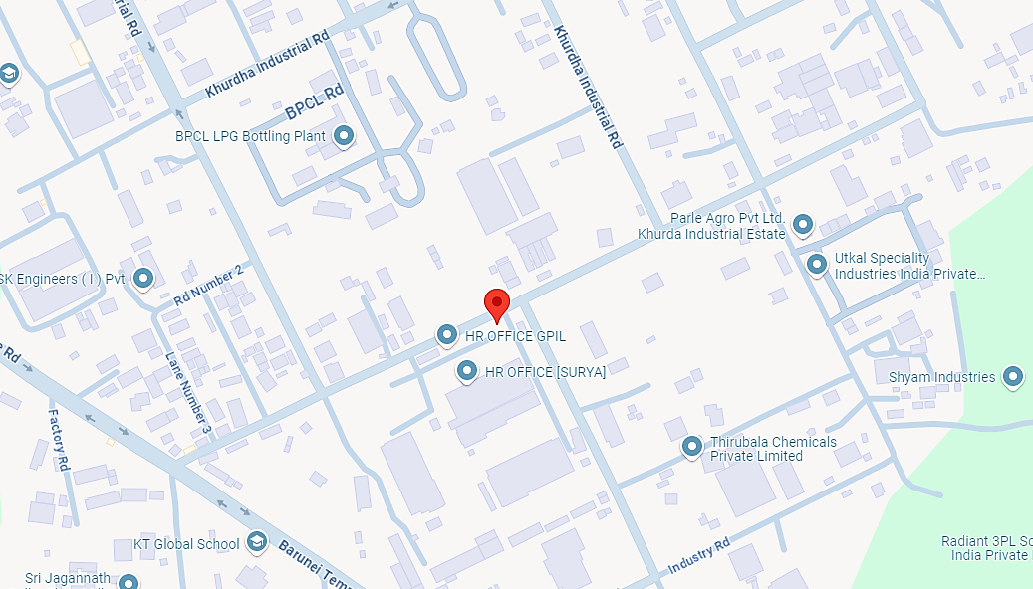
- Google Layout Plan: Demarcation of the land on the Google map is as in the below picture.
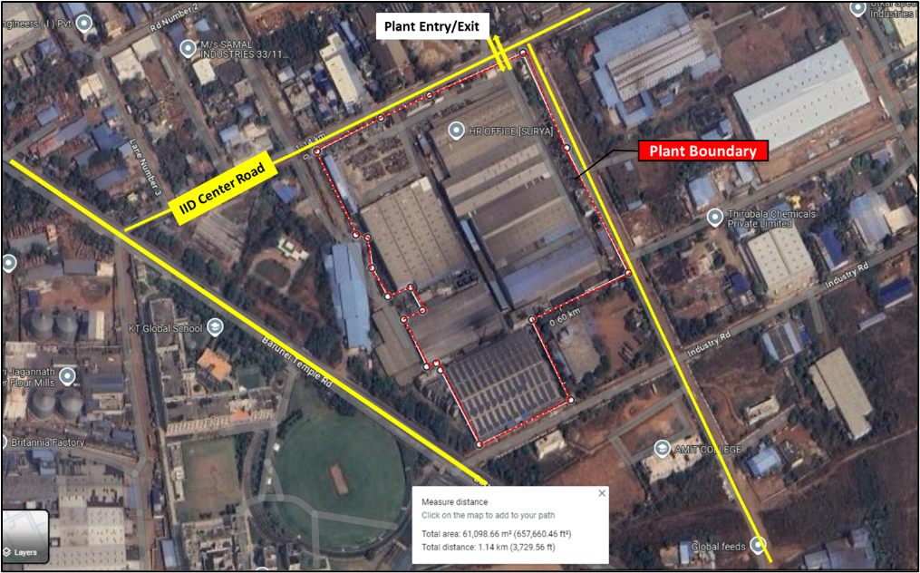

- KASHIPUR PLANT:

- UNIT I (Plot No. 132, 132B, 132C)
Google Map: Project location would be 29°07'39.7"N 78°57'37.6"E in Kashipur, Uttarakhand and the location as per the Google map been attached below.
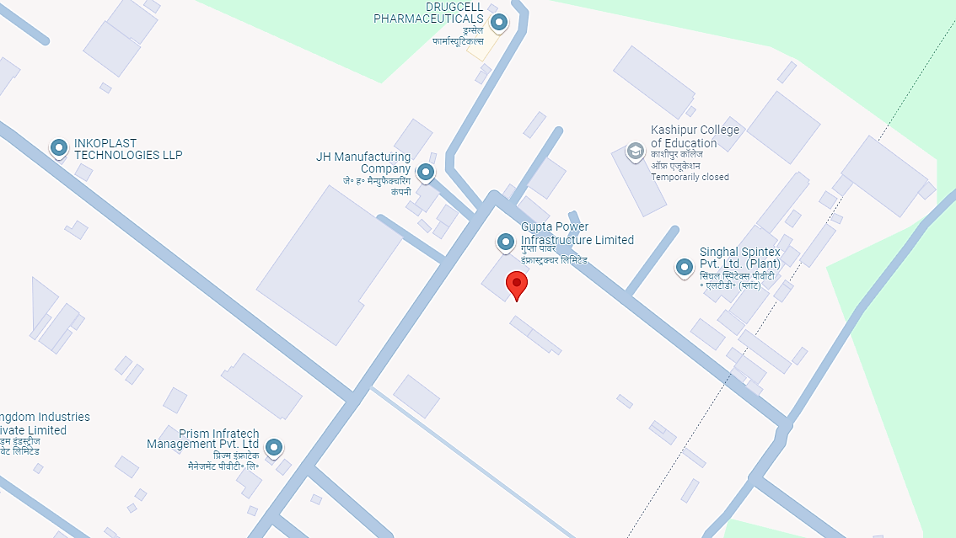
Google Layout Plan: Demarcation of the land on the Google map is as in the below picture.
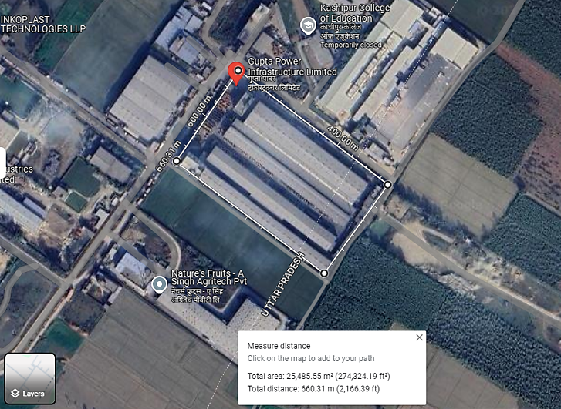

- UNIT II (Plot No. 145)
Google Map: Project location would be 29°07'40.3"N 78°57'34.7"E in Kashipur, Uttarakhand and the location as per the Google map been attached below.
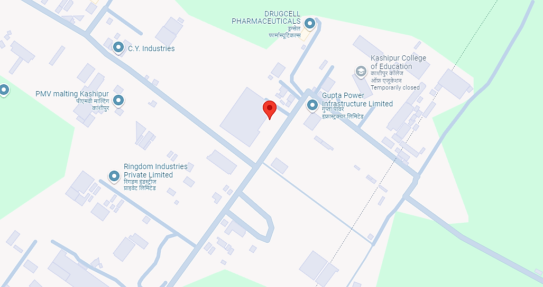
Google Layout Plan: Demarcation of the land on the Google map is as in the below picture.
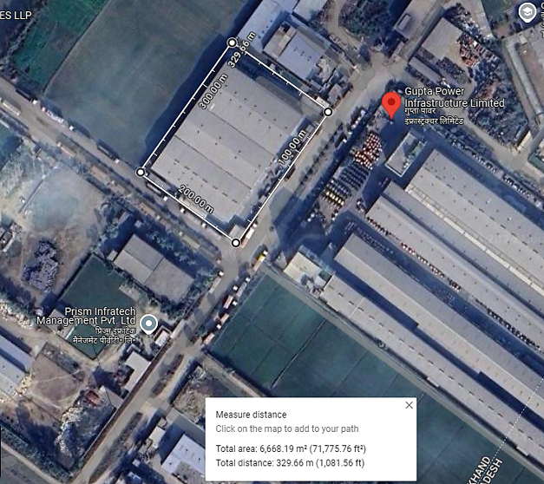

- CHENNAI PLANT
- UNIT I (Plot No. 10/S1)
Google Map: Project location would be 13°24'31.1"N 80°06'35.1"E in Gummidipoondi, Chennai in the state of Tamil Nadu and the location as per the Google map been attached below.
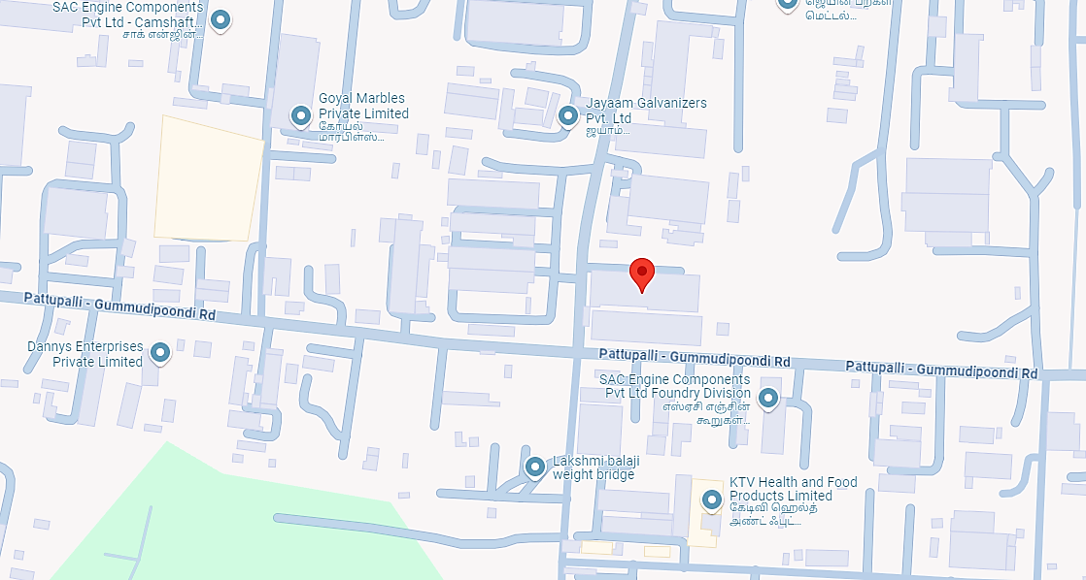
Google Layout Plan: Demarcation of the land on the Google map is as in the below picture.
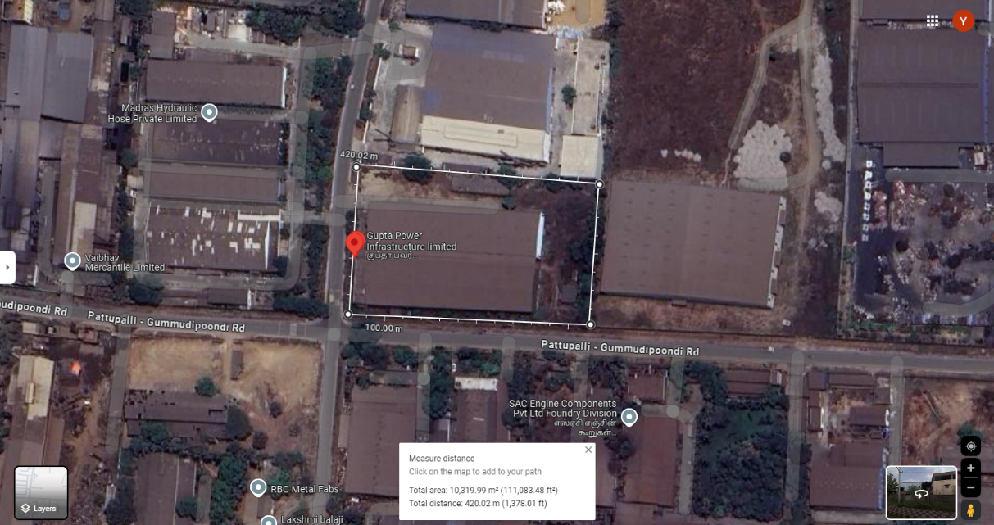
- UNIT II (Shed no. 13 & 18)
Google Map: Project location would be 13°25'17.1"N 80°06'36.8"E in Gummidipoondi, Chennai in the state of Tamil Nadu and the location as per the Google map been attached below.
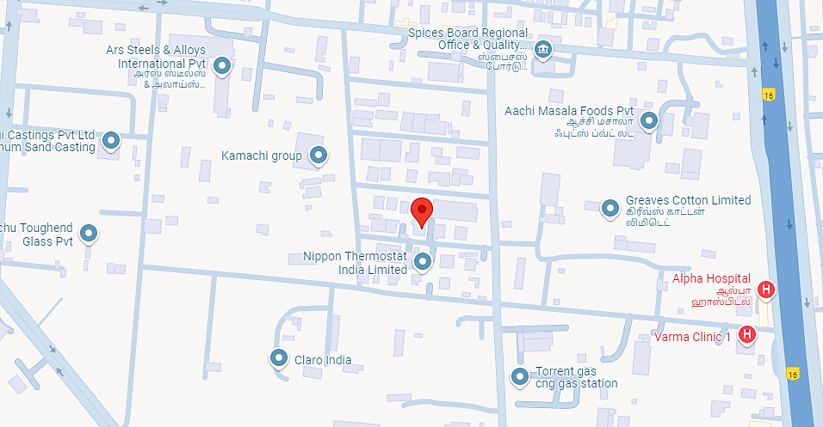
Google Layout Plan: Demarcation of the land on the Google map is as in the below picture.
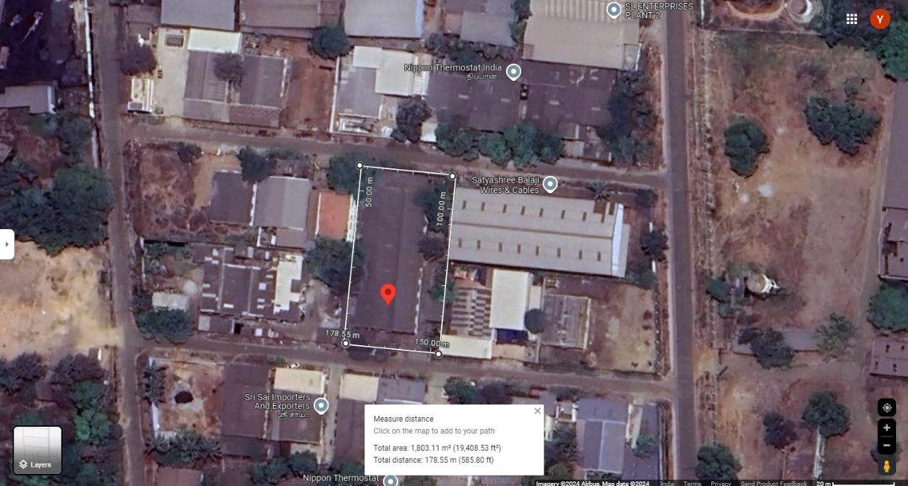

- SITE PICTURES:
- KHURDA PLANT: Some of the site pictures has been taken during the site survey, are attached below:
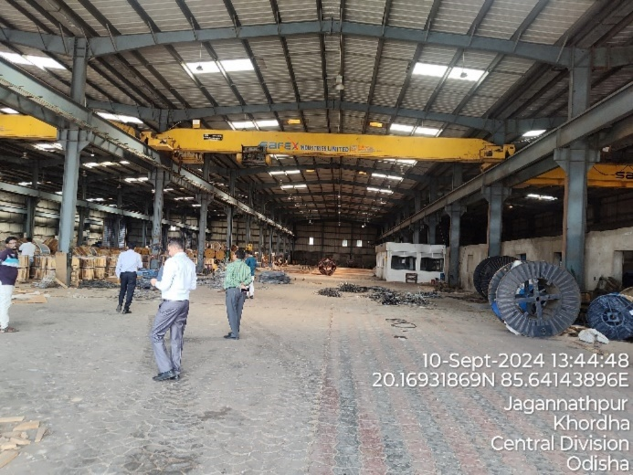 | 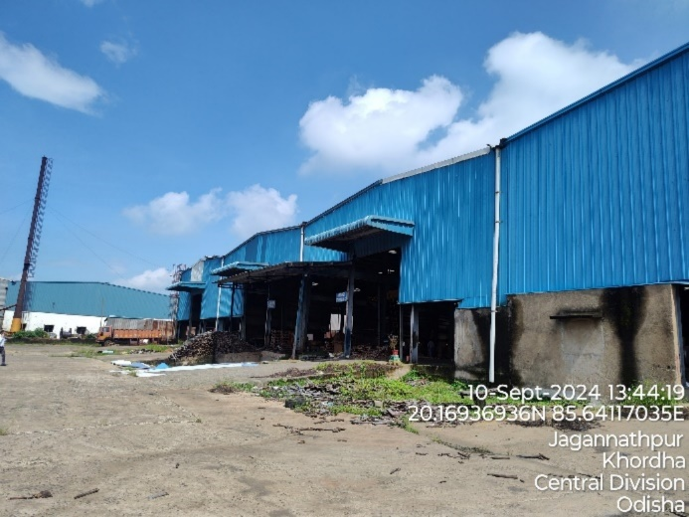
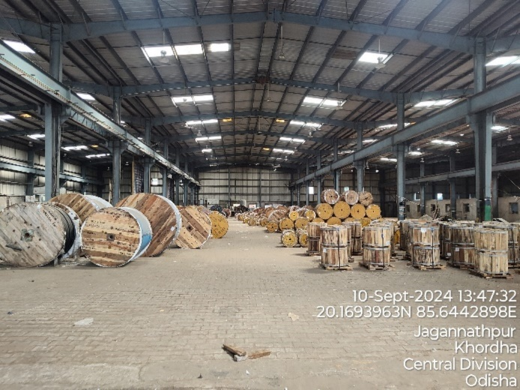 | 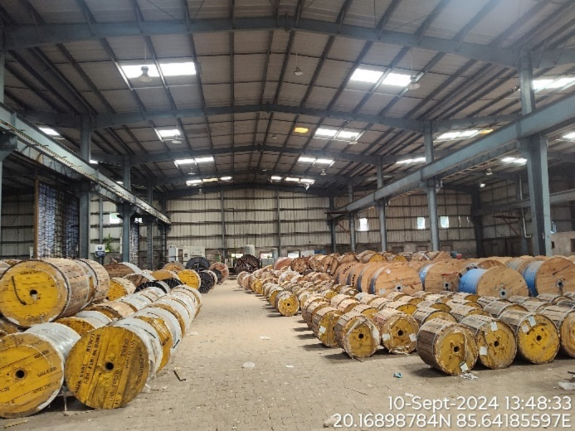
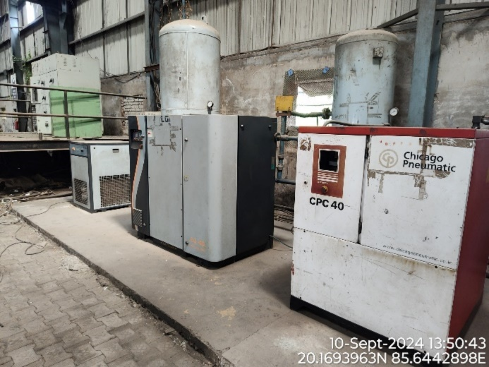 | 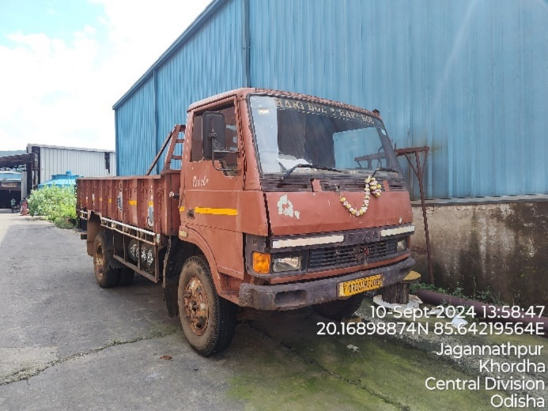
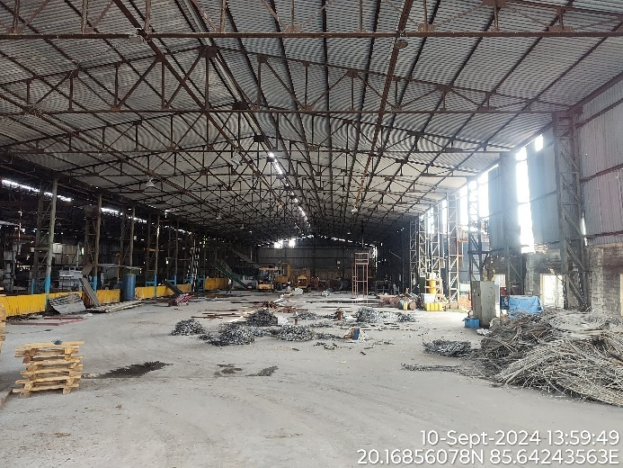 | 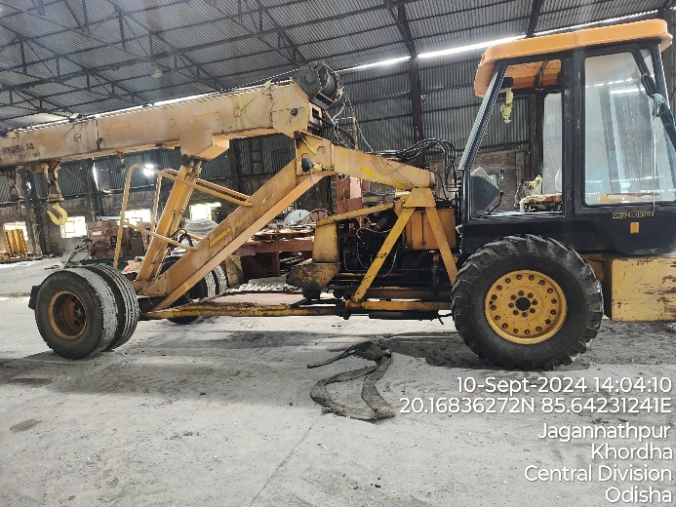
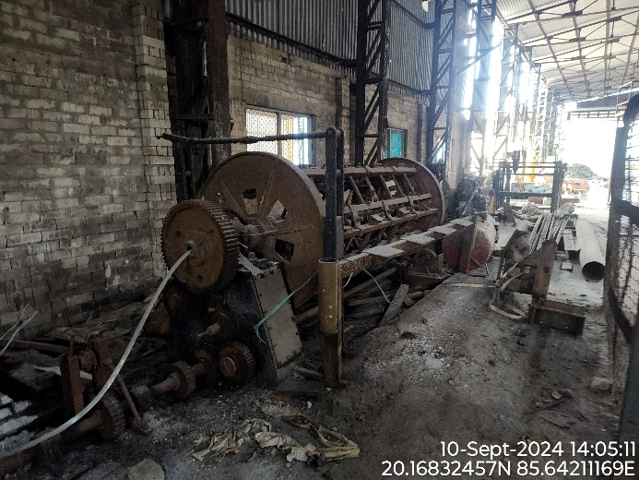 | 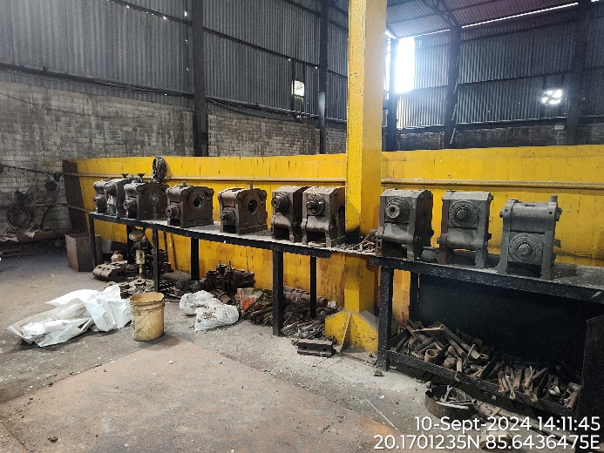
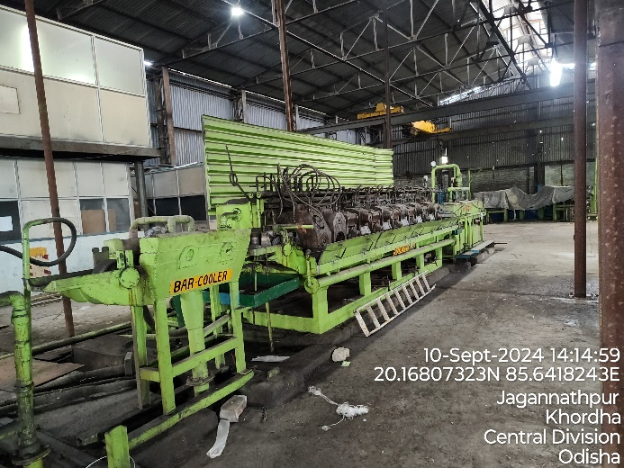 | 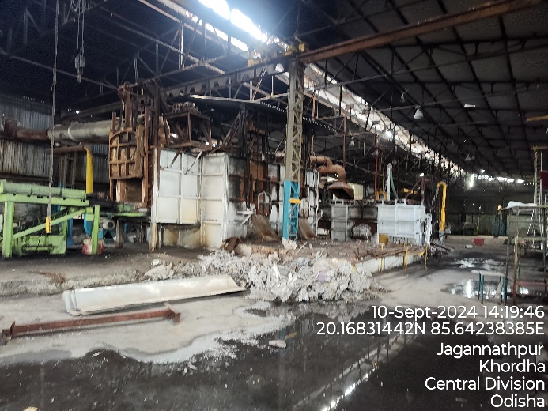
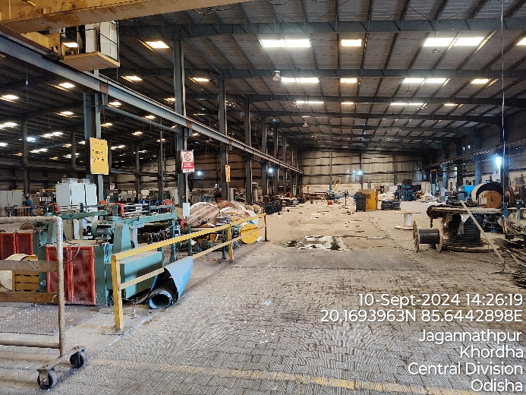 | 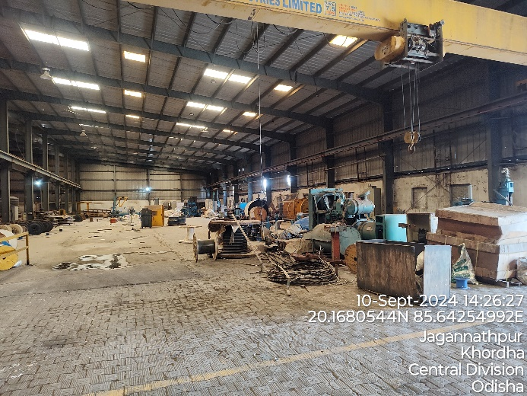
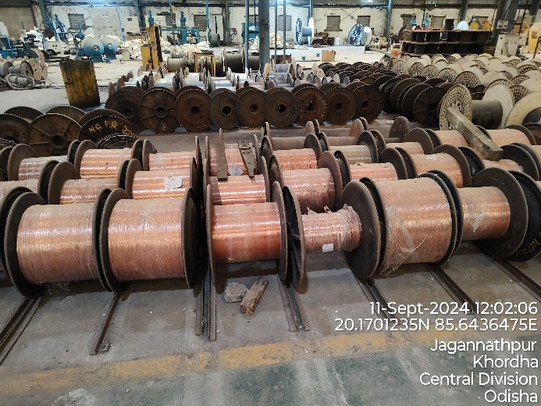 | 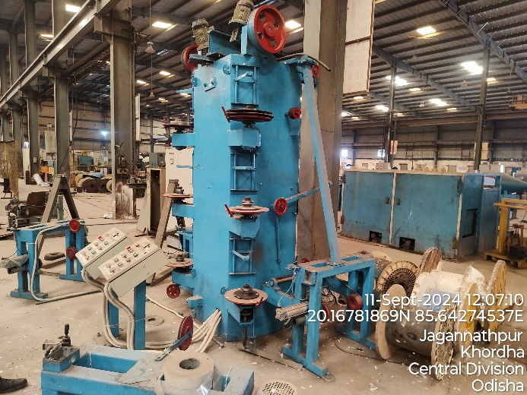
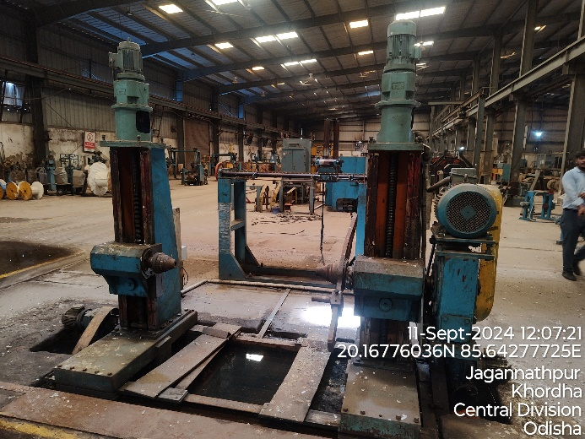 | 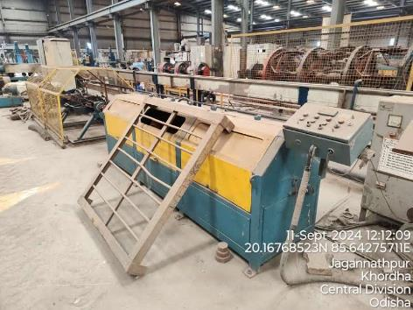
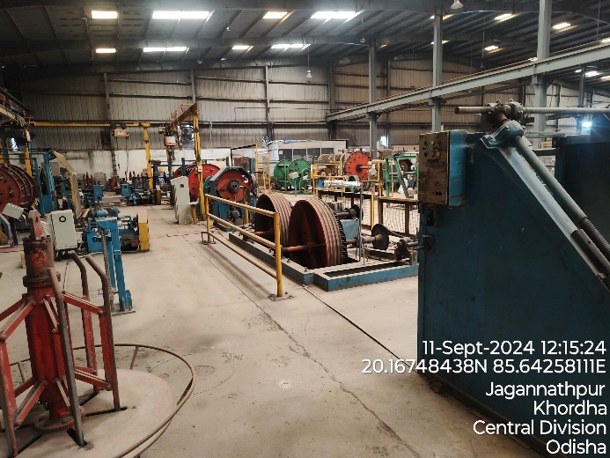 | 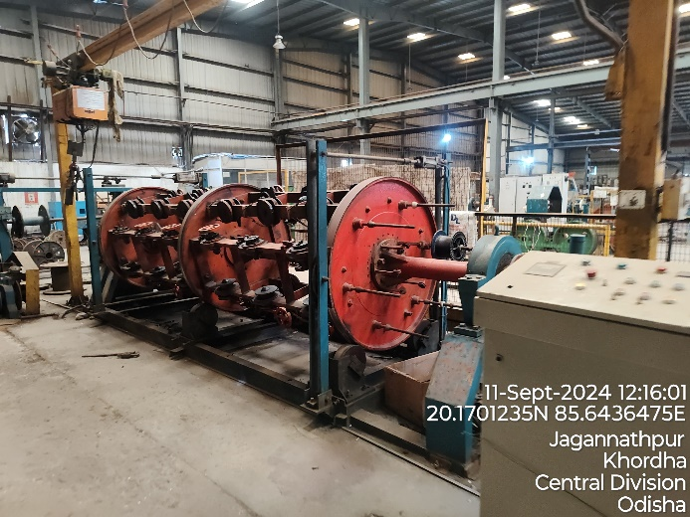
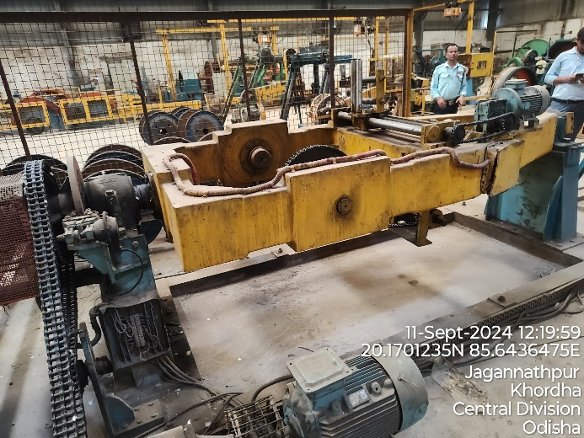 | 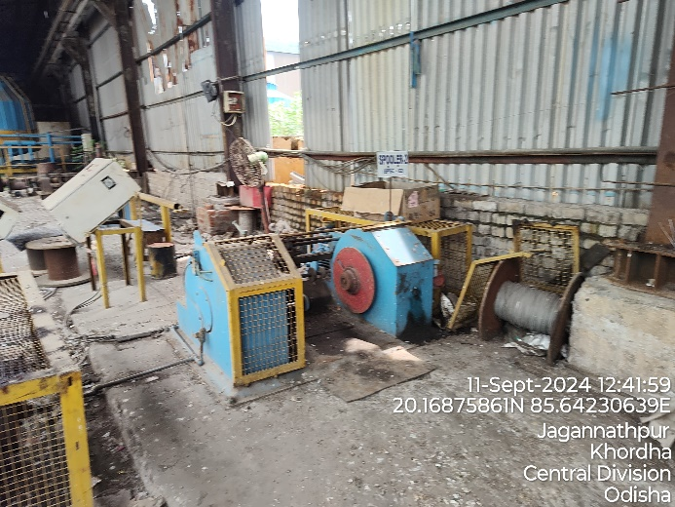
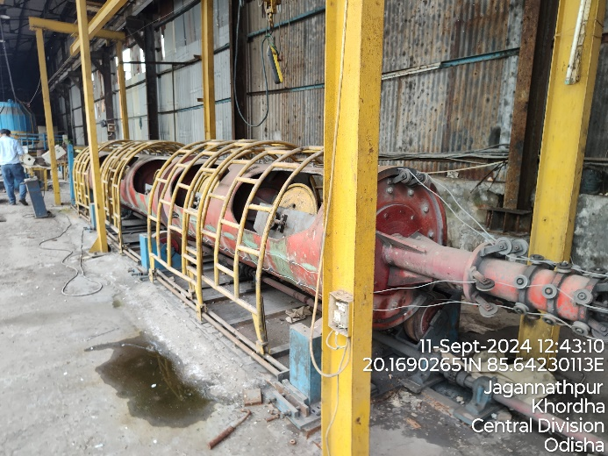 | 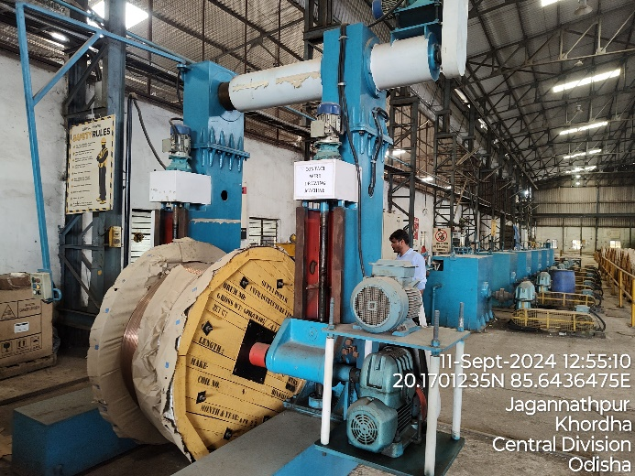
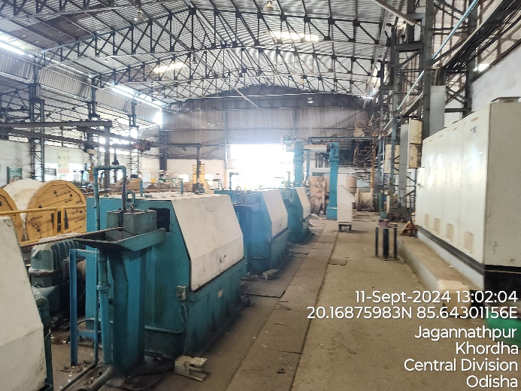 | 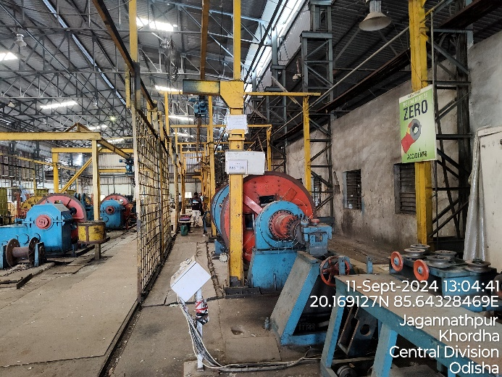
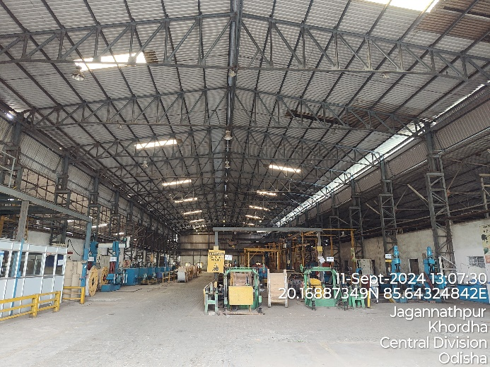 | 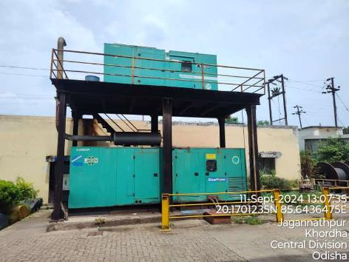
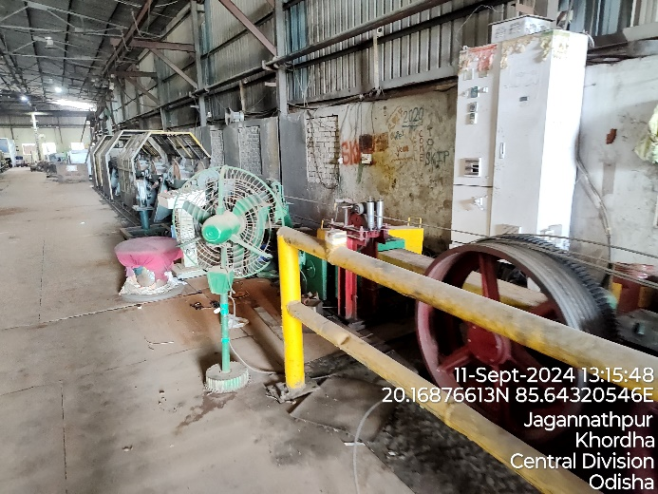 | 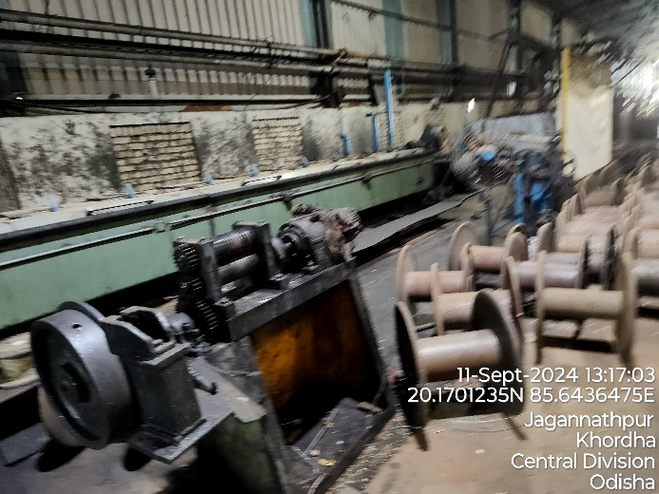
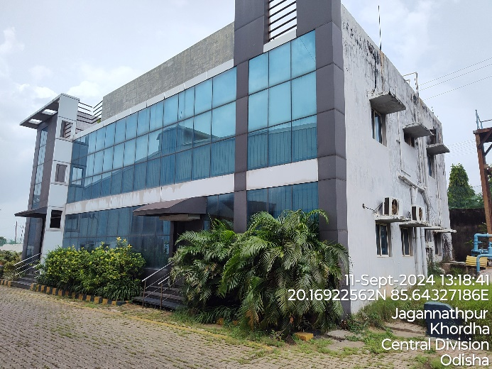 | 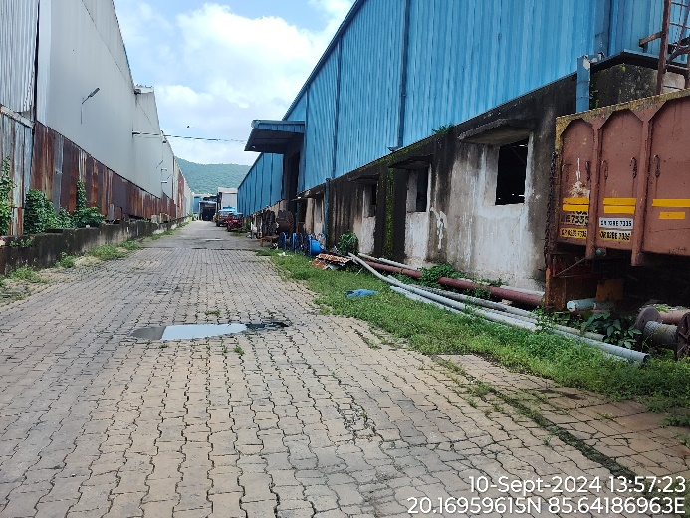
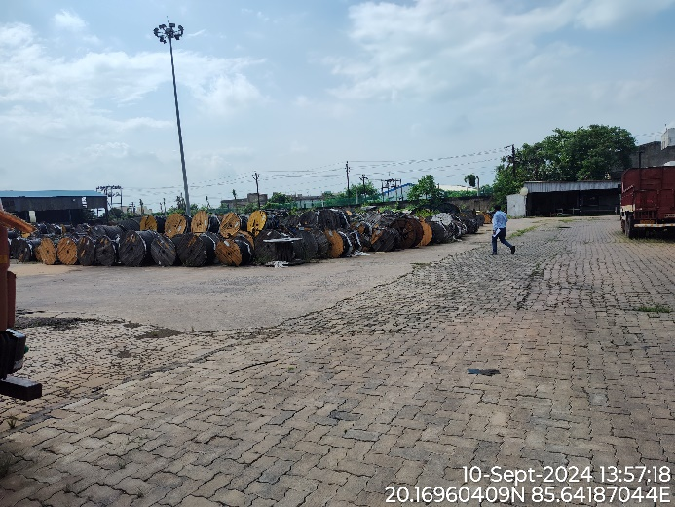 | 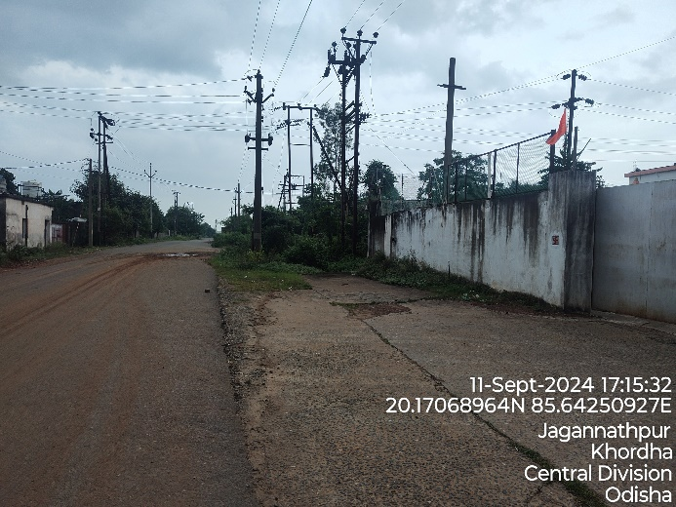
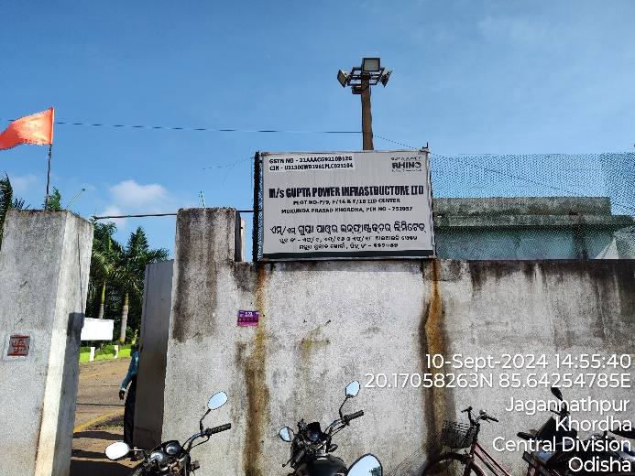 | 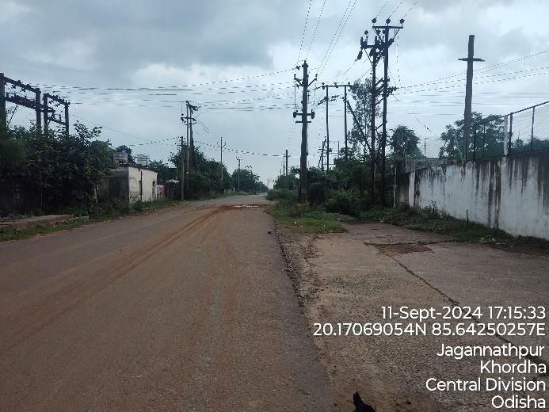
- KASHIPUR PLANT: Some of the site pictures has been taken during the site survey, are attached below:
- UNIT I (Plot No. 132, 132B, 132C)
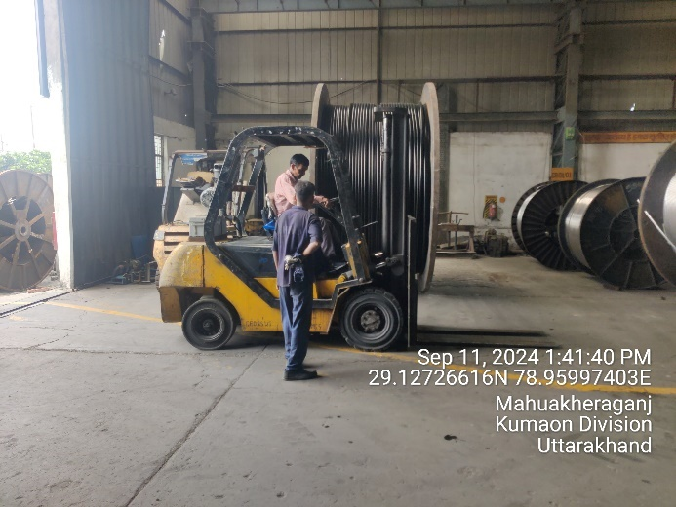 | 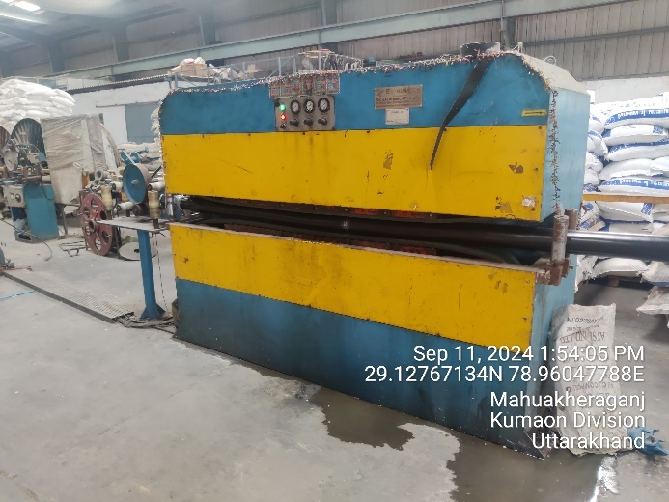
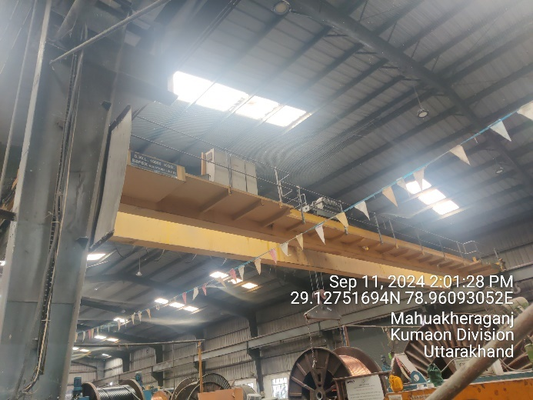 | 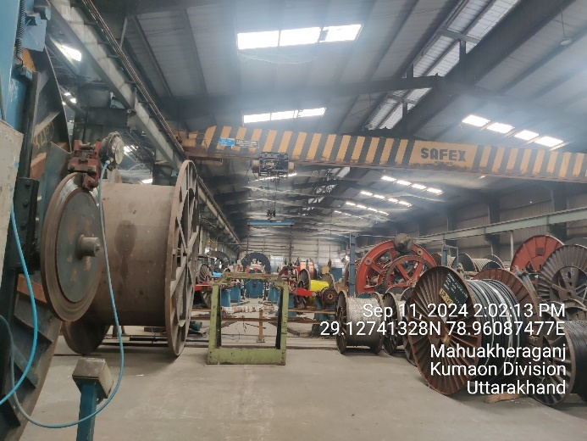
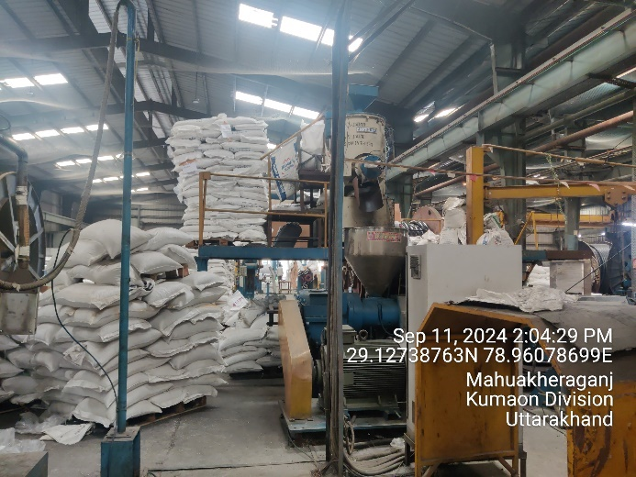 | 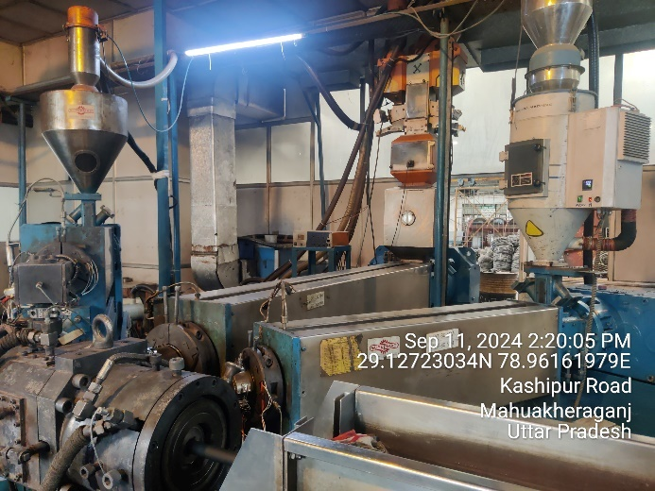
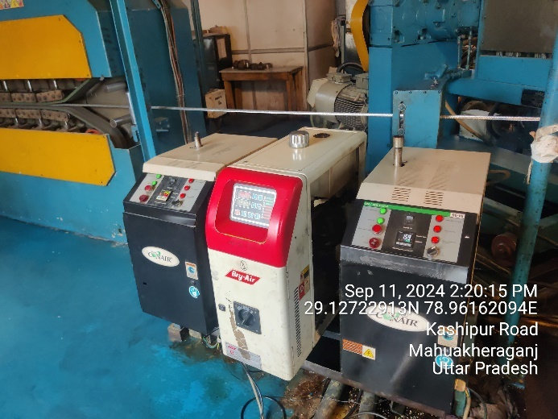 | 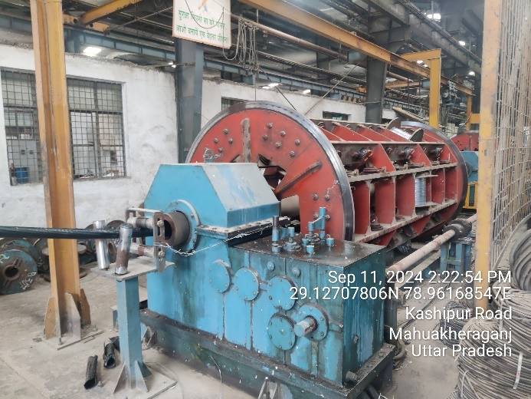
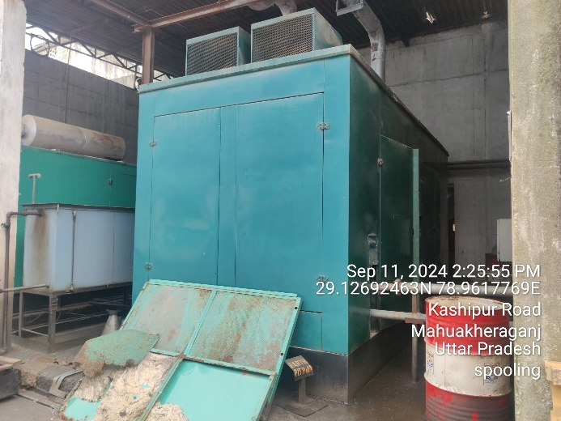 | 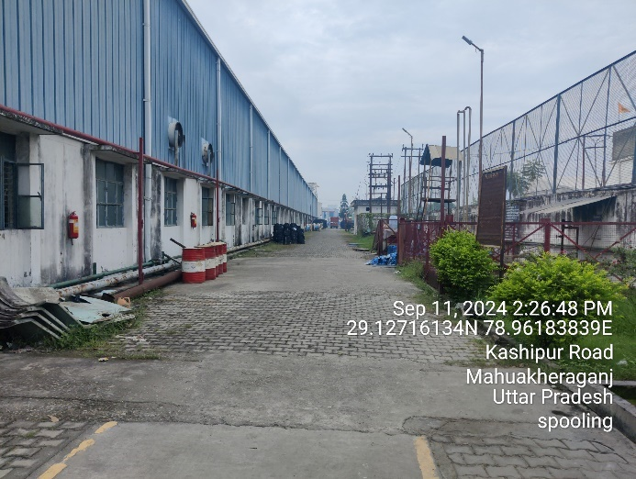
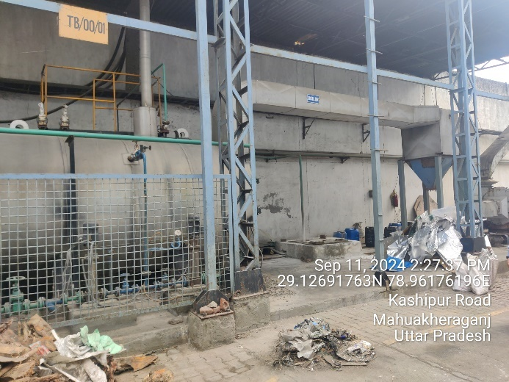 | 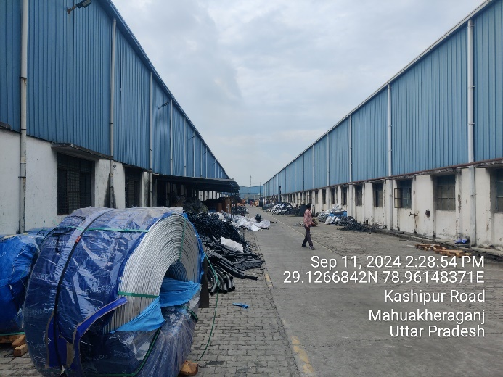
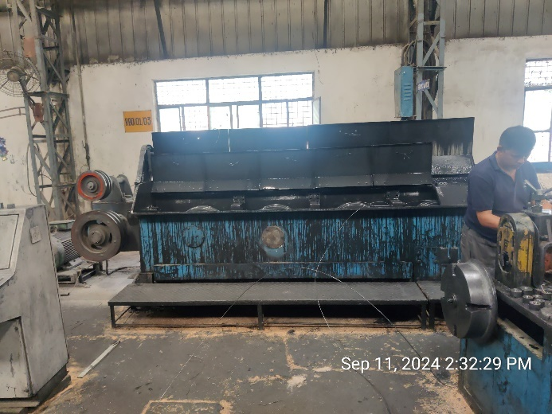 | 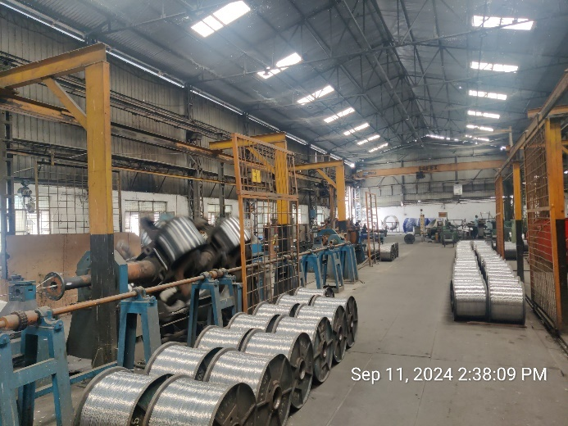
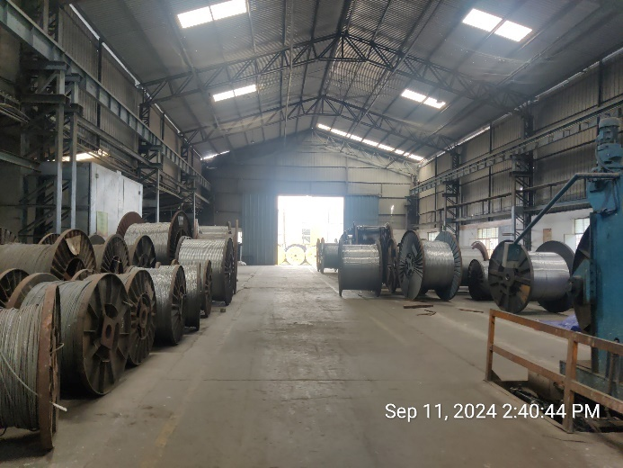 | 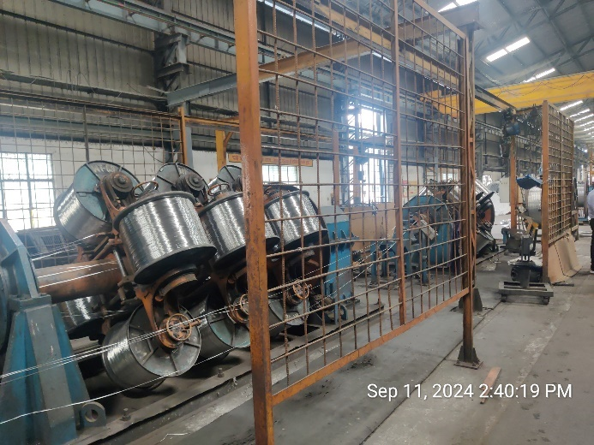
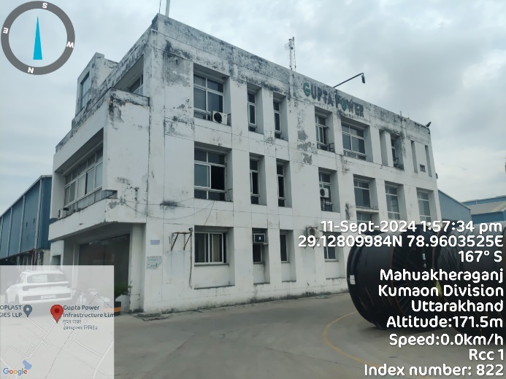 | 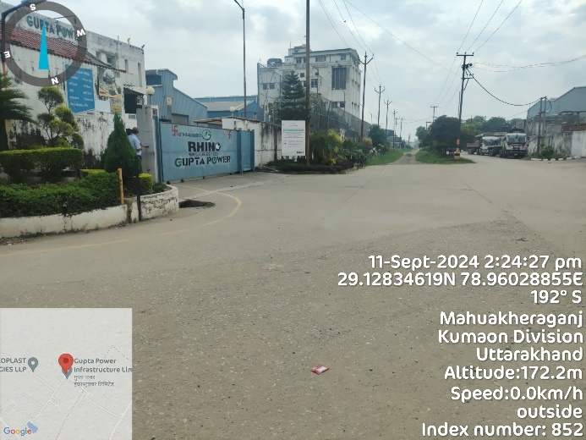
- UNIT II (Plot No. 145)
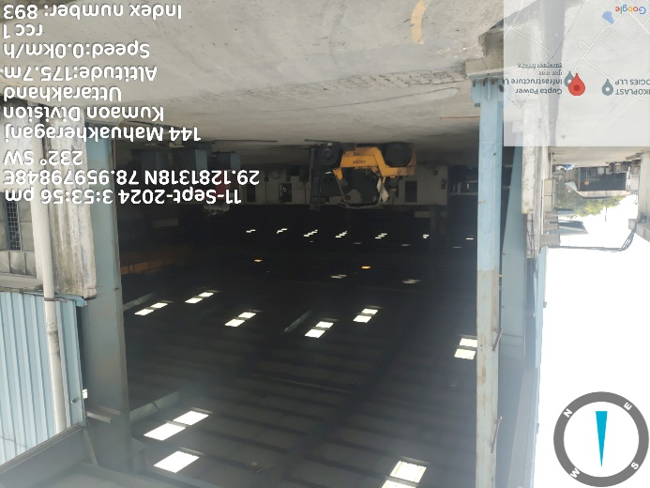 | 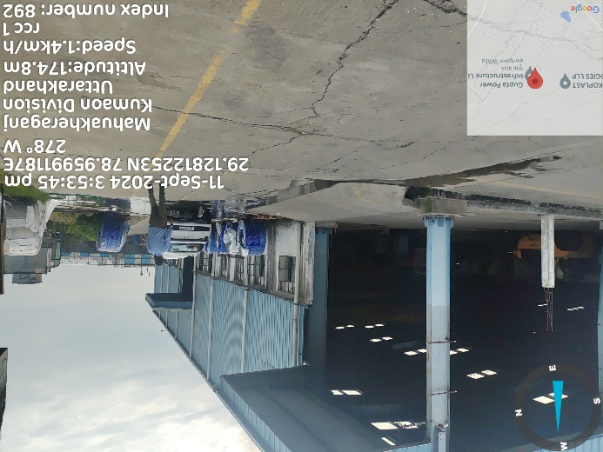
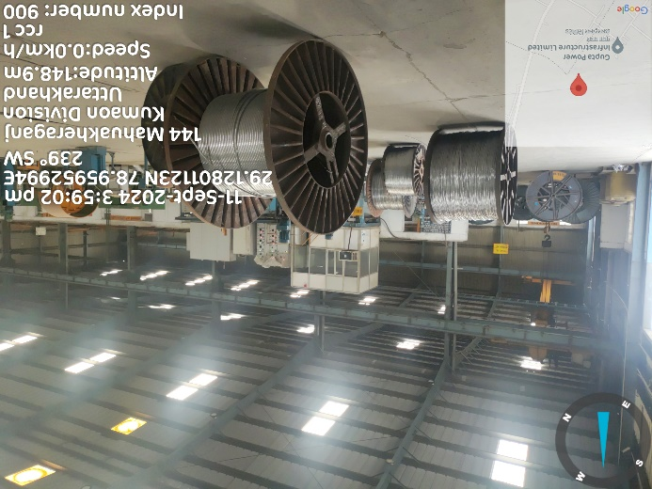 | 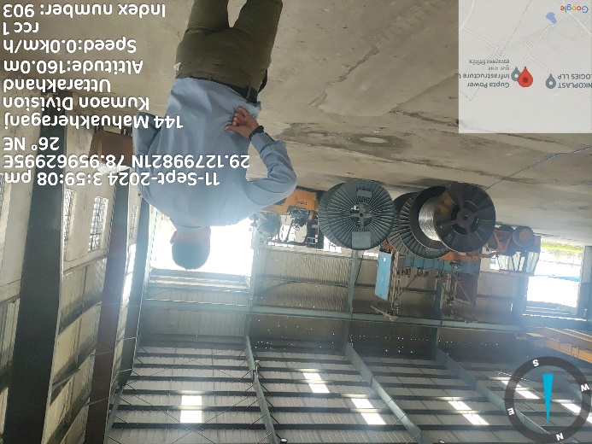
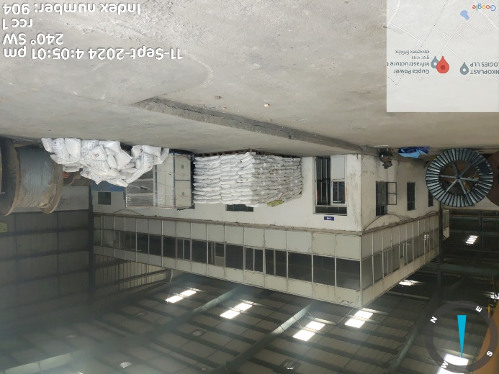 | 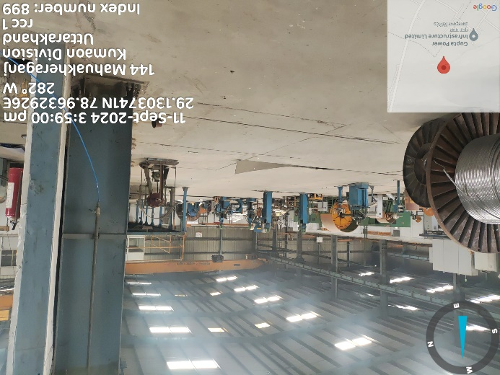
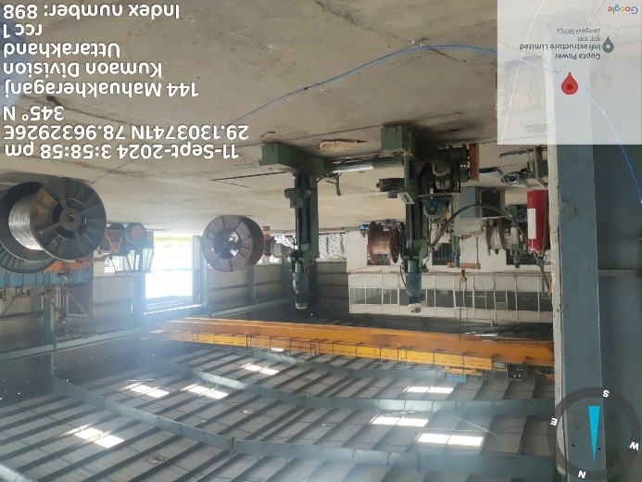 | 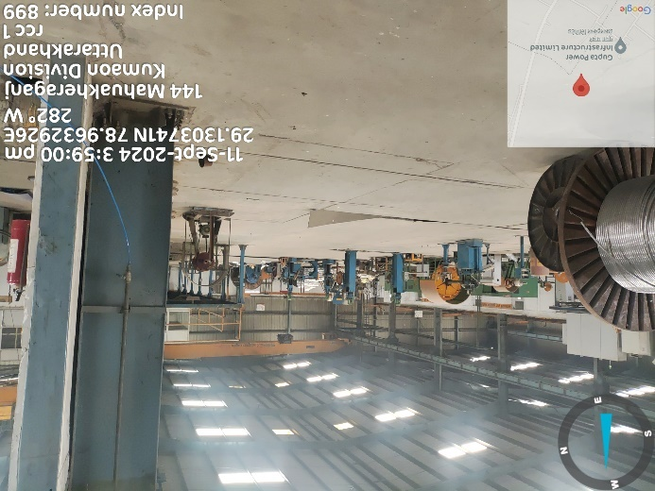
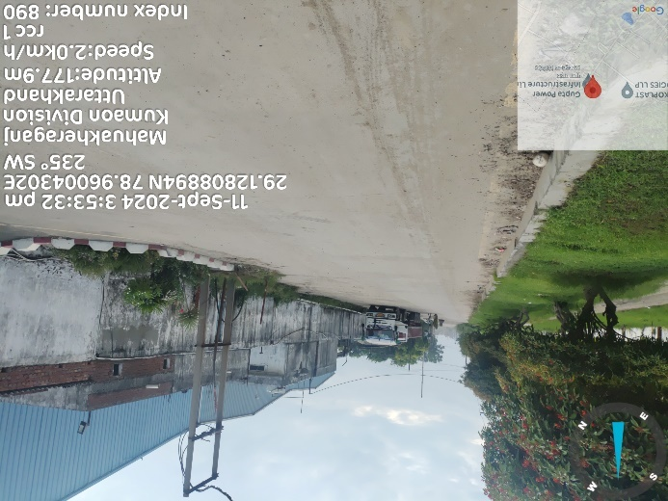 | 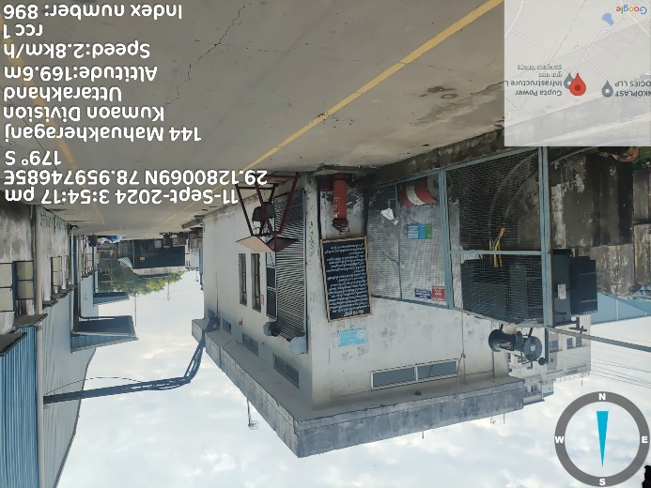
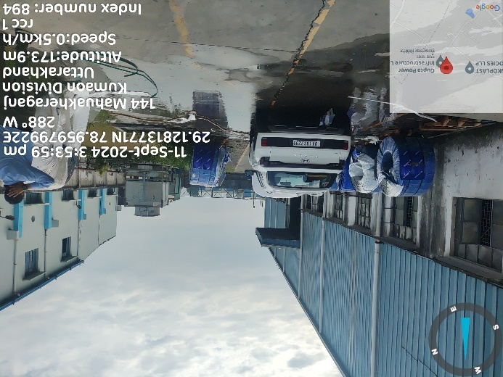 | 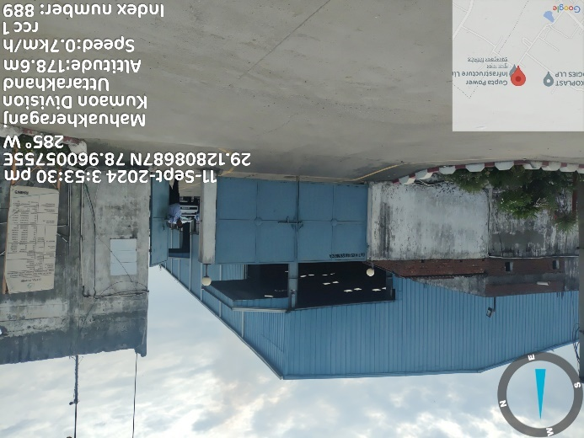
- CHENNAI PLANT: Some of the site pictures has been taken during the site survey, are attached below:
- UNIT I (Plot No. 10/S1)
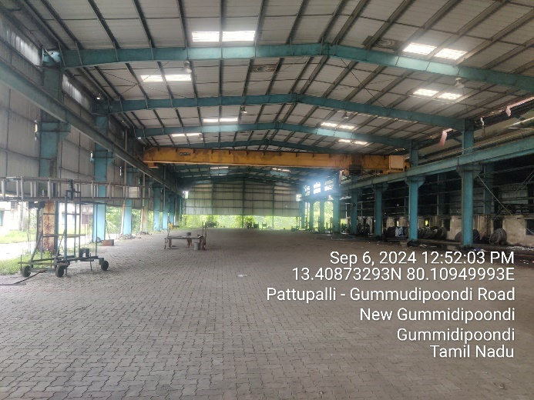 | 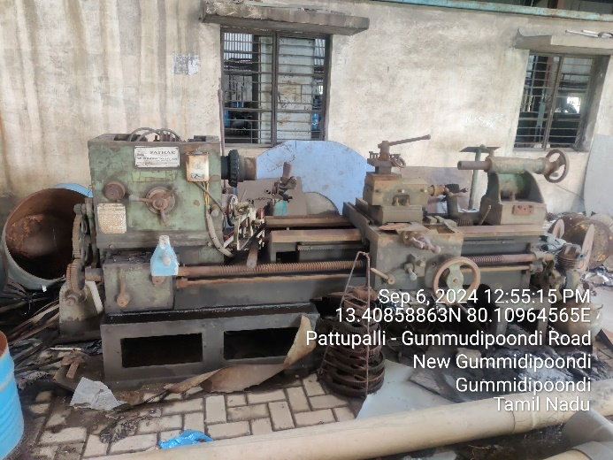
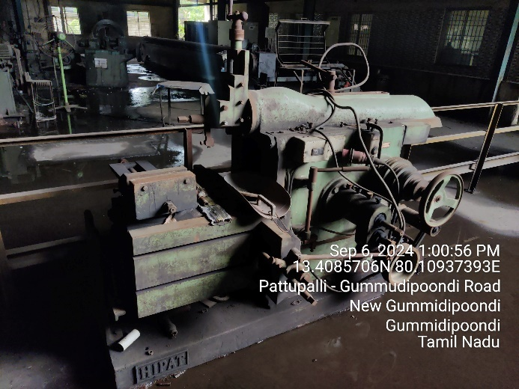 | 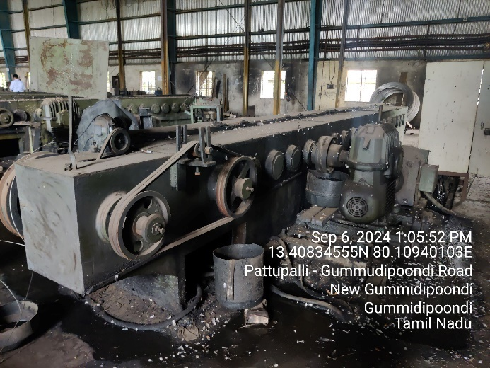
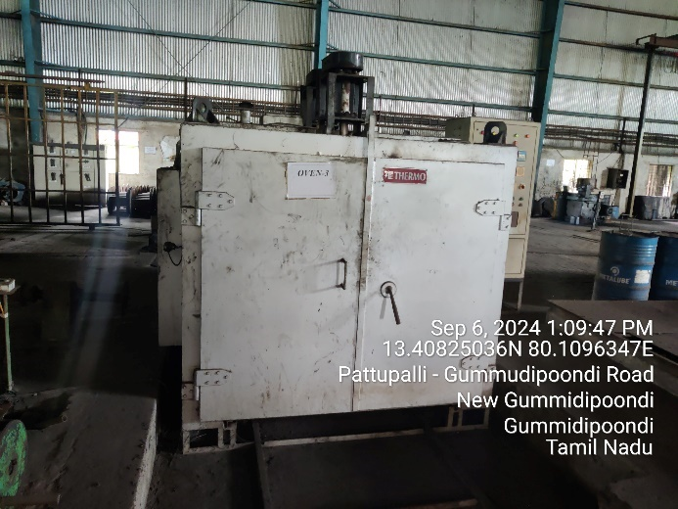 | 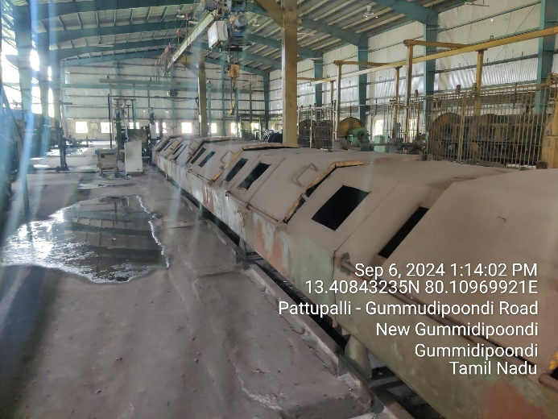
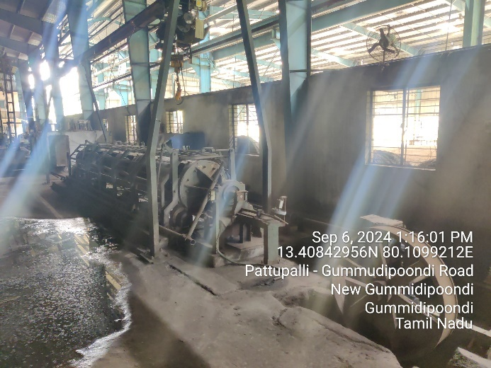 | 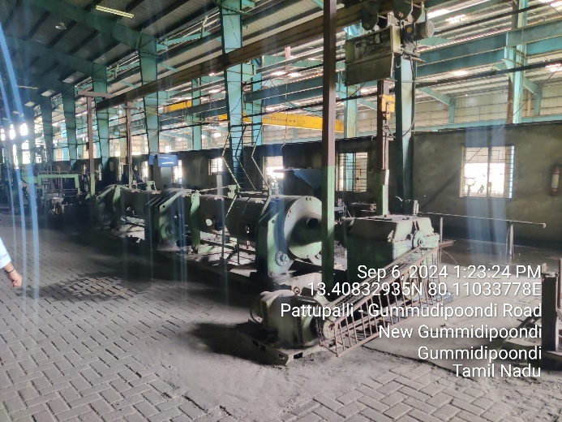
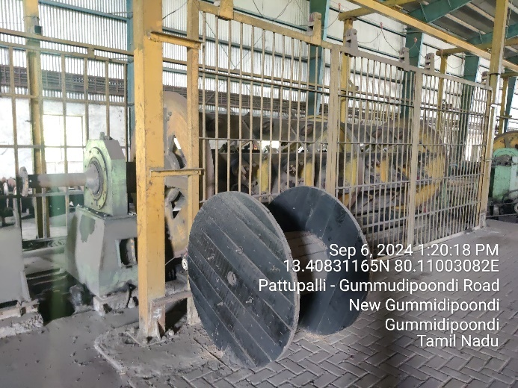 | 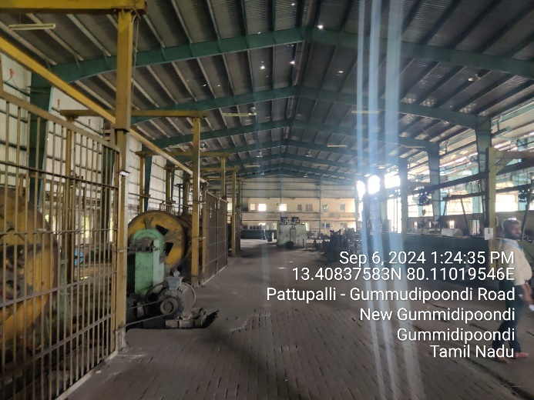
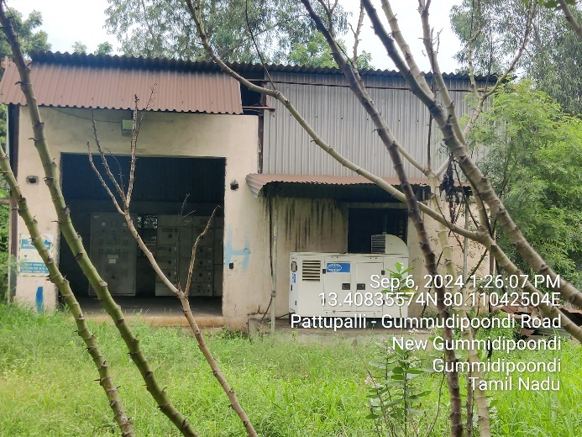 | 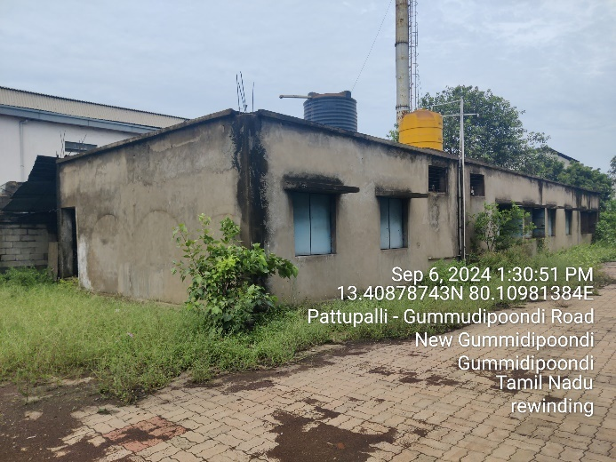
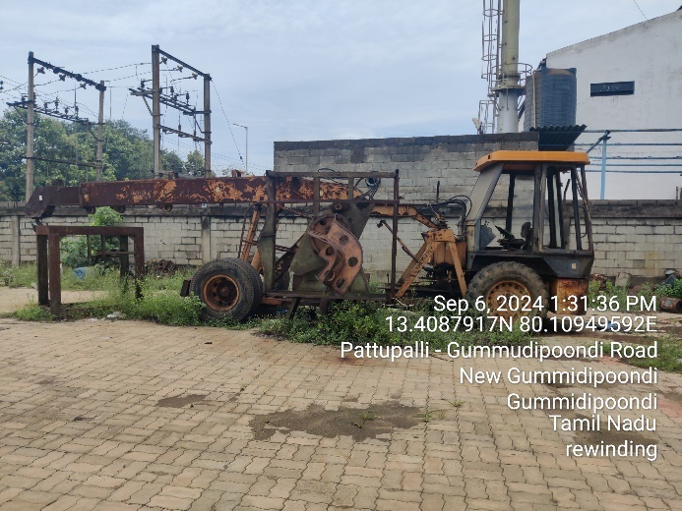 | 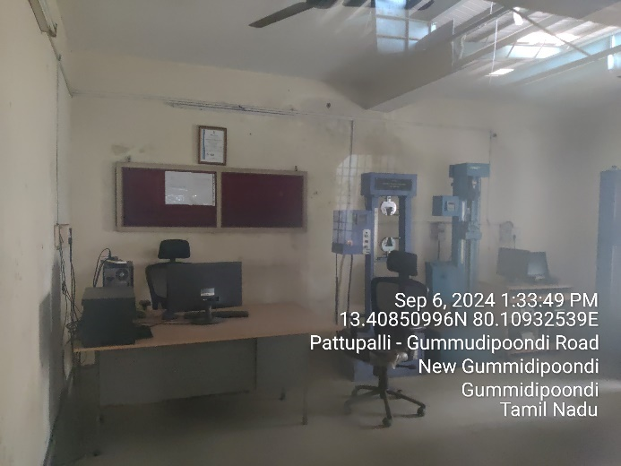
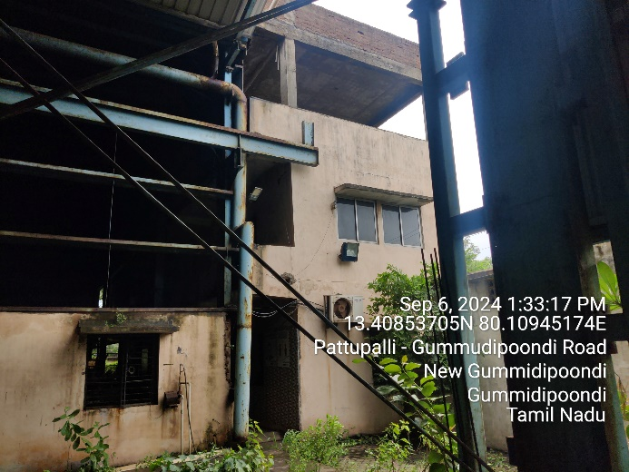 | 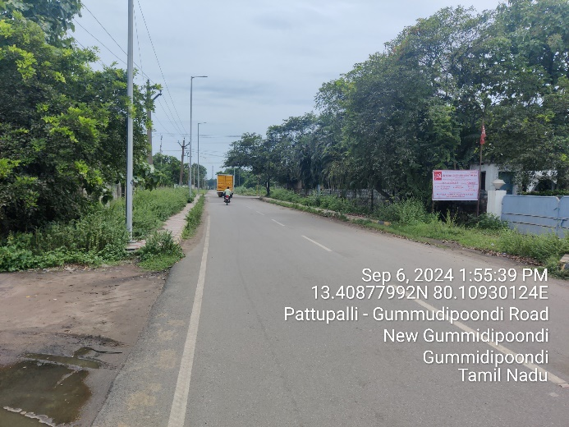
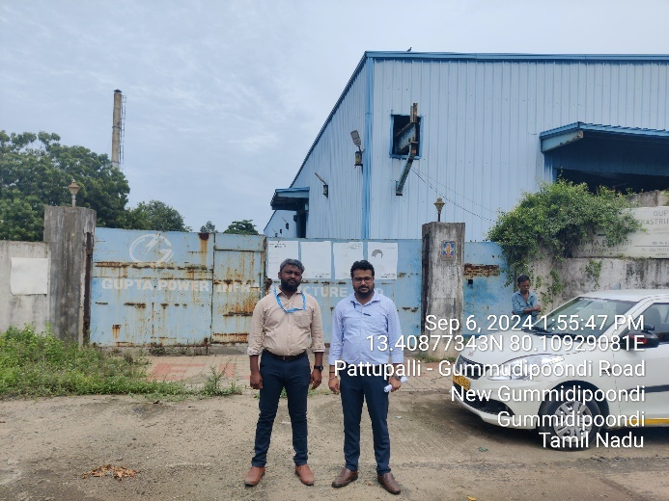 | 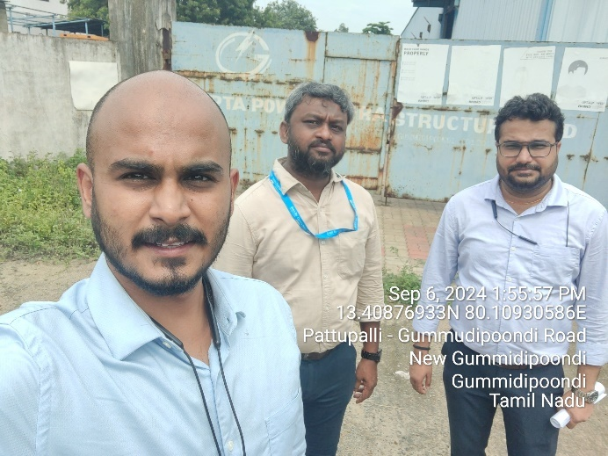
- UNIT II (Shed no. 13 & 18)
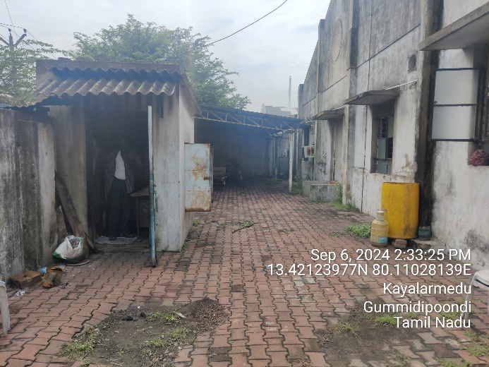 | 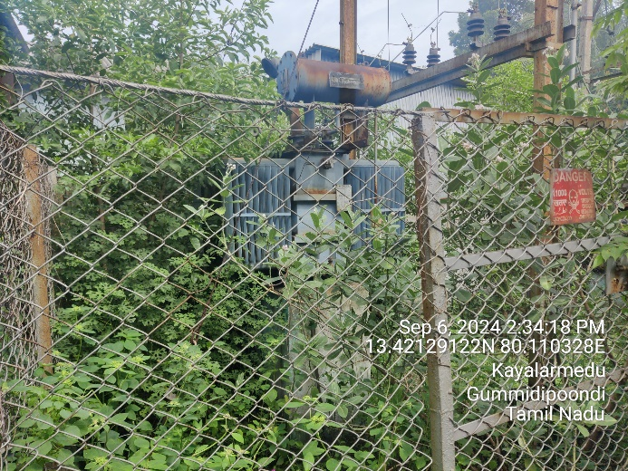
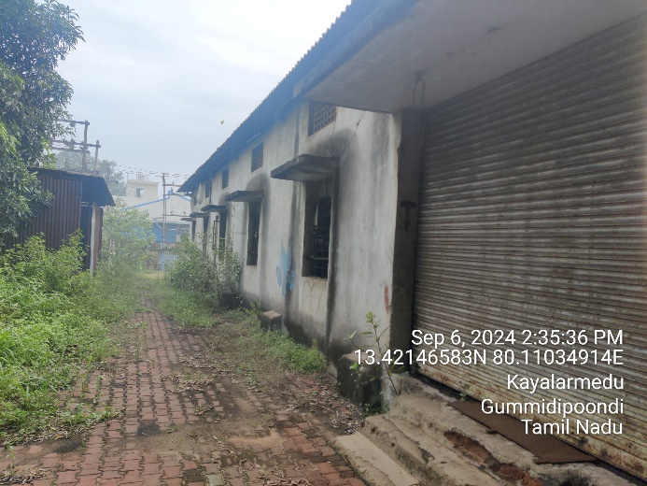 | 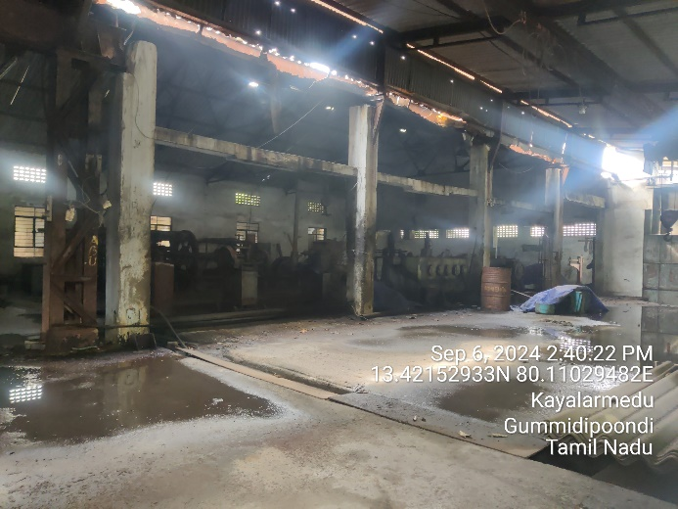
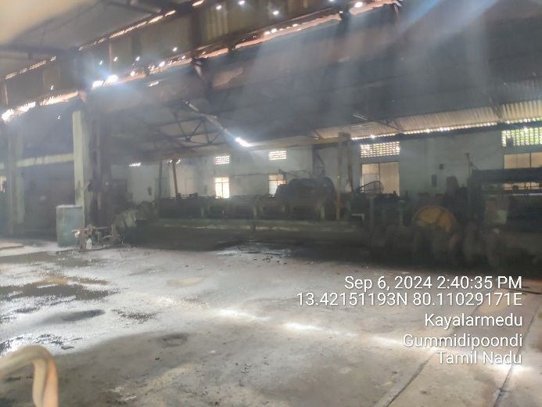 | 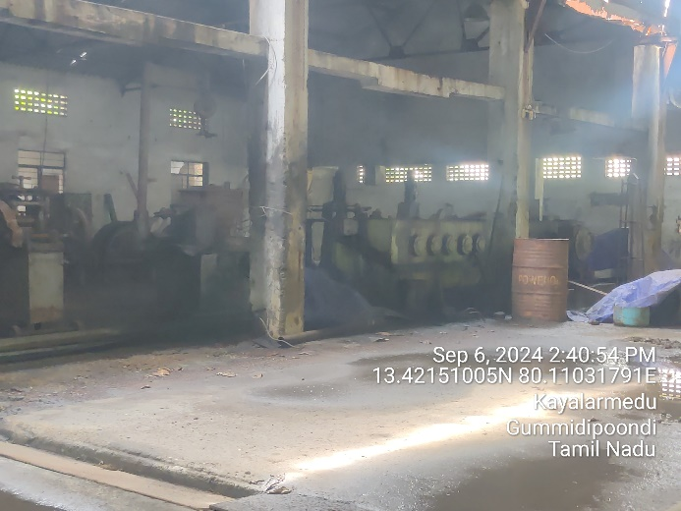
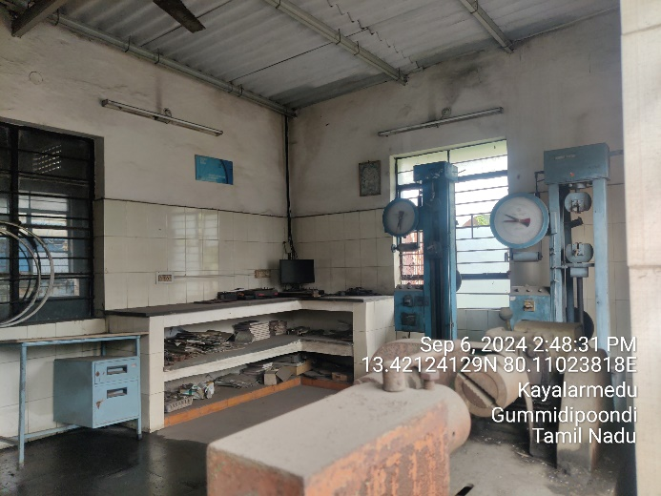 | 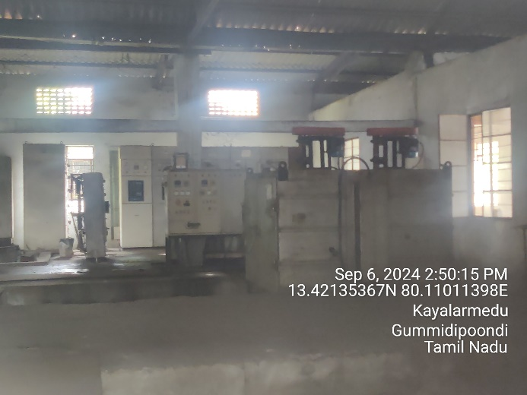
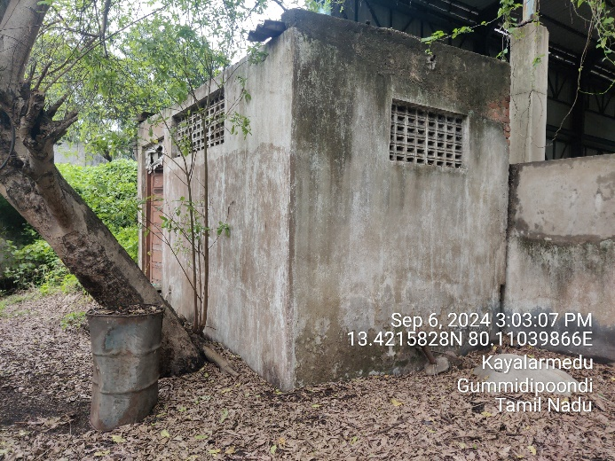 | 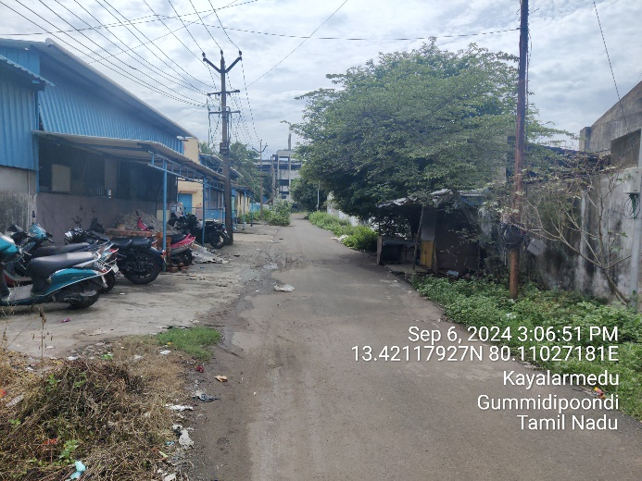
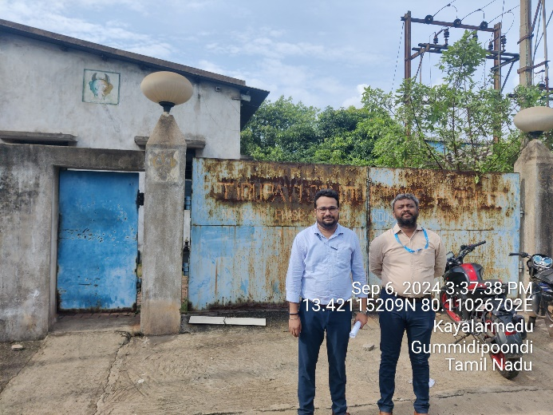 | 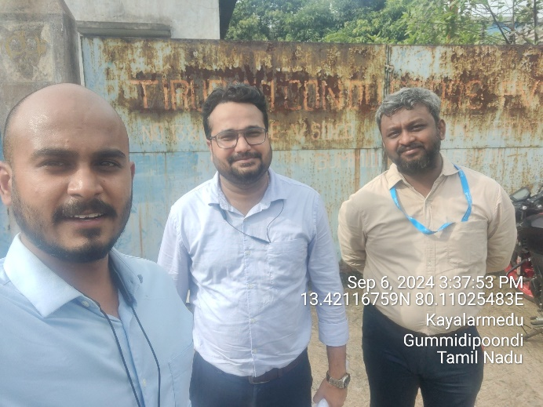

- LAND DETAILS:
- KHURDA PLANT: The subject property is located at F/9, F/16 & F/18, IID Center, Village-Mukundaprasad, District: Khurda, Odisha in the midst of well-developed area of industrial area named as IID Center, Khurda under Odisha Industrial Infrastructure Development Corporation (IDCO). As per copy of sale/lease deed, out of the land area 9.891 acre is lease hold and 4.259 acre is freehold in nature. The copy of Khasra Map is not shared with us; hence we cannot comment upon which portion of plant is either freehold or leasehold.
The plant is located at a distance of 1.1 km from Chennai-Kolkata Highway and is about 22 km from Bhubaneshwar. Nearest railway station is Khurda Town Railway Station which is about 6.5 km and Biju Patnaik International Airport is about 26 km from the subject property. All other basic civic amenities are within close vicinity.
The fair value of land at Khurda plant is estimated at INR 40.06 Cr. For detailed valuation of the same kindly refer our Fixed Asset Valuation Report (VIS (2024-25)- PL434-384-529).
- KASHIPUR PLANT: The subject property situated at the aforesaid address having total land area admeasuring 7.88 acres/ 31,870 sq. mt. as per copy documents provided. The subject property comprises of two locations Plot no. 132, 132B & 132C and Plot no. 145. The land area of Plot no. 132, 132B & 132C is 25,068 sq. mt. and for Plot no. 145 the land area is 6,802 sq. mt. as per the sale deeds provided. The land of both units is freehold in nature and are in front of each other.
The plant is situated in the averagely maintained industrial area named as Nandnagar Industrial Area Phase-II, Kashipur. The plant is located at a distance of 4 km from Chandpur-Kashipur Road and is about ~45 km from Moradabad. Nearest railway station is Moradabad Railway Station which is about ~50 km and Pantnagar Airport is about 80 km from the subject property. All other basic civic amenities are within close vicinity.
The fair value of land at Kashipur plant is estimated at INR 16.57 Cr. For detailed valuation of the same kindly refer our Fixed Asset Valuation Report (VIS (2024-25)-PL434-384-528).
- CHENNAI PLANT:
The subject property situated at the aforesaid address having total land area admeasuring 2.994 acres as per copy of documents provided. The subject property comprises of two locations Plot no. 10/S1 and Shed no. 13 & 18. The land area of plot no. 10/S1 is 2.55 acre as per lease deed provided and for shed no. 13 & 18 the land area is 0.444 acre as per the LSR provided. As per copy of LSR provided, shed no. 13 & 18 are purchased from SIPCOT via 2 sale deeds dated 17/11/2009. The land of both units is leasehold in nature and are at a distance of ~1.7 km from each other.
The plant is situated in the midst of well-developed area of industrial area named as SIPCOT industrial complex, Gummidipoondi. The plant is located at a distance of 1.1 km from Chennai-Kolkata Highway and is about ~40 km from Chennai. Nearest railway station is Gummidipoondi Railway Station which is about 2 km and Chennai International Airport is about 60 km from the subject property. All other basic civic amenities are within close vicinity.
The fair value of land at Kashipur plant is estimated at INR 5.39 Cr. For detailed valuation of the same kindly refer our Fixed Asset Valuation Report (VIS (2024-25)-PL434-384-527).

- BUILDING & CIVIL WORKS:
- KHURDA PLANT: The property situated at the aforesaid address having total land area admeasuring 14.15 acres as per OVR & multiple copy of land documents provided to us. We have also crossed checked the area from google satellite measurement and it seems to match with the area mentioned in the document.
The copy of approved sanction plan or building area details are not shared with us. Thus, for building valuation/assessment purpose, the physical measurement of building/structure is conducted on site. The whole plant could not be surveyed as it was restricted by the company officials. The plant section which was surveyed is marked in the google map below: -
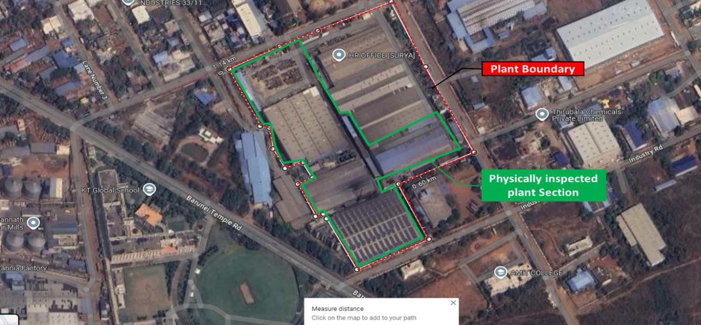
As per observation made during site survey, it was observed that the plant comprises of multiple sheds & RCC structures. In the absence of required data mentioned above, we have used satellite measurement tools & physical measurement to determine total built-up area of the plant which are as follows:
S. No. | Description | Built-up area (In Sq. Ft.) | Height (Ft.) | Type of Structure
1 | RM Shed | 70,944 | 35 ft | GI Shed
2 | Rolling Mill Shop | 42,561 | 35 ft | GI Shed
3 | Rhino Shed | 72,390 | 40 ft | RCC Wall & GI Shed
4 | Workshop | 6,185 | 27 ft | GI Shed
5 | Copper Wire Shed | 26,719 | 35 ft | RCC Wall & GI Shed
6 | Copper Wire Shed-Left | 9,149 | 26 ft | GI Shed
7 | Copper Wire Shed-Right | 9,406 | 26 ft | GI Shed
8 | Office | 8,045 | 14 ft | RCC
9 | Scrap Yard Shed | 5,517 | 12 ft | GI Shed
10 | Shed-1 (Not Visited) | 55,650 | 30-40 ft | GI Shed
11 | Shed-2 (Not Visited) | 48,398 | 30-40 ft | GI Shed
12 | Shed-3 (Not Visited) | 48,170 | 30-40 ft | GI Shed
13 | Building-1 (Not Visited) | 3,258 |  | RCC
14 | Building-2 (Not Visited) | 1,908 |  | RCC
15 | Security (Not Visited) | 102 |  | RCC
Total |  | 4,08,401

- KASHIPUR PLANT: The both units are situated at their respective aforesaid address having total land area admeasuring 7.88 acres/ 31,870 sq. mt. as per copy of documents provided to us. We have also crossed checked the area from google satellite measurement and it seems to match with the area mentioned in the document.
The copy of approved sanction plan or building area details are not shared with us. Thus, for building valuation/assessment purpose, the physical measurement of building/structure is conducted on site. Both of the units of the Kashipur Plant are affront to each other as marked in the google map below:
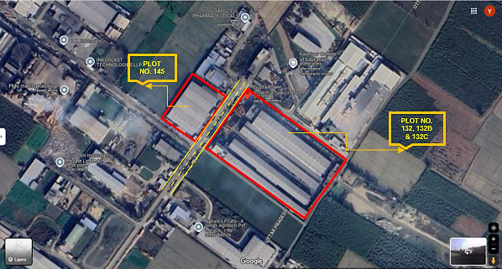
During the site visit to both units of Kashipur Plant, it was observed that the structure is maintained properly and no major maintenance is required for the building structure of the unit. As per observation made during site survey, it was observed that both plants comprise of multiple structures. In the absence of required data mentioned above, we have used satellite measurement tools & physical measurement to determine total built-up area of the plant which are as follows:
S. No. | Building Name | Floor | Height  (in feet) Approx. | Type of Structure | Area  (in sq. mt.) | Area  (in sq. ft.)
Plot No. 132, 132B & 132C
1 | Office Building | Ground Floor | 24 & 11 | RCC | 265.70 | 2,860
2 | Office Building | First Floor | 11 | RCC | 130.06 | 1,400
3 | Office Building | Second Floor | 11 | RCC | 265.70 | 2,860
4 | CCV Building | Ground Floor | 15 | RCC | 410.63 | 4,420
5 | CCV Building | First Floor | 17 | RCC | 410.63 | 4,420
6 | CCV Building | Second Floor | 15 | RCC | 410.63 | 4,420
7 | CCV Building | Third Floor | 15 | RCC | 410.63 | 4,420
8 | Office | Fourth Floor | 11 | RCC | 215.54 | 2,320
9 | Shed 1 | Ground Floor | 35 | PEB Structure | 3157.78 | 33,990
10 | Shed 2 | Ground Floor | 35 | PEB Structure | 4094.24 | 44,070
11 | Shed 3 | Ground Floor | 35 | PEB Structure | 4586.63 | 49,370
12 | Shed 4 | Ground Floor | 49 | PEB Structure | 2704.60 | 29,112
13 | DG Shed | Ground Floor | 16 | Shed with Brick wall | 72.46 | 780
14 | Panel Room | Ground Floor | 14 | RCC | 112.227 | 1208
Plot No. 145
1 | Shed 1 | Ground Floor | 37 | PEB Structure | 1566.35 | 16,860
2 | Shed 2 | Ground Floor | 37 | PEB Structure | 1254.19 | 13,500
3 | Shed 3 | Ground Floor | 37 | PEB Structure | 1245.83 | 13,410
4 | Meter & VCB room | Ground Floor | 12 | RCC | 36.23 | 390
5 | Panel room | Ground Floor | 14 | RCC | 63.17 | 680
6 | Guard Room | Ground Floor | 12 | RCC | 24.53 | 264
7 | Production office | Ground Floor | 12 | Iron Girder with Brick wall | 278.71 | 3,000
TOTAL |  |  |  |  | 21,716.48 | 2,33,754

- CHENNAI PLANT:
The both units are situated at their respective aforesaid address having total land area admeasuring 2.994 acres as per copy of documents provided to us. We have also crossed checked the area from google satellite measurement and it seems to match with the area mentioned in the document.
The copy of approved sanction plan or building area details are not shared with us. Thus, for building valuation/assessment purpose, the physical measurement of building/structure is conducted on site. During the site visit to Unit I of Chennai Plant, it was observed that the structure is maintained properly and no major maintenance is required for the building structure of the unit. During the site visit to Unit II of Chennai Plant, the main shed of the plant was locked and the structure could only be observed through the windows of the building. There were some visible damages to the structure of the building which will require some maintenance expenses for the unit to become operational.
As per observation made during site survey, it was observed that both plants comprise of multiple structures. In the absence of required data mentioned above, we have used satellite measurement tools & physical measurement to determine total built-up area of the plant which are as follows:
Unit I (Plot No. 10/S1)
S. No. | Building Name | Floor | Height  (in feet) Approx. | Type of Structure | Area  (in sq. mt.)
1 | Shed 1 | Ground | 32.5 | PEB Structure | 2,101.47
2 | Shed 2 | Ground | 32.5 | PEB Structure | 2,101.47
3 | Office & Lab building | G+2 | 30 | RCC | 401.34
4 | Canteen | Ground | 9 | Asbestos Shed with brick wall | 11.75
5 | Toilet | Ground | 10 | RCC | 19.32
6 | Security Room | Ground | 9 | Asbestos Shed with brick wall | 11.75
7 | Employee Rooms | Ground | 10 | RCC | 213.68
8 | DG room | Ground | 14 | Tin Shed with brick wall | 60.39
TOTAL |  |  |  |  | 4,921.17
Unit II (Shed No. 13 & 18)
S. No. | Building Name | Floor | Height  (in feet) Approx. | Type of Structure | Area  (in sq. mt.)
1 | Main Shed | Ground | 13.6 | Asbestos Shed with brick wall | 809.93
2 | Misc. Shed | Ground | 9.5 | Asbestos Shed with brick wall | 91.05
3 | Security Room | Ground | 8 | Asbestos Shed with brick wall | 3.58
4 | Scrap Shed | Ground | 11 | Tin Shed | 19.42
5 | Structure | Ground | 10 | Brick Wall with no roof | 16.05
TOTAL |  |  |  |  | 940.02

- PLANT AND MACHINERY/ EQUIPMENTS DETAILS:
- KHURDA PLANT: As per the information shared with us, the installed capacity of Khurda Plant is 100,000 MT (for Wire Rod, Conductors & Cables), 8,000 MT (for Copper-Contact & Catenary Wire) and 60,000 kms (for Optic Fibre Cable). During the site visit, the plant was found to be non-operational. Based on observations and information gathered, the plant was engaged in the manufacturing of MS Wire, Nails, HDPE Wire, AAC (Aluminium Alloy Conductors), ACSR (Aluminium Conductor Steel-Reinforced) Conductors, and Copper Conductors. It was informed that the plant has not been in operation for over a year. We were not provided with copy of the Fixed Asset Register (FAR) or detailed machine inventory.
However, we conducted a machine inventory assessment during the site survey. The machinery was generally in average condition and will require repairs and maintenance to restore full operational functionality.
For detailed description of the plant & machinery at the project location kindly refer to our Fixed Asset Valuation Report (VIS (2024-25)-PL434-384-529).
As per the information shared with us and collected during the survey, the economic life of such type of plants is around 18-20 years, However, the aforementioned plant is 15-16 years old. Thus, the current balance economic life of the plant is around 3-4 years. As per our analysis, the Capex of ~INR 9 crores shall be incurred for refurbishment for plant which can enhance the expected remaining useful life of the Khurda Plant to approximately 8 years subject to the regular repair and maintenance and technological upgradation of the unit, if and when needed.

- KASHIPUR PLANT: As per the information shared with us, the combined installed capacity for both unit of Kashipur Plant is 40,000 MT for Aluminium Conductors & Cables and 2,000 MT for Copper-Contact & Catenary Wire. During the site visit, the plant was found to be operational although no information was provided regarding the capacity at which plant was running. Based on observations and information gathered, the plant is engaged in the manufacturing of AAC (Aluminium Alloy Conductors), ACSR (Aluminium Conductor Steel-Reinforced) Conductors, and Copper Conductors. The plant was in operation during the site visit. We were not provided with copy of the Fixed Asset Register (FAR) or detailed machine inventory.
However, we conducted a machine inventory assessment during the site survey and machine capacities & technical specification were not shared with us. The machinery was in good condition and plant was maintained properly. The major machines found during site visit of both the units are Wire Stranding Machine, Wiredrawing machines, Armoring machine, Copper taping, HT cable core making machine, Triple extrusion machine along with the compressors, DG set and Lathe machine.
For detailed description of the plant & machinery at the project location kindly refer to our Fixed Asset Valuation Report (VIS (2024-25)-PL434-384-528).
As per the information shared with us and collected during the survey, the economic life of such type of plants is around 18-20 years, However, the aforementioned plant is 12-13 years old. Thus, the current balance economic life of the plant is around 6-7 years. Although, with regular repair and maintenance and technological upgradation of the unit, if and when needed, the expected remaining useful life of the Kashipur Plant can increase to around 8-9 years.

- CHENNAI PLANT: As per the information shared with us, the combined installed capacity for both unit of Chennai Plant is 10,000 MT for Aluminium Conductors. During the site visit Plot No. 10/S1, the plant was found to be non-operational. Based on observations and information gathered, the plant is engaged in the manufacturing of AAC (Aluminium Alloy Conductors). It was informed that the plant has not been in operation for more than two years. We were not provided with copy of the Fixed Asset Register (FAR) or detailed machine inventory.
However, we conducted a machine inventory assessment during the site survey. The machinery was in poor condition and will require major repairs and maintenance to restore full operational functionality.
During the site visit to sheds no. 13 and 18, the main shed was locked. As a result, all observations regarding the machinery and equipment were made from the outside, based on what was visible through the windows.
The major machines found during site visit of both the units are Wire Stranding Machine, Skip machine, Wiredrawing machines along with the compressors, DG set and Lathe machine. Some of the machines were rusted and water is logged near the machines which will require major repairs and maintenance to restore full operational functionality.
For detailed description of the plant & machinery at the project location kindly refer to our Fixed Asset Valuation Report (VIS (2024-25)-PL434-384-527).

- UTILITIES: Details of Water, Electricity and other utilities are describing as below:
- KHURDA PLANT:
- Electricity: We have not received any details regarding the sanctioned load of the Khurda Plant. Although, during the site visit we have observed that the plant had two DG sets of 500 KVA and 200 KVA.
- Water: No Details Available with us.
As the plant was operational for a long time before the operations of the plant were stopped since more than 1 year, we can only comment that the utilities of the plant would have been adequate for the current operating capacities as no details regarding the utilities of the plant were shared and no technical person was available during the site visit. Thus, we suggest the client to confirm the sanctioned power load, water level requirement, etc. to identify any additional requirements needed at the current installed capacity of the plant.
- KASHIPUR PLANT:
- Electricity: We have not received any details regarding the sanctioned load of the Khurda Plant. Although, during the site visit we have observed that the plant had three DG sets of 1000 KVA, 500 KVA and 125 KVA.
- Water: No Details Available with us.
At the time of site visit, it was observed that the plant was operating efficiently which suggests that the utilities available at the plant would have been adequate to support the operations at the plant. Although we suggest the client to confirm the sanctioned power load, water level requirement, etc. to confirm the utilities of the plant at the current operating level. If and when, the company increases its operating capacity levels, it would require to increase its level of utilities at the site.
- CHENNAI PLANT:
- Electricity: No Details Available with us.
- Water: No Details Available with us.
During the site visit, it was noted that the plant has been non-operational for approximately 2-3 years. As a result, we currently lack the necessary data to assess the availability and capacity of utilities such as electricity and water. Thus, we suggest the client to confirm the sanctioned power load, water level requirement, etc. to determine any additional requirements needed at the current installed capacity of the plant.
PART E | TECHNICAL ASSESSMENT OF THE COMPANY

- CAPACITY OF MANUFACTURING FACILITY: Below table shows the existing capacity for the three units located at Khurda, Kashipur & Chennai:
Particulars | Khurda Unit | Kashipur Unit | Chennai Plant | Total Capacity
Wire Rod, Conductors and Cables (Aluminium + Alloy + Copper) | 1,00,000 MT | 40,000 MT | 10,000 MT | 1,50,000 MT
Copper - Contact & Catenary Wire | 8,000 MT | 2,000 MT | - | 10,000 MT
Optic Fibre Cable | 60,000 KMs | - | - | 60,000 KMs

- PROCESS FLOW CHART: As per the information shared by the company, below diagram shows the process flow chart for major products manufactured by the company:
- OVERHEAD CONDUCTORS

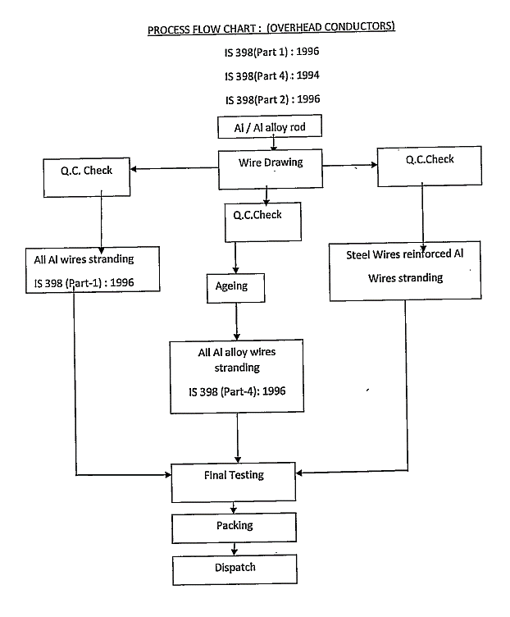
- XLPE CABLE
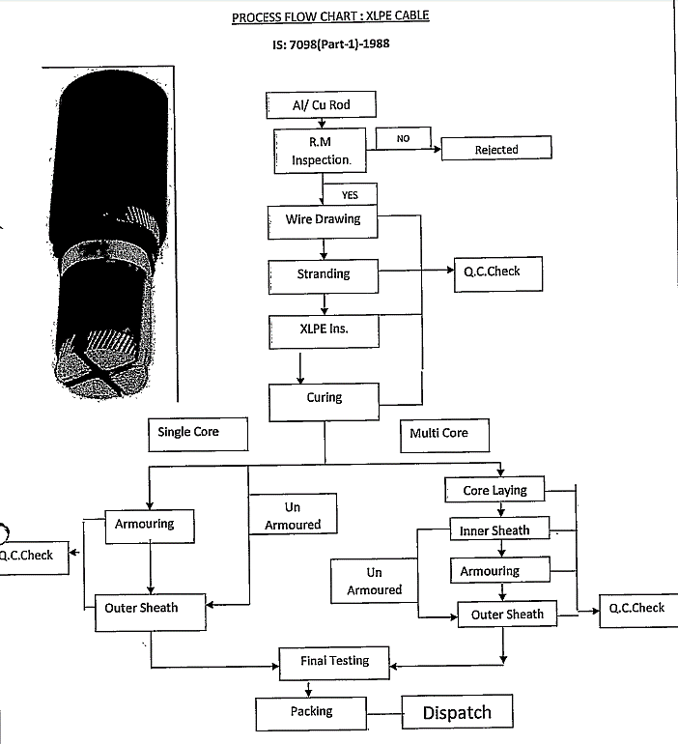
- LIGHT DUTY PVC CABLE:
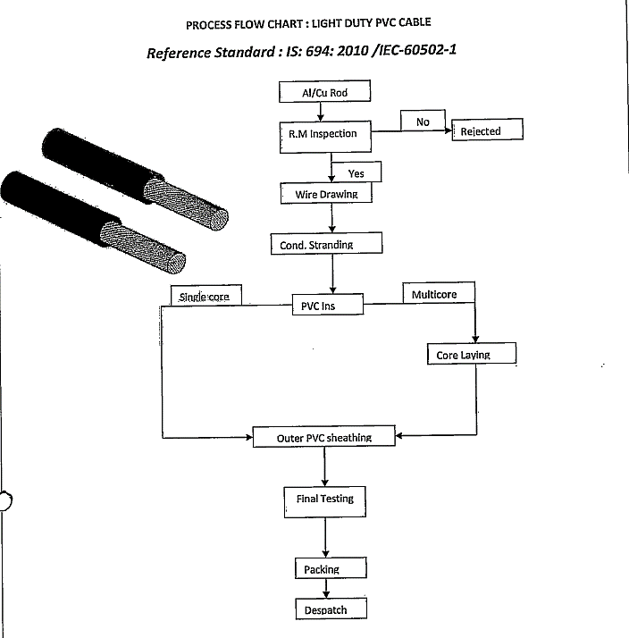
- INSTRUMENTATION CABLE:
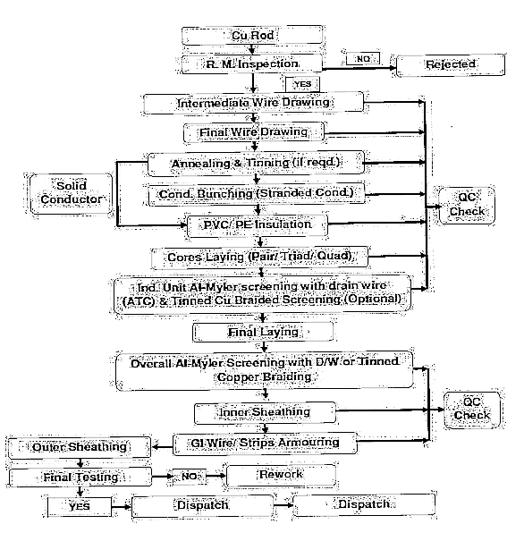
- TECHNICAL SPECIFICATIONS/TECHNOLOGY USED:
Wires are manufactured by the Metal forming process known as wire drawing in which the large size wire rod is pulled with tensile force through the die having small hole (orifice) to get the rod or wire of desired cross sectional area generally it is carried out at room temperatures but sometimes to reduce the stresses it may be carried out at elevated temperatures, generally the process of wire drawing is used to produce the wires made of copper and aluminium which is further used in electrical winding purposes, for electrical winding wire basically both of the Copper and aluminium metals are being used as both the metals are good conductor of electricity and the process involved in drawing the wire is almost same that can be explained with the help of figure given below :-
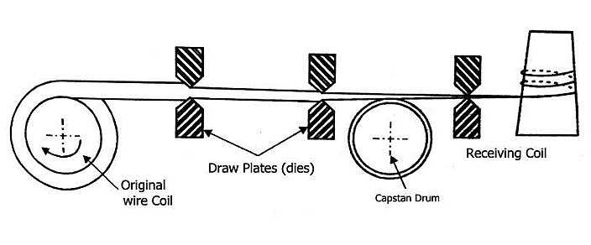
- Wire Drawing: The first step in manufacturing process consists of reducing the diameter of the copper wire gradually to its final diameter. The coil of wire is generally 8mm to 12 mm cross-section is mounted over a drum/flywheel then the wire is pulled through the orifice with the help of dies and due to the plastic deformation the cross-sectional area of the wire is reduced and then wire is drawn from the series of die sets of less cross-sectional area to get the wire of desired size, generally the wire is drawn upto the size of 1.2mm and in case of copper wire due to the wire drawing process and large plastic deformation lots of stresses are developed in the structure and if we further try to reduce the cross-section the wire will get break and to reduce the developed heat treatment is done.
- Annealing: Annealing is the heat treatment process which is also known as stress relieving process basically used to relive the stress and homogenising the structure of copper, in which the drawn wire coil is loaded in the annealing furnace and it is exposed to the high temperature and then it is kept at room temperature for slow cooling and developing the softness in the mechanical properties of copper. The above-mentioned heat treatment process is optional in case of aluminium as it possesses the different mechanical properties.
- Stranding: Annealing is followed by a “stranding” step in which the copper wires are grouped together to make conductors with different cross-sections, e.g., 0.5 mm² to 240 mm², 400 mm² or even higher for larger current capacities.
- Insulation: The next process in the manufacture of electrical cables is the insulation. It involves the placement of an insulating cover over the conductor to prevent current leakages. The insulating material is added by a process of extrusion at high temperature. Several insulating materials may be used: PVC, EPR, XLPE, etc. The material’s insulation capacity and its thickness determine the cable’s maximum service voltage.
- Laying Up: The operation which allows putting together the various elements of the cable into its core, can be done in one or several steps Phase wiring is the grouping of different insulated conductors to make a multicore cable. The phases can be identified by color or by numbering them. A voltage test is also carried out on the whole length of the manufactured cable during this process.
- Additional Coverings: In some cases, the cable may require additional elements in order to improve its protection or operation. Mechanical coverings, also called “armor”, protect the cable from external damage. The armor is made from steel or aluminium and can come in the form of metal strips, wires or braids. Electrical coverings, also called “screens”, insulate the signals that circulate in the cable from possible external interference.
- Outer Sheath: Cables usually have an outer polymer covering for protection. This is called the “outer sheath”. This sheath protects the conductors and their insulation from external elements including mechanical aggression, which may occur during the installation of the cable. The outer-sheath is applied like the insulation via a process of extrusion at high temperature. The sheath may be made from different materials depending on the required protection level, the final flexibility of the cable, the work environment, etc.
- Quality Control: Once the cable is manufactured, the quality of all cables is verified by carrying out rigorous checks before shipping items. In order to guarantee the high quality required by customers, extensive quality control checks in laboratories must be conducted thus, ensuring that all the cables are free from defects and are ready to be sold.
- Spooling and Packaging: Cables are wound onto spools or reels for easy handling and installation. They are then packaged and labelled according to specifications and customer requirements.

LATEST/MODERN TECHNOLOGY:
Wire and cable manufacturing is completely different from the production methods of most electromechanical products. Electromechanical products are usually assembled into multiple parts, and then assembled into a single product, and then the product is measured in units or pieces. Wires and cables are based on length. All wires and cables start with conductor processing, and increase insulation, shielding, cables and sheaths layer by layer around the conductors to manufacture wire and cable products. The more complex the product structure, the more overlapping layers.
Traditionally, cables were constructed using conventional materials like copper and aluminium. However, the latest advancements are introducing a spectrum of novel materials that promise enhanced performance, durability, and conductivity. Innovations in raw materials are not only about performance but also about sustainability. The industry is witnessing a shift towards eco-friendly materials, driven by the global focus on environmentally conscious practices. This includes the exploration of biodegradable polymers and recycled materials, aligning cable production with the broader goal of creating a more sustainable and environmentally friendly technological landscape.
Recent innovations in cable and wire manufacturing include:
- Smart Manufacturing: Incorporating IoT and AI to optimize production processes, improve quality control, and reduce waste. Smart sensors can monitor equipment health and production efficiency in real time.
- Additive Manufacturing (3D Printing): Used for creating prototypes and complex components, enabling customization and reducing lead times.
- Advanced Materials: Development of new alloys and polymers that enhance conductivity, flexibility, and durability, such as carbon nanotubes and thermoplastic elastomers.
- Automated and Robotics Solutions: Automation in handling and assembling wires reduces labor costs and improves precision, while robotic systems enhance the speed of manufacturing.
- Sustainable Practices: Increased focus on eco-friendly materials and processes, including recycling initiatives and the use of renewable energy sources in manufacturing.
- High-Voltage Direct Current (HVDC) Technology: Innovations in cables designed for HVDC systems are improving efficiency in power transmission over long distances.
- Cable Design Optimization: Advanced simulation tools are being used to enhance cable designs for specific applications, improving performance and reducing costs.
These advancements aim to improve efficiency, sustainability, and the overall quality of wire and cable products. In summary, the Latest Innovations in Wire and Cable Production Technology signify a transformative wave in the industry. From revolutionary changes in materials to the integration of cutting-edge technologies, cables are no longer just connectors, they are enablers of progress. As we embrace 5G, prioritize safety with fire-resistant cables, and leverage AI for quality control, the industry is not just adapting but shaping the future of connectivity.
The adoption of technology has dramatically changed so many aspects of our lives, and it’s thrilling to see how the cable and wire sector has witnessed change as a result. It incorporates automated quality control and effective work models to maximise consistency and profitability. The sectors integration of AI and automation, will increase total efficiency.
At present, the company is using traditional multistage manufacturing process, which are recognised and on-going processes in the market/industry. However, technological advancement may occur in the future to run the plants optimally, since automation, artificial intelligence and robotics advancements are taking place and becoming more prominent and environment friendly day-by-day. Also, the government is appreciating and encouraging to reduce the carbon footprint and reduce the technological obsolescence in all the industries.

- TESTING STANDARDS FOR PRODUCTION:
We have not received any details/information regarding the testing standards / procedure followed by the company but during the site visit, we have observed that GPIL has a lab testing facility in both Khurda and Kashipur plant. Some of the machines present in the labs were Universal Testing Machine, Hot Air Oven, Double Kelvin Bridge, Digital Balancing Machine, Profile Projector, Hardness Tester, etc. These machines were observed from outside only as these were present in the closed facility lab.
Main quality parameters for winding wire are dimension – Diameter, Electrical resistance Elongation, springiness, Heat Shock, flexibility and adherence, Temperature index. High temperature failure, insulation thickness Resistance to solvent, breakdown voltage, weight etc. IS 13730Main BIS standard for winding wire and IS 13778-5 (2012) is related to Winding Wires – Test Methods.

- MANPOWER: As per the information shared by the client/company and observed by during the site visits, the Khurda and Chennai Plant were not operational, but the Kashipur Plant was running efficiently. However, we have not received any details regarding the manpower employed by the GPIL, hence, we cannot comment on the current manpower capability of the company. But when the company is able to expand its operations and restart its plants, it will need to hire additional manpower to sustain the increased level of operations in the future.
For reference, approximately a manpower of 300 personnel is needed in a proposed 38,400 MT proposed Cables and Conductor Wires manufacturing unit by Oswal Cables Private Limited as per proposal submitted by the company for obtaining Environmental Clearance. Thus, keeping it as a benchmark, the company will be needed to increase the manpower in the all Plants, when they will be able to increase its operating levels. Thus, as per the above analysis, the company will require approximately 750 to 900 number of manpower to work efficiently in future considering the fact that an entity is supposed to get the economies of scale at larger operations and dependency on the technology i.e., Manual plant/Semi-Automatic Plant/Fully Automatic.

PART F | PRODUCT PROFILE

- INTRODUCTION:
The Company has three plants located at Khurda (Odisha), Kashipur (Uttarakhand) and Chennai (Tamil Nadu). GPIL has a total installed capacity of 1,50,000 MTPA for Wire Rod, Conductor and Cables, 10,000 MTPA for Copper Contact & Catenary Wire and 60,000 KMs for Optic Fibre Cable. Gupta Power offers a single window solution for all types of Electrical needs through its inimitable product offering that includes Overhead Conductors, HT-LT Power Cables upto 66 KV, Instrumentation Cables, Mining Cables, Thermocouple Cables, Airfield Lighting Cables, Railway Signalling Cables & Specialized Cables.

- PRODUCT CATEGORY:
As per the information shared by the client/company and data/information available on the public domain, the list of products manufactured by GPIL has been shown below:
S. No. | Category / Sub-Category | Description
1 | Conductors
a) | Stacir Conductor | - STACIR Conductors are very similar in construction to a conventional ACSR conductor but the EC Grade Aluminium wires are replaced with Heat Resistant Aluminium Zirconium Alloy (generally known as STAL).  - These conductors work at High Temperature upto 210°C without any loss of Strength. They have excellent corrosion resistance and are easy to install.  - STACIR conductors are manufactured in accordance to IEC 62004, IEC 62774; Generally, to IEC 61089 & other Standard.
b) | TACSR Conductor | - TACSR/AW Conductors are very similar in construction to a conventional ACSR conductor but the EC Grade Aluminium wires are replaced with Heat Resistant Aluminium Zirconium Alloy (generally known as TAL).  - Zirconium doped aluminium alloy maintain the electrical and mechanical properties at elevated temperatures, thus making these conductors cost effective with enhanced capacity.  - TACSR/AW conductors are manufactured in accordance to IEC 62004, IEC 61232, Generally to IEC 61089 & Other Standard
c) | ACSS Conductor | - ACSS Conductor, a non-homogenous conductor, is a concentric-lay stranded conductor made from round annealed aluminium 1350-O wires and round coated steel core wire(s).  - ACSS conductors are prone to resist the effects of aeolian vibration due to very little or no mechanical load on the annealed aluminium wires.  - ACSS conductors are manufactured in accordance to ASTM B 856 & Other Standard
d) | AAAC Conductor | - AAAC conductors are made up of high strength Aluminium – Magnesium – Silicon Alloy (Alloy Type 6201/6101). These conductors are preferred over AAC and ACSR conductors as they have better strength to weight ratio and offer improved electrical properties, excellent sag-tension characteristics and superior corrosion resistance property.  - Lighter weight, high strength and current carrying capacity, lower electrical losses and superior corrosion resistance have given AAAC a wide acceptance in the distribution and transmission of medium and high voltage lines.  - AAAC conductors are manufactured in accordance to the following standards AS; ASTM; EN (BS EN); CAN -CSA; DIN; IEC; IEEE; IS; NFC; SS; UL; ANSI.
e) | AAC Conductor | - AAC conductors are made up of single or multiple strands of hard drawn 1350 - H19 aluminium. These conductors are used in low, medium and high voltage overhead lines.  - These are extensively used in urban areas where pans are usually short but conductivity is high. Due to high corrosion resistance property of aluminium, AAC conductor are majorly preferred and used in coastal areas.  - AAC conductors are manufactured in accordance to the following standards AS; ASTM; EN (BS EN); CAN -CSA; DIN; IEC; IEEE; IS; NFC; SS; UL; ANSI.
f) | ACSR Conductor | - AACSR made up of concentrically stranded conductor with single or multiple layers of Aluminium - Magnesium - Silicon Alloy wire stranded around a high strength coated steel core. The core of the conductor can be of either single wire or stranded multi wire.  - Steel Core of AACSR is available in Class A, Class B or Class C galvanizing for corrosion protection. These are used in transmission and distribution projects.  - AACSR conductors are manufactured in accordance to the following standards AS; ASTM; EN (BS EN); CAN -CSA; DIN; IEC; IEEE; IS; NFC; SS; UL; ANSI.
2 | Wire and Cable
a) | 600/1000 V Fire Survival Cable | - These cables are produced with special construction to withstand 950 °C for three hours.  - These cables are used in fixed installations in high occupancy buildings like airport, railways etc and strategically sensitive buildings like defence establishments, industrial areas etc.  - The cable is manufactured as per BS 7846 and tested as per BS 6387 and other international standards.
b) | Industrial Wire | - Greater current-carrying capacity offers economy of wire-gauge.  - Higher Short-Term and Long-term temperature rating.  - No overheating or melting.  - Steam and boiling water resistant.  - Flame Retardant/Fire Guard/FR-LSH Type
c) | Mining Cable | - The cables are designed to operate in the harshest environments on earth. GPIL manufactures cables in 1.1 kV and 3.3 kV voltage grade and are normally with copper conductor and doubled wire armoured to provide higher mechanical protection and flexibility. The conductivity of the armour is not less than 75% of the phase conductor.  - The cables are manufactured by GPIL as per IS: 1554 (Part 1) & IS: 7098 (Part 1 & 2) and as per customer requirement.
d) | Airfield Lighting Cable | - The cables are designed for airport and airfield systems especially for illuminating runways.  - The company produces complete range of Airfield Lighting Cables i.e., S/C x 6 sq. mm, 2C x 6 sq. mm, S/C x 16 sq. mm, 2C x 6 sq. mm, in copper and 2C x 25 sq. mm with round Aluminium conductor.  - These cables are PVC insulated, armoured with steel strip and PVC sheathed with anti-rodent and anti-termite properties.
e) | HT Power Cable | - HT Power Cables manufactured by GPIL range from 1900 volts to 33000 volts with sizes up to 1000 sq. mm.  - The Power Cables possesses excellent electrical, mechanical and heat-resistant properties.  - XLPE cables are manufactured and tested in accordance with IS: 7098 (Part 2) and other international standards.
f) | UNI Tube Steel Tape Armoured Cable | - Rhino Uni – Tube Steel Tape Armoured Cable (2F - 12F) single loose cables offer a low-cost alternative to traditional stranded loose tube cables.  - The rugged single loose tube is placed inside a single gel-filled tube. The core tube can include up to 24 fibers. The core is covered with a water-blocking tape.  - Corrugated steel tape armour is applied and then encased with the outer sheath. A ripcord is provided under the armour for ease of access.
g) | UNI Tube Cable | - Over View Rhino Uni – Tube (CATV) Cable (2F - 12F) consists of fibers placed in a central tube.  - They have Nylon/LSZH/FRPE as outer Jacketing. A ripcord is provided under the armour for ease of access.
h) | ADSS Optical Fiber 11.5mm | - Multi – Tube Single Sheath ADSS Cable (2F - 144F) fibers are placed inside filled buffer tubes containing gel. The core is constructed by stranding the buffer tubes around a central strength member. The core is covered with a water-blocking tape.  - Aramid yarns and a black outer sheath are applied. A ripcord is provided under the armour for ease of access.
i) | Multi Tube Micro Duct Cable | - Rhino Multi – Tube Micro Duct Cable (2F – 144F) have strain free fibers due to S-Z stranding and loose tube design. Longitudinal water protection is enabled by water blocking compounds in tube and core.
j) | Simplex Duplex Cable | - Rhino Simplex – Duplex cable have high strength and good bending performance. 900 microns buffers are surrounded with aramid yarn and jacketed with outer sheath.
k) | FTTH Drop Lite Indoor Cable | - Rhino FTTH Drop Lite Indoor Cable has two dielectric strength members and a sub unit surrounded by polyethylene/ LSZH jacket.  - The sub unit consists of 1-12 fibers placed inside buffer tube which are filled with gel and protected by two FRP rods. The fibers are sheathed with HDPE.
Apart from the above-mentioned range of products, GPIL also has an ISO 9001:2015 certified EPC division which was started with an objective of empowering lives by offering integrated turnkey solution. The division provides engineering services, procurement and construction services across various verticals. As per the information available on the public domain, the division has been involved in different types of power infrastructure projects for esteemed clients like NHPC, NTPC, OPTCL, CESU, MESCO, SOUTHCO, IOCL and others.

- MARKETING AND SELLING ARRANGEMENT:
As per the data/information shared by the client, the company manufactures wire and cables on the basis of contracts which have to completed within a specified time. Generally, the supply of orders is completed within a short duration with lower profitability. In case of supply to state owned transmission companies, supply order execution is considered complete only after stringing of conductors / cables. Some of the major customers of GPIL are as follows:
S. No. | Name of Party | Nature
1. | Power Grid Corporation of India Limited | Conductor
2. | KEC International Limited | Conductor
3. | TATA Power Delhi Distribution Limited | Cable
4. | TANGEDCO | Conductor & Cable
5. | Knigwire | Cable
6. | L&T | Conductor & Cable
7. | Ethopian Electric Utility Project | Conductor & Cable
8. | Nepal Electricity Board | Covered Conductor
9. | Planet International | Cable
10. | Anapurna Cables | Cable
Source: Information provided by client

- RAW MATERIAL PROCUREMENT:
As per the data/information shared by the client, Company generally procures aluminium rods and Copper rods. Production of different varieties of copper items, optical fiber cables, HTLS Conductors, Catenary & Contact wires for railways, covered conductors, AL 59 etc. which requires company to maintain higher levels of stock.
The company procures majority of the materials through LC and rest through advance payments. The company usually gets bulk order from Government departments and the same is inspected before dispatch. For manufacturing bulk quantity, the company purchases raw materials in bulk. Some of the major suppliers of GPIL are as follows:

S. No. | Name of the Creditor | Products Offered
1 | National Aluminium Company Ltd. | Aluminium Products
2 | Hindalco Industries | Aluminium & Copper
3 | Bharat Aluminium Company Ltd. | Aluminium Wire Rods and Ingots
4 | Kkalpana Industries India Ltd. | LDPE, HDPE, PP Granules
5 | Vedanta Limited | Aluminium & Copper
6 | Kritika Wires Limited | Steel Wire and Galvanized Wire
7 | Yash Poly Industries | PVC Compound, PVC Master batches, PP Fibrillated Yarns and PVC Fillers
8 | Rashtriya Metal Industries | Aluminium & Copper
Source: Information provided by client
PART G | INDUSTRY OVERVIEW & ANALYSIS

- INTRODUCTION:
The International Monetary Fund (IMF) in July revised India’s GDP growth forecast for FY 25, increasing it by 20 basis points to 7% projected by the financial institution earlier this year as a result of stronger domestic investment, which is reflecting momentum from stronger-than-expected growth in the fourth quarter of 2023 which is a result of stronger domestic investment. The Reserve Bank of India (RBI) has also projected the Indian economy to grow at 7.2 per cent for FY25.
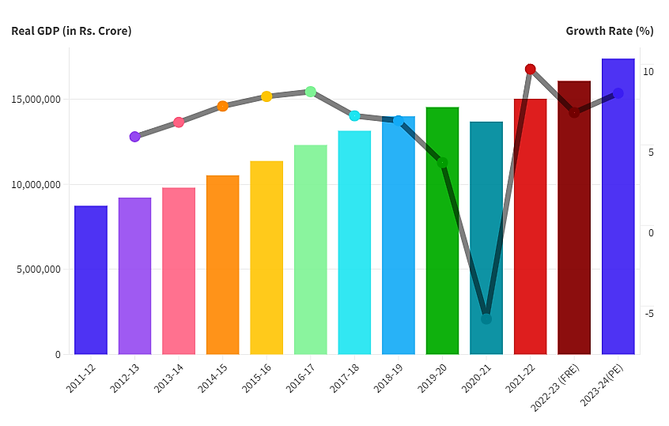
Source: MoSPI, India
According to data from the National Statistical Office (NSO), India’s Industrial Production Growth (IIP) growth rate for the month of May 2024 over the corresponding period of previous year is 5.9% which was 5.7% in May 2023. The growth rates of the three sectors, Mining, Manufacturing and Electricity for the month of May 2024 over May 2023 are 6.6%, 4.6% and 13.7% respectively. Within the manufacturing sector, the growth rate of the top three positive contributors to the growth of IIP for the month of May 2024 are – “Manufacture of basic metals” (7.8%), “Manufacture of pharmaceuticals, medicinal chemical and botanical products” (7.5%), and “Manufacture of electrical equipment” (14.7%).
The Indian wire and cable industry is a crucial segment of the electrical equipment market, supporting various sectors such as construction, telecommunications, automotive, and power generation. The Indian cables & wires industry, along with FMEG products, is estimated to be ~INR1.8t in FY23. The industry offers huge growth potential and is estimated to report ~10% CAGR over the next few years, led by increased traction in the infrastructure and real estate sectors. The cables & wires industry constitutes ~39% of the electrical industry and forms a crucial part of construction and infrastructure activities.
This growth is driven by several key segments: power cables for electricity transmission, telecommunication cables facilitating connectivity, instrumentation cables used in various industries, and building wires essential for residential and commercial construction. Government initiatives aimed at infrastructure development and rural electrification, coupled with the expansion of renewable energy projects, are significantly boosting demand.
The industry should benefit from the rising exports of cables from India, as exports have clocked a 16% CAGR vs. ~8% CAGR for imports over FY17-23 (~15% YoY growth during 9MFY24). The organized players are also anticipated to benefit from the rising demand for branded products due to their safety features and quality. As per industry estimates, branded players currently constitute ~74% of the industry (vs. 61% in FY14), which is expected to improve to 80% by FY27.

- CABLE AND WIRE INDUSTRY IN INDIA:
Indian Wires and Cables Market would grow on the back of rapidly growing investment by the government towards the development of infrastructural projects. The development of smart cities in the country along with the increase in electronic devices in the household would increase the demand for wires and cables in the Indian market. The development of manufacturing industries as a part of the Make in India initiative would also result in the growth of the wires and cables market during the forecast period.
As a result of infrastructure development, urbanization, smart cities, the growth of residential and commercial real estate, rural electrification, and the move towards renewable energy, the cables & wires segment is expected to experience significant growth. The cables & wires market reported ~8% CAGR over FY14-23 to reach INR700b and it is estimated to clock ~10% CAGR over FY23-27 (INR1.2-1.3t). The industry growth rate was hit by the challenges associated with Covid-19 in FY20-21 and it recorded a CAGR of mere 2.7% during FY19-22. The cables & wires industry can be split into five categories with housing wire having the largest share as shown in the image below:
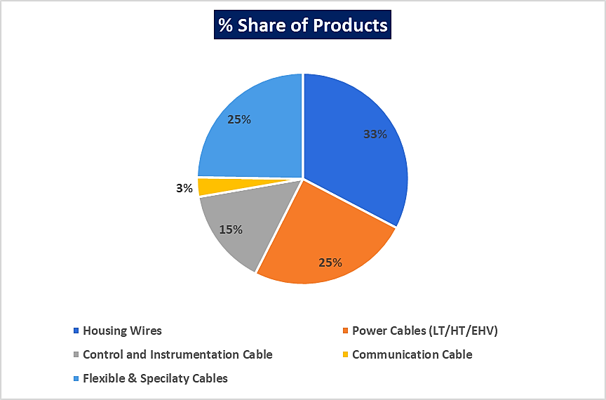
Source: MOFSL, Industry
The domestic cables & wires market has steadily moved to an organized play from a largely unorganized play, including regional/national players. The shift was led by rising awareness among consumers towards safety and quality, the advent of GST regime, technological innovation, brand building, and technical & regulatory compliance.
Indian wires and cables market is expected to witness progressive growth in the upcoming six years backed by the growing telecommunication sector in the country. The increased number of internet subscribers due to rising internet penetration rapidly from past years is an active contributor to the India wires and cables market growth. On the other side, telecom operators are spending in bulk on the integration of telecom towers in rural areas and all this can be possible with the needful resources for the same and as a result, the use of wires and cables is rising in the telecom sector which tends to ensure better signals through consistent power supply. As a result, it is estimated to strengthen India wires and cables market growth in the forthcoming years.

- GROWTH POTENTIAL OF WIRE AND CABLE INDUSTRY IN INDIA:
The growth potential of the wire and cable industry in India is substantial, driven by several key factors:
  - Infrastructure Development: The Indian government’s focus on infrastructure projects, including smart cities, transportation networks, and housing schemes, is a significant growth driver. Initiatives like the Smart Cities Mission and the Pradhan Mantri Gram Sadak Yojana are expected to boost demand for power and telecommunication cables.
  - Rural Electrification: With ongoing efforts to electrify rural areas, such as the Saubhagya Scheme, there is a rising need for power cables. This initiative aims to provide electricity to every household, creating new markets and enhancing quality of life in rural communities.
  - Renewable Energy Expansion: India’s ambitious targets to reach 500 GW of renewable energy capacity by 2030 will require substantial investments in specialized cables for solar and wind energy projects. This transition to cleaner energy sources is a key area of growth.
  - Urbanization and Housing: Rapid urbanization is leading to increased residential and commercial construction. The demand for building wires and cables is expected to grow as urban areas expand and modernize their electrical infrastructure.
  - Digital Transformation: The surge in digital services and the need for high-speed internet connectivity are driving demand for telecommunication cables, particularly fiber optics. This trend is further accelerated by the expansion of 4G and 5G networks across the country.
  - Technological Innovations: The adoption of advanced manufacturing technologies, including automation and IoT, is improving production efficiency and product quality. Companies are increasingly focusing on developing innovative, high-performance cables to meet diverse market needs.
  - Government Initiatives: Various government initiatives aimed at improving manufacturing and export capabilities, such as the Make in India program, are fostering a conducive environment for industry growth. These initiatives encourage local manufacturing and investment in the sector.
  - Sustainability Trends: There is a growing emphasis on sustainable practices and eco-friendly materials in cable manufacturing. Companies that adopt green practices are likely to gain a competitive edge as consumers increasingly prefer environmentally responsible products.
In summary, As the country continues to develop, the demand for efficient and innovative cable solutions is expected to rise, creating numerous opportunities for manufacturers and stakeholders in the industry.

- CHALLENGES FACED BY THE INDUSTRY:
The wire and cable industry in India faces several challenges that can impact its growth and operational efficiency:
  - Fluctuating Raw Material Prices: The fluctuation in the prices of raw materials (copper, zinc and aluminium) carries a critical impact on profit margins. Apart from this, the wire and cable industry solely depend on imports from Russia, China, UAE and Japan. So, the exchange rate variations have a considerable impact on the industry.
  - De-regulation lowers barriers of entry: Until recently, the electricity and telecom markets were marked by monopoly suppliers purchasing largely from domestic cable suppliers. However, deregulation has increased customers incentives to bargain more aggressively with cable manufacturers. In addition, transportation costs are estimated at less than 5% of production costs.
  - Supply Chain Disruptions: Cable manufacturing companies often find themselves dealing with large suppliers of raw materials on one side and large consolidated customers (e.g., wholesalers, telecom and energy operators) on the other side. Further, few cable manufactures have direct interaction with end customers, giving them relatively little power in the supply chain.
  - High Working Capital Requirement: The expensive raw materials and work-in-progress (WIP) can consume excessive amounts of the financial resources of a company. The large inventories of non-ferrous metals (Cu, Al) can pose a significant price variation risk on the company. This requires cable manufacturers to carefully manage the risk of volatile prices of these raw materials.
In conclusion, the wire and cable industry in India has significant growth potential, these challenges must be addressed to ensure sustained progress. Companies that can effectively navigate these hurdles through strategic planning, innovation, and investment in quality will be better positioned for success in a competitive landscape.

- POLICY INITIATIVES BY THE GOVERNMENT:
The Indian government has implemented several initiatives to support the wire and cable industry, recognizing its critical role in infrastructure development and economic growth. Here are some key initiatives:
  - Make in India: This flagship program aims to boost domestic manufacturing, enhance skill development, and promote investment in various sectors, including the wire and cable industry. It encourages companies to produce locally and reduce dependence on imports.
  - National Policy on Electronics (NPE): Launched to promote the electronics sector, this policy includes provisions to enhance the manufacturing of electronic components, which are essential for modern cable technologies. It aims to create a robust ecosystem for electronics manufacturing, including wires and cables.
  - Pradhan Mantri Gram Sadak Yojana (PMGSY): This rural road development program indirectly boosts the wire and cable industry by enhancing infrastructure in rural areas, increasing demand for electrical wiring and communication cables as electrification projects expand.
  - Saubhagya Scheme: The Pradhan Mantri Sahaj Bijli Har Ghar Yojana aims to provide electricity to all households, particularly in rural and underserved areas. This initiative significantly drives the demand for power cables as the country seeks to achieve universal electrification.
  - Renewable Energy Initiatives: The government’s commitment to increasing renewable energy capacity to 500 GW by 2030 creates significant demand for specialized cables. Policies and subsidies aimed at solar and wind energy projects directly benefit the wire and cable sector.
  - Skill India Mission: To address the skilled labour shortage in the manufacturing sector, the Skill India initiative focuses on training programs that enhance the skills of the workforce. This helps meet the growing demand for skilled professionals in the wire and cable industry.
  - Production Linked Incentive (PLI) Scheme: This scheme incentivizes manufacturers to boost production in various sectors, including electronics and renewable energy. It aims to enhance domestic manufacturing capabilities and attract investment in high-value cable production.
  - Foreign Direct Investment (FDI) Policies: The government has liberalized FDI norms to attract foreign investment in the manufacturing sector. This influx of capital can lead to technology transfer and improved production capabilities in the wire and cable industry.
  - National Electric Mobility Mission Plan (NEMMP): While primarily aimed at promoting electric vehicles, this initiative encourages the development of charging infrastructure, thereby increasing demand for specialized cables and wiring solutions.
  - Research and Development Support: The government provides funding and support for R&D in advanced manufacturing techniques and materials, fostering innovation in cable technology and helping the industry stay competitive.
These government initiatives are designed to create a conducive environment for the growth of the wire and cable industry in India. By promoting local manufacturing, enhancing skills, and supporting infrastructure development, the government aims to boost the sector’s contribution to the economy and improve overall connectivity and electrification across the country.

- OUTLOOK:
The outlook for the wire and cable industry in India is highly optimistic, driven by robust infrastructure development, government initiatives, and increasing market demand. With ongoing projects under the Smart Cities Mission and electrification efforts like the Saubhagya Scheme, the demand for power and building cables is set to rise significantly. Additionally, India’s transition to renewable energy, aiming to boost its capacity through solar and wind projects, will create a substantial market for specialized cables.
Technological advancements in manufacturing, such as automation and IoT, will enhance production efficiency and product quality, providing a competitive edge for forward-thinking companies. The growing digital economy, fuelled by high-speed internet demand and the rollout of 5G networks, further boosts the need for telecommunication cables, particularly fiber optics. Government support through initiatives like Make in India and the Production Linked Incentive (PLI) scheme creates a favourable environment for investment and local production.
As sustainability becomes increasingly important, manufacturers are likely to adopt eco-friendly materials and practices, aligning with consumer preferences. Moreover, the rising focus on electric vehicles and the corresponding need for charging infrastructure will present new opportunities for the industry. Overall, the Indian wire and cable sector is well-positioned for substantial growth, with companies that adapt to these trends likely to thrive in a dynamic market landscape.
The MoFPl is the key ministry in formulating policies and reforms to grow and develop the industry. The government also launched several initiatives to promote the industry and incentivise export growth, with support from the government, strong positioning in an attractive market and effective execution, India's food processing industry is bound to reach new heights.
The Indian wire and cable industry is poised for significant growth driven by infrastructure development and technological advancements. While there are challenges, the overall outlook remains positive, with numerous opportunities for both established and new players in the market.
Cables play a small but significant part in infrastructure activities. On the retail side, demand for house wires continued to be firm. With strong investments proposed across sectors such as power, realty, industrial sector and telecom, the cable industry in India is slated for a strong growth going forward. The domestic cable and wire industry is highly matured though it is characterized by the few players in the organized sector and has become a price sensitive industry that has in turn impacted the quality standards. Also, with the raw material price volatility and high fund requirement for day-to-day operations most of the players might get impacted adversely due to margin pressure. However, the industry has started showing good growth in cable export business and that may help to some extent in mitigating the margin pressure.
Recent Invasion of Ukraine will play an important role going forward in the supply side inflation which can hamper growth of the industry. However, irrespective of the stage of the project, based on the sheer strength of order backlog in the infrastructure and power sector space, the healthy growth in the revenue of the large players given in this study and given an overall improvement in the funding scenario and with the overall economic scenario gaining accelerated momentum, robust growth over the next few years for the cable industry in India is, in our opinion, ensured.

PART H | SWOT ANALYSIS

SWOT ANALYSIS
STRENGTHS | - Location Advantage: The company has a geographically diverse manufacturing base as it has three facilities located at Odisha (East India), Chennai (South India) and Kashipur (North India) which enables the company to cater to pan-India demand efficiently.  - Diversified Revenue Profile: The company's product portfolio comprises aluminium, aluminium-alloy, and aluminium-steel reinforced conductors, high tension and low-tension power cables, control cables, instrumentation and signal cables, Ariel bunched cables, and industrial cables. Further, the company also undertakes EPC contracts.  - Reputed and Diversified Clientele: The company has various well-recognised companies, which include various government departments and large private players like PGCIL, KEC International Ltd, Odisha Power Transmission, JSW, etc.
WEAKNESSES | - Elongated Receivable Cycle: GPIL's receivable cycle has remained lengthy mainly because of prolonged payment periods from its clients and substantial retention money within the EPC division.  - Volatile Input Prices: Dependency on key raw materials like aluminium, steel, and copper, which are typically sourced from nearby suppliers. The prices of these materials can be quite volatile, and this unpredictability can hurt the profitability of companies in the industry.  - Increased Interest Burden: The rising interest rates and increased penalties over the past few years have created a financial strain on the GPIL.  - Limited Differentiation: In the wire and cable manufacturing industry, many products are very similar, which leads to fierce competition primarily based on price. This lack of differentiation means that companies often find it challenging to stand out in the market which squeezes the profit margins.
OPPORTUNITIES | - Favourable outlook of cable/conductors and wires in India: The outlook for cables and conductors is positive due to the government’s ongoing efforts to boost power generation capacity, reduce transmission and distribution losses, and enhance rural electrification initiatives.  - Emerging Markets: Expansion into developing regions with increasing electrification and infrastructure development presents significant growth potential.  - Sustainability Trends: Growing consumer and regulatory focus on sustainable products can lead to the development of eco-friendly cables.
THREATS | - Intense Competition: The industry is quite fragmented, with many unorganized players, which limits the ability of established companies to set prices. GPIL not only competes with these unorganized rivals but also faces challenges from other players in the organized sector.  - Regulatory Challenges: Adhering to strict environmental and safety regulations can raise operational costs and require additional investments to ensure compliance.  - Supply Chain Disruptions: Events like pandemics or geopolitical tensions can significantly disrupt supply chains, causing delays and increasing costs for manufacturers.

PART I | STATUTORY APPROVALS | LICENCES | NOC

As per the information provided by the client below are the unit wise details of statutory approvals/licence/NOC:

- KHURDA, ODISHA
S. No. | NAME OF LICENSE/ REGISTRATION | PURPOSE | LICENCE NO. WITH DATE | Current Status
 | ISSUING AUTHORITY
1. | Land Deed |  | As per copies shared, there are multiple sale and lease deeds of the land admeasuring total area of 14.15 Acres | Approved
2. | Approval of Building/ site Plans | Grant of approval on building plans | Document Not Provided | -
3. | NOC for fire fighting | NOC under firefighting scheme | Document Not Provided | -
4. | Approval for Ground Water Extraction | NOC for Water & Environment | Document Not Provided | -
5. | Power load sanction/ Electric connection | For Power load sanction | Document Not Provided | -
6. | Factory Registration |  | Document Not Provided | -
 | Registration and grant of license under The Factories Act 1948
7. | Boiler License | For establishing and operating Boilers | Document Not Provided | -
 | Registration of Boilers under Indian Boilers Act 1923
8. | Environmental and Pollution control | Environmental clearance | Document Not Provided | -
 | Consent to Establish & Operate Under Air and Water Act (NOC)
Observations & Comments:
- No specific information regarding statutory approvals, clearances and permits were shared and thus there cannot be any conclusive remarks on the continued validity of the operations.
- For Detailed deed-wise bifurcation of sale deeds of Khurda, Odisha Plant, refer to the ‘Infrastructure Section’ of the report.
- KASHIPUR, UTTARAKHAND
S. No. | NAME OF LICENSE/ REGISTRATION | PURPOSE | LICENCE NO. WITH DATE | Current Status
 | ISSUING AUTHORITY
1. | Sale Deed |  | Deed dated 18.07.2007; 23.03.2010; & 06.03.2012 | Approved
 | Sub-Registrar, Kashipur
2. | Approval of Building/ site Plans | Grant of approval on building plans | Document Not Provided | -
3. | NOC for fire fighting | NOC under firefighting scheme | Document Not Provided | -
 | Chief Firefighting Officer
4. | Approval for Ground Water Extraction | NOC for Water & Environment | Document Not Provided | -
5. | Power load sanction/ Electric connection | For Power load sanction | Document Not Provided | -
6. | Factory Registration |  | Document Not Provided | -
 | Registration and grant of license under The Factories Act 1948
7. | Boiler License | For establishing and operating Boilers | Document Not Provided | -
 | Registration of Boilers under Indian Boilers Act 1923
8. | Environmental and Pollution control | Environmental clearance | Document Not Provided | -
 | Consent to Establish & Operate Under Air and Water Act (NOC)
Observations & Comments:
- No specific information regarding statutory approvals, clearances and permits were shared and thus there cannot be any conclusive remarks on the continued validity of the operations.

- CHENNAI, TAMIL NADU
S. No. | NAME OF LICENSE/ REGISTRATION | PURPOSE | LICENCE NO. WITH DATE | Current Status
 | ISSUING AUTHORITY
1. | Lease Deed |  | Deed dated 07.05.2005 | Approved
 | Sub-Registrar, Gummidipoondi
2. | Approval of Building/ site Plans | Grant of approval on building plans | Document Not Provided | -
3. | NOC for fire fighting | NOC under firefighting scheme | Document Not Provided | -
 | Chief Firefighting Officer
4. | Approval for Ground Water Extraction | NOC for Water & Environment | Document Not Provided | -
5. | Power load sanction/ Electric connection | For Power load sanction | Document Not Provided | -
6. | Factory Registration |  | Document Not Provided | -
 | Registration and grant of license under The Factories Act 1948
7. | Boiler License | For establishing and operating Boilers | Document Not Provided | -
 | Registration of Boilers under Indian Boilers Act 1923
8. | Environmental and Pollution control | Environmental clearance | Document Not Provided | -
 | Consent to Establish & Operate Under Air and Water Act (NOC)
Observations & Comments:
- No specific information regarding statutory approvals, clearances and permits were shared and thus there cannot be any conclusive remarks on the continued validity of the operations.

PART J | COMPANY’S FINANCIAL FEASIBILITY

- HISTORICAL FINANCIAL PERFORMANCE OF THE COMPANY: Historical financial performance/analysis has been assessed below:
- Historical Performance of the Company:
(Value in INR Crores)
Particulars | Mar-19 | Mar-20 | Mar-21 | Mar-22 | Mar-23
 | Audited | Audited | Audited | Audited | Prov.
Sales | 404.94 | 31.80 | 40.19 | 98.57 | 82.54
Other Income | 1.64 | 0.48 | 4.16 | 4.92 | 1.71
Total Revenue | 406.58 | 32.27 | 44.35 | 103.48 | 84.25
Expenses
Material Cost | 498.57 | 19.88 | 17.88 | 65.11 | 31.01
Employee Cost | 25.44 | 19.35 | 17.79 | 5.94 | 5.87
Manufacturing Expenses | 32.99 | 27.41 | 13.51 | 13.45 | 22.05
Administrative Expenses | 111.26 | 17.51 | 17.98 | 5.86 | 7.92
Selling & Distribution Expenses | 48.93 | 7.77 | 3.10 | 10.02 | 4.30
Impairment of Assets | 39.78 | 0.00 | 4.42 | 1.85 | 0.00
Total Expenses | 578.24 | 43.51 | 45.99 | 100.59 | 71.13
EBITDA | -171.66 | -11.24 | -1.64 | 2.89 | 13.12
Depreciation | 12.97 | 10.83 | 9.04 | 7.73 | 6.71
EBIT | -184.63 | -22.07 | -10.68 | -4.83 | 6.41
Finance Cost | 22.98 | 2.83 | 1.11 | 0.67 | 17.99
Net Profit before Exceptional Items and Tax | -207.60 | -24.90 | -11.79 | -5.51 | -11.58
Exceptional Items | 83.79 | 193.96 | -8.53 | 0.00 | -7.81
Profit before Tax | -291.39 | -218.86 | -3.26 | -5.51 | -4.84
Income Tax | 94.19 | 6.92 | 1.89 | 0.80 | -0.73
Profit after Tax | -385.57 | -225.77 | -5.15 | -6.30 | -4.12

EBITDA Margin | 3.20% | -42.39% | -35.34% | -4.08% | 2.93% | 15.90%
EBIT Margin | 1.41% | -45.59% | -69.41% | -26.58% | -4.90% | 7.77%
Net Profit Margin | -8.27% | -95.22% | -710.08% | -12.81% | -6.40% | -4.99%
Revenue Growth Rate |  | -52.87% | -92.15% | 26.41% | 145.24% | -16.26%

Below is the graphical representation of the key financial metrics of the company:
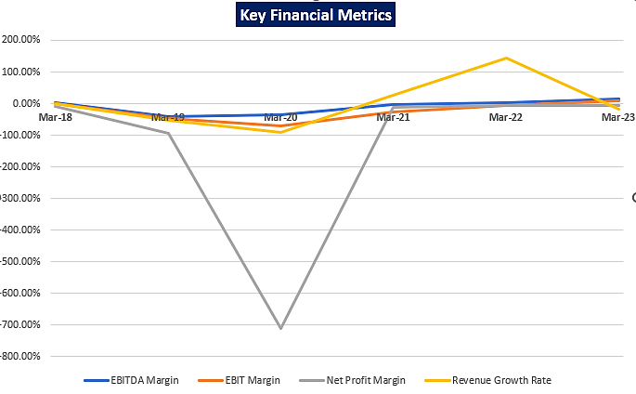
- Balance sheet

Particulars | Audited | Audited | Audited | Audited | Provisional
 | Mar-19 | Mar-20 | Mar-21 | Mar-22 | Mar-23
Non-Current Assets
Fixed Asset
Property, Plant & Equipment | 210.46 | 207.08 | 211.36 | 493.39 | 445.21
Intangible Assets | 0.31 | 0.17 | 0.07 | 0.01 | 0.01
Capital WIP | 31.42 | 25.13 | 2.46 | 6.34 | 16.82
Intangible Assets under development | - | - | - | 0.24 | -
Financial Assets
Long Term Loans & Advances | 8.35 | 12.77 | 14.83 | 15.85 | 14.92
Investments | 3.51 | 3.07 | 3.70 | 3.67 | 3.23
Deferred Tax Assets | - | - | - | 0.23 | 0.23
Total Non-Current Assets | 254.05 | 248.23 | 232.43 | 519.73 | 480.43
Current Assets
Inventories | 487.78 | 547.90 | 704.49 | 896.40 | 1,054.41
Trade Receivables | 742.34 | 911.68 | 1,178.47 | 1,480.94 | 1,403.83
Cash & Cash Equivalents | 131.97 | 124.36 | 123.71 | 141.83 | 171.91
Short Term Loans & Advances | 33.80 | 29.99 | 20.57 | 22.35 | 27.91
Other Current Assets | - | - | - | 0.02 | 0.32
Total Current Assets | 1,395.89 | 1,613.93 | 2,027.23 | 2,541.54 | 2,658.39
Total Assets | 1,649.93 | 1,862.15 | 2,259.67 | 3,061.27 | 3,138.82
Equity
Equity Share Capital | 9.54 | 9.54 | 9.54 | 9.54 | 9.54
Reserves & Surplus | 534.51 | 582.83 | 637.01 | 1,003.19 | 963.07
Total Equity | 544.05 | 592.38 | 646.55 | 1,012.73 | 972.61
Liabilities
Non-Current Liabilities
Long Term Borrowings | 61.23 | 61.85 | 138.91 | 143.10 | 125.57
Deferred Tax Liabilities | 0.31 | 0.85 | 0.84 | - | -
Total Non-Current Liabilities | 61.55 | 62.70 | 139.76 | 143.10 | 125.57
Current Liabilities
Short Term Borrowings | 680.41 | 803.82 | 810.85 | 1,051.66 | 1,247.24
Trade Payables | 268.50 | 301.15 | 607.68 | 786.34 | 763.32
Other Sundry Creditors | 47.27 | 87.15 | 40.04 | 55.38 | -
Other Current Liabilities | 42.92 | 8.16 | 6.60 | 4.98 | 27.18
Short Term Provisions | 5.25 | 6.81 | 8.19 | 7.07 | 2.91
Total Current Liabilities | 1,044.34 | 1,207.08 | 1,473.36 | 1,905.43 | 2,040.64
Total Equity and Liabilities | 1,649.93 | 1,862.15 | 2,259.67 | 3,061.27 | 3,138.82

- PROJECTION OF THE COMPANY: The projections of the company are done From FY 2024 to FY 2033 based on the revenue generation capacity of the project and total expected expenses considering the historical financials/current scenarios are shown as below:
- Projected Profit & Loss Account: Below table shows the Projected Profit & Loss Account of M/s Gupta Power Infrastructure Limited from the period FY 2024 to FY 2033.
(Unless otherwise specified, all financials are in INR Crore)
Particulars | Mar-24 | Mar-25 | Mar-26 | Mar-27 | Mar-28 | Mar-29 | Mar-30 | Mar-31 | Mar-32 | Mar-33
 | Estimated | Projected | Projected | Projected | Projected | Projected | Projected | Projected | Projected | Projected
Installed Capacity (MTPA) | 1,40,000.00 | 1,40,000.00 | 1,40,000.00 | 1,40,000.00 | 1,40,000.00 | 1,40,000.00 | 1,40,000.00 | 1,40,000.00 | 1,40,000.00 | 1,40,000.00
Capacity Utilization | 20.00% | 25.00% | 35.00% | 40.00% | 42.00% | 44.00% | 46.00% | 48.00% | 50.00% | 20.00%
Annual Production (MTPA) | 28,000.00 | 35,000.00 | 49,000.00 | 56,000.00 | 58,800.00 | 61,600.00 | 64,400.00 | 67,200.00 | 70,000.00 | 28,000.00
Revenue from Operations | 400.00 | 266.85 | 1,387.62 | 2,020.38 | 2,401.37 | 2,622.29 | 2,857.05 | 3,106.39 | 3,371.11 | 3,652.04
Other Income | 0.04 | 0.03 | 0.15 | 0.22 | 0.27 | 0.29 | 0.32 | 0.34 | 0.37 | 0.40
Total Income | 400.04 | 266.88 | 1,387.78 | 2,020.60 | 2,401.63 | 2,622.58 | 2,857.37 | 3,106.74 | 3,371.48 | 3,652.44
Net COGS | 344.00 | 229.49 | 1,193.36 | 1,737.53 | 2,065.17 | 2,255.17 | 2,457.06 | 2,671.50 | 2,899.15 | 3,140.75
Employee Cost | 30.00 | 30.00 | 60.00 | 63.00 | 66.15 | 69.46 | 72.93 | 76.58 | 80.41 | 84.43
Finance Costs | - | 17.54 | 56.44 | 35.38 | 30.40 | 25.84 | 21.69 | 17.54 | 12.36 | 6.14
Depreciation & Amortization | 34.80 | 30.76 | 27.31 | 23.74 | 20.67 | 18.02 | 15.73 | 13.75 | 12.03 | 10.53
Other Expenses | 33.33 | 27.23 | 89.59 | 119.88 | 138.70 | 150.26 | 162.52 | 175.53 | 189.32 | 203.93
Total Expenses | 442.13 | 335.02 | 1,426.70 | 1,979.53 | 2,321.10 | 2,518.75 | 2,729.94 | 2,954.89 | 3,193.26 | 3,445.78
Profit Before Tax and Exceptional Items | -42.09 | -68.14 | -38.92 | 41.08 | 80.53 | 103.83 | 127.43 | 151.84 | 178.22 | 206.66
Exceptional Items/Prior Period Item | -7.85 | - | - | - | - | - | - | - | - | -
Write-off of Trade Receivables, Inventories & Trade Payables | 1,419.93 | - | - | - | - | - | - | - | - | -
Diff. in o/s Debt as on 31st March 2024 as per CB's PIM | 1,778.62 | - | - | - | - | - | - | - | - | -
Profit Before Tax | -3,232.79 | -68.14 | -38.92 | 41.08 | 80.53 | 103.83 | 127.43 | 151.84 | 178.22 | 206.66
Taxes | - | - | - | 14.35 | 28.14 | 36.28 | 44.53 | 53.06 | 62.28 | 72.22
Profit After Taxes | -3,232.79 | -68.14 | -38.92 | 26.72 | 52.39 | 67.55 | 82.90 | 98.78 | 115.94 | 134.45
Notes:
- The financials / revenue / expenses for the FY 2024 are estimated on conservative basis in accordance with data/information shared, historical financials, etc.
- For the purpose of projecting the financials, we have assumed that the Chennai plant will remain closed for the foreseeable future as restarting the operations at the plant will require a significant CAPEX. Hence, the installed capacity is reduced to 1,40,000 MTPA.
- The Khurda and Kashipur plants are assumed to be operational for 3 months during the FY2024-25.

- Projected Balance Sheet: Below table shows the Projected Balance Sheet of M/s Gupta Power Infrastructure Limited from the period FY 2024 to FY 2033.
(Value in INR Crores)
Particulars | Mar-24 | Mar-25 | Mar-26 | Mar-27 | Mar-28 | Mar-29 | Mar-30 | Mar-31 | Mar-32 | Mar-33
 | Estimated | Projected | Projected | Projected | Projected | Projected | Projected | Projected | Projected | Projected
ASSETS
Non-Current Assets
Property, Plant & Equipment | 418.26 | 396.50 | 369.19 | 345.44 | 324.77 | 306.75 | 291.02 | 277.27 | 265.24 | 254.71
Intangible Assets | 0.01 | 0.01 | 0.01 | 0.01 | 0.01 | 0.01 | 0.01 | 0.01 | 0.01 | 0.01
Capital WIP | 16.82 | 16.82 | 16.82 | 16.82 | 16.82 | 16.82 | 16.82 | 16.82 | 16.82 | 16.82
Long Term Loans & Advances | 14.92 | 14.92 | 14.92 | 14.92 | 14.92 | 14.92 | 14.92 | 14.92 | 14.92 | 14.92
Investments | 3.23 | 3.23 | 3.23 | 3.23 | 3.23 | 3.23 | 3.23 | 3.23 | 3.23 | 3.23
Deferred Tax Assets | 0.23 | 0.23 | 0.23 | 0.23 | 0.23 | 0.23 | 0.23 | 0.23 | 0.23 | 0.23
Total Non-Current Assets | 453.47 | 431.71 | 404.40 | 380.65 | 359.98 | 341.96 | 326.22 | 312.48 | 300.45 | 289.92
Current Assets
Inventories
Inventories (Old) | - | - | - | - | - | - | - | - | - | -
Inventories (New) | 94.25 | 62.87 | 196.17 | 285.62 | 339.48 | 370.71 | 403.90 | 439.15 | 476.57 | 516.29
Trade Receivables
Trade Receivables (Old) | - | - | - | - | - | - | - | - | - | -
Trade Receivables (Old & considered good) | 275.00 | 137.50 | - | - | - | - | - | - | - | -
Trade Receivables (New) | 142.47 | 95.04 | 342.15 | 498.18 | 592.12 | 646.59 | 704.48 | 765.96 | 831.23 | 900.50
Cash & Cash Equivalents | 3.32 | 562.83 | 322.45 | 137.31 | 48.72 | 27.93 | 16.15 | 13.98 | 1.99 | 2.26
Short Term Loans & Advances | 27.91 | 27.91 | 27.91 | 27.91 | 27.91 | 27.91 | 27.91 | 27.91 | 27.91 | 27.91
Other Current Assets | 0.32 | 0.32 | 0.32 | 0.32 | 0.32 | 0.32 | 0.32 | 0.32 | 0.32 | 0.32
Total Current Assets | 543.27 | 886.49 | 889.01 | 949.35 | 1,008.55 | 1,073.48 | 1,152.76 | 1,247.32 | 1,338.03 | 1,447.28
Total Assets | 996.74 | 1,318.20 | 1,293.40 | 1,330.00 | 1,368.53 | 1,415.43 | 1,478.99 | 1,559.80 | 1,638.49 | 1,737.21
EQUITY
Equity Share Capital | 9.54 | 9.54 | 9.54 | 9.54 | 9.54 | 9.54 | 9.54 | 9.54 | 9.54 | 9.54
Reserves & Surplus | -2,269.72 | -2,337.86 | -2,376.78 | -2,350.06 | -2,297.66 | -2,230.12 | -2,147.22 | -2,048.43 | -1,932.49 | -1,798.04
Total Equity | -2,260.18 | -2,328.31 | -2,367.24 | -2,340.51 | -2,288.12 | -2,220.57 | -2,137.67 | -2,038.89 | -1,922.95 | -1,788.50
LIABILITIES
Non-Current Liabilities
Long Term Borrowings | 3,151.44 | 3,499.78 | 3,450.02 | 3,400.25 | 3,358.78 | 3,317.31 | 3,275.84 | 3,213.64 | 3,151.44 | 3,151.44
Deferred Tax Liabilities
Total Non-Current Liabilities | 3,151.44 | 3,499.78 | 3,450.02 | 3,400.25 | 3,358.78 | 3,317.31 | 3,275.84 | 3,213.64 | 3,151.44 | 3,151.44
Current Liabilities
Short Term Borrowings | - | 66.35 | 49.76 | 49.76 | 41.47 | 41.47 | 41.47 | 62.20 | 62.20 | -
Trade Payables
Trade Payables (Old) | - | - | - | - | - | - | - | - | - | -
Trade Payables (New) | 75.40 | 50.30 | 130.78 | 190.41 | 226.32 | 247.14 | 269.27 | 292.77 | 317.72 | 344.19
Other Sundry Creditors | - | - | - | - | - | - | - | - | - | -
Other Current Liabilities | 27.18 | 27.18 | 27.18 | 27.18 | 27.18 | 27.18 | 27.18 | 27.18 | 27.18 | 27.18
Short Term Provisions | 2.91 | 2.91 | 2.91 | 2.91 | 2.91 | 2.91 | 2.91 | 2.91 | 2.91 | 2.91
Total Current Liabilities | 105.48 | 146.73 | 210.62 | 270.26 | 297.87 | 318.69 | 340.82 | 385.05 | 410.00 | 374.27
Total Equity and Liabilities | 996.74 | 1,318.20 | 1,293.41 | 1,330.00 | 1,368.54 | 1,415.44 | 1,478.99 | 1,559.80 | 1,638.49 | 1,737.21

- Projected Cash Flow Statement: Below table shows the Projected Cash Flow statement of M/s Gupta Power Infrastructure Limited from the period FY 2024 to FY 2033.
(Value in INR Crores)
Particulars | Mar-24 | Mar-25 | Mar-26 | Mar-27 | Mar-28 | Mar-29 | Mar-30 | Mar-31 | Mar-32 | Mar-33
Cash Flow from Operating Activities
Net Income | -3,232.79 | -68.14 | -38.92 | 26.72 | 52.39 | 67.55 | 82.90 | 98.78 | 115.94 | 134.45
Depreciation | 34.80 | 30.76 | 27.31 | 23.74 | 20.67 | 18.02 | 15.73 | 13.75 | 12.03 | 10.53
Extra-Ordinary Item | -7.85 | - | - | - | - | - | - | - | - | -
Extra-Ordinary Item - WC | 1,419.93 | - | - | - | - | - | - | - | - | -
Extra-Ordinary Item - Debt | 1,778.62 | - | - | - | - | - | - | - | - | -
Interest and finance charges | - | 17.54 | 56.44 | 35.38 | 30.40 | 25.84 | 21.69 | 17.54 | 12.36 | 6.14
Cash flow before WC changes | -7.29 | -19.84 | 44.84 | 85.84 | 103.46 | 111.41 | 120.32 | 130.07 | 140.33 | 151.11
Working Capital changes | 161.32 | -191.20 | 162.43 | 185.84 | 111.90 | 64.89 | 68.95 | 73.23 | 77.75 | 82.51
Cash Flow from Operating Activities (A) | -168.60 | 171.36 | -117.59 | -100.00 | -8.43 | 46.52 | 51.37 | 56.84 | 62.58 | 68.61
Cash Flow from Financing Activities
Increase/Decrease:
Long Term Borrowings | 1,247.24 | 348.35 | -49.76 | -49.76 | -41.47 | -41.47 | -41.47 | -62.20 | -62.20 | -
Deferred Tax Liabilities | - | - | - | - | - | - | - | - | - | -
Short Term Borrowings | -1,247.24 | 66.35 | -16.59 | - | -8.29 | - | - | 20.73 | - | -62.20
Other Current Liabilities | - | - | - | - | - | - | - | - | - | -
Short Term Provisions | - | - | - | - | - | - | - | - | - | -
Interest and finance charges | - | -17.54 | -56.44 | -35.38 | -30.40 | -25.84 | -21.69 | -17.54 | -12.36 | -6.14
Cash Flow from Financing Activities (B) | 0.00 | 397.15 | -122.79 | -85.14 | -80.16 | -67.31 | -63.16 | -59.01 | -74.56 | -68.34
Cash Flow from Investing Activities
Increase/ Decrease:
Property, Plant & Equipment | - | -9.00 | - | - | - | - | - | - | - | -
Intangible Assets | - | - | - | - | - | - | - | - | - | -
Capital WIP | - | - | - | - | - | - | - | - | - | -
Long Term Loans & Advances | - | - | - | - | - | - | - | - | - | -
Investments | 0.01 | - | - | - | - | - | - | - | - | -
Short Term Loans & Advances | - | - | - | - | - | - | - | - | - | -
Other Current Assets | - | - | - | - | - | - | - | - | - | -
Cash Flow from Investing Activities (C) | 0.01 | -9.00 | - | - | - | - | - | - | - | -
Total Cash Surplus/Deficit | -168.59 | 559.51 | -240.38 | -185.14 | -88.60 | -20.78 | -11.79 | -2.17 | -11.98 | 0.26
Opening Cash or Bank Balance | 171.91 | 3.32 | 562.83 | 322.45 | 137.31 | 48.72 | 27.93 | 16.15 | 13.98 | 1.99
Closing Cash or Bank Balance | 3.32 | 562.83 | 322.45 | 137.31 | 48.72 | 27.93 | 16.15 | 13.98 | 1.99 | 2.26

- ENTERPRISE VALUATION:
- METHODOLOGY/ MODEL ADOPTED: Out of the various models & theories available, we have adopted the most widely used & acceptable approach to calculate the Enterprise Value of the Company, which is, Income based approach (Discounted Cash Flow Model).
- FCFF is more practical when substantial capital changes are expected because weighted average cost of capital (WACC) is less sensitive to the cost of equity.
- In this method, we calculate the free cash flow to firm (FCFF) for the projected period.
- Finally, we calculate the present value of future cash flows by using a required rate of return based on the riskiness of the project, which we determine by using the Weighted Average Cost of Capital (WACC).
- The terminal value is calculated by applying a discount rate to the fair market value of assets at the end of the projected years. Then, the terminal value is discounted back to the present by using the appropriate discount rate.
FCFF Model Formula and Key Inputs:
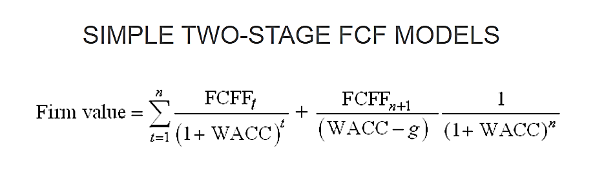
Free Cash Flow to Firm (FCFF): FCFF is the cash available to pay investors after a company pays its costs of doing business, invests in short-term assets like inventory, and invests in assets like property, plants and equipment.
FCFF = Net Income + Non-Cash Charges + Interest (1 - tax rate) – Working Capital Investment – Fixed Capital Investment.

- CALCULATION OF FREE CASH FLOW TO FIRM:
(Value in INR Crores)
Particulars | Mar-25 | Mar-26 | Mar-27 | Mar-28 | Mar-29 | Mar-30 | Mar-31 | Mar-32 | Mar-33
EBITDA | -19.84 | 44.84 | 100.20 | 131.60 | 147.69 | 164.85 | 183.13 | 202.60 | 223.33
Depreciation | 30.76 | 27.31 | 23.74 | 20.67 | 18.02 | 15.73 | 13.75 | 12.03 | 10.53
EBIT | -50.60 | 17.52 | 76.45 | 110.93 | 129.67 | 149.12 | 169.39 | 190.58 | 212.80
Less: Taxes | - | - | 14.35 | 28.14 | 36.28 | 44.53 | 53.06 | 62.28 | 72.22
NOPAT | -50.60 | 17.52 | 62.10 | 82.79 | 93.39 | 104.59 | 116.33 | 128.30 | 140.59
ADD: Depreciation | 30.76 | 27.31 | 23.74 | 20.67 | 18.02 | 15.73 | 13.75 | 12.03 | 10.53
Less: Change in WC | -191.20 | 162.43 | 185.84 | 111.90 | 64.89 | 68.95 | 73.23 | 77.75 | 82.51
Less: Capex | 9.00 | - | - | - | - | - | - | - | -
Unlevered Free Cash Flow (UFCF)/ FCFF | 162.36 | -117.59 | -100.00 | -8.43 | 46.52 | 51.37 | 56.84 | 62.58 | 68.61
Discount Rate (WACC) | 13.0%
Valuation Date | 30th September 2024
Period | 0.50 | 1.50 | 2.50 | 3.50 | 4.50 | 5.50 | 6.50 | 7.50 | 8.50
Discount Factor | 0.94 | 0.83 | 0.74 | 0.65 | 0.58 | 0.51 | 0.45 | 0.40 | 0.35
Terminal Value | - | - | - | - | - | - | - | - | 672.07
PV of FCFF | 152.76 | -97.91 | -73.68 | -5.50 | 26.84 | 26.23 | 25.68 | 25.01 | 24.26
PV of Terminal Value | - | - | - | - | - | - | - | - | 237.70
PV of FCFF + PV of TV | 152.76 | -97.91 | -73.68 | -5.50 | 26.84 | 26.23 | 25.68 | 25.01 | 261.97

- CALCULATION OF ENTERPRISE VALUE:
Particulars | Amount (In INR Crore)
Present Value of Free Cash Flow to Firm | 103.69
Present Value of Terminal Value | 237.70
Enterprise Value | 341.39

ENTERPRISE VALUE OF THE FIRM
INR THREE HUNDRED FORTY-ONE CRORES AND THIRTY-NINE LAKHS (INR 341.39 CRORES)
NOTES:
- The Company account has been converted to Non-Performing Asset (NPA) in the month of August and September 2023.
- The overall valuation is estimated based on the financial statements up to FY 2022-23 and further it has been projected based on the previous data as reference from 2024-25 onwards. The financials / revenue / expenses for the FY 2024 are estimated on conservative basis in accordance with data/information shared, historical financials, etc.
- No claim amount or tenable claim amount has been considered in the financial projections as the cases are currently ongoing.
- For the projected years, revenue solely encompasses revenue earned from the sale of finished goods produced at Khurda and Kashipur Plant only.

- SENSITIVITY ANALYSIS:
The proposed project is found comparatively more sensitive with respect to the revenue, than the cost of goods sold and any surge in the interest rate. Sensitivity analysis of the project with respect to 1% & 2% decrease in the revenue, 1% & 2% increase in the cost of construction and 1% increment in the proposed interest rate has been shown in the below table:

Sensitivity Analysis of D.S.C.R.
S. No. | Particular | Average D.S.C.R. | Enterprise Value
 | As a Base Case | 1.36 | INR 341.39 Crore
 | If the projected revenue decreased by 1% | 1.14 | INR 266.13 Crore
 | If the projected revenue decreased by 2% | 0.91 | INR 190.88 Crore
 | If the projected Cost of Goods Sold increased by 1% | 1.16 | INR 272.15 Crore
 | If the projected Cost of Goods Sold increased by 2% | 0.96 | INR 202.99 Crore
 | If interest rate is increased by 1% | 1.33 | INR 344.04 Crore

- ESTIMATED KEY FINANCIAL METRICES:
Particulars | Mar-25 | Mar-26 | Mar-27 | Mar-28 | Mar-29 | Mar-30 | Mar-31 | Mar-32 | Mar-33
Current Ratio | 6.04 | 4.22 | 3.51 | 3.39 | 3.37 | 3.38 | 3.24 | 3.26 | 3.87
Inventory Turnover Ratio | 3.65 | 10.37 | 7.97 | 7.26 | 6.97 | 6.95 | 6.94 | 6.92 | 6.91
Receivables Turnover Ratio | 0.82 | 4.83 | 4.81 | 4.40 | 4.23 | 4.23 | 4.23 | 4.22 | 4.22
Payables Turnover Ratio | 4.56 | 14.83 | 11.96 | 10.89 | 10.45 | 10.43 | 10.40 | 10.38 | 10.36
Total Assets Turnover Ratio | 0.23 | 1.06 | 1.54 | 1.78 | 1.88 | 1.97 | 2.04 | 2.11 | 2.16
ROCE | -4.32% | 1.62% | 7.21% | 10.36% | 11.82% | 13.10% | 14.42% | 15.51% | 15.61%
Interest Coverage Ratio | -1.13 | 0.79 | 2.83 | 4.33 | 5.72 | 7.60 | 10.44 | 16.39 | 36.38
EBITDA Margin | -7.43% | 3.23% | 4.96% | 5.48% | 5.63% | 5.77% | 5.90% | 6.01% | 6.12%
EBIT Margin | -18.96% | 1.26% | 3.78% | 4.62% | 4.94% | 5.22% | 5.45% | 5.65% | 5.83%
Net Profit Margin | -25.53% | -2.80% | 1.32% | 2.18% | 2.58% | 2.90% | 3.18% | 3.44% | 3.68%

- DEBT SERVICE COVERAGE RATIO
Particulars | Mar-25 | Mar-26 | Mar-27 | Mar-28 | Mar-29 | Mar-30 | Mar-31 | Mar-32 | Mar-33 | TOTAL
PAT | -68.14 | -38.92 | 26.72 | 52.39 | 67.55 | 82.90 | 98.78 | 115.94 | 134.45 | 471.67
Depreciation | 30.76 | 27.31 | 23.74 | 20.67 | 18.02 | 15.73 | 13.75 | 12.03 | 10.53 | 172.54
Interest | 17.54 | 56.44 | 35.38 | 30.40 | 25.84 | 21.69 | 17.54 | 12.36 | 6.14 | 223.33
Total Cash Flow Available for Debt Service (A) | -19.84 | 44.84 | 85.84 | 103.46 | 111.41 | 120.32 | 130.07 | 140.33 | 151.11 | 867.55
Interest | 17.54 | 56.44 | 35.38 | 30.40 | 25.84 | 21.69 | 17.54 | 12.36 | 6.14 | 223.33
Debt Repayment | - | 66.35 | 49.76 | 49.76 | 41.47 | 41.47 | 41.47 | 62.20 | 62.20 | 414.70
Total Outflow (B) | 17.54 | 122.79 | 85.14 | 80.16 | 67.31 | 63.16 | 59.01 | 74.56 | 68.34 | 638.03
D.S.C.R. (A/B) | -1.13 | 0.37 | 1.01 | 1.29 | 1.66 | 1.91 | 2.20 | 1.88 | 2.21 | 1.36
Average D.S.C.R. | 1.36

- WORKING CAPITAL FUNDING REQUIREMENT:
(In INR Crores)
Particulars | Mar-26 | Mar-27 | Mar-28 | Mar-29 | Mar-30 | Mar-31 | Mar-32 | Mar-33
Total Current Assets (Excl. Cash) | 566.56 | 812.03 | 959.83 | 1,045.54 | 1,136.61 | 1,233.35 | 1,336.04 | 1,445.03
Total Current Liabilities (Excl. ST Borrowings) | 160.86 | 220.50 | 256.40 | 277.22 | 299.35 | 322.85 | 347.80 | 374.27
Working Capital Gap | 405.70 | 591.54 | 703.43 | 768.32 | 837.26 | 910.50 | 988.24 | 1,070.75
WCTL Loan to be raised (%) | 100%
WCTL | 405.70
NOTE: WC Requirement is calculated during the first full operational year (i.e., FY2025-26). Working Capital loan to be taken is calculated as 100% of Working Capital Funding Gap. As per the discussion with the client/company officials, the rate of interest is taken as 14% for the first two years of the forecast period i.e., FY 2025 & FY 2026 for both WCTL and Capex Loan. Thereafter it has been taken as 10% till the end of forecast period.

- DEBT REPAYMENT SCHEDULE:
Particulars | Mar-25 | Mar-26 | Mar-27 | Mar-28 | Mar-29 | Mar-30 | Mar-31 | Mar-32 | Mar-33
Sustainable Debt (In INR Crores)
Opening Balance | - | 414.70 | 348.35 | 298.58 | 248.82 | 207.35 | 165.88 | 124.41 | 62.20
Additions | 414.70 | - | - | - | - | - | - | - | -
Principal Repayment | - | 66.35 | 49.76 | 49.76 | 41.47 | 41.47 | 41.47 | 62.20 | 62.20
Closing Balance | 414.70 | 348.35 | 298.58 | 248.82 | 207.35 | 165.88 | 124.41 | 62.20 | -
Interest Repayment | 14.51 | 53.41 | 32.35 | 27.37 | 22.81 | 18.66 | 14.51 | 9.33 | 3.11
Unsustainable Debt (In INR Crores)
Opening Balance | 3,029.06 | 3,029.06 | 3,029.06 | 3,029.06 | 3,029.06 | 3,029.06 | 3,029.06 | 3,029.06 | 3,029.06
Additions | - | - | - | - | - | - | - | - | -
Principal Repayment | - | - | - | - | - | - | - | - | -
Closing Balance | 3,029.06 | 3,029.06 | 3,029.06 | 3,029.06 | 3,029.06 | 3,029.06 | 3,029.06 | 3,029.06 | 3,029.06
Interest Repayment | 3.03 | 3.03 | 3.03 | 3.03 | 3.03 | 3.03 | 3.03 | 3.03 | 3.03

- KEY ASSUMPTIONS & BASIS:
S. No. | Item | Assumptions and Basis
1. | General | - The projections of the firm are done for the period from FY 2024-25 to FY 2032-33, to cover the term loan period as per the industry best practices.  - Revenue and expense modelling has been done based on the capacity utilization during the respective year.  - As per the discussion with client and data available with us, the financials for the FY 2024 have been estimated on conservative basis for maintaining the continuity of the financials of M/s GPIL.
2. | Capacity Utilization | - For the purpose of estimating revenue during the forecasted years, we have assumed that only Kashipur Unit and Khurda Unit (with some Capex) will be operational during the projection years and the Chennai Unit will remain closed. Thus, the total installed capacity for this purpose is considered as 140000 MTPA.  Year Installed Capacity (MTPA) Capacity Utilization % Annual Production (MTPA)  Mar-25 140000 20% 28000  Mar-26 140000 25% 35000  Mar-27 140000 35% 49000  Mar-28 140000 40% 56000  Mar-29 140000 42% 58800  Mar-30 140000 44% 61600  Mar-31 140000 46% 64400  Mar-32 140000 48% 67200  Mar-33 140000 50% 70000  - For the FY 2025, both the plants are assumed to be operational for the period of three months only.
3. | Revenue | - For FY 2025, the average price per MT is taken as INR 3,81,215.31 which is the average of last 4 audited historical years (FY19 to FY22) with an annual escalation of 4% from FY 2026 onwards.  - Other Income is kept at 0.01% of operational revenue throughout the forecast period which is line with the average of last 4 audited historical years (FY 2019 to FY 2022).
4. | Expenses | - Cost of Materials consumed, being variable in nature is taken as % of revenue. Assumption for Cost of Materials consumed is taken at 86% of the operational revenue, which is line with the average of last 4 audited historical years (FY 2019 to FY 2022).  - Employee Expenses is taken as INR 30 Cr each for FY 2024 and FY 2025 and INR 60 Cr for FY 2026 (close to latest available historical data i.e., FY 2023) with an annual escalation of 5% from FY 2027 onwards.  - Manufacturing Expenses is kept at 3.48% of operational revenue throughout the forecast period which is line with the average of last 4 audited historical years (FY 2019 to FY 2022).  - Administrative Expenses is taken as INR 15 Cr each for FY 2024 and FY 2025 and INR 26 Cr for FY 2026 (close to latest available historical data i.e., FY 2023) with an annual escalation of 5% from FY 2027 onwards.  - Selling & Distribution Expenses is assumed at 1.10% of operational revenue throughout the forecast period which is line with the average of last 4 audited historical years (FY 2019 to FY 2022).  - In the absence of detailed Fixed Asset schedule for the provisional financial statements for the FY 2023, the depreciation schedule has been based on the historical trend which has resulted into a difference of amount of INR 7.84 cr. and the same is charged to P&L Statement as an exceptional item in FY 2024.
5. | Capital Expenditure (CAPEX) | - As per the data/information shared by client and collected by us during the site visit to Kashipur and Khurda Plant, It was observed that the Kashipur plant will not require any major Capex as the plant was operational at the time of survey.  - However, the Khurda Plant will require some Capital Expenditure towards repair & maintenance of the plant as it has been non-operational for more than 6 months. For estimation of required Capex, we have assumed 15% of the FMV of the major plant and machinery of the Khurda Plant which calculates as ~ INR 9.0 cr. to operate the plant efficiently.
5. | Loan | - Entire Existing debt of INR 3,029.06 cr. as per the PIM of GPIL received from the client is considered as Unsustainable Debt and the interest rate is assumed at 0.10%.  - The total debt of GPIL as per the provisional financial statements for FY23 is INR 1,250.44 Cr. However, as per the data received the total debt outstanding as on 31.03.2024 is INR 3,029.06 cr. which has resulted into a difference of amount of INR 1,778.62 cr. and the same is charged to P&L Statement as an exceptional item in FY 2024.  - We have assumed that the 100% of the Working Capital Gap for the FY 2026 which is first full operational year post restructuring will be financed through a Working Capital Term Loan (WCTL).  - We have assumed that the estimated required Capex of INR 9 cr. will be financed through a term loan of INR 9 cr.  - The interest rate for both the WCTL and Capex Loan has been considered as 14% for FY 2025 and FY 2026 and thereafter as per discussion with client, the debt shall be refinanced at revised ROI of 10%.  - It has been assumed that both the loans will be availed by 01.01.2025 and the loan repayment period will be from FY 2025 to FY 2033.
6. | Working Capital | - As per the discussion with the client, Inventories of INR 1,054.41 Cr. and Trade Payables of INR 763.32 Cr. as per the provisional financials of FY 2023 is considered to be written off and shown as an exceptional item in the P&L Statement of FY 2024.  - As per the discussion with the client, the following table exhibits calculation with respect to write-off of Trade Receivables as per the provisional financials of FY 2023:  Particulars Amount (INR Cr.)  Opening Debtors as on Mar 2023 (P) 1,403.83  Less: Debtors considered as misleading/overstated as per Forensic Audit Report:  India Power Corporation Ltd 115.15  Tirupati Conductors Pvt Ltd 223.00  Kunj Alloys Pvt Ltd 245.79  Gupta Power Technologies Pvt Ltd 152.70  Less: Debtors more than 6 months old 94.52  Sub-total 831.16  Net 572.67  Probability of Realisation 48%  Net Realisable Debtors 275.00  - As per the historical trends of the company and the discussion held with the client, the following assumptions are made related to working capital:  Particulars FY 2024 & 2025 FY 2026 Onwards  Days Sales Outstanding 130.0 Days 90.0 Days  Days Inventory Outstanding 100.0 Days 60.0 Days  Days Payables Outstanding 80.0 Days 40.0 Days  For FY 2024 & 2025, the working capital days are kept in line with the latest available historical data i.e., FY 2023 but from FY 2026 onwards, we have assumed that the working capital days for GPIL will reduce to the pre-covid requirements of the company as per the data/information shared with us.
7. | Discount Rate | As communicated by client/BOBCaps, the discount rate for such assets as per NARCL policy is 13% which is used for the purpose of valuation of M/s Gupta Power Infrastructure Limited.
8. | Terminal Value | - We have projected the cash flow till FY 2033 and afterwards Salvage Value of Fixed Assets and Net Current Assets has been assumed to be realised and the present value of this Terminal Value has been considered for valuation.  - Salvage Discount of 50% is considered for the calculation of the Terminal Value.  Particulars FY 33 Salvage % Terminal Value  Property, Plant & Equipment 254.71 50% 127.36  Intangible Assets 0.01 50% 0.01  Capital WIP 16.82 50% 8.41  Inventories 516.29 50% 258.14  Trade Receivables 900.50 50% 450.25  Trade Payables -344.19 50% -172.10  Total (Rs. Crore) 1,344.14 672.07  Terminal Value (TV) is calculated by using the following formulae:  TV = [Book Value of Fixed Asset as on FY 2033 + Inventory (2033) + Trade Receivable (2033) – Trade Payables (2033)] * (1 – Salvage Discount)
Conclusion:
      - The company has achieved DSCR of more than 1 during the loan repayment period (Only Sustainable Debt).
      - Average DSCR, EBIDTA margin, EBIT margin is 1.36, 3.96%, and 1.98% respectively during the estimated period.
Based on the above key financial ratios of the Project during the forecast period shows that the project looks financially viable if the Project Company & promoters are able to maintain assumed capacity utilization, revenue and can contain cost as assumed above.

PART K | CONCLUSION

Based on the technological, economical and market analysis done above, various assumptions of sectoral trends taken, product pricing to be adopted by the company, the Project appears to be Techno-commercially viable subject to the risks, threats, weaknesses, limitations of the product as detailed previously.
As per financial projections for the estimated period, Average DSCR, EBITDA Margin and EBIT Margin of the project are 1.36, 6.24%, and 5.50% respectively, where DSCR greater than 1 show that the project will be able to pay out its assumed sustainable debt and EBITDA margin shows the capability of the project to generate the operating profits over the forecasted period, which is slightly lower in comparison with sectoral trends primarily due to the asset being stressed. Additionally, the projected revenue has been estimated conservatively, which contributes to this reduced margin.
The Wire & Cable Manufacturing Facility is having a positive NPV (Enterprise Valuation) of INR 341.39 Crore. While future projections may change in the upcoming years due to various socio-economic factors impacting the operation, managerial, financial efficiency and economies of scale of the project.
While it is not avoidable that the future projections may change in the upcoming years due to various factors impacting the operation, managerial, financial efficiency and economies of scale of the project. It would be depending on the management’s capability in future that how efficiently company adopts marketing and advertisement strategy, supply chain and carry out inventory & resource management to achieve higher profitability. After considering the foreseen demand of the wire and cables industry both domestically and globally, various initiatives taken by government, financial analysis of the project based on the assumptions taken over the projected period, it appears reasonable to comment that the project is “Technically and Economically” Viable subject to current assumptions considered and occurring the same in the upcoming years same as the forecasted period which is dependent on the sincerity and efforts of the management and various micro and macroeconomic & industry situation.
We have tried our level best to analyse the Project techno-economic feasibility of the Project based on the industry research, Project information and various futuristic assumption taken. However, achieving the financial milestones depends on the ability, sincerity and efforts of the company, promoters and its key managerial performance.

Declaration | - The undersigned does not have any direct/indirect interest in the above property.  - The information furnished herein is true and correct to the best of our knowledge, logical and scientific assumptions.  - This TEV Report is carried out by our Financial Analyst team on the request from BOB Capital Markets Ltd, Parinee Crescenzo, 1704, B Wing, 17th Floor, Bandra Kurla Complex, G Block, Bandra East, Mumbai-.0400051.  - Meeting of Financial projections will be subject to subject to the market & economy stability factors, judicious business operations and proper & timely implementation of its process & product re-engineering & improvement plans for achieving high productivity, efficiency and achieving cost saving benefits.  - We have submitted TEV report to the Client.
Number of Pages in the Repost | 99
Enclosed Documents | Disclaimer & Remarks 96-99
Place | Noida
Date | XXXXXXX

FOR ON BEHALF OF
M/S. R.K. ASSOCIATES VALUER & TECHNO ENGINEERING CONSULTANTS PVT. LTD.
SURVEYED BY | PREPARED BY | REVIEWED BY
Mr. Yash Bhatnagar  Mr. Anirban Roy  Mr. Abhinav Chaturvedi  Mr. Atul Gola  Mr. Kishanu Sagar | Mr. Rachit Gupta | Mr. Gaurav Kumar

PART L | DISCLAIMER | REMARKS

      - No employee or member of R.K Associates has any direct/ indirect interest in the Project.
      - This report is prepared based on the copies of the documents/ information which the Bank/ Company has provided to us out of the standard checklist of documents sought from them and further based on our assumptions and limiting conditions. The client/owner and its management/representatives warranted to us that the information they supplied was complete, accurate and true and correct to the best of their knowledge. All such information provided to us has been relied upon in good faith and we have assumed that it is true and correct in all respect. I/We shall not be liable for any loss, damages, cost or expenses arising from fraudulent acts, misrepresentations, or wilful default on part of the owner, company, its directors, employee, representative or agents. Verification or cross checking of the documents provided to us from the originals or from any Govt. departments/ Record of Registrar has not been done at our end since this is beyond the scope of our work. If at any time in future, it is found or came to our knowledge that misrepresentation of facts or incomplete or distorted information has been provided to us then this report shall automatically become null & void.
      - Legal aspects for e.g., investigation of title, ownership rights, lien, charge, mortgage, lease, sanctioned maps, verification of documents, etc. have not been done at our end and same has to be taken care by legal expert/ Advocate. It is assumed that the concerned Lender/ Financial Institution has satisfied them with the authenticity of the documents, information given to us and for which the legal verification has been already taken and cleared by the competent Advocate before requesting for this report. I/ We assume no responsibility for the legal matters including, but not limited to, legal or title concerns.
      - This report is a general analysis of the project based on the scope mentioned in the report. This is not an Audit report, Design document, DPR or Techno feasibility study. All the information gathered is based on the facts seen on the site during survey, verbal discussion & documentary evidence provided by the client and is believed that information given by the company is true best of their knowledge.
      - This Techno Economic-Viability study is prepared based on certain futuristic assumption which are intra dependent on economic, market and sectorial growth condition in future and socio-economic, socio-political condition at macro and micro level.
      - Meeting of assumption and financial ratio will entirely depend on the sincerity and efforts of the company, promoters and its key managerial performance.
      - All observations mentioned in the report is only based on the visual observation and the documents/ data/ information provided by the client. No mechanical/ technical tests, measurements or any design review have been performed or carried out from our side during Project assessment.
      - This report has been diligently prepared by our techno-financial team to the best of their ability. However, it's important to note that the recommendations provided in this Total Economic Viability (TEV) assessment do not imply an endorsement, validation, or certification of the accuracy or completeness of the disclosed information by the involved stakeholders. Furthermore, we do not claim or endorse that the opinions presented herein are the sole best course of action for decision-makers to follow. There may exist additional approaches and inputs that have not been covered within this report or fall outside the scope of this report.
      - Bank/FII should ONLY take this report as an Advisory document from the Financial/ Chartered Engineering firm and its specifically advised to the creditor to cross verifies the original documents for the facts mentioned in the report which can be availed from the borrowing company directly.
      - In case of any default in loans or the credit facility extended to the borrowing company, R.K Associates shall not be held responsible for whatsoever reason may be and any request for seeking any explanation from the employee/s of R.K Associates will not be entertained at any instance or situation.
      - The documents, information, data provided to us during the course of this assessment by the client are reviewed only up to the extent required in relation to the scope of the work. No document has been reviewed beyond the scope of the work.
      - This report only contains general assessment & opinion as per the scope of work evaluated as per the information given in the copy of documents, information, data provided to us and/ and confirmed by the owner/ owner representative to us at site which has been relied upon in good faith. It doesn’t contain any other recommendations of any sort including but not limited to express of any opinion on the suitability or otherwise of entering into any transaction with the borrower.
      - We have relied on data from third party, external sources & information available on public domain also to conclude this report. These sources are believed to be reliable and therefore, we assume no liability for the truth or accuracy of any data, opinions or estimates furnished by others that have been used in this analysis. Where we have relied on data, opinions or estimates from external sources, reasonable care has been taken to ensure that such data has been correctly extracted from those sources and /or reproduced in its proper form and context, however still we can’t vouch its authenticity, correctness or accuracy.
      - This Report is prepared by our competent technical team which includes Engineers and financial experts & analysts.
      - This is just an opinion report and doesn’t hold any binding on anyone. It is requested from the concerned Financial Institution which is using this report for taking financial decision on the project that they should consider all the different associated relevant & related factors also before taking any business decision based on the content of this report.
      - All Pages of the report including annexure are signed and stamped from our office. In case any paper in the report is without stamp & signature then this should not be considered a valid paper issued from this office.
      - Though adequate care has been taken while preparing this report as per its scope, but still, we can’t rule out typing, human errors, over sightedness of any information or any other mistakes. Therefore, the concerned organization is advised to satisfy themselves that the report is complete & satisfactory in all respect. Intimation regarding any discrepancy shall be brought into our notice immediately. If no intimation is received within 15 (Fifteen) days in writing from the date of issuance of the report, to rectify these timely, then it shall be considered that the report is complete in all respect and has been accepted by the client up to their satisfaction & use and further to which R.K Associates shall not be held responsible in any manner.
      - Defect Liability Period is 15 DAYS. We request the concerned authorized reader of this report to check the contents, data and calculations in the report within this period and intimate us in writing if any corrections are required or in case of any other concern with the contents or opinion mentioned in the report. Corrections only related to typographical, calculation, spelling mistakes, incorrect data/ figures/ statement will be entertained within the defect liability period. Any new changes for any additional information in already approved report will be regarded as additional work for which additional fees may be charged. No request for any illegitimate change in regard to any facts & figures will be entertained.
      - R.K Associates encourages its customers to give feedback or inform concerns over its services through proper channel at valuers@rkassociates.org in writing within 15 days of report delivery. After this period no concern/ complaint/ proceedings in connection with the Techno- Economic Viability Study Services will be entertained due to possible change in situation and condition of the subject Project.
      - Our Data retention policy is of ONE YEAR. After this period, we remove all the concerned records related to the assignment from our repository. No clarification or query can be answered after this period due to unavailability of the data.
      - This Techno Economic Viability Study report is governed by our (1) Internal Policies, Processes & Standard Operating Procedures, (2) Information/ Data/ Inputs given to us by the client and (3) Information/ Data/ Facts given to us by our field/ office technical team. Management of R.K Associates never gives acceptance to any unethical or unprofessional practice which may affect fair, correct & impartial assessment and which is against any prevailing law. In case of any indication of any negligence, default, incorrect, misleading, misrepresentation or distortion of facts in the report then it is the responsibility of the user of this report to immediately or at least within the defect liability period bring all such act into notice of R.K Associates management so that corrective measures can be taken instantly.
      - R.K Associates never releases any report doing alterations or modifications from pen. In case any information/ figure of this report is found altered with pen then this report will automatically become null & void.
      - If this report is prepared for the matter under litigation in any Indian court, no official or employee of R.K Associates will be under any obligation to give in person appearance in the court as a testimony. For any explanation or clarification, only written reply can be submitted on payment of charges by the plaintiff or respondent which will be 10% of the original fees charged where minimum charges will be Rs. 15,000/.

