REPORT FORMAT: CL-1 | Version: 1.0_2018

FILE No.: VIS (2024-25)-PL464-414-574 Date: 17-10-2024

- CERTIFICATE NAME: Progress and Cost verification Report for the machinery and equipment.
- FOR ORGANIZATION: Punjab National Bank, Corporate Banking Branch, Panipat.
- BORROWER COMPANY’S NAME: M/s. MDJ International Private Limited.
- ASSET TYPE: Machinery required for Greige fabric/ Grey Fabric for Bedsheets manufacturing.
- CURRENT LOCATION OF THE MACHINES: Khewat No. 954,1005,1006,1007,1008, Tehsil- Balla, Village- Munak, Karnal, Haryana - 132040
TO WHOMSOEVER IT MAY CONCERN

S. NO. | PARTICULARS | DESCRIPTION
1. | Date of Survey | 16-10-2024
2. | Date of Certificate | 17-10-2024
3. | Date of Commercial Operation | 20-08-2024 (48 machines started initially)
4. | Documents provided for perusal | List of machines, Invoices/Performa Invoices
5. | Current Location of the Machines | Khewat No. 954,1005,1006,1007,1008,Tehsil- Balla, Village- Munak, Karnal, Haryana - 132040
6. | Borrowing Company | M/s. MDJ International Private Limited
7. | Type of Asset | Machinery required for Greige fabric/ Grey Fabric for Bedsheets manufacturing.
8. | Type of Assessment | Progress of machines purchased, installed
9. | Scope of Assessment | Progress of machines purchased, installed
10. | Nature of Machinery | Machinery & equipment required for Greige fabric/ Grey Fabric for Bedsheets manufacturing
11. | Current Progress of the machines | As per physical inspection made during site visit, company has purchased all the machines as per the list provided except 48 nos. of waterjet looms which is in transit as per information provided by the client.
12. | Condition of Machines | Purchased machines and equipment are new and operational.

Status of Machinery & Equipment:-

S. No. | Description | Supplier | Invoice No. & Date | Qty. (in nos.) | Total Value (incl. of all Freight and Taxes) | Remarks
1 | Semi-Automatic Sectional Warping | Wuxi Zhongyin Textiles Tech Co. Ltd. | ZY2414B Dated : 05.06.2024 | 4 | 50,95,493 | Machines Purchased and Operational
2 | Shuttleless Waterjet Looms | Qingdao Haixi Yuefeng Machinery Co. Ltd. | CI20240528 Dated : 28.05.2024 | 48 | 2,66,20,581 | Machines Purchased and Operational
3 | Shuttleless Waterjet Looms | Qingdao Haixi Yuefeng Machinery Co. Ltd. | CI20240619 Dated : 19.06.2024 | 24 | 1,33,30,888 | Machines Purchased and Operational
4 | Shuttleless Waterjet Looms | Qingdao Haixi Yuefeng Machinery Co. Ltd. | CI20240701 Dated : 01.07.2024 | 24 | 1,33,28,788 | Machines Purchased and Operational
5 | Shuttleless Waterjet Looms | Qingdao Haixi Yuefeng Machinery Co. Ltd. | CI20240804 Dated : 04.08.2024 | 48 | 2,62,37,044 | Machines Purchased and Installed
6 | Shuttleless Waterjet Looms | Qingdao Haixi Yuefeng Machinery Co. Ltd. | CI20240807 Dated : 27.08.2024 | 48 | 2,63,36,239 | Machines in Transit
TOTAL |  |  |  | 196 | 11,09,49,033

Cost Verification of Machinery & Equipment:-

S. No. | Description | Qty. | Rate per unit | Rate with G.S.T. | Total Value | Remarks
1 | Semi-Automatic Sectional Warping | 4 | 12,00,000 | 14,16,000 | 56,64,000 | Verified, Purchase price is within the range of market comparable available. As we have only considered the purchase cost Inclusive of G.S.T. and not considered any freight and other charges. (Refer Annexure)
2 | Shuttle less Waterjet Looms | 192 | 5,00,000 | 5,90,000 | 11,32,80,000
Total |  | 196 |  |  | 11,89,44,000

OBSERVATIONS:

- We have been provided with the list of machines that had been purchased/ installed by the company.
- Plant was partially operational 4 nos. of Sectional warping and 120 nos. of Shuttle less Waterjet loom machines were running at the time of site visit. Also, 24 nos. of Shuttle less Waterjet loom machines were installed and other 48 nos. of machine is in transit as per information provided to us during site survey.
- Based on the information provided by the subject company (M/s. MDJ International Private Limited), it is certified that the above machines are purchased and installed at the above-mentioned site address.

Capacity Utilization of Machinery :-
- Also during site visit we verified the production capacity of machines as per the Daily Production Report and also calculated the Target and Actual Production capacity of machines by means of the HMI (Human Machine Interface) and compared it with the production target mentioned in the appraisal note provided by the bank.
- The Production capacity is shown in the table below as per our site visit and considering factors such as breakdown, maintenance etc. Also, it is not possible to calculate the exact production capacity of each machine individually. So, we did random inspection of 10 machines and calculated the hourly production of the machines and considered their average for the further calculation.

S.  No. | Machine Name | No. of Machines  (A) | Hourly Production (in mtr.)  (B) | Daily Working Hours  (C) | Daily Production (in mtr.)  (D=A*B*C) | Average Capacity Utilization (65% of D) | No. of Working Days | Production  Capacity per Annum (in mtr.)
1 | Shuttle less Waterjet loom | 96 | 24 | 24 | 55296 | 35,942 | 300 | 1,07,82,720
2 | Shuttle less Waterjet loom | 192 | 24 | 24 | 110592 | 71,885 | 300 | 2,15,65,440
Note: Average capacity utilization is considered as 65% as per the term loan appraisal note provided to us.
- As per information provided during site survey the machines take around 1 month to achieve efficiency above 90% also, it is observed that the machines installed in September month have less efficiency as compared to machines installed in August month.

WATERJET LOOM INSTALLED IN SEPTEMBER | WATERJET LOOM INSTALLED IN AUGUST
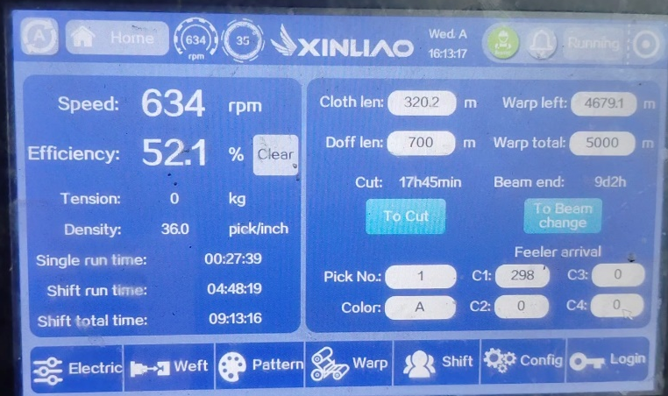 | 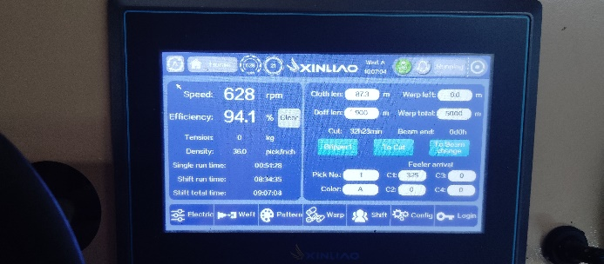
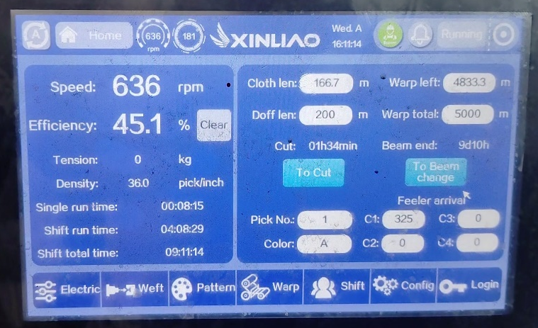 | 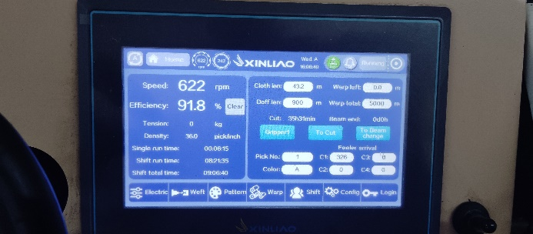

Disclaimer:

  - This progress report is stated on the basis of the site visit by the surveyor and we don’t recommend any sort of recommendation in our Certificate.
  - As per physical inspection and observation made during site visit dated 16th October, 2024. Company has installed all the machines except 48 nos. of Shuttle less Waterjet loom machines mentioned in the provided list.
  - This certificate doesn’t include any work related to drawing, design, sketch plan, and technical specifications of the machines.
  - Ownership and other legal point of view in respect of the asset is not considered in this report as same is out of scope of this certificate.
  - This certificate is made at the request of the Bank.

For R.K Associates Valuers & Techno FOR INTERNAL USE Engineering Consultants (P) Ltd.
TYPED BY: Er. Manmohan
REVIEWED BY: Er. Abhinav Chaturvedi

ANNEXURE: LIST OF MACHINES AS PROVIDED BY THE CLIENT

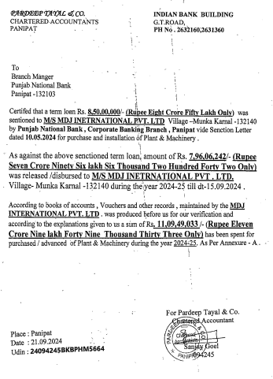

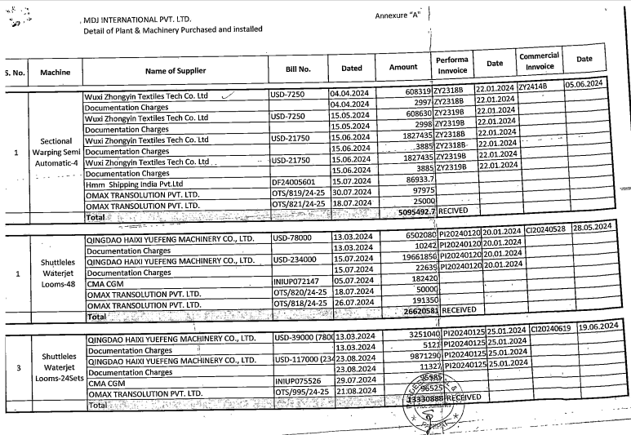
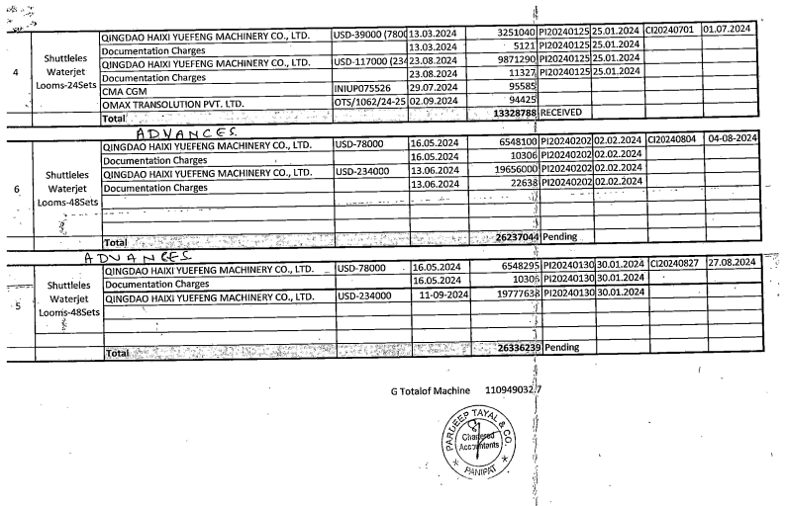

ANNEXURE: PHOTOGRAPHS

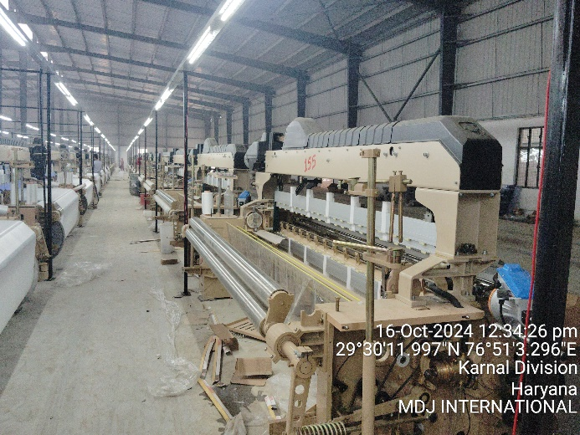 | 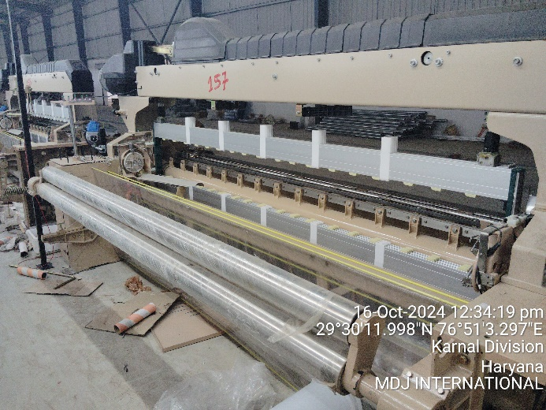
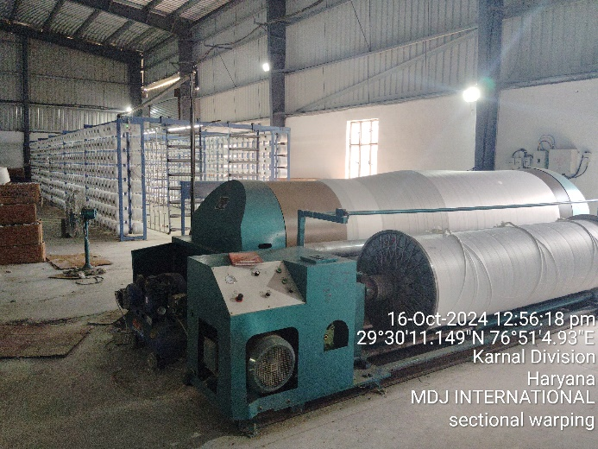 | 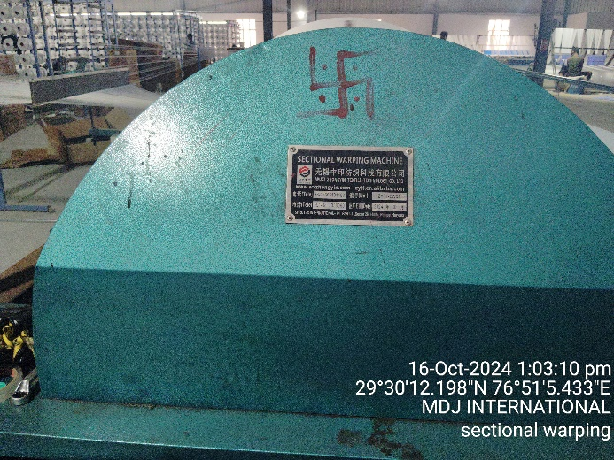
 | 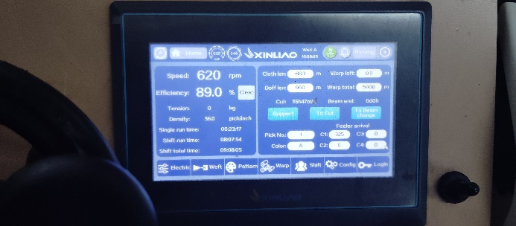
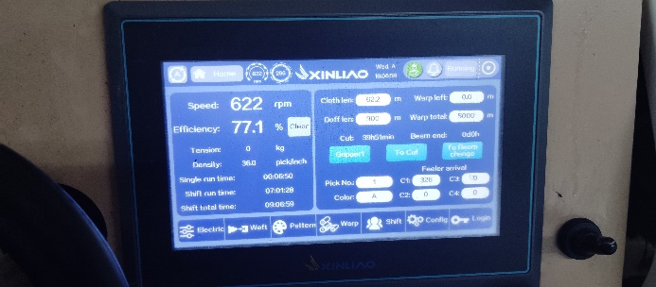

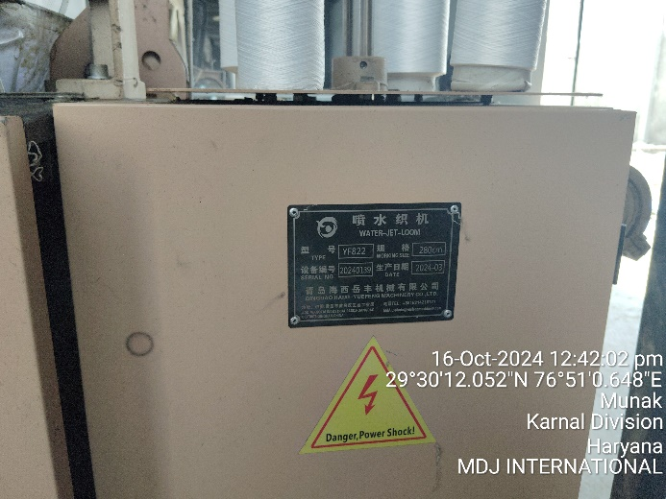 | 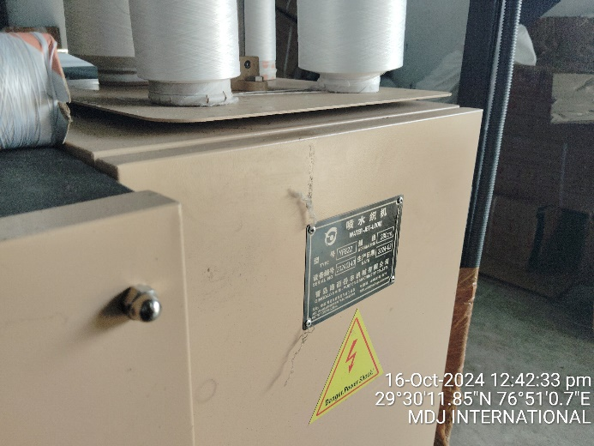
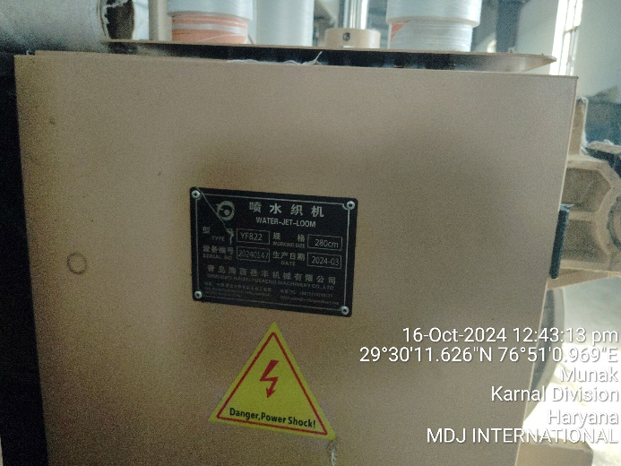 | 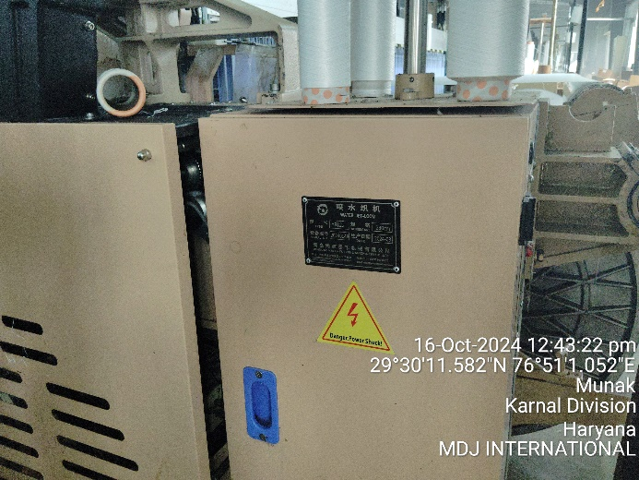
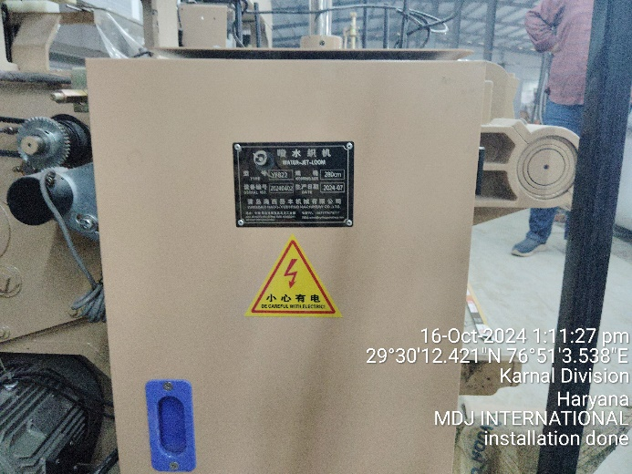 | 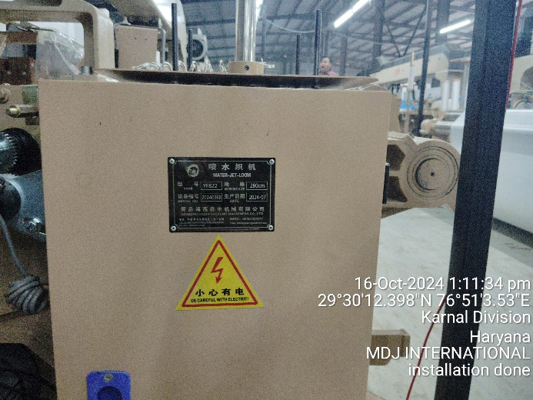

ANNEXURE: MARKET REFERENCES

