REPORT FORMAT: CL-1 | Version: 1.0_2018

FILE No.: VIS(2024-25)-PL468-418-586 Date: 29-10-2024

CERTIFICATE NAME: Progress Report on the machines and equipment for Pharmaceutical Machinery which is proposed to be installed in Village- Sirchandi, Bhagwanpur, Haridwar.
- FOR ORGANIZATION: State Bank of India, SME Branch, Ranipur, Haridwar.

- BORROWER COMPANY’S NAME: M/s. Nephron Pharmaceuticals Private Limited

ASSET TYPE: Pharmaceuticals – Capsule Manufacturing Machineries
- CURRENT LOCATION OF THE MACHINES: Installed & Proposed to be installed at Khasra No. 754, Village- Sirchandi, Pargana & Tehsil Bhagwanpur, Haridwar, Uttarakhand

TO WHOMSOEVER IT MAY CONCERN

S. NO. | PARTICULARS | DESCRIPTION
1. | Date of Survey | 22-10-2024
2. | Date of Certificate | 29-10-2024
3. | Documents provided for perusal | List of machines
4. | Current Location of the Machines | Installed & Proposed to be installed at Khasra No. 754, Village- Sirchandi, Pargana & Tehsil Bhagwanpur, Haridwar, Uttarakhand
5. | Borrowing Company | M/s. Nephron Pharmaceuticals Private Limited
6. | Type of Asset | Machinery required for installing Pharmaceutical Industry
7. | Type of Assessment | Progress of machines purchased, installed & proposed to be installed at site.
8. | Scope of Assessment | Progress of machines purchased, installed & proposed to be installed at site.
9. | Nature of Machinery | Machines used in pharmaceutical industry and other general machines.
10. | Current Progress of the machines | As per physical inspection made during site visit,  Company has purchased and installed all the machines as per the list provided.
11. | Condition of Machines | Purchased machines and equipment are new and ready for production.

OBSERVATIONS:

We have been provided with the list of machines that has to be purchased / installed / proposed to be installed by the borrower company.
  - Based on the information provided by the subject company (M/s. Nephron Pharmaceuticals Private Limited), it is certified that the following machines have been purchased, installed & proposed to be installed at the above-mentioned site address.

Sr. No. | Name | Vendor | Status During Site Visit
1 | Fire | Naveen | Purchased & installed
2 | HVAC works | SAIFIAN AIRCON | Purchased & installed
3 | Fully automatic blister packing machine GMP Model: EXCEL – 44. | Accurate Machines | Purchased & installed
4 | CT-70 Model Automatic capsules filling machine | Capteach system | Purchased & installed
5 | Clean room Panel & Windows | Sky line aluminium | Purchased & installed
6 | Purified water plant with return loop 2000 ltrs/ hours | Nikhil Enterpries | Purchased & installed
7 | Auto Coater 48” GMP Model | PROVENTIQ PHARMA MACHINERIES | Purchased & installed
8 | AHU Ducting | WEATHER COMFORT ENGINEERSNEAR | Purchased & installed
9 | HPLC | Agilent Technologies India Pvt. Ltd. | Purchased & installed
10 | ACCURA DOUBLE ROTARY PRESS II-37 D TOOLING | Fluidpack | Purchased & installed
11 | Out door & DX cooling unit of HVAC & Istallation | WEATHER COMFORT ENGINEERSNEAR | Purchased & installed
12 | RMG 400 Liters cGMP Machine With Push button controls | PROVENTIQ PHARMA MACHINERIES | Purchased & installed
13 | Furniture (SS) | Nikhil Enterpries | Purchased & installed
14 | PU and Epoxy Work | Arcal | Purchased & installed
15 | HPVA Autoclave 430 ltrs | Pharma Vaild | Purchased & installed
16 | Door | Trio India | Purchased & installed
17 | ACCURA B4 27 STN "D" TOOLING HIGH SPEED | Fluid pack | Purchased & installed
18 | Fully automatic blister packing machine  GMP Model: 240 PLUS. | Accurate Machines | Purchased & installed
19 | Lift material | Aman enterprise | Purchased & installed
20 | Electrical wire & light | Shree shyam trading | Purchased & installed
21 | Fluid Bed Dryer 120 Kg cGMP Machine with push button controls | PROVENTIQ PHARMA MACHINERIES | Purchased & installed
22 | TOC anaylizer | LCGC Bio Analytic Solutions LLP | Purchased but not installed
23 | PCB-600 Ltr. Bin Blender cGMP Machine | PROVENTIQ PHARMA MACHINERIES | Purchased & installed
24 | STABILITY CHAMBER 1000 ltrs | RUPALI LABORATORIES | Purchased & installed
s | DG set 250 kVA | National Engineering company | Purchased & installed
26 | Floor Mounted Electrical Tray Dryer (12) – TRAYS) with Single Leaf Door Model: GT-EHTD | GroyneTech | Purchased & installed
27 | Electrical Penal | National Engineering company | Purchased & installed
28 | UPS 15 KVA, Battery and rack | Nexus Power system | Purchased & installed
29 | ETP & STP 10KL | PARAM ENVIRONMENTAL SOLUTIONS | Purchased & installed
30 | BOD INCUBATOR with PID Controller 600 ltrs | RUPALI LABORATORIES | Purchased & installed
31 | Air Compressor | National Engineering company | Purchased & installed
32 | Transformer 500 KVA | National Engineering company | Purchased & installed
33 | Difference pressure gauge with SS box and tubing | Airtech Equipments System | Purchased & installed
34 | Dispensing Booth (RLAF) | Airtech Equipments System | Purchased & installed
35 | SQ. Bin Type Blender Machine 300 Liters cGMP Machine With PLC | PROVENTIQ PHARMA MACHINERIES | Purchased & installed
36 | VCB 600 AMP. | National Engineering company | Purchased & installed
37 | Tablet Inspection Machine Roller Type– cGMP Model | PROVENTIQ PHARMA MACHINERIES | Under Transit
38 | Paste Kettle 100 Liters cGMP Machine with stirrer | PROVENTIQ PHARMA MACHINERIES | Purchased & installed
39 | DG set 30 kVA | National Engineering company | Purchased & installed
40 | Servo capacity 400KVA | National Engineering company | Purchased & installed
41 | Sampling Booth (RLAF) | Airtech Equipments System | Purchased & installed
42 | Vibro Sifter 30" | PROVENTIQ PHARMA MACHINERIES | Purchased & installed
43 | Shimadzu AP125WD Dual Range Semi-Micro Analytical | RUPALI LABORATORIES | Purchased & installed
44 | Dynamic Pass Box of Size: 900 x 900 x 900 mm | Airtech Equipments System | Purchased & installed
45 | LAF | RUPALI LABORATORIES | Purchased & installed
46 | FUME HOOD | RUPALI LABORATORIES | Purchased & installed
47 | TABLET DISSOLUTION APPARATUS | RUPALI LABORATORIES | Purchased & installed
48 | Disintegration Test Apparatus | RUPALI LABORATORIES | Purchased & installed
49 | Electromagnetic Sieve Shaker | RUPALI LABORATORIES | Purchased & installed
50 | Multi Mill cGMP Machine | PROVENTIQ PHARMA MACHINERIES | Purchased & installed
51 | Hot Air Oven 90 ltrs | RUPALI LABORATORIES | Purchased & installed
52 | Colloid Mill M/c. cGMP Horizontal Model Motor 3 HP | PROVENTIQ PHARMA MACHINERIES | Purchased & installed
53 | Microcontroller Based Karl Fischer Titrator, | RUPALI LABORATORIES | Purchased & installed
54 | CG-150 Platform Scale | Xeon Technologies | Purchased & installed
55 | DIGITAL SEMI AUTOMATIC POLARIMETER | RUPALI LABORATORIES | Purchased & installed
56 | Moisture Analyzer | RUPALI LABORATORIES | Purchased & installed
57 | Portable Tablet Hardness Tester | RUPALI LABORATORIES | Purchased & installed
58 | Autoclave 110 ltrs verticale | RUPALI LABORATORIES | Purchased & installed
59 | Earthing | National Engineering company | Purchased & installed
60 | CG-203L Precision Balance | Xeon Technologies | Purchased & installed
61 | Vacuum Oven 30 ltrs with vaccume pump | RUPALI LABORATORIES | Purchased & installed
62 | SHIMADZU BL3200H TOP LOADING BALANCE | RUPALI LABORATORIES | Purchased & installed
63 | Convery belt 10 feet | Airtech Equipments System | Purchased & installed
64 | ANALYTICAL BALANCE - 0.1mg | RUPALI LABORATORIES | Purchased & installed
65 | Tap Density Tester | RUPALI LABORATORIES | Purchased & installed
66 | Digital Bursting Strength Tester | RUPALI LABORATORIES | Purchased & installed
67 | Covery belt 5 feet | Airtech Equipments System | Purchased & installed
68 | OIML Standard Weights - Class E2 (With NABL Calibration Certificate) | RUPALI LABORATORIES | Purchased & installed
69 | CG-6 Table Top Balance | Xeon Technologies | Purchased & installed
70 | Olympus Binocular Research Microscope | RUPALI LABORATORIES | Purchased & installed
71 | Microcontroller Based Melting/Boiling Point Apparatus | RUPALI LABORATORIES | Purchased & installed
72 | AUTO RANGING CONDUCTIVITY/TDS/oCANALYZER | RUPALI LABORATORIES | Purchased & installed
73 | Semi Automatic LEAK TEST APPARATUS with 300mm esiccator | RUPALI LABORATORIES | Purchased & installed
74 | CG-602L Precision Balance | Xeon Technologies | Purchased & installed
75 | pH/mV/oC/ORP Analyzer (Three/Five Point Calibration) | RUPALI LABORATORIES | Purchased & installed
76 | Vacuum-Cum-Pressure Pump | RUPALI LABORATORIES | Purchased & installed
77 | Rectangular Muffle Furnace | RUPALI LABORATORIES | Purchased & installed
78 | Body shwaer | Tong bio Madical | Not Purchased Yet
79 | Digital Colony Counter | RUPALI LABORATORIES | Purchased & installed
80 | Eye shower | Tong bio Madical | Not Purchased Yet

Disclaimer:
- This progress report is stated on the basis of the site visit by the surveyor and we don’t recommend any sort of recommendation in our Certificate.
- As per physical inspection and observation made during site visit dated 22th October 2024. Company has installed & proposed to be installed of all the machines mentioned in the provided list.
- This certificate doesn’t include any work related to drawing, design, sketch plan, and technical specifications of the machines.
- Ownership and other legal point of view in respect of the asset is not considered in this report as same is out of scope of this certificate.
- This certificate is made at the request of the Bank.

For R.K Associates Valuers & Techno FOR INTERNAL USE Engineering Consultants (P) Ltd.
TYPED BY: Er. Nischay Gautam

REVIEWED BY: Er. Abhinav Chaturvedi

ANNEXURE: LIST OF MACHINES AS PROVIDED BY THE CLIENT

Sr. No. | Name | Vendor
1 | Fire | Naveen
2 | HVAC works | SAIFIAN AIRCON
3 | Fully automatic blister packing machine GMP Model: EXCEL – 44. | Accurate Machines
4 | CT-70 Model Automatic capsules filling machine | Capteach system
5 | Clean room Panel & Windows | Sky line aluminium
6 | Purified water plant with return loop 2000 ltrs/ hours | Nikhil Enterpries
7 | Auto Coater 48” GMP Model | PROVENTIQ PHARMA MACHINERIES
8 | AHU Ducting | WEATHER COMFORT ENGINEERSNEAR
9 | HPLC | Agilent Technologies India Pvt. Ltd.
10 | ACCURA DOUBLE ROTARY PRESS II-37 D TOOLING | Fluidpack
11 | Outdoor & DX cooling unit of HVAC & Istallation | WEATHER COMFORT ENGINEERSNEAR
12 | RMG 400 Liters cGMP Machine With Push button controls | PROVENTIQ PHARMA MACHINERIES
13 | Furniture (SS) | Nikhil Enterpries
14 | PU and Epoxy Work | Arcal
15 | HPVA Autoclave 430 ltrs | Pharma Vaild
16 | Door | Trio India
17 | ACCURA B4 27 STN "D" TOOLING HIGH SPEED | Fluidpack
18 | Fully automatic blister packing machine  GMP Model: 240 PLUS. | Accurate Machines
19 | Lift material | Aman enterpries
20 | Electrical wire & light | Shree shyam trading
21 | Fluid Bed Dryer 120 Kg cGMP Machine with push button controls | PROVENTIQ PHARMA MACHINERIES
22 | TOC anaylizer | LCGC BioAnalytic Solutions LLP
23 | PCB-600 Ltr. Bin Blender cGMP Machine | PROVENTIQ PHARMA MACHINERIES
24 | STABILITY CHAMBER 1000 ltrs | RUPALI LABORATORIES
25 | DG set 250 kVA | National Engineering company
26 | Floor Mounted Electrical Tray Dryer (12) – TRAYS) with Single Leaf Door Model: GT-EHTD | GroyneTech
27 | Electrical Penal | National Engineering company
28 | UPS 15 KVA, Battery and rack | Nexus Power system
29 | ETP & STP 10KL | PARAM ENVIRONMENTAL SOLUTIONS
30 | BOD INCUBATOR with PID Controller 600 ltrs | RUPALI LABORATORIES
31 | Air Compresser | National Engineering company
32 | Transformer 500 KVA | National Engineering company
33 | Differnace pressure gauge with SS box and tubing | Airtech Equipments System
34 | Dispensing Booth (RLAF) | Airtech Equipments System
35 | SQ. Bin Type Blender Machine 300 Liters cGMP Machine With PLC | PROVENTIQ PHARMA MACHINERIES
36 | VCB 600 AMP. | National Engineering company
37 | Tablet Inspection Machine Roller Type– cGMP Model | PROVENTIQ PHARMA MACHINERIES
38 | Paste Kettle 100 Liters cGMP Machine with stirrer | PROVENTIQ PHARMA MACHINERIES
39 | DG set 30 kVA | National Engineering company
40 | Servo capacity 400KVA | National Engineering company
41 | Sampling Booth (RLAF) | Airtech Equipments System
42 | Vibro Sifter 30" | PROVENTIQ PHARMA MACHINERIES
43 | Shimadzu AP125WD Dual Range Semi-Micro Analytical | RUPALI LABORATORIES
44 | Dynamic Pass Box of Size: 900 x 900 x 900 mm | Airtech Equipments System
45 | LAF | RUPALI LABORATORIES
46 | FUME HOOD | RUPALI LABORATORIES
47 | TABLET DISSOLUTION APPARATUS | RUPALI LABORATORIES
48 | Disintegration Test Apparatus | RUPALI LABORATORIES
49 | Electromagnetic Sieve Shaker | RUPALI LABORATORIES
50 | Multi Mill cGMP Machine | PROVENTIQ PHARMA MACHINERIES
51 | Hot Air Oven 90 ltrs | RUPALI LABORATORIES
52 | Colloid Mill M/c. cGMP Horizontal Model Motor 3 HP | PROVENTIQ PHARMA MACHINERIES
53 | Microcontroller Based Karl Fischer Titrator, | RUPALI LABORATORIES
54 | CG-150 Platform Scale | Xeon Technologies
55 | DIGITAL SEMI AUTOMATIC POLARIMETER | RUPALI LABORATORIES
56 | Moisture Analyzer | RUPALI LABORATORIES
57 | Portable Tablet Hardness Tester | RUPALI LABORATORIES
58 | Autoclave 110 ltrs verticale | RUPALI LABORATORIES
59 | Earthing | National Engineering company
60 | CG-203L Precision Balance | Xeon Technologies
61 | Vacuum Oven 30 ltrs with vaccume pump | RUPALI LABORATORIES
62 | SHIMADZU BL3200H TOP LOADING BALANCE | RUPALI LABORATORIES
63 | Convery belt 10 feet | Airtech Equipments System
64 | ANALYTICAL BALANCE - 0.1mg | RUPALI LABORATORIES
65 | Tap Density Tester | RUPALI LABORATORIES
66 | Digital Bursting Strength Tester | RUPALI LABORATORIES
67 | Covery belt 5 feet | Airtech Equipments System
68 | OIML Standard Weights - Class E2 (With NABL Calibration Certificate) | RUPALI LABORATORIES
69 | CG-6 Table Top Balance | Xeon Technologies
70 | Olympus Binocular Research Microscope | RUPALI LABORATORIES
71 | Microcontroller Based Melting/Boiling Point Apparatus | RUPALI LABORATORIES
72 | AUTO RANGING CONDUCTIVITY/TDS/oCANALYZER | RUPALI LABORATORIES
73 | Semi Automatic LEAK TEST APPARATUS with 300mm esiccator | RUPALI LABORATORIES
74 | CG-602L Precision Balance | Xeon Technologies
75 | pH/mV/oC/ORP Analyzer (Three/Five Point Calibration) | RUPALI LABORATORIES
76 | Vacuum-Cum-Pressure Pump | RUPALI LABORATORIES
77 | Rectangular Muffle Furnace | RUPALI LABORATORIES
78 | Body shwaer | Tong bio Madical
79 | Digital Colony Counter | RUPALI LABORATORIES
80 | Eye shower | Tong bio Madical

ANNEXURE: PHOTOGRAPHS

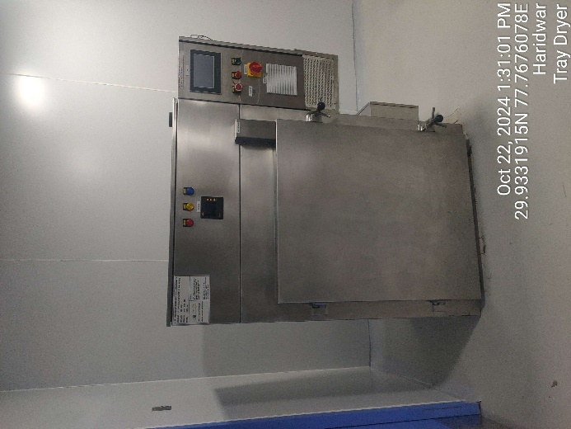 | 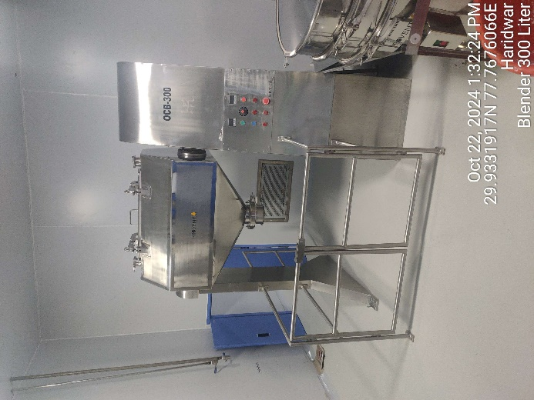
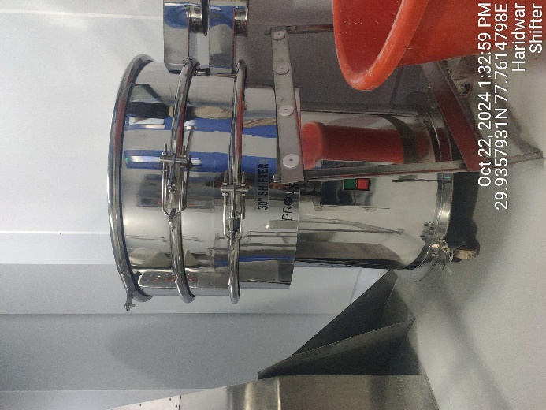 | 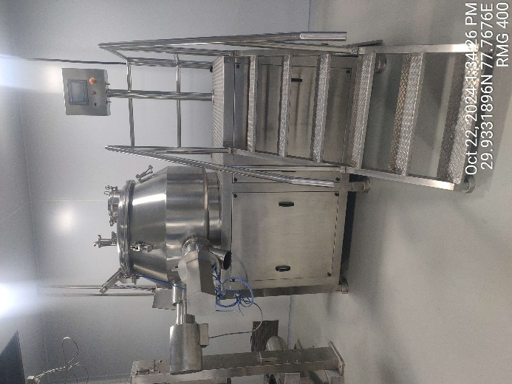
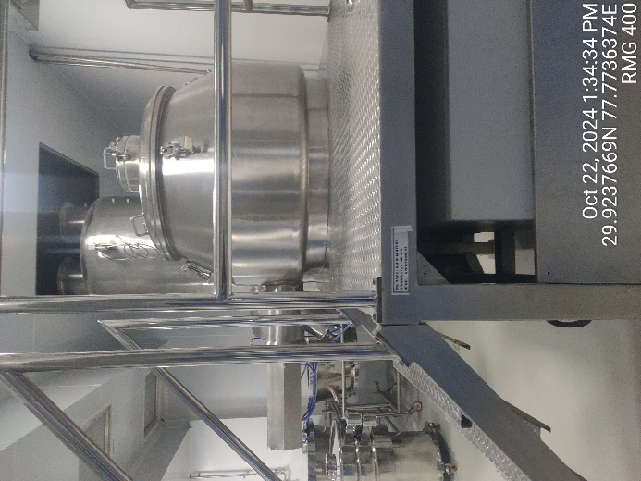 | 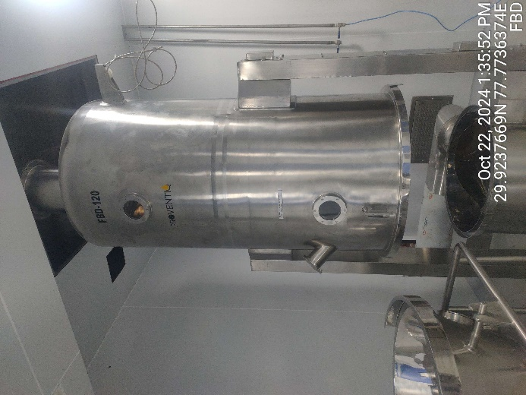

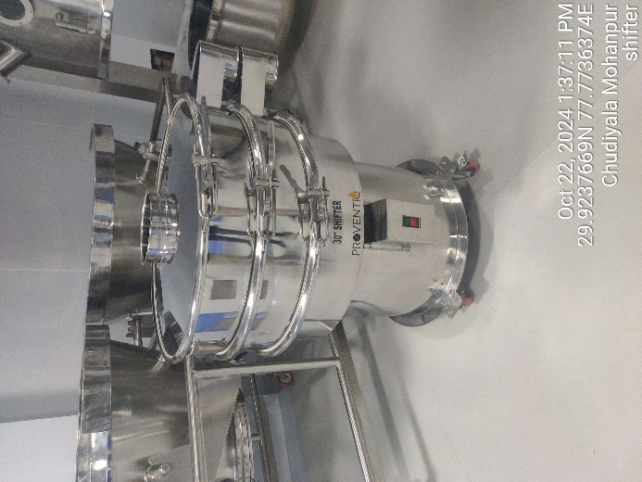 | 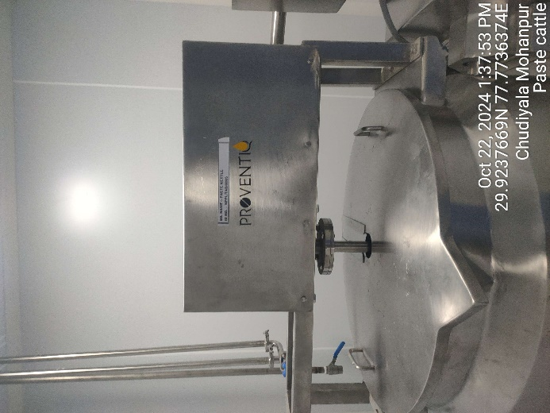
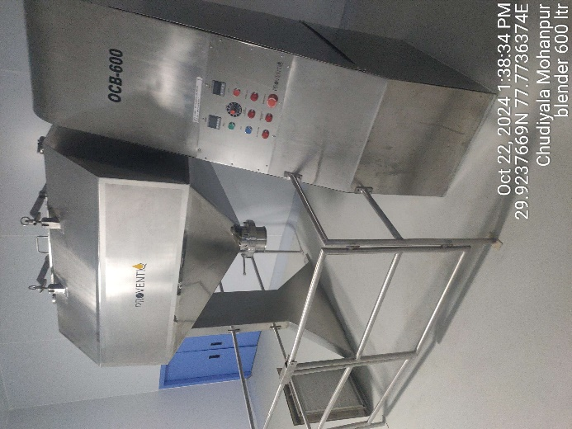 | 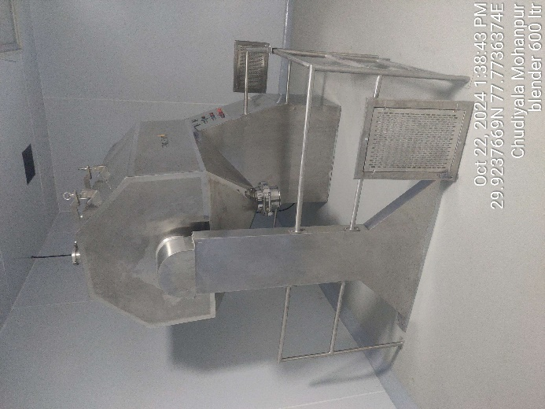
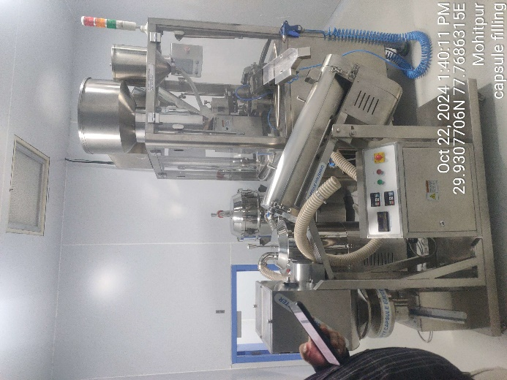 | 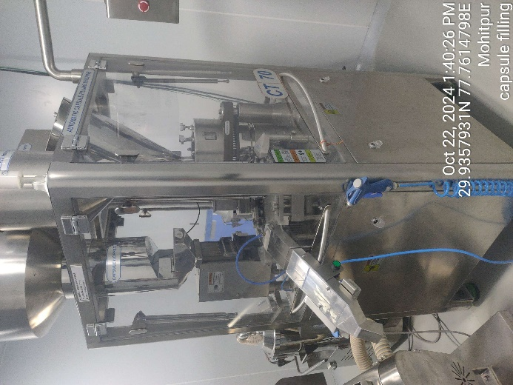

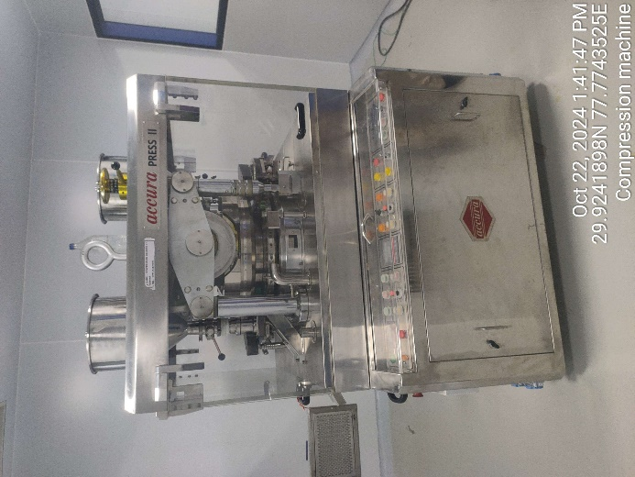 | 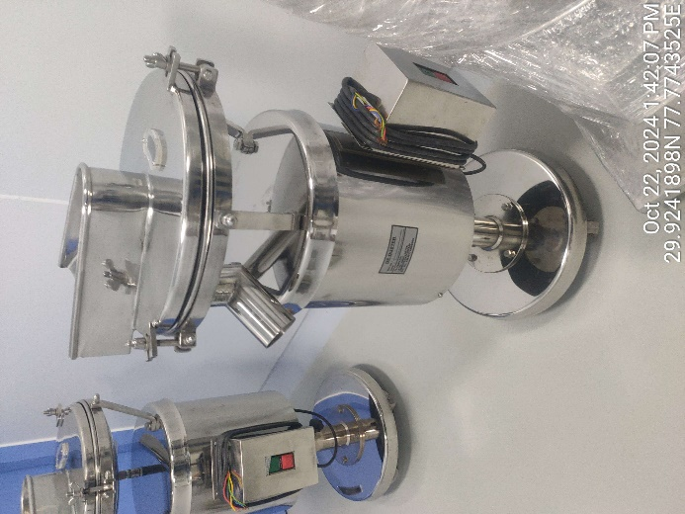
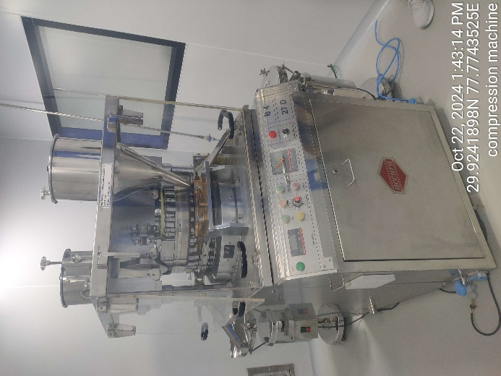 | 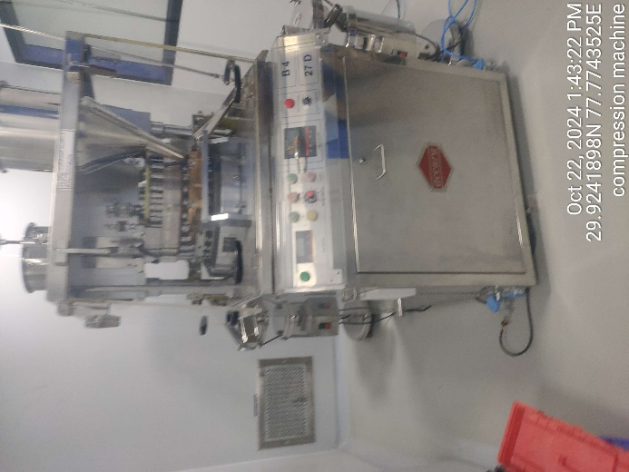
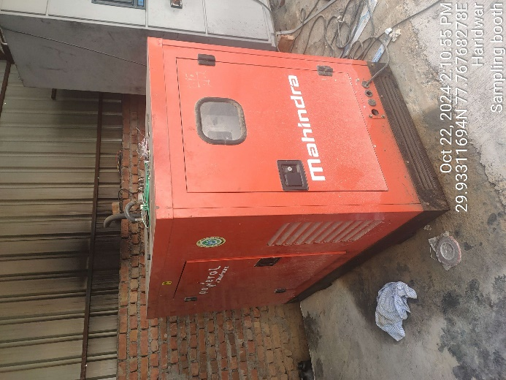 | 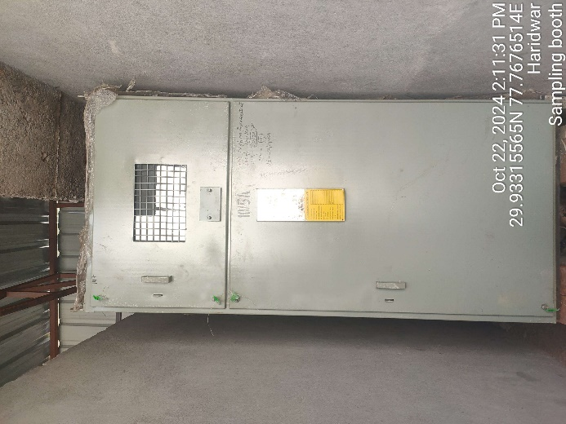

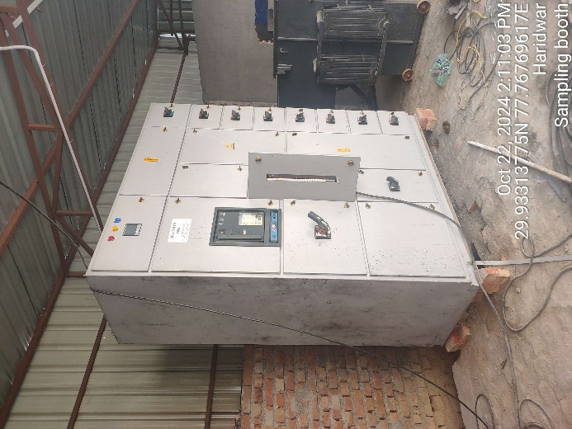 | 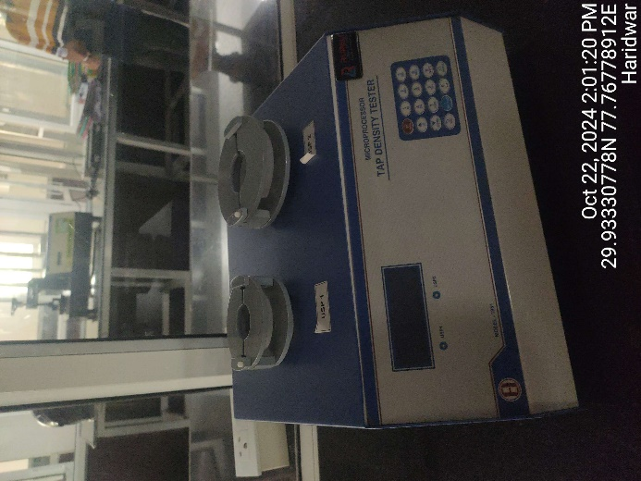
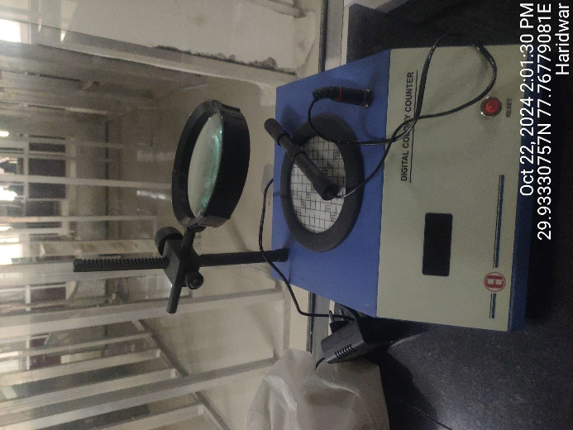 | 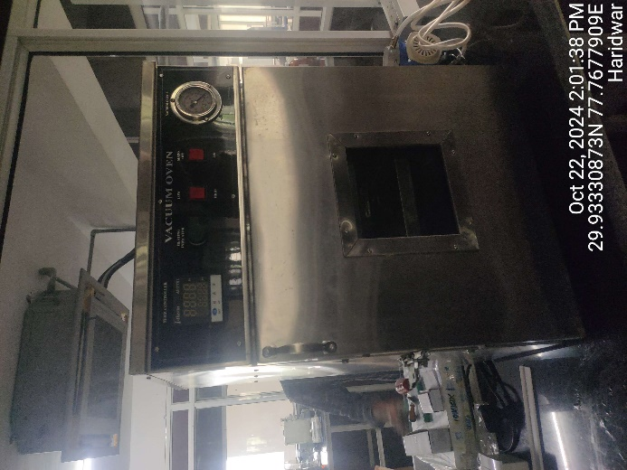
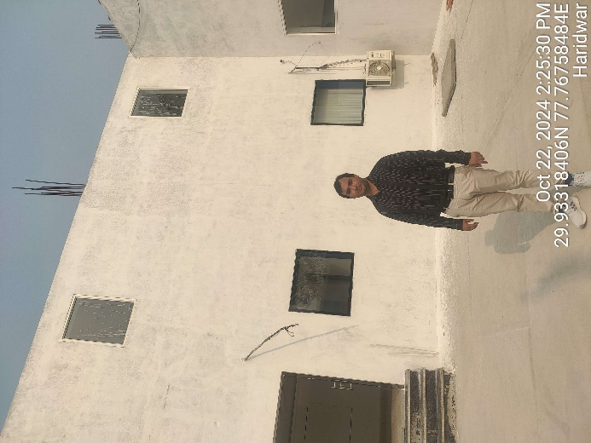 | 