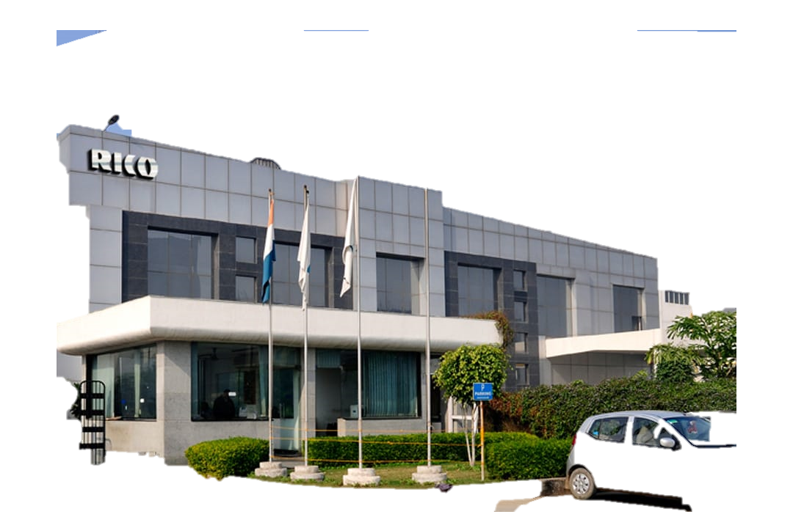



Detailed Project Report

For

635.8KWp _{(DC)} /500KW _{(AC)}
Solar PV Project

RICO Jinfei Wheels Limited
Sector 8, IMT Manesar,
Gurugram, Haryana 122051

https://www.ricoauto.com

Table of Contents
Contents
1. Introduction 3
2. Executive Summary 6
3. Project Summary 7
4. Project Introduction 8
5. Solar Power Generation System Description 9
6. Components of Solar Power Projects 11
7. Energy Estimation 14
8. Project Implementation Plan 20
Appendix A – Overall Plant Layout 21
Appendix B – AC-DC Single line diagram 22

Introduction
- Rico is a world-class engineering company supplying a wide range of high precision fully machined aluminium and ferrous components and assemblies to automotive OEM’s across the globe.
- Rico’s consolidated group total turnover is over US$ 245 Million
- Rico’s integrated services include design, development, tooling, casting, machining and assembly across ferrous and aluminium products.

Our Products:
- Rico Auto Industries manufactures a range of automotive components, primarily focused on precision-engineered parts for various automotive applications. Their product portfolio includes:
- Aluminum Casting Products: These are lightweight components used extensively in the automotive sector for engine parts, transmission systems, and structural components. Aluminum casting products are valued for their durability and lightweight properties, improving vehicle fuel efficiency and reducing emissions​.
- Ferrous Casting Products: These include components made from iron and steel, which are used in areas requiring higher strength and durability, such as engine blocks, gears, and other critical automotive parts​.
- Machining and Assembly: Rico Auto offers fully machined and assembled components to OEMs, ensuring that their products are ready for immediate use in vehicle assembly lines. This service includes precision machining and testing to meet stringent quality requirements​.
- Tooling and Patterns: The company also designs and manufactures custom tooling and dies to produce various auto components, ensuring high-quality production standards and efficiency​.

These products are used by major global automotive manufacturers, making Rico Auto a significant player in the automotive supply chain.

HISTORY & MILESTONES
1984-86
- Rico Auto Incorporated (1984-85) and Commercial Production Started (1986)
- First Aluminum High Pressure Die Casting Plant set up in Dharuhera (50 Kms from IGI Airport Delhi)
- Preferred relationship with Hero Moto Corp and Maruti Suzuki
1990-92
- Ferrous Casting & Machining Plant set up in Gurgaon (20 Kms from Delhi, India)
- Entered International Market as OEM Supplier to MEC Japan.
1994-96
- FCC RICO (50:50) JV formed
- Started supplying globally to USA & UK (Eaton, Cummins, GM etc.)
- 1998-00
- Second Aluminum HPDC & Machining Plant set up in Gurgaon

2000-02
- Set up full-service Engineering, Design & Development function.
- Added Customers: Ford, Jaguar, Land Rover
- Certified TS 16949, ISO 140001, OHSAS 18001
2002-04
- Enhanced Ferrous & Aluminum Capacity
- Added Customers: Caterpillar, Honeywell, Detroit Diesel, Volvo
2004-06
- R&D Center started
- Added Customers: Nissan, Tata, Perkins
2007-09
- JV (50:50) with CONTINENTAL GERMANY (Hydraulic Brakes)
- JV (50:50) with MAGNA INTERNATIONAL (Oil and water pump)
- JV (92.5:7.5) with JINFEI CHINA (Aluminum Alloy Wheels - 2 Wheelers)
- Added Customers: Renault, BMW, JATCO, Magna
2010-14
- Added new facilities/plant at Bawal, Bhiwadi, Sanand, Chennai & Haridwar
- Added Customers: GKN, Toyota, Allison Transmissions, Volkswagen India, Musashi, Kohler, Avtec, Bentley
- AAN Engineering setup as a Defense Vertical.
- Divested stake in Continental and FCC JV
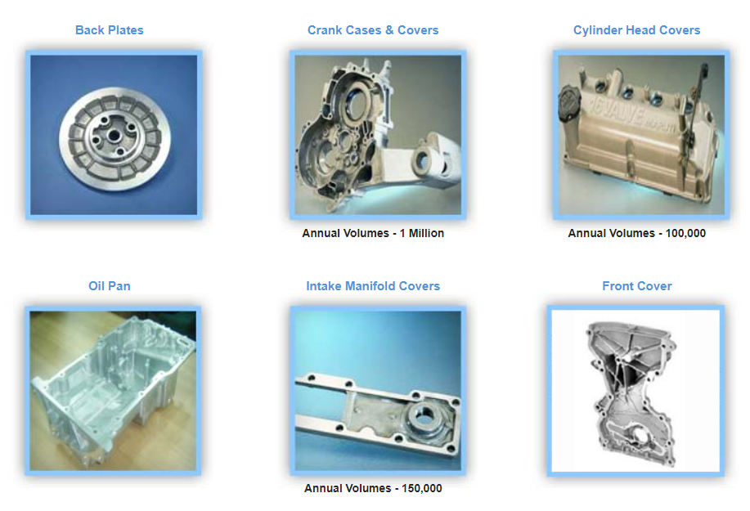
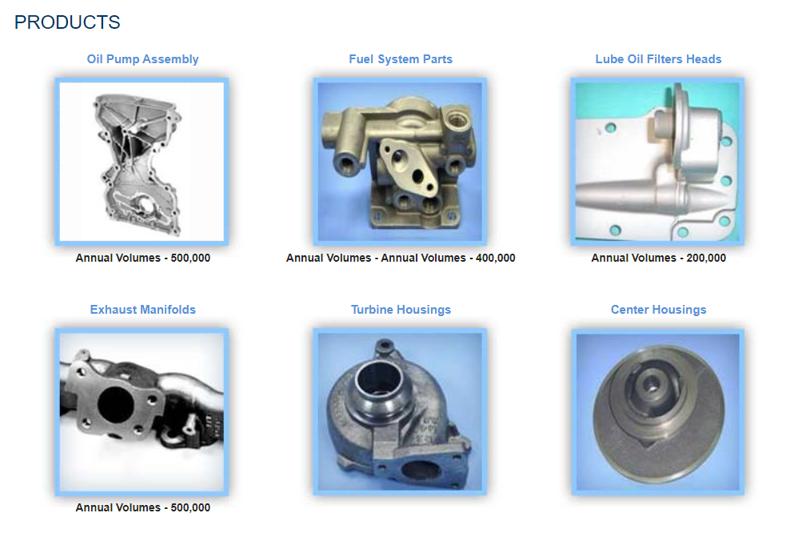

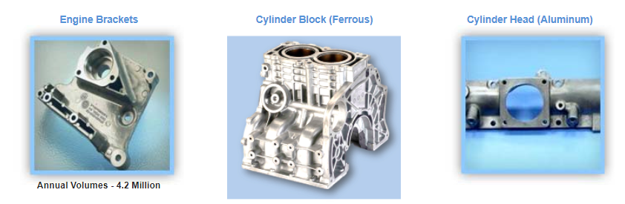
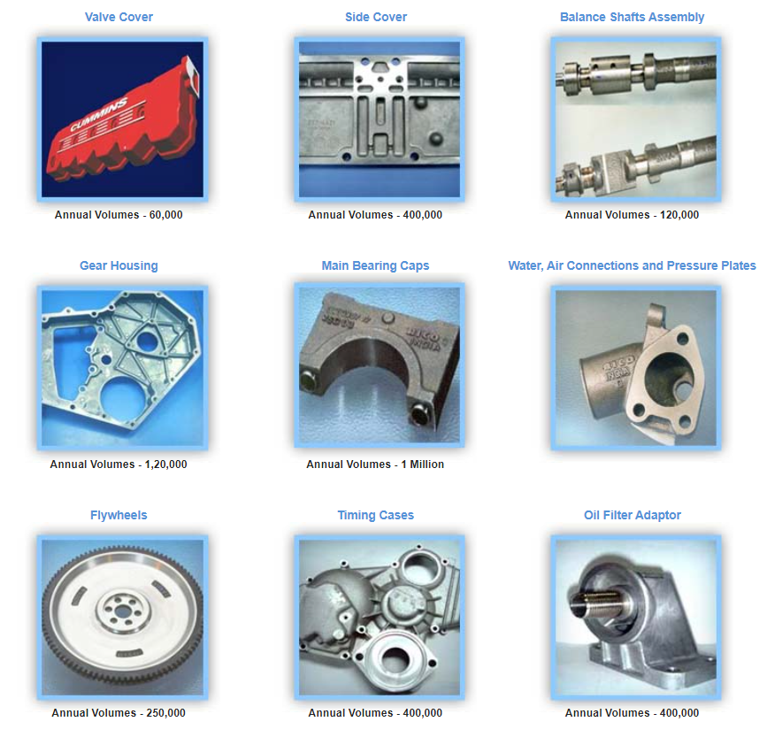

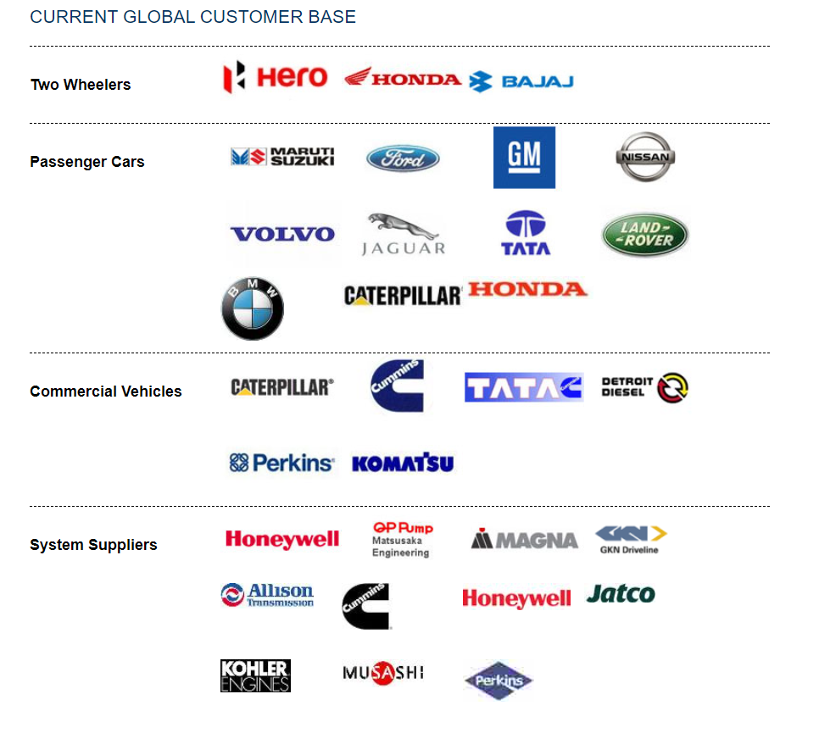

Aluminium Casting
- Rico has over 100 High Pressure Die Casting (High Pressure Die Casting Machines) from 135 Ton to 2500 Ton locking force equipped with Real time Shot monitoring & Robots.
- Rico is one of the largest High Pressure Die Casting facility in India.
- Rico is currently producing over 50,000 MT of High Pressure Die Cast components per annum.
- Die Casting component weight range from 100gms up to 12 kgs
- Current High Pressure Die Casting machines are from Buhler, Toshiba, UBE, ITAL Presse etc.
- Alloys produced today: ADC 12, ADC 14, LM24, A 380, A 383, ENAC46500, A356.
- Post processing & Heat Treatment facility

Engineering and R & D
Engineering CAD CAM CAE
Rico has over 60 seats and all the required engineering CAD CAM CAE software's.
CAD & CAM : Unigraphics, Pro Engineer, Catia, C3P, Ideas, Veri cut, Solid edge, AutoCAD
CAE : Magma soft, FEA, CFD, Ansys, FCX, GT Suite, MSC Fatigue

R & D Capabilities
- Design & Analysis: Structural, Thermal, Fatigue, NVH (Noise, Vibration, Harshness)
- Material research & development
- Testing & validation
- Real Time X-Ray, Particle Counter, Millipore Testing, Spectrometer, Scanning Electron Microscope, Electronic Gauges & Online CMM

Executive Summary
India is a fast-developing economy and along with development it requires energy to boost up industries and various consumption needs of power and this growing demand led to a strong thought of a concept named as solar energy.
With the Current Government strong emphasis is placed on the development of renewable power and energy sector, and thus solar energy has come into limelight. The government has come up with a number of solutions to boost the solar power, so that increasing need of power can be fulfilled.
India is a country having average annual temperature that ranges from 25°C to 27.5 °C because of it is located between the tropic of cancer and the equator, the average sunny days in country are about 300 and this implies that India has a very high potential of generating solar energy as availability of solar radiation in various parts of the country is quite good.
Keeping in mind the growing demand for power and various other criteria of solar energy generation government has target of deploying 500 GW of solar power by 2030.
This mission proved that solar power is going to be viable energy source in coming years.
The huge potential of Solar Power has led to development and installation of major projects, this report brings into limelight details of proposed power generation scheme, electrical system evacuation of generated power, environmental & safety aspects, distribution mechanism, cost estimation and project viability. This report also highlights complete schedule of project implementation.

Project Summary

The below table depicts the complete summarized form of introduction of the project, keeping in track essential detailing:
Sr. No. | Titles | Description
1 | Project Beneficiary | M/s Rico Jinfei Wheels Ltd
2 | Project Capacity | 635.8KWp _{(DC) /} 500KW (AC)
3 | Project Location | IMT Manesar
a) | Site Name | Sector 8, Imt Manesar, Sector 8, Imt Manesar, Gurugram, Haryana 122051
b) | District | Gurugram
c) | State | Haryana
d) | Latitude | 28.378325532269727,
e) | Longitude | 76.8953123152362
f) | Installation Type | SHED TYPE
g) | Structure type | Aluminium
h) | Altitude | 239 meters
i) | Tilt | 12°
j) | Azimuth | 0°
4 | Connectivity
a) | Nearest Railway Station | Gurgaon RLYN
b) | Nearest Airport | Delhi Airport (DEL)
6 | Power Evacuation Details | 415 Volt
a) | Energy Estimation | 1552_KWh/kWp/year
b) | Estimated Net Energy Generation per annum | 986.6_MWh/Year
c) | CUF | 18 %
d) | Expected Life of Power Plant | 25 Years

Project Introduction

The thrust and urge of establishing solar plant have given rise to this project. Enriching the evaluating suitability of multiple commercially established solar PV technologies and mounting systems for the Project site location, polycrystalline half cut PV module technology with fixed tilt system is being selected to give a better economic viability from the various combinations. The technical evaluation was based on the benefits of technology which can probably offer for the project lifecycle of 25 years. The project site is well connected with all infrastructural and human resource facilities in and around. The plant will encompass of all the necessary components starting from modules, module mounting structure, inverters and other basic accessories needed. The power generated will be evacuated to LT panels. Thus, the main motive and perception is that setting up these power plant will go a long way satisfying the energy need of the client.

PV modules are likely to underperform due to multiple losses including negative temperature coefficient. Moreover, the irradiation received at the site is not at peak throughout the day; it varies over a day and is also inconsistent around the year.

Solar Power Generation System Description

The sun is a natural nuclear reactor. It releases tiny packets of energy called photons, which travels approximately 93 million miles from the sun to Earth in about 8.5 minutes. Every hour, enough photons impact our planet to generate enough solar energy. When these generated photons hit a solar cell, which is made up of photovoltaic solar panels, they knock electrons loose from their atoms. If conductors are attached to the positive and negative sides of a cell, it forms an electrical circuit. When electrons flow through such a circuit, they generate electricity. These phenomena have led to establishment of solar power plants. Solar Power Plant are broadly classified into two major categories based on their location they are:

- Ground-mounted Projects: It is solar solution that can be easily implemented in a large yard or field. The panels are similar to pole-mounted solar panels, but instead of being elevated on poles, they are installed directly on the ground. In this case, the solar panels are mounted on mounting structures that are set up on available land on respective mounting foundations. The entire system including all the components like modules, inverters, cables, evacuation infrastructure are based on ground only.

- Rooftop/SHED Projects: In this case the solar modules are mounted on the roof of an existing building via appropriate mounting structures. The buildings may be of residential, commercial or industrial. The roofs may be sloping sheet roofs or flat RCC roofs.

Solar Power Working Mechanism:

Solar power systems work on the same basic principles. Solar panels first convert solar energy or sunlight into DC power using photovoltaic (PV) effect. The DC power can then be stored in a battery or converted by a solar inverter into AC power which can be used to fulfil the electricity requirements. Depending on the type of system, excess solar energy can either be fed into the electricity grid for credits or stored in a variety of different battery storage systems.
Moreover, solar irradiation varies throughout the day and since the power output of the system is directly proportional to the level of irradiation on the module surface, the power output of the solar array too varies throughout the day. As a result, the inverter continuously matches the output of the PV array with a reference power source to maximize the PV array output. Based on this reference power source, PV systems are classified as:
- Off-Grid Systems: In this case, the system comprises a battery bank that functions as the reference power source as well as a storage mechanism which can supply power at night when the Sun is not available.

- Grid-connected systems: In this case, the solar power system is coupled with the grid
Which provides the reference power source. Any excess power can be exported to grid.

A general schematic of the working of a Grid-Connected Rooftop PV System is shown below:
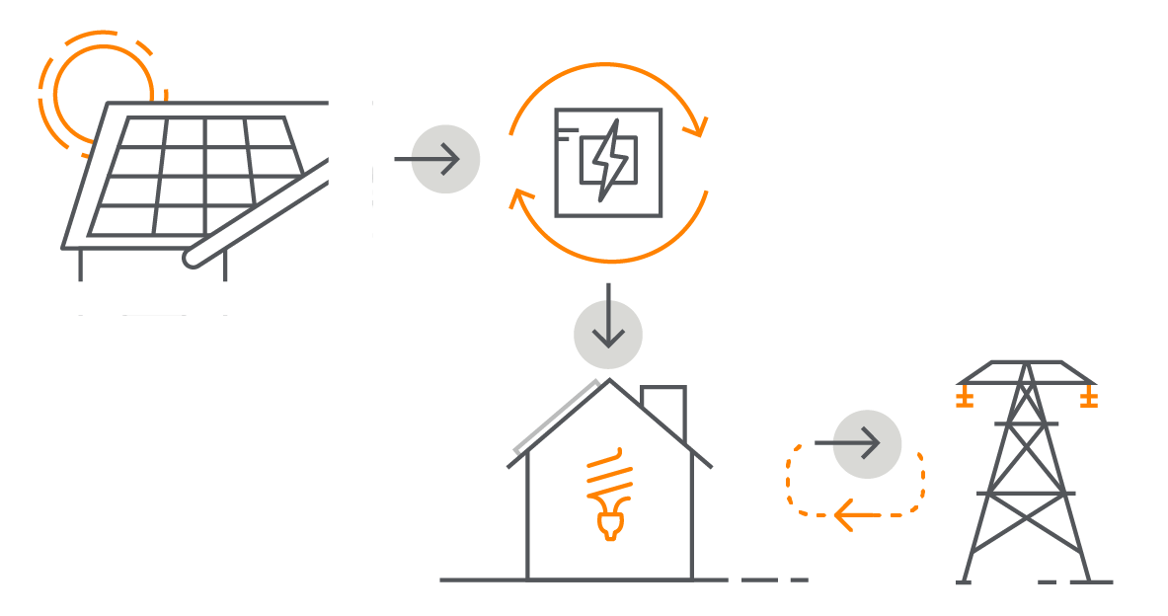

Components of Solar Power Projects

As discussed above the two major type of solar plants implemented namely roof-top or ground mount serve to generate energy. Standard residential or commercial solar power systems consist of a core set of components mainly Solar Panels, Inverters, DC/AC Disconnects, Meters, Wiring, Racking and Mounting they are usually grid-tied. Whereas some system requires additional components like Charge Controllers, Batteries, Additional Balance of Systems items and more these are usually off-grid. The components are briefed below:

- PV Modules – They are the devices that convert solar energy to electricity. PV modules are made from PV cells, manufactured using silicon and other materials.

- These silicon-based solar cells provide higher efficiency (18% - 23%), whereas thin film cells are less efficient (10% - 15%). As there are different type of PV modules each bear unique characteristics in terms of efficiency, cost, performance, low irradiation levels, degradation rate and so on. Higher quality of PV module generally has life span of 20 to 25 years, so it is vital to analyse the quality of module to be installed in the plant

- Inverter –The main role of inverter is to converts the DC power produced by the PV modules into AC power. There are different types of inverters available in the market; selection of an inverter for a project depends on ample of factors, like application, size, cost, function, usage, etc. Inverters also perform energy monitoring functions. These inverters are basically string inverters, which have smaller capacities (typically <300kW) and central inverters, which have larger capacities (typically >2000 kW). Central inverters are generally used in MW-scale solar PV projects. It is acclaimed that top-of-the-line inverters offer efficiencies in the range of 97% - 99%. These days inverter comes in with feature of performing energy monitoring function.

- Module Mounting Structure– These forms the real support structure that holds the solar panels. These are also known as racking structure. Mounting structures can be either fixed or tracking for ground & we are using clamps as per shed profile & install it by pasting or riveting. Fixed tilt mounting systems are simpler, involves low-maintenance and are cheaper as compared to tracking systems. Mounting structure designs are highly specific to the site, and over time have seen improvement in durability and reduction in costs. Mounting of structure on ground or on roof top require compliance with regulations or guidelines associated with the structural and composition aspects of the roof/ ground such as load-bearing capacity, wind loading, etc.

- Balance of System – Balance of system (BoS) consist of cables, switchboards, junction.
box, meters, etc. Here electricity meters record the amount of electricity consumed or produced (in kWh and kVAh) within premises. The tabular representation reflects the overview of components of balance of system:

Headings | Description
1)Junction Box | - A metal or plastic enclosure consisting of junction of electric wires.  - Facilities in combining groups of modules into independent charging sub-arrays that will be wired into the controller.  - Enabling arrangement for disconnection of each of the groups of arrays formed.  - Serves as a test point for each sub-group for quick fault location.  - Leads to group array isolation
2)LT Panel | - It is a gadget that receives power from solar panels and distributes same to various electronic devices  - Alternatively called as AC Distribution Box (ACDB) that is provided between the PCU and the main LT distribution panel to ensure suitable protection, insulation and change-over between the load and the power output of the PCU  - The ACDB consists of a distribution feeder that is used to cater to the existing loads of the facility with solar generated electrical power.
3) Cables | - Cables used are extremely robust and resist high mechanical load and abrasion.  - Good temperature resistance and excellent weather proofing characteristics also provide long service life to the cables used.  - Mainly two variety of cable fall under these categories i.e., LT cable and Control Cable
4)Meter Box | - For energy accounting, Solar based generation projects will have to provide ABT compliant meters at the interface points.  - Interfacing metering shall confirm to the Central Electricity Authority (Installation and Operation of Meters) Regulations, 2006.
5)Data Logger | - The data logger takes care of data monitoring and regular data logging of the SPV system.  - It also allows user to perform monitoring and logging of multiple connected PCU’s. Once the system is configured real time data can be obtained and displayed.
6)Fire Fighting Instruments | - The type of fire protection systems for complete plant shall be including portable fire extinguishers and wheel/trolley mounted fire extinguishers.  - Adequate number of portable fire extinguishers of dry chemical powder and carbon dioxide type shall be provided at suitable locations in different buildings.
7)Sign Boards | - They contain the brief of the Power Plant. The Signboard will be made of steel coated aluminium letters with proper illumination arrangement.  - The design & size of the signboard shall be befitting with control room and matter.

Energy Estimation

For energy yields:

- Sourced average monthly horizontal irradiation, wind speed and temperature data with the other sources which included satellite image derived data. These data have been assessed for use in the energy yield simulation software.
- Calculated the global incident radiation on the tilted plane, considering shading.
- Calculated the losses, using details of the inverter specifications, PV module specifications, site layout and characteristics.
- Applying downtime losses, AC ohmic losses, and module degradation losses to obtain energy yields that reflect twenty-five-year plant life.

Using statistical analysis of resource data for inter-annual variability to derive appropriate levels of uncertainty in the energy yield prediction, steps 2 and 3 are facilitated using industry standard photovoltaic simulation software which simulates the energy yield using hourly time steps. The software takes as input detailed specifications of:

- Solar PV modules
- Inverters
- Mounting Orientations and arrangements
- Electrical configuration

The view of solar path, radiation computation, losses etc has mentioned below for the study purpose.

a) | Radiation data source | GIS API TMY
b) | Energy Estimation | (P90)_1532 kWh/kWp/year
c) | Estimated Net Energy Generation per annum | 974.06 MWh
d) | CUF | 18 %
e) | Expected Life of Power Plant | 25 Years

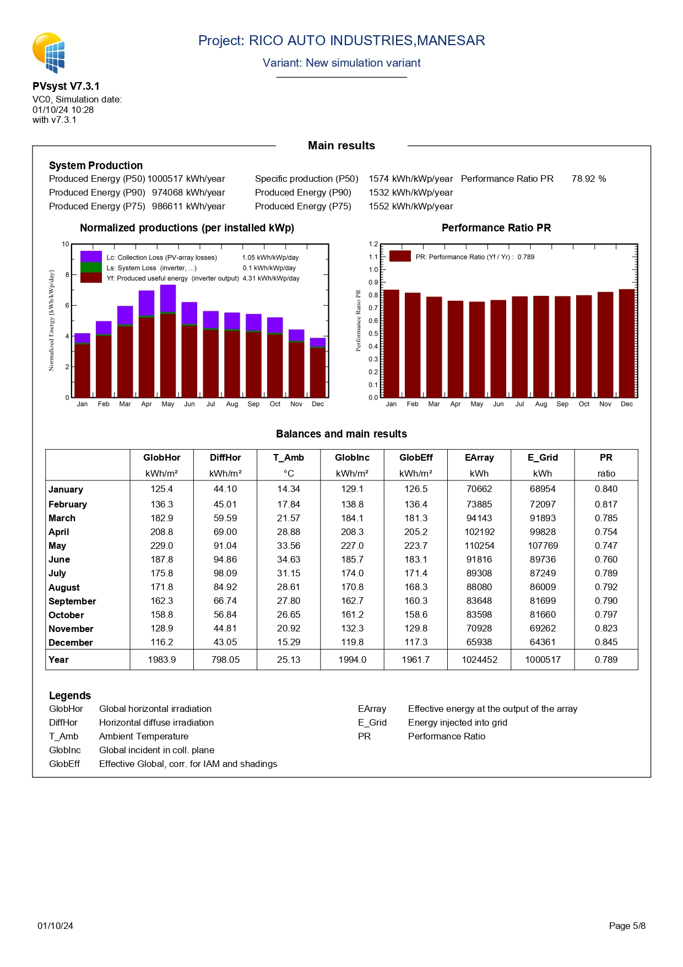

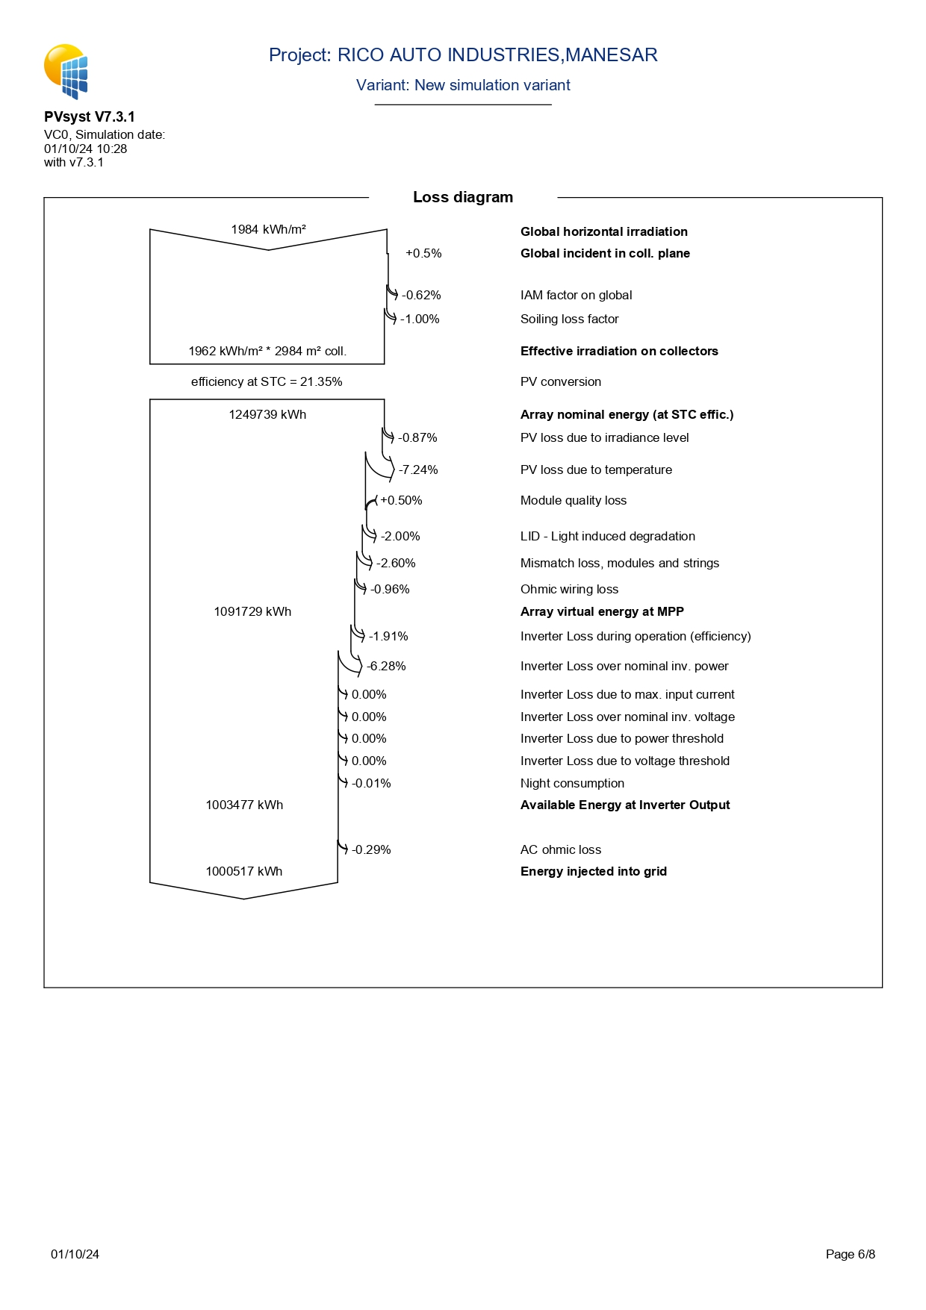

Correction and Losses:

The PV module, inverter specifications and plant configuration are input into the PV modelling software to calculate DC energy generated from the modules in hourly time steps throughout the year. This direct current is converted to AC in the inverter.

Several losses occur during the process of converting irradiated solar energy into AC electricity fed into the grid.

The losses may be described as a yield loss factor. It has calculated within the PV modelling software and calculated from the cable dimensions. Others are nominal figures applied from knowledge of performance of similar PV plants.

Capacity Utilisation Factor:
The Capacity Utilization Factor (CUF) also known as Plant Load Factor (PLF) of a PV power plant (usually expressed as a percentage) is the ratio of the actual output over the period of a year and its output if it had operated at nominal power the entire year, as described in the formula below.
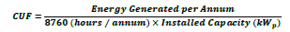
The CUF on contracted DC capacity of the Solar PV plant is 16.24%.
Performance Ratio
The quality of a PV power plant may be described by its Performance Ratio (PR). The PR, usually expressed as a percentage, can be used to compare PV systems independent of size and solar resource. The PR may be expressed as:
PR _{Yearly} shall be calculated as
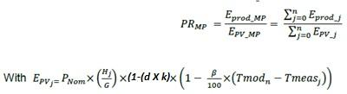
Where:
Measurement period = 12 Months after COD\PAC
N = sum of time increments (j = ONE min or as per agreed interval by

Developer) comprising the 12-month test period after completion of COD\PAC

j | = ONE min time increment or as per agreed interval by Developer
𝑃𝑅𝑀𝑃 | = Performance Ratio calculated during the relevant Measurement Period, %
E_{PV_MP} | = Energy theoretically produced by the PV modules (before cabling and inverters) during the Measurement Period, kWh
𝐸_{𝑝𝑟𝑜𝑑_𝑀𝑃} | = Net of energy generation over the Measurement period. The Net Energy generation is the difference between the Energy exported and the Energy imported recorded at the billing meter
^{E}PV _ j | = Energy theoretically produced by the PV modules in timeframe j, kWh
^{E}Prod _ j | = Net of energy generation over a period of “j”. The Net Energy generation is the difference between the Energy exported and the Energy imported recorded at the agreed metering point, kWh
^{P}Nom | = Nominal Peak Power of the modules in Standard Test Conditions, as defined in the main body of the contract kWp
H _{j} | = Median of the in-plane irradiation hitting the PV Modules in timeframe j,  kWh / m2 (pyranometers data), outliers and anomalous values should be excluded
G | = Irradiance under Standard Test Conditions = 1 kW/m2
d | = Agreed degradation to be defined appropriately for each Performance Test, linear annual degradation rate to be Considered as per the module data sheet.
k | = (1- number of years from issue of the Provisional Acceptance Certificate).
𝛽 | = factor for temperature influencing module power losses from the module data sheet (%/⁰C)
𝑇𝑚𝑒𝑎𝑠𝑗 | = the average module temperature measured during each Metering Interval j collected through the monitoring system (in ⁰C)
𝑇𝑚𝑜𝑑𝑛 | = irradiance weighted average of the expected module temperature calculated based on the extracted PVSYST hourly output file (in ⁰C) for the measurement period

The end of first year performance test will be deemed to have passed if:

PR Yearly ≥ Guaranteed Performance Ratio
The test results will be reviewed and approved by the owner or owner’s engineer appointed by the Owner for the validation of the test.

By normalizing with respect to irradiation at STC, the PR quantifies the overall effect of losses on the rated output and allows a comparison between PV plants.

Project Implementation Plan

The management of the construction phase of a solar PV project should not be considered different from any other industry. An essential aspect of any project management remains programme and scheduling, implementation milestones and risk managements.

A realistic and comprehensive construction programme is a vital tool for the construction planning and management of any utility solar PV project. The programme should be sufficiently detailed to show:

- Tasks and durations.
- Restrictions placed on any task.
- Contingency of each task.
- Milestones and key dates.
- Interdependencies between tasks.
- Parties responsible for tasks.
- Project critical path.
- Actual progress against plan.

All tasks and the expected timescales for completion should be detailed along with any restrictions to a particular task.

For a solar PV project, it is likely that that the programme will have different levels, incorporating different levels of detail around each of the following main work areas:
Site access.
- Security.
- Foundation construction.
- Module assembly.
- Mounting frame construction.
- Electrical site works.
- Grid interconnection works.
- Commissioning and testing.

A high-level programme should be produced to outline the timescales of each task, the ordering of the tasks and any key deadlines.

This should be completed as part of the detailed design. The programme will then be built up to detail all the associated tasks and sub tasks, ensuring that they will be completed within the critical timescale.

A thorough programme will keep aside time and resources for any contingency. It will also allocate allowance for weather risk or permit restrictions for each task.

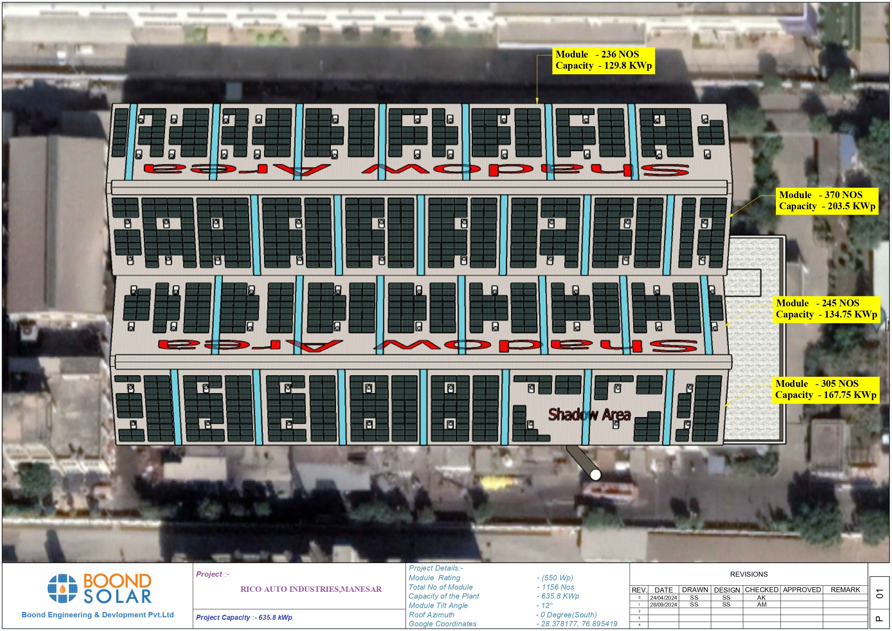
Appendix A – Overall Plant Layout

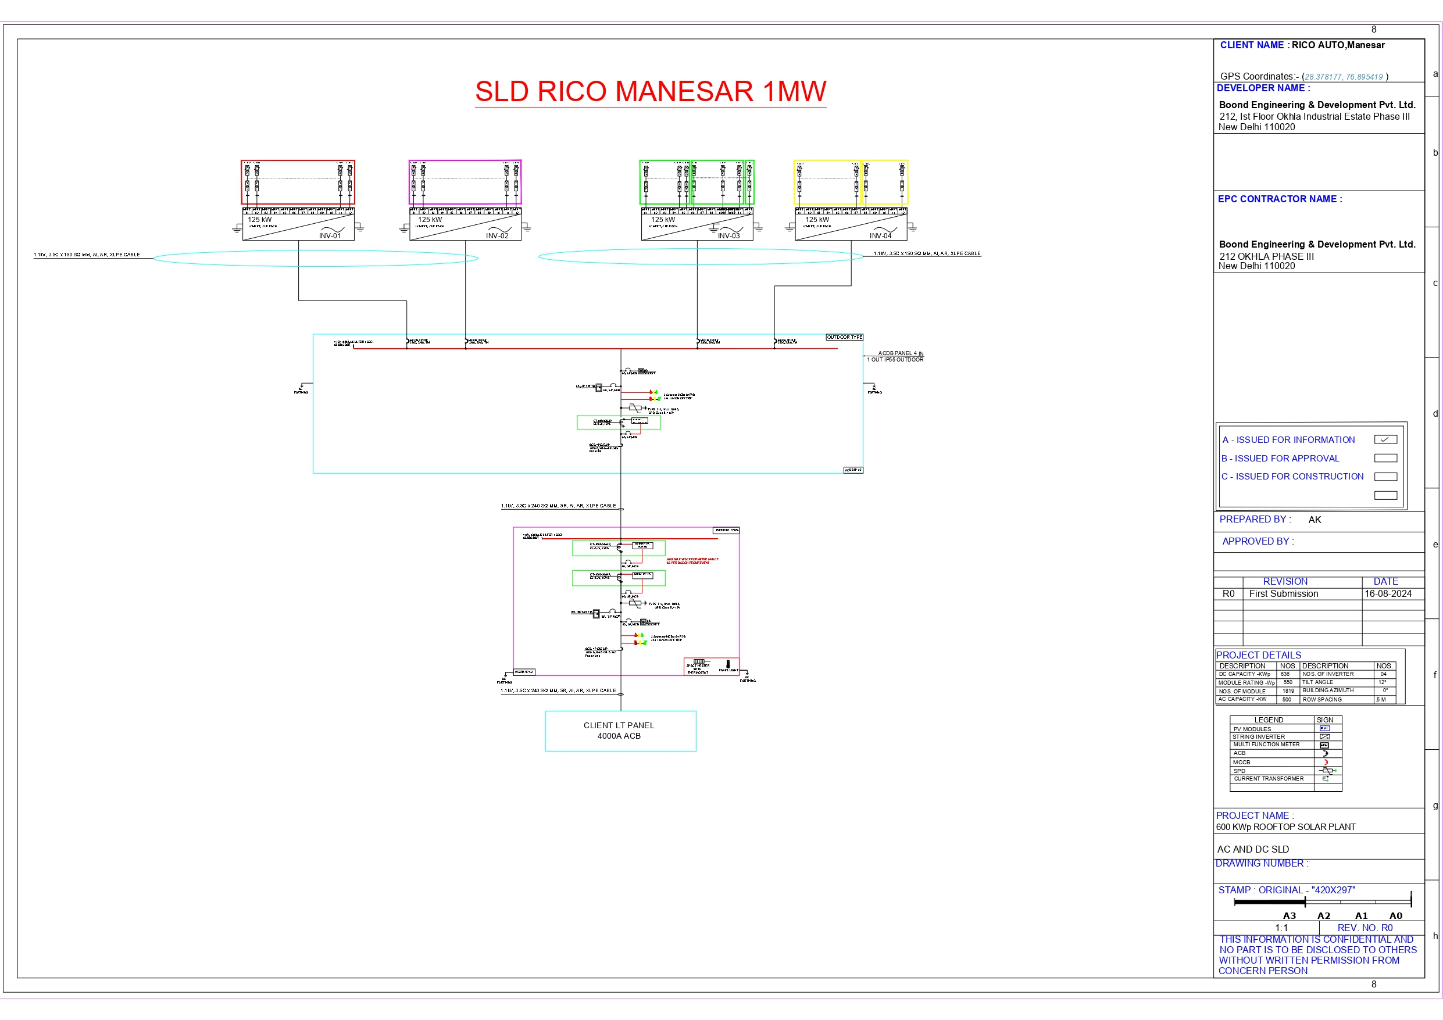
Appendix B– AC-DC Single line Diagram

