**REPORT FORMAT:** CL-1 | Version: 1.0_2018

# FILE No.: VIS (2024-25)-PL482-431-600 Date: 06-11-2024

* **REPORT NAME:** Physical Verification Report for the machinery and equipment.
* **FOR ORGANIZATION:** EXIM Bank India, M.G Road, Bengaluru.
* **BORROWER COMPANY’S NAME:** M/s. Mysore ESDM Cluster.
* **ASSET TYPE**: Machinery & equipment required for Testing of Advanced Electronics.
* **CURRENT LOCATION OF THE MACHINES:** Plot No. – 336/4 & 336/5, Infosys Road, Hebbal Industrial Area, Mysore, Karnataka - 570016

**TO WHOMSOEVER IT MAY CONCERN**

|  |  |  |
| --- | --- | --- |
| **S. NO.** | **PARTICULARS** | **DESCRIPTION** |
| 1. | Date of Survey | 27-10-2024 |
| 2. | Date of Report | 06-11-2024 |
| 3. | Documents provided for perusal | * List of machines * Installation and Commissioning Report |
| 4. | Current Location of the Machines | Plot No. – 336/4 & 336/5, Infosys Road, Hebbal Industrial Area, Mysore, Karnataka - 570016 |
| 5. | Borrowing Company | M/s. Mysore ESDM Cluster |
| 6. | Type of Asset | Machinery & equipment required for Testing of Advanced Electronics |
| 7. | Type of Assessment | Physical Verification of machines purchased, installed |
| 8. | Scope of Assessment | Physical Verification of machines purchased, installed |
| 9. | Nature of Machinery | Machinery & equipment required for Testing of Advanced Electronics |
| 10. | Current Status of the machines | As per physical inspection made during site visit, company has installed all the machines and equipment’s as per the list provided. |
| 11. | Condition of Machines | Purchased machines and equipment are new. |

## Status of Machinery & Equipment:-

|  |  |  |  |  |  |  |
| --- | --- | --- | --- | --- | --- | --- |
| **S. No.** | **Section** | **Supplier** | **Item Description** | **Qty. (in nos.)** | **Total Value (incl. of all Taxes)** | **Remarks** |
| 1 | Shock & Vibration | Spectral Dynamics | Shock & Vibration | 1 | 2,44,72,039 | Machines Installed |
| 2 | HALT & HASS | JOST Engg. | HALT & HASS | 1 | 1,55,76,000 |
| 3 | Rain Chamber | C K INSTO | Rain Test Equipments | 1 | 28,71,036 | Machines Installed |
| 4 | SAFETY | Onsys Technologies | Programmable - AC source+F6+F5:F68+F6+F5:F68+F+F5:F68 | 1 | 23,60,000 |
| 5 | Rain Chamber Room | CHANDI CREATIVES | Vibration Room construction | 1 | 19,18,080 | Machines Installed |
| 6 | SAFETY | Rohde & Schwarz India Pvt. Ltd | Oscilloscope -6 GHz | 1 | 11,21,055 |
| 7 | SAFETY | AARJAY INTERNATIONAL | Programmable - AC source ( CVCF) 5 KVA | 1 | 11,09,200 | Machines Installed |
| 8 | SAFETY | CONVERGENT | Digital Storage Oscilloscope 500MHz | 1 | 9,98,480 |
| 9 | SAFETY | AARJAY INTERNATIONAL | DC Power Supply ( Reversible ) | 1 | 9,44,000 | Machines Installed |
| 10 | SAFETY | Keith Electronics | Safety Analyzer | 1 | 6,99,740 |
| 11 | SAFETY | TEKIKNOW | Ferrite tile | 1 | 6,78,500 | Machines Installed |
| 12 | SAFETY | AVM INSUSTRIES | HFG | 1 | 5,84,100 |
| **13** | **SAFETY** | **COMPLUS** | **Calibration Adapters for EFT.** | **1** | **5,54,600** | **Sent for Calibration** |
| 14 | SAFETY | SCR | Surge generator | 1 | 5,05,040 | Machines Installed |
| 15 | Rain Chamber | APS CRANE | EOT Crane | 1 | 4,90,500 |
| 16 | SAFETY | SCR | Impulse generator | 1 | 4,66,100 |
| 17 | SAFETY | SCR | Impulse generator | 1 | 4,36,600 | Machines Installed |
| 18 | HALT & HASS | INDUS VACUUM AND CRYOJENIC | LN2 Pipe line | 1 | 4,16,319 |
| 19 | Flooring & Misc. | Raghuveer Enterprises | Partition Work | 1 | 3,97,434 | Machines Installed |
| 20 | SAFETY | AARJAY INTERNATIONAL | LCR METER- LAB | 1 | 3,71,700 |
| 21 | SAFETY | AARJAY INTERNATIONAL | Data Logger - Multichannel | 1 | 3,65,800 | Machines Installed |
| 22 | DROP | C K INSTO | DROP Test | 1 | 3,53,115 |
| 23 | SAFETY | AARJAY INTERNATIONAL | Digital Power Meter- 3P | 1 | 3,48,100 | Machines Installed |
| 24 | SAFETY | C K INSTO | Comparative Tracking Index Test | 1 | 3,13,285 |
| 25 | SAFETY | CONET | CDN M5 for CS TEST | 1 | 2,33,750 | Machines Installed |
| 26 | SAFETY | C K INSTO | Glow Wire Tester | 1 | 2,23,775 |
| 27 | SAFETY | C K INSTO | Cord Anchorage Test | 1 | 2,06,992 |
| 28 | Rain Chamber | BHAKTHI ENTERPRISES | Tile work | 1 | 2,00,536 | Completed |
| 29 | SAFETY | C K INSTO | Inclined Plane (Stability) | 1 | 1,67,560 | Machines Installed |
| 30 | SAFETY | C K INSTO | Pendulum Impact Test Apparatus(Ground Mount) | 1 | 1,65,593 |
| 31 | SAFETY | ANALITICAL ELECTRONIC SERVICES | Differential PROBE | 1 | 1,63,784 | Available at site |
| 32 | SAFETY | C K INSTO | Abrasion resistance test | 1 | 1,56,643 | Installed |
| **33** | **SAFETY** | **AVM INSUSTRIES** | **Differential PROBE DP-16K** | **1** | **1,44,550** | **Sent for Calibration** |
| 34 | SAFETY | C K INSTO | Spring Hammer | 1 | 1,40,982 | Machines Installed |
| 35 | SAFETY | CONVERGENT | TRUE RMS Multimeter 6-1/2 Digital Bench | 1 | 1,38,060 |
| 36 | SAFETY | TEKLAB | DC electronic load | 2 | 1,35,783 | Machines Installed |
| 37 | SAFETY | C K INSTO | Needle Flame | 1 | 1,23,076 |
| 38 | SAFETY | C K INSTO | Black test corner | 1 | 1,06,293 | Machines Installed |
| 39 | SAFETY | TEKLAB | DC electronic load | 1 | 82,408 |
| 40 | SAFETY | JK Powertronix | Resistive load 30 KVA | 1 | 81,000 | Machines Installed |
| 41 | SAFETY | T.SAIFUDDIN & CO | DIAL HEIGHT GAUGE | 1 | 80,809 |
| 42 | SAFETY | C K INSTO | Dead Weights set | 1 | 66,080 | Available at site |
| 43 | SAFETY | SAPHIRE | CLAMP METER | 1 | 53,994 |
| 44 | SAFETY | SAPHIRE | Digital Multi Meter | 3 | 31,915 | Available at site |
| 45 | SAFETY | SAPHIRE | Digital Tachometer | 1 | 26,187 |
| 46 | SAFETY | T.SAIFUDDIN & CO | Digital dial - indicator -4 | 1 | 26,012 | Machines Installed |
| 47 | SAFETY | T.SAIFUDDIN & CO | Digital dial - indicator -3 | 1 | 25,095 |
| 48 | SAFETY | C K INSTO | Articulated Test Finger | 1 | 24,615 | Available at site |
| 49 | SAFETY | C K INSTO | Wedge Probe UL 60950 | 1 | 24,615 |
| 50 | SAFETY | T.SAIFUDDIN & CO | Digimatic Vernier caliper | 1 | 24,064 | Available at site |
| 51 | SAFETY | C K INSTO | Sharp edge Test Corner | 1 | 22,937 |
| 52 | SAFETY | T.SAIFUDDIN & CO | Digital dial - indicator - 2 | 1 | 21,550 | Machines Installed |
| 53 | SAFETY | JK Powertronix | Resistive load 5 KVA | 1 | 21,000 |
| 54 | SAFETY | C K INSTO | Digital Push-Pull Gauge | 1 | 20,705 | Machines Installed |
| 55 | SAFETY | T.SAIFUDDIN & CO | Digital dial - indicator -1 | 1 | 20,012 |
| 56 | SAFETY | C K INSTO | Socket Gauge/Plug Gauge | 1 | 16,783 | Available at site |
| 57 | SAFETY | C K INSTO | IP 2X Test Probe (Jointed Test Finger) | 1 | 15,104 |
| 58 | SAFETY | C K INSTO | TEST PROBE 18 | 1 | 15,104 | Available at site |
| 59 | SAFETY | C K INSTO | TEST PROBE 19 | 1 | 15,104 |
| 60 | SAFETY | C K INSTO | Test Finger Nail Probe | 1 | 15,104 | Available at site |
| 61 | SAFETY | C K INSTO | Low Voltage Panel | 1 | 14,750 |
| 62 | SAFETY | SAPHIRE | CLAMP METER | 1 | 12,318 | Available at site |
| 63 | SAFETY | C K INSTO | TEST PROBE 31 (Ground Probe) | 1 | 11,748 |
| 64 | SAFETY | C K INSTO | 75mm test probe | 1 | 11,747 | Available at site |
| 65 | SAFETY | C K INSTO | Antenna Coaxial socket test plug | 1 | 11,210 |
| 66 | SAFETY | SAPHIRE | SOUND LEVEL METER | 1 | 10,897 | Available at site |
| 67 | SAFETY | C K INSTO | TEST PROBE 43 | 1 | 10,070 |
| 68 | SAFETY | JK Powertronix | Resistive load 2.5 KVA | 1 | 9,750 | Machines Installed |
| 69 | SAFETY | C K INSTO | Rigid Test Sphere Probe (IP1X Probe) | 1 | 8,950 |
| 70 | SAFETY | C K INSTO | IP 3X Probe | 1 | 8,950 | Available at site |
| 71 | SAFETY | C K INSTO | IP 4X Probe | 1 | 8,950 |
| 72 | SAFETY | C K INSTO | Test Probe 11 | 1 | 8,950 | Available at site |
| 73 | SAFETY | C K INSTO | TEST PROBE 32, Dia. 25 mm (AUTO 32) | 1 | 8,950 |
| 74 | SAFETY | C K INSTO | TEST PROBE 41 ( TEST THORN PROBE ) | 1 | 8,950 | Available at site |
| 75 | SAFETY | C K INSTO | UL 507 PA160B Test Probe | 1 | 8,950 |
| 76 | SAFETY | C K INSTO | Digital protector | 1 | 7,275 | Available at site |
| 77 | SAFETY | C K INSTO | RIGID SPHERE DIA. 12.5 | 1 | 6,713 |
| 78 | SAFETY | C K INSTO | LONG TEST PIN DIA (TEST PROBE 12) | 1 | 6,713 |

|  |  |  |  |  |  |  |
| --- | --- | --- | --- | --- | --- | --- |
| 79 | SAFETY | C K INSTO | TEST PROBE 13 | 1 | 6,713 | Available at site |
| 80 | SAFETY | C K INSTO | GAUGE FOR CHECKING NON-ACCESSIBILITY OF LIVE PARTS (TEST PROBE 14) | 1 | 6,713 |
| 81 | SAFETY | C K INSTO | TEST PROBE 17 | 1 | 6,713 |
| 82 | SAFETY | C K INSTO | Ball Pressure Test | 1 | 6,490 | Available at site |
| 83 | SAFETY | C K INSTO | TEST SPHERE ( STEEL SPHERE) | 1 | 4,475 |
| 84 | SAFETY | C K INSTO | TEST SPHERE DIA. 50, 0.51 kg  (With Hook) | 1 | 4,475 | Available at site |
| **Total** | | | | | **6,15,99,817** |  |

## OBSERVATIONS:

1. We have been provided with the list of machines that had been purchased/ installed by the company.
2. As per observation made during site survey, all the machines and accessories are installed and present at site except Differential PROBE DP-16K and Calibration Adapters for EFT which were sent by the company for calibration purpose for which we have received the copy of Gate Pass and the same is enclosed with the report also.
3. Based on the information provided by the subject company (M/s. Mysore ESDM Cluster), it is certified that all the machines are purchased and installed at the above-mentioned site address.

***Disclaimer:***

* 1. *This Physical Verification report is stated on the basis of the site visit by the surveyor and we don’t recommend any sort of recommendation in our Certificate.*
  2. *As per physical inspection and observation made during site visit dated 27th October, 2024. Company has installed all the machines mentioned in the provided list.*
  3. *This certificate doesn’t include any work related to drawing, design, sketch plan, and technical specifications of the machines.*
  4. *We have not verified Invoices, Ownership and other legal point of view in respect of the asset in this report as same is out of scope of this certificate.*
  5. *This certificate is made at the request of the Bank.*

**For R.K Associates Valuers & Techno FOR INTERNAL USE Engineering Consultants (P) Ltd.**

***TYPED BY:*** *Er. Man Mohan*

***REVIEWED BY:*** *Er. Abhinav Chaturvedi*

# ANNEXURE: LIST OF MACHINES AS PROVIDED BY THE CLIENT

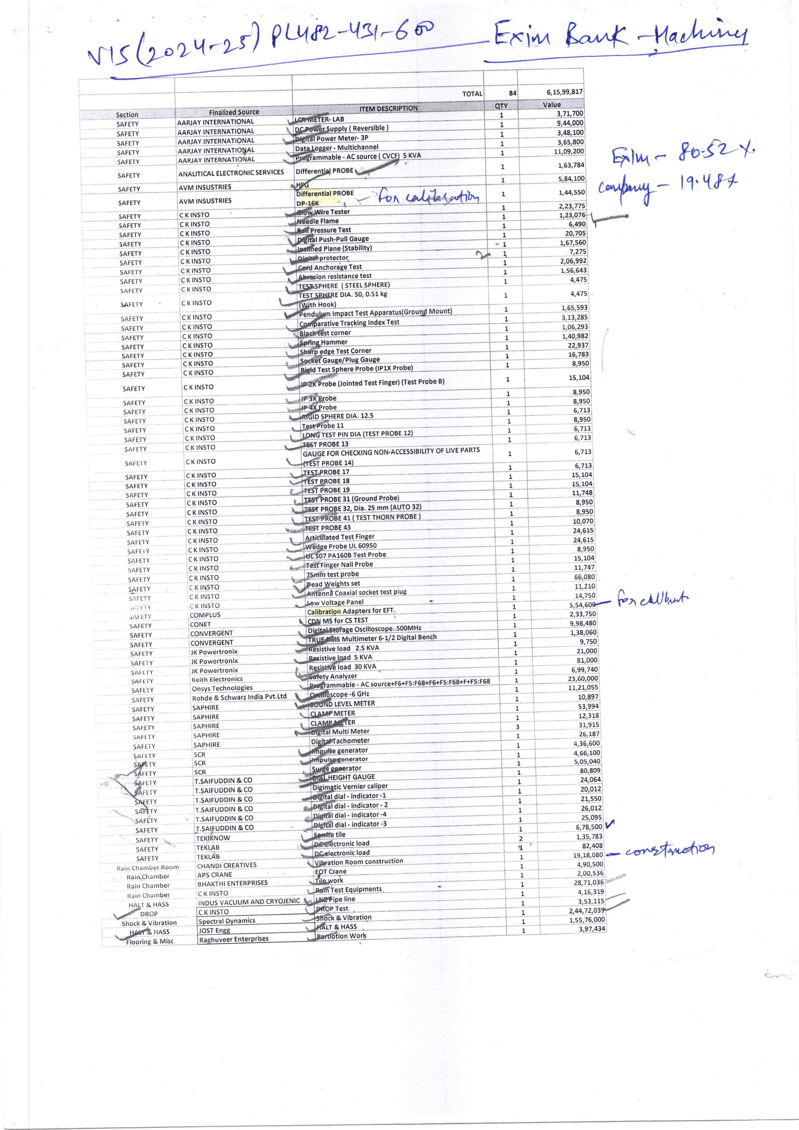

# GATE PASS

|  |
| --- |
|  |
|  |

# INSTALLATION REPORT

# HALT/ HASS CHAMBER

# 

# SHOCK & VIBRATION SHAKER

# 

# ANNEXURE: PHOTOGRAPHS

|  |  |
| --- | --- |
| **SHOCK AND VIBRATION** | **CONTROLLER OF SHOCK & VIBRATION** |
| **HALT & HASS** | **HALT & HASS** |
| **RAIN TEST EQUIPMENTS** | **DROP TEST EQUIPMENT** |

|  |  |
| --- | --- |
| **SURGE METER** | **10 KVA IMPULSE TESTER** |
| **LOAD TESTER** | **GLOW WIRE TESTER** |
| **NEEDLE FLAME TESTER** | **LN 2 PIPELINE** |

|  |  |
| --- | --- |
| **CORD ANCHORAGE** | **BLACK TEST CORNER** |
| **6GHZ OSCILLOSCOPE** | **FERRITE TILES** |
| **PARTITION WORK** | **SITE VISIT** |

|  |  |
| --- | --- |
| **BUILDING OF SHOCK & VIBRATION** | **INCLINE PLANE** |
| **EOT CRANE IN SHOCK & VIBRATION BUILDING** | **30 KVA POWER SOURCE** |
| **DIGITAL MULTIMETERS** | **CLAMP MULTIMETERS** |