**REPORT FORMAT:** CL-1 | Version: 1.0_2018

# FILE No.: VIS (2024-25)-PL493-442-615 Date: 20-12-2024

* **CERTIFICATE NAME:** Physical Progress Assessment Report of M/s. TT Distilleries Private Limited (TTDPL).
* **PREPARED FOR ORGANIZATION:** IFCI Venture Capital Funds Ltd.
* **BORROWER COMPANY’S NAME:** M/s. TT Distilleries Private Limited (TTDPL).
* **ASSET TYPE**: Project Civil work and Machines required for setting up Manufacturing unit for packaged drinking water.
* **LOCATION OF THE PLANT**: Karjipara, Alipurdwar-II, District- Alipurdwar, West Bengal Pin-736121.

|  |  |  |
| --- | --- | --- |
| **S. NO.** | **PARTICULARS** | **DESCRIPTION** |
|  | Date of Work Order | Via e-mail dated 18-10-2024 |
|  | Documents provided for perusal | * Land Deeds * Cost Estimate, DPR. |
|  | Project Location | Plot no. LR-162/757, Karjipara, Alipurdwar-II, District- Alipurdwar, West Bengal Pin-736121 |
|  | Borrowing Company | M/s. TT Distilleries Private Limited (TTDPL) |
|  | Type of Asset | Project Civil work and Machines required for setting up Manufacturing unit for packaged drinking water. |
|  | Type of Assessment | Physical Progress Assessment Report of Under-construction Manufacturing unit for packaged drinking water |
|  | Scope of Assessment | Physical Progress Assessment Report of Under-construction Manufacturing unit for packaged drinking water |
|  | Nature of Plant | Manufacturing unit for packaged drinking water. |
|  | Total Project Cost | **Rs. 268.72 Lakh** (*As per the List/ quotations / invoices / Cost Estimate/ documents provided by the company of machineries and civil works)* |
|  | Current Status of Project | As per the site visit, the construction of superstructure with brickwork and 90% plastering of office building is completed and shed structure is completed only minor finishing work is required. And all the Plant & Machinery is arrived at site and some additional machinery also found during site visit. Please refer to **PART A** for detailed analysis. |
|  | Total number of pages with Annexure. | 23 |

|  |  |
| --- | --- |
| **VALUATION ENGINEER** | **L1/ L2 REVIEWER** |
| Manmohan | Abhinav Chaturvedi |
|  |  |

|  |  |
| --- | --- |
| **PART A** | **PROJECT PHYSICAL PROGRESS ASSESSMENT** |

1. **EXECUTIVE SUMMARY:** M/s. TT Distilleries Private Limited is setting up a Manufacturing unit for Packaged Water at Plot no. LR-162/757, Karjipara, Alipurdwar-II, District- Alipurdwar, West Bengal. In respect to financial assistance of this Project, M/s. TT Distilleries Private Limited has approached IFCI Venture Capitals Fund Ltd. As per IFCI the project cost of the project as shown by the company is Rs.268.72 Lakhs.

|  |  |  |
| --- | --- | --- |
| **Sr. No.** | **Particulars** | **Project Cost (TT Distillery of 6,000 LPH)** |
| 1 | Land & Site Development | 3.00 |
| 2 | Shed & Building | 83.20 |
| 3 | Plant & Machinery | 106.17 |
| 4 | Other Fixed Assets | 24.65 |
| 5 | Preliminary & Pre-operative exp. | 2.70 |
| 6 | Interest During Construction | 19.00 |
| 7 | Margin Money for WC (25% of Total WC Requirement) | 30.00 |
| 8 | Miscellaneous Expenses | - |
| **TOTAL** | | **268.72** |

**Details of Civil Work & Land and Building:**

|  |  |  |  |
| --- | --- | --- | --- |
| **Sr. No.** | **Particulars** | **Area**  **(in Sq.ft.)** | **Status During Site Visit Dated 21.11.2024** |
| 1. | Office Building | 864 | Superstructure completed finishing work like doors, plastering and painting etc. left. |
| 2. | Working Shed | 5000 | Shed Structure completed only minor finishing work is required. |
| 3. | Lab Room | ~368 | It is built by only Aluminium Partition inside working shed. |
| 4. | Jar Washing and Refilling Section | ~180 | It is built by only Aluminium Partition inside working shed. |
| 5. | Boundary wall | --- | Completed for 33 decimals land parcel. |

**Observations Civil Works:**

1. The constructed built-up area is considered as per site visit because no relevant document was provided to us.
2. This progress assessment report is stated on the basis of the site visit by the surveyor and we don’t recommend any sort of recommendation in our Document.
3. This Document doesn’t include any work related to drawing, design, sketch plan, and technical specifications of the machines.
4. Ownership and other legal point of view in respect of the asset is not considered in this report as same is out of scope of this Document.

**Details of Plant & Machinery:**

|  |  |  |
| --- | --- | --- |
| **S. NO.** | **NAME OF MACHINERY** | **Status During Site Visit Dated 21.11.2024** |
| 1 | UV Ozonator, complete set, Vessels 3 Unit SS including SS tank 3,000 Ltrs 2 units | Machine Purchased & arrived at site |
| 2 | Batch Printing Machine | Machine Purchased & arrived at site |
| 3 | Automatic Filling cum washing cum capping machine (60 Bottle per minute) | Machine Purchased & arrived at site |
| 4 | Blowing Machine - 800 to 1000 Bottle per Hour (15 HP Compressor, moulds -500 ml, 1 Ltrs, 2 Ltrs) | Machine Purchased & arrived at site |
| 5 | Pipeline for filling & interconnectivity requirement (approx..) as per construction area- SS pines | Pipeline work 90% done as per site visit. |
| 6 | Laboratory Set-up as per IS: 14543:2004 Complete With Chemicals, Instruments & Glassware. | Equipments arrived at site |
| 7 | SS Tank - 40,000 Ltr | Storage Tanks found at site are 3nos. 5000 Ltr. PVC water tanks. |

**Observations Plant & Machinery:**

1. We have been provided with the DPR for the machines/ equipment proposed to be installed by the borrower company. Please refer to annexures for the list of machines.
2. This progress assessment report is stated on the basis of the site visit by the surveyor and we don’t recommend any sort of recommendation in our Document.
3. As per site visit and information provided by the client it seems to appear that all the Machines/Equipments already placed as per the plant layout and installation is in progress.
4. As per physical inspection and observation made during site visit dated 21st November, 2024 almost all machines mentioned in the provided list have arrived at site and proposed to be installed and commissioned within 2 months. But 2 nos. of SS Tank of 40,000 Ltr. Capacity is seems to be replaced with the 3 nos. 5000 Ltr. PVC tanks.
5. This Document doesn’t include any work related to drawing, design, sketch plan, and technical specifications of the machines.
6. Ownership and other legal point of view in respect of the asset is not considered in this report as same is out of scope of this Document.
7. This Document is made at the request of the Bank.

***DISCLAIMERS:***

1. *We have not received BOQ and receipts of material machines procured and contract agreement for site work. This report is purely based on the site visit and physical existence of machine rather than its technical specifications.*
2. *We also found few machinery which is not mentioned in the list like the Auto Bottle Wrapping machine.*
3. *The client/ owner and its management/ representatives warranted to us that the information they have supplied was complete, accurate and true and correct to the best of their knowledge. All such information provided to us either verbally, in writing or through documents has been relied upon in good faith and we have assumed that it is true & correct without any fabrication or misrepresentation. I/We shall not be held liable for any loss, damages, cost or expenses arising from fraudulent acts, misrepresentations, or willful default on part of the owner, company, its directors, employee, representative or agents.*
4. *Legal aspects for eg. Investigation of title, ownership rights, lien, charge, mortgage, lease, sanctioned maps, and verification of documents provided to us such as title documents, Map, etc. from any concerned Govt. office etc. have to be taken care by legal expert/ Advocate and same is not done at our end. I/ We assume no responsibility for the legal matters including, but not limited to, legal or title concerns.*
5. *Wherever any details are mentioned in the report in relation to any legal aspect of the property such as name of the owner, leases, etc. is only for illustration purpose and should not be construed as a professional opinion. Legal aspects are out of scope of this report. Details mentioned related to legal aspect are only based on the copy of the documents provided to us and whatever we can interpret as a non-legally trained person. This should be cross validated with a legal expert. We do not vouch any responsibility regarding the same.*
6. *We have relied on the data provided to us by bank/client.These sources are believed to be reliable and therefore, we assume no liability for the truth or accuracy of any data, opinions or estimates furnished by others that have been used in this analysis. Where we have relied on the data, opinions or estimates from external sources, reasonable care has been taken to ensure that such data is extracted from authentic sources, however we still can’t vouch its authenticity, correctness, or accuracy.*
7. *Documents, information, data including title deeds provided to us during the course of this assessment by the client is reviewed only upto the extent required in relation to the scope of the work. No document has been reviewed beyond the scope of the work. These are not reviewed in terms of legal rights for which we do not have expertise. Wherever any information mentioned in this report is mentioned from the documents like owners name, etc., it is only for illustration purpose and may not necessary represent accuracy.*

# ANNEXURES - (A) - INVOICES

**Civil Work for Partition in Shed**

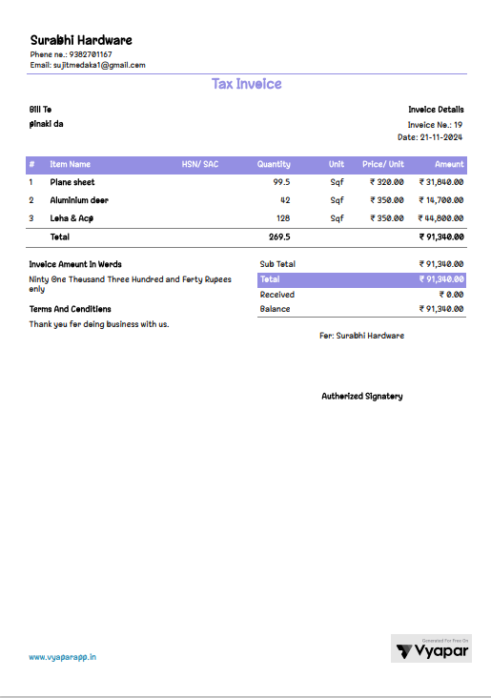

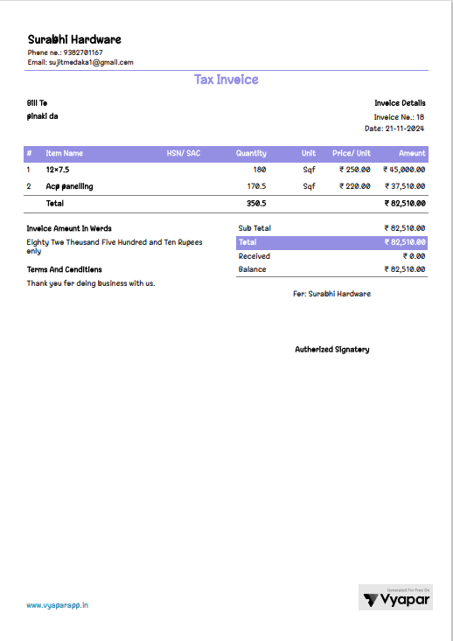

**Invoices of Machines**

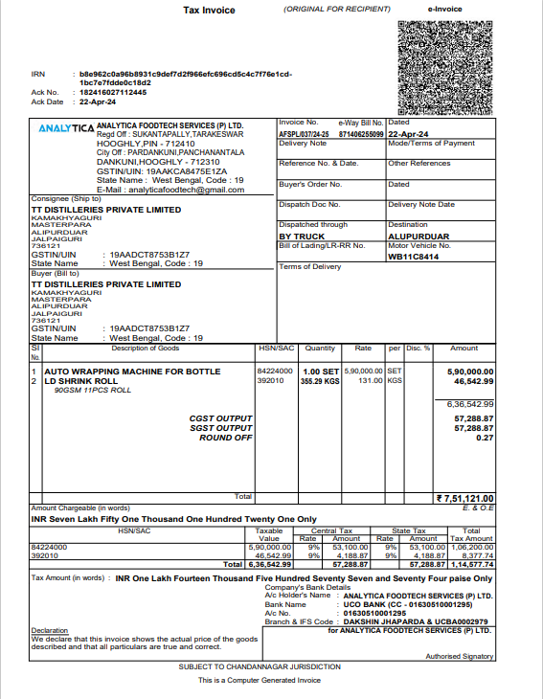

# ANNEXURE - (B) – IMPORTANT DOCUMENT EXHIBIT

**Land Deed**

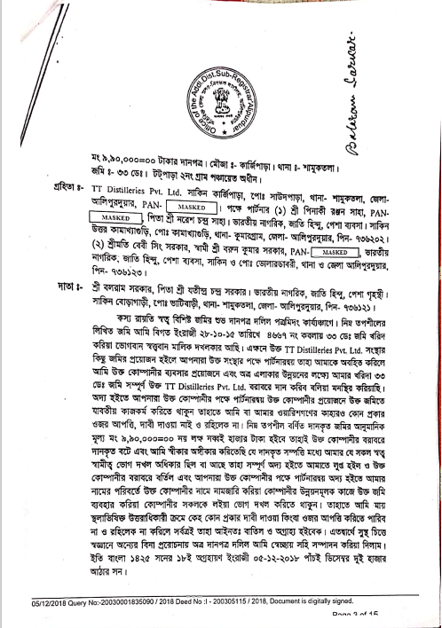

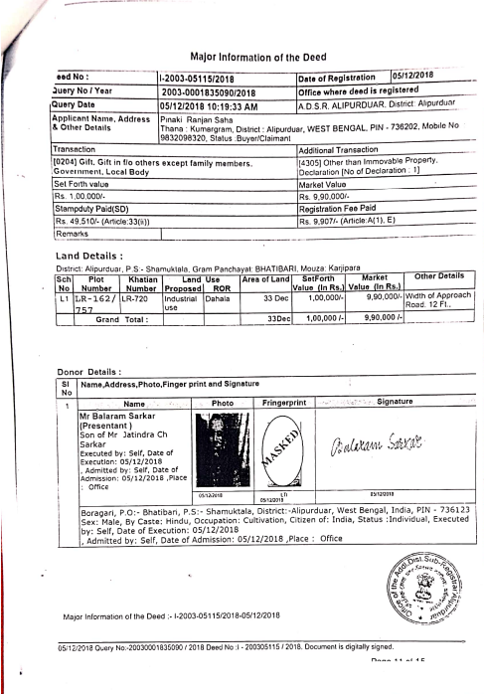

**Change of Land Use**

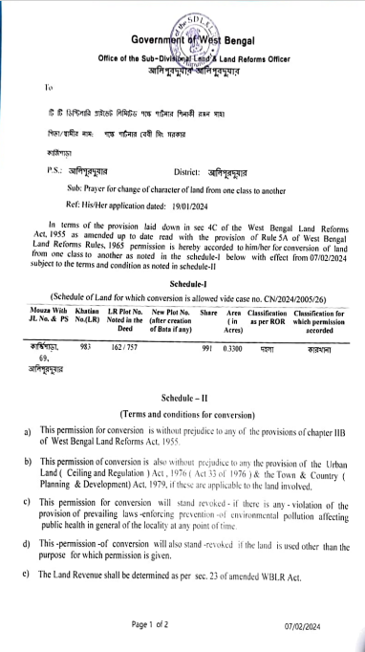

**Cizra Map**

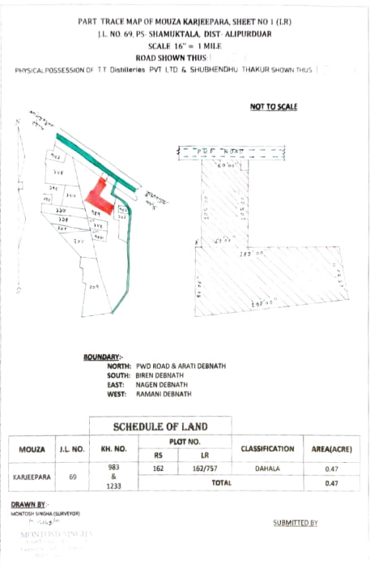

**Snapshot of DPR**

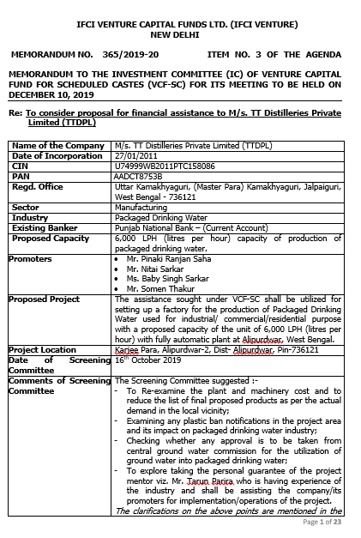

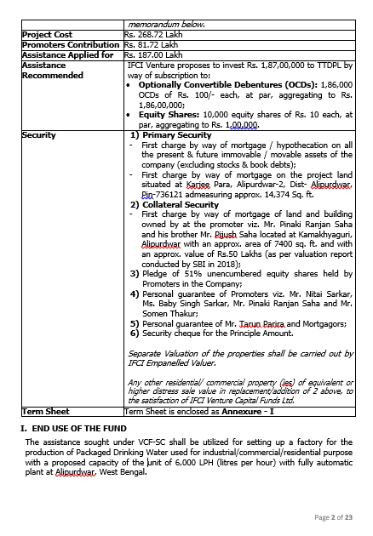

***Reference: DPR (IFCI)***

**List of Plant and Machinery**

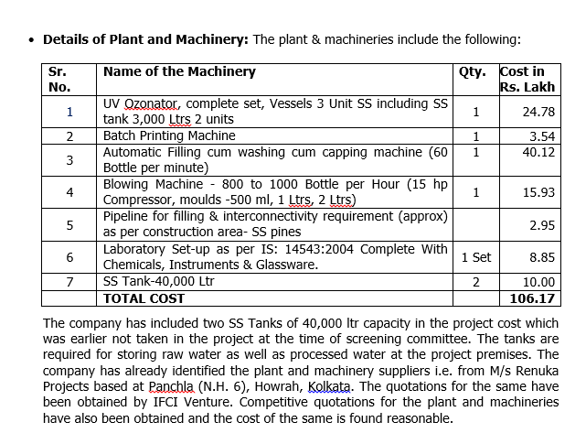

***Reference: DPR (IFCI)***

# ANNEXURE - (C) – SITE VISIT PHOTOGRAPHS

|  |  |
| --- | --- |
|  |  |
|  |  |
|  |  |

|  |  |
| --- | --- |
|  |  |
|  |  |
|  |  |

|  |  |
| --- | --- |
|  |  |
|  |  |
|  |  |

# ANNEXURE - (D) – NOC & APPROVALS

