IFCI VENTURE CAPITAL FUNDS LTD. (IFCI VENTURE)
NEW DELHI

MEMORANDUM NO. 365/2019-20 ITEM NO. 3 OF THE AGENDA
MEMORANDUM TO THE INVESTMENT COMMITTEE (IC) OF VENTURE CAPITAL FUND FOR SCHEDULED CASTES (VCF-SC) FOR ITS MEETING TO BE HELD ON DECEMBER 10, 2019
Re: To consider proposal for financial assistance to M/s. TT Distilleries Private Limited (TTDPL)

Name of the Company | M/s. TT Distilleries Private Limited (TTDPL)
Date of Incorporation | 27/01/2011
CIN | U74999WB2011PTC158086
PAN | AADCT8753B
Regd. Office | Uttar Kamakhyaguri, (Master Para) Kamakhyaguri, Jalpaiguri, West Bengal - 736121
Sector | Manufacturing
Industry | Packaged Drinking Water
Existing Banker | Punjab National Bank – (Current Account)
Proposed Capacity | 6,000 LPH (litres per hour) capacity of production of packaged drinking water.
Promoters | - Mr. Pinaki Ranjan Saha  - Mr. Nitai Sarkar  - Ms. Baby Singh Sarkar  - Mr. Somen Thakur
Proposed Project | The assistance sought under VCF-SC shall be utilized for setting up a factory for the production of Packaged Drinking Water used for industrial/ commercial/residential purpose with a proposed capacity of the unit of 6,000 LPH (litres per hour) with fully automatic plant at Alipurdwar, West Bengal.
Project Location | Karjee Para, Alipurdwar-2, Dist- Alipurdwar, Pin-736121
Date of Screening Committee | 16th October 2019
Comments of Screening Committee | The Screening Committee suggested :-  - To Re-examine the plant and machinery cost and to reduce the list of final proposed products as per the actual demand in the local vicinity;  - Examining any plastic ban notifications in the project area and its impact on packaged drinking water industry;  - Checking whether any approval is to be taken from central ground water commission for the utilization of ground water into packaged drinking water;  - To explore taking the personal guarantee of the project mentor viz. Mr. Tarun Parira who is having experience of the industry and shall be assisting the company/its promoters for implementation/operations of the project.  The clarifications on the above points are mentioned in the memorandum below.
Project Cost | Rs. 268.72 Lakh
Promoters Contribution | Rs. 81.72 Lakh
Assistance Applied for | Rs. 187.00 Lakh
Assistance Recommended | IFCI Venture proposes to invest Rs. 1,87,00,000 to TTDPL by way of subscription to:  - Optionally Convertible Debentures (OCDs): 1,86,000 OCDs of Rs. 100/- each, at par, aggregating to Rs. 1,86,00,000;  - Equity Shares: 10,000 equity shares of Rs. 10 each, at par, aggregating to Rs. 1,00,000.
Security | - Primary Security  - First charge by way of mortgage / hypothecation on all the present & future immovable / movable assets of the company (excluding stocks & book debts);  - First charge by way of mortgage on the project land situated at Karjee Para, Alipurdwar-2, Dist- Alipurdwar, Pin-736121 admeasuring approx. 14,374 Sq. ft.  - Collateral Security  - First charge by way of mortgage of land and building owned by at the promoter viz. Mr. Pinaki Ranjan Saha and his brother Mr. Pijush Saha located at Kamakhyaguri, Alipurdwar with an approx. area of 7400 sq. ft. and with an approx. value of Rs.50 Lakhs (as per valuation report conducted by SBI in 2018);  - Pledge of 51% unencumbered equity shares held by Promoters in the Company;  - Personal guarantee of Promoters viz. Mr. Nitai Sarkar, Ms. Baby Singh Sarkar, Mr. Pinaki Ranjan Saha and Mr. Somen Thakur;  - Personal guarantee of Mr. Tarun Parira and Mortgagors;  - Security cheque for the Principle Amount.  Separate Valuation of the properties shall be carried out by IFCI Empanelled Valuer.  Any other residential/ commercial property (ies) of equivalent or higher distress sale value in replacement/addition of 2 above, to the satisfaction of IFCI Venture Capital Funds Ltd.
Term Sheet | Term Sheet is enclosed as Annexure - I

- END USE OF THE FUND

The assistance sought under VCF-SC shall be utilized for setting up a factory for the production of Packaged Drinking Water used for industrial/commercial/residential purpose with a proposed capacity of the unit of 6,000 LPH (litres per hour) with fully automatic plant at Alipurdwar, West Bengal.

- DETAILS OF THE COMPANY

- Background:

The Company viz. M/s TT Distilleries Private Limited is a closely held Pvt. Ltd. The Company was incorporated on 27th January 2011 by Mr. Tarun Parira & Mr. Tapan Kumar Parira. In 2015, new promoters’ viz. Mr. Nitai Sarkar, Ms. Baby Singh Sarkar, Mr. Pinaki Ranjan Saha and Mr. Somen Thakur purchased the shares of above two shareholders and become the owners of the company. The company then acquired the project land and converted the same to Industrial Land (Karkhana) and has also initiated the construction work on it.

Presently, there are no operations in the company, but the promoters (group of friends) are already involved in varied business activities from past few years such as restaurant services, grocery shop, fisheries and trading of packaged drinking water. There is a huge demand of the packaged drinking water in entire Alipurdwar region and nearby districts of Kolkata and Assam and the small scale productions as mentioned above caters to the water requirements only in the local vicinity.

As per the survey conducted by the firm, there are approx. 24 number of running brands in west Bengal which includes national brands such as Bisleri, Kinley, Aquafina, Royal Challenge, KingFisher, McDowell, Bailley, Prime, Mother Dairy, etc. and some local brands such as Crystalline, Big Indian, Health, Titas, Top one, Delta, Teesta, Ganga Jamuna, etc. As per the survey conducted by the firm, the daily average production in the area is around 4,50,000 litres and the daily average consumption is around 7,90,000 litres. There is a deficit in daily average production and daily average consumption in the area and to fulfill the deficit, other brands are coming from outside West Bengal like Jharkhand, Bihar and Orissa.

Looking into the overall shortfall in the supply of the growing demands within the city, the Company now wants to supply its products in the other untapped parts of Alipurdwar and Jalpaiguri. For this, the company has planned to enter in the packaged drinking water industry and set up a manufacturing unit for the production of packaged drinking water which shall be utilized further for industrial/commercial/residential purposes at Karjee Para, Alipurdwar-2, Dist- Alipurdwar, West Bengal.

The promoters proposes to set up Packaged Drinking Water unit with an end product of 1 Ltr. Bottles, 2 Ltr Bottles, 20 Ltr Refill Jar and 600 ml Soda Bottles. The Company is proposing to setup the factory on owned premises at Alipurdwar, West Bengal. The company has already purchased a land admeasuring approx. 14,374 Sq. ft.

The project envisages production of purified RO water from underground raw water, production of preformed bottles with hot air blowers, packaging of purified water in such bottles, labeling, price coding and final packaging & selling them in the market with the trade mark of “Bliss ™” (not yet registered).

Further, the company has already identified plant and machinery suppliers i.e. M/s Renuka Projects based at Panchla (N.H. 6), Howrah, Kolkata.

- Promoters:

- Mr. Pinaki Ranjan Saha (Managing Director): He is 34 years old. He has completed his graduation. He has experience in running a restaurant and bar for past 8 years and he also owns a lodge. Now after understanding the demand and supply of the packaged drinking industry, he proposes to set up a production unit of packaged drinking water under TTDPL.

- Mr. Nitai Sarkar (Director): He is 41 years old, is a friend of Mr. Pinaki. He has completed his SSC education. He has experience in running a shop of wholesale grocery items for past 10 years.

- Ms. Baby singh Sarkar (Director): She is 34 years old. She is also a friend of Mr. Pinaki. She has completed her HSC education. She has experience of running wholesale business of fisheries for past 5 years.

- Mr. Somen Thakur (Director): He is 25 years old. He has completed his graduation. He has experience in the packaged drinking water industry for past 3 years as he has done trading business of the packaged drinking water in the region.

- Key Management Persons:

- Tarun Parira (Proposed Director): He is 49 years old. He has completed his graduation. He has experience of trading packaged drinking water and confectionary products and has an overall experience of around 25 years. He is well versed with the packaged drinking water industry and hence he shall act as a mentor in the proposed project and assist in establishment and marketing aspects of the project. He shall also become shareholder in the company in future.

"As per the Screening Committee suggestion for taking the personal guarantee of the project mentor viz. Mr. Tarun Parira, the same has been included in the security".

- Capital Structure & Shareholding Pattern:

- Capital Structure as on 31st March, 2019:

A. Authorized Capital | Amount (In Rs.)
10,00,000 Equity shares of Rs.10/-each | 1,00,00,000/-
B. Issued, Subscribed & Paid Up Capital
10,000 Equity shares of Rs.10/-each, fully paid up | 1,00,000/-
Note:- The above stated paid-up capital of the Company has been verified from the MCA’s website. Further the Authorized and Paid up capital shall be increased upon for the new project.

- Shareholding Pattern as on 31st March 2019:

S. No. | Name of Shareholder | No. of Share | Amount of Capital | Shareholding %
 | Mr. Pinaki Ranjan Saha | 5,100 | 51,000 | 51%
 | Mr. Nitai Sarkar | 500 | 5,000 | 5%
 | Mr. Baby singh Sarkar | 2,000 | 20,000 | 20%
 | Mr. Somen Thakur | 2,400 | 24,000 | 24%
Total |  | 10,000 | 1,00,000 | 100%
- The company is 51% held by Scheduled Caste promoters and thus meeting the eligibility criteria of VCF-SC.
- Past financials: Currently there are no operations in the company.

Balance Sheet As on 31st October 2019 (Provisional)
Particulars | Amount in Rs. Lakh
Paid-up Capital | 1.00
Share Application Money (Conversion to Paid up Capital is in process) | 30.00
Reserves & Surplus | 12.37
Networth | 43.37
Unsecured Loan | 3.29
Current liabilities | 0.035
Total Liabilities | 46.695
Fixed Assets | 16.05
Cash & Bank Balance | 0.03
Other Current Assets | 30.60
Total Assets | 46.695
Note:
- The increase of SAM of Rs.30 Lakhs to Paid up Capital of Company is in process.
- The reserve & surplus includes revaluation of land amount of Rs.14.55 lakh.
- Other current assets include Loans and Advances given for building/construction work at project premises.
- Fixed assets include cost of Land and building.

- Net-Worth of the Promoters/Shareholders of the Company:-
(in Rs. Lakh)
S. No. | Name of the Promoter | Net worth statement as on 31st Oct’ 19
 | Mr. Pinaki Ranjan Saha | 59,09,559/-
 | Mr. Nitai Sarkar | 17,11,740/-
 | Ms. Baby singh Sarkar | 18,93,217/-
 | Mr. Somen Thakur | 20,87,073/-
 | Mr. Tarun Parira | 21,39,033/-
TOTAL |  | 1,37,40,622/-

- CIBIL:-
Personal CIBIL Score
 | Mr. Pinaki Ranjan Saha | 762, as per CIBIL report dated 16th Oct’ 2019
 | Mr. Nitai Sarkar | 723, as per CIBIL report dated 16th Oct’ 2019
 | Ms. Baby singh Sarkar | 761, as per CIBIL report dated 16th Oct’ 2019
 | Mr. Somen Thakur | -1, Insufficient History To Score as per CIBIL report dated 16th Oct’ 2019
 | Mr. Tarun Parira | 660, as per CIBIL report dated 3rd Dec’ 2019

- NET WORTH ELIGIBILITY FOR ASSISTANCE
Rs. in Lakh.
Particulars | Share Capital (A) | Reserves and Surplus (B) | Share Application Money (C) | Net Worth (A+B+C+D)
Net Worth of the company as on 31/10/19 (Provisional) | 1.00 | 12.37 | 30.00* | 95.09
Additional Funds to be brought in by Promoters in the company for New Project (D) | 51.72** | 0 | 0 | 95.09
Proposed Total Net worth |  |  |  | 95.09
Assistance Requested From VCF-SC |  |  |  | 187.00
No. of times of Net Worth |  |  |  | 1.96
Whether the company is eligible for availing financial assistance (Yes/ No) |  |  |  | Yes
Note: *The existing paid-up capital of the Company which is Rs.1.00 Lakh and Share Application Money (SAM) of Rs.30 Lakhs is already in process of conversion to Paid Up Capital. Hence, as per provisional balance sheet the SAM has been taken into consideration for calculating the net worth eligibility of the proposed project as per the guidelines of VCF-SC and the same is in process for roc filling.

** These are the additional funds to be brought in by Promoters in the company for New Project in addition to the already spent amount of Rs.30 Lakh in the proposed project.

- PROPOSED PROJECT

- Proposed Project:

The promoters are willing to work in this industry from past many years and are developing clientele in the market. In order to cater to increased demands of the market, the Company is now proposing to set up a unit wherein the manufacturing of packaged drinking water used in industrial / commercial / residential purpose. The manufacturing will be done by the Company for supply to vast market including restaurants, wedding functions, parties and similar social occasions. The final products would be sold mainly through direct contacts and distributors. With increasing awareness about health and consequently increasing demand of packaged drinking water coming up at the state and national level, the demand for packaged drinking water is anticipated to continually improve.

The Company will produce different products such as packaged drinking water in 1 Ltr. Bottles, 2 Ltr Bottles, 20 Ltr Refill Jar and 600 ml Soda Bottles. The proposed capacity of the unit shall be 6,000 LPH (litres per hour) of drinking water.

The Company is proposing to setup the factory on owned land at Alipurdwar. The company has already purchased a land admeasuring approx. 14,374 Sq. ft. at Karjee Para, Alipurdwar-2, Dist- Alipurdwar, West Bengal.

The project envisages setting up of manufacturing facility with basic infrastructure with civil works and complete plant including automated machineries for production of purified RO water from raw water, production of preformed bottled with hot air blowers, packaging of purified water in such bottles, labeling, price coding and final packaging & sell them in the market with the trade mark of " Bliss ™ ".

- Project Location

The company has already purchased a land admeasuring approx. 14,374 Sq. ft. at Karjee Para, Alipurdwar-2, Dist- Alipurdwar, West Bengal.

Connectivity | Approx. Distance ( in Km.)
Railway | 10 km
Airport | - km
- Product: Following are the proposed Product Line and their Capacities:

20 Litre Jars: Mostly 20 litres can be supplied to households, industries, offices, schools and colleges. | 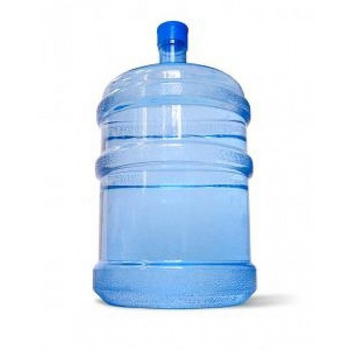
2 Litre bottle: 2 litres bottles are being introduced to slowly and steadily replace the conventional 1 litre bottles. Small offices, households, shopkeepers shall be the consumers for 2 litre bottles.  1 Litre bottle: 1 litre bottles account for 30 per cent of the share in industry. It’s perfect for general consumers and travellers. | 
600 ml soda bottle: The 600 ml soda bottles category refocused as a trendy product, targeted at the teenage crowd and for the roadside consumers. | 

Further, the company shall have the flexibility to interchangeably produce varied sizes of packaged water as per the requirement of the customers.

- Production Capacity:

Installed Capacity of the plant will be 6,000 LPH (Ltr. Per Hour). The plant shall be operated for 1 shift per day of 8 hour. At 100% capacity utilization, the plant shall be operated for 25 days in a month and therefore the annual production capacity of the plant shall be 1,44,00,000 Ltrs. The packaging of water would tentatively be as per below mentioned categories:

Sr. No | Products | Production Mix in %
1 | 1 Ltr. Bottle | 50.00%
2 | 2 Ltr. Bottle | 20.00%
4 | 20 Ltr. Refill Jar | 20.00%
5 | 600 ml. Soda Bottle | 10.00%
Total |  | 100%
"As per the Screening Committee suggestion for reducing the list of final proposed products as per the actual demand in the local vicinity, the earlier proposed 250 ml bottle is removed from the business plan"

- PROJECT COST & MEANS OF FINANCE

"As per the Screening Committee suggestion for re-examining the plant and machinery cost, the revised list of plant and machinery and its cost is as below"

- Project Cost:
(Amount in Rs. Lakh)
Sr. No. | Particulars | Amount as presented in Screening Committee | Revised Project Cost (TT Distillery of 6,000 LPH)
1 | Land & Site Development | 15.00 | 3.00
2 | Shed & Building | 83.20 | 83.20
3 | Plant & Machinery | 96.17 | 106.17
4 | Other Fixed Assets | 24.65 | 24.65
5 | Preliminary & Pre-operative exp. | 2.70 | 2.70
6 | Interest During Construction | 19.00 | 19.00
7 | Margin Money for WC (25% of Total WC Requirement) | 31.00 | 30.00
8 | Miscellaneous Expenses | - | -
TOTAL |  | 271.72 | 268.72

- Means of Finance:-
(Amount in Rs. Lakh)
Means of Finance Particulars | Amount as presented in Screening Committee | Revised Amount for Proposed Project | % Holding
Promoters Contribution (in Equity) | 90.72 | 81.72 | 30.41%
Assistance under VCF-SC (in Equity) | 1.00 | 1.00 | 69.59%
Assistance under VCF-SC (in OCDs) | 180.00 | 186.00 | 69.59%
TOTAL | 271.72 | 268.72 | 100%
* The promoters will arrange their contribution towards the proposed project from their own sources.
- Notes to the Project Cost:

- Land development: The cost of the site development is Rs.3 Lakh. The cost of project land was considered in the screening committee and the same has been excluded from the revised project cost.

- Factory Building: The amount includes cost towards construction of factory shed, office building, boundary wall and gate. The civil estimate has already been taken for the complete construction work from M/s D.K. Sarkar & Co.

Sr. No. | Particulars | Amount in Rs.
1. | Factory Shed | 41,32,119
2. | Office Building | 27,13,891
3. | Boundary Wall & Gate | 14,69,515
 | TOTAL | 83,15,525

- Details of Plant and Machinery: The plant & machineries include the following:

Sr. No. | Name of the Machinery | Qty. | Cost in Rs. Lakh
1 | UV Ozonator, complete set, Vessels 3 Unit SS including SS tank 3,000 Ltrs 2 units | 1 | 24.78
2 | Batch Printing Machine | 1 | 3.54
3 | Automatic Filling cum washing cum capping machine (60 Bottle per minute) | 1 | 40.12
4 | Blowing Machine - 800 to 1000 Bottle per Hour (15 hp Compressor, moulds -500 ml, 1 Ltrs, 2 Ltrs) | 1 | 15.93
5 | Pipeline for filling & interconnectivity requirement (approx) as per construction area- SS pines |  | 2.95
6 | Laboratory Set-up as per IS: 14543:2004 Complete With Chemicals, Instruments & Glassware. | 1 Set | 8.85
7 | SS Tank-40,000 Ltr | 2 | 10.00
 | TOTAL COST |  | 106.17

The company has included two SS Tanks of 40,000 ltr capacity in the project cost which was earlier not taken in the project at the time of screening committee. The tanks are required for storing raw water as well as processed water at the project premises. The company has already identified the plant and machinery suppliers i.e. from M/s Renuka Projects based at Panchla (N.H. 6), Howrah, Kolkata. The quotations for the same have been obtained by IFCI Venture. Competitive quotations for the plant and machineries have also been obtained and the cost of the same is found reasonable.

Few of the customers of plant and machinery supplier viz. M/s Renuka Projects are as below:-

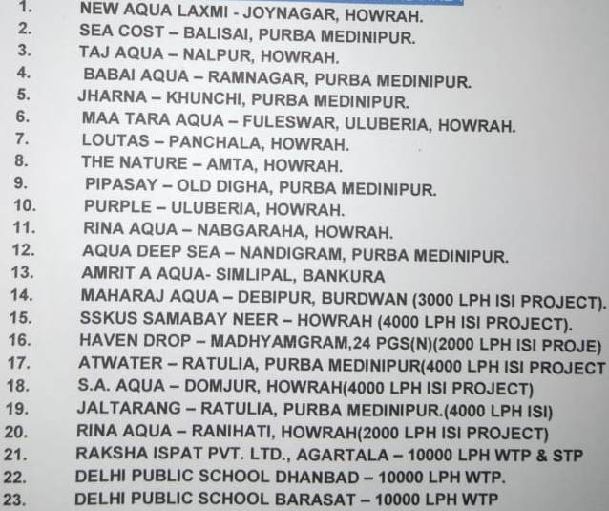

Note: The above supplier / vendor may change during the actual implementation period based on their availability, costs offered for supply of products and delivery timelines made available to the company / its promoters.

- Other Fixed Assets:

Item No. | Particulars | Amount in Rs. Lakh
1 | Electrical Installations | 8.75
2 | Furniture & Fixture | 2.50
3 | Computer | 1.70
4 | Submersible | 2.20
5 | Generator | 9.00
6 | Moulds | 0.50
TOTAL |  | 24.65
- Preliminary and Pre-operative expenses:

Particulars | Amount in Rs. Lakh
Establishment & Capital Issue Expenses | 1.50
Taxes | 0.20
Travelling & Conveyance | 0.50
Other Miscellaneous Expenses | 0.50
Total | 2.70

- Working Capital Margin: The Company proposes to take working capital loan of Rs.90 Lakh from bank and margin money is being provided by VCF-SC of approx. Rs 30 Lakh.

- UTILITIES

Item | Requirement
Power | The required load is expected to be around 45 KV. Electricity shall be available from West Bengal State Electricity Board and a transformer of 65 KV shall be installed at the project premises. A DG of same capacity is been taken in the proposed project as a backup supply of electricity.
Water | Water is available from bore well at the site which would be sufficient and fulfill the requirements. As per the promoters, the water was available at a depth of 20-30 ft. underground.

- MANPOWER REQUIREMENT

The Company proposes to work in two shifts of 8 hours each in a day. Since the plant would be an automatic plant hence required workforce/manpower shall be limited and the details of the same are as given under:

S. No. | Particulars | No. of Workers
1 | Manager | 2
2 | Chemist | 2
3 | Office Staff | 4
4 | Skilled Labour | 10
5 | Semi Skilled Labour | 2
6 | Unskilled Labour | 12
 | Total | 32

- RAW MATERIAL AND IT’S AVAILABILITY:

The project require following raw material for the proposed project.

"As per the Screening Committee suggestion for checking whether any approval is to be taken from central ground water commission for the utilization of ground water into packaged drinking water, the below clarification is provided".

- Water: The water capacity required in the plant shall be extracted from Bore Well already available at the project premises. The company has already taken approval from Gram Panchayat (Permit Copy available with IFCI Venture) for utilizing the ground water for packaged drinking water. The company has also taken the permit for sinking of well at the project premises from Office of the Geologist, Jalpaiguri. As per Central Ground Water Commission (CGWA), there is no requirement of NOC for ground water withdrawal to Industrial / Infrastructural / Mining Projects in the State of West Bengal.

TDS contents of underground water: The Company has submitted the Chemical and Microbiological Analysis report provided by Water Resource Investigation & Development Department, Government of West Bengal of underground water available at the site. The TDS content of underground water is 140 mg/l. As per the promoters, the water was available at a depth of 20-30 ft. underground.

- Preform Bottles:
- Preform for PET Bottles
- Cap for PET Bottles
- LDPE Film for Shrink Wrapper
- BOPP Labels for PET Bottles

- Label;

- Packaging materials.
[
* The abovementioned raw material shall be procured from local vendors of Kolkata.

- MANUFACTURING PROCESS:
The water is processed with multi stage purification processes such as – sand filter, activated carbon filter, ultraviolet disinfection, ultra filtration, Reverse Osmosis and Ozonization. The major steps involved on the purification process are given below:

- Water treatment & Purification
- Mixing of negligible mineral necessary for human life.
- RFC (rinsing filling & cleaning)
- Inspection and Packing
- Dispatch
- Raw water to be processed is collected in tanks. A known quantity is pumped in to the above tank where the water is dozed with alum for coagulation with heavy metals or insoluble matters. The water after coagulation is allowed to settle for an hour. The impurities may be removed by reserved osmosis techniques also. The supernatant water is taken to the chlorination tank where primary disinfection is brought about by bubbling chlorine gas. The water is then passed through sand filters for trapping of undissolved impurities. The water after sand filtration is passed through carbon filters for removal of odour, colour and also for dechlorination. It is then passed through series of micro fillers comprising 5 micron, 1 micron and 0.4 micron filter followed by ultraviolet disinfection system for terminal disinfection. Packing is done in PET bottles of 1 litre capacity through an automatic rinsing, filling and capping machine fitted with an ozone generator. The bottles after capping are shrink wrapped (optical) and packed in corrugated boxes of one dozen each. The plain drinking water has to be bottled in pet bottle as per IS: 14543:1998.
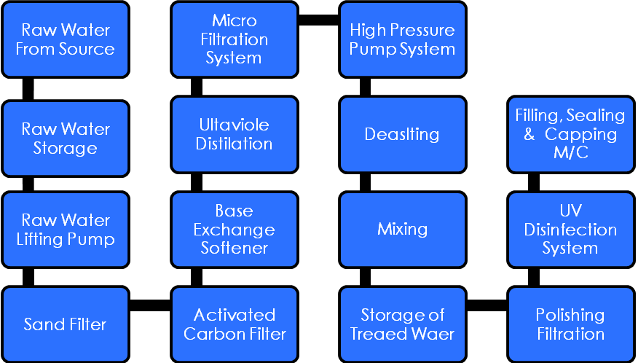
- POLLUTION CONTROL SYSTEMS:-

- Water waste: Reject water from RO / plant will be used partially for outer bottle cleaning purpose of used Jars, reuse to lower TDS waste water, internal floor cleanings and remaining will be used for rain water harvesting. The water left after processing ground water shall be discharged in the ground itself for maintaining the ground water level.

- Solid waste: Solid waste like rejected pet preforms / plastic waste / paper waste will be disposed off to scrap vendors for recycling.

- IMPLEMENTATION SCHEDULE:-

Activity | Required Period | Start Period | End Period
Land | Already Available
Land development | 1 month | 1st Month | 2nd Month
Building Construction | 5 months | 2nd Month | 6th Month
Plant & Machinery - Ordering | 1 month | 5th Month | 6th Month
Plant & Machinery - Delivery | 2 month | 7th Month | 8th Month
Plant & Machinery - Erection | 2 months | 9th Month | 10th Month
Commencement of commercial operations | 2 months | 10th Month | 12th Month

- PERMISSIONS AND APPROVALS:

Sl. No. | Particulars | Status
 | BIS Registration Certification | To be applied post installation & commissioning of Plant
 | Pollution Control Certification | Consent to Establish Certificate from Pollution Control Board received
 | Testing Reports of the Raw and Pure Water | To be applied post installation & commissioning of Plant
 | FSSAI | To be applied post installation & commissioning of Plant
 | SSI Registration | Obtained
 | Pest Control Certificate | Obtained
 | Trade Mark " Bliss ™ " | To be registered

- MARKETING STRATEGY:

- As the consumers are becoming hygiene conscious and their purchasing power is also increasing, they are moving towards mineral / packaged drinking water. Both domestic and international tourists are the potential customers of bottled water because of the scarcity of pure drinking water in most parts of the country.

- The Promoters have indicated that they will conduct market survey and short listing of area for Retail outlets, Distributors, Corporate Sector and Institutional Sales.

- Publicity & Advertising: The company shall undertake following activities like Media Coverage, Editorial Services, Arranging Press Conferences, Generating News-Stories, enhancing reach through social applications (Facebook, Twitter, Google etc.) appointing Brand Ambassador, Designing & Printing, Content Development, Designing of Stalls for Exhibitions & launch their product in the market with the trade mark of Bliss™.

- The company has already received few Work Orders / Expression of Interests within Alipurdwar and nearby districts for their proposed products mainly from:-

S.No. | Name of Distributor / Vendor | Quantity in Ltrs per day
 | M/s Sarkar Enterprise | 10,000
 | M/s Rupmahal Enterprise | 20,000
 | M/s Agarwal Agency | 15,000
 | M/s Anuarul Enterprise | 15,000
 | M/s Rishi Enterprise | 20,000
 | M/s Jyoti Industries | 15,000
Total |  | 95,000 Ltrs per day

- NEWS ON PLASTIC BAN AND ALTERNATIVES FOR PACKAGED DRINKING WATER:-

"As per the Screening Committee suggestion for examining any plastic ban notifications in the project area and its impact on packaged drinking water industry, the below clarification is submitted".

- Food ministry asked manufacturers of packaged drinking water, like Pepsi and Coco Cola, to come up with alternative packaging. In view of above, All India Association of Natural Mineral Water Industry, Secretary, Mr. Behram Mehta said the packaged bottle water industry uses PET (polyethylene terephthalate), which is 100% recyclable and even used globally. He said the industry has achieved 92% recycling and will soon achieve 100%. Mr. Mehta who is also an MD of AVA Natural Mineral, said the bottled water industry is worth Rs.30,000 crore. The entire plastic industry is worth Rs.7.5 lakh crore and involves 7 (seven) crore people. Mr. Mehta stressed that paper, glass and steel are neither an affordable alternatives nor environment friendly.

Source: https://economictimes.indiatimes.com/news/politics-and-nation/food-ministry-seeks-alternatives-for-packaged-drinking-water/articleshow/71049611.cms

- Packaged water industry warns government on plastic ban. The packaged drinking water industry told the government that the PET bottles used by them should not be classified as single use plastic (SUP) and warned of adverse impact on the Rs 30,000 crore industry since no alternative was immediately possible. Government officials also admitted that currently there is no definition of single use plastic (SUP) in India.

Source: https://timesofindia.indiatimes.com/india/classifying-packaged-water-bottles-as-single-use-plastic-will-impact-rs-30000-crore-industry/articleshow/71054974.cms
- In the states of Maharashtra and Odisha, Government had banned pet water bottle of small capacities i.e. 200 ml. and 500 ml. while Odisha has banned the ones of less than 500 ml. It may be mentioned that packaged drinking water of 1 ltrs and more is highly consumable item on daily basis in the country.

- SITE VISIT REPORT

IFCI Venture officials visited the site of the company at Karjee Para, Alipurdwar-2, Dist- Alipurdwar, West Bengal on 26th & 27th Nov’ 2019. The promoters of the company viz. Mr. Pinaki Ranjan Saha, Mr. Nitai Sarkar and Ms. Baby Singh Sarkar were present at the time of visit along with Mr. Tarun Parira. The fourth promoter i.e. Mr. Somen Thakur was not available at the time of visit as he was out of station. It was understood that they possess required knowledge for implementing the project. While interacting with the promoters, it was also understood that they were already involved in the trading business of packaged drinking water for past few years. It was informed by the promoters that they have market available and capabilities to tap the same from their existing networks. The promoter informed that they also have prospective clientele in the market for their proposed products and have also received expression of interests from them in written. The company is tying up for more such prospective clientele.

Few points observed during the site visit are mentioned below:

- The Project premise is well connected by road and also has easy access from National Highway;

- An area of approx. 14,374 Sq. ft. is currently available at the project premises for proposed factory installation. The company has already built the boundary wall and has also done the land leveling work. They have also installed main gate at the premises and have developed a temporary set-up used as labour room. The land is in the name of TTDPL. The same land shall be mortgaged with IFCI Venture.

- There are few other industries set-up nearby to the project premises such as Plywood industry.

- The electricity supply shall be made available at the premises through state electricity board. The electricity poles were already available at the location. The electric supply was also available at the premises;

- Water supply was already available through bore well at the site. As per the promoters, the water was available at a depth of 20-30 ft. However, the company has digged borewell to a depth of 365 ft for better quality of raw water;

- There is a river named Gadadhar within vicinity of 200-300 mtrs from which the farmers of the nearby agricultural fields procure water for their requirement of irrigation purposes.

- The property provided as collateral by the promoter was also visited at the time of site visit. The main promoter of the company viz. Mr. Pinaki Ranjan Saha already runs his existing business of Restaurant and bar at this property and he is also constructing rooms for serving the lodge facility. This collateral property exactly adjacent to the National Highway no. NH-31(c) and is a corner plot.

- Few site visit pictures are attached as Annexure - II.

- INDUSTRY OVERVIEW

Industry Overview:
- Bottled water market has emerged as one of the most rapidly growing and competitive markets worldwide. The global Bottled Water Industry is a multibillion dollar industry. It has been a remarkable growth trajectory for the sector.
- India is among the top ten countries in terms of bottled water consumption. Today Bottled Water is one of the India’s fastest growing industrial sectors.
- On the back of rising health awareness among citizens and inability of the Indian government to provide safe drinking water, bottled water industry has flourished during the past decade. Evolving perception of bottled water has made its consumption a bare necessity especially in the water scarce areas of the nation. And these factors will bring the next wave of growth in the sector.
- Along with these, rising disposable income, growing organized retail, rising awareness among the consumer segment and growing focus on product extension and quality will further stimulate the gains for the industry. Rising urban drift in the country will also be a wheel of growth for the industry. Estimation of the industry to grow at a CAGR of 18% and would be soaring to new heights..
Market & Competition Analysis
- The packaged bottled water industry in India is currently valued at Rs.6,000 Crore and has been growing @ 15% for the last three years. Value Notes estimates that the industry will be worth approximately Rs.16,000 Crore, growing at CAGR @ 22%.
- The packaged bottled water industry is segmented into:
- Packaged drinking water: Packaged drinking water means water derived from any source of potable water and subjected to various treatments to meet the prescribed standard before being packed in a plastic or glass container.
- Natural mineral water: Water containing less than 250ppm of total dissolved solids is defined as natural mineral water.
- Packaged drinking water, which holds about 85% of the market, is witnessing strong growth owing to various factors such as changes in life style, increase in Foreign Tourist Arrivals (FTAs), health awareness, etc. Natural mineral water on the other hand, which falls under the premium water segment and is primarily consumed by the urban populace owing to its high cost, will witness growth that will be restricted to urban consumers.
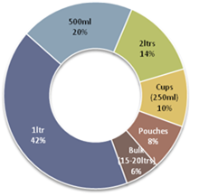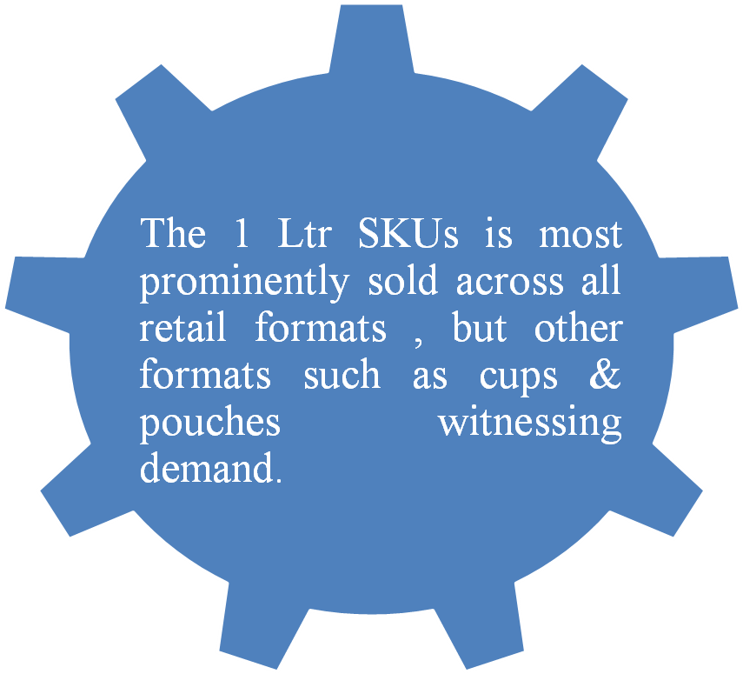
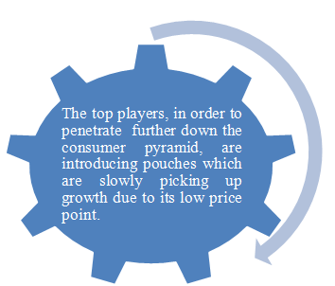
- The Bureau of Indian Standards (BIS) had formulated Indian Standard (IS) for packaged drinking water (PDW) and packaged natural mineral water (PNMW) under mandatory BIS certification as per Food Safety and Standards Regulation (FSS). This implementation led major players to acquire ISI and BIS certifications to avoid any cancellation of licenses.
- The increase in the number of domestic and foreign tourists in the past years, and in the years to come, is expected to be a major driver for bottled water sales in India.
- Catchment area of project: The range of Packaging Drinking Water targeted to following Areas:
- Retail Customer’s. | - Foods & Shopping Mall.
- Railway Station’s & Bus Stand | - Corporate Offices
- Toll Naka’s. | - Multiplex Theater’s
- Hospitals | - Marriage Hall
- Trade Fares & Exhibitions | - Garden
- Petrol pumps | - Government Offices
- Religious Places | - Schools & colleges
- Sports Ground | - Tourist spots
- Social & Public Gatherings | - Sponsorship for Orphanages’ & Hostels
- Market potential: Unfortunately sufficient safe potable water is not available everywhere in the country; either harmful chemical substance is found in the layers of the earth which enter into water or it may be contaminated due to pathogenic micro-organisms. If such water is consumed, the body suffers from water borne diseases. Due to this, it has become imperative to process and bottle safe potable water for mankind in the prevailing conditions. The demand for purified water becomes more during the summer season. Although few companies have already entered in the bottling of safe potable water and mineralized water, a huge gap still exist in between demand and supply at all metropolitan-cities and towns. The product is widely accepted in offices, restaurants, railway stations, airport, bus stands, and hospitals and to some extent even in rich house-holds. So there is good scope for establishing the units for processing and bottling plain and mineralized drinking water in different parts of the country.
Though a large number of manufacturers have recently taken up production of packaged drinking water, yet there exists a wide gap between demand and supply. A number of units can be set up in NE Region to meet the local demand in institutions, hotels, restaurants, offices, tourist and household.

In the peak Seasons from January to August however all the existing brands face an overall average shortage of 60 to 65% with the demand shooting up and supply falling down which is a clear indicative of the potential growth in the Industry.

- GOVERNMENT INITIATIVES

- Central Govt. Act: Mandatory policy for Central & State Govt. and their undertakings to purchase 4% of Goods & Products manufactured by SME Entrepreneurs belonging to SC community.

- xS

- Assumptions:

Particulars at 100% Capacity Utilization
Capacity (Ltrs/Annum) @ 6000/hr @ 1 shift per day of 8 hrs for 300 day/p.a. | 1,44,00,000
Sales in Liters | in Liters | No. of Units
a) 20 ltr Jar Sale @ 20% | 2,880,000 | 144,000
b) 1 ltr Bottle Sale@ 50% | 7,200,000 | 7,200,000
c) 600ml Soda Bottle Sale@ 10% | 1,440,000 | 2,400,000
d) 2 ltr Bottle Sale@ 20% | 2,880,000 | 1,440,000

 | 20 ltr Jar | 1 ltr Bottle | 600ml Soda Bottle | 2 ltr Bottle
Quantity per Box (Nos.) | 1 | 12 | 20 | 9
Sale Price Per Box (in Rs.) | 15 | 66 | 190 | 72
Sale Price Per Unit (in Rs.) | 15 | 5.5 | 9.5 | 8
Cost Per Box (in Rs.) | 5.13 | 48 | 101.6 | 46.35
Cost per Unit (in Rs.) | 5.13 | 4 | 5.08 | 5.15

Amount in Rs. Lakh
Particulars |  | Year 1 | Year 2 | Year 3 | Year 4 | Year 5 | Year 6 | Year 7
Capacity Utilization | 100% | 50% | 55% | 60% | 65% | 65% | 65% | 65%
Sales | 761 | 380.4 | 418.44 | 456.48 | 494.52 | 494.52 | 494.52 | 494.52
Cost of production | 491 | 245.73 | 270.31 | 294.88 | 319.45 | 319.45 | 319.45 | 319.45

- Profit and Loss Statement:

Amount in Rs. Lakhs
Particulars | Year 1 | Year 2 | Year 3 | Year 4 | Year 5 | Year 6 | Year 7
Capacity Utilization | 50% | 55% | 60% | 65% | 65% | 65% | 65%
Total Revenue | 380.40 | 418.44 | 456.48 | 494.52 | 494.52 | 494.52 | 494.52
Cost of Production | 245.73 | 270.31 | 294.88 | 319.45 | 319.45 | 319.45 | 319.45
Selling, Gen. & Adm. Exps. | 73.72 | 81.09 | 88.46 | 95.84 | 95.84 | 95.84 | 95.84
Depreciation | 21.40 | 21.40 | 21.40 | 21.40 | 21.40 | 21.40 | 21.40
VCF-SC Interest | 14.45 | 12.31 | 10.02 | 7.75 | 5.44 | 3.15 | 0.86
PBT | 25.09 | 33.33 | 41.72 | 50.08 | 52.39 | 54.68 | 56.97
Tax | 7.75 | 10.30 | 12.89 | 15.48 | 16.19 | 16.90 | 17.60
Net Profit | 17.34 | 23.03 | 28.83 | 34.61 | 36.20 | 37.78 | 39.37
Net Profit Margin (%) | 4.56% | 5.50% | 6.32% | 7.00% | 7.32% | 7.64% | 7.96%

- DSCR:
Amount in Rs. Lakhs
Particulars | Year 1 | Year 2 | Year 3 | Year 4 | Year 5 | Year 6 | Year 7
PAT | 17.34 | 23.03 | 28.83 | 34.61 | 36.2 | 37.78 | 39.37
Depreciation | 21.4 | 21.4 | 21.4 | 21.4 | 21.4 | 21.4 | 21.4
Interest on OCDs | 14.45 | 12.31 | 10.02 | 7.75 | 5.44 | 3.15 | 0.86
Sources of Funds | 53.19 | 56.74 | 60.24 | 63.75 | 63.04 | 62.33 | 61.63
Interest on OCDs | 14.45 | 12.31 | 10.02 | 7.75 | 5.44 | 3.15 | 0.86
Principal Repayment | 21.46 | 28.62 | 28.62 | 28.62 | 28.62 | 28.62 | 21.46
Application of funds | 35.92 | 40.92 | 38.63 | 36.36 | 34.05 | 31.77 | 22.32
DSCR | 1.48 | 1.39 | 1.56 | 1.75 | 1.85 | 1.96 | 2.76
Average DSCR | 1.65

- Balance Sheet:
Amount in Rs. Lakhs
Particulars | Year 1 | Year 2 | Year 3 | Year 4 | Year 5 | Year 6 | Year 7
Liabilities
Share Capital | 83.72 | 83.72 | 83.72 | 83.72 | 83.72 | 83.72 | 83.72
Reserves & Surplus | 29.71 | 52.74 | 81.57 | 116.18 | 152.38 | 190.16 | 229.53
Total Shareholder's Fund | 113.43 | 136.46 | 165.29 | 199.9 | 236.1 | 273.88 | 313.25
VCF-SC OCDs | 164.54 | 135.92 | 107.31 | 78.69 | 50.08 | 21.46 | -
Total Liabilities | 277.97 | 272.39 | 272.6 | 278.59 | 286.18 | 295.34 | 313.25
Assets
Net Block | 195.62 | 174.22 | 152.82 | 131.42 | 110.02 | 88.62 | 67.22
Cash and Bank Balances | 26 | 43 | 69 | 97 | 122 | 141 | 148
Other Current Assets | 18.78 | 18.39 | 16.93 | 16.72 | 18.05 | 21.91 | 32.68
Non Current Assets | 37.57 | 36.78 | 33.85 | 33.45 | 36.1 | 43.82 | 65.35
Total Assets | 277.97 | 272.39 | 272.6 | 278.59 | 286.18 | 295.34 | 313.25

- Payback Period:

Amount in Rs. Lakhs
Particulars | Year 1 | Year 2 | Year 3 | Year 4 | Year 5 | Year 6
PAT | 17.34 | 23.03 | 28.83 | 34.61 | 36.2 | 37.78
Add: Dep. | 21.4 | 21.4 | 21.4 | 21.4 | 21.4 | 21.4
Add: Int. on TL | 14.45 | 12.31 | 10.02 | 7.75 | 5.44 | 3.15
Cash Inflow | 53.19 | 56.74 | 60.24 | 63.75 | 63.04 | 62.33
Cumulative cash flow | 53.19 | 109.93 | 170.18 | 233.93 | 296.97 | 359.31
Payback period | 4.07 Yrs

- Sensitivity Analysis:
Particulars | Details of case | Resulted DSCR
Base Case |  | 1.65
Case 1 | Revenue increased by 5% | 2.09
Case 2 | Revenue decreased by 5% | 1.22
Case 3 | Expenses decreased by 5% | 2.02
Case 4 | Expenses increased by 5% | 1.29

- DSCR increases from 1.65 to 2.09 when revenue is expected to increase by 5% which may happen on account of moderate sale price increase.
- DSCR dipped to 1.22 in worst case scenario which may occur on account of reduction in sale price resulting in revenue dip of 5%.

- SWOT ANALYSIS:
Strengths
- Promoters had gained knowledge about the industry and had done intensive work for getting the work orders in the local market;
- Abundant local market availability for product. Also there are very few players in the project vicinity and setting up of such project shall support in early market tapping opportunity;
- Good network & logistic facility are available to ensure on-time delivery of the products;
- Skilled & unskilled man power available at optimal cost;
- Industry is dependent on peoples need and clean water forms the basic need of the society.
Weaknesses
- Competition from the already established brands in the market. To overcome this company needs to market and advertise their products efficiently with maintaining quality and availability to the consumers and through establishment of their own brand.
Opportunities
- Availability of wide range of bottled water products to meet the demands of the consumers as almost all Indians and people from all over the world can afford bottled water and they consume it regularly.
- Tremendous Market Potential
- Accepted in both Urban and Rural Markets
Threats
- Unfavorable Government policy may affect the overall operations of the company.
- Water level at present is suitable for the project but any unforeseen natural calamity cannot be countervailed.
- Economic downturn may affect purchasing power of the people which might affect their intent to purchase bottled water.
- Highly competitive industry and thus establishment of brand may take time.

- COMPLIANCE POSITION AS PER ELIGIBILITY CRITERIA UNDER VENTURE CAPITAL FUND FOR SCHEDULED CASTES (VCF-SC):

Sl. No. | Eligibility Criteria | Details | Compliances/ Remarks
 | Companies having at least 51% stake holding by Scheduled Caste entrepreneurs for the past 12 months with management control. |  | Yes
 | Documentary proofs of being Scheduled Caste. | Copy of SC Certificate – Certifying Promoter belonging to SC Category. | Yes
 | Investment Focus | The projects/units being set up in manufacturing and services sector ensuring asset creation out of the funds deployed in the unit | Manufacturing sector
 | Investment Size | Rs. 0.20 Crore to Rs. 15 Crore | Rs.187.00 Lakhs
 | Investment Size | Aggregate assistance not more than two times the current net worth of the company | Disbursement shall be in done in tranches and in proportion to the promoter’s contribution in the company to ensure that assistance under VCF-SC in the company should remain 2 times of the net-worth of the company at all times
 | Funding Pattern | Investment under the fund will be categorised as follows:  - Financial assistance upto Rs 5 Crore - Investment under this category shall be funded maximum upto 75% of the project cost and the balance 25% of the project cost will be funded by the promoters;  - Financial assistance above Rs. 5 Crore –  - Investment under this category shall be funded maximum upto 50% of the project cost. At least 25% of the project cost has to be financed by bank/other institutions. Balance 25% of the project cost will be funded by the promoters.  - The proposals forwarded by Banks or other financial institutions with sanction of 25% of the total project shall be considered. In this case, the projects shall have to be compulsorily appraised by the Banks or other financial institutions. | Yes  NA  NA
 | Nature of Financial Assistance | - Equity/ Optionally/ Compulsorily convertible preference shares (maximum up to 25% of the corpus);  - Equity linked debt instruments such as:  - Compulsorily convertible debentures;  - Optionally convertible debentures;  - Non-Convertible debentures, etc;  - Debt / Subordinate Debt; | Optionally Convertible Debentures (OCDs) and Equity
 | Expected Returns through Investment | - Equity instruments may yield returns at 15% p.a.  - Debt/Convertible Instruments may carry returns at 8% p.a. | 8.00% p.a. on OCDs & 15% p.a. on Equity
 | Time limit for completion of the project | - The time for completion of the project would be as envisaged at the sanction stage, subject to maximum of 24 months period from the date of disbursement of the first instalment of assistance under the scheme which may be extended by a further period of 3 months, if reasons for delay are considered justified by the AMC.  - In case of non-compliance to the implementation schedule, the further balance disbursements of sanctioned amount would be subject to approval by Investment Committee. | 12 months
 | Moratorium on Principal/ Redemption of Debentures | On case to case basis but not more than 36 months from the date of investment. Interest payment shall commence from date of investment in the company at a regular interval determined by the Investment Committee. | Moratorium of 18 months and redemption of debentures within 8 years from the date of disbursement of the assistance under VCF-SC.
 | Security | The following securities may be envisaged during the investment:  - The assets of the project being funded/ assisted under the scheme shall be charged for security. The project assets will include land, building, plant & machinery and rights on licenses/ patents.  - Pari-pasu charge on assets with the Banks/FIs in case of the companies applying for assistance of more than Rs. 5 Crore.  - 2nd charge of the assets created out of the investment where the 1st charge in held by the Bank/FIs.  - In addition to the charge on assets, post-dated cheques and promissory notes shall be taken.  - Personal guarantees of the promoters along with buyback agreement shall be entered.  - Pledge of Shares held by promoters and forming atleast 26% stake and upto 51% of the Issued and Paid up capital shall be taken. However, the percentage of pledged shares would be decided on case to case basis.  - In case no mortgage is available, the borrower may arrange collateral and corporate guarantees from family / friends / associates / group companies. | - Primary Security  - First charge by way of mortgage / hypothecation on all the present & future immovable / movable assets of the company (excluding stocks & book debts);  - First charge by way of mortgage on the project land situated at Karjee Para, Alipurdwar-2, Dist- Alipurdwar, Pin-736121 admeasuring approx. 14,374 Sq. ft.  - Collateral Security  - First charge by way of mortgage of land and building owned by at the promoter viz. Mr. Pinaki Ranjan Saha and his brother Mr. Pijush Saha located at Kamakhyaguri, Alipurdwar with an approx. area of 7400 sq. ft. and with an approx. value of Rs.50 Lakhs (as per valuation report conducted by SBI in 2018);  - Pledge of 51% unencumbered equity shares held by Promoters in the Company;  - Personal guarantee of Promoters viz. Mr. Nitai Sarkar, Ms. Baby Singh Sarkar, Mr. Pinaki Ranjan Saha and Mr. Somen Thakur;  - Personal guarantee of Mr. Tarun Parira and Mortgagors;  - Security cheque for the Principle Amount.  Separate Valuation of the properties shall be carried out by IFCI Empanelled Valuer.  Any other residential/ commercial property (ies) of equivalent or higher distress sale value in replacement/addition of 2 above, to the satisfaction of IFCI Venture Capital Funds Ltd.
 | Exit mechanism | Exit through payments out of operations, buyback/ redemptions by promoters / companies, strategic investments, listing at Stock Exchanges or any other exit process. | Envisaged through buyback/ redemptions by promoters / company.
 | Default interest Rate | - | 10% p.a. from the date of default.

- SUMMARY AND RECOMMENDATION

From the above analysis, it can be construed that the promoters possess relevant industry experience. The promoters have business acumen. The promoters have the experience of establishing and running businesses and take up the business challenges. The promoters are networked in the field of packaged drinking water business and have experience of trading the packaged drinking water. The company has already received few work orders within the vicinity of the proposed project premises for their proposed products.

The current proposition of setting up a Packaged Drinking Water facility appears to be lucrative in view of the rising packaged water Industry and simplicity in its putting up without loss of much time. However the business is being set up for the first time and hence possess general business risk. The structuring of deal is being done diligently to ensure optimum returns.

In view of above, it is recommended that the Investment Committee of Venture Capital Fund for Scheduled Castes (VCF-SC) may accord its approval for investment of Rs.1.87 Crore in M/s TT Distilleries Private Limited by way of subscription to 1,86,000 OCDs of Rs. 100/- each, at par, aggregating to Rs.1,86,00,000/- and 10,000 equity shares of Rs. 10 each, at par, aggregating to Rs. 1,00,000/- on terms and conditions mentioned in Memorandum No. 365/2019-20.

The Committee may also severally authorize, the Managing Director (IFCI Venture), Deputy General Manager (IFCI Venture), Assistant General Manager (IFCI Venture), Manager-Law (IFCI Venture) to do all such acts and deeds, and to sign all such documents agreements, deeds and writings, as may be necessary, expedient and incidental thereto, to give effect to the above approval and/or governing of future relationship as investor in M/s TT Distilleries Private Limited under VCF-SC.

Submitted By:-

Aditya Vikram Arindam Roy
(Officer-Funds) (AGM)

Recommended By:-
Bhavana Rao
Date: 04/12/19 (Deputy General Manager)

