REPORT FORMAT: CL-1 | Version: 1.0_2018

FILE No.: VIS (2024-25)-PL508-456-628 Date: 29-11-2024

- REPORT NAME: Cost Verification Report for machines which are proposed to be purchased and installed at Khata No. 8, Khasra No. 264m, Village - Gangnoli, Pargana Manglore, Tehsil Laksar, Haridwar, Uttarakhand.
- PREPARED FOR ORGANIZATION: State Bank of India, SME Branch, Roorkee, Haridwar, Uttarakhand
- BORROWER COMPANY’S NAME: M/s. Alfa Ingot Pvt. Ltd.
- ASSET TYPE: Induction Furnace with Transformer, Cranes and Other Electricals assets.
- CURRENT LOCATION OF THE MACHINES: Proposed to be installed at Khata No. 8 Khasra No. 264m Village Gangnoli, Pargana Manglore, Tehsil Laksar, Haridwar, Uttarakhand.

TO WHOM IT MAY CONCERN

S. NO. | PARTICULARS | DESCRIPTION
 | Date of Survey | Not Applicable
 | Date of Report | 29-11-2024
 | Documents provided for perusal | Quotations of the machines
 | Current Location of the Machines | Khata No. 8, Khasra No. 264m, Village - Gangnoli, Pargana Manglore, Tehsil Laksar, Haridwar, Uttarakhand.
 | Borrowing Company | M/s. Alfa Ingot Pvt. Ltd.
 | Type of Asset | Induction Furnace with Transformer, Cranes and Other Electricals assets
 | Type of Assessment | Cost Verification
 | Scope of Assessment | Cost Verification of the refurbished machines & equipment which are proposed to be purchased and installed by the company
 | Year of Manufacturing | Yet to be purchased
 | Total Project Cost | Rs. 1.90 crore (Total project cost includes only the purchase cost as per the quotations / invoices / purchase orders provided by the company). Excluding G.S.T.
 | Current Estimated Market Value | The range of current market rates of such type of machinery & equipment is verified from various suppliers and also from the public domain for the new machinery and equipment’s.  As per quotes received from market and online references, we are of the view that rate range for establishing the plant with new machinery of similar kind it will cost around Rs.3.5 crores to Rs.4.0 crores.  According to our observation, the rate as per the list of machinery and their total purchase price provided to us by the company/ bank are quite reasonable when compared to the rates of similar machines currently prevailing in the market.  But all machines require major overhauling and proper maintenance because the major machinery is around 10 years old. And as per discussion with the client the supplier will provide the machines after doing proper maintenance and in running condition.
 | Condition of Machines | The machines are yet to be purchased / installed.

COST ANALYSIS: As per site survey and quotations provided to us the purchase price of refurbished machines and equipment’s is Rs. 1,90,50,000/- and as per our market research and market price of new machinery is around Rs. 3,64,59,000/- as it is not possible to calculate the depreciated market value because we do not have any invoices of the machines by which we can estimate the remaining useful life of the machinery and equipment’s.

S. No. | Name | Specifications | Vendor | QTY (in nos.) | As per Company (Excluding GST) | Market Price for New Machinery  (as per RKA)
1 | Old and Used Inductotherm Make Induction Furnace | Induction Furnace 10MT with 4000KW Power Panel & Hydraulic System and Bus bar Panel | AAS Trading Company | 2 (Furnace)  1 panel | 82,00,000 | 2,13,60,000
2 | Old and Used MP Make Transformer | 4600 KVA |  | 1 | 30,00,000 | 42,00,000
3 | EOT Crane | 25/15 MT & 15/10 MT |  | 2 | 27,00,000 | 50,00,000
4 | Performance Pump and Pipeline | Performance Pump and Pipeline |  | 1 | 15,00,000 | 15,00,000
5 | Gantry Line | Gantry Line |  | 1 | 15,00,000 | 15,00,000
6 | Magnet Crane with Panel | 10MT Dia 72" |  | 1 | 7,00,000 | 12,00,000
7 | Jaw Crusher | Jaw Crusher |  | 1 | 5,00,000 | 5,00,000
8 | Compressor with Accessories | Compressor with Accessories |  | 1 | 6,00,000 | 8,49,000
9 | Electrical Cables | Electrical Cables |  | 1 | 3,50,000 | 3,50,000
Total |  |  |  |  | 1,90,50,000 | 3,64,59,000
OBSERVATIONS:
- We have been provided with the copy of used/refurbished machines quotation mentioning cost of machines/ equipment by the borrower company.
- As per the information provided by the company officials these machines are proposed to be installed at Khata No. 8, Khasra No. 264m, Village - Gangnoli, Pargana Manglore, Tehsil Laksar, Haridwar, Uttarakhand.
- We have considered the cost of new machinery against the quotation provided of refurbished machinery because we do not have exact cost and date of commissioning of the machines or any invoice, maintenance record by which we can estimate the remaining useful life of the machinery and equipment’s.
- As per site visit all the machinery and equipment’s is dismantled and proper maintenance is required for smooth functioning of the plant. Without which only salvage value is to be considered for all the machinery and equiments.
- We have contacted several suppliers for similar items and also did research on the public domain. Accordingly, we have got the quotation from the suppliers and found that the price given in the list of quotations provided to us, that the price range of new furnace is much higher but in case of other items there is less difference in terms of price for new and refurbished items like compressor, cranes, transformer etc.
- Also, there are few items like electrical installation, gantry line and pipeline work which depends on the layout of machines and requirement. So, we have considered the same amount as per quotation provided to us.
- In this report, there is difference in the cost of most of the machines because we have considered the cost of new items as compared to the quotation provided by the company of refurbished machinery.
- Also, the installation cost of any equipment like labour cost varies according to the scope of work and it is not possible to calculate exact amount for any fabrication work. So, we have considered the same as mentioned in the quotations provided by the company.
- Based on the information provided by the company (M/s. Alfa Ingot Pvt. Ltd.) and enquiries made by us in the open market and references found on the public domain for similar machines/equipment, it is certified that the total market cost for the procurement of new machines of similar type with similar specifications should be around Rs. 3.5 crores to Rs. 4.0 crores and therefore the total purchase price of Rs. 1.90 crore (Excl. GST) (as per the quotations provided to us by the company) appears to be reasonable (Only if supplier provides all the machinery in running condition).

Disclaimer:
  - As per site visit currently these machines are at the premises of supplier and under maintenance. So, we can’t comment about the current status of machines whether these are purchased, installed or in transit. This cost vetting is done only on the basis of quotations provided to us by the company and we don’t recommend any sort of recommendation in our Report.
  - The estimated cost verification of item to item can’t exactly match as per our vetting due to several market consideration. In some of the items it is lower while in some of the item’s price comes to be higher but on an average the price as per list provided to us falls in the range as confirmed by us.
  - There can be variation in the estimated price if the specification & make of any items procured is different from the list provided to us during assessment.
  - The estimated cost verification is made based on the third-party information which has been replied upon in good faith.
  - The estimated price may vary at the time of actual procurement because of change in prices in the market for such kind of machinery/items for which we will not have any control. The cost vetting is only limited to the date of Report issued. We do not assume any responsibility in change of prices of the said machinery/items after this date.
  - This report doesn’t include any work related to drawing, design, sketch plan, procurement of the machines.
  - Ownership and other legal point of view in respect of the asset is not considered in this report as same is out of scope of this report.
  - This report is made at the request of the Bank.

For R.K Associates Valuers & Techno FOR INTERNAL USE Engineering Consultants (P) Ltd. TYPED BY: Manmohan REVIEWED BY: Abhinav Chaturvedi

ANNEXURE:- I (QUOTATIONS/ REFERENCES FROM MARKET)

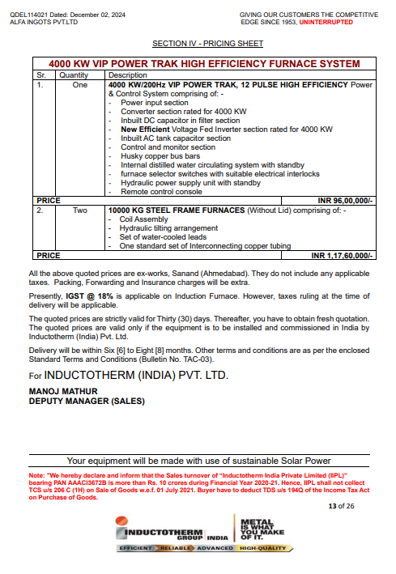

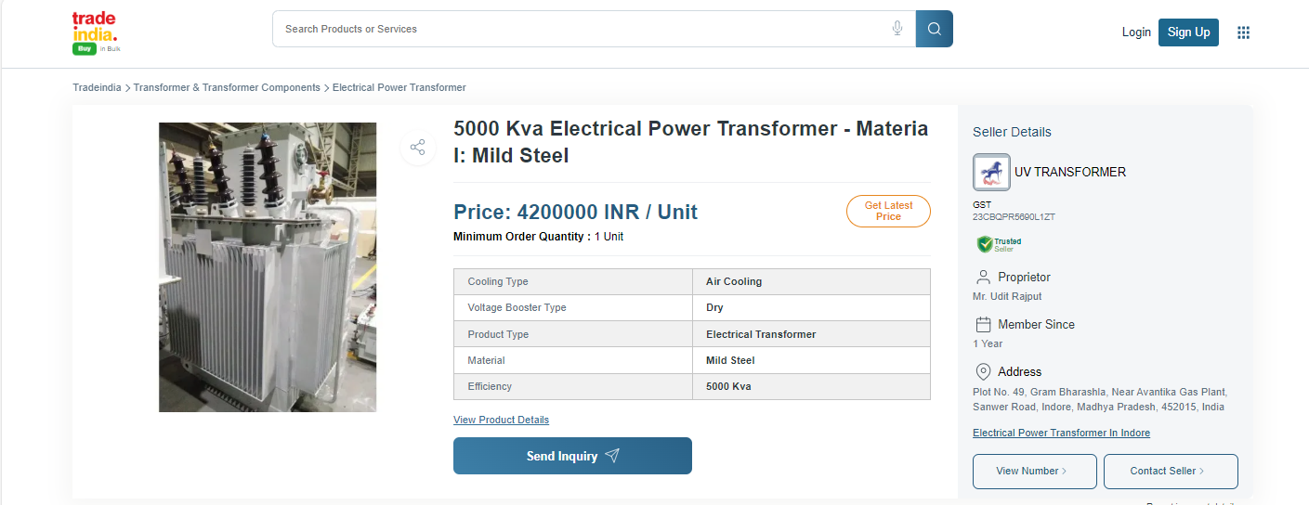
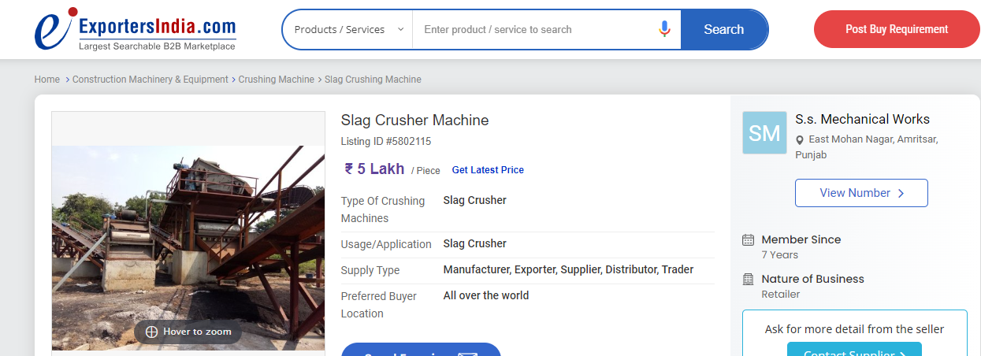
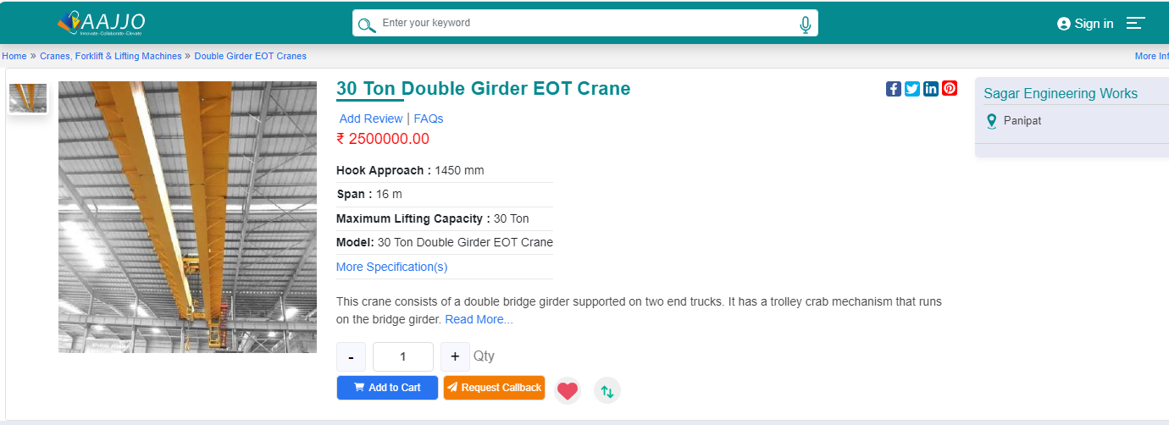
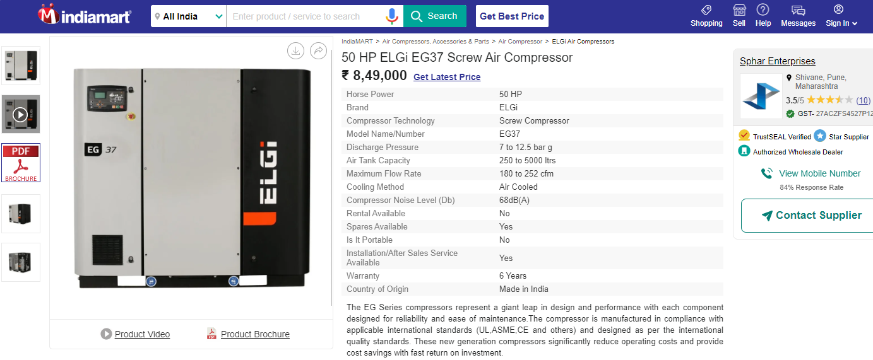
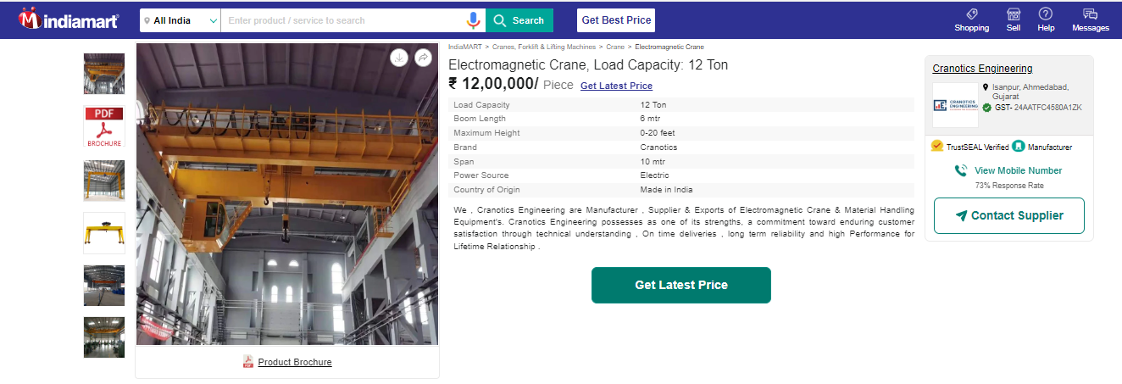

ANNEXURE: - III (DOCUMENTS PROVIDED BY CLIENT)
