REPORT FORMAT: V-L4 (RKA - Medium) | Version: 11.0_2022

CASE NO.: VIS (2024-25)-PL522-468-678 DATED: 16/12/2024

TECHNICAL SURVEY REPORT

OF

NATURE OF ASSETS | LAND & BUILDING
CATEGORY OF ASSETS | HERITAGE PROPERTY
TYPE OF ASSETS | KOTHI

SITUATED AT
ALAMBAGH MAHAL, CHANDER NAGAR, ALAMBAGH, LUCKNOW, UTTAR PRADESH-226005

REPORT PREPARED FOR
DIRECTORATE OF TOURISM, GOVERNMENT OF UTTAR PRADESH

**Important - In case of any query/ issue/ concern or escalation you may please contact Incident Manager @ valuers@rkassociates.org. We will appreciate your feedback in order to improve our services.
NOTE: As per IBA Guidelines please provide your feedback on the report within 15 days of its submission after which report will be considered to be accepted & correct.
Valuation Terms of Services & Valuer’s Important Remarks are available at www.rkassociates.org for reference.

PART A | SNAPSHOT OF THE HERITAGE PROPERTY

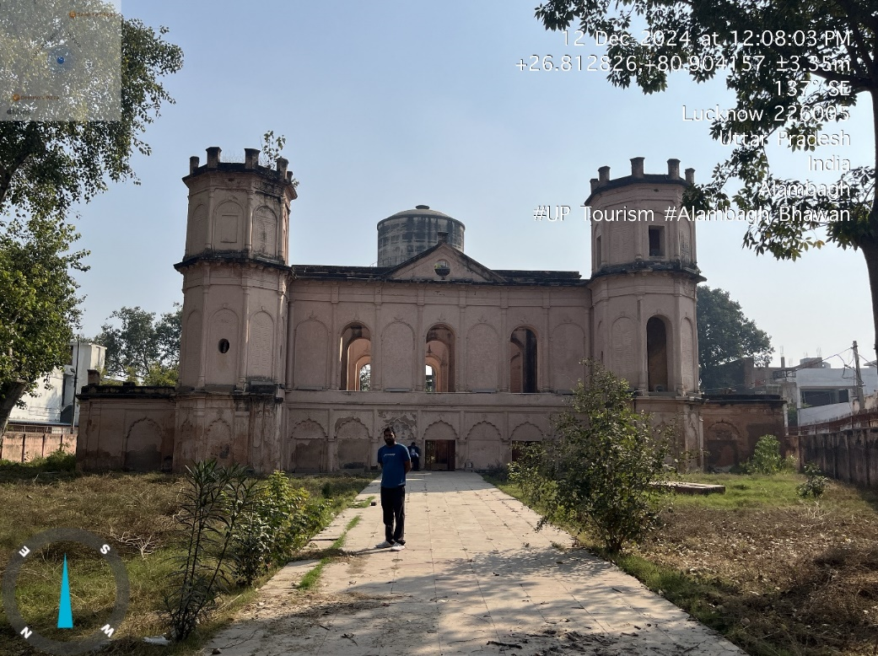

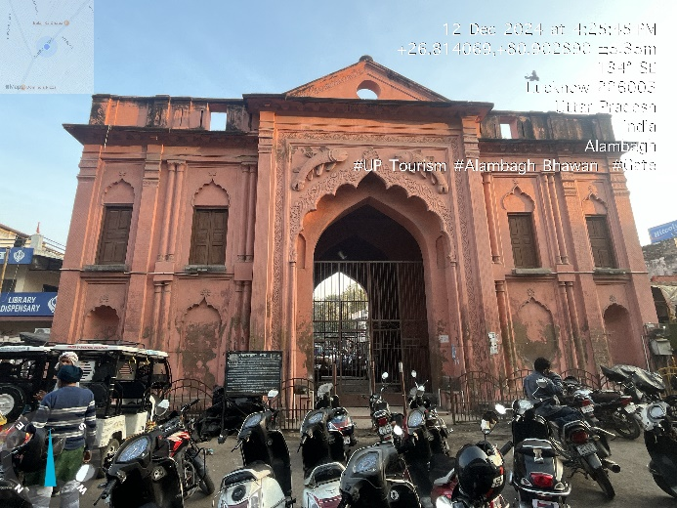

SITUATED AT
ALAMBAGH MAHAL, CHANDER NAGAR, ALAMBAGH, LUCKNOW, UTTAR PRADESH-226005

PART B | SUMMARY OF THE REPORT

S.NO. | CONTENTS | DESCRIPTION
 | GENERAL DETAILS
 | Report prepared for | Directorate of Tourism, Government of Uttar Pradesh
 | Work Order No. & Date | 11 November 2024
 | Name of the Customer | Directorate of Tourism, Government of Uttar Pradesh
 | Name of Property Owner | Government of Uttar Pradesh
 | Address & Phone Number of the owner | ---
 | Type of the Property | Heritage Property
 | Type of Report | Technical Survey Report and Circle rate Valuation
 | Date of Inspection of the Property | 12 December 2024
 | Date of Report | 16 December 2024
 | Property Shown By | Name |  | Relationship with Owner | Contact Number
 |  | Mr. Lakesh Singh  Mr.Tinku Sharma |  | Lekhpal (Tehsil-Sadar)  Caretaker/Guard | 8853416401  8005032228
 | Purpose of the Report | For redevelopment for adaptive reuse
 | Scope of the Report | In respect to Alambagh Bhawan measuring ~0.25 Acre (as per work order issued by Directorate of Tourism Government of Uttar Pradesh, Dated- 11 November 2024)  - To carry out technical survey and provide Govt. Guideline Value.  - Comments for any encroachment at site.  - Trees present in the premises (type & numbers)  - Layout, location in map clearly highlighting the different components at the site.  - Coordination with the Revenue Department related to the land and property.  - Potential Product Mix and usage as per market analysis.
 | Documents provided for perusal | Documents Requested |  | Documents Provided |  | Documents Reference No.
 |  | Total 02 Documents requested. |  | Total 0 Documents provided. |  | ---
 |  | Property Title document |  | Not Available |  | ---
 |  | Approved Map |  | Not Available |  | --
 |  | --- |  | Notification issued by UP Govt.( For development on PPP Model) |  | Dated: 28/09/2024
 |  | --- |  | Extract Khatauni by Lekhpal of concerned area |  | Dated: 12/12/2024
 | Identification of the property
 |  | ☒ | Done from the name plate displayed on the property
 |  | ☒ | Identified by the Lekhpal of the concerned area

 | VALUATION SUMMARY
 | Govt. Circle/ Guideline Value Land | Rs. 4,35,59,000/-
 | Govt. Circle/ Guideline Value Building | Rs. 1,39,25,979/-
 | Total Govt. Circle/ Guideline Value of Land & Building | Rs. 5,74,84,979/-

 | ENCLOSURES
 | Part A | Snapshot of The Heritage Property
 | Part B | Summary of the Report
 | Part C | Characteristics Description of The Asset
 | Part D | Area Description of The Property
 | Part E | Schedule of Tree
 | Part F | Circle Rate Valuation of Land & Building
 | Enclosure 1 | Google Map – Page No.18
 | Enclosure 2 | Photographs – Pages No.19, 20 & 21
 | Enclosure 3 | Copy of Circle Rate – Pages No. 22
 | Enclosure 4 | Important Property Documents Exhibit – Pages No.23 to 26
 | Enclosure 5 | Valuer’s Important Remarks Pages No. 27 & 28

PART C | CHARACTERISTICS DESCRIPTION OF THE PROPERTY

 | PHYSICAL CHARACTERISTICS OF THE PROPERTY
 | Brief Description Of The Property
This report is prepared for the Heritage property named “Alambagh Bhawan”, located at Chander Nagar, Alambagh, Lucknow, Uttar Pradesh. The property is in two parts i.e. Alambagh Gate (Phatak) and Alambagh Bhawan Both are approximately 200 mtrs apart. As per available information from public domain and site inspection, both the buildings were constructed by Nawab Wajid Ali Shah, the last ruler of Lucknow, between 1847 and 1856 for his wife, Alam Aara.
Alambagh gate is right on Lucknow – Kanpur road, just opposite to Alambagh Metro Station. Entrance to the gate is closed and to reach to the Bhawan one has to take a detour from left side road. Road leading to the Bhawan is approximately 25 ft wide and 200 mtrs long. There are various properties such as BSNL office, several shops, Sanatan Dharm Mandir, Madhyanchal Vidyut Vitaran Nigam Ltd., etc along the both side of approach road and therefore the road is a common road as of now. Also there are Office of Nagar Nigam Zone-5, Gurudwara,Alambagh Fire Station, Janta College. Jal Kal Vibhag Lucknow in near to the subject loction. Moreover, in close proximity, there is also a protected monument, the Havelock Memorial.
Alambagh Gate. This two storied structures is spread over approximately 0.013 Hectare (130 sq.mtrs) as per the Khatauni records. However as per the site survey the area comes around ~0.028 Hectare (280 sq.mtrs). The Alambagh Gate structure is spread over approximately in ~214 sq. mtrs. made up of 70 cm thick Lakhauri brick wall casted with lime surkhi mortor. The structure was designed by architect Chote Khan. The structure consists of two stairs one on each side, 6 rooms on each floor, total 12 rooms and ~16 feet wide and ~25 feet high opening for passing through the gate. Structure is in average condition, maintenance of which is required before it could be used for public utility.
Alambagh Bhawan. This two storied structures is spread over approximately 0.519 Hectare (5190 sq.mtrs) as per the Khatauni records. However as per the site survey the area comes around ~0.241 Hectare only (2417 sq.mtrs). The Main Alambagh Bhawan structure is spread over approximately in ~655 sq. mtrs. and made up of 70 cm thick Lakhauri brick wall casted with lime surkhi mortor. The building was originally designed with four staircases, one at each corner. However, at present, only one staircase remains intact, while the others have collapsed. There is 15 rooms on ground floor and 9 at first floor, total 24 rooms. The two-story structure was constructed in Indo-Muslim and European architectural styles featuring circular arches in the interior and octagonal minarets at each of its four corners. Two of the minarets have however, collapsed.
The building is in a dilapidated condition due to low maintenance. The structural integrity of both the ground and first floors has significantly deteriorated, with most of the slabs having collapsed over time. The existing slab, which exists in few areas are in poor condition. The once-decorative floral walls design inside is now in ramshackle.
Both structures were illuminated with fancy lights in different colors, creating an astonishing view in the evening. According to the representative caretaker, the lights are also designed with theme lighting, making them perfect for special occasions like Independence Day (15th August) and Holi.
The property is located within the municipal limits of Lucknow Municipal Corporation, making it easily accessible. It is situated about ~200 meters from Alambagh Metro Station and the Kanpur-Lucknow Road, offering good connectivity to transportation networks. The property is enclosed by a boundary wall, providing some level of security, although the overall condition of the buildings demands immediate attention.
 | Is property clearly demarcated by permanent/ temporary boundary on site | Yes, clearly demarcated with boundary wall.
 | Independent access/ approach to the property | Clear independent access is available
 | Is the property merged or colluded with any other property | No, it is an independent single bounded property
 |  | ---
 | Land Physical Factors | Shape | Size | Layout
 |  | Irregular | Normal | NA

 | DOCUMENT DETAILS AND LEGAL ASPECTS OF THE PROPERTY
 | Property documents available | Notification issued by UP Govt.( For development on PPP Model) | Dated: 28/09/2024
 |  | Extract Khatauni by Lekhpal of concerned area | Dated: 12/12/2024
 | Names of the Legal Owner/s as per Revenue Records | UP Govt.
 | Constitution of the Property | Heritage Property preserved by UP Govt.
 | Property presently occupied/ possessed by | Heritage Property under UP Govt.

 | LOCATION CHARACTERISTICS OF THE PROPERTY
 | Nearby Landmark |  | Alambagh Metro Station (~ 200 mtr )
 | Postal Address of the Property |  | Alambagh Mahal, Chander Nagar, Alambagh, Lucknow, Uttar Pradesh-226005
 | Google Map Location of the Property with a neighborhood layout map |  | Enclosed with the Report
 |  |  | Coordinates or URL: 26°48'45.9"N 80°54'15.9"E
 | Description of adjoining property |  | Residential and Commercial Mix
 | Plot No./ Survey No. |  | Please refer to the table on pg no.13 for land details
 | Village/ Zone |  | Lucknow Municipal Corporation (Zone-5)
 | Sub registrar |  | Lucknow
 | District |  | Lucknow
 | City Categorization |  | Metro City |  |  | Urban developed
 | Characteristics of the locality |  | Average |  |  | Within urban developed area
 | Property location classification |  | Corner Plot |  | Near to Metro Station |  |  |  | Near to Market
 | Property Facing |  | North-West Facing
 | Details of the roads abutting the property
 | - Main Road Name & Width |  | Kanpur-Lucknow Road |  |  |  |  | ~55 feet wide
 | - Front Road Name & width |  | Chander Nagar Market Road |  |  |  |  | ~20 feet wide
 | - Type of Approach Road |  | Bituminous Road
 | - Distance from the Main Road |  | ~ 200 mtr.
 | Boundaries schedule of the Property
 | Directions | As per the documents |  | Actual found at Site
 | East | Not Available |  | Entry/Chander Nagar Market Road
 | West | Not Available |  | Gurudwara/Fire Station
 | North | Not Available |  | Janta Inter College Internal Road/Nagar Nigam Office Zone-5
 | South | Not Available |  | Jal Nigam Over Head Water Tank/Janta Inter College
 | Neighbourhood amenities |  | Mixed of residential & commercial area with some Govt. offices.
 | Any New Development in surrounding area |  | None |  |  |  | None

 | TOWN PLANNING/ ZONING PARAMETERS
 | Planning Area/ Zone | Town and village Planning Department, U.P
 | Master Plan currently in force | Lucknow Masterplan-2031
 | Municipal limits | Lucknow Municipal Corporation - Zone 5
 | Developmental controls/ Authority | Lucknow Municipal Corporation -Zone 5
 | Zoning regulations | Residential
 | Master Plan provisions related to property in terms of Land use | Residential
 | Any conversion of land use done | NA
 | Current activity done in the property | Heritage Property
 | Is property usage as per applicable zoning | Yes
 | Any notification on change of zoning regulation | NA
 | Street Notification | Not notified
 | Comment on the surrounding land uses & adjoining properties in terms of uses | The surrounding properties are currently being used for both commercial and residential purpose.
 | Comment of Demolition proceedings if any | No
 | Comment on Compounding/ Regularization proceedings | No
 | Any information on encroachment | In respect to Alambagh Bhawan, the property is clearly demarcated within a permanent boundary wall, and there is no visible evidence of encroachment within the confines of the boundary wall.

 | SOCIO - CULTURAL ASPECTS OF THE PROPERTY
 | Descriptive account of the location of the property in terms of social structure of the area in terms of population, social stratification, regional origin, age groups, economic levels, location of slums/squatter settlements nearby, etc. | The Alambagh Bhawan area in Lucknow features a diverse population with various age groups, economic backgrounds, and regional origins. It is a mix of residential, commercial, and institutional spaces, with local businesses, religious sites, and government offices contributing to a vibrant community. Informal settlements are also present nearby, adding to the area's dynamic social structure.
 | Whether property belongs to social infrastructure like hospital, school, old age homes etc. | No

 |  | FUNCTIONAL AND UTILITARIAN SERVICES, FACILITIES & AMENITIES
 | Drainage arrangements |  |  |  |  | Yes
 |  | Water Treatment Plant |  |  |  | NA
 |  | Power Supply arrangements |  | NA |  | Yes, Electric Meter found installed at main gate of the site, though no details of billing available.
 |  |  |  | NA |  | No
 |  | HVAC system |  |  |  | No
 |  | Security provisions |  |  |  | Caretaker/Guard kept by UP Govt.
 |  | Lift/ Elevators |  |  |  | No
 |  | Compound wall/ Main Gate |  |  |  | Yes
 |  | Whether gated society |  |  |  | Yes
 |  | Car parking facilities |  |  |  | On Ground
 |  | Ventilation |  |  |  | ---
 |  | Internal development
 |  | Garden/ Park/ Land scraping | Water bodies |  | Internal roads |  | Pavements | Boundary Wall
 |  | No | No |  | No |  | No | Yes

 | INFRASTRUCTURE AVAILABILITY
 | Description of Aqua Infrastructure availability in terms of:
 | - Water Supply |  |  |  | There was a Water Pump installed at site but it was not in working condition.
 | - Sewerage/ sanitation system |  |  |  | Underground
 | - Storm water drainage |  |  |  | No
 | Description of other Physical Infrastructure facilities in terms of:
 | - Solid waste management |  |  |  | Yes, within the locality.
 | - Electricity |  |  |  | Yes
 | - Road and Public Transport connectivity |  |  |  | Yes
 | - Availability of other public utilities nearby |  |  |  | Transport, Market, Hospital etc. available in close vicinity
 | Proximity & availability of civic amenities & social infrastructure
 | School | Hospital | Market | Bus Stop |  | Railway Station | Metro | Airport
 | ~500 m. | ~500 m. | ~100 m. | ~2 km. |  | ~5 km. | ~200 m. | ~7 km.
 | Availability of recreation facilities (parks, open spaces etc.) |  |  | This is an old habited area since ancient times with migrant habitation settled down nearby after independence. Therefore this area is not a holistic planned development.

 | MARKETABILITY ASPECTS OF THE PROPERTY:
 | Location attribute of the subject property | Normal
 | Scarcity | Being Heritage property it is unique.
 | Any New Development in surrounding area | None | None
 | Any negativity/ defect/ disadvantages in the property/ location | Narrow approach and around 200 mtrs inside of main road. | Low maintenance and poor condition of structure.
 | Any other aspect which has relevance on the value or marketability of the property | Yes, Due to area and location.

 | BUILDING & CONSTRUCTION ASPECTS OF THE PROPERTY:
 | Type of construction & design | Please refer to the table on pg no.13 & 14 for building/structure details
 | Method of construction | Ancient masonry techniques.
 | Specifications
 | - Class of construction | Old Construction- Heritage property
 | - Appearance/ Condition of structures | Internal - Poor Condition
 |  | External - Poor Condition
 | - Roof | Floors/ Blocks |  | Type of Roof
 |  | G+1 |  | NA
 |  | NA |  | NA
 | - Floor height | Please refer to the table on pg no.13 & 14 for building/structure details
 | - Type of flooring | Brick flooring
 | - Doors/ Windows | Iron gate
 | - Interior Finishing | Simple Plastered Walls
 | - Exterior Finishing | Simple Plastered Walls, with floral design.
 | - Interior decoration/ Special architectural or decorative feature | Simple Plastered Walls, with floral design.
 | - Class of electrical fittings | Not Applicable
 | - Class of sanitary & water supply fittings | Not Applicable
 | Maintenance issues | Poor condition and maintenance
 | Age of building/ Year of construction | ~168 years | ~1856
 | Total life of the structure/ Remaining life expected | ~168 years | 0
 | Extent of deterioration in the structure | Most of the Slab are already collapsed, Multiple visible cracks & damages.
 | Protection against natural disasters viz. earthquakes etc. | NA
 | Visible damage in the building if any | Yes, Multiple visible cracks in Slabs, stairs and walls.

 | ARCHITECTURAL AND AESTHETIC QUALITY OF THE PROPERTY:
 | Descriptive account on whether the building is modern, old fashioned, etc., plain looking or with decorative elements, heritage value if applicable, presence of landscape elements,  etc. | Traditional structure, Indo-Muslim and European architectural style as a heritage property built in between 1847 and 1856.

 | POTENTIAL PRODUCT MIX AND USAGE:
 | Neighborhood establishment | The surroundings area is a mix of residential, commercial, and institutional establishments. Key nearby establishments include the BSNL office, numerous shops along both sides of the road, and the Sanatan Dharm Mandir, Havalok cemetery which indicate a busy and accessible area with local commercial and religious significance. The Madhyanchal Vidyut Vitaran Nigam Ltd. office adds to the presence of utility services in the vicinity. Moreover, in close proximity, there is also a protected monument, the Havelock Memorial.  In addition, important administrative and civic offices are located nearby, including the Nagar Nigam Zone-5 office, the Alambagh Fire Station, and the Jal Kal Vibhag Lucknow, ensuring the provision of essential municipal services. The Gurudwara and Janta College further contribute to the area's socio-cultural diversity. Given the concentration of such establishments, the road abutting the Bhawan is a commonly used route, facilitating access and transport to and from various parts of the region.  This blend of residential, commercial, civic, and institutional facilities reflects a dynamic and well-connected locality.
 | Nearby Attraction & Catchments | Alambagh Bhawan is located with several key attractions nearby: Eco Garden (~5 km), Bada Imambara and Chota Imambara (~9 to 9.5 km), Lucknow Zoo (~10 km), and the Gomati River Front (~12 km).

Potential Product Mix and Usage
(considering PPP adaptive reuse model)
Category | Potential Products/Services | Usage | Advantage | Disadvantage
Event and Wedding Venue | - Luxury wedding packages | The Mahal can be promoted as a premium event and wedding venue, offering a royal and historical ambience. It could cater to high-profile weddings, corporate events, and social gatherings, with bespoke services tailored to client preferences. | Amidst dense middle class residential area | Not as such for this activity as can be used by local community
 | - Corporate and private event hosting
 | - Cultural performances (Nawabi music, dance, cuisine)
Museum/ Heritage/ Cultural/ Artistic/ Exhibitions Centre | - Historical exhibits on Lucknow’s Mughal, Nawabi, and colonial past | Transforming Alambagh Mahal into a museum or heritage center would provide an educational space to explore the rich history of Lucknow. This could include hands-on exhibits, educational outreach programs, and historical displays focusing on key periods like the 1857 rebellion. | - Historical site  - 200 mtrs from Metro Station | - Narrow approach and around 200 mtrs inside of main road.  - Other attractions are far away.  - Present foot fall is negligible.  - Not a very prominent historical site.
 | - Interactive multimedia displays (virtual tours, augmented reality)
 | - Educational programs and workshops
 | -Restaurant or Café with Nawabi Cuisine
 | -Light Shows and Entertainment

PART D | AREA DESCRIPTION OF THE PROPERTY

- LAND AREA: Land area details are tabulated below as per the khatauni details confirmed by Mr. Lakesh Singh - Lekhpal (Tehsil- Sadar) of the subject locality with area actual found at site:
ALAMBAGH BHAWAN:

As Per Khatauni Details |  |  |  |  |  | Area As Per Site Survey
SL.No | District | Village | Khasra/Gata No. | Type of property/Owner | Area in Hectare | Area in Hectare
1 | Lucknow | Bhillava | 457 | Kothi | 0.101 | ~0.241
2 | Lucknow | Bhillava | 458 | Banjar | 0.228
3 | Lucknow | Bhillava | 456 | Banjar | 0.19
Total: |  |  |  |  | 0.519 | ~0.241

ALAMBAGH GATE (PHAATAK):

As Per Khatauni Details |  |  |  |  |  | Area As Per Site Survey
SL.No | District | Village Name | Khasra/Gata No. | Type of property/Owner | Area in Hectare | Area in Hectare
1 | Lucknow | Bhillava | 467 | Phaatak (Gate) | 0.013 | ~0.028
Total: |  |  |  |  | 0.013 | ~0.028

- BUILDING & CIVIL WORKS:

ALAMBAGH BHAWAN:
S.No. | Building Description | No. of Floors | Height  (Mtr) | Type of Structure | Buit-up area  (in sq mtrs) | Year of Construction
1 | Alambagh bhawan | Ground Floor | ~3.2 | Load Bearing Structure, beam column structure with wooden plank | ~655 | ~1856
 | Alambagh bhawan | First Floor | ~5.3 | Load Bearing Structure, beam column structure with wooden plank | ~655 | ~1856
2 | Toilet | GF | ~3.0 | RCC framed pillar beam column structure on RCC Slab | ~6.86 | ~2020

ALAMBAGH GATE (PHAATAK):

S.No. | Building Description | No. of Floors | Height  (Mtr) | Type of Structure | Buit-up area  (in sq mtrs) | Year of Construction
1 | Alambagh Gate | Ground Floor | ~3.6 | Load Bearing Structure, beam column structure with wooden plank | ~214 | ~1856
 | Alambagh Gate | First floor | ~3.6 | Load Bearing Structure, beam column structure with wooden plank | ~214 | ~1856

Note:

- Alambagh Gate. This two storied structures is spread over approximately 0.013 Hectare (130 sq.mtrs) as per the Khatauni records. However as per the site survey the area comes around ~0.028 Hectare (280 sq.mtrs).
The Alambagh Gate structure is spread over approximately in ~214 sq. mtrs.
- Alambagh Bhawan. This two storied structures is spread over approximately 0.519 Hectare (5190 sq.mtrs) as per the Khatauni records. However as per the site survey the area comes around ~0.241 Hectare only (2417 sq.mtrs).
The Main Alambagh Bhawan structure is spread over approximately in ~655 sq. mtrs.
- Topographical survey drawing of the site is shared separately in .pdf format.

PART E | SCHEDULE OF TREE
During the site survey, we also observed few trees found at the property.

The Schedule of tree is tabulated below:

Type of Tree | No. of Tree | Girth of Tree | Approx. Height of Tree
Peepal | 2 | ~ 3.4m each | ~9m & ~13m
Semar (Wild Thorn Tree) | 1 | ~ 1m | ~9m

PART F | CIRCLE RATE VALUATION OF LAND & BUILDING

S.No. | Particulars | Govt. Circle/ Guideline Value of Land Alambagh Bhawan | Govt. Circle/ Guideline Value of Land Alambagh Gate (Phaatak)
 | Prevailing Rate range | Rs.17,000/- per sq.mtr | Rs.19,000/- per sq.mtr
 | Circle Rate adopted | From the Circle Rate List Issued by Office of District Magistrate, Lucknow, Dated: 15/12/2015 | From the Circle Rate List Issued by Office of District Magistrate, Lucknow, Dated: 15/12/2015
 | Rate Classification | Non-Agricultural Land | Non-Agricultural Land
 | Rate adopted considering all characteristics of the property | Rs.17,000/- per sq.mtr | Rs.19,000/- per sq.mtr
 | Total Land Area considered (documents vs site survey whichever is less) | The land area considered, as determined during the site visit, is approximately 0.241 Hectare or 2417 square meters. This measurement pertains to the area of Alambagh Bhawan only, within the demarcated boundary wall of the property. | The land area considered 0.013 Hectare or 130 square meters, as per the Khatauni records.
 | Total Value of land | 2417 per sq. mtr. x Rs.17,000/- per sq.mtr | 130 per sq. mtr. x Rs.19,000/- per sq.mtr
 |  | Rs. 4,10,89,000/- | Rs. 24,70,000/-
 |  | Total : Rs. 4,35,59,000/-

Govt. Circle/ Guideline Value of Buildings (Alambagh Gate)
S.no. | Building Description | No. of Floors | Height  (Mtr) | Type of Structure | Built-up area (in sq.mtr) | Year of Construction | Circle Rate  (INR per sq. mtr.) | Guideline Value (INR)
1 | Alambagh Gate | Ground Floor | ~3.6 | Load Bearing Structure, beam column structure with wooden plank | ~214 | ~1856 | 9,000 | 19,26,000
 | Alambagh Gate | First floor | ~3.6 | Load Bearing Structure, beam column structure with wooden plank | ~214 | ~1856 | 9,000 | 19,26,000
Total |  |  |  |  | 428.00 |  |  | 38,52,000

Govt. Circle/ Guideline Value of Building (Alambagh Bhawan)
S.no. | Building Description | No. of Floors | Height  (Mtr) | Type of Structure | Built-up area (in sq.mtr) | Year of Construction | Circle Rate  (INR per sq. mtr.) | Guideline Value (INR) | Discount of 15% given as most of the slabs has been collapsed
1 | Alambagh Bhawan | Ground Floor | ~3.2 | Load Bearing Structure, beam column structure with wooden plank | ~655 | ~1856 | 9,000 | 58,95,000 | 50,10,750
 | Alambagh Bhawan | First Floor | ~5.3 | Load Bearing Structure, beam column structure with wooden plank | ~655 | ~1856 | 9,000 | 58,95,000 | 50,10,750
2 | Toilet | GF | ~3.0 | RCC framed pillar beam column structure on RCC Slab | ~6.86 | ~2020 | 9,000 | 61,740 | 52,479
Total |  |  |  |  | 1,316.86 |  |  |  | 1,00,73,979

Summary- Guideline Value of Building Structure
S.No | location | Guideline Value
1 | Alambagh Bhawan | Rs. 1,00,73,979/-
2 | Alambagh Gate | Rs. 38,52,000/-
Total |  | Rs. 1,39,25,979/-

IMPORTANT NOTES

DEFECT LIABILITY PERIOD - In case of any query/ issue or escalation you may please contact Incident Manager by writing at valuers@rkassociates.org. We try our level best to ensure maximum accuracy in the Calculations done, Rates adopted and various other data points & information mentioned in the report but still can’t rule out typing, human errors, assessment or any other mistakes. In case you find any mistake, variation, discrepancy or inaccuracy in any data point mentioned in the report, please help us by bringing all such points into our notice in writing at valuers@rkassociates.org within 30 days of the report delivery, to get these rectified timely, failing which R.K Associates shouldn’t be held responsible for any inaccuracy in any manner. Also, if we do not hear back anything from you within 30 days, we will assume that the report is correct in all respect and no further claim of any sort will be entertained thereafter. We would welcome and appreciate your feedback & suggestions in order to improve our services.

Our DATA RETENTION POLICY is of ONE YEAR. After this period we remove all the concerned records related to the assignment from our repository. No clarification or query can be answered after this period due to unavailability of the data.

COPYRIGHT FORMAT - This report is prepared on the copyright format of R.K Associates to serve our clients in the best possible way. Legally no one can copy or distribute this format without prior approval from R.K Associates. It is meant only for the organization as mentioned on the cover page of this report. Distribution or use of this format or any content of this report wholly or partially other than R.K Associates will be seen as unlawful act and necessary legal action can be taken against the defaulters.

SURVEY ANALYST | ENGINEER | L1/ L2 REVIEWER
Er. Rajat Choudhary | Rajat Choudhary | Er. Anil Kumar

ENCLOSURE: 1 – GOOGLE MAP LOCATION

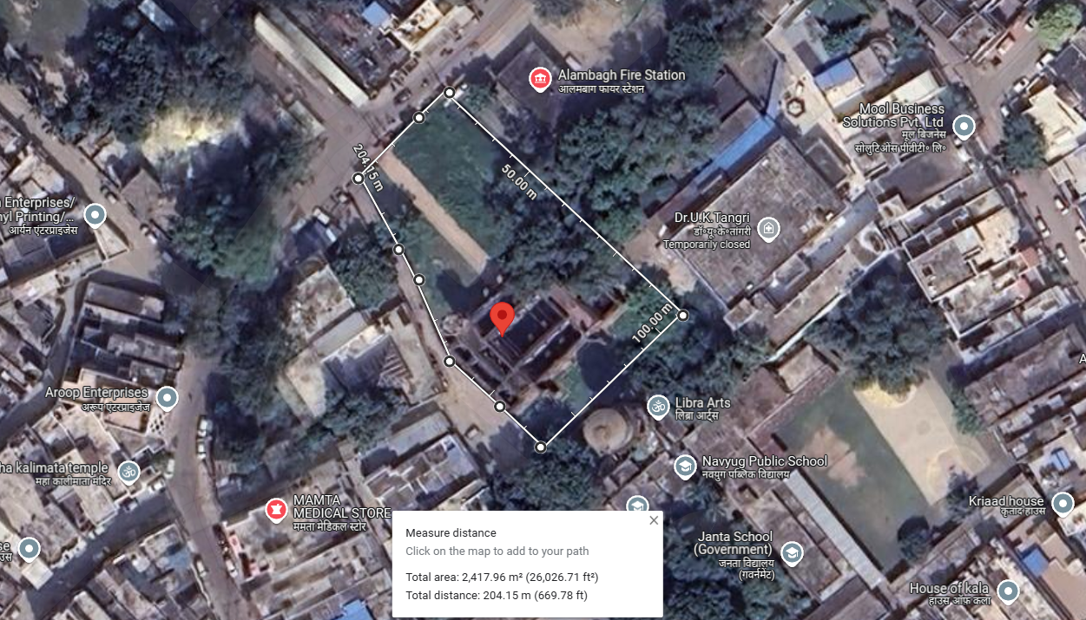

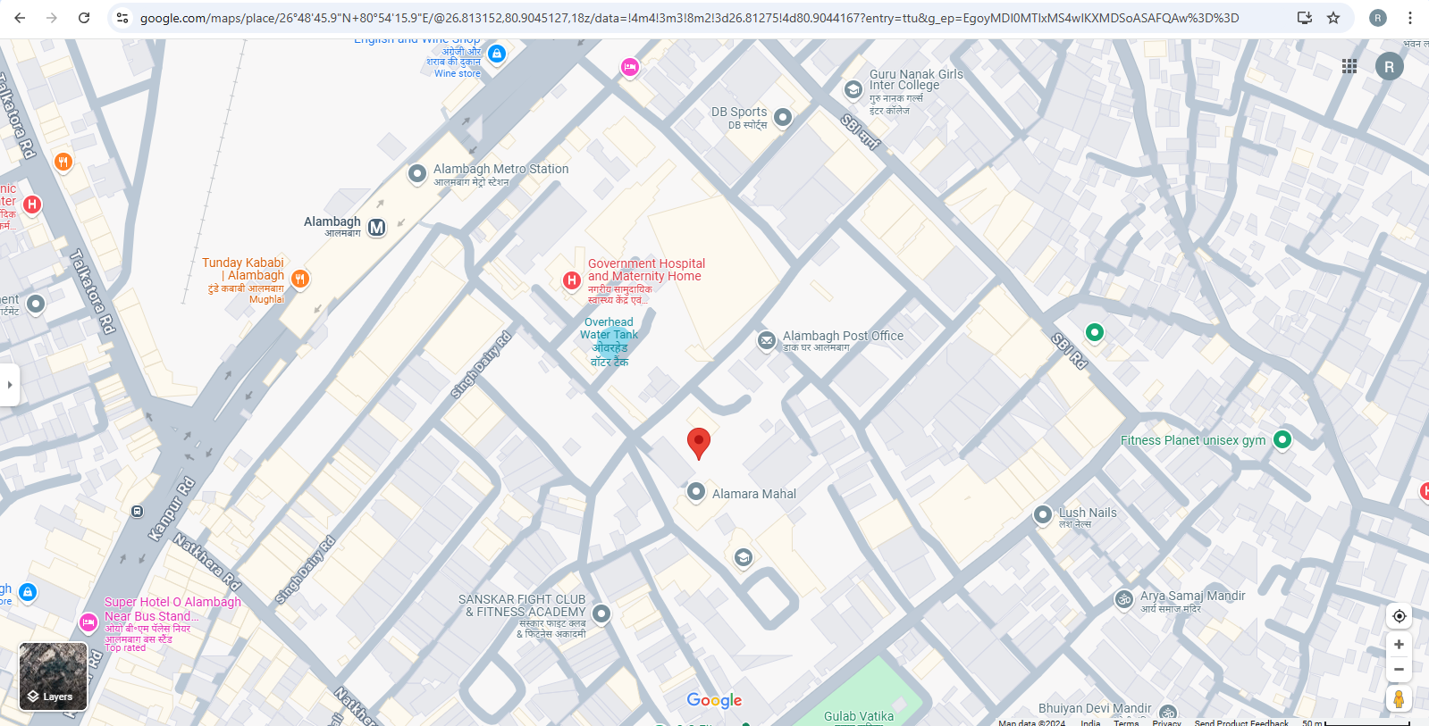

ENCLOSURE: 2– PHOTOGRAPHS OF THE PROPERTY

ALAMBAGH BHAWAN
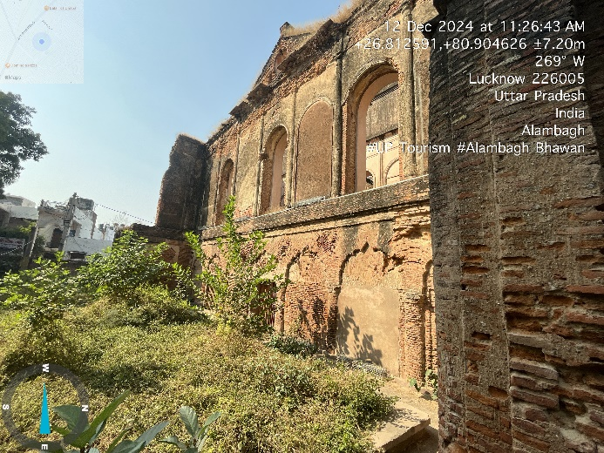 | 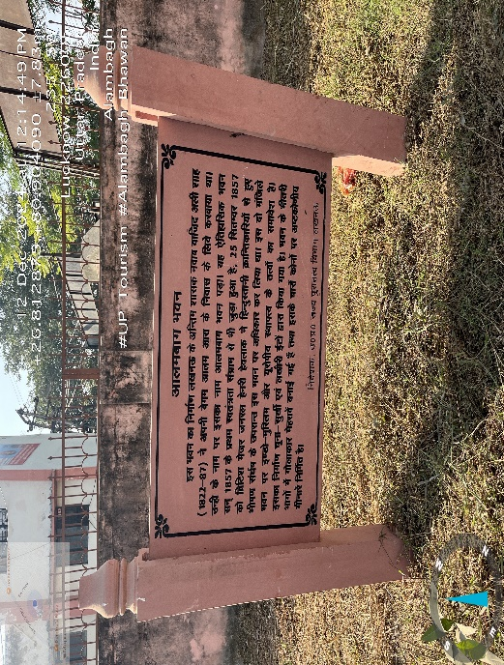
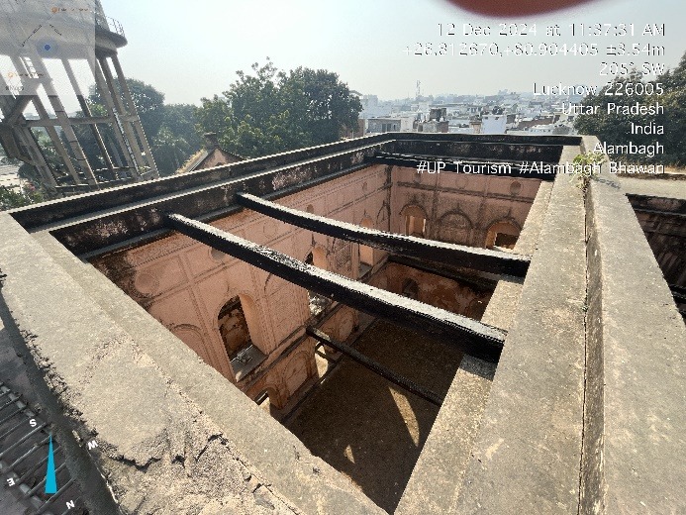 | 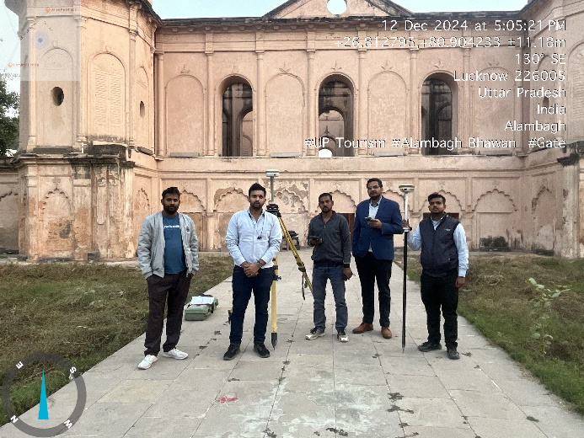
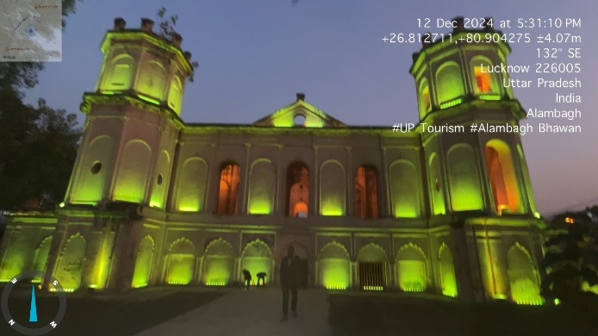 | 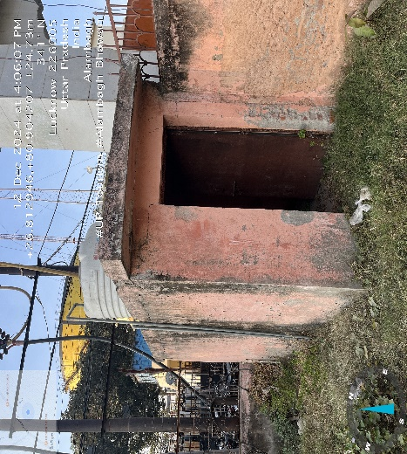

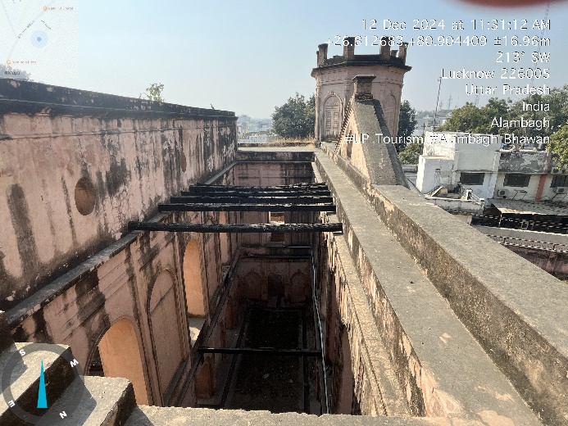 | 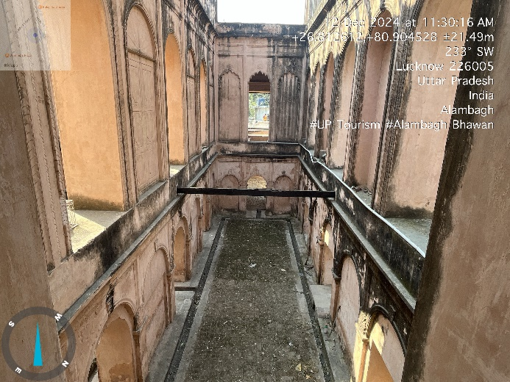
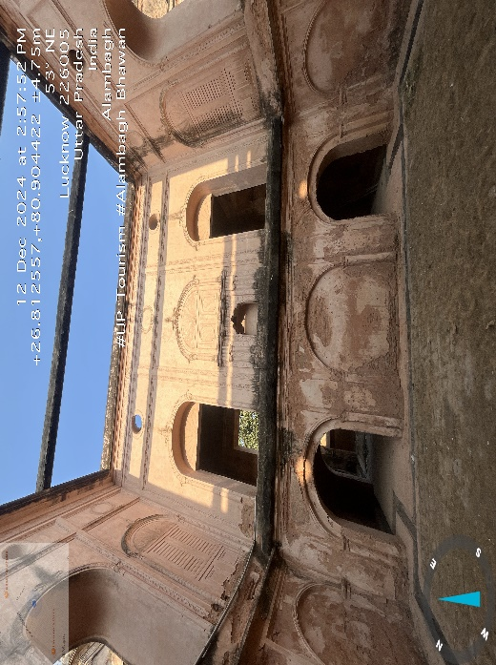 | 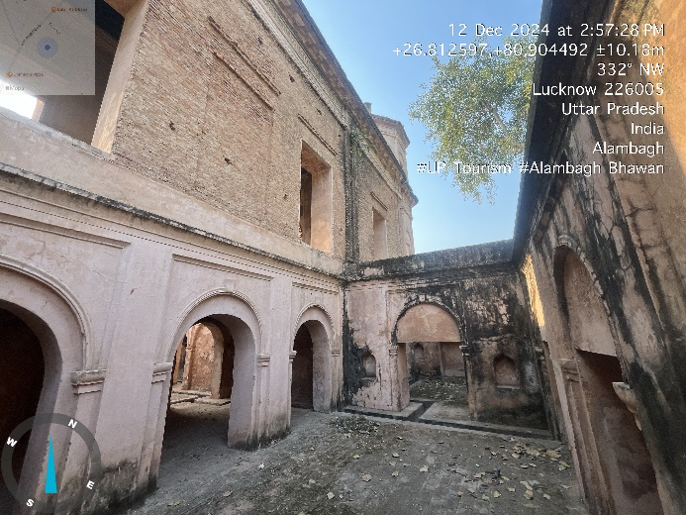
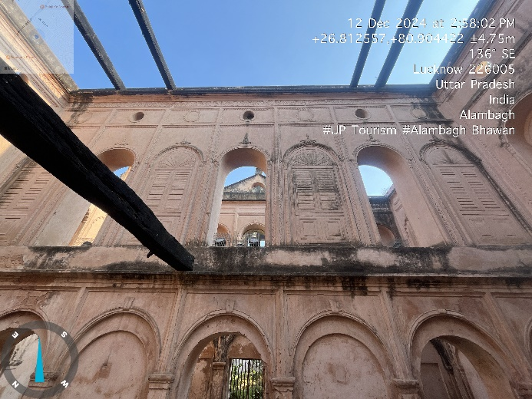 | 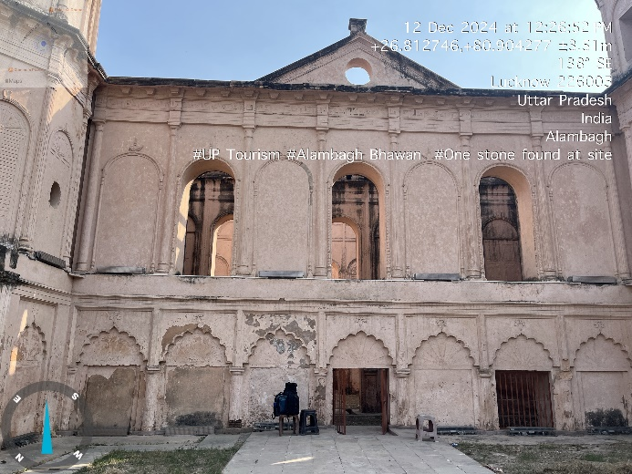

ALAMBAGH GATE
 | 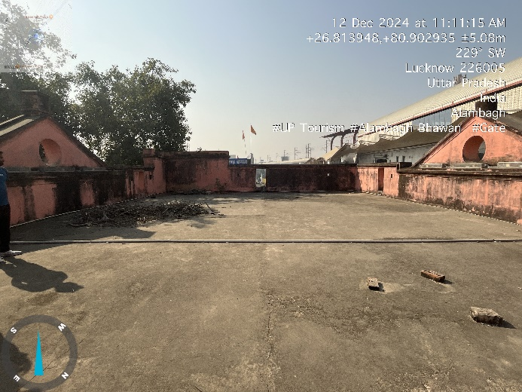
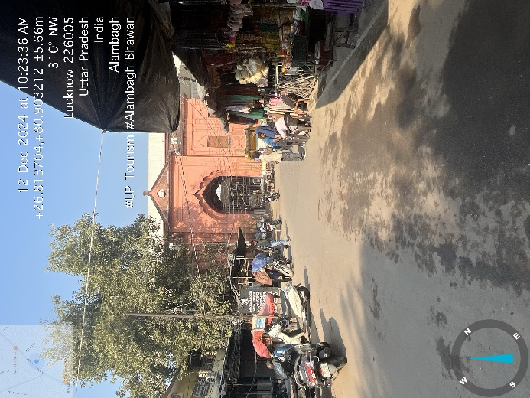 | 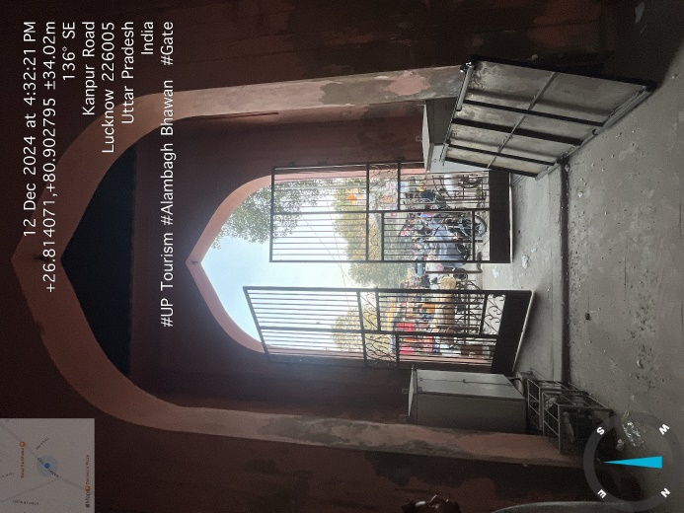
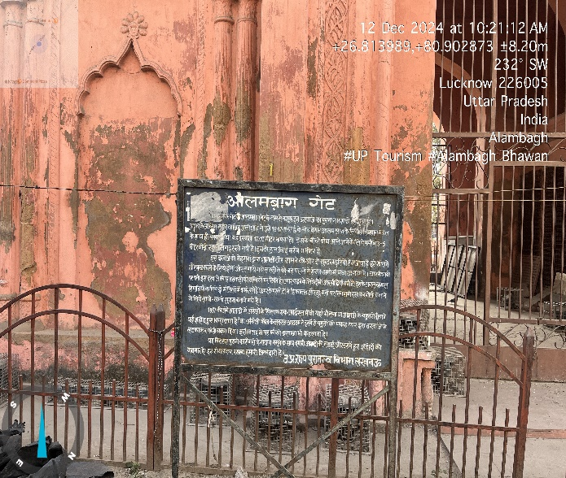 | 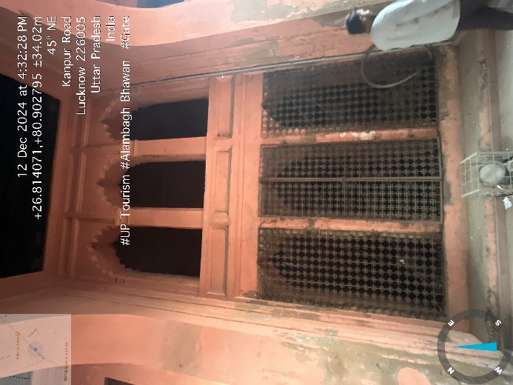

ENCLOSURE: 3– COPY OF CIRCLE RATE

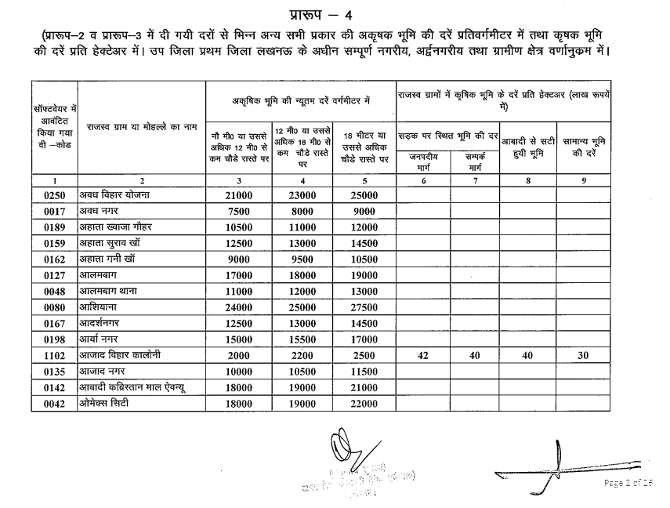

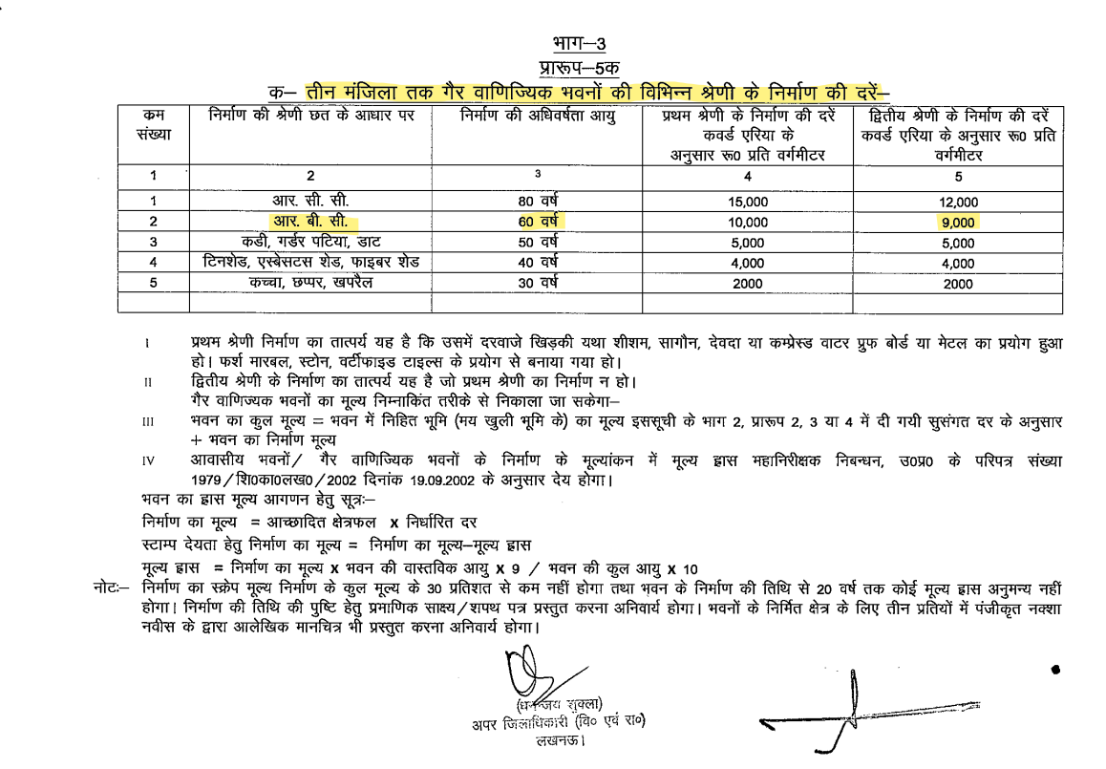

ENCLOSURE: 4 – IMPORTANT PROPERTY DOCUMENTS EXHIBIT

KHATAUNI
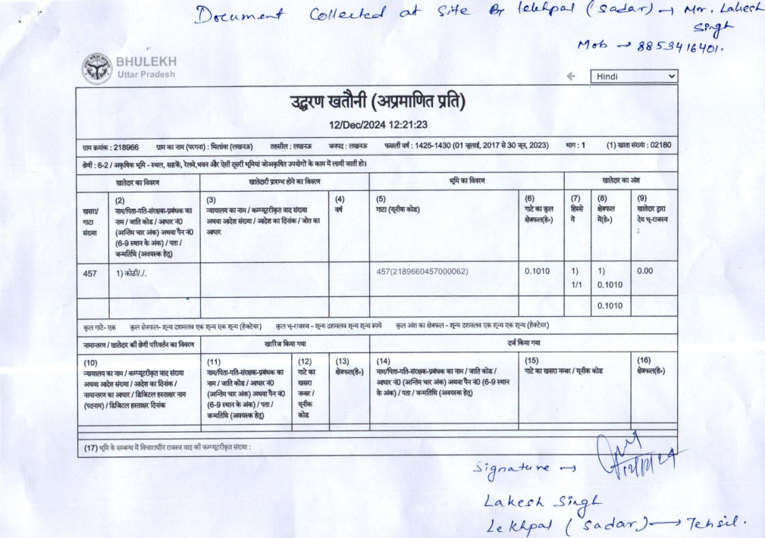
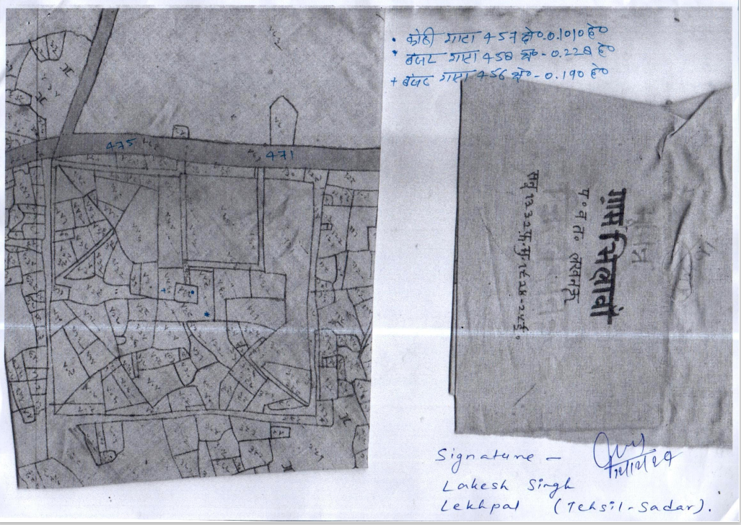
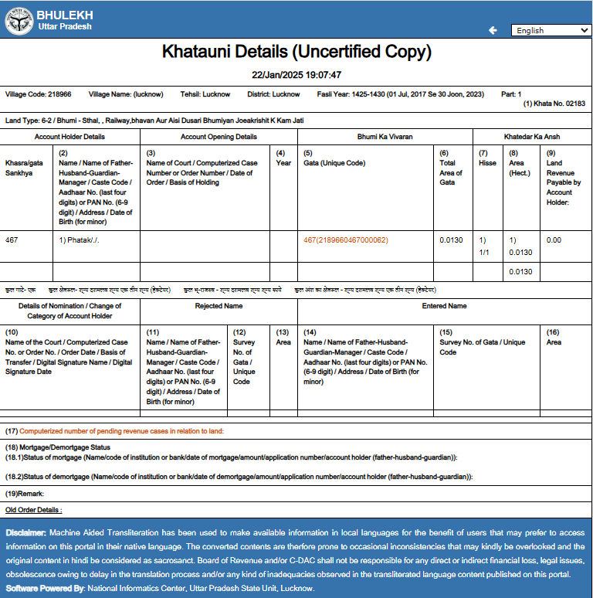

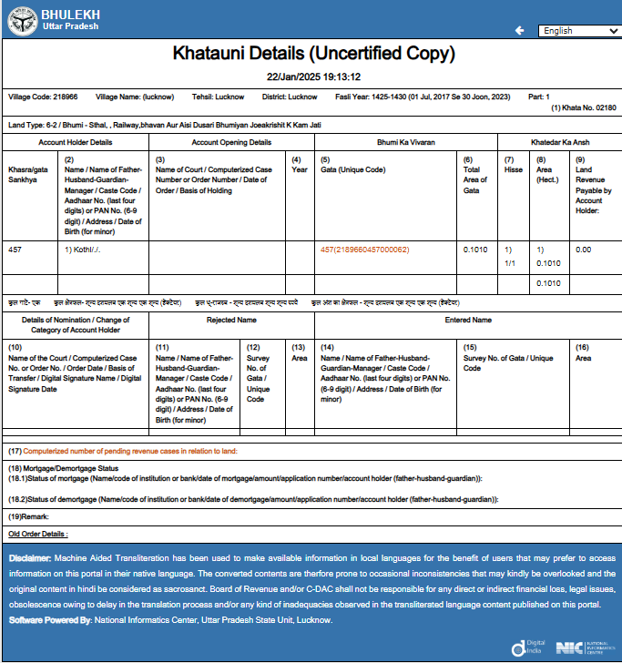

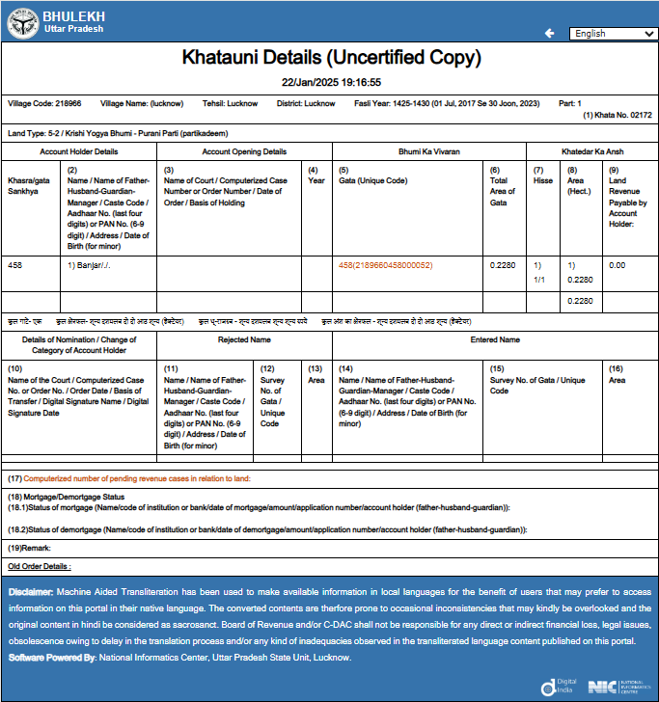

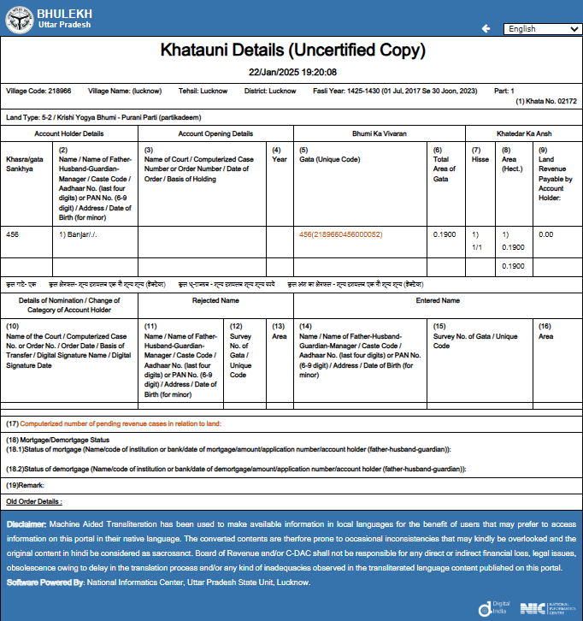
ADHISUCHNA 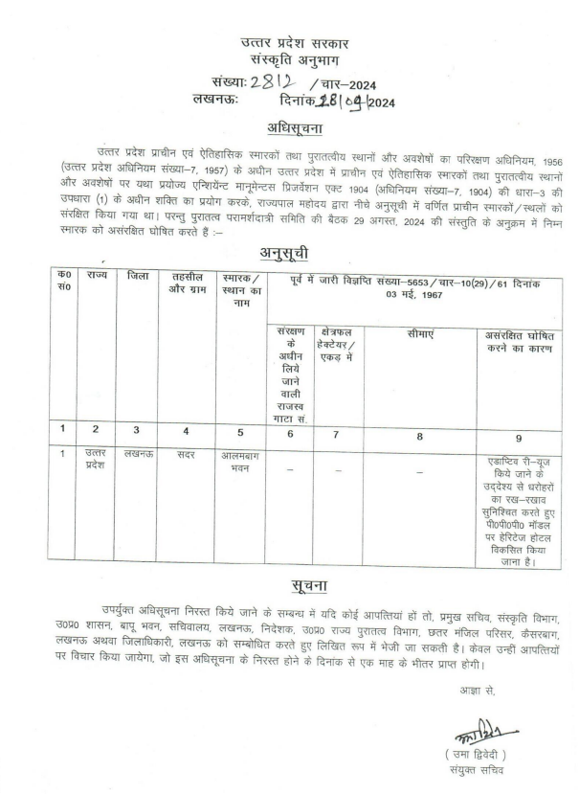
ENCLOSURE: 5 – VALUER’S IMPORTANT REMARKS

This report is prepared for the asset found on as-is-where basis which Lekhpal of the concerned area has shown/ identified to us on the site unless otherwise mentioned in the report of which some reference has been taken from the information/ data given in the copy of documents provided to us and informed verbally or in writing out of the standard checklist of documents sought from the client & its customer which they could provide within the reasonable expected time out of the standard checklist of documents sought from them and further based on certain assumptions and limiting conditions. The information, facts, documents, data which has become primary basis of the report has been supplied by the client which has been relied upon in good faith and is not generated by the Valuer.
The client/ owner and its management/ representatives warranted to us that the information they have supplied was complete, accurate and true and correct to the best of their knowledge. All such information provided to us either verbally, in writing or through documents has been relied upon in good faith and we have assumed that it is true & correct without any fabrication or misrepresentation. I/We shall not be held liable for any loss, damages, cost or expenses arising from fraudulent acts, misrepresentations, or willful default on part of the owner, company, its directors, employee, representative or agents.
Legal aspects for eg. Investigation of title, ownership rights, lien, charge, mortgage, lease, sanctioned maps, verification of documents provided to us such as title documents, Map, etc. from any concerned Govt. office etc. have to be taken care by legal expert/ Advocate and same is not done at our end. It is assumed that the concerned authority has asked for the report of that property after satisfying the authenticity of the documents given to us for which the legal verification has been already taken and cleared by the competent Advocate before requesting for the technical report. I/ We assume no responsibility for the legal matters including, but not limited to, legal or title concerns.
In the course of the report, we were provided with both written and verbal information. We have however, evaluated the information provided to us through broad inquiry, analysis and review but have not carried out a due diligence or audit of the information provided for the purpose of this engagement. Our conclusions are based on the assumptions and other information provided to us by the client during the course of the assessment.
Getting cizra map or coordination with revenue officers for site identification is a separate activity and is not part of the services and same has not been done in this report unless otherwise stated.
Wherever any details are mentioned in the report in relation to any legal aspect of the property such as name of the owner, leases, etc. is only for illustration purpose and should not be construed as a professional opinion. Legal aspects are out of scope of this report. Details mentioned related to legal aspect are only based on the copy of the documents provided to us and whatever we can interpret as a non-legally trained person. This should be cross validated with a legal expert. We do not vouch any responsibility regarding the same.
We have made certain assumptions in relation to facts, conditions & situations affecting the subject of, or approach to this exercise that has not been verified as part of the engagement rather, treated as “a supposition taken to be true”. If any of these assumptions prove to be incorrect then our estimate on value will need to be reviewed.
This is just an opinion report based on technical & market information having general assessment & opinion on the indicative.
We have relied on the data from third party, external sources & information available on public domain to conclude this report. These sources are believed to be reliable and therefore, we assume no liability for the truth or accuracy of any data, opinions or estimates furnished by others that have been used in this analysis. Where we have relied on the data, opinions or estimates from external sources, reasonable care has been taken to ensure that such data is extracted from authentic sources, however we still can’t vouch its authenticity, correctness, or accuracy.
Analysis and conclusions adopted in the report are limited to the reported assumptions, conditions and information came to our knowledge during the course of the work and based on the Standard Operating Procedures, Best Practices, Caveats, Limitations, Conditions, Remarks, Important Notes, Valuation TOR and definition of different nature of values.
Our report is meant ONLY for the purpose mentioned in the report and should not be used for any other purpose. The Report should not be copied or reproduced for any purpose other than the purpose for which it is prepared for. I/we do not take any responsibility for the unauthorized use of this report.
We owe responsibility only to the authority/client that has appointed us as per the scope of work mentioned in the report. We will not be liable for any losses, claims, damages or liabilities arising out of the actions taken, omissions or advice given by any other person. In no event shall we be liable for any loss, damages, cost or expenses arising in any way from fraudulent acts, misrepresentations or willful default on part of the client or companies, their directors, employees or agents.
While our work has involved an analysis & computation as pert scope of work, it does not include detailed estimation, design/ technical/ engineering/ financial/ structural/ environmental/ architectural/ compliance survey/ safety audit & works in accordance with generally accepted standards of audit & other such works. The report in this work in not investigative in nature. It is mere an opinion based on the facts & details presented to us by the client and third party market information came in front of us within the limited time of this assignment, which may vary from situation to situation.
No document has been reviewed beyond the scope of the work. These are not reviewed in terms of legal rights for which we do not have expertise. Wherever any information mentioned in this report is mentioned from the documents like owners name, etc., it is only for illustration purpose and may not necessary represent accuracy.
This report is not a qualification for accuracy of land boundaries, schedule (in physical terms), dimensions & identification. For this land/ property survey report can be sought from a qualified private or Govt. surveyor.

This report is done for the property identified to us by the Lekhpal of the concerned area. Method by which identification of the property is carried out is also mentioned in the report clearly. Responsibility of identifying the correct property to the Valuer/ its authorized surveyor is solely of the client/ owner for which Valuation has to be carried out.
In India more than 70% of the geographical area is lying under rural/ remote/ non municipal/ unplanned area where the subject property is surrounded by vacant lands having no physical demarcation or having any display of property survey or municipal number / name plate on the property clearly. Even in old locations of towns, small cities & districts where property number is either not assigned or not displayed on the properties clearly and also due to the presence of multiple/ parallel departments due to which ownership/ rights/ illegal possession/ encroachment issues are rampant across India and due to these limitations at many occasions it becomes tough to identify the property with 100% surety from the available documents, information & site whereabouts and thus chances of error, misrepresentation by the borrower and margin of chances of error always persists in such cases.
Due to fragmented & frequent change in building/ urban planning laws/ guidelines from time to time, different laws/ guidelines between regions/ states and no strict enforceability of Building Bye-Laws in India specially in non-metro and scale b & c cities & Industrial areas, property owners many times extend or make changes in the covered area/ layout from the approved/ applicable limits. There are also situations where properties are decades old when there was no formal Building Bye-Laws applicable the time when the construction must have been done. Due to such discrete/ unplanned development in many regions sometimes it becomes tough for the Valuer to determine the exact lawful situation on ground. Unless otherwise mentioned in the report, the covered area present on the site as per site survey will be considered in the report.
Area of the large land parcels of more than 2500 sq.mtr or of uneven shape in which there can be practical difficulty in sample measurement, is taken as per property documents which has been relied upon unless otherwise stated.

Drawing Map, design & detailed estimation of the property/ building is out of scope of the technical report services.
This report is prepared on the RKA V-L1 (Basic) format as per the client requirement and scope of work. This report is having limited scope as per its fields & format to provide only the general estimated & indicative basic idea of the value of the property. No detailed analysis, audit or verification has been carried out of the subject property. There may be matters, other than those noted in this report, which might be relevant in the context of the transaction and which a wider scope might uncover.
All Pages of the report including annexures are signed and stamped from our office. In case any paper in the report is without stamp & signature then this should not be considered a valid paper issued from this office.
Defect Liability Period is 15 DAYS. We request the concerned authorized reader of this report to check the contents, data, information, and calculations in the report within this period and intimate us in writing at valuers@rkassociates.org within 15 days of report delivery, if any corrections are required or in case of any other concern with the contents or opinion mentioned in the report. If no intimation is received within 15 (Fifteen) days in writing from the date of issuance of the report, then it shall be considered that the report is complete in all respect and has been accepted by the client upto their satisfaction & use and further to which R.K Associates shall not be held responsible in any manner. After this period no concern/ complaint/ proceedings in connection with the services will be entertained due to possible change in situation and condition of the property.
Though adequate care has been taken while preparing this report as per its scope, but still we can’t rule out typing, human errors, over sightedness of any information or any other mistakes. Therefore, the concerned organization is advised to satisfy themselves that the report is complete & satisfactory in all respect. Intimation regarding any discrepancy shall be brought into our notice immediately. If no intimation is received within 15 (Fifteen) days in writing from the date of issuance of the report, to rectify these timely, then it shall be considered that the report is complete in all respect and has been accepted by the client upto their satisfaction & use and further to which R.K Associates shall not be held responsible in any manner.
Our Data retention policy is of ONE YEAR. After this period we remove all the concerned records related to the assignment from our repository. No clarification or query can be answered after this period due to unavailability of the data.
This report is governed by our (1) Internal Policies, Processes & Standard Operating Procedures, (2) R.K Associates Quality Policy, (3) Valuation & Survey Best Practices Guidelines formulated by management of R.K Associates, (4) Information input given to us by the customer and (4) Information/ Data/ Facts given to us by our field/ office technical team. Management of R.K Associates never gives acceptance to any unethical or unprofessional practice which may affect fair, correct & impartial assessment and which is against any prevailing law. In case of any indication of any negligence, default, incorrect, misleading, misrepresentation or distortion of facts in the report then we request the user of this report to immediately or atleast within the defect liability period to bring all such act into notice of R.K Associates management so that corrective measures can be taken instantly.
R.K Associates never releases any report doing alterations or modifications by pen. In case any information/ figure of this report is found altered with pen then this report will automatically become null & void.
We are fully aware that based on the opinion of value expressed in this report, we may be required to give testimony or attend court / judicial proceedings with regard to the subject assets, although it is out of scope of the assignment, unless specific arrangements to do so have been made in advance, or as otherwise required by law. In such event, the party seeking our evidence in the proceedings shall bear the cost/professional fee of attending court / judicial proceedings and my / our tendering evidence before such authority shall be under the applicable laws.
The final copy of the report shall be considered valid only if it is in hard copy on the company’s original letter head with proper stamp and sign on it of the authorized official upon payment of the agreed fees. User shall not use the content of the report for the purpose it is prepared for only on draft report, scanned copy, email copy of the report and without payment of the agreed fees. In such a case the report shall be considered as unauthorized and misused.

