**REPORT FORMAT:** V-L4 (RKA - Medium) | Version: 11.0\_2022

**CASE NO.:** **VIS (2024-25)-PL522-468-682 DATED: 22/03/2025**

**TECHNICAL SURVEY REPORT**

**OF**

|  |  |
| --- | --- |
| **NATURE OF ASSETS** | **LAND & BUILDING** |
| **CATEGORY OF ASSETS** | **HERITAGE PROPERTY** |
| **TYPE OF ASSETS** | **MAHAL** |

**SITUATED AT**

**RAGHUNATH RAO MAHAL, KHAJOOR BAGH, INDRAPURI, JHANSI, UTTAR PRADESH-284002**

**REPORT PREPARED FOR**

**DIRECTORATE OF TOURISM, GOVERNMENT OF UTTAR PRADESH**

***\*\*Important - In case of any query/ issue/ concern or escalation you may please contact Incident Manager @ valuers@rkassociates.org. We will appreciate your feedback in order to improve our services.***

***NOTE: As per IBA Guidelines please provide your feedback on the report within 15 days of its submission after which report will be considered to be accepted & correct.***

***Valuation Terms of Services & Valuer’s Important Remarks are available at*** [***www.rkassociates.org***](http://www.rkassociates.org) ***for reference.***

|  |  |
| --- | --- |
| **PART A** | **SNAPSHOT OF THE HERITAGE PROPERTY** |

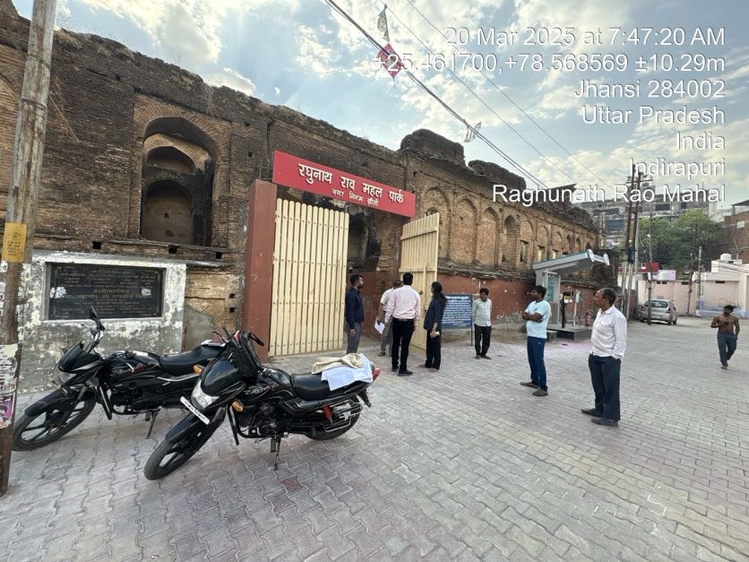

**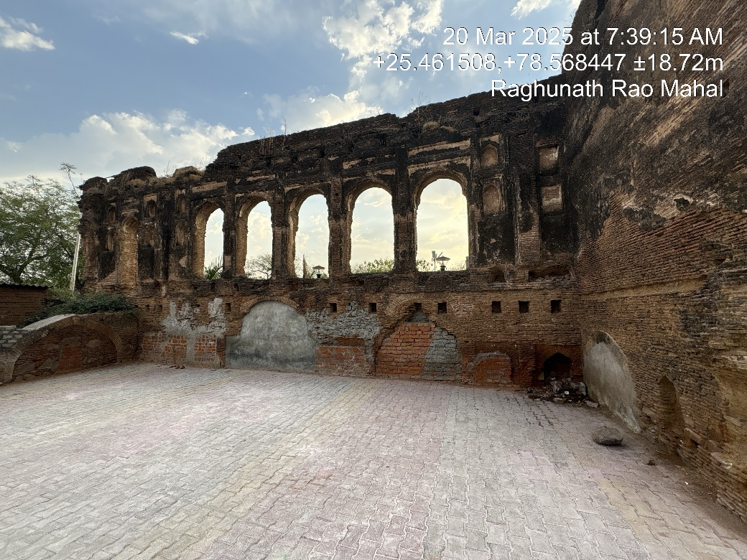**

**SITUATED AT**

**RAGHUNATH RAO MAHAL, KHAJOOR BAGH, INDRAPURI, JHANSI, UTTAR PRADESH - 284002**

|  |  |
| --- | --- |
| **PART B** | **SUMMARY OF THE REPORT** |

|  |  |  |  |  |  |
| --- | --- | --- | --- | --- | --- |
| **S.NO.** | **CONTENTS** | **DESCRIPTION** | | | |
|  | **GENERAL DETAILS** | | | | |
|  | Report prepared for | Directorate of Tourism, Government of Uttar Pradesh | | | |
|  | Work Order No. & Date | 11 November 2024 | | | |
|  | Name of the Customer | Directorate of Tourism, Government of Uttar Pradesh | | | |
|  | Name of Property Owner | Government of Uttar Pradesh | | | |
|  | Address & Phone Number of the owner | --- | | | |
|  | Type of the Property | Heritage Property | | | |
|  | Type of Report | Technical Survey Report and Circle rate Valuation | | | |
|  | Date of Inspection of the Property | 20 March 2025 | | | |
|  | Date of Report | 22 March 2025 | | | |
|  | Property Shown By | **Name** | **Relationship with Owner** | **Contact Number** | |
| Mr. Bhupendra Singh | Lekhpal (Tehsil-Jhansi Khas) | 9935956660 | |
|  | Purpose of the Report | For redevelopment for adaptive reuse | | | |
|  | Scope of the Report | In respect to Raghunath Rao Mahal built-up over land area admeasuring ~1.83 Acre (as per work order issued by Directorate of Tourism Government of Uttar Pradesh, Dated- 11 November 2024)   * To carry out technical survey and provide Govt. Guideline Value. * Comments for any encroachment at site. * Trees present in the premises (type & numbers) * Layout, location in map clearly highlighting the different components at the site. * Coordination with the Revenue Department related to the land and property. * Potential Product Mix and usage as per market analysis. | | | |
|  | Documents provided for perusal | **Documents Requested** | **Documents Provided** | | **Documents Reference No.** |
| Total **02** Documents requested. | Total **0** Documents provided. | | --- |
| Property Title document | Not Available | | --- |
| Cizra Map | Cizra Map | | -- |
| --- | Culture Section Notification | | Dated: 03/01/02023 |
| --- | Khatauni/Khasra document (Signed by RTO & Lekhpal of concerned area) | | Dated: 22/07/2024 |
|  | Identification of the property | ☒ Identified by the Lekhpal of the concerned area | | | |

|  |  |  |
| --- | --- | --- |
|  | **VALUATION SUMMARY** | |
|  | **Govt. Circle/ Guideline Value Land** | **Rs. 8,15,10,000/-** |
|  | **Govt. Circle/ Guideline Value Building** | **Rs.** **29,36,250/-** |
|  | **Total Govt. Circle/ Guideline Value of Land & Building** | **Rs. 8,44,46,250/-** |

|  |  |  |
| --- | --- | --- |
|  | **ENCLOSURES** | |
|  | **Part A** | **Snapshot of The Heritage Property** |
|  | **Part B** | **Summary of the Report** |
|  | **Part C** | **Characteristics Description of The Asset** |
|  | **Part D** | **Area Description of The Property** |
|  | **Part E** | **Schedule of Tree** |
|  | **Part F** | **Circle Rate Valuation of Land & Building** |
|  | Enclosure 1 | Google Map – Page No.17 |
|  | Enclosure 2 | Photographs – Pages No.18 to 24 |
|  | Enclosure 3 | Copy of Circle Rate – Pages No. 25 |
|  | Enclosure 4 | Important Property Documents Exhibit – Pages No.26 & 27 |
|  | Enclosure 5 | Valuer’s Important Remarks Pages No. 28 & 29 |

|  |  |
| --- | --- |
| **PART C** | **CHARACTERISTICS DESCRIPTION OF THE PROPERTY** |

|  |  |  |  |  |
| --- | --- | --- | --- | --- |
|  | **PHYSICAL CHARACTERISTICS OF THE PROPERTY** | | | |
|  | **Brief Description of The Property** | | | |
| This report is prepared for the heritage property named Raghunath Rao Mahal, located in Jhansi, Uttar Pradesh. A historical site of immense significance, the Mahal once embodied the splendor and grandeur of the Maratha Empire during the 18th century. Though it has undergone considerable deterioration due to natural factors and years of neglect, the structure still echoes the cultural and architectural brilliance of its time. The Mahal served as the royal residence and a strategic stronghold during the era of Raghunath Rao (also known as Raghoba), a prominent Maratha general. Despite its current condition, the site stands as an important reminder of Jhansi's rich history and its association with the Maratha Empire.  The property is located approximately 5 kilometers away from the Jhansi railway station and is about 3 kilometers from the main town area. The Mahal was constructed with a mix of traditional Maratha and Mughal architectural styles, showcasing intricate designs and craftsmanship. The structure was once a symbol of power, complete with grand halls and fortifications.  While the Mahal is currently in a deteriorated state, it still offers valuable insight into the history of the Maratha presence in Bundelkhand and serves as a culturally significant landmark in Jhansi. The ruins continue to attract heritage enthusiasts and historians, seeking to understand the glory of this royal residence.  **Land Details:**  The total land area, as per the Culture Section Notification documents provided to us, is approximately 30.341 Hectare or 30,3410 sq.mtr. But, as per work order and the site visit and confirmation by Mr. Bhupendra Singh (Lekhpal-Jhansi Khas), we came to know that only ~7,410 sq mtr or ~1.83 Acre land area is available for redevelopment. Because most of the land is occupied by local habitants and also it is transferred in their names. But, around 800-900 sq.mtr. of land is illegally occupied by local habitant by constructing temporary structures without any valid document which needs to be vacated by issuing evictions notice and removing the encroachment by the Govt. of Uttar Pradesh.  **Building & Civil Work:**  The details of the building as per the site survey measurements is as given below:   |  |  |  |  |  |  | | --- | --- | --- | --- | --- | --- | | **S. No.** | **Building Description** | **No. of Floors** | **Height  (Mtr)** | **Type of Structure** | **Covered area (in sq.mtr)** | | 1 | Raghunath Rao Mahal Park Rooms | GF | ~3.8 | Load Bearing Structure | 189 | | 2 | Main Gate Block | GF | ~6 | Load Bearing Structure | 45 | | **Total** | | | | | **234** |   Building/structures of Raghunath Rao Mahal is in a dilapidated condition due to no maintenance, with major structural damage and overall condition is also poor due to no maintenance.  **Location of the subject property:**    The access to the Raghunath Rao Mahal is through a narrow, locally used road, which is about 8-10 ft. wide. The nearest major highway is National Highway 44 (Agra – Mumbai Highway), which is about 2 kilometers from the Mahal.  The property is located within the limits of the Jhansi Development Authority (Nagar Nigam) and have good connectivity to local communication networks. There are various residential establishments, historical landmarks such as Jhansi Fort and Rani Lakshmibai Memorial, as well as educational institutions like Bundelkhand University and Maharani Laxmi Bai Government Girls College. | | | |
|  | Is property clearly demarcated by permanent/ temporary boundary on site | Partially demarcated (Only the Park is demarcated properly). | | |
|  | Independent access/ approach to the property | Clear independent access is available | | |
|  | Is the property merged or colluded with any other property | Yes, it is merged with the adjoining properties | | |
| --- | | |
|  | Land Physical Factors | **Shape** | **Size** | **Layout** |
| Irregular | Normal | NA |

|  |  |  |  |
| --- | --- | --- | --- |
|  | **DOCUMENT DETAILS AND LEGAL ASPECTS OF THE PROPERTY** | | |
|  | Property documents available | Khatauni/Khasra document (Signed by RTO & Lekhpal of concerned area) | Dated: 22/07/2024 |
|  | Names of the Legal Owner/s as per Revenue Records | UP Govt. (It is a Nazool Property) | |
|  | Constitution of the Property | Heritage Property. | |
|  | Property presently occupied/ possessed by | UP Govt. | |

|  |  |  |  |  |  |  |  |  |
| --- | --- | --- | --- | --- | --- | --- | --- | --- |
|  | **LOCATION CHARACTERISTICS OF THE PROPERTY** | | | | | | | |
|  | Nearby Landmark | | Itself is a landmark. | | | | | |
|  | Postal Address of the Property | | Raghunath Rao Mahal, Khajoor Bagh, Indrapuri, Jhansi, Uttar Pradesh-284002 | | | | | |
|  | Google Map Location of the Property with a neighborhood layout map | | Enclosed with the Report | | | | | |
| Coordinates or URL: 25°27'42.9"N 78°34'08.2"E | | | | | |
|  | Description of adjoining property | | Residential | | | | | |
|  | Plot No./ Survey No. | | Please refer to the table on pg no.13 for land details | | | | | |
|  | Village/ Zone | | Jhansi Khas | | | | | |
|  | Sub registrar | | Jhansi | | | | | |
|  | District | | Jhansi | | | | | |
|  | City Categorization | | Tehsil | | | Semi Urban | | |
|  | Characteristics of the locality | | Average | | | Within good village area | | |
|  | Property location classification | | Normal location within locality | | Average location within locality | | | Near to Highway |
|  | Property Facing | | East Facing | | | | | |
|  | **Details of the roads abutting the property** | | | | | | | |
| 1. Main Road Name & Width | | Internal Colony Road | | | | ~12-15 feet wide | |
| 1. Front Road Name & width | | Gwalior Road | | | | ~55-60 feet wide | |
| 1. Type of Approach Road | | Bituminous Road | | | | | |
| 1. Distance from the Main Road | | ~1.2 Km | | | | | |
|  | **Boundaries schedule of the Property** | | | | | | | |
|  | **Directions** | **As per the documents** | | **Actual found at Site** | | | | |
| East | Harijan Colony (Municipality) | | Road | | | | |
| West | Plot of Kallu Kushwaha etc. | | Road | | | | |
| North | Population | | Residential Area | | | | |
| South | Road | | Road | | | | |
|  | Neighbourhood amenities | | Average. | | | | | |
|  | Any New Development in surrounding area | | None | | | | | |

|  |  |  |
| --- | --- | --- |
|  | **TOWN PLANNING/ ZONING PARAMETERS** | |
|  | Planning Area/ Zone | No zoning regulations defined for this area |
|  | Master Plan currently in force | --- |
|  | Municipal limits | Jhansi Nagar Nigam |
|  | Developmental controls/ Authority | Jhansi Nagar Nigam |
|  | Zoning regulations | No zoning regulations defined for this area |
|  | Master Plan provisions related to property in terms of Land use | No zoning regulations defined for this area |
|  | Any conversion of land use done | NA |
|  | Current activity done in the property | Park and some encroached residential temporary houses. |
|  | Is property usage as per applicable zoning | No zoning regulations defined for this area |
|  | Any notification on change of zoning regulation | NA |
|  | Street Notification | Not notified |
|  | Comment on the surrounding land uses & adjoining properties in terms of uses | The surrounding properties are currently being used for residential purpose. |
|  | Comment of Demolition proceedings if any | No |
|  | Comment on Compounding/ Regularization proceedings | No |
|  | Any information on encroachment | Some encroached Residential temporary houses and Shops. |

|  |  |  |
| --- | --- | --- |
|  | **SOCIO - CULTURAL ASPECTS OF THE PROPERTY** | |
|  | Descriptive account of the location of the property in terms of social structure of the area in terms of population, social stratification, regional origin, age groups, economic levels, location of slums/squatter settlements nearby, etc. | The Raghunath Rao Mahal in Jhansi is situated in a historically significant and culturally rich area. The city of Jhansi is home to a diverse community, with a mix of urban, rural, and working-class families. The predominant languages spoken are Hindi and Bundeli, with the local population actively participating in traditional festivals that celebrate the region’s cultural heritage. Jhansi is well-connected to neighboring towns like Orchha and Kanpur, with a robust road and rail network ensuring easy accessibility. The population is primarily composed of low to middle-income families, with livelihoods based on agriculture, trade, and small businesses. Nearby attractions include historical landmarks like the Jhansi Fort and the Rani Lakshmibai Memorial, reflecting the area’s royal and revolutionary history. |
|  | Whether property belongs to social infrastructure like hospital, school, old age homes etc. | Yes, property is being used as a park developed by Municipal Council. |

|  |  |  |  |  |  |  |  |  |
| --- | --- | --- | --- | --- | --- | --- | --- | --- |
|  | | **FUNCTIONAL AND UTILITARIAN SERVICES, FACILITIES & AMENITIES** | | | | | | |
|  | Drainage arrangements | | | | | Yes | | |
|  | | Water Treatment Plant | | | | No | | |
|  | | Power Supply arrangements | | Permanent | | Yes | | |
| Auxiliary | | No | | |
|  | | HVAC system | | | | No | | |
|  | | Security provisions | | | | No | | |
|  | | Lift/ Elevators | | | | No | | |
|  | | Compound wall/ Main Gate | | | | Compound Wall (Only for Park Area) | | |
|  | | Whether gated society | | | | No | | |
|  | | Car parking facilities | | | | On Ground | | |
|  | | Ventilation | | | | --- | | |
|  | | Internal development | | | | | | |
| Garden/ Park/ Land scraping | Water bodies | | Internal roads | | Pavements | Boundary Wall |
| Yes | Yes | | No | | Yes | Yes, Partially |

|  |  |  |  |  |  |  |  |  |
| --- | --- | --- | --- | --- | --- | --- | --- | --- |
|  | **INFRASTRUCTURE AVAILABILITY** | | | | | | | |
|  | Description of Aqua Infrastructure availability in terms of: | | | | | | | |
|  | 1. Water Supply | | | | Yes | | | |
| 1. Sewerage/ sanitation system | | | | Underground | | | |
| 1. Storm water drainage | | | | No | | | |
|  | Description of other Physical Infrastructure facilities in terms of: | | | | | | | |
|  | 1. Solid waste management | | | | Yes, within the locality. | | | |
| 1. Electricity | | | | Yes | | | |
| 1. Road and Public Transport connectivity | | | | Yes | | | |
| 1. Availability of other public utilities nearby | | | | Transport, Market, Hospital etc. available in close vicinity | | | |
|  | Proximity & availability of civic amenities & social infrastructure | | | | | | | |
|  | School | Hospital | Market | Bus Stop | | Railway Station | Metro | Airport |
| ~1 Km. | ~2 Km. | ~1 Km. | ~2 km. | | ~3 km. | --- | --- |
|  | Availability of recreation facilities (parks, open spaces etc.) | | | This is a semi urban area. No recreational facility is available nearby. | | | | |

|  |  |  |  |
| --- | --- | --- | --- |
|  | **MARKETABILITY ASPECTS OF THE PROPERTY:** | | |
|  | Location attribute of the subject property | Normal | |
|  | Scarcity | Being Heritage property it is unique. | |
|  | Any New Development in surrounding area | None | ---- |
|  | Any negativity/ defect/ disadvantages in the property/ location | Low maintenance and poor condition of structure | ---- |
|  | Any other aspect which has relevance on the value or marketability of the property | Yes, Due to area and location. | |

|  |  |  |  |  |
| --- | --- | --- | --- | --- |
|  | **BUILDING & CONSTRUCTION ASPECTS OF THE PROPERTY:** | | | |
|  | Type of construction & design | Please refer to the table on pg no.14 & 15 for building/structure details | | |
|  | Method of construction | Ancient masonry techniques. | | |
|  | Specifications | | | |
| 1. Class of construction | Old Construction- Heritage property | | |
| 1. Appearance/ Condition of structures | Internal - Poor Condition | | |
| External - Poor Condition | | |
| 1. Roof | **Floors/ Blocks** | | **Type of Roof** |
| Please refer to the table on pg no.14 & 15 for building/structure details | | Please refer to the table for building/structure details |
| 1. Floor height | Please refer to the table on pg no.14 & 15 for building/structure details | | |
| 1. Type of flooring | PCC | | |
| 1. Doors/ Windows | Iron gate | | |
| 1. Interior Finishing | Brick walls without plaster | | |
| 1. Exterior Finishing | Brick walls without plaster | | |
| 1. Interior decoration/ Special architectural or decorative feature | Simple Plastered Walls | | |
| 1. Class of electrical fittings | Not Applicable | | |
| 1. Class of sanitary & water supply fittings | Not Applicable | | |
|  | Maintenance issues | Poor condition and maintenance | | |
|  | Age of building/ Year of construction | ~175 years | ~1850 | |
|  | Total life of the structure/ Remaining life expected | ~175 years | 0 | |
|  | Extent of deterioration in the structure | Multiple visible cracks & damages. | | |
|  | Protection against natural disasters viz. earthquakes etc. | NA | | |
|  | Visible damage in the building if any | Yes, Multiple visible cracks in Slabs, stairs and walls. | | |

|  |  |  |
| --- | --- | --- |
|  | **ARCHITECTURAL AND AESTHETIC QUALITY OF THE PROPERTY:** | |
|  | Descriptive account on whether the building is modern, old fashioned, etc., plain looking or with decorative elements, heritage value if applicable, presence of landscape elements,  etc. | The Mahal was constructed with a mix of traditional Maratha and Mughal architectural styles. |

|  |  |  |
| --- | --- | --- |
|  | **POTENTIAL PRODUCT MIX AND USAGE:** | |
|  | Neighborhood establishment | The surrounding area serves various institutional purposes, providing essential services to the local community. Key establishments include a primary school, Shri Kunj Bihari Mandir, Antia Talab, Ganesh Temple and Ganesh Khidki. |
|  | Nearby Attraction & Catchments | Jhansi Fort (~2 km), Jhansi Museum (~2 km), Orchha Fort (~20 km), Jahangir Fort (~20 km), Jhansi University (~5 km). |

|  |  |  |  |  |
| --- | --- | --- | --- | --- |
| **Potential Product Mix and Usage** | | | | |
| *(considering PPP adaptive reuse model)* | | | | |
| **Category** | **Potential Products/Services** | **Usage** | **Advantage** | **Disadvantage** |
| **Cultural Events & Performances** | Traditional Music Concerts, Folk Dance, Theatre Plays | Utilizing the theatre for live performances and cultural showcases throughout the year | Enhances cultural heritage, provides year-round engagement, and supports the arts community | Requires ongoing promotion and audience engagement, potential seasonal limitations |
| **Mandir & Spiritual Services** | Daily Aarti, Special Pujas, Religious Celebrations | Offering daily spiritual services and hosting religious events for devotees and visitors | Creates a serene, spiritual environment, strengthens community connections | Needs consistent attendance, effective crowd management, and space planning |
| **Wedding & Event Venue** | Weddings, Receptions, Religious Ceremonies, Pandal Setups | Leveraging the expansive grounds and mandir to host weddings and large-scale events | Provides a unique, sacred venue for significant life events, with ample space for large gatherings | High demand during peak wedding seasons, requires detailed logistical coordination and infrastructure |

|  |  |
| --- | --- |
| **PART D** | **AREA DESCRIPTION OF THE PROPERTY** |

1. **LAND AREA:** Land area details are tabulated below as per the Khasra/Khatauni record document provided to us and confirmed during the site visit by Mr. Bhupendra Singh - Lekhpal (Tehsil- Jhansi) of the subject locality with area actual found at site:

|  |  |  |  |  |  |  |
| --- | --- | --- | --- | --- | --- | --- |
| **Area As Per Khasra/Khatauni Documents** | | | | | | **Area As Per Site Survey** |
| **SL.No** | **District** | **Mouza** | **Khasra/Gata No.** | **Type of property/Owner** | **Area in**  **Hectares** | **Area in Hectare** |
| 1 | Jhansi | Jhansi Khas, N.Z.A | 3160 | Nazool | 30.341 | ~0.7410 |
| **Total:** | | | | | 30.341 | ~0.7410 |

1. **BUILDING & CIVIL WORKS:** The details of the building as per the site survey measurements is as attached below:

|  |  |  |  |  |  |
| --- | --- | --- | --- | --- | --- |
| **S. No.** | **Building Description** | **No. of Floors** | **Height  (Mtr)** | **Type of Structure** | **Covered area (in sq.mtr)** |
| 1 | Raghunath Rao Mahal Park Rooms | GF | ~3.8 | Load Bearing Structure | 189 |
| 2 | Main Gate Block | GF | ~6 | Load Bearing Structure | 45 |
| **Total** | | | | | **234** |

***Note:***

1. *Topographical survey drawing of the site is shared separately in .pdf format.*

|  |  |
| --- | --- |
| **PART E** | **SCHEDULE OF TREE** |

During the site survey, we found various trees at the property. Also, there are new trees planted inside the park by the Municipal Council. So, there are around 50-60 nos. of small trees thus, we have not considered the small trees.

|  |  |  |  |  |
| --- | --- | --- | --- | --- |
| S.No | Type of Tree | No. of Tree | Girth of Tree | Approx Height of Tree as per surveyor drawing |
| 1 | Gular Tree | 1 | 2m | 4m |
| 2 | Kadam Tree | 4 | 40cm | 4m |
| 3 | Kadam Tree | 1 | 50cm | 4m |
| 4 | Kadam Tree | 1 | 30cm | 3m |
| 5 | Ashoka Tree | 5 | 30cm | 3m |
|  | **Total** | **36** |  |  |

|  |  |
| --- | --- |
| **PART F** | **CIRCLE RATE VALUATION OF LAND & BUILDING** |

|  |  |  |
| --- | --- | --- |
| **S.No.** | **Particulars** | **Govt. Circle/ Guideline Value of Land Senapati Mahal** |
|  | Prevailing Rate range | Rs.11,000/- per sq.mtr |
|  | Circle Rate adopted | From the Circle Rate List Issued by Office of District Magistrate, Jhansi Sadar, Dated: 07/09/2023 |
|  | Rate Classification | Non-Agricultural Land |
|  | Rate adopted considering all characteristics of the property | Rs.11,000/- per sq.mtr |
|  | Total Land Area considered *(documents vs site survey whichever is less)* | The land area considered, as determined during the site visit also confirmed by the Lekhpal of the concerned area approximately **1.83 Acres or 7,410 square meters**. |
|  | **Total Value of land** | 7,410 per sq. mtr. x Rs. 11,000/- per sq.mtr |
| **Total: Rs. 8,15,10,000 /-** |

|  |  |  |  |  |  |  |  |  |
| --- | --- | --- | --- | --- | --- | --- | --- | --- |
| **Govt. Circle/ Guideline Value of Buildings Raghunath Rao Mahal** | | | | | | | | |
| **S. No.** | **Building Description** | **No. of Floors** | **Height  (Mtr.)** | **Type of Structure** | **Covered area (in sq.mtr.)** | **Govt. Circle Rates per sq.mtr.** | **Guideline Value (INR)** | **Remark** |
| 1 | Raghunath Rao Mahal Park Rooms | GF | ~3.8 | Load Bearing Structure | 189 | 14,500 | 27,40,500 | **This Structure is renovated recently when the park is developed.** |
| 2 | Main Gate Block | GF | ~6 | Load Bearing Structure | 45 | 14,500 | 1,95,750 | **Discount of 70% due to age, poor condition of structure and no maintenance.** |
| **Total** | | | | | **234** |  | **29,36,250** | **-** |
| ***Remarks:*** | | | | | | | | |
| *1. All the details pertaining to the building area statement such as area, floor, etc. has been taken as per the site survey measurement and Google tool measurement.* | | | | | | | | |
| *2. The maintenance of the building was poor as per site survey observation.* | | | | | | | | |
| *3. Age of construction taken from the information available on internet(No available documents available which can confirm the same)* | | | | | | | | |

**IMPORTANT NOTES**

***DEFECT LIABILITY PERIOD****- In case of any query/ issue or escalation you may please contact Incident Manager by writing at valuers@rkassociates.org. We try our level best to ensure maximum accuracy in the Calculations done, Rates adopted and various other data points & information mentioned in the report but still can’t rule out typing, human errors, assessment or any other mistakes. In case you find any mistake, variation, discrepancy or inaccuracy in any data point mentioned in the report, please help us by bringing all such points into our notice in writing at valuers@rkassociates.org* *within 30 days of the report delivery, to get these rectified timely, failing which R.K Associates shouldn’t be held responsible for any inaccuracy in any manner. Also, if we do not hear back anything from you within 30 days, we will assume that the report is correct in all respect and no further claim of any sort will be entertained thereafter. We would welcome and appreciate your feedback & suggestions in order to improve our services.*

*Our* ***DATA RETENTION POLICY*** *is of* ***ONE YEAR****. After this period we remove all the concerned records related to the assignment from our repository. No clarification or query can be answered after this period due to unavailability of the data.*

***COPYRIGHT FORMAT*** *- This report is prepared on the copyright format of R.K Associates to serve our clients in the best possible way. Legally no one can copy or distribute this format without prior approval from R.K Associates. It is meant only for the organization as mentioned on the cover page of this report. Distribution or use of this format or any content of this report wholly or partially other than R.K Associates will be seen as unlawful act and necessary legal action can be taken against the defaulters.*

|  |  |  |
| --- | --- | --- |
| SURVEY ANALYST | ENGINEER | L1/ L2 REVIEWER |
| Er. Manmohan &  Er. Anuj Sharma | Er. Manmohan | Er. Anil Kumar |
|  |  |  |

**ENCLOSURE: 1 – GOOGLE MAP LOCATION**

**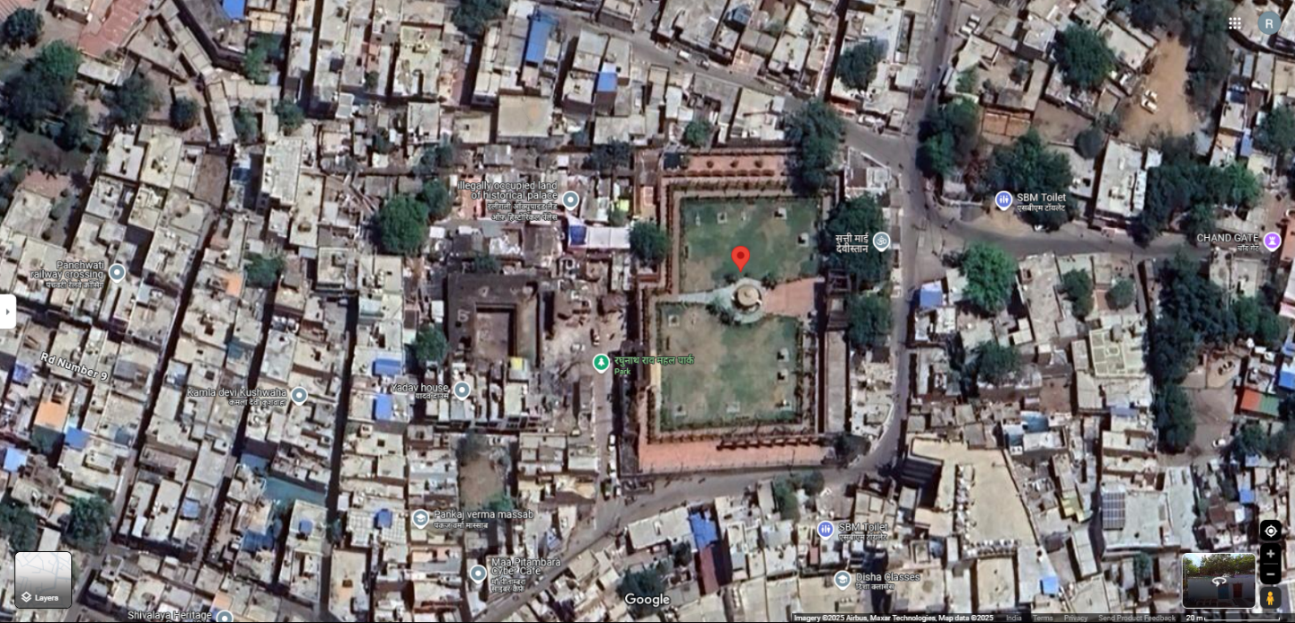**

**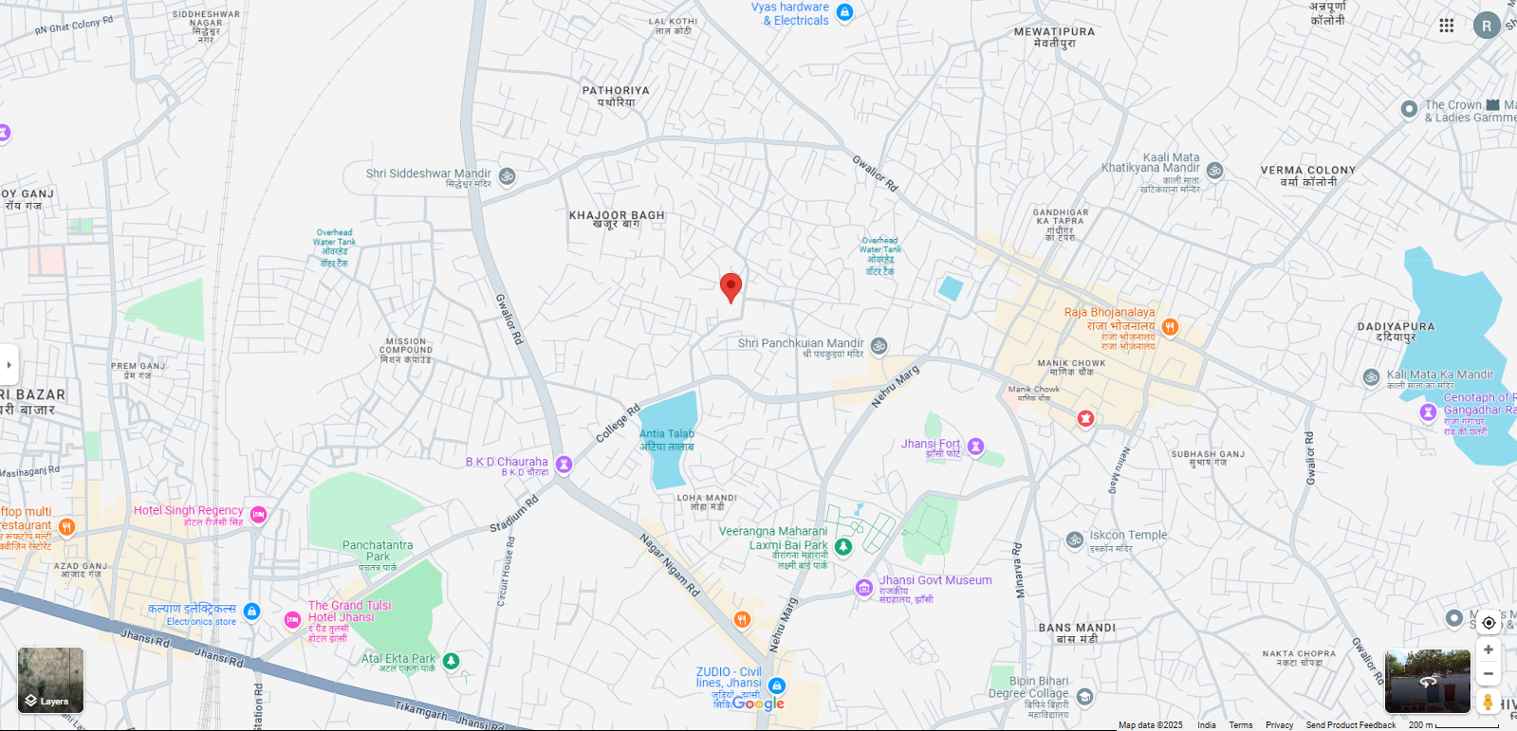**

**ENCLOSURE: 2 – PHOTOGRAPHS OF THE PROPERTY**

**RAGHUNATH RAO MAHAL**

|  |  |
| --- | --- |
| **Z:\In Progress Files\Rajat\U P Tourism Heritage Properties (Phase II)\Ragunath Rao\Pics\TC_00784.JPG** | **Z:\In Progress Files\Rajat\U P Tourism Heritage Properties (Phase II)\Ragunath Rao\Pics\TC_00778.JPG** |
| **Z:\In Progress Files\Rajat\U P Tourism Heritage Properties (Phase II)\Ragunath Rao\Pics\TC_00777.JPG** | **Z:\In Progress Files\Rajat\U P Tourism Heritage Properties (Phase II)\Ragunath Rao\Pics\TC_00779.JPG** |
| **Z:\In Progress Files\Rajat\U P Tourism Heritage Properties (Phase II)\Ragunath Rao\Pics\TC_00780.JPG** | **Z:\In Progress Files\Rajat\U P Tourism Heritage Properties (Phase II)\Ragunath Rao\Pics\TC_00802.JPG** |

|  |  |
| --- | --- |
| **Z:\In Progress Files\Rajat\U P Tourism Heritage Properties (Phase II)\Ragunath Rao\Pics\TC_00836.JPG** | **Z:\In Progress Files\Rajat\U P Tourism Heritage Properties (Phase II)\Ragunath Rao\Pics\TC_00838.JPG** |
| **Z:\In Progress Files\Rajat\U P Tourism Heritage Properties (Phase II)\Ragunath Rao\Pics\TC_00819.JPG** | **Z:\In Progress Files\Rajat\U P Tourism Heritage Properties (Phase II)\Ragunath Rao\Pics\TC_00820.JPG** |
| **Z:\In Progress Files\Rajat\U P Tourism Heritage Properties (Phase II)\Ragunath Rao\Pics\TC_00828.JPG** | **Z:\In Progress Files\Rajat\U P Tourism Heritage Properties (Phase II)\Ragunath Rao\Pics\TC_00831.JPG** |

|  |  |
| --- | --- |
| **Z:\In Progress Files\Rajat\U P Tourism Heritage Properties (Phase II)\Ragunath Rao\Pics\TC_00793.JPG** | **Z:\In Progress Files\Rajat\U P Tourism Heritage Properties (Phase II)\Ragunath Rao\Pics\TC_00795.JPG** |
| **Z:\In Progress Files\Rajat\U P Tourism Heritage Properties (Phase II)\Ragunath Rao\Pics\TC_00801.JPG** | **Z:\In Progress Files\Rajat\U P Tourism Heritage Properties (Phase II)\Ragunath Rao\Pics\TC_00805.JPG** |
| **Z:\In Progress Files\Rajat\U P Tourism Heritage Properties (Phase II)\Ragunath Rao\Pics\TC_00844.JPG** | **Z:\In Progress Files\Rajat\U P Tourism Heritage Properties (Phase II)\Ragunath Rao\Pics\TC_00848.JPG** |
| **Z:\In Progress Files\Rajat\U P Tourism Heritage Properties (Phase II)\Ragunath Rao\Pics\TC_00834.JPG** | **Z:\In Progress Files\Rajat\U P Tourism Heritage Properties (Phase II)\Ragunath Rao\Pics\TC_00841.JPG** |
| **Z:\In Progress Files\Rajat\U P Tourism Heritage Properties (Phase II)\Ragunath Rao\Pics\TC_00859.JPG** | **Z:\In Progress Files\Rajat\U P Tourism Heritage Properties (Phase II)\Ragunath Rao\Pics\TC_00860.JPG** |
| **Z:\In Progress Files\Rajat\U P Tourism Heritage Properties (Phase II)\Ragunath Rao\Pics\TC_00867.JPG** | **Z:\In Progress Files\Rajat\U P Tourism Heritage Properties (Phase II)\Ragunath Rao\Pics\TC_00868.JPG** |

|  |  |
| --- | --- |
| **Z:\In Progress Files\Rajat\U P Tourism Heritage Properties (Phase II)\Ragunath Rao\Pics\TC_00898.JPG** | **Z:\In Progress Files\Rajat\U P Tourism Heritage Properties (Phase II)\Ragunath Rao\Pics\TC_00901.JPG** |
| **Z:\In Progress Files\Rajat\U P Tourism Heritage Properties (Phase II)\Ragunath Rao\Pics\TC_00906.JPG** | **Z:\In Progress Files\Rajat\U P Tourism Heritage Properties (Phase II)\Ragunath Rao\Pics\TC_00776.JPG** |
| **Z:\In Progress Files\Rajat\U P Tourism Heritage Properties (Phase II)\Ragunath Rao\Pics\TC_00775.JPG** | **Z:\In Progress Files\Rajat\U P Tourism Heritage Properties (Phase II)\Ragunath Rao\Pics\TC_00788.JPG** |

**ENCLOSURE: 3 – COPY OF CIRCLE RATE**

|  |
| --- |
|  |
|  |

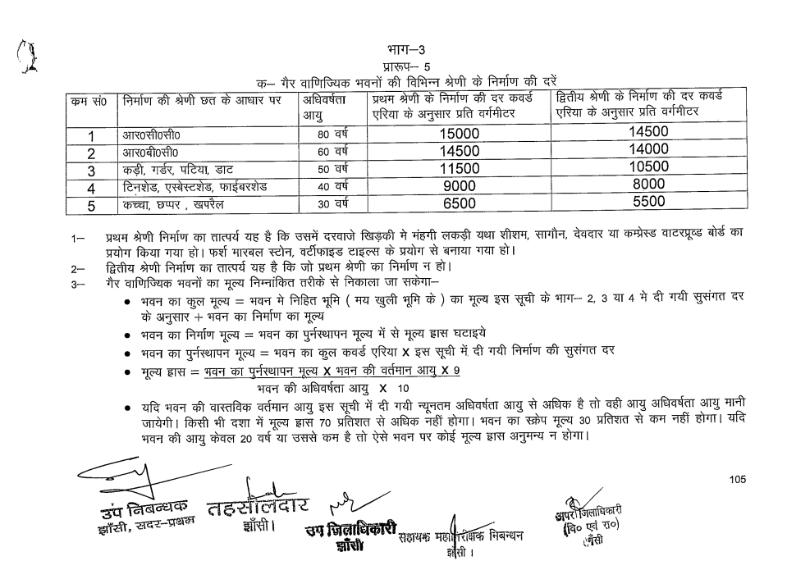

**ENCLOSURE: 4 – IMPORTANT PROPERTY DOCUMENTS EXHIBIT**

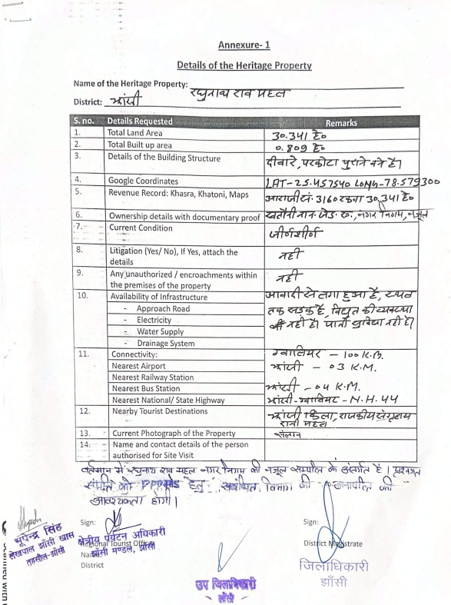**KHASRA/KHATAUNI DOCUMENTS**

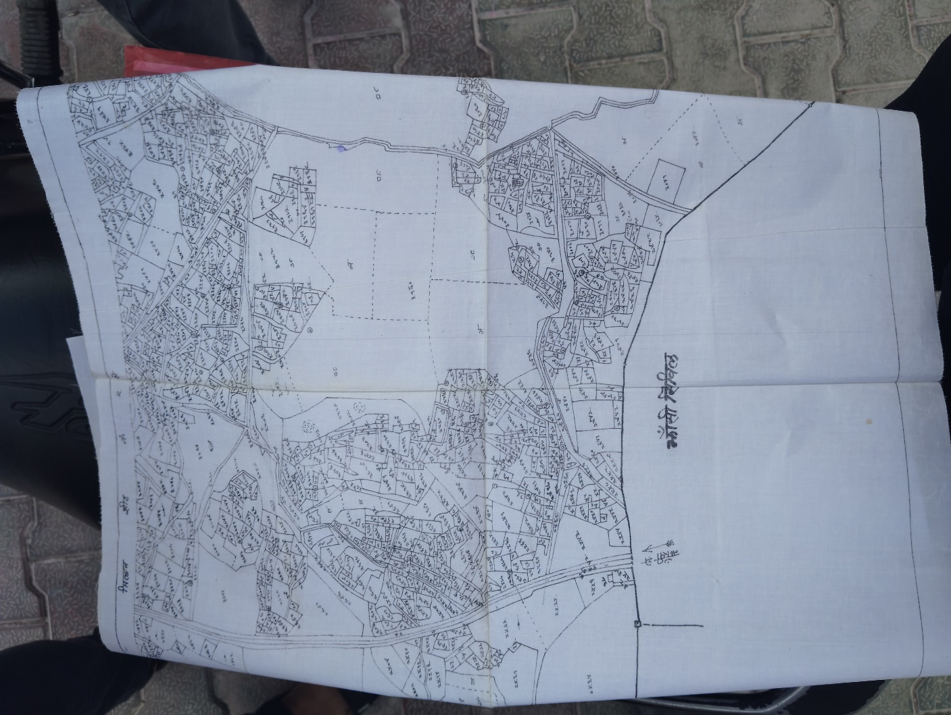

|  |
| --- |
|  |
|  |

**LEKHPAL CONFIRMATION WITH SIGN**

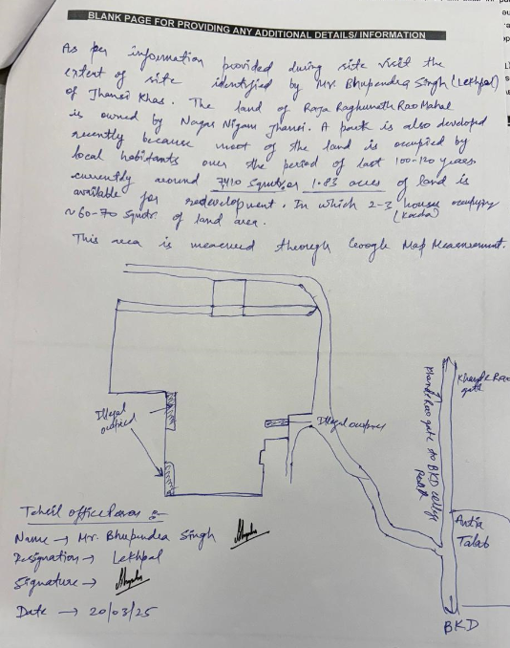

**ENCLOSURE: 5 – VALUER’S IMPORTANT REMARKS**

|  |  |
| --- | --- |
|  | This report is prepared for the asset found on as-is-where basis which Lekhpal of the concerned area has shown/ identified to us on the site unless otherwise mentioned in the report of which some reference has been taken from the information/ data given in the copy of documents provided to us and informed verbally or in writing out of the standard checklist of documents sought from the client & its customer which they could provide within the reasonable expected time out of the standard checklist of documents sought from them and further based on certain assumptions and limiting conditions. The information, facts, documents, data which has become primary basis of the report has been supplied by the client which has been relied upon in good faith and is not generated by the Valuer. |
|  | The client/ owner and its management/ representatives warranted to us that the information they have supplied was complete, accurate and true and correct to the best of their knowledge. All such information provided to us either verbally, in writing or through documents has been relied upon in good faith and we have assumed that it is true & correct without any fabrication or misrepresentation. I/We shall not be held liable for any loss, damages, cost or expenses arising from fraudulent acts, misrepresentations, or willful default on part of the owner, company, its directors, employee, representative or agents. |
|  | Legal aspects for eg. Investigation of title, ownership rights, lien, charge, mortgage, lease, sanctioned maps, verification of documents provided to us such as title documents, Map, etc. from any concerned Govt. office etc. have to be taken care by legal expert/ Advocate and same is not done at our end. It is assumed that the concerned authority has asked for the report of that property after satisfying the authenticity of the documents given to us for which the legal verification has been already taken and cleared by the competent Advocate before requesting for the technical report. I/ We assume no responsibility for the legal matters including, but not limited to, legal or title concerns. |
|  | In the course of the report, we were provided with both written and verbal information. We have however, evaluated the information provided to us through broad inquiry, analysis and review but have not carried out a due diligence or audit of the information provided for the purpose of this engagement. Our conclusions are based on the assumptions and other information provided to us by the client during the course of the assessment. |
|  | Getting cizra map or coordination with revenue officers for site identification is a separate activity and is not part of the services and same has not been done in this report unless otherwise stated. |
|  | Wherever any details are mentioned in the report in relation to any legal aspect of the property such as name of the owner, leases, etc. is only for illustration purpose and should not be construed as a professional opinion. Legal aspects are out of scope of this report. Details mentioned related to legal aspect are only based on the copy of the documents provided to us and whatever we can interpret as a non-legally trained person. This should be cross validated with a legal expert. We do not vouch any responsibility regarding the same. |
|  | We have made certain assumptions in relation to facts, conditions & situations affecting the subject of, or approach to this exercise that has not been verified as part of the engagement rather, treated as “a supposition taken to be true”. If any of these assumptions prove to be incorrect then our estimate on value will need to be reviewed. |
|  | This is just an opinion report based on technical & market information having general assessment & opinion on the indicative. |
|  | We have relied on the data from third party, external sources & information available on public domain to conclude this report. These sources are believed to be reliable and therefore, we assume no liability for the truth or accuracy of any data, opinions or estimates furnished by others that have been used in this analysis. Where we have relied on the data, opinions or estimates from external sources, reasonable care has been taken to ensure that such data is extracted from authentic sources, however we still can’t vouch its authenticity, correctness, or accuracy. |
|  | Analysis and conclusions adopted in the report are limited to the reported assumptions, conditions and information came to our knowledge during the course of the work and based on the Standard Operating Procedures, Best Practices, Caveats, Limitations, Conditions, Remarks, Important Notes, Valuation TOR and definition of different nature of values. |
|  | Our report is meant ONLY for the purpose mentioned in the report and should not be used for any other purpose. The Report should not be copied or reproduced for any purpose other than the purpose for which it is prepared for. I/we do not take any responsibility for the unauthorized use of this report. |
|  | We owe responsibility only to the authority/client that has appointed us as per the scope of work mentioned in the report. We will not be liable for any losses, claims, damages or liabilities arising out of the actions taken, omissions or advice given by any other person. In no event shall we be liable for any loss, damages, cost or expenses arising in any way from fraudulent acts, misrepresentations or willful default on part of the client or companies, their directors, employees or agents. |
|  | While our work has involved an analysis & computation as pert scope of work, it does not include detailed estimation, design/ technical/ engineering/ financial/ structural/ environmental/ architectural/ compliance survey/ safety audit & works in accordance with generally accepted standards of audit & other such works. The report in this work in not investigative in nature. It is mere an opinion based on the facts & details presented to us by the client and third party market information came in front of us within the limited time of this assignment, which may vary from situation to situation. |
|  | No document has been reviewed beyond the scope of the work. These are not reviewed in terms of legal rights for which we do not have expertise. Wherever any information mentioned in this report is mentioned from the documents like owners name, etc., it is only for illustration purpose and may not necessary represent accuracy. |
|  | This report is not a qualification for accuracy of land boundaries, schedule (in physical terms), dimensions & identification. For this land/ property survey report can be sought from a qualified private or Govt. surveyor. |
|  | This report is done for the property identified to us by the Lekhpal of the concerned area. Method by which identification of the property is carried out is also mentioned in the report clearly. Responsibility of identifying the correct property to the Valuer/ its authorized surveyor is solely of the client/ owner for which Valuation has to be carried out. |
|  | In India more than 70% of the geographical area is lying under rural/ remote/ non municipal/ unplanned area where the subject property is surrounded by vacant lands having no physical demarcation or having any display of property survey or municipal number / name plate on the property clearly. Even in old locations of towns, small cities & districts where property number is either not assigned or not displayed on the properties clearly and also due to the presence of multiple/ parallel departments due to which ownership/ rights/ illegal possession/ encroachment issues are rampant across India and due to these limitations at many occasions it becomes tough to identify the property with 100% surety from the available documents, information & site whereabouts and thus chances of error, misrepresentation by the borrower and margin of chances of error always persists in such cases. |
|  | Due to fragmented & frequent change in building/ urban planning laws/ guidelines from time to time, different laws/ guidelines between regions/ states and no strict enforceability of Building Bye-Laws in India specially in non-metro and scale b & c cities & Industrial areas, property owners many times extend or make changes in the covered area/ layout from the approved/ applicable limits. There are also situations where properties are decades old when there was no formal Building Bye-Laws applicable the time when the construction must have been done. Due to such discrete/ unplanned development in many regions sometimes it becomes tough for the Valuer to determine the exact lawful situation on ground. Unless otherwise mentioned in the report, the covered area present on the site as per site survey will be considered in the report. |
|  | Area of the large land parcels of more than 2500 sq.mtr or of uneven shape in which there can be practical difficulty in sample measurement, is taken as per property documents which has been relied upon unless otherwise stated. |
|  | Drawing Map, design & detailed estimation of the property/ building is out of scope of the technical report services. |
|  | This report is prepared on the RKA V-L1 (Basic) format as per the client requirement and scope of work. This report is having limited scope as per its fields & format to provide only the general estimated & indicative basic idea of the value of the property. No detailed analysis, audit or verification has been carried out of the subject property. There may be matters, other than those noted in this report, which might be relevant in the context of the transaction and which a wider scope might uncover. |
|  | All Pages of the report including annexures are signed and stamped from our office. In case any paper in the report is without stamp & signature then this should not be considered a valid paper issued from this office. |
|  | **Defect Liability Period is 15 DAYS.** We request the concerned authorized reader of this report to check the contents, data, information, and calculations in the report within this period and intimate us in writing at [**valuers@rkassociates.org**](mailto:valuers@rkassociates.org) within 15 days of report delivery, if any corrections are required or in case of any other concern with the contents or opinion mentioned in the report. If no intimation is received within 15 (Fifteen) days in writing from the date of issuance of the report, then it shall be considered that the report is complete in all respect and has been accepted by the client upto their satisfaction & use and further to which R.K Associates shall not be held responsible in any manner. After this period no concern/ complaint/ proceedings in connection with the services will be entertained due to possible change in situation and condition of the property. |
|  | Though adequate care has been taken while preparing this report as per its scope, but still we can’t rule out typing, human errors, over sightedness of any information or any other mistakes. Therefore, the concerned organization is advised to satisfy themselves that the report is complete & satisfactory in all respect. Intimation regarding any discrepancy shall be brought into our notice immediately. If no intimation is received within 15 (Fifteen) days in writing from the date of issuance of the report, to rectify these timely, then it shall be considered that the report is complete in all respect and has been accepted by the client upto their satisfaction & use and further to which R.K Associates shall not be held responsible in any manner. |
|  | Our Data retention policy is of **ONE YEAR**. After this period we remove all the concerned records related to the assignment from our repository. No clarification or query can be answered after this period due to unavailability of the data. |
|  | This report is governed by our (1) Internal Policies, Processes & Standard Operating Procedures, (2) R.K Associates Quality Policy, (3) Valuation & Survey Best Practices Guidelines formulated by management of R.K Associates, (4) Information input given to us by the customer and (4) Information/ Data/ Facts given to us by our field/ office technical team. Management of R.K Associates never gives acceptance to any unethical or unprofessional practice which may affect fair, correct & impartial assessment and which is against any prevailing law. In case of any indication of any negligence, default, incorrect, misleading, misrepresentation or distortion of facts in the report then we request the user of this report to immediately or atleast within the defect liability period to bring all such act into notice of R.K Associates management so that corrective measures can be taken instantly. |
|  | R.K Associates never releases any report doing alterations or modifications by pen. In case any information/ figure of this report is found altered with pen then this report will automatically become null & void. |
|  | We are fully aware that based on the opinion of value expressed in this report, we may be required to give testimony or attend court / judicial proceedings with regard to the subject assets, although it is out of scope of the assignment, unless specific arrangements to do so have been made in advance, or as otherwise required by law. In such event, the party seeking our evidence in the proceedings shall bear the cost/professional fee of attending court / judicial proceedings and my / our tendering evidence before such authority shall be under the applicable laws. |
|  | The final copy of the report shall be considered valid only if it is in hard copy on the company’s original letter head with proper stamp and sign on it of the authorized official upon payment of the agreed fees. User shall not use the content of the report for the purpose it is prepared for only on draft report, scanned copy, email copy of the report and without payment of the agreed fees. In such a case the report shall be considered as unauthorized and misused. |