REPORT FORMAT: V-L2 (L&B) | Version: 9.0_2019

FILE NO. VIS(2024-25)-PL538-483-675 DATED:21/11/2024

VALUATION ASSESSMENT

OF

INDUSTRIAL LAND & BUILDING

SITUATED AT

PLOT NO. D-29, INDUSTRAIL AREA BAHADARABAD, TEHSIL & DISTRICT HARIDWAR, UTTARKHAND

OWNER/S
MRS. AASHI GUPTA W/O. MR. ASHISH GUPTA

A/C: M/S. VISION METALS AIDS PRIVATE LIMITED

REPORT PREPARED FOR
STATE BANK OF INDIA, SME BRANCH, RANIPUR, HARIDWAR

**Important - In case of any query/ issue/ concern or escalation you may please contact Incident Manager @ valuers@rkassociates.org. We will appreciate your feedback in order to improve our services.
Valuation TOR is available at www.rkassociates.org for reference.
NOTE: As per IBA Guidelines please provide your feedback on the report within 15 days of its submission after which report will be considered to be correct.
VALUATION ASSESSMENT AS PER SBI FORMAT

Name & Address of Branch: | State Bank Of India, SME Branch, Ranipur, Haridwar.
Name Of Customer (S)/ Borrower Unit | M/s. Vision Metals Aids Private Limited

I. | GENERAL
 | Purpose for which the valuation is made |  |  | For Periodic Re-valuation of the mortgaged property
 |  | Date of inspection |  | 20/11/2024
 |  | Date on which the valuation is made |  | 21/11/2024
- SATISH | List of documents produced for perusal |  |  | Documents Requested | Documents Provided |  | Documents Reference No.
- SATISH |  |  |  | Total 04 documents requested. | Total 01 documents provided. |  | 01
- SATISH |  |  |  | Property Title document | Copy of TIR |  | Dated-02/11/2020
- SATISH |  |  |  | Completion Certificate | NA |  | ---
- SATISH |  |  |  | Last paid Electricity Bill | NA |  | ---
- SATISH |  |  |  | Last paid Municipal Tax Receipt | NA |  | ---
 | Name of the owner/s |  |  | Mrs. Aashi Gupta W/O. Mr. Ashish Gupta
 | Address and Phone no. of the owner/s |  |  | C-28, Shivalik Nagar, BHEL Ranipur Haridwar, Tehsil and District- Haridwar, Uttarkhand.
- Plo | Brief description of the property |  |  | This opinion on valuation report is prepared for the Industrial Land and building situated at the aforesaid address having total land area admeasuring 2137.24 sq.yrd / 1787 sq. mtr. as per the copy of TIR provided to us by the bank.  The subject property is a lease hold land acquired by Mrs. Aashi Gupta w/o. Mr. Ashish Gupta via single lease deed dated 04/11/2006. The lease deed dated 04/11/2006 executed by U.P. State Industrial Development Corporation Limited in favor of Mrs. Aashi Gupta W/O. Mr. Ashish Gupta via deed No. 12147.  The subject property is used as a manufacturing facility for the production, packing and storage of chemical products.  The subject property is located in the midst of developing Bahadarabad Industrial Area approached from Rawali Mehdood main road, at Plot No. D-29, Industrail Area At Bahadarabad, District – Haridwar, Uttarkhand The subject industrial area is now notified under SIDC and known as SIDC Bahadarabad.  The aforesaid property has a 3 floored RCC structure constructed with the Ground floor, First Floor and Mezzanine admeasuring with a total covered area of around 15,894 sq. ft. as per the measurement done during the site survey.  The structure was constructed in the year 1997 and all the structure is being completely used for the production and storage activity, and the condition of the structure was found to be average during the survey.  The subject property is located in developing industrial area known Bahadarabad Industrial Area in Haridwar. Some industries are setup nearby with few being functional and others being non-functional.  The subject property is around 200 mtr. away from the Rawali Mehdood main road and can be easily accessed by industrial area road.  This report only contains general assessment & opinion on the Guideline Value and the indicative, estimated Market Value of the property found on as-is-where basis on site for which the Bank/ customer has shown & asked us to conduct the Valuation for which photographs is also attached with the report. No legal aspects in terms of ownership or any other legal aspect is taken into consideration. It doesn’t contain any due-diligence other than the valuation assessment of the property shown to us on site. Information/ data/ documents given to us by Bank/ client has been relied upon in good faith. This report doesn’t contain any other recommendations of any sort.
 | Location of property
 |  | Plot No. / Survey No. |  | D-29
 |  | Door No. |  | Industrial Area at Bahadarabad
 |  | T. S. No. / Village |  | Haridwar
 |  | Ward / Taluka |  | Haridwar Industrial Area
 |  | Mandal / District |  | Uttarkhand
 |  | Date of issue and validity of layout of approved map / plan |  | NA
 |  | Approved map / plan issuing authority |  | NA.
 |  | Whether genuineness or authenticity of approved map / plan is verified |  | Map not provided to us
 |  | Any other comments by our empaneled Valuers on authenticity of approved plan |  | No
 | Postal address of the property |  |  | Plot No. D-29, Industrial Area At Bahadarabad, District – Haridwar, Uttarkhand.
 |  | City / Town |  | Haridwar
 |  | Residential Area |  | No
 |  | Commercial Area |  | No
 |  | Industrial Area |  | Yes
 | Classification of the area
 |  | High / Middle / Poor |  | Middle
 |  | Urban / Semi Urban / Rural |  | Semi Urban
 | Coming under Corporation limit/ Village Panchayat / Municipality |  |  | State Industrial Development Corporation Limited (SIDC)
 | Whether covered under any State / Central Govt. enactments (e.g. Urban and Ceiling Act) or notified under agency area / scheduled area / cantonment area |  |  | Not applicable
 | In case it is an agricultural land, any conversion to house site plots is contemplated |  |  | Not applicable
 | Boundaries of the property
 | Are Boundaries matched |  |  | No, Boundaries does not match from available document. The identification of the property was done by the owner’s representative.
 | Directions |  | As per Copy of Lease Deed |  |  | Actual found at Site
 | North |  | Plot No. D-30 |  |  | Plot No. E-44 & E-45
 | South |  | Plot No. D-28 |  |  | Road 24 mtr. wide
 | East |  | Plot No. E-44 & E-45 |  |  | Plot No. D-30
 | West |  | Road 24 mtr. wide |  |  | Plot No. D-28
14.1 | Dimensions of the site |  | A |  |  | B
14.1 |  |  | As per the Deed |  |  | Actuals (As per Survey)
14.1 | North |  | -- |  |  | --
14.1 | South |  | -- |  |  | --
14.1 | East |  | -- |  |  | --.
14.1 | West |  | -- |  |  | --.
14.2 | Latitude, Longitude & Co-Ordinates Of Industrial Property |  |  | 29°55'50.6"N 78°03'32.4"E
15. | Extent of the site |  |  | Land Area as per TIR - 2137.24 sq.yrd / 1787 sq. mtr.
16. | Extent of the site considered for valuation (least of 14 A & 14 B) |  |  | Land Area as per TIR - 2137.24 sq.yrd / 1787 sq. mtr.
17. | Whether occupied by the owner / tenant? |  |  | Lessee
17. | If occupied by tenant, since how long? |  |  | N.A.
17. | Rent received per month. |  |  | N.A.

II. | CHARACTERISTICS OF THE SITE
 | Classification of locality | Industrial Area
 | Development of surrounding areas | Industrial Land
 | Possibility of frequent flooding / sub-merging | No
 | Feasibility to the Civic amenities like school, hospital, bus stop, market etc. | Civic Amenities such as School and Market is available in close vicinity at a distance of around 3 km. from the subject property. The nearest railway station is around 8 km. away from the property.
 | Number of Floors | Refer to the sheet Attached below.
 | Type of Structure | Please refer to the attached specifications annexure
 | Type of use to which it can be put | Industrial purpose
 | Any usage restriction | Yes, It’s in an Industrial area and nearby properties mostly are being used for Industrial purpose or either vacant land.
 | Is plot in town planning approved layout? | Yes
 | Corner plot or intermittent plot? | Intermittent Plot
 | Road facilities | Yes
 | Type of road available at present | Bitumen Surfaced Road
 | Width of road – is it below 20 ft. or more than 20 ft. | More than 20 ft.
 | Is it a land – locked land? | No
 | Water potentiality | Water Submersible
 | Underground sewerage system | Yes  KHASRA NO. 11//18/2, 19/2, 12//6/2, 13, 14/1, 15, 16, 2/2, 3, 4, 8/2, 9/1, 8/1, 5, 14/2, 17, 6/1, 3//22/2, 23, 24, 25, VILLAGE KURAHWATA, ZERPUR MANDOLA ROAD, DISTT. MOHINDERGARH, HARYANA-123029  6,54,616 sq.ft. / 60835.67 sq. mtr.  M/s Star Wire India Vidyut Pvt. Ltd.
 | Is power supply available at the site? | Yes
 | Advantage of the site | The subject property is in Industrial area.
 | Special remarks, if any, like threat of acquisition of land for public service purposes, road widening or applicability of CRZ provisions etc. (Distance from sea-coast / tidal level must be incorporated) | None

PART B | VALUATION OF LAND

 | Size of Plot | Land Area as per TIR - 2137.24 sq.yrd / 1787 sq. mtr.
 | North & South | --
 | East & West | --
 | Total extent of the plot | Land Area as per TIR - 2137.24 sq.yrd / 1787 sq. mtr.
 | Area adopted on the basis of | Property documents & site survey both
 | Remarks & observations, if any | None
3. | Prevailing market rate (Along with details /reference of at least two latest deals/transactions with respect to adjacent properties in the areas) | References on prevailing market Rate/ Price trend of the property and Details of the sources from where the information is gathered (from property search sites & local information).  - Name: Risha Chawla ( Property Dealer)  Contact No.: +91-9997444400  Size of the Property: Approx. 800 sq. mtr.  Rates/ Price informed: Rs.15,000/- to Rs.18,000/- per sq.mtr.  Comment: As per the discussion held with the above mentioned property dealer we came to know that the rates in the concerned area ranges around Rs.15,000 to Rs.18,000 per sq.mtr. Allotment of large parcel of land is done through SIDC as the subject locality is a notified industrial area.  - Name: Manav Gupta  Contact No.: +91-7088550008  Size of the Property: Approx. 800 sq. mtr.  Rates/ Price informed: Rs.16,000/- to Rs.18,000/- per sq.mtr.  Comment: As per the discussion held with the local inhabitants we came to know that the rates in the concerned area were around Rs.16,000/- to Rs.18,000/- per sq.mtr. for small area of land.  During our micro market survey and discussion with local inhabitants and property dealer we came to know following information:  - The prevailing land rate in the subject locality depends on the size, shape, frontage, approach road width and location.  - The subject property is located in the SIDC notified industrial area located in Bahadarabad.  - The industrial area can be easily accessed through the Rawali Mehdood main road.  - The demand of the Industrial land in this area is good and industries are set up in the subject locality.  - The subject locality is located around 8 km away from the Jwalapur railway station.  The subject property is located at a distance of 200 mtr. from Rawali Mehdood main road and can be easily approached through 20mtr. wide internal road. Since it is a notified industrial area, the demand for industrial property is good in the vicinity.  The available market rates land in the subject locality mainly ranges from Rs.15,000/- to Rs.18,000/- per sq.mtr.  Since the subject property is a developed industrial property lying in industrial zone an considering all the above factors such as size, shape, frontage, approach road width and location we are in the view that the rate for the subject land can be considered Rs.16,000/- per sq. mtr.  No authentic last two transactions details could be known. However prospective transaction details as per information available on public domain and gathered during site survey is mentioned above. Valuation Assessment Factors of the report and the screenshots of the references are annexed in the report for reference.
 | Guideline rate obtained from the Registrar’s office (an evidence thereof to be enclosed) | Rs. 10,000/- per sq.mtr  Guideline value:  Land: 1787 sq.mtr. X Rs. 10,000/- per sq.mtr.  Rs.1,78,70,000/-
 | Assessed / adopted rate of valuation | Rs.16,000/- per sq.mtr
 | Estimated value of land (A) | Market Value:  Land: 1787 sq.mtr X Rs.16,000/- per sq.mtr  Rs.2,85,92,000/-

PART C | VALUATION OF BUILDING

 | Technical details of the building |  | Construction done based on daily hire mason & labourers using average quality matierial.
 |  | Type of Building (Residential / Commercial/ Industrial) | Industrial
 |  | Type of construction (Load bearing / RCC/ Steel Framed) | Tin shed mounted on iron pillars, trusses frame structure, RCC framed pillar beam column structure on RCC slab
 |  | Year of construction | 1997
 |  | Number of floors and height of each floor including basement, if any | Please Refer to the sheet attached below
 |  | Plinth area floor-wise | Please Refer to the sheet attached below
 |  | Condition of the building | Average
 |  | Interior Finishing | Simple Plastered Walls
 |  | Exterior Finishing | Simple plastered walls
 | Status of Building Plans/ Maps |  | Sanctioned Map not provided to us
 |  | Date of issue and validity of layout of approved map / plan | Cannot comment since approved map is not provided to us.
 |  | Is Building as per approved Map | Cannot comment since approved map is not provided to us.
 |  | Whether genuineness or authenticity of approved map / plan is verified | Cannot comment since approved map is not provided to us.
 |  | Any other comments by our empaneled valuers on authentic of approved plan | No
 |  | Details of alterations/ deviations/ illegal construction/ encroachment noticed in the structure from the original approved plan | NA

 | SPECIFICATIONS OF CONSTRUCTION (FLOOR-WISE) IN RESPECT OF
S.No. | Description | Ground floor | Other floors
 | Foundation | Yes | ---
 | Ground Floor | Yes | ---
 | Superstructure | Yes | ---
 | Joinery / Doors & Windows (please furnish details about size of frames, shutters, glazing, fitting etc. and specify the species of timber) | Aluminum windows and Wooden Door , Glass Panels | ---
 | RCC works | completed | ---
 | Plastering | completed | ---
 | Flooring, Skirting, dadoing | completed | ---
 | Special finish as marble, granite, wooden paneling, grills, etc. | completed | ---
 | Roofing including weather proof course | completed | ---
 | Drainage | Yes, underground drainage system exists in the area | ---

S.No. | Description |  | Ground floor | Other floors
 | Compound wall |  | Yes | NA
 | Height |  | NA | NA
 | Length |  | --- | NA
 | Type of construction |  | RCC Brick Wall | NA
 | Electrical installation
 | Type of wiring |  | Internal | ---
 | Class of fittings (superior / ordinary / poor) |  | Ordinary | ---
 | Number of light points |  | NA | NA
 | Fan points |  | NA | NA
 | Spare plug points |  | NA | NA
 | Any other item |  | NA | NA
 | Plumbing installation
 |  | No. of water closets and their type | NA | NA
 |  | No. of wash basins | NA | NA
 |  | No. of urinals | NA | NA
 |  | No. of bath tubs | NA | NA
 |  | Water meter, taps, etc. | NA | NA
 |  | Any other fixtures | NA | NA

PART D | EXTRA ITEMS

 | Portico | NA
 | Ornamental front door | NA
 | Sit out/ Verandah with steel grills | NA
 | Overhead water tank | NA
 | Extra steel/ collapsible gates | NA
 | Total (C) | NA

PART E | AMENITIES

 | Wardrobes | NA
 | Glazed tiles | NA
 | Extra sinks and bath tub | NA
 | Marble / Ceramic tiles flooring | NA
 | Interior decorations | NA
 | Architectural elevation works | NA
 | Paneling works | NA
 | Aluminum works | NA
 | Aluminum hand rails | NA
 | False ceiling | NA
 | Total (D) | NA

PART F | MISCELLANEOUS

 | Separate toilet room | NA
 | Separate lumber room | NA
 | Separate water tank/ sump | NA
 | Trees, gardening | NA
 | Total (E) | NA

PART G | SERVICES

 | Water supply arrangements | NA
 | Drainage arrangements | NA
 | Compound wall | NA
 | C. B. deposits, fittings etc. | NA
 | Pavement | NA
 | Total (F) | NA

SR. No. | Particulars | Type of Structure | Area  (in sq.ft) | Height (in ft.) | Year of Construction | Plinth Area Rate  (in per sq.ft) | Gross Replacement Value  (INR) | Depreciated Replacement Market Value  (INR)
1 | Ground Floor | RCC | 4,048 | 15 | 1997 | 1400 | 56,67,200 | 33,71,984.00
2 | Mezzanine Floor | RCC | 4,048 | 8 | 1997 | 1400 | 56,67,200 | 33,71,984.00
3 | First Floor | RCC | 4,048 | 8 | 1997 | 1400 | 56,67,200 | 33,71,984.00
4 | Ground Floor New Building | RCC | 444 | 10 | 2024 | 1200 | 5,32,800 | 5,32,800.00
5 | Ground Floor | Tin Shed | 3,306 | 20 | 2024 | 800 | 26,44,800 | 26,44,800.00
 |  |  | 15,894 |  |  |  | 2,01,79,200 | 1,32,93,552
Remarks:
1. All the details pertaining to the building area statement such as area, floor,type of structure, age of the building etc. has been taken as per the Site Survey.
2. Construction year of the building is taken as per the details mentioned by the owner's representative.
3. All the structure that has been taken as per site survey measurment and approved map.
4. The valuation is done by considering the depreciated replacement cost approach.

PART H | CONSOLIDATED VALUATION ASSESSMENT OF THE INDUSTRY

S.No. | Particulars | Govt. Circle/ Guideline Value | Indicative & Estimated Prospective Fair Market Value
 | Land (A) | Rs.1,78,70,000/- | Rs.2,85,92,000/-
 | Structure Construction Value (B) (B) | --- | Rs.1,32,93,552/-
 | Extra Items (C) | --- | ---
 | Amenities (D) | --- | ---
 | Miscellaneous (E) | --- | ---
 | Services (F) | --- | ---
 | Total Add (A+B+C+D+E+E+F) | Rs.1,78,70,000/- | Rs.4,18,85,552/-
 | Additional Premium if any | --- | ---
 | Details/ Justification | --- | ---
 | Deductions charged if any | --- | ---
 | Details/ Justification | --- | ---
 | Total Indicative & Estimated Prospective Fair Market Value# | --- | Rs.4,18,85,552/-
 | Rounded Off | ---- | Rs.4,19,00,000/-
 | Expected Realizable Value^ (@ ~15% less) | ---- | Rs.3,56,15,000/-
 | Expected Forced Distress Sale Value* (@ ~25% less) | ---- | Rs.3,14,25,000/-

(RUPEES THREE CRORE ELEVEN LAKHS ONLY)
 | Justification for more than 20% difference in Market & Circle Rate | Circle rates are determined by the District administration as per their own theoretical internal policy and Market rates are adopted based on current practical market dynamics which is explained clearly in Valuation Assessment Factors
 | Concluding comments & Disclosures if any | - The boundaries of the property doesn’t match with the provided documents during the site visit, and hence the subject property considered for valuation is as per the identification done by the owner’s representative during the site survey.  - The subject locality is a notified industrial area in Bahadarabad known as SIDC Bahadarabad.  - The covered area of the building structure has been adopted as per the site survey measurements only since copy of approved map not provided.  - This Valuation report is prepared based on the copies of the documents/ information which interested organization or customer could provide to us out of the standard checklist of documents sought from them and further based on our assumptions and limiting conditions. All such information provided to us has been relied upon in good faith and we have assumed that it is true and correct.  - Legal aspects for eg. Investigation of title, ownership rights, lien, charge, mortgage, lease, verification of documents from originals, etc. has to be taken care by legal experts/ Advocates.  - This report only contains technical & market information which came to knowledge during course of the assignment. It doesn’t contain any recommendations.  - This report is prepared following our Standard Operating Procedures & Best Practices, Limitations, Conditions, Remarks, Important Notes, Valuation TOR.

 | DECLARATION BY VALUER FIRM
 | As a result of my appraisal and analysis, it is my considered opinion that the present fair market value of the above property in the prevailing condition with aforesaid specifications is Rs.4,19,00,000/- (Rupees Four Crore Ninteen Lakhs Only) The Realizable value of the above property is Rs.3,56,15,000/- (Three Crore Fifty Six Lakhs Fifteen Thousand only). The book value of the above property as of XXX is Rs. Rupees________only and the distress value Rs.3,14,25,000/- (Rupees Three Crore Forteen Lakhs Twenty Five Thousand only).
 | Name & Address of Valuer company | M/s R.K. Associates Valuers & Techno Engineering Consultants Pvt. Ltd. D- 39, 2nd floor, Sector- 2, Noida
 | Enclosed Documents | S.No | Documents |  | No. of Pages
 | Enclosed Documents |  | General Details |  | 02
 | Enclosed Documents |  | Screenshot of the price trend references of the similar related properties available on public domain |  | 01
 | Enclosed Documents |  | Google Map |  | 01
 | Enclosed Documents |  | Photographs |  | 04
 | Enclosed Documents |  | Copy of Circle Rate |  | 01
 | Enclosed Documents |  | Survey Summary Sheet |  | 02
 | Enclosed Documents |  | Valuer’s Remark |  | 02
 | Enclosed Documents |  | Copy of relevant papers from the property documents referred in the Valuation |  | 05
 | Total Number of Pages in the Report with Enclosures
 | Engineering Team worked on the report | SURVEYED BY: ER. Sandeep
 | Engineering Team worked on the report | PREPARED BY: ER Nischay Gautam
 | Engineering Team worked on the report | REVIEWED BY: ER. Rajani Gupta

DECLARATION BY BANK
The undersigned has inspected the property detailed in the Valuation Report dated on . We are satisfied that the fair and reasonable market value of the property is Rs. ( Rs. only).
Name of Bank of Manager
Name of Branch
Signature

ANNEXURE: I- ASSUMPTIONS | REMARKS | LIMITING CONDITIONS
Qualification in TIR/Mitigation Suggested, if any:None
Is property SARFAESI compliant: Yes
Whether property belongs to social infrastructure like hospital, school, old age home etc.:No
Whether entire piece of land on which the unit is set up / property is situated has been mortgaged or to be mortgaged: Yes, already mortgaged
Details of last two transactions in the locality/area to be provided, if available: Information couldn’t be found.
Any other aspect which has relevance on the value or marketability of the property: This report is prepared following our standard operating procedures & best practices, limitations, conditions, remarks, Important Notes, Valuation TOR.
- This Valuation report is prepared based on the copies of the documents/ information which interested organization or customer could provide to us out of the standard checklist of documents sought from them and further based on our assumptions and limiting conditions. All such information provided to us has been relied upon in good faith and we have assumed that it is true and correct. Verification or cross checking of the copy of the documents provided to us from the originals has not been done at our end.
- Legal aspects for e.g. investigation of title, ownership rights, lien, charge, mortgage, lease, etc. are not considered in this report. It is assumed and taken into account that the concerned Bank/ Financial Institution has got the legal verification cleared by the competent Advocate while requesting for the Valuation report.
- Value varies with the Purpose/ Date/ Condition prevailing in the market. We recommend not to refer the Value of the asset given in this report if any of these points are different from the one mentioned aforesaid in the Report. We also recommend that the indicative estimated Value in the Valuation Report holds good only upto the period of 3 months from the date of Valuation.

R.K ASSOCIATES IMPORTANT NOTES

DEFECT LIABILITY PERIOD - In case of any query/ issue or escalation you may please contact Incident Manager by writing at valuers@rkassociates.org. We try our level best to ensure maximum accuracy in the Calculations done, Rates adopted and various other data points & information mentioned in the report but still can’t rule out typing, human errors or any other mistakes. In case you find any mistake, variation, discrepancy or inaccuracy in any data point of the report, please help us by bringing all such points into our notice in writing at valuers@rkassociates.org within 30 days of the report delivery, to get these rectified timely, failing which R.K Associates won’t be held responsible for any inaccuracy in any manner. Also if we will not hear back anything from you within 30 days, we will assume that report is correct in all respect and no further claim of any sort will be entertained thereafter. We would welcome and appreciate your feedback & suggestions in order to improve our services.

Our DATA RETENTION POLICY is of ONE YEAR. After this period we remove all the concerned records related to the assignment from our repository. No clarification or query can be answered after this period due to unavailability of the data.

COPYRIGHT FORMAT - This report is prepared on the copyright format of R.K Associates to serve our clients in the best possible way. Legally no one can copy or distribute this format without prior approval from R.K Associates. It is meant only for the organization as mentioned on the cover page of this report. Distribution or use of this format other than R.K Associates will be seen as unlawful act and necessary legal action can be taken against the defaulters.

IF REPORT IS USED FOR BANK/ FIs
NOTE: As per IBA Guidelines in case the valuation report submitted by the valuer is not in order, the banks / FIs shall bring the same to the notice of the valuer within 15 days of submission for rectification and resubmission. In case no such communication is received, it shall be presumed that the valuation report has been accepted.
At our end we have not verified the authenticity of any documents provided to us. Bank is advised to verify the genuineness of the property documents before taking any credit decision.

ANNEXURE: II- REFERENCES ON PRICE TREND OF THE SIMILAR RELATED PROPERTIES AVAILABLE ON PUBLIC DOMAIN

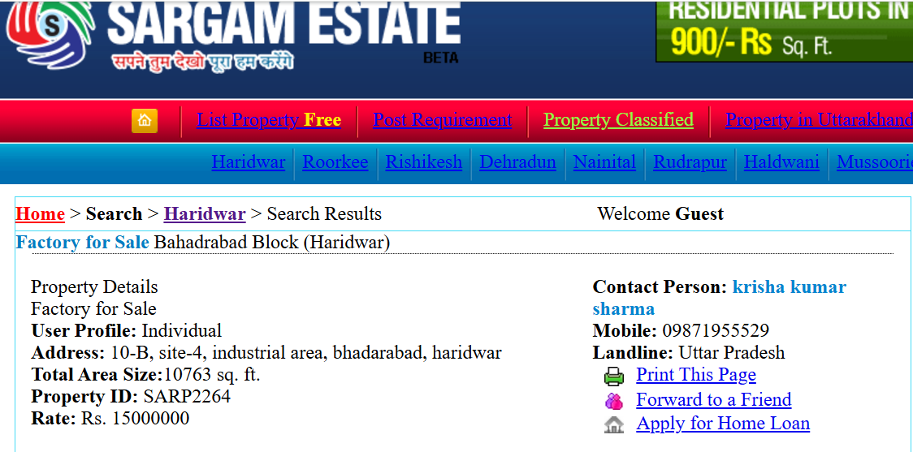

ANNEXURE: III – GOOGLE MAP LOCATION

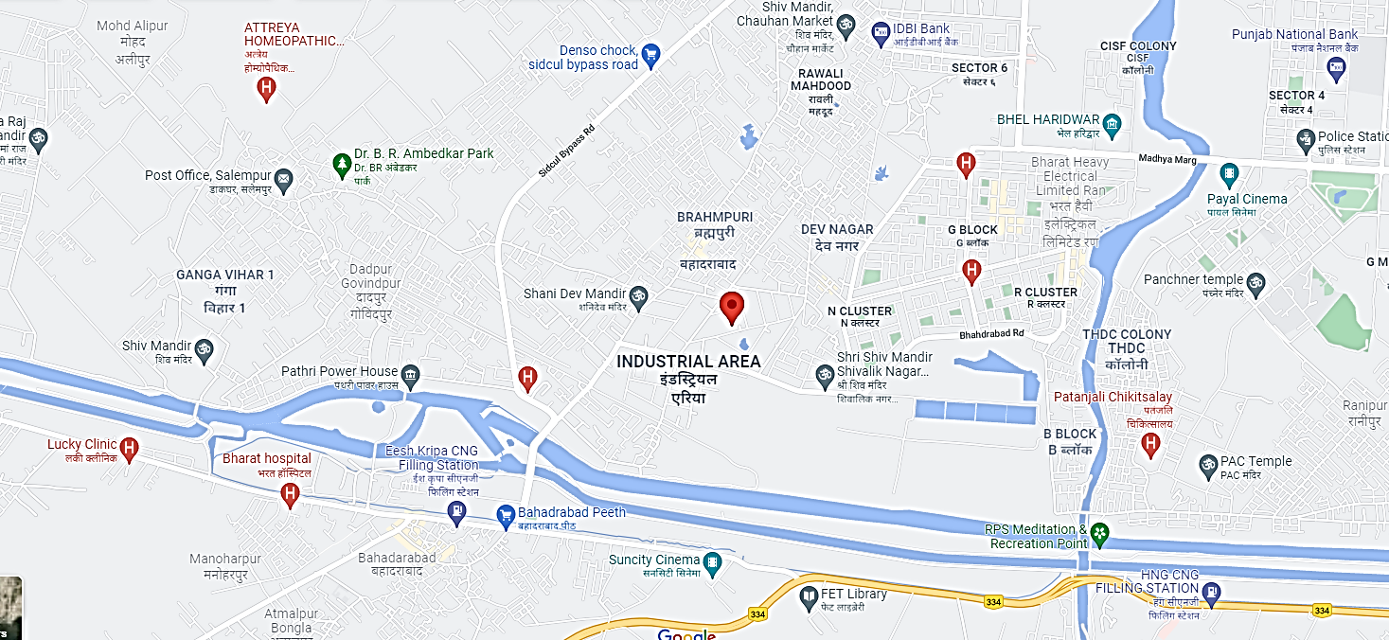
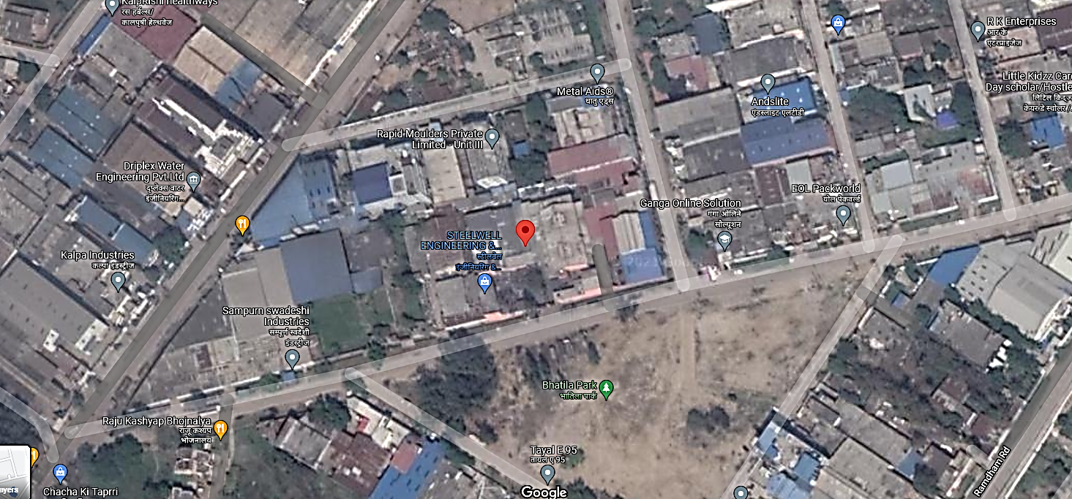
ANNEXURE: IV – PHOTOGRAPHS OF THE PROPERTY
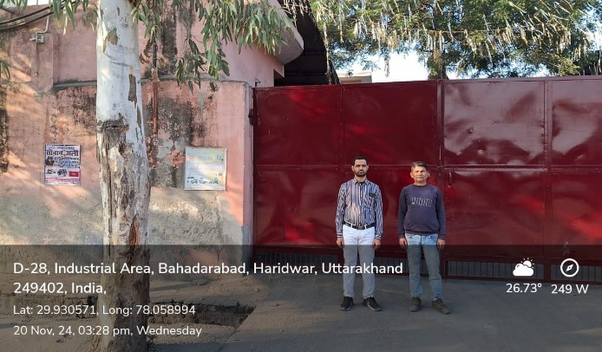 | 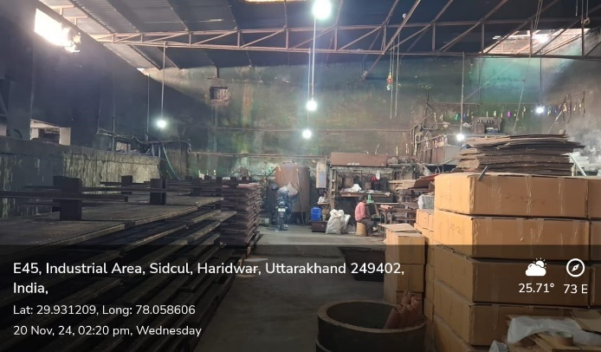
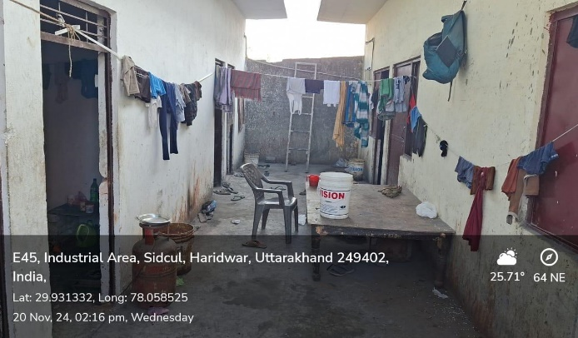 | 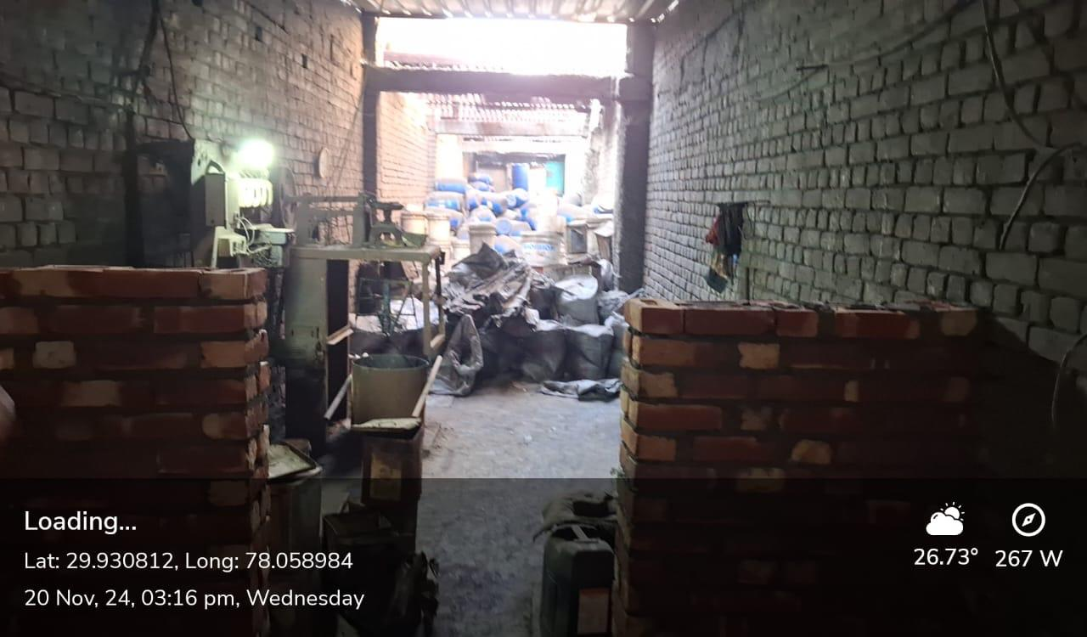
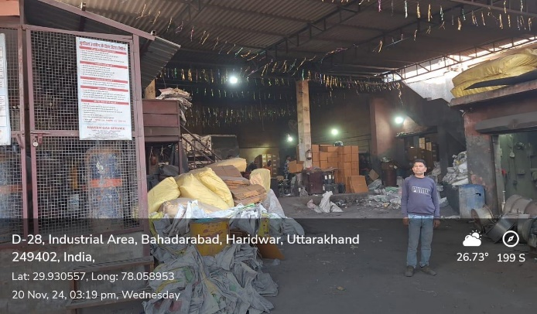 | 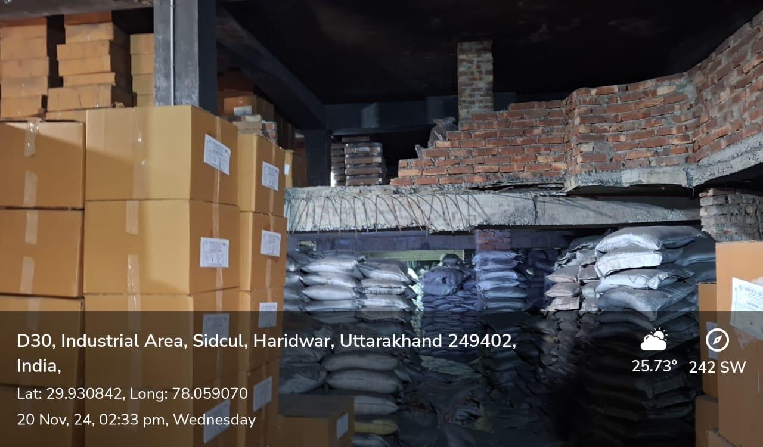

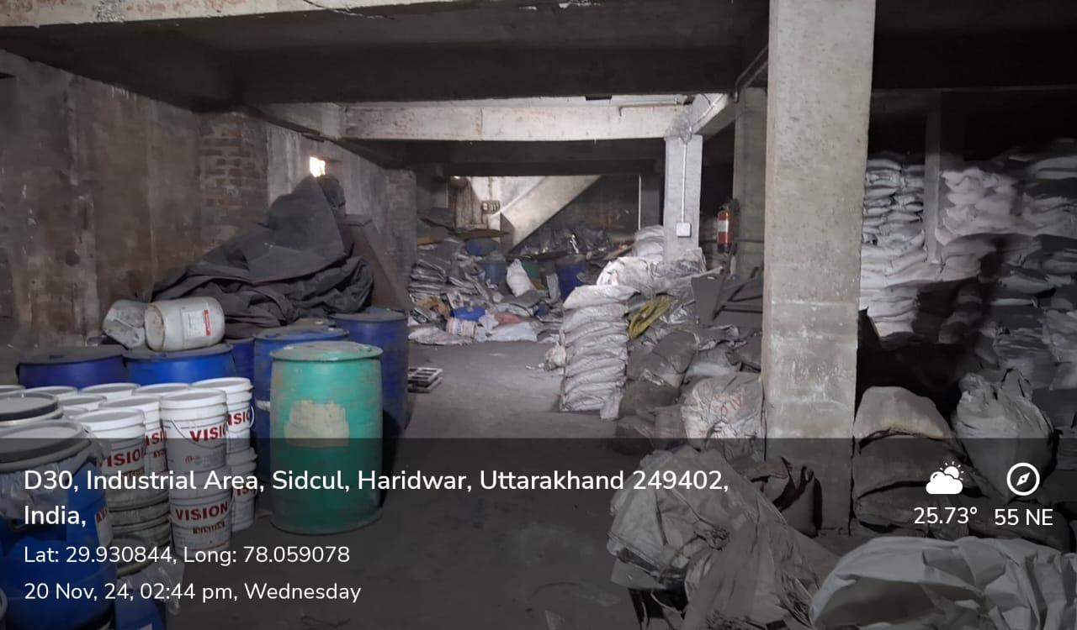 | 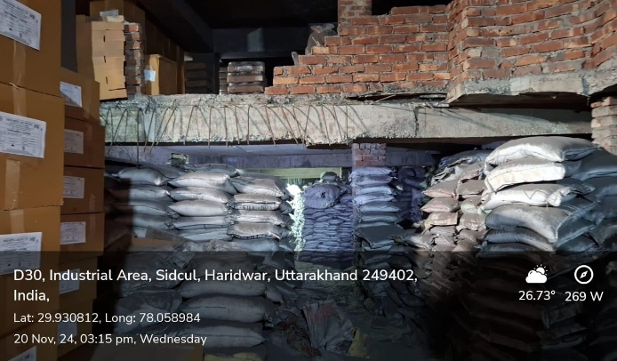
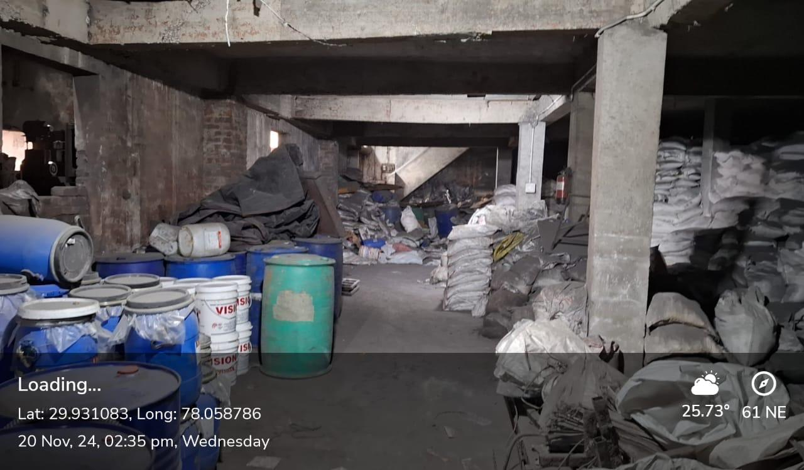 | 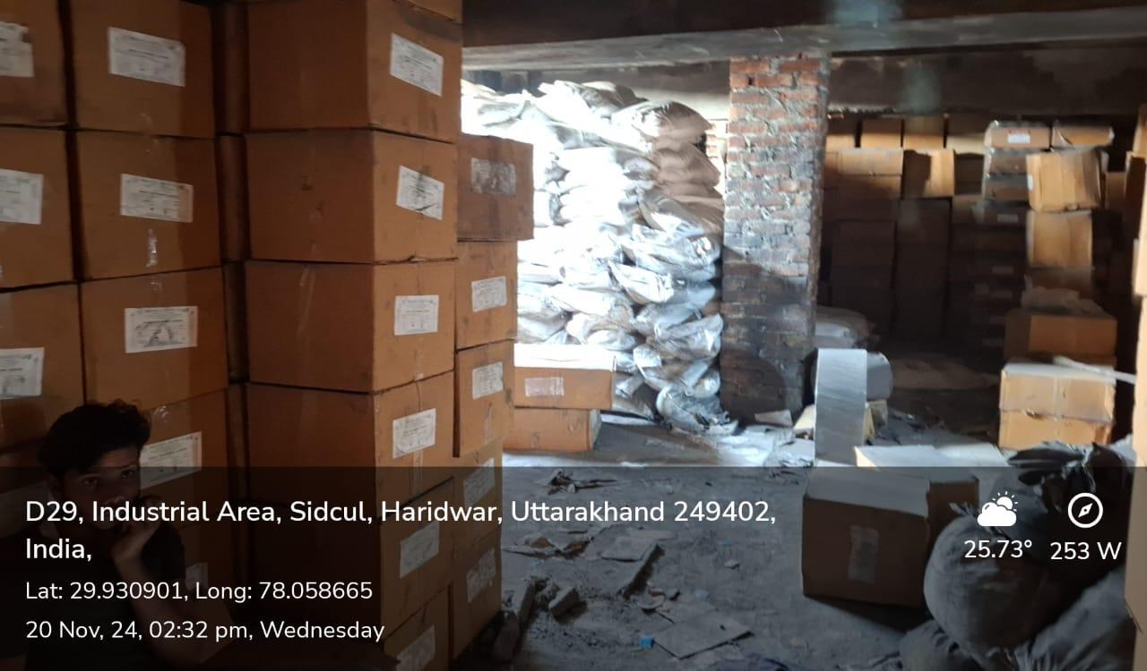
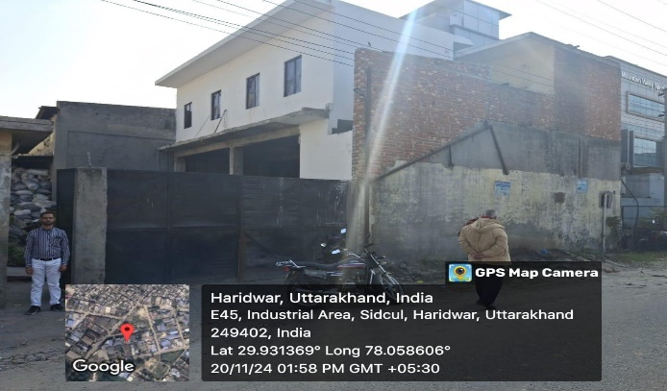 | 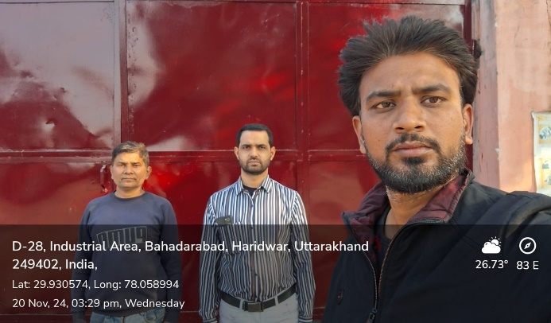

ANNEXURE: V– COPY OF CIRCLE RATE

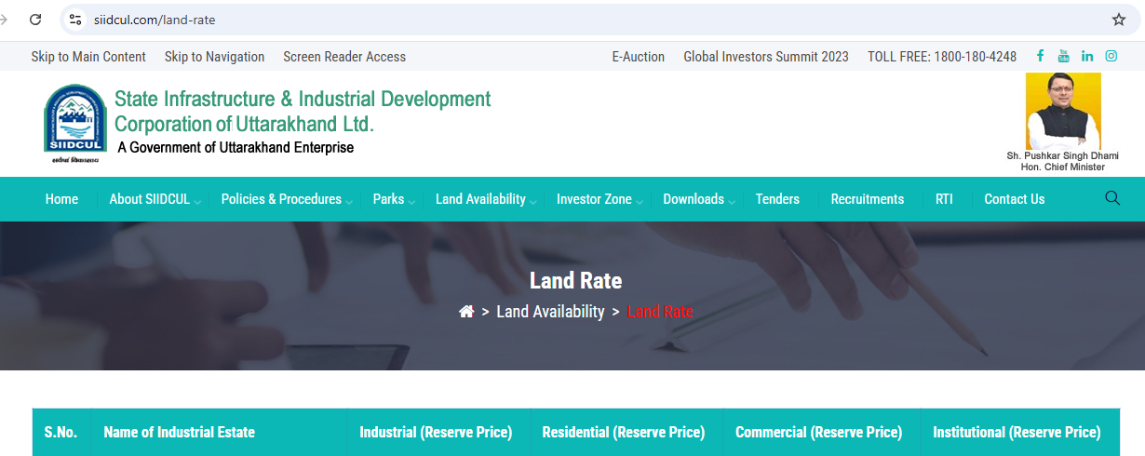
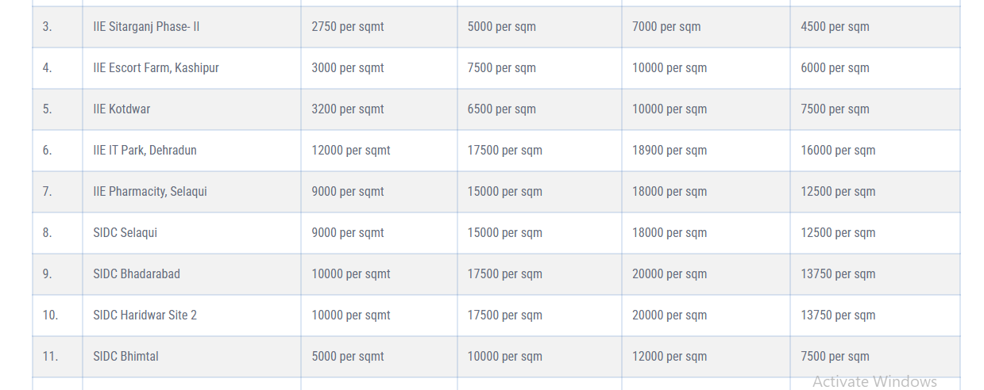

ANNEXURE: VI- DECLARATION-CUM-UNDERTAKING

- I am a citizen of India.
- No employee or member of R.K Associates has any direct/ indirect interest in the property or become so interested at any time during a period of three years prior to my appointment as valuer or three years after the valuation of assets was conducted by me.
- The information furnished in our valuation report dated 21/11/2024 is true and correct to the best of my knowledge and belief and we have made an impartial and true valuation of the property.
- Our authorized Engineer/ surveyor Mr. Sandeep have personally inspected the property on 20/11/2024 the work is not subcontracted to any other valuer and is carried out by us.
- Valuation report is submitted in the format as prescribed by the Bank.
- We have not been depanelled/ delisted by any other bank and in case any such depanelment by other banks during my empanelment with you, we will inform you within 3 days of such depanelment.
- We have not been removed/ dismissed from service/employment earlier.
- We have not been convicted of any offence and sentenced to a term of imprisonment.
- We have not been found guilty of misconduct in professional capacity.
- I have not been declared to be unsound mind.
- We are not undischarged bankrupt, or has not applied to be adjudicated as a bankrupt;
- We are not an undischarged insolvent.
- I have not been levied a penalty under section 271J of Income-tax Act, 1961 (43 of 1961) and time limit for filing appeal before Commissioner of Income tax (Appeals) or Income-tax Appellate Tribunal, as the case may be has expired, or such penalty has been confirmed by Income-tax Appellate Tribunal, and five years have not elapsed after levy of such penalty.
- I have not been convicted of an offence connected with any proceeding under the Income Tax Act 1961, Wealth Tax Act 1957 or Gift Tax Act 1958 and
- Our PAN Card number/ GST number as applicable is AAHCR0845G/ 09AAHCR0845G1ZP
- We undertake to keep you informed of any events or happenings which would make me ineligible for empanelment as a valuer.
- We have not concealed or suppressed any material information, facts and records and I have made a complete and full disclosure.
- We have read the Handbook on Policy, Standards and procedure for Real Estate Valuation, 2011 of the IBA and this report is in conformity to the “Standards” enshrined for valuation in the Part-B of the above handbook to the best of my ability.
- We have read the International Valuation Standards (IVS) and the report submitted to the Bank for the respective asset class is in conformity to the “Standards” as enshrined for valuation in the IVS in “General Standards” and “Asset Standards” as applicable.
- I abide by the Model Code of Conduct for empanelment of valuer in the Bank.
- I am registered under Section 34 AB of the Wealth Tax Act, 1957. (Strike off, if not applicable).
- I am valuer registered with Insolvency & Bankruptcy Board of India (IBBI) (Strike off, if not applicable).
- My CIBIL Score and credit worthiness is as per Bank’s guidelines.
- I am the proprietor / partner / authorized official of the firm / company, who is competent to sign this valuation report.
- I will undertake the valuation work on receipt of Letter of Engagement generated from the system (i.e. LLMS/LOS) only.
- Further, I hereby provide the following information.
S. No. | Particulars | Valuer comment
 | Background information of the asset being valued | This is an Industrial property located at address: Plot No. D-29, Industrial Area at Bahadarabad, District – Haridwar, Uttarkhand. having total land area 2137.24 sq.yrd / 1787 sq. mtr. as per the documents/ information provided to us by the Bank/ client.
 | Purpose of valuation and appointing authority | Please refer to Page No.01 of the Report.
 | Identity of the Valuer and any other experts involved in the valuation | Survey Analyst: Er. Sandeep  Engineering Analyst: Er. Nischay Gautam  Valuer/ Reviewer: Er. Rajani Gupta
 | Disclosure of valuer interest or conflict, if any | No relationship with the borrower or any kind of conflict of interest.
 | Date of appointment, valuation date and date of report | Date of Appointment: | 19/11/2024
 | Date of appointment, valuation date and date of report | Date of Survey: | 20/11/2024
 | Date of appointment, valuation date and date of report | Valuation Date: | 21/11/2024
 | Date of appointment, valuation date and date of report | Date of Report: | 21/11/2024
 | Inspections and/or investigations undertaken | Yes by our authorized Survey AE Sandeep bearing knowledge of that area on 21/11/2024. Property was shown and identified by owner’s representative Mr. Azad Ali (-9690162506).
 | Nature and sources of the information used or relied upon | Please refer to Page No. 04 of the Report.
 | Procedures adopted in carrying out the valuation and valuation standards followed | Land value is calculated on the basis of ‘Market Comparable Sales Approach’ and building construction value is calculated on the basis of ‘Depreciated Replacement cost Approach’.
 | Restrictions on use of the report, if any | Value varies with the Purpose/ Date/ Market & Asset Condition & Situation prevailing in the market. We recommend not to refer the indicative & estimated prospective Value of the asset given in this report if any of these points are different from the one mentioned aforesaid in the Report.  This report has been prepared for the purposes stated in the report and should not be relied upon for any other purpose. Our client is the only authorized user of this report and is restricted for the purpose indicated in the engagement letter. I/we do not take any responsibility for the unauthorized use of this report.  During the course of the assignment we have relied upon various information, data, documents provided by Bank/ client in good faith. If at any point of time in future it comes to knowledge that the information given to us is untrue, fabricated, misrepresented then the use of this report at very moment will become null & void.  This report only contains general assessment & opinion on the indicative, estimated Market Value of the property for which Bank has asked to conduct the Valuation and found as per the information given in the copy of documents, information, data provided to us and/ or confirmed by the owner/ owner representative to us at site which has been relied upon in good faith. It doesn’t contain any other recommendations of any sort including but not limited to express of any opinion on the suitability or otherwise of entering into any transaction with the borrower.
 | Major factors that were taken into account during the valuation | Please refer to Page No. 4-8 of the Report.
 | Major factors that were not taken into account during the valuation | NA
 | Caveats, limitations and disclaimers to the extent they explain or elucidate the limitations faced by valuer, which shall not be for the purpose of limiting his responsibility for the valuation report. | Please see attached Annexure.

Date: 21/11/2024

Place: Noida
Signature

(Authorized Person of R.K Associates Valuers & Techno Engg. Consultants (P) Ltd.)
ANNEXURE: VII- MODEL CODE OF CONDUCT FOR VALUERS

Integrity and Fairness

- A valuer shall, in the conduct of his/its business, follow high standards of integrity and fairness in all his/its dealings with his/its clients and other valuers.
- A valuer shall maintain integrity by being honest, straightforward, and forthright in all professional relationships.
- A valuer shall endeavour to ensure that he/it provides true and adequate information and shall not misrepresent any facts or situations.
- A valuer shall refrain from being involved in any action that would bring disrepute to the profession.
- A valuer shall keep public interest foremost while delivering his services.

Professional Competence and Due Care

- A valuer shall render at all times high standards of service, exercise due diligence, ensure proper care and exercise independent professional judgment.
- A valuer shall carry out professional services in accordance with the relevant technical and professional standards that may be specified from time to time.
- A valuer shall continuously maintain professional knowledge and skill to provide competent professional service based on up-to-date developments in practice, prevailing regulations/guidelines and techniques.
- In the preparation of a valuation report, the valuer shall not disclaim liability for his/its expertise or deny his/its duty of care, except to the extent that the assumptions are based on statements of fact provided by the company or its auditors or consultants or information available in public domain and not generated by the valuer.
- A valuer shall not carry out any instruction of the client insofar as they are incompatible with the requirements of integrity, objectivity and independence.
- A valuer shall clearly state to his client the services that he would be competent to provide and the services for which he would be relying on other valuers or professionals or for which the client can have a separate arrangement with other valuers.

Independence and Disclosure of Interest
- A valuer shall act with objectivity in his/its professional dealings by ensuring that his/its decisions are made without the presence of any bias, conflict of interest, coercion, or undue influence of any party, whether directly connected to the valuation assignment or not.
- A valuer shall not take up an assignment if he/it or any of his/its relatives or associates is not independent in terms of association to the company.
- A valuer shall maintain complete independence in his/its professional relationships and shall conduct the valuation independent of external influences.
- A valuer shall wherever necessary disclose to the clients, possible sources of conflicts of duties and interests, while providing unbiased services.
- A valuer shall not deal in securities of any subject company after any time when he/it first becomes aware of the possibility of his/its association with the valuation, and in accordance with the Securities and Exchange Board of India (Prohibition of Insider Trading) Regulations, 2015 or till the time the valuation report becomes public, whichever is earlier.
- A valuer shall not indulge in “mandate snatching or offering ”convenience valuations” in order to cater to a company or client’s needs.
- As an independent valuer, the valuer shall not charge success fee.
- In any fairness opinion or independent expert opinion submitted by a valuer, if there has been a prior engagement in an unconnected transaction, the valuer shall declare the association with the company during the last five years.

Confidentiality

- A valuer shall not use or divulge to other clients or any other party any confidential information about the subject company, which has come to his/its knowledge without proper and specific authority or unless there is a legal or professional right or duty to disclose.

Information Management

- A valuer shall ensure that he/ it maintains written contemporaneous records for any decision taken, the reasons for taking the decision, and the information and evidence in support of such decision. This shall be maintained so as to sufficiently enable a reasonable person to take a view on the appropriateness of his/its decisions and actions.
- A valuer shall appear, co-operate and be available for inspections and investigations carried out by the authority, any person authorised by the authority, the registered valuers organization with which he/it is registered or any other statutory regulatory body.
- A valuer shall provide all information and records as may be required by the authority, the Tribunal, Appellate Tribunal, the registered valuers organization with which he/it is registered, or any other statutory regulatory body.
- A valuer while respecting the confidentiality of information acquired during the course of performing professional services, shall maintain proper working papers for a period of three years or such longer period as required in its contract for a specific valuation, for production before a regulatory authority or for a peer review. In the event of a pending case before the Tribunal or Appellate Tribunal, the record shall be maintained till the disposal of the case.

Gifts and hospitality.

- A valuer or his/its relative shall not accept gifts or hospitality which undermines or affects his independence as a valuer.
Explanation: For the purposes of this code the term ‘relative’ shall have the same meaning as defined in clause (77) of Section 2 of the Companies Act, 2013 (18 of 2013).
- A valuer shall not offer gifts or hospitality or a financial or any other advantage to a public servant or any other person with a view to obtain or retain work for himself/ itself, or to obtain or retain an advantage in the conduct of profession for himself/ itself.

Remuneration and Costs.

- A valuer shall provide services for remuneration which is charged in a transparent manner, is a reasonable reflection of the work necessarily and properly undertaken, and is not inconsistent with the applicable rules.
- A valuer shall not accept any fees or charges other than those which are disclosed in a written contract with the person to whom he would be rendering service.

Occupation, employability and restrictions.

- A valuer shall refrain from accepting too many assignments, if he/it is unlikely to be able to devote adequate time to each of his/ its assignments.
- A valuer shall not conduct business which in the opinion of the authority or the registered valuer organisation discredits the profession.

Miscellaneous
- A valuer shall refrain from undertaking to review the work of another valuer of the same client except under written orders from the bank or housing finance institutions and with knowledge of the concerned valuer.
- A valuer shall follow this code as amended or revised from time to time

Signature of the Valuer: ________________

Name of the Valuer: R.K Associates Valuers & Techno Engg. Consultants (P) Ltd.

Address of the Valuer: D-39, Sector-2, Noida-201301

Date: 21/11/2024

Place: Noida

ENCLOSURE: VI – VALUER’S REMARKS

This Valuation report is prepared based on the copies of the documents/ information which interested organization or customer could provide to us out of the standard checklist of documents sought from them and further based on our assumptions and limiting conditions. All such information provided to us has been relied upon in good faith and we have assumed that it is true and correct. Verification or cross checking of the documents provided to us from the originals has not been done at our end.
Legal aspects for eg. investigation of title, ownership rights, lien, charge, mortgage, lease, verification of documents, etc. have to be taken care by legal expert/ Advocate and same are not done at our end. It is assumed that the concerned Lender/ Financial Institution has asked for the valuation of that property for which the legal verification has been already taken and cleared by the competent Advocate before requesting for the Valuation report.
Analysis and conclusions adopted in the report are limited to the reported assumptions, conditions and information came to our knowledge during the course of the work.
Value varies with the Purpose/ Date/ Condition prevailing in the market. We recommend not to refer the indicative & estimated prospective Value of the asset given in this report if any of these points are different from the one mentioned aforesaid in the Report. We also recommend that the indicative estimated Value in the Valuation Report holds good only upto the period of 3 months from the date of Valuation.
This report is having limited scope as per its fields & format to provide only the general basic idea of the value of the property prevailing in the market based on the documents/ data/ information provided by the client. The suggested indicative prospective estimated value should be considered only if transaction is happened as free market transaction.
This Valuation report is prepared based on the facts of the property on the date of the survey. It is a well-known fact that the market value of any asset varies with time & socio-economic conditions prevailing in the country. In future property Market may go down, property conditions may change or may go worse, Property reputation may differ, Property vicinity conditions may go down or become worse, Property market may change due to impact of Govt. policies or effect of World economy, Usability prospects of the property may change, etc. Hence before financing, Banker/ FI should take into consideration all such future risk and should loan conservatively to keep the advanced money safe in case of the downward trend of the property value.
Valuation of the same asset/ property can fetch different values in different situations. For eg. Valuation of a running/ operational shop/ hotel/ factory will fetch better value and in case of closed shop/ hotel/ factory it will have considerable lower value. Similarly an asset sold directly by an owner in the market will fetch better value and if the same asset/ property is sold by any financer due to encumbrance on it will fetch lower value. Hence before financing, Banker/ FI should take into consideration all such future risks and should loan conservatively to keep the advanced money safe in case of any such situation.
Getting cizra map or coordination with revenue officers for site identification is not done at our end.

Valuation is done for the property identified to us by the owner/ owner representative. At our end we have just cross verified the identification of the property with reference to the documents produced for perusal. Method by which identification of the property is carried out is also mentioned in the report clearly. Responsibility of identifying the correct property to the Valuer/ its authorized surveyor is solely of the client/ owner for which Valuation has to be carried out. It is requested from the Bank to cross check from their own records/ information if this is the same property for which Valuation has to be carried out to ensure that owner has not misled the Valuer company or misrepresented the property due to any vested interest.
In India more than 70% of the geographical area is lying under rural/ remote/ non municipal/ unplanned area where the subject property is surrounded by vacant lands having no physical demarcation or having any display of property survey or municipal number / name plate on the property clearly. Even in old locations of towns, small cities & districts where property number is either not assigned or not displayed on the properties clearly and also due to the presence of multiple/ parallel departments due to which ownership/ rights/ illegal possession/ encroachment issues are rampant across India and due to these limitations at many occasions it becomes tough to identify the property with 100% surety from the available documents, information & site whereabouts and thus chances of error, misrepresentation by the borrower and margin of chances of error always persists in such cases. To avoid any such chances of error it is advised to the Bank to engage municipal/ revenue department officials to get the confirmation of the property to ensure that the property shown to Valuer/ Banker is the same as for which documents are provided.
If this Valuation Report is prepared for the Flat/ dwelling unit situated in a Group Housing Society or Integrated Township then approvals, maps of the complete group housing society/ township is out of scope of this report and this report will be made for the specific unit based on the assumption that complete Group Housing Society/ Integrated Township must be approved in all respect..
Due to fragmented & frequent change in building/ urban planning laws/ guidelines from time to time, different laws/ guidelines between regions/ states and no strict enforceability of Building Bye-Laws in India specially in non-metro and scale b & c cities & Industrial areas, property owners many times extend or make changes in the covered area/ layout from the approved/ applicable limits. There are also situations where properties are decades old when there was no formal Building Bye-Laws applicable when the construction must have been done. Due to such discrete/ unplanned development in many regions sometimes it becomes tough to determine the exact lawful situation on ground for the Valuer. In case nothing specific is noted on the covered built-up area considered in the Valuation Report, the covered area present on the site as per site survey will be considered in the Valuation.
Valuation is a subjective field and opinion may differ from consultant to consultant. To check the right opinion, it is important to evaluate the methodology adopted and various data point/ information/ factors/ assumption considered by the consultant which became the basis for the Valuation report before reaching to any conclusion.
Value analysis of any asset cannot be regarded as an exact science and the conclusions arrived at in many cases will, of necessity, be subjective and dependent on the exercise of individual judgment. Given the same set of facts and using the same assumptions, expert opinions may differ due to the number of separate judgment decisions, which have to be made. Therefore, there can be no standard formula to establish an indisputable exchange ratio. In the event of a transaction, the actual transaction value achieved may be higher or lower than our indicative analysis of value depending upon the circumstances of the transaction. The knowledge, negotiability and motivations of the buyers and sellers and the applicability of a discount or premium for control will also affect actual price achieved. Accordingly, our indicative analysis of value will not necessarily be the price at which any agreement proceeds. The final transaction price is something on which the parties themselves have to agree. However our Valuation analysis can definitely help the stakeholders to make them informed and wise decision about the Value of the asset and can help in facilitating the arm’s length transaction.
This report is prepared on the RKA V-L1 (Basic) Valuation format as per the client requirement and scope of work. This report is having limited scope as per its fields & format to provide only the general estimated & indicative basic idea of the value of the property prevailing in the market based on the information provided by the client. No detailed analysis, audit or verification has been carried out of the subject property.
This is just an opinion report and doesn’t hold any binding on anyone. It is requested from the concerned Client/ Bank/ Financial Institution which is using this report for mortgaging the property that they should consider all the different associated relevant & related factors & risks before taking any business decision based on the content of this report.
All Pages of the report including annexures are signed and stamped from our office. In case any paper in the report is without stamp & signature then this should not be considered a valid paper issued from this office.
Defect Liability Period is 30 DAYS. We request the concerned authorized reader of this report to check the contents, data and calculations in the report within this period and intimate us in writing if any corrections are required or in case of any other concern with the contents or opinion mentioned in the report. Corrections only related to typographical, calculation, spelling mistakes will be entertained within the defect liability period. No request for any illegitimate value revision, date change or any other change will be entertained other than the one mentioned above.
R.K Associates encourages its customers to give feedback or inform concerns over its services through proper channel at valuers@rkassociates.org in writing within 30 days of report delivery. After this period no concern/ complaint/ proceedings in connection with the Valuation Services can be entertained due to possible change in situation and condition of the property.
Our Data retention policy is of ONE YEAR. After this period we remove all the concerned records related to the assignment from our repository. No clarification or query can be answered after this period due to unavailability of the data.
This Valuation report is governed by our (1) Internal Policies, Processes & Standard Operating Procedures, (2) R.K Associates Quality Policy, (3) Valuation & Survey Best Practices Guidelines formulated by management of R.K Associates, (4) Information input given to us by the customer and (4) Information/ Data/ Facts given to us by our field/ office technical team. Management of R.K Associates never gives acceptance to any unethical or unprofessional practice which may affect fair, correct & impartial assessment and which is against any prevailing law. In case of any indication of any negligence, default, incorrect, misleading, misrepresentation or distortion of facts in the report then it is the responsibility of the user of this report to immediately or atleast within the defect liability period bring all such act into notice of R.K Associates management so that corrective measures can be taken instantly.
R.K Associates never releases any report doing alterations or modifications by pen. In case any information/ figure of this report is found altered with pen then this report will automatically become null & void.

