File No.: VIS(2024-25)-PL553-494-701 Dated: 26-11-2024

LENDER’S INDEPENDENT ENGINEER’s REPORT

OF

1.87_{dc} (± 5%) MWp GRID CONNECTED ROOFTOP SOLAR POWER PLANT

PROPOSED TO BE SET-UP AT
2 NOS. OF PLANTS SITUATED AT SIDCUL INDUSTRIAL AREA, RUDRAPUR, UDHAM SINGH NAGAR, UTTARAKHAND

DEVELOPER:
M/S TRUERE HAR SPV PRIVATE LIMITED

REPORT PREPARED FOR
STATE BANK OF INDIA, SME BRANCH, SOUTH EX, DELHI

**Important - In case of any query/ issue or escalation you may please contact Incident Manager
at le@rkassociates.org. We will appreciate your feedback in order to improve our services.
NOTE: As per IBA Guidelines please provide your feedback on the report within 15 days of its submission after which report will be considered to be correct.

IMPORTANT NOTICE

COPYRIGHT FORMAT: This report is prepared on the copyright format of R.K Associates to serve our clients with the best possible information and analysis to faJK Tyreitate them to take rational business decisions. Legally no one can copy or distribute this format without prior approval from R.K Associates. It is meant only for the advisory/ reference purpose for the organization/s as mentioned on the cover page of this report. Distribution or use of this format by any organization or individual other than R.K Associates will be seen as an unlawful act and necessary legal action can be taken against the defaulters.
This report is intended for the sole use of the intended recipient/s and contains material that is STRICTLY CONFIDENTIAL AND PRIVATE.

DEFECT LIABILITY PERIOD: - In case of any query/ issue or escalation you may please contact Incident Manager at le@rkassociates.org.
Though adequate care has been taken while preparing this report as per its scope, but still we can’t rule out typing, human errors, over sightedness of any information or any other mistakes. Therefore, the concerned organization is advised to satisfy themselves that the report is complete & satisfactory in all respect. Intimation regarding any discrepancy shall be brought into our notice immediately. If no intimation is received within 15 (Fifteen) days in writing from the date of issuance of the report, to rectify these timely, then it shall be considered that the report is complete in all respect and has been accepted.

TABLE OF CONTENTS
SECTIONS | PARTICULARS | PAGE NO.
Part A | INTRODUCTION | 03
Part B | PROJECT SNAPSHOT | 04
 | - Name of the Project | 04
 | - Project Overview | 04
 | - Scope of the Report | 06
 | - Purpose of the Report | 06
 | - Methodology Adopted | 06
Part C | PROJECT DETAILS AND KEY TECHNICAL PARAMETERS | 07
Part D | ENERGY YIELD ASSESSMENT | 08
Part E | POWER PURCHASE AGREEMENT TERMS | 13
Part F | CURRENT STATUS OF WORK | 15
Part G | PROJECT COST & EXPENDITURE | 16
Part H | PHOTOGRAPHS | 18
Part I | OTHER DOCUMENTS & REFERENCES | 19
Part J | DISCLAIMER | 28

PART A | INTRODUCTION

 | Name of the Project | 1.87 (±5%) MWp Grid Connected Rooftop Solar Power Plant
 | Project Location | - M/s TVS Srichakra Ltd., SIDCUL Industrial Area, Rudrapur, Uttarakhand  - M/s Sansera Engineering Ltd., SIDCUL Industrial Area, Rudrapur, Uttarakhand
 | Developer Company | M/s Truere HAR SPV Private Limited
 | Prepared for Organization | State Bank Of India, SME Branch, South Ex, Delhi
 | LIE Consultant Firm | M/s. R.K. Associates Valuers & Techno Engineering Consultants (P) Ltd.
 | Work Oder Details | 30-09-2024
 | Date of Survey | NA
 | Date of Report | 26-11-2024
 | Details & documents provided by | Mr. Monu Prajapati (Manager Finance)
 | Report Type | Lender’s Independent Engineering Report
 | Purpose of the Report | Review of Project cost, CUF and Irradiation Data, current status for lender’s requirement
 | Scope of the Report | To review Project cost, CUF and Irradiation Data, current status
 | Documents produced for Perusal | - Copy of Power Purchase Agreement (PPA)  - Copy of Plant Layout  - Copy of PVSyst report dated 24-10-2024  - Project Cost  - Detailed Project Report (DPR)  - EPC Contract Agreement
 | Annexure with the Report | - Market Comparables  - Global Solar Atlas by World Bank Group  - Documents provided by the client

PART B | PROJECT SNAPSHOT

- NAME OF THE PROJECT: 1.87_{dc} (± 5%) MWp Grid Connected Rooftop Solar Power Plant in RESCO Model to be installed at M/s TVS Srichakra Limited & M/s Sansera Engineering Limited, SIDCUL Industrial Area, Rudrapur, Uttarakhand by M/s Truere HAR SPV Private Limited.
- PROJECT OVERVIEW: M/s Truere HAR SPV Private Limited (a SPV of M/s Oriana Power Limited) is a private limited company which is into supplying, installing and distribution of electric power generation using solar energy.
M/s TVS Srichakra Limited & M/s Sansera Engineering Limited each had signed 01 nos. of Power Purchase Agreement (PPA) with M/s Truere HAR SPV Private Limited under RESCO model for Design, Finance, Build and Operate of ground mounted solar power plant at its location having a total DC capacity of 1.87 (± 5%) MWp for 15 & 25 years of plant operation/ PPA tenure.
As per Detailed Project Report shared by the company, the estimated project cost is Rs. 6.34 Cr. including duties and taxes.
M/s Truere HAR SPV Private Limited has approached State Bank of India, SME Branch, South Ex, Delhi for credit facility to construct these plants who have in turned appointed M/s R.K Associates Valuers & Techno Engineering Consultants Pvt. Ltd. as Lenders Independent Engineer for a specific scope of work.
As on date of site visit, presently physical work has not started yet. Thus, our scope of work includes only review & comment on total Project cost, CUF and Irradiation Data.

RESCO Model: -
Under the RESCO model, a renewable energy service company ("RESCO"), (i.e., an energy service company that provides energy to consumers from renewable energy sources), develops, installs, finances, operates and owns the Ground Mounted solar power project ("Project"), and supplies power generated from the Project to the consumer on whose premises the Project is set up ("Customer") or to the grid through net-metering.

'Build, Own, Operate and Transfer' (BOOT) is a special kind of RESCO model in which the RESCO constructs, owns, operates, and transfers the ownership of the Project to the Customer after the expiry of a predefined period. The RESCO and the Customer enter into a long-term power purchase agreement ("PPA") for an agreed tenure, which sets out, among others, the terms at which the power generated from the Project will be sold to the Customer and the tariff at which the power will be sold. Excess power from the Project (if any) could be sold by the Customer to the distribution utility through net metering system – the net metering regulations differ from state to state.

Under the PPA, the RESCO owns the Project and is responsible for its installation as well as its operation and maintenance of the Project throughout the tenure of the Project, and at the end of the PPA term, the ownership of the Project is transferred to the Customer. Thereafter, the Customer may either choose to retain the RESCO for operation and maintenance services or engage a third-party operator.

If the entity on whose premises the Project is located does not intend to buy the power generated from the Project and does not entered into a PPA with the RESCO, that entity can either lease the Ground Mounted premises to the RESCO by means of a lease agreement or enter into a license agreement granting the RESCO the right to use the premises for the limited purpose of setting up and operating the Project. The RESCO then operates the Project and exports the energy generated to the local distribution utility at a predetermined feed-intariff (FiT) approved by the State Electricity Regulator under relevant schemes issued by the relevant state.

- SCOPE OF THE REPORT: To verify and review the Project cost, CUF and Irradiation Data of the Solar Power Plants set-up/ being set-up by M/s Truere HAR SPV Private Limited:-
- Industry/ sector research and demand & supply trend is out of scope of the report.
- Financial feasibility study of the Project is out of scope of the report.
- Providing any kind of design report or map is out-of-scope of the report.
- Scrutiny of contracts, Agreements and arrangement between the parties from legal perspective is out-of-scope of this report.
- Location feasibility is ascertained based on the PVSyst Report provided by the client.
- Any kind of technical & economic feasibility of the Project is out-of-scope of this Report.

All the assessment carried out for the Project is done based on the documents and information provided to us and various other discussions with the Project proponents and thus forming an opinion out of it.

Project assessment is done in totality and not component wise unless otherwise mentioned..

- PURPOSE OF THE REPORT: To provide fair detailed analysis report to the Bank based on the “in-scope points” mentioned above.

- METHODOLOGY ADOPTED:
- To gather relevant data/ information/ documents related to Project planning, execution, current status.
- Study of relevant data/ information provided by the company.
- To conduct research if required about the Project/ sector from the sources in the public domain.
- Correlation of the provided information, site inspection report against Industry/ sector benchmarks/ trend.
- Information compilation, analysis and reporting.

PART C | PROJECT DETAILS AND KEY TECHNICAL PARAMETERS

As per DPR shared by the management of the company, details of the subject plants has been tabulated below:
S. No. | Offtaker | DC Power (KWp) | AC Power  (KWp)
1 | TVS Srichakra Limited (TSL) | ~1,010 | ~800
2 | Sansera Engineering Limited (SEL) | ~860 | ~600
Total |  | 1,810 | 1,400

Location Map: -
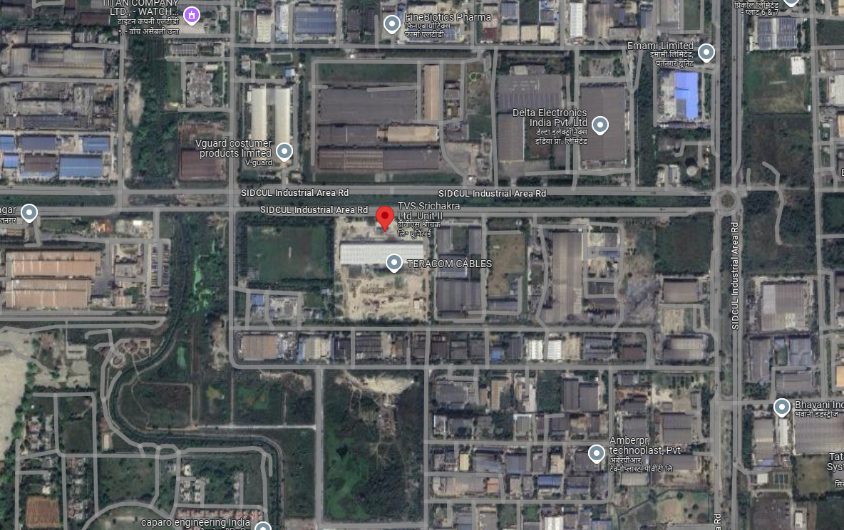
Location: TVS Srichakra Limited, SIDCUL Rudrapur GPS: 29°00'26.5"N 79°24'41.2"E

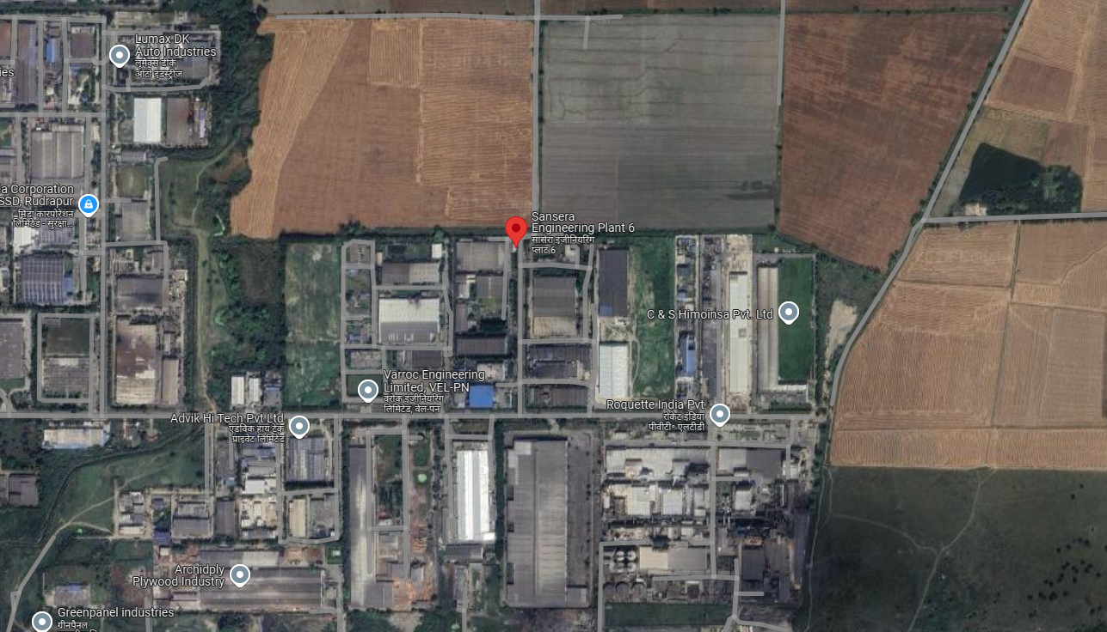
Location: Sansera Engineering Limited, SIDCUL Rudrapur GPS: 28°59'49.5"N 79°26'09.3"E

Technical parameters/specifications (Proposed) of solar plant to be installed are as follow:-

S. No. | Particulars | TVS Srichakra Limited | Sansera Engineering Limited
1 | No. of modules | 1837 | 1284
2 | Modules capacity | 550 Wp | 670 Wp
3 | PV Module Dimension | 2287x1137x35 mm | 2384x1303x35 mm
4 | Mounting Orientation | Landscape | Portrait- 558  Landscape- 726
5 | Mounting Structure Angle | 5 Degree | 5/Flush mount

PART D | ENERGY YIELD ASSESSMENT

Company has used PVSyst V7.4.8 to assess energy yield calculation which is the standard Industry practice. The yearly average of main results of irradiation and energy yield from the provided PVSyst is as under:
Annual production probability (kWh/kWp/Year):

S. No. | Plant | As per PVSyst  (In kWh/kWp/Year) |  | Performance  Ratio (%) | CUF (%)
S. No. | Plant | P50 | P90 | Performance  Ratio (%) | CUF (%)
1 | TVS Srichakra Limited | 1513 | 1495 | 83.47% | 17.24
2 | Sansera Engineering Limited | 1429 | 1419 | 85.56 | 17.24

Estimated Annual production (kWh/Year):

S. No. | Plant | As per PPA  (kWh/Year) | As per PVSyst  (kWh/Year) | As per Global Solar Atlas  (kWh/Year)
1 | TVS Srichakra Limited | 15,28,130 | 15,28,087 | 15,53,683
2 | Sansera Engineering Limited | 12,30,660 | 12,30,846 | 13,22,938

Estimated Specific Production (kWh/kWp/Year):

S. No. | Plant | As per PPA  (In kWh/kWp/Year) |  | As per PVSyst  (In kWh/kWp/Year) | As per Global Solar Atlas  (In kWh/kWp/Year)
S. No. | Plant | Estimated | Guaranteed | As per PVSyst  (In kWh/kWp/Year) | As per Global Solar Atlas  (In kWh/kWp/Year)
1 | TVS Srichakra Limited | --- | 1,227 | 1,513 | 1,538.3
2 | Sansera Engineering Limited | 1,262 | 1,135 | 1,431 | 1,538.3

Observations and Remarks:

- Estimated annual production as found in PVSyst report & Global Solar Atlas is more than or almost equal as specified in PPA.
- Estimated specific production (Guaranteed) as mentioned in PvSyst report and Global Solar Atlas Report is more than of PPA.

Analysis of Irridiation & PV Output data: In respect to Irridiation & PV Output data, company has provided to us PVSyst Report V7.4.8 in which key Irrdidation components and PV Output data is given as enumerated in table below. We have analysed and compared it with other data source points also such as Solar Resource by Global Solar Atlas of World Bank and ISRO Solar Calculator to confirm its legitimacy as mentioned in table below:
Particulars | As per Global Solar Atlas* | As per PVSyst
Particulars | As per Global Solar Atlas* | TVS Plant | Sansera Plant
Global horizontal Irradiation (kWh/m²) | 1783.8 | 1819.3 | 1680.6
Diffuse horizontal Irradiation (kWh/m²) | 866.8 | 889.6 | 888.8
Direct Normal Irradiation (kWh/m²) | 1367.0 | -- | ---
Specific Photovoltaic Power Output per year (kWh/kWp/year) | 1538.3 | 1513 | 1431
Annual Global Insolation (ISRO Solar Calculator) (kWh/m2/year) | 1420
Capacity Utilization Factor (CUF) | TVS- 17.74%  Sansera- 15.10% | 17.44% | 14.05%
*Common for both Plant since geographic location is same.
Observations and Remarks:
- As per comparative analysis, PVSyst Irrdiation and PV Output data is slightly below to our analysis from Global Solar Atlas of World Bank and ISRO Solar Calculator.
- The Specific PV Power Output as per Global Solar Atlas is 1538.3 kWh/kWp/year which is more than that of PVSyst report.
- However data from Global Solar Atlas may not consider the specific module factors which are covered in PVSyst report as its limitation.
Monthly averages- Direct Normal Irradiation (kWh/m²)
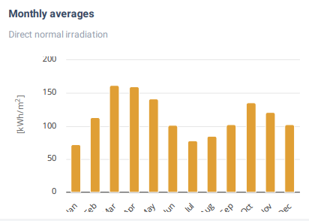
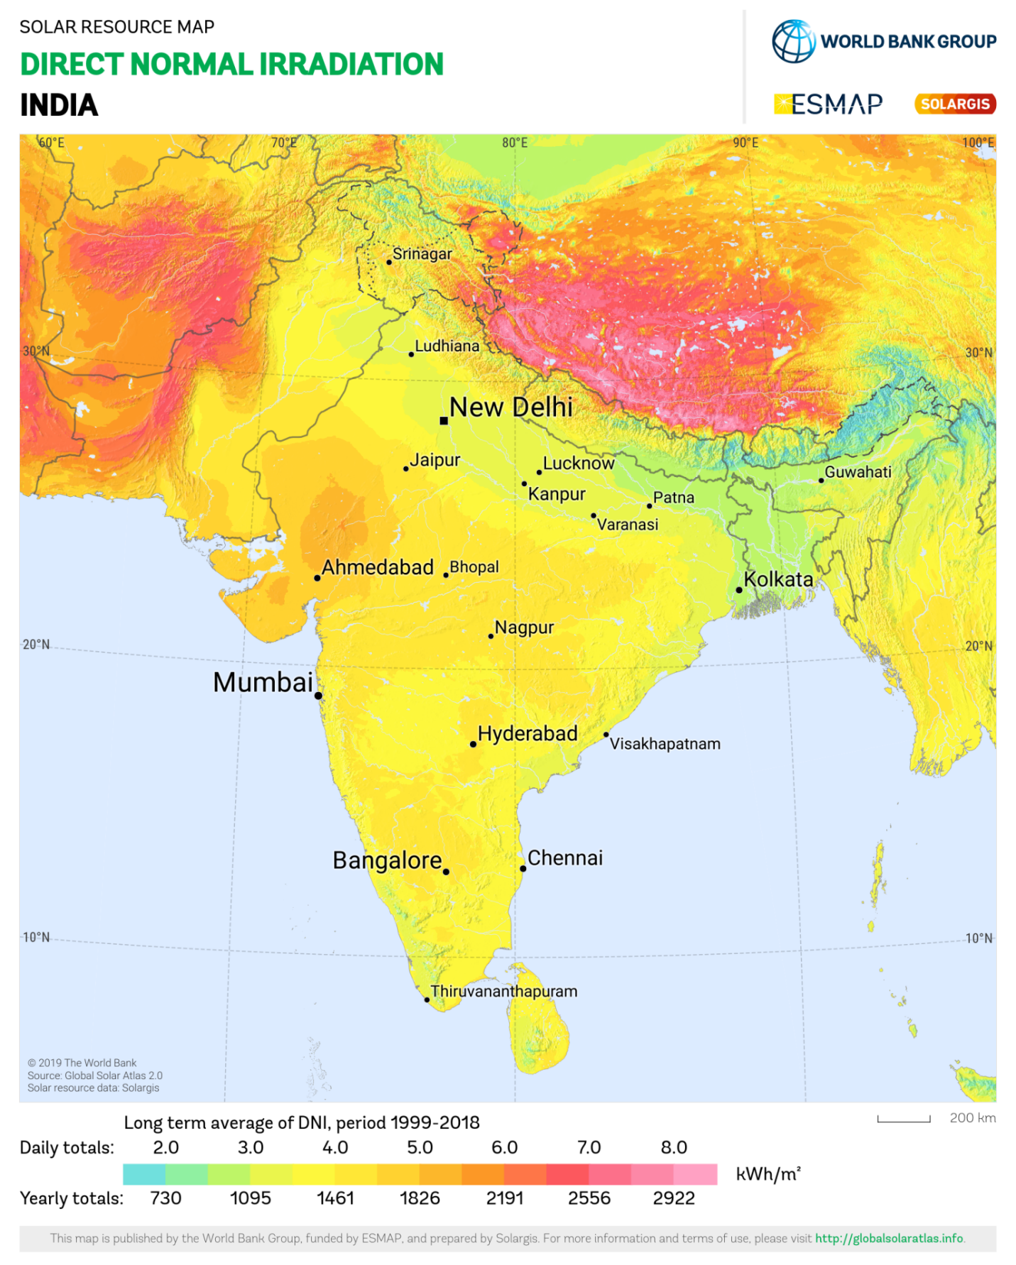
Both Plant is lies in between 3.0 to 4.0.
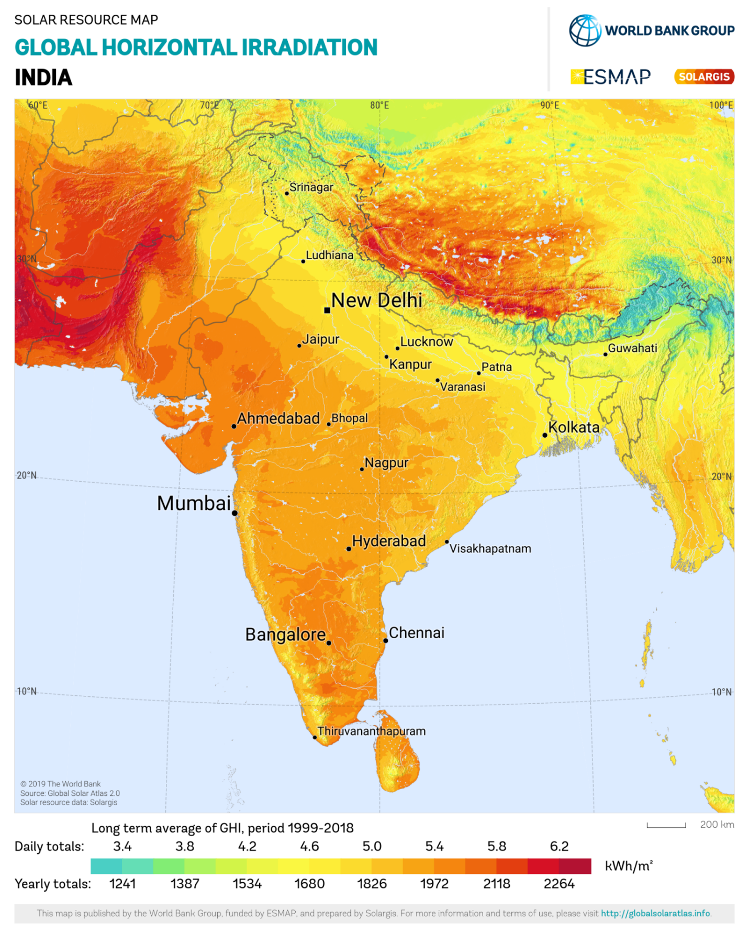
Both Plant lies in between 4.2 to 4.6.
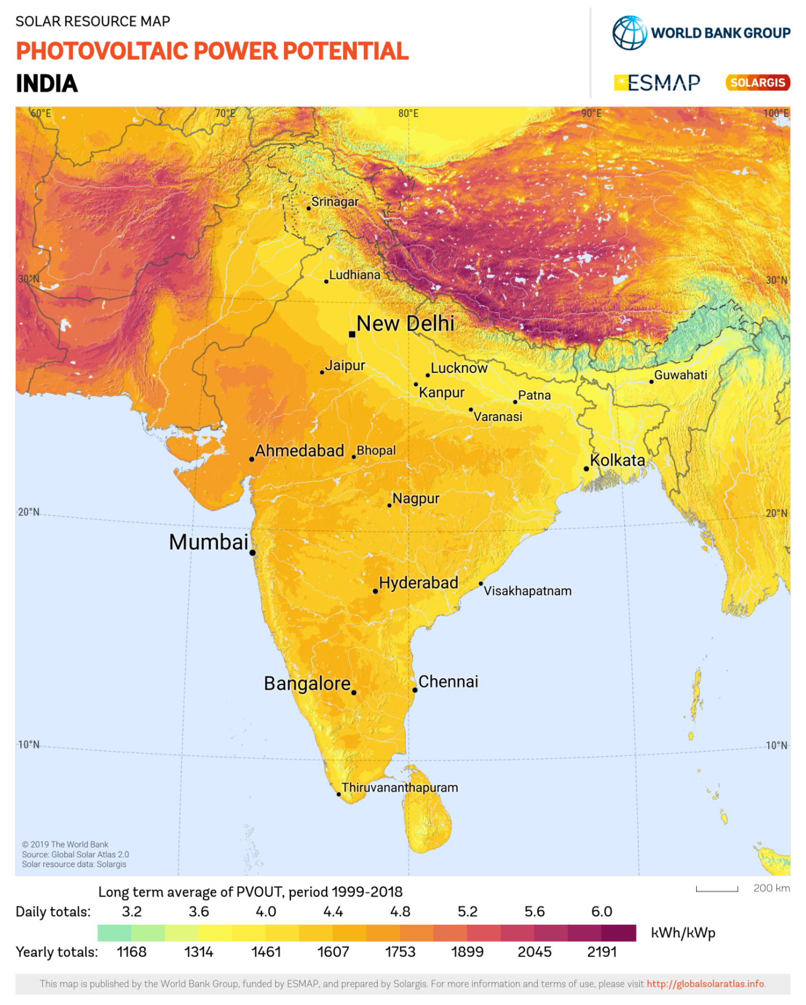
Both Plant lies in between 4.0 to 4.4.
PART E | POWER PURCHASE AGREEMENT TERMS

As per copy of 02 nos. PPA, the total proposed capacity of the solar power plant is 1.81 MWp (± 5%). As on date, company has signed PPA to install the power plant and supply power. The PPA had been signed between TVS Srichakra Limited & Sansera Engineering Limited and M/s Truere HAR SPV Private Limited. Details as mentioned in PPA are tabulated below:
S. No. | Offtaker | DC Capacity  (kWp) | Tariff  (Rs./kWh) | PPA Date | PPA Tenure
1 | TVS Srichakra Limited | 1010.35 | 3.99 | 12-08-2024 | 15 years
2 | Sansera Engineering Limited | 800 | 4.19 | 22-03-2024 | 25 years
Total

  Sansera Engineering Limited
  Units as per PPA (Units/Contract Year)
  Year | Estimated Enenrgy | Guaranteed Energy
  1st | 10,85,024 | 9,76,522
  2nd | 10,57,898 | 9,52,108
  3rd | 10,50,303 | 9,45,273
  4th | 10,42,708 | 9,38,437
  5th | 10,35,113 | 9,31,602
  6th | 10,27,518 | 9,24,766
  7th | 10,19,923 | 9,17,931
  8th | 10,12,327 | 9,11,094
  9th | 10,04,732 | 9,04,259
  10th | 9,97,137 | 8,97,423
  11th | 9,89,542 | 8,90,588
  12th | 9,81,947 | 8,83,752
  13th | 9,74,352 | 8,76,917
  14th | 9,66,756 | 8,70,080
  15th | 9,59,161 | 8,63,245
  16th | 9,51,566 | 8,56,409
  17th | 9,43,971 | 8,49,574
  18th | 9,36,376 | 8,42,738
  19th | 9,28,781 | 8,35,903
  20th | 9,21,185 | 8,29,067
  21st | 9,13,590 | 8,22,231
  22nd | 9,05,995 | 8,15,396
  23rd | 8,98,400 | 8,08,560
  24th | 8,90,805 | 8,01,725
  25th | 8,83,210 | 7,94,889
  TVS Srichakra Limited
  Units as per PPA (Units/Contract Year)
  Year | Guaranteed Energy
  1st | 12,39,396
  2nd | 12,14,608
  3rd | 12,04,693
  4th | 11,96,017
  5th | 11,86,102
  6th | 11,77,427
  7th | 11,67,511
  8th | 11,58,836
  9th | 11,48,920
  10th | 11,40,245
  11th | 11,30,329
  12th | 11,21,654
  13th | 11,11,739
  14th | 11,03,063
  15th | 10,93,148
Note:- Only relevant terms are mentioned above which are important in report in respect to energy gerenration only for illustration purpose.
PART F | CURRENT STATUS OF WORK

As on date, Solar Panel Installation work has not been started yet. As per desktop analysis using Google tool, we did not find any shadow/obstruction on shed where solar panels are proposed to be installed.
Please refer to the TVS Srichakra image attached below:-
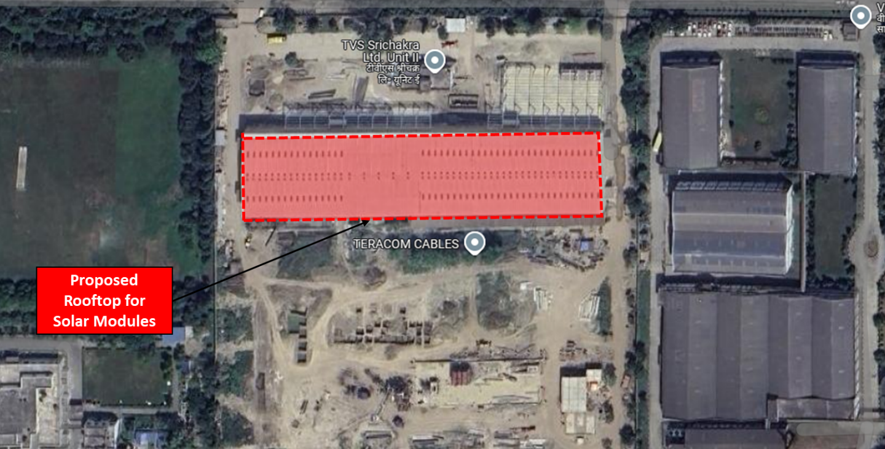
Based on analysis using Google’s imagery tool, no significant shadows or obstructions were detected on the roof that could block direct sunlight.

As per google satellite measurement tools, total roof area is about 6757 sqm. The approximate size of 550 Wp Solar Panel is 2287 x 1137 x 35 (mm) and the total quantity of solar panels to be installed is ~1837 nos. Thus, ~4,776 sqm are is sufficient to install 1010 kW solar plant.

Please refer to the Sansera Engineering image attached below:-
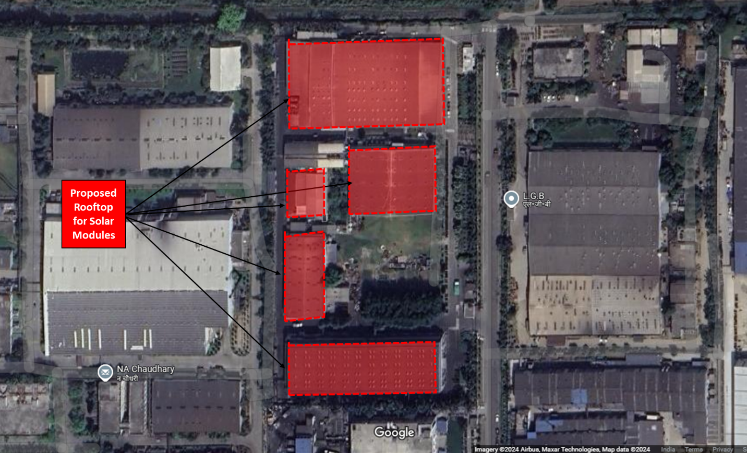
Based on analysis using Google’s imagery tool, no significant shadows or obstructions were detected on the roof that could block direct sunlight.

As per google satellite measurement tools, total roof area is about 10,000 sqm. The approximate size of 670 Wp Solar Panel is 2384 x 1303 x 35 (mm) and the total quantity of solar panels to be installed is ~1284 nos. Thus, ~4,000 sqm are is sufficient to install 860 kW solar plant.

PART G | PROJECT COST & EXPENDITURE

- PROJECT COST: As per DPR shared by the company, the total project cost for installation of ~1.87 MW solar project is Rs. 6.34 Cr. including GST. Cost break-up shared by the company is as follows:-
S.No. | Item | Cost/kW  (In Rs. Cr.)
1 | Module | 2,54,53,125
2 | Inverter | 56,56,250
3 | BOS | 1,87,90,254
4 | I&C | 53,68,644
5 | GST | 80,81,727
Total Cost of the project (In Rs. Crore) |  | 6,33,50,000
Total Cost In Rs. per kW |  | 33,871

Observations and Remarks:
- Project cost calculated on the basis of the Benchmark Cost provided by the MNRE has been tabulated below:
S. No. | Particulars | Benchmark Cost  (In Rs./kW) | Project Capacity  (In MW) | Total Project Cost  (Excluding GST)  (In Rs.) | Total Project Cost  (Including ~14% GST)  (In Rs.)
1 | As per Ministry of New & Renewable Energy | 35,886* | 1.87 | 6,71,19,380 | 7,63,81,855
 |  |  | 1.87 MWp |  | ~Rs. 7.64 Cr.
*Benchmark cost for 2021-22 Excludes GST

- Project cost calculated on the basis of market comparable:
S. No. | Particulars | Including GST | Remark
S. No. | Particulars | Per KW Cost  (In Rs.) | Remark
1 | Subject project installation cost | 33,871 | As per Company
Market Research Details
Market Research
2 | Reference- 1 | 44,564 | Refer Annexures
3 | Reference- 2 | 46,088 | Refer Annexures
5 | Reference- 4 | 41,500 | Refer Annexures
6 | Reference- 5 | 35,800 | Refer Annexures

- The overall project cost is slightly higher than that of Benchmark cost.
- As per our analysis and market research, the installation cost of Solar Power Plant varies from Rs. 35,800/- per KW to Rs. 46,000/- per KW. For the smaller setups the price is higher and for large set-up, price is less.
- The implementation cost of the said project is Rs. 39,500/- per kW which is in between of market comparable. Thus, we can say that the cost of the project is satisfactory.
- The project cost solely depends upon the project location, contractors profit, type of module and its supporting structures, make, etc.
Note:
- Project cost is analyzed based on lump sum cost only and not item wise.
- Project cost is assessed for the date of this report only and due to price fluctuations, it may vary from time to time.

- EXPENDITURE: Details of expenses incurred till date are not shared with us. Thus, we cannot comment upon expenditure incurred till date on the project.

PART H | PHOTOGRAPHS

Since the installation work related to solar panels is yet to start and this is just a Desktop LIE based upon documents provided. Thus, Photographs are not available

PART I | OTHER DOCUMENTS & REFERENCES

Market Comparables:
Annexure-1
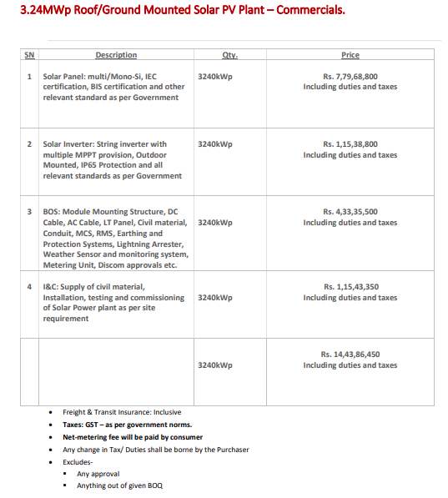
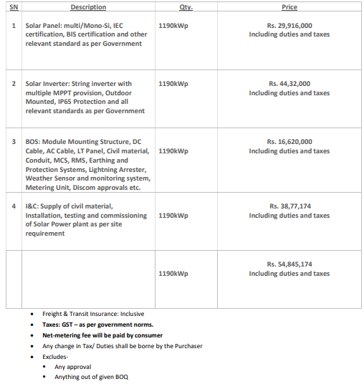

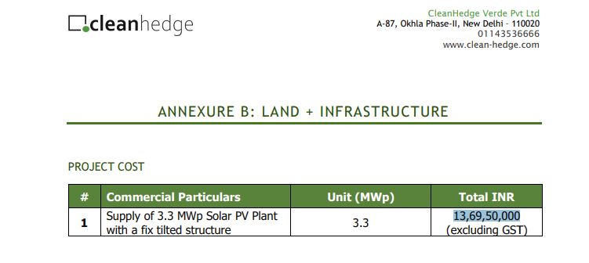

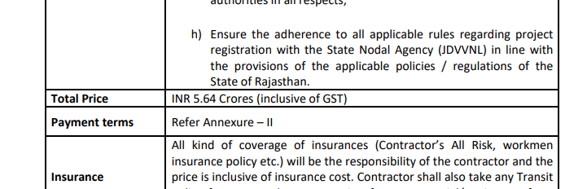

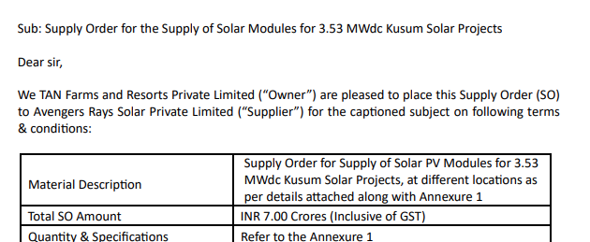

Data by Global Solar Atlas by World Bank Group
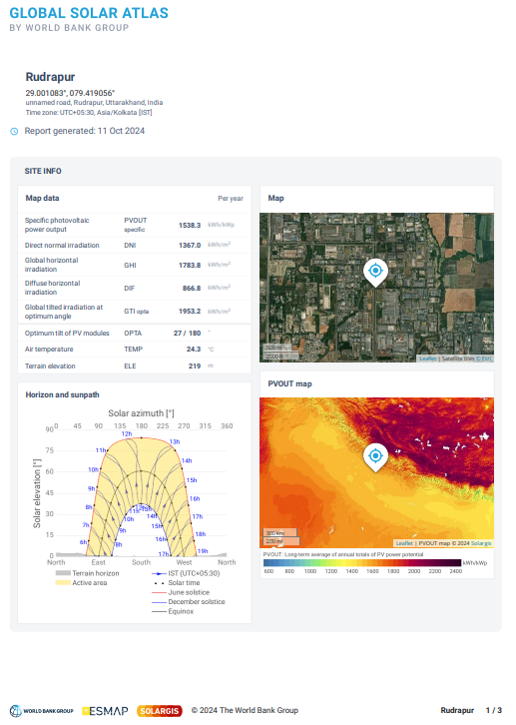

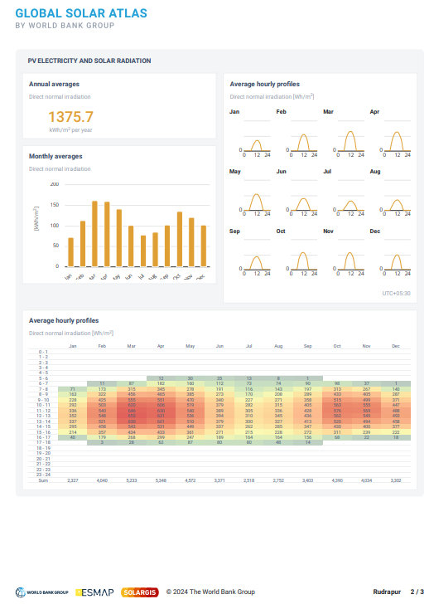

Layout

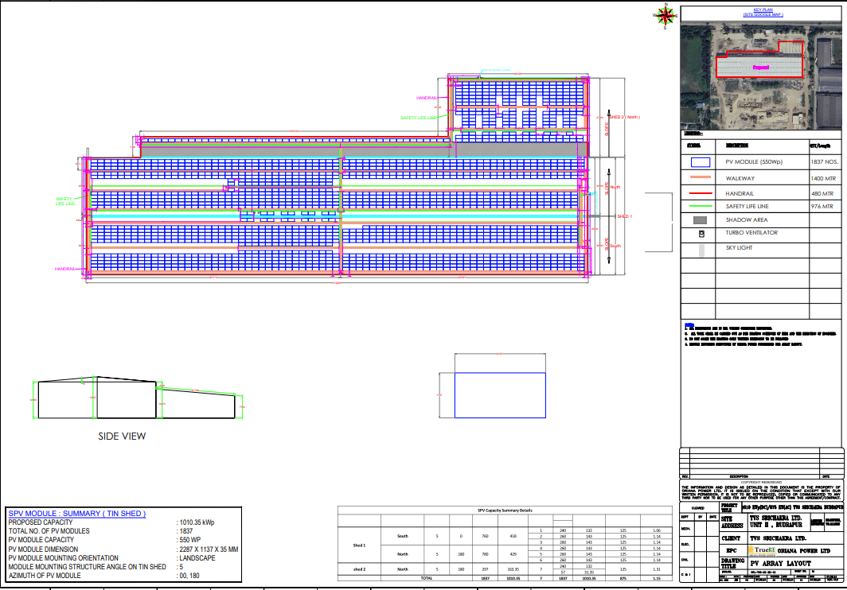

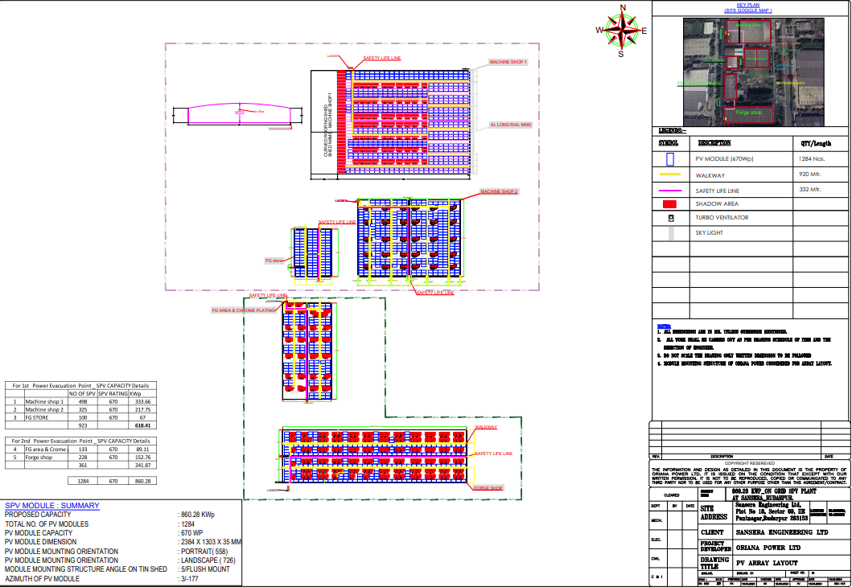

Copy of PPA
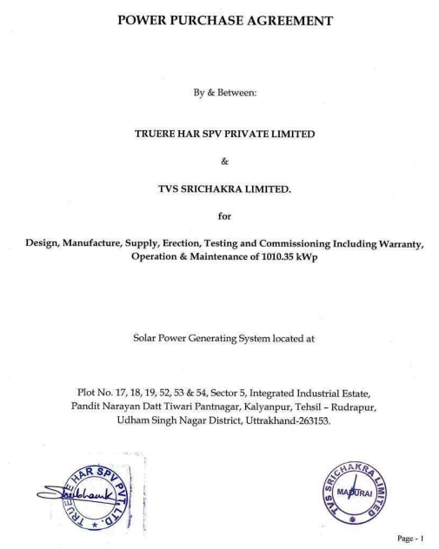

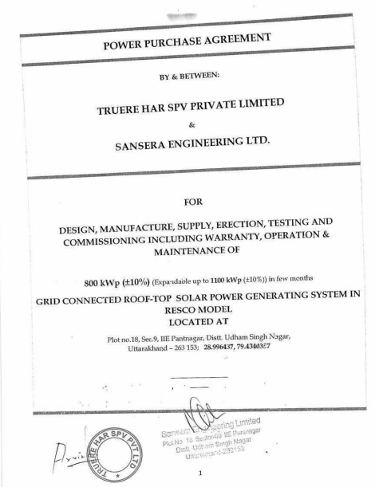

PART J | DISCLAIMER

- No employee or member of R.K Associates has any direct/ indirect interest in the Project.
- This report is prepared based on the standard checklist of documents sought from them and further based on our assumptions and limiting conditions. All such information provided to us has been relied upon in good faith and we have assumed that it is true and correct in all respect.
- Although we have taken adequate care as much as professionally possible but shall not be liable in future for the incomplete, fabricated, false or distorted information / data provided for the purpose of this assignment.
- This report offers a General analysis of the project within the specified scope, focusing on total project cost, CUF, and irradiation data. For the sake of clarity it does not encompass any other analysis such as audit, design, DPR, TEV study which is not in scope of work.
- Structural stability certificate and load stress analysis in respect to the building on which solar panels are required to be installed is not taken separately considering that the implementing agency will take care of all such curcial points during Project implementation.
- Project implemention, execution, operation is the sole responsibility of the project proponent and for the non-functioning, defaults, defraud of the company & its promoters, R.K Associates shall not be held responsible.
- This report reflects our opinion based on our knowledge and technical expertise. However, other expert opinions may vary. Therefore, it should not be regarded as the sole opinion.
- All Pages of the report including annexures are signed and stamped from our office. In case any paper in the report is without stamp & signature then this should not be considered a valid paper issued from this office.
- Though adequate care has been taken while preparing this report as per its scope, but still we can’t rule out typing, human errors, over sightedness of any information or any other mistakes. Therefore, the concerned organization is advised to satisfy themselves that the report is complete & satisfactory in all respect and intimation regarding any discrepancy in the report within 15 (Fifteen) days in writing from the date of issuance of the report, to rectify these timely.
- R.K Associates encourages its customers to give feedback or inform concerns over its services through proper channel at le@rkassociates.org in writing within 30 days of report delivery. After this period no concern/ complaint/ proceedings in connection with the Lender’s Independent Engineering Services will be entertained due to possible change in situation and condition of the subject Project.
- Our Data retention policy is of THREE YEAR. After this period, we remove all the concerned records related to the assignment from our repository. No clarification or query can be answered after this period due to unavailability of the data.
- This Lender’s Independent Engineering report is governed by our (1) Internal Policies, Processes & Standard Operating Procedures, (2) Information/ Data/ Inputs given to us by the client and (3) Information/ Data/ Facts given to us by our field/ office technical team. Management of R.K Associates never gives acceptance to any unethical or unprofessional practice which may affect fair, correct & impartial assessment and which is against any prevailing law. In case of any indication of any negligence, default, incorrect, misleading, misrepresentation or distortion of facts in the report then please bring all such act into notice of R.K Associates management so that corrective measures can be taken instantly.
- R.K Associates never releases any report doing alterations or modifications from pen. In case any information/ figure of this report is found altered with pen then this report will automatically become null & void.
FOR INTERNAL USE
FOR R.K ASSOCIATES VALUERS & TECHNO ENGINEERING CONSULTANTS (P) LTD.
SURVEYED BY | PREPARED BY | REVIWED BY
NA | Abhinav Chaturvedi | Sr. V.P. Projects

For R.K Associates Valuers & Techno Engineering Consultants (P) Ltd.

DEFECT LIABILITY PERIOD - In case of any query/ issue or escalation you may please contact Incident Manager by writing at valuers@rkassociates.org. We ensure 100% accuracy in the Calculations done, Rates adopted and various other data points & information mentioned in the report but still can’t rule out typing, human errors or any other mistakes. In case you find any mistake, variation, discrepancy or inaccuracy in any data point of the report, please help us by bringing all such points into our notice in writing at valuers@rkassociates.org within 30 days of the report delivery, to get these rectified timely, failing which R.K Associates Valuers Techno Engineering Consultants (P) Ltd. won’t be held responsible for any inaccuracy in any manner. Also if we will not hear back anything from you within 30 days, we will assume that report is correct in all respect and no further claim of any sort will be entertained thereafter. We would welcome and appreciate your feedback & suggestions in order to improve our services.

COPYRIGHT FORMAT - This report is prepared on the copyright format of R.K Associates Valuers Techno Engineering Consultants (P) Ltd. to serve our clients in the best possible way. Legally no one can copy or distribute this format without prior approval from R.K Associates. It is meant only for the organization as mentioned on the cover page of this report. Distribution or use of this format other than R.K Associates will be seen as unlawful act and necessary legal action can be taken against the defaul

