Dated: 20-12-2024

To,
Mr. Prashant Soni
Punjab National Bank
CBB Branch Race Course, Dehradun,

Subject: Project Status Certificate for the under-construction Project of M/s MMBM Hospitality Pvt. Ltd.Habitat Centre located at Khasra No. 1134, 1135ka, 1136, 1137kha, 1150ka, Village- Banshiwala, Jhajra, Pargana- Pachwadoon, Tehsil- Vikas Nagar, District- Dehradun.

Dear Sir,

This is in reference to your bank email dated 02nd December 2024.
It is stated that our authorized surveyor visited the project site on 4th December 2024 and as per the observations & physical measurement recorded during the site survey, it was noted that the construction work for the project has been completely stalled. There has been no discernible progress of work since the previous site survey conducted on the 27th June 2024. Even after the passage of nearly six months, no substantial changes or advancements in the progress of the project was evident.

NOTE: Material lying at site is not taken into consideration.

For R.K Associates Valuers & Techno Engg. Consultants (P) Ltd.

Authorized Signatory

1. | DECLARATION
- This cost estimate is done based on the documents/ details/ information provided by the customer.
- The undersigned does not have any direct/indirect interest in the above property.
- The information furnished herein is true and correct to the best of our knowledge.
- We have submitted this certificate directly to the Bank.
- This estimate is carried out by our Engineering team on the request from Punjab National Bank, CBB Branch, Racecourse, Dehradun.
2. | Name & Address of Valuer company |  | Signature of the authorized person
2. | M/s R.K. Associates Valuers & Techno Engineering  Consultants Pvt. Ltd. D-39, Sector-2, Noida, U.P.
3. | Enclosed Documents | - Sanction Plan.  - Photographs
4. | Total Number of Pages in the Report with Enclosures | 07
5. | Engineering Team worked on the report | SURVEYED BY: Er. Deepak Joshi
5. | Engineering Team worked on the report | PREPARED BY: Er. Abhinav Chaturvedi
5. | Engineering Team worked on the report | REVIEWED BY: Mr. Anil Kumar

R.K ASSOCIATES IMPORTANT NOTES:

DEFECT LIABILITY PERIOD - In case of any query/ issue or escalation you may please contact Incident Manager by writing at valuers@rkassociates.org. We ensure 100% accuracy in the Calculations done, Rates adopted and various other data points & information mentioned in the report but still can’t rule out typing, human errors or any other mistakes. In case you find any mistake, variation, discrepancy or inaccuracy in any data point of the report, please help us by bringing all such points into our notice in writing at valuers@rkassociates.orgwithin 30 days of the report delivery, to get these rectified timely, failing which R.K Associates won’t be held responsible for any inaccuracy in any manner. Also if we will not hear back anything from you within 30 days, we will assume that report is correct in all respect and no further claim of any sort will be entertained thereafter. We would welcome and appreciate your feedback & suggestions in order to improve our services.

COPYRIGHT FORMAT - This report is prepared on the copyright format of R.K Associates to serve our clients in the best possible way. Legally no one can copy or distribute this format without prior approval from R.K Associates. It is meant only for the Organization as mentioned on the cover page of this report. Distribution or use of this format other than R.K Associates will be seen as unlawful act and necessary legal action can be taken against the defaulters.

IF REPORT IS USED FOR BANK/ FIs

NOTE: As per IBA Guidelines in case the valuation report submitted by the valuer is not in order, the banks / FIs shall bring the same to the notice of the valuer within 15 days of submission for rectification and resubmission. In case no such communication is received, it shall be presumed that the valuation report has been accepted.

At our end we have not verified the authenticity of any documents provided to us. Bank is advised to verify the genuineness of the property documents before taking any credit decision.
ENCLOSURE

SANCTION PLAN
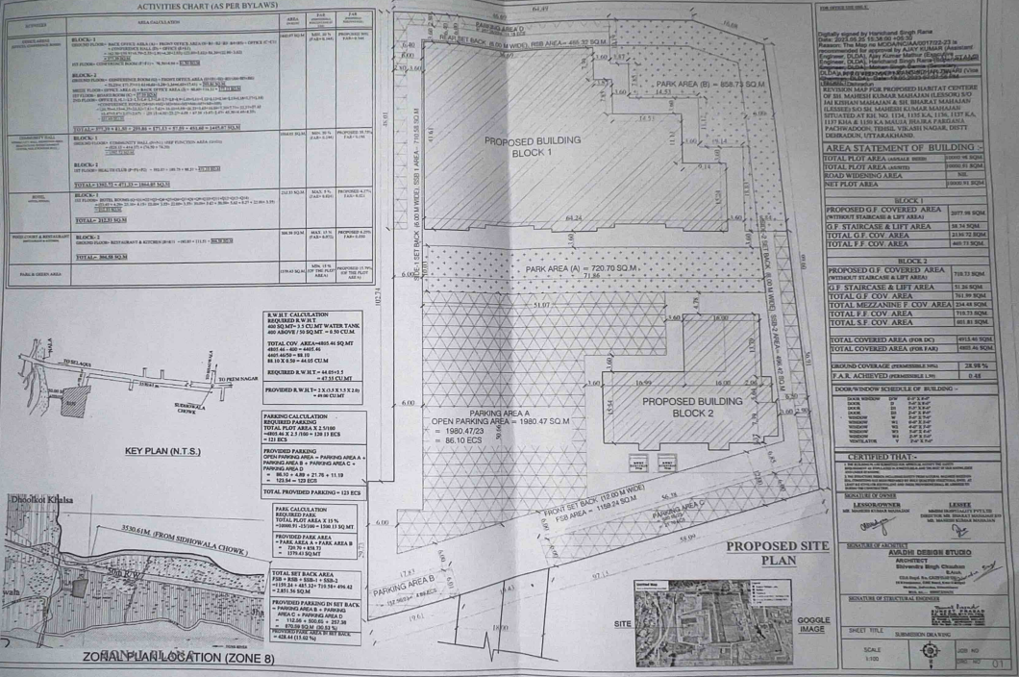

PHOTOGRAPHS AS ON 04-12-2024
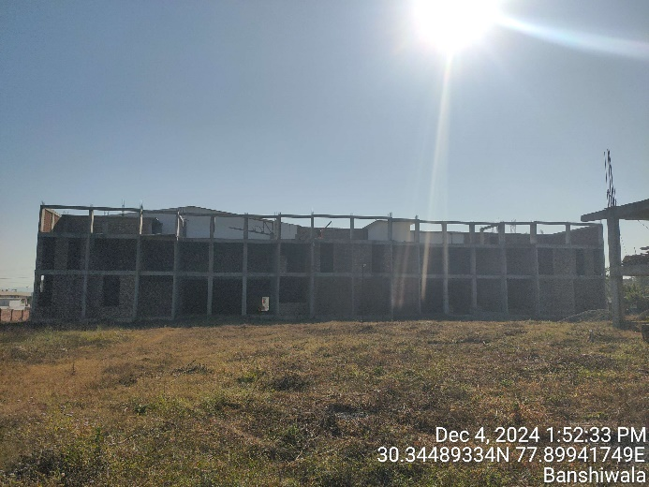 | 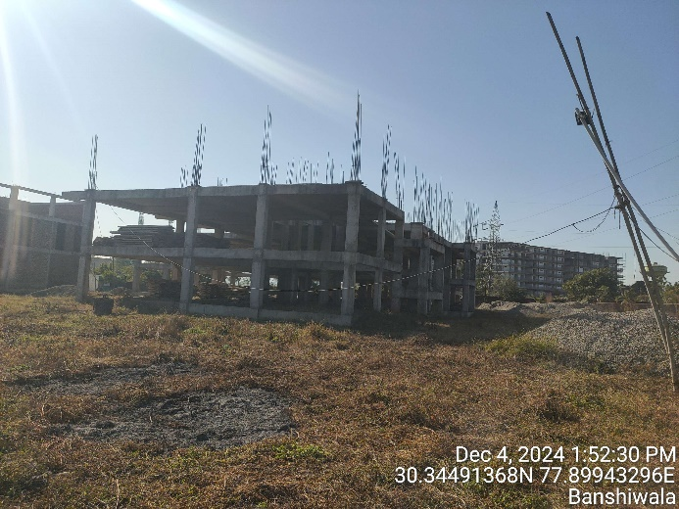
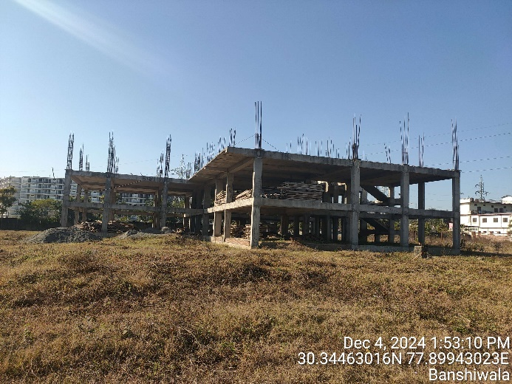 | 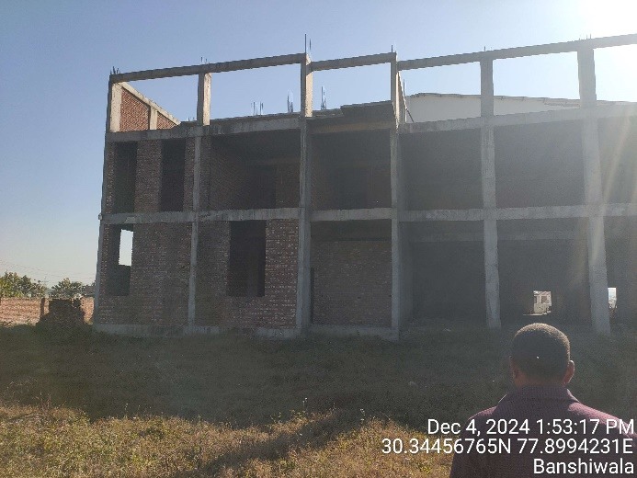
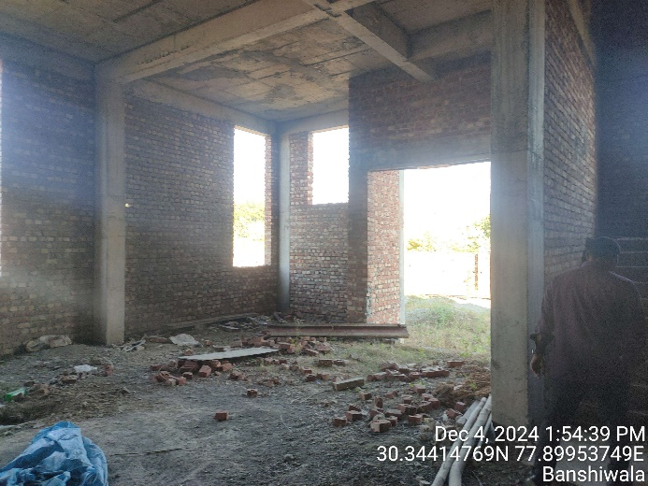 | 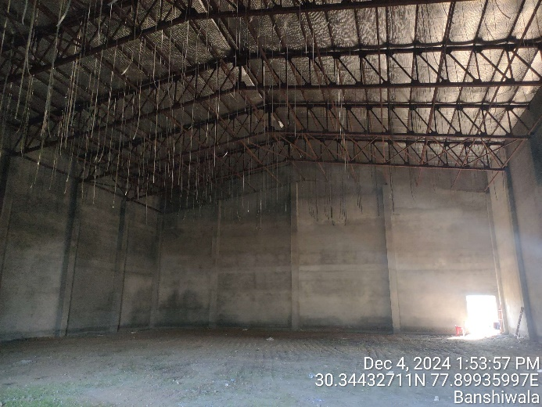

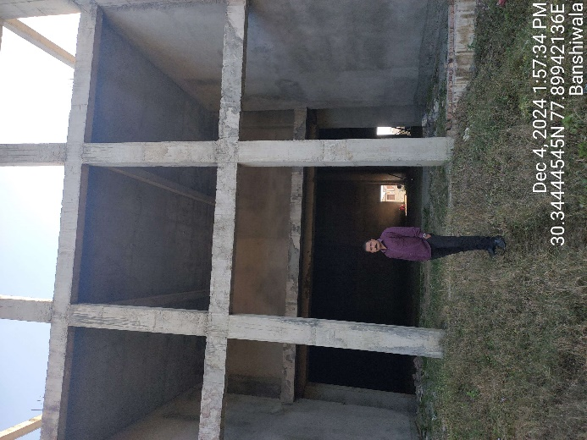 | 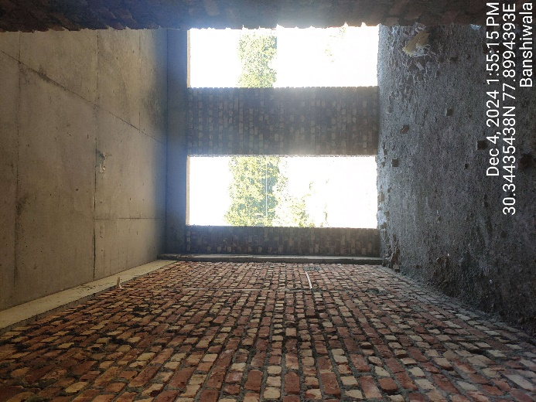
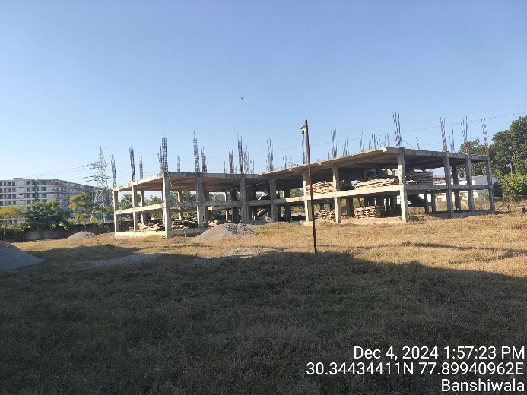 | 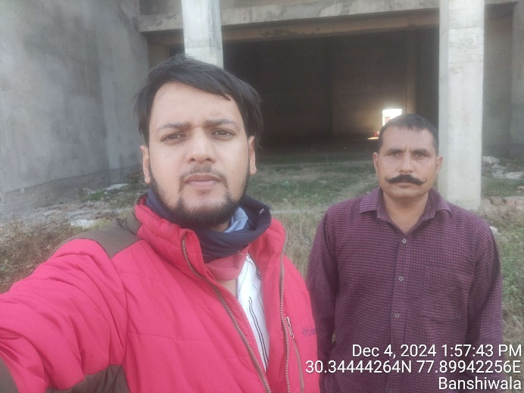

PHOTOGRAPHS AS ON 27-06-2024
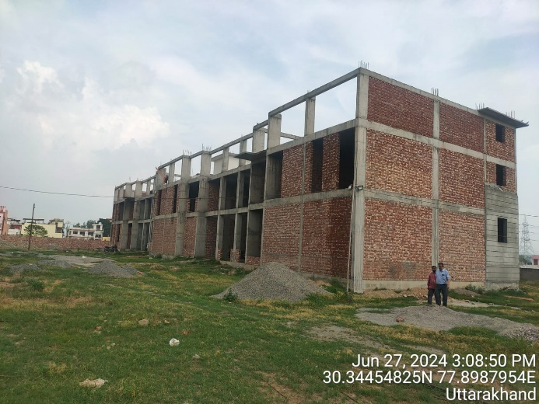 | 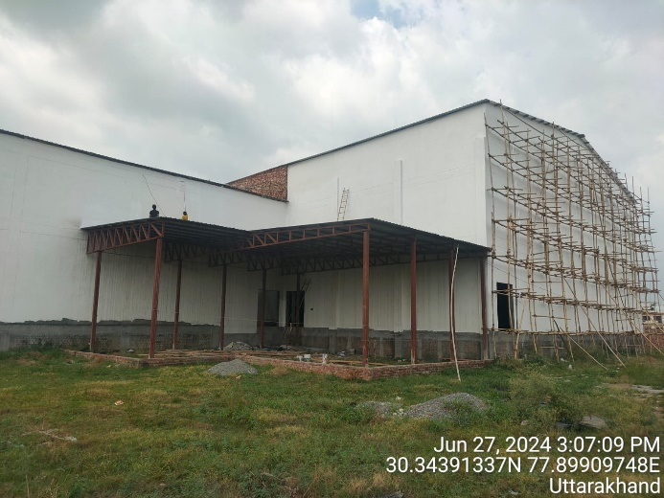
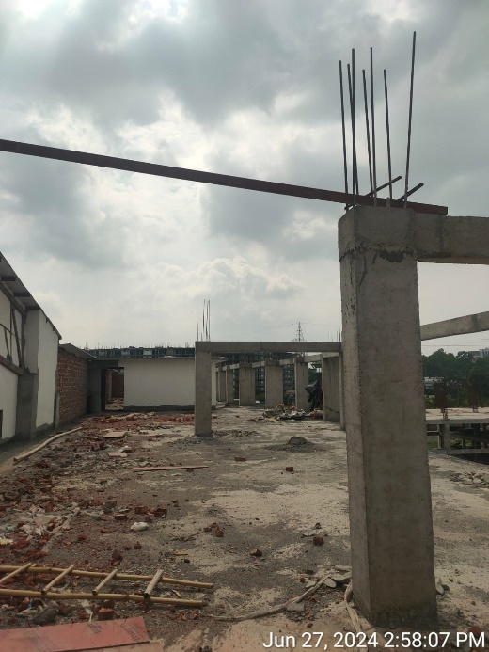 | 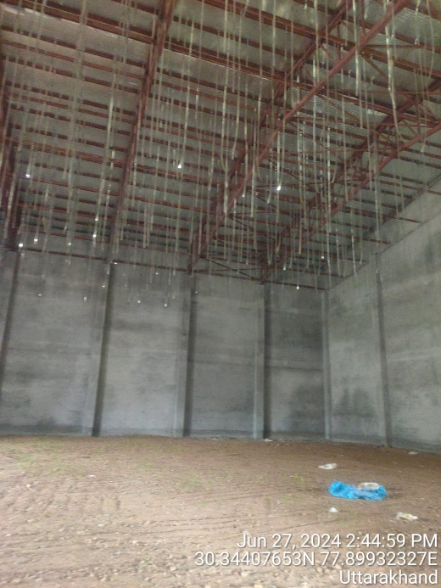
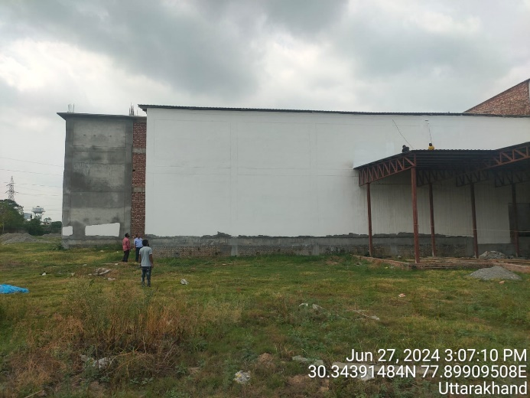 | 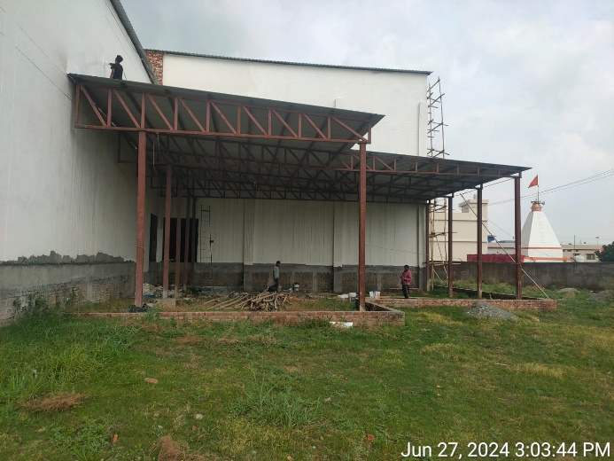

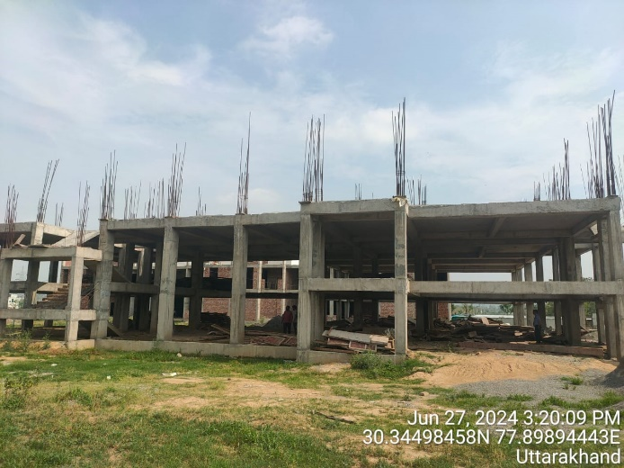 | 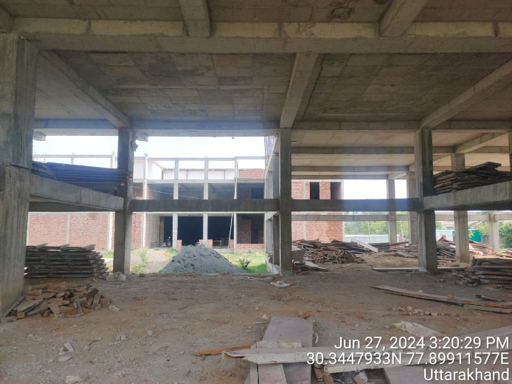
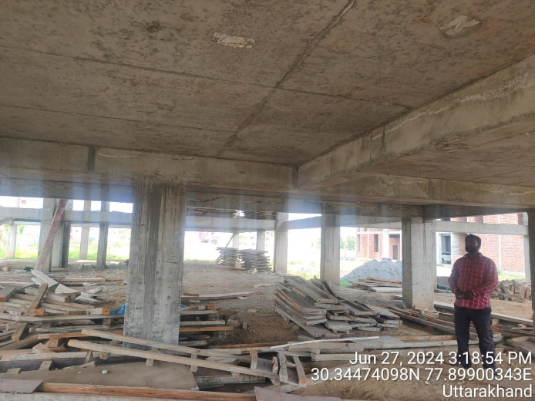 | 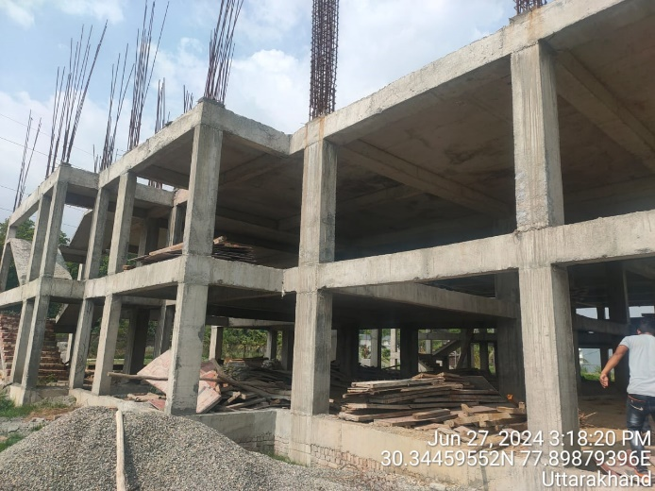
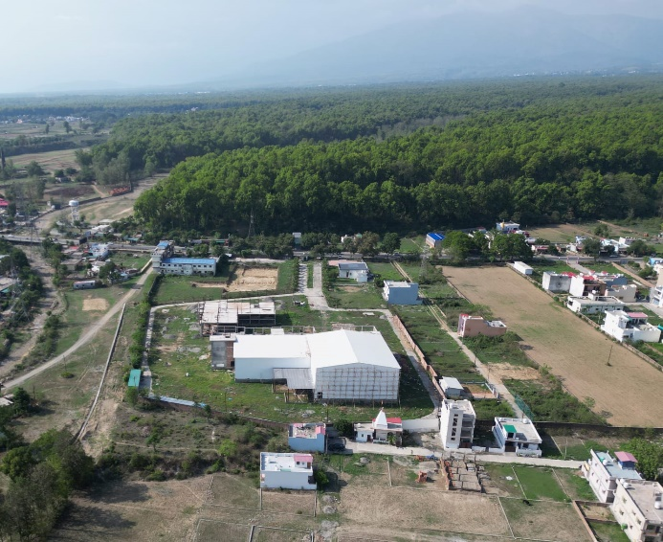 | 