File No.: VIS (2024-25)-PL586-Q055-524-772 Dated: 20.01.2025

TECHNO-ECONOMIC VIABILITY
STUDY REPORT

OF
M/S CRPL INFRA PRIVATE LIMITED
(COLD STORES AT PUNE, AHMEDABAD, NOIDA AND BHIWANDI)

SETUP BY

M/S CRPL INFRA PRIVATE LIMITED

REPORT PREPARED FOR

M/S CRPL INFRA PRIVATE LIMITED
121, CHITTARANJAN AVENUE, GROUND FLOOR, KOLKATA, WEST BENGAL, INDIA, 700073

**Important - In case of any query/ issue or escalation you may please contact Incident Manager Valuers@rkassociates.org. We will appreciate your feedback in order to improve our services.

NOTE: As per IBA Guidelines please provide your feedback on the report within 15 days of its submission after which report will be considered to be correct.

IMPORTANT NOTICE

COPYRIGHT FORMAT: This report is prepared on the copyright format of R. K. Associates Valuers & Techno Engineering Consultants (P) Ltd. (R. K. Associates) to serve our clients with the best possible information and analysis to facilitate them to take rational business decisions. Legally no one can copy or distribute this format without prior approval from R. K. Associates. It is meant only for the advisory/ reference purpose for the organization/s as mentioned on the cover page of this report. Distribution or use of this format or report or any of its content/ information/ data by any organization or individual other than R.K Associates will be seen as an unlawful act and necessary legal action can be taken against the defaulters.
This report is intended for the sole use of the intended recipient/s and contains material that is STRICTLY CONFIDENTIAL AND PRIVATE.

DEFECT LIABILITY PERIOD: In case of any query/ issue or escalation you may please contact Incident Manager at valuers@rkassociates.org. Though adequate care has been taken while preparing this report as per its scope, but still, we can’t rule out typing, human errors, over sightedness of any information or any other mistakes. Therefore, the concerned organization is advised to satisfy themselves that the report is complete & satisfactory in all respect. Intimation regarding any discrepancy shall be brought into our notice immediately. If no intimation is received within 15 (Fifteen) days in writing from the date of issuance of the report, to rectify these timely, then it will be considered that the report is complete in all respect and has been accepted by the client up to their satisfaction & use and further to which R.K Associates shall not be held responsible in any manner.

Part O: R. K. Associates Important Disclaimer and Remarks are integral part of this report and Feasibility assessment is subject to this section. Reader of the report is advised to read all the points mentioned in these sections carefully.

TABLE OF CONTENTS
SECTIONS | PARTICULARS | PAGE NO.
Part A | Report Summary | 4
Part B | INTRODUCTION
 | - About the Report | 6
 | - Executive summary | 6
 | - Purpose of the Report | 9
 | - Scope of the Report | 9
 | - Methodology/ Model Adopted | 10
 | - Data Information received from | 10
 | - Documents/ Data Referred | 11
Part C | Company Profile
 | - Incorporation Details | 12
 | - Company Overview | 13
 | - Existing Shareholding Pattern | 14
 | - Key Promoters/Directors Profile | 14
Part D | Proposed Unit’s Infrastructure Details
 | - Proposed Locations | 17
 | - Google Map Location | 18
 | - Schematic Layout Plan | 23
 | - Land Details | 25
 | - Site pictures | 25
 | - Building & Civil Works | 35
 | - Plant and Machinery/ Equipment details | 45
 | - Utilities | 49
Part E | Project Technical details
 | - Capacity of Proposed Project | 51
 | - Commercial Agreement Details | 51
 | - Technical Specification of Plant & Machinery | 53
 | - Technological Assessment | 59
 | - Manpower | 59
Part F | Industry Overview & Analysis | 62
Part G | SWOT Analysis | 64
Part H | Project Cost and Means of Finance | 67
Part I | Project Implementation Schedule | 72
Part J | Statutory Approvals | Licences | NOC | 79
Part K | Company’s Financial Feasibility | 85
Part L | Conclusion | 180
Part M | Disclaimer | Remarks | 182

PART A | REPORT SUMMARY

S. No. | PARTICULAR | DESCRIPTION
 | Name of the Company: | M/s CRPL Infra Private Limited
 | Registered Address: | 121, Chittaranjan Avenue, Ground Floor, Kolkata, West Bengal, India, 700073
 | Project Name | Cold Storage/Warehouse solution on Built-to-suit (BTS) mode
 | Project Location: | Noida, Pune, Ahmedabad (Kheda), Ahmedabad (Detroj) and Bhiwandi
 | Project Type: | Cold Storage/Warehouse solution on Built-to-suit (BTS) mode
 | Project Industry: | Cold Storage/Warehouse
 | Product Type / Deliverables: | Cold Storage/Warehouse solution on Built-to-suit (BTS) mode
 | Report Prepared for Organization: | M/s. CRPL Infra Private Limited
 | TEV Consultant Firm: | M/s. R.K Associates Valuers & Techno Engineering Consultants (P) Ltd.
 | Report type: | Techno-Economic Viability Report
 | Purpose of the Report: | To assess Technical & Economic Viability for the purpose of seeking external financial assistance to setup 5 new Cold Storage/Warehouse at different locations in India.
 | Scope of the Report: | To assess, evaluate & comment on Technical, Economical & Commercial Viability of the Project as per data information provided by the client, independent Industry research and data/ information available on public domain.
 | Date of Report: | 20th January 2025
 | Documents referred for the Project: | - PROJECT INITIATION DOCUMENTS:  - Information Memorandum  - Financial Projections of the Project  - Project proposed Schedule  - Statutory Approval Details  - Layout and Master Plan  - PROCUREMENT DOCUMENTS:  - LOI with property owners  - Commercial Agreement with e-commerce companies  - List of Plant & Machinery along with acquisition costs & supplier for the same  - Sanction/proposed map of the sites  - Lease/Sale deeds of the Land  - STATUTORY APPROVALS, LICENCES & NOCs  - Certificate of Incorporation  - MSME UDYAM Registration Certificate  - Fire NOC  - NOC/Application for Ground water
 | Means of Finance: | Equity & Debt (D/E Ratio 3.00 Combined)
 | Key Financial Indicators (Combined): | Key Indicators Value  Average DSCR 1.63  Average EBITDA Margin 51.17%  Avg. PAT Margin 26.43%  NPV & IRR INR 237.79 Cr. & 47.58%  Payback Period 2.87 years
Note: Above financial indicators are based on the financial projections of the proposed project provided by the firm and assessment and analysis of the same done by us.
PART B | INTRODUCTION

- ABOUT THE REPORT:
This is a Techno-Economic Viability Study Report of the proposed Cold Storage/Warehouse projects at Noida, Pune, Ahmedabad (Kheda), Ahmedabad (Detroj) and Bhiwandi (under evaluation) set up by CRPL Infra Private limited.

- EXECUTIVE SUMMARY:
This executive summary outlines the development of multiple Cold Storage/Warehouse solution on Built-to-suit (BTS) model by M/s CRPL Infra Private Limited (CRPL) for its q-commerce customers like Zepto, Blinkit, Swiggy Instamart, BB, Falcon etc.
M/s. CRPL Infra Private Limited (CRPL), a Crystal Group company, was incorporated on 12th October 1998 by Shri Murali Lal Agarwal with strategy to venture into cold chain logistics. The Company was incorporated in the name of Crystal Roadways Pvt Ltd, which was later renamed to CRPL Infra Pvt Ltd in October 2017.The Company provides complete logistics services (primary logistics, warehousing, and secondary logistics) to its customers.
Its parent, Crystal Logistic (Cool Chain) Ltd (CLCCL), provides inland logistics or transportation solutions across India and is the major shareholder of the company with 99.99% shareholding in CRPL. CLCCL is predominantly into cold chain logistics, while as a subsidiary, CRPL’s focus is on cold storage warehousing. The overall affairs of the Company are being managed by Mr. Rajesh Agarwal, Mr. Naresh Agarwal and Mr. Akash Agarwal as a director and promoter of the company.
As per the data/information provided by client, Company has existing warehouse facilities of ~12,000 Pallet capacity at Sudharas Food Park, Sankrail, Howrah and ~6,000 Pallet Capacity at Seafood Park in Bhubaneshwar, Odisha. The company has addition ~2,000 Pallet Capacity O&M facility at Seafood Park in Bhubaneshwar, Odisha. The company also has an ice factory in Bhubaneswar.
The green field cold storage facility at Howrah was commissioned in 2015 with capacity of 3000 pallet. The capacity was later increased to 6000 pallets in 2017. The facility became fully Operational with 12,000 Pallet capacity in FY 2020. The warehouse facility in Bhubaneshwar became partially operational in March 2022 and remaining in October 2022. The O&M facility in Bhubaneshwar became operational in FY 2022.
Total Facilities | Total Capacity | Number of Customer | Number of Fleet
3 Strategically  Located Warehouses | ~ 20,000 Pallet  ~ 600+ No. of TEU | 100 plus Key  clients across sector | ~ 50 plus  Reefer trucks
Source: Data/information provided by the client.
As per the audited financials shared by client, historical financial position of the company is shown in the below table as on from 31st March 2022 to 31st March 2024:
Particular | As on 31st March 2022 (Lakhs) | As on 31st March 2023 (Lakhs) | As on 31st March 2024 (Lakhs)
Total Assets | 9386.36 | 9565.83 | 8815.29
Long term borrowings | 4786.57 | 5052.92 | 4118.61
Short term borrowings | 448.34 | 163.75 | 409.37
Turnover | 1961.36 | 2789.07 | 2560.90
PAT | 153.50 | 254.19 | 242.71
Cash flow at the end | 45.76 | 61.51 | 14.82
Source: Data/information provided by the client.
To tap the opportunity of growing demand of Cold Storage/Warehouse led by strong dark-store additions by the e-commerce players, CRPL Infra is exploring this business opportunity with large sized e-commerce players like Zepto, Swiggy Instamart, Blinkit (Zomato), Big Basket etc. to develop Cold Storage/Warehouse solution on Built-to-suit (BTS) model for these players.
Based on its expansion strategy, CRPL Infra is offering Built-to-suit solutions for all e-commerce, quick-Commerce, logistics, FMCG, industrial companies, and other major businesses who are looking for warehouses/Cold storages solutions with very specific needs and qualities but are not keen to spend capex, time and manpower on the same as it is not part of their business plan but a cost item.
To begin, the Company is focussing on delivering around 20 Cold Storage/Warehouse solution on Built-to-suit (BTS) model to Zepto and a couple of Cold Storage/Warehouse solution to Falcon in a phased manner as informed by client.
As a part of expansion, company has planned to set up 5 Greenfield Cold Storage/Warehouse at Noida, Pune, Ahmedabad (Kheda), Ahmedabad (Detroj) and Bhiwandi as shown in the below table:
Particular | Location | Area (Sq. Ft.) | Client name
Noida | Virinder Engineering & Chemicals Pvt. Ltd., Dhoom Manikpur, Dadri, Noida, U.P 203207 | 68,000 Sq. Ft. | Kiranakart Technologies Pvt Ltd (Zepto)
Pune | Dreambig Infraspace, Gate No. 998(P), Perne Phata, Pune Nagar Road, Village:Perne- Tal Haveli, Dist: Pune, Maharastra - 412216 | 27,800 Sq. Ft. | Kiranakart Technologies Pvt Ltd (Zepto)
Ahmedabad (Kheda) | Plot P6/A (Front Side), Prime Industrial & Logistics Hub, Near Ambica Polymer, Haryala, Kheda 387570 | 26,132 Sq. Ft. | Kiranakart Technologies Pvt Ltd (Zepto)
Ahmedabad (Detroj) | SA Logistics, Land Survey No. 839, 840 Sadatpura Detroj to Vithalapura Road, Detroj, Rampura, Ahmedabad, 382120 | 33,000 Sq. Ft. | Falcon
Bhiwandi, Maharashtra | Project is Under Evaluation as informed by the client | 68,000 Sq. Ft. | Kiranakart Technologies Pvt Ltd (Zepto)
Source: Data/information provided by the client.
CRPL has signed LOI for leasing industrial shed/warehouse premises of 27,800 Sq. Ft. at Pune dated 27th Nov 2024, 68,000 Sq. Ft. at Noida dated 9th Dec 2024, 26,132 Sq. Ft. Industrial/Warehouse at Kheda, Ahmedabad and 33,000 Sq. Ft. Industrial/Warehouse at Detroj, Ahmedabad and 68,000 Sq. Ft. at Bhiwandi, Maharashtra (yet to be signed). Out of 5 units, 4 cold storage/warehouses (Noida, Pune, Kheda and Bhiwandi) will be developed as per the commercial agreement with Kiranakart Technologies Pvt Ltd (Zepto) based on the reimbursement business model and cold storage at Detroj, Ahmedabad will be developed as per the commercial agreement with Q-commerce player Falcon for non-reimbursement model. Proposed cold storage at Bhiwandi is under evaluation as informed by the client.
As per the commercial agreement with Zepto, CRPL has agreed to provide minimum 965 (+/- 10% variance basis final layout) Nos Pellets with 15 work station at Pune location, 689 (+/- 10% variance basis final layout) Nos Pellets with 15 work station at Kheda, Ahmedabad location, 2730 (+/- 10% variance basis final layout) Nos Pellets with 30 work station at Noida location. Similarly, as per the commercial agreement with Falcon Agrifriz Foods Pvt Ltd, a minimum guarantee of 3500 Pellets is promised by CRPL.
As informed by client, Bhiwandi cold storage will be similar of scope & scale of Noida location and thus 2730 (+/- 10% variance basis final layout) Nos Pellets with 30 work station has been considered at Bhiwandi location, however the project is under evaluation till the date of preparation of this TEV report.
As per the revised plan provided by the client, Company will provide ~1300 (basis final layout) Nos Pellets with 15 work station at Kheda, Ahmedabad location. However revised agreement has not been shared by the company. We recommend the bank to suggest the client to submit a validated agreement of increased Nos of pellets at Kheda cold storage before disbursement.
As per data/information shared by the client, Schematic/proposed layout plan has been prepared and shared by the client for 4 locations, which can be change during implementation period as informed by the management. The company is in the process to obtain the required Statutory Approvals/NOC’s. (Refer the section Statutory Approval in the later part of the report).
During the site visit, we found that the proposed premises are industrial tin shed/warehouse. Civil work at Pune location has already started and as per informed by client, civil work at Noida and Ahmedabad will start post financial closure. Bhiwandi cold storage project is under evaluation and company is in the process to finalise the location, LOI & commercial agreement for it. (Kindly refer the site pictures captured during the survey attached in the later section of the report).
As per the location wise project cost shared by client, the proposed 5 cold storage/warehouses will be setting up with an initial investment of INR 78.38 Crore including, IDC, Contingencies & Preliminary & Pre-operative expenses, which is proposed to be funded through a term loan of INR 58.78 Crore and promoter’s equity of INR 19.59 Crore.
At present, the company is in discussion with Financial Institutions to fund the project through a term loan of INR 58.78 Crore. In this regard M/s CRPL Infra Private Limited has appointed R.K. associates to assess the Techno-Economic Viability of the proposed cold storages expansion project.
- PURPOSE OF THE REPORT:
To assess Project’s Technical and Financial Feasibility for Client’s requirement.
- SCOPE OF THE REPORT:
To only assess, evaluate & comment on Technical & Financial Feasibility of the proposed expansion of Cold storage/ warehouses being set up by M/s CRPL Infra Private Limited as per the data/information provided by the company.

NOTES:
- Project status is taken as per the Site inspection carried out by our survey team dated 10/01/2025 at Dhoom Manikpur, Noida, 21/01/2025 at Pune, Kheda and Detroj locations.
- Project status of Bhiwandi, Maharashtra cold storage is considered as under evaluation as informed by the client. Company is in the process to finalise the location, LOI & commercial agreement for it. This cold store will be similar to the scope & scale of Noida cold storage and thus inputs for Bhiwandi cold storage are considered as similar to the Noida cold storage during the projected period on the request of promoters.
- Scrutiny about the company, background check, and credibility, credit worthiness of the company or its promoters is out-of-scope of this report.
- Any verification of the documents/ information from originals/ source is out-of-scope of this report.
- This report is only an opinion in respect to Technical and Financial Feasibility of the project as per the future Projections provided by the firm and independent analysis done by us and doesn’t contain any recommendations including taking decision on the loan or any other financial exposure.
- This is not an audit activity of any kind. We have relied upon the data/ information shared by the company in good faith.
- Any review of the existing business of the promoters is out of scope of this report.
- Detailed cost estimation or detailed cost vetting is out of scope of the project.
- This is not a Detailed Project Report or a detailed design or architecture document. Land and property details mentioned in the report is only for illustration purpose as per the information provided to us by the client. The same doesn’t tantamount for taking any responsibility regarding its legality, ownership and conforming to statutory norms.
- METHODOLOGY/ MODEL ADOPTED:
- Data/ Information collection.
- Review of Data/ Information collected related to TEV study.
- Independent review & assessment of technology used and financial projections provided by the company.
- Projections of Revenue, P&L, Balance Sheet, Working Capital Schedule, Depreciation Schedule, Loan Schedule as per the inputs given by the company and assessed by us
- Calculation of key financial indicators and ratio analysis including DSCR, NPV & IRR and payback period of the project.
- Report compilation and Final conclusion.

- DATA/ INFORMATION RECEIVED FROM:
All the data/Information has been received from M/s CRPL Infra Private Limited and the required details about them shown in the below table:
Particulars | Details
Company | M/s CRPL Infra Private Limited
Contact Person | Mr. Rajesh Agarwal
Email Address | ra@crystalgroup.in
Contact No. | +91-9831167771

- DOCUMENTS / DATA REFFERED:

- Detailed Project Report and Promoters Profile
- Financial Projections.
- LOI with property owners
- Commercial agreement of CRPL with its Q-commerce customers/players Zepto & Falcon.
- Civil work estimates.
- List of plant & Machinery along with quotations of vendors
- Schematic Layout Plant
- Certificates of Statutory approvals/NOCs.
- Survey Report.

PART C | COMPANY PROFILE

- INCORPORATION DETAILS:
M/s. CRPL Infra Private Limited (CRPL), a Crystal Group company, was incorporated on 12th October 1998 by Shri Murali Lal Agarwal with strategy to venture into cold chain logistics. The Company was incorporated in the name of Crystal Roadways Pvt Ltd, which was later renamed to CRPL Infra Pvt Ltd in October 2017. Below table shows the incorporation details of the company:
Incorporation Details of the Company
Particular | Description
Company Name | M/s CRPL Infra Private Limited
CIN | U63090WB1998PTC088100
Date of Incorporation | 12/10/1998
Registration Number | 088100
ROC Name | ROC Kolkata
Company Category | Company limited by shares
Company Subcategory | Non-government company
Class of Company | Private
Registered Address | 121, Chittaranjan Avenue, Ground Floor, Kolkata, West Bengal, India, 700073
Authorized Capital | INR 8,00,00,000
Paid up Capital | INR 7,55,88,680
Date of last AGM | 30/09/2024
Date of Balance Sheet | 31/03/2024
Company Status | Active
Source: Information extracted from MCA website & public domain
As per the amended Memorandum of Association (MoA) shared by the client, the company was incorporated to undertake and carry on the business of trading, cartage and haulage, contractors, garage proprietors, carriers of goods and passengers by land, air or water, tour operator and travel agent, wharfingers, packers, warehouseman and storekeepers and to maintain, equip and wore public transport vehicles, automobiles, ships and vessels and air craft of any class.
The company is categorised as medium enterprise with Udyam Registration Number UDYAM-WB-10-0003653 dated 16th Sep 2020. In this company, the promoters have proposed to set up the proposed to develop multiple cold storage/warehouses at multiple locations.
- COMPANY OVERVIEW:
CRPL Infra Pvt Ltd (Warehouse Business)

Quatre Agro Enterprises Pvt Ltd
(Container Business)

99.99%

99.99%

Promoters

100%

Crystal Logistics Cool Chain Limited
(Transportation Business)

Origin of the Group dates back to 1962 when the foundation of business was laid by Late Shri Murari Lal Agarwal under the name of M/s Haryana Transport Company. The Group entered into cold storage & warehousing operations in 2001 has a legacy of more than two decade in the integrated cold chain management -logistics/transportation, warehousing and leasable refrigerated container and vehicles. The Group operates in three business lines:
- Cold Chain Warehousing
- Portable temperature-controlled Container Business
- Cold Chain Transportation (Reefer Trucks).
CLCCL is predominantly into cold chain logistics, while as a subsidiary, CRPL’s focus is on cold storage warehousing. As per the data/information provided by client, Company has existing warehouse facilities of ~12,000 Pallet capacity at Sudharas Food Park, Sankrail, Howrah and ~6,000 Pallet Capacity at Seafood Park in Bhubaneshwar, Odisha. The company has addition ~2,000 Pallet Capacity O&M facility at Seafood Park in Bhubaneshwar, Odisha. The company also has an ice factory in Bhubaneswar.
The green field cold storage facility at Howrah was commissioned in 2015 with capacity of 3000 pallet. The capacity was later increased to 6000 pallets in 2017. The facility became fully Operational with 12,000 Pallet capacity in FY 2020. The warehouse facility in Bhubaneshwar became partially operational in March 2022 and remaining in October 2022. The O&M facility in Bhubaneshwar became operational in FY 2022.
Total Facilities | Total Capacity | Number of Customer | Number of Fleet
3 Strategically  Located Warehouses | ~ 20,000 Pallet  ~ 600+ No. of TEU | 100 plus Key  clients across sector | ~ 50 plus  Reefer trucks
Source: Data/information provided by the client.
- EXISTING SHAREHOLDING PATTERN:
As per the data/information provided by the client, Shareholding of promoters dated 30th September 2023 is as follows:
Nature of Shareholders | No. of Shares | Amount (Rs.) | % Holding
Crystal Logistic (Cool Chain) Ltd | 75,58,867 | 7,55,88,670 | 99.99%
Rajesh Agarwal | 1 | 10 | 0.01%
TOTAL | 75,58,868 | 7,55,88,680 | 100%
Source: Data/Information provided by the client.
- KEY PROMOTER’S/DIRECTORS PROFILE:
As per data/information provided by the client about the promoters & directors, below table illustrates the educational & professional experience of the promoters along with the Address, DIN and contact details as on 20th Jan 2025:
Name/  D.O. B | Designation/DIN | Address & Contact Details | Appointment  Date | Qualifications/Experience
Mr. Rajesh Agarwal  (14/05/1968) | Whole-time Director  DIN: 00447047 | Geetanjali Apartment, Flat No. 2g 8b Middleton Street, Middleton Row Circus Avenue, Kolkata, W.B, 700071  +91-9372888750  ra@crystalgroup.in | 10/04/2015 | Mr. Rajesh Agarwal is a commerce graduate and he has 25 years‟ experience in logistic industry. He looks after the finance function of the group
Mrs. Naresh Agarwal  (D.O.B: 18/11/1971) | Whole-time Director  DIN: 00601105 | 1303, A-Aster tower Rani Sati Marg, Goregaon East Mumbai Maharashtra 400097 | 03/09/2013 | Mr. Naresh Agarwal is a commerce graduate. He has 23 years’ experience in logistic industry. He supports various CSR activities through his partnerships & presence in multiple associations.
Mr. Akash Agarwal  (D.O.B: 04/01/1974) | Whole-time Director DIN: 00601047 | 1303, A-Aster tower Rani Sati Marg, Goregaon East Mumbai Maharashtra 400097 | 10/04/2025 | Mr. Akash Agarwal completed Programme in Family Managed Business from NMIMS. He is CEO of Crystal & led JV set up with TITAN Containers A/S, Denmark. He gained approximately 17 years‟ experience in logistic industry.
Source: Data/Information provided by the client and data extracted from MCA
Below tables shows the information of the companies/LLPs with which each Director is associated with to give a basic background detail of the promoters as found on public domain in general/ tertiary category research.
(MR. RAJESH AGARWAL DIN: 00447047)
S. No | Company Name  (CIN/FCRN) | Designation | Original Date of Appointment | Date Of Appointment at Current Designation
1 | CRPL Infra Private Limited (U63090WB1998PTC088100) | Whole-time director | 01/07/2020 | 01/04/2022
2 | Crystal Logistic (Cool Chain) Limited  (U60210WB2007PLC113305) | Director | 01/07/2020 | 31/12/2020
Source: Information extracted from MCA website & public domain.
(MRS. NARESH AGARWAL DIN: 00601105)
S. No | Company Name  (CIN/FCRN) | Designation | Original Date of Appointment | Date Of Appointment at Current Designation
1 | CRPL Infra Private Limited (U63090WB1998PTC088100) | Whole-time director | 03/09/2013 | 31/05/2022
2 | Quatre Agro Enterprises Private Limited  (U01500MH2014PTC252008) | Director | 13/01/2014 | 13/01/2014
3 | Crystal Logistic (Cool Chain) Limited (U60210WB2007PLC113305) | Director | 16/12/2014 | 30/09/2015
4 | Crystal Titan Containers Private Limited  (U71210MH2015PTC266640) | Director | 14/07/2015 | 14/07/2015
5 | CRPL Visakhapatnam Cold Chain Private Limited  (U63000WB2019PTC234073) | Director | 24/09/2019 | 24/09/2019
Source: Information extracted from MCA website & public domain
(MR. AKASH AGARWAL DIN: 10810751)
S. No | Company Name  (CIN/FCRN) | Designation | Original Date of Appointment | Date Of Appointment at Current Designation
List of Associated Companies:
1 | CRPL Infra Private Limited (U63090WB1998PTC088100) | Whole-time director | 10/04/2015 | 31/05/2022
2 | Quatre Agro Enterprises Private Limited  (U01500MH2014PTC252008) | Director | 13/01/2014 | 13/01/2014
3 | Crystal Logistic (Cool Chain) Limited  (U60210WB2007PLC113305) | Director | 16/12/2014 | 30/09/2015
4 | CRPL Visakhapatnam Cold Chain Private Limited  (U63000WB2019PTC234073) | Director | 24/09/2019 | 24/09/2019
5 | Crystal Titan Containers Private Limited  (U71210MH2015PTC266640) | Director | 14/07/2015 | 14/07/2015
List of Associated LLPs:
1 | Merlin Capital Technologies LLP  (AAD-2061) | Partner | - | 25/01/2022
2 | Kennis Ai Solutions LLP  (AAE-3245) | Partner | - | 09/01/2020
3 | KKD Advisors LLP (AAE-1346) | Partner | - | 30/03/2019
Source: Information extracted from MCA website & public domain.

PART D | PROPOSED INFRASTRUCTURE DETAILS

- PROPOSED LOCATIONS:
CRPL has proposed to set up 5 new cold storage at 5 different locations as per the requirement of its Q-commerce customers. Project wise location details are as follows as per the shared Letter of Intent (LOI) with lessors/property owners:
Project wise location details
Cold Storage Location | Address of the unit | Lessor | Tenant
Dadri, Noida | Dhoom Manikpur, Dadri, Noida, U.P 203207 | Virinder Engineering & Chemicals Pvt. Limited | Crystal Group
Pune, Maharashtra | Dream big Infraspace, Gate No. 998(P), Perne Phata, Pune Nagar Road, Haveli, Pune, Maharashtra - 412216 | Dream Big Infraspace | CRPL Infra Private Limited
Kheda, Ahmedabad | Plot P6/A (Front Side), Prime Industrial & Logistics Hub, Near Ambica Polymer, Haryala, Kheda 387570 | Prime Industrial & Logistics Hub | CRPL Infra Private Limited
Detroj, Ahmedabad | SA Logistics, Land Survey No. 839, 840 Sadatpura Detroj to Vithalapura Road, Detroj, Rampura, Ahmedabad, 382120 | SA Logistics | CRPL Infra Private Limited
Bhiwandi, Maharashtra | Under Evaluation
Source: As per the LOI shared by client.
Table: 1 is showing the details of the location wise adjoining properties of the proposed premises and Table: 2 is showing the Connectivity Details of the Proposed Locations:
Table: 1 Adjoining Property Details
Particular | East | West | North | South
Dadri, Noida | Internal road | Another shed | Internal road | Internal road
Pune | Sadhu House | Residential apartments & shops | Shantai Hospital | Residential houses
Kheda, Ahmedabad | Internal road | Internal road | Frontice Logistics | Internal road
Detroj, Ahmedabad | Internal road | Internal road/open plot | Internal road/open plot | Internal road/open plot

Table: 2 Connectivity Details of the Proposed Locations
Particular | Road | Rail | Airport
Dadri, Noida | G.T. Road 1 km away | Dadri Railway Station ~8 km away | IGI Airport ~ 50 km away
Pune | 24 Mt. wide Parner-Pune Highway ~20 Mt. away | Manjari Budruk Railway Station ~20 km away | Pune International Airport ~away
Kheda, Ahmedabad | 120 Ft. wide Baroda-Ahmedabad Highway ~2.5 km away | Nenpur Railway Station ~20 km away | Sardar Vallabhbhai Patel International Airport ~50 km away
Detroj, Ahmedabad | 80 Ft. wide Sadatpura Randheja road ~1 km away | Detroj Railway Station ~7 km away | Vadodra Airport ~40 km away

Location wise other amenities details are shown in the below table:
Nearby Amenities Details of the Proposed Locations
Particular | School | Hospital | Market | Metro | Others
Dadri, Noida | ~2 km away | ~3 km  away | ~1 km away |  | Property is well connected with 50 ft. wide road (NH 91)
Pune | ~1 km away | ~0 km  away | ~500 m away |  | Property is well connected with internal Perne road
Kheda, Ahmedabad | ~3 km away | ~7 km  away | ~7 km away |  | Property is well connected with 40 ft. wide Haryala Kheda road
Detroj, Ahmedabad | ~5 km away | ~8 km  away | ~7 km away | - | Property is well connected with 20 ft. wide internal approach road

- LOCATION MAP:
NOIDA:
- GOOGLE MAP LOCATION:
The Dhoom Manikpur, Dadri, Noida Cold Storage is proposed to be commissioned at Dhoom Manikpur Dadri U.P 203207 with GPS coordinates 28°34'04.9"N 77°32'02.8"E as per the Google map attached below:
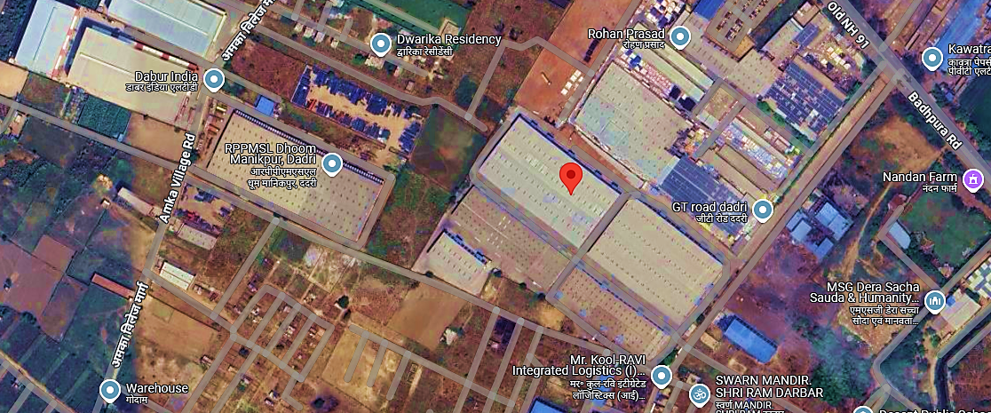
- GOOGLE MAP LAYOUT:
Demarcation of the land with approximate measurement on the Google map is attached in the below picture:
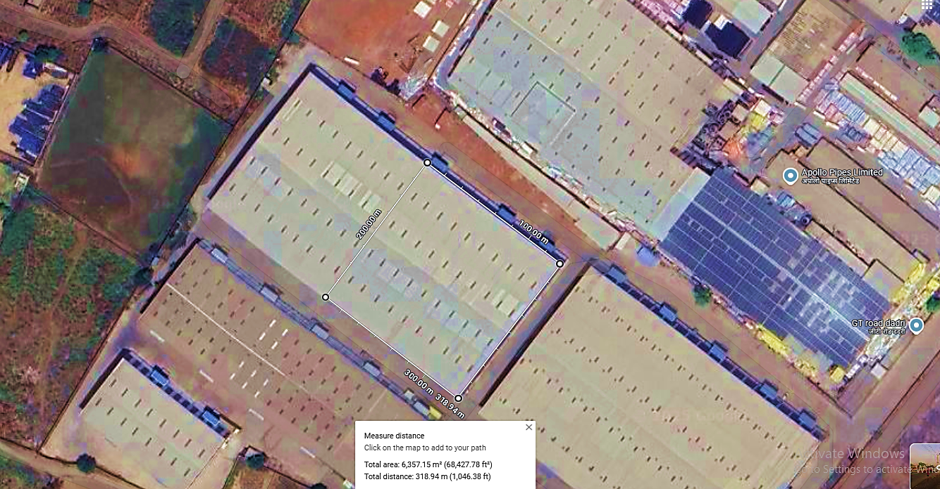
PUNE:
- GOOGLE MAP LOCATION:
The Pune Cold Storage is proposed to be commissioned at Dreambig Infraspace, Gate No. 998(P), Perne Phata, Pune Nagar Road, Village:Perne- Tal Haveli, Dist: Pune, Maharastra - 412216 with GPS coordinates East 18°38'19.5"N 74°02'54.5"E as per the Google map attached below:
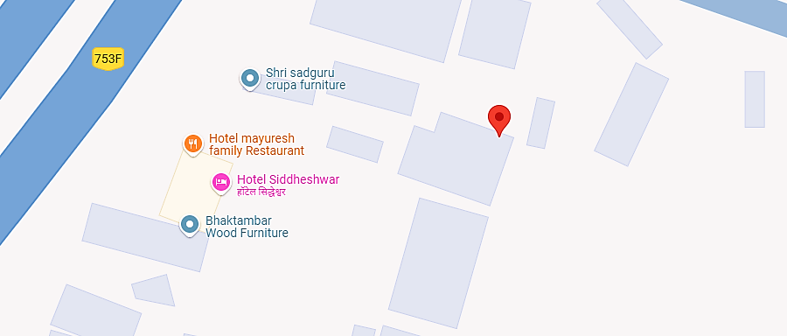
- GOOGLE MAP LAYOUT:
Demarcation of the land with approximate measurement on the Google map is attached in the below picture:
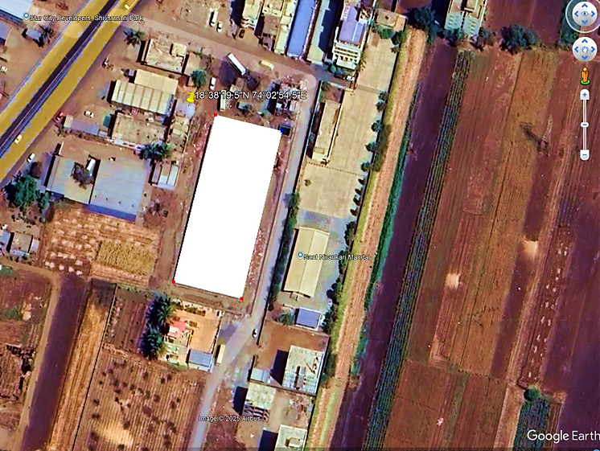
AHMEDABAD (KHEDA:
- GOOGLE MAP LOCATION:
The Kheda (Ahmedabad) Cold Storage is proposed to be commissioned at Plot P6/A (Front Side), Prime Industrial & Logistics Hub, Near Ambica Polymer, Haryala, Kheda 387570 with GPS coordinates 22°45'11.7"N 72°38'14.7"E as per the Google map attached below:
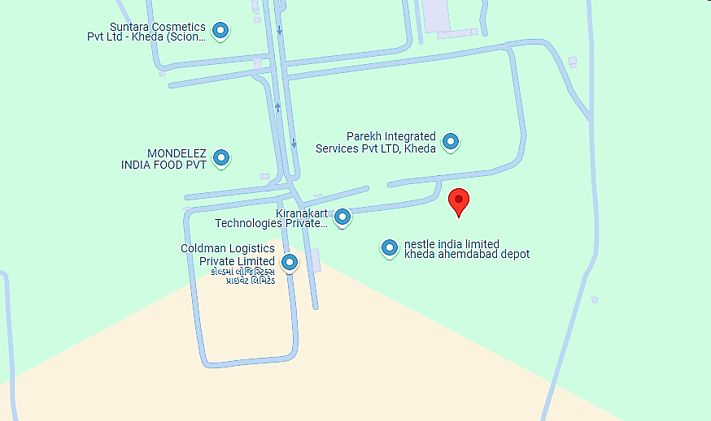
- GOOGLE MAP LAYOUT:
Demarcation of the land with approximate measurement on the Google map is attached in the below picture:
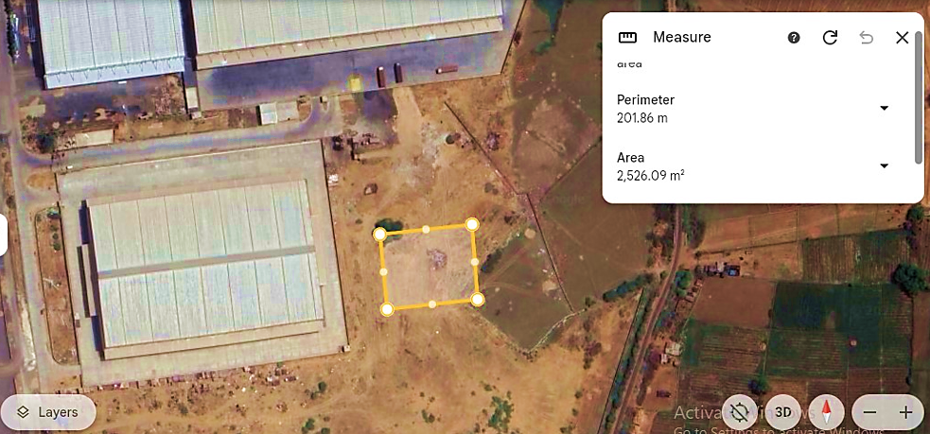
AHMEDABAD (DETROJ):
- GOOGLE MAP LOCATION:
The Detroj (Ahmedabad) Cold Storage is proposed to be commissioned at SA Logistics, Land Survey No. 839, 840 Sadatpura Detroj to Vithalapura Road, Detroj, Rampura, Ahmedabad, 382120 with GPS coordinates 23°21'17.4"N 72°07'47.4"E as per the Google map attached below:
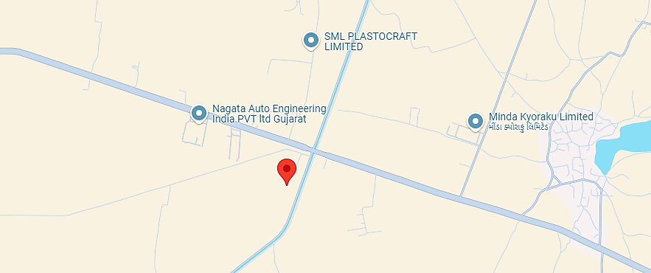
- GOOGLE MAP LAYOUT:
Demarcation of the land with approximate measurement on the Google map is attached in the below picture:
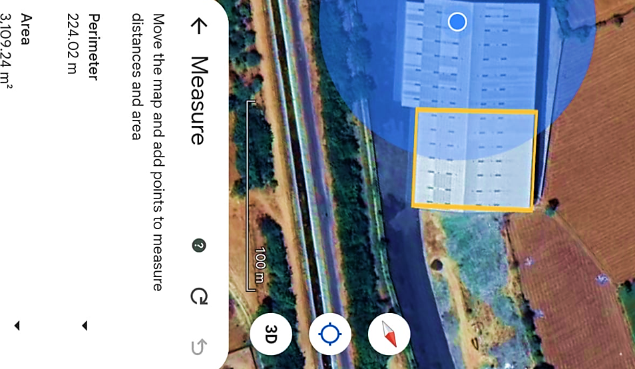
Note: Proposed cold storage at Bhiwandi is under evaluation.
- SCHEMATIC/PROPOSED LAYOUT PLAN:
As per the data/information provided by the client/Company, Schematic layout plan layout plan is attached below for reference:
NOIDA
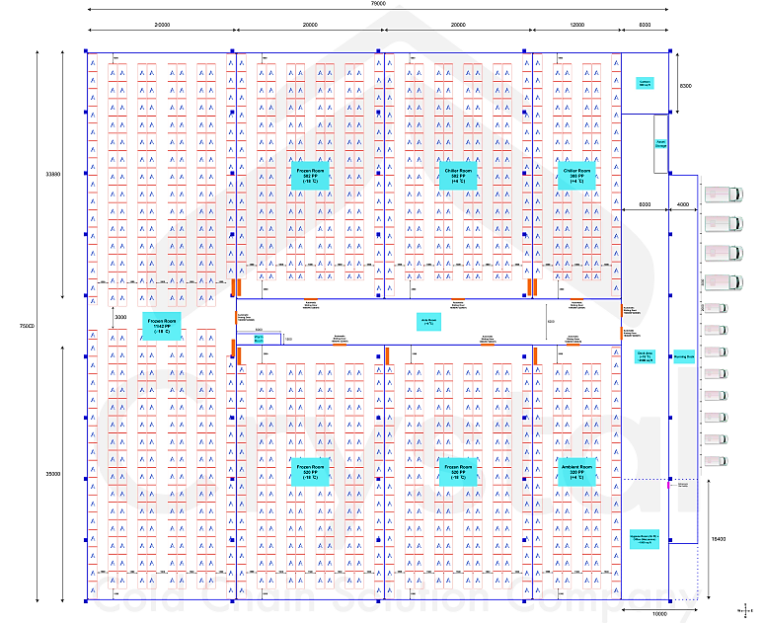
PUNE:
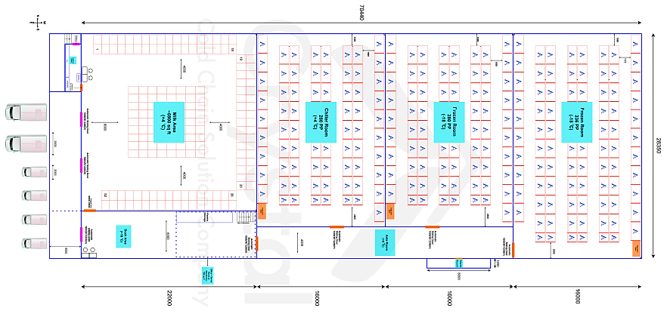
AHMEDABAD (KHEDA)
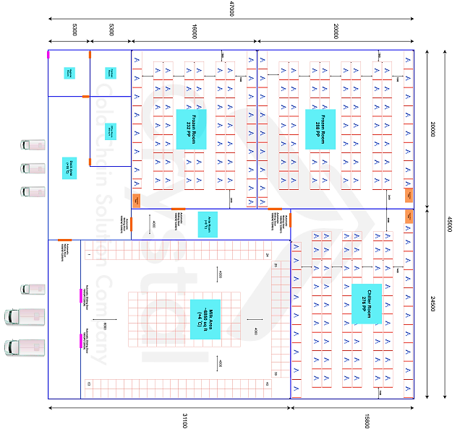
AHMEDABAD (DETROJ)
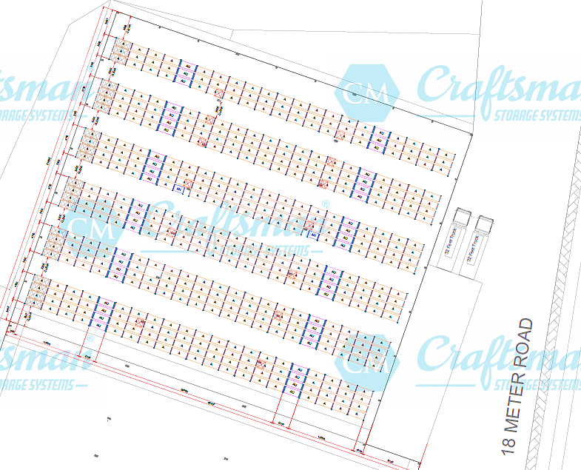
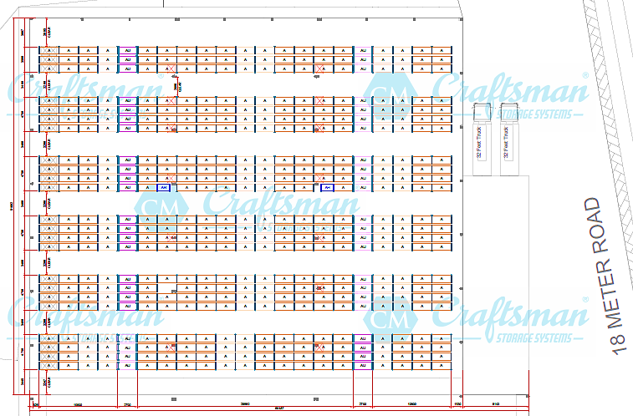
Note: As informed by the client, the schematic layout plan is subject to change as per the actual implementation plan. Further, proposed cold storage at Bhiwandi, Maharashtra is under evaluation and we recommend the bank to suggest the client to submit the required information along with supporting documents as per actual.
- LAND DETAILS:
As per the shared LOI, CRPL has leased out 68,000 Sq. Ft. industrial ready to use tin shed premises at Dhoom, Manikpur U.P, 27,800 Sq. Ft. industrial/warehouse premises at Pune, 26,132 Sq. Ft. at Kheda (Ahmedabad) and 35,000 Sq. Ft. at Detroj (Ahmedabad).
As per the data/information provided by the client, M/s CRPL is in the process to acquire an industrial premises of 68,000 Sq. Ft. on lease basis at Bhiwandi, Maharashtra location as this cold storage project is under evaluation stage and location is not finalised yet. We recommend the bank to suggest the client to submit the required information such as lease agreement, LOI as per actual.
During the site visit, we found that all the properties are industrial premises. (Kindly refer the site pictures captured during the survey attached in the later section of the report).

- SITE PICTURES:
Site pictures were captured during the site visit, for reference few of the pictures are attached below:
NOIDA: (10th JANUARY 2025)

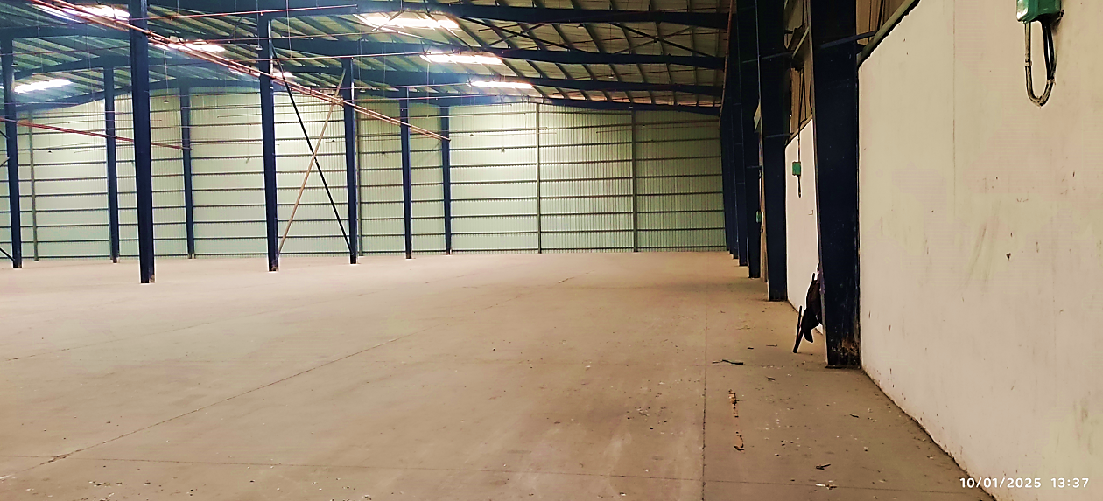
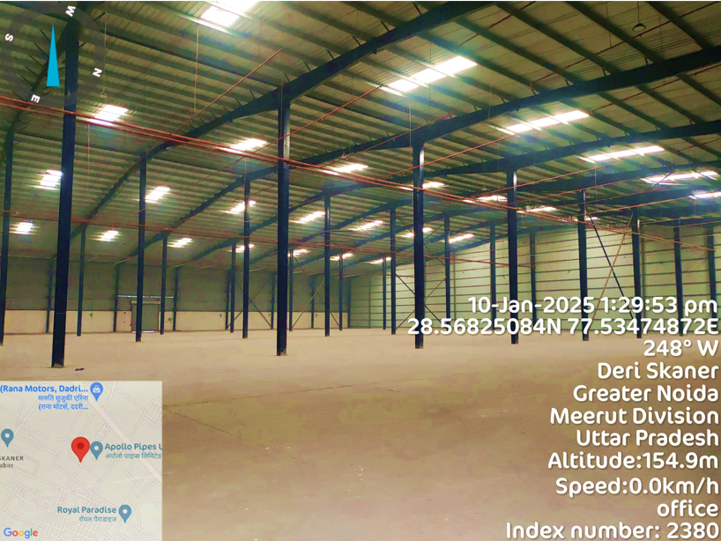
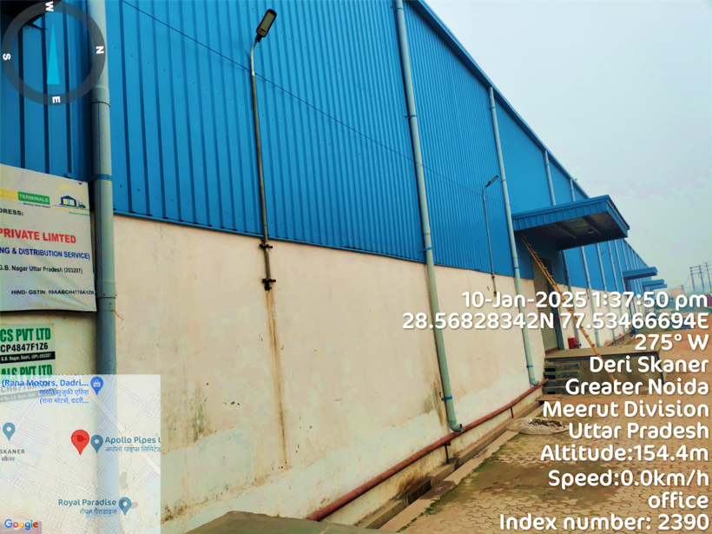
PUNE: (21st JANUARY 2025)
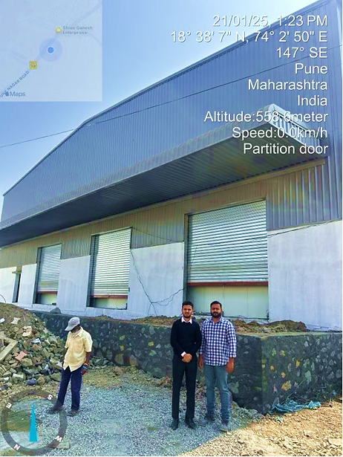
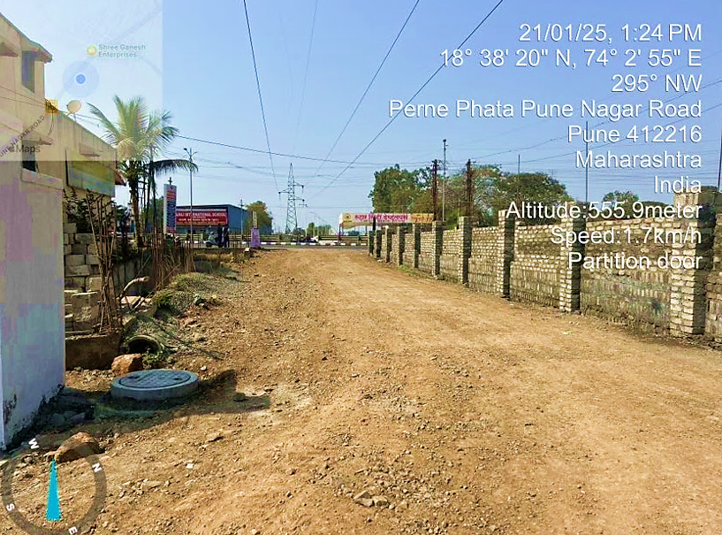
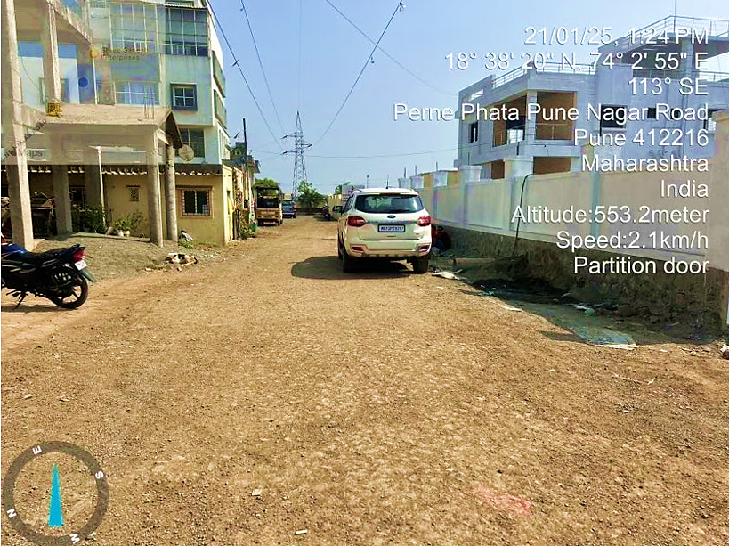
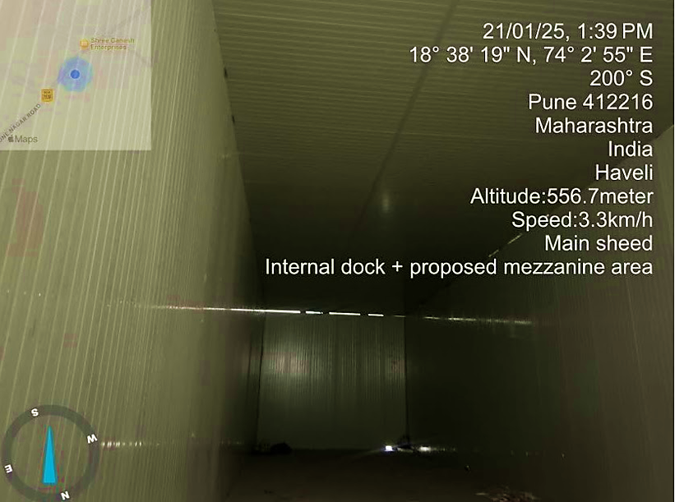
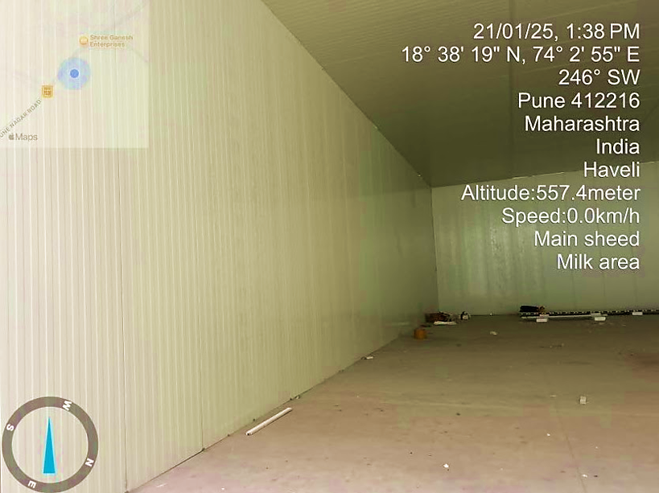
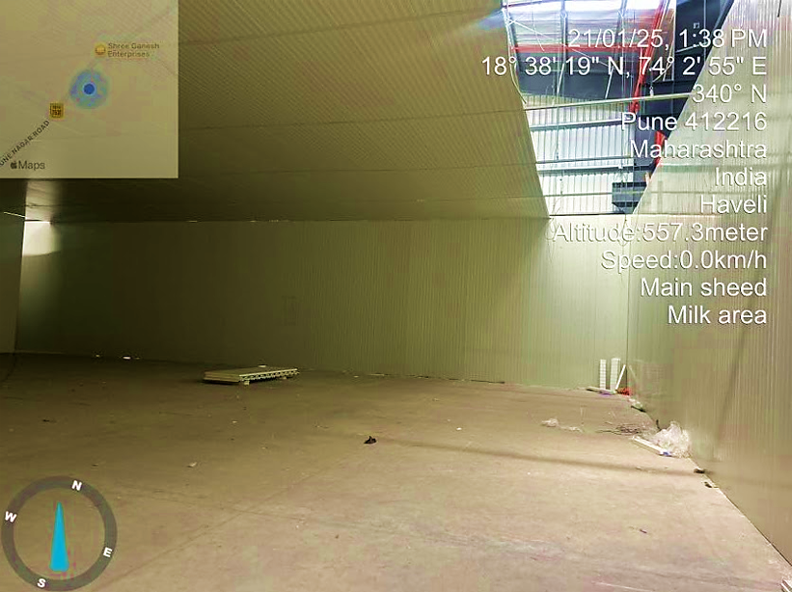
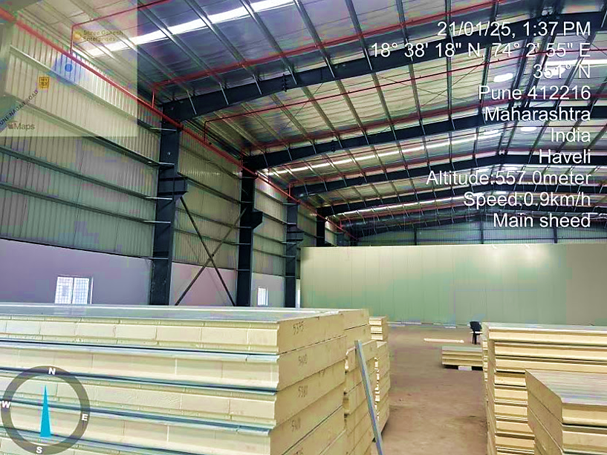
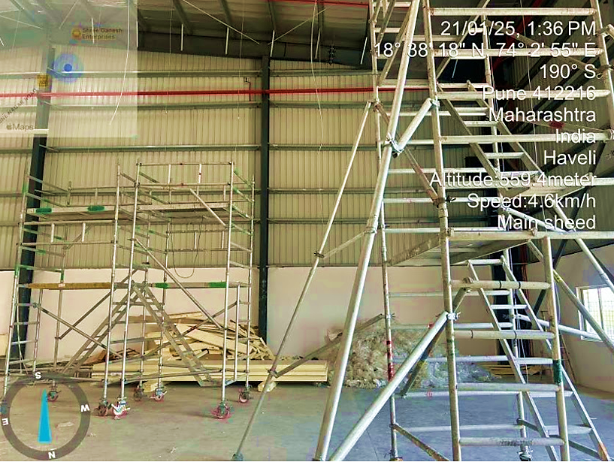
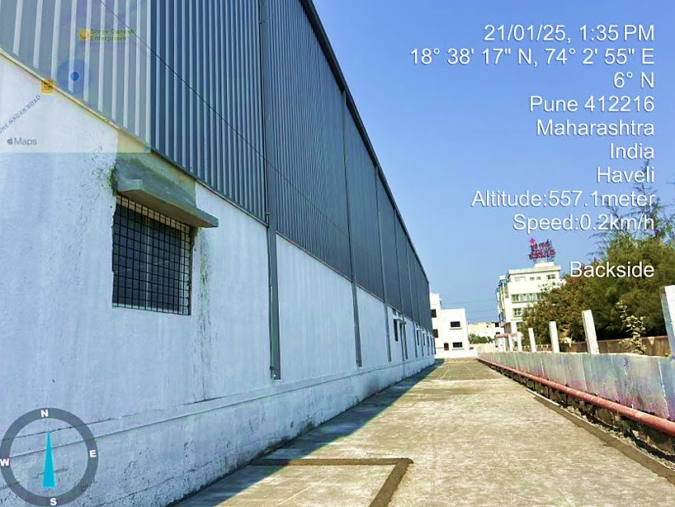
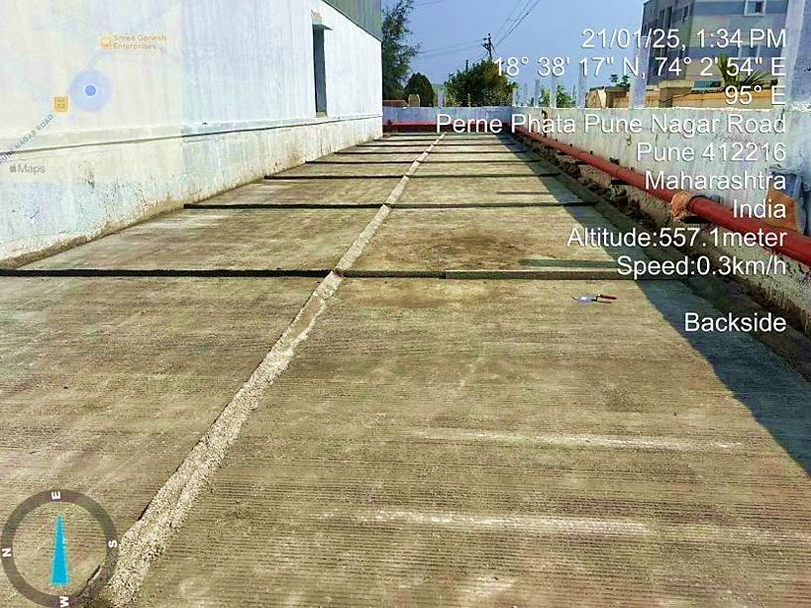
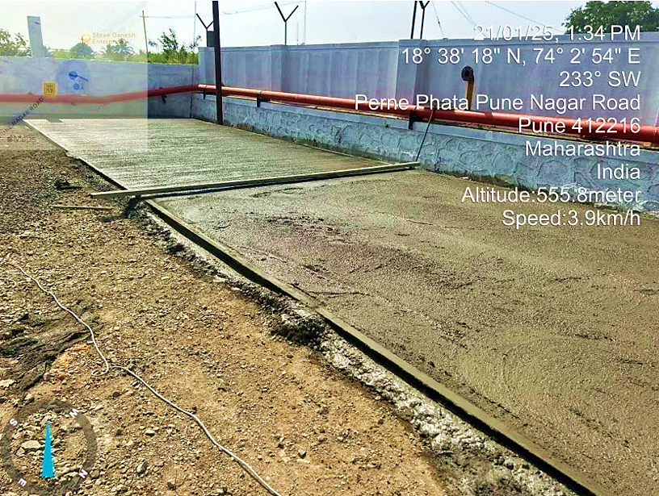
AHMEDABAD (KHEDA) (21ST JANUARY 2025)
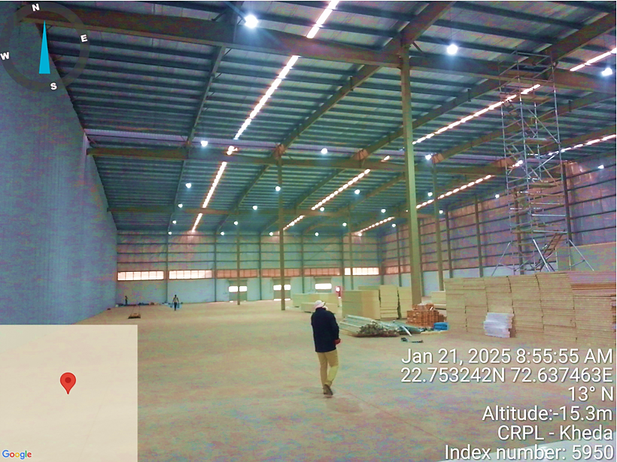
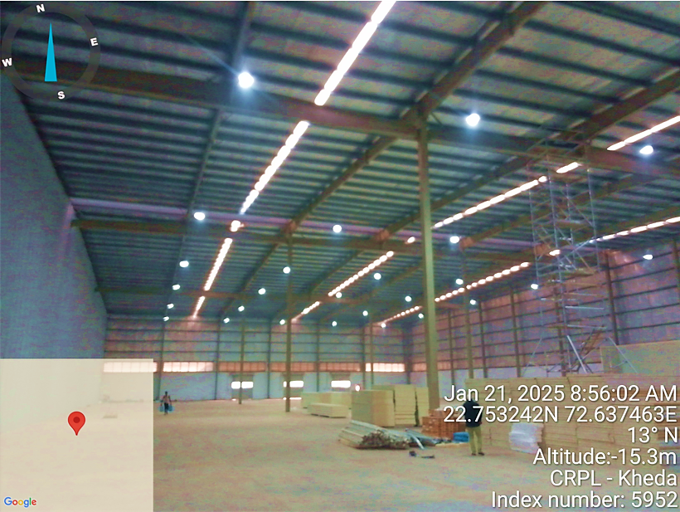
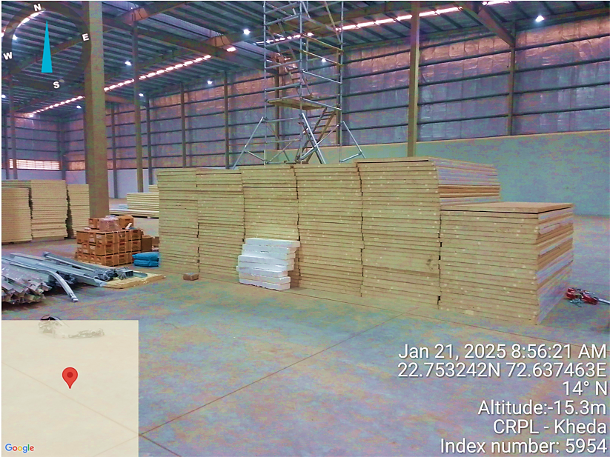
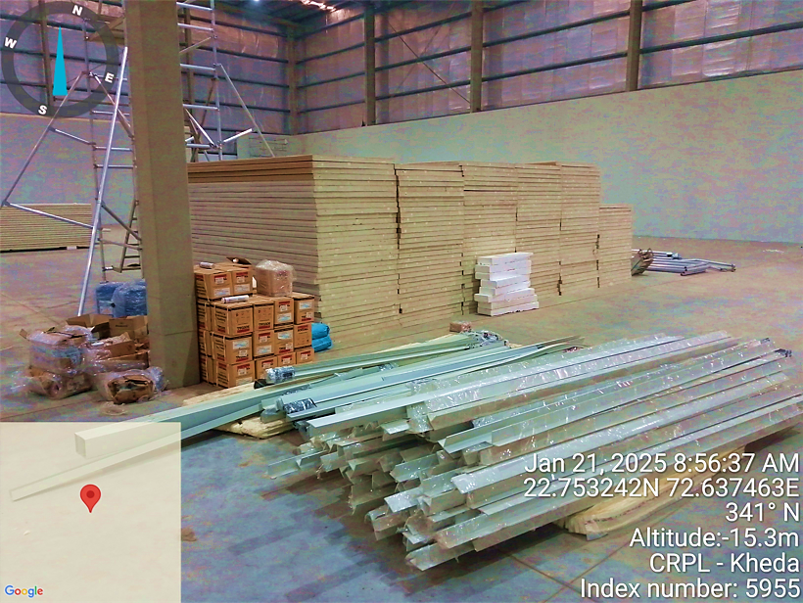
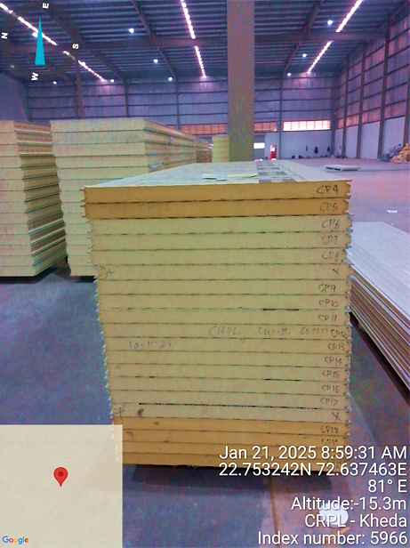
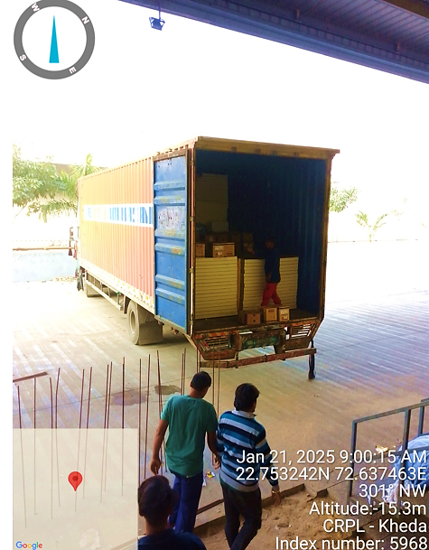
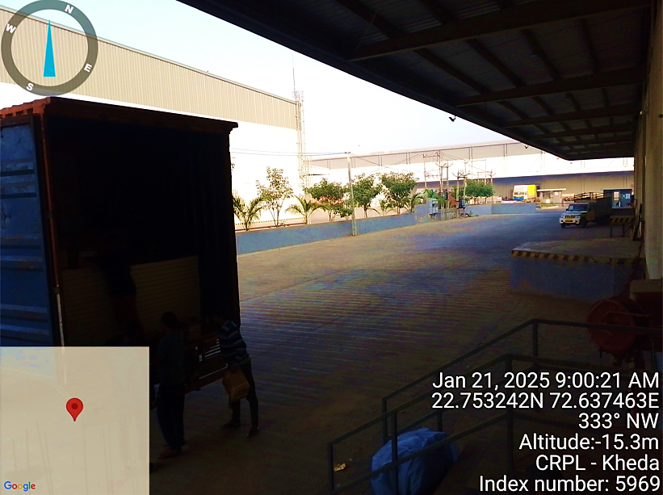
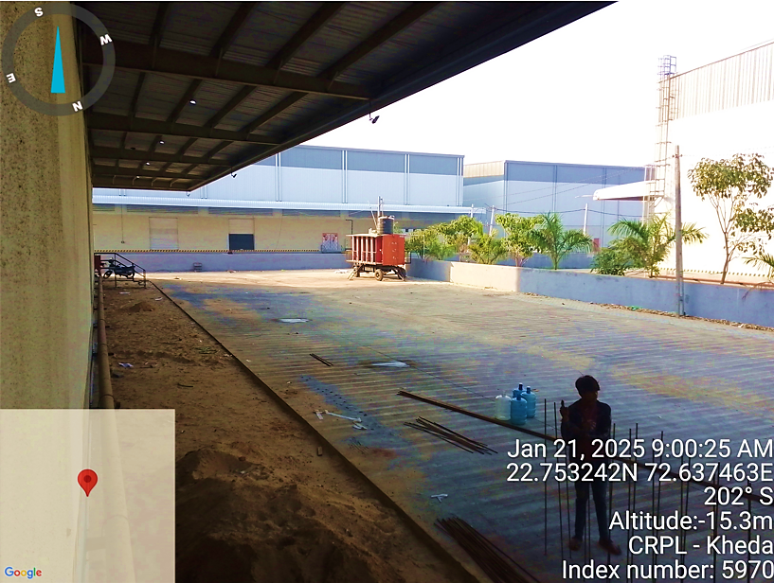
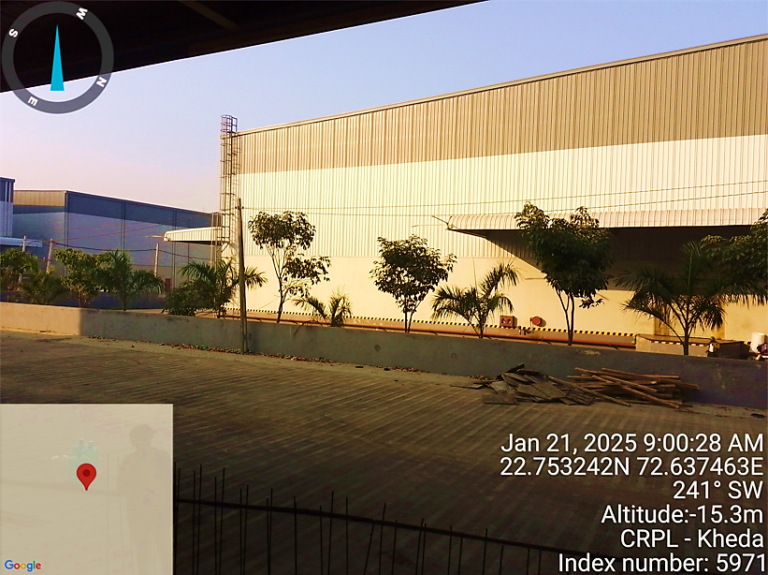
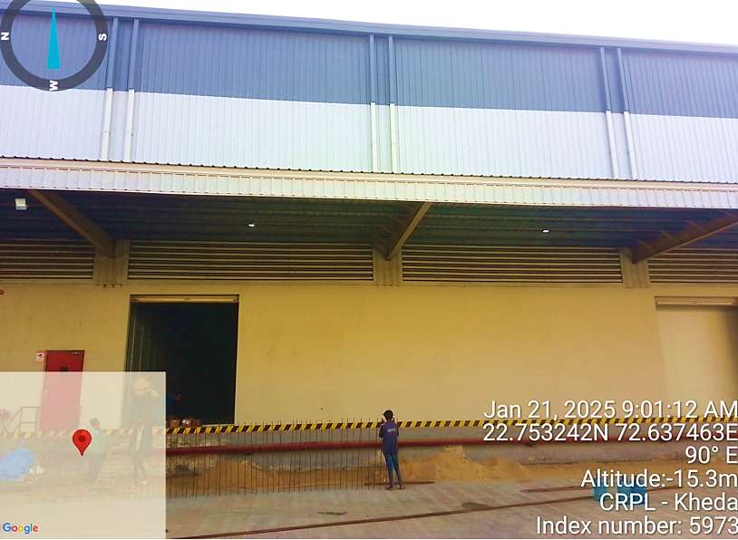
AHMEDABAD (DETROJ) (21st JANUARY 2025)
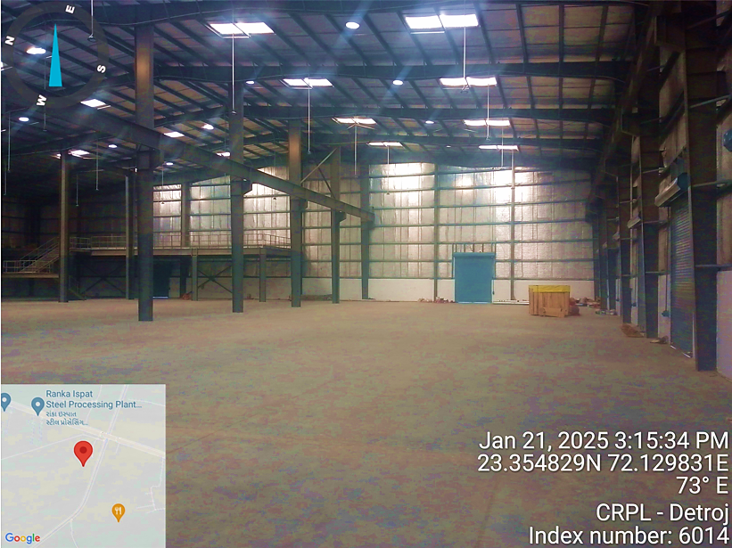
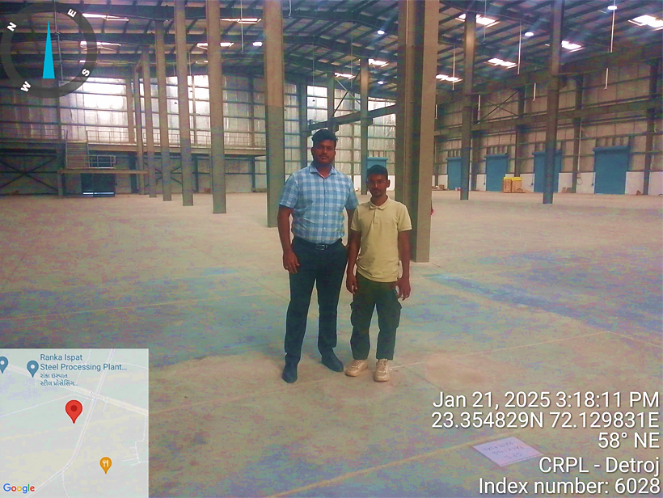
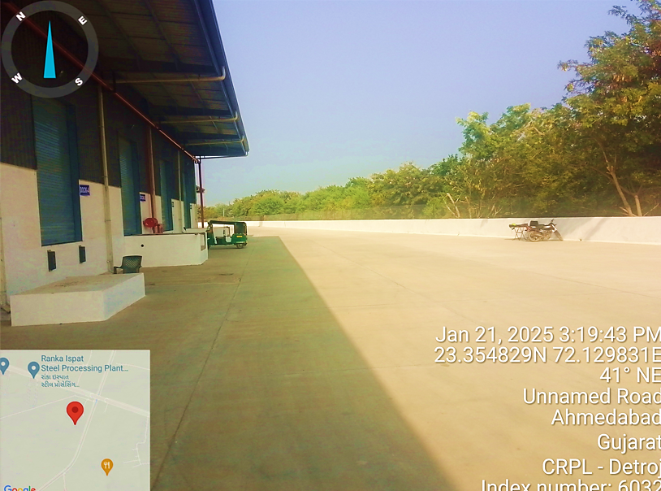
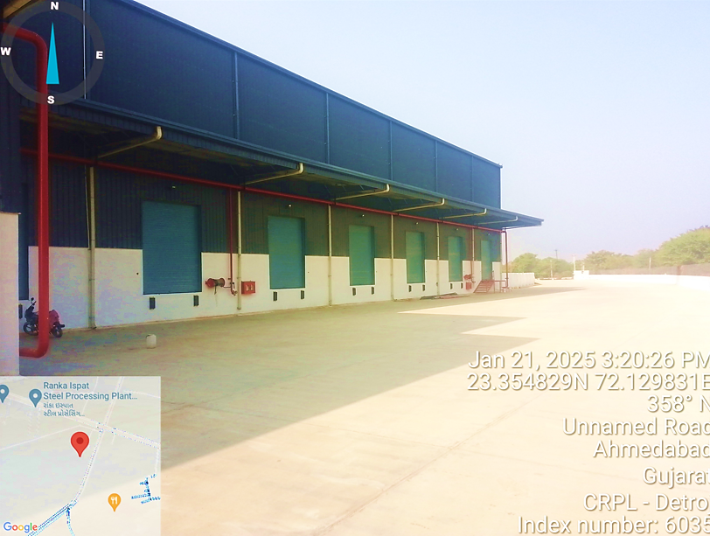
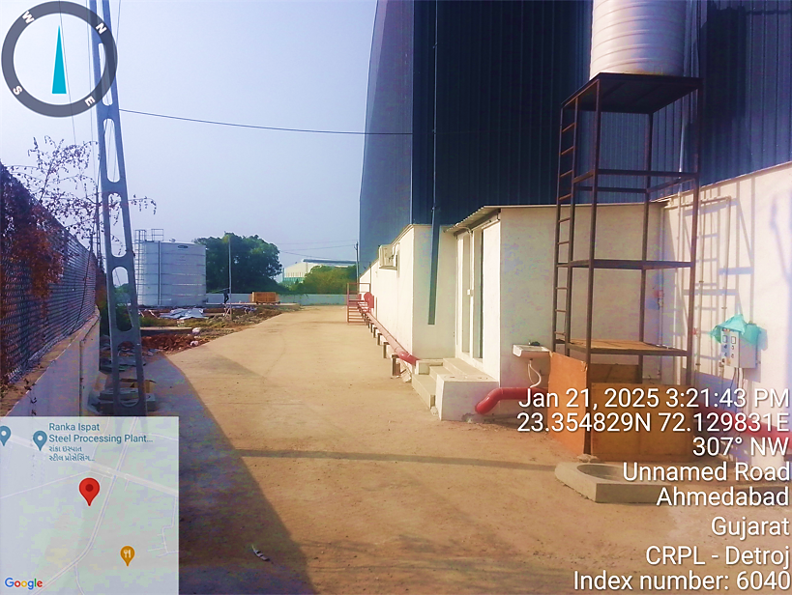
- BUILDING & CIVIL WORKS:
As per the shared LOI, CRPL has leased out 68,000 Sq. Ft. industrial ready to use tin shed premises at Dhoom, Manikpur U.P, 27,800 Sq. Ft. industrial/warehouse premises at Pune, 26,132 Sq. Ft. at Kheda (Ahmedabad) and 35,000 Sq. Ft. at Detroj (Ahmedabad). As per the data/information provided by the client, below are the location wise cost estimate of proposed building & civil works:
DHOOM MANIKPUR, DADRI, NOIDA LOCATION:
S. No | Description | Unit | Total Qty | Rate | Total Amount
1 | Earth Work Excavation in All Types of Soil Including Soft Disintegrated Rock in Foundation Trenches or Drains, Except Hard Rock
1.1 | A) For Lift Up To 1.50 Mt | Sq. Ft. | 26500 | 20 | 530000
1.2 | B) For Lift Above 1.5mt & Up To 3.0mt | Sq. Ft. | 26500 | 30 | 795000
2 | Banking / Filling with CNS Soil / Moorum Below FGL In Plinth / Backfilling of Foundations Etc.
2.1 | A) With Approved Cns Earth | Sq. Ft. | 26500
2.2 | B) With Moorum | Sq. Ft. | Qro
2.3 | C) With River Sand | Sq. Ft. | Qro
2.4 | Providing And Spreading of Good Quality Hard Granite Aggregates In 200 Mm Thick Layer Above FGL | Sq. Ft. | 26500
3 | Anti-Termite Treatment | Sq. Ft. | 26500 | 20 | 530000
4.1 | Plain And Reinforced Cement Concrete Providing and Laying Plain Cement Concrete 1:3:6 | Cum | 1988 | 800 | 1590400
4.2 | Providing And Laying Plain Cement Concrete 1:2:4 | Cum | 26 | 3600 | 93600
4.3 | Providing And Laying in Position M-25 Grade Reinforced Cement Concrete | Cum | 5300 | 450 | 2385000
 | A) Foundations, Footings, Rafts, Grade Slabs, Pile Caps and Like | Cum | 150 | 450 | 67500
 | B) Pedestals And like | Cum | 60 | 450 | 27000
 | C) Plinth Beams | Cum | 55 | 450 | 24750
 | D) Columns And like | Cum | 55 | 450 | 24750
 | E) Lintels, Beams, Brackets Including Inclined/Sloped & Circular Beams and Like | Cum | 25 | 450 | 11250
 | F) Roof Slabs Including Chajjah and Like | Cum | Qro
 | G) Retaining Wall, Shear Walls and Other Rcc Walls, Drains and Like | Cum | 30 | 450 | 13500
 | H) Staircase And like | Cum | Qro
4.4 | Providing, Fabricating & Fixing in Position Reinforcement for Rcc Work with Thermo Mechanically Treated (Tmt) Bar, Tmt Bars of Grade Fe-500 Conforming to Is - 1786/85 | Mt. | 10 | 75000 | 750000
4.5 | Providing, Fabricating and Erecting Form Work
 | 1) Plywood Shuttering Shall Be Considered for All Vertical Elements, Beam Soffit, Core Walls, Stairs, Ramps, Tanks, Rcc Pedestals, Slabs, Chajjas Etc., 2) M.S. Plates Shall Be Considered for Substructure Works Except For Underground Water Tank Structure.
 | A) Foundations, Footings, Rafts, Grade Slabs, Pile Cap and Like | Sq. Mt. | 80 | 10000 | 800000
 | B) Pedestals And like | Sq. Mt. | 80 | 10000 | 800000
 | C) Plinth Beams | Sq. Mt. | 80 | 10000 | 800000
 | D) Columns And like | Sq. Mt. | 30 | 10000 | 300000
 | E) Lintels, Beams, Brackets Including Inclined/Sloped & Circular Beams and Like | Sq. Mt. | 25 | 10000 | 250000
 | F) Roof Slabs Including Chajjah and Like | Sq. Mt. | Qro | 10000
 | G) Retaining Wall, Shear Walls and Other Rcc Walls and Like | Sq. Mt. | 15 | 10000 | 150000
 | H) Staircase And like | Sq. Mt. | Qro | 10000
 | I) For Circular Beams and Like | Sq. Mt. | 30 | 10000 | 300000
5 | Brick Masonry Works:
Bw - 1 | Providing And Construction of Cement Concrete Solid Block Masonry
 | A) 400x200x200 (Lxhxw) | Cum | 25 | 5000 | 125000
 | B) 400x200x100 (Lxhxw) | Cum | Qro
6 | Plastering And Surface Treatment:
6.1 | 6 Mm Thick Plastering | Sq. Mt. | Qro
6.2 | 15 Mm Thick Plastering | Sq. Mt. | 100 | 2500 | 250000
6.3 | 18 Mm Thick Cement Plastering | Sq. Mt. | 50 | 2500 | 125000
6.4 | Providing And Applying Two Coats of Plastic Acrylic Emulsion Paint | Sqm | 50 | 3500 | 175000
6.5 | Providing And Applying External Weather Shield Paint | Sqm | 50 | 3500 | 175000
6.6 | Providing And Applying Wall Putty of Approved Equivalent Over the Plastered Surface | Sqm | 50 | 2000 | 100000
7 | Flooring Works:
7.1 | Carrying Out Subgrade Using Gsb and Wmm in A Layer Of 230 Mm Each. Well Compaction Shall Be Achieved Targeting 98% Proctor Density | Cum | 25 | 2200 | 55000
F - 3 | Designing, Providing and Laying Seamless (Joint Free) Floor, Vapour Barrier Protection, Concrete Floor Finishing, Fibre Reinforcement, Dry Shake Floor Hardeners, Concrete Floor Treatment
 | A) 200 Mm Thick | Sq. Mt. | 500 | 4500 | 2250000
F - 4 | Providing And Laying 100 Mm Thick Concrete Flooring in Pcc 1:2:4 (1 Cement: 2 Coarse Sand: 4 Graded Granite Stone Aggregate Of 20 Mm Nominal Size), Steel Fibres Will Be Paid Separately Under Respective Items). | Sq. Mt. | 70 | 3600 | 252000
F - 8 | Providing And Laying Pavement Quality Concrete by Design Mix in Roads | Cum | 125 | 6500 | 812500
F - 9 | Providing And Filling with Sealant Colpor - 200
 | A) 10mm X 25 Mm Deep | Rmt | 250 | 450 | 112500
 | A) 25mm X 10 Mm Deep | Rmt | 350 | 1050 | 367500
 | Total |  |  |  | 15042250
 | Total |  |  |  | 1.50 Cr.
As per previously mentioned in report. The client has leased the industrial Shed structure for the development of Cool Storage. Regarding the same, the site i.e., shed structure is required to be developed accordingly. The brief description of the development is mentioned in the following points:
- Excavation and site development i.e., spreading aggregate, reinforcement of flooring with M25 grade material.
- Providing fabrication and erection work with brick walls for partition
- Plastering and surface treatment, flooring with 100 mm thick PCC work
The above-mentioned work can be completed in approx. Rs. 200 – Rs. 250 per sq. The estimate provided is within the market range i.e., Rs. 220 per Sq. ft. and same is found inline. Thus, Civil work cost for Dhoom Manikpur, Dadri, Noida location cold storage would be INR 1.77 Cr. including applicable 18% GST of INR 0.27 Cr.
PUNE LOCATION:
S. No | Description | Unit | Total Qty. |  | Rate | Total Amount
1 | Earth Work Excavation:
1 | Earth work in excavation in all types of soil including soft disintegrated rock in foundation trenches or drains, Except Hard Rock
1.1 | a) For Lift up to 1.50 mt | Sq. Ft. | 13500 |  | 20 | 270000
1.2 | b) For Lift above 1.5mt & up to 3.0mt | Sq. Ft. | 13500 |  | 30 | 405000
2 | Banking / filling with CNS SOIL / Moorum below FGL in plinth / backfilling of foundations etc.
2.1 | a) With Approved CNS Earth | Sq. Ft. |  | 13500
2.2 | b) With Moorum | Sq. Ft. |  | QRO
2.3 | c) With River Sand | Sq. Ft. |  | QRO
2.4 | Providing and spreading of good quality hard granite aggregates in 200 mm thick layer above FGL | Sq. Ft. |  | 13500
3 | Anti-Termite Treatment
2 | Supply, diluting and injecting approved quality chemical emulsion for PRE-CONSTRUCTIONAL Anti-Termite Treatment and creating a continuous chemical barrier. | Sq. Ft. |  | 13500 | 20 | 270000
4 | Plain And Reinforced Cement Concrete:
4 | Providing and laying Plain Cement Concrete 1:3:6 | Cum |  | 990 | 800 | 792000
4.2 | Providing and laying Plain Cement Concrete 1:2:4 | Cum |  | 13 | 3600 | 46800
4.3 | Providing and laying in position M-25 Grade Reinforced Cement Concrete | Cum |  | 2650 | 450 | 1192500
 | a) Foundations, Footings, Rafts, Grade Slabs, Pile Caps and like | Cum |  | 75 | 450 | 33750
 | b) Pedestals and like | Cum |  | 30 | 450 | 13500
 | c) Plinth Beams | Cum |  | 25 | 450 | 11250
 | d) Columns and like | Cum |  | 25 | 450 | 11250
 | e) Lintels, Beams, Brackets including inclined/sloped & circular beams and like | Cum |  | 15 | 450 | 6750
 | f) Roof slabs including chajjah and like | Cum |  | QRO
 | j) Retaining wall, Shear walls and other RCC walls, drains and like | Cum |  | 15 | 450 | 6750
 | j) Staircase and like | Cum |  | QRO
4 | Providing, fabricating & fixing in position reinforcement for RCC work with Thermo mechanically Treated (TMT) bar
 | a) TMT bars of grade Fe-500 conforming to IS - 1786/85 | MT |  | 8 | 75000 | 600000
4.5 | Providing, Fabricating and Erecting Form Work  1) Plywood shuttering shall be considered for all vertical elements, beam soffit, core walls, stairs, ramps, tanks, RCC pedestals, slabs, chajjas etc., 2) M.S. plates shall be considered for Substructure works except for underground water tank structure.
 | a) Foundations, Footings, rafts, Grade Slabs, Pile Cap and like | Sq. Mt. |  | 50 | 10000 | 500000
 | b) Pedestals and like | Sq. Mt. |  | 50 | 10000 | 500000
 | c) Plinth Beams | Sq. Mt. |  | 50 | 10000 | 500000
 | d) Columns and like | Sq. Mt. |  | 20 | 10000 | 200000
 | e) Lintels, Beams, Brackets including inclined/sloped & circular beams and like | Sq. Mt. |  | 20 | 10000 | 200000
 | f) Roof slabs including chajjah and like | Sq. Mt. |  | QRO | 10000
 | j) Retaining wall, Shear walls and other RCC walls and like | Sq. Mt. |  | 20 | 10000 | 200000
 | j) Staircase and like | Sq. Mt. |  | QRO | 10000
 | j) For circular beams and like | Sq. Mt. |  | 20 | 10000 | 200000
5 | Brick Masonry Works:
BW - 1 | Providing and construction of Cement Concrete Solid Block masonry
 | a) 400x200X200 (LXHXW) | Cum |  | 20 | 5000 | 100000
 | b) 400x200X100 (LXHXW) | Cum |  | QRO
5 | Plastering And Surface Treatment:
5.1 | 6 mm thick Plastering | Sq. Mt. |  | QRO
5.2 | 15 mm thick Plastering | Sq. Mt. |  | 60 | 2500 | 150000
5.3 | 18 mm thick Cement Plastering | Sq. Mt. |  | 35 | 2500 | 87500
5.4 | Providing and applying two coats of Plastic Acrylic Emulsion Paint | Sq. Mt. |  | 35 | 3500 | 122500
5.5 | Providing and applying External Weather Shield Paint | Sq. Mt. |  | 35 | 3500 | 122500
5.6 | Providing and applying Wall Putty of approved equivalent over the Plastered surface. | Sq. Mt. |  | 35 | 2000 | 70000
7 | Flooring Works:
7.1 | Carrying out subgrade using GSB and WMM in a layer of 230 mm each. Well compaction shall be achieved targeting 98% proctor density | Cum |  | 20 | 2200 | 44000
F - 3 | Designing, providing and laying Seamless (Joint free) Floor, Vapour Barrier Protection, Concrete Floor Finishing, Fibre Reinforcement, Dry Shake Floor Hardeners, Concrete Floor Treatment
 | a) 200 mm thick | Sq. Mt. |  | 250 | 4500 | 1125000
F - 4 | Providing and laying 100 mm thick Concrete flooring in PCC 1:2:4 (1 cement: 2 coarse sands: 4 graded granite stone aggregate of 20 mm nominal size). (Steel fibres will be paid separately under respective items). | Sq. Mt. |  | 30 | 3600 | 108000
F - 8 | Providing and laying pavement quality concrete by design mix in Roads | Cum |  | 60 | 6500 | 390000
F - 9 | Providing and filling with Sealant Colpor - 200
 | a) 10mm X 25 mm deep | Rmt |  | 100 | 450 | 45000
 | a) 25mm X 10 mm deep | Rmt |  | 200 | 1050 | 210000
 | Total |  |  |  |  | 8534050
 |  |  |  |  |  | 0.85 Cr.
As per previously mentioned in report. The client has leased the industrial Shed structure for the development of Cool Storage. Regarding the same, the site i.e., shed structure is required to be developed accordingly. The brief description of the development is mentioned in the following points:
- Excavation and site development i.e., spreading aggregate, reinforcement of flooring with M25 grade material.
- Providing fabrication and erection work with brick walls for partition
- Plastering and surface treatment, flooring with 100 mm thick PCC work
The above-mentioned work can be completed in approx. Rs. 300 – Rs. 350 per sq. The estimate provided is within the market range i.e., Rs. 306 per Sq. ft. and same is found inline. Thus, Civil work cost for Pune location cold storage would be INR 1.00 Cr. including applicable 18% GST of INR 0.15 Cr.
AHMEDABAD (KHEDA) LOCATION:
S. No | Description | Unit | Total Qty. | Rate | Total Amount
1 | Earth Work Excavation:
1 | Earth work in excavation in all types of soil including soft disintegrated rock in foundation trenches or drains, Except Hard Rock
1.1 | a) For Lift up to 1.50 mt | Sq. Ft. | 13500 | 20 | 270000
1.2 | b) For Lift above 1.5mt & up to 3.0mt | Sq. Ft. | 13500 | 30 | 405000
2 | Banking / filling with CNS SOIL / Moorum below FGL in plinth / backfilling of foundations etc.
2.1 | a) With Approved CNS Earth | Sq. Ft. | 13500
2.2 | b) With Moorum | Sq. Ft. | QRO
2.3 | c) With River Sand | Sq. Ft. | QRO
2.4 | Providing and spreading of good quality hard granite aggregates in 200 mm thick layer above FGL | Sq. Ft. | 13500
3 | Anti-Termite Treatment
2 | Supply, diluting and injecting approved quality chemical emulsion for PRE-CONSTRUCTIONAL Anti-Termite Treatment and creating a continuous chemical barrier. | Sq. Ft. | 13500 | 20 | 270000
4 | Plain And Reinforced Cement Concrete:
4 | Providing and laying Plain Cement Concrete 1:3:6 | Cum | 990 | 800 | 792000
4.2 | Providing and laying Plain Cement Concrete 1:2:4 | Cum | 13 | 3600 | 46800
4.3 | Providing and laying in position M-25 Grade Reinforced Cement Concrete | Cum | 2650 | 450 | 1192500
 | a) Foundations, Footings, Rafts, Grade Slabs, Pile Caps and like | Cum | 75 | 450 | 33750
 | b) Pedestals and like | Cum | 30 | 450 | 13500
 | c) Plinth Beams | Cum | 25 | 450 | 11250
 | d) Columns and like | Cum | 25 | 450 | 11250
 | e) Lintels, Beams, Brackets including inclined/sloped & circular beams and like | Cum | 15 | 450 | 6750
 | f) Roof slabs including chajjah and like | Cum | QRO
 | j) Retaining wall, Shear walls and other RCC walls, drains and like | Cum | 15 | 450 | 6750
 | j) Staircase and like | Cum | QRO
4 | Providing, fabricating & fixing in position reinforcement for RCC work with Thermo mechanically Treated (TMT) bar
 | a) TMT bars of grade Fe-500 conforming to IS - 1786/85 | MT | 8 | 75000 | 600000
4.5 | Providing, Fabricating and Erecting Form Work  1) Plywood shuttering shall be considered for all vertical elements, beam soffit, core walls, stairs, ramps, tanks, RCC pedestals, slabs, chajjas etc., 2) M.S. plates shall be considered for Substructure works except for underground water tank structure.
 | a) Foundations, Footings, rafts, Grade Slabs, Pile Cap and like | Sq. Mt. | 50 | 10000 | 500000
 | b) Pedestals and like | Sq. Mt. | 50 | 10000 | 500000
 | c) Plinth Beams | Sq. Mt. | 50 | 10000 | 500000
 | d) Columns and like | Sq. Mt. | 20 | 10000 | 200000
 | e) Lintels, Beams, Brackets including inclined/sloped & circular beams and like | Sq. Mt. | 20 | 10000 | 200000
 | f) Roof slabs including chajjah and like | Sq. Mt. | QRO | 10000
 | j) Retaining wall, Shear walls and other RCC walls and like | Sq. Mt. | 20 | 10000 | 200000
 | j) Staircase and like | Sq. Mt. | QRO | 10000
 | j) For circular beams and like | Sq. Mt. | 20 | 10000 | 200000
5 | Brick Masonry Works:
BW - 1 | Providing and construction of Cement Concrete Solid Block masonry
 | a) 400x200X200 (LXHXW) | Cum | 20 | 5000 | 100000
 | b) 400x200X100 (LXHXW) | Cum | QRO
5 | Plastering And Surface Treatment:
5.1 | 6 mm thick Plastering | Sq. Mt. | QRO
5.2 | 15 mm thick Plastering | Sq. Mt. | 60 | 2500 | 150000
5.3 | 18 mm thick Cement Plastering | Sq. Mt. | 35 | 2500 | 87500
5.4 | Providing and applying two coats of Plastic Acrylic Emulsion Paint | Sq. Mt. | 35 | 3500 | 122500
5.5 | Providing and applying External Weather Shield Paint | Sq. Mt. | 35 | 3500 | 122500
5.6 | Providing and applying Wall Putty of approved equivalent over the Plastered surface | Sq. Mt. | 35 | 2000 | 70000
7 | Flooring Works:
7.1 | Carrying out subgrade using GSB and WMM in a layer of 230 mm each. Well compaction shall be achieved targeting 98% proctor density | Cum | 20 | 2200 | 44000
F - 3 | Designing, providing and laying Seamless (Joint free) Floor, Vapour Barrier Protection, Concrete Floor Finishing, Fibre Reinforcement, Dry Shake Floor Hardeners, Concrete Floor Treatment
 | a) 200 mm thick | Sq. Mt. | 250 | 4500 | 1125000
F - 4 | Providing and laying 100 mm thick Concrete flooring in PCC 1:2:4 | Sq. Mt. | 30 | 3600 | 108000
F - 8 | Providing and laying pavement quality concrete by design mix in Roads | Cum | 60 | 6500 | 390000
F - 9 | Providing and filling with Sealant Colpor - 200
 | a) 10mm X 25 mm deep | Rmt | 100 | 450 | 45000
 | a) 25mm X 10 mm deep | Rmt | 200 | 1050 | 210000
 | Total |  |  |  | 8534050
 |  |  |  |  | 0.85 Cr.
As per previously mentioned in report. The client has leased the industrial Shed structure for the development of Cool Storage. Regarding the same, the site i.e., shed structure is required to be developed accordingly. The brief description of the development is mentioned in the following points:
- Excavation and site development i.e., spreading aggregate, reinforcement of flooring with M25 grade material.
- Providing fabrication and erection work with brick walls for partition
- Plastering and surface treatment, flooring with 100 mm thick PCC work
The above-mentioned work can be completed in approx. Rs. 300 – Rs. 350 per sq. The estimate provided is within the market range i.e., Rs. 326 per Sq. ft. and same is found inline. Thus, Civil work cost for Ahmedabad (Kheda) location cold storage would be INR 1.00 Cr. including applicable 18% GST of INR 0.15 Cr.
AHMEDABAD (DETROJ) LOCATION:
S. No | Description | Unit | Total Qty | Rate | Total Amount
1 | Earth Work Excavation in All Types of Soil Including Soft Disintegrated Rock in Foundation Trenches or Drains, Except Hard Rock
1.1 | A) For Lift Up To 1.50 Mt | Sq. Ft. | 26500 | 20 | 530000
1.2 | B) For Lift Above 1.5mt & Up To 3.0mt | Sq. Ft. | 26500 | 30 | 795000
2 | Banking / Filling with CNS Soil / Moorum Below FGL In Plinth / Backfilling of Foundations Etc.
2.1 | A) With Approved Cns Earth | Sq. Ft. | 26500
2.2 | B) With Moorum | Sq. Ft. | Qro
2.3 | C) With River Sand | Sq. Ft. | Qro
2.4 | Providing And Spreading of Good Quality Hard Granite Aggregates In 200 Mm Thick Layer Above FGL | Sq. Ft. | 26500
3 | Anti-Termite Treatment | Sq. Ft. | 26500 | 20 | 530000
4.1 | Plain And Reinforced Cement Concrete Providing and Laying Plain Cement Concrete 1:3:6 | Cum | 1988 | 800 | 1590400
4.2 | Providing And Laying Plain Cement Concrete 1:2:4 | Cum | 26 | 3600 | 93600
4.3 | Providing And Laying in Position M-25 Grade Reinforced Cement Concrete | Cum | 5300 | 450 | 2385000
 | A) Foundations, Footings, Rafts, Grade Slabs, Pile Caps and Like | Cum | 150 | 450 | 67500
 | B) Pedestals And like | Cum | 60 | 450 | 27000
 | C) Plinth Beams | Cum | 55 | 450 | 24750
 | D) Columns And like | Cum | 55 | 450 | 24750
 | E) Lintels, Beams, Brackets Including Inclined/Sloped & Circular Beams and Like | Cum | 25 | 450 | 11250
 | F) Roof Slabs Including Chajjah and Like | Cum | Qro
 | G) Retaining Wall, Shear Walls and Other Rcc Walls, Drains and Like | Cum | 30 | 450 | 13500
 | H) Staircase And like | Cum | Qro
4.4 | Providing, Fabricating & Fixing in Position Reinforcement for Rcc Work with Thermo Mechanically Treated (Tmt) Bar, Tmt Bars of Grade Fe-500 Conforming to Is - 1786/85 | Mt. | 10 | 75000 | 750000
4.5 | Providing, Fabricating and Erecting Form Work
 | 1) Plywood Shuttering Shall Be Considered for All Vertical Elements, Beam Soffit, Core Walls, Stairs, Ramps, Tanks, Rcc Pedestals, Slabs, Chajjas Etc., 2) M.S. Plates Shall Be Considered for Substructure Works Except For Underground Water Tank Structure.
 | A) Foundations, Footings, Rafts, Grade Slabs, Pile Cap and Like | Sq. Mt. | 80 | 10000 | 800000
 | B) Pedestals And like | Sq. Mt. | 80 | 10000 | 800000
 | C) Plinth Beams | Sq. Mt. | 80 | 10000 | 800000
 | D) Columns And like | Sq. Mt. | 30 | 10000 | 300000
 | E) Lintels, Beams, Brackets Including Inclined/Sloped & Circular Beams and Like | Sq. Mt. | 25 | 10000 | 250000
 | F) Roof Slabs Including Chajjah and Like | Sq. Mt. | Qro | 10000
 | G) Retaining Wall, Shear Walls and Other Rcc Walls and Like | Sq. Mt. | 15 | 10000 | 150000
 | H) Staircase And like | Sq. Mt. | Qro | 10000
 | I) For Circular Beams and Like | Sq. Mt. | 30 | 10000 | 300000
5 | Brick Masonry Works:
Bw - 1 | Providing And Construction of Cement Concrete Solid Block Masonry
 | A) 400x200x200 (Lxhxw) | Cum | 25 | 5000 | 125000
 | B) 400x200x100 (Lxhxw) | Cum | Qro
6 | Plastering And Surface Treatment:
6.1 | 6 Mm Thick Plastering | Sq. Mt. | Qro
6.2 | 15 Mm Thick Plastering | Sq. Mt. | 100 | 2500 | 250000
6.3 | 18 Mm Thick Cement Plastering | Sq. Mt. | 50 | 2500 | 125000
6.4 | Providing And Applying Two Coats of Plastic Acrylic Emulsion Paint | Sqm | 50 | 3500 | 175000
6.5 | Providing And Applying External Weather Shield Paint | Sqm | 50 | 3500 | 175000
6.6 | Providing And Applying Wall Putty of Approved Equivalent Over the Plastered Surface | Sqm | 50 | 2000 | 100000
7 | Flooring Works:
7.1 | Carrying Out Subgrade Using Gsb and Wmm in A Layer Of 230 Mm Each. Well Compaction Shall Be Achieved Targeting 98% Proctor Density | Cum | 25 | 2200 | 55000
F - 3 | Designing, Providing and Laying Seamless (Joint Free) Floor, Vapour Barrier Protection, Concrete Floor Finishing, Fibre Reinforcement, Dry Shake Floor Hardeners, Concrete Floor Treatment
 | A) 200 Mm Thick | Sq. Mt. | 500 | 4500 | 2250000
F - 4 | Providing And Laying 100 Mm Thick Concrete Flooring in Pcc 1:2:4 (1 Cement: 2 Coarse Sand: 4 Graded Granite Stone Aggregate Of 20 Mm Nominal Size), Steel Fibres Will Be Paid Separately Under Respective Items). | Sq. Mt. | 70 | 3600 | 252000
F - 8 | Providing And Laying Pavement Quality Concrete by Design Mix in Roads | Cum | 125 | 6500 | 812500
F - 9 | Providing And Filling with Sealant Colpor - 200
 | A) 10mm X 25 Mm Deep | Rmt | 250 | 450 | 112500
 | A) 25mm X 10 Mm Deep | Rmt | 350 | 1050 | 367500
 | Total |  |  |  | 15042250
 | Total |  |  |  | 1.50 Cr.
As informed by client, civil work at Pune location is already started. However, civil work of Noida, and Ahmedabad (Kheda & Detroj) will start as per the proposed implementation plan.
As per the detailed civil estimates shared by client, Cost of civil works would be INR 1.77 Crore including 18% GST for Noida location, INR 1.00 Crore including 18% GST for Pune location, INR 1.00 Crore including 18% GST for Kheda (Ahmedabad) location and INR 1.00 Crore including 18% GST for Pune location, INR 1.77 Crore including 18% GST for Detroj (Ahmedabad) location.
BHIWANDI, MAHARASHTRA LOCATION:
As per the data/information provided by the client, M/s CRPL is in the process to acquire an industrial premises of 68,000 Sq. Ft. on lease basis at Bhiwandi, Maharashtra location as this cold storage project is under evaluation stage and scope & scale of this cold storage are supposed to be similar to Noida cold storage project. Thus, the cost of building & civil works for this cold storage is considered as same as Noida cold storage tentatively i.e. INR 1.77 Cr. including applicable 18% GST of INR 0.27 Cr.
We recommend that the bank/financial institutions advice the company to submit actual cost based on the final quotations/invoices/bills. This will help validate the assertion of estimated civil costs considered by the client.
Thus, the cost of civil works would be ~7.31 Crore for all the 5 cold storages on combined basis including 18% applicable G.S.T. Accordingly, INR 324.99 per Sq. Ft. is the civil cost of the proposed cold storage project of CRPL on combined basis for 2,24,932 Sq. Ft. combined area, considering the fact that these customized cold stores are proposed to be setup for Q-commerce players as per their requirement.
As a TEV consultant, the estimated Civil works cost has been verified independently by us, which we have found reasonable & in the permissible range while it may change as per specifications & material brand. (Detailed cost estimate of the project is out of scope of this TEV report)
- PLANT & MACHINERY/ EQUIPMENTS DETAILS:
As per the data/information provided by client, below table shows the location wise details of proposed plant & Machinery:
DHOOM MANIKPUR NOIDA LOCATION:
S. No. | Description | Amount (INR Cr.)
1 | Supply & Installation of Refrigeration System | 2.52
2 | Supply & Installation of Doors | 0.58
3 | Supply & Installation of Lighting | 0.30
4 | Supply & Installation - Cabling, Wiring, Cable Tray, MCB Switches | 0.44
5 | Supply & Installation - PUF Panels | 2.72
6 | Supply & Installation- Storage Solutions (Racking & Mezzanine) | 1.75
7 | Sectional Overhead Door, Dock Leveller, Dock Shelter | 0.10
8 | Generator | 0.40
9 | Transformers, VCB, Panels | 0.40
10 | Pallets, Crates & Trolleys | 0.35
11 | Material Handling Equipment | 0.20
12 | Supply & Installation of Hygiene & Warm Room | 0.15
13 | Supply & Installation of Fire & Safety Equipment | 0.30
14 | Office, Furniture & Office Equipment | 0.50
15 | Portable Containerised Toilet, Changeroom & Crate Washer | 0.12
16 | Reefer Container | 0.52
17 | Transportation Charges | 0.40
 | Total | 11.75
 | GST @18% | 2.12
 | Grand Total | 13.87
PUNE LOCATION:
S. No. | Description | Amount (INR Cr.)
1 | Supply & Installation of Refrigeration System | 1.20
2 | Supply & Installation of Doors | 0.45
3 | Supply & Installation of Lighting | 0.16
4 | Supply & Installation - Cabling, Wiring, Cable Tray, MCB Switches | 0.32
5 | Supply & Installation - PUF Panels | 1.65
6 | Supply & Installation- Storage Solutions (Racking & Mezzanine) | 1.40
7 | Sectional Overhead Door, Dock Leveller, Dock Shelter | 0.05
8 | Generator | 0.28
9 | Transformers, VCB, Panels | 0.20
10 | Pallets, Crates & Trolleys | 0.18
11 | Material Handling Equipment | 0.08
12 | Supply & Installation of Hygiene & Warm Room | 0.12
13 | Supply & Installation of Fire & Safety Equipment | 0.26
14 | Office, Furniture & Office Equipment | 0.30
15 | Portable Containerised Toilet, Changeroom & Crate Washer | 0.08
16 | Reefer Container | 0.42
17 | Transportation Charges | 0.50
 | Total | 7.65
 | GST @18% | 1.38
 | Grand Total | 9.03
AHMEDABAD (KHEDA) LOCATION:
S. No. | Description | Amount (INR Cr.)
1 | Supply & Installation of Refrigeration System | 1.20
2 | Supply & Installation of Doors | 0.45
3 | Supply & Installation of Lighting | 0.16
4 | Supply & Installation - Cabling, Wiring, Cable Tray, MCB Switches | 0.32
5 | Supply & Installation - PUF Panels | 1.65
6 | Supply & Installation- Storage Solutions (Racking & Mezzanine) | 1.40
7 | Sectional Overhead Door, Dock Leveller, Dock Shelter | 0.05
8 | Generator | 0.28
9 | Transformers, VCB, Panels | 0.20
10 | Pallets, Crates & Trolleys | 0.18
11 | Material Handling Equipment | 0.08
12 | Supply & Installation of Hygiene & Warm Room | 0.12
13 | Supply & Installation of Fire & Safety Equipment | 0.26
14 | Office, Furniture & Office Equipment | 0.30
15 | Portable Containerised Toilet, Changeroom & Crate Washer | 0.08
16 | Reefer Container | 0.42
17 | Transportation Charges | 0.50
 | Total | 7.65
 | GST @18% | 1.38
 | Grand Total | 9.03
AHMEDABAD (DETROJ) LOCATION:
S. No. | Description | Amount (INR Cr.)
1 | Supply & Installation of Refrigeration System | 1.80
2 | Supply & Installation of Doors | 0.75
3 | Supply & Installation of Lighting | 0.30
4 | Supply & Installation - Cabling, Wiring, Cable Tray, MCB Switches | 0.44
5 | Supply & Installation - PUF Panels | 3.30
6 | Supply & Installation- Storage Solutions (Racking & Mezzanine) | 2.20
7 | Sectional Overhead Door, Dock Leveller, Dock Shelter | 0.40
8 | Generator | 0.40
9 | Transformers, VCB, Panels | 0.40
10 | Pallets, Crates & Trolleys | 0.35
11 | Material Handling Equipment | 0.20
12 | Supply & Installation of Hygiene & Warm Room | 0.15
13 | Supply & Installation of Fire & Safety Equipment | 0.30
14 | Office, Furniture & Office Equipment | 0.50
15 | Portable Containerised Toilet, Changeroom & Crate Washer | 0.12
16 | Reefer Container | 1.04
17 | Transportation Charges | 0.60
 | Total | 13.25
 | GST @18% | 2.39
 | Grand Total | 15.64
BHIWANDI, MAHARASHTRA LOCATION:
S. No. | Description | Amount (INR Cr.)
1 | Supply & Installation of Refrigeration System | 2.52
2 | Supply & Installation of Doors | 0.58
3 | Supply & Installation of Lighting | 0.30
4 | Supply & Installation - Cabling, Wiring, Cable Tray, MCB Switches | 0.44
5 | Supply & Installation - PUF Panels | 2.72
6 | Supply & Installation- Storage Solutions (Racking & Mezzanine) | 1.75
7 | Sectional Overhead Door, Dock Leveller, Dock Shelter | 0.10
8 | Generator | 0.40
9 | Transformers, VCB, Panels | 0.40
10 | Pallets, Crates & Trolleys | 0.35
11 | Material Handling Equipment | 0.20
12 | Supply & Installation of Hygiene & Warm Room | 0.15
13 | Supply & Installation of Fire & Safety Equipment | 0.30
14 | Office, Furniture & Office Equipment | 0.50
15 | Portable Containerised Toilet, Changeroom & Crate Washer | 0.12
16 | Reefer Container | 0.52
17 | Transportation Charges | 0.40
 | Total | 11.75
 | GST @18% | 2.12
 | Grand Total | 13.87
As per the estimated cost shared by client, Cost of plant & machinery for Noida location would be INR 13.87 Crore including 18% applicable GST and transportation charges, INR 9.03 Crore including 18% applicable GST and transportation charges for Pune location, INR 9.03 Crore including 18% applicable GST and transportation charges for Kheda (Ahmedabad) location, INR 15.64 Crore including 18% applicable GST and transportation charges for Detroj (Ahmedabad) location and INR 13.87 Crore including 18% applicable GST and transportation charges for Bhiwandi location.
Bhiwandi cold storage project is under evaluation stage and scope & scale of this cold storage are supposed to be similar to Noida cold storage project. Thus, the cost of plant & machinery for this cold storage is considered as same as Noida cold storage tentatively i.e. INR 13.87 Cr. including applicable 18% GST and transportation charges.
We recommend that the bank/financial institutions advice the company to submit actual cost based on the final quotations/invoices/bills. This will help validate the assertion of estimated plant & machinery costs considered by the client.
Thus, the cost of plant & machinery would be ~61.44 Crore for all the 5 cold storages on combined basis including 18% applicable G.S.T and transportation charges.
The estimated cost of the Plant & Machinery has been provided to us by the client as per quotations received by them from various vendors/suppliers. However, as a TEV consultant, the cost of major plant & machinery has been verified by us independently, which we found reasonable & in the permissible range although the cost may change as per specifications & brand. It is to be noted here that detailed cost vetting is out of scope of this TEV report.
- UTILITIES: Details of Water, Electricity and other utilities are describing as below:
- WATER:
As per the data/information provided by the client, drinking water will be arranged through local drinking water supply chain at all the proposed locations.
- ELECTRICITY:
As per the LOI with property owners, below table shows the required power arrangements for all 4 locations:
Electricity Arrangements as per LOI with property owners
Location | Electricity arrangements | Description
Dhoom Manikpur, Dadri, Noida, U. P. | 450 KVA electricity connection will be provided by land owner with power point supplied to LT panel inside as per scope of work mentioned in the LOI. Separate meter to be provided. | This cold storage will be developed based on the reimbursement model. Accordingly, Zepto will pay electricity charge along with 4% management fees to CRPL as per Commercial agreement.  ~1.2 unit per day per pellet would be the estimated consumption of cold storage.  Thus, based on 2730 Nos of pellets, ~3276 units per day will be the consumption of Noida cold storage.  Fixed charges per KVA and per unit applicable tariff are considered as per the current prevailing rates in the state of Uttar Pradesh.
Pune | 300 KVA electricity connection will be provided by licensor with electric point supply within warehouse as per scope of work mentioned in the LOI. | This cold storage will be developed based on the reimbursement model. Accordingly, Zepto will pay electricity charge along with 4% management fees to CRPL as per Commercial agreement.  ~1.2 unit per day per pellet would be the estimated consumption of cold storage.  Thus, based on 965 Nos of pellets, ~1158 units per day will be the consumption of Pune cold storage.  Fixed charges per KVA and per unit applicable tariff are considered as per the current prevailing rates in the state of Maharashtra.
Ahmedabad (Kheda) | 300 KVA electricity connection will be provided by lessor with line up to LT panel within warehouse as per scope of work mentioned in the LOI. | This cold storage will be developed based on the reimbursement model. Accordingly, Zepto will pay electricity charge along with 4% management fees to CRPL as per Commercial agreement.  ~1.2 unit per day per pellet would be the estimated consumption of cold storage.  Thus, based on 900 Nos of pellets, ~1080 units per day will be the consumption of Kheda cold storage.  Fixed charges per KVA and per unit applicable tariff are considered as per the current prevailing rates in the state of Gujarat.
Ahmedabad (Detroj) | 450 KVA electricity connection will be provided by licensor with electric point supply within warehouse as per scope of work mentioned in the LOI. | This cold storage will be developed based on the non-reimbursement model.  ~1.2 unit per day per pellet would be the estimated consumption of cold storage.  Thus, based on 3500 Nos of pellets, ~4200 units per day will be the consumption of Detroj cold storage.  Fixed charges per KVA and per unit applicable tariff are considered as per the current prevailing rates in the state of Gujarat.
Bhiwandi, Maharashtra | Under evaluation | Considered as same as Noida cold storage. Fixed charges per KVA and per unit applicable tariff are considered as per the current prevailing rates in the state of Maharashtra.
Source: Data/information provided by client.

PART E | PROJECT TECHNICAL DETAILS

- CAPACITY OF THE PROPOSED COLD STORAGE/WAREHOUSE PROJECT:
As per the data/information provided by client, CRPL has entered into commercial agreement with Q-commerce players such as Zepto (previously known as Kiran kart) and Falcon Agrifriz foods Private Limited to provide customized cold storage/ware house to these players. Location wise proposed capacity of cold storages/ware houses are as illustrated in the below table:
Proposed Capacity of Cold Storage/ Warehouse
Location | Area | Number of Pellets | Number of Work Station
Dhoom Manikpur, Dadri, Noida, U. P. | 68,000 Sq. Ft. | 2730 Nos +/- 10% variance basis final layout | 30
Pune | 27,800 Sq. Ft. | 965 Nos +/- 10% variance basis final layout | 15
Ahmedabad (Kheda) | 26,132 Sq. Ft. | 689 Nos +/- 10% variance basis final layout  As per actual implementation plan, 1300 Nos basis final layout | 15
Ahmedabad (Detroj) | 33,000 Sq. Ft. | Minimum Guarantee of 3500 Nos of pellets | -
Bhiwandi, Maharashtra | 68,000 Sq. Ft. | 2730 Nos +/- 10% variance basis final layout | 30
Source: Data/information provided by the client.
Note: CRPL is required to revise the terms of agreement for Ahmadabad (Kheda) location for increased number of pellets from 689 Nos to 1300 Nos as per actual implementation plan.
- COMMERCIAL AGREEMENT DETAILS:
As per the data/information shared by client, proposed 4 cold storages/ warehouses at Dhoom Manikpur, Dadri Noida, Pune, Ahmedabad (Kheda) and Bhiwandi locations are proposed to be set up as per the commercial agreement with Zepto (Kiran Kart) based on the reimbursement model and 1 cold store at Ahmedabad (Detroj) is proposed to be set up as per the commercial agreement with Falcon Agrifriz Foods Private Limited based on the non-reimbursement model. Accordingly, below table illustrates the commercial terms and conditions of proposed cold storages with Q-commerce companies:
Commercial arrangements with Q-Commerce Companies
Location | Commercial Terms & Conditions
Dhoom Manikpur, Dadri, Noida, U. P. | - Reimbursement Model  - CRPL has given a minimum guarantee of 2730 Nos (+/- 10% variance basis final layout) of pellets as per the commercial agreement with Zepto.  - Chiller/Frozen charges including pellet rental cost would be INR 1053 per pellet.  - Monthly management fee on warehouse rent is 4%.  - Monthly management fees on electricity and manpower are 4% and 8% respectively. Annual Interest rate on security deposit is 11%.  - Work station charges would be INR 5000 per month per work station.  - The rental agreement with landlord will be back-to-back arrangements and service provider to share sub-lease agreement copy with Zepto (Kiran kart).
Pune | - Reimbursement Model  - CRPL has given a minimum guarantee of 965 Nos (+/- 10% variance basis final layout) of pellets as per the commercial agreement with Zepto.  - Chiller/Frozen charges including pellet rental cost would be INR 1053 per pellet.  - Monthly management fee on warehouse rent is 4%.  - Monthly management fees on electricity and manpower are 4% and 8% respectively. Annual Interest rate on security deposit is 11%.  - Work station charges would be INR 5000 per month per work station.  - The rental agreement with landlord will be back-to-back arrangements and service provider to share sub-lease agreement copy with Zepto (Kiran kart).
Ahmedabad (Kheda) | - Reimbursement Model  - CRPL has given a minimum guarantee of 689 Nos of pellets as per the commercial agreement with Zepto., However as per actual implementation plan company will provide 1300 Nos of pellets to its client.  - Chiller/Frozen charges including pellet rental cost would be INR 1053 per pellet.  - Monthly management fee on warehouse rent is 4%.  - Monthly management fees on electricity and manpower are 4% and 8% respectively. Annual Interest rate on security deposit is 11%.  - Work station charges would be INR 5000 per month per work station.  - The rental agreement with landlord will be back-to-back arrangements and service provider to share sub-lease agreement copy with Zepto (Kiran kart).
Ahmedabad (Detroj) | - Non-Reimbursement Model  - Minimum guarantee of 3500 Nos of pellets as per LOI with Falcon Agrifriz Foods private limited.  - Pellet dimensions: 1200(L) X 1000 (W) X 2000(H) mm.  - Charges INR 1300 per pellet per month.  - Handling charges INR 225 per pellet outward.
Bhiwandi, Maharashtra | - Reimbursement Model  - Scope & Scale are considered as same as Noida Cold storage on request of company as the Cold Storage is under evaluation.
- TECHNICAL SPECIFICATIONS OF PLANT & MACHINERY/EQUIPMENT:
Proposed Plant & Machinery
Location | Plant & Machinery | Description
Dhoom Manikpur, Dadri, Noida, U. P. And Bhiwandi, Maharashtra | PUF Panels | - BNAL Prefabs Private Limited Make 60mm and 120 mm Micro Ribbed Continuous Line PUF Wall Panel having 0.4mm TCT PPGL 150 GSM RMP Sheet on both sides, PUF Infill Density 40±2 Kg/M3.RAL 9002 (Sheet Make - JINDAL/TATA & Chemical - Dow/BASF)
 | Doors & Accessories | - Metaflex make Mak Freezer Automatic Door (MF5A) with 120mm door thickness for negative temperature up to -28°C, PIR insulation, hermetic sealing, press and seal door handle, unique heavy duty rail system, heavy gauge aluminium framework, frame heaters in all 4 sides for de-icing. SS cladding SIZE:1800×2200MM  - Metaflex make Mak Chiller Automatic Door (MC5A) with 80mm door thickness for positive temperature up to +1°C, PIR insulation, hermetic sealing, press and seal door handle, unique heavy duty rail system, heavy gauge aluminium frameworks cladding SIZE:1800×2200MM  - Metaflex make Mak Swing Freezer Door with 120mm door thickness for negative temperature up to -28˚C and PIR insulation, rising hinges, Heavy duty steel reinforcement in door blade, specially designed bottom gasket for hermetic sealing, frame heaters in all sides for de-icing. SIZE:900×2000MM  - Metaflex make Single Leaf PPGL Skin Insulated Clean Room Door with 44 mm Door thickness, PPGL Skin on both sides with pressure injected High Grade PIR as Door Blade core material with Alu anodized Door Frame, Rubber Gasket Non-Particle Shredding Type Seal, Ball Bearing Hinges, Drop seal, Door Closer on active leaf, Door Lock and SS 304 Door Handle D-Type for smooth passage. SIZE:1000×2000MM  - Metaflex make Double Leaf Flip Flap Door with 40 mm Door thickness with SS Skin on both sides with pressure injected High Grade PIR as Door Blade core material. SIZE:1000×2000MM  - Metaflex make Swing Lip Dock Leveller double cylinder, platform hight 600mm with 60KN load SIZE:2000×2500MM  - Double profile Automatic Rolling Shutter made of GI sheet with class 3 wind resistance capacity, powder coated SIZE:2000×2000MM & SIZE:3000×2500MM
 | Refrigeration system  (Southern Refrigeration) | Dual Temperature Store:  - No of rooms: 5  - Frozen Store Size: 32.05 m x 20 m x 5.2 m h Internal  - Product to be stored: Frozen Shrimp / Fish /Fruits/Vegetables  - Product Entering Temperature: -14 ºC to -16 ºC/ +20ºC to +25ºC  - Design Room Temperature: - 18 ºC to - 20 ºC / +2ºC to 4ºC  - Total Storage Capacity: Up to 500 Pallets per chamber  - Daily Loading: Up to 30 MT per Chamber  - Insulation: 150 mm thick PUF Panels for Ceiling and Walls, 150 mm PUF Slabs for floor Insulation (As per scope)  - Refrigeration System: Air Cooled Condensing Units and Ceiling Suspended Evaporators  - Air Cooled Condensing Units: Air Cooled Condensing Unit Consisting with Bitzer Semi-hermetic compressor with copper coils and Aluminium fins, High Efficiency axial Fans, Receiver, Crank Case Heater, Oil Pressure Switch with Integrated Check Valve.  - Evaporator: Capacity: 27 KW each @ -28 Deg. C SST Qty: 15 Nos (3 Nos for each Room), High Efficiency Ceiling Suspended Evaporators Coil made of Copper and Aluminium fins with Min. 7mm fin spacing and Efficient Axial Flow Fans, Hot defrost for Coil electric heaters for Tray & Fan Ring Heaters, Drain Pipe Heaters.  - Electrical Control Panel without VFD: Capacity: 27 KW each, Qty: 15 Nos (3 Nos for each Room), Outdoor type with Double door enclosure Electrical Control Panel for Frozen Storage Units comprising of Single-Phase Preventer with High and Low Voltage Protection  Chiller Room (Milk):  - Cold Room Size (External): 71 m x 17.44 m x 3.5 m h  - Total Capacity of Cold Room: 1,00,000 Lt.  - Product to be cooled: Milk  - Product Entering Temp: +15 ºC  - Design Room Temp: +4 ºC  - Pull Down Hours: 8 Hours  - Insulation & Doors: 80 mm thick PUF Panels for Ceiling and Walls, 80 mm PUF Slabs for floor Insulation  - Proposed Refrigeration System: Air Cooled Condensing Units and Ceiling Suspended Evaporators  - Evaporator Unit: Make: Southern, Capacity: 40 KW each Qty: 9 Sets, High efficiency Ceiling Suspended Evaporator with copper coil & aluminium fins with high efficiency axial flow fans, air defrost and Condensate drain pan  - Refrigeration Accessories: Capacity: 40 KW each Qty: 9 Sets  Chiller Room (Perishable Items):  - No. of Rooms: Two  - Cold Room Size Int: 32.43 m x 20 m x 5.2 m h  - Product to be Stored: Fruits & Vegetables  - Total storage capacity: 400 MT  - Daily Loading of Product: 15 MT  - Product Entering Temp: up to 25 ºC  - Design Room Temp: 4 ºC to 6ºC  - Insulation & Doors: 100 mm thick PUF Panels for Ceiling and Walls, 100 mm PUF Slabs for floor Insulation  - Proposed Refrigeration System: Air Cooled Condensing Units and Ceiling Suspended Evaporators  - Air Cooled Condensing Units: Air cooled Condensing unit with heavy duty Refrigeration scroll Compressor with Coil made of Copper and Aluminium fins with HP/LP Switch, Filter Drier.  - Evaporator Unit: Capacity: 20 KW each Qty: 3 Nos  - Electrical Control Panels: Capacity: 20 KW each Qty: 3 Nos  Ante Room:  - No. of Rooms: One  - Cold Room Size Int: 70 m x 6.15 m x 5.2 m h  - Design Room Temp: 4 ºC to 7ºC  - Insulation & Doors: 80 mm thick PUF Panels for Ceiling and Walls, 80 mm PUF Slabs for floor Insulation  - Proposed Refrigeration System: Air Cooled Condensing Units and Ceiling Suspended Evaporators  - Air Cooled Condensing Units: Air cooled Condensing unit comprising of Refrigeration Compressor with Coil made of Copper and Aluminium fins with HP/LP Switch, Filter Drier.  - Evaporator Unit: Make: Southern Capacity: 12 KW each Qty: 3 Nos  - Refrigeration Accessories and Electrical controls: Capacity: 12 KW each Qty: 3 Nos
 | Lighting | - Wipro  - Well Glass or Low Bay 120 Lumens Per watt, IP66, Housing made up of Pressure Die Cast Aluminium & diffuser is Polycarbonate, Surface/Pendant Mount. LED must have Burning Hrs 50,000 Hrs., Input Voltage Range of 150-300V, IK07, Suitable to operate in amb temp of -20 to +45Deg C, Internal Surge Protections of 4KV, THD <=10%, PF>=0.95  - Well Glass or Low Bay 120 Lumens Per watt, IP66, IK07 Housing made up of Pressure Die Cast Aluminium & diffuser is Polycarbonate, Surface Mount/Pendent Mounting. LED have Burning Hrs 50,000 Hrs, Input Voltage Range of 150-300V, Suitable to operate in amb temp of 0-45Deg C, Internal Surge Protections of 4KV, THD <=10%, PF>=0.95
Pune & Ahmedabad (Kheda) | PUF Panels | Celling Panel and Wall Panel:  - COLDWELL 1000 & COLDWELL: Top Sheet: 0.5 mm TCT PPGL RMP sheet with 300 Mpa tensile strength, Bottom Sheet: 0.5 mm TCT PPGL RMP sheet with 300 Mpa tensile strength, Panels Thickness: 150 mm, 80 mm, 60 mm  Floor Panel:  - PUF SLAB: Top Sheet: Brown Craft Paper, Bottom Sheet: Brown Craft Paper 120, 80 AND 60 mm.
 | Doors & Accessories | Similar to Noida cold storage
 | Refrigeration system | - All Semi-Hermetic Compressor  - Refrigeration System for Frozen Room - 01-336-PP: Refrigeration system Comprising of Ref. Piping as per specification and accessories as per the technical specs for cold Room. (20 Kw @ -23 Deg Evaporation & 50 Deg Condensing).  - Refrigeration System for Frozen Room - 02-280-PP: Refrigeration system Comprising of Ref. Piping as per specification and accessories as per the technical specs for cold Room. (20 Kw @ -23 Deg Evaporation & 50 Deg Condensing)  - Refrigeration System for Chiller Room - 03-280-PP: Refrigeration system Comprising of Ref. Piping as per specification and accessories as per the technical specs for cold Room. (25 Kw @ -2 Deg Evaporation, 4 Deg Room Temp & 50 Deg Condensing)  - Refrigeration System for MILK Chiller Room – 04: Refrigeration system Comprising of Ref. Piping as per specification and accessories as per the technical specs for cold Room. (25 Kw @ -2 Deg Evaporation, 4 Deg Room Temp & 50 Deg Condensing)
 | Lighting | Similar to Noida cold storage
Ahmedabad (Detroj) | PUF Panels | Supply double skin PUF Insulated sandwich Wall Panel having core with Micro-ribbed sheet in Top & Bottom skin. The PUF panel shall be manufactured on continuous line running on uninterrupted power supply. Panel shall have pre coated GL sheet on both side of Puf. The PPGL sheet shall have plastic protective guard film of minimum 25 microns to avoid scratches during transportation. The PU Foam shall be self-extinguishing type confirming to IS 12436. Density = 40 Kg/m3.  Top Sheet: 0.4 mm TCT PPGL RMP sheet with 300 Mpa tensile strength. Bottom Sheet: 0.4 mm TCT PPGL RMP sheet with 300 Mpa tensile strength. 180 & 100 mm Puf Slab Thickness: 150 mm
 | Doors & Accessories | Similar to Noida cold storage
 | Racks | Craftsman Racks: Double Deep Pallet Racking - 3664 PP but 3612 PP Usable
 | Compressor | 250 kW Single Stage EG Screw Compressor
 | Refrigeration system | Cold Room Size: 58 x 58 x 11 Mtr  Refrigeration Capacity: 250 Kw, Room Temperature: (-) 20 Deg C, SST: (-) 27 Deg C, SDT-Air Cooled: (+) 50 Deg C, S & I of Refrigerant R 404A: 900 kg, S & I of Guntner Evaporator: 5 Nos @ 50Kw, Type of Defrost: Electrical, S & I of Air-Cooled Condenser: 1 No Guntner Make  Evaporator - Guntner Evaporator (Model No. S-GACV RX 071.1LF/2A-70. E)  Air-Cooled Condenser (Model No. S-GCHV RD 090.2OF/24A-68)
 | Lighting | Similar to Noida cold storage

- TECHNOLOGICAL ASSESSMENT:
CRPL has proposed to set up all 5 cold storages with standard make refrigeration systems, PUF, Doors & Accessories, Lightening systems. Southern Refrigeration, Refstar India Solution and Supplytech consultancy are few well stabilised refrigeration solution provider as per data/information available in the public domain. Similarly, Wipro lightening are proposed for this project. As per the above technical analysis, it can be commented positively that CRPL will be able to meet expectation of its Q-commerce customers as a service-provider.
- MANPOWER:
As per the data/information provided by the client, location wise number of manpower required are shown in the below table along with proposed salary & wages:
Proposed Manpower & Wages
Location | Required Manpower | Description
Dhoom Manikpur, Dadri, Noida, U. P., Pune, Ahmedabad (Kheda) | 150 Nos; 50 Nos;  50 Nos | - These cold storages are proposed to be setup for M/s Kiranakart Technologies Pvt Ltd (Zepto) based on reimbursement model.  - As informed by client, ~150, 50 and 50 workers (Unskilled) are required at Noida, Pune and Ahmedabad (Kheda) cold storages respectively. INR 20,000 per employee per month reimbursement is proposed by CRPL along with 8% management fees as per the commercial agreement with Q-commerce client for all 3 cold storages.  - However, cost of manpower is considered as INR 17,000, 17,000 and 16,500 per employee per month tentatively by CRPL based on labour market rates for Noida, Pune and Ahmedabad (Kheda) cold storages respectively as per respective states minimum wages law.  - As per the addendum to agreement dated 20th December 2024, manpower rates will be covered under separate addendum on actual basis. We recommend that the bank/financial institutions advice the company to submit actual cost based on the final quotations/invoices/bills. This will help validate the assertion of different costs considered by the client.
Bhiwandi, Maharashtra |  | - Similar to the Noida Cold storage.
Ahmedabad (Detroj) |  | - This cold storage is proposed to be setup for Falcon Agrifriz Foods Pvt Ltd based on non-reimbursement model i.e., all the operational costs will be borne by service provider (CRPL).  - As informed by client, this cold storage is operated mechanically and thus lesser number of manpower are required.  - As informed by client, ~20 workers (Unskilled) are required and cost of manpower is considered as INR 17,000, per employee per month tentatively by CRPL based on labour market rates as per respective states minimum wages law.  - We recommend that the bank/financial institutions advice the company to submit actual cost based on the final quotations/invoices/bills. This will help validate the assertion of different costs considered by the client.

PART F | QUICK-COMMERCE INDUSTRY OVERVIEW

- INTRODUCTION:
A larger part of physical retailers has either gone or are going to go online. Direct item delivery to the end-shopper requires a different approach. It requires more advanced logistical technologies compared to deliveries to large stores. Flipkart and Amazon are pioneers of this trend in India. India is experiencing rapid growth in e-commerce, which is significantly impacting the warehouse and industrial market.
The impact has led to new developments in the form of distribution and fulfilment centres, cross-docks, and small well-equipped warehouses. These developments cater to last-mile deliveries. While consumers benefit from faster and more convenient shopping options Quick commerce companies such as Zepto and Blinkit offer ultra-fast delivery services, often within 10 to 30 minutes, for a wide range of products including groceries, electronics, clothing, and beauty items. Currently, these services are primarily concentrated in urban pockets, providing consumers with a convenient and swift shopping experience.

- INDIAN QUICK-COMMERCE LANDSCAPE:
India's quick commerce industry has seen significant growth, with sales increasing by over 280 per cent in the last two years. The Gross Merchandise Value rose from USD 0.5 billion in FY22 to USD 3.3 billion in FY24. This sector is growing faster than traditional e-commerce, highlighting a shift towards rapid delivery services.
Quick commerce, which refers to the rapid delivery of small orders within a short time frame, is growing at a much faster pace than traditional e-commerce. India's e-commerce sector is registering an annual growth rate of 14 per cent, wherein quick commerce has expanded at an impressive 73 per cent annual growth rate during FY 2023-24. This highlights the significant shift in consumer behaviour towards faster and more convenient delivery options.
Furthermore, the tech infrastructure of quick commerce platforms is designed to ensure continuous improvements in operational processes, enhancing agility and speed across the value chain. These innovations are helping quick commerce platforms to deliver faster and more efficiently, meeting the growing demand for instant deliveries in India.
- GROWTH OPPORTUINITY:
The quick commerce market in India is currently valued at USD 3.34 billion in 2024 and is projected to reach USD 9.95 billion by 2029, growing at a compound annual growth rate (CAGR) of more than 4.5 per cent over the forecast period (2024-2029). Despite this rapid growth, the sector remains relatively untapped, with a penetration rate of only 7 per cent of the total addressable market, which is valued at USD 45 billion. This indicates a significant opportunity for further expansion, with quick commerce already surpassing the market size of food delivery. As the industry continues to evolve, experts predict that quick commerce will play an increasingly important role in India's retail landscape.
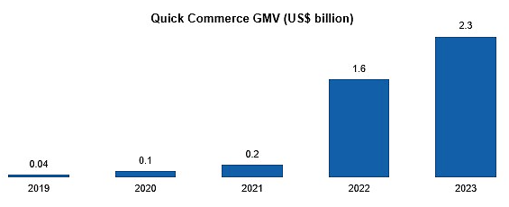
- CONCLUSION:
Quick commerce which started as a grocery delivery business — has expanded fast in several categories during the course of the year where platforms are carrying at least 10,000 items or stock keeping units (SKUs). During the festive season, they are bulking up further with an aim to hit 20,000-25,000 SKUs to be available for quick deliveries.
As per the industry experts over the last eight quarters, the selection available to customers had increased four-five times, while in some neighbourhoods it offers as many as 25,000 SKUs. Elara Capital said in a note that quick commerce may account for 40-50% of ecommerce (in some categories) over the next three years as per its checks from the current levels of 10-15% of the total ecommerce segment. According to a recent Nomura report, the quick-commerce space is expected to clock 100-110% year-on-year growth in gross order value during FY26, led by strong dark-store additions by the players. Notably, platforms such as Dunzo, Swiggy Instamart, and Blinkit have established 20-30 micro-fulfilment centres in major cities, facilitating 10–20-minute delivery services.

PART G | SWOT ANALYSIS

SWOT ANALYSIS
STRENGTHS | - Cold Storage Demand: With increasing demand for perishable goods (fruits, vegetables, dairy, etc.), the cold storage sector in India is expanding rapidly.  - Improved Supply Chain Efficiency: Cold storage helps reduce spoilage and wastage, leading to better supply chain management, which increases marketability of perishable products.  - Experienced Promoters: Promoters of the company are having rich experience in the same industry, which will give synergies to the expansion in the form of effective operations management.  - Government Incentives: The Indian government has fostered the growth of quick commerce (Q-commerce) through initiatives like "Digital India" to improve digital infrastructure, "Start-up India" to encourage new ventures, "Skill India" for workforce training, promoting digital payments through UPI and RuPay, enhancing broadband access with BharatNet, and creating the Open Network for Digital Commerce (ONDC) to integrate smaller vendors into the online marketplace, thereby enabling wider reach for Q-commerce platforms; all contributing to a favourable environment for the sector to flourish. The Indian government is offering incentives and subsidies for cold storage infrastructure development under various schemes like PM-KISAN and the National Mission on Food Processing.  - Location: CRPL has planned to open all the cold storage at fastest growing Indian cities such as Noida, Pune, and Ahmedabad, which will give a better connectivity and easy outreach for the clientele of its customers.  - Reimbursement Business Model: As per the Commercial agreement with Zepto, CRPL has entered into reimbursement model which will be a risk-free avenue of revenue generation for the proposed project.
WEAKNESSES | - High Initial Capital Investment: INR 78.38 Crore required for the initial setup of 5 new proposed Cold Storage Warehouse might strain CRPL Infra Pvt Limited’s capital, affecting short-term financial stability.  - Energy Costs: Cold storage units consume large amounts of energy, making operating costs high, especially with frequent power outages in some regions. Further, challenges like fluctuating energy prices can hit the profitability of CRPL.  - Long Payback Period: With an estimated payback period of 6-7 years for the proposed cold storage project, CRPL Infra Private Limited might face challenges in demonstrating short-term returns to stakeholders. However, payback period of CRPL on combined basis is 2-3 years including the financial projections of existing businesses of CRPL.
OPPORTUNITIES | - Growing Industry: According to recent reports, the Q-commerce industry in India is expected to grow at a Compound Annual Growth Rate (CAGR) of over 4.5%. This translates to a projected market size of around $9.95 billion by 2029, from its current valuation of approximately $3.34 billion.  - Expansion of E-commerce & Retail: With the rise of e-commerce and organized retail, there is an increased demand for cold storage to support online grocery and frozen food delivery.  - Large Agricultural Base: India’s vast agricultural base provides a consistent supply of perishable products, offering huge potential for the cold storage industry.  - Regulatory Support: Government support in the form of Digitalization and infrastructure.  - Export Potential: India’s cold storage industry supports exports of perishable goods, such as fruits, vegetables, and seafood, by ensuring quality preservation and compliance with international standards.  - Expansion Potential: The quick-commerce space is expected to clock 100-110% year-on-year growth in gross order value during FY 2026, led by strong dark-store additions by the players. This gives huge scope for players like CRPL to tap the opportunity and develop multiple Cold Storage/Warehouse solution on Built-to-suit (BTS) model to players like Zepto, Blinkit, Swiggy Instamart, BB etc.
THREATS | - Market Competition: Increased competition from other players with the options of different business models might affect the market share and bargaining power of CRPL Infra Pvt Limited with its potential Q-commerce clients.  - High Maintenance Costs: Maintaining cold storage units requires regular upkeep of refrigeration equipment, which can be costly over time.  - Economic Fluctuations: Economic downturns could affect investment availability and delay project implementation or expansion plans.  - Climate Change & Temperature Variability: Climate-related challenges, such as rising temperatures, can strain the capacity of cold storage facilities to maintain optimal storage conditions.

PART H | PROJECT COST AND MEANS OF FINANCE
As per data/information shared by the client, the proposed 5 cold storages/warehouses are proposed to be commissioned by making an investment of INR 78.38 Crore as shown in the below location wise tables along with Means of finance:
NOIDA LOCATION:
Total Project Cost
Particular | Amount INR Crore
Land Acquisition Cost | 0.00
Land Development Cost | 0.00
Building & Civil Works | 1.77
Plant & Machinery | 11.75
Misc. Fix Assets | 0.00
GST on Capital Goods | 2.12
Security Deposit to landlord | 0.85
Interest During Construction (IDC) | 0.83
Sub Total | 17.31
Preliminary and Pre-Operative Expenses | 0.94
Contingencies | 0.14
Sub Total | 18.39
Working Capital Margins | 0.23
Sub Total | 18.62
Means of Finance
Particular | Amount INR Crore
Equity (25%) | 4.65
Debt (75%) | 13.96
Sub Total | 18.62
Source: Data/Information provided by the company.
PUNE LOCATION:
Total Project Cost
Particular | Amount INR Crore
Land Acquisition Cost | 0.00
Land Development Cost | 0.00
Building & Civil Works | 1.00
Plant & Machinery | 7.65
Misc. Fix Assets | 0.00
GST on Capital Goods | 1.38
Security Deposit to landlord | 0.38
Interest During Construction (IDC) | 0.50
Sub Total | 10.91
Preliminary and Pre-Operative Expenses | 0.05
Contingencies | 0.09
Sub Total | 11.05
Working Capital Margins | 0.10
Sub Total | 11.15
Means of Finance
Particular | Amount INR Crore
Equity (25%) | 2.79
Debt (75%) | 8.36
Sub Total | 11.15
Source: Data/Information provided by the company.
AHMEDABAD (KHEDA) LOCATION:
Total Project Cost
Particular | Amount INR Crore
Land Acquisition Cost | 0.00
Land Development Cost | 0.00
Building & Civil Works | 1.00
Plant & Machinery | 7.65
Misc. Fix Assets | 0.00
GST on Capital Goods | 1.38
Security Deposit to landlord | 0.38
Interest During Construction (IDC) | 0.50
Sub Total | 10.91
Preliminary and Pre-Operative Expenses | 0.05
Contingencies | 0.09
Sub Total | 10.05
Working Capital Margins | 0.10
Sub Total | 11.15
Means of Finance
Particular | Amount INR Crore
Equity (25%) | 2.79
Debt (75%) | 8.36
Sub Total | 11.15
Source: Data/Information provided by the company.
AHMEDABAD (DETROJ) LOCATION:
Total Project Cost
Particular | Amount INR Crore
Land Acquisition Cost | 0.00
Land Development Cost | 0.00
Building & Civil Works | 1.77
Plant & Machinery | 13.25
Misc. Fix Assets | 0.00
GST on Capital Goods | 2.39
Security Deposit to landlord | 0.16
Interest During Construction (IDC) | 0.84
Sub Total | 18.40
Preliminary and Pre-Operative Expenses | 0.16
Contingencies | 0.15
Sub Total | 18.71
Working Capital Margins | 0.15
Sub Total | 18.86
Means of Finance
Particular | Amount INR Crore
Equity (25%) | 4.71
Debt (75%) | 14.14
Sub Total | 18.86
Source: Data/Information provided by the company.
BHIWANDI LOCATION:
Total Project Cost
Particular | Amount INR Crore
Land Acquisition Cost | 0.00
Land Development Cost | 0.00
Building & Civil Works | 1.77
Plant & Machinery | 11.75
Misc. Fix Assets | 0.00
GST on Capital Goods | 2.12
Security Deposit to landlord | 0.85
Interest During Construction (IDC) | 0.83
Sub Total | 17.31
Preliminary and Pre-Operative Expenses | 0.94
Contingencies | 0.14
Sub Total | 18.39
Working Capital Margins | 0.23
Sub Total | 18.62
Means of Finance
Particular | Amount INR Crore
Equity (25%) | 4.65
Debt (75%) | 13.96
Sub Total | 18.62
Source: Data/Information provided by the company.
Notes:
- It is to be noted that the detailed vetting of the project cost is out of scope of this TEV report and we have relied upon the data/information provided by the client regarding Total Project cost in good faith, however as a TEV consultant we have cross verified the cost of the major components of TPC independently wherever required for the purpose of TEV only.
- As per the shared LOI, CRPL has leased out 68,000 Sq. Ft. industrial ready to use tin shed premises at Dhoom, Manikpur U.P, 27,800 Sq. Ft. industrial/warehouse premises at Pune, 26,132 Sq. Ft. at Kheda (Ahmedabad) and 35,000 Sq. Ft. at Detroj (Ahmedabad).
As per the data/information provided by the client, M/s CRPL is in the process to acquire an industrial premises of 68,000 Sq. Ft. on lease basis at Bhiwandi, Maharashtra location as this cold storage project is under evaluation stage and scope & scale of this cold storage are supposed to be similar to Noida cold storage project. Hence, cost of land & land development and building will be Nil for the proposed project.
- As per data/information provided by the client, Cost of civil works would be ~7.31 Crore for all the 5 cold storages on combined basis including 18% applicable G.S.T.
Thus, the cost of civil works would be ~7.31 Crore for all the 5 cold storages on combined basis including 18% applicable G.S.T. Accordingly, INR 324.99 per Sq. Ft. is the civil cost of the proposed cold storage project of CRPL on combined basis for 2,24,932 Sq. Ft. combined area, considering the fact that these customized cold stores are proposed to be setup for Q-commerce players as per their requirement.
As a TEV consultant, the estimated Civil works cost has been verified independently by us, which we have found reasonable & in the permissible range while it may change as per specifications & material brand.
- As per the detailed cost estimates based on quotations of various vendors shared by client, Cost of proposed Plant & Machinery would be ~61.44 Cr. for all the 5 cold storages on combined basis including 18% applicable G.S.T and transportation charges.
The estimated cost of the Plant & Machinery has been provided to us by the client as per quotations received by them from various vendors/suppliers. However, as a TEV consultant, the cost of major plant & machinery has been verified by us independently, which we found reasonable & in the permissible range although the cost may change as per specifications & brand. It is to be noted here that the cost verification done by us is just a general assessment for TEV purpose and detailed cost vetting is out of scope of this TEV report.
- As per the data/information provided by the client, applicable Interest during Construction (IDC) is 9.50%. Thus, the company is required to pay INR 3.50 Crore as IDC from January 2025 to January 2026 as per the location wise proposed Loan repayment schedule.
- Preliminary & Pre-Operative Expenses has been considered based on the estimate of company’s resources involvement as INR 2.14 Crore. However, Company did not provide us any invoices/bills against these tentative costs considered. We recommend that the bank/financial institutions advice the company to submit actual cost based on the final quotations/invoices/bills. This will help validate the assertion of different costs considered by the client.
- Contingency cost of INR 0.61 Crore has been considered based on general assumption and professional experience (~1% of Hard Cost of the Project).
- Out of total project cost of INR 78.38 Cr., the project is proposed to be funded through a term loan of INR 58.78 crores and promoter’s Equity of INR 19.59 crores.
- Thus, ~INR 3484.61 per Sq. Ft. is the expected CAPEX for the proposed 2,24,932 Sq. Ft. (combined) cold storage project of CRPL.
PART I | PROJECT IMPLEMENTETION SCHEDULE

Below tables represents the location wise proposed implementation schedule:
NOIDA LOCATION
S. No. | Particulars | Activity | Expected completion date | Status
 | Land | Land Procurement | NA | NA
 |  | Land Development | NA | NA
 | Sanction of Rupee Term Loan | Sanction of Rupee Term Loan | 1st March 2025 | Scheduled
 | Building & Civil Works | Appointment of Architect | NA | NA
 |  | Building/Layout Plan Preparation | NA | NA
 |  | Building Plan Sanction | NA | NA
 |  | Appointment of Civil contractor/ developer | NA | NA
 |  | Building & Civil Works completion | May 2025 | Scheduled
 | Plant & Machinery | Finalization of P&M suppliers | Jan 2025 | Completed
 |  | Orders to P&M suppliers | March 2025 | Scheduled
 |  | Arrival of P&M | May 2025 | Scheduled
 |  | Installation of P&M | August 2025 | Scheduled
 |  | Utility Installation | October 2026 | Scheduled
 | Statutory Approvals, registrations & NOCs | From the respective authorities | November, 2025 | Pending except the approval obtained as per “Section L”
 | Finishing & Trail Run | Informed by client | November, 2025 | Scheduled
 | Commercial Operation Date | Informed by client | 1st December 2025 | Scheduled

PUNE LOCATION
S. No. | Particulars | Activity | Expected completion date | Status
 | Land | Land Procurement | NA | NA
 |  | Land Development | NA | NA
 | Sanction of Rupee Term Loan | Sanction of Rupee Term Loan | January 2025 | Scheduled
 | Building & Civil Works | Appointment of Architect | NA | NA
 |  | Building/Layout Plan Preparation | NA | NA
 |  | Building Plan Sanction | NA | NA
 |  | Appointment of Civil contractor/ developer | NA | NA
 |  | Building & Civil Works completion | March 2025 | Scheduled
 | Plant & Machinery | Finalization of P&M suppliers | January 2025 | Completed
 |  | Orders to P&M suppliers | Feb 2025 | Scheduled
 |  | Arrival of P&M | April 2025 | Scheduled
 |  | Installation of P&M | July 2025 | Scheduled
 |  | Utility Installation | September 2025 | Scheduled
 | Statutory Approvals, registrations & NOCs | From the respective authorities | September, 2025 | Pending except the approval obtained as per “Section L”
 | Finishing & Trail Run | Informed by client | September, 2025 | Scheduled
 | Commercial Operation Date | Informed by client | 1st October 2025 | Scheduled

AHMEDABAD (KHEDA) LOCATION
S. No. | Particulars | Activity | Expected completion date | Status
 | Land | Land Procurement | NA | NA
 |  | Land Development | NA | NA
 | Sanction of Rupee Term Loan | Sanction of Rupee Term Loan | February 2025 | Scheduled
 | Building & Civil Works | Appointment of Architect | NA | NA
 |  | Building/Layout Plan Preparation | NA | NA
 |  | Building Plan Sanction | NA | NA
 |  | Appointment of Civil contractor/ developer | NA | NA
 |  | Building & Civil Works completion | April 2025 | Scheduled
 | Plant & Machinery | Finalization of P&M suppliers | February 2025 | Completed
 |  | Orders to P&M suppliers | March 2025 | Scheduled
 |  | Arrival of P&M | May 2025 | Scheduled
 |  | Installation of P&M | August 2025 | Scheduled
 |  | Utility Installation | October 2025 | Scheduled
 | Statutory Approvals, registrations & NOCs | From the respective authorities | October, 2025 | Pending except the approval obtained as per “Section L”
 | Finishing & Trail Run | Informed by client | October, 2025 | Scheduled
 | Commercial Operation Date | Informed by client | 1st November 2025 | Scheduled

AHMEDABAD (DETROJ) LOCATION
S. No. | Particulars | Activity | Expected completion date | Status
 | Land | Land Procurement | NA | NA
 |  | Land Development | NA | NA
 | Sanction of Rupee Term Loan | Sanction of Rupee Term Loan | April 2025 | Scheduled
 | Building & Civil Works | Appointment of Architect | NA | NA
 |  | Building/Layout Plan Preparation | NA | NA
 |  | Building Plan Sanction | NA | NA
 |  | Appointment of Civil contractor/ developer | NA | NA
 |  | Building & Civil Works completion | June 2025 | Scheduled
 | Plant & Machinery | Finalization of P&M suppliers | April 2025 | Completed
 |  | Orders to P&M suppliers | May 2025 | Scheduled
 |  | Arrival of P&M | July 2025 | Scheduled
 |  | Installation of P&M | October 2025 | Scheduled
 |  | Utility Installation | December 2025 | Scheduled
 | Statutory Approvals, registrations & NOCs | From the respective authorities | December, 2025 | Pending except the approval obtained as per “Section L”
 | Finishing & Trail Run | Informed by client | December, 2025 | Scheduled
 | Commercial Operation Date | Informed by client | 1st January 2026 | Scheduled

BHIWANDI, MAHARASHTRA LOCATION
S. No. | Particulars | Activity | Expected completion date | Status
 | Land | Land Procurement | NA | NA
 |  | Land Development | NA | NA
 | Sanction of Rupee Term Loan | Sanction of Rupee Term Loan | 1st March 2025 | Scheduled
 | Building & Civil Works | Appointment of Architect | NA | NA
 |  | Building/Layout Plan Preparation | NA | NA
 |  | Building Plan Sanction | NA | NA
 |  | Appointment of Civil contractor/ developer | NA | NA
 |  | Building & Civil Works completion | May 2025 | Scheduled
 | Plant & Machinery | Finalization of P&M suppliers | Jan 2025 | Completed
 |  | Orders to P&M suppliers | March 2025 | Scheduled
 |  | Arrival of P&M | May 2025 | Scheduled
 |  | Installation of P&M | August 2025 | Scheduled
 |  | Utility Installation | October 2026 | Scheduled
 | Statutory Approvals, registrations & NOCs | From the respective authorities | November, 2025 | Pending except the approval obtained as per “Section L”
 | Finishing & Trail Run | Informed by client | November, 2025 | Scheduled
 | Commercial Operation Date | Informed by client | 1st December 2025 | Scheduled

Notes:
- Schedule has been made as per feasibility to achieve different milestones.
- Achievement of Milestone will depend on sanction of term loan as per proposed timeline.
- For current status of statutory approvals, kindly refer the “Section L” of this report.

PART J | STATUTORY APPROVALS | LICENCES | NOC

As shown in the below table along with current status, following major approvals are required, However the list is not exhaustive and State/District Authorities may be approached for further clearances required (if any):
NOIDA LOCATION
S. No. | REQUIRED APPROVALS | DATE  REFERENCE NO. | STATUS  (Approved/ Applied For/ Pending)
 | Consent to Establish (CTE) under air & water Act  Uttar Pradesh Pollution Control Board (UPPCB) | - | Pending
 | Land conversion to Industrial/Non agriculture  Sub Divisional Magistrate, Noida, UP. | - | Done
 | FSSAI License  The Food Safety and Standards Authority of India (FSSAI) | - | Pending
 | Electricity Regulatory Compliance  Uttar Pradesh Power Corporation Limited | - | Pending
 | Building and civil works Plan Sanction Approval  Concerned local development authority | - | Pending
 | Pre-establishment fire NOC  Uttar Pradesh Fire and Emergency Services, Government of Uttar Pradesh | - | Apply in due course
 | Fire NOC (on completion)  Uttar Pradesh Fire and Emergency Services, Government of Uttar Pradesh | - | Will be Applied post C. O. D

PUNE LOCATION
S. No. | REQUIRED APPROVALS | DATE  REFERENCE NO. | STATUS  (Approved/ Applied For/ Pending)
 | Consent to Establish (CTE) under air & water Act  Maharashtra Pollution Control Board (MPCB) | - | Pending
 | Land conversion to Industrial/Non agriculture  Sub Divisional Magistrate, Pune, Maharastra. | - | Done
 | FSSAI License  The Food Safety and Standards Authority of India (FSSAI) | - | Pending
 | Electricity Regulatory Compliance  Maharashtra State Electricity Distribution Company Limited (MSEDCL) | - | Pending
 | Building and civil works Plan Sanction Approval  Concerned local development authority | - | Pending
 | Pre-establishment fire NOC  The fire department of the Pune Municipal Corporation (PMC) | - | Apply in due course
 | Fire NOC (on completion)  The fire department of the Pune Municipal Corporation (PMC) | - | Will be Applied post C.O. D

AHMEDABAD (KHEDA) LOCATION
S. No. | REQUIRED APPROVALS | DATE  REFERENCE NO. | STATUS  (Approved/ Applied For/ Pending)
 | Consent to Establish (CTE) under air & water Act  Gujrat Pollution Control Board (GPCB) | - | Pending
 | Land conversion to Industrial/Non agriculture  Sub Divisional Magistrate, Ahmedabad, Gujrat. | - | Done
 | FSSAI License  The Food Safety and Standards Authority of India (FSSAI) | - | Pending
 | Electricity Connection  Gujarat Electricity Regulatory Commission (GERC) | NA | Pending
 | Building and civil works Plan Sanction Approval  Concerned local development authority | - | Pending
 | Pre-establishment fire NOC  The Fire and Emergency Services (FES) department of the Ahmedabad Municipal Corporation (AMC) | - | Apply in due course
 | Fire NOC (on completion)  The Fire and Emergency Services (FES) department of the Ahmedabad Municipal Corporation (AMC) | - | Will be Applied post C.O. D
AHMEDABAD (DETROJ) LOCATION
S. No. | REQUIRED APPROVALS | DATE  REFERENCE NO. | STATUS  (Approved/ Applied For/ Pending)
 | Consent to Establish (CTE) under air & water Act  Gujrat Pollution Control Board (GPCB) | - | Pending
 | Land conversion to Industrial/Non agriculture  Sub Divisional Magistrate, Ahmedabad, Gujrat. | NA | Done
 | FSSAI License  The Food Safety and Standards Authority of India (FSSAI) | - | Pending
 | Gujarat Electricity Regulatory Commission (GERC) | NA | Pending
 | Building and civil works Plan Sanction Approval  Concerned local development authority | - | Pending
 | Pre-establishment fire NOC  The Fire and Emergency Services (FES) department of the Ahmedabad Municipal Corporation (AMC) | - | Apply in due course
 | Fire NOC (on completion)  The Fire and Emergency Services (FES) department of the Ahmedabad Municipal Corporation (AMC) | - | Will be Applied post C.O. D

BHIWANDI, MAHARASHTRA LOCATION
S. No. | REQUIRED APPROVALS | DATE  REFERENCE NO. | STATUS  (Approved/ Applied For/ Pending)
 | Consent to Establish (CTE) under air & water Act  Maharashtra Pollution Control Board (MPCB) | - | Pending
 | Land conversion to Industrial/Non agriculture  Sub Divisional Magistrate, Bhiwandi,Maharastra. | - | Done
 | FSSAI License  The Food Safety and Standards Authority of India (FSSAI) | - | Pending
 | Electricity Regulatory Compliance  Maharashtra State Electricity Distribution Company Limited (MSEDCL) | - | Pending
 | Building and civil works Plan Sanction Approval  Concerned local development authority | - | Pending
 | Pre-establishment fire NOC  The fire department of the Bhiwandi Municipal Corporation (PMC) | - | Apply in due course
 | Fire NOC (on completion)  The fire department of the Bhiwandi Municipal Corporation (PMC) | - | Will be Applied post C.O. D

Observation Note:
- As per the data/information provided by client, CRPL will apply for Consent to establish to the respective Pollution control board authorities.
- As per the LOI with property owners shared by client, CRPL has taken Industrial premises at Dhoom, Manikpur, (U.P.), Pune, Kheda & Detroj (Ahmedabad) for developing cold storage/warehouses as a part of expansion. Hence Company does not require to apply for any CLU.
- Bhiwandi cold storage is under evaluation stages and thus company will require to obtain all the statutory approval as tabulated above.
- As per the data/information provided by the client, FSSAI certificates will be obtained by the clients of CRPL (Zepto & Falcon) on or before C.O.D. as it is out of scope of M/s CRPL.
- As per the LOI with property owners shared by client, Electricity connections with electric supply point will be provided by respective property owners as per the scope of work mentioned. Accordingly, power supply of 400Kva at Dhoom Manikpur, (UP), 300Kva at Pune, 300Kva at Kheda (Ahmedabad), 500Kva at Detroj (Ahmedabad) will be available for proposed cold storage/warehouses and CRPL does not required to apply for new electricity connections.
- CRPL is in the process to apply for Pre-establishment fire NOC and Fire NOC (on completion) will be applied post C.O.D by the company to the respective Fire department authorities.
- Above is the only illustration of the major approvals sought or to be sought by the company. It should not be construed as the exhaustive list and in case any approval is missed to be mentioned then it is the sole responsibility of the company to keep the unit compliant with the necessary statutory approvals/ NOCs.

PART K | PROJECT’S FINANCIAL FEASIBILITY

- PROJECTIONS OF THE PROJECT:
The financial projections of the proposed Cold Store project are prepared from FY 2025 to FY 2035 based on the expected COD and loan tenure as per the best practice in industry to assess the financial feasibility of the project:
LOCATION 1: NOIDA COLD STORE
- PROJECTED PROFIT & LOSS ACCOUNT:
(INR Crore)
Year Ending | 31-Mar-26 | 31-Mar-27 | 31-Mar-28 | 31-Mar-29 | 31-Mar-30 | 31-Mar-31 | 31-Mar-32 | 31-Mar-33 | 31-Mar-34 | 31-Mar-35
Year Counter | 1 | 2 | 3 | 4 | 5 | 6 | 7 | 8 | 9 | 10
Months Counter | 4 | 12 | 12 | 12 | 12 | 12 | 12 | 12 | 12 | 12
Revenue
Revenue | 3.72 | 11.43 | 11.90 | 12.41 | 12.96 | 13.54 | 14.15 | 14.81 | 15.52 | 16.27
Cost of Sales
Rental Expenses | 0.68 | 2.14 | 2.25 | 2.36 | 2.48 | 2.60 | 2.73 | 2.87 | 3.01 | 3.16
Cost of Manpower Supply | 1.02 | 3.29 | 3.54 | 3.80 | 4.09 | 4.39 | 4.72 | 5.08 | 5.46 | 5.87
Repair & Maintenance | 0.00 | 0.00 | 0.20 | 0.21 | 0.22 | 0.23 | 0.25 | 0.26 | 0.27 | 0.29
Electricity Expenses | 0.40 | 1.25 | 1.30 | 1.35 | 1.41 | 1.46 | 1.53 | 1.59 | 1.66 | 1.73
Selling, General & Administrative Expenses | 0.06 | 0.17 | 0.18 | 0.19 | 0.19 | 0.20 | 0.21 | 0.22 | 0.23 | 0.24
Operating Expenses | 2.15 | 6.85 | 7.46 | 7.91 | 8.39 | 8.90 | 9.44 | 10.02 | 10.64 | 11.29
EBITDA | 1.57 | 4.58 | 4.44 | 4.50 | 4.57 | 4.64 | 4.71 | 4.79 | 4.88 | 4.98
Depreciation | 0.30 | 0.91 | 0.91 | 0.91 | 0.91 | 0.91 | 0.91 | 0.91 | 0.91 | 0.91
EBIT | 1.26 | 3.66 | 3.53 | 3.59 | 3.65 | 3.72 | 3.80 | 3.88 | 3.97 | 4.06
Interest expenses
Interest on term loan | 0.44 | 1.23 | 1.06 | 0.89 | 0.71 | 0.51 | 0.32 | 0.10 | 0.00 | 0.00
Interest on working capital | 0.05 | 0.05 | 0.05 | 0.05 | 0.05 | 0.05 | 0.05 | 0.05 | 0.05 | 0.05
Total Interest Expenses | 0.49 | 1.28 | 1.11 | 0.94 | 0.75 | 0.56 | 0.37 | 0.15 | 0.05 | 0.05
Profit before Taxes (PBT) | 0.77 | 2.39 | 2.42 | 2.65 | 2.90 | 3.16 | 3.43 | 3.73 | 3.92 | 4.02
Current Tax | 0.00 | 0.41 | 0.41 | 0.45 | 0.50 | 0.64 | 0.88 | 0.98 | 1.06 | 1.10
Deferred Tax | -0.48 | -0.25 | -0.18 | -0.12 | -0.07 | -0.02 | 0.01 | 0.04 | 0.07 | 0.09
Applicable taxes | 0.48 | 0.66 | 0.59 | 0.57 | 0.57 | 0.66 | 0.86 | 0.94 | 0.99 | 1.01
Profit after Taxes (PAT) | 0.29 | 1.73 | 1.82 | 2.08 | 2.33 | 2.50 | 2.57 | 2.79 | 2.94 | 3.01

- PROFORMA BALANCE SHEET:
Below table shows the Projected Balance Sheet of the proposed Noida location cold store project from the period FY 2025 to FY 2035. From 1st March 2025 to 30th November 2025 would be the implementation period of the project:
(INR Crore)
Year Ending | 31-Mar-25 | 30-Nov-25 | 31-Mar-26 | 31-Mar-27 | 31-Mar-28 | 31-Mar-29 | 31-Mar-30 | 31-Mar-31 | 31-Mar-32 | 31-Mar-33 | 31-Mar-34 | 31-Mar-35
Year Counter | 0 | 0 | 1 | 2 | 3 | 4 | 5 | 6 | 7 | 8 | 9 | 10
Months Counter | 1 | 8 | 4 | 12 | 12 | 12 | 12 | 12 | 12 | 12 | 12 | 12
Liabilities
Equity | 4.43 | 4.43 | 4.65 | 4.65 | 4.65 | 4.65 | 4.65 | 4.65 | 4.65 | 4.65 | 4.65 | 4.65
Reserve & Surplus |  |  | 0.29 | 2.02 | 3.85 | 5.93 | 8.26 | 10.76 | 13.33 | 16.13 | 19.06 | 22.07
Secured Loan | 3.49 | 13.82 | 12.07 | 10.33 | 8.44 | 6.42 | 4.39 | 2.30 | 0.00 | 0.00 | 0.00 | 0.00
Current Liabilities
Trade Payables |  |  | 0.01 | 0.02 | 0.05 | 0.05 | 0.05 | 0.05 | 0.06 | 0.06 | 0.06 | 0.07
Term Liabilities Payable Within One Year | 0.00 | 0.15 | 1.75 | 1.75 | 1.89 | 2.02 | 2.02 | 2.09 | 2.30 | 0.00 | 0.00 | 0.00
Cc Limit |  |  | 0.50 | 0.50 | 0.50 | 0.50 | 0.50 | 0.50 | 0.50 | 0.50 | 0.50 | 0.50
Total | 7.92 | 18.39 | 19.27 | 19.27 | 19.38 | 19.57 | 19.88 | 20.36 | 20.84 | 21.34 | 24.28 | 27.29
Gross Assets
Land Acquisition Cost | 0.00 | 0.00 | 0.00 | 0.00 | 0.00 | 0.00 | 0.00 | 0.00 | 0.00 | 0.00 | 0.00 | 0.00
Land Development Cost | 0.00 | 0.00 | 0.00 | 0.00 | 0.00 | 0.00 | 0.00 | 0.00 | 0.00 | 0.00 | 0.00 | 0.00
Civil Work / Construction | 2.02 | 2.02 | 2.02 | 2.02 | 2.02 | 2.02 | 2.02 | 2.02 | 2.02 | 2.02 | 2.02 | 2.02
Plant & Machinery | 5.05 | 13.41 | 13.41 | 13.41 | 13.41 | 13.41 | 13.41 | 13.41 | 13.41 | 13.41 | 13.41 | 13.41
Misc. Fix Assets | 0.00 | 0.00 | 0.00 | 0.00 | 0.00 | 0.00 | 0.00 | 0.00 | 0.00 | 0.00 | 0.00 | 0.00
Total Gross Block | 7.07 | 15.42 | 15.42 | 15.42 | 15.42 | 15.42 | 15.42 | 15.42 | 15.42 | 15.42 | 15.42 | 15.42
Depreciation |  |  | 0.30 | 1.22 | 2.13 | 3.04 | 3.95 | 4.87 | 5.78 | 6.69 | 7.60 | 8.52
Net Block | 7.07 | 15.42 | 15.12 | 14.21 | 13.30 | 12.38 | 11.47 | 10.56 | 9.64 | 8.73 | 7.82 | 6.91
Differed Tax Asset | 0.00 | 0.00 | -0.48 | -0.73 | -0.90 | -1.02 | -1.09 | -1.11 | -1.10 | -1.06 | -0.99 | -0.90
Balance With Gov. Authorities | 0.00 | 2.12 | 1.83 | 1.01 | 0.21 | 0.00 | 0.00 | 0.00 | 0.00 | 0.00 | 0.00 | 0.00
Mat Credit Entitlement |  |  | 0.00 | 0.41 | 0.39 | 0.30 | 0.13 | 0.00 | 0.00 | 0.00 | 0.00 | 0.00
Security Deposit to Landlord | 0.85 | 0.85 | 0.85 | 0.85 | 0.85 | 0.85 | 0.85 | 0.85 | 0.85 | 0.85 | 0.85 | 0.85
Current Assets
Trade Receivables |  |  | 0.31 | 0.94 | 0.98 | 1.02 | 1.06 | 1.11 | 1.16 | 1.22 | 1.28 | 1.34
Cash & Bank | 0.00 | 0.00 | 1.64 | 2.58 | 4.56 | 6.04 | 7.45 | 8.96 | 10.29 | 11.60 | 15.32 | 19.09
Preliminary Expenses W/Off |  | 0.00 | 0.00 | 0.00 | 0.00 | 0.00 | 0.00 | 0.00 | 0.00 | 0.00 | 0.00 | 0.00
Total | 7.92 | 18.39 | 19.27 | 19.27 | 19.38 | 19.57 | 19.88 | 20.36 | 20.84 | 21.34 | 24.28 | 27.29

- PROJECTED CASH FLOW STATEMENT:
(INR Crore)
Year Ending | 31-Mar-25 | 30-Nov-25 | 31-Mar-26 | 31-Mar-27 | 31-Mar-28 | 31-Mar-29 | 31-Mar-30 | 31-Mar-31 | 31-Mar-32 | 31-Mar-33 | 31-Mar-34 | 31-Mar-35
Year Counter | 0 | 0 | 1 | 2 | 3 | 4 | 5 | 6 | 7 | 8 | 9 | 10
Months Counter | 1 | 8 | 4 | 12 | 12 | 12 | 12 | 12 | 12 | 12 | 12 | 12
Cash Flow from Operating Activities
Profit before Tax | 0.00 | 0.00 | 0.77 | 2.39 | 2.42 | 2.65 | 2.90 | 3.16 | 3.43 | 3.73 | 3.92 | 4.02
Add: Non-Cash Expenses/ Non-Operating Expenses/ (Non-Operating Income) | 0.00 | 0.00 | 0.30 | 0.91 | 0.91 | 0.91 | 0.91 | 0.91 | 0.91 | 0.91 | 0.91 | 0.91
Add: Interest Expense | 0.00 | 0.00 | 0.49 | 1.28 | 1.11 | 0.94 | 0.75 | 0.56 | 0.37 | 0.15 | 0.05 | 0.05
Increase in Sundry Debtors | 0.00 | 0.00 | -0.31 | -0.63 | -0.04 | -0.04 | -0.04 | -0.05 | -0.05 | -0.05 | -0.06 | -0.06
NET GST ASSET | 0.00 | -2.12 | 0.28 | 0.82 | 0.80 | 0.81 | 0.82 | 0.83 | 0.85 | 0.86 | 0.88 | 0.90
Change in MAT | 0.00 | 0.00 | 0.00 | -0.41 | 0.02 | 0.09 | 0.16 | 0.13 | 0.00 | 0.00 | 0.00 | 0.00
Increase in Sundry Creditors | 0.00 | 0.00 | 0.01 | 0.01 | 0.03 | 0.00 | 0.00 | 0.00 | 0.00 | 0.00 | 0.00 | 0.00
Cash Generated from Operations | 0.00 | -2.12 | 1.55 | 4.37 | 5.24 | 5.37 | 5.51 | 5.56 | 5.51 | 5.61 | 5.71 | 5.81
GST Paid | 0.00 | 0.00 | 0.00 | 0.00 | 0.00 | 0.60 | 0.82 | 0.83 | 0.85 | 0.86 | 0.88 | 0.90
Income Taxes paid | 0.00 | 0.00 | 0.00 | 0.41 | 0.41 | 0.45 | 0.50 | 0.64 | 0.88 | 0.98 | 1.06 | 1.10
Net Cash from Operating Activities | 0.00 | -2.12 | 1.55 | 3.96 | 4.83 | 4.31 | 4.19 | 4.09 | 3.79 | 3.76 | 3.77 | 3.81
Cash Flow from Investing Activities
Purchase of Fixed Assets | -7.07 | -8.36 | 0.00 | 0.00 | 0.00 | 0.00 | 0.00 | 0.00 | 0.00 | 0.00 | 0.00 | 0.00
Security Deposit | -0.85 | 0.00 | 0.00 | 0.00 | 0.00 | 0.00 | 0.00 | 0.00 | 0.00 | 0.00 | 0.00 | 0.00
Net Cash from Investing Activities | -7.92 | -8.36 | 0.00 | 0.00 | 0.00 | 0.00 | 0.00 | 0.00 | 0.00 | 0.00 | 0.00 | 0.00
Cash Flow from Financing Activities
Increase in Equity / Share Capital/USL | 4.43 | 0.00 | 0.23 | 0.00 | 0.00 | 0.00 | 0.00 | 0.00 | 0.00 | 0.00 | 0.00 | 0.00
Increase in TL | 3.49 | 10.47 | -0.15 | -1.75 | -1.75 | -1.89 | -2.02 | -2.02 | -2.09 | -2.30 | 0.00 | 0.00
Increase in CC Limit | 0.00 | 0.00 | 0.50 | 0.00 | 0.00 | 0.00 | 0.00 | 0.00 | 0.00 | 0.00 | 0.00 | 0.00
Interest Paid | 0.00 | 0.00 | -0.49 | -1.28 | -1.11 | -0.94 | -0.75 | -0.56 | -0.37 | -0.15 | -0.05 | -0.05
Net Cash from Financing Activities | 7.92 | 10.47 | 0.09 | -3.02 | -2.86 | -2.82 | -2.78 | -2.59 | -2.46 | -2.45 | -0.05 | -0.05
Net increase in cash and cash equivalents | 0.00 | 0.00 | 1.64 | 0.94 | 1.97 | 1.49 | 1.41 | 1.50 | 1.33 | 1.31 | 3.72 | 3.77
Cash and cash equivalents at beginning | 0.00 | 0.00 | 0.00 | 1.64 | 2.58 | 4.56 | 6.04 | 7.45 | 8.96 | 10.29 | 11.60 | 15.32
Cash and cash equivalents | 0.00 | 0.00 | 1.64 | 2.58 | 4.56 | 6.04 | 7.45 | 8.96 | 10.29 | 11.60 | 15.32 | 19.09

- KEY FINANCIAL RATIO:
Year Ending | 31-Mar-26 | 31-Mar-27 | 31-Mar-28 | 31-Mar-29 | 31-Mar-30 | 31-Mar-31 | 31-Mar-32 | 31-Mar-33 | 31-Mar-34 | 31-Mar-35
Year Counter | 1 | 2 | 3 | 4 | 5 | 6 | 7 | 8 | 9 | 10
Months Counter | 4 | 12 | 12 | 12 | 12 | 12 | 12 | 12 | 12 | 12
EBITDA Margin % | 42.10% | 40.06% | 37.30% | 36.26% | 35.24% | 34.26% | 33.29% | 32.36% | 31.46% | 30.59%
Average | 35.29%
EBIT Margin % | 33.93% | 32.08% | 29.64% | 28.91% | 28.20% | 27.51% | 26.85% | 26.20% | 25.58% | 24.98%
Average | 28.39%
PAT Margin % | 7.88% | 15.16% | 15.33% | 16.73% | 18.02% | 18.48% | 18.16% | 18.86% | 18.91% | 18.48%
Average | 16.60%
Revenue growth rate Y-o-Y (%) |  | 207.02% | 4.18% | 4.28% | 4.38% | 4.47% | 4.57% | 4.66% | 4.75% | 4.84%
Average | 27.02%
Note: The proposed Noida cold storage project is having an average revenue growth rate of 27.02% during the forecasted period. Average EBITDA Margin & EBIT Margin of the project are 35.29% & 28.43% respectively. The project will be operational from 1st December 2025 and as per the trends analysis above, PAT margin is growing from 7.88% in FY 2026 to 18.48% in FY 2035 due to the lower interest cost on borrowings in the later projected years.
- ESTIMATED KEY FINANCIAL METRICS: DEBT SERVICE COVERAGE RATIO (D.S.C.R)
(INR Crore except D.S.C.R)
Year Ending | 31-Mar-26 | 31-Mar-27 | 31-Mar-28 | 31-Mar-29 | 31-Mar-30 | 31-Mar-31 | 31-Mar-32 | 31-Mar-33 | 31-Mar-34 | 31-Mar-35
Year Counter | 1 | 2 | 3 | 4 | 5 | 6 | 7 | 8 | 9 | 10
Months Counter | 4 | 12 | 12 | 12 | 12 | 12 | 12 | 12 | 12 | 12
Cash accrual | 1.08 | 2.89 | 2.91 | 3.11 | 3.32 | 3.44 | 3.47 | 3.66 | 3.78 | 3.83
Interest on term loan | 0.44 | 1.23 | 1.06 | 0.89 | 0.71 | 0.51 | 0.32 | 0.10 | 0.00 | 0.00
Interest on WC | 0.05 | 0.05 | 0.05 | 0.05 | 0.05 | 0.05 | 0.05 | 0.05 | 0.05 | 0.05
Subtotal | 1.57 | 4.17 | 4.03 | 4.05 | 4.07 | 4.00 | 3.84 | 3.81 | 3.83 | 3.87
Interest on term loan | 0.44 | 1.23 | 1.06 | 0.89 | 0.71 | 0.51 | 0.32 | 0.10 | 0.00 | 0.00
Interest on WC | 0.05 | 0.05 | 0.05 | 0.05 | 0.05 | 0.05 | 0.05 | 0.05 | 0.05 | 0.05
Loan Repayment | 0.15 | 1.75 | 1.75 | 1.89 | 2.02 | 2.02 | 2.09 | 2.30 | 0.00 | 0.00
Subtotal | 0.63 | 3.02 | 2.86 | 2.82 | 2.78 | 2.59 | 2.46 | 2.45 | 0.05 | 0.05
DSCR | 2.47 | 1.38 | 1.41 | 1.43 | 1.46 | 1.55 | 1.56 | 1.56
Average DSCR | 1.60
Maximum DSCR | 2.47
Note: D.S.C.R has been calculated for loan repayment period from FY 2026 to FY 2033. The proposed Noida Cold storage project is having a D.S.C.R of more than 1 during the projected loan repayment period.
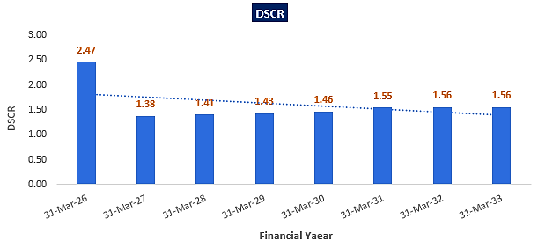
- NPV,IRR AND PAYBACK PERIOD OF THE PROJECT:
(INR Crore)
Year Ending | 31-Mar-25 | 30-Nov-25 | 31-Mar-26 | 31-Mar-27 | 31-Mar-28 | 31-Mar-29 | 31-Mar-30 | 31-Mar-31 | 31-Mar-32 | 31-Mar-33 | 31-Mar-34 | 31-Mar-35
Year Counter | 0 | 0 | 1 | 2 | 3 | 4 | 5 | 6 | 7 | 8 | 9 | 10
Months Counter | 1 | 8 | 4 | 12 | 12 | 12 | 12 | 12 | 12 | 12 | 12 | 12
EBIT | 0.00 | 0.00 | 1.26 | 3.66 | 3.53 | 3.59 | 3.65 | 3.72 | 3.80 | 3.88 | 3.97 | 4.06
Less: Taxes | 0.00 | 0.00 | 0.32 | 0.92 | 0.89 | 0.90 | 0.92 | 0.94 | 0.96 | 0.98 | 1.00 | 1.02
Add: Depreciation & Amortisation | 0.00 | 0.00 | 0.30 | 0.91 | 0.91 | 0.91 | 0.91 | 0.91 | 0.91 | 0.91 | 0.91 | 0.91
NOPAT | 0.00 | 0.00 | 1.25 | 3.65 | 3.55 | 3.60 | 3.65 | 3.70 | 3.76 | 3.82 | 3.88 | 3.95
Increase/(Decrease) in working capital | 0.00 | 0.00 | 0.30 | 0.62 | 0.01 | 0.04 | 0.04 | 0.05 | 0.05 | 0.05 | 0.05 | 0.06
Capex | 7.07 | 8.36 | 0.00 | 0.00 | 0.00 | 0.00 | 0.00 | 0.00 | 0.00 | 0.00 | 0.00 | 0.00
Free Cash Flow to Firm (FCFF) | -7.07 | -8.36 | 0.95 | 3.04 | 3.54 | 3.56 | 3.60 | 3.65 | 3.71 | 3.77 | 3.83 | 3.90
Discount Period | 0.08 | 0.75 | 1.08 | 2.08 | 3.08 | 4.08 | 5.08 | 6.08 | 7.08 | 8.08 | 9.08 | 10.08
Discount Factor | 0.99 | 0.93 | 0.90 | 0.81 | 0.74 | 0.67 | 0.60 | 0.55 | 0.50 | 0.45 | 0.41 | 0.37
PV of FCFF | -7.01 | -7.76 | 0.85 | 2.47 | 2.61 | 2.37 | 2.18 | 2.00 | 1.84 | 1.69 | 1.55 | 1.43
Terminal Value of the project |  |  |  |  |  |  |  |  |  |  |  | 39.40
PV of Terminal Value |  |  |  |  |  |  |  |  |  |  |  | 14.48
FCFF+TV | -7.07 | -8.36 | 0.95 | 3.04 | 3.54 | 3.56 | 3.60 | 3.65 | 3.71 | 3.77 | 3.83 | 43.29
PV of FCF+ PV of Terminal Value | -7.01 | -7.76 | 0.85 | 2.47 | 2.61 | 2.37 | 2.18 | 2.00 | 1.84 | 1.69 | 1.55 | 15.91
NPV | INR 18.54 Crore
IRR | 25.62%

Key Input for NPV & IRR
Weight of Debt Wd | 75%
Cost of Debt Kd | 9.50%
Tax | 25.17%
Post tax Kd | 7.11%
Weight of Equity We | 25%
Cost of Equity Ke | 12.42%
WACC | 8.44%
Project Risk Premium | 2.00%
Discount rate | 10.44%
Expected growth rate (Terminal) | 0.50%

Payback Period of the project
Year Ending | 31-Mar-26 | 31-Mar-27 | 31-Mar-28 | 31-Mar-29 | 31-Mar-30 | 31-Mar-31 | 31-Mar-32 | 31-Mar-33 | 31-Mar-34 | 31-Mar-35
Year Counter | 1 | 2 | 3 | 4 | 5 | 6 | 7 | 8 | 9 | 10
Months Counter | 4 | 12 | 12 | 12 | 12 | 12 | 12 | 12 | 12 | 12
No. Of Years | 1 | 2 | 3 | 4 | 5 | 6 | 7 | 8 | 9 | 10
Cash Accrual | 1.08 | 2.89 | 2.91 | 3.11 | 3.32 | 3.44 | 3.47 | 3.66 | 3.78 | 3.83
Accumulated Cash Accrual | 1.08 | 3.97 | 6.88 | 9.99 | 13.30 | 16.74 | 20.22 | 23.88 | 27.66 | 31.48
TPC | INR 18.39 Cr.
Payback Period | 6.47 Years
Thus, the Noida cold storage project will be having a payback period of 6.47 years and NPV & IRR of the project is INR 18.54 Crore & 25.62% respectively from C.O.D to loan repayment period, which indicates worthiness of the project.
- SENSITIVITY ANALYSIS:
Sensitivity analysis of the project with respect to various expected variables has been shown in the below table:
Sensitivity Analysis | Average DSCR | NPV | IRR | Payback Period
As a base case | 1.60 | INR 18.54 Crore | 25.62% | 6.47 years
If Sales is decreased by 5% | 1.41 | INR 13.73 Crore | 22.37% | 7.34 years
If sales is decreased by 10% | 1.22 | INR 8.92 Crore | 18.77% | 8.63 years
If operating expenses is increased by 5% | 1.49 | INR 15.28 Crore | 23.48% | 6.97 years
If operating expenses is increased by 10% | 1.36 | INR 12.09 Crore | 21.19% | 7.67 years
If interest rate increased by 1% | 1.54 | INR 16.54 Crore | 25.15% | 6.64 years
If Repairs & Maintenance Expenses increased by 1% | 1.57 | INR 17.53 Crore | 25.03% | 6.62 years
If Administrative Expenses increased by 1% | 1.56 | INR 17.58 Crore | 25.00% | 6.65 years
Observation: The proposed project is found comparatively higher sensitive with respect to the downside variation in the projected revenue, than the upside variation in the projected operational expenses and any surge in the interest rate.
- OTHER FINANCIAL RATIOS:
Year Ending | 31-Mar-26 | 31-Mar-27 | 31-Mar-28 | 31-Mar-29 | 31-Mar-30 | 31-Mar-31 | 31-Mar-32 | 31-Mar-33 | 31-Mar-34 | 31-Mar-35
Year Counter | 1 | 2 | 3 | 4 | 5 | 6 | 7 | 8 | 9 | 10
Months Counter | 4 | 12 | 12 | 12 | 12 | 12 | 12 | 12 | 12 | 12
Return on Capital employed (%) | 7.42% | 21.55% | 20.82% | 21.11% | 21.11% | 21.02% | 21.13% | 18.68% | 16.74% | 15.21%
Average | 18.48%
Return on Investment (%) | 1.59% | 10.35% | 12.18% | 15.86% | 21.09% | 27.65% | 36.97% | 60.04% | 63.06% | 64.58%
Average | 31.34%
Return on Net Worth | 5.92% | 25.92% | 21.46% | 19.63% | 18.08% | 16.23% | 14.29% | 13.45% | 12.38% | 11.25%
Average | 15.86%
DSCR | 2.47 | 1.38 | 1.41 | 1.43 | 1.46 | 1.55 | 1.56 | 1.56 | 0.00 | 0.00
Average | 1.60
ISCR | 3.20 | 3.58 | 3.99 | 4.79 | 6.06 | 8.27 | 12.90 | 32.54 | 102.78 | 104.78
Average | 28.29
Fixed Asset Coverage Ratio | 1.25 | 1.38 | 1.57 | 1.93 | 2.61 | 4.59
Average | 2.22
Current Ratio | 44.44 | 44.44 | 20.81 | 20.73 | 20.67 | 20.61 | 20.57 | 20.53 | 20.50 | 20.49
Average | 25.38
TOL/TNW | 2.90 | 1.89 | 1.28 | 0.85 | 0.54 | 0.32 | 0.16 | 0.03 | 0.02 | 0.02
Average | 0.80
Debt to Equity Ratio | 2.97 | 2.59 | 2.22 | 1.81 | 1.38 | 0.94 | 0.49 | 0.00 | 0.00 | 0.00
Average | 1.24

- BREAK-EVEN ANALYSIS:
Year Ending | 31-Mar-26 | 31-Mar-27 | 31-Mar-28 | 31-Mar-29 | 31-Mar-30 | 31-Mar-31 | 31-Mar-32 | 31-Mar-33 | 31-Mar-34 | 31-Mar-35
Year Counter | 1 | 2 | 3 | 4 | 5 | 6 | 7 | 8 | 9 | 10
Months Counter | 4 | 12 | 12 | 12 | 12 | 12 | 12 | 12 | 12 | 12
Sales | 3.72 | 11.43 | 11.90 | 12.41 | 12.96 | 13.54 | 14.15 | 14.81 | 15.52 | 16.27
Variable Expenses | 0.06 | 0.17 | 0.18 | 0.19 | 0.19 | 0.20 | 0.21 | 0.22 | 0.23 | 0.24
Contribution | 3.67 | 11.25 | 11.72 | 12.23 | 12.76 | 13.33 | 13.94 | 14.59 | 15.29 | 16.03
Fixed Expenses | 2.10 | 6.68 | 7.28 | 7.73 | 8.20 | 8.70 | 9.23 | 9.80 | 10.40 | 11.05
Profit / PBT | 1.57 | 4.58 | 4.44 | 4.50 | 4.57 | 4.64 | 4.71 | 4.79 | 4.88 | 4.98
PV RATIO (Contr. / Sales) | 98.50% | 98.50% | 98.50% | 98.50% | 98.50% | 98.50% | 98.50% | 98.50% | 98.50% | 98.50%
BEP Sales (Fix Exps. / Contr. * Sales) | 2.13 | 6.78 | 7.40 | 7.84 | 8.32 | 8.83 | 9.37 | 9.95 | 10.56 | 11.22
BEP% (BEP Sales / sales) | 57.26% | 59.33% | 62.13% | 63.19% | 64.22% | 65.22% | 66.20% | 67.14% | 68.06% | 68.94%

- TERM LOAN INPUTS:
Term Loan Repayment Inputs
Total loan amount | INR 13.96 Crore
Rate of Interest | 9.50%
1st Disbursement | March-25
IDC Start & End Month | March-25 to Nov-25
IDC Period (construction period) | 9 Month
Commencement /Operation Start | 1st December 2025
Moratorium Start & End Month (only interest to pay) | March 2025 to Feb 2026
Moratorium Period after COD | 03 Month
Repayment Start | March-2026
Repayment End | Feb-2033
Repayment Period | 07 Years

(INR Crore)
Year Ending | 31-Mar-25 | 30-Nov-25 | 31-Mar-26 | 31-Mar-27 | 31-Mar-28 | 31-Mar-29 | 31-Mar-30 | 31-Mar-31 | 31-Mar-32 | 31-Mar-33 | 31-Mar-34 | 31-Mar-35
Year Counter | 0 | 0 | 1 | 2 | 3 | 4 | 5 | 6 | 7 | 8 | 9 | 10
Months Counter | 1 | 8 | 4 | 12 | 12 | 12 | 12 | 12 | 12 | 12 | 12 | 12
Opening Bal | 0.00 | 3.49 | 13.96 | 13.82 | 12.07 | 10.33 | 8.44 | 6.42 | 4.39 | 2.30 | 0.00 | 0.00
Disbursement | 3.49 | 10.47 | 0.00 | 0.00 | 0.00 | 0.00 | 0.00 | 0.00 | 0.00 | 0.00 | 0.00 | 0.00
Repayment | 0.00 | 0.00 | 0.15 | 1.75 | 1.75 | 1.89 | 2.02 | 2.02 | 2.09 | 2.30 | 0.00 | 0.00
Closing Principal o/s | 3.49 | 13.96 | 13.82 | 12.07 | 10.33 | 8.44 | 6.42 | 4.39 | 2.30 | 0.00 | 0.00 | 0.00
Interest | 0.03 | 0.80 | 0.44 | 1.23 | 1.06 | 0.89 | 0.71 | 0.51 | 0.32 | 0.10 | 0.00 | 0.00
IDC | 0.03 | 0.80 | 0.00 | 0.00 | 0.00 | 0.00 | 0.00 | 0.00 | 0.00 | 0.00 | 0.00 | 0.00
TL Interest | 0.00 | 0.00 | 0.44 | 1.23 | 1.06 | 0.89 | 0.71 | 0.51 | 0.32 | 0.10 | 0.00 | 0.00

- DEPRECIATION SCHEDULE (STRAIGHT LINE METHOD):
(INR Crore)
Depreciation Schedule as per Company's Act, 2013
Particular | 31-Mar-26 | 31-Mar-27 | 31-Mar-28 | 31-Mar-29 | 31-Mar-30 | 31-Mar-31 | 31-Mar-32 | 31-Mar-33 | 31-Mar-34 | 31-Mar-35
Building & Civil Works | 2.02 | 2.02 | 2.02 | 2.02 | 2.02 | 2.02 | 2.02 | 2.02 | 2.02 | 2.02
Less: SLM Depreciation | 0.02 | 0.06 | 0.06 | 0.06 | 0.06 | 0.06 | 0.06 | 0.06 | 0.06 | 0.06
Carrying Value Building & Civil Works | 2.00 | 1.93 | 1.87 | 1.81 | 1.74 | 1.68 | 1.61 | 1.55 | 1.49 | 1.42
Plant & Machinery | 13.41 | 13.41 | 13.41 | 13.41 | 13.41 | 13.41 | 13.41 | 13.41 | 13.41 | 13.41
Less: SLM Depreciation | 0.28 | 0.85 | 0.85 | 0.85 | 0.85 | 0.85 | 0.85 | 0.85 | 0.85 | 0.85
Carrying Value of Plant & Machinery | 13.12 | 12.27 | 11.43 | 10.58 | 9.73 | 8.88 | 8.03 | 7.18 | 6.33 | 5.49
Misc. Fix Assets | 0.00 | 0.00 | 0.00 | 0.00 | 0.00 | 0.00 | 0.00 | 0.00 | 0.00 | 0.00
Less: SLM Depreciation | 0.00 | 0.00 | 0.00 | 0.00 | 0.00 | 0.00 | 0.00 | 0.00 | 0.00 | 0.00
Carrying Value of Misc. Fixed Asset | 0.00 | 0.00 | 0.00 | 0.00 | 0.00 | 0.00 | 0.00 | 0.00 | 0.00 | 0.00
Total SLM Depreciation | 0.30 | 0.91 | 0.91 | 0.91 | 0.91 | 0.91 | 0.91 | 0.91 | 0.91 | 0.91

- WORKING CAPITAL ASSESSMENT:
(INR Crore)
Year Ending | 31-Mar-26 | 31-Mar-27 | 31-Mar-28 | 31-Mar-29 | 31-Mar-30 | 31-Mar-31 | 31-Mar-32 | 31-Mar-33 | 31-Mar-34 | 31-Mar-35
Current Assets | 0.31 | 0.94 | 0.98 | 1.02 | 1.06 | 1.11 | 1.16 | 1.22 | 1.28 | 1.34
Current Liabilities | 0.01 | 0.02 | 0.05 | 0.05 | 0.05 | 0.05 | 0.06 | 0.06 | 0.06 | 0.07
Working Capital | 0.30 | 0.92 | 0.93 | 0.97 | 1.01 | 1.06 | 1.11 | 1.16 | 1.21 | 1.27
Working Capital Margin @25% | 0.07 | 0.23 | 0.23 | 0.24 | 0.25 | 0.26 | 0.28 | 0.29 | 0.30 | 0.32
Working Capital gap | 0.22 | 0.69 | 0.70 | 0.73 | 0.76 | 0.79 | 0.83 | 0.87 | 0.91 | 0.95
Working Capital Requirement | 0.50 | 0.50 | 0.50 | 0.50 | 0.50 | 0.50 | 0.50 | 0.50 | 0.50 | 0.50
Interest on working capital loan | 0.05 | 0.05 | 0.05 | 0.05 | 0.05 | 0.05 | 0.05 | 0.05 | 0.05 | 0.05
LOCATION 2: PUNE COLD STORAGE
- PROJECTED PROFIT & LOSS ACCOUNT:
(INR Crore)
Year Ending | 31-Mar-26 | 31-Mar-27 | 31-Mar-28 | 31-Mar-29 | 31-Mar-30 | 31-Mar-31 | 31-Mar-32 | 31-Mar-33 | 31-Mar-34 | 31-Mar-35
Year Counter | 1 | 2 | 3 | 4 | 5 | 6 | 7 | 8 | 9 | 10
Months Counter | 6 | 12 | 12 | 12 | 12 | 12 | 12 | 12 | 12 | 12
Revenue
Revenue | 2.53 | 5.20 | 5.39 | 5.59 | 5.80 | 6.02 | 6.26 | 6.52 | 6.79 | 7.08
Cost of Sales
Rental Expenses | 0.38 | 0.81 | 0.85 | 0.89 | 0.93 | 0.98 | 1.03 | 1.08 | 1.13 | 1.19
Cost of Manpower Supply | 0.51 | 1.10 | 1.18 | 1.27 | 1.36 | 1.46 | 1.57 | 1.69 | 1.82 | 1.96
Repair & Maintenance | 0.00 | 0.00 | 0.13 | 0.14 | 0.14 | 0.15 | 0.16 | 0.17 | 0.17 | 0.18
Electricity Expenses | 0.47 | 0.98 | 1.02 | 1.06 | 1.10 | 1.15 | 1.19 | 1.25 | 1.30 | 1.35
Selling, General & Administrative Expenses | 0.04 | 0.08 | 0.08 | 0.08 | 0.09 | 0.09 | 0.09 | 0.10 | 0.10 | 0.11
Operating Expenses | 1.40 | 2.96 | 3.25 | 3.43 | 3.63 | 3.83 | 4.05 | 4.28 | 4.53 | 4.79
EBITDA | 1.13 | 2.24 | 2.13 | 2.15 | 2.17 | 2.19 | 2.21 | 2.24 | 2.27 | 2.29
Depreciation | 0.28 | 0.55 | 0.55 | 0.55 | 0.55 | 0.55 | 0.55 | 0.55 | 0.55 | 0.55
EBIT | 0.85 | 1.69 | 1.58 | 1.60 | 1.62 | 1.64 | 1.66 | 1.69 | 1.71 | 1.74
Interest expenses
Interest on term loan | 0.39 | 0.72 | 0.62 | 0.52 | 0.41 | 0.29 | 0.17 | 0.04 | 0.00 | 0.00
Interest on working capital | 0.03 | 0.03 | 0.03 | 0.03 | 0.03 | 0.03 | 0.03 | 0.03 | 0.03 | 0.03
Total Interest Expenses | 0.42 | 0.75 | 0.65 | 0.55 | 0.43 | 0.32 | 0.20 | 0.07 | 0.03 | 0.03
Profit before Taxes (PBT) | 0.43 | 0.94 | 0.93 | 1.05 | 1.18 | 1.32 | 1.46 | 1.62 | 1.68 | 1.71
Current Tax | 0.00 | 0.11 | 0.16 | 0.18 | 0.20 | 0.23 | 0.26 | 0.43 | 0.47 | 0.49
Deferred Tax | -0.27 | -0.15 | -0.11 | -0.07 | -0.04 | -0.01 | 0.01 | 0.03 | 0.04 | 0.06
Applicable taxes | 0.27 | 0.26 | 0.27 | 0.25 | 0.24 | 0.24 | 0.25 | 0.41 | 0.42 | 0.43
Profit after Taxes (PAT) | 0.16 | 0.68 | 0.67 | 0.80 | 0.94 | 1.08 | 1.20 | 1.21 | 1.26 | 1.28

- PROFORMA BALANCE SHEET:
Below table shows the Projected Balance Sheet of the proposed Pune location cold storage project from the period FY 2025 to FY 2035. From 1st January 2025 to 30th September 2025 would be the implementation period of the project:
(INR Crore)
Year Ending | 31-Mar-25 | 30-Sep-25 | 31-Mar-26 | 31-Mar-27 | 31-Mar-28 | 31-Mar-29 | 31-Mar-30 | 31-Mar-31 | 31-Mar-32 | 31-Mar-33 | 31-Mar-34 | 31-Mar-35
Year Counter | 0 | 0 | 1 | 2 | 3 | 4 | 5 | 6 | 7 | 8 | 9 | 10
Months Counter | 3 | 6 | 6 | 12 | 12 | 12 | 12 | 12 | 12 | 12 | 12 | 12
Liabilities
Equity | 2.68 | 2.68 | 2.79 | 2.79 | 2.79 | 2.79 | 2.79 | 2.79 | 2.79 | 2.79 | 2.79 | 2.79
Reserve & Surplus |  |  | 0.16 | 0.84 | 1.51 | 2.31 | 3.25 | 4.33 | 5.53 | 6.74 | 8.00 | 9.28
Secured Loan | 6.27 | 8.10 | 7.06 | 6.01 | 4.88 | 3.67 | 2.46 | 1.20 | 0.00 | 0.00 | 0.00 | 0.00
Current Liabilities
Trade Payables |  |  | 0.00 | 0.01 | 0.03 | 0.03 | 0.03 | 0.03 | 0.03 | 0.03 | 0.03 | 0.04
Term Liabilities Payable Within One Year | 0.00 | 0.26 | 1.05 | 1.05 | 1.13 | 1.21 | 1.21 | 1.25 | 1.20 | 0.00 | 0.00 | 0.00
Cc Limit |  |  | 0.30 | 0.30 | 0.30 | 0.30 | 0.30 | 0.30 | 0.30 | 0.30 | 0.30 | 0.30
Total | 8.96 | 11.05 | 11.36 | 11.00 | 10.63 | 10.31 | 10.03 | 9.90 | 9.85 | 9.86 | 11.12 | 12.40
Gross Assets
Land Acquisition Cost | 0.00 | 0.00 | 0.00 | 0.00 | 0.00 | 0.00 | 0.00 | 0.00 | 0.00 | 0.00 | 0.00 | 0.00
Land Development Cost | 0.00 | 0.00 | 0.00 | 0.00 | 0.00 | 0.00 | 0.00 | 0.00 | 0.00 | 0.00 | 0.00 | 0.00
Civil Work / Construction | 1.08 | 1.08 | 1.08 | 1.08 | 1.08 | 1.08 | 1.08 | 1.08 | 1.08 | 1.08 | 1.08 | 1.08
Plant & Machinery | 7.50 | 8.21 | 8.21 | 8.21 | 8.21 | 8.21 | 8.21 | 8.21 | 8.21 | 8.21 | 8.21 | 8.21
Misc. Fix Assets | 0.00 | 0.00 | 0.00 | 0.00 | 0.00 | 0.00 | 0.00 | 0.00 | 0.00 | 0.00 | 0.00 | 0.00
Total Gross Block | 8.57 | 9.29 | 9.29 | 9.29 | 9.29 | 9.29 | 9.29 | 9.29 | 9.29 | 9.29 | 9.29 | 9.29
Depreciation |  |  | 0.28 | 0.83 | 1.38 | 1.94 | 2.49 | 3.05 | 3.60 | 4.15 | 4.71 | 5.26
Net Block | 8.57 | 9.29 | 9.01 | 8.46 | 7.90 | 7.35 | 6.79 | 6.24 | 5.69 | 5.13 | 4.58 | 4.03
Differed Tax Asset | 0.00 | 0.00 | -0.27 | -0.42 | -0.52 | -0.59 | -0.63 | -0.65 | -0.64 | -0.61 | -0.57 | -0.51
Balance With Gov. Authorities | 0.00 | 1.38 | 1.17 | 0.77 | 0.39 | 0.00 | 0.00 | 0.00 | 0.00 | 0.00 | 0.00 | 0.00
Mat Credit Entitlement |  |  | 0.00 | 0.11 | 0.27 | 0.26 | 0.20 | 0.11 | 0.00 | 0.00 | 0.00 | 0.00
Security Deposit to Landlord | 0.38 | 0.38 | 0.38 | 0.38 | 0.38 | 0.38 | 0.38 | 0.38 | 0.38 | 0.38 | 0.38 | 0.38
Current Assets
Trade Receivables |  |  | 0.21 | 0.43 | 0.44 | 0.46 | 0.48 | 0.50 | 0.51 | 0.54 | 0.56 | 0.58
Cash & Bank | 0.00 | 0.00 | 0.85 | 1.26 | 1.77 | 2.45 | 2.81 | 3.32 | 3.91 | 4.42 | 6.17 | 7.92
Preliminary Expenses W/Off |  | 0.00 | 0.00 | 0.00 | 0.00 | 0.00 | 0.00 | 0.00 | 0.00 | 0.00 | 0.00 | 0.00
Total | 8.96 | 11.05 | 11.36 | 11.00 | 10.63 | 10.31 | 10.03 | 9.90 | 9.85 | 9.86 | 11.12 | 12.40

- PROJECTED CASH FLOW STATEMENT:
(INR Crore)
Year Ending | 31-Mar-25 | 30-Sep-25 | 31-Mar-26 | 31-Mar-27 | 31-Mar-28 | 31-Mar-29 | 31-Mar-30 | 31-Mar-31 | 31-Mar-32 | 31-Mar-33 | 31-Mar-34 | 31-Mar-35
Year Counter | 0 | 0 | 1 | 2 | 3 | 4 | 5 | 6 | 7 | 8 | 9 | 10
Months Counter | 3 | 6 | 6 | 12 | 12 | 12 | 12 | 12 | 12 | 12 | 12 | 12
Cash Flow from Operating Activities
Profit before Tax | 0.00 | 0.00 | 0.43 | 0.94 | 0.93 | 1.05 | 1.18 | 1.32 | 1.46 | 1.62 | 1.68 | 1.71
Add: Non-Cash Expenses/ Non-Operating Expenses/(Non-Operating Income) | 0.00 | 0.00 | 0.28 | 0.55 | 0.55 | 0.55 | 0.55 | 0.55 | 0.55 | 0.55 | 0.55 | 0.55
Add: Interest Expense | 0.00 | 0.00 | 0.42 | 0.75 | 0.65 | 0.55 | 0.43 | 0.32 | 0.20 | 0.07 | 0.03 | 0.03
Increase in Sundry Debtors | 0.00 | 0.00 | -0.21 | -0.22 | -0.02 | -0.02 | -0.02 | -0.02 | -0.02 | -0.02 | -0.02 | -0.02
NET GST ASSET | 0.00 | -1.38 | 0.20 | 0.40 | 0.38 | 0.39 | 0.39 | 0.39 | 0.40 | 0.40 | 0.41 | 0.41
Change in MAT | 0.00 | 0.00 | 0.00 | -0.11 | -0.16 | 0.01 | 0.05 | 0.09 | 0.11 | 0.00 | 0.00 | 0.00
Increase in Sundry Creditors | 0.00 | 0.00 | 0.00 | 0.00 | 0.02 | 0.00 | 0.00 | 0.00 | 0.00 | 0.00 | 0.00 | 0.00
Cash Generated from Operations | 0.00 | -1.38 | 1.13 | 2.32 | 2.36 | 2.54 | 2.60 | 2.66 | 2.71 | 2.62 | 2.65 | 2.68
GST Paid | 0.00 | 0.00 | 0.00 | 0.00 | 0.00 | 0.00 | 0.39 | 0.39 | 0.40 | 0.40 | 0.41 | 0.41
Income Taxes paid | 0.00 | 0.00 | 0.00 | 0.11 | 0.16 | 0.18 | 0.20 | 0.23 | 0.26 | 0.43 | 0.47 | 0.49
Net Cash from Operating Activities | 0.00 | -1.38 | 1.13 | 2.21 | 2.20 | 2.36 | 2.01 | 2.04 | 2.05 | 1.79 | 1.78 | 1.78
Cash Flow from Investing Activities
Purchase of Fixed Assets | -8.57 | -0.71 | 0.00 | 0.00 | 0.00 | 0.00 | 0.00 | 0.00 | 0.00 | 0.00 | 0.00 | 0.00
Security Deposit | -0.38 | 0.00 | 0.00 | 0.00 | 0.00 | 0.00 | 0.00 | 0.00 | 0.00 | 0.00 | 0.00 | 0.00
Net Cash from Investing Activities | -8.96 | -0.71 | 0.00 | 0.00 | 0.00 | 0.00 | 0.00 | 0.00 | 0.00 | 0.00 | 0.00 | 0.00
Cash Flow from Financing Activities
Increase in Equity / Share Capital/USL | 2.68 | 0.00 | 0.10 | 0.00 | 0.00 | 0.00 | 0.00 | 0.00 | 0.00 | 0.00 | 0.00 | 0.00
Increase in TL | 6.27 | 2.09 | -0.26 | -1.05 | -1.05 | -1.13 | -1.21 | -1.21 | -1.25 | -1.20 | 0.00 | 0.00
Increase in CC Limit | 0.00 | 0.00 | 0.30 | 0.00 | 0.00 | 0.00 | 0.00 | 0.00 | 0.00 | 0.00 | 0.00 | 0.00
Interest Paid | 0.00 | 0.00 | -0.42 | -0.75 | -0.65 | -0.55 | -0.43 | -0.32 | -0.20 | -0.07 | -0.03 | -0.03
Net Cash from Financing Activities | 8.96 | 2.09 | -0.28 | -1.79 | -1.69 | -1.68 | -1.65 | -1.53 | -1.46 | -1.27 | -0.03 | -0.03
Net increase in cash and cash equivalents | 0.00 | 0.00 | 0.85 | 0.41 | 0.51 | 0.68 | 0.36 | 0.51 | 0.59 | 0.51 | 1.75 | 1.76
Cash and cash equivalents at beginning of period | 0.00 | 0.00 | 0.00 | 0.85 | 1.26 | 1.77 | 2.45 | 2.81 | 3.32 | 3.91 | 4.42 | 6.17
Cash and cash equivalents at end of period | 0.00 | 0.00 | 0.85 | 1.26 | 1.77 | 2.45 | 2.81 | 3.32 | 3.91 | 4.42 | 6.17 | 7.92

- KEY FINANCIAL RATIO:
Year Ending | 31-Mar-26 | 31-Mar-27 | 31-Mar-28 | 31-Mar-29 | 31-Mar-30 | 31-Mar-31 | 31-Mar-32 | 31-Mar-33 | 31-Mar-34 | 31-Mar-35
Year Counter | 1 | 2 | 3 | 4 | 5 | 6 | 7 | 8 | 9 | 10
Months Counter | 6 | 12 | 12 | 12 | 12 | 12 | 12 | 12 | 12 | 12
EBITDA Margin % | 44.67% | 43.12% | 39.63% | 38.53% | 37.46% | 36.40% | 35.36% | 34.34% | 33.35% | 32.39%
Average | 37.52%
EBIT Margin % | 33.73% | 32.47% | 29.35% | 28.62% | 27.90% | 27.20% | 26.52% | 25.85% | 25.20% | 24.57%
Average | 28.14%
PAT Margin % | 6.48% | 13.04% | 12.35% | 14.34% | 16.21% | 17.91% | 19.23% | 18.54% | 18.54% | 18.08%
Average | 15.47%
Revenue growth rate Y-o-Y (%) |  | 105.29% | 3.61% | 3.70% | 3.80% | 3.90% | 3.99% | 4.09% | 4.18% | 4.27%
Average | 15.20%
Note: The proposed Pune cold storage project is having an average revenue growth rate of 15.20% during the forecasted period. Average EBITDA Margin & EBIT Margin of the project are 37.52% & 28.14% respectively. The project will be operational from 1st October 2025 and as per the trends analysis above, PAT margin is growing from 6.48% in FY 2026 to 18.08% in FY 2035 due to the lower interest cost on borrowings in the later projected years.
- ESTIMATED KEY FINANCIAL METRICS: DEBT SERVICE COVERAGE RATIO (D.S.C.R)
(INR Crore except D.S.C.R)
Year Ending | 31-Mar-26 | 31-Mar-27 | 31-Mar-28 | 31-Mar-29 | 31-Mar-30 | 31-Mar-31 | 31-Mar-32 | 31-Mar-33 | 31-Mar-34 | 31-Mar-35
Year Counter | 1 | 2 | 3 | 4 | 5 | 6 | 7 | 8 | 9 | 10
Months Counter | 6 | 12 | 12 | 12 | 12 | 12 | 12 | 12 | 12 | 12
Cash accrual | 0.71 | 1.38 | 1.33 | 1.43 | 1.53 | 1.65 | 1.75 | 1.74 | 1.77 | 1.78
Interest on term loan | 0.39 | 0.72 | 0.62 | 0.52 | 0.41 | 0.29 | 0.17 | 0.04 | 0.00 | 0.00
Interest on WC | 0.03 | 0.03 | 0.03 | 0.03 | 0.03 | 0.03 | 0.03 | 0.03 | 0.03 | 0.03
Subtotal | 1.13 | 2.13 | 1.97 | 1.97 | 1.97 | 1.97 | 1.95 | 1.81 | 1.80 | 1.81
Interest on term loan | 0.39 | 0.72 | 0.62 | 0.52 | 0.41 | 0.29 | 0.17 | 0.04 | 0.00 | 0.00
Interest on WC | 0.03 | 0.03 | 0.03 | 0.03 | 0.03 | 0.03 | 0.03 | 0.03 | 0.03 | 0.03
Loan Repayment | 0.26 | 1.05 | 1.05 | 1.13 | 1.21 | 1.21 | 1.25 | 1.20 | 0.00 | 0.00
Subtotal | 0.68 | 1.79 | 1.69 | 1.68 | 1.65 | 1.53 | 1.46 | 1.27 | 0.03 | 0.03
DSCR | 1.65 | 1.19 | 1.17 | 1.18 | 1.19 | 1.28 | 1.34 | 1.42
Average DSCR | 1.30
Maximum DSCR | 1.65
Note: D.S.C.R has been calculated for loan repayment period from FY 2026 to FY 2033. The proposed Pune Cold storage project is having a D.S.C.R of more than 1 during the projected loan repayment period.
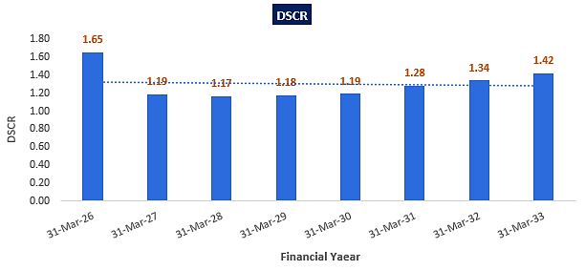
- NPV,IRR AND PAYBACK PERIOD OF THE PROJECT:
(INR Crore)
Year Ending | 31-Mar-25 | 30-Sep-25 | 31-Mar-26 | 31-Mar-27 | 31-Mar-28 | 31-Mar-29 | 31-Mar-30 | 31-Mar-31 | 31-Mar-32 | 31-Mar-33 | 31-Mar-34 | 31-Mar-35
Year Counter | 0 | 0 | 1 | 2 | 3 | 4 | 5 | 6 | 7 | 8 | 9 | 10
Months Counter | 3 | 6 | 6 | 12 | 12 | 12 | 12 | 12 | 12 | 12 | 12 | 12
EBIT | 0.00 | 0.00 | 0.85 | 1.69 | 1.58 | 1.60 | 1.62 | 1.64 | 1.66 | 1.69 | 1.71 | 1.74
Less: Taxes | 0.00 | 0.00 | 0.21 | 0.42 | 0.40 | 0.40 | 0.41 | 0.41 | 0.42 | 0.42 | 0.43 | 0.44
Add: Depreciation & Amortisation | 0.00 | 0.00 | 0.28 | 0.55 | 0.55 | 0.55 | 0.55 | 0.55 | 0.55 | 0.55 | 0.55 | 0.55
NOPAT | 0.00 | 0.00 | 0.92 | 1.82 | 1.74 | 1.75 | 1.76 | 1.78 | 1.80 | 1.81 | 1.83 | 1.86
Increase/(Decrease) in working capital | 0.00 | 0.00 | 0.20 | 0.21 | 0.00 | 0.02 | 0.02 | 0.02 | 0.02 | 0.02 | 0.02 | 0.02
Capex | 8.57 | 0.71 | 0.00 | 0.00 | 0.00 | 0.00 | 0.00 | 0.00 | 0.00 | 0.00 | 0.00 | 0.00
Free Cash Flow to Firm (FCFF) | -8.57 | -0.71 | 0.71 | 1.60 | 1.74 | 1.73 | 1.75 | 1.76 | 1.78 | 1.80 | 1.81 | 1.83
Discount Period | 0.25 | 0.75 | 1.25 | 2.25 | 3.25 | 4.25 | 5.25 | 6.25 | 7.25 | 8.25 | 9.25 | 10.25
Discount Factor | 0.98 | 0.93 | 0.88 | 0.80 | 0.72 | 0.66 | 0.59 | 0.54 | 0.49 | 0.44 | 0.40 | 0.36
PV of FCFF | -8.36 | -0.66 | 0.63 | 1.28 | 1.26 | 1.14 | 1.04 | 0.95 | 0.87 | 0.79 | 0.72 | 0.66
Terminal Value of the project |  |  |  |  |  |  |  |  |  |  |  | 18.54
PV of Terminal Value |  |  |  |  |  |  |  |  |  |  |  | 6.70
FCFF+TV | -8.57 | -0.71 | 0.71 | 1.60 | 1.74 | 1.73 | 1.75 | 1.76 | 1.78 | 1.80 | 1.81 | 20.38
PV of FCF+ PV of Terminal Value | -8.36 | -0.66 | 0.63 | 1.28 | 1.26 | 1.14 | 1.04 | 0.95 | 0.87 | 0.79 | 0.72 | 7.37
NPV | INR 7.07 Crore
IRR | 20.35%

Key Input for NPV & IRR
Weight of Debt Wd | 75%
Cost of Debt Kd | 9.50%
Tax | 25.17%
Post tax Kd | 7.1%
Weight of Equity We | 25%
Cost of Equity Ke | 12.42%
WACC | 8.44%
Project Risk Premium | 2.00%
Discount rate | 10.44%
Expected growth rate (Terminal) | 0.50%

Payback Period of the project
Year Ending | 31-Mar-26 | 31-Mar-27 | 31-Mar-28 | 31-Mar-29 | 31-Mar-30 | 31-Mar-31 | 31-Mar-32 | 31-Mar-33 | 31-Mar-34 | 31-Mar-35
Year Counter | 1 | 2 | 3 | 4 | 5 | 6 | 7 | 8 | 9 | 10
Months Counter | 6 | 12 | 12 | 12 | 12 | 12 | 12 | 12 | 12 | 12
No. Of Years | 1 | 2 | 3 | 4 | 5 | 6 | 7 | 8 | 9 | 10
Cash Accrual | 0.71 | 1.38 | 1.33 | 1.43 | 1.53 | 1.65 | 1.75 | 1.74 | 1.77 | 1.78
Accumulated Cash Accrual | 0.71 | 2.09 | 3.41 | 4.84 | 6.37 | 8.02 | 9.77 | 11.51 | 13.28 | 15.05
TPC | INR 11.05 Cr.
Payback Period | 7.24 Years
Thus, the Pune cold storage project will be having a payback period of 7.24 years and NPV & IRR of the project is INR 7.07 Crore & 20.35% respectively from C.O.D to loan repayment period, which indicates worthiness of the project.
- SENSITIVITY ANALYSIS:
Sensitivity analysis of the project with respect to various expected variables has been shown in the below table:
Sensitivity Analysis | Average DSCR | NPV | IRR | Payback Period
As a base case | 1.30 | INR 7.07 Crore | 20.35% | 7.24 years
If Sales is decreased by 5% | 1.16 | INR 4.92 Crore | 17.72% | 8.31 years
If sales is decreased by 10% | 1.02 | INR 2.77 Crore | 14.81% | 9.59 years
If operating expenses is increased by 5% | 1.22 | INR 5.66 Crore | 18.68% | 7.80 years
If operating expenses is increased by 10% | 1.13 | INR 4.25 Crore | 16.89% | 8.47 years
If interest rate increased by 1% | 1.26 | INR 6.10 Crore | 19.91% | 7.46 years
If Repairs & Maintenance Expenses increased by 1% | 1.26 | INR 6.43 Crore | 19.65% | 7.50 years
If Administrative Expenses increased by 1% | 1.27 | INR 6.64 Crore | 19.85% | 7.44 years
Observation: The proposed project is found comparatively higher sensitive with respect to the downside variation in the projected revenue, than the upside variation in the projected operational expenses and any surge in the interest rate.
- OTHER FINANCIAL RATIOS:
Year Ending | 31-Mar-26 | 31-Mar-27 | 31-Mar-28 | 31-Mar-29 | 31-Mar-30 | 31-Mar-31 | 31-Mar-32 | 31-Mar-33 | 31-Mar-34 | 31-Mar-35
Year Counter | 1 | 2 | 3 | 4 | 5 | 6 | 7 | 8 | 9 | 10
Months Counter | 6 | 12 | 12 | 12 | 12 | 12 | 12 | 12 | 12 | 12
Return on Capital employed (%) | 8.53% | 17.51% | 17.22% | 18.24% | 19.05% | 19.70% | 19.97% | 17.69% | 15.87% | 14.42%
Average | 16.82%
Return on Investment (%) | 1.51% | 6.89% | 7.56% | 10.45% | 14.55% | 20.56% | 30.19% | 43.37% | 45.18% | 45.94%
Average | 22.62%
Return on Net Worth | 5.56% | 18.68% | 15.49% | 15.72% | 15.57% | 15.16% | 14.48% | 12.69% | 11.67% | 10.61%
Average | 13.56%
DSCR | 1.65 | 1.19 | 1.17 | 1.18 | 1.19 | 1.28 | 1.34 | 1.42 | 0.00 | 0.00
Average | 1.30
ISCR | 2.68 | 2.99 | 3.29 | 3.94 | 5.00 | 6.86 | 10.95 | 32.14 | 79.48 | 80.48
Average | 22.78
Fixed Asset Coverage Ratio | 1.28 | 1.41 | 1.62 | 2.00 | 2.77 | 5.19
Average | 2.38
Current Ratio | 44.44 | 44.44 | 17.05 | 16.92 | 16.80 | 16.69 | 16.59 | 16.50 | 16.42 | 16.34
Average | 22.22
TOL/TNW | 2.85 | 2.03 | 1.48 | 1.02 | 0.66 | 0.39 | 0.18 | 0.03 | 0.03 | 0.03
Average | 0.87
Debt to Equity Ratio | 2.91 | 2.53 | 2.16 | 1.75 | 1.32 | 0.88 | 0.43 | 0.00 | 0.00 | 0.00
Average | 1.20

- BREAK-EVEN ANALYSIS:
Year Ending | 31-Mar-26 | 31-Mar-27 | 31-Mar-28 | 31-Mar-29 | 31-Mar-30 | 31-Mar-31 | 31-Mar-32 | 31-Mar-33 | 31-Mar-34 | 31-Mar-35
Year Counter | 1 | 2 | 3 | 4 | 5 | 6 | 7 | 8 | 9 | 10
Months Counter | 6 | 12 | 12 | 12 | 12 | 12 | 12 | 12 | 12 | 12
Sales | 2.53 | 5.20 | 5.39 | 5.59 | 5.80 | 6.02 | 6.26 | 6.52 | 6.79 | 7.08
Variable Expenses | 0.04 | 0.08 | 0.08 | 0.08 | 0.09 | 0.09 | 0.09 | 0.10 | 0.10 | 0.11
Contribution | 2.49 | 5.12 | 5.30 | 5.50 | 5.71 | 5.93 | 6.17 | 6.42 | 6.69 | 6.98
Fixed Expenses | 1.36 | 2.88 | 3.17 | 3.35 | 3.54 | 3.74 | 3.96 | 4.18 | 4.43 | 4.68
Profit / PBT | 1.13 | 2.24 | 2.13 | 2.15 | 2.17 | 2.19 | 2.21 | 2.24 | 2.27 | 2.29
PV RATIO (Contr. / Sales) | 98.50% | 98.50% | 98.50% | 98.50% | 98.50% | 98.50% | 98.50% | 98.50% | 98.50% | 98.50%
BEP Sales | 1.38 | 2.92 | 3.22 | 3.40 | 3.59 | 3.80 | 4.02 | 4.25 | 4.49 | 4.75
BEP% (BEP Sales / sales) | 54.65% | 56.22% | 59.76% | 60.88% | 61.97% | 63.05% | 64.10% | 65.13% | 66.14% | 67.12%

- TERM LOAN INPUTS:
Term Loan Repayment Inputs
Total loan amount | INR 8.36 Crore
Rate of Interest | 9.50%
1st Disbursement | Jan-25
IDC Start & End Month | Jan 25 to Sep-25
IDC Period (construction period) | 9 Month
Commencement /Operation Start | 1st October 2025
Moratorium Start & End Month (only interest to pay) | Jan 2025 to Jan 2026
Moratorium Period after COD | 03 Month
Repayment Start | Jan-2026
Repayment End | Dec-2032
Repayment Period | 07 Years

(INR Crore)
Year Ending | 31-Mar-25 | 30-Sep-25 | 31-Mar-26 | 31-Mar-27 | 31-Mar-28 | 31-Mar-29 | 31-Mar-30 | 31-Mar-31 | 31-Mar-32 | 31-Mar-33 | 31-Mar-34 | 31-Mar-35
Year Counter | 0 | 0 | 1 | 2 | 3 | 4 | 5 | 6 | 7 | 8 | 9 | 10
Months Counter | 3 | 6 | 6 | 12 | 12 | 12 | 12 | 12 | 12 | 12 | 12 | 12
Opening Bal | 0.00 | 6.27 | 8.36 | 8.10 | 7.06 | 6.01 | 4.88 | 3.67 | 2.46 | 1.20 | 0.00 | 0.00
Disbursement | 6.27 | 2.09 | 0.00 | 0.00 | 0.00 | 0.00 | 0.00 | 0.00 | 0.00 | 0.00 | 0.00 | 0.00
Repayment | 0.00 | 0.00 | 0.26 | 1.05 | 1.05 | 1.13 | 1.21 | 1.21 | 1.25 | 1.20 | 0.00 | 0.00
Closing Principal o/s | 6.27 | 8.36 | 8.10 | 7.06 | 6.01 | 4.88 | 3.67 | 2.46 | 1.20 | 0.00 | 0.00 | 0.00
Interest | 0.10 | 0.40 | 0.39 | 0.72 | 0.62 | 0.52 | 0.41 | 0.29 | 0.17 | 0.04 | 0.00 | 0.00
IDC | 0.10 | 0.40 | 0.00 | 0.00 | 0.00 | 0.00 | 0.00 | 0.00 | 0.00 | 0.00 | 0.00 | 0.00
TL Interest | 0.00 | 0.00 | 0.39 | 0.72 | 0.62 | 0.52 | 0.41 | 0.29 | 0.17 | 0.04 | 0.00 | 0.00

- DEPRECIATION SCHEDULE (STRAIGHT LINE METHOD):
(INR Crore)
Depreciation Schedule as per Company's Act, 2013
Particular | 31-Mar-26 | 31-Mar-27 | 31-Mar-28 | 31-Mar-29 | 31-Mar-30 | 31-Mar-31 | 31-Mar-32 | 31-Mar-33 | 31-Mar-34 | 31-Mar-35
Building & Civil Works | 1.08 | 1.08 | 1.08 | 1.08 | 1.08 | 1.08 | 1.08 | 1.08 | 1.08 | 1.08
Less: SLM Depreciation | 0.02 | 0.03 | 0.03 | 0.03 | 0.03 | 0.03 | 0.03 | 0.03 | 0.03 | 0.03
Carrying Value Building & Civil Works | 1.06 | 1.03 | 0.99 | 0.96 | 0.92 | 0.89 | 0.85 | 0.82 | 0.79 | 0.75
Plant & Machinery | 8.21 | 8.21 | 8.21 | 8.21 | 8.21 | 8.21 | 8.21 | 8.21 | 8.21 | 8.21
Less: SLM Depreciation | 0.26 | 0.52 | 0.52 | 0.52 | 0.52 | 0.52 | 0.52 | 0.52 | 0.52 | 0.52
Carrying Value of Plant & Machinery | 7.95 | 7.43 | 6.91 | 6.39 | 5.87 | 5.35 | 4.83 | 4.31 | 3.79 | 3.27
Misc. Fix Assets | 0.00 | 0.00 | 0.00 | 0.00 | 0.00 | 0.00 | 0.00 | 0.00 | 0.00 | 0.00
Less: SLM Depreciation | 0.00 | 0.00 | 0.00 | 0.00 | 0.00 | 0.00 | 0.00 | 0.00 | 0.00 | 0.00
Carrying Value of Misc. Fixed Asset | 0.00 | 0.00 | 0.00 | 0.00 | 0.00 | 0.00 | 0.00 | 0.00 | 0.00 | 0.00
Total SLM Depreciation | 0.28 | 0.55 | 0.55 | 0.55 | 0.55 | 0.55 | 0.55 | 0.55 | 0.55 | 0.55

- WORKING CAPITAL ASSESSMENT:
(INR Crore)
Year Ending | 31-Mar-26 | 31-Mar-27 | 31-Mar-28 | 31-Mar-29 | 31-Mar-30 | 31-Mar-31 | 31-Mar-32 | 31-Mar-33 | 31-Mar-34 | 31-Mar-35
Current Assets | 0.21 | 0.43 | 0.44 | 0.46 | 0.48 | 0.50 | 0.51 | 0.54 | 0.56 | 0.58
Current Liabilities | 0.00 | 0.01 | 0.03 | 0.03 | 0.03 | 0.03 | 0.03 | 0.03 | 0.03 | 0.04
Working Capital | 0.20 | 0.42 | 0.42 | 0.43 | 0.45 | 0.47 | 0.48 | 0.50 | 0.52 | 0.55
Working Capital Margin @25% | 0.05 | 0.10 | 0.10 | 0.11 | 0.11 | 0.12 | 0.12 | 0.13 | 0.13 | 0.14
Working Capital gap | 0.15 | 0.31 | 0.31 | 0.32 | 0.34 | 0.35 | 0.36 | 0.38 | 0.39 | 0.41
Working Capital Requirement | 0.30 | 0.30 | 0.30 | 0.30 | 0.30 | 0.30 | 0.30 | 0.30 | 0.30 | 0.30
Interest on working capital loan | 0.03 | 0.03 | 0.03 | 0.03 | 0.03 | 0.03 | 0.03 | 0.03 | 0.03 | 0.03
LOCATION 3: AHMEDABAD-1 (KHEDA) COLD STORAGE
- PROJECTED PROFIT & LOSS ACCOUNT:
(INR Crore)
Year Ending | 31-Mar-26 | 31-Mar-27 | 31-Mar-28 | 31-Mar-29 | 31-Mar-30 | 31-Mar-31 | 31-Mar-32 | 31-Mar-33 | 31-Mar-34 | 31-Mar-35
Year Counter | 1 | 2 | 3 | 4 | 5 | 6 | 7 | 8 | 9 | 10
Months Counter | 5 | 12 | 12 | 12 | 12 | 12 | 12 | 12 | 12 | 12
Revenue
Revenue | 2.04 | 4.96 | 5.09 | 5.32 | 5.47 | 5.63 | 5.90 | 6.08 | 6.28 | 6.61
Cost of Sales
Rental Expenses | 0.23 | 0.55 | 0.55 | 0.63 | 0.63 | 0.63 | 0.73 | 0.73 | 0.73 | 0.83
Cost of Manpower Supply | 0.41 | 1.06 | 1.14 | 1.23 | 1.32 | 1.42 | 1.53 | 1.64 | 1.77 | 1.90
Repair & Maintenance | 0.00 | 0.00 | 0.13 | 0.14 | 0.14 | 0.15 | 0.16 | 0.17 | 0.17 | 0.18
Electricity Expenses | 0.24 | 0.60 | 0.62 | 0.65 | 0.68 | 0.71 | 0.74 | 0.77 | 0.81 | 0.84
Selling, General & Administrative Expenses | 0.03 | 0.07 | 0.08 | 0.08 | 0.08 | 0.08 | 0.09 | 0.09 | 0.09 | 0.10
Operating Expenses | 0.91 | 2.28 | 2.52 | 2.73 | 2.86 | 2.99 | 3.24 | 3.40 | 3.57 | 3.86
EBITDA | 1.13 | 2.68 | 2.57 | 2.59 | 2.61 | 2.63 | 2.66 | 2.69 | 2.71 | 2.75
Depreciation | 0.23 | 0.55 | 0.55 | 0.55 | 0.55 | 0.55 | 0.55 | 0.55 | 0.55 | 0.55
EBIT | 0.90 | 2.12 | 2.02 | 2.04 | 2.06 | 2.08 | 2.11 | 2.13 | 2.16 | 2.19
Interest expenses
Interest on term loan | 0.33 | 0.73 | 0.63 | 0.53 | 0.41 | 0.30 | 0.18 | 0.05 | 0.00 | 0.00
Interest on working capital | 0.02 | 0.02 | 0.02 | 0.02 | 0.02 | 0.02 | 0.02 | 0.02 | 0.02 | 0.02
Total Interest Expenses | 0.35 | 0.75 | 0.65 | 0.54 | 0.43 | 0.32 | 0.20 | 0.07 | 0.02 | 0.02
Profit before Taxes (PBT) | 0.55 | 1.37 | 1.37 | 1.49 | 1.62 | 1.76 | 1.90 | 2.07 | 2.14 | 2.17
Current Tax | 0.00 | 0.24 | 0.23 | 0.26 | 0.28 | 0.33 | 0.49 | 0.55 | 0.58 | 0.60
Deferred Tax | -0.28 | -0.15 | -0.11 | -0.07 | -0.04 | -0.01 | 0.01 | 0.03 | 0.04 | 0.06
Applicable taxes | 0.28 | 0.38 | 0.34 | 0.33 | 0.32 | 0.35 | 0.48 | 0.52 | 0.54 | 0.55
Profit after Taxes (PAT) | 0.27 | 0.99 | 1.03 | 1.17 | 1.30 | 1.41 | 1.43 | 1.55 | 1.60 | 1.63

- PROFORMA BALANCE SHEET:
Below table shows the Projected Balance Sheet of the proposed Ahmedabad-1 location cold storage project from the period FY 2025 to FY 2035. From 1st February 2025 to 31st October 2025 would be the implementation period of the project:
(INR Crore)
Year Ending | 31-Mar-25 | 31-Oct-25 | 31-Mar-26 | 31-Mar-27 | 31-Mar-28 | 31-Mar-29 | 31-Mar-30 | 31-Mar-31 | 31-Mar-32 | 31-Mar-33 | 31-Mar-34 | 31-Mar-35
Year Counter | 0 | 0 | 1 | 2 | 3 | 4 | 5 | 6 | 7 | 8 | 9 | 10
Months Counter | 2 | 7 | 5 | 12 | 12 | 12 | 12 | 12 | 12 | 12 | 12 | 12
Liabilities
Equity | 2.69 | 2.69 | 2.79 | 2.79 | 2.79 | 2.79 | 2.79 | 2.79 | 2.79 | 2.79 | 2.79 | 2.79
Reserve & Surplus |  |  | 0.27 | 1.26 | 2.29 | 3.45 | 4.76 | 6.17 | 7.60 | 9.14 | 10.74 | 12.37
Secured Loan | 4.18 | 8.19 | 7.14 | 6.10 | 4.97 | 3.75 | 2.54 | 1.29 | 0.00 | 0.00 | 0.00 | 0.00
Current Liabilities
Trade Payables |  |  | 0.00 | 0.01 | 0.03 | 0.03 | 0.03 | 0.03 | 0.03 | 0.03 | 0.03 | 0.03
Term Liabilities Payable Within One Year | 0.00 | 0.17 | 1.04 | 1.04 | 1.13 | 1.21 | 1.21 | 1.25 | 1.29 | 0.00 | 0.00 | 0.00
Cc Limit |  |  | 0.20 | 0.20 | 0.20 | 0.20 | 0.20 | 0.20 | 0.20 | 0.20 | 0.20 | 0.20
Total | 6.87 | 11.05 | 11.45 | 11.40 | 11.40 | 11.43 | 11.53 | 11.73 | 11.90 | 12.16 | 13.76 | 15.39
Gross Assets
Land Acquisition Cost | 0.00 | 0.00 | 0.00 | 0.00 | 0.00 | 0.00 | 0.00 | 0.00 | 0.00 | 0.00 | 0.00 | 0.00
Land Development Cost | 0.00 | 0.00 | 0.00 | 0.00 | 0.00 | 0.00 | 0.00 | 0.00 | 0.00 | 0.00 | 0.00 | 0.00
Civil Work / Construction | 1.08 | 1.08 | 1.08 | 1.08 | 1.08 | 1.08 | 1.08 | 1.08 | 1.08 | 1.08 | 1.08 | 1.08
Plant & Machinery | 5.41 | 8.21 | 8.21 | 8.21 | 8.21 | 8.21 | 8.21 | 8.21 | 8.21 | 8.21 | 8.21 | 8.21
Misc. Fix Assets | 0.00 | 0.00 | 0.00 | 0.00 | 0.00 | 0.00 | 0.00 | 0.00 | 0.00 | 0.00 | 0.00 | 0.00
Total Gross Block | 6.48 | 9.29 | 9.29 | 9.29 | 9.29 | 9.29 | 9.29 | 9.29 | 9.29 | 9.29 | 9.29 | 9.29
Depreciation |  |  | 0.23 | 0.78 | 1.34 | 1.89 | 2.45 | 3.00 | 3.55 | 4.11 | 4.66 | 5.21
Net Block | 6.48 | 9.29 | 9.06 | 8.50 | 7.95 | 7.39 | 6.84 | 6.29 | 5.73 | 5.18 | 4.62 | 4.07
Deferred Tax Asset | 0.00 | 0.00 | -0.28 | -0.43 | -0.53 | -0.60 | -0.64 | -0.66 | -0.65 | -0.62 | -0.58 | -0.52
Balance With Gov. Authorities | 0.00 | 1.38 | 1.17 | 0.69 | 0.23 | 0.00 | 0.00 | 0.00 | 0.00 | 0.00 | 0.00 | 0.00
Mat Credit Entitlement |  |  | 0.00 | 0.24 | 0.23 | 0.18 | 0.09 | 0.00 | 0.00 | 0.00 | 0.00 | 0.00
Security Deposit to Landlord | 0.38 | 0.38 | 0.38 | 0.38 | 0.38 | 0.38 | 0.38 | 0.38 | 0.38 | 0.38 | 0.38 | 0.38
Current Assets
Trade Receivables |  |  | 0.17 | 0.41 | 0.42 | 0.44 | 0.45 | 0.46 | 0.48 | 0.50 | 0.52 | 0.54
Cash & Bank | 0.00 | 0.00 | 0.95 | 1.60 | 2.72 | 3.64 | 4.40 | 5.25 | 5.95 | 6.72 | 8.82 | 10.92
Preliminary Expenses W/Off |  | 0.00 | 0.00 | 0.00 | 0.00 | 0.00 | 0.00 | 0.00 | 0.00 | 0.00 | 0.00 | 0.00
Total | 6.87 | 11.05 | 11.45 | 11.40 | 11.40 | 11.43 | 11.53 | 11.73 | 11.90 | 12.16 | 13.76 | 15.39

- PROJECTED CASH FLOW STATEMENT:
(INR Crore)
Year Ending | 31-Mar-25 | 31-Oct-25 | 31-Mar-26 | 31-Mar-27 | 31-Mar-28 | 31-Mar-29 | 31-Mar-30 | 31-Mar-31 | 31-Mar-32 | 31-Mar-33 | 31-Mar-34 | 31-Mar-35
Year Counter | 0 | 0 | 1 | 2 | 3 | 4 | 5 | 6 | 7 | 8 | 9 | 10
Months Counter | 2 | 7 | 5 | 12 | 12 | 12 | 12 | 12 | 12 | 12 | 12 | 12
Cash Flow from Operating Activities
Profit before Tax | 0.00 | 0.00 | 0.55 | 1.37 | 1.37 | 1.49 | 1.62 | 1.76 | 1.90 | 2.07 | 2.14 | 2.17
Add: Non-Cash Expenses/ Non-Operating Expenses/ (Non-Operating Income) | 0.00 | 0.00 | 0.23 | 0.55 | 0.55 | 0.55 | 0.55 | 0.55 | 0.55 | 0.55 | 0.55 | 0.55
Add: Interest Expense | 0.00 | 0.00 | 0.35 | 0.75 | 0.65 | 0.54 | 0.43 | 0.32 | 0.20 | 0.07 | 0.02 | 0.02
Increase in Sundry Debtors | 0.00 | 0.00 | -0.17 | -0.24 | -0.01 | -0.02 | -0.01 | -0.01 | -0.02 | -0.02 | -0.02 | -0.03
NET GST ASSET | 0.00 | -1.38 | 0.20 | 0.48 | 0.46 | 0.47 | 0.47 | 0.47 | 0.48 | 0.48 | 0.49 | 0.49
Change in MAT | 0.00 | 0.00 | 0.00 | -0.24 | 0.00 | 0.05 | 0.09 | 0.09 | 0.00 | 0.00 | 0.00 | 0.00
Increase in Sundry Creditors | 0.00 | 0.00 | 0.00 | 0.01 | 0.02 | 0.00 | 0.00 | 0.00 | 0.00 | 0.00 | 0.00 | 0.00
Cash Generated from Operations | 0.00 | -1.38 | 1.17 | 2.69 | 3.04 | 3.09 | 3.16 | 3.19 | 3.12 | 3.16 | 3.19 | 3.22
GST Paid | 0.00 | 0.00 | 0.00 | 0.00 | 0.00 | 0.24 | 0.47 | 0.47 | 0.48 | 0.48 | 0.49 | 0.49
Income Taxes paid | 0.00 | 0.00 | 0.00 | 0.24 | 0.23 | 0.26 | 0.28 | 0.33 | 0.49 | 0.55 | 0.58 | 0.60
Net Cash from Operating Activities | 0.00 | -1.38 | 1.17 | 2.45 | 2.81 | 2.60 | 2.41 | 2.38 | 2.15 | 2.12 | 2.12 | 2.12
Cash Flow from Investing Activities
Purchase of Fixed Assets | -6.48 | -2.80 | 0.00 | 0.00 | 0.00 | 0.00 | 0.00 | 0.00 | 0.00 | 0.00 | 0.00 | 0.00
Security Deposit | -0.38 | 0.00 | 0.00 | 0.00 | 0.00 | 0.00 | 0.00 | 0.00 | 0.00 | 0.00 | 0.00 | 0.00
Net Cash from Investing Activities | -6.87 | -2.80 | 0.00 | 0.00 | 0.00 | 0.00 | 0.00 | 0.00 | 0.00 | 0.00 | 0.00 | 0.00
Cash Flow from Financing Activities
Increase in Equity / Share Capital/USL | 2.69 | 0.00 | 0.10 | 0.00 | 0.00 | 0.00 | 0.00 | 0.00 | 0.00 | 0.00 | 0.00 | 0.00
Increase in TL | 4.18 | 4.18 | -0.17 | -1.04 | -1.04 | -1.13 | -1.21 | -1.21 | -1.25 | -1.29 | 0.00 | 0.00
Increase in CC Limit | 0.00 | 0.00 | 0.20 | 0.00 | 0.00 | 0.00 | 0.00 | 0.00 | 0.00 | 0.00 | 0.00 | 0.00
Interest Paid | 0.00 | 0.00 | -0.35 | -0.75 | -0.65 | -0.54 | -0.43 | -0.32 | -0.20 | -0.07 | -0.02 | -0.02
Net Cash from Financing Activities | 6.87 | 4.18 | -0.22 | -1.79 | -1.69 | -1.67 | -1.65 | -1.53 | -1.45 | -1.36 | -0.02 | -0.02
Net increase in cash and cash equivalents | 0.00 | 0.00 | 0.95 | 0.66 | 1.11 | 0.92 | 0.77 | 0.85 | 0.70 | 0.77 | 2.10 | 2.10
Cash and cash equivalents at beginning of period | 0.00 | 0.00 | 0.00 | 0.95 | 1.60 | 2.72 | 3.64 | 4.40 | 5.25 | 5.95 | 6.72 | 8.82
Cash and cash equivalents at end of period | 0.00 | 0.00 | 0.95 | 1.60 | 2.72 | 3.64 | 4.40 | 5.25 | 5.95 | 6.72 | 8.82 | 10.92

- KEY FINANCIAL RATIO:
Year Ending | 31-Mar-26 | 31-Mar-27 | 31-Mar-28 | 31-Mar-29 | 31-Mar-30 | 31-Mar-31 | 31-Mar-32 | 31-Mar-33 | 31-Mar-34 | 31-Mar-35
Year Counter | 1 | 2 | 3 | 4 | 5 | 6 | 7 | 8 | 9 | 10
Months Counter | 5 | 12 | 12 | 12 | 12 | 12 | 12 | 12 | 12 | 12
EBITDA Margin % | 55.40% | 53.96% | 50.48% | 48.73% | 47.76% | 46.79% | 45.08% | 44.14% | 43.20% | 41.58%
Average | 47.71%
EBIT Margin % | 44.09% | 42.79% | 39.60% | 38.31% | 37.63% | 36.95% | 35.70% | 35.04% | 34.39% | 33.20%
Average | 37.77%
PAT Margin % | 13.32% | 19.97% | 20.17% | 21.92% | 23.87% | 25.09% | 24.16% | 25.41% | 25.51% | 24.63%
Average | 22.40%
Revenue growth rate Y-o-Y (%) |  | 143.14% | 2.66% | 4.45% | 2.84% | 2.95% | 4.82% | 3.13% | 3.25% | 5.17%
Average | 19.16%
Note: The proposed Ahmedabad (Kheda) cold storage project is having an average revenue growth rate of 19.16% during the forecasted period. Average EBITDA Margin & EBIT Margin of the project are 47.71% & 37.77% respectively. The project will be operational from 1st November 2025 and as per the trends analysis above, PAT margin is growing from 13.32% in FY 2026 to 24.63% in FY 2035 due to the lower interest cost on borrowings in the later projected years.
- ESTIMATED KEY FINANCIAL METRICS: DEBT SERVICE COVERAGE RATIO (D.S.C.R)
(INR Crore except D.S.C.R)
Year Ending | 31-Mar-26 | 31-Mar-27 | 31-Mar-28 | 31-Mar-29 | 31-Mar-30 | 31-Mar-31 | 31-Mar-32 | 31-Mar-33 | 31-Mar-34 | 31-Mar-35
Year Counter | 1 | 2 | 3 | 4 | 5 | 6 | 7 | 8 | 9 | 10
Months Counter | 5 | 12 | 12 | 12 | 12 | 12 | 12 | 12 | 12 | 12
Cash accrual | 0.78 | 1.69 | 1.69 | 1.79 | 1.90 | 1.98 | 1.97 | 2.07 | 2.11 | 2.12
Interest on term loan | 0.33 | 0.73 | 0.63 | 0.53 | 0.41 | 0.30 | 0.18 | 0.05 | 0.00 | 0.00
Interest on WC | 0.02 | 0.02 | 0.02 | 0.02 | 0.02 | 0.02 | 0.02 | 0.02 | 0.02 | 0.02
Subtotal | 1.13 | 2.44 | 2.33 | 2.33 | 2.33 | 2.30 | 2.17 | 2.14 | 2.13 | 2.14
Interest on term loan | 0.33 | 0.73 | 0.63 | 0.53 | 0.41 | 0.30 | 0.18 | 0.05 | 0.00 | 0.00
Interest on WC | 0.02 | 0.02 | 0.02 | 0.02 | 0.02 | 0.02 | 0.02 | 0.02 | 0.02 | 0.02
Loan Repayment | 0.17 | 1.04 | 1.04 | 1.13 | 1.21 | 1.21 | 1.25 | 1.29 | 0.00 | 0.00
Subtotal | 0.52 | 1.79 | 1.69 | 1.67 | 1.65 | 1.53 | 1.45 | 1.36 | 0.02 | 0.02
DSCR | 2.16 | 1.36 | 1.38 | 1.40 | 1.42 | 1.50 | 1.49 | 1.58
Average DSCR | 1.54
Maximum DSCR | 2.16
Note: D.S.C.R has been calculated for loan repayment period from FY 2026 to FY 2033. The proposed Ahmedabad (Kheda) Cold storage project is having a D.S.C.R of more than 1 during the projected loan repayment period.
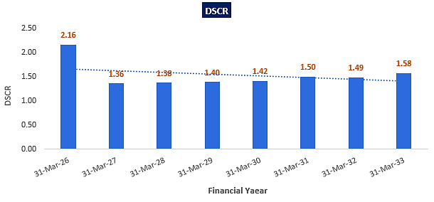
- NPV,IRR AND PAYBACK PERIOD OF THE PROJECT:
(INR Crore)
Year Ending | 31-Mar-25 | 31-Oct-25 | 31-Mar-26 | 31-Mar-27 | 31-Mar-28 | 31-Mar-29 | 31-Mar-30 | 31-Mar-31 | 31-Mar-32 | 31-Mar-33 | 31-Mar-34 | 31-Mar-35
Year Counter | 0 | 0 | 1 | 2 | 3 | 4 | 5 | 6 | 7 | 8 | 9 | 10
Months Counter | 2 | 7 | 5 | 12 | 12 | 12 | 12 | 12 | 12 | 12 | 12 | 12
EBIT | 0.00 | 0.00 | 0.90 | 2.12 | 2.02 | 2.04 | 2.06 | 2.08 | 2.11 | 2.13 | 2.16 | 2.19
Less: Taxes | 0.00 | 0.00 | 0.23 | 0.53 | 0.51 | 0.51 | 0.52 | 0.52 | 0.53 | 0.54 | 0.54 | 0.55
Add: Depreciation & Amortisation | 0.00 | 0.00 | 0.23 | 0.55 | 0.55 | 0.55 | 0.55 | 0.55 | 0.55 | 0.55 | 0.55 | 0.55
NOPAT | 0.00 | 0.00 | 0.90 | 2.14 | 2.06 | 2.08 | 2.09 | 2.11 | 2.13 | 2.15 | 2.17 | 2.20
Increase/(Decrease) in working capital | 0.00 | 0.00 | 0.16 | 0.23 | -0.01 | 0.02 | 0.01 | 0.01 | 0.02 | 0.01 | 0.01 | 0.03
Capex | 6.48 | 2.80 | 0.00 | 0.00 | 0.00 | 0.00 | 0.00 | 0.00 | 0.00 | 0.00 | 0.00 | 0.00
Free Cash Flow to Firm (FCFF) | -6.48 | -2.80 | 0.74 | 1.91 | 2.07 | 2.06 | 2.08 | 2.10 | 2.11 | 2.14 | 2.16 | 2.17
Discount Period | 0.17 | 0.75 | 1.17 | 2.17 | 3.17 | 4.17 | 5.17 | 6.17 | 7.17 | 8.17 | 9.17 | 10.17
Discount Factor | 0.98 | 0.93 | 0.89 | 0.81 | 0.73 | 0.66 | 0.60 | 0.54 | 0.49 | 0.44 | 0.40 | 0.36
PV of FCFF | -6.38 | -2.60 | 0.66 | 1.54 | 1.51 | 1.36 | 1.25 | 1.14 | 1.04 | 0.95 | 0.87 | 0.79
Terminal Value of the project |  |  |  |  |  |  |  |  |  |  |  | 21.95
PV of Terminal Value |  |  |  |  |  |  |  |  |  |  |  | 8.00
FCFF+TV | -6.48 | -2.80 | 0.74 | 1.91 | 2.07 | 2.06 | 2.08 | 2.10 | 2.11 | 2.14 | 2.16 | 24.12
PV of FCF+ PV of Terminal Value | -6.38 | -2.60 | 0.66 | 1.54 | 1.51 | 1.36 | 1.25 | 1.14 | 1.04 | 0.95 | 0.87 | 8.79
NPV | INR 10.11 Crore
IRR | 24.20%

Key Input for NPV & IRR
Weight of Debt Wd | 75%
Cost of Debt Kd | 9.50%
Tax | 25.17%
Post tax Kd | 7.11%
Weight of Equity We | 25%
Cost of Equity Ke | 12.42%
WACC | 8.44%
Project Risk Premium | 2.00%
Discount rate | 10.44%
Expected growth rate (Terminal) | 0.50%

Payback Period of the project
Year Ending | 31-Mar-26 | 31-Mar-27 | 31-Mar-28 | 31-Mar-29 | 31-Mar-30 | 31-Mar-31 | 31-Mar-32 | 31-Mar-33 | 31-Mar-34 | 31-Mar-35
Year Counter | 1 | 2 | 3 | 4 | 5 | 6 | 7 | 8 | 9 | 10
Months Counter | 5 | 12 | 12 | 12 | 12 | 12 | 12 | 12 | 12 | 12
No. Of Years | 0.42 | 1.42 | 2.42 | 3.42 | 4.42 | 5.42 | 6.42 | 7.42 | 8.42 | 9.42
Cash Accrual | 0.78 | 1.69 | 1.69 | 1.79 | 1.90 | 1.98 | 1.97 | 2.07 | 2.11 | 2.12
Accumulated Cash Accrual | 0.78 | 2.47 | 4.16 | 5.95 | 7.85 | 9.83 | 11.80 | 13.87 | 15.99 | 18.11
TPC | INR 11.05 Cr.
Payback Period | 6.03 Years
Thus, the Ahmedabad-1 cold storage project will be having a payback period of 6.03 years and NPV & IRR of the project is INR 10.11 Crore & 24.20% respectively from C.O.D to loan repayment period, which indicates worthiness of the project.
- SENSITIVITY ANALYSIS:
Sensitivity analysis of the project with respect to various expected variables has been shown in the below table:
Sensitivity Analysis | Average DSCR | NPV | IRR | Payback Period
As a base case | 1.54 | INR 10.11 Crore | 24.20% | 6.03 years
If Sales is decreased by 5% | 1.41 | INR 8.11 Crore | 21.96% | 6.67 years
If sales is decreased by 10% | 1.27 | INR 6.10 Crore | 19.54% | 7.54 years
If operating expenses is increased by 5% | 1.48 | INR 9.00 Crore | 23.00% | 6.31 years
If operating expenses is increased by 10% | 1.41 | INR 7.88 Crore | 21.75% | 6.69 years
If interest rate increased by 1% | 1.50 | INR 8.98 Crore | 23.76% | 6.13 years
If Repairs & Maintenance Expenses increased by 1% | 1.52 | INR 9.47 Crore | 23.75% | 6.15 years
If Administrative Expenses increased by 1% | 1.53 | INR 9.72 Crore | 23.77% | 6.10 years
Observation: The proposed project is found comparatively higher sensitive with respect to the downside variation in the projected revenue, than the upside variation in the projected operational expenses and any surge in the interest rate.
- OTHER FINANCIAL RATIOS:
Year Ending | 31-Mar-26 | 31-Mar-27 | 31-Mar-28 | 31-Mar-29 | 31-Mar-30 | 31-Mar-31 | 31-Mar-32 | 31-Mar-33 | 31-Mar-34 | 31-Mar-35
Year Counter | 1 | 2 | 3 | 4 | 5 | 6 | 7 | 8 | 9 | 10
Months Counter | 5 | 12 | 12 | 12 | 12 | 12 | 12 | 12 | 12 | 12
Return on Capital employed (%) | 8.81% | 20.91% | 20.07% | 20.37% | 20.39% | 20.29% | 20.28% | 17.87% | 15.96% | 14.47%
Average | 17.94%
Return on Investment (%) | 2.47% | 9.97% | 11.56% | 15.03% | 19.95% | 26.50% | 34.97% | 55.47% | 57.50% | 58.39%
Average | 29.18%
Return on Net Worth | 8.88% | 24.46% | 20.23% | 18.67% | 17.30% | 15.77% | 13.73% | 12.96% | 11.84% | 10.73%
Average | 15.46%
DSCR | 2.16 | 1.36 | 1.38 | 1.40 | 1.42 | 1.50 | 1.49 | 1.58 | 0.00 | 0.00
Average | 1.54
ISCR | 3.24 | 3.58 | 3.97 | 4.76 | 6.03 | 8.28 | 13.23 | 40.51 | 142.83 | 144.58
Average | 37.10
Fixed Asset Coverage Ratio | 1.27 | 1.39 | 1.60 | 1.97 | 2.69 | 4.88
Average | 2.30
Current Ratio | 44.44 | 44.44 | 16.46 | 16.41 | 16.19 | 15.99 | 15.97 | 15.79 | 15.62 | 15.63
Average | 21.69
TOL/TNW | 2.74 | 1.82 | 1.25 | 0.83 | 0.53 | 0.31 | 0.15 | 0.02 | 0.02 | 0.02
Average | 0.77
Debt to Equity Ratio | 2.94 | 2.56 | 2.19 | 1.78 | 1.35 | 0.91 | 0.46 | 0.00 | 0.00 | 0.00
Average | 1.22

- BREAK-EVEN ANALYSIS:
Year Ending | 31-Mar-26 | 31-Mar-27 | 31-Mar-28 | 31-Mar-29 | 31-Mar-30 | 31-Mar-31 | 31-Mar-32 | 31-Mar-33 | 31-Mar-34 | 31-Mar-35
Year Counter | 1 | 2 | 3 | 4 | 5 | 6 | 7 | 8 | 9 | 10
Months Counter | 5 | 12 | 12 | 12 | 12 | 12 | 12 | 12 | 12 | 12
Sales | 2.04 | 4.96 | 5.09 | 5.32 | 5.47 | 5.63 | 5.90 | 6.08 | 6.28 | 6.61
Variable Expenses | 0.03 | 0.07 | 0.08 | 0.08 | 0.08 | 0.08 | 0.09 | 0.09 | 0.09 | 0.10
Contribution | 2.01 | 4.88 | 5.01 | 5.24 | 5.38 | 5.54 | 5.81 | 5.99 | 6.19 | 6.51
Fixed Expenses | 0.88 | 2.21 | 2.44 | 2.65 | 2.77 | 2.91 | 3.15 | 3.31 | 3.47 | 3.76
Profit / PBT | 1.13 | 2.68 | 2.57 | 2.59 | 2.61 | 2.63 | 2.66 | 2.69 | 2.71 | 2.75
PV RATIO (Contr. / Sales) | 98.50% | 98.50% | 98.50% | 98.50% | 98.50% | 98.50% | 98.50% | 98.50% | 98.50% | 98.50%
BEP Sales | 0.89 | 2.24 | 2.48 | 2.69 | 2.82 | 2.95 | 3.20 | 3.36 | 3.53 | 3.82
BEP% (BEP Sales / sales) | 43.75% | 45.22% | 48.75% | 50.53% | 51.51% | 52.50% | 54.23% | 55.18% | 56.14% | 57.78%

- TERM LOAN INPUTS:
Term Loan Repayment Inputs
Total loan amount | INR 8.36 Crore
Rate of Interest | 9.50%
1st Disbursement | Feb-25
IDC Start & End Month | Feb 25 to October-25
IDC Period (construction period) | 9 Month
Commencement /Operation Start | 1st November 2025
Moratorium Start & End Month (only interest to pay) | Feb 2025 to Jan 2026
Moratorium Period after COD | 03 Month
Repayment Start | Feb-2026
Repayment End | Jan-2033
Repayment Period | 07 Years

(INR Crore)
Year Ending | 31-Mar-25 | 31-Oct-25 | 31-Mar-26 | 31-Mar-27 | 31-Mar-28 | 31-Mar-29 | 31-Mar-30 | 31-Mar-31 | 31-Mar-32 | 31-Mar-33 | 31-Mar-34 | 31-Mar-35
Year Counter | 0 | 0 | 1 | 2 | 3 | 4 | 5 | 6 | 7 | 8 | 9 | 10
Months Counter | 2 | 7 | 5 | 12 | 12 | 12 | 12 | 12 | 12 | 12 | 12 | 12
Opening Bal | 0.00 | 4.18 | 8.36 | 8.19 | 7.14 | 6.10 | 4.97 | 3.75 | 2.54 | 1.29 | 0.00 | 0.00
Disbursement | 4.18 | 4.18 | 0.00 | 0.00 | 0.00 | 0.00 | 0.00 | 0.00 | 0.00 | 0.00 | 0.00 | 0.00
Repayment | 0.00 | 0.00 | 0.17 | 1.04 | 1.04 | 1.13 | 1.21 | 1.21 | 1.25 | 1.29 | 0.00 | 0.00
Closing Principal o/s | 4.18 | 8.36 | 8.19 | 7.14 | 6.10 | 4.97 | 3.75 | 2.54 | 1.29 | 0.00 | 0.00 | 0.00
Interest | 0.05 | 0.45 | 0.33 | 0.73 | 0.63 | 0.53 | 0.41 | 0.30 | 0.18 | 0.05 | 0.00 | 0.00
IDC | 0.05 | 0.45 | 0.00 | 0.00 | 0.00 | 0.00 | 0.00 | 0.00 | 0.00 | 0.00 | 0.00 | 0.00
TL Interest | 0.00 | 0.00 | 0.33 | 0.73 | 0.63 | 0.53 | 0.41 | 0.30 | 0.18 | 0.05 | 0.00 | 0.00

- DEPRECIATION SCHEDULE (STRAIGHT LINE METHOD):
(INR Crore)
Depreciation Schedule as per Company's Act, 2013
Particular | 31-Mar-26 | 31-Mar-27 | 31-Mar-28 | 31-Mar-29 | 31-Mar-30 | 31-Mar-31 | 31-Mar-32 | 31-Mar-33 | 31-Mar-34 | 31-Mar-35
Building & Civil Works | 1.08 | 1.08 | 1.08 | 1.08 | 1.08 | 1.08 | 1.08 | 1.08 | 1.08 | 1.08
Less: SLM Depreciation | 0.01 | 0.03 | 0.03 | 0.03 | 0.03 | 0.03 | 0.03 | 0.03 | 0.03 | 0.03
Carrying Value Building & Civil Works | 1.06 | 1.03 | 0.99 | 0.96 | 0.93 | 0.89 | 0.86 | 0.82 | 0.79 | 0.76
Plant & Machinery | 8.21 | 8.21 | 8.21 | 8.21 | 8.21 | 8.21 | 8.21 | 8.21 | 8.21 | 8.21
Less: SLM Depreciation | 0.22 | 0.52 | 0.52 | 0.52 | 0.52 | 0.52 | 0.52 | 0.52 | 0.52 | 0.52
Carrying Value of Plant & Machinery | 7.99 | 7.47 | 6.95 | 6.43 | 5.91 | 5.39 | 4.87 | 4.36 | 3.84 | 3.32
Misc. Fix Assets | 0.00 | 0.00 | 0.00 | 0.00 | 0.00 | 0.00 | 0.00 | 0.00 | 0.00 | 0.00
Less: SLM Depreciation | 0.00 | 0.00 | 0.00 | 0.00 | 0.00 | 0.00 | 0.00 | 0.00 | 0.00 | 0.00
Carrying Value of Misc. Fixed Asset | 0.00 | 0.00 | 0.00 | 0.00 | 0.00 | 0.00 | 0.00 | 0.00 | 0.00 | 0.00
Total SLM Depreciation | 0.23 | 0.55 | 0.55 | 0.55 | 0.55 | 0.55 | 0.55 | 0.55 | 0.55 | 0.55

- WORKING CAPITAL ASSESSMENT:
(INR Crore)
Year Ending | 31-Mar-26 | 31-Mar-27 | 31-Mar-28 | 31-Mar-29 | 31-Mar-30 | 31-Mar-31 | 31-Mar-32 | 31-Mar-33 | 31-Mar-34 | 31-Mar-35
Current Assets | 0.17 | 0.41 | 0.42 | 0.44 | 0.45 | 0.46 | 0.48 | 0.50 | 0.52 | 0.54
Current Liabilities | 0.00 | 0.01 | 0.03 | 0.03 | 0.03 | 0.03 | 0.03 | 0.03 | 0.03 | 0.03
Working Capital | 0.16 | 0.40 | 0.39 | 0.41 | 0.42 | 0.43 | 0.45 | 0.47 | 0.48 | 0.51
Working Capital Margin @25% | 0.04 | 0.10 | 0.10 | 0.10 | 0.11 | 0.11 | 0.11 | 0.12 | 0.12 | 0.13
Working Capital gap | 0.12 | 0.30 | 0.29 | 0.31 | 0.32 | 0.33 | 0.34 | 0.35 | 0.36 | 0.38
Working Capital Requirement | 0.20 | 0.20 | 0.20 | 0.20 | 0.20 | 0.20 | 0.20 | 0.20 | 0.20 | 0.20
Interest on working capital loan | 0.02 | 0.02 | 0.02 | 0.02 | 0.02 | 0.02 | 0.02 | 0.02 | 0.02 | 0.02
LOCATION 4: AHMEDABAD-2 (DETROJ) COLD STORAGE
- PROJECTED PROFIT & LOSS ACCOUNT:
(INR Crore)
Year Ending | 31-Mar-26 | 31-Mar-27 | 31-Mar-28 | 31-Mar-29 | 31-Mar-30 | 31-Mar-31 | 31-Mar-32 | 31-Mar-33 | 31-Mar-34 | 31-Mar-35
Year Counter | 1 | 2 | 3 | 4 | 5 | 6 | 7 | 8 | 9 | 10
Months Counter | 3 | 12 | 12 | 12 | 12 | 12 | 12 | 12 | 12 | 12
Revenue
Revenue | 1.84 | 7.35 | 7.35 | 7.35 | 7.35 | 7.35 | 7.35 | 7.35 | 7.35 | 7.35
Cost of Sales
Rental Expenses | 0.13 | 0.50 | 0.50 | 0.58 | 0.58 | 0.58 | 0.67 | 0.67 | 0.67 | 0.77
Cost of Manpower Supply | 0.10 | 0.44 | 0.47 | 0.51 | 0.54 | 0.59 | 0.63 | 0.68 | 0.73 | 0.78
Repair & Maintenance | 0.00 | 0.00 | 0.23 | 0.24 | 0.25 | 0.26 | 0.27 | 0.29 | 0.30 | 0.32
Electricity Expenses | 0.36 | 1.52 | 1.59 | 1.66 | 1.74 | 1.82 | 1.91 | 2.00 | 2.09 | 2.19
Selling, General & Administrative Expenses | 0.03 | 0.11 | 0.11 | 0.11 | 0.11 | 0.11 | 0.11 | 0.11 | 0.11 | 0.11
Operating Expenses | 0.62 | 2.57 | 2.90 | 3.09 | 3.22 | 3.36 | 3.59 | 3.74 | 3.90 | 4.16
EBITDA | 1.22 | 4.78 | 4.45 | 4.26 | 4.13 | 3.99 | 3.76 | 3.61 | 3.45 | 3.19
Depreciation | 0.24 | 0.96 | 0.96 | 0.96 | 0.96 | 0.96 | 0.96 | 0.96 | 0.96 | 0.96
EBIT | 0.98 | 3.82 | 3.49 | 3.29 | 3.17 | 3.03 | 2.80 | 2.65 | 2.49 | 2.22
Interest expenses
Interest on term loan | 0.34 | 1.26 | 1.09 | 0.92 | 0.73 | 0.53 | 0.33 | 0.11 | 0.00 | 0.00
Interest on working capital | 0.04 | 0.04 | 0.04 | 0.04 | 0.04 | 0.04 | 0.04 | 0.04 | 0.04 | 0.04
Total Interest Expenses | 0.37 | 1.30 | 1.13 | 0.96 | 0.77 | 0.57 | 0.37 | 0.15 | 0.04 | 0.04
Profit before Taxes (PBT) | 0.60 | 2.52 | 2.36 | 2.34 | 2.40 | 2.46 | 2.43 | 2.50 | 2.45 | 2.18
Current Tax | 0.00 | 0.43 | 0.40 | 0.40 | 0.41 | 0.42 | 0.56 | 0.68 | 0.69 | 0.65
Deferred Tax | -0.53 | -0.26 | -0.19 | -0.12 | -0.07 | -0.02 | 0.01 | 0.05 | 0.08 | 0.10
Applicable taxes | 0.53 | 0.69 | 0.59 | 0.52 | 0.48 | 0.45 | 0.54 | 0.63 | 0.62 | 0.55
Profit after Taxes (PAT) | 0.08 | 1.83 | 1.77 | 1.81 | 1.92 | 2.01 | 1.89 | 1.87 | 1.84 | 1.63

- PROFORMA BALANCE SHEET:
Below table shows the Projected Balance Sheet of the proposed Ahmedabad-2 location cold storage project from the period FY 2025 to FY 2035. From 1st April 2025 to 31st December 2025 would be the implementation period of the project:
(INR Crore)
Year Ending | 31-Mar-25 | 31-Dec-25 | 31-Mar-26 | 31-Mar-27 | 31-Mar-28 | 31-Mar-29 | 31-Mar-30 | 31-Mar-31 | 31-Mar-32 | 31-Mar-33 | 31-Mar-34 | 31-Mar-35
Year Counter | 0 | 0 | 1 | 2 | 3 | 4 | 5 | 6 | 7 | 8 | 9 | 10
Months Counter | 0 | 9 | 3 | 12 | 12 | 12 | 12 | 12 | 12 | 12 | 12 | 12
Liabilities
Equity |  | 4.57 | 4.71 | 4.71 | 4.71 | 4.71 | 4.71 | 4.71 | 4.71 | 4.71 | 4.71 | 4.71
Reserve & Surplus |  |  | 0.08 | 1.91 | 3.68 | 5.49 | 7.41 | 9.42 | 11.31 | 13.18 | 15.01 | 16.65
Secured Loan |  | 14.14 | 12.38 | 10.61 | 8.70 | 6.65 | 4.60 | 2.33 | 0.00 | 0.00 | 0.00 | 0.00
Current Liabilities
Trade Payables |  |  | 0.00 | 0.01 | 0.04 | 0.04 | 0.04 | 0.05 | 0.05 | 0.05 | 0.05 | 0.05
Term Liabilities Payable Within One Year |  | 0.00 | 1.77 | 1.77 | 1.91 | 2.05 | 2.05 | 2.26 | 2.33 | 0.00 | 0.00 | 0.00
Cc Limit |  |  | 0.40 | 0.40 | 0.40 | 0.40 | 0.40 | 0.40 | 0.40 | 0.40 | 0.40 | 0.40
Total |  | 18.71 | 19.34 | 19.41 | 19.44 | 19.35 | 19.21 | 19.18 | 18.81 | 18.34 | 20.18 | 21.82
Gross Assets
Land Acquisition Cost |  | 0.00 | 0.00 | 0.00 | 0.00 | 0.00 | 0.00 | 0.00 | 0.00 | 0.00 | 0.00 | 0.00
Land Development Cost |  | 0.00 | 0.00 | 0.00 | 0.00 | 0.00 | 0.00 | 0.00 | 0.00 | 0.00 | 0.00 | 0.00
Civil Work / Construction |  | 1.91 | 1.91 | 1.91 | 1.91 | 1.91 | 1.91 | 1.91 | 1.91 | 1.91 | 1.91 | 1.91
Plant & Machinery |  | 14.26 | 14.26 | 14.26 | 14.26 | 14.26 | 14.26 | 14.26 | 14.26 | 14.26 | 14.26 | 14.26
Misc. Fix Assets |  | 0.00 | 0.00 | 0.00 | 0.00 | 0.00 | 0.00 | 0.00 | 0.00 | 0.00 | 0.00 | 0.00
Total Gross Block |  | 16.17 | 16.17 | 16.17 | 16.17 | 16.17 | 16.17 | 16.17 | 16.17 | 16.17 | 16.17 | 16.17
Depreciation |  |  | 0.24 | 1.20 | 2.17 | 3.13 | 4.09 | 5.06 | 6.02 | 6.98 | 7.95 | 8.91
Net Block |  | 16.17 | 15.93 | 14.96 | 14.00 | 13.04 | 12.07 | 11.11 | 10.15 | 9.18 | 8.22 | 7.26
Deferred Tax Asset |  | 0.00 | -0.53 | -0.78 | -0.97 | -1.09 | -1.16 | -1.19 | -1.17 | -1.13 | -1.05 | -0.95
Balance With Gov. Authorities |  | 2.39 | 2.17 | 1.30 | 0.50 | 0.00 | 0.00 | 0.00 | 0.00 | 0.00 | 0.00 | 0.00
Mat Credit Entitlement |  |  | 0.00 | 0.43 | 0.43 | 0.36 | 0.24 | 0.07 | 0.00 | 0.00 | 0.00 | 0.00
Security Deposit to Landlord |  | 0.16 | 0.16 | 0.16 | 0.16 | 0.16 | 0.16 | 0.16 | 0.16 | 0.16 | 0.16 | 0.16
Current Assets
Trade Receivables |  |  | 0.15 | 0.60 | 0.60 | 0.60 | 0.60 | 0.60 | 0.60 | 0.60 | 0.60 | 0.60
Cash & Bank |  | 0.00 | 1.47 | 2.73 | 4.71 | 6.27 | 7.30 | 8.42 | 9.07 | 9.52 | 12.25 | 14.75
Preliminary Expenses W/Off |  | 0.00 | 0.00 | 0.00 | 0.00 | 0.00 | 0.00 | 0.00 | 0.00 | 0.00 | 0.00 | 0.00
Total |  | 18.71 | 19.34 | 19.41 | 19.44 | 19.35 | 19.21 | 19.18 | 18.81 | 18.34 | 20.18 | 21.82

- PROJECTED CASH FLOW STATEMENT:
(INR Crore)
Year Ending | 31-Mar-25 | 31-Dec-25 | 31-Mar-26 | 31-Mar-27 | 31-Mar-28 | 31-Mar-29 | 31-Mar-30 | 31-Mar-31 | 31-Mar-32 | 31-Mar-33 | 31-Mar-34 | 31-Mar-35
Year Counter | 0 | 0 | 1 | 2 | 3 | 4 | 5 | 6 | 7 | 8 | 9 | 10
Months Counter | 0 | 9 | 3 | 12 | 12 | 12 | 12 | 12 | 12 | 12 | 12 | 12
Cash Flow from Operating Activities
Profit before Tax |  | 0.00 | 0.60 | 2.52 | 2.36 | 2.34 | 2.40 | 2.46 | 2.43 | 2.50 | 2.45 | 2.18
Add: Non-Cash Expenses/ Non-Operating Expenses/(Non-Operating Income) |  | 0.00 | 0.24 | 0.96 | 0.96 | 0.96 | 0.96 | 0.96 | 0.96 | 0.96 | 0.96 | 0.96
Add: Interest Expense |  | 0.00 | 0.37 | 1.30 | 1.13 | 0.96 | 0.77 | 0.57 | 0.37 | 0.15 | 0.04 | 0.04
Increase in Sundry Debtors |  | 0.00 | -0.15 | -0.45 | 0.00 | 0.00 | 0.00 | 0.00 | 0.00 | 0.00 | 0.00 | 0.00
NET GST ASSET |  | -2.39 | 0.22 | 0.86 | 0.80 | 0.77 | 0.74 | 0.72 | 0.68 | 0.65 | 0.62 | 0.57
Change in MAT |  | 0.00 | 0.00 | -0.43 | 0.00 | 0.06 | 0.12 | 0.17 | 0.07 | 0.00 | 0.00 | 0.00
Increase in Sundry Creditors |  | 0.00 | 0.00 | 0.01 | 0.03 | 0.00 | 0.00 | 0.00 | 0.00 | 0.00 | 0.00 | 0.00
Cash Generated from Operations |  | -2.39 | 1.29 | 4.77 | 5.28 | 5.09 | 4.99 | 4.89 | 4.51 | 4.27 | 4.08 | 3.76
GST Paid |  | 0.00 | 0.00 | 0.00 | 0.00 | 0.26 | 0.74 | 0.72 | 0.68 | 0.65 | 0.62 | 0.57
Income Taxes paid |  | 0.00 | 0.00 | 0.43 | 0.40 | 0.40 | 0.41 | 0.42 | 0.56 | 0.68 | 0.69 | 0.65
Net Cash from Operating Activities |  | -2.39 | 1.29 | 4.33 | 4.88 | 4.42 | 3.84 | 3.75 | 3.28 | 2.94 | 2.76 | 2.54
Cash Flow from Investing Activities
Purchase of Fixed Assets |  | -16.17 | 0.00 | 0.00 | 0.00 | 0.00 | 0.00 | 0.00 | 0.00 | 0.00 | 0.00 | 0.00
Security Deposit |  | -0.16 | 0.00 | 0.00 | 0.00 | 0.00 | 0.00 | 0.00 | 0.00 | 0.00 | 0.00 | 0.00
Net Cash from Investing Activities |  | -16.33 | 0.00 | 0.00 | 0.00 | 0.00 | 0.00 | 0.00 | 0.00 | 0.00 | 0.00 | 0.00
Cash Flow from Financing Activities
Increase in Equity / Share Capital/USL |  | 4.57 | 0.15 | 0.00 | 0.00 | 0.00 | 0.00 | 0.00 | 0.00 | 0.00 | 0.00 | 0.00
Increase in TL |  | 14.14 | 0.00 | -1.77 | -1.77 | -1.91 | -2.05 | -2.05 | -2.26 | -2.33 | 0.00 | 0.00
Increase in CC Limit |  | 0.00 | 0.40 | 0.00 | 0.00 | 0.00 | 0.00 | 0.00 | 0.00 | 0.00 | 0.00 | 0.00
Interest Paid |  | 0.00 | -0.37 | -1.30 | -1.13 | -0.96 | -0.77 | -0.57 | -0.37 | -0.15 | -0.04 | -0.04
Net Cash from Financing Activities |  | 18.71 | 0.17 | -3.07 | -2.90 | -2.86 | -2.82 | -2.62 | -2.63 | -2.49 | -0.04 | -0.04
Net increase in cash and cash equivalents |  | 0.00 | 1.47 | 1.27 | 1.98 | 1.56 | 1.02 | 1.12 | 0.65 | 0.45 | 2.73 | 2.50
Cash and cash equivalents at beginning of period |  | 0.00 | 0.00 | 1.47 | 2.73 | 4.71 | 6.27 | 7.30 | 8.42 | 9.07 | 9.52 | 12.25
Cash and cash equivalents at end of period |  | 0.00 | 1.47 | 2.73 | 4.71 | 6.27 | 7.30 | 8.42 | 9.07 | 9.52 | 12.25 | 14.75

- KEY FINANCIAL RATIO:
Year Ending | 31-Mar-26 | 31-Mar-27 | 31-Mar-28 | 31-Mar-29 | 31-Mar-30 | 31-Mar-31 | 31-Mar-32 | 31-Mar-33 | 31-Mar-34 | 31-Mar-35
Year Counter | 1 | 2 | 3 | 4 | 5 | 6 | 7 | 8 | 9 | 10
Months Counter | 5 | 12 | 12 | 12 | 12 | 12 | 12 | 12 | 12 | 12
EBITDA Margin % | 66.37% | 65.04% | 60.57% | 57.90% | 56.17% | 54.34% | 51.21% | 49.16% | 46.99% | 43.33%
Average | 55.11%
EBIT Margin % | 53.27% | 51.94% | 47.47% | 44.80% | 43.06% | 41.23% | 38.11% | 36.06% | 33.89% | 30.23%
Average | 42.00%
PAT Margin % | 4.30% | 24.88% | 24.07% | 24.67% | 26.08% | 27.37% | 25.74% | 25.43% | 24.97% | 22.23%
Average | 22.97%
Revenue growth rate Y-o-Y (%) |  | 300.00% | 0.00% | 0.00% | 0.00% | 0.00% | 0.00% | 0.00% | 0.00% | 0.00%
Average | 33.33%
Note: The proposed Ahmedabad (Detroj) cold storage project is having an average revenue growth rate of 33.33% during the forecasted period. Average EBITDA Margin & EBIT Margin of the project are 55.11% & 42.00% respectively. The project will be operational from 1st Jan 2026 and as per the trends analysis above, PAT margin is growing from 4.30% in FY 2026 to 22.23% in FY 2035 due to the lower interest cost on borrowings in the later projected years.
- ESTIMATED KEY FINANCIAL METRICS: DEBT SERVICE COVERAGE RATIO (D.S.C.R)
(INR Crore except D.S.C.R)
Year Ending | 31-Mar-26 | 31-Mar-27 | 31-Mar-28 | 31-Mar-29 | 31-Mar-30 | 31-Mar-31 | 31-Mar-32 | 31-Mar-33 | 31-Mar-34 | 31-Mar-35
Year Counter | 1 | 2 | 3 | 4 | 5 | 6 | 7 | 8 | 9 | 10
Months Counter | 3 | 12 | 12 | 12 | 12 | 12 | 12 | 12 | 12 | 12
Cash accrual | 0.85 | 3.05 | 2.92 | 2.90 | 2.95 | 3.00 | 2.84 | 2.79 | 2.72 | 2.50
Interest on term loan | 0.34 | 1.26 | 1.09 | 0.92 | 0.73 | 0.53 | 0.33 | 0.11 | 0.00 | 0.00
Interest on WC | 0.04 | 0.04 | 0.04 | 0.04 | 0.04 | 0.04 | 0.04 | 0.04 | 0.04 | 0.04
Subtotal | 1.22 | 4.35 | 4.05 | 3.85 | 3.72 | 3.57 | 3.21 | 2.94 | 2.76 | 2.54
Interest on term loan | 0.34 | 1.26 | 1.09 | 0.92 | 0.73 | 0.53 | 0.33 | 0.11 | 0.00 | 0.00
Interest on WC | 0.04 | 0.04 | 0.04 | 0.04 | 0.04 | 0.04 | 0.04 | 0.04 | 0.04 | 0.04
Loan Repayment | 0.00 | 1.77 | 1.77 | 1.91 | 2.05 | 2.05 | 2.26 | 2.33 | 0.00 | 0.00
Subtotal | 0.37 | 3.07 | 2.90 | 2.86 | 2.82 | 2.62 | 2.63 | 2.49 | 0.04 | 0.04
DSCR | 3.26 | 1.42 | 1.40 | 1.35 | 1.32 | 1.36 | 1.22 | 1.18
Average DSCR | 1.56
Maximum DSCR | 3.26
Note: D.S.C.R has been calculated for loan repayment period from FY 2026 to FY 2033. The proposed Ahmedabad (Detroj) Cold storage project is having a D.S.C.R of more than 1 during the projected loan repayment period.
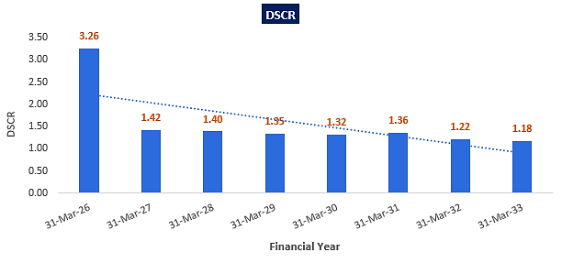
- NPV,IRR AND PAYBACK PERIOD OF THE PROJECT:
(INR Crore)
Year Ending |  | 31-Mar-25 | 31-Dec-25 | 31-Mar-26 | 31-Mar-27 | 31-Mar-28 |  | 31-Mar-29 | 31-Mar-30 | 31-Mar-31 |  | 31-Mar-32 | 31-Mar-33 | 31-Mar-34 | 31-Mar-35
Year Counter |  | 0 | 0 | 1 | 2 | 3 |  | 4 | 5 | 6 |  | 7 | 8 | 9 | 10
Months Counter |  | 0 | 9 | 3 | 12 | 12 |  | 12 | 12 | 12 |  | 12 | 12 | 12 | 12
EBIT |  | 0.00 | 0.00 | 0.98 | 3.82 | 3.49 |  | 3.29 | 3.17 | 3.03 |  | 2.80 | 2.65 | 2.49 | 2.22
Less: Taxes |  | 0.00 | 0.00 | 0.25 | 0.96 | 0.88 |  | 0.83 | 0.80 | 0.76 |  | 0.70 | 0.67 | 0.63 | 0.56
Add: Depreciation & Amortisation |  | 0.00 | 0.00 | 0.24 | 0.96 | 0.96 |  | 0.96 | 0.96 | 0.96 |  | 0.96 | 0.96 | 0.96 | 0.96
NOPAT |  | 0.00 | 0.00 | 0.97 | 3.82 | 3.57 |  | 3.43 | 3.33 | 3.23 |  | 3.06 | 2.95 | 2.83 | 2.63
Increase/(Decrease) in working capital |  | 0.00 | 0.00 | 0.15 | 0.44 | -0.03 |  | 0.00 | 0.00 | 0.00 |  | 0.00 | 0.00 | 0.00 | 0.00
Capex |  | 0.00 | 16.17 | 0.00 | 0.00 | 0.00 |  | 0.00 | 0.00 | 0.00 |  | 0.00 | 0.00 | 0.00 | 0.00
Free Cash Flow to Firm (FCFF) |  | 0.00 | -16.17 | 0.83 | 3.38 | 3.60 |  | 3.43 | 3.33 | 3.23 |  | 3.06 | 2.95 | 2.83 | 2.63
Discount Period |  | 0.00 | 0.75 | 1.00 | 2.00 | 3.00 |  | 4.00 | 5.00 | 6.00 |  | 7.00 | 8.00 | 9.00 | 10.00
Discount Factor |  | 1.00 | 0.93 | 0.91 | 0.82 | 0.74 |  | 0.67 | 0.61 | 0.55 |  | 0.50 | 0.45 | 0.41 | 0.37
PV of FCFF |  | 0.00 | -15.01 | 0.75 | 2.77 | 2.67 |  | 2.30 | 2.03 | 1.78 |  | 1.53 | 1.33 | 1.16 | 0.97
Terminal Value of the project |  |  |  |  |  |  |  |  |  |  |  |  |  |  | 26.58
PV of Terminal Value |  |  |  |  |  |  |  |  |  |  |  |  |  |  | 9.85
FCFF+TV |  | 0.00 | -16.17 | 0.83 | 3.38 | 3.60 |  | 3.43 | 3.33 | 3.23 |  | 3.06 | 2.95 | 2.83 | 29.20
PV of FCF+ PV of Terminal Value |  | 0.00 | -15.01 | 0.75 | 2.77 | 2.67 |  | 2.30 | 2.03 | 1.78 |  | 1.53 | 1.33 | 1.16 | 10.82
NPV |  | INR 12.13 Crore
IRR |  | 23.03%
 | Key Input for NPV & IRR
 | Weight of Debt Wd |  |  |  |  |  | 75%
 | Cost of Debt Kd |  |  |  |  |  | 9.50%
 | Tax |  |  |  |  |  | 25.17%
 | Post tax Kd |  |  |  |  |  | 7.11%
 | Weight of Equity We |  |  |  |  |  | 25%
 | Cost of Equity Ke |  |  |  |  |  | 12.42%
 | WACC |  |  |  |  |  | 8.44%
 | Project Risk Premium |  |  |  |  |  | 2.00%
 | Discount rate |  |  |  |  |  | 10.44%
 | Expected growth rate (Terminal) |  |  |  |  |  | 0.50%

Payback Period of the project
Year Ending | 31-Mar-26 | 31-Mar-27 | 31-Mar-28 | 31-Mar-29 | 31-Mar-30 | 31-Mar-31 | 31-Mar-32 | 31-Mar-33 | 31-Mar-34 | 31-Mar-35
Year Counter | 1 | 2 | 3 | 4 | 5 | 6 | 7 | 8 | 9 | 10
Months Counter | 5 | 12 | 12 | 12 | 12 | 12 | 12 | 12 | 12 | 12
No. Of Years | 1 | 2 | 3 | 4 | 5 | 6 | 7 | 8 | 9 | 10
Cash Accrual | 0.85 | 3.05 | 2.92 | 2.90 | 2.95 | 3.00 | 2.84 | 2.79 | 2.72 | 2.50
Accumulated Cash Accrual | 0.85 | 3.90 | 6.81 | 9.71 | 12.66 | 15.66 | 18.50 | 21.29 | 24.01 | 26.51
TPC | INR 18.71 Cr.
Payback Period | 6.32 Years
Thus, the Ahmedabad-2 cold storage project will be having a payback period of 6.32 years and NPV & IRR of the project is INR 12.13 Crore & 23.03% respectively from C.O.D to loan repayment period, which indicates worthiness of the project.
- SENSITIVITY ANALYSIS: Sensitivity analysis of the project with respect to various expected variables has been shown in the below table:
Sensitivity Analysis | Average DSCR | NPV | IRR | Payback Period
As a base case | 1.56 | INR 12.13 Crore | 23.03% | 6.32 years
If Sales is decreased by 5% | 1.46 | INR 9.66 Crore | 20.80% | 6.96 years
If sales is decreased by 10% | 1.33 | INR 7.18 Crore | 18.44% | 7.85 years
If operating expenses is increased by 5% | 1.53 | INR 10.90 Crore | 21.99% | 6.55 years
If operating expenses is increased by 10% | 1.48 | INR 9.67 Crore | 20.91% | 6.85 years
If interest rate increased by 1% | 1.51 | INR 10.70 Crore | 22.57% | 6.46 years
If Repairs & Maintenance Expenses increased by 1% | 1.54 | INR 11.00 Crore | 22.14% | 6.51 years
If Administrative Expenses increased by 1% | 1.56 | INR 11.64 Crore | 22.60% | 6.40 years
Observation: The proposed project is found comparatively higher sensitive with respect to the downside variation in the projected revenue, than the upside variation in the projected operational expenses and any surge in the interest rate.
- OTHER FINANCIAL RATIOS:
Year Ending | 31-Mar-26 | 31-Mar-27 | 31-Mar-28 | 31-Mar-29 | 31-Mar-30 | 31-Mar-31 | 31-Mar-32 | 31-Mar-33 | 31-Mar-34 | 31-Mar-35
Year Counter | 1 | 2 | 3 | 4 | 5 | 6 | 7 | 8 | 9 | 10
Months Counter | 3 | 12 | 12 | 12 | 12 | 12 | 12 | 12 | 12 | 12
Return on Capital employed (%) | 5.70% | 22.15% | 20.41% | 19.54% | 18.93% | 18.40% | 17.48% | 14.81% | 12.62% | 10.40%
Average | 16.05%
Return on Investment (%) | 0.42% | 10.70% | 11.54% | 13.52% | 16.87% | 21.60% | 26.84% | 39.65% | 38.93% | 34.66%
Average | 21.47%
Return on Net Worth | 1.65% | 27.62% | 21.08% | 17.77% | 15.81% | 14.23% | 11.81% | 10.45% | 9.30% | 7.65%
Average | 13.74%
DSCR | 3.26 | 1.42 | 1.40 | 1.35 | 1.32 | 1.36 | 1.22 | 1.18 | 0.00 | 0.00
Average | 1.56
ISCR | 3.26 | 3.68 | 3.94 | 4.46 | 5.38 | 6.98 | 10.25 | 23.78 | 90.89 | 83.82
Average | 25.64
Fixed Asset Coverage Ratio | 1.29 | 1.41 | 1.61 | 1.96 | 2.63 | 4.76
Average | 2.28
Current Ratio | 44.44 | 44.44 | 14.60 | 14.13 | 13.66 | 13.21 | 12.76 | 12.32 | 11.89 | 11.47
Average | 19.29
TOL/TNW | 3.03 | 1.93 | 1.32 | 0.90 | 0.59 | 0.36 | 0.17 | 0.03 | 0.02 | 0.02
Average | 0.84
Debt to Equity Ratio | 3.00 | 2.63 | 2.25 | 1.85 | 1.41 | 0.97 | 0.49 | 0.00 | 0.00 | 0.00
Average | 1.26

- BREAK-EVEN ANALYSIS:
Year Ending | 31-Mar-26 | 31-Mar-27 | 31-Mar-28 | 31-Mar-29 | 31-Mar-30 | 31-Mar-31 | 31-Mar-32 | 31-Mar-33 | 31-Mar-34 | 31-Mar-35
Year Counter | 1 | 2 | 3 | 4 | 5 | 6 | 7 | 8 | 9 | 10
Months Counter | 3 | 12 | 12 | 12 | 12 | 12 | 12 | 12 | 12 | 12
Sales | 1.84 | 7.35 | 7.35 | 7.35 | 7.35 | 7.35 | 7.35 | 7.35 | 7.35 | 7.35
Variable Expenses | 0.03 | 0.11 | 0.11 | 0.11 | 0.11 | 0.11 | 0.11 | 0.11 | 0.11 | 0.11
Contribution | 1.81 | 7.24 | 7.24 | 7.24 | 7.24 | 7.24 | 7.24 | 7.24 | 7.24 | 7.24
Fixed Expenses | 0.59 | 2.46 | 2.79 | 2.98 | 3.11 | 3.25 | 3.48 | 3.63 | 3.79 | 4.05
Profit / PBT | 1.22 | 4.78 | 4.45 | 4.26 | 4.13 | 3.99 | 3.76 | 3.61 | 3.45 | 3.19
PV RATIO (Contr. / Sales) | 98.50% | 98.50% | 98.50% | 98.50% | 98.50% | 98.50% | 98.50% | 98.50% | 98.50% | 98.50%
BEP Sales | 0.60 | 2.50 | 2.83 | 3.03 | 3.16 | 3.30 | 3.53 | 3.68 | 3.84 | 4.12
BEP% (BEP Sales / sales) | 32.62% | 33.97% | 38.50% | 41.21% | 42.98% | 44.84% | 48.01% | 50.09% | 52.29% | 56.01%

- TERM LOAN INPUTS:
Term Loan Repayment Inputs
Total loan amount | INR 14.14 Crore
Rate of Interest | 9.50%
1st Disbursement | April-25
IDC Start & End Month | April 25 to December-25
IDC Period (construction period) | 9 Month
Commencement /Operation Start | 1st Jan 2026
Moratorium Start & End Month (only interest to pay) | April 2025 to March 2026
Moratorium Period after COD | 03 Month
Repayment Start | April-2026
Repayment End | March-2033
Repayment Period | 07 Years

(INR Crore)
Year Ending | 31-Mar-25 | 31-Dec-25 | 31-Mar-26 | 31-Mar-27 | 31-Mar-28 | 31-Mar-29 | 31-Mar-30 | 31-Mar-31 | 31-Mar-32 | 31-Mar-33 | 31-Mar-34 | 31-Mar-35
Year Counter | 0 | 0 | 1 | 2 | 3 | 4 | 5 | 6 | 7 | 8 | 9 | 10
Months Counter | 0 | 9 | 3 | 12 | 12 | 12 | 12 | 12 | 12 | 12 | 12 | 12
Opening Bal | 0.00 | 0.00 | 14.14 | 14.14 | 12.38 | 10.61 | 8.70 | 6.65 | 4.60 | 2.33 | 0.00 | 0.00
Disbursement | 0.00 | 14.14 | 0.00 | 0.00 | 0.00 | 0.00 | 0.00 | 0.00 | 0.00 | 0.00 | 0.00 | 0.00
Repayment | 0.00 | 0.00 | 0.00 | 1.77 | 1.77 | 1.91 | 2.05 | 2.05 | 2.26 | 2.33 | 0.00 | 0.00
Closing Principal o/s | 0.00 | 14.14 | 14.14 | 12.38 | 10.61 | 8.70 | 6.65 | 4.60 | 2.33 | 0.00 | 0.00 | 0.00
Interest | 0.00 | 0.84 | 0.34 | 1.26 | 1.09 | 0.92 | 0.73 | 0.53 | 0.33 | 0.11 | 0.00 | 0.00
IDC | 0.00 | 0.84 | 0.00 | 0.00 | 0.00 | 0.00 | 0.00 | 0.00 | 0.00 | 0.00 | 0.00 | 0.00
TL Interest | 0.00 | 0.00 | 0.34 | 1.26 | 1.09 | 0.92 | 0.73 | 0.53 | 0.33 | 0.11 | 0.00 | 0.00

- DEPRECIATION SCHEDULE (STRAIGHT LINE METHOD):
(INR Crore)
Depreciation Schedule as per Company's Act, 2013
Particular | 31-Mar-26 | 31-Mar-27 | 31-Mar-28 | 31-Mar-29 | 31-Mar-30 | 31-Mar-31 | 31-Mar-32 | 31-Mar-33 | 31-Mar-34 | 31-Mar-35
Building & Civil Works | 1.91 | 1.91 | 1.91 | 1.91 | 1.91 | 1.91 | 1.91 | 1.91 | 1.91 | 1.91
Less: SLM Depreciation | 0.02 | 0.06 | 0.06 | 0.06 | 0.06 | 0.06 | 0.06 | 0.06 | 0.06 | 0.06
Carrying Value Building & Civil Works | 1.89 | 1.83 | 1.77 | 1.71 | 1.65 | 1.59 | 1.53 | 1.47 | 1.41 | 1.35
Plant & Machinery | 14.26 | 14.26 | 14.26 | 14.26 | 14.26 | 14.26 | 14.26 | 14.26 | 14.26 | 14.26
Less: SLM Depreciation | 0.23 | 0.90 | 0.90 | 0.90 | 0.90 | 0.90 | 0.90 | 0.90 | 0.90 | 0.90
Carrying Value of Plant & Machinery | 14.04 | 13.13 | 12.23 | 11.33 | 10.43 | 9.52 | 8.62 | 7.72 | 6.81 | 5.91
Misc. Fix Assets | 0.00 | 0.00 | 0.00 | 0.00 | 0.00 | 0.00 | 0.00 | 0.00 | 0.00 | 0.00
Less: SLM Depreciation | 0.00 | 0.00 | 0.00 | 0.00 | 0.00 | 0.00 | 0.00 | 0.00 | 0.00 | 0.00
Carrying Value of Misc. Fixed Asset | 0.00 | 0.00 | 0.00 | 0.00 | 0.00 | 0.00 | 0.00 | 0.00 | 0.00 | 0.00
Total SLM Depreciation | 0.24 | 0.96 | 0.96 | 0.96 | 0.96 | 0.96 | 0.96 | 0.96 | 0.96 | 0.96

- WORKING CAPITAL ASSESSMENT:
(INR Crore)
Year Ending | 31-Mar-26 | 31-Mar-27 | 31-Mar-28 | 31-Mar-29 | 31-Mar-30 | 31-Mar-31 | 31-Mar-32 | 31-Mar-33 | 31-Mar-34 | 31-Mar-35
Current Assets | 0.15 | 0.60 | 0.60 | 0.60 | 0.60 | 0.60 | 0.60 | 0.60 | 0.60 | 0.60
Current Liabilities | 0.00 | 0.01 | 0.04 | 0.04 | 0.04 | 0.05 | 0.05 | 0.05 | 0.05 | 0.05
Working Capital | 0.15 | 0.59 | 0.56 | 0.56 | 0.56 | 0.56 | 0.56 | 0.56 | 0.55 | 0.55
Working Capital Margin @25% | 0.04 | 0.15 | 0.14 | 0.14 | 0.14 | 0.14 | 0.14 | 0.14 | 0.14 | 0.14
Working Capital gap | 0.11 | 0.44 | 0.42 | 0.42 | 0.42 | 0.42 | 0.42 | 0.42 | 0.41 | 0.41
Working Capital Requirement | 0.40 | 0.40 | 0.40 | 0.40 | 0.40 | 0.40 | 0.40 | 0.40 | 0.40 | 0.40
Interest on working capital loan | 0.04 | 0.04 | 0.04 | 0.04 | 0.04 | 0.04 | 0.04 | 0.04 | 0.04 | 0.04
LOCATION 5: BHIVANDI COLD STORE
- PROJECTED PROFIT & LOSS ACCOUNT:
(INR Crore)
Year Ending | 31-Mar-26 | 31-Mar-27 | 31-Mar-28 | 31-Mar-29 | 31-Mar-30 | 31-Mar-31 | 31-Mar-32 | 31-Mar-33 | 31-Mar-34 | 31-Mar-35
Year Counter | 1 | 2 | 3 | 4 | 5 | 6 | 7 | 8 | 9 | 10
Months Counter | 4 | 12 | 12 | 12 | 12 | 12 | 12 | 12 | 12 | 12
Revenue
Revenue | 3.72 | 11.43 | 11.90 | 12.41 | 12.96 | 13.54 | 14.15 | 14.81 | 15.52 | 16.27
Cost of Sales
Rental Expenses | 0.68 | 2.14 | 2.25 | 2.36 | 2.48 | 2.60 | 2.73 | 2.87 | 3.01 | 3.16
Cost of Manpower Supply | 1.02 | 3.29 | 3.54 | 3.80 | 4.09 | 4.39 | 4.72 | 5.08 | 5.46 | 5.87
Repair & Maintenance | 0.00 | 0.00 | 0.20 | 0.21 | 0.22 | 0.23 | 0.25 | 0.26 | 0.27 | 0.29
Electricity Expenses | 0.40 | 1.25 | 1.30 | 1.35 | 1.41 | 1.46 | 1.53 | 1.59 | 1.66 | 1.73
Selling, General & Administrative Expenses | 0.06 | 0.17 | 0.18 | 0.19 | 0.19 | 0.20 | 0.21 | 0.22 | 0.23 | 0.24
Operating Expenses | 2.15 | 6.85 | 7.46 | 7.91 | 8.39 | 8.90 | 9.44 | 10.02 | 10.64 | 11.29
EBITDA | 1.57 | 4.58 | 4.44 | 4.50 | 4.57 | 4.64 | 4.71 | 4.79 | 4.88 | 4.98
Depreciation | 0.30 | 0.91 | 0.91 | 0.91 | 0.91 | 0.91 | 0.91 | 0.91 | 0.91 | 0.91
EBIT | 1.26 | 3.66 | 3.53 | 3.59 | 3.65 | 3.72 | 3.80 | 3.88 | 3.97 | 4.06
Interest expenses
Interest on term loan | 0.44 | 1.23 | 1.06 | 0.89 | 0.71 | 0.51 | 0.32 | 0.10 | 0.00 | 0.00
Interest on working capital | 0.05 | 0.05 | 0.05 | 0.05 | 0.05 | 0.05 | 0.05 | 0.05 | 0.05 | 0.05
Total Interest Expenses | 0.49 | 1.28 | 1.11 | 0.94 | 0.75 | 0.56 | 0.37 | 0.15 | 0.05 | 0.05
Profit before Taxes (PBT) | 0.77 | 2.39 | 2.42 | 2.65 | 2.90 | 3.16 | 3.43 | 3.73 | 3.92 | 4.02
Current Tax | 0.00 | 0.41 | 0.41 | 0.45 | 0.50 | 0.64 | 0.88 | 0.98 | 1.06 | 1.10
Deferred Tax | -0.48 | -0.25 | -0.18 | -0.12 | -0.07 | -0.02 | 0.01 | 0.04 | 0.07 | 0.09
Applicable taxes | 0.48 | 0.66 | 0.59 | 0.57 | 0.57 | 0.66 | 0.86 | 0.94 | 0.99 | 1.01
Profit after Taxes (PAT) | 0.29 | 1.73 | 1.82 | 2.08 | 2.33 | 2.50 | 2.57 | 2.79 | 2.94 | 3.01

- PROFORMA BALANCE SHEET:
Below table shows the Projected Balance Sheet of the proposed Bhiwandi location cold store project from the period FY 2025 to FY 2035. From 1st March 2025 to 30th November 2025 would be the implementation period of the project:
(INR Crore)
Year Ending | 31-Mar-25 | 30-Nov-25 | 31-Mar-26 | 31-Mar-27 | 31-Mar-28 | 31-Mar-29 | 31-Mar-30 | 31-Mar-31 | 31-Mar-32 | 31-Mar-33 | 31-Mar-34 | 31-Mar-35
Year Counter | 0 | 0 | 1 | 2 | 3 | 4 | 5 | 6 | 7 | 8 | 9 | 10
Months Counter | 1 | 8 | 4 | 12 | 12 | 12 | 12 | 12 | 12 | 12 | 12 | 12
Liabilities
Equity | 4.43 | 4.43 | 4.65 | 4.65 | 4.65 | 4.65 | 4.65 | 4.65 | 4.65 | 4.65 | 4.65 | 4.65
Reserve & Surplus |  |  | 0.29 | 2.02 | 3.85 | 5.93 | 8.26 | 10.76 | 13.33 | 16.13 | 19.06 | 22.07
Secured Loan | 3.49 | 13.82 | 12.07 | 10.33 | 8.44 | 6.42 | 4.39 | 2.30 | 0.00 | 0.00 | 0.00 | 0.00
Current Liabilities
Trade Payables |  |  | 0.01 | 0.02 | 0.05 | 0.05 | 0.05 | 0.05 | 0.06 | 0.06 | 0.06 | 0.07
Term Liabilities Payable Within One Year | 0.00 | 0.15 | 1.75 | 1.75 | 1.89 | 2.02 | 2.02 | 2.09 | 2.30 | 0.00 | 0.00 | 0.00
Cc Limit |  |  | 0.50 | 0.50 | 0.50 | 0.50 | 0.50 | 0.50 | 0.50 | 0.50 | 0.50 | 0.50
Total | 7.92 | 18.39 | 19.27 | 19.27 | 19.38 | 19.57 | 19.88 | 20.36 | 20.84 | 21.34 | 24.28 | 27.29
Gross Assets
Land Acquisition Cost | 0.00 | 0.00 | 0.00 | 0.00 | 0.00 | 0.00 | 0.00 | 0.00 | 0.00 | 0.00 | 0.00 | 0.00
Land Development Cost | 0.00 | 0.00 | 0.00 | 0.00 | 0.00 | 0.00 | 0.00 | 0.00 | 0.00 | 0.00 | 0.00 | 0.00
Civil Work / Construction | 2.02 | 2.02 | 2.02 | 2.02 | 2.02 | 2.02 | 2.02 | 2.02 | 2.02 | 2.02 | 2.02 | 2.02
Plant & Machinery | 5.05 | 13.41 | 13.41 | 13.41 | 13.41 | 13.41 | 13.41 | 13.41 | 13.41 | 13.41 | 13.41 | 13.41
Misc. Fix Assets | 0.00 | 0.00 | 0.00 | 0.00 | 0.00 | 0.00 | 0.00 | 0.00 | 0.00 | 0.00 | 0.00 | 0.00
Total Gross Block | 7.07 | 15.42 | 15.42 | 15.42 | 15.42 | 15.42 | 15.42 | 15.42 | 15.42 | 15.42 | 15.42 | 15.42
Depreciation |  |  | 0.30 | 1.22 | 2.13 | 3.04 | 3.95 | 4.87 | 5.78 | 6.69 | 7.60 | 8.52
Net Block | 7.07 | 15.42 | 15.12 | 14.21 | 13.30 | 12.38 | 11.47 | 10.56 | 9.64 | 8.73 | 7.82 | 6.91
Differed Tax Asset | 0.00 | 0.00 | -0.48 | -0.73 | -0.90 | -1.02 | -1.09 | -1.11 | -1.10 | -1.06 | -0.99 | -0.90
Balance With Gov. Authorities | 0.00 | 2.12 | 1.83 | 1.01 | 0.21 | 0.00 | 0.00 | 0.00 | 0.00 | 0.00 | 0.00 | 0.00
Mat Credit Entitlement |  |  | 0.00 | 0.41 | 0.39 | 0.30 | 0.13 | 0.00 | 0.00 | 0.00 | 0.00 | 0.00
Security Deposit to Landlord | 0.85 | 0.85 | 0.85 | 0.85 | 0.85 | 0.85 | 0.85 | 0.85 | 0.85 | 0.85 | 0.85 | 0.85
Current Assets
Trade Receivables |  |  | 0.31 | 0.94 | 0.98 | 1.02 | 1.06 | 1.11 | 1.16 | 1.22 | 1.28 | 1.34
Cash & Bank | 0.00 | 0.00 | 1.64 | 2.58 | 4.56 | 6.04 | 7.45 | 8.96 | 10.29 | 11.60 | 15.32 | 19.09
Preliminary Expenses W/Off |  | 0.00 | 0.00 | 0.00 | 0.00 | 0.00 | 0.00 | 0.00 | 0.00 | 0.00 | 0.00 | 0.00
Total | 7.92 | 18.39 | 19.27 | 19.27 | 19.38 | 19.57 | 19.88 | 20.36 | 20.84 | 21.34 | 24.28 | 27.29

- PROJECTED CASH FLOW STATEMENT:
(INR Crore)
Year Ending | 31-Mar-25 | 30-Nov-25 | 31-Mar-26 | 31-Mar-27 | 31-Mar-28 | 31-Mar-29 | 31-Mar-30 | 31-Mar-31 | 31-Mar-32 | 31-Mar-33 | 31-Mar-34 | 31-Mar-35
Year Counter | 0 | 0 | 1 | 2 | 3 | 4 | 5 | 6 | 7 | 8 | 9 | 10
Months Counter | 1 | 8 | 4 | 12 | 12 | 12 | 12 | 12 | 12 | 12 | 12 | 12
Cash Flow from Operating Activities
Profit before Tax | 0.00 | 0.00 | 0.77 | 2.39 | 2.42 | 2.65 | 2.90 | 3.16 | 3.43 | 3.73 | 3.92 | 4.02
Add: Non-Cash Expenses/ Non-Operating Expenses/ (Non-Operating Income) | 0.00 | 0.00 | 0.30 | 0.91 | 0.91 | 0.91 | 0.91 | 0.91 | 0.91 | 0.91 | 0.91 | 0.91
Add: Interest Expense | 0.00 | 0.00 | 0.49 | 1.28 | 1.11 | 0.94 | 0.75 | 0.56 | 0.37 | 0.15 | 0.05 | 0.05
Increase in Sundry Debtors | 0.00 | 0.00 | -0.31 | -0.63 | -0.04 | -0.04 | -0.04 | -0.05 | -0.05 | -0.05 | -0.06 | -0.06
NET GST ASSET | 0.00 | -2.12 | 0.28 | 0.82 | 0.80 | 0.81 | 0.82 | 0.83 | 0.85 | 0.86 | 0.88 | 0.90
Change in MAT | 0.00 | 0.00 | 0.00 | -0.41 | 0.02 | 0.09 | 0.16 | 0.13 | 0.00 | 0.00 | 0.00 | 0.00
Increase in Sundry Creditors | 0.00 | 0.00 | 0.01 | 0.01 | 0.03 | 0.00 | 0.00 | 0.00 | 0.00 | 0.00 | 0.00 | 0.00
Cash Generated from Operations | 0.00 | -2.12 | 1.55 | 4.37 | 5.24 | 5.37 | 5.51 | 5.56 | 5.51 | 5.61 | 5.71 | 5.81
GST Paid | 0.00 | 0.00 | 0.00 | 0.00 | 0.00 | 0.60 | 0.82 | 0.83 | 0.85 | 0.86 | 0.88 | 0.90
Income Taxes paid | 0.00 | 0.00 | 0.00 | 0.41 | 0.41 | 0.45 | 0.50 | 0.64 | 0.88 | 0.98 | 1.06 | 1.10
Net Cash from Operating Activities | 0.00 | -2.12 | 1.55 | 3.96 | 4.83 | 4.31 | 4.19 | 4.09 | 3.79 | 3.76 | 3.77 | 3.81
Cash Flow from Investing Activities
Purchase of Fixed Assets | -7.07 | -8.36 | 0.00 | 0.00 | 0.00 | 0.00 | 0.00 | 0.00 | 0.00 | 0.00 | 0.00 | 0.00
Security Deposit | -0.85 | 0.00 | 0.00 | 0.00 | 0.00 | 0.00 | 0.00 | 0.00 | 0.00 | 0.00 | 0.00 | 0.00
Net Cash from Investing Activities | -7.92 | -8.36 | 0.00 | 0.00 | 0.00 | 0.00 | 0.00 | 0.00 | 0.00 | 0.00 | 0.00 | 0.00
Cash Flow from Financing Activities
Increase in Equity / Share Capital/USL | 4.43 | 0.00 | 0.23 | 0.00 | 0.00 | 0.00 | 0.00 | 0.00 | 0.00 | 0.00 | 0.00 | 0.00
Increase in TL | 3.49 | 10.47 | -0.15 | -1.75 | -1.75 | -1.89 | -2.02 | -2.02 | -2.09 | -2.30 | 0.00 | 0.00
Increase in CC Limit | 0.00 | 0.00 | 0.50 | 0.00 | 0.00 | 0.00 | 0.00 | 0.00 | 0.00 | 0.00 | 0.00 | 0.00
Interest Paid | 0.00 | 0.00 | -0.49 | -1.28 | -1.11 | -0.94 | -0.75 | -0.56 | -0.37 | -0.15 | -0.05 | -0.05
Net Cash from Financing Activities | 7.92 | 10.47 | 0.09 | -3.02 | -2.86 | -2.82 | -2.78 | -2.59 | -2.46 | -2.45 | -0.05 | -0.05
Net increase in cash and cash equivalents | 0.00 | 0.00 | 1.64 | 0.94 | 1.97 | 1.49 | 1.41 | 1.50 | 1.33 | 1.31 | 3.72 | 3.77
Cash and cash equivalents at beginning | 0.00 | 0.00 | 0.00 | 1.64 | 2.58 | 4.56 | 6.04 | 7.45 | 8.96 | 10.29 | 11.60 | 15.32
Cash and cash equivalents | 0.00 | 0.00 | 1.64 | 2.58 | 4.56 | 6.04 | 7.45 | 8.96 | 10.29 | 11.60 | 15.32 | 19.09

- KEY FINANCIAL RATIO:
Year Ending | 31-Mar-26 | 31-Mar-27 | 31-Mar-28 | 31-Mar-29 | 31-Mar-30 | 31-Mar-31 | 31-Mar-32 | 31-Mar-33 | 31-Mar-34 | 31-Mar-35
Year Counter | 1 | 2 | 3 | 4 | 5 | 6 | 7 | 8 | 9 | 10
Months Counter | 4 | 12 | 12 | 12 | 12 | 12 | 12 | 12 | 12 | 12
EBITDA Margin % | 42.10% | 40.06% | 37.30% | 36.26% | 35.24% | 34.26% | 33.29% | 32.36% | 31.46% | 30.59%
Average | 35.29%
EBIT Margin % | 33.93% | 32.08% | 29.64% | 28.91% | 28.20% | 27.51% | 26.85% | 26.20% | 25.58% | 24.98%
Average | 28.39%
PAT Margin % | 7.88% | 15.16% | 15.33% | 16.73% | 18.02% | 18.48% | 18.16% | 18.86% | 18.91% | 18.48%
Average | 16.60%
Revenue growth rate Y-o-Y (%) |  | 207.02% | 4.18% | 4.28% | 4.38% | 4.47% | 4.57% | 4.66% | 4.75% | 4.84%
Average | 27.02%
Note: The proposed Bhiwandi cold storage project is having an average revenue growth rate of 27.02% during the forecasted period. Average EBITDA Margin & EBIT Margin of the project are 35.29% & 28.39% respectively. The project will be operational from 1st December 2025 and as per the trends analysis above, PAT margin is growing from 7.88% in FY 2026 to 18.48% in FY 2035 due to the lower interest cost on borrowings in the later projected years.
- ESTIMATED KEY FINANCIAL METRICS: DEBT SERVICE COVERAGE RATIO (D.S.C.R)
(INR Crore except D.S.C.R)
Year Ending | 31-Mar-26 | 31-Mar-27 | 31-Mar-28 | 31-Mar-29 | 31-Mar-30 | 31-Mar-31 | 31-Mar-32 | 31-Mar-33 | 31-Mar-34 | 31-Mar-35
Year Counter | 1 | 2 | 3 | 4 | 5 | 6 | 7 | 8 | 9 | 10
Months Counter | 4 | 12 | 12 | 12 | 12 | 12 | 12 | 12 | 12 | 12
Cash accrual | 1.08 | 2.89 | 2.91 | 3.11 | 3.32 | 3.44 | 3.47 | 3.66 | 3.78 | 3.83
Interest on term loan | 0.44 | 1.23 | 1.06 | 0.89 | 0.71 | 0.51 | 0.32 | 0.10 | 0.00 | 0.00
Interest on WC | 0.05 | 0.05 | 0.05 | 0.05 | 0.05 | 0.05 | 0.05 | 0.05 | 0.05 | 0.05
Subtotal | 1.57 | 4.17 | 4.03 | 4.05 | 4.07 | 4.00 | 3.84 | 3.81 | 3.83 | 3.87
Interest on term loan | 0.44 | 1.23 | 1.06 | 0.89 | 0.71 | 0.51 | 0.32 | 0.10 | 0.00 | 0.00
Interest on WC | 0.05 | 0.05 | 0.05 | 0.05 | 0.05 | 0.05 | 0.05 | 0.05 | 0.05 | 0.05
Loan Repayment | 0.15 | 1.75 | 1.75 | 1.89 | 2.02 | 2.02 | 2.09 | 2.30 | 0.00 | 0.00
Subtotal | 0.63 | 3.02 | 2.86 | 2.82 | 2.78 | 2.59 | 2.46 | 2.45 | 0.05 | 0.05
DSCR | 2.47 | 1.38 | 1.41 | 1.43 | 1.46 | 1.55 | 1.56 | 1.56
Average DSCR | 1.60
Maximum DSCR | 2.47
Note: D.S.C.R has been calculated for loan repayment period from FY 2026 to FY 2033. The proposed Bhiwandi Cold storage project is having a D.S.C.R of more than 1 during the projected loan repayment period.
- NPV,IRR AND PAYBACK PERIOD OF THE PROJECT:
(INR Crore)
Year Ending | 31-Mar-25 | 30-Nov-25 | 31-Mar-26 | 31-Mar-27 | 31-Mar-28 | 31-Mar-29 | 31-Mar-30 | 31-Mar-31 | 31-Mar-32 | 31-Mar-33 | 31-Mar-34 | 31-Mar-35
Year Counter | 0 | 0 | 1 | 2 | 3 | 4 | 5 | 6 | 7 | 8 | 9 | 10
Months Counter | 1 | 8 | 4 | 12 | 12 | 12 | 12 | 12 | 12 | 12 | 12 | 12
EBIT | 0.00 | 0.00 | 1.26 | 3.66 | 3.53 | 3.59 | 3.65 | 3.72 | 3.80 | 3.88 | 3.97 | 4.06
Less: Taxes | 0.00 | 0.00 | 0.32 | 0.92 | 0.89 | 0.90 | 0.92 | 0.94 | 0.96 | 0.98 | 1.00 | 1.02
Add: Depreciation & Amortisation | 0.00 | 0.00 | 0.30 | 0.91 | 0.91 | 0.91 | 0.91 | 0.91 | 0.91 | 0.91 | 0.91 | 0.91
NOPAT | 0.00 | 0.00 | 1.25 | 3.65 | 3.55 | 3.60 | 3.65 | 3.70 | 3.76 | 3.82 | 3.88 | 3.95
Increase/(Decrease) in working capital | 0.00 | 0.00 | 0.30 | 0.62 | 0.01 | 0.04 | 0.04 | 0.05 | 0.05 | 0.05 | 0.05 | 0.06
Capex | 7.07 | 8.36 | 0.00 | 0.00 | 0.00 | 0.00 | 0.00 | 0.00 | 0.00 | 0.00 | 0.00 | 0.00
Free Cash Flow to Firm (FCFF) | -7.07 | -8.36 | 0.95 | 3.04 | 3.54 | 3.56 | 3.60 | 3.65 | 3.71 | 3.77 | 3.83 | 3.90
Discount Period | 0.08 | 0.75 | 1.08 | 2.08 | 3.08 | 4.08 | 5.08 | 6.08 | 7.08 | 8.08 | 9.08 | 10.08
Discount Factor | 0.99 | 0.93 | 0.90 | 0.81 | 0.74 | 0.67 | 0.60 | 0.55 | 0.50 | 0.45 | 0.41 | 0.37
PV of FCFF | -7.01 | -7.76 | 0.85 | 2.47 | 2.61 | 2.37 | 2.18 | 2.00 | 1.84 | 1.69 | 1.55 | 1.43
Terminal Value of the project |  |  |  |  |  |  |  |  |  |  |  | 39.40
PV of Terminal Value |  |  |  |  |  |  |  |  |  |  |  | 14.48
FCFF+TV | -7.07 | -8.36 | 0.95 | 3.04 | 3.54 | 3.56 | 3.60 | 3.65 | 3.71 | 3.77 | 3.83 | 43.29
PV of FCF+ PV of Terminal Value | -7.01 | -7.76 | 0.85 | 2.47 | 2.61 | 2.37 | 2.18 | 2.00 | 1.84 | 1.69 | 1.55 | 15.91
NPV | INR 18.54 Crore
IRR | 25.62%

Key Input for NPV & IRR
Weight of Debt Wd | 75%
Cost of Debt Kd | 9.50%
Tax | 25.17%
Post tax Kd | 7.11%
Weight of Equity We | 25%
Cost of Equity Ke | 12.42%
WACC | 8.44%
Project Risk Premium | 2.00%
Discount rate | 10.44%
Expected growth rate (Terminal) | 0.50%

Payback Period of the project
Year Ending | 31-Mar-26 | 31-Mar-27 | 31-Mar-28 | 31-Mar-29 | 31-Mar-30 | 31-Mar-31 | 31-Mar-32 | 31-Mar-33 | 31-Mar-34 | 31-Mar-35
Year Counter | 1 | 2 | 3 | 4 | 5 | 6 | 7 | 8 | 9 | 10
Months Counter | 4 | 12 | 12 | 12 | 12 | 12 | 12 | 12 | 12 | 12
No. Of Years | 1 | 2 | 3 | 4 | 5 | 6 | 7 | 8 | 9 | 10
Cash Accrual | 1.08 | 2.89 | 2.91 | 3.11 | 3.32 | 3.44 | 3.47 | 3.66 | 3.78 | 3.83
Accumulated Cash Accrual | 1.08 | 3.97 | 6.88 | 9.99 | 13.30 | 16.74 | 20.22 | 23.88 | 27.66 | 31.48
TPC | INR 18.39 Cr.
Payback Period | 6.47 Years
Thus, the Bhiwandi Cold storage project will be having a payback period of 6.47 years and NPV & IRR of the project is INR 18.54 Crore & 25.62% respectively from C.O.D to loan repayment period, which indicates worthiness of the project.
- SENSITIVITY ANALYSIS:
Sensitivity analysis of the project with respect to various expected variables has been shown in the below table:
Sensitivity Analysis | Average DSCR | NPV | IRR | Payback Period
As a base case | 1.60 | INR 18.54 Crore | 25.62% | 6.47 years
If Sales is decreased by 5% | 1.41 | INR 13.73 Crore | 22.37% | 7.34 years
If sales is decreased by 10% | 1.22 | INR 8.92 Crore | 18.77% | 8.63 years
If operating expenses is increased by 5% | 1.49 | INR 15.28 Crore | 23.48% | 6.97 years
If operating expenses is increased by 10% | 1.36 | INR 12.09 Crore | 21.19% | 7.67 years
If interest rate increased by 1% | 1.54 | INR 16.54 Crore | 25.15% | 6.64 years
If Repairs & Maintenance Expenses increased by 1% | 1.57 | INR 17.53 Crore | 25.03% | 6.62 years
If Administrative Expenses increased by 1% | 1.56 | INR 17.58 Crore | 25.00% | 6.65 years
Observation: The proposed project is found comparatively higher sensitive with respect to the downside variation in the projected revenue, than the upside variation in the projected operational expenses and any surge in the interest rate.
- OTHER FINANCIAL RATIOS:
Year Ending | 31-Mar-26 | 31-Mar-27 | 31-Mar-28 | 31-Mar-29 | 31-Mar-30 | 31-Mar-31 | 31-Mar-32 | 31-Mar-33 | 31-Mar-34 | 31-Mar-35
Year Counter | 1 | 2 | 3 | 4 | 5 | 6 | 7 | 8 | 9 | 10
Months Counter | 4 | 12 | 12 | 12 | 12 | 12 | 12 | 12 | 12 | 12
Return on Capital employed (%) | 7.42% | 21.55% | 20.82% | 21.11% | 21.11% | 21.02% | 21.13% | 18.68% | 16.74% | 15.21%
Average | 18.48%
Return on Investment (%) | 1.59% | 10.35% | 12.18% | 15.86% | 21.09% | 27.65% | 36.97% | 60.04% | 63.06% | 64.58%
Average | 31.34%
Return on Net Worth | 5.92% | 25.92% | 21.46% | 19.63% | 18.08% | 16.23% | 14.29% | 13.45% | 12.38% | 11.25%
Average | 15.86%
DSCR | 2.47 | 1.38 | 1.41 | 1.43 | 1.46 | 1.55 | 1.56 | 1.56 | 0.00 | 0.00
Average | 1.60
ISCR | 3.20 | 3.58 | 3.99 | 4.79 | 6.06 | 8.27 | 12.90 | 32.54 | 102.78 | 104.78
Average | 28.29
Fixed Asset Coverage Ratio | 1.25 | 1.38 | 1.57 | 1.93 | 2.61 | 4.59
Average | 2.22
Current Ratio | 44.44 | 44.44 | 20.81 | 20.73 | 20.67 | 20.61 | 20.57 | 20.53 | 20.50 | 20.49
Average | 25.38
TOL/TNW | 2.90 | 1.89 | 1.28 | 0.85 | 0.54 | 0.32 | 0.16 | 0.03 | 0.02 | 0.02
Average | 0.80
Debt to Equity Ratio | 2.97 | 2.59 | 2.22 | 1.81 | 1.38 | 0.94 | 0.49 | 0.00 | 0.00 | 0.00
Average | 1.24

- BREAK-EVEN ANALYSIS:
Year Ending | 31-Mar-26 | 31-Mar-27 | 31-Mar-28 | 31-Mar-29 | 31-Mar-30 | 31-Mar-31 | 31-Mar-32 | 31-Mar-33 | 31-Mar-34 | 31-Mar-35
Year Counter | 1 | 2 | 3 | 4 | 5 | 6 | 7 | 8 | 9 | 10
Months Counter | 4 | 12 | 12 | 12 | 12 | 12 | 12 | 12 | 12 | 12
Sales | 3.72 | 11.43 | 11.90 | 12.41 | 12.96 | 13.54 | 14.15 | 14.81 | 15.52 | 16.27
Variable Expenses | 0.06 | 0.17 | 0.18 | 0.19 | 0.19 | 0.20 | 0.21 | 0.22 | 0.23 | 0.24
Contribution | 3.67 | 11.25 | 11.72 | 12.23 | 12.76 | 13.33 | 13.94 | 14.59 | 15.29 | 16.03
Fixed Expenses | 2.10 | 6.68 | 7.28 | 7.73 | 8.20 | 8.70 | 9.23 | 9.80 | 10.40 | 11.05
Profit / PBT | 1.57 | 4.58 | 4.44 | 4.50 | 4.57 | 4.64 | 4.71 | 4.79 | 4.88 | 4.98
PV RATIO (Contr. / Sales) | 98.50% | 98.50% | 98.50% | 98.50% | 98.50% | 98.50% | 98.50% | 98.50% | 98.50% | 98.50%
BEP Sales (Fix Exps. / Contr. * Sales) | 2.13 | 6.78 | 7.40 | 7.84 | 8.32 | 8.83 | 9.37 | 9.95 | 10.56 | 11.22
BEP% (BEP Sales / sales) | 57.26% | 59.33% | 62.13% | 63.19% | 64.22% | 65.22% | 66.20% | 67.14% | 68.06% | 68.94%

- TERM LOAN INPUTS:
Term Loan Repayment Inputs
Total loan amount | INR 13.96 Crore
Rate of Interest | 9.50%
1st Disbursement | March-25
IDC Start & End Month | March-25 to Nov-25
IDC Period (construction period) | 9 Month
Commencement /Operation Start | 1st December 2025
Moratorium Start & End Month (only interest to pay) | March 2025 to Feb 2026
Moratorium Period after COD | 03 Month
Repayment Start | March-2026
Repayment End | Feb-2033
Repayment Period | 07 Years

(INR Crore)
Year Ending | 31-Mar-25 | 30-Nov-25 | 31-Mar-26 | 31-Mar-27 | 31-Mar-28 | 31-Mar-29 | 31-Mar-30 | 31-Mar-31 | 31-Mar-32 | 31-Mar-33 | 31-Mar-34 | 31-Mar-35
Year Counter | 0 | 0 | 1 | 2 | 3 | 4 | 5 | 6 | 7 | 8 | 9 | 10
Months Counter | 1 | 8 | 4 | 12 | 12 | 12 | 12 | 12 | 12 | 12 | 12 | 12
Opening Bal | 0.00 | 3.49 | 13.96 | 13.82 | 12.07 | 10.33 | 8.44 | 6.42 | 4.39 | 2.30 | 0.00 | 0.00
Disbursement | 3.49 | 10.47 | 0.00 | 0.00 | 0.00 | 0.00 | 0.00 | 0.00 | 0.00 | 0.00 | 0.00 | 0.00
Repayment | 0.00 | 0.00 | 0.15 | 1.75 | 1.75 | 1.89 | 2.02 | 2.02 | 2.09 | 2.30 | 0.00 | 0.00
Closing Principal o/s | 3.49 | 13.96 | 13.82 | 12.07 | 10.33 | 8.44 | 6.42 | 4.39 | 2.30 | 0.00 | 0.00 | 0.00
Interest | 0.03 | 0.80 | 0.44 | 1.23 | 1.06 | 0.89 | 0.71 | 0.51 | 0.32 | 0.10 | 0.00 | 0.00
IDC | 0.03 | 0.80 | 0.00 | 0.00 | 0.00 | 0.00 | 0.00 | 0.00 | 0.00 | 0.00 | 0.00 | 0.00
TL Interest | 0.00 | 0.00 | 0.44 | 1.23 | 1.06 | 0.89 | 0.71 | 0.51 | 0.32 | 0.10 | 0.00 | 0.00

- DEPRECIATION SCHEDULE (STRAIGHT LINE METHOD):
(INR Crore)
Depreciation Schedule as per Company's Act, 2013
Particular | 31-Mar-26 | 31-Mar-27 | 31-Mar-28 | 31-Mar-29 | 31-Mar-30 | 31-Mar-31 | 31-Mar-32 | 31-Mar-33 | 31-Mar-34 | 31-Mar-35
Building & Civil Works | 2.02 | 2.02 | 2.02 | 2.02 | 2.02 | 2.02 | 2.02 | 2.02 | 2.02 | 2.02
Less: SLM Depreciation | 0.02 | 0.06 | 0.06 | 0.06 | 0.06 | 0.06 | 0.06 | 0.06 | 0.06 | 0.06
Carrying Value Building & Civil Works | 2.00 | 1.93 | 1.87 | 1.81 | 1.74 | 1.68 | 1.61 | 1.55 | 1.49 | 1.42
Plant & Machinery | 13.41 | 13.41 | 13.41 | 13.41 | 13.41 | 13.41 | 13.41 | 13.41 | 13.41 | 13.41
Less: SLM Depreciation | 0.28 | 0.85 | 0.85 | 0.85 | 0.85 | 0.85 | 0.85 | 0.85 | 0.85 | 0.85
Carrying Value of Plant & Machinery | 13.12 | 12.27 | 11.43 | 10.58 | 9.73 | 8.88 | 8.03 | 7.18 | 6.33 | 5.49
Misc. Fix Assets | 0.00 | 0.00 | 0.00 | 0.00 | 0.00 | 0.00 | 0.00 | 0.00 | 0.00 | 0.00
Less: SLM Depreciation | 0.00 | 0.00 | 0.00 | 0.00 | 0.00 | 0.00 | 0.00 | 0.00 | 0.00 | 0.00
Carrying Value of Misc. Fixed Asset | 0.00 | 0.00 | 0.00 | 0.00 | 0.00 | 0.00 | 0.00 | 0.00 | 0.00 | 0.00
Total SLM Depreciation | 0.30 | 0.91 | 0.91 | 0.91 | 0.91 | 0.91 | 0.91 | 0.91 | 0.91 | 0.91

- WORKING CAPITAL ASSESSMENT:
(INR Crore)
Year Ending | 31-Mar-26 | 31-Mar-27 | 31-Mar-28 | 31-Mar-29 | 31-Mar-30 | 31-Mar-31 | 31-Mar-32 | 31-Mar-33 | 31-Mar-34 | 31-Mar-35
Current Assets | 0.31 | 0.94 | 0.98 | 1.02 | 1.06 | 1.11 | 1.16 | 1.22 | 1.28 | 1.34
Current Liabilities | 0.01 | 0.02 | 0.05 | 0.05 | 0.05 | 0.05 | 0.06 | 0.06 | 0.06 | 0.07
Working Capital | 0.30 | 0.92 | 0.93 | 0.97 | 1.01 | 1.06 | 1.11 | 1.16 | 1.21 | 1.27
Working Capital Margin @25% | 0.07 | 0.23 | 0.23 | 0.24 | 0.25 | 0.26 | 0.28 | 0.29 | 0.30 | 0.32
Working Capital gap | 0.22 | 0.69 | 0.70 | 0.73 | 0.76 | 0.79 | 0.83 | 0.87 | 0.91 | 0.95
Working Capital Requirement | 0.50 | 0.50 | 0.50 | 0.50 | 0.50 | 0.50 | 0.50 | 0.50 | 0.50 | 0.50
Interest on working capital loan | 0.05 | 0.05 | 0.05 | 0.05 | 0.05 | 0.05 | 0.05 | 0.05 | 0.05 | 0.05

COMBINED FINANCIALS OF M/S CRPL INFRA PVT LTD. INCLUDING EXISTING OPERATIONS:
- PROJECTED COMBINED PROFIT & LOSS ACCOUNT:
(INR Crore)
Year Ending | 31-Mar-26 | 31-Mar-27 | 31-Mar-28 | 31-Mar-29 | 31-Mar-30 | 31-Mar-31 | 31-Mar-32 | 31-Mar-33 | 31-Mar-34 | 31-Mar-35
Year Counter | 1 | 2 | 3 | 4 | 5 | 6 | 7 | 8 | 9 | 10
Months Counter | 6 | 12 | 12 | 12 | 12 | 12 | 12 | 12 | 12 | 12
Revenue
Revenue | 38.54 | 66.28 | 68.85 | 71.66 | 74.54 | 77.59 | 80.91 | 84.32 | 87.94 | 91.88
Cost of Sales
Rental Expenses | 2.10 | 6.14 | 6.40 | 6.82 | 7.10 | 7.40 | 7.89 | 8.21 | 8.55 | 9.12
Cost of Manpower Supply | 3.06 | 9.18 | 9.87 | 10.61 | 11.40 | 12.26 | 13.18 | 14.16 | 15.23 | 16.37
Repair & Maintenance | 0.00 | 0.00 | 0.89 | 0.94 | 0.98 | 1.03 | 1.08 | 1.14 | 1.19 | 1.25
Electricity Expenses | 1.87 | 5.58 | 5.82 | 6.07 | 6.33 | 6.60 | 6.89 | 7.20 | 7.52 | 7.85
Selling, General & Administrative Expenses | 0.21 | 0.61 | 0.62 | 0.65 | 0.67 | 0.69 | 0.72 | 0.74 | 0.77 | 0.80
Existing Operating Expenses | 8.39 | 8.81 | 9.26 | 9.72 | 10.20 | 10.71 | 11.25 | 11.81 | 12.40 | 13.02
Operating Expenses | 15.63 | 30.32 | 32.85 | 34.79 | 36.69 | 38.69 | 41.01 | 43.27 | 45.67 | 48.42
EBITDA | 22.91 | 35.96 | 36.00 | 36.86 | 37.85 | 38.89 | 39.90 | 41.06 | 42.27 | 43.46
Depreciation | 9.65 | 10.82 | 9.58 | 8.57 | 7.76 | 7.10 | 6.56 | 6.13 | 5.77 | 5.48
Other Non-Operating Income | 1.46 | 1.46 | 1.46 | 1.46 | 1.23 | 1.00 | 1.00 | 1.00 | 1.00 | 1.00
EBIT | 14.72 | 26.60 | 27.89 | 29.75 | 31.32 | 32.79 | 34.34 | 35.93 | 37.50 | 38.98
Interest expenses
Interest on term loan | 1.94 | 5.17 | 4.47 | 3.74 | 2.96 | 2.15 | 1.32 | 0.40 | 0.00 | 0.00
Interest on working capital | 0.18 | 0.18 | 0.18 | 0.18 | 0.18 | 0.18 | 0.18 | 0.18 | 0.18 | 0.18
Existing Finance Cost | 3.92 | 3.23 | 2.42 | 1.70 | 1.08 | 0.52 | 0.24 | 0.15 | 0.06 | 0.00
Total Interest Expenses | 6.04 | 8.58 | 7.07 | 5.62 | 4.22 | 2.85 | 1.74 | 0.73 | 0.24 | 0.18
Profit before Taxes (PBT) | 8.68 | 18.02 | 20.82 | 24.13 | 27.10 | 29.94 | 32.60 | 35.20 | 37.26 | 38.80
Current Tax | 1.63 | 3.86 | 4.53 | 5.25 | 5.89 | 6.73 | 7.98 | 8.95 | 9.58 | 10.07
Deferred Tax | -2.18 | -1.19 | -0.81 | -0.49 | -0.24 | -0.03 | 0.14 | 0.28 | 0.40 | 0.49
Applicable taxes | 3.52 | 4.77 | 5.23 | 5.76 | 6.23 | 6.91 | 8.02 | 8.86 | 9.38 | 9.77
Profit after Taxes (PAT) | 5.16 | 13.26 | 15.59 | 18.37 | 20.88 | 23.03 | 24.58 | 26.34 | 27.89 | 29.04

- PROFORMA BALANCE SHEET:
Below table shows the Projected Combined Balance Sheet of the CRPL including Existing Financials from the period FY 2025 to FY 2035. From 1st Jan 2025 to 31st December 2025 would be the implementation period of the proposed 5 cold storage project:
(INR Crore)
Year Ending | 31-Mar-25 | 30-Sep-25 | 31-Mar-26 | 31-Mar-27 | 31-Mar-28 | 31-Mar-29 | 31-Mar-30 | 31-Mar-31 | 31-Mar-32 | 31-Mar-33 | 31-Mar-34 | 31-Mar-35
Year Counter | 0 | 0 | 1 | 2 | 3 | 4 | 5 | 6 | 7 | 8 | 9 | 10
Months Counter | 3 | 6 | 6 | 12 | 12 | 12 | 12 | 12 | 12 | 12 | 12 | 12
Liabilities
Equity |  |  | 7.56 | 7.56 | 7.56 | 7.56 | 7.56 | 7.56 | 7.56 | 7.56 | 7.56 | 7.56
Reserve & Surplus |  |  | 9.50 | 22.76 | 38.34 | 56.72 | 77.59 | 100.62 | 125.20 | 151.54 | 179.43 | 208.46
Securities premium amount |  |  | 26.53 | 26.53 | 26.53 | 26.53 | 26.53 | 26.53 | 26.53 | 26.53 | 26.53 | 26.53
Secured Loan | 17.43 | 58.07 | 80.11 | 64.20 | 50.08 | 34.77 | 21.47 | 11.56 | 1.19 | 0.01 | 0.00 | 0.00
Promoter’s Contribution | 14.22 | 18.79 | 19.60 | 19.60 | 19.60 | 19.60 | 19.60 | 19.60 | 19.60 | 19.60 | 19.60 | 19.60
Existing Non-Current Liabilities |  |  | 1.30 | 0.84 | 0.38 | -0.08 | 0.15 | 0.15 | 0.15 | 0.15 | 0.15 | 0.15
Current Liabilities
Trade Payables | 0.00 | 0.00 | 0.73 | 0.81 | 0.96 | 1.00 | 1.05 | 1.11 | 1.16 | 1.22 | 1.28 | 1.34
Term Liabilities Payable Within One Year | 0.00 | 0.73 | 15.41 | 15.91 | 14.12 | 15.31 | 13.30 | 9.91 | 10.37 | 1.18 | 0.00 | 0.00
Cc Limit | 0.00 | 0.00 | 3.90 | 3.90 | 3.90 | 3.90 | 3.90 | 3.90 | 3.90 | 3.90 | 3.90 | 3.90
Other Current Liabilities |  |  | 4.89 | 1.73 | 1.73 | 1.28 | 1.28 | 1.28 | 1.28 | 1.28 | 1.28 | 1.28
Total | 31.66 | 77.58 | 169.53 | 163.84 | 163.21 | 166.59 | 172.43 | 182.22 | 196.94 | 212.97 | 239.72 | 268.82
Gross Assets
Land Acquisition Cost | 0.00 | 0.00 | 0.00 | 0.00 | 0.00 | 0.00 | 0.00 | 0.00 | 0.00 | 0.00 | 0.00 | 0.00
Land Development Cost | 0.00 | 0.00 | 0.00 | 0.00 | 0.00 | 0.00 | 0.00 | 0.00 | 0.00 | 0.00 | 0.00 | 0.00
Civil Work / Construction | 6.19 | 8.10 | 8.10 | 8.10 | 8.10 | 8.10 | 8.10 | 8.10 | 8.10 | 8.10 | 8.10 | 8.10
Plant & Machinery | 23.00 | 57.49 | 57.49 | 57.49 | 57.49 | 57.49 | 57.49 | 57.49 | 57.49 | 57.49 | 57.49 | 57.49
Existing Fixed Assets | 0.00 | 0.00 | 54.27 | 54.27 | 54.27 | 54.27 | 54.27 | 54.27 | 54.27 | 54.27 | 54.27 | 54.27
Total Gross Block | 29.19 | 65.59 | 119.85 | 119.85 | 119.85 | 119.85 | 119.85 | 119.85 | 119.85 | 119.85 | 119.85 | 119.85
Depreciation |  |  | 9.65 | 20.47 | 30.05 | 38.62 | 46.37 | 53.47 | 60.04 | 66.16 | 71.93 | 77.41
Net Block | 29.19 | 65.59 | 110.21 | 99.38 | 89.81 | 81.24 | 73.48 | 66.38 | 59.82 | 53.69 | 47.92 | 42.45
Deferred Tax Asset | 0.00 | 0.00 | -1.26 | -2.16 | -2.85 | -3.36 | -3.70 | -3.87 | -3.91 | -3.82 | -3.61 | -3.31
Mat Credit Entitlement | 0.00 | 0.00 | 0.00 | 1.60 | 1.72 | 1.41 | 0.81 | 0.18 | 0.00 | 0.00 | 0.00 | 0.00
Security Deposit to Landlord | 2.47 | 2.63 | 2.63 | 2.63 | 2.63 | 2.63 | 2.63 | 2.63 | 2.63 | 2.63 | 2.63 | 2.63
Other Non-Current Assets |  |  | 21.11 | 21.11 | 21.11 | 20.48 | 20.48 | 20.48 | 20.48 | 20.48 | 20.48 | 20.48
Current Assets
Trade Receivables |  |  | 3.20 | 6.03 | 6.38 | 7.39 | 7.79 | 8.20 | 8.64 | 9.11 | 9.59 | 10.11
Cash & Bank | 0.00 | 0.00 | 17.42 | 22.61 | 35.23 | 49.36 | 63.70 | 81.18 | 102.44 | 124.24 | 156.27 | 190.23
Bank deposits |  |  | 2.85 | 2.85 | 2.85 | 2.85 | 2.85 | 2.85 | 2.85 | 2.85 | 2.85 | 2.85
Balance with Gov. Authorities | 0.00 | 9.37 | 8.18 | 4.79 | 1.54 | 0.00 | 0.00 | 0.00 | 0.00 | 0.00 | 0.00 | 0.00
Preliminary Expenses W/Off |  | 0.00 | 0.00 | 0.00 | 0.00 | 0.00 | 0.00 | 0.00 | 0.00 | 0.00 | 0.00 | 0.00
Other current assets |  |  | 5.19 | 4.99 | 4.79 | 4.59 | 4.39 | 4.19 | 3.99 | 3.79 | 3.59 | 3.38
Total | 31.66 | 77.58 | 169.53 | 163.84 | 163.21 | 166.59 | 172.43 | 182.22 | 196.94 | 212.97 | 239.72 | 268.82

- PROJECTED COMBINED CASH FLOW STATEMENT:
(INR Crore)
Year Ending | 31-Mar-25 | 30-Sep-25 | 31-Mar-26 | 31-Mar-27 | 31-Mar-28 | 31-Mar-29 | 31-Mar-30 | 31-Mar-31 | 31-Mar-32 | 31-Mar-33 | 31-Mar-34 | 31-Mar-35
Year Counter | 0 | 0 | 1 | 2 | 3 | 4 | 5 | 6 | 7 | 8 | 9 | 10
Months Counter | 3 | 6 | 6 | 12 | 12 | 12 | 12 | 12 | 12 | 12 | 12 | 12
Cash Flow from Operating Activities
Net Cash from Operating Activities | 0.00 | -9.37 | 27.76 | 31.76 | 34.59 | 32.88 | 32.87 | 32.62 | 31.91 | 31.90 | 32.46 | 33.14
Cash Flow from Investing Activities
Net Cash from Investing Activities | -31.66 | -36.56 | 1.00 | -2.58 | 1.00 | 1.00 | 1.00 | 1.00 | 1.00 | 1.00 | 1.00 | 1.00
Cash Flow from Financing Activities
Net Cash from Financing Activities | 31.66 | 45.93 | -12.80 | -23.99 | -22.98 | -19.75 | -19.53 | -16.15 | -11.65 | -11.10 | -1.43 | -0.18
Net increase in cash and cash equivalents | 0.00 | 0.00 | 15.96 | 5.19 | 12.61 | 14.14 | 14.34 | 17.48 | 21.26 | 21.80 | 32.03 | 33.96
Cash and cash equivalents at beginning of period | 0.00 | 0.00 | 1.46 | 17.42 | 22.61 | 35.23 | 49.36 | 63.70 | 81.18 | 102.44 | 124.24 | 156.27
Cash and cash equivalents at end of period | 0.00 | 0.00 | 17.42 | 22.61 | 35.23 | 49.36 | 63.70 | 81.18 | 102.44 | 124.24 | 156.27 | 190.23

- KEY FINANCIAL RATIO:
Year Ending | 31-Mar-26 | 31-Mar-27 | 31-Mar-28 | 31-Mar-29 | 31-Mar-30 | 31-Mar-31 | 31-Mar-32 | 31-Mar-33 | 31-Mar-34 | 31-Mar-35
Year Counter | 1 | 2 | 3 | 4 | 5 | 6 | 7 | 8 | 9 | 10
Months Counter | 6 | 12 | 12 | 12 | 12 | 12 | 12 | 12 | 12 | 12
EBITDA Margin % | 59.44% | 54.26% | 52.29% | 51.44% | 50.78% | 50.13% | 49.32% | 48.69% | 48.07% | 47.30%
Average | 51.17%
EBIT Margin % | 38.20% | 40.13% | 40.50% | 41.52% | 42.02% | 42.27% | 42.44% | 42.61% | 42.65% | 42.43%
Average | 41.48%
PAT Margin % | 13.40% | 20.00% | 22.64% | 25.64% | 28.01% | 29.69% | 30.38% | 31.24% | 31.71% | 31.60%
Average | 26.43%
Revenue growth rate Y-o-Y (%) |  | 71.97% | 3.88% | 4.08% | 4.02% | 4.09% | 4.28% | 4.22% | 4.29% | 4.48%
Average | 11.70%
Note: Thus M/s CRPL (Including proposed Cold storage project and existing operations) is having an average revenue growth rate of 11.70% (combined) during the forecasted period. Average EBITDA Margin & EBIT Margin of the combined projects are 51.17% & 41.48% respectively. The proposed project will be operational from 1st Jan 2025 and as per the trends analysis above, PAT margin is growing from 13.40% in FY 2026 to 31.60% in FY 2035 due to the lower interest cost on borrowings in the later projected years.
- ESTIMATED KEY FINANCIAL METRICS: COMBINED DEBT SERVICE COVERAGE RATIO (D.S.C.R)

(INR Crore except D.S.C.R)
Year Ending | 31-Mar-26 | 31-Mar-27 | 31-Mar-28 | 31-Mar-29 | 31-Mar-30 | 31-Mar-31 | 31-Mar-32 | 31-Mar-33 | 31-Mar-34 | 31-Mar-35
Year Counter | 1 | 2 | 3 | 4 | 5 | 6 | 7 | 8 | 9 | 10
Months Counter | 6 | 12 | 12 | 12 | 12 | 12 | 12 | 12 | 12 | 12
Cash accrual | 16.99 | 25.27 | 25.97 | 27.44 | 28.87 | 30.16 | 31.00 | 32.18 | 33.26 | 34.02
Interest on term loan | 5.86 | 8.40 | 6.89 | 5.44 | 4.04 | 2.67 | 1.56 | 0.55 | 0.06 | 0.00
Interest on WC | 0.18 | 0.18 | 0.18 | 0.18 | 0.18 | 0.18 | 0.18 | 0.18 | 0.18 | 0.18
Subtotal | 23.03 | 33.85 | 33.04 | 33.06 | 33.09 | 33.01 | 32.74 | 32.92 | 33.50 | 34.20
Interest on term loan | 5.86 | 8.40 | 6.89 | 5.44 | 4.04 | 2.67 | 1.56 | 0.55 | 0.06 | 0.00
Interest on WC | 0.18 | 0.18 | 0.18 | 0.18 | 0.18 | 0.18 | 0.18 | 0.18 | 0.18 | 0.18
Loan Repayment | 6.97 | 23.47 | 24.47 | 20.31 | 22.10 | 18.07 | 10.86 | 11.32 | 2.36 | 0.00
Subtotal | 13.01 | 32.05 | 31.54 | 25.93 | 26.32 | 20.92 | 12.60 | 12.05 | 2.60 | 0.18
DSCR | 1.77 | 1.06 | 1.05 | 1.27 | 1.26 | 1.58 | 2.60 | 2.73 | 12.88 | 189.48
Average DSCR | 1.63
Note: D.S.C.R has been calculated for loan repayment period from FY 2026 to FY 2034. The Cold storage project (combined) including existing operations is having a D.S.C.R of more than 1 during the projected loan repayment period.
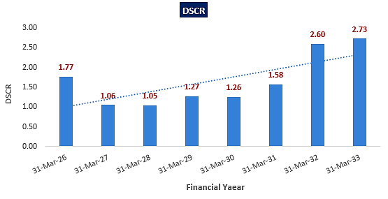
- NPV,IRR AND PAYBACK PERIOD OF THE PROJECT:
(INR Crore)
Year Ending | 31-Mar-25 | 30-Sep-25 | 31-Mar-26 | 31-Mar-27 | 31-Mar-28 | 31-Mar-29 | 31-Mar-30 | 31-Mar-31 | 31-Mar-32 | 31-Mar-33 | 31-Mar-34 | 31-Mar-35
Year Counter | 0 | 0 | 1 | 2 | 3 | 4 | 5 | 6 | 7 | 8 | 9 | 10
Months Counter | 3 | 6 | 6 | 12 | 12 | 12 | 12 | 12 | 12 | 12 | 12 | 12
EBIT | 0.00 | 0.00 | 14.72 | 26.60 | 27.89 | 29.75 | 31.32 | 32.79 | 34.34 | 35.93 | 37.50 | 38.98
Less: Taxes | 0.00 | 0.00 | 3.71 | 6.69 | 7.02 | 7.49 | 7.88 | 8.25 | 8.64 | 9.04 | 9.44 | 9.81
Add: Depreciation & Amortisation | 0.00 | 0.00 | 9.65 | 10.82 | 9.58 | 8.57 | 7.76 | 7.10 | 6.56 | 6.13 | 5.77 | 5.48
NOPAT | 0.00 | 0.00 | 20.66 | 30.73 | 30.44 | 30.84 | 31.20 | 31.64 | 32.26 | 33.01 | 33.83 | 34.65
Increase/(Decrease) in working capital | 0.00 | 0.00 | 2.77 | 5.71 | 0.00 | 1.21 | 0.14 | 0.16 | 0.19 | 0.20 | 0.23 | 0.25
Capex | -29.19 | -36.40 | 0.00 | 0.00 | 0.00 | 0.00 | 0.00 | 0.00 | 0.00 | 0.00 | 0.00 | 0.00
Free Cash Flow to Firm (FCFF) | -29.19 | -36.40 | 17.89 | 25.02 | 30.44 | 29.62 | 31.05 | 31.47 | 32.07 | 32.81 | 33.61 | 34.40
Discount Period | 0.25 | 0.75 | 1.25 | 2.25 | 3.25 | 4.25 | 5.25 | 6.25 | 7.25 | 8.25 | 9.25 | 10.25
Discount Factor | 0.98 | 0.93 | 0.88 | 0.80 | 0.72 | 0.66 | 0.59 | 0.54 | 0.49 | 0.44 | 0.40 | 0.36
PV of FCFF | -28.47 | -33.79 | 15.80 | 20.01 | 22.05 | 19.43 | 18.44 | 16.92 | 15.61 | 14.46 | 13.42 | 12.43
Terminal Value of the project |  |  |  |  |  |  |  |  |  |  |  | 347.91
PV of Terminal Value |  |  |  |  |  |  |  |  |  |  |  | 125.76
FCFF+TV | -29.19 | -36.40 | 17.89 | 25.02 | 30.44 | 29.62 | 31.05 | 31.47 | 32.07 | 32.81 | 33.61 | 382.31
PV of FCF+ PV of Terminal Value | -28.47 | -33.79 | 15.80 | 20.01 | 22.05 | 19.43 | 18.44 | 16.92 | 15.61 | 14.46 | 13.42 | 138.20
NPV | INR 237.79 Crore
IRR | 47.58%

Key Input for NPV & IRR
Weight of Debt Wd | 75%
Cost of Debt Kd | 9.50%
Tax | 25.17%
Post tax Kd | 7.11%
Weight of Equity We | 25%
Cost of Equity Ke | 12.42%
WACC | 8.44%
Project Risk Premium | 2.00%
Discount rate | 10.44%
Expected growth rate (Terminal) | 0.50%

Payback Period of the project (Combined)
Year Ending | 31-Mar-26 | 31-Mar-27 | 31-Mar-28 | 31-Mar-29 | 31-Mar-30 | 31-Mar-31 | 31-Mar-32 | 31-Mar-33 | 31-Mar-34 | 31-Mar-35
Year Counter | 1 | 2 | 3 | 4 | 5 | 6 | 7 | 8 | 9 | 10
Months Counter | 6 | 12 | 12 | 12 | 12 | 12 | 12 | 12 | 12 | 12
No. Of Years | 1 | 2 | 3 | 4 | 5 | 6 | 7 | 8 | 9 | 10
Cash Accrual | 16.78 | 24.94 | 25.56 | 27.02 | 28.46 | 29.78 | 30.74 | 31.93 | 32.88 | 33.64
Accumulated Cash Accrual | 16.78 | 41.72 | 67.28 | 94.31 | 122.76 | 152.54 | 183.28 | 215.21 | 248.09 | 281.73
TPC | INR 78.38 Cr.
Payback Period | 2.87 Years
Thus, the combined cold storage project will be having a payback period of 2.87 years and NPV & IRR of the project is INR 237.79 Crore & 47.58% respectively from C.O.D to loan repayment period, which indicates worthiness of the project.
- OTHER FINANCIAL RATIOS:
Year Ending | 31-Mar-26 | 31-Mar-27 | 31-Mar-28 | 31-Mar-29 | 31-Mar-30 | 31-Mar-31 | 31-Mar-32 | 31-Mar-33 | 31-Mar-34 | 31-Mar-35
Year Counter | 1 | 2 | 3 | 4 | 5 | 6 | 7 | 8 | 9 | 10
Months Counter | 6 | 12 | 12 | 12 | 12 | 12 | 12 | 12 | 12 | 12
Return on Capital employed (%) | 10.27% | 18.91% | 19.62% | 20.50% | 20.51% | 19.77% | 19.07% | 17.51% | 16.09% | 14.87%
Average | 17.71%
Return on Investment (%) | 3.46% | 9.91% | 13.22% | 17.71% | 23.60% | 30.64% | 37.67% | 48.00% | 51.94% | 54.09%
Average | 29.02%
Return on Net Worth | 8.17% | 17.34% | 16.93% | 16.64% | 15.90% | 14.93% | 13.74% | 12.83% | 11.96% | 11.08%
Average | 13.95%
DSCR | 1.77 | 1.06 | 1.05 | 1.27 | 1.26 | 1.58 | 2.60 | 2.73 | 12.88 | 189.48
Average | 1.63
Fixed Asset Coverage Ratio | 1.38 | 1.55 | 1.79 | 2.34 | 3.42 | 5.74
Average | 2.70
TOL/TNW | 1.58 | 1.11 | 0.75 | 0.50 | 0.30 | 0.17 | 0.09 | 0.03 | 0.02 | 0.02
Average | 0.46
Debt to Equity Ratio | 1.51 | 1.05 | 0.70 | 0.45 | 0.26 | 0.14 | 0.06 | 0.01 | 0.00 | 0.00
Average | 0.42

- BREAK-EVEN ANALYSIS:
Year Ending | 31-Mar-26 | 31-Mar-27 | 31-Mar-28 | 31-Mar-29 | 31-Mar-30 | 31-Mar-31 | 31-Mar-32 | 31-Mar-33 | 31-Mar-34 | 31-Mar-35
Year Counter | 1 | 2 | 3 | 4 | 5 | 6 | 7 | 8 | 9 | 10
Months Counter | 6 | 12 | 12 | 12 | 12 | 12 | 12 | 12 | 12 | 12
Sales | 38.54 | 66.28 | 68.85 | 71.66 | 74.54 | 77.59 | 80.91 | 84.32 | 87.94 | 91.88
Variable Expenses | 2.43 | 2.94 | 3.07 | 3.22 | 3.37 | 3.53 | 3.70 | 3.87 | 4.06 | 4.25
Contribution | 36.11 | 63.34 | 65.78 | 68.44 | 71.17 | 74.06 | 77.21 | 80.45 | 83.88 | 87.63
Fixed Expenses | 13.20 | 27.38 | 29.78 | 31.58 | 33.32 | 35.17 | 37.31 | 39.40 | 41.61 | 34.59
Profit / PBT | 22.91 | 35.96 | 36.00 | 36.86 | 37.85 | 38.89 | 39.90 | 41.06 | 42.27 | 53.04
PV RATIO (Contr. / Sales) | 93.70% | 95.57% | 95.53% | 95.51% | 95.48% | 95.45% | 95.43% | 95.41% | 95.39% | 95.37%
BEP Sales | 14.09 | 28.65 | 31.17 | 33.06 | 34.90 | 36.84 | 39.10 | 41.29 | 43.62 | 36.27
BEP% (BEP Sales / sales) | 36.56% | 43.23% | 45.27% | 46.14% | 46.82% | 47.49% | 48.32% | 48.97% | 49.60% | 39.48%

Note: It is to be noted here that the existing financials of CRPL has been shared by the client as prepration of financial projections or vetting of the existing business operations of CRPL is out of scope of this TEV report. Financial projections of existing businessess of CRPL shared by company/client, are merged with the projected combined financials of proposed 5 cold stareges projects located at Noida, Pune, Ahmedabad (Kheda), Ahmedabad (Detroj) and Bhiwandi on request of the bank/financial institution. We recommend the bank/financial instituition to validate the existing financial projection of CRPL by appointing a proffesional or suggest the client to submit a validated/signed/approved model of existing business.

- KEY ASSUMPTIONS & BASIS:
S. No. | Item | Assumptions and Basis
 | General | - Location wise financial projections of the proposed cold storage/ware house project are done for the period from FY 2025 to FY 2035, ~10 years, to cover the term loan period as per the industry best practices and inputs shared by client, considering the fact that M/s CRPL has proposed to set up 5 cold storage/warehouse at Dhoom Manikpur, Dadri, Noida, Pune, Ahmedabad (Kheda), Ahmedabad (Detroj) and Bhiwandi, Maharashtra for its Q-commerce clients based on reimbursement & non-reimbursement business model.  - As per the implementation plan of CRPL, Dhoom Manikpur, Dadri, Noida cold storage will be achieving COD on 1st December 2025, Pune cold storage will be achieving COD on 1st October 2025, Ahmedabad (Kheda) cold storage will be achieving COD on 1st November 2025, Ahmedabad (Detroj) cold storage will be achieving COD on 1st January 2026 and Bhiwandi cold storage will be achieving COD on 1st December 2025.  - As per the commercial agreement, Dhoom Manikpur, Dadri, Noida, Pune, Ahmedabad (Kheda) and Bhiwandi cold storages/warehouses will be setting up for Q-commerce player Zepto based on reimbursement business model and Ahmedabad (Detroj) cold storage/warehouse will be setting up for Falcon Agrifriz Foods Private Limited based non-reimbursement business model.  - It is to be noted here that the Bhiwandi cold storage project is under evaluation stages and scope & scale of the cold storage would be similar to the Noida cold storage. Thus, projections of Bhiwandi cold storage are prepared similar to Noida cold storage based on the similar inputs and assumptions.  - We have considered both Revenue & cost-based model (top to bottom approach) while making the future financial projections.  - Revenue and Expense modelling has been done based on the based-on reimbursement & non-reimbursement business model as per the commercial agreements and LOIs with respective parties involved.  - All 5 cold storages are assumed to be operational for 365 days for (24 X 7) annually.
 | Revenue Build up | Zepto (Noida, Pune, Ahmedabad (Kheda) and Bhiwandi:  - As per the commercial agreement, Cold storages for Zepto would be operational based on reimbursement model i.e., operating expenses will be reimbursed by Zepto and thus the key source of revenue from these cold storages are as follows:  - Management fee on rent, manpower and electricity are 4%, 8% and 4% respectively as per the commercial terms.  - As per the data/information shared by client, CRPL will facilitate 30, 15, 15 and 30 number of work stations at Noida, Pune, Ahmedabad (Kheda) and Bhiwandi locations respectively to Zepto.  - As per the commercial agreement, CRPL has given a minimum guarantee of 2730 pellets, 965 pellets and 1300 pellets as per actual implementation plan (689 pellets (+/- 10% variance basis final layout) at Noida, Pune, Ahmedabad (Kheda) locations respectively to Zepto, which will be a source of revenue in the form of Capital Reimbursement including Management Fee. Number of pellets for Bhiwandi cold storage are considered as similar to the Noida cold storage i.e., 2730 pellets.  - As per the commercial terms, CRPL will charge 11% annual interest rate on security deposit given to the landlords.  Falcon (Ahmedabad (Detroj):  - As per the commercial agreement, Cold storages for Falcon would be operational based on non-reimbursement model i.e., all the operating expenses will be borne by CRPL. As per the commercial agreement, CRPL has given a minimum guarantee of 3500 pellets at Ahmedabad (Detroj) locations to Falcon. And thus, the key source of revenue generation from this cold storage would be frozen and handling charges of 3500 pellets. As informed by client, ~7000 pellets would be handled by CRPL on monthly basis.  - Thus, M/s CRPL is expected to generate INR 13.85 Crore annual revenue in the initial operating financial year FY 2026 from proposed 5 cold storage projects, which is expected to increase up to INR 53.58 Crore till FY 2035. (Kindly refer Section-K “combined financials of CRPL”)  - On request of bank, projected financials of proposed 5 cold storages are merged with the projections of existing businesses of CRPL. In this case, Company is expected to generate INR 38.54 Cr. revenue on combined basis in the initial operating financial year, which is expected to increase up to INR 91.88 Crore till FY 2035.
 | Pricing (Average Price Per Unit) | Zepto (Noida, Pune, Ahmedabad (Kheda) and Bhiwandi:  - Lease Rentals are considered as per the Letter of intent with property owners shared by client. Accordingly, Monthly rental for Dhoom Manikpur, Dadri, Noida (68,000 Sq. Ft.) cold storage is INR 25 per Sq. Ft. Similarly, Monthly rental for Pune (27,800 Sq. Ft.) and Ahmedabad (Kheda 26,132 Sq. Ft.) cold storage are INR 23 per Sq. Ft. and INR 17.50 per Sq. Ft. respectively. Lease rentals for Bhiwandi project is considered as same as Noida cold storage as informed by client tentatively.  - Escalation of 5% per annum for Noida, Bhiwandi & Pune cold stores and 15% every 3 years for Ahmedabad (Kheda) cold storage are considered as per lease terms mentioned in LOI shared by client.  - As informed by client, INR 20000 per employee per month will be the manpower cost for Noida, Bhiwandi, Pune, Ahmedabad (Kheda) cold storages tentatively. However, manpower rates will be covered under separate addendum on actual basis. An escalation rate of 7.50% on manpower cost is considered based on the macro-economic trends.  - Fixed charges per KVA and per unit tariffs are considered as per the current prevailing commercial charges in the respective states. (Kindly refer Section-D of this report for more details). Escalation of 5% in electricity tariffs are considered during the projected period.  - As per the commercial terms, cold storages for Zepto are proposed to be set up based on the reimbursement model, thus, CRPL will transfer rental, manpower and electricity charges on Zepto in the form of reimbursement and revenue for CRPL would be management fee on rent, manpower and electricity are 4%, 8% and 4% respectively as per the commercial terms.  - As per the data/information shared by client, CRPL will charge INR 5000 per station per month for Noida, Bhiwandi (tentative), Pune, Ahmedabad (Kheda) cold storages as per commercial terms.  - As per the LOI with Zepto, CRPL will charge INR 1053 per pellet per month at Noida, Bhiwandi (tentative), Pune, Ahmedabad (Kheda) cold storages respectively to Zepto.  Falcon (Ahmedabad, Detroj):  - As per commercial terms mentioned in LOI, INR 1300 per pellet per month will be the frozen & storage charges and INR 225 per pellet outward will be the handling charges for Ahmedabad, Detroj cold storage.
 | Capacity Utilization | - As per the commercial agreement with its Q-commercial clients, CRPL will facilitate minimum number of pellets to Zepto & Falcon. Accordingly, Zepto & Falcon will pay for these minimum facilitated pellets as per the commercial terms. Thus, capacity utilization will be 100% for CRPL and accordingly, location wise revenue has been projected for the proposed Cold storage/warehouse project. (It is to be noted here that the capacity utilization of Zepto & Falcon, who are the client of CRPL, is out of scope of this TEV).
 | Capital Expenditure | - Capex on Land and Building is NIL for the proposed cold storage/warehouse project as ready to use industrial premises is taken on lease basis by CRPL at all 4 proposed locations.  - As per the detailed civil estimates shared by client, Cost of civil works would be INR 1.77 Crore including 18% GST for Noida location, INR 1.00 Crore including 18% GST for Pune location, INR 1.00 Crore including 18% GST for Kheda (Ahmedabad) location, INR 1.77 Crore including 18% GST for Detroj (Ahmedabad) location and INR 1.77 Crore including 18% GST for Bhiwandi location tentatively.  Thus, the cost of civil works would be ~7.31 Crore for all the 5 cold storages on combined basis including 18% applicable G.S.T. Accordingly, INR 324.99 per Sq. Ft. is the civil cost of the proposed cold storage project of CRPL on combined basis for 2,24,932 Sq. Ft. combined area, considering the fact that these customized cold stores are proposed to be setup for Q-commerce players as per their requirement. (Kindly refer Section-D of this report for more details)  As a TEV consultant, the estimated Civil works cost has been verified independently by us, which we have found reasonable & in the permissible range while it may change as per specifications & material brand. (Detailed cost estimate of the project is out of scope of this TEV report)  - As per the estimated cost shared by, Cost of plant & machinery for Noida location would be INR 13.87 Crore including 18% applicable GST and transportation charges, INR 9.03 Crore including 18% applicable GST and transportation charges for Pune location, INR 9.03 Crore including 18% applicable GST and transportation charges for Kheda (Ahmedabad) location, INR 15.64 Crore including 18% applicable GST and transportation charges for Detroj (Ahmedabad) location and INR 13.87 Crore including 18% applicable GST and transportation charges for Bhiwandi location (tentative).  Thus, the cost of plant & machinery would be ~61.44 Crore for all the 5 cold storages on combined basis including 18% applicable G.S.T and transportation charges. (Kindly refer Section-D of this report for more details)  The estimated cost of the Plant & Machinery has been provided to us by the client as per quotations received by them from various vendors/suppliers. However, as a TEV consultant, the cost of major plant & machinery has been verified by us independently, which we found reasonable & in the permissible range although the cost may change as per specifications & brand. It is to be noted here that the cost verification done by us is just a general assessment for TEV purpose and detailed cost vetting is out of scope of this TEV report.  - As per the data/information provided by the client, applicable Interest during Construction (IDC) is 9.50%. Thus, the company is required to pay INR 3.50 Crore (combined) as IDC from January 2025 to January 2026 as per the location wise proposed Loan repayment schedule.  - Preliminary & Pre-Operative Expenses has been considered based on the estimate of company’s resources involvement as INR 2.14 Crore (combined). However, Company did not provide us any invoices/bills against these tentative costs considered. We recommend that the bank/financial institutions advice the company to submit actual cost based on the final quotations/invoices/bills. This will help validate the assertion of different costs considered by the client.  - Contingency cost of INR 0.61 Crore (combined) has been considered based on general assumption and professional experience (~1% of Hard Cost of the Project).  - Thus, the proposed cold storage/warehouse project will be setting up with an initial investment of INR 78.38 Crore including IDC, and Contingencies & Preliminary & Pre-operative expenses.  - Thus, ~INR 3484.61 per Sq. Ft. is the expected CAPEX for the proposed 2,24,932 Sq. Ft. (combined) cold storage project of CRPL, which seems to be reasonable and in the line with industrial benchmark.
 | Expenses | Zepto (Noida, Pune, Ahmedabad (Kheda), Bhiwandi:  - Lease Rentals are considered as per the Letter of intent with property owners shared by client. Accordingly, Monthly rental for Dhoom Manikpur, Dadri, Noida (68,000 Sq. Ft.) cold storage is INR 25 per Sq. Ft. Similarly, Monthly rental for Pune (27,800 Sq. Ft.), Ahmedabad (Kheda 26,132 Sq. Ft.) cold storage are INR 23 per Sq. Ft. and INR 17.50 per Sq. Ft. and Bhiwandi (68,000 Sq. Ft.) cold storage is INR 25 per Sq. Ft. (tentative).  - Escalation of 5% per annum for Noida, Bhiwandi & Pune cold stores and 15% every 3 years for Ahmedabad (Kheda) cold storage are considered as per lease terms mentioned in LOI shared by client.  - As informed by client, ~150, 150, 50 and 50 number of manpower will require at Noida, Bhiwandi, Pune and Kheda cold storages respectively. INR 17000 per employee per month will be the manpower cost for Noida, Bhiwandi & Pune cold storages and INR 16500 per employee per month for Ahmedabad (Kheda) cold storages tentatively. However, manpower rates will be covered under separate addendum on actual basis. An escalation rate of 7.50% on manpower cost is considered based on the macro-economic trends.  - Fixed charges per KVA and per unit tariffs are considered as per the current prevailing commercial charges in the respective states. (Kindly refer Section-D of this report for more details). Escalation of 5% in electricity tariffs are considered during the projected period.  - As per the commercial terms, cold storages for Zepto are proposed to be set up based on the reimbursement model, thus, CRPL will transfer rental, manpower and electricity charges on Zepto in the form of reimbursement and revenue for CRPL would be management fee on rent, manpower and electricity are 4%, 8% and 4% respectively as per the commercial terms.  - Repair and maintenance expenses are considered as 1.50% of gross value of plant & machinery from 3rd year onwards for Noida, Bhiwandi, Pune and Ahmedabad (Kheda) location. An escalation of 5% has been considered during the forecasted period.  - Administrative expenses are considered as 1.5% of sales as informed by client.  Falcon (Ahmedabad, Detroj):  - Lease Rentals are considered as per the Letter of intent with property owners shared by client. Accordingly, Monthly rental for Ahmedabad (Detroj 26,132 Sq. Ft.) cold storage is INR 12 per Sq. Ft. An escalation of 15% every 3 years for Ahmedabad (Detroj) cold storage is considered as per lease terms mentioned in LOI shared by client.  - As informed by client, most of the work at this cold store will be handled mechanically and thus, only ~20 number of manpower will require for this cold storage and INR 17000 per employee per month will be the manpower cost for Ahmedabad (Detroj) cold storages tentatively. However, manpower rates will be covered under separate addendum on actual basis. An escalation rate of 7.50% on manpower cost is considered based on the macro-economic trends.  - Repair and maintenance expenses are considered as 1.50% of gross value of plant & machinery from 3rd year onwards for Ahmedabad (Detroj) location. An escalation of 5% has been considered during the forecasted period.  - Administrative expenses are considered as 1.5% of sales as informed by client.  - Fixed charges per KVA and per unit tariffs are considered as per the current prevailing commercial charges in the respective states. (Kindly refer Section-D of this report for more details). Escalation of 5% in electricity tariffs are considered during the projected period.
 | Term Loan | - Noida, Bhiwandi, Pune, Ahmedabad (Kheda) and Ahmedabad (Detroj) cold storages are proposed to be funded through a term loan of INR 13.96 Cr., INR 13.96 Cr., INR 8.36 Cr., INR 8.36 Cr. and INR 14.14 Cr. respectively and promoter’s margin of INR 4.65 Cr., INR 4.65 Cr., INR 2.79 Cr., INR 2.79 Cr. and INR 4.71 Cr. respectively.  - As informed by client, CRPL Infra Pvt Ltd. will arrange required promoters’ margin of Rs. 19.59 Crores and that part of the financing will be provided through equity contributions of Rs 19.59 Cr. The source of the equity financing will be equity/equity like instruments/unsecured loans from Promoters & Group Companies. CRPL will also infuse the surplus amount from cash accruals generated through ongoing operations for the said BTS projects. Sister concern of the Company M/s Quatre Agro has already infused a sum of Rs 2.50 Crore towards the same.  - It is to be noted here that information regarding promoter’s margin is provided by client and cash accruals of existing operations are completely out of scope of this TEV. Similarly, we have not received any supporting document of equity infusion of INR 2.50 Crore. Thus, we have relied on data/information provided by client in this regard. We recommend that the bank/financial institutions advice the company to submit actual amount infused and proposed equity arrangements along with the supporting documents. This will help validate the assertion of amounts considered by the client.  - Interest rate has been considered as 9.50% on the term loan and required working capital loan for all the locations.  - Moratorium period of 3 months post C.O.D is considered in each project as informed by client.  - Loan repayment period will be for 8 years as per informed by bank/client/financial Institution.
Key Findings:
      - All these key financial ratios expressed below are assessed including the projections of existing businesses of CRPL on request of the bank.
      - Average DSCR, EBIDTA margin, EBIT margin is 1.63, 51.17%, and 41.48% respectively during the estimated period of the company including proposed cold storage projects
      - D.S.C.R of the proposed Cold Storage project is found highly sensitive with respect to any downside fluctuation in the projected revenue.
      - Company including proposed cold storage projects is having a positive NPV and IRR of INR 237.79 Crore and 47.58% respectively from C.O.D to loan repayment period while it may vary with changes in the assumptions & micro and macro-economic trends considered as on date.
      - Company including proposed cold storage projects is having a payback period of 2.87 years.
      - Based on the above key financial ratios of the proposed Project during the forecasted period shows that the project appears financially viable if the promoters of the project are able to maintain assumed capacity utilization, revenue and can contain cost as assumed above in the calculation.

PART L | CONCLUSION

Based on the technological, economical and market analysis done above, various assumptions of sectoral trends taken, product pricing to be adopted by the company, the Project appears to be Techno-commercially viable subject to the risks, threats, weaknesses, limitations of the product as detailed previously.
As per financial projections for the estimated period, Average DSCR, EBITDA Margin and EBIT Margin of the project are 1.63, 51.17% and 41.48% respectively, where higher DSCR is the indicator of the project capability to pay out its outstanding debt and EBITDA margin shows the capability of the project to generate the operating profits over the forecasted period. Also, the Company including proposed cold storage projects is having the payback period of 2.87 Years in the line with sectoral trends.
Company including proposed cold storage projects is having a positive NPV and IRR as INR 237.79 Crore and 47.58% respectively from C.O.D till loan repayment period as the industry is expectedly growing at a CAGR of 11.7% during the forecasted period. While it is not avoidable that the future projections may change in the upcoming years due to various factors impacting the operation, managerial, financial efficiency and economies of scale of the project.
While it would be depending on the management’s capability in future that how efficiently company adopts marketing and advertisement strategy, supply chain and carry out inventory & resource management to achieve higher profitability. After considering the foreseen demand of the Cold Storages/ Warehouses domestically, various initiatives taken by the government, financial analysis of the project based on the assumptions taken over the projected period, it appears reasonable to comment that the proposed project is “Technically and Economically” Viable subject to current assumptions considered and occurring the same in the upcoming years same as considered during the forecasted period which is dependent on the sincerity and efforts of the management and various micro and macroeconomic factors & industry situation.
We have tried our level best to analyse the Project techno-economic feasibility of the Project based on the industry research, Project information and various futuristic assumption taken within the limitations and challenges came in front of us. However, achieving the financial milestones depends on the ability, sincerity and efforts of the company, promoters and its key management to maintain the projected revenue level Y-o-Y basis keeping the fact in mind that the project is found sensitive with respect to the down side fluctuation in the revenue.

Declaration | - The undersigned does not have any direct/indirect interest in the above property/project/Company.  - The information furnished herein is true and correct to the best of our knowledge, logical and scientific assumptions.  - This TEV Report is carried out by our Financial Analyst team on the request from M/s CRPL Infra Private Limited.  - Meeting of Financial projections will be subject to the market & economy stability factors, judicious business operations and proper & timely implementation of the project and putting proper plan for achieving high productivity, efficiency and achieving cost saving benefits to increase profitability.  - We have submitted TEV report to M/s CRPL Infra Private Limited.
Number of Pages in the Report | 187
Enclosed Documents | Disclaimer & Remarks 182-185
Place | Noida
Date | 20th January 2025

FOR ON BEHALF OF
M/S. R.K. ASSOCIATES VALUER & TECHNO ENGINEERING CONSULTANTS PVT. LTD.
SURVEYED BY | PREPARED BY | REVIEWED BY
Mr. Atul, Mr. Anit and Mr. Dhaval | Mr. Gaurav Kumar | Mr. Rachit Gupta

PART M | DISCLAIMER | REMARKS

      - No employee or member of R.K Associates has any direct/ indirect interest in the Project.
      - This report is prepared based on the copies of the documents/ information which the Bank/ Company has provided to us out of the standard checklist of documents sought from them and further based on our assumptions and limiting conditions. The client/owner and its management/representatives warranted to us that the information they supplied was complete, accurate and true and correct to the best of their knowledge. All such information provided to us has been relied upon in good faith and we have assumed that it is true and correct in all respect. I/We shall not be liable for any loss, damages, cost or expenses arising from fraudulent acts, misrepresentations, or wilful default on part of the owner, company, its directors, employee, representative or agents. Verification or cross checking of the documents provided to us from the originals or from any Govt. departments/ Record of Registrar has not been done at our end since this is beyond the scope of our work. If at any time in future, it is found or came to our knowledge that misrepresentation of facts or incomplete or distorted information has been provided to us then this report shall automatically become null & void.
      - Legal aspects for e.g., investigation of title, ownership rights, lien, charge, mortgage, lease, sanctioned maps, verification of documents, etc. have not been done at our end and same has to be taken care by legal expert/ Advocate. It is assumed that the concerned Lender/ Financial Institution has satisfied them with the authenticity of the documents, information given to us and for which the legal verification has been already taken and cleared by the competent Advocate before requesting for this report. I/ We assume no responsibility for the legal matters including, but not limited to, legal or title concerns.
      - This report is a general analysis of the project based on the scope mentioned in the report. This is not an Audit report, Design document, DPR or Techno feasibility study. All the information gathered is based on the facts seen on the site during survey, verbal discussion & documentary evidence provided by the client and is believed that information given by the company is true best of their knowledge.
      - This Techno Economic-Viability study is prepared based on certain futuristic assumption which are intra dependent on economic, market and sectorial growth condition in future and socio-economic, socio-political condition at macro and micro level.
      - Meeting of assumption and financial ratio will entirely depend on the sincerity and efforts of the company, promoters and its key managerial performance.
      - All observations mentioned in the report is only based on the visual observation and the documents/ data/ information provided by the client. No mechanical/ technical tests, measurements or any design review have been performed or carried out from our side during Project assessment.
      - This report has been diligently prepared by our techno-financial team to the best of their ability. However, it's important to note that the recommendations provided in this Total Economic Viability (TEV) assessment do not imply an endorsement, validation, or certification of the accuracy or completeness of the disclosed information by the involved stakeholders. Furthermore, we do not claim or endorse that the opinions presented herein are the sole best course of action for decision-makers to follow. There may exist additional approaches and inputs that have not been covered within this report or fall outside the scope of this report.
      - Bank/FII should ONLY take this report as an Advisory document from the Financial/ Chartered Engineering firm and its specifically advised to the creditor to cross verifies the original documents for the facts mentioned in the report which can be availed from the borrowing company directly.
      - In case of any default in loans or the credit facility extended to the borrowing company, R.K Associates shall not be held responsible for whatsoever reason may be and any request for seeking any explanation from the employee/s of R.K Associates will not be entertained at any instance or situation.
      - The documents, information, data provided to us during the course of this assessment by the client are reviewed only up to the extent required in relation to the scope of the work. No document has been reviewed beyond the scope of the work.
      - This report only contains general assessment & opinion as per the scope of work evaluated as per the information given in the copy of documents, information, data provided to us and/ and confirmed by the owner/ owner representative to us at site which has been relied upon in good faith. It doesn’t contain any other recommendations of any sort including but not limited to express of any opinion on the suitability or otherwise of entering into any transaction with the borrower.
      - We have relied on data from third party, external sources & information available on public domain also to conclude this report. These sources are believed to be reliable and therefore, we assume no liability for the truth or accuracy of any data, opinions or estimates furnished by others that have been used in this analysis. Where we have relied on data, opinions or estimates from external sources, reasonable care has been taken to ensure that such data has been correctly extracted from those sources and /or reproduced in its proper form and context, however still we can’t vouch its authenticity, correctness or accuracy.
      - This Report is prepared by our competent technical team which includes Engineers and financial experts & analysts.
      - This is just an opinion report and doesn’t hold any binding on anyone. It is requested from the concerned Financial Institution which is using this report for taking financial decision on the project that they should consider all the different associated relevant & related factors also before taking any business decision based on the content of this report.
      - All Pages of the report including annexure are signed and stamped from our office. In case any paper in the report is without stamp & signature then this should not be considered a valid paper issued from this office.
      - Though adequate care has been taken while preparing this report as per its scope, but still we can’t rule out typing, human errors, over sightedness of any information or any other mistakes. Therefore, the concerned organization is advised to satisfy themselves that the report is complete & satisfactory in all respect. Intimation regarding any discrepancy shall be brought into our notice immediately. If no intimation is received within 15 (Fifteen) days in writing from the date of issuance of the report, to rectify these timely, then it shall be considered that the report is complete in all respect and has been accepted by the client up to their satisfaction & use and further to which R.K Associates shall not be held responsible in any manner.
      - Defect Liability Period is 15 DAYS. We request the concerned authorized reader of this report to check the contents, data and calculations in the report within this period and intimate us in writing if any corrections are required or in case of any other concern with the contents or opinion mentioned in the report. Corrections only related to typographical, calculation, spelling mistakes, incorrect data/ figures/ statement will be entertained within the defect liability period. Any new changes for any additional information in already approved report will be regarded as additional work for which additional fees may be charged. No request for any illegitimate change in regard to any facts & figures will be entertained.
      - R.K Associates encourages its customers to give feedback or inform concerns over its services through proper channel at valuers@rkassociates.org in writing within 15 days of report delivery. After this period no concern/ complaint/ proceedings in connection with the Techno- Economic Viability Study Services will be entertained due to possible change in situation and condition of the subject Project.
      - Our Data retention policy is of ONE YEAR. After this period, we remove all the concerned records related to the assignment from our repository. No clarification or query can be answered after this period due to unavailability of the data.
      - This Techno Economic Viability Study report is governed by our (1) Internal Policies, Processes & Standard Operating Procedures, (2) Information/ Data/ Inputs given to us by the client and (3) Information/ Data/ Facts given to us by our field/ office technical team. Management of R.K Associates never gives acceptance to any unethical or unprofessional practice which may affect fair, correct & impartial assessment and which is against any prevailing law. In case of any indication of any negligence, default, incorrect, misleading, misrepresentation or distortion of facts in the report then it is the responsibility of the user of this report to immediately or at least within the defect liability period bring all such act into notice of R.K Associates management so that corrective measures can be taken instantly.
      - R.K Associates never releases any report doing alterations or modifications from pen. In case any information/ figure of this report is found altered with pen then this report will automatically become null & void.
      - If this report is prepared for the matter under litigation in any Indian court, no official or employee of R.K Associates will be under any obligation to give in person appearance in the court as a testimony. For any explanation or clarification, only written reply can be submitted on payment of charges by the plaintiff or respondent which will be 10% of the original fees charged where minimum charges will be Rs. 15,000/.

EXTRACTS OF IMPORTANT STATUTORY APPROVALS/OTHER DATA PROVIDED BY THE CLIENT

