REPORT FORMAT: CL-1 | Version: 1.0_2018

FILE No.: VIS (2024-25)-PL592-530-755 Date: 16-12-2024

DOCUMENT NAME: Progress Report on the machines and equipment for manufacturing Sterile water for injection plant which is proposed to be installed in Khasra No.398, Village Nanhera Roorkee, Haridwar, Uttarakhand.

PREPARED FOR ORGANIZATION: State Bank of India, SME Branch, Ranipur, Haridwar.

- BORROWER COMPANY’S NAME: M/s. GNE Life Sciences Private Limited.

ASSET TYPE: Machines required for manufacturing of Sterile Water for Injection.

CURRENT LOCATION OF THE MACHINES: Machines supplied at site and are proposed to be installed in Khasra No.398, Village Nanhera Roorkee, Haridwar, Uttarakhand.
TO WHOMSOEVER IT MAY CONCERN

S. NO. | PARTICULARS | DESCRIPTION
1. | Date of Survey | 12-12-2024
2. | Date of Report | 16-12-2024
3. | Documents provided for perusal | List of machines verified during site visit
4. | Current Location of the Machines | Khasra No.398, Village Nanhera Roorkee, Haridwar, Uttarakhand.
5. | Borrowing Company | M/s. GNE Life Sciences Private Limited.
6. | Type of Asset | Machines required for manufacturing of Sterile Water for Injection.
7. | Type of Assessment | Progress of machines purchased and proposed to be installed at site.
8. | Scope of Assessment | Progress of machines purchased and proposed to be installed at site.
9. | Nature of Machinery | Machines required for manufacturing of Sterile Water for Injection.
10. | Current Progress of the machines | As per physical inspection made during site visit, few machines have been installed, and few machines have been arrived at site and are proposed to be installed at the site and 4 nos. of machines are in transit.
11. | Condition of Machines | Purchased machines and equipment are new and few machines have been installed and for few installation about to start.

OBSERVATIONS:

We have been provided with the list of machines that has to be purchased/ installed/ proposed to be installed by the borrower company.
Based on the information provided by the subject company (M/s. GNE Life Sciences Private Limited.) and site visit dated 12-12-2024, it is assessed that the following machines have been purchased & proposed to be installed at the above-mentioned site address.

LIST OF MACHINES AND EQUIPMENTS
S. NO. | NAME OF MACHINERY | Status During Site Visit Dated 12.12.2024
1 | HPLC | Machine Purchased & arrived at site
2 | Electronic Balance (Citizen Analytical) | Arrived at site and Kept on Foundation.
3 | UV-Vis Spectrophotometer | Purchased & arrived at site
4 | Vaccum Oven | Purchased & arrived at site
5 | UV Kit | Purchased & arrived at site
6 | PH Meter | Machine Purchased & Arrived at site
7 | Hot Plate | Purchased & arrived at site
8 | Muffle Furnace | Work In Progress of Ducting
9 | Hot Air Oven | Purchased & arrived at site
10 | Water Bath | Machine Purchased & arrived at site
11 | Ultrasonic | Machine Purchased & arrived at site
12 | Stability Chamber | Machine Purchased & arrived at site
13 | Magnetic Stirrer | Purchased & arrived at site
14 | TOC | Purchased & arrived at site
15 | Antibiotic Zone Reader | Purchased & arrived at site
16 | DIGITAL Colony Counter | Purchased & arrived at site
17 | Incubator | Purchased & Installed at site
18 | BOD Incubator | Purchased & Installed at site
19 | Vernier Caliper | Purchased & arrived at site
20 | Fume Hood | Purchased & Installed at site
21 | Bursting measurement machine | In Transit
22 | Auto Clave | Purchased & Installed at site
23 | Bet Dry Bath(Hot Bath) | Purchased & arrived at site
24 | LAF | In Transit
25 | LAF | In Transit
26 | Weigh Balance | Purchased & arrived at site
27 | Air Sampler | Purchased & arrived at site
28 | Vaccum Cleaner | Purchased & Installed at site
29 | Sampling Booth | Purchased & Installed at site
30 | Dispensing Booth | Purchased & Installed at site
31 | Wood Fired Boiler 800kg | Purchased & Installed at site
32 | Transformer &Servo Capacity 630 KW | Purchased & Installed at site
33 | DG Set 500 KVA | Purchased & Installed at site
34 | RO Water treatment plant 3000 ltr. | Purchased & Installed at site
35 | EDI 2400 LPH | Purchased & Installed at site
36 | DM Water Storage tank 3000 ltr. jacketed | Purchased & Installed at site
37 | Multi Column Distillation Plant 1000 ltr. | Purchased & Installed at site
38 | Distilled water Storage tank 3000 ltr. jacketed | Purchased & Installed at site
39 | Air Compressor 30 HP | Purchased & Installed at site
40 | Loop Line 2000 mtr | Purchased & Installed at site
41 | HVAC Works | Purchased & Installed at site
42 | Electric Works | Purchased & Installed at site
43 | ETP AND STP 10KL | In Transit
44 | FFS Machine | Purchased & Installed at site
45 | Sticker Labelling Machine for Vial | Purchased & Installed at site
46 | Batch Manufacturing tank 5000 ltr | Purchased & Installed at site
47 | Bubble Point test apparatus | Purchased & arrived at site
48 | Fire Hydrant | Purchased & Installed at site
49 | Trolleys for superheated | Purchased & Installed at site
50 | Super-heated tunnel | Purchased & Installed at site
51 | Hydraulic Lift | Installation Work in Progress
52 | Passenger Lift | Installation Work in Progress
Disclaimer:
- This progress report is stated on the basis of the site visit by the surveyor and we don’t recommend any sort of recommendation in our Document.
- As per physical inspection and observation made during site visit dated 12st December, 2024. Company has started ducting work of HVAC and almost 50% of machines are installed and rest have arrived at site and proposed to be installed of all the machines mentioned in the provided list, except 4 machines which are in transit as mentioned in the table above.
- This Document doesn’t include any work related to drawing, design, sketch plan, and technical specifications of the machines.
- Ownership and other legal point of view in respect of the asset is not considered in this report as same is out of scope of this Document.
- This Document is made at the request of the Bank.

For R.K Associates Valuers & Techno FOR INTERNAL USE Engineering Consultants (P) Ltd.
TYPED BY: Er. Manmohan

REVIEWED BY: Er. Abhinav Chaturvedi

ANNEXURE: LIST OF MACHINES AS PROVIDED BY THE CLIENT

S. NO. | NAME OF MACHINERY
1 | HPLC
2 | Electronic Balance (Citizen Analytical)
3 | UV-Vis Spectrophotometer
4 | Vaccum Oven
5 | UV Kit
6 | PH Meter
7 | Hot Plate
8 | Muffle Furnace
9 | Hot Air Oven
10 | Water Bath
11 | Ultrasonic
12 | Stability Chamber
13 | Magnetic Stirrer
14 | TOC
15 | Antibiotic Zone Reader
16 | DIGITAL Colony Counter
17 | Incubator
18 | BOD Incubator
19 | Vernier Caliper
20 | Fume Hood
21 | Bursting measurement machine
22 | Auto Clave
23 | Bet Dry Bath(Hot Bath)
24 | LAF
25 | LAF
26 | Weigh Balance
27 | Air Sampler
28 | Vaccum Cleaner
29 | Sampling Booth
30 | Dispensing Booth
31 | Wood Fired Boiler 800kg
32 | Transformer &Servo Capacity 630 KW
33 | DG Set 500 KVA
34 | RO Water treatment plant 3000 ltr.
35 | EDI 2400 LPH
36 | DM Water Storage tank 3000 ltr. jacketed
37 | Multi Column Distillation Plant 1000 ltr.
38 | Distilled water Storage tank 3000 ltr. jacketed
39 | Air Compressor 30 HP
40 | Loop Line 2000 mtr
41 | HVAC Works
42 | Electric Works
43 | ETP AND STP 10KL
44 | FFS Machine
45 | Sticker Labelling Machine for Vial
46 | Batch Manufacturing tank 5000 ltr.
47 | Bubble Point test apparatus
48 | Fire Hydrant
49 | Trolleys for superheated
50 | Super-heated tunnel
51 | Hydraulic Lift
52 | Passenger Lift

ANNEXURE: PHOTOGRAPHS

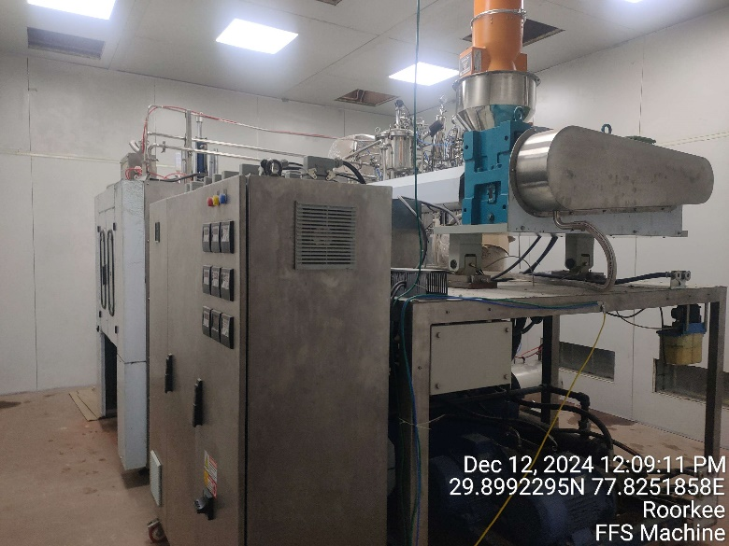 |  | 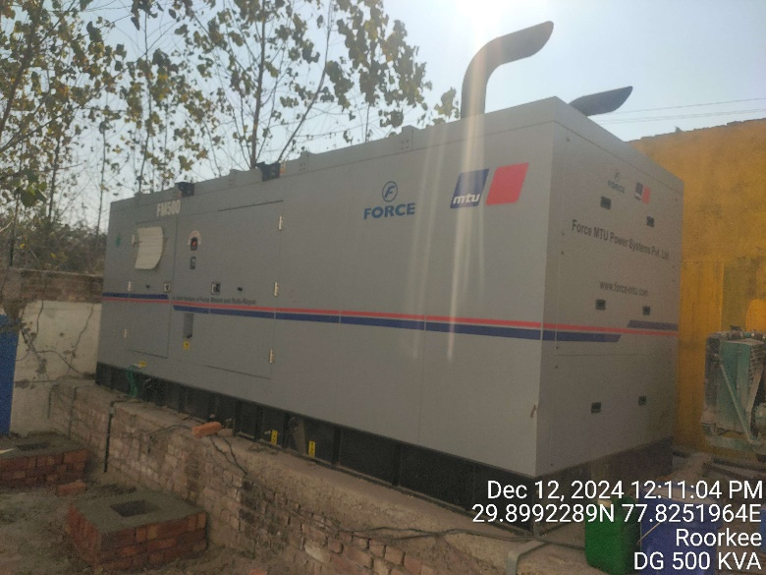
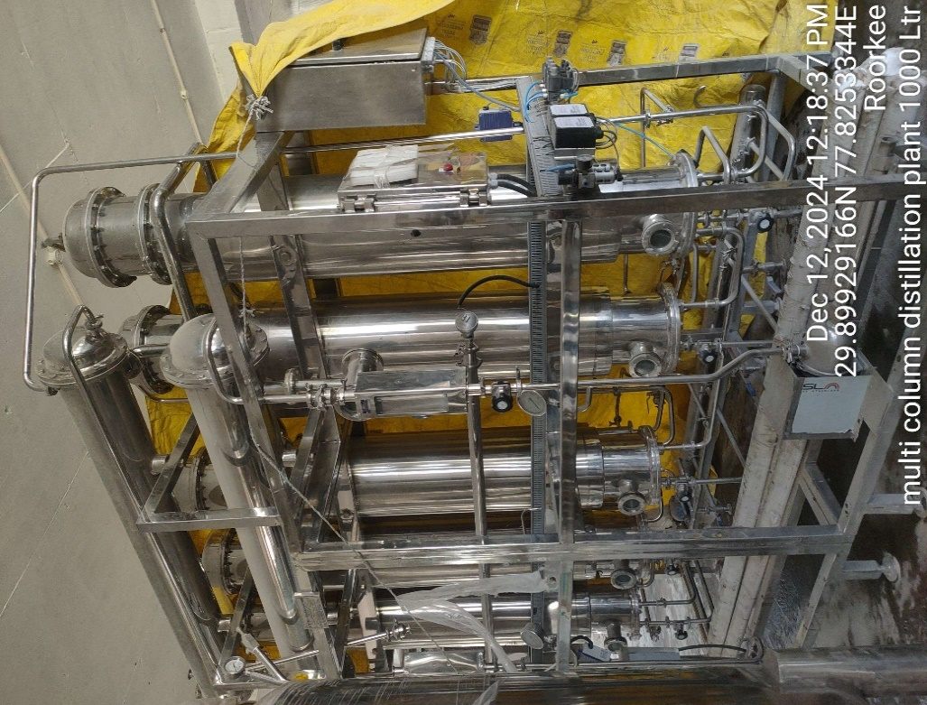 |  | 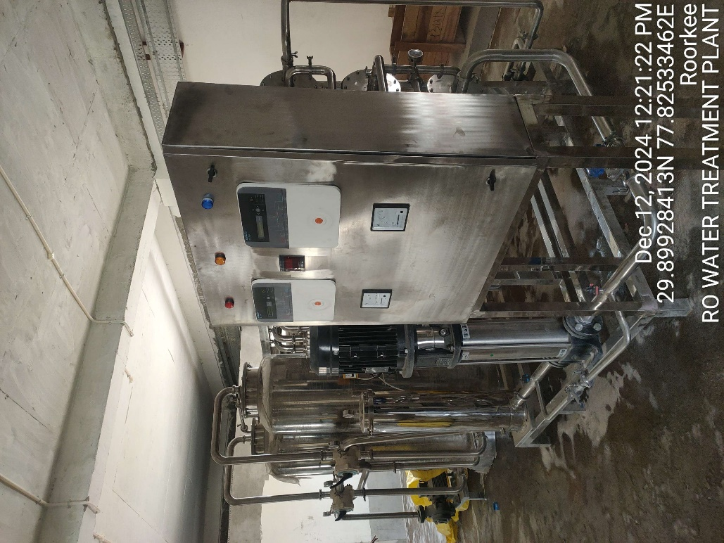
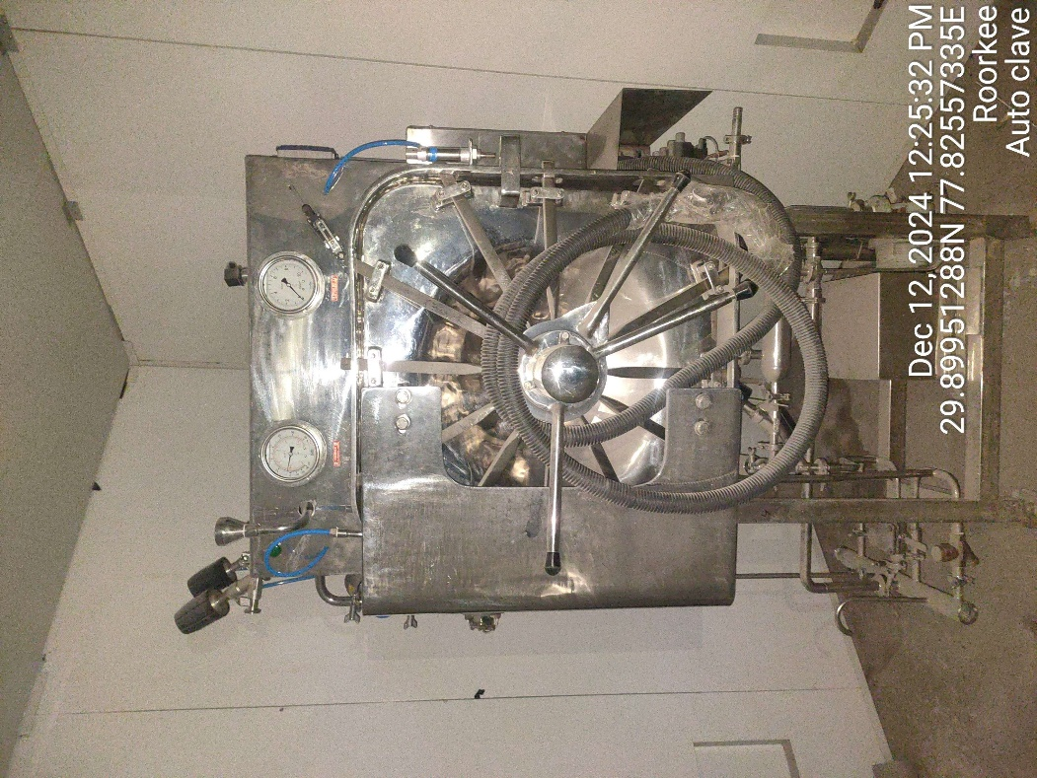 | 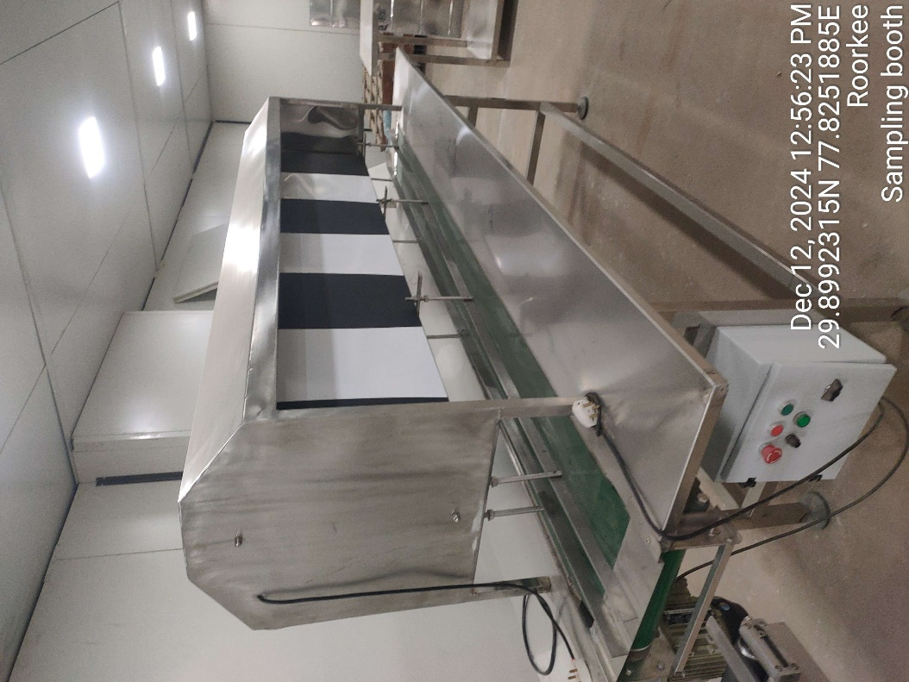
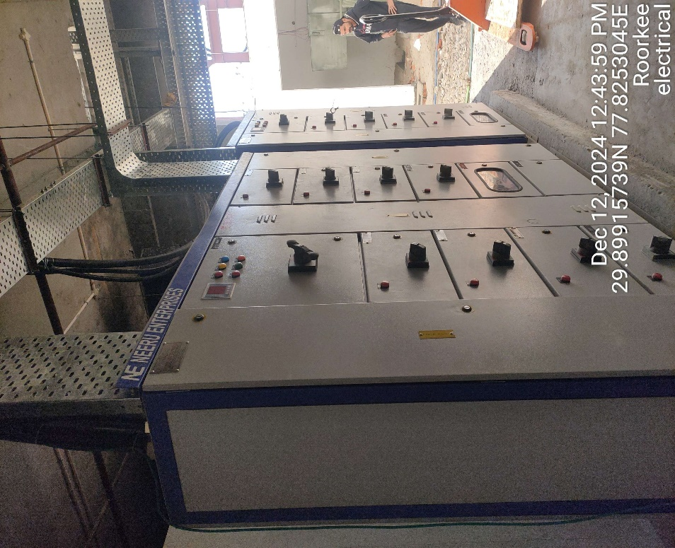 | 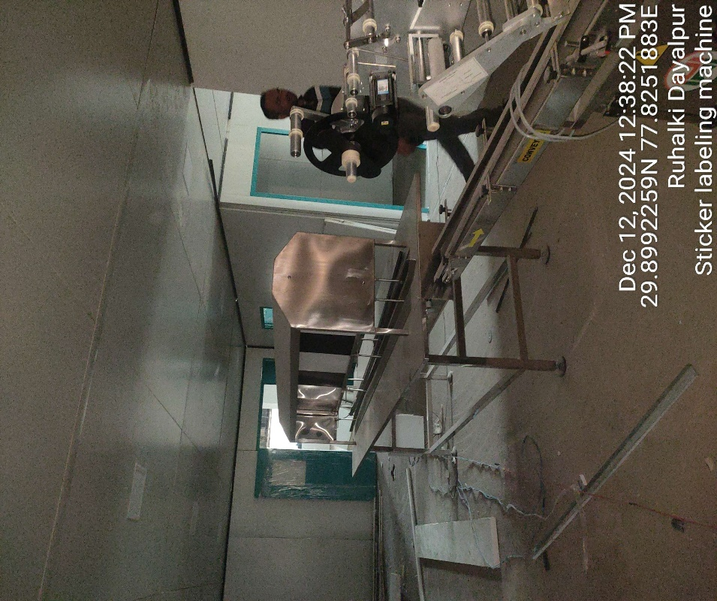

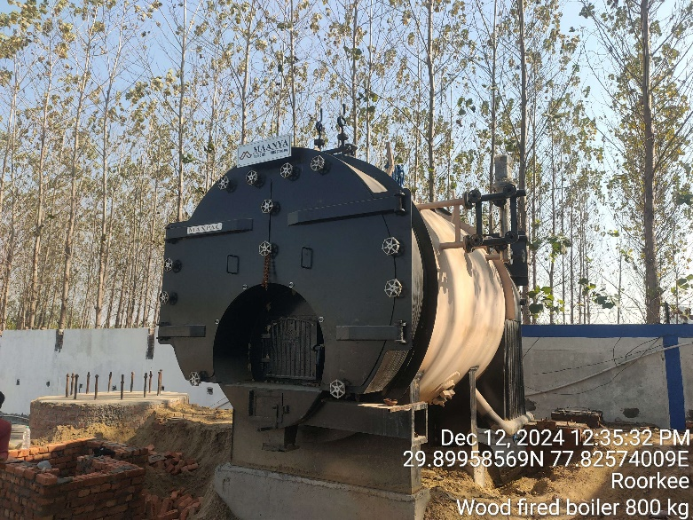 | 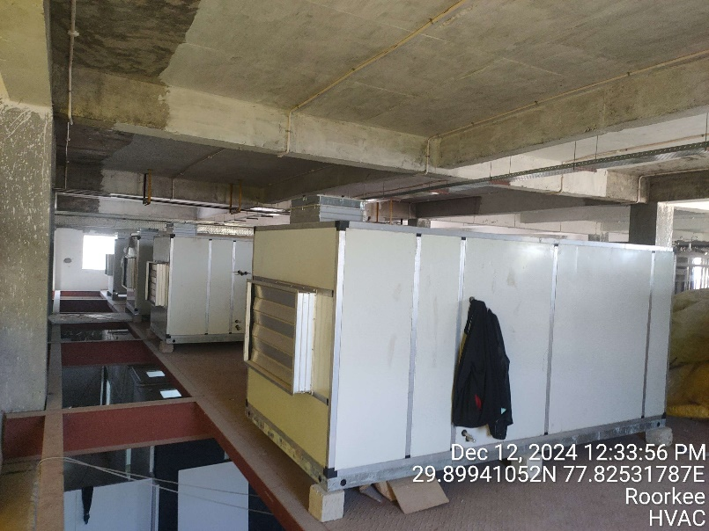
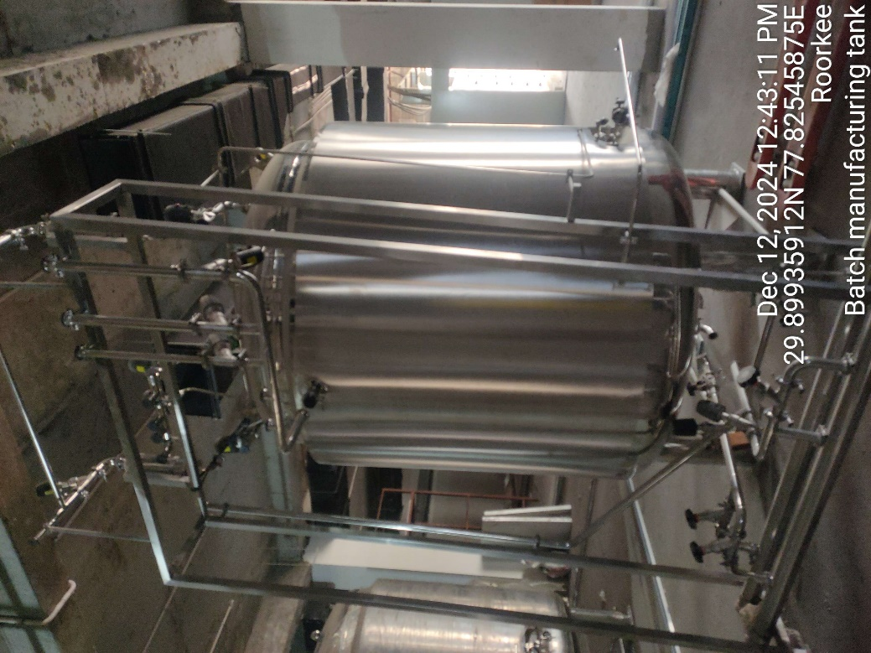 | 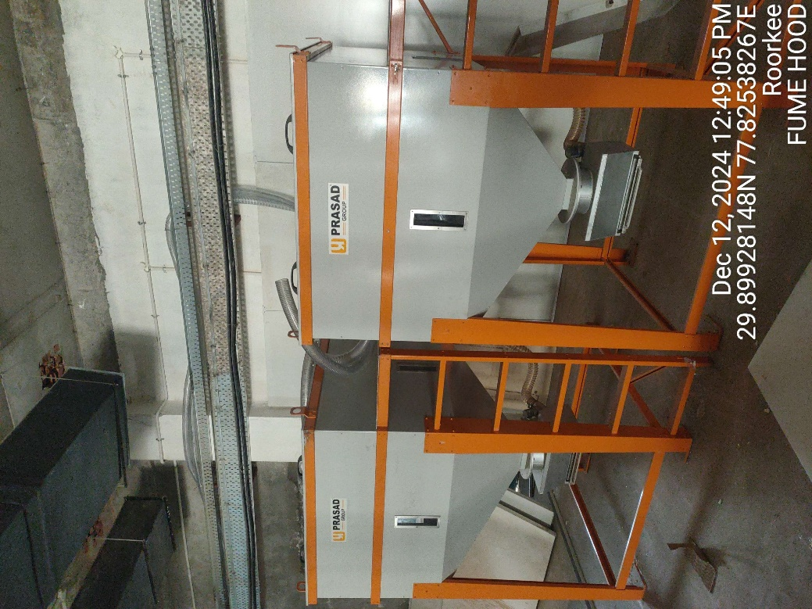

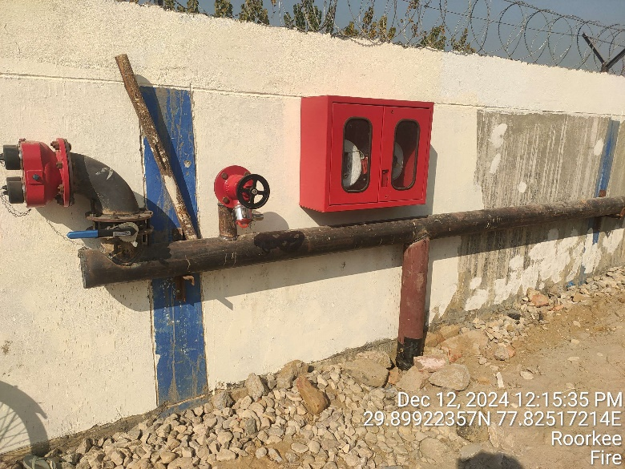 | 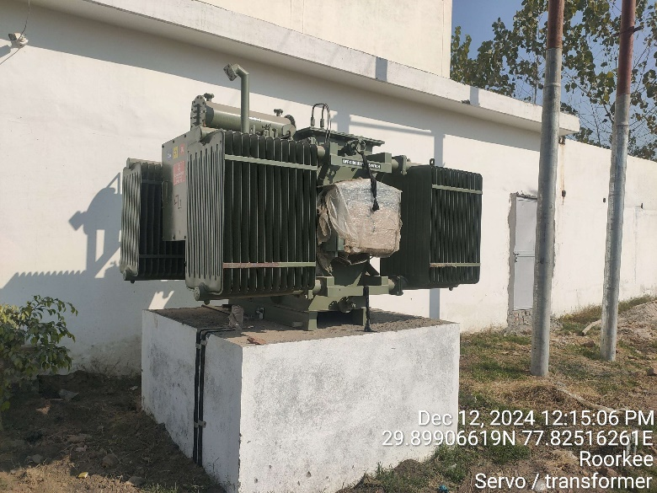
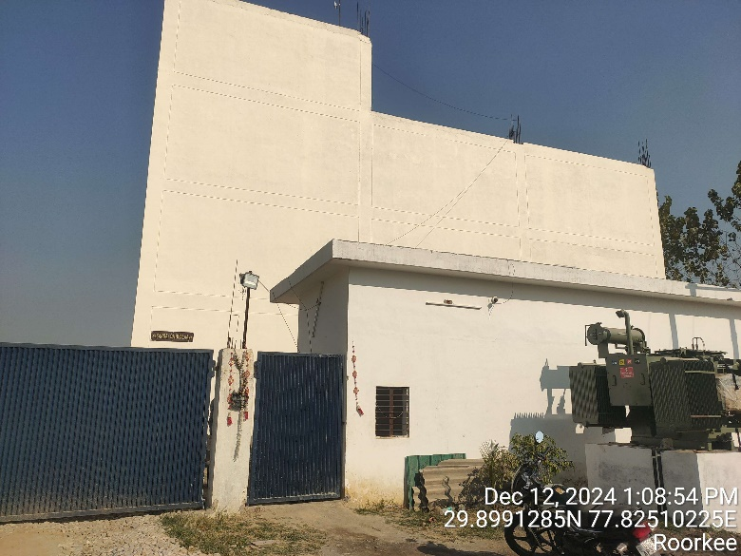 | 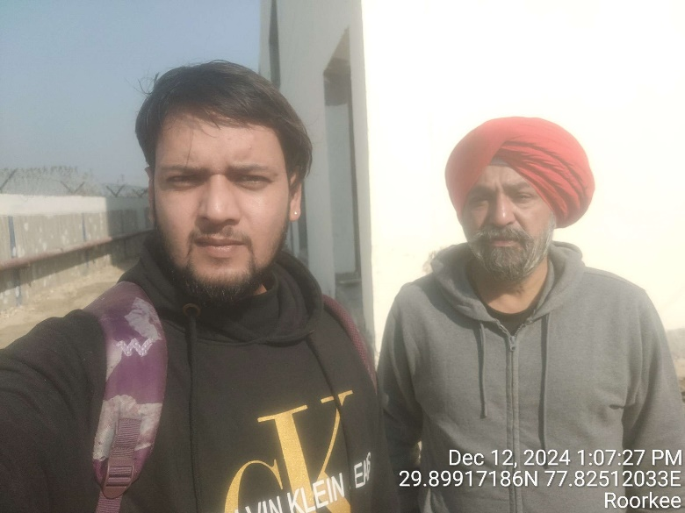
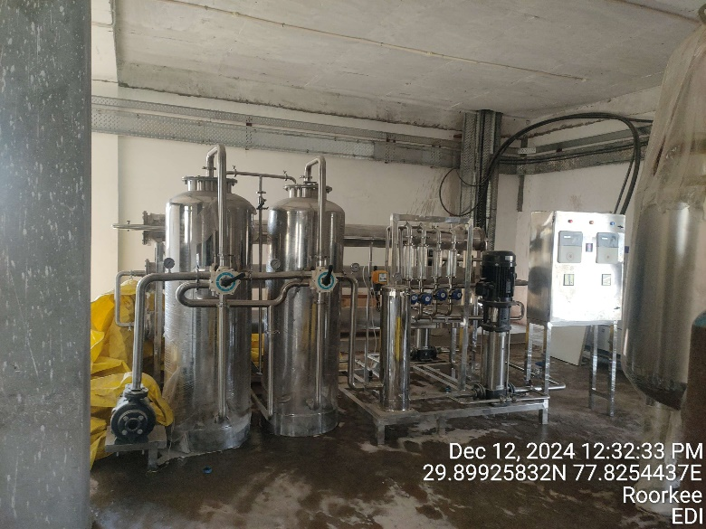 | 