REPORT FORMAT: V-L2 (Medium – CBOI) | Version: 12.0_2022

CASE NO. VIS (2024-25)-PL603-541-769-A DATED: 20/01/2025

FIXED ASSETS VALUATION REPORT

OF

NATURE OF ASSETS | LAND & BUILDING
CATEGORY OF ASSETS | INDUSTRIAL
TYPE OF ASSETS | INDUSTRIAL PROJECT LAND & BUILDING

SITUATED AT
M/S. IHSEDU AGROCHEM PVT. LTD., SURVEY NO. 667, 238/5, 238/6 & 238/7, VILLAGE JAGANA, TALUKA PALANPUR, DISTRICT BANASKANTHA, GUJARAT

REPORT PREPARED FOR
CENTRAL BANK OF INDIA, CORPORATE FINANCE BRANCH, 1ST FLOOR, MMO BUILDING, M.G. ROAD, FORT MUMBAI- 400001

**Important - In case of any query/ issue/ concern or escalation you may please contact Incident Manager @ valuers@rkassociates.org. We will appreciate your feedback in order to improve our services.
NOTE: As per IBA Guidelines please provide your feedback on the report within 15 days of its submission after which report will be considered to be accepted & correct.
Valuation Terms of Services & Valuer’s Important Remarks are available at www.rkassociates.org for reference.

PART A | SNAPSHOT OF THE ASSET/ PROPERTY UNDER VALUATION

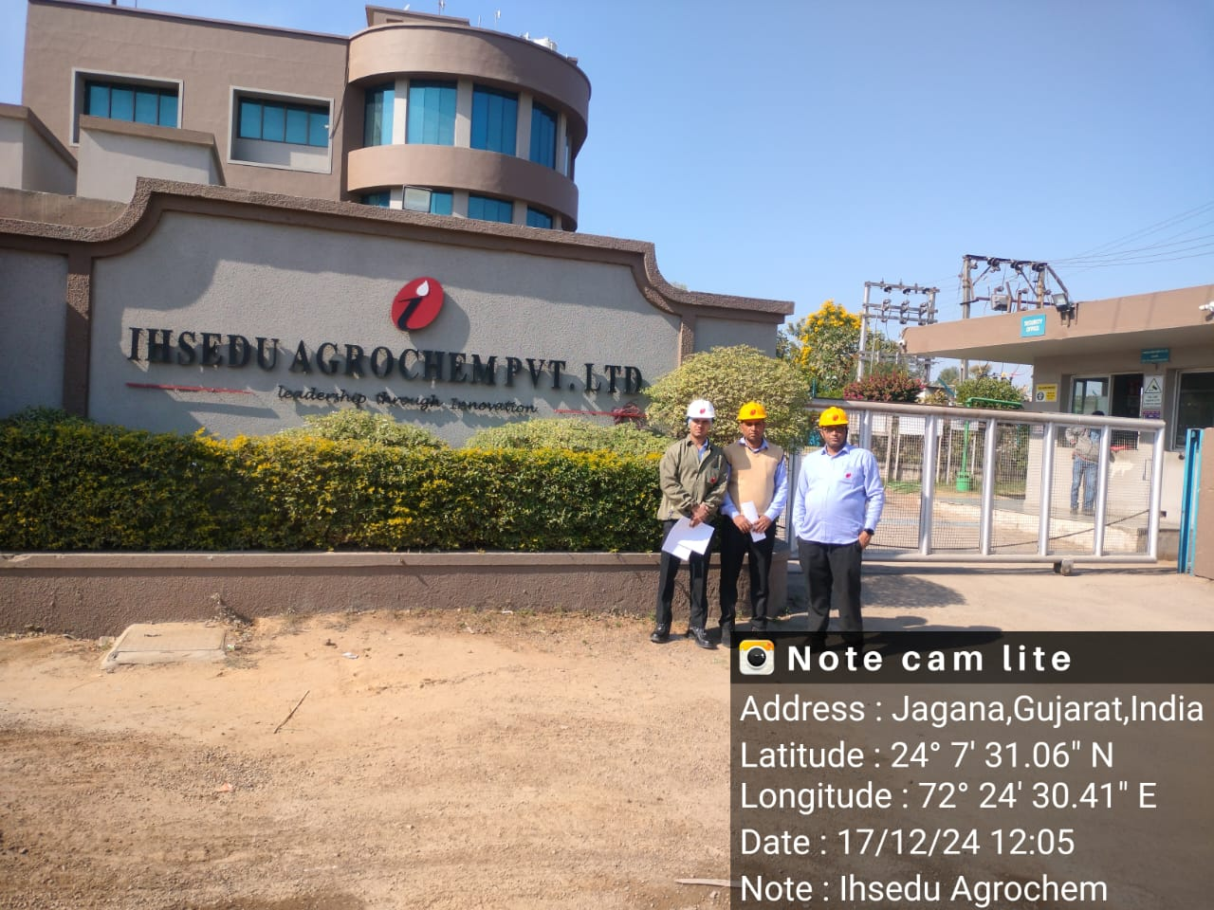
SITUATED AT
M/S. IHSEDU AGROCHEM PVT. LTD., SURVEY NO. 667, 238/5, 238/6 & 238/7, VILLAGE JAGANA, TALUKA PALANPUR, DISTRICT BANASKANTHA, GUJARAT

PART B | CBOI FORMAT ON OPINION REPORT ON VALUATION

Name & Address of the Branch | Central Bank Of India, 1st Floor, MMO Building, M.G. Road, Fort Mumbai- 400001
Name & Designation of concerned officer | Mr. Gaurav Saxena (Banker)
Work Order No. & Date | Via e-mail dated 03.12.2024
Name of the Customer | M/s Ihsedu Agrochem Pvt. Ltd.

SL.NO. | CONTENTS | DESCRIPTION
 | GENERAL
 | Purpose of Valuation | For Periodic Re-valuation of the mortgaged property
 | - Date of Inspection of the Property | 17 December 2024
 | - Date of Valuation Assessment | 20 January 2025
 | - Date of Valuation Report | 20 January 2025
 | Property shown by | Name | Relationship with Owner |  | Contact Number
 | Property shown by | Mr. Rajesh Bhati | Employee |  | +91-9925520859
 | List of documents produced for perusal (Documents has been referred only for reference purpose) | Documents Requested | Documents Provided | Documents Reference No.
 |  | Property Title document | Sale Deeds & Conveyance Deed | Multiple documents as mentioned in the table below
 |  | Copy of TIR | Legal Scrutiny Report | Dated: 31/01/2019
 |  | Approved Map | Approved Site Plan | Dated: 11/04/2023
 |  | Cizra Map | --- | ---
 |  | Approvals & NOCs | Pollution NOC & Factory License | Dated: 19/11/2024 &  Dated: 01/01/2004
 |  | CLU | NA order | ---
 |  | Last paid Electricity Bill | Last paid Electricity Bill | Dated: 02/12/2024
 | Documents provided by | Bank through owner
 | Name of the owner(s) | M/s Ihsedu Agrochem Pvt. Ltd.
 | Address/ Phone no. | Address: M/s. Ihsedu Agrochem Pvt. Ltd., Survey No. 667, 238/5, 238/6 & 238/7, Village Jagana, Taluka Palanpur , District Banaskantha, Gujarat
 | Address/ Phone no. | Phone No.: ---

 | BRIEF DESCRIPTION OF THE PROPERTY
This valuation report is prepared for the Industrial plant situated at the aforesaid address owned by M/s. Ihsedu Agrochem Pvt. Ltd having total land area admeasuring 56,455 sq. mtr purchased via multiple deeds as per copy of documents provided to us.
The details regarding land are mentioned in the table below :
Land Details
Survey no. | Document | Dated | Area  (in sqm)
238(4) | Sale Deed | 07-01-2009 | 4,350
238(5) | Sale Deed | 02-12-2005 | 9,814
238(6) | Sale Deed | 01-04-2005 | 10,522
667 | Conveyance Deed | 14-08-2003 | 31,769
TOTAL |  |  | 56,445

The subject plant comprises of RCC and shed structures with total built-up area 16,255.17 sq.mtr/ 1,74,969 sq.ft.
According to the CLU & documents provided, all the land parcels are classified as non-agricultural and are used for manufacturing castor oil, except for Survey No. 238(4). Therefore, the agricultural land rate is applied to Survey No. 238(4), while the non-agricultural land rate is applied to Survey Nos. 238(5), 238(6), and 667 for the valuation assessment.
The property is situated in Jagana Village which is a rural area. The unit is situated opposite to Government Engineering college and can be reached through ~90 ft. wide state highway. The nearest railway station is about 5 km. Basic or civic amenities are not available in close vicinity.
M/s. Ihsedu Agrochem Pvt. Ltd is involved in the production of Castor oil. At the time of site visit the subject plant was fully operational and after discussion with the company representative we came to know that its inception year is 2002. The plant and machines were in good condition. The major machines of the plant were Cooling Towers, Expeller, SILO, Boilers, etc.
Valuation of the property is conducted as shown on the site by the customer of which photographs is also attached with the report and same is to be considered in this report irrespective of any details taken from any documents which might have been updated, changed or incorrect.
 | Location of the property
 | - Plot No. / Survey No. |  |  |  | Survey No. 667, 238/5, 238/6 & 238/7  (as per documents provided to us)
 | - Door No. |  |  |  | ---
 | - T. S. No. / Village |  |  |  | Jagana
 | - Ward / Taluka |  |  |  | Palanpur
 | - Mandal / District |  |  |  | Banaskantha
 | - Postal address of the property |  |  |  | M/s. Ihsedu Agrochem Pvt. Ltd., Survey No. 667, 238/5, 238/6 & 238/7, Village Jagana, Taluka Palanpur, District Banaskantha, Gujarat
 | - Latitude, Longitude & Coordinates of the site |  |  |  | 24°07'30.2"N 72°24'29.5"E
 | - Nearby Landmark |  |  |  | Opposite Govt. Engineering college
 | Area Categorization |  |  |  | Village |  |  |  |  | Rural
 | Type of Area/ Adjoining Properties |  |  |  | Majorly all nearby lands are used for Agriculture purpose
 | Classification of the area |  |  |  | Middle Class (Ordinary) |  |  |  |  | Rural
 |  |  |  |  | Within good village area
 | Local Government Body Category  (Corporation limit / Village Panchayat / Municipality) - Type & Name |  |  |  | Rural |  |  |  |  | Village Panchayat (Gram Panchayat)
 |  |  |  |  | Gram Panchayat Jagana
 | Whether covered under any prohibited/ restricted/ reserved area/ zone through State / Central Govt. enactments (e.g. Urban Land Ceiling Act) or notified under agency area / scheduled area / cantonment area/ heritage area/ coastal area |  |  |  | No
 | In case it is an agricultural land, any conversion of land use done |  |  |  | Yes from Agriculture to Non Agriculture for 52,105 sq.mtr area only
 | Boundary schedule of the Property
 | Are Boundaries matched |  |  |  | Yes from the available documents only
 | Directions |  |  | As per Documents |  |  |  |  | Actually, found at Site
 | North |  |  | Different for Different Survey Nos. |  |  |  |  | State highway
 | South |  |  | Different for Different Survey Nos. |  |  |  |  | Open Land
 | East |  |  | Different for Different Survey Nos. |  |  |  |  | Open Land
 | West |  |  | Different for Different Survey Nos. |  |  |  |  | Open Land
 | Dimensions of the site
 | Directions |  |  | As per Documents (A) |  |  |  |  | Actually, found at Site (B)
 | North |  |  | --- |  |  |  |  | ---
 | South |  |  | --- |  |  |  |  | ---
 | East |  |  | --- |  |  |  |  | ---
 | West |  |  | --- |  |  |  |  | ---
 | Extent of the site |  |  | 56,455 sq. mtr |  |  |  |  | ~60,000 sq.mtr(Google Measurement)
 | Extent of the site considered for valuation (least of 16A & 16B) |  |  |  | 56,455 sq. mtr
 | Property presently occupied/ possessed by |  |  |  | Owner
 | If occupied by tenant, since how long? |  |  |  | NA
 | Rent received per month |  |  |  | NA
 | CHARACTERISTICS OF THE SITE
 | Classification of the locality |  |  |  | Average location within locality
 | Development of surrounding areas |  |  |  | Rural area
 | Possibility of frequent flooding / sub-merging |  |  |  | No such information came into knowledge
 | Proximity to the Civic amenities & social infrastructure like school, hospital, bus stop, market, etc.
 | School | Hospital | Market |  |  | Bus Stop | Railway Station |  |  |  | Metro |  | Airport
 | ~5 km. | ~5 km. | ~5 km. |  |  | ~0.5 mtr. | ~5 km. |  |  |  | --- |  | ---
 | Level of land with topographical conditions |  |  |  | Solid Land/ on road level
 | Shape of land |  |  |  | Irregular
 | Type of use to which it can be put |  |  |  | Best for industrial use
 | Any usage restriction |  |  |  | No not as such since area is out of zoning limits
 | Is plot in town planning approved layout?/ Zoning regulation |  |  |  | Can't say since no confirmation on jurisdiction
 | Corner plot or intermittent plot? |  |  |  | It is not a corner plot
 | Road facilities
 | - Main Road Name & Width |  |  |  | Ahmedabad Palanpur Highway |  |  |  |  | Approx. 90 ft. wide
 | - Front Road Name & width |  |  |  | Ahmedabad Palanpur Highway |  |  |  |  | Approx. 90 ft. wide
 | - Type of Approach Road |  |  |  | Bituminous Road
 | - Distance from the Main Road |  |  |  | Located on main highway
 | Type of road available at present |  |  |  | Bituminous Road
 | Width of road – is it below 20 ft. or more than |  |  |  | More than 20 ft.
 | Is it a land – locked land? |  |  |  | No
 | Water potentiality |  |  |  | Yes available from borewell/ submersible
 | Underground sewerage system |  |  |  | Yes
 | Is power supply available at the site? |  |  |  | Yes
 | Advantages of the site |  |  |  | The subject property is located on Highway
 | Special remarks, if any, like:
 | - Notification of land acquisition if any in the area |  |  |  | No such information came in front of us and could not be found on public domain
 | - Notification of road widening if any in the area |  |  |  | No such information came in front of us and could not be found on public domain
 | - Applicability of CRZ provisions etc. (Distance from sea-coast / tidal level must be incorporated) |  |  |  | No
 | - Any other |  |  |  | None
 | VALUATION OF LAND
 | Size of plot |  |  |  | Please refer to Part B – Area description of the Property.
 | North & South
 | East & West
 | Total extent of the plot
 | Prevailing market rate (Along with details/reference of at least two latest deals/ transactions with respect to adjacent properties in the areas) |  |  |  | Please refer to Part C - Procedure of Valuation Assessment section.
 | Guideline rate obtained from the Registrar’s Office (evidence thereof to be enclosed)
 | Assessed / adopted rate of valuation
 | Estimated Value of Land
 | VALUATION OF BUILDING
 | Technical details of the building
 | - Type of Building (Residential / Commercial/ Industrial) |  |  |  | INDUSTRIAL / INDUSTRIAL PLANT
 | - Type of construction (Load bearing / RCC/ Steel Framed) |  |  |  | Structure |  |  | Slab |  |  |  | Walls
 |  |  |  |  | RCC & Iron Truss |  |  | RCC & Shed |  |  |  | Brick wall
 | - Architecture design & finishing |  |  |  | Interior |  |  |  |  | Exterior
 |  |  |  |  | Ordinary regular architecture / Plain ordinary finishing |  |  |  |  | Ordinary regular architecture / Plain ordinary finishing
 | - Class of construction |  |  |  | Class of construction: Class C construction (Simple/ Average)
 | - Year of construction/ Age of construction |  |  |  | Refer to Building Sheet attached |  |  |  |  | Refer to Building Sheet attached
 | - Number of floors and height of each floor including basement, if any |  |  |  | Refer to Building Sheet attached
 | - Plinth area floor-wise |  |  |  | Refer to Building Sheet attached
 | - Condition of the building |  |  |  | Interior |  |  |  |  | Exterior
 |  |  |  |  | Class C construction (Simple/ Average) |  |  |  |  | Average
 | - Maintenance issues |  |  |  | No maintenance issue, structure is maintained properly
 | - Visible damage in the building if any |  |  |  | No visible damages in the structure
 | - Type of flooring |  |  |  | Vitrified tiles, PCC
 | - Class of electrical fittings |  |  |  | Class C construction (Simple/ Average)
 | - Class of plumbing, sanitary & water supply fittings |  |  |  | Class C construction (Simple/ Average)
 | Map approval details
 | - Status of Building Plans/ Maps and Date of issue and validity of layout of approved map / plan |  |  |  | Sanctioned by competent authority as per copy of Map provided to us.
 | - Approved map / plan issuing authority |  |  |  | Industrial Safety & Health, Gujarat State
 | - Whether genuineness or authenticity of approved map / plan is verified |  |  |  | Verification of authenticity of documents with the respective authority can be done by a legal/ liasoning person and same is not done at our end.
 | - Any other comments on authenticity of approved plan |  |  |  | No
 | - Is Building as per copy of approved Map provided to Valuer? |  |  |  | Sanctioned by competent authority as per copy of Map provided to us
 | - Details of alterations/ deviations/ illegal construction/ encroachment noticed in the structure from the approved plan |  |  |  | ☐ Permissible alterations |  |  |  |  | No as per the visual observation made during site survey
 |  |  |  |  | ☐ Non permissible alterations |  |  |  |  | No as per the visual observation made during site survey
 | - Is this being regularized
 | SPECIFICATIONS OF CONSTRUCTION (FLOOR-WISE) IN RESPECT OF
 | Foundation |  |  |  | This Valuation is conducted based on the macro analysis of the asset/ property considering it in totality and not based on the micro, component or item wise analysis. These points are covered in totality in lumpsum basis under Technical details of the building under “Class of construction, architecture design & finishing” point.
 | Basement
 | Superstructure
 | Joinery / Doors & Windows (please furnish details about size of frames, shutters, glazing, fitting etc. and specify the species of timber)
 | RCC works
 | Plastering
 | Flooring, Skirting, dadoing
 | Special finish as marble, granite, wooden paneling, grills, etc
 | Roofing including weather proof course
 | Drainage
 | Compound wall |  |  |  | Yes
 | Height |  |  |  | ~8 ft.
 | Length |  |  |  | ~ 1,100 mtr.
 | Type of construction |  |  |  | Brick Wall
 | Electrical installation |  |  |  | Please refer to “Class of electrical fittings” under Technical details of the building above in totality and lumpsum basis. This Valuation is conducted based on the macro analysis of the asset/ property considering it in totality and not based on the micro, component or item wise analysis.
 | Type of wiring
 | Class of fittings (superior / ordinary / poor)
 | Number of light points
 | Fan points
 | Spare plug points
 | Any other item
 | Plumbing installation |  |  |  | Please refer to “Class of plumbing, sanitary & water supply fittings” under Technical details of the building above in totality and lumpsum basis. This Valuation is conducted based on the macro analysis of the asset/ property considering it in totality and not based on the micro, component or item wise analysis.
 | No. of water closets and their type
 | No. of wash basins
 | No. of urinals
 | No. of bath tubs
 | No. of water closets and their type
 | Water meter, taps, etc.
 | Any other fixtures
 | EXTRA ITEMS |  |  |  | This Valuation is conducted based on the macro analysis of the asset/ property considering it in totality and not based on the micro, component or item wise analysis. These points are covered in totality in lumpsum basis under Technical details of the building under “Class of construction, architecture design & finishing” point.
 | Portico
 | Ornamental front door
 | Sit out/ Verandah with steel grills
 | Overhead water tank
 | Extra steel/ collapsible gates
 | AMENITIES |  |  |  | This Valuation is conducted based on the macro analysis of the asset/ property considering it in totality and not based on the micro, component or item wise analysis. These points are covered in totality in lumpsum basis under Technical details of the building under “Class of construction, architecture design & finishing” point.
 | Wardrobes
 | Glazed tiles
 | Extra sinks and bath tub
 | Marble / Ceramic tiles flooring
 | Interior decorations
 | Architectural elevation works
 | Paneling works
 | Aluminum works
 | Aluminum hand rails
 | False ceiling
 | MISCELLANEOUS |  |  |  | This Valuation is conducted based on the macro analysis of the asset/ property considering it in totality and not based on the micro, component or item wise analysis. These points are covered in totality in lumpsum basis under Technical details of the building under “Class of construction, architecture design & finishing” point.
 | Separate toilet room
 | Separate lumber room
 | Separate water tank/ sump
 | Trees, gardening
 | SERVICES |  |  |  | This Valuation is conducted based on the macro analysis of the asset/ property considering it in totality and not based on the micro, component or item wise analysis. These points are covered in totality in lumpsum basis under Technical details of the building under “Class of construction, architecture design & finishing” point.
 | Water supply arrangements
 | Drainage arrangements
 | Compound wall
 | C. B. deposits, fittings etc.
 | Pavement

TOTAL ABSTRACT OF THE ENTIRE PROPERTY

 | CONSOLIDATED VALUATION ASSESSMENT OF THE ASSET
S.No. | Particulars | Govt. Circle/ Guideline Value | Indicative & Estimated Prospective Fair Market Value
 | Land Value (A) | Rs. 4,44,30,471/- | Rs. 104,70,44,918/-
 | Total Building & Civil Works (B) | --- | Rs. 13,65,14,813/-
 | Additional Aesthetic Works Value (C) | --- | Rs. 50,00,000/-
 | Total Add (A+B+C) | Rs. 4,44,30,471/- | Rs. 118,85,59,730/-
 | Additional Premium if any | --- | ---
 | Details/ Justification | --- | ---
 | Deductions charged if any | --- | ---
 | Details/ Justification | --- | ---
 | Total Indicative & Estimated Prospective Fair Market Value | --- | Rs. 118,85,59,730/-
 | Rounded Off | --- | Rs. 118,90,00,000/-
 | Indicative & Estimated Prospective Fair Market Value in words | --- | Rupees One hundred Eighteen Crore Ninety Lakhs Only
 | Expected Realizable Value (@ ~15% less) | --- | Rs. 101,06,50,000/-
 | Expected Distress Sale Value (@ ~25% less) | --- | Rs. 89,17,50,000/-
 | Percentage difference between Circle Rate and Fair Market Value | ~20% More Than

*NOTE:
- For detailed calculation, approach, basis & procedure of valuation please refer to Part D - Procedure of Valuation Assessment section.
- Estimated Value is subject to the assumptions, limitations, basis of computation, caveats, information, facts came during valuation within the limited available time & cost.
- This report is not a certification of ownership or survey number/ property number/ Khasra number which are merely referred from the copy of the documents provided to us and property shown to us.
- Standard IBBI (Insolvency & Bankruptcy Board of India) caveats & disclaimers are applicable on this report.
- This Valuation is guided by Valuation Terms of Service and Valuer’s Important Remarks which can also be found at www.rkassociates.org.
ENCLOSURE: I
PART C | AREA DESCRIPTION OF THE PROPERTY

 | Land Area considered for Valuation | 56,455 sq.mtr
 | Area adopted on the basis of | Property documents & site survey both
 | Remarks & observations, if any | The land area has been taken as per the documents provided to us and has been cross checked via satellite measurement tools.
 | Constructed Area considered for Valuation  (As per IS 3861-1966) | Built-up Area | 16,255.17 sq.mtr/ 1,74,969 sq.ft
 | Area adopted on the basis of | Property documents & site survey both
 | Remarks & observations, if any | The built-up area is considered on the basis of approved map provided and more or less same was found during site survey.

Note:
- Area measurements considered in the Valuation Report pertaining to Land & Building is adopted from relevant approved documents or actual site measurement whichever is less. All area measurements are on approximate basis only.

- Verification of the area measurement of the property is done based on sample random checking only.

- Area of the large land parcels of more than 2500 sq.mtr or of uneven shape, is taken as per property documents verified with digital survey through google which has been relied upon.

- Drawing Map, design & detailed estimation of the property/ building is out of scope of the Valuation services.

ENCLOSURE: II
PART D | PROCEDURE OF VALUATION ASSESSMENT

 | GENERAL INFORMATION
 | Important Dates | Date of Appointment |  | Date of Inspection of the Property | Date of Valuation Assessment | Date of Valuation Report
 | Important Dates | 3 December 2024 |  | 17 December 2024 | 20 January 2025 | 20 January 2025
 | Client | Central Bank of India, Corporate Finance Branch, MMO Building, Fort, Mumbai
 | Intended User | Central Bank of India, Corporate Finance Branch, MMO Building, Fort, Mumbai
 | Intended Use | To know the general idea on the market valuation trend of the property as per free market transaction. This report is not intended to cover any other internal mechanism, criteria, considerations of any organization as per their own need, use & purpose.
 | Purpose of Valuation | For Periodic Re-valuation of the mortgaged property
 | Scope of the Assessment | Non binding opinion on the assessment of Plain Physical Asset Valuation of the property identified to us by the owner or through his representative.
 | Restrictions | This report should not be referred for any other purpose, by any other user and for any other date other then as specified above. This report is not a certification of ownership or survey number/ property number/ Khasra number which are merely referred from the copy of the documents provided to us.
 | Manner in which the proper is identified | ☐ | Identified by the owner
 | Manner in which the proper is identified |  | Identified by owner’s representative
 | Manner in which the proper is identified |  | Done from the name plate displayed on the property
 | Manner in which the proper is identified |  | Cross checked from boundaries or address of the property mentioned in the documents
 | Manner in which the proper is identified | ☐ | Enquired from local residents/ public
 | Manner in which the proper is identified | ☐ | Identification of the property could not be done properly
 | Manner in which the proper is identified | ☐ | Survey was not done
 | Is property number/ survey number displayed on the property for proper identification? | No.
 | Type of Survey conducted | Full survey (inside-out with approximate measurements verification & photographs).

 | ASSESSMENT FACTORS
 | Valuation Standards considered | Mix of standards such as IVS and others issued by Indian authorities & institutions and improvised by the RKA internal research team as and where it is felt necessary to derive at a reasonable, logical & scientific approach. In this regard proper basis, approach, working, definitions considered is defined below which may have certain departures to IVS.
 | Nature of the Valuation | Fixed Assets Valuation
 | Nature/ Category/ Type/ Classification of Asset under Valuation | Nature |  |  |  |  | Category |  |  |  |  | Type
 |  | LAND & BUILDING |  |  |  |  | INDUSTRIAL |  |  |  |  | INDUSTRIAL PLANT
 |  | Classification |  |  |  |  | Income/ Revenue Generating Asset
 | Type of Valuation (Basis of Valuation as per IVS) | Primary Basis |  |  |  | Market Value & Govt. Guideline Value
 | Type of Valuation (Basis of Valuation as per IVS) | Secondary Basis |  |  |  | On-going concern basis
 | Present market state of the Asset assumed (Premise of Value as per IVS) | Under Normal Marketable State
 |  | Reason: Asset under free market transaction state
 | Property Use factor | Current/ Existing Use |  |  |  |  |  | Highest & Best Use  (in consonance to surrounding use, zoning and statutory norms) |  |  |  | Considered for Valuation purpose
 | Property Use factor | Industrial |  |  |  |  |  | Industrial |  |  |  | Industrial
 | Legality Aspect Factor | Assumed to be fine as per copy of the documents & information produced to us.However Legal aspects of the property of any nature are out-of-scope of the Valuation Services. In terms of the legality, we have only gone by the documents provided to us in good faith.  Verification of authenticity of documents from originals or cross checking from any Govt. deptt. have to be taken care by Legal expert/ Advocate.
 | Class/ Category of the locality | Middle Class (Ordinary)
 | Property Physical Factors | Shape |  |  |  |  |  |  | Size |  |  | Layout
 | Property Physical Factors | Irregular |  |  |  |  |  |  | Large |  |  | Normal Layout
 | Property Location Category Factor | City Categorization |  |  | Locality Characteristics |  |  |  |  |  | Property location characteristics |  | Floor Level
 | Property Location Category Factor | Village |  |  | Ordinary |  |  |  |  |  | Near to Highway |  | As mentioned in building sheet
 | Property Location Category Factor | Urban Remote |  |  | Average |  |  |  |  |  | Road Facing
 | Property Location Category Factor |  |  |  | Within good village area |  |  |  |  |  | Good location within locality
 | Property Location Category Factor | Property Facing
 | Property Location Category Factor | East Facing
 | Physical Infrastructure availability factors of the locality | Water Supply |  |  | Sewerage/ sanitation system |  |  |  |  |  | Electricity |  | Road and Public Transport connectivity
 | Physical Infrastructure availability factors of the locality | Yes from borewell/ submersible |  |  | Underground |  |  |  |  |  | Yes |  | Easily available
 | Physical Infrastructure availability factors of the locality | Availability of other public utilities nearby |  |  |  |  |  |  |  |  | Availability of communication facilities
 | Physical Infrastructure availability factors of the locality | Transport, Market, Hospital etc. are available in close vicinity |  |  |  |  |  |  |  |  | Major Telecommunication Service Provider & ISP connections are available
 | Social structure of the area (in terms of population, social stratification, regional origin, age groups, economic levels, location of slums/ squatter settlements nearby, etc.) | Medium Income Group
 | Neighbourhood amenities | Average
 | Any New Development in surrounding area | None
 | Any specific advantage in the property | The subject property is located on Highway.
 | Any specific drawback in the property | None
 | Property overall usability/ utility Factor | Good
 | Do property has any alternate use? | No, can only be used for industrial purpose
 | Is property clearly demarcated by permanent/ temporary boundary on site | Demarcated with permanent boundary
 | Is the property merged or colluded with any other property | No, it is an independent singly bounded property
 | Is the property merged or colluded with any other property | Comments: ---
 | Is independent access available to the property | Clear independent access is available
 | Is property clearly possessable upon sale | Yes
 | Best Sale procedure to realize maximum Value (in respect to Present market state or premise of the Asset as per point (iv) above) | Fair Market Value
 |  | Free market transaction at arm's length wherein the parties, after full market survey each acted knowledgeably, prudently and without any compulsion.
 | Hypothetical Sale transaction method assumed for the computation of valuation | Fair Market Value
 |  | Free market transaction at arm's length wherein the parties, after full market survey each acted knowledgeably, prudently and without any compulsion.
 | Approach & Method of Valuation Used | Land |  | Approach of Valuation |  |  |  |  |  |  | Method of Valuation
 | Approach & Method of Valuation Used |  |  | Market Approach |  |  |  |  |  |  | Market Comparable Sales Method
 | Approach & Method of Valuation Used | Building |  | Cost Approach |  |  |  |  |  |  | Depreciated Replacement Cost Method
 | Type of Source of Information | Level 3 Input (Tertiary)
 | Market Comparable
 | References on prevailing market Rate/ Price trend of the property and Details of the sources from where the information is gathered (from property search sites & local information) | 1. | Name: |  |  |  |  |  |  |  | Mr. Manish
 |  | 1. | Contact No.: |  |  |  |  |  |  |  | +91-932858800
 |  | 1. | Nature of reference: |  |  |  |  |  |  |  | Habitant of subject location
 |  | 1. | Size of the Property: |  |  |  |  |  |  |  | ~4-5 acres
 |  | 1. | Location: |  |  |  |  |  |  |  | Subject location
 |  | 1. | Rates/ Price informed: |  |  |  |  |  |  |  | Rs. 2,200/- to Rs. 2,800/- per sq.ft
 |  | 1. | Any other details/ Discussion held: |  |  |  |  |  |  |  | As per the discussion with the habitant of the subject locality, we came to know that the land is available in the above-mentioned range.
 |  | 2. | Name: |  |  |  |  |  |  |  | Om Developers
 |  | 2. | Contact No.: |  |  |  |  |  |  |  | +91-9558452484
 |  | 2. | Nature of reference: |  |  |  |  |  |  |  | Property Consultant
 |  | 2. | Size of the Property: |  |  |  |  |  |  |  | ---
 |  | 2. | Location: |  |  |  |  |  |  |  | Subject location
 |  | 2. | Rates/ Price informed: |  |  |  |  |  |  |  | Rs. 2,000/- to Rs. 2,200/- per sq.ft
 |  | 2. | Any other details/ Discussion held: |  |  |  |  |  |  |  | As per the discussion with the habitant of the subject locality, we came to know that the land is available in the above-mentioned range.
 |  | NOTE: The given information above can be independently verified to know its authenticity.
 | Adopted Rates Justification | As per our discussion with the property dealers of the subject location we have gathered the following information:  - There is good availability of vacant land similar as our subject property in the locality.  - Land parcel abutting the Highway are in the range around Rs. 2,200/- to Rs. 2,800/- per sq.ft for land parcel of ~5 acres.  - Land rate away from the Highway is around Rs. 1,800/- per sq.ft to Rs. 2,200/- per sq.ft.  Based on the above information and keeping in mind the availability of land in subject locality we are of the view to adopt a rate of Rs. 2,500/- per sq.ft for NA land and Rs. 2,000/- per sq.ft for agriculture land for the purpose of this valuation assessment.
NOTE: We have taken due care to take the information from reliable sources. The given information above can be independently verified from the provided numbers to know its authenticity. However due to the nature of the information most of the market information came to knowledge is only through verbal discussion with market participants which we have to rely upon where generally there is no written record.
Related postings for similar properties on sale are also annexed with the Report wherever available.
 | Other Market Factors
 | Current Market condition | Normal
 | Current Market condition | Remarks: ---
 | Current Market condition | Adjustments (-/+): 0%
 | Comment on Property Salability Outlook | ---
 | Comment on Property Salability Outlook | Adjustments (-/+): -5%
 | Comment on Demand & Supply in the Market | Demand |  |  |  |  |  |  |  | Supply
 | Comment on Demand & Supply in the Market | Moderate |  |  |  |  |  |  |  | Adequately available
 | Comment on Demand & Supply in the Market | Remarks: ---
 | Comment on Demand & Supply in the Market | Adjustments (-/+): 0%
 | Any other special consideration | Reason: The references are available for smaller land parcel compare to subject property.
 | Any other special consideration | Adjustments (-/+): -30%
 | Any other aspect which has relevance on the value or marketability of the property | NA  Valuation of the same asset/ property can fetch different values under different circumstances & situations. For e.g. Valuation of a running/ operational shop/ hotel/ factory will fetch better value and in case of closed shop/ hotel/ factory it will fetch considerably lower value. Similarly, an asset sold directly by an owner in the open market through free market arm’s length transaction then it will fetch better value and if the same asset/ property is sold by any financer or court decree or Govt. enforcement agency due to any kind of encumbrance on it then it will fetch lower value. Hence before financing, Lender/ FI should take into consideration all such future risks while financing.  This Valuation report is prepared based on the facts of the property & market situation on the date of the survey. It is a well-known fact that the market value of any asset varies with time & socio-economic conditions prevailing in the region/ country. In future property market may go down, property conditions may change or may go worse, property reputation may differ, property vicinity conditions may go down or become worse, property market may change due to impact of Govt. policies or effect of domestic/ world economy, usability prospects of the property may change, etc. Hence before financing, Banker/ FI should take into consideration all such future risk while financing.
 |  | Adjustments (-/+): 0%
 | Final adjusted & weighted Rates considered for the subject property | Rs.1,750/- per sq.ft. (for NA land)  Rs. 1,400/- per sq.ft. (for agriculture land)
 | Considered Rates Justification | As per the thorough property & market factors analysis as described above, the considered estimated market rates appears to be reasonable in our opinion.
 | Basis of computation & working
- Valuation of the asset is done as found on as-is-where basis on the site as identified to us by client/ owner/ owner representative during site inspection by our engineer/s unless otherwise mentioned in the report.
- Analysis and conclusions adopted in the report are limited to the reported assumptions, conditions and information came to our knowledge during the course of the work and based on the Standard Operating Procedures, Best Practices, Caveats, Limitations, Conditions, Remarks, Important Notes, Valuation TOR and definition of different nature of values.
- For knowing comparable market rates, significant discreet local enquiries have been made from our side based on the hypothetical/ virtual representation of ourselves as both buyer and seller for the similar type of properties in the subject location and thereafter based on this information and various factors of the property, rate has been judiciously taken considering the factors of the subject property, market scenario and weighted adjusted comparison with the comparable properties unless otherwise stated.
- References regarding the prevailing market rates and comparable are based on the verbal/ informal/ secondary/ tertiary information which are collected by our team from the local people/ property consultants/ recent deals/ demand-supply/ internet postings are relied upon as may be available or can be fetched within the limited time & resources of the assignment during market survey in the subject location. No written record is generally available for such market information and analysis has to be derived mostly based on the verbal information which has to be relied upon.
- Market Rates are rationally adopted based on the facts of the property which came to our knowledge during the course of the assessment considering many factors like nature of the property, size, location, approach, market situation and trends and comparative analysis with the similar assets. During comparative analysis, valuation metrics is prepared and necessary adjustments are made on the subject asset.
- The indicative value has been suggested based on the prevailing market rates that came to our knowledge during secondary & tertiary market research and is not split into formal & informal payment arrangements. Most of the deals takes place which includes both formal & informal payment components. Deals which takes place in complete formal payment component may realize relatively less actual transaction value due to inherent added tax, stamp registration liabilities on the buyer.
- Secondary/ Tertiary costs related to asset transaction like Stamp Duty, Registration charges, Brokerage, Commission, Bank interest, Selling cost, Marketing cost, etc. pertaining to the sale/ purchase of this property are not considered while assessing the indicative estimated Market Value.
- This report includes both, Govt. Guideline Value and Indicative Estimated Prospective Market Value as described above. As per the current market practice, in most of the cases, formal transaction takes place for an amount less than the actual transaction amount and rest of the payment is normally done informally.
- Area measurements considered in the Valuation Report pertaining to asset/ property is adopted from relevant approved documents or sample site measurement whichever is less unless otherwise mentioned. All area measurements are on approximate basis only.
- Verification of the area measurement of the property is done based on sample random checking only.
- Area of the large land parcels of more than 2500 sq.mtr or of uneven shape in which there can be practical difficulty in sample measurement, is taken as per property documents which has been relied upon unless otherwise stated.
- Drawing, Map, design & detailed estimation of the property/ building is out of scope of the Valuation services.
- Construction rates are adopted based on the present market replacement cost of construction and calculating applicable depreciation & deterioration factor as per its age, existing condition & specifications based on visual observation only of the structure. No structural, physical tests have been carried out in respect of it. No responsibility is assumed for latent defects of any nature whatsoever, which may affect value, or for any expertise required to disclose such conditions.
- Construction rates are adopted based on the plinth area rates prevailing in the market for the structure as a whole and not based on item wise estimation or Bills of Quantity method unless otherwise stated.
- The condition assessment and the estimation of the residual economic life of the structure are only based on the visual observations and appearance found during the site survey. We have not carried out any structural design or stability study; nor carried out any physical tests to assess structural integrity & strength.
- Any kind of unpaid statutory, utilities, lease, interest or any other pecuniary dues on the asset or on its owners has not been factored in the Valuation.
- This Valuation is conducted based on the macro analysis of the asset/ property considering it in totality and not based on the micro, component or item wise analysis. Analysis done is a general assessment and is neither investigative in nature nor an audit activity.
- Valuation is done for the asset found on as-is-where basis which owner/ owner representative/ client/ bank has shown to us on site of which some reference has been taken from the information/ data given in the copy of documents provided to us which have been relied upon in good faith and we have assumed that it to be true and correct.
 | ASSUMPTIONS
- Documents/ Information/ Data provided by the client/ property owner or his representative both written & verbally is true and correct without any fabrication and has been relied upon in good faith.
- Local verbal enquiries during micro market research came to our knowledge are assumed to be taken on record as true & factual.
- The assets and interests therein have been valued free and clear of any liens or encumbrances unless stated otherwise. No hidden or apparent conditions regarding the subject assets or their ownership are assumed to exist. No opinion of title is rendered in this report and a good title is assumed unless stated otherwise.
- It is assumed that the concerned Lender/ Financial Institution has asked for the valuation of that property after satisfying the authenticity of the documents given to us and for which the legal verification has been already taken and cleared by the competent Advocate before requesting for the Valuation report. I/ We assume no responsibility for the legal matters including, but not limited to, legal or title concerns.
- Payment condition during transaction in the Valuation has been considered on all cash bases which includes both formal & informal payment components as per market trend.
- Sale transaction method of the asset is assumed as Free market transaction without any compulsion unless otherwise mentioned while assessing Indicative & Estimated Fair Prospective Market Value of the asset unless otherwise stated.
- If this Valuation Report is prepared for the Flat/ dwelling unit situated in a Group Housing Society or Integrated Township then approvals, maps of the complete group housing society/ township is out of scope of this report. This valuation report is prepared for the specific unit based on the assumption that complete Group Housing Society/ Integrated Township is approved and complied with all relevant laws and the subject unit is also approved within the Group Housing Society/ Township.
 | SPECIAL ASSUMPTIONS
 | ---
 | LIMITATIONS
 | The subject property is in rural area so no reference are available on public domain

3. | VALUATION OF LAND
 | Particulars | Govt. Circle/ Guideline Value | Indicative & Estimated Prospective Fair Market Value
 | Prevailing Rate range | Rs 4,801/- per sq. mtr. | Refer to sheet attached below
 | Rate adopted considering all characteristics of the property | Rs 4,801/- per sq. mtr. | Refer to sheet attached below
 | Total Land Area considered (documents vs site survey whichever is less) | 56,455 sq. mtr./ 6,07,676 sq.ft | Refer to sheet attached below
 | Total Value of land (A) | 56,455 sq. mtr.X Rs. 4,801/- per sq. mtr. | Refer to sheet attached below
 | Total Value of land (A) | Rs. 28,32,81,133/- | Rs. 1,04,70,44,918/-

FAIR MARKET VALUE OF LAND
Survey no. | Area  (in sqm) | Area  (in sq.ft) | Type of land | Land Rate  (INR per sqft) | FMV  (INR)
238(4) | 4,350 | 46,823 | Agriculture land | 1,400 | 6,55,52,151
238(5) | 9,814 | 1,05,637 | NA land | 1,750 | 18,48,64,601
238(6) | 10,522 | 1,13,258 | NA land | 1,750 | 19,82,01,073
667 | 31,769 | 3,41,958 | NA land | 1,750 | 59,84,27,093
TOTAL | 56,455 | 6,07,676 |  |  | 1,04,70,44,918

4. | VALUATION COMPUTATION OF BUILDING & CIVIL WORKS

M/s. Ishedu Agrochem Pvt. Ltd.
S. no. | Description | Floor | Height  (ft.) | Type of Structure | Built-up area  (in sq.ft) | Total Life Consumed  (In year) | Total Economical Life  (In year) | Plinth Area Rate  (INR per sq feet) | Gross Replacement Value  (INR) | Depreciated Replacement Market Value  (INR)
1 | Drum Filling Section | G+2 | 10 | RCC | 25,950 | 23 | 60 | 1,400 | 3,63,30,000 | 2,37,96,150
2 | DOC Godown no.2 | G | 25 | GI Shed with Steel Structure | 29,850 | 23 | 45 | 1,400 | 4,17,90,000 | 2,25,66,600
3 | Solvent plant no.2 | G+2 | 10 | RCC + AC Shed | 5,658 | 23 | 45 | 1,400 | 79,21,200 | 42,77,448
4 | Administrative Office | G+2 | 10 | RCC + GI Shed | 14,400 | 23 | 45 | 1,500 | 2,16,00,000 | 1,16,64,000
5 | Old Office | G | 10 | RCC | 2,079 | 23 | 60 | 1,500 | 31,18,500 | 20,42,618
6 | DOC Godown no.1 | G | 25 | AC Shed with wall | 14,600 | 23 | 45 | 1,500 | 2,19,00,000 | 1,18,26,000
7 | Solvent plant no.1 | G+2 | 10 | RCC + AC Shed with steel structure | 5,343 | 23 | 45 | 1,300 | 69,45,900 | 37,50,786
8 | PPT Department | G | 15 | AC Shed with steel structure | 14,924 | 23 | 45 | 1,200 | 1,79,08,800 | 96,70,752
9 | Main Store | G | 10 | RCC | 3,120 | 23 | 60 | 1,600 | 49,92,000 | 32,69,760
10 | Boiler room & RO Plant | G | 45 | AC Shed with RCC column | 6,195 | 23 | 45 | 1,400 | 86,73,000 | 46,83,420
11 | Power Plant | G | 30 | AC Shed with steel structure | 850 | 23 | 45 | 1,400 | 11,90,000 | 6,42,600
12 | Oil Refinery | G | 30 | GI Shed with Steel Structure & walls | 7,705 | 23 | 45 | 1,400 | 1,07,87,000 | 58,24,980
13 | Oil Mill | G | 45 | AC Shed with steel structure | 9,500 | 23 | 45 | 1,400 | 1,33,00,000 | 71,82,000
14 | L.F. Depatment | G | 30 | AC Shed with steel structure | 3,230 | 23 | 45 | 1,400 | 45,22,000 | 24,41,880
15 | Seeds Cleaning Section | G | 20 | GI Shed with Steel Structure | 12,980 | 23 | 45 | 1,200 | 1,55,76,000 | 84,11,040
16 | Castor seeds godown | G | 30 | GI Shed with RCC column | 2,546 | 23 | 45 | 1,400 | 35,64,400 | 19,24,776
17 | Frame Department | G | 30 | AC Shed with RCC column | 9,600 | 23 | 45 | 1,500 | 1,44,00,000 | 77,76,000
18 | Work Shop Dept. | G | 10 | AC Shed with steel structure | 1,575 | 23 | 45 | 1,200 | 18,90,000 | 10,20,600
19 | Seeds unloading point | G | 15 | GI Shed with Steel Structure | 2,665 | 23 | 45 | 1,200 | 31,98,000 | 17,26,920
20 | Sun Blichs block | G | 12 | RCC | 1,035 | 23 | 60 | 1,400 | 14,49,000 | 9,49,095
21 | Toilet Bolck | G | 10 | RCC | 648 | 23 | 60 | 1,400 | 9,07,200 | 5,94,216
22 | Security office & seeds selling dept. | G | 10 | RCC | 516 | 23 | 60 | 1,400 | 7,22,400 | 4,73,172
Total |  |  |  |  | 1,74,969 |  |  |  | 24,26,85,400 | 13,65,14,813
Remarks:
1. All the details pertaining to the building area statement such as area, floor, etc has been taken as per the site plan & survey measurement.
2. The maintenance of the building was good as per site survey observation.
3. Age of construction taken from the information provided to us.

5. | VALUATION OF ADDITIONAL AESTHETIC/ INTERIOR WORKS IN THE PROPERTY
S.No. | Particulars | Specifications | Depreciated Replacement Value
 | Add extra for Architectural aesthetic developments, improvements  (add lump sum cost) | ---- | ----
 | Add extra for fittings & fixtures  (Doors, windows, wood work, cupboards, modular kitchen, electrical/ sanitary fittings) | ---- | ----
 | Add extra for services  (Water, Electricity, Sewerage, Main gate, Boundary, Lift, Auxiliary power, AC, HVAC, Firefighting etc.) | ---- | Rs. 50,00,000/-  (For Boundary wall & other developments)
 | Add extra for internal & external development  (Internal roads, Landscaping, Pavements, Street lights, Green area development, External area landscaping, Land development, Approach road, etc.) | --- | Rs. 50,00,000/-  (For Boundary wall & other developments)
 | Depreciated Replacement Value (B) | (L.S.) | Rs. 50,00,000/-
Note:
- Value for Additional Building & Site Aesthetic Works is considered only if it is having exclusive/ super fine work specification above ordinary/ normal work. Ordinary/ normal work value is already covered under basic rates above.

6. | CONSOLIDATED VALUATION ASSESSMENT OF THE ASSET
S.No. | Particulars | Govt. Circle/ Guideline Value | Indicative & Estimated Prospective Fair Market Value
 | Land Value (A) | Rs. 4,44,30,471/- | Rs. 104,70,44,918/-
 | Total Building & Civil Works (B) | --- | Rs. 13,65,14,813/-
 | Additional Aesthetic Works Value (C) | --- | Rs. 50,00,000/-
 | Total Add (A+B+C) | Rs. 4,44,30,471/- | Rs. 118,85,59,730/-
 | Additional Premium if any | --- | ---
 | Details/ Justification | --- | ---
 | Deductions charged if any | --- | ---
 | Details/ Justification | --- | ---
 | Total Indicative & Estimated Prospective Fair Market Value | --- | Rs. 118,85,59,730/-
 | Rounded Off | --- | Rs. 118,90,00,000/-
 | Indicative & Estimated Prospective Fair Market Value in words | --- | Rupees One hundred Eighteen Crore Ninety Lakhs Only
 | Expected Realizable Value (@ ~15% less) | --- | Rs. 101,06,50,000/-
 | Expected Distress Sale Value (@ ~25% less) | --- | Rs. 89,17,50,000/-
 | Percentage difference between Circle Rate and Fair Market Value | ~20% More Than
 | Concluding Comments/ Disclosures if any
- We are independent of client/ company and do not have any direct/ indirect interest in the property.
- This valuation has been conducted by R.K Associates Valuers & Techno Engineering Consultants (P) Ltd. and its team of experts.
- This Valuation is done for the property found on as-is-where basis as shown on the site by the Bank/ customer of which photographs is also attached with the report.
- Reference of the property is also taken from the copies of the documents/ information which interested organization or customer could provide to us out of the standard checklist of documents sought from them and further based on our assumptions and limiting conditions. All such information provided to us has been relied upon in good faith and we have assumed that it is true and correct. However, we do not vouch the absolute correctness of the property identification, exact address, physical conditions, etc. based on the documents provided to us since property shown to us may differ on site Vs as mentioned in the documents or incorrect/ fabricated documents may have been provided to us.
- Legal aspects for e.g. investigation of title, ownership rights, lien, charge, mortgage, lease, verification of documents from originals or from any Govt. department, etc. has to be taken care by legal experts/ Advocates and same has not been done at our end.
- The valuation of an asset is an estimate of the worth of that asset which is arrived at by the Valuer in his expert opinion after factoring in multiple parameters and externalities. This may not be the actual price of that asset and the market may discover a different price for that asset.
- This report only contains opinion based on technical & market information which came to our knowledge during the course of the assignment. It doesn’t contain any recommendations.
- This report is prepared following our Standard Operating Procedures & Best Practices and will be subject to Limitations, Conditions, Valuer’s Remarks, Important Notes, Valuation TOS and basis of computation & working as described above.
- The use of this report will become valid only after payment of full fees as per the Payment Terms. Using this report or any part content created in this report without payment of charges will be seen as misuse and unauthorized use of the report.
 | IMPORTANT KEY DEFINITIONS
Fair Value suggested by the competent Valuer is that prospective estimated amount in his expert & prudent opinion of the subject asset/ property without any prejudice after he has carefully & exhaustively evaluated the facts & information came in front of him or which he could reasonably collect during the course of the assessment related to the subject asset on an as-is, where-is basis in its existing conditions, with all its existing advantages & disadvantages and its potential possibilities which is just & equitable at which the subject asset/ property should be exchanged between a willing buyer and willing seller at an arm’s length transaction in an open & unrestricted market, in an orderly transaction after proper marketing, wherein the parties, each acted knowledgeably, prudently without any compulsion on the date of the Valuation.
Fair Value without using the term “Market” in it describes that the value suggested by the Valuer may not mandatorily follow or may not be in complete consonance to the established Market in his expert opinion. It may or may not follow market dynamics. But if the suggested value by the valuer is not within the prevailing Market range or is assessed for an asset is located in an un-established Market then the valuer will give reasonable justification & reasoning that for what reasons the value suggested by him doesn’t follow the prevailing market dynamics.
Fair Market Value suggested by the competent Valuer is that prospective estimated amount in his expert & prudent opinion of the subject asset/ property without any prejudice in consonance to the Market dynamics after he has carefully & exhaustively evaluated the facts & information came in front of him or which he could reasonably collect during the course of assessment related to the subject asset on an as-is, where-is basis in its existing conditions, with all its existing advantages & disadvantages and its potential possibilities which is just & equitable at which the subject asset/ property should be exchanged between a willing buyer and willing seller at an arm’s length transaction in an open & unrestricted market, in an orderly transaction after proper marketing, wherein the parties, each acted knowledgeably, prudently without any compulsion on the date of the Valuation.
Here the words “in consonance to the established Market” means that the Valuer will give opinion within the realms & dynamics of the prevailing market rates after exhaustively doing the micro market research. However due to the element of “Fair” in it, valuer will always look for the factors if the value should be better than the market realms which is just & equitable backed by strong justification and reasoning.
Market Value suggested by the competent Valuer is that prospective estimated amount which is average price of the similar comparable assets prevailing in an open & established market during the near period of the date of valuation at which the subject asset/ property should be exchanged between a willing buyer and willing seller on an as-is, where-is basis in its existing conditions, with all its existing advantages & disadvantages and its potential possibilities at an arm’s length transaction in an open, established & unrestricted market, in an orderly transaction, wherein the parties, each acted without any compulsion on the date of the Valuation.
Using the term “Market Value” without “Fair” omits the elements of proper marketing, acting knowledgeably & prudently.
Market and market participants can be sentimental, inclined towards the transaction without the element of complete knowledge & prudence about facts or due diligence of the asset therefore “each acted knowledgeably, prudently” has been removed from the marker Value definition.
 | Realizable Value is that minimum prospective estimated value of the asset/ property which it may be able to fetch at the time of actual property transaction factoring in the element of discount due to the prospects of deep negotiations between the buyer & seller when the parties in-principally find Fair Market Value reasonable and sits together to close the deal and the transaction across the table. Discount percentage on the Fair Market Value due to negotiation will depend on the nature, size, various salability prospects of the subject asset, the needs of the buyer & the seller and kind of payment terms. In some of the cases Realizable and Fair Market Value may also be equal.
 | Distress Sale Value* is that value when the property is attached with any process such as mortgaged financing, financial or operational dues which is under any stress condition or situation and the stakeholders are under process of finding resolution towards it to save the property from being attached to a formal recovery process. In this type of sale, minimum fetch value assessed will always be less than the estimated Fair Market Value where the discount of percentage will depend upon various circumstances and factors such as nature, size, salability prospects of the property and kind of encumbrance on the property. In this type of sale, negotiation power of the buyer is always more than the seller and eagerness & pressure of selling the property will be more on the seller than the buyer.
 | Liquidation Value is the amount that would be realized when an asset or group of assets are sold due to any compulsion or constraints such as in a recovery process guided by statute, law or legal process, clearance sale or any such condition or situation thereof where the pressure of selling the asset/ property is very high to realize whatever maximum amount can be from the sale of the assets in a limited time for clearance of dues or due to closure of business. In other words, this kind of value is also called as forced sale value.
Difference between Cost, Price & Value: Generally, these words are used and understood synonymously. However, in reality each of these has a completely different meaning, premise and also having different definitions in professional & legal terms. Therefore, it is our professional responsibility to describe the definitions of these words to avoid ambiguity & confusion in the minds of the user of this report.
The Cost of an asset represents the actual amount spend in the construction/ actual creation of the asset.
The Price is the amount paid for the procurement of the same asset.
The Value is defined as the present worth of future rights in the property/ asset and is a hypothetical or notional price that buyers and sellers are most likely to conclude for a good or service. Value is not a fact, but an estimate of the likely price to be paid for a good or service at a given time in accordance with a particular definition of value.
Therefore, in actual for the same asset/ property, cost, price & value remain different since these terms have different usage & meaning.
Enclosures with the Report:

- Enclosure: III- Google Map
- Enclosure: IV- References on price trend of the similar related properties available on public domain, if available
- Enclosure: V- Photographs of the property
- Enclosure: VI- Copy of Circle Rate
- Enclosure: VII- Important property documents exhibit
- Enclosure: VIII- CBOI Annexure: VI - Declaration-Cum-Undertaking
- Enclosure: IX- Part E:: Valuer’s Important Remarks

IMPORTANT NOTES
DEFECT LIABILITY PERIOD - In case of any query/ issue or escalation you may please contact Incident Manager by writing at valuers@rkassociates.org. We try our level best to ensure maximum accuracy in the Calculations done, Rates adopted and various other data points & information mentioned in the report but still can’t rule out typing, human errors, assessment or any other mistakes. In case you find any mistake, variation, discrepancy or inaccuracy in any data point mentioned in the report, please help us by bringing all such points into our notice in writing at valuers@rkassociates.org within 30 days of the report delivery, to get these rectified timely, failing which R.K Associates shouldn’t be held responsible for any inaccuracy in any manner. Also, if we do not hear back anything from you within 30 days, we will assume that the report is correct in all respect and no further claim of any sort will be entertained thereafter. We would welcome and appreciate your feedback & suggestions in order to improve our services.

Our DATA RETENTION POLICY is of ONE YEAR. After this period we remove all the concerned records related to the assignment from our repository. No clarification or query can be answered after this period due to unavailability of the data.

COPYRIGHT FORMAT - This report is prepared on the copyright format of R.K Associates to serve our clients in the best possible way. Legally no one can copy or distribute this format without prior approval from R.K Associates. It is meant only for the organization as mentioned on the cover page of this report. Distribution or use of this format or any content of this report wholly or partially other than R.K Associates will be seen as unlawful act and necessary legal action can be taken against the defaulters.
IF REPORT IS USED FOR BANK/ FIs
NOTE: As per IBA Guidelines in case the valuation report submitted by the valuer is not in order, the banks / FIs shall bring the same to the notice of the valuer within 15 days of submission for rectification and resubmission. In case no such communication is received, it shall be presumed that the valuation report has been accepted.

At our end we have not verified the authenticity of any documents provided to us. Bank is advised to verify the genuineness of the property documents before taking any credit decision.
Valuation Terms of Services & Valuer’s Important Remarks are available at www.rkassociates.org for reference.

SURVEY ANALYST | VALUATION ENGINEER | L1/ L2 REVIEWER
Er. Dhawal Vanjari | Er. Yash Bhatnagar | Er. Rajani Gupta
ENCLOSURE: III – GOOGLE MAP LOCATION

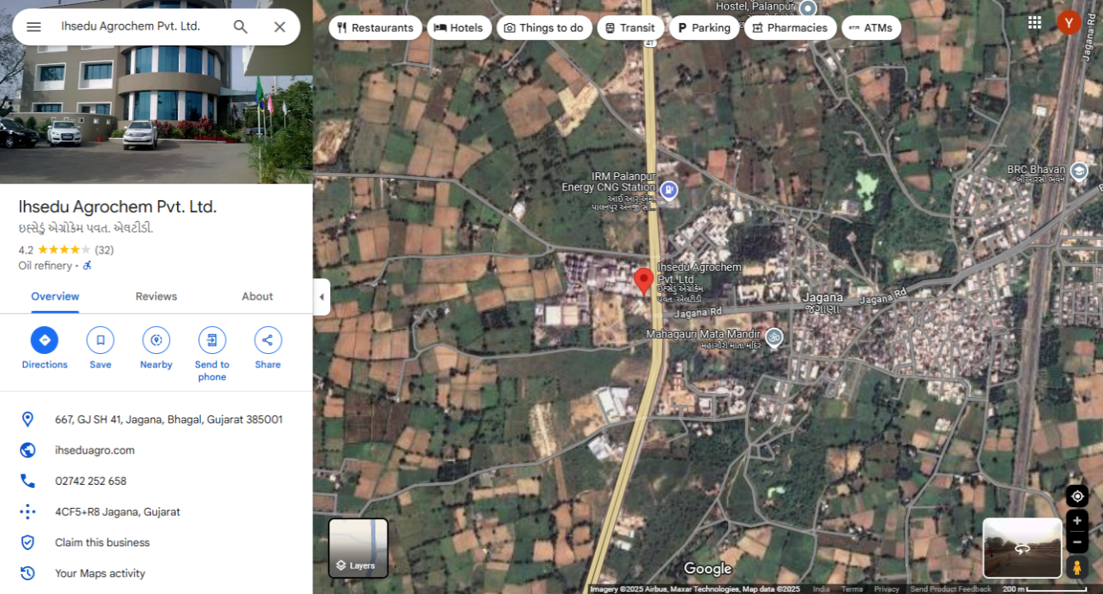
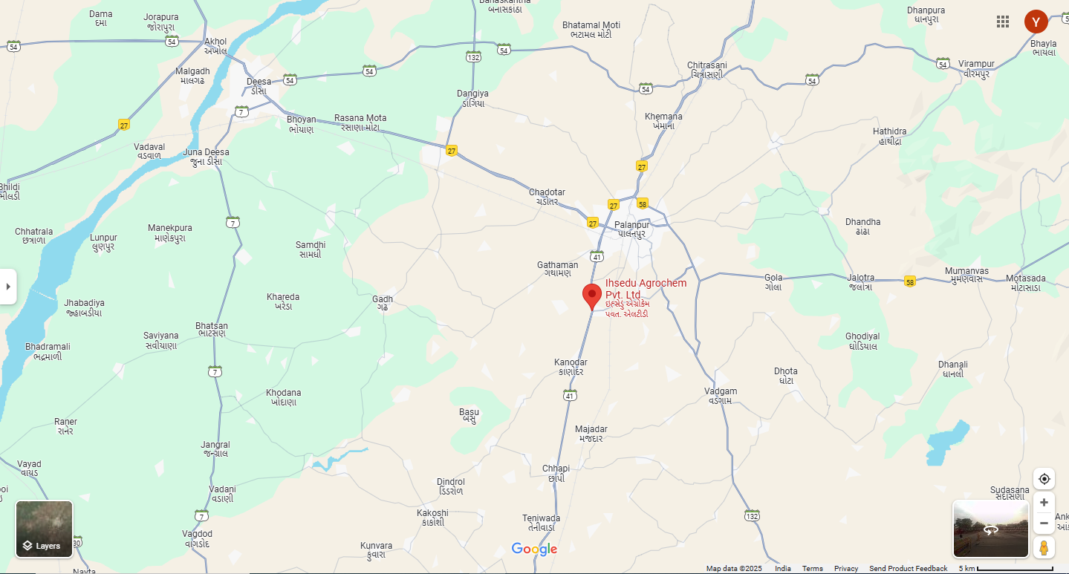
ENCLOSURE: IV - REFERENCES ON PRICE TREND OF THE SIMILAR RELATED PROPERTIES AVAILABLE ON PUBLIC DOMAIN

THE SUBJECT PROPERTY IS IN RURAL AREA SO NO REFERENCE ARE AVAILABLE ON PUBLIC DOMAIN

ENCLOSURE: V – PHOTOGRAPHS OF THE PROPERTY
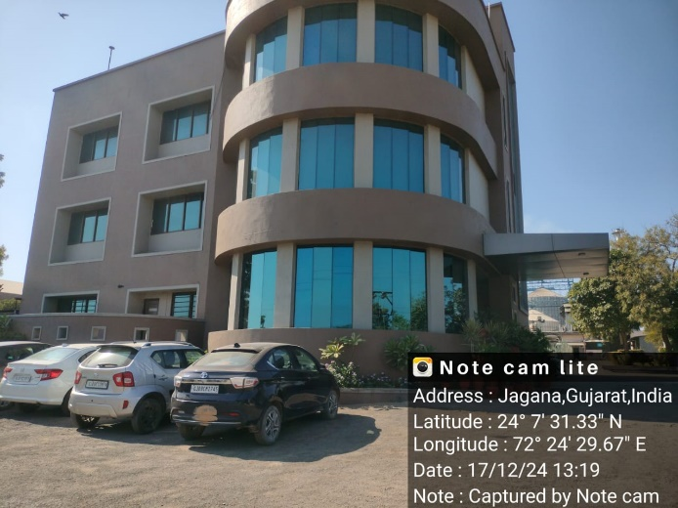 | 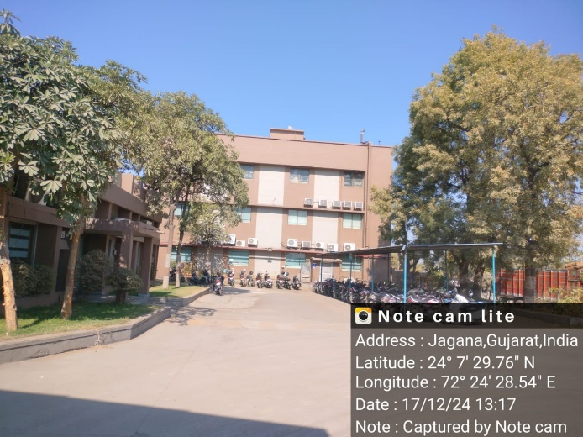
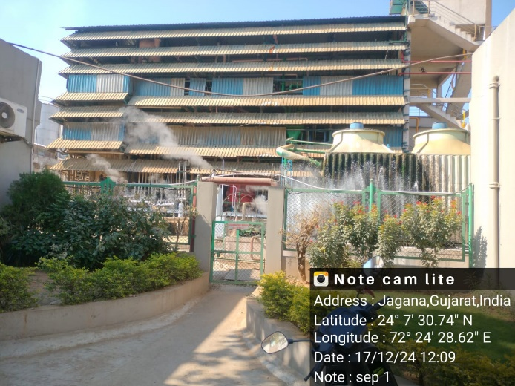 | 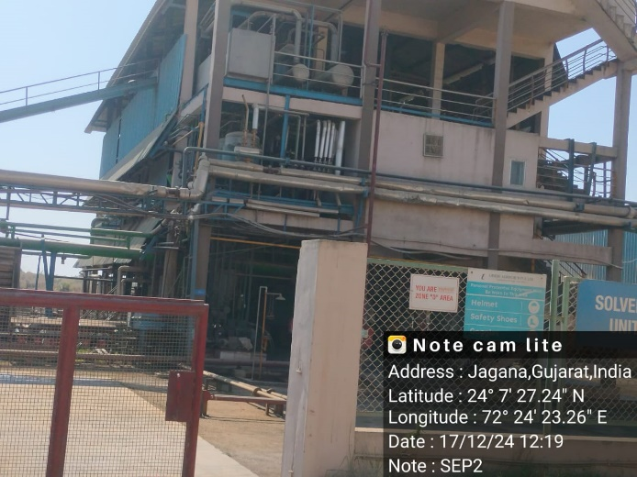
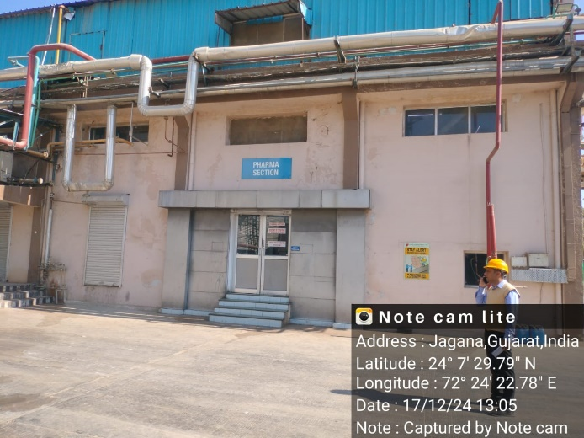 | 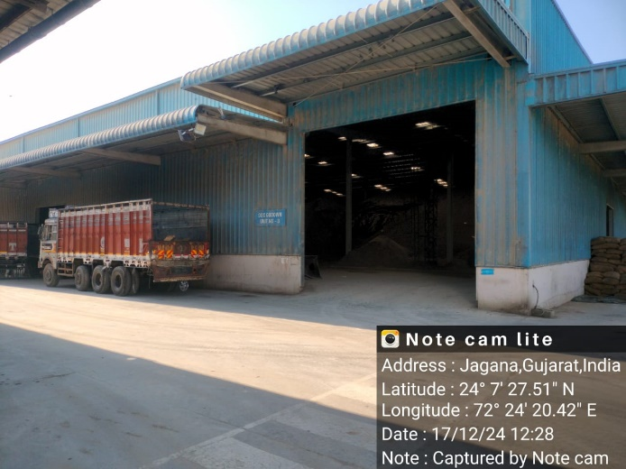

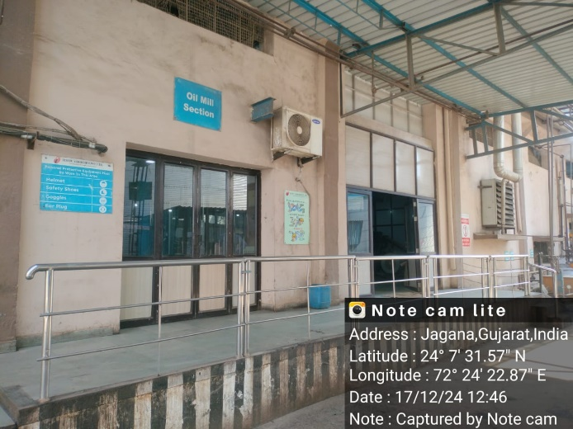 | 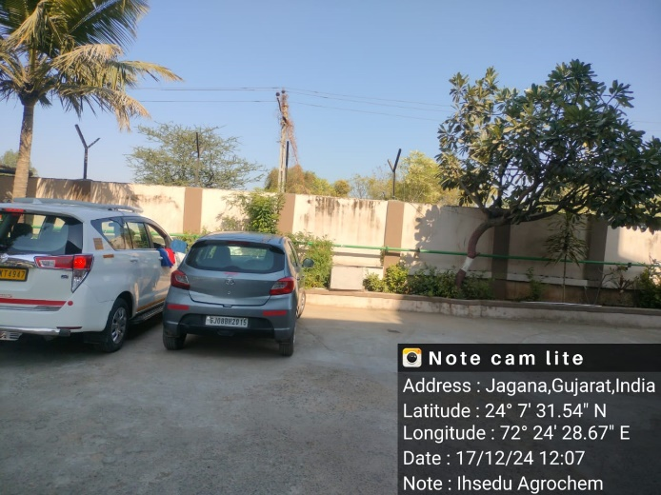
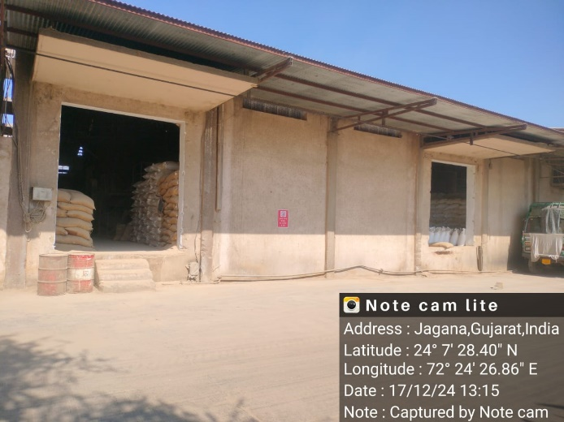 | 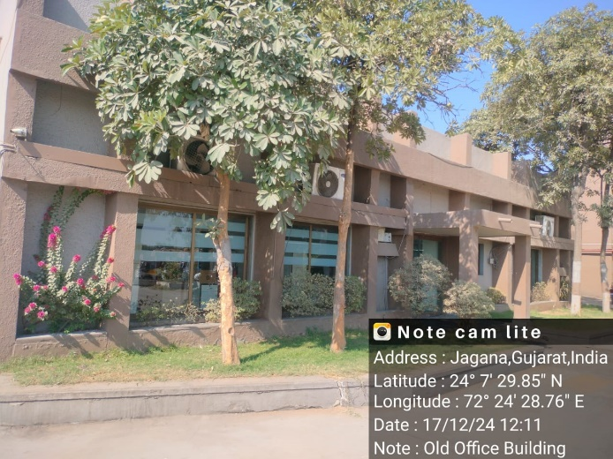
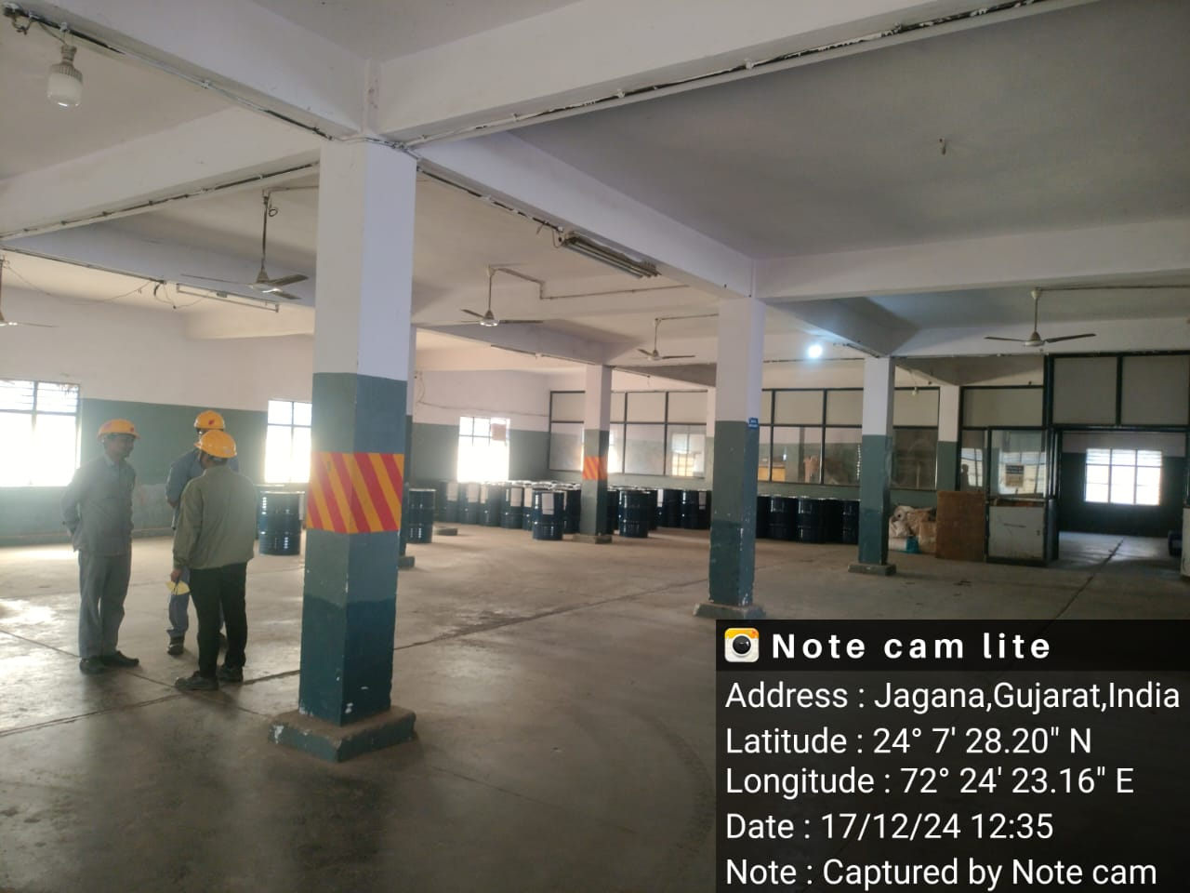 | 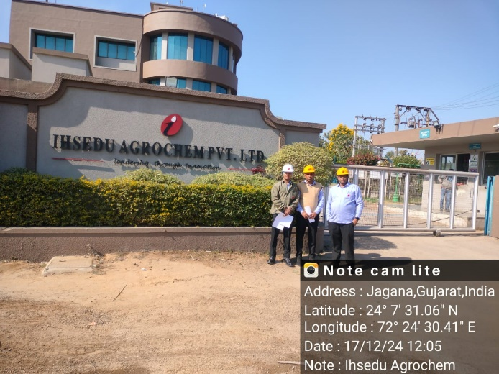

ENCLOSURE: VI – COPY OF CIRCLE RATE

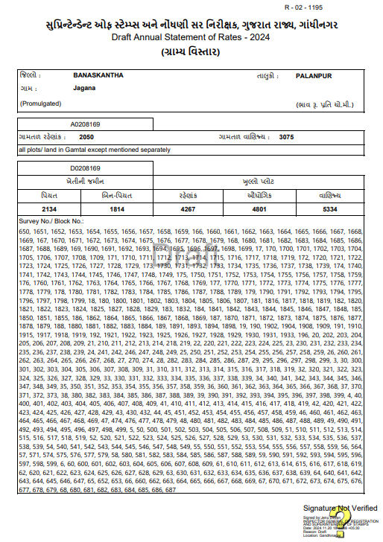
ENCLOSURE VII: IMPORTANT PROPERTY DOCUMENTS EXHIBIT

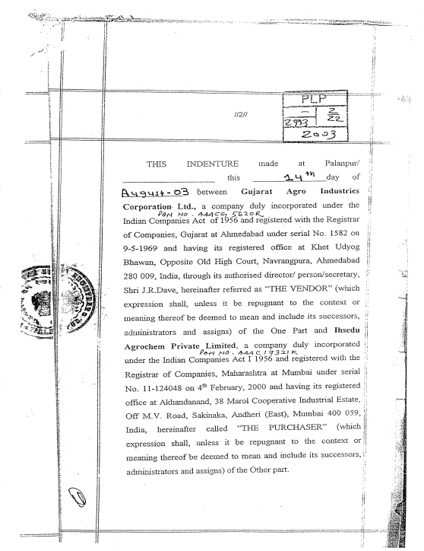

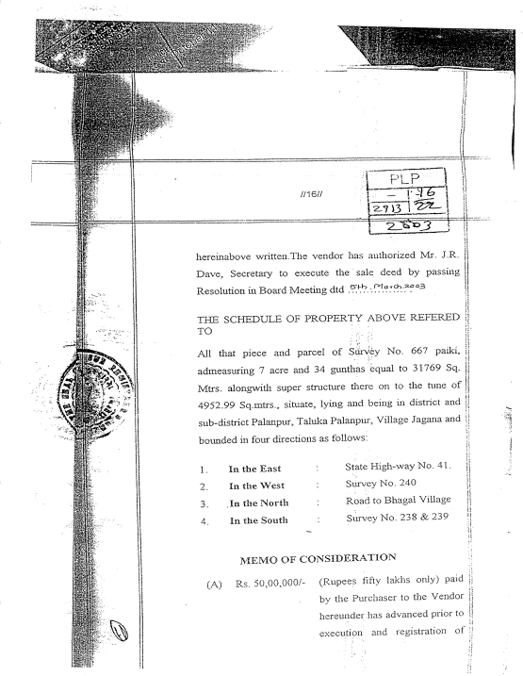

COPY OF TIR
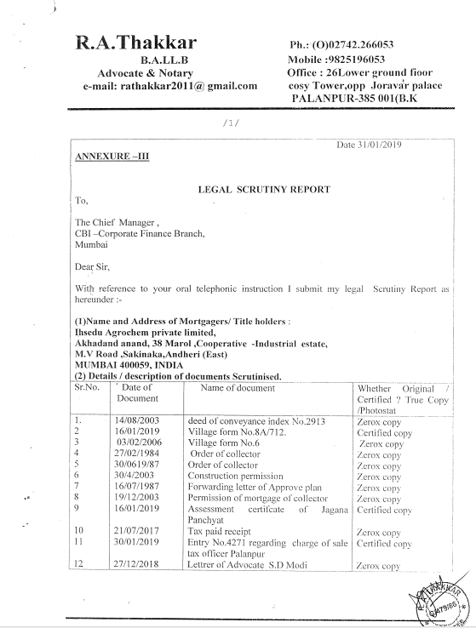 | 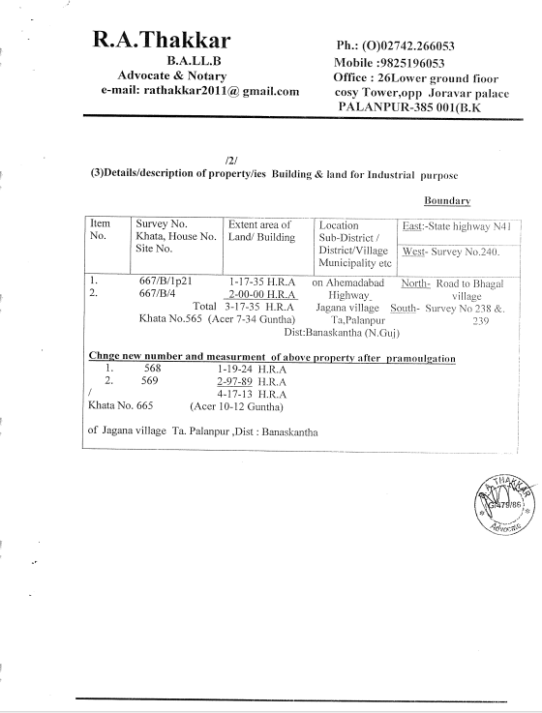

PLANT LAYOUT

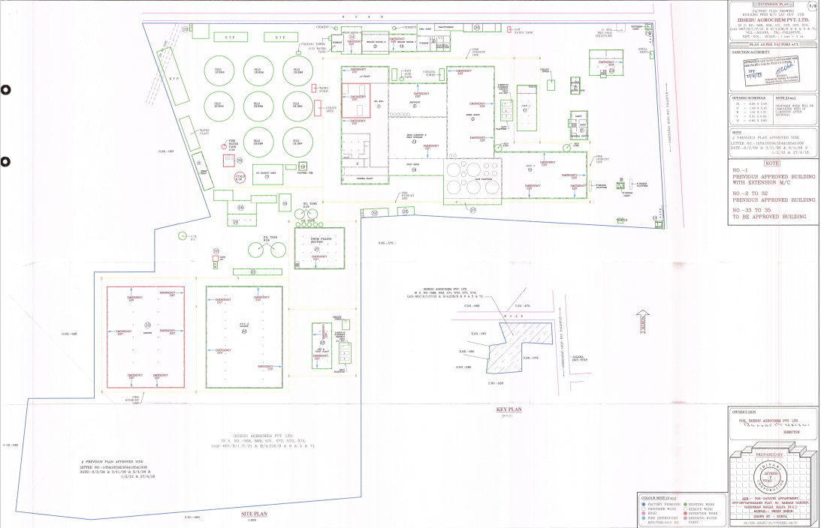

FACTORY LICENSE
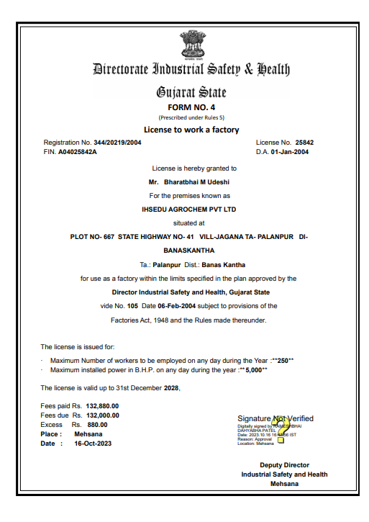

LICENSE TO IMPORT AND STORE PETROLEUM
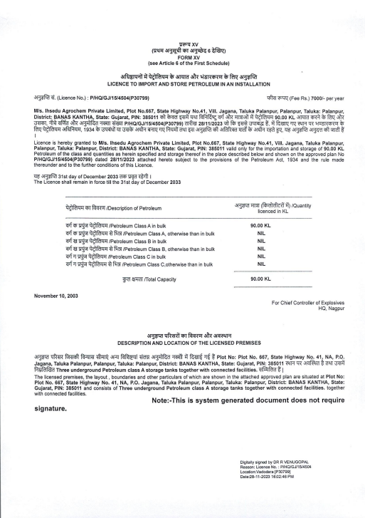

POLLUTION NOC
