**File No. VIS (2024-25)-PL606-544-776 DATED: 05.12.2024**

**CHARTERED ENGINEERING ASSESSMENT REPORT**

**OF**

**MANUFACTURING UNIT OF LED COMPONENTS**

**SITUATED AT**

**KHASRA NUMBER 122 & 265, CENTRAL HOPE TOWN, SELAQUI INDUSTRIAL AREA, DEHRADUN, UTTARAKHAND - 248011**

**IMPLEMENTED BY**

**[DIXON TECHNOLOGIES SOLUTIONS PRIVATE LIMITED](https://www.zaubacorp.com/company/JGN-SUGAR-AND-BIOFUELS-PRIVATE-LIMITED/U15420DL2022PTC404736)**

**REPORT PREPARED FOR**

**IFCI LIMITED, IFCI TOWER, 61, NEHRU PLACE, NEW DELHI – 110019**

***\*\*Important - In case of any query/ issue or escalation you may please contact Incident Manager at le@rkassociates.org. We will appreciate your feedback in order to improve our services.***

***NOTE: As per IBA Guidelines please provide your feedback on the report within 15 days of its submission after which report will be considered to be correct.***

|  |  |  |
| --- | --- | --- |
| **TABLE OF CONTENTS** | | |
| **SR. NO.** | **DESCRIPTION** | **PAGE NO.** |
| **PART A** | **Introduction** | **04-05** |
| **PART B** | **Certificate For PLI Scheme (as per format of IFCI)** | **06** |
| **PART C** | **Project Details** | **07-09** |
| **PART D** | **Annexure-I – Assets for Eligible Investment** | **10-12** |
| **Annexure-II – Photographs of Assets and Site Visit** | **13-16** |
| **Annexure-III – Claim Year Capacity** | **17-19** |
| **Annexure-IV – Claim Year Incremental Capacity** | **20** |
| **Annexure-V – Details of assets at third parties** | **21** |
| **Annexure-VI – Details of Insurance Cover** | **22-23** |
| **Annexure-VII – Manufacturing Process Flow Diagram** | **24-26** |
| **Annexure-VIII – Empanelment Document** | **27** |
| **Annexure-IX – Project Approval Letter** | **28** |
| **Annexure-X – Invoices of Major Machinery** | **29-31** |
| **Annexure-XI – Property Documents** | **32-33** |
| **PART E** | **Chartered Engineer Remarks, Caveats, Limitations & Disclaimers** | **34** |

*NOTE: Part – B, C & D are strictly as per format of IFCI. Any additional CE’s Remarks, Observations, Caveats, Limitations & Disclaimers are covered in Notes of various Annexures and Part-E.*

# IMPORTANT NOTICE

*This report is intended for the sole use of the intended recipient/s and contain material that is STRICTLY CONFIDENTIAL AND PRIVATE.*

***DEFECT LIABILITY PERIOD:*** *- In case of any query/ issue or escalation you may please contact Incident Manager at*[*le@rkassociates.org*](mailto:le@rkassociates.org)*.*

*Though adequate care has been taken while preparing this report as per its scope, but still, we can’t rule out typing, human errors, over sightedness of any information or any other mistakes. Therefore, the concerned organization is advised to satisfy themselves that the report is complete & satisfactory in all respect. Intimation regarding any discrepancy shall be brought into our notice immediately. If no intimation is received within 15 (Fifteen) days in writing from the date of issuance of the report, to rectify these timely, then it shall be considered that the report is complete in all respect and has been accepted. CE Important Remarks / Limitations/ Caveats/ Disclaimers mentioned in Part-E is the integral part of this assessment.*

|  |  |
| --- | --- |
| **PART A** | **INTRODUCTION** |

|  |  |  |  |  |
| --- | --- | --- | --- | --- |
| **S.NO.** | **PARTICULARS** | **DETAILS** | | |
|  | **Report/ Certificate Type** | Chartered Engineering Assessment for GOI PLI Scheme | | |
|  | **Name of the Project** | M/s Dixon Technologies Solutions Private Limited, Manufacturing Unit of LED Components at Khasra Number 122 & 265, Central Hope Town, Selaqui Industrial Area, Dehradun, Uttarakhand - 248011 | | |
|  | **Project Location** | * City: Dehradun * District: Dehradun * State: Uttarakhand | | |
|  | **Name of the Company** | M/s Dixon Technologies Solutions Private Limited | | |
|  | **Client Name** | M/s Dixon Technologies Solutions Private Limited | | |
|  | **Coordinating Person Name and Number** | Name | Designation | Number |
| Mr. Satyapal Chaudhary | Plant Head | +91- 8477004803 |
|  | **Work Order Number** | Email Dated: 19.10.2024 | | |
|  | **Chartered Engineering Firm Name** | M/s. R.K. Associates Valuers & Techno Engineering Consultants (P) Ltd. | | |
|  | **Date of Survey** | 23 November 2024 | | |
|  | **Date of Report** | 05 December 2024 | | |
|  | **Purpose of the Assessment** | For GOI Production Linked Incentive claims | | |
|  | **Scope of the work** | To review production capacity of the Project based on the information/ data supplied by the company | | |
|  | **Documents provided/ pursued for the Project** | 1. Bills/Invoices 2. FAR 3. GST Details 4. Project Approval Letter 5. Manufacturing Process Flow Diagram 6. Production and Stock RM Data 7. Daily Sales Register 8. Catalogue of Major Machinery 9. Production Target and Capacity of Major Machinery 10. Insurance Cover Details 11. Property Documents | | |
|  | **Documents/ Information Provided by** | Name | Designation | Number |
| Mr. Ritik Jain | AGM | 09311242256 |
|  | **Annexure with the report** | 1. Bills/Invoices 2. FAR 3. Site Visit Photographs 4. Project Approval Letter 5. Empanelment Letter 6. Manufacturing Process Flow Diagram 7. Catalogue of Major Machinery 8. Production Target and Capacity of Major Machinery 9. Insurance Cover Details | | |

|  |  |
| --- | --- |
| **PART B** | **CERTIFICATE FOR PLI SCHEME** |

To,

IFCI Limited,

IFCI Tower, 61,

Nehru Place,

New Delhi – 110019

This certificate is being issued in connection with Production Linked Incentive Scheme (PLI) for promoting domestic manufacturing of AC and LED Light in India (hereinafter referred as ‘PLI Scheme’) as notified vide **Notification No. CG-DL-E-16042021-226671 dated 16.04.2021** read with operational guideline dated **4th June 2021**, as amended from time to time (hereinafter referred as ‘the PLI Scheme’).

**M/s Dixon Technologies Solutions Private Limited** was approved under PLI Scheme vide letter no. **IFCI/CASD/DPIIT/PLIWG-211112041** dated **12th November, 2021** issued by IFCI Limited (Project Management Agency appointed under the Scheme).

**M/s R.K. Associates Valuers and Techno Engineering Consultants Pvt. Ltd.** is empaneled with IFCI Ltd. for evaluation of asset class **‘Plant, Machinery & Equipment’** vide letter no. **IFCI/CAD/-221006029** Dated **06th October, 2022** valid till **05th October, 2025** issued by IFCI. **M/s Dixon Technologies Solutions Private Limited** appointed us for the said certification work.

To evaluate and give a certificate on status of compliance with eligibility criteria of Greenfield Project and Committed investment for the period FY 2021 – 2023 by **M/s Dixon Technologies Solutions Private Limited** under PLI Scheme. We have carried out the physical inspection of the plant, examined the relevant records and other documents to evaluate whether applicant has met the eligibility criteria of Greenfield Project and Committed Investment under Production Linked Incentive (PLI) Scheme for FY 2021 – 2023.

To carry out an independent verification/determination of Claim production capacities for the claim year 2023 – 2024 of **M/s Dixon Technologies Solutions Private Limited** under PLI Scheme.

We have carried out the physical inspection of the plant and machinery installed and examined the relevant records for determining claim capacity of all the manufacturing processes involved in the production of eligible products for FY 2023 – 2024. In this regard, we enclosed the capacity of F.Y 2023 – 2024 & incremental capacity generated from incremental investments for the year in **Annexure III and Annexure IV.**

**Thanks & regards,**

**For R.K Associates Valuers & Techno Engg. Consultants (P) Ltd.**

**Project Engineering Team**

|  |  |
| --- | --- |
| **PART C** | **PROJECT DETAILS** |

1. **Details of the Project Set-up by the applicant:**

|  |  |  |
| --- | --- | --- |
| **S.NO.** | **PARTICULARS** | **DETAILS** |
|  | Name of the Applicant | M/s Dixon Technologies Solutions Private Limited |
|  | Project Address | Khasra Number 122 & 265, Central Hope Town, Selaqui Industrial Area, Dehradun, Uttarakhand 248011 |
|  | Eligible products being manufactured | LED Drivers, LED Engines & LED Modules |
|  | Committed investment during the Scheme Period | Rs. 100 crores |
|  | Threshold Investment up to 31st March 2023 | Rs. 20 crores |
|  | Eligible investment physically verified of the investment period F.Y. 2021-23 | **Rs.28.10 crores (Details attached as Annexure I)** |
|  | Date of site visit and company officials facilitating the inspection | **Date: 23-11-2024**  **Company Official:** Mr. Satyapal Chaudhary (Plant Head) |
|  | Whether Project has been set-up in a new factory premises or the existing factory premises | New Factory Premises*.(As per Lease Deed with M/s Allure Consumer Products Pvt. Ltd. for 9 years)* |
|  | Whether claimed Associated Utilities are exclusive to PLI-White Goods or shared with other activities | As per site visit, the said unit is only exclusively for LED Modules, LED Engines and LED Drivers and therefore all associates facilities are exclusively used for it. |
|  | Whether plant/ unit was operational on the date of visit? | Yes |
|  | Status of Land & Building (leased/ Owned/ Common Facilities with any other person or group company) | Lease hold (As per Lease Deed with M/s Allure Consumer Products Pvt. Ltd. for 9 years from 07.11.2022) |

|  |  |  |
| --- | --- | --- |
| **Cumulative Eligible Investment Details** | | |
| **S. No.** | **Particular** | **Amount (Rs. In Crore)** |
|  | Eligible Investment in FY 21-22 (Gross Book Value) | NA |
|  | Eligible Investment in FY 22-23 (Gross Book Value) | Rs. 28.10 crores |
|  | Eligible Investment in FY 23-24 (Gross Book Value) | NA |
|  | Eligible Investment in FY 24-25 (Gross Book Value) | NA |
|  | Eligible Investment in FY 25-26 (Gross Book Value) | NA |
|  | Eligible Investment in FY 26-27 (Gross Book Value) | NA |
|  | **Total (A)** | **Rs. 28.10 crores** |
|  | Less: - Sold/ Written off Eligible Investment (if any) for investment period as on 31st March, 2023 | NA |
|  | Eligible Investment in FY 21-22 (Gross Book Value) | NA |
|  | Eligible Investment in FY 22-23 (Gross Book Value) | NA |
|  | Eligible Investment in FY 23-24 (Gross Book Value) | NA |
|  | Eligible Investment in FY 24-25 (Gross Book Value) | NA |
|  | Eligible Investment in FY 25-26 (Gross Book Value) | NA |
|  | Eligible Investment in FY 26-27 (Gross Book Value) | NA |
|  | **Total (B)** | NA |
|  | **Net Cumulative Investment as on 31st March, 2023 (A - B)** | **Rs. 28.10 crores** |

1. We visited the project site on **23-11-2024** and the photograph of the site with visiting team is attached at **Annexure II**.
2. The project set-up by **M/s Dixon Technologies Solutions Private Limited** at **Khasra Number 122 & 265, Central Hope Town, Selaqui Industrial Area, Dehradun, Uttarakhand 248011** for eligible products **LED Drivers, LED Engines & LED Modules** is a Greenfield Project as defined under clause 2.21 respectively of the Scheme Guidelines.

All the Plant & Machinery, Associated Utilities or R&D Equipment being utilized in the production of eligible projects are new as per the Invoices and declaration given by the company. No second hand/ used/ refurbished plant, machinery, equipment, utilities has been used to manufacture the eligible products approved under PLI Scheme in compliance with clause 14.1.4. of the Scheme Guidelines.

1. The capex items claimed for eligibility criteria of committed investment under the PLI Scheme are required for the manufacturing of eligible products Control Assemblies for IDU, ODU and Remotes and all such plant & machinery have been installed in the factory premises of **M/s Dixon Technologies Solutions Private Limited** at **Khasra Number 122 & 265, Central Hope Town, Selaqui Industrial Area, Dehradun, Uttarakhand.**
2. All capital items which have been claimed as products eligibility criteria of investment are being used in regular course for the manufacturing of eligible product under PLI scheme and the cost of investment claim under PLI scheme is reasonable.
3. All capital items have been purchased at prices that are in our opinion reasonable and in-line with prevailing market value as on the date of the purchase.

*Please note that all capital items have been considered as per the Invoices/ FAR provided to us. Some of these are special and custom design machines procured from NMTronics (India) Pvt. Ltd. which is a Partner of Fuji Corporation, Japan and market rates are not available openly for such machines.*

1. With reference to clause 8.4.2 of the Scheme Guidelines, the amount of Associated Utilities claimed under eligible capex is **Rs. 3,83,30,199/-** as per the FAR given by the company.
2. We confirm that utilization of the Plant, Machinery and Equipment for manufacturing of eligible product(s) under target segment for financial year for which the applicant is claiming incentive under the Scheme.
3. The manufacturing of the eligible products in the Greenfield Project meets the criteria set up under clause 2.21 of the Scheme Guidelines.
4. The capex items included in Eligible Capex are installed at the Project Location except for certain items situated at third parties/ vendors whose details are furnished as **Annexure V.**
5. We have examined the insurance policies for capex items considered under Eligible Investment. Company has taken insurance cover for an amount of ₹ 50.00 crore (For Plant and Machinery). Extract of insurance policies is furnished as **Annexure VI**. In our view insurance cover obtained by the Company for the Eligible Investment is adequate.
6. The manufacturing process flow diagram (MPFD) of each eligible product is attached as **Annexure-VII.** We have observed the manufacturing process followed by the Company and the same is in line with the MPFD(s) attached.at **Annexure VII.**
7. Site Photographs with GPS coordinates (the factory premises, visiting team from CE and company official (give name and designation) should be appearing in photograph at **Annexure – II.**

**DECLARATIONS:**

1. It has been ensured that the information furnished is true and correct as furnished by the company to the best of our knowledge. No part of it is false or misleading and no relevant information has been concealed or withheld to the best of our knowledge.
2. We have requisite expertise, experience, and qualification to evaluate the project and give this certificate.
3. Neither of our director/ partner/ proprietor or employee has any present or prospective interest in the Greenfield Project of **M/s Dixon Technologies Solutions Private Limited** (name of the applicant).
4. Neither I nor any of my partners or director or employee is a partner, director or an employee of **M/s Dixon Technologies Solutions Private Limited** (name of applicant) or its associated concerns.
5. That the assessment is done based on the inputs/ data/ information provided by the company verbally or in writing has been relied upon.

This report is issued without prejudice or conflict of interest.

**Signature & Seal of CE firm**

**CE Name: -**

**Date:-**

**Registration No.:-**

**ANNEXURE-I – ASSETS FOR ELIGIBLE INVESTMENT**

|  |  |  |  |  |  |  |  |
| --- | --- | --- | --- | --- | --- | --- | --- |
| **S. No.** | **Type as per PLI** | **Usage in Production** | **Asset Code in FAR** | **Asset Description as per FAR** | **Capitalisation Date** | **Balance Sheet Head** | **Amount Capitalized** |
| 1 | Plant & Machinery | SMT | 16000000 | FUJI SMT MACHINE -NXT III (60MIII + 1M6III With Access.) | 28-03-2023 | P&MC Imported | 16,90,87,800 |
| 2 | Plant & Machinery | Printer | 16000017 | FUJI GPX-CSII Automatic Printer (8 Sec) Including | 28-03-2023 | P&MC Imported | 2,89,09,980 |
| 3 | Plant & Machinery | Soldering Machine | 16000015 | JT RS-1200III (Air) Reflow Oven With Accessories | 27-03-2023 | P&MC Imported | 1,47,39,990 |
| 4 | Plant & Machinery | LED Mounting | 16000009 | LED Mounter (Model-L500) | 24-03-2023 | P&MC Imported | 1,10,86,346 |
| 5 | Plant & Machinery | Testing Unit | 16000001 | Post SMT Testing (5-50M) (Model-LS50TEST) | 24-03-2023 | P&MC Imported | 84,74,314 |
| 6 | Associated Utilities | Electrical Installation | 16000066 | CABLES FOR ELECTRICAL WORK PROJECT  122/265 BUILDI | 22-03-2023 | ELECTRICAL INSTALL | 62,41,856 |
| 7 | Plant & Machinery | Civil Work | 16000025 | ESD TILES WITH INSTALLATION 2MM | 21-01-2023 | Buildings Others | 56,64,000 |
| 8 | Associated Utilities | Power Equipments | 16000022 | 910KVA,415V MODEL- KTA38-G17SILENT DG SET CUMMINS | 10-03-2023 | P&M India | 56,50,000 |
| 9 | Associated Utilities | Air Conditioning | 16000067 | HVAC OUTDOOR UNIT 122/265 BUILDING | 15-02-2023 | P&M India | 37,99,559 |
| 10 | Associated Utilities | Air Conditioning | 16000068 | INDOOR UNIT HVAC 122/265 BUILDING | 15-02-2023 | P&M India | 32,97,562 |
| 11 | Associated Utilities | Utilities | 16000040 | Air Pipe line work for SMT & MI Floor | 09-02-2023 | P&M India | 29,62,537 |
| 12 | Associated Utilities | Power Equipments | 16000023 | 3150KVA 11/.433 KV TRANSFORMER WITH OLTC ,RTCC PAN | 27-02-2023 | P&M India | 26,50,000 |
| 13 | Associated Utilities | Electrical Installation | 16000062 | Electrical Installation & Fixing of LT/HT PANEL,C | 18-02-2023 | ELECTRICAL INSTALL | 24,24,458 |
| 14 | Associated Utilities | Water Treatment | 16000024 | S.T.P.50 KLD WITH ADDITIONAL WORK AS PER SITE | 31-03-2023 | P&M India | 23,74,360 |
| 15 | Associated Utilities | Electrical Installation | 16000050 | BUSCOUPLER | 22-03-2023 | P&M India | 17,25,737 |
| 16 | Plant & Machinery | Soldering Machine | 16000012 | 10 Zone Reflow Oven (2 Lane) (Model-LK-10M) | 31-03-2023 | P&MC Imported | 16,85,160 |
| 17 | Associated Utilities | Utilities | 16000026 | AIR COMPRESSOR 90-357 CFM 8.0 KG/CM^2 PRESSURE ELG | 25-03-2023 | P&M India | 11,50,000 |
| 18 | Associated Utilities | Power Equipments | 16000034 | 160KVA ON-LINE UPS DOUBLE CONVERSION BPE MAKE EPX+ | 16-01-2023 | P&M India | 8,35,000 |
| 19 | Plant & Machinery | Lift | 16000064 | GOODS LIFT PROVIDING, 1000KGS (12MONTH) MAINT FREE | 09-02-2023 | P&M India | 6,90,000 |
| 20 | Associated Utilities | Electrical Installation | 16000059 | 800KVAr APFC PANEL | 22-03-2023 | P&M India | 6,84,282 |
| 21 | Plant & Machinery | Goods Handling | 16000011 | 43M Bridge Belt Line (Model-LK-BR43M) | 24-03-2023 | P&MC Imported | 5,70,864 |
| 22 | Plant & Machinery | Repair Table | 16000014 | Repairing Desk Including Fixtures (Model-LK-RPFX) | 24-03-2023 | P&MC Imported | 5,37,770 |
| 23 | Plant & Machinery | Printer | 16000007 | Semi-Automatic Printer (1.2M) (Model-LK-S1200) | 24-03-2023 | P&MC Imported | 4,96,405 |
| 24 | Plant & Machinery | Goods Handling | 16000010 | 25M Flat Belt line (Model-LK-CON25M) | 24-03-2023 | P&MC Imported | 4,70,712 |
| 25 | Associated Utilities | Power Equipments | 16000031 | 600KVA 3PH SERVO OIL COOLED ABC MAKE OUTPUT 415V(+ | 24-02-2023 | P&M India | 4,65,000 |
| 26 | Associated Utilities | Power Equipments | 16000032 | 500KVA 3PH SERVO OIL COOLED ABC MAKE OUTPUT 415V(+ | 24-02-2023 | P&M India | 3,90,000 |
| 27 | Associated Utilities | Power Utilities | 16000035 | SMF BATTERY FOR 15MIN BACKUP | 16-01-2023 | P&M India | 3,56,800 |
| 28 | Associated Utilities | Electrical Installation | 16000063 | LT/HT PANEL CABELE TRAY | 21-01-2023 | P&M India | 3,21,750 |
| 29 | Associated Utilities | Electrical Installation | 16000095 | SUPPLY & INSTALLATION 3200AMP ISOLATOR WITH ON OFF | 17-03-2023 | P&M India | 3,20,000 |
| 30 | Associated Utilities | Power Equipments | 16000069 | 30KVA STEP DOWN ISOLATION TRANSFORMER (THREE PHASE | 10-03-2023 | P&M India | 2,76,000 |
| 31 | Associated Utilities | Electrical Installation | 16000047 | MAIN LT PANEL-1 | 22-03-2023 | P&M India | 2,42,408 |
| 32 | Associated Utilities | Electrical Installation | 16000060 | SERVO INPUT PANEL 1 | 22-03-2023 | P&M India | 2,41,029 |
| 33 | Associated Utilities | Electrical Installation | 16000061 | SERVO INPUT PANEL 2 | 22-03-2023 | P&M India | 2,41,029 |
| 34 | Associated Utilities | Utilities | 16000027 | AIR DRYER REFRIFERATOR TYPE 500CFM ELGI | 25-03-2023 | P&M India | 2,00,000 |
| 35 | Associated Utilities | Electrical Installation | 16000051 | UPS PANEL -01nos | 22-03-2023 | P&M India | 1,83,667 |
| 36 | Associated Utilities | Computers | 16000071 | ACER DESKTOP i3/8GB/1TB/WIN10/5YRS | 28-03-2023 | Computer-Hardware | 1,79,400 |
| 37 | Associated Utilities | Electrical Installation | 16000048 | 910KVA DG PANEL | 22-03-2023 | P&M India | 1,72,649 |
| 38 | Associated Utilities | Electrical Installation | 16000049 | 750KVA DG PANEL | 22-03-2023 | P&M India | 1,61,855 |
| 39 | Associated Utilities | Utilities | 16000028 | VERTICAL AIR RECEIER CAPACITY 2000L ELGI | 25-03-2023 | P&M India | 1,10,000 |
| 40 | Plant & Machinery | Goods Handling | 16000008 | Buffer Conveyor (Model-LK-BFC) | 24-03-2023 | P&MC Imported | 1,07,467 |
| 41 | Plant & Machinery | Goods Handling | 16000006 | Flexible PCB Loader (Model-LK-LD) | 24-03-2023 | P&MC Imported | 99,280 |
| 42 | Plant & Machinery | Goods Handling | 16000013 | Unloader (Model-LK-ULD) | 24-03-2023 | P&MC Imported | 99,280 |
| 43 | Associated Utilities | Electrical Installation | 16000057 | LIGHT & POWER PANEL (GROUND FLOOR PANEL) | 22-03-2023 | P&M India | 98,928 |
| 44 | Associated Utilities | Electrical Installation | 16000052 | UPS OUTPUT PANEL 1 FOR SMT LINES | 22-03-2023 | P&M India | 74,345 |
| 45 | Associated Utilities | Electrical Installation | 16000053 | UPS OUTPUT PANEL 2 FOR SMT LINE | 22-03-2023 | P&M India | 74,345 |
| 46 | Associated Utilities | Electrical Installation | 16000054 | AC PANEL-1 | 22-03-2023 | P&M India | 65,305 |
| 47 | Associated Utilities | Electrical Installation | 16000055 | AC PANEL-2 | 22-03-2023 | P&M India | 65,305 |
| 48 | Associated Utilities | Electrical Installation | 16000033 | 50KVA 3PH SERVO OIL COOLED ABC MAKE OUTPUT 415V(+/ | 24-02-2023 | P&M India | 65,000 |
| 49 | Associated Utilities | Networking | 16000070 | CYBER RACK 42U | 28-02-2023 | Computer-Hardware | 59,600 |
| 50 | Associated Utilities | Electrical Installation | 16000058 | LIGHT & POWER PANEL (FIRST FLOOR PANEL) | 22-03-2023 | P&M India | 44,549 |
| 51 | Associated Utilities | Computers | 16000072 | TFT ACER 19.5" | 28-03-2023 | Computer-Hardware | 35,700 |
| 52 | Associated Utilities | Networking | 16000036 | CONNECTION AND RACK | 16-01-2023 | P&M India | 28,000 |
| 53 | Associated Utilities | Utilities | 16000039 | Fire Fitting Pipe line work | 22-03-2023 | Office Equipment | 22,184 |
| 54 | Associated Utilities | Utilities | 16000030 | FINE FILTER TO REDUCE OIL CARRYOVER <0.01PPM WITH | 25-03-2023 | P&M India | 20,000 |
| 55 | Associated Utilities | Air Conditioning | 16000029 | PARTICULAR FILTER TO REDUCE OIL CARRYOVER <0.5PPM | 25-03-2023 | P&M India | 20,000 |
|  |  |  |  | **Total** | | | **28,10,49,567** |

***Source: Company’s FAR***

**Note: -**

1. Above is the complete list of the machines as per FAR and Invoices shared by the company.
2. All the major machines/ equipment’s were verified at site against the FAR and Invoices shared by the company covering approximately 95% of the total amount.
3. Bill of customs clearance from third parties is also reviewed for some of major machines on sample basis in respect of the imported machines.

**ANNEXURE – II – PHOTOGRAPHS OF THE ASSETS AND SITE VISIT**

|  |  |  |  |  |  |  |
| --- | --- | --- | --- | --- | --- | --- |
| **S.**  **No.** | **Machine/ Asset Name** | **Model#** | **Serial#** | **Make/ Manufacturer** | **Fixed Asset Code**  **Asset ID** | **Building where installed** |
| 1. | Pick & Place | Fuji NXT III | SD0109324,  SD0109326 | FUJI CORPORATION | 5000000 | Khasra No. 122&265 , Selaqui, Dehradun |

|  |  |  |  |  |  |
| --- | --- | --- | --- | --- | --- |
| **Invoice#** | **Invoice date** | **Description of Asset as per Invoice** | **Name of**  **Seller/ Vendor** | **Status (Running/ Idle/ Under maintenance/ To be commissioned/ etc.)** | **Amount Capitalized**  **(₹)** |
| CHG23194 | 16-03-2023 | Pick and Place Machine | NMTRONICS (INDIA) PRIVATE LIMITED | Running | 16,90,87,800 |

|  |  |
| --- | --- |
| **Photo of Asset:** | |
|  |  |
|  |  |

|  |  |  |  |  |  |  |
| --- | --- | --- | --- | --- | --- | --- |
| **S.**  **No.** | **Machine/ Asset Name** | **Model#** | **Serial#** | **Make/ Manufacturer** | **Fixed Asset Code**  **Asset ID** | **Building where installed** |
| 2. | FUJI Automatic Printer | GPX-CSII | S5125-S5129,S5143,  S5144,S5134 | FUJI CORPORATION | 5000020 to 5000027 | Khasra No. 122&265 , Selaqui, Dehradun |

|  |  |  |  |  |  |
| --- | --- | --- | --- | --- | --- |
| **Invoice#** | **Invoice date** | **Description of Asset as per Invoice** | **Name of**  **Seller/ Vendor** | **Status (Running/ Idle/ Under maintenance/ To be commissioned/ etc.)** | **Amount Capitalized**  **(₹)** |
| CHG23193 | 16.03.2023 | Automatic Printer | NMTRONICS (INDIA) PRIVATE LIMITED | Running | 2,89,09,980 |

|  |  |
| --- | --- |
| **Photo of Asset:** | |
|  |  |
|  |  |

**PHOTOS OF SITE VISIT**

|  |  |
| --- | --- |
|  |  |
|  |  |
|  |  |

|  |  |
| --- | --- |
|  |  |
|  |  |
|  |  |

**ANNEXURE - III**

**DETERMINATION OF CLAIM YEAR CAPACITY:**

|  |  |  |  |
| --- | --- | --- | --- |
|  | **Manufacturing location(s)** | **Date of Inspection** | **Greenfield/ Brownfield/ Both** |
| Khasra Number 122 & 265, Central Hope Town, Selaqui Industrial Area, Dehradun, Uttarakhand - 248011 | 23-11-2024 | Greenfield |
|  | **Actual Investment: up to 31st March 2023** | Rs. 28.10 crores (eligible investment) | |
|  | **Eligible products manufactured** | LED Drivers, LED Engines & LED Modules | |
|  | **No. of working shift on the date of site visits** | 1 shift (Manual Insertion) , 2 shifts (Automatic) | |
|  | **New Manufacturing Facility** | | |
| **5.1** | **Production/ Manufacturing capacity as**  **per the Machinery installed p.a. (FY 2023-24)** | **ITEM** | **QUANTITY (IN NOS.)** |
| LED Drivers | 10,21,24,800 |
| LED Engines | 3,88,80,000 |
| LED Modules | 7,56,86,400 |
|  |  | **Total** | **21,66,91,200** |
| **5.2** | **Present Utilization of total production/ manufacturing Capacity by unit p.a. (Actual capacity) for FY 2023-24.** | **ITEM** | **QUANTITY (IN NOS.)** |
| LED Drivers | 6,41,51,480 |
| LED Engines | 3,04,61,751 |
| LED Modules | 6,64,07,164 |
|  |  | **Total** | **16,10,20,395** |

**CHARTERED ENGINEER’S COMMENTS ON SITE INSPECTION FINDINGS:**

1. We have thoroughly inspected all the machines/items described above and hereby we confirm that they are in compliance with the records.
2. We have verified the eligible product wise Manufacturing Process Flow Charts and found in conformity with the productions processes observed at the manufacturing location(s) for the following Eligible Products. Process Flow Charts is annexed as Annexure – VII.
3. LED Drivers,
4. LED Engines and
5. LED Modules
6. We have verified the number of eligible products manufactured in the year (2023- 2024) from the examination of the ERP/internal production records provided by the company, explanations provided by the company and the capacity of the Production lines as detailed in the process flow chart and information submitted in the PLI-White Goods portal and the capacity for the locations visited and on the basis of our verification as detailed below.
7. **DETAILS OF AVERAGE CAPACITY UTILIZATION OF COMPANY’S PRODUCTS AT THE COMPANY’S MANUFACTURING FACILITIES FOR THE SPECIFIED PERIODS:**

|  |  |  |  |  |  |  |  |
| --- | --- | --- | --- | --- | --- | --- | --- |
| **S.**  **No** | **Name of Eligible Products** | **Standard Capacity as on 31.03.2024**  **(in nos.)** | **No. of products manufactured in the**  **F.Y 2023-24**  **(in nos.)** | **No. of Days the products was/were manufactured in the F.Y 2023-24**  **(in nos.)** | **Number of working Shifts**  **per day** | **No. of Products manufacture per day per shift in the year** | **Variance as per CE’s**  **findings** |
| **Location – Khasra Number 122 & 265, Central Hope Town, Selaqui Industrial Area, Dehradun, Uttarakhand** | | | | | | | |
| 1. | LED Drivers | 10,21,24,800 | 6,41,51,480 | 227 | 2 shifts | 2,24,944 | --- |
| 2. | LED Engines | 3,88,80,000 | 3,04,61,751 | 250 | 2 shifts | 77,760 | --- |
| 3. | LED Modules | 7,56,86,400 | 6,64,07,164 | 268 | 2 shifts | 1,41,206 | --- |
| **Total** | | **21,66,91,200** | **16,10,20,395** |  |  |  |  |

**Notes:**

1. The information relating to the installed capacity as of the dates included above are based on ‘various assumptions’ *(details are given under in foot note)* and estimates that have been taken into account for calculation of the installed capacity. The assumption is also based on the three (3) shifts that the Company is running for eight (8) hours a shift. The assumptions and estimates taken into account include the following: (i) Number of working days in a fiscal year-300, (ii) Number of days in a month-30, (iii) Number of shifts in a day- 3, (iv)Number of hours- 8 in a shift and (v) Schedule preventive maintenance days-8.
2. The information relating to the actual production as of the dates included above are based on the examination of the ERP/internal production records provided by the Company, explanations given, the period during which the manufacturing facilities operate in a fiscal year, expected operations, availability of raw materials, downtime resulting from schedule maintenance activities, unscheduled breakdowns, as well as expected operational efficiencies.

**CE Observations**

1. As per discussion with the company proponents and as per the manufacturing process the capacity of the unit can be determined based on Pick & Place machine. The capacity of the machine is different for different products manufactured depending on its size & specifications. All the segments have different cycle time. Company also manufactures different segments; therefore, no fixed capacity can be fixed.
2. Based on the above specification, company has given the calculation for the Production capacity on hourly basis.
3. There are no in built counters in the machines which shows the production record.
4. Production data of the company is also corroborated from the Sale record of the company for the corresponding period which is found to be inline.
5. The hourly production targets for different segment as follows:

|  |  |  |  |  |  |
| --- | --- | --- | --- | --- | --- |
| **PICK AND PLACE PRODUCTION TARGETS** | | | | |  |
| **Product Classification** | **Subtype of Products** | **Unit** | **Machine Used** | **Target per Hour (in pcs.)** | **Cycle Time**  **(in sec.)** |
| LED Engine | LED Engine | Pcs. | FUJI NXT IIII | 7500 | 0.90 |
| LED Driver | LED Driver | Pcs. | FUJI NXT IIII | 4400 | 0.31 |
| LED Driver on Board | Pcs. | FUJI NXT IIII | 12600 | 0.44 |
| LED Module | LED Batten Module | Pcs. | FUJI NXT IIII | 9600 | 1.02 |
| LED Module | Pcs. | FUJI NXT IIII | 4000 | 0.60 |

***Source: Company***

1. *Company has 4 sets of pick and place machines with total 60 modules which run simultaneously for different products.*
2. *Above is the average estimation and has been rounded off to the next whole number.*
3. *In case of Driver Manual Insertion of few components is involved so we have considered only the finished product after MI because al other products are manufactured on SMT only as per information provided by the company officials.*
4. Accordingly, the total achievable Production is assessed if a single product is produced and all 3 products are produced simultaneously:

|  |  |  |  |  |
| --- | --- | --- | --- | --- |
| **STANDARD PRODUCTION CAPACITY** | | | | |
|  |
| **Working Days** | **Working hours (24 hrs.)** | **Production Capacity (in nos.) (A)** | | |  |
| **LED Drivers** | **LED Engine** | **LED Module** |  |
| **300** | **14400** | **11,34,72,000** | **4,32,00,000** | **8,40,96,000** |  |
| **Time loss (less 10% of production capacity)(B)** | | **1,13,47,200** | **43,20,000** | **84,09,600** |  |
| **Production capacity as per plan (A-B)** | | **10,21,24,800** | **3,88,80,000** | **7,56,86,400** |  |
| **Expected Capacity Grand Total of all products (Driver+ Engine+ Module)** | | | | **21,66,91,200 1** |  |
| **Adjusted Expected Production Capacity (Rounded off) (in nos.)** | | | | **21,67,00,000 2** |  |

1. *This is the expected capacity if product is produced without considering major breakdown and Changeover time.*
2. *This shows the adjusted number of products produced within the optimum production assessment which appears to be reasonable if all 3 products are produced simultaneously.*
3. Therefore, based on the above assessment, ERP/internal production records provided by the company, explanations provided by the company and the capacity of the Production lines as detailed in the process flow chart.

**ANNEXURE IV - INCREMENTAL CAPACITY FOR THE CLAIM YEAR**

**Annexure A**

|  |  |  |  |
| --- | --- | --- | --- |
| **S. No.** | **Name of Eligible Products** | **Standard Capacity as on 31.03.2024 from new manufacturing facility as per section 2.10 or 2.21 of the scheme guidelines (in nos.)** | **No. of products manufactured in the year 2023-24 from new manufacturing facility as per section 2.10 or 2.21 of the scheme guidelines (in nos.)** |
| **Location – Khasra Number 122 & 265, Central Hope Town, Selaqui Industrial Area, Dehradun, Uttarakhand** | | | |
|  | LED Drivers | 10,21,24,800 | 6,41,51,480 |
|  | LED Engines | 3,88,80,000 | 3,04,61,751 |
|  | LED Modules | 7,56,86,400 | 6,64,07,164 |
| **Total** | | **21,66,91,200** | **16,10,20,395\*** |

**Annexure B**

|  |  |  |  |  |
| --- | --- | --- | --- | --- |
| **S. No.** | **Name of Eligible Products** | **Standard Baseline Capacity as per Original Baseline Certificate (B) (in nos.)** | **Base Year actual Production as per CE Certificate (in nos.)** | **No. of products manufactured in the year F.Y 2023-24 (in nos.)** |
| **Location – Khasra Number 122 & 265, Central Hope Town, Selaqui Industrial Area, Dehradun, Uttarakhand** | | | | |
| **1.** | LED Drivers | 0 | 0 | 6,41,51,480 |
| **2.** | LED Engines | 0 | 0 | 3,04,61,751 |
| **3.** | LED Modules | 0 | 0 | 6,64,07,164 |
|  |  |  |  | **16,10,20,395\*** |

**Note:**

1. Baseline Capacity certificate is not applicable as this is a new project and commercial production started on 31.03.2023 and the Claim year is FY 2023-24.
2. *Number of products manufactured in the year 2023-24 is as per the records and explanation furnished by the company.

**ANNEXURE -V**

**Details of assets at third parties**

No assets claimed as Eligible Investment under the Scheme Guidelines are lying outside the premises of the Company at premises of third parties which are its vendors/ suppliers/ etc.

**ANNEXURE -VI - DETAILS OF INSURANCE COVER**

|  |  |  |  |  |  |  |  |
| --- | --- | --- | --- | --- | --- | --- | --- |
| **S.**  **No.** | **Type of Insurance**  **(Assets covered)** | **Policy No.** | **Name of Insurer** | **Start date of cover** | **Details of risks**  **covered** | **End date of**  **cover** | **Amount**  **(Rs. cr.)** |
| 1. | Plant and Machinery | 2999206362564100000 | HDFC ERGO General Insurance Company Limited | 01-04-2024 | P&M | 31-03-2025 | 50.00 |
|  |  |  |  | **Total** |  |  | **50.00** |

|  |  |
| --- | --- |
|  | |
|  |

|  |
| --- |
|  |
|  |

**ANNEXURE -VII - MANUFACTURING PROCESS FLOW DIAGRAM (MPFD)**

**LED DRIVER**

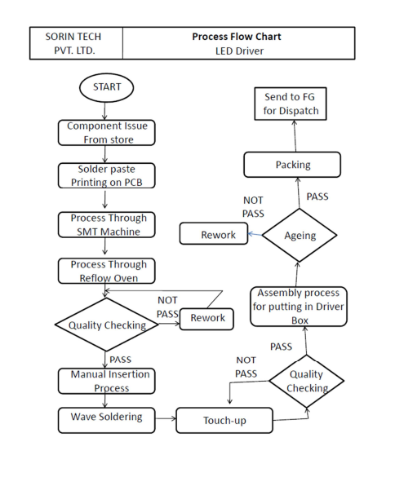

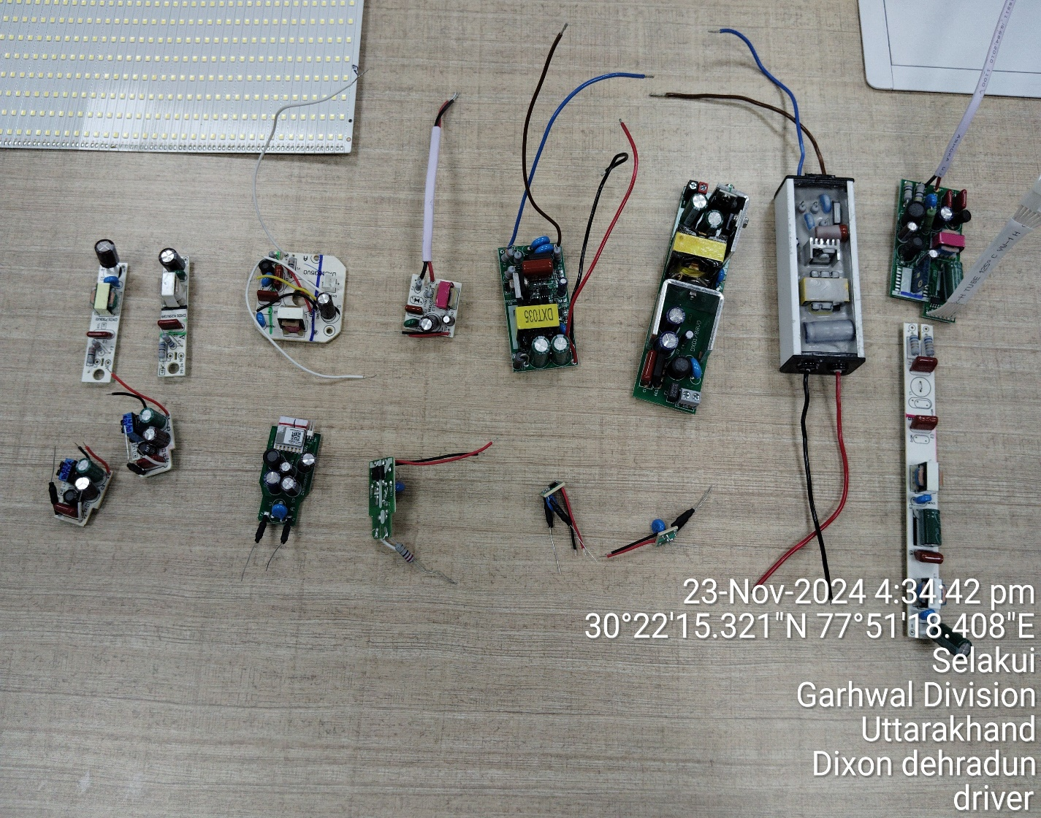

***Source: Company***

**LED ENGINE**

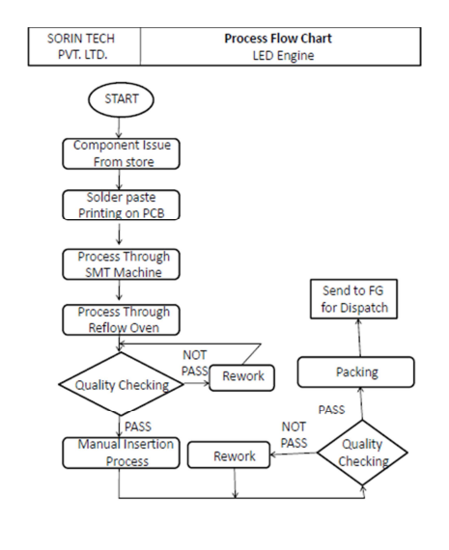

|  |
| --- |
|  |

***Source: Company***

**LED MODULE**

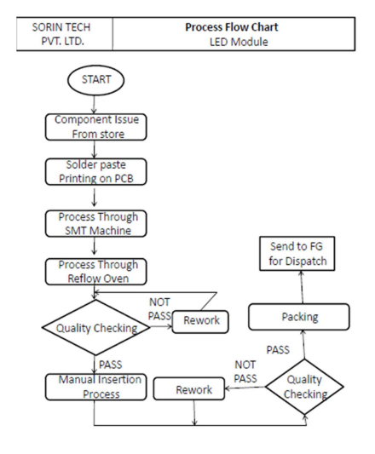

***Source: Company***

**ANNEXURE -VIII - EMPANELMENT DOCUMENT**

|  |
| --- |
| **ANNEXURE -IX – PROJECT APPROVAL LETTER FROM IFCI(PMA)** |
|  |

**ANNEXURE – X- INVOICES OF MAJOR MACHINERY**

**PICK AND PLACE**

|  |
| --- |
|  |

|  |
| --- |
|  |

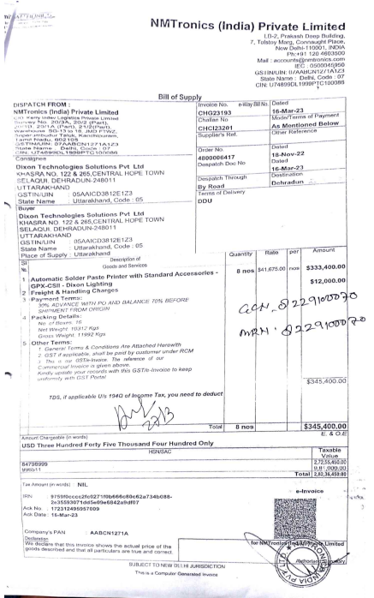

**ANNEXURE – XI - IMPORTANT PROPERTY DOCUMENTS EXHIBIT**

**Lease Deed**

|  |
| --- |
|  |

|  |  |
| --- | --- |
|  | |
| **PART E** | **CE IMPORTANT REMARKS / LIMITATIONS/ CAVEATS/ DISCLAIMERS** | |

1. Our team has verified almost 95% of the machines as per value as mentioned in the FAR and Invoices provided by the client and shown by the client during site visit.
2. Any amount referred in the assessment is based on the Invoices and FAR provided by the client.
3. In the course of the assessment, we were provided with both written and verbal information. We have however, evaluated the information provided to us through broad inquiry, analysis and review but have not carried out a due diligence or audit of the information provided for the purpose of this engagement. Our conclusions are based on the assumptions and other information provided to us by the client during the course of this assessment.
4. The client/ owner and its management/ representatives warranted to us that the information they have supplied was complete, accurate and true and correct to the best of their knowledge. All such information provided to us either verbally, in writing or through documents has been relied upon in good faith and we have assumed that it is true & correct without any fabrication or misrepresentation. I/We shall not be held liable for any loss, damages, cost or expenses arising from fraudulent acts, misrepresentations, or willful default on part of the owner, company, its directors, employee, representative or agents.
5. Legal aspects for e.g. Investigation of title, ownership rights, lien, charge, mortgage, lease, verification of documents from source or any concerned Govt. office etc. has not been covered in this assessment.
6. Machines are assessed as seen on site on as-is-where basis at the time of survey.
7. The condition of the machinery and assets are only based on the visual observations and appearance found during the site survey. We have not carried out any physical tests to assess the working and efficiency of the machines and assets.
8. We have not commented upon machines operating efficiency, useful or residual life.
9. Site Survey has been carried out on the basis of the physical existence of the assets rather than their technical expediency.
10. We have made certain assumptions in relation to facts, conditions & situations affecting the subject of, or approach to this exercise that has not been verified as part of the engagement rather, treated as “a supposition taken to be true”. If any of these assumptions prove to be incorrect then our estimate on value will need to be reviewed.
11. Our report is meant only for the purpose and the client mentioned in the report and should not be used for any other purpose or by any other person. The Report should not be copied or reproduced for any purpose other than the purpose for which it is prepared for. I/we do not take any responsibility for the unauthorized use of this report.
12. We owe responsibility only to the authority/client that has appointed us as per the scope of work mentioned in the report. We will not be liable for any losses, claims, damages or liabilities arising out of the actions taken, omissions or advice given by any other person. In no event shall we be liable for any loss, damages, cost or expenses arising in any way from fraudulent acts, misrepresentations or wilful default on part of the client or companies, their directors, employees or agents.
13. At our end we have not verified the authenticity of any documents provided to us from the originals or any Govt. authority. Documents/ details/ information submitted to us both verbally or in writing have been relied upon in good faith.
14. This CE assessment is done by R.K Associates Valuers & Techno Engineering Consultants (P) Ltd. and its team of engineers.