**REPORT FORMAT:** CL-1 | Version: 1.0\_2018

**CASE NO.:** **VIS (2024-25)-PL607-545-777 Dated: 19.12.2024**

**COST VETTING ASSIGNMENT**

**OF**

|  |  |
| --- | --- |
| **NATURE OF ASSETS** | **CBG PLANT** |
| **CATEGORY OF ASSETS** | **INDUSTRIAL** |
| **TYPE OF ASSETS** | **INDUSTRIAL PLANT** |

**SITUATED AT**

**VILLAGE SHAHPUR DANDI, TEHSHIL: BAHERI, DISTRICT: BAREILLY**

**REPORT PREPARED FOR**

**STATE BANK OF INDIA, SME RUDRAPUR**

***\*\*Important - In case of any query/ issue or escalation you may please contact Incident Manager***

***At valuers@rkassociates.org. We will appreciate your feedback in order to improve our services.***

***NOTE: As per IBA & Bank’s Guidelines please provide your feedback on the report within 15 days of its submission after which report will be considered to be correct.***

***Valuation Terms of Services & Valuer’s Important Remarks are available at*** [***www.rkassociates.org***](http://www.rkassociates.org) ***for reference***

|  |  |
| --- | --- |
| **PART A** | **INTRODUCTION** |

1. **ABOUT THE PROJECT: M/S. Carbon Circle Private Limited (CCPL**) is establishing a Compressed Biogas (CBG) plant in Baheri Tehsil, Bareilly District, Uttar Pradesh, with an aggregate capacity of 10 Tons per Day (TPD). The project is implemented in two sequential phases, Phase-I and Phase-II, each dedicated to setting up a 5 TPD plant.

The phase-1 (5 TPD) plant has achieved commercial operation and the phase-II (5 TPD) plant work is to be started apart from common facilities of Civil work, Plant, machineries & electrical equipment’s which has already being established in Phase-I.

1. **PROJECT LOCATION:**

Details about Location of Unit is as below:

|  |  |
| --- | --- |
| **Particulars** | **Description** |
| **Postal Address** | |
| Village- Shahpur Dandi, Tehhshil- Baheri, District-Bareilly, State-Uttar Pradesh, India | |
| **Location** | |
| The location is in rural part of village area, nearby lands are mostly agricultural area. | |
| **Google Coordinates** | |
| Latitude | 28°42'35.9"N |
| Longitude | 79°29'20.1"E |
| **Connectivity Systems** | |
| Road | Baheri is around 45-50 km from Bareilly city through SH 37. The project site is currently accessible via a non-metallic road of ~15-20 feet wide, which runs parallel to the railway track. |
| Rail | The Nearest Railway station to the subject locality is Richha Railway Station which is about approximately 0.5 Km from the Subject Project. |
| Air | The nearest airport to subject location, i.e, Bareilly Airport, is located approximately 40 kilometres away. |
| **Geographical Conditions On The Site** | |
| Temperature | The maximum temperature is around 104°F while the minimum is 41°F. |
| Rainfall | The average annual rainfall of this area is about 970 mm. |
| Seismic Zone | The above plant site area falls in Seismic Zone III. |

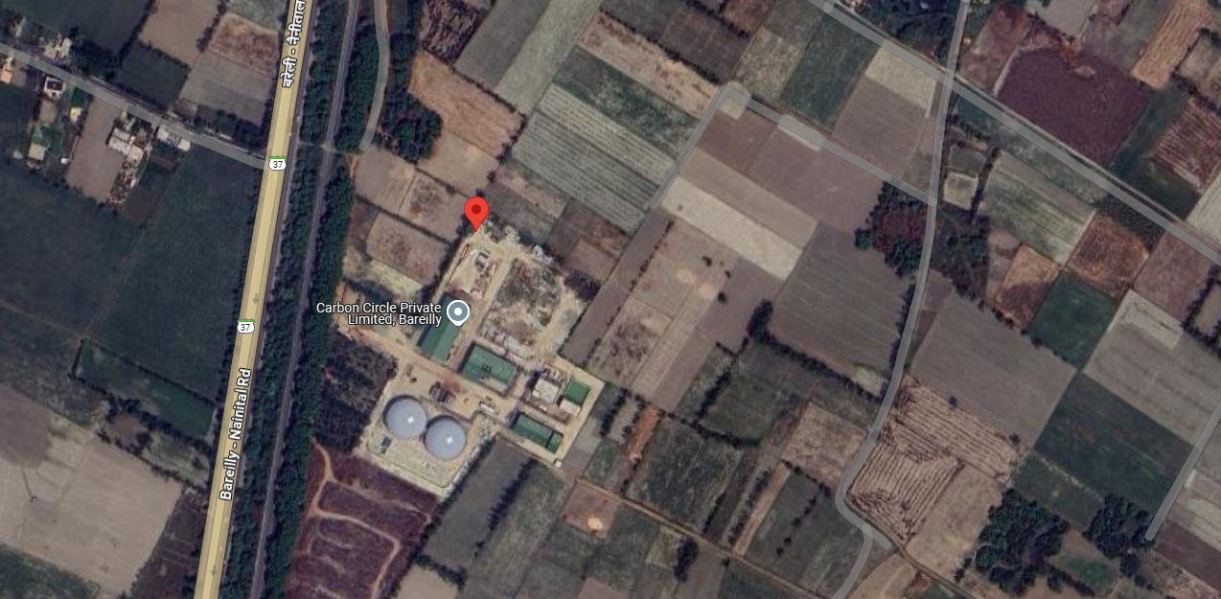

**Source: Google Map**

**Figure: Location of CBG Plant**

1. **SCOPE OF THE WORK:** ProjectCost vetting of 10 TPD Compressed Biogas Plant**.**
2. **PURPOSE OF THE REPORT:** To provide fair detailed analysis report to the Bank based on the “in-scope point” mentioned above.
3. **METHODOLOGY ADOPTED:** Cost assessment is done based on Industry benchmark cost and not on item wise.

|  |  |
| --- | --- |
| **PART B** | **PROJECT COST AND EXPENDITURE** |

1. **TOTAL PROJECT COST & STATUS OF EXPERNDITURE:**M/s Carbon Circle Private Limited has estimated the total Project Cost amounting to Rs.84.77 Cr. and Rs.62.77 Cr. has been spent till 16th August 2024 as per CA Certificate dated 19th August 2024 with UDIN No. 24519826BKARXI5653.

|  |  |  |  |  |
| --- | --- | --- | --- | --- |
| **Particulars** | **Project Cost as Budgeted** | **Phase-1 (5 TPD)** | **Phase-II (5 TPD)** | **Expenditure Incurred Till 16th August 2024**  ***(As per CA Certificate)*** |
| Land including land developments | 1.9 | 1.15 | 0.75 | 1.90 |
| Building & Civil works | 11 | 8.74 | 2.26 | 9.73 |
| Plant Machinery | 63.4 | 26.16 | 37.24 | 42.67 |
| Preoperative Expenses | 5.31 | 1.75 | 3.56 | 5.31 |
| Interest During Construction | 2.6 | 2.4 | 0.2 | 2.60 |
| Margin Money for Working Capital | 0.56 | 0.21 | 0.35 | 0.56 |
| **Total** | **84.77** | **40.41** | **44.36** | **62.77** |

*(Rs in Cr)*

***For the balance work company has estimated amount Rs.22.23 crore company has planned to spent it in the expansion of Phase-II plant (5TPD), details are as follows: -***

|  |  |
| --- | --- |
| **Particulars** | **Balance to Spent** |
| Land including land developments | 0.00 |
| Building & Civil works | 1.56 |
| Plant Machinery | 20.32 |
| Preoperative Expenses | 0.00 |
| Interest During Construction | 0.00 |
| Margin Money for Working Capital | 0.35 |
| **Total** | **22.23** |

*(Rs in Cr)*

***The break-up of plant & machineries expenditure to be incurred in phase-II plant (5 TPD) is as follows: -***

|  |  |
| --- | --- |
| **Particulars** | **Amount** |
| Anaerobic Digester (AD) Package (Vendor : PlanET Global Biogas GmbH) | 15.54 |
| Digester Civil Works | 2.4 |
| Insulation, cladding and walkway around the Digester | 0.5 |
| Erection & Commissioning cost related to AD | 0.5 |
| Cabling - electrical | 0.5 |
| Engineering & designing | 0.3 |
| Consultants Fee (Safety, PESO, PCB,etc.) | 0.3 |
| SCADA (Automation) | 0.3 |
| **TOTAL** | **20.34** |

*(Rs in Cr)*

***Note:***

1. *In present 5 TPD Plant, expenses incurred for Anaerobic Digester (AD) Package (Vendor : PlanET Global Biogas GmbH) is approximately Rs.14.49 Crores including custom duty of Rs.2 crores.*
2. *Digester civil cost during 5 TPD Plant implementation has come pur approximately Rs.1.7 crores as per our assessment.*
3. *Accordingly, the above estimated cost is taken on a higher side to adjust any contingency. As per company there is scope of achieving price reduction at the time of final negotiation.*
4. **BUILDING & CIVIL WORKS:** For setting up the plant / development of below listed sections and other civil worksare being constructed***: -***

|  |  |
| --- | --- |
| **S. No.** | **Description** |
| 1. | Bagging Unit |
| 2. | Sun Drying Area |
| 3. | Biogas Up gradation Plant |
| 4. | Master control room and Office room |
| 5. | Raw water Storage |
| 6. | Hot Water Generator |
| 7. | Mixer |
| 8. | Anaerobic Digesters |
| 9. | Liquid Digest lagoon |
| 10. | Guard Room & Meter Room |
| 11. | Internal Road & Drainage |
| 12. | Pump House |

1. **PLANTS/ MACHINERIES & OTHER EQUIPMENTS AND UTILITIES: -** The following sections are being establishing in plant as follows**:**

|  |  |  |
| --- | --- | --- |
| **S. No** | **Particulars** | **Supplier/Vendor** |
|  | Digester | Planet Biogas Global Gmbh |
|  | Biogas Up gradation Plant | Biogas Engineering India Private Limited |
|  | Mixer | Planet Biogas Global Gmbh |
|  | Compressor | Kirloskar Pneumatic Comp. |
|  | Hot Water Generator | HME Boilers Pvt Ltd. |
|  | Water Treatment Plant | --- |
|  | Transformer | Voltamp Transformers Ltd. |
|  | HT/LT Panels | Electro Control Systems |
|  | Bagging Unit | --- |
|  | Weigh bridge | Eagle Scale Manufacturing Works |
|  | DG Set | Sterling Generators Pvt. Ltd |

**Mass Balance Diagram for Biomass to CBG Plant**

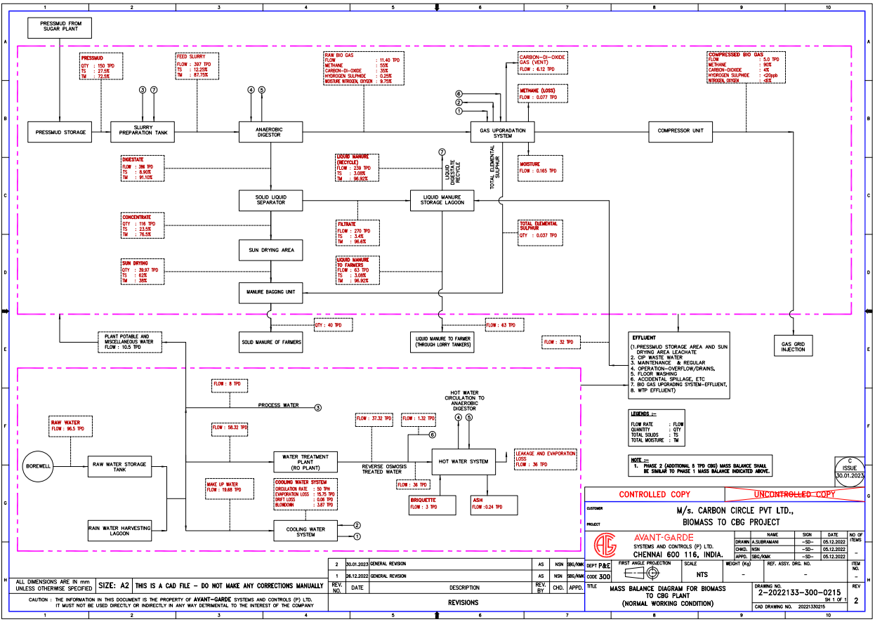 **S*ource:*** *As per DPR*

|  |  |
| --- | --- |
| **PART C** | **COST VETTING** |

|  |  |  |
| --- | --- | --- |
| **S. NO.** | **PARTICULARS** | **DESCRIPTION** |
|  | Report Type | Cost Verification Report of 10 TPD CBG Plant |
|  | Type of Assessment | Cost Vetting |
|  | Work Order Number | Via Email Dated – 09/12/2024 |
|  | Customer Name | M/s. Carbon Circle Pvt. Ltd. |
|  | Coordinating Person Name and Number | Mr. Rahul Madaan & +91-8130206655 |
|  | Scope of Work | Cost Vetting of the 10 TPD CBG Plant |
|  | Purpose of the Assessment | Cost Vetting of the 10 TPD CBG Plant |
|  | Date of Survey | 13-12-2024 |
|  | Date of Report | 19-12-2024 |
|  | Documents provided for perusal | * Detailed Project Report. * Project Cost Budget * CA Certificate |
|  | Current Location of the Plant | Village Shahpur Dandi, Tehshil: Baheri, District: Bareilly. |
|  | Borrowing Company | M/s. Carbon Circle Pvt. Ltd. |
|  | Type of Plant | Anaerobic Digestion using PSA (Pressurised Swing Adsorption) using 2 stage membrane technology. |
|  | Plant Capacity | 10 TPD CBG Plant |
|  | Year of Establishment | Phase-I (5 TPD) has achieved COD in 2024.  Phase-II (5 TPD) is under process of establishment. |
|  | Total Project Cost | **Rs. 84.77 Crore (Rs.8.47 Crore per TPD)**  *(Total project cost includes the total expenditure to be incurred in establishing the plant.)* |
|  | Our opinion | Cost at **Rs.8.47 Crore per TPD** is within the established plant references but on the higher side of the upper range of the market references.  As per the sector consultant and implementing agencies the capital cost for setting up 5 to 10 TPD plant comes around **Rs.5.5 to Rs.6.5 Crore per TPD**, details of which is annexed in **Annexure-I.**  As per MNRE the cost Is Rs.4 to 5 crore per TPD.  As per various Plant references the cost is ranging from Rs.6.5 crores to Rs.9.5 crores excluding one exceptional case at Garhmukteshwar which is Rs.3.25 per TPD, list of which is annexed in **Annexure-II.**  Plant capex depends on various factors such as scale of the Plant and technology used.  **Company has already implemented 5 TPD Plant for which COD has already been achieved. The cost details of it is already shared above. 5 TPD will be extended from 5 TPD to 10 TPD now in which major expense is of Digester machines and its civil works as shown in Part-B of the report. Both these costs for the extension are estimated on little higher side for estimation purpose considering any eventuality of contingency.**  There is a scope of achieving better cost efficiency at the time of finalization of orders.  The range of current market rates of similar capacity & type of plant is verified from various existing biogas plants and also from the public domain for the establishment of new CBG plants. |

**NOTES:**

1. The cost assessment is done based on Project cost rather than machine wise cost.
2. We have been provided with the details of project cost budgeted by the borrower company.
3. As per the site survey this plant is being established at Village Shahpur Dandi, Tehshil: Baheri, District: Bareilly.
4. In this report, there can be some difference in the cost of establishing the plant on the basis of technology and feeding to obtain CBG.

***Disclaimer:***

* 1. *This cost vetting is done only on the basis of project cost provided to us by the company and we do not pass any other recommendation in respect to the Project.*
  2. *The estimated cost verification is made based on the third-party information which has been replied upon in good faith.*
  3. *We have only suggested the estimated cost range of such kind of Projects as per market information. This can’t be construed as the actual cost.*
  4. *The estimated price may vary at the time of actual procurement because of change in prices in the market, negotiations with the supplier, currency fluctuation, other market factors for such kind of machinery/items for which we will not have any control. The cost vetting is only limited to the date of Report issued. We do not assume any responsibility in change of prices of the said machinery/items after this date.*
  5. *This report doesn’t include any work related to drawing, design, sketch plan, procurement of the machines.*
  6. *Ownership and other legal point of view in respect of the asset is not considered in this report as same is out of scope of this report.*
  7. *This report is made at the request of the Bank.*

|  |  |
| --- | --- |
| **FOR R.K ASSOCIATES VALUERS & TECHNO ENGINEERING CONSULTANTS (P) LTD.** | |
| **VALUATION ENGINEER** | **L1/ L2 REVIEWER** |
| Er. Deepak Kumar Singh | Sr. V.P. Projects |
|  |  |

# ANNEXURE: - I (COMPARISON LIST)

|  |  |  |  |
| --- | --- | --- | --- |
| **Reference for Bio Gas Plant** | | | |
| **S. No.** | **Name of the Party** | **Contact details** | **Remarks** |
|  | M/s Jog Waste to Energy Pvt Ltd | [info@jogwte.com](mailto:info@jogwte.com)  +91 9723269295  [www.jogwte.com](http://www.jogwte.com) | * As per JOGWTE, the average installation cost as per EPC basis from scratch to successful trial run would be ranging INR 5.5-6.5 Crore per ton including preliminary and pre-operative expenses and other contingent costs. |
|  | The Global Green Growth Institute, GGGI India | [nishant.bhardwaj@gggi.org](mailto:nishant.bhardwaj@gggi.org) | * As per information provided by GGGI, The capital expenditure (CAPEX) for a typical 8-10 TPD Bio-CNG plant varies from INR 32-50 Crore which varies based on the type of biomass feedstock and technology deployed. * It has been estimated that the plant and machinery costs contributes ~76% of CAPEX. (Excluding preliminary and pre-operative expenses and excluding all other costs such as engineering, consultancy, installation costs etc. i.e. EPC Costs) |
|  | Ministry of New & Renewable energy | **MNRE** | * The economics of a CBG plant can vary depending on various factors such as the scale of the plant, technology used, feedstock cost, government incentives and market demand for CBG. * ~INR 20-25 crore is the cost of installing a 5 TPD capacity CBG plant, while ~75-80% of the CAPEX cost is for purchasing plant machinery. |
|  | Others vendors | **On the public domain** | * CSTR technology which is flexible for all types of organic wastes including mixed wastes. Capital cost for this technology is approximately INR 4-6 Crore per ton including all the costs from scratch to Successful trial run. |

# ANNEXURE: - II (PLANT COMPARISON LIST)

|  |  |  |  |
| --- | --- | --- | --- |
| **Reference OF Bio Gas Plant** | | | |
| **S. No.** | **Name of the Company** | **Plant Location** | **Remarks** |
|  | Verbio AG | Lehragaga, Sangrur, Punjab | * Production capacity – 33 TPD * Biogas purification method – Amines (Chemical Based) * Cost Rs. 230 Crore (Rs. 6.96 Crore per TPD) |
|  | EverEnviro | Indore, Madhya Pradesh | * Production capacity – 17 - 18 TPD * Biogas purification method – PSA * Cost Rs. 150 Crore (Rs. 8.82 – 8.33 Crore per TPD) |
|  | Mittal Enterprises | Garhmukhteshwar, Uttar Pradesh | * Production capacity – 8 TPD * Biogas purification method – Water Scrubbing Technology * Cost Rs. 26 Crore (Rs. 3.25 Crore per TPD) |
|  | Badaun CBG Plant | Badaun, Uttar Pradesh | * Production capacity – 14 TPD * Biogas purification method – NA * Cost Rs. 133 Crore (Rs. 9.5 Crore per TPD) |
|  | Gobardhan Bio CNG Plant | Madhya Pradesh | * Production capacity – 15 - 20 TPD * Biogas purification method – NA * Cost Rs. 6.5 to 9 Crore per TPD |

# ANNEXURE: - III SOME OF THE INVOICES

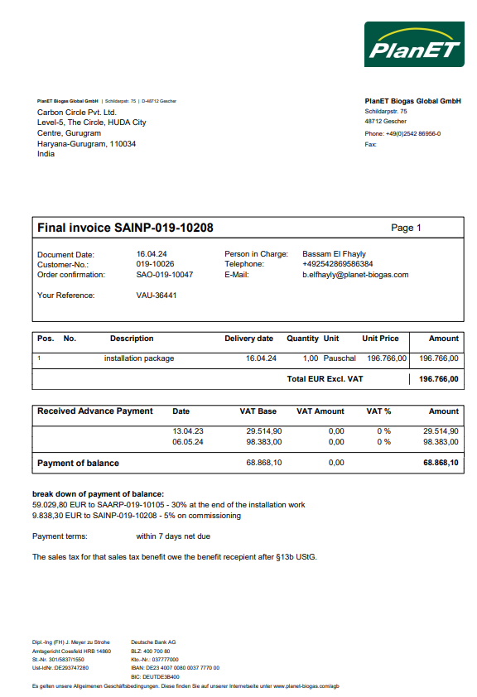

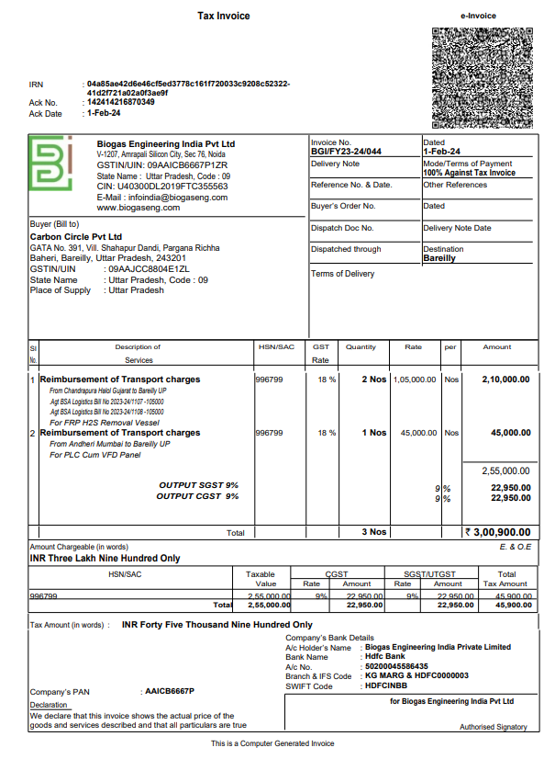

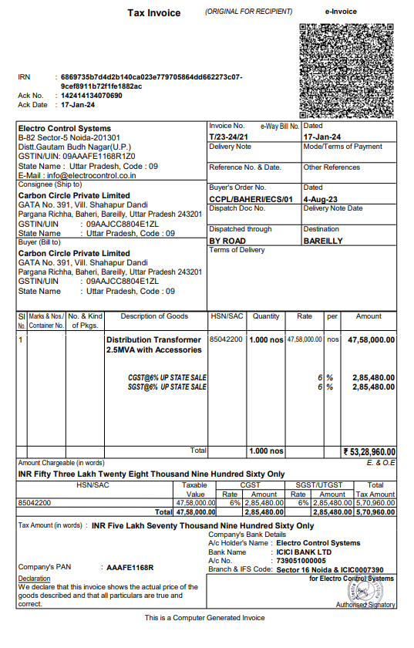

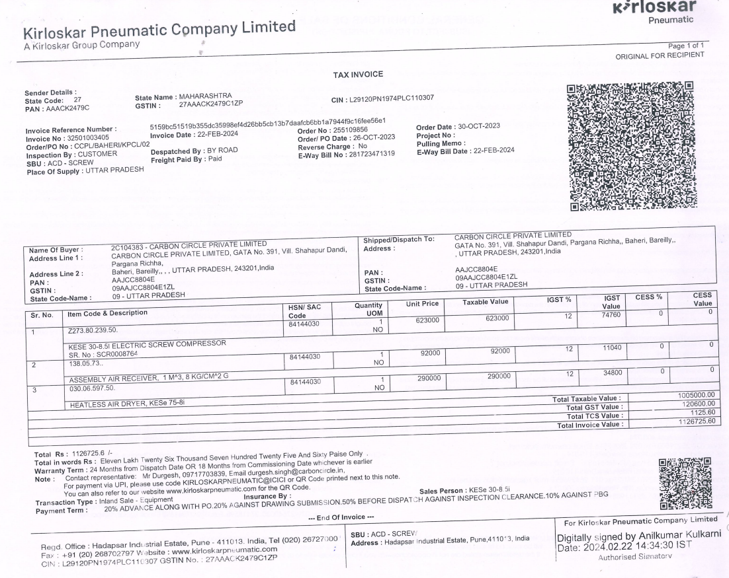

# ANNEXURE: - IV SITE PHOTOGRAPHS

|  |  |
| --- | --- |
| **X:\In Progress Files\Deepak Singh\Nov-Dec 2024\VIS(2024-25)-PL148-124-164\site images\TimePhoto_20241213_154531.jpg** | **X:\In Progress Files\Deepak Singh\Nov-Dec 2024\VIS(2024-25)-PL148-124-164\site images\TimePhoto_20241213_155524.jpg** |
| **X:\In Progress Files\Deepak Singh\Nov-Dec 2024\VIS(2024-25)-PL148-124-164\site images\TimePhoto_20241213_150038.jpg** | **X:\In Progress Files\Deepak Singh\Nov-Dec 2024\VIS(2024-25)-PL148-124-164\site images\TimePhoto_20241213_150233.jpg** |
| **X:\In Progress Files\Deepak Singh\Nov-Dec 2024\VIS(2024-25)-PL148-124-164\site images\TimePhoto_20241213_150739.jpg** | **X:\In Progress Files\Deepak Singh\Nov-Dec 2024\VIS(2024-25)-PL148-124-164\site images\TimePhoto_20241213_153041.jpg** |

|  |  |
| --- | --- |
| **X:\In Progress Files\Deepak Singh\Nov-Dec 2024\VIS(2024-25)-PL148-124-164\site images\TimePhoto_20241213_160405.jpg** | **X:\In Progress Files\Deepak Singh\Nov-Dec 2024\VIS(2024-25)-PL148-124-164\site images\TimePhoto_20241213_154217.jpg** |
| **X:\In Progress Files\Deepak Singh\Nov-Dec 2024\VIS(2024-25)-PL148-124-164\site images\TimePhoto_20241213_155031.jpg** | **X:\In Progress Files\Deepak Singh\Nov-Dec 2024\VIS(2024-25)-PL148-124-164\site images\TimePhoto_20241213_151123.jpg** |
| **X:\In Progress Files\Deepak Singh\Nov-Dec 2024\VIS(2024-25)-PL148-124-164\site images\TimePhoto_20241213_151523.jpg** | **X:\In Progress Files\Deepak Singh\Nov-Dec 2024\VIS(2024-25)-PL148-124-164\site images\TimePhoto_20241213_153422.jpg** |

|  |  |
| --- | --- |
| **X:\In Progress Files\Deepak Singh\Nov-Dec 2024\VIS(2024-25)-PL148-124-164\site images\TimePhoto_20241213_153923.jpg** | **X:\In Progress Files\Deepak Singh\Nov-Dec 2024\VIS(2024-25)-PL148-124-164\site images\TimePhoto_20241213_155908.jpg** |
| **X:\In Progress Files\Deepak Singh\Nov-Dec 2024\VIS(2024-25)-PL148-124-164\site images\TimePhoto_20241213_164446.jpg** | **X:\In Progress Files\Deepak Singh\Nov-Dec 2024\VIS(2024-25)-PL148-124-164\site images\TimePhoto_20241213_155821.jpg** |
| X:\In Progress Files\Deepak Singh\Nov-Dec 2024\VIS(2024-25)-PL148-124-164\site images\TimePhoto_20241213_154721.jpg | **X:\In Progress Files\Deepak Singh\Nov-Dec 2024\VIS(2024-25)-PL148-124-164\site images\TimePhoto_20241213_154954.jpg** |