File No.: VIS (2024-25)- PL-609-556-778 Dated: 07.01.2025

TECHNO-ECONOMIC VIABILITY
STUDY REPORT

OF

INTEGRATED FROZEN BUFFALO MEAT PLANT
(DEBT RESTRUCTURING PROPOSAL)

SETUP BY

M/S AL-SAQIB EXPORTS PVT LTD

REPORT PREPARED FOR

PUNJAB NATIONAL BANK, ZONAL SASTRA BRANCH, GHAZIABAD - 201002

**Important - In case of any query/ issue or escalation you may please contact Incident Manager Valuers@rkassociates.org. We will appreciate your feedback in order to improve our services.

NOTE: As per IBA Guidelines please provide your feedback on the report within 15 days of its submission after which report will be considered to be correct.

IMPORTANT NOTICE

COPYRIGHT FORMAT: This report is prepared on the copyright format of R. K. Associates Valuers & Techno Engineering Consultants (P) Ltd. (R. K. Associates) to serve our clients with the best possible information and analysis to facilitate them to take rational business decisions. Legally no one can copy or distribute this format without prior approval from R. K. Associates. It is meant only for the advisory/ reference purpose for the organization/s as mentioned on the cover page of this report. Distribution or use of this format or report or any of its content/ information/ data by any organization or individual other than R.K Associates will be seen as an unlawful act and necessary legal action can be taken against the defaulters.
This report is intended for the sole use of the intended recipient/s and contains material that is STRICTLY CONFIDENTIAL AND PRIVATE.

DEFECT LIABILITY PERIOD: In case of any query/ issue or escalation you may please contact Incident Manager at valuers@rkassociates.org. Though adequate care has been taken while preparing this report as per its scope, but still we can’t rule out typing, human errors, over sightedness of any information or any other mistakes. Therefore, the concerned organization is advised to satisfy themselves that the report is complete & satisfactory in all respect. Intimation regarding any discrepancy shall be brought into our notice immediately. If no intimation is received within 15 (Fifteen) days in writing from the date of issuance of the report, to rectify these timely, then it will be considered that the report is complete in all respect and has been accepted by the client up to their satisfaction & use and further to which R.K Associates shall not be held responsible in any manner.

Part J: R. K. Associates Important Disclaimer and Remarks are integral part of this report and Feasibility assessment is subject to this section. Reader of the report is advised to read all the points mentioned in these sections carefully.

TABLE OF CONTENTS
SECTIONS | PARTICULARS | PAGE NO.
Part A | REPORT SUMMARY | 3
Part B | INTRODUCTION
 | - About the Report | 5
 | - Executive summary | 5
 | - Purpose of the Report | 8
 | - Scope of the Report | 8
 | - Methodology/ Model Adopted | 9
 | - Data Information received from | 9
 | - Documents/ Data Referred | 10
Part C | Company Profile
 | - Company Overview | 11
 | - Shareholding Details | 12
 | - Directors Profile | 12
Part D | Infrastructure Details
 | - Plant Location | 15
 | - Location Map | 15
 | - Layout Plan | 16
 | - Land Details | 18
 | - Site pictures | 19
 | - Building & Civil Works | 26
 | - Plant and Machinery/ Equipment details | 27
 | - Utilities | 29
Part E | Industry Overview | 31
Part F | SWOT Analysis | 36
Part G | Statutory Approvals | Licences | NOC | 38
Part H | Company’s Financial Feasibility | 40
Part I | Conclusion | 55
Part J | Disclaimer | Remarks | 57

PART A | REPORT SUMMARY

S. No. | PARTICULAR | DESCRIPTION
 | Name of the Company: | M/s Al-Saqib Exports Pvt Ltd
 | Registered Address: | 12, New Rajdhani Enclave, Preet Vihar, Delhi-110092
 | Project Name | Integrated Frozen Buffalo Meat Plant running on Job Work Basis for M/s Touro Primeiro Private Limited
 | Project Location: | 11 KM Milestone, Opposite – Naugaza Peer, Alipur, Jijwana, Hapur Road, Meerut, Uttar Pradesh – 250002.
 | Project Type: | Integrated Frozen Buffalo Meat Plant
 | Project Industry: | Meat Processing Industry
 | Product Type / Deliverables: | Frozen Buffalo Meat
 | Report Prepared for Organization: | Punjab National Bank, Zonal Sastra Branch, Ghaziabad - 201002
 | TEV Consultant Firm: | M/s. R.K Associates Valuers & Techno Engineering Consultants (P) Ltd.
 | Report type: | Techno-Economic Viability Report
 | Purpose of the Report: | To assess Technical & Economic Viability to help lender/s to take financial exposure decision on the Project.
 | Scope of the Report: | To assess, evaluate & comment on Technical, Economical & Commercial Viability of the Project as per data information provided by the client, independent Industry research and data/ information available on public domain.
 | Date of Report: | 7th January, 2025
 | Documents referred for the Project: | - PROJECT INITIATION DOCUMENTS:  - Project Report  - Financial Projections of the Project  - Statutory Approval Details  - Land deeds  - Layout and Site Plan  - PROCUREMENT DOCUMENTS:  - List of Plant & Machinery  - Agreements between Touro Primeiro Private Limited  - Bank Statements  - Shareholding Pattern  - Loan Repayment Chart  - MOA & AOA  - STATUTORY APPROVALS, LICENCES & NOCs  - UDYAM Registration Certificate  - GST Registration Certificate  - FSSAI Certificate
 | Means of Finance: | Equity & Debt
 | Key Financial Indicators: | KEY INDICATORS VALUE  Average DSCR 1.43  Average EBITDA Margin 81.90%  Avg. PAT Margin 44.97%  NPV INR 5,305.06 Lakhs
Note: Above financial indicators are based on the financial projections of the proposed project provided by the firm and assessment and analysis of the same done by us.

PART B | INTRODUCTION

- ABOUT THE REPORT:
This is a Techno-Economic Viability Study Report of the proposed expansion of Integrated Frozen Buffalo Meat Plant at Opp. Power Sub Station, Meerut Road, Sardhana, Meerut, Uttar Pradesh - 250342, setup by M/s Al-Saqib Exports Private Limited.

- EXECUTIVE SUMMARY:
M/s Al-Saqib Exports Private Limited (ASEPL) was incorporated on 24th April, 1996 with Registrar of Companies Delhi vide Corporate Identification Number U6303DL1996PTC078460. M/s Al-Saqib Exports Private Limited has been into the business of Manufacturing/Processing & Trading of Frozen Buffalo Meat since 1996 and having its presence in the market as one of the oldest abattoirs-cum-meat processing plant in Meerut.
The company is established as a public (non-govt.) company limited by shares with Registration no. 078460. The company is registered at ROC, Delhi having registered office at 12, New Rajdhani Enclave, Preet Vihar, Delhi-110092 & the facility is located at 11 KM Milestone, Opp. – Naugaza Peer, Alipur, Jijwana, Hapur Road, Meerut, Uttar Pradesh – 250002, under the directorship of Mohd. Shahid Qureshi, Mohd. Sajid, Mohd. Saliq Qureshi and Mohd. Wali Akhlaq.
M/s Al-Saqib Exports Private Limited is currently being managed by Mohd. Shahid Qureshi (Chairman & Managing Director) who has accumulated vast experience of nearly three decades in meat processing industry through his association with this entity and other family run business. Mohd. Sajid holds experience of nearly two and half decades in meat processing industry through his association with this entity. They are well supported by other directors of the company in managing day-to-day operations of the company. The company had a considerable track record in this business which resulted in long term relationships with both suppliers and customers.
As per the data/information provided by the client, the plant is operational at a land parcel of 91,033 Sq. mts. which has been purchased through multiple deeds. Out of which ~47,565 sq. mts. has been mortgaged with the bank. The company has only provided the sale deeds of the mortgaged land. The copy of approved plan is in name of previous owner M/s Madan Mohan Textiles Ltd. which is not very clear. For survey and our analysis, we have relied upon the theodolite site plan shared by the company (Refer the section Statutory Approval in the later part of the report).
Al-Saqib Exports Pvt. Ltd. operated in modern integrated complex incorporating live-stock quarantine facilities, mechanised abattoirs, chilling, deboning, packing, freezing and cold storage facilities at strategic locations. The company is engaged in the processing and supplying of frozen buffalo meat. The processing facility of the company is located at Meerut, Uttar Pradesh and has its own slaughter house and currently has permission to process 1200 buffaloes per day.
As per the data/information provided by the client, M/s ASEPL covered lots of countries in South East Asia, Middle East, Africa and the Pacific Basin Nations for the export of meat products when the company was operating under its name. The range of processed products included frozen boneless compensated Buffalo meat which includes the Hindquarter cuts such as Topside, Silverside, Thick flank, Rump steak, Tenderloin, Stripling and Fore quarter meat comprising of Blade, Cube Roll, Chuck Tender, Brisket PE, Brisket NE and shanks.
All frozen meat products & offal are compulsorily examined by the competent official designated Government agency which issues international Sanitary/Health Certificate confirming suitability of product for human consumption. These certificates issued after microbiological analysis also confirm the aspect of the meat being derived from healthy, disease-free livestock subjected to Ante & Post Mortem examinations.
In compliance with the applicable rules and regulations, ASEPL has appointed following veterinary doctors to oversee the health of livestock.
S. No. | Name of Veterinary Doctor | Registration No.
1 | Dr. Vishal Kumar | UPVC-2020-07307
2 | Dr. Nitish Kumar | UPVC-2014-05930
3 | Dr. Kapil Kumar | UPVC-2015-06385
4 | Dr. Mahendra Kumar Singh | UPVC-2020-07377
5 | Dr. Pushpendra Kumar | UPVC-2020-07261
6 | Dr. Anmol Tomar | UPVC-2023-07891
As per data/information provided to us, the company has obtained some necessary Statutory Approvals/NOC’s such as APEDA, FSSAI, Sanctioned Map approval, Fire NOC etc. from the respective authorities. (Refer the section Statutory Approval in the later part of the report).

Graphical Representation of the Key Financials of the previous 7 years:
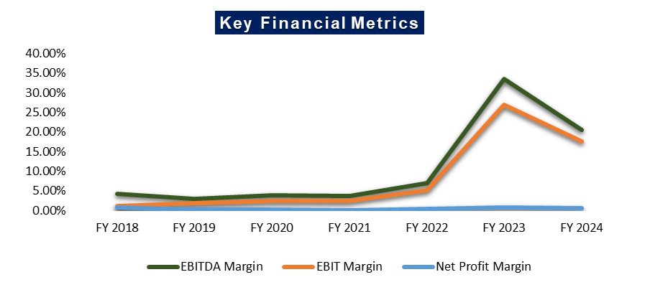
The profitability margins of the company stood low for the financial years (FY18-FY22) on account of limited value addition given the highly competitive nature of industry. However, EBITDA margin of the company improved and stood at 6.91%, 33.55% & 20.49% in FY22, FY23 & FY24 respectively as against 3.62% in FY21 on the back of proportionate decline in overhead expenses due to discontinuation of exports. Similarly, PAT margin also improved and stood at 0.47%, 0.76% & 0.55% in FY22, FY23 & FY24 respectively as against 0.11% in FY21.
As per the information shared by the client, during FY 2018-19, ASEPL had achieved exports turnover of INR 122.50 Crore and INR 70.13 Crore in FY 2019-20 alongwith domestic sales of FY 25.36 Crore and INR 20.76 Crore respectively.
The company was predominately an export-oriented unit for frozen buffalo meat products when it was operating under its own name. Due to outbreak of COVID-19 pandemic, there was an adverse impact for the demand of processed frozen buffalo meat mainly from middle east countries and the same impacted the revenues adversely, as the export orders of frozen meat were halted from overseas countries and company had to relied only on domestic sales.
During COVID-19, the overseas buyers informed the company to keep goods on hold till the normalisation of the situation. Although the global impact of COVID-19 continued for more than 2 years and the company had to off load the stocks in the local markets to save the company from further losses. Due to the shortage of liquid funds and exports orders, the company could not continue the exports as the recovery from debtors was very slow.
Currently, the company has leased its meat processing plant to M/s Touro Primeiro Private Limited (TPPL) for a monthly rental of INR 2.00 Lakhs. M/s TPPL has agreed to lease the facility for meat processing, while ASEPL will handle buffalo slaughtering for TPPL at a monthly job charge of INR 88.00 Lakhs, for a period of 5 years starting from 21st May 2023. The agreement includes an option to renew the arrangement at the end of the term, subject to mutual consent from both parties. According to the information provided, ASEPL will also carry out slaughtering to meet local demand, as only 30%-40% of the plant's installed capacity is currently being utilized by TPPL.
Restructuring Proposal: M/s ASEPL was classified as a Non-Performing Asset (NPA) by the bank on 29th January 2024. Due to a shortage of funds and the company's inability to sustain its operations, the company is requesting the bank to convert the principal portion of its working capital limit, amounting to INR 2,996.28 Lakhs, into a Working Capital Term Loan (WCTL), and the interest portion of INR 502.72 Lakhs into a Flexible Interest Term Loan (FITL), both to be repaid over a period of 7 years.
In this regard, Punjab National Bank, Zonal Sastra, Ghaziabad has appointed R.K. associates as TEV consultant to review technical, commercial and financial viability of the proposed restructuring based on our independent EIC research and information/data provided to us by M/s Al-Saqib Exports Private Limited.

- PURPOSE OF THE REPORT:
To assess Project’s Technical and Financial Feasibility to help lender/s to take further course of action on loan account.

- SCOPE OF THE REPORT:
To only assess, evaluate & comment on Technical & Financial Feasibility of the Project as per the information provided by the company.
NOTES:
- Scrutiny about the company, background check, and credibility, credit worthiness of the company or its promoters is out-of-scope of this report.
- Any verification of the documents/ information from originals/ source is out-of-scope of this report.
- This report is only an opinion in respect to Technical and Financial Feasibility of the project as per the future Projections provided by the firm and independent analysis done by us and doesn’t contain any recommendations including taking decision on the loan or any other financial exposure.
- This is not an audit activity of any kind. We have relied upon the data/ information shared by the company in good faith.
- Any review of the existing business of the promoters is out of scope of this report.
- Detailed cost estimation or detailed cost vetting is out of scope of the project.
- This is not a Detailed Project Report or a detailed design or architecture document. Land and property details mentioned in the report is only for illustration purpose as per the information provided to us by the client. The same doesn’t tantamount for taking any responsibility regarding its legality, ownership and conforming to statutory norms.
- This report is the revised version of the TEV report prepared by RK Associates, dated 7th June 2024 (Ref: VIS (2024-25)-PL-031-031-039), at the request of the bank. As the site survey is outside the scope of this report, we have referenced the site survey conducted on 31st May 2024.
- Current Status of the project is in this report is considered as per the site visit dated 31st May 2024.

- METHODOLOGY/ MODEL ADOPTED:
- Data/ Information collection.
- Review of Data/ Information collected related to TEV study.
- Review of Restructuring Proposal.
- Independent review & assessment of technology used and financial projections provided by the company.
- Projections of Revenue, P&L, Balance Sheet, Working Capital Schedule, Depreciation Schedule, Loan Schedule as per the inputs given by the company and assessed by us.
- Calculation of key financial indicators and ratio analysis including DSCR, NPV & IRR and payback period of the project.
- Report compilation and Final conclusion.

- DATA/ INFORMATION RECEIVED FROM:
All the data/Information has been received from Mr. Ashok Agrawal and the required details about him shown in the below table:

Particulars | Details
Company | M/s Al-Saqib Exports Private Limited
Email Address | ak64ca@gmail.com
Contact No. | +91-9997232751

- DOCUMENTS / DATA REFFERED:

- Business Profile and Promoters Profile.
- Financial Projections of the Project.
- Previous Five Year’s Financial Statements of the company.
- List of Plant & Machinery.
- Shareholding Pattern
- Approved Site/Layout Plan
- Land Deeds
- Agreements with M/s Touro Primeiro Private Limited
- Certificates of Statutory approvals/NOCs.
- Survey Report conducted at the site dated 31st May 2024.
PART C | COMPANY PROFILE

- COMPANY OVERVIEW:
As per certificate of incorporation shared by the client/company, M/s Al-Saqib Exports Pvt Ltd has been into the business of Frozen Buffalo Meat since 1996. Company was incorporated on 24th April 1996 as an unlisted private company limited by shares with Registration no. 078460.
The Permanent Account Number (PAN) of the company is AACCA8455G and GSTIN is 09AACCA8455G1ZJ. As per Udyam registration certificate provided by the client, the company is categorised as Small Manufacturing enterprise having the Udyam Registration Number UDYAM-UP-56-0007132.
Currently, the company has given processing plant and slaughtering house to M/s Touro Primeiro Private Limited (TPPL) on lease for the period of 5 years w.e.f. 21.05.2023. The company has also agreed to slaughter the buffaloes for TPPL on Job-work basis. Below table shows the incorporation details of the company:
Incorporation Details of the Company
Particular | Description
Company / LLP Name | M/s Al-Saqib Exports Private Limited
Date of Incorporation | 24th April, 1996
CIN | U63023DL1996PTC078460
Company Category | Unlisted Company limited by Share
Company Subcategory | Non-govt. company
ROC | Delhi
Registration Number | 078460
Registered Address | 12, New Rajdhani Enclave, Preet Vihar, Delhi - 110092
Authorized Capital | INR 20,00,00,000/-
Paid up Capital | INR 20,00,00,000/-
Date of last AGM | 30/11/2021
Date of Balance Sheet | 31/03/2021
Company Status | Active
Source: As per the data available on the MCA website

- SHAREHOLDING DETAILS:
As per the provisional financials as on 31st March 2024 shared by the client, the company is having authorized share capital of INR 20.00 crores and the total subscribed and paid-up capital is INR 20.00 crores. The shareholding pattern of the company is mentioned in the below table:

Particulars | As at 31st March, 2024
 | No. of Shares | INR Crore
Authorised Share Capital
Equity shares of Rs. 100/- each | 20,00,000 | 20.00
Subscribed & fully paid up
Equity Share of Rs. 100/- each fully subscribed & paid up | 20,00,000 | 20.00
Source: Data/Information provided by the Client.

Details of Shareholders

S. No. | Name of Shareholder | Number of shares as on 31.03.2024 | % of Holding | Number of shares as on 31.03.2023 | % of Holding
1 | Mohd. Shahid | 10,16,919 | 50.85% | 10,16,919 | 50.85%
2 | Mohd. Sajid | 10,300 | 0.52% | 10,300 | 0.52%
3 | Hasiba Parveen | 2,22,781 | 11.14% | 2,22,781 | 11.14%
4 | Saqib Qureshi | 2,00,000 | 10.00% | 2,00,000 | 10.00%
5 | Mohd. Saliq Qureshi | 1,94,970 | 9.75% | 1,94,970 | 9.75%
6 | Shoaib Akhlaq | 1,94,970 | 9.75% | 1,94,970 | 9.75%
7 | Danish Akhlaq | 1,60,060 | 8.00% | 1,60,060 | 8.00%
Source: Data/Information provided by the Client.

- DIRECTORS PROFILE:
Mohammad Shahid Qureshi, Mohd. Sajid, Mohammad Wali & Mohammad Saliq Qureshi are the directors of M/s Al-Saqib Exports Private Limited. As per data/information provided to us, below table illustrate the educational & professional experience of the directors along with the DIN and contact details:
- Directors/Promoters Details
Name | DIN | Age | Designation
Mohammad Shahid Qureshi | 02203226 | 57 | Managing Director
Mohd Sajid | 02180558 | 50 | Director
Mohammad Wali | 09219288 | 22 | Additional Director
Mohammad Saliq Qureshi | 09219287 | 27 | Additional Director
- Education & Experience
Mohammad Shahid Qureshi | - Appointed as Director on 24th April 1996.  - As per data/information shared by the client, Mohammad Shahid Qureshi is an Ex-MP & Mayor of Meerut Constituency. He has an experience of over 30 years in the industry.  - Currently Mohammad Shahid Qureshi is engaged in the business exclusively.
Mohd Sajid | - Appointed as Director on 20th August 2001.  - As per data/information shared by the client, Mohd. Sajid has several years of experience in the relevant industry.  - Currently Mohd. Sajid is successfully running M/s ASEPL.
Mohammad Wali | - Appointed as Director on 2nd August 2021.  - As per data/information shared by the client, Mohammad Wali is looking after the production work in M/s ASEPL.
Mohammad Saliq Qureshi | - Appointed as Director on 2nd August 2021.  - As per data/information shared by the client, Mohammad Saliq Qureshi is looking after the administrative work in M/s ASEPL.
Source: Data/ Information provided by the company
Below tables shows the information of the companies with which each Director is associated with to give a basic background detail of the promoters as found on public domain in general/ tertiary category research.
(MOHAMMAD SHAHID QURESHI)
S. No | Company Name  (CIN/FCRN) | Designation | Original Date of Appointment | Date Of Appointment at Current Designation | Date Of Cessation (If Applicable)
1 | Al-Saqib Exports Private Limited (U63023DL1996PTC078460) | Managing Director | 24/04/1996 | 08/04/2021 | -
2 | Al Akhlaq Exports Limited (U74120UP2011PLC046807) | Whole-time director | - | 09/07/2019 | 09/08/2022
3 | Al-Saqib Exports Private Limited (U63023DL1996PTC078460) | Director | - | 24/04/1996 | 08/04/2021
4 | Al Akhlaq Exports Limited (U74120UP2011PLC046807) | Director | - | 03/10/2011 | 09/07/2019
Source: Information extracted from MCA website & public domain
(MOHD SAJID)
S. No | Company Name  (CIN/FCRN) | Designation | Original Date of Appointment | Date Of Appointment at Current Designation | Date Of Cessation (If Applicable)
1 | Al-Saqib Exports Private Limited (U63023DL1996PTC078460) | Director | 20/08/2001 | 20/08/2001 | -
2 | Al Akhlaq Exports Limited (U74120UP2011PLC046807) | Director | - | 03/10/2011 | 09/08/2022
Source: Information extracted from MCA website & public domain

(MOHAMMAD WALI)
S. No | Company Name  (CIN/FCRN) | Designation | Original Date of Appointment | Date Of Appointment at Current Designation | Date Of Cessation (If Applicable)
1 | Al-Saqib Exports Private Limited (U63023DL1996PTC078460) | Additional Director | 02/08/2021 | 02/08/2021 | -
Source: Information extracted from MCA website & public domain

(MOHAMMAD SALIQ QURESHI)
S. No | Company Name  (CIN/FCRN) | Designation | Original Date of Appointment | Date Of Appointment at Current Designation | Date Of Cessation (If Applicable)
1 | Al-Saqib Exports Private Limited (U63023DL1996PTC078460) | Additional Director | 02/08/2021 | 02/08/2021 | -
Source: Information extracted from MCA website & public domain
PART D | INFRASTRUCTURE DETAILS

- PLANT LOCATION:
M/s Al-Saqib Exports Private Limited is located at, 11 KM Milestone, Opp. – Naugaza Peer, Alipur, Jijwana, Hapur Road, Meerut, Uttar Pradesh – 250002, which is spread over an area of ~91,033 Square meter as per the site plan provided to us by the company. However, the company had only shared the sale deed of the land which has been mortgaged with bank admeasuring ~47,565 sq. meters.
The property is having the proximity to the civic amenities such as hospital is situated ~6 km away, school is situated ~10.0 km away and market is situated ~6.0 km away from the plant location. The site is located at a distance of 20 meters from the NH-334. Table: 1 is showing the details of the adjoining properties of the land for plant’s site location and Table: 2 is showing the Connectivity Details of the Proposed Location:
Table: 1 Adjoining Property Details
Location | Details
East | Road (NH-334)
West | Agricultural Land
North | Agricultural Land
South | Agricultural Land

Table: 2 Connectivity Details of the Proposed Location
Connectivity | Details
Road | NH 334 - ~20 Meters away
Rail | Meerut Railway Station - ~14.5 km away
Airport | Indira Gandhi International Airport – Delhi - ~98 km away

- LOCATION MAP:
- GOOGLE MAP LOCATION:
Project location is 28°54'20.7" North and 77°44'05.8" East at 11 KM Milestone, Opp. – Naugaza Peer, Alipur, Jijwana, Hapur Road, Meerut, Uttar Pradesh – 250002 and the location as per the Google map has been attached below:
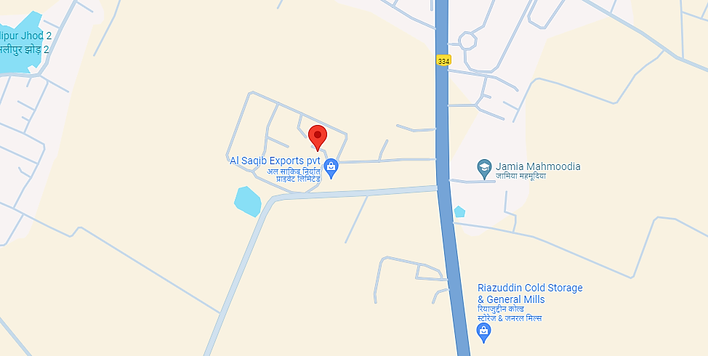
- Google Map Layout:
Demarcation of the whole plant site with approximate measurement on the Google map are attached below:
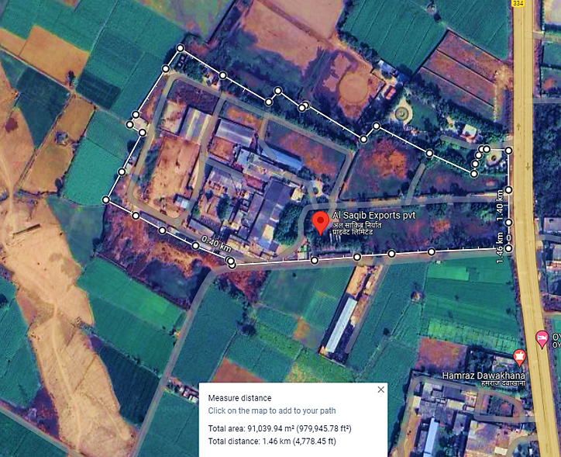

- LAYOUT PLAN:
As per the data/information provided by the client, the copy of approved plan is in name of previous owner M/s Madan Mohan Textiles Ltd. which is not very clear. For survey and our analysis, we have relied upon the theodolite site plan shared by the company which has been shown below:
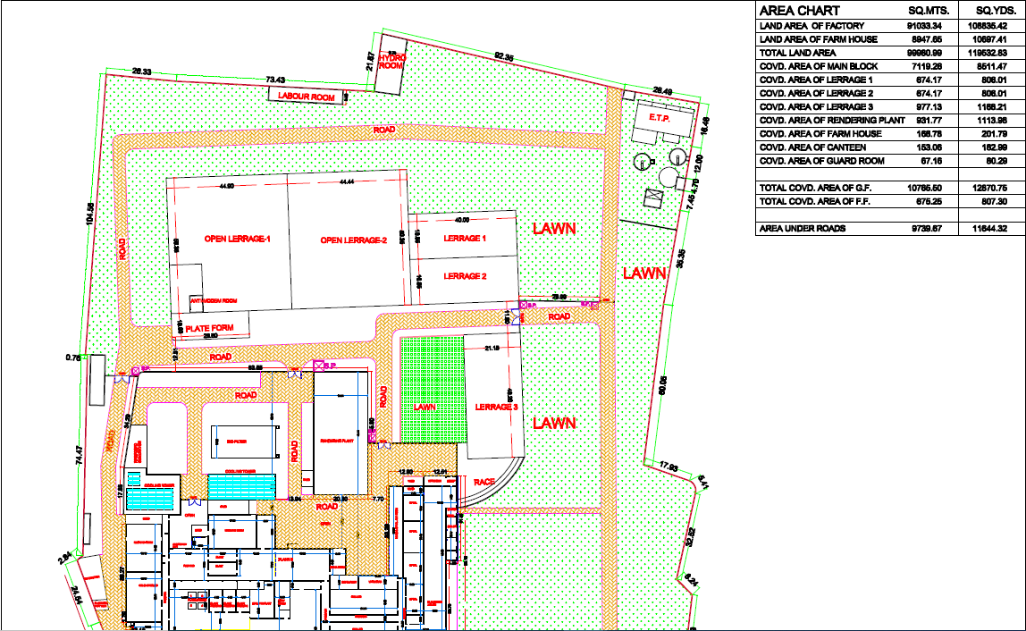
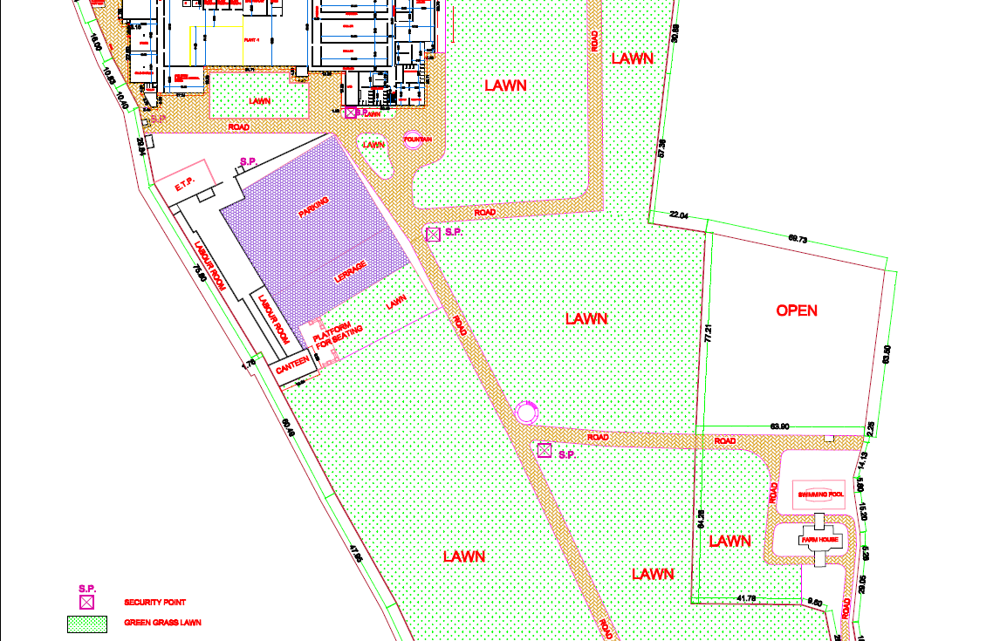
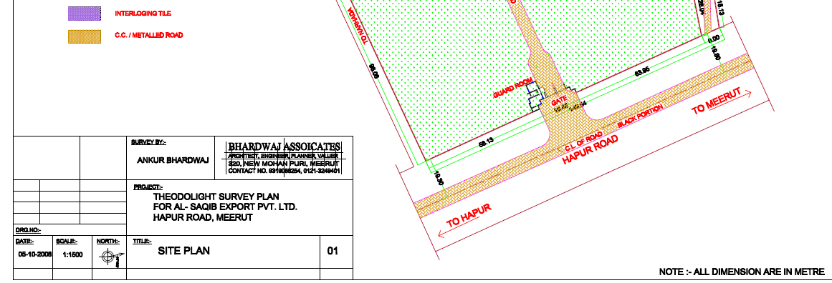
- LAND DETAILS:
The land is freehold in nature having total area admeasuring 91,033 sq. mts. purchased by multiple deeds out of which ~47,565 has been mortgaged with the bank. The subject property is located at 11 KM Milestone, Opp. – Naugaza Peer, Alipur, Jijwana, Hapur Road, Meerut, Uttar Pradesh – 250002. The plant is located on NH 334 with the nearest railway station, i.e., Meerut Railway Station at ~14.5 KM and IGI Airport is about ~98 KM from the subject property. All other basic civic amenities are within close vicinity. Only the sale deeds of the area mortgaged with bank is provided to us which is admeasuring ~47,565 sq. meters. The mortgaged land area is highlighted in the image shown below:
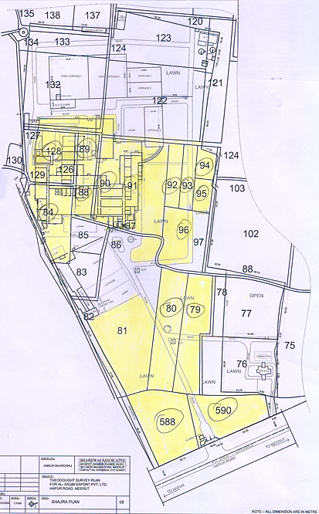
As per the information shared with client/company, the summary of the land mortgage with bank is shown in the table below:
Plot No. | Area (Sq. Mtr.)
A1 | 2,009.00
A2 | 2,003.00
B1 | 2,009.00
B2 | 2,009.00
C1 | 2,009.00
C2 | 2,009.00
E | 15,198.63
F | 11,007.61
G | 3,641.16
H | 2,643.00
K & L | 1,637.37
J | 1,389.00
Total | 47,564.77
As per the details available with us, we have verified the areas of respective plots with the sale deeds of the land and found the areas/details in line with information presented here. During the site visit on 31st May 2024, we found that the factory was closed for the day, it being a weekly holiday. However, the cleaning and maintenance work was going on at the time of survey.
Note: We have only had the deeds of the land mortgaged with the bank admeasuring ~47,564.77 sq. metres. The deeds for the rest of the plot area were not made available to us. We recommend that the bank/financial institutions advice the company to submit the sale deeds for the rest of the area as some part of the access road to the factory premises from the National Highway – 334 is located on the remaining plot area of ~43,468.23 sq. metres.

- SITE PICTURES:
This report is the revised version of the TEV report prepared by RK Associates, dated 7th June 2024 (Ref: VIS (2024-25)-PL-031-031-039), at the request of the bank. As the site survey is outside the scope of this report, we have referenced the site survey conducted on 31st May 2024. Site pictures captured during the 31st May 2024 survey are included for reference, with a few of them attached below.
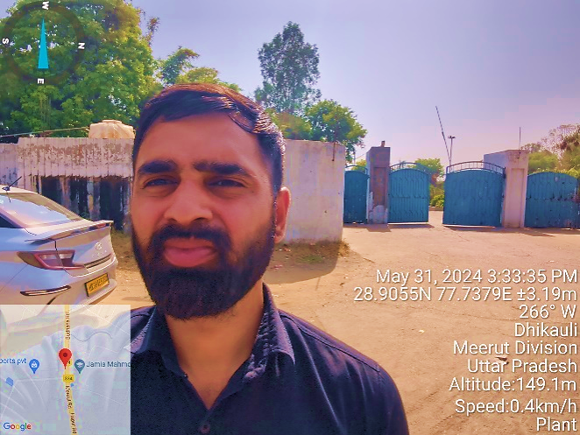 | 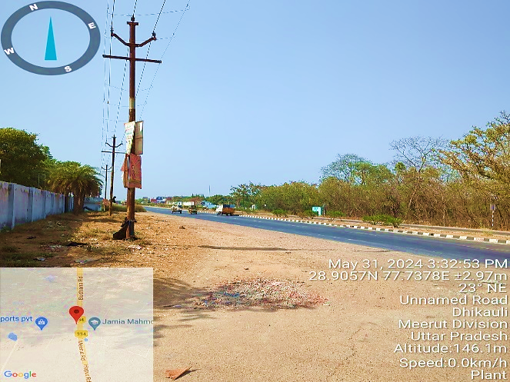
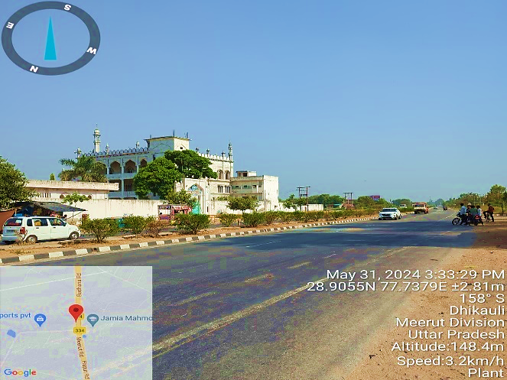 | 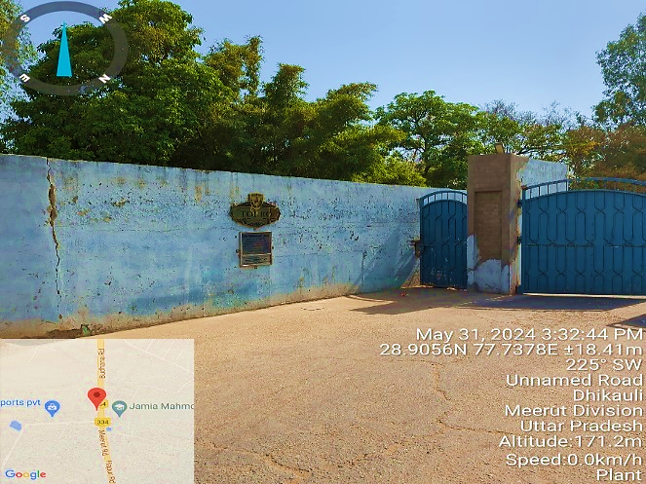
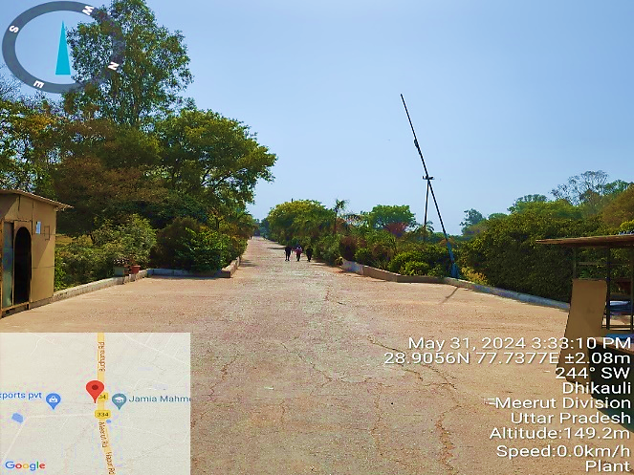 | 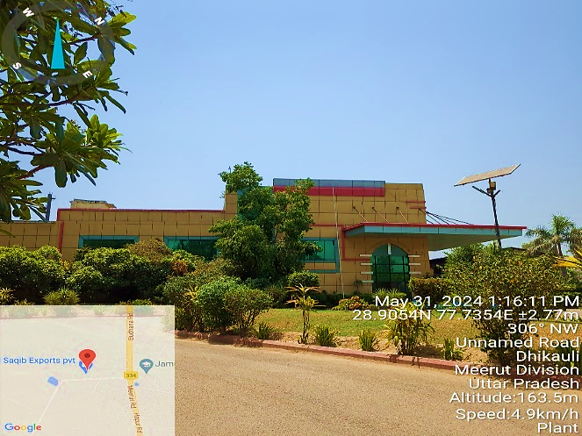
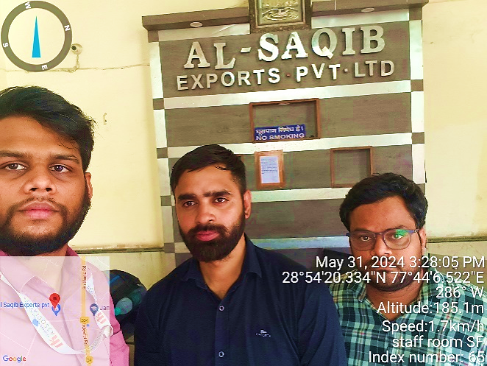 | 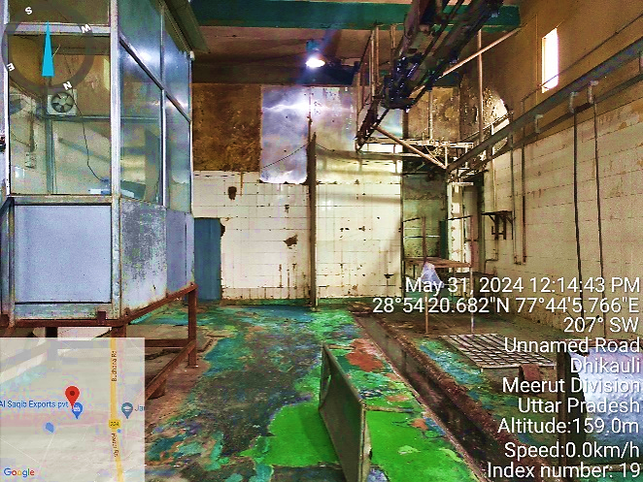
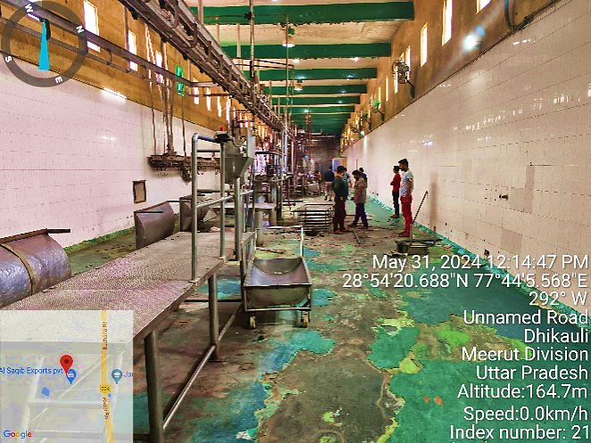 | 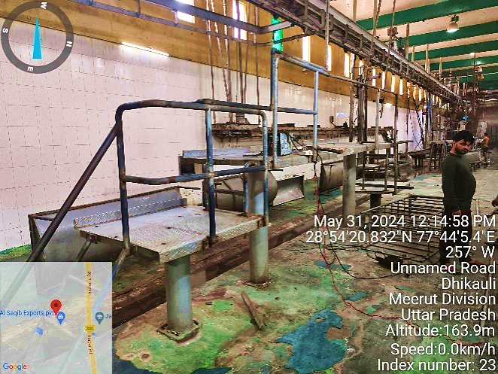
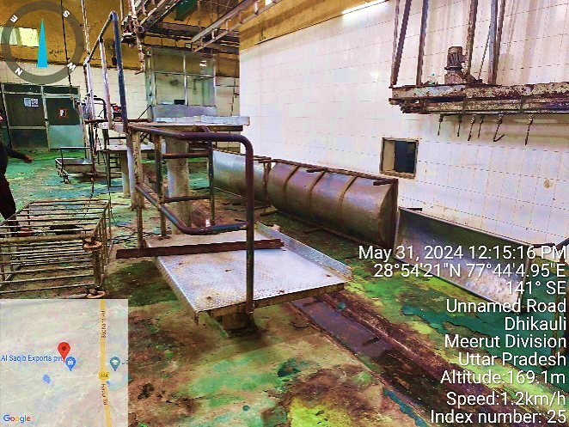 | 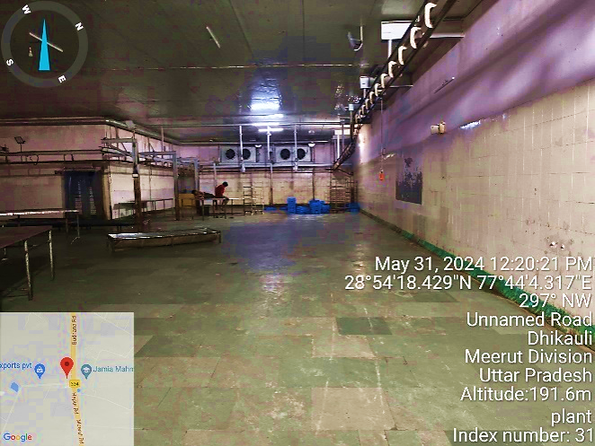
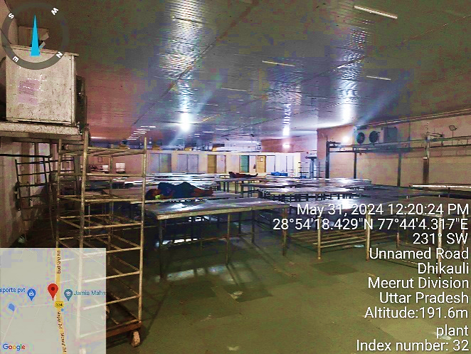 | 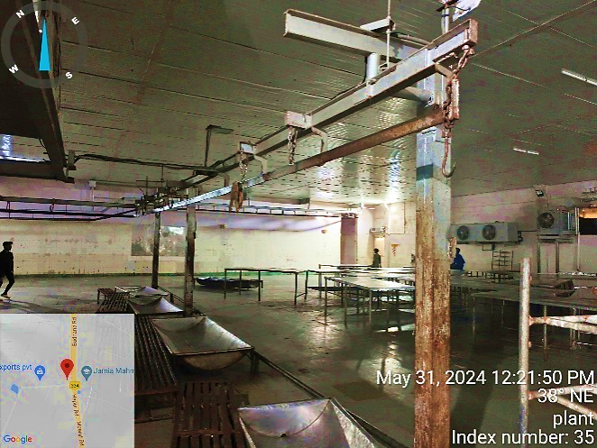
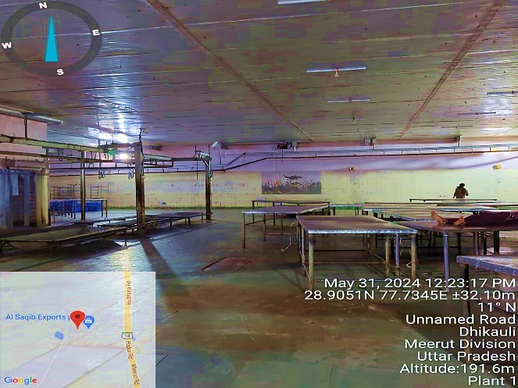 | 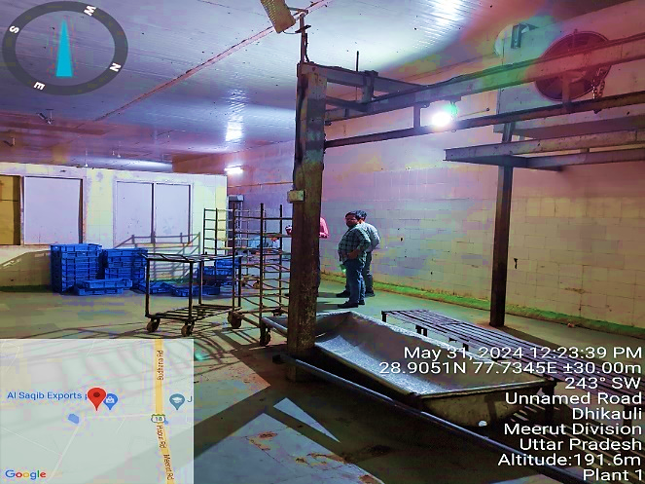
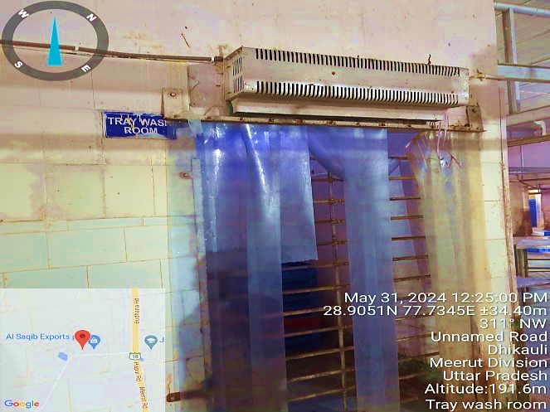 | 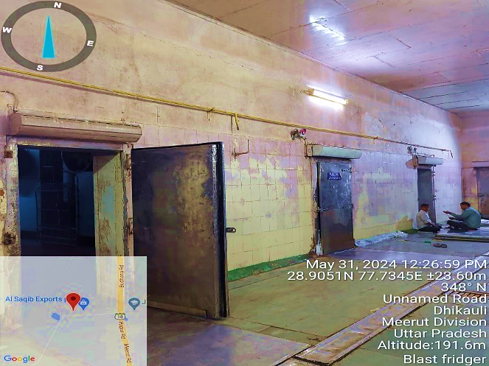
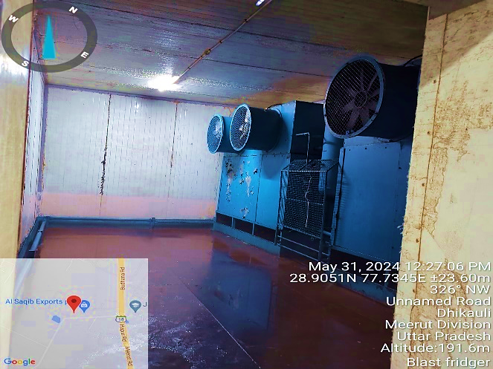 | 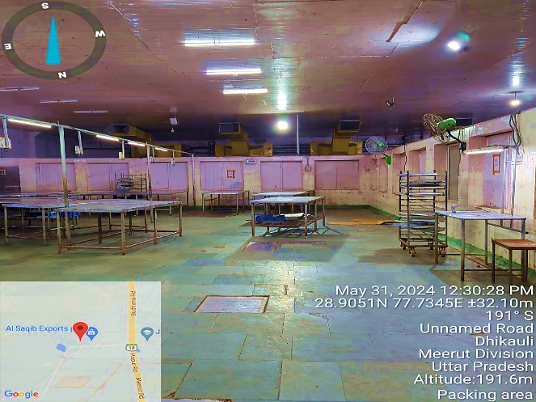
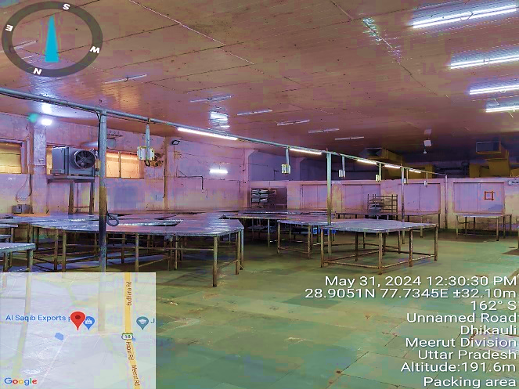 | 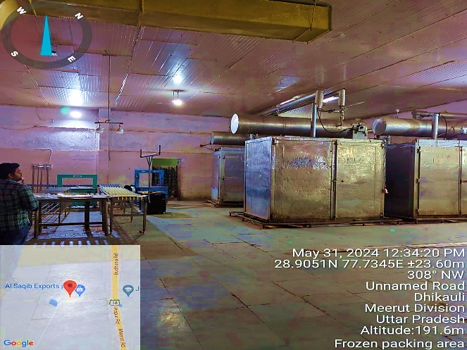
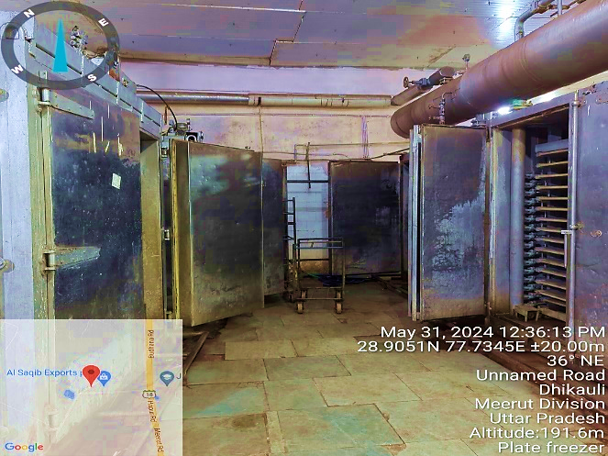 | 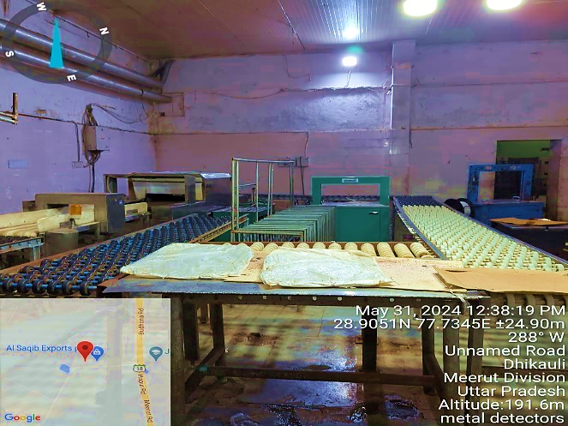
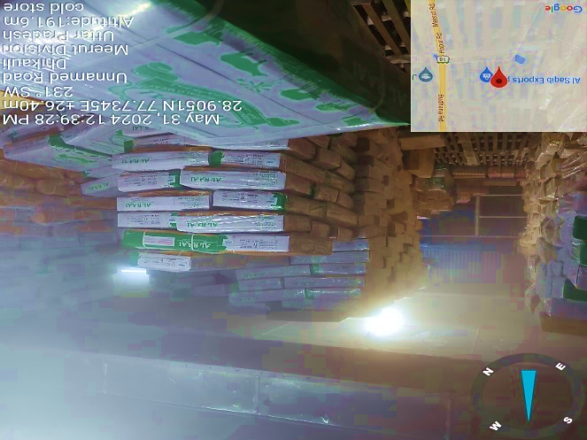 | 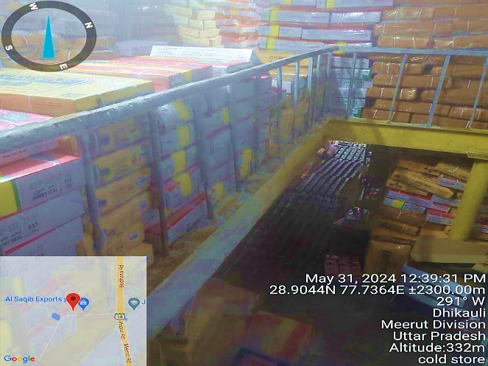
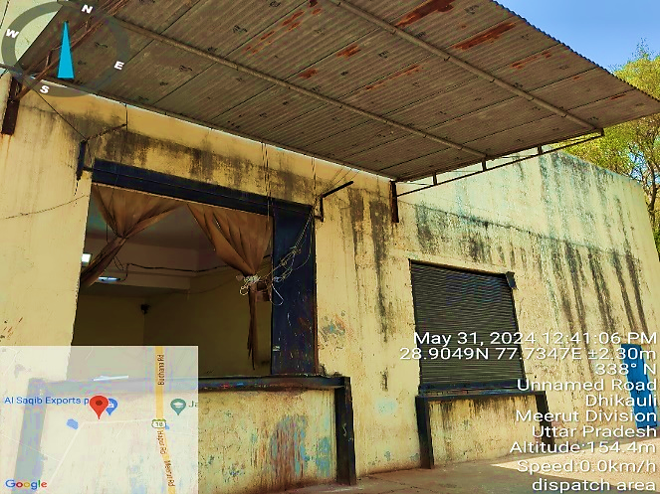 | 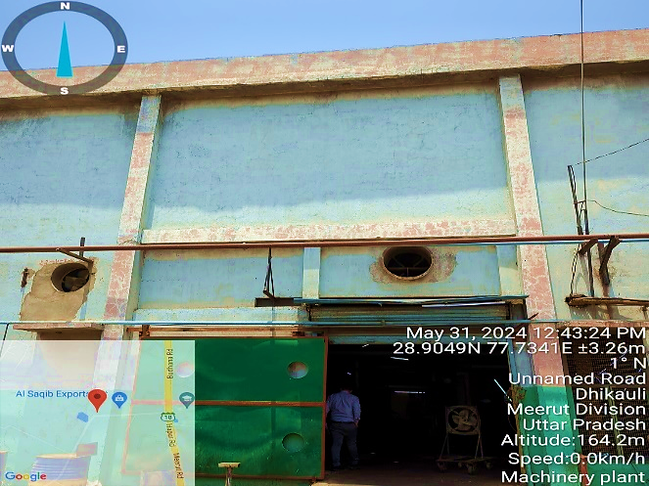
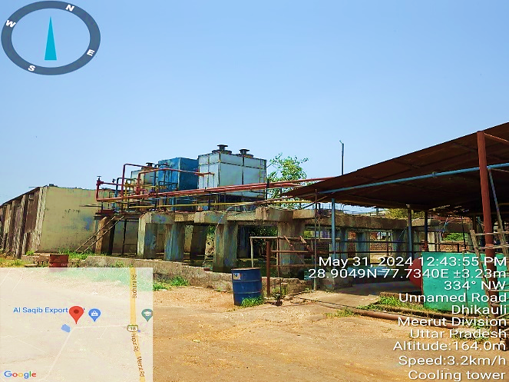 | 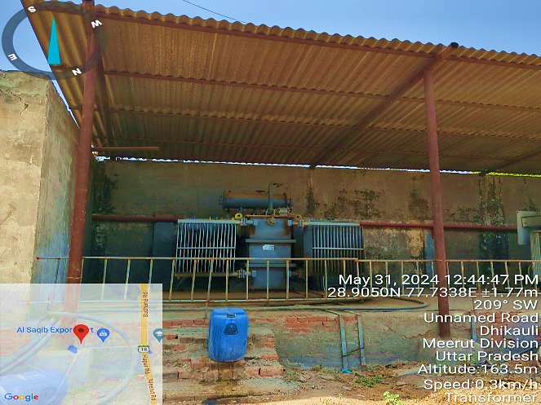
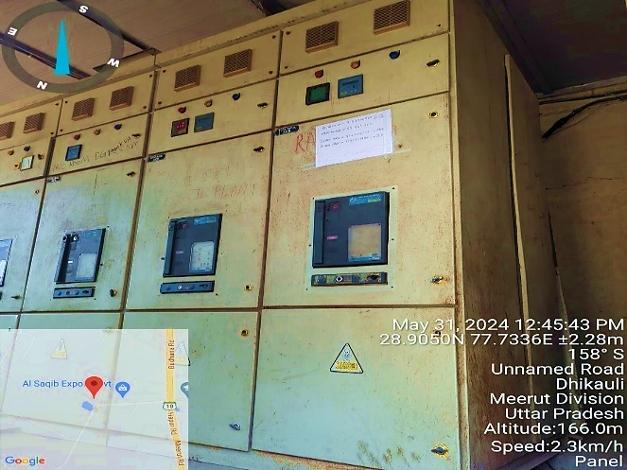 | 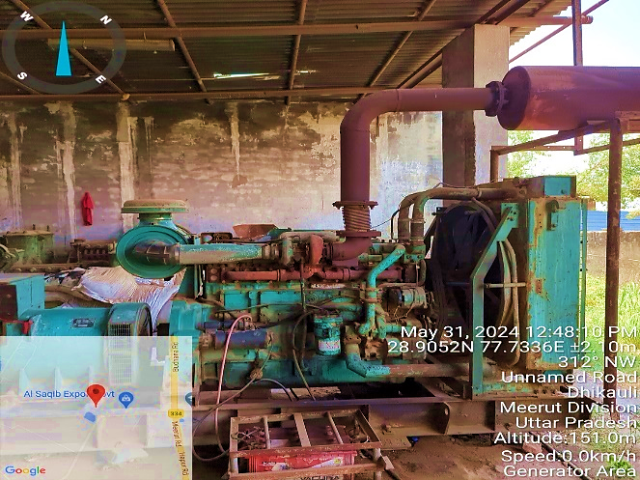
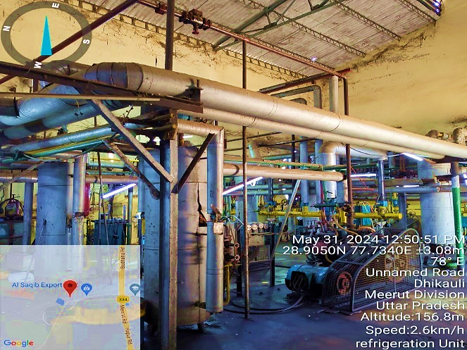 | 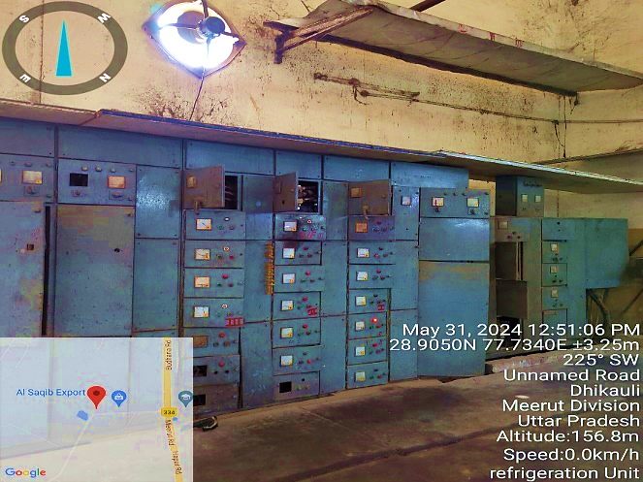
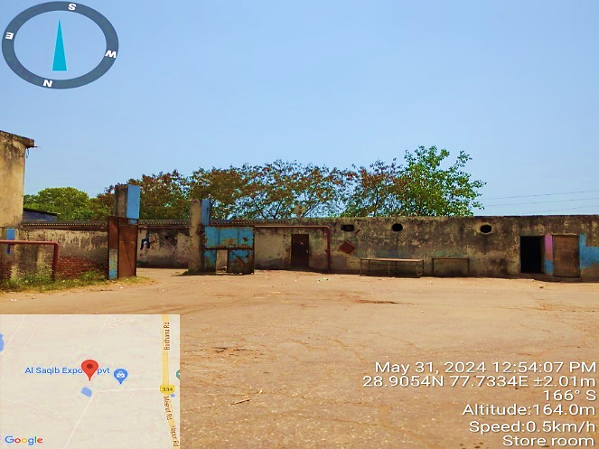 | 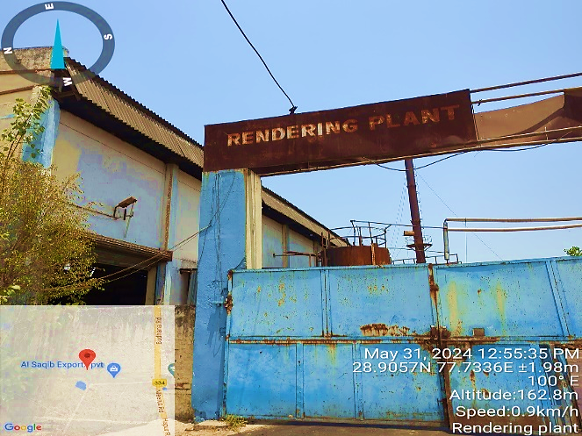
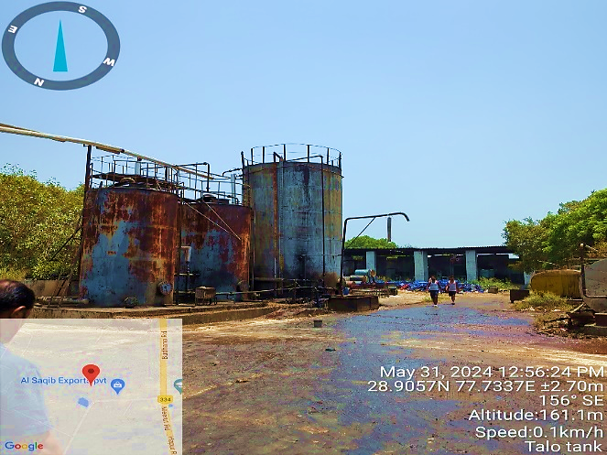 | 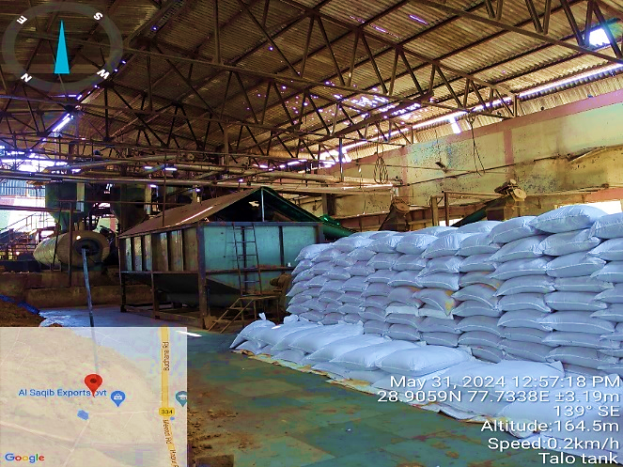
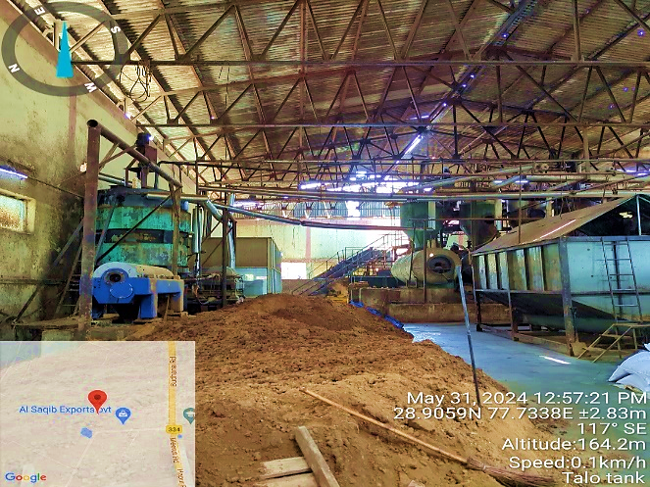 | 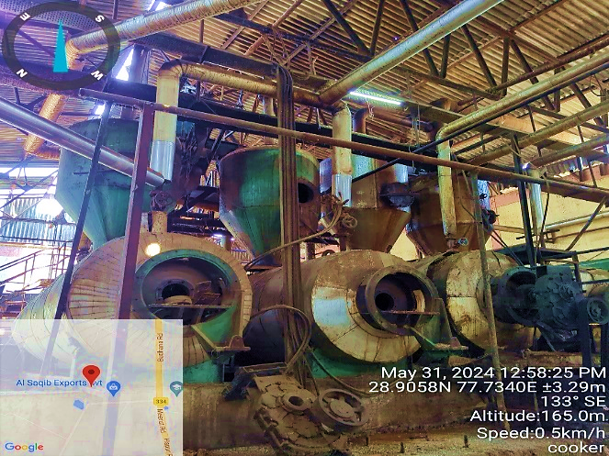
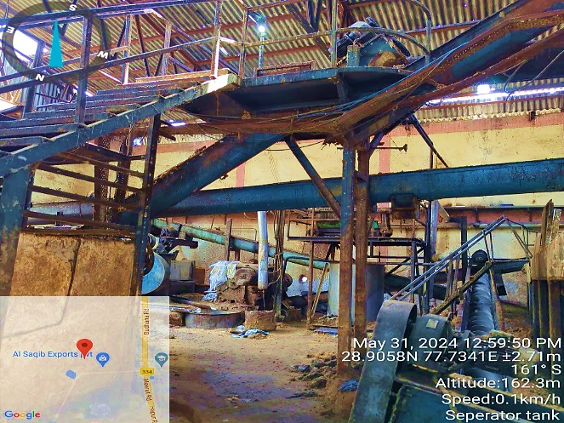 | 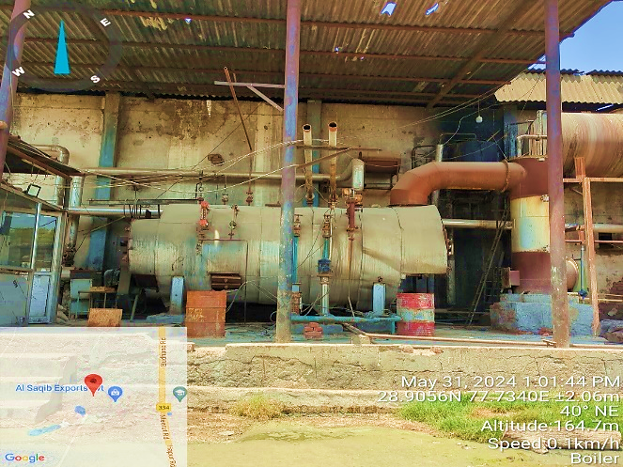
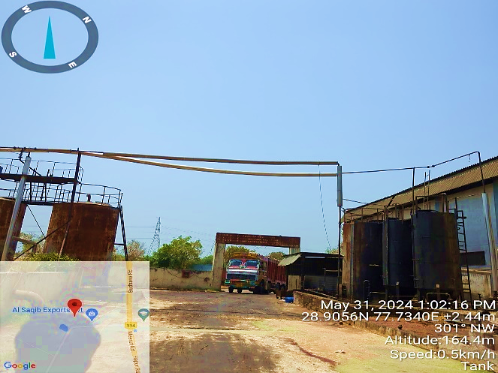 | 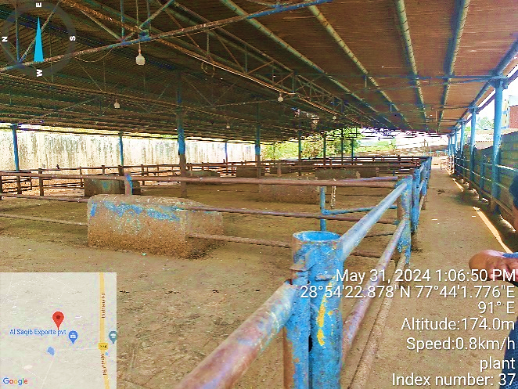
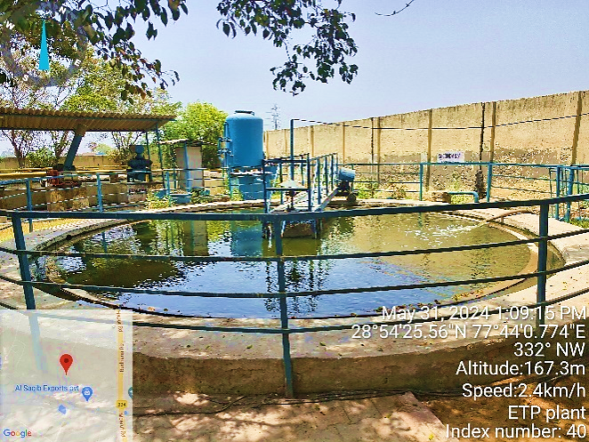 | 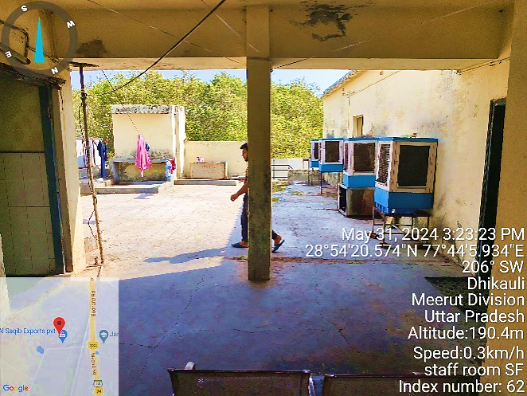
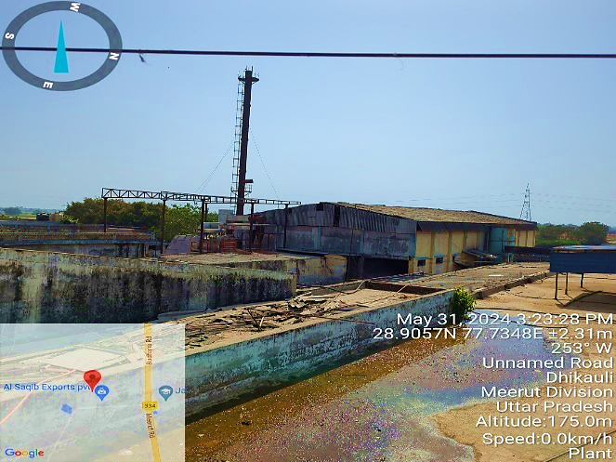 | 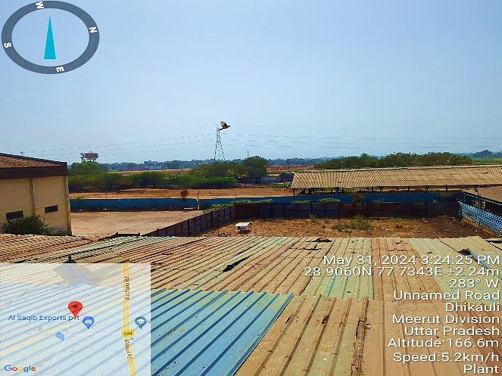
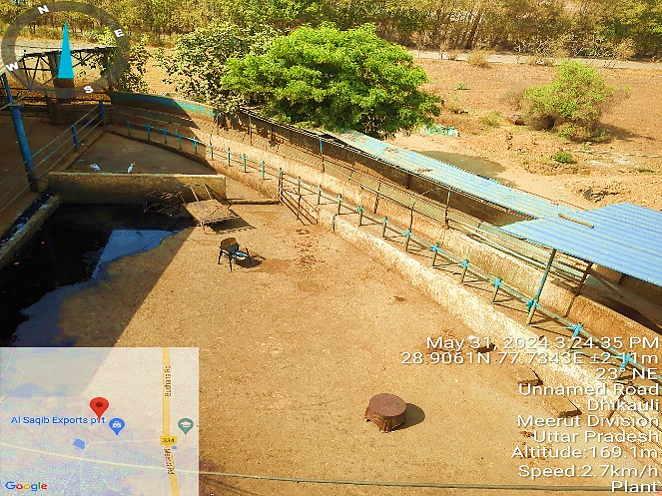 | 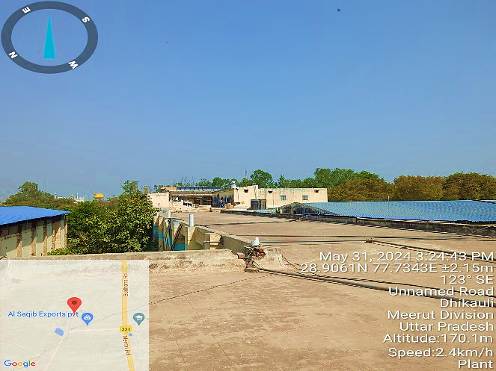

- BUILDING & CIVIL WORKS:
As per the shared layout plan, the plant is situated at the aforesaid address having total land area admeasuring ~ 91,033 sq. mts., out of which ~47,565 is mortgaged with bank as per the documents shared with us.
We have also cross-checked the area from google satellite measurement and it seems to match with the area mentioned in the document. The copy of approved plan is in name of previous owner M/s Madan Mohan Textiles Ltd. which is not very clear. For survey and our analysis, we have relied upon the theodolite layout plan shared by the company.
The main block of the plant is spreading over a covered area of ~7119.26 Sq. Mts., Lairage 1, 2 & 3 spread over a covered area of ~674.17 Sq. Mt., 674.17 Sq. Mt. & 977.13 Sq. Mt. respectively. The rendering plant is spread over a covered area of ~ 931.77 and ~220.22 Sq. Mt. of covered area is required to house the various other structures like canteen & guard room.
This integrated Meat Complex is located at Meerut City of Uttar Pradesh in India. It has been designed and built to meet most stringent EEC and US FDA standards. In this vertically integrated plant, the main products mainly, Corned Buffalo & Frozen Meat are pressed on the upper floor while the inedible by products processing is carried out on the ground floor to maintain plant hygiene standards at the highest level.
The plant comprises 8 nos. of structures including Office Building, Lairage (1, 2 & 3), Rendering Plant, Main Block, etc. The details of built-up area of all building/structures measured at site are as follows:
S. No. | Particular | Floor | Structure | Height | Area (Sq. Mtr.)
1 | Office Building | First Floor | RCC | 10 | 675.25
2 | Covered Area of Main Block | Ground Floor | RCC & Shed | 20 | 7,119.26
3 | Lairage 1 | Ground Floor | Shed | 20 | 674.17
4 | Lairage 2 | Ground Floor | Shed | 20 | 674.17
5 | Lairage 3 | Ground Floor | Shed | 20 | 977.13
6 | Rendering Plant | Ground Floor | RCC & Shed | 20 | 931.77
7 | Covered Area Guard Room | Ground Floor | RCC & Shed | 8 | 67.16
8 | Covered Area of Canteen | Ground Floor | RCC & Shed | 10 | 153.06
Total Area |  |  |  |  | 11,271.97
As per the observation made during site visit on 31st May 2024, we found that the plant area is fenced with walls on all the four sides of the property, with its dedicated entry from the Eastern Side of the Property. The property is adjoined with NH-334 on the East Side, Other Agricultural Land on the West, North & South Side.

- PLANT & MACHINERY/ EQUIPMENTS DETAILS:
As per the information provided by client/company, the plant has capacity of 1200 buffaloes per day. Details of the major plant and machinery at Meerut unit is mentioned in the table below along with the manufacturer and specification details:
S. No. | Name of Machine |  | M/C No. | Make | Description of Machine |  | Remark
Slaughter House Machines
1 | Ritual Killing Box | RKB |  | Assembled | Hydraulic
2 | Dehiding Machine | DM |  | Assembled | Hydraulic
3 | Bone Cutting Machine | BCM |  | Alloys USA | Cutter 2 Unit
4 | D.G Generator 380 KVA | DG-04 |  | Cumins | Non-Silent Type
5 | GA 15 Compressor | CMP-15 |  | Atlas Copco | Single Stage Compressor |  | 75 BHP
6 | Slaughtering Line |  |  | Assembled
Processing Plant Machines
1 | KC 3 Compressor | CMP-01 |  | Kirloskar | Single Stage Compressor |  | 65 BHP
2 | KC 4 Compressor | CMP-02 |  | Kirloskar | Single Stage Compressor |  | 75 BHP
3 | KC 4 Compressor | CMP-03 |  | Kirloskar | Single Stage Compressor |  | 75 BHP
4 | KC 4 Compressor | CMP-04 |  | Kirloskar | Single Stage Compressor |  | 75 BHP
5 | KC 4 Compressor | CMP-05 |  | Kirloskar | Single Stage Compressor |  | 75 BHP
6 | KC 6 Compressor | CMP-06 |  | Kirloskar | Single Stage Compressor |  | 75 BHP
7 | KC 31 Compressor | CMP-07 |  | Kirloskar | Two Stage Compressor |  | 100 BHP
8 | KC 31 Compressor | CMP-08 |  | Kirloskar | Two Stage Compressor |  | 100 BHP
9 | KC 42 Compressor | CMP-09 |  | Kirloskar | Two Stage Compressor |  | 100 BHP
10 | KC 55 Compressor | CMP-10 |  | Kirloskar | Two Stage Compressor |  | 100 BHP
11 | KC 55 Compressor | CMP-11 |  | Kirloskar | Two Stage Compressor |  | 100 BHP
12 | KC 55 Compressor | CMP-12 |  | Kirloskar | Two Stage Compressor |  | 100 BHP
13 | KC 55 Compressor | CMP-13 |  | Kirloskar | Two Stage Compressor |  | 100 BHP
14 | KC 55 Compressor | CMP-14 |  | Kirloskar | Two Stage Compressor |  | 100 BHP
15 | D.G Generator 625 KVA | DG-01 |  | Cumins | Silent Type
16 | D.G Generator 500 KVA | DG-02 |  | Cumins | Non-Silent Type
17 | D.G Generator 500 KVA | DG-03 |  | Cumins | Non-Silent Type
18 | D.G Generator 220 KVA | DG-05 |  | Kirloskar | Non-Silent Type
19 | Cooling/Refrigeration Units |  |  | Frick India Ltd | Refrigeration Unit
List of Instrument, Equipment/Checking Fixtures
S. NO. | NAME OF EQUIPMENT |  |  | MAKE |  | MODEL | SERIAL NO.
1. | Autoclave (Temperature) |  |  | Globus |  | - | 01
2. | Autoclave (Compound Gauge) |  |  | Globus |  | - | 02
3. | Autoclave (Temperature) |  |  | Globus |  | - | 03
4. | Autoclave (Compound Gauge) |  |  | Globus |  | - | 04
5. | Biosafety Cabinet |  |  | - |  | - | 01
6. | Data Logger |  |  | - |  | - | 01
7. | Mercury Thermometer |  |  | - |  | - | 01
8. | Digital Temp. Indicator with Sensor |  |  | Hanna |  | Hl98501 | 01
9. | Digital Temp. Indicator with Sensor |  |  | Hanna |  |  | 02
10. | Digital Temp. Indicator with Sensor |  |  | Hanna |  |  | 04
11. | Digital Temp. Indicator with Sensor |  |  | Hanna |  |  | 05
12. | Digital Temp. Indicator with Sensor |  |  | Hanna |  |  | 03
13. | Water Bath |  |  | Shivaki |  | PID-S- 702 | 01
14. | Heating Plate |  |  | Shri A.N.  Sci. & chemical |  | - | 01
15. | Refrigerator |  |  | Videocon |  | - | -
16. | Vortex Shaker {Rpm) |  |  | - |  | - | -
17. | Digital Lux Meter |  |  | Hsetin
18. | Digital Weighing Balance |  |  | Kerro |  | BL- P3/6002 | 01
19. | Dial Thickness Gauge |  |  | Mxrady |  | DMG-15 | 01
20. | Vernier Calliper |  |  | ZHART |  | - | 01
21. | Micropipette |  |  | Vertex |  | - | 01
22. | Micropipette |  |  | Vertex |  | - | 02
23. | PH Meter |  |  | Hanna |  | Hl98107 | 01
24. | PH Meter |  |  | Hanna |  | Hl98107 | 02
25. | Digital Colony Counter |  |  | - |  | - | -
26. | Infrared Thermometer |  |  | BOSS |  |  | -
27. | Hot Air Oven |  |  | Tanco |  | PLT-125 | -
28. | Bacteriological Incubator |  |  | Tanco |  | PLT-136 | -
29. | Bacteriological Incubator |  |  | Tanco |  | PLT-136 | -
30. | BOD Incubator |  |  | Sentwin India |  | PM-3043 | -
31. | COD Digester |  |  | - |  | - | -
32. | Filter Assembly |  |  | - |  | - | -
33. | Heating Mantle |  |  | SUSTAR |  | - | -
34. | Moisture Oven |  |  | Tanco |  | - | -
35. | PH Meter |  |  | Labtroins |  | LT-11 | -
36. | Digital Weighing Balance |  |  | Kerro |  | BL-P3/6002 | -
37. | Bacteriological Incubator |  |  | Tanco |  | PLT-136 | -
38. | Muffle Furnace |  |  | - |  | - | -
39. | BOD Incubator |  |  | - |  | - | -
40. | TDS Meter |  |  | Hanna |  | Hl-98301
41. | DO Analyzer |  |  | - |  | - | -
42. | Kjeldal Apparatus (Apparatus Unit) |  |  | - |  | - | -
43. | Soxhlet Apparatus (Apparatus Unite) |  |  | - |  | - | -
44. | Soxhlet Apparatus (Apparatus Unite) |  |  | - |  | - | -
45. | Heating Mantle |  |  | - |  | - | -
46. | Hot Plate |  |  | - |  | - | -
47. | Digital Weighing Balance |  |  | - |  | - | -
48. | Hot Air Oven |  |  | - |  | - | -
49. | Muffle Furnace |  |  | - |  | - | -
50 | Sterilizer (S-1) |  |  | Haidrulg |  | - | 1
51. | Sterilizer (S-2) |  |  | Haidrulg |  | - | 2
52. | Sterilizer (S-3) |  |  | Haidrulg |  | - | 3
53. | Sterilizer (S-4) |  |  | Haidrulg |  | - | 4

As per the observation made during site visit on 31st May 2024, we found that the plant & machineries installed at the site are well maintained and in good running condition with timely maintenance when required.

- UTILITIES:
Details of Water, Electricity and other utilities are as below:
- WATER:
The source of water to meet the plant’s make up water requirement will be through Bore wells. The company had already obtained two separate NOC certificate for ground water from Uttar Pradesh government which are as follows:
S. No. | Maximum Allowable Rate of Withdrawal | Maximum Allowable Annual Extraction | Certificate | Validity
1 | 15 m³/hr | 52800 | NOC027740 | 09.12.2022 to 08.12.2027
2 | 15 m³/hr | 52800 | NOC044764 | 09.12.2022 to 08.12.2027

- ELECTRICITY:
As per the data/information provided to us by the client, the company has a sanctioned load of 1000 KVA for the integrated meat processing plant. The company has also installed 2 DG sets of 500 KVA and 1 DG set of 625 KVA, 380 KVA & 220 KVA each.
- ETP (EFFLUENT TREATMENT PLANT):
As per the data/information shared with us, the plant has an operational effluent treatment plant with a capacity of 300KL per day.
PART E | INDUSTRY OVERVIEW

- INTRODUCTION:
The Meat production segment in India has seen massive growth in recent years. In recent years, India’s meat production sector has experienced notable growth, with an annual output surpassing 6.3 million tons. Globally, India ranks fifth in terms of production volume, reflecting the industry’s increasing prominence on the international stage. Demand for meat is increasing eventually as they are very rich in protein and other nutrients such as riboflavin, niacin, omega-6 fatty acids, vitamin B6 and B12.
India has the world’s largest population of livestock at about 515 million and the nation contributes 3% of the total meat production in the world. More than 65% of the Indian population is non-vegetarian and chicken and fish have the highest consumption rate. The per capita meat consumption in India is more than 4.9 kg.
Consumers are preferring processed foods as the processes such as salting and smoking improve the taste and retain the qualities of the meat products. India exports more than 7,000 metric tons of poultry meat every year as it has the largest resource pool of animal castings and lower per capita meat consumption. India is currently exporting frozen meat to 60 countries. Malaysia, Egypt, UAE, Jordan, Thailand, and Yemen are identified as major buyers of Indian processed meat.

- MARKET OVERVIEW:
With over 65% of the population being non-vegetarian, chicken and fish dominate consumption. The per capita meat consumption exceeds 4.9 kg, with a growing preference for processed options like salted and smoked products, enhancing taste and retaining quality. Leveraging abundant resources and relatively lower per capita consumption, India annually exports over 7,000 metric tons of poultry meat. Presently, frozen meat exports reach 60 countries, with major buyers including Malaysia, Egypt, UAE, Jordan, Thailand, and Yemen, signifying India’s expanding presence in the global meat market.
Some of the key factors driving the market are changes in dietary preferences, increased awareness about nutritional benefits, increasing influence of international cuisines and escalating demand for convenience and processed meats and government initiatives. According to a report by Statista, revenue in the Indian processed meat market amounts to US$ 2.72 billion in 2024 and is expected to grow annually by 6.05% (CAGR 2024-28).
India’s raw meat exports reached a value of US$ 3.6 billion in 2023, growing by 12.1% YoY. A large share of this value is taken up by Meat of bovine animals (US$ 3.2 billion). Exports of poultry products was recorded at US$ 168.6 million, growing by 44.5% YoY. The country was ranked 13th in terms of exports globally. Indian meat products are in demand globally due to cost competitiveness, perceived organic nature and low-fat proportion. The Government of India has established standards for exports of meat which include standards for abattoirs and processing plants.
However, India’s exports of processed meat products is much lower at US$ 2.65 million, growing by 57.2% YoY. The country’s exports under HS 16 (Preparations of meat, of fish or of crustaceans, molluscs or other aquatic invertebrates) reached US$ 718.64 million in 2023, declining by 16.6% YoY, with US (US$ 577.3 million) dominating. The country was ranked 20th in global exports. But this export is dominated by marine products, particularly preparations of crustaceans (HS 1605, US$ 633.3 million) and prepared or preserved fish (HS 1604, US$ 82.9 million).
India has vast resource of livestock and poultry, which play a vital role in improving the socio-economic conditions of rural masses. There are about 303.76 million bovines (cattle, buffalo, mithun and yak), 74.26 million sheep, 148.88 million goats, 9.06 million pigs and about 851.81 million poultry as per 20th Livestock Census in the country. The species wise population of animals in Livestock and Poultry population during the last two Censuses is given in the table below:
S. No. | Species | 19th Livestock Census 2012 (No. in millions) | 20th Livestock Census 2019 (No. in millions) | Growth Rate (%) 2012-19
1 | Cattle | 190.9 | 193.46 | 1.34
2 | Buffalo | 108.7 | 109.85 | 1.06
3 | Yaks | 0.08 | 0.06 | -24.9
4 | Mithun | 0.3 | 0.39 | 29.52
Total Bovines |  | 299.98 | 303.76 | 1.26
5 | Sheep | 65.07 | 74.26 | 14.13
6 | Goat | 135.17 | 148.88 | 10.14
7 | Pigs | 10.29 | 9.06 | -12.03
8 | Other Animals | 1.54 | 0.79 | -48.7
Total Livestock |  | 512.05 | 536.75 | 4.82
9 | Poultry | 729.21 | 851.81 | 16.81
Source: Department of Animal Husbandry, Dairying and Fisheries (DAHD)

Meat production during 2014-15 was 6.69 million tonnes which has been further increased to 9.29 million tonnes in 2021-22. The Meat production has shown positive growth as 5.62% during 2021-23. The production of meat and the corresponding annual growth rate (%) per year of the country from 2011-12 to 2021-22 is shown in graph given below:
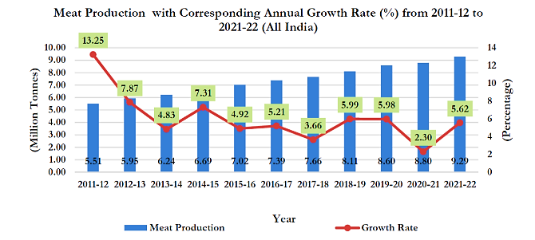
Source: Department of Animal Husbandry, Dairying and Fisheries (DAHD)

- GOVERNMENT INITIATIVES:
Some of the major initiatives taken by the Government of India to promote the Indian Meat Processing Industry are as follows:
- 100% FDI permitted through automatic route in food processing sector.
- Mega Food Park Scheme by Ministry of Food Processing Industries. Government of India through MoFPI is putting up 42 mega food parks (35 approved). The parks have around 1,200 developed plots (of approximately 1 acre each) with basic infrastructure enabled, that entrepreneurs can lease for the setting up of food processing and ancillary units.
- Concessional rate of Customs Duty applicable on imported equipment under the project import benefits.
- Income Tax deductions on capital expenditure allowed at the rate of 150% for setting up and operating cold chain or warehouse for storage of agriculture produce.
- 100% income tax exemption available to new food processing, preservation and packaging units for the first 5 years of operation, and at the rate of 25%-30% thereafter.
- A fund of INR 20 billion created with National Bank for Agriculture and Rural Development (NABARD) for extending affordable credit to designated Food Parks and units therein.
- Scheme for Cold Chain, Value addition and Preservation Infrastructure by Ministry of Food Processing Industries.
- Scheme for setting up/modernization of abattoirs (for Government abattoirs) by Ministry of Food Processing Industries.

- ROAD AHEAD:
India has enormous untapped potential in the meat processing industry. It boasts the world’s largest livestock population, estimated at around 515 million and a global share of 3%. Contribution of livestock in total gross value added of the agriculture and allied sector has increased from 24.4% in 2014-15 to 30.2% in 2021-22. Further, as per Food and Agriculture Organization Corporate Statistical Database (FAOSTAT) production data (2021), India ranks 2nd in Egg Production and 5th in meat production in the world.
Egg production in the country has increased from 78.48 billion in 2014-15 to 138.38 billion nos. in 2022-23, growing at a strong CAGR of 7.35% over the past 9 years. The per capita availability reached 101 eggs per annum in 2022-23 as against 62 eggs in 2014-15. Meat production has increased from 6.7 million tonnes in 2014-15 to 9.77 million tonnes in 2022-23. As per 2019 data, meat processing levels are still very low at around 6% of poultry and 21% of meat.
Moreover, it must be noted that meat processing machinery industry globally is growing at a very strong pace, driven by innovation and disruptive technological advancement. The use of advanced machinery and automated systems have revolutionized traditional processes, with strongly positive improvements in production rates as well as product quality. Tedious and potentially dangerous jobs like slaughter, cutting, and deboning are being increasingly automated with robots. This improves worker safety and consistency.
AI powered vision systems can now assess meat on various quality parameters, optimise cutting processes and minimise waste. Moreover, advanced rendering techniques can also help leverage leftovers for other end use sectors like biofuels or feedstock. The growing interest in environmental conservation is also leading to various interventions, like the use of improved sanitation measures that use less water and utilisation of biodegradable bioplastics for sustainable packaging.
Within this extremely dynamic landscape, the Indian meat processing technology sector is buoyant with opportunities for trade, investment and also innovation, given various factors including strong policy support, a robust domestic market, cost competitiveness, untapped potential in meat processing and a rapidly emerging technology ecosystem. Moreover, discerning customers are increasingly demanding transparency, traceability and diversity in product offerings.
By leveraging its large and growing market, skilled workforce, and focus on sustainability, India can become a hub for developing, deploying and also commercialising advanced technologies that could in fact transform how meat is produced and consumed globally.

PART F | SWOT ANALYSIS

SWOT ANALYSIS
STRENGTHS | - Manufacturing Experience: Directors are having several years of experience in the same line of business & industry as company is running the existing unit since 1996.  - Established chain of buyers and sellers: The company is running the meat processing plant since 1996 and has developed connections with both the buyers of the final product and suppliers of the raw material.  - Steady Revenue Stream: ASEPL currently running the plant on Job-work basis for TPPL on a monthly charge of INR 88 Lacs per month. Apart from this, the company has also given the processing plant and slaughtering house on rent @ INR 2.00 Lakhs per month.
WEAKNESSES | - Reliance on Suppliers: The success of the business will depend on having a reliable supply of quality meat and other products. If the suppliers cannot meet demand or provide consistent quality, the business will suffer.  - Risk of Contamination: Food Processing Plants are vulnerable to contamination from pathogens such as E. Coli or Salmonella. Even a single instance of contamination can harm the business’s reputation and lead to costly recalls.  - Health Concerns: Growing awareness of health issues associated with excessive meat consumption, such as heart disease and obesity, could lead to a decline in demand for certain products.  - Volatile Input Costs: Fluctuations in the prices of feed, energy, and labour can significantly impact profit margins, especially for companies with limited pricing power.
OPPORTUNITIES | - Healthier Alternatives: Rising demand for plant-based and lab-grown meat alternatives presents an opportunity for meat processors to diversify their product offerings and capture new market segments.  - Expansion Potential: Growing populations and increasing meat consumption in emerging markets offer opportunities for expansion and market penetration.  - E-Commerce: The business can create a website to enable customers to order their processed/packaged meats and products online, which will significantly increase sales.  - Growing Demand: Demand for India’s Processed Meat Market is expected to grow annually by 6.05% (CAGR 2024-28).
THREATS | - Increasing Competition: The meat processing industry is highly competitive with many established players. New entrants to the market may struggle to gain a foothold.  - Regulatory Compliance: Meat processing plants must comply with strict regulatory requirements to ensure food safety. Failure to comply can lead to fines, legal action, or even closure of the business.  - Changing Consumer Preferences: Consumers are becoming more health-conscious and environmentally aware, which may result in a decline in demand for meat products. This could affect sales and revenue of the business.  - Public Perception: The meat processing industry has faced negative criticism over animal welfare, environmental damage and health concerns. These issues could damage the reputation of the business and affect sales.  - Economic Downturns: Decline in the economy can influence customers' spending habits, potentially reducing their frequency of purchasing premium meats.

PART G | STATUTORY APPROVALS | LICENCES | NOC

As shown in the below table along with current status, following major approvals are required. However, the list is not exhaustive and State/District Authorities may be approached for further clearances required (if any):
S. No. | REQUIRED APPROVALS | DATE  REFERENCE NO. | STATUS  (Approved/ Applied For/ Pending)
 | Certificate of Incorporation  Asst. Registrar of Companies, NCT of Delhi & Haryana | 24th April 1996  Registration Number : 55-78460 | Approved
 | GST Registration Certificate | 28th July 2018  Registration Number : 09AACCA8455G1ZJ | Approved
 | Importer-Exporter Code  DGFT, Ministry of Commerce and Industry, GOI | Date of Issue: 1st October 1997  IEC: 0597039836 | Approved
 | Building and Civil Works Plan Sanction Approval  Meerut Development Authority | 3rd April 1986  Reference No. : 13/86 | Approved
 | Fire NOC  Fire Services Department | Validity: 17th September 2022 to 16th September 2025  UID No.: UPF/2022/60967/MRT/MEERUT/985/DD | Approved
 | Consent to Operate under Section 25(7) of The Water (Prevention and Control of Pollution) Act, 1974  Uttar Pradesh Pollution Control Board | Validity: 15th March 2024 to 31st December 2028  Letter No.: 1471/C/Al-Saqib Exports/2024 | Approved
 | No Objection Certificate (NOC) for ground water extraction  (Namami Gange & Rural Water Supply Department)  Ministry Of Jal Shakti, Govt. Of India | 1. Validity: 9th December 2022 to 8th December 2027  NOC: NOC044764 | Approved
 |  | 2. Validity: 9th December 2022 to 8th December 2027  NOC: NOC027740 | Approved
 | Udyam Registration Certificate (MSME) | 25th February 2021  UDYAM-UP-56-0007132 | Approved
 | HACCP  UK Certification & Inspection Ltd. | Validity: 20th September 2021 to 19th September 2024  Certificate No. UQ-2021092039 | Approved
 | APEDA  Ministry of Commerce, Govt. of India | Validity: 8th April 2024 to 7th March 2025 | Approved
 | FSSAI  FSSAI, Delhi Regional Office-I, Govt. of India | Validity: 25th March 2021 to 24th March 2026  License No.: 10021051000330 | Approved

Observation Note:
- *As per the information shared with us, AL-Saqib Exports Pvt Ltd. Add: 11KM milestone, Opp. Naugaza Peer, Alipur Jijmana, Hapur Road, Meerut is purchased from PICKUP (U.P. Government) under auction which is already approved as Madan Mohan Textile Limited by Meerut Development authority. The copy of approved plan is still in the name of previous owner M/s Madan Mohan Textiles Ltd. For survey and our analysis, we have relied upon the theodolite layout plan shared by the company.
- Above is the only illustration of the major approvals sought or to be sought by the company. It should not be construed as the exhaustive list and in case any approval is missed to be mentioned then it is the sole responsibility of the company to keep the unit compliant with the necessary statutory approvals/ NOCs.

PART H | COMPANY’S FINANCIAL FEASIBILITY

- HISTORICAL PERFORMANCE OF THE COMPANY:
As per the financial statements provided by the company/client, below table shows the historical performance of the company from FY 2017-18 to FY 2024-25 (Till Nov-24 Prov.).
- HISTORICAL PROFIT & LOSS ACCOUNT:
(INR Lakhs)
Particulars | FY 2018 A | FY 2019 A | FY 2020 A | FY 2021 A | FY 2022 A | FY 2023 A | FY 2024 A | Nov-24 P
Sales & Services | 4,923.20 | 14,786.37 | 9,090.04 | 10,652.36 | 7,033.84 | 1,675.97 | 2,797.54 | 690.67
Other Income | 31.14 | 107.18 | 15.40 | 16.39 | 4.03 | 7.80 | 442.67 | 224.00
Total Revenue | 4,954.34 | 14,893.55 | 9,105.44 | 10,668.74 | 7,037.87 | 1,683.77 | 3,240.20 | 914.67
Purchase of Raw Material | 4,002.99 | 14,435.45 | 8,121.98 | 8,271.18 | 3,601.16 | 718.29 | - | -
Changes in inventories of stock-in-trade | -104.23 | -2,570.83 | -1,445.78 | 756.51 | 1,328.51 | -265.97 | 2,071.47 | -
Employee Benefits Expense | 142.93 | 256.81 | 264.95 | 151.84 | 182.98 | 127.84 | 139.09 | 103.79
Other Expenses | 704.91 | 2,335.88 | 1,807.95 | 1,102.98 | 1,438.95 | 538.68 | 365.77 | 37.20
Total Operating Expenses | 4,746.60 | 14,457.30 | 8,749.10 | 10,282.50 | 6,551.60 | 1,118.84 | 2,576.34 | 140.98
EBITDA | 207.74 | 436.25 | 356.33 | 386.24 | 486.27 | 564.93 | 663.87 | 773.68
Depreciation | 154.26 | 148.04 | 140.96 | 128.24 | 119.14 | 111.06 | 96.36 | 55.33
EBIT | 53.48 | 288.21 | 215.37 | 258.00 | 367.13 | 453.88 | 567.51 | 718.36
Interest Expense | 0.11 | 253.53 | 190.56 | 241.43 | 322.27 | 436.47 | 549.78 | 372.24
PBT | 53.37 | 34.68 | 24.82 | 16.57 | 44.86 | 17.41 | 17.73 | 346.12
Tax Expense | 13.50 | 9.02 | 6.45 | 4.31 | 11.66 | 4.53 | - | 89.99
PAT | 39.87 | 25.66 | 18.37 | 12.26 | 33.20 | 12.88 | 17.73 | 256.13

- HISTORICAL BALANCE SHEET:
(INR Lakhs)
Particulars | FY 2018 A | FY 2019 A | FY 2020 A | FY 2021 A | FY 2022 A | FY 2023 A | FY 2024 A | Nov-2024 P
Equity & Liabilities
Shareholders' Funds
Share Capital | 850.00 | 850.00 | 2,000.00 | 2,000.00 | 2,000.00 | 2,000.00 | 2,000.00 | 2,000.00
Reserve & Surplus | 829.24 | 854.90 | 873.27 | 885.53 | 918.73 | 931.60 | 949.33 | 1,205.45
Total Equity | 1,679.24 | 1,704.90 | 2,873.27 | 2,885.53 | 2,918.73 | 2,931.60 | 2,949.33 | 3,205.45
Non-Current Liabilities
Long-term Borrowings | 552.85 | 4,527.43 | 4,438.03 | 5,152.03 | 1,253.31 | 1,376.62 | 1,073.46 | 1,082.37
Deferred Tax Liability | 73.69 | 73.69 | 73.69 | 73.69 | 73.69 | 73.69 | 73.69 | 73.69
Total Non-Current Liabilities | 626.54 | 4,601.12 | 4,511.72 | 5,225.72 | 1,327.00 | 1,450.30 | 1,147.15 | 1,156.06
Current Liabilities
Short Term Borrowings | - | - | - | - | 3,026.54 | 3,034.95 | 3,138.01 | 3,499.00
Trade Payables | 1,250.41 | 1,488.61 | 569.32 | 664.72 | 721.42 | 746.19 | 724.88 | 724.98
Other Current Liabilities | 54.93 | 123.39 | 97.24 | 75.96 | 59.51 | 174.76 | 229.92 | 321.93
Total Current Liabilities | 1,305.34 | 1,612.00 | 666.56 | 740.68 | 3,807.47 | 3,955.90 | 4,092.82 | 4,545.92
Total Equity & Liabilities | 3,611.13 | 7,918.02 | 8,051.55 | 8,851.94 | 8,053.20 | 8,337.81 | 8,189.30 | 8,907.43
Assets
Non-Current Assets
Tangible Assets | 1,674.75 | 1,674.58 | 1,582.97 | 1,506.29 | 1,468.41 | 1,396.80 | 1,294.11 | 1,234.01
Investment in shares of Al-Akhlaq Exports Limited | 1,000.00 | 1,000.00 | 1,000.00 | 1,000.00 | 1,000.00 | 1,000.00 | 1,114.00 | 1,114.00
Other Non-Current Assets | - | - | - | - | 24.73 | 24.73 | 24.73 | 24.73
Total Non-Current Assets | 2,674.75 | 2,674.58 | 2,582.97 | 2,506.29 | 2,493.14 | 2,421.53 | 2,432.84 | 2,372.74
Current Assets
Inventory | 104.23 | 2,675.07 | 4,120.85 | 3,364.34 | 2,035.82 | 2,301.79 | 230.32 | 230.32
Sundry Debtors | 677.36 | 2,018.49 | 921.65 | 2,675.63 | 3,420.09 | 3,449.00 | 5,144.89 | 5,955.45
Cash & Bank Balance | 9.88 | 208.73 | 23.46 | 55.89 | 12.75 | 75.18 | 87.20 | 54.87
Short-term Loans & Advances | 102.96 | 218.05 | 126.04 | 152.84 | 71.25 | 85.91 | 269.98 | 269.98
Other Current Assets | 41.95 | 123.10 | 276.59 | 96.95 | 20.15 | 4.40 | 24.07 | 24.07
Total Current Assets | 936.37 | 5,243.44 | 5,468.58 | 6,345.65 | 5,560.06 | 5,916.28 | 5,756.45 | 6,534.69
Total Assets | 3,611.13 | 7,918.02 | 8,051.55 | 8,851.94 | 8,053.20 | 8,337.81 | 8,189.30 | 8,907.43

- KEY FINANCIAL RATIO:
YEAR | FY 2018 A | FY 2019 A | FY 2020 A | FY 2021 A | FY 2022 A | FY 2023 A | FY 2024 A | Nov – 2024 P
EBITDA Margin % | 4.19% | 2.93% | 3.91% | 3.62% | 6.91% | 33.55% | 20.49% | 84.59%
EBIT Margin % | 1.08% | 1.94% | 2.37% | 2.42% | 5.22% | 26.96% | 17.51% | 78.54%
PAT Margin % | 0.80% | 0.17% | 0.20% | 0.11% | 0.47% | 0.76% | 0.55% | 28.00%
Note: As per the historical analysis, it is observed that EBITDA Margin of the company is showing an upward trend as it has gone up from 2.93% in FY 2018-19 to 33.55% in FY 2022-23 but dipped to 20.49% in FY2023-24 due to fluctuation in the cost of raw material consumed. EBIT Margin of the company is showing an upward trend as it has gone up from 1.08% in FY 2017-18 to 26.96% in FY 2022-23 but dipped to 17.51% in FY2023-24 due to fluctuation in the cost of raw material consumed.

- GRAPHICAL REPRESENTATION OF KEY RATIOS:
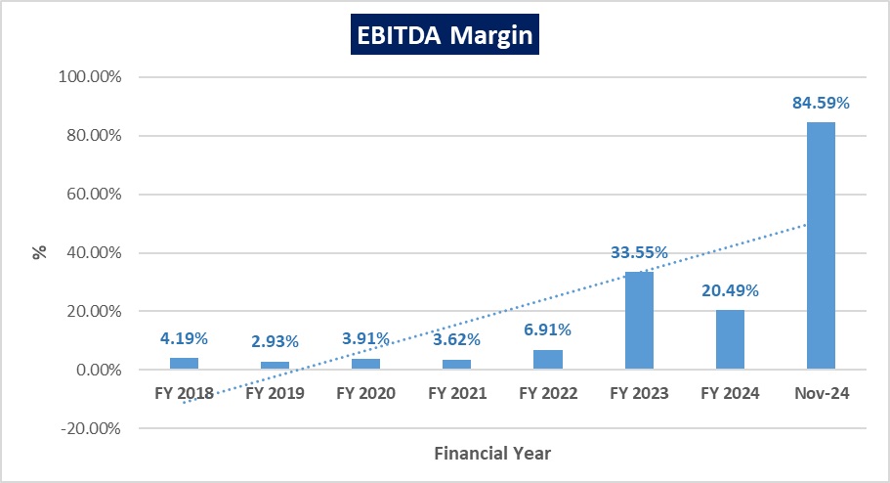
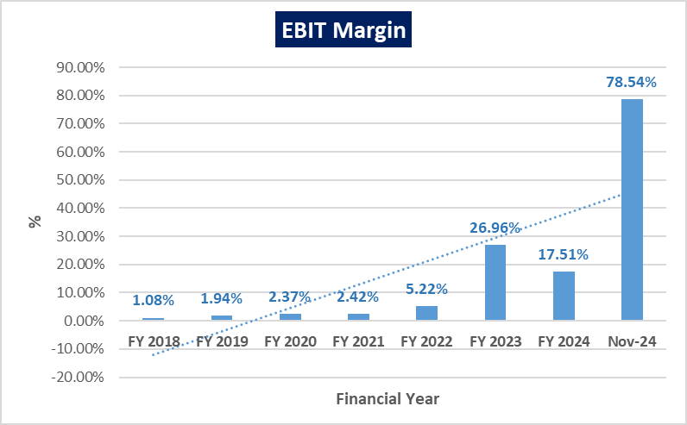
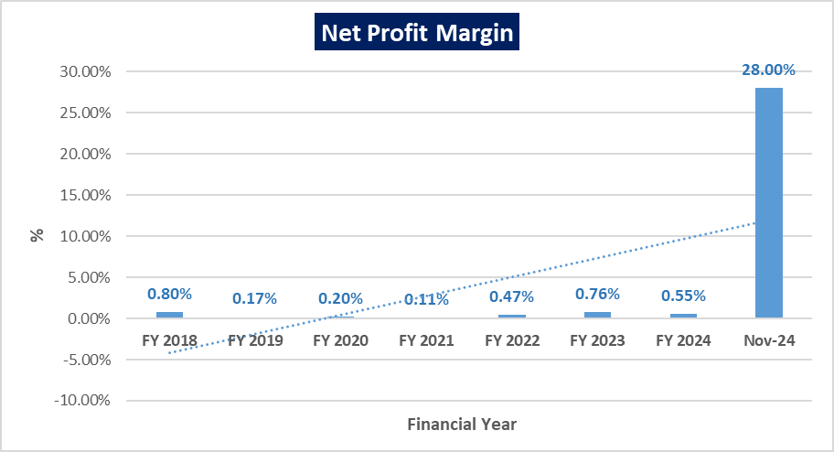

- PROJECTIONS OF THE FIRM:
The financial projections of the project are prepared from FY 2024-25 to FY 2031-32 based on the expected restructured loan tenor as per the discussion with client/company to assess the financial feasibility of the project which are elaborated below:
- PROJECTED PROFIT & LOSS ACCOUNT:
(INR Lakhs)
Particulars | 2024-25 | 2025-26 | 2026-27 | 2027-28 | 2028-29 | 2029-30 | 2030-31 | 2031-32
From Rental | 1,050.67 | 1,080.00 | 1,080.00 | 1,080.00 | 1,080.00 | 1,080.00 | 1,080.00 | 1,080.00
From Local Slaughtering | 566.32 | 352.80 | 370.44 | 388.96 | 408.41 | 428.83 | 450.27 | 472.79
Total Revenue | 1,616.99 | 1,432.80 | 1,450.44 | 1,468.96 | 1,488.41 | 1,508.83 | 1,530.27 | 1,552.79
Raw Materials | 0.00 | 0.00 | 0.00 | 0.00 | 0.00 | 0.00 | 0.00 | 0.00
Direct Labour | 155.68 | 163.46 | 171.64 | 180.22 | 189.23 | 198.69 | 208.63 | 219.06
Other Manufacturing Expenses | 0.00 | 0.00 | 0.00 | 0.00 | 0.00 | 0.00 | 0.00 | 0.00
Repair & Maintenance | 0.00 | 0.00 | 0.00 | 0.00 | 0.00 | 0.00 | 0.00 | 0.00
Depreciation | 82.99 | 71.56 | 61.76 | 53.35 | 46.12 | 39.91 | 34.56 | 29.95
Sub Total | 238.67 | 235.02 | 233.40 | 233.57 | 235.35 | 238.60 | 243.18 | 249.01
Add: Opening Finished Goods | 230.32 | 0.00 | 0.00 | 0.00 | 0.00 | 0.00 | 0.00 | 0.00
Less: Closing Finished Goods | 0.00 | 0.00 | 0.00 | 0.00 | 0.00 | 0.00 | 0.00 | 0.00
Total Cost of Sales | 468.99 | 235.02 | 233.40 | 233.57 | 235.35 | 238.60 | 243.18 | 249.01
Selling & Distribution Exp. | 55.79 | 56.91 | 58.05 | 59.21 | 60.39 | 61.60 | 62.83 | 64.09
Sub Total | 524.79 | 291.93 | 291.44 | 292.78 | 295.75 | 300.20 | 306.02 | 313.10
Operating Profit Before Interest | 1,092.20 | 1,140.87 | 1,159.00 | 1,176.19 | 1,192.66 | 1,208.63 | 1,224.25 | 1,239.69
(a) Interest on T/L | 492.83 | 352.57 | 312.86 | 268.54 | 219.10 | 163.94 | 102.40 | 33.73
(b) Interest on W/C | 0.00 | 0.00 | 0.00 | 0.00 | 0.00 | 0.00 | 0.00 | 0.00
Profit Before Tax | 599.37 | 788.29 | 846.14 | 907.64 | 973.56 | 1,044.69 | 1,121.86 | 1,205.96
Provision for Taxes | 160.45 | 219.30 | 235.40 | 252.51 | 270.84 | 290.63 | 312.10 | 335.50
Net Profit | 438.93 | 568.99 | 610.74 | 655.14 | 702.72 | 754.06 | 809.76 | 870.46

- PROJECTED BALANCE SHEET:
Below table shows the Projected Balance Sheet of the project from the period FY 2024-25 to FY 2031-32:
(INR Lakhs)
Particulars | 2024-25 | 2025-26 | 2026-27 | 2027-28 | 2028-29 | 2029-30 | 2030-31 | 2031-32
EQUITY & LIABILITIES
Shareholders' Funds
Share Capital | 2,000.00 | 2,000.00 | 2,000.00 | 2,000.00 | 2,000.00 | 2,000.00 | 2,000.00 | 2,000.00
Reserve & Surplus | 1,388.25 | 1,957.24 | 2,567.99 | 3,223.12 | 3,925.84 | 4,679.89 | 5,489.65 | 6,360.11
Total Equity | 3,388.25 | 3,957.24 | 4,567.99 | 5,223.12 | 5,925.84 | 6,679.89 | 7,489.65 | 8,360.11
Non-Current Liabilities
Long-term Borrowings | 3,359.42 | 3,016.20 | 2,633.27 | 2,206.02 | 1,729.33 | 1,197.48 | 604.08 | -
Deferred Tax Liability | 73.69 | 73.69 | 73.69 | 73.69 | 73.69 | 73.69 | 73.69 | 73.69
Unsecured Loan | 895.01 | 895.01 | 895.01 | 895.01 | 895.01 | 895.01 | 895.01 | 895.01
Total Non-Current Liabilities | 4,328.12 | 3,984.90 | 3,601.96 | 3,174.71 | 2,698.02 | 2,166.17 | 1,572.78 | 968.70
Current Liabilities
Short Term Borrowings | - | - | - | - | - | - | - | -
Trade Payables | 724.98 | 724.98 | 724.98 | 724.98 | 724.98 | 724.98 | 724.98 | 724.98
Other Current Liabilities | 321.93 | 321.93 | 321.93 | 321.93 | 321.93 | 321.93 | 321.93 | 321.93
Total Current Liabilities | 1,046.91 | 1,046.91 | 1,046.91 | 1,046.91 | 1,046.91 | 1,046.91 | 1,046.91 | 1,046.91
TOTAL EQUITY & LIABILITIES | 8,763.28 | 8,989.05 | 9,216.86 | 9,444.75 | 9,670.77 | 9,892.98 | 10,109.34 | 10,375.72
ASSETS
Non-Current Assets
Property, Plant & Equipment (Gross) | 4,045.08 | 4,045.08 | 4,045.08 | 4,045.08 | 4,045.08 | 4,045.08 | 4,045.08 | 4,045.08
Less: Accumulated Depreciation | 2,833.96 | 2,905.51 | 2,967.27 | 3,020.62 | 3,066.74 | 3,106.65 | 3,141.21 | 3,171.16
Net Block | 1,211.12 | 1,139.57 | 1,077.81 | 1,024.46 | 978.34 | 938.43 | 903.87 | 873.92
Non-Current Investment | 1,114.00 | 1,114.00 | 1,114.00 | 1,114.00 | 1,114.00 | 1,114.00 | 1,114.00 | 1,114.00
Other Non-Current Assets | 24.73 | 24.73 | 24.73 | 24.73 | 24.73 | 24.73 | 24.73 | 24.73
Total Non-Current Assets | 2,349.85 | 2,278.29 | 2,216.54 | 2,163.19 | 2,117.06 | 2,077.16 | 2,042.60 | 2,012.65
Current Assets
Inventory | - | - | - | - | - | - | -
Sundry Debtors | 5,955.45 | 5,955.45 | 5,955.45 | 5,955.45 | 5,955.45 | 5,955.45 | 5,955.45 | 5,955.45
Cash & Bank Balance | 163.93 | 461.26 | 750.83 | 1,032.06 | 1,304.21 | 1,566.32 | 1,817.24 | 2,113.57
Short-term Loans & Advances | 269.98 | 269.98 | 269.98 | 269.98 | 269.98 | 269.98 | 269.98 | 269.98
Other Current Assets | 24.07 | 24.07 | 24.07 | 24.07 | 24.07 | 24.07 | 24.07 | 24.07
Total Current Assets | 6,413.43 | 6,710.76 | 7,000.33 | 7,281.56 | 7,553.71 | 7,815.82 | 8,066.74 | 8,363.07
TOTAL ASSETS | 8,763.28 | 8,989.05 | 9,216.86 | 9,444.75 | 9,670.77 | 9,892.98 | 10,109.34 | 10,375.72

- PROJECTED CASH FLOW STATEMENT:
(INR Lakhs)
PARTICULARS | 2024-25 | 2025-26 | 2026-27 | 2027-28 | 2028-29 | 2029-30 | 2030-31 | 2031-32
A. SOURCES OF FUNDS:
Change in Share Capital | - | - | - | - | - | - | - | -
Increase in Working Capital Limit | - | - | - | - | - | - | - | -
Cash Accruals | 521.92 | 640.55 | 672.50 | 708.48 | 748.84 | 793.96 | 844.31 | 900.41
Increase In Secured Loan | 42.95 | - | - | - | - | - | - | -
Increase in Unsecured Loan | - | - | - | - | - | - | - | -
Decrease in Current Assets | - | - | - | - | - | - | - | -
Increase in Current Liabilities | 92.11 | - | - | - | - | - | - | -
Decrease in Non-Current Assets | - | - | - | - | - | - | - | -
TOTAL | 656.98 | 640.55 | 672.50 | 708.48 | 748.84 | 793.96 | 844.31 | 900.41
B. APPLICATION OF FUNDS:
Acquisition of Fixed Assets | - | - | - | - | - | - | - | -
Decrease in Secured Loan | - | 343.22 | 382.94 | 427.25 | 476.69 | 531.85 | 593.40 | 604.08
Decrease in Current Liabilities | - | - | - | - | - | - | - | -
Increase in Current Assets | 580.24 | - | - | - | - | - | - | -
Increase in Non-Current Assets | - | - | - | - | - | - | - | -
TOTAL | 580.24 | 343.22 | 382.94 | 427.25 | 476.69 | 531.85 | 593.40 | 604.08
C. SURPLUS
Opening Balance | 87.20 | 163.93 | 461.26 | 750.83 | 1,032.06 | 1,304.21 | 1,566.32 | 1,817.24
Surplus (A-B) | 76.74 | 297.33 | 289.57 | 281.23 | 272.15 | 262.11 | 250.92 | 296.33
Closing Balance | 163.93 | 461.26 | 750.83 | 1,032.06 | 1,304.21 | 1,566.32 | 1,817.24 | 2,113.57

- KEY FINANCIAL RATIO:
YEAR | FY 2025 | FY 2026 | FY 2027 | FY 2028 | FY 2029 | FY 2030 | FY 2031 | FY 2032
EBITDA Margin % | 72.68% | 84.62% | 84.16% | 83.70% | 83.23% | 82.75% | 82.26% | 81.77%
Average | 81.90%
EBIT Margin % | 67.55% | 79.63% | 79.91% | 80.07% | 80.13% | 80.10% | 80.00% | 79.84%
Average | 78.40%
PAT Margin % | 27.14% | 39.71% | 42.11% | 44.60% | 47.21% | 49.98% | 52.92% | 56.06%
Average | 44.97%

- GRAPHICAL REPRESENTATION OF KEY RATIOS:
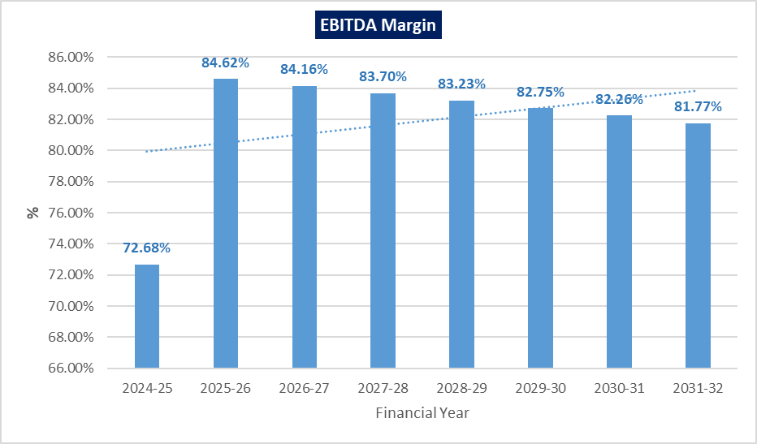
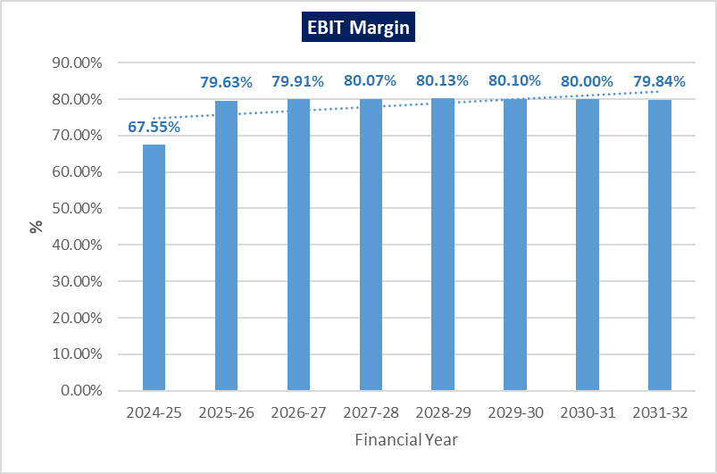
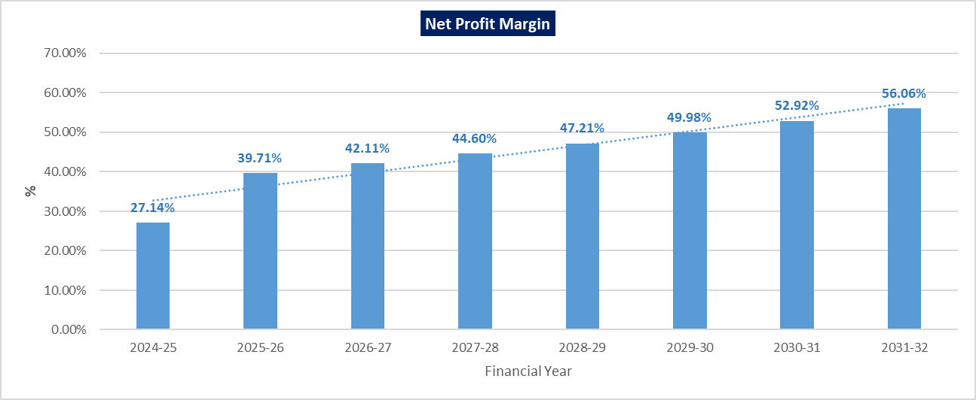

- DEBT SERVICE COVERAGE RATIO (DSCR):
(INR Lakhs)
PARTICULARS | 2024-25 | 2025-26 | 2026-27 | 2027-28 | 2028-29 | 2029-30 | 2030-31 | 2031-32
Cash Accruals | 210.46 | 640.55 | 672.50 | 708.48 | 748.84 | 793.96 | 844.31 | 900.41
Interest on Term Loan | 120.59 | 352.57 | 312.86 | 268.54 | 219.10 | 163.94 | 102.40 | 33.73
Total "A" | 331.05 | 993.12 | 985.36 | 977.03 | 967.94 | 957.91 | 946.71 | 934.14
Instalment of T/L | 26.94 | 343.22 | 382.94 | 427.25 | 476.69 | 531.85 | 593.40 | 604.08
Interest on Term Loan | 120.59 | 352.57 | 312.86 | 268.54 | 219.10 | 163.94 | 102.40 | 33.73
Total "B" | 147.53 | 695.79 | 695.79 | 695.79 | 695.79 | 695.79 | 695.79 | 637.81
D.S.C.R. (A/B) | 2.24 | 1.43 | 1.42 | 1.40 | 1.39 | 1.38 | 1.36 | 1.46
Average D.S.C.R. | 1.43
Max. D.S.C.R. | 2.24
Note: The cutoff date of the loan is 30.11.2024 as communicated by the bank. Hence, DSCR for FY 2024-25 is calculated for 4 months since the cutoff date to March 2025.

- LOAN-LIFE COVERAGE RATIO (LLCR):
(INR Lakhs)
PARTICULARS | Mar-25 | Mar-26 | Mar-27 | Mar-28 | Mar-29 | Mar-30 | Mar-31 | Mar-32
Cash Flow Available for Debt Service | 331.05 | 993.12 | 985.36 | 977.03 | 967.94 | 957.91 | 946.71 | 934.14
Discount Rate | 11.00%*
Period | 0.33 | 1.33 | 2.33 | 3.33 | 4.33 | 5.33 | 6.33 | 7.33
Discount Factor | 0.97 | 0.87 | 0.78 | 0.71 | 0.64 | 0.57 | 0.52 | 0.47
PV of Cash Flow Available for Debt Service | 319.74 | 864.12 | 772.40 | 689.97 | 615.81 | 549.04 | 488.85 | 434.55
Present Value of Total Available Cash Flow (ACF) during the loan life period | 4,734.47
Outstanding Loan Amount as on 30.11.2024 | 3,386.36
L.L.C.R. | 1.40
* Discount Rate is taken as 11% as communicated by bank.

- SENSITIVITY ANALYSIS OF D.S.C.R:
The proposed project is found comparatively more sensitive with respect to the revenue, than with the cost of raw material. Sensitivity analysis of the project with respect to 5% decrease in the revenue and 5% increase in the expenses has been shown in the below table:
Sensitivity Analysis of D.S.C.R.
S. No. | Particular | Average D.S.C.R. | Max. D.S.C.R.
 | If the projected revenue decreased by 5% | 1.35 | 2.07
 | If the projected expenses increased by 5% | 1.42 | 2.23

- NET PRESENT VALUE (NPV) OF THE PROJECT:
(INR Lakhs)
Particulars | Mar-25 | Mar-26 | Mar-27 | Mar-28 | Mar-29 | Mar-30 | Mar-31 | Mar-32
EBIT | 1,092.20 | 1,140.87 | 1,159.00 | 1,176.19 | 1,192.66 | 1,208.63 | 1,224.25 | 1,239.69
Less: Taxes | 303.85 | 317.39 | 322.43 | 327.21 | 331.80 | 336.24 | 340.59 | 344.88
NOPAT | 788.35 | 823.48 | 836.56 | 848.97 | 860.86 | 872.39 | 883.67 | 894.81
Add: Depreciation & Amortisation | 82.99 | 71.56 | 61.76 | 53.35 | 46.12 | 39.91 | 34.56 | 29.95
+/- WCC | -488.13 | - | - | - | - | - | - | -
Capex | - | - | - | - | - | - | - | -
Free Cash Flow to Firm (FCFF) | 383.21 | 895.04 | 898.32 | 902.32 | 906.99 | 912.30 | 918.22 | 924.76
Discount Rate | 17.85%
Expected Growth Rate (Terminal) | 1.00%
Discount Period | 0.33 | 1.33 | 2.33 | 3.33 | 4.33 | 5.33 | 6.33 | 7.33
Discount Factor | 0.95 | 0.80 | 0.68 | 0.58 | 0.49 | 0.42 | 0.35 | 0.30
Terminal Value of the project | - | - | - | - | - | - | - | 5,543.05
FCF+TV | 383.21 | 895.04 | 898.32 | 902.32 | 906.99 | 912.30 | 918.22 | 6,467.81
PV of FCF+ PV of Terminal Value | 362.79 | 719.01 | 612.34 | 521.91 | 445.15 | 379.94 | 324.49 | 1,939.43

Key Input for NPV
Key Input | Description
Nifty 50 Returns (CAGR) in the Last 5 Years (https://www.niftyindices.com/market-data/return-profile) | 15.85%
Company Risk Premium | 2.00%
Discount Rate | 17.85%
Perpetual Growth Rate | 1.00%
Net Present Value (NPV) | INR 5,305.06 Lakhs

- OTHER FINANCIAL RATIOS:
Particulars | Mar-25 | Mar-26 | Mar-27 | Mar-28 | Mar-29 | Mar-30 | Mar-31 | Mar-32
Current Ratio | 6.13 | 6.41 | 6.69 | 6.96 | 7.22 | 7.47 | 7.71 | 7.99
DER | 1.28 | 1.01 | 0.79 | 0.61 | 0.46 | 0.32 | 0.21 | 0.12
TOL/ATNW | 1.59 | 1.27 | 1.02 | 0.81 | 0.63 | 0.48 | 0.35 | 0.24
ROE | 5.40% | 14.38% | 13.37% | 12.54% | 11.86% | 11.29% | 10.81% | 10.41%
ROCE | 14.15% | 14.36% | 14.19% | 14.01% | 13.83% | 13.66% | 13.51% | 13.29%

- BREAK-EVEN ANALYSIS:
(INR Lakhs)
Particulars | Mar-25 | Mar-26 | Mar-27 | Mar-28 | Mar-29 | Mar-30 | Mar-31 | Mar-32
Sales | 1616.99 | 1432.80 | 1450.44 | 1468.96 | 1488.41 | 1508.83 | 1530.27 | 1552.79
Variable Expenses | 390.76 | 219.30 | 235.40 | 252.51 | 270.84 | 290.63 | 312.10 | 335.50
Contribution | 1226.22 | 1213.50 | 1215.04 | 1216.46 | 1217.57 | 1218.20 | 1218.17 | 1217.29
Fixed Expenses | 631.62 | 481.04 | 432.66 | 381.10 | 325.62 | 265.45 | 199.79 | 127.77
BEP% | 51.51% | 39.64% | 35.61% | 31.33% | 26.74% | 21.79% | 16.40% | 10.50%
CASH BEP% | 44.74% | 33.74% | 30.53% | 26.94% | 22.96% | 18.51% | 13.56% | 8.04%

- TERM LOAN INPUTS:
Term Loan Repayment Inputs
Outstanding CC Limit | INR 3,386.36 Lakhs
Cut Off Date | 1st December 2024
Proposed Rate of Interest | 11.00%
Proposed Restructured WCTL – Principal Portion | INR 2,996.28 Lakhs
Proposed Restructured FITL – Interest Portion | INR 390.08 Lakhs
Repayment Start – WCTL & FITL | March 2025
Repayment End – WCTL & FITL | February 2032
Repayment Period – WCTL & FITL | 84 Months
Sacrifice | Nil

As per Loan repayment schedule shared by the client/company, below table shows the balance of principle and interest during the projected period.
(INR Lakhs)
Particulars | Mar-25 | Mar-26 | Mar-27 | Mar-28 | Mar-29 | Mar-30 | Mar-31 | Mar-32
Term Loan & its Repayment and Interest Schedule Restructured WCTL (PNB)
Opening balance | 2996.28 | 2972.44 | 2668.76 | 2329.93 | 1951.90 | 1530.12 | 1059.54 | 534.50
Principal Repayment | 23.84 | 303.68 | 338.82 | 378.03 | 421.78 | 470.59 | 525.04 | 534.50
Interest Expense | 109.86 | 311.96 | 276.82 | 237.61 | 193.86 | 145.06 | 90.60 | 29.84
Closing Balance | 2972.44 | 2668.76 | 2329.93 | 1951.90 | 1530.12 | 1059.54 | 534.50 | -
Term Loan & its Repayment and Interest Schedule Restructured FITL (PNB)
Opening balance | 390.08 | 386.98 | 347.44 | 303.33 | 254.12 | 199.20 | 137.94 | 69.59
Principal Repayment | 3.10 | 39.54 | 44.11 | 49.22 | 54.91 | 61.27 | 68.35 | 69.59
Interest Expense | 10.73 | 40.61 | 36.04 | 30.93 | 25.24 | 18.88 | 11.80 | 3.89
Closing Balance | 386.98 | 347.44 | 303.33 | 254.12 | 199.20 | 137.94 | 69.59 | -
TL Interest | 120.59 | 352.57 | 312.86 | 268.54 | 219.10 | 163.94 | 102.40 | 33.73

- DEPRECIATION SCHEDULE (WRITTEN DOWN VALUE METHOD):
(INR Lakhs)
Particulars | Mar-25 | Mar-26 | Mar-27 | Mar-28 | Mar-29 | Mar-30 | Mar-31 | Mar-32
Depreciation - Building | 15.23 | 13.70 | 12.33 | 11.10 | 9.99 | 8.99 | 8.09 | 7.28
Depreciation - P&M | 32.95 | 28.01 | 23.81 | 20.24 | 17.20 | 14.62 | 12.43 | 10.56
Depreciation - Furniture & Fixtures | 6.51 | 5.86 | 5.27 | 4.74 | 4.27 | 3.84 | 3.46 | 3.11
Depreciation - Computer | 0.29 | 0.17 | 0.10 | 0.06 | 0.04 | 0.02 | 0.01 | 0.01
Depreciation - Office Equipment | 1.70 | 1.45 | 1.23 | 1.05 | 0.89 | 0.76 | 0.64 | 0.55
Depreciation - Power Supply | 2.22 | 1.89 | 1.60 | 1.36 | 1.16 | 0.98 | 0.84 | 0.71
Depreciation - Slaughter House | 6.18 | 5.26 | 4.47 | 3.80 | 3.23 | 2.74 | 2.33 | 1.98
Depreciation - Vehicle | 17.81 | 15.14 | 12.87 | 10.94 | 9.30 | 7.90 | 6.72 | 5.71
Depreciation - ETP | 0.00 | 0.00 | 0.00 | 0.00 | 0.00 | 0.00 | 0.00 | 0.00
Depreciation – Security Equipment | 0.10 | 0.09 | 0.07 | 0.06 | 0.05 | 0.04 | 0.04 | 0.03
Total WDV Depreciation | 82.99 | 71.56 | 61.76 | 53.35 | 46.12 | 39.91 | 34.56 | 29.95
*Depreciation as taken as Nil for ETP as the company has already charged 100% depreciation in the 1st year of installation of ETP itself.

- KEY ASSUMPTIONS & BASIS:
S. No. | Item | Assumptions and Basis
 | General | - The projections of the firm for restructuring purpose are done for the period from FY 2024-25 to FY 2031-32, 7 years, to cover the proposed restructured loan repayment period.  - We have considered both Revenue & cost-based model (top to bottom approach) while making the future financial projections.  - Revenue modelling and Expense modelling has been done based on the capacity utilization during the respective year.
 | Revenue Build up | - As per the information shared with us, Al-Saqib has entered into an agreement with Touro Primeiro Private Limited to give the processing plant and slaughtering house on rent @ INR 2.00 Lakhs per month.  - ASEPL has also agreed to slaughter the buffaloes for TPPL on monthly job charges @ INR 88.00 Lakhs per month.  - Both of these agreements are for a period of 5 years w.e.f. 21.05.2023. However, we have assumed that the arrangement between ASEPL & TPPL will continue during the projection period, i.e., till FY2031-32.  - According to the information provided, ASEPL will also carry out slaughtering to meet local demand, as only 30%-40% of the plant's installed capacity is currently being utilized by TPPL. As per the provisional balance sheet dated 30.11.2024, the company has earned INR 224.00 Lakhs from the local slaughtering, which are assumed to increase @ 5% per annum.  - We have assumed that the inventory on 30.11.2024 will be sold off at cost during the FY 2024-25.
 | Expenses | - As per discussion with client and the information available with us all the major expenses related to meat processing plant are to borne by TPPL. Major expenses include raw material, power and fuel, salaries and wages, Repair and maintenance, etc.  - As per the provisional balance sheet dated 30.11.2024, the company has incurred INR 103.79 lakhs towards the wages & salary of the employees under the employment of ASEPL, which are assumed to increase @ 5% per annum.  - Expenses which are not related to the meat processing plant and work done on behalf of TPPL are to be borne by ASEPL, e.g., Audit fees, Director’s Remuneration, Legal & Professional Charges, Insurance, Other Miscellaneous Expenses, etc. For the FY 2024-25 till Nov-2024, ASEPL has incurred INR 37.20 Lakhs on these expenses as part of SG&A Expenses.  - Selling & Administrative Overheads are assumed to increase @ 2% per annum.
 | Term Loan | - As per the information shared by the client, the company has two active loans of INR 1.63 Crore under the GECL scheme and INR 20.54 Lakhs in the car loan account. Both these accounts are with the Punjab National Bank.  - As per the information shared with us, the company has deposited INR 3.00 Crores with the PNB and the same is utilised to pay off these two loans as instructed by the bank/client. The remaining INR 1.13 Crores is utilised to pay off the interest portion of the CC limit.  - The bank had declared the account of the company as NPA on 29th January 2024.
 | Debt Restructuring Proposal | - Apart from these two loan accounts, the company has INR 34.99 Crores outstanding under the CC Limit.  - As per discussion with client and the restructuring proposal prepared by the company, the company is requesting the bank for conversion of principal portion of its working capital limit, amounting to INR 2,996.28 Lakhs, into a Working Capital Term Loan (WCTL), and the interest portion of INR 502.72 Lakhs into a Flexible Interest Term Loan (FITL).  - The remaining INR 1.13 Crores from the INR 3.00 Crores deposited by the company is utilised to pay off the interest portion of the CC limit.  - As per informed by bank, the proposed repayment period of both these loans is 84 Months, i.e., it is proposed to be repaid till February 2032.  - As per informed by bank, the interest rate assumed on the restructured WCTL & FITL is 11%.

Key Findings:
      - Average DSCR, EBIDTA margin, EBIT margin is 1.43, 81.90% and 78.40% respectively during the estimated period.
      - The company is having a positive NPV of INR 5,305.06 Lakhs as the base case while it may vary with changes in the assumptions & micro and macro-economic trends considered as on date.
      - Based on the above key financial ratios of the Project during the forecasted period shows that the project appears financially viable if the promoters of the project are able to maintain assumed revenue and can contain cost as assumed above in the calculation.

PART I | CONCLUSION

Based on the technological, economical and market analysis done above, various assumptions of sectoral trends taken, product pricing to be adopted by the company, the proposed restructuring of the Project by financial institution appears to be Techno-commercially viable subject to the risks, threats, weaknesses, limitations of the product and credibility of the promoters as detailed previously.
As per financial projections for the estimated period, Average DSCR, EBITDA Margin and EBIT Margin of the project are 1.43, 81.90% and 78.40% respectively, where higher DSCR is the indicator of the project capability to pay out its outstanding debt and EBITDA margin shows the capability of the project to generate the operating profits over the forecasted period.
The proposed restructuring plan of Integrated Meat Processing Plant running on Job Work Basis is having a positive NPV of INR 5,305.06 Lakhs. While it is not avoidable that the future projections may change in the upcoming years due to various factors impacting the operation, managerial, financial efficiency and economies of scale of the project.
As per the agreement shared with us, the plant will operate on both a Job Work Basis for Touro Primeiro Private Limited and for local market slaughtering. After considering the anticipated demand for Frozen Buffalo Meat, both domestically and globally, along with a financial analysis of the project based on the assumptions for the projected period, it appears reasonable to conclude that the proposed restructuring plan is "Technically and Economically" viable subject to current assumptions considered and occurring the same in the upcoming years same as the forecasted period which is dependent on the sincerity and efforts of the management and various micro and macroeconomic & industry situation.
We have tried our level best to analyse the Project techno-economic feasibility of the Project based on the industry research, Project information and various futuristic assumption taken within the limitations and challenges came in front of us. However, achieving the financial milestones depends on the ability, sincerity and efforts of the company, promoters and its key management to maintain the projected revenue level Y-o-Y basis keeping the fact in mind that the project is found sensitive with respect to the down side fluctuation in the revenue.

Declaration | - The undersigned does not have any direct/indirect interest in the above property/project/Company.  - The information furnished herein is true and correct to the best of our knowledge, logical and scientific assumptions.  - This TEV Report is carried out by our Financial Analyst team on the request from Punjab National Bank, Zonal Sastra Branch, Ghaziabad.  - Meeting of Financial projections will be subject to the market & economy stability factors, judicious business operations and proper & timely implementation of the project and putting proper plan for achieving high productivity, efficiency and achieving cost saving benefits to increase profitability.  - We have submitted TEV report to the client.
Number of Pages in the Report | 64
Enclosed Documents | Disclaimer & Remarks 57-60
Place | Noida
Date | 7th January 2025

FOR ON BEHALF OF
M/s. R.K. ASSOCIATES VALUERS & TECHNO ENGINEERING CONSULTANTS PVT. LTD.
SURVEYED BY | PREPARED BY | REVIEWED BY
Mr. Nischay Gautam | Mr. Rachit Gupta | Mr. Gaurav Kumar

PART J | DISCLAIMER | REMARKS

      - No employee or member of R.K Associates has any direct/ indirect interest in the Project.
      - This report is prepared based on the copies of the documents/ information which the Bank/ Company has provided to us out of the standard checklist of documents sought from them and further based on our assumptions and limiting conditions. The client/owner and its management/representatives warranted to us that the information they supplied was complete, accurate and true and correct to the best of their knowledge. All such information provided to us has been relied upon in good faith and we have assumed that it is true and correct in all respect. I/We shall not be liable for any loss, damages, cost or expenses arising from fraudulent acts, misrepresentations, or wilful default on part of the owner, company, its directors, employee, representative or agents. Verification or cross checking of the documents provided to us from the originals or from any Govt. departments/ Record of Registrar has not been done at our end since this is beyond the scope of our work. If at any time in future, it is found or came to our knowledge that misrepresentation of facts or incomplete or distorted information has been provided to us then this report shall automatically become null & void.
      - Legal aspects for e.g. investigation of title, ownership rights, lien, charge, mortgage, lease, sanctioned maps, verification of documents, etc. have not been done at our end and same has to be taken care by legal expert/ Advocate. It is assumed that the concerned Lender/ Financial Institution has satisfied them with the authenticity of the documents, information given to us and for which the legal verification has been already taken and cleared by the competent Advocate before requesting for this report. I/ We assume no responsibility for the legal matters including, but not limited to, legal or title concerns.
      - This report is a general analysis of the project based on the scope mentioned in the report. This is not an Audit report, Design document, DPR or Techno feasibility study. All the information gathered is based on the facts seen on the site during survey, verbal discussion & documentary evidence provided by the client and is believed that information given by the company is true best of their knowledge.
      - This Techno Economic-Viability study is prepared based on certain futuristic assumption which are intra dependent on economic, market and sectorial growth condition in future and socio-economic, socio-political condition at macro and micro level.
      - Meeting of assumption and financial ratio will entirely depend on the sincerity and efforts of the company, promoters and its key managerial performance.
      - All observations mentioned in the report is only based on the visual observation and the documents/ data/ information provided by the client. No mechanical/ technical tests, measurements or any design review have been performed or carried out from our side during Project assessment.
      - This report has been diligently prepared by our techno-financial team to the best of their ability. However, it's important to note that the recommendations provided in this Total Economic Viability (TEV) assessment do not imply an endorsement, validation, or certification of the accuracy or completeness of the disclosed information by the involved stakeholders. Furthermore, we do not claim or endorse that the opinions presented herein are the sole best course of action for decision-makers to follow. There may exist additional approaches and inputs that have not been covered within this report or fall outside the scope of this report.
      - Bank/FII should ONLY take this report as an Advisory document from the Financial/ Chartered Engineering firm and its specifically advised to the creditor to cross verifies the original documents for the facts mentioned in the report which can be availed from the borrowing company directly.
      - In case of any default in loans or the credit facility extended to the borrowing company, R.K Associates shall not be held responsible for whatsoever reason may be and any request for seeking any explanation from the employee/s of R.K Associates will not be entertained at any instance or situation.
      - The documents, information, data provided to us during the course of this assessment by the client are reviewed only up to the extent required in relation to the scope of the work. No document has been reviewed beyond the scope of the work.
      - This report only contains general assessment & opinion as per the scope of work evaluated as per the information given in the copy of documents, information, data provided to us and/ and confirmed by the owner/ owner representative to us at site which has been relied upon in good faith. It doesn’t contain any other recommendations of any sort including but not limited to express of any opinion on the suitability or otherwise of entering into any transaction with the borrower.
      - We have relied on data from third party, external sources & information available on public domain also to conclude this report. These sources are believed to be reliable and therefore, we assume no liability for the truth or accuracy of any data, opinions or estimates furnished by others that have been used in this analysis. Where we have relied on data, opinions or estimates from external sources, reasonable care has been taken to ensure that such data has been correctly extracted from those sources and /or reproduced in its proper form and context, however still we can’t vouch its authenticity, correctness or accuracy.
      - This Report is prepared by our competent technical team which includes Engineers and financial experts & analysts.
      - This is just an opinion report and doesn’t hold any binding on anyone. It is requested from the concerned Financial Institution which is using this report for taking financial decision on the project that they should consider all the different associated relevant & related factors also before taking any business decision based on the content of this report.
      - All Pages of the report including annexure are signed and stamped from our office. In case any paper in the report is without stamp & signature then this should not be considered a valid paper issued from this office.
      - Though adequate care has been taken while preparing this report as per its scope, but still we can’t rule out typing, human errors, over sightedness of any information or any other mistakes. Therefore, the concerned organization is advised to satisfy themselves that the report is complete & satisfactory in all respect. Intimation regarding any discrepancy shall be brought into our notice immediately. If no intimation is received within 15 (Fifteen) days in writing from the date of issuance of the report, to rectify these timely, then it shall be considered that the report is complete in all respect and has been accepted by the client up to their satisfaction & use and further to which R.K Associates shall not be held responsible in any manner.
      - Defect Liability Period is 15 DAYS. We request the concerned authorized reader of this report to check the contents, data and calculations in the report within this period and intimate us in writing if any corrections are required or in case of any other concern with the contents or opinion mentioned in the report. Corrections only related to typographical, calculation, spelling mistakes, incorrect data/ figures/ statement will be entertained within the defect liability period. Any new changes for any additional information in already approved report will be regarded as additional work for which additional fees may be charged. No request for any illegitimate change in regard to any facts & figures will be entertained.
      - R.K Associates encourages its customers to give feedback or inform concerns over its services through proper channel at valuers@rkassociates.org in writing within 15 days of report delivery. After this period no concern/ complaint/ proceedings in connection with the Techno- Economic Viability Study Services will be entertained due to possible change in situation and condition of the subject Project.
      - Our Data retention policy is of ONE YEAR. After this period, we remove all the concerned records related to the assignment from our repository. No clarification or query can be answered after this period due to unavailability of the data.
      - This Techno Economic Viability Study report is governed by our (1) Internal Policies, Processes & Standard Operating Procedures, (2) Information/ Data/ Inputs given to us by the client and (3) Information/ Data/ Facts given to us by our field/ office technical team. Management of R.K Associates never gives acceptance to any unethical or unprofessional practice which may affect fair, correct & impartial assessment and which is against any prevailing law. In case of any indication of any negligence, default, incorrect, misleading, misrepresentation or distortion of facts in the report then it is the responsibility of the user of this report to immediately or at least within the defect liability period bring all such act into notice of R.K Associates management so that corrective measures can be taken instantly.
      - R.K Associates never releases any report doing alterations or modifications from pen. In case any information/ figure of this report is found altered with pen then this report will automatically become null & void.
      - If this report is prepared for the matter under litigation in any Indian court, no official or employee of R.K Associates will be under any obligation to give in person appearance in the court as a testimony. For any explanation or clarification, only written reply can be submitted on payment of charges by the plaintiff or respondent which will be 10% of the original fees charged where minimum charges will be Rs. 15,000/.

EXTRACTS OF IMPORTANT STATUTORY APPROVALS PROVIDED BY THE CLIENT

