**REPORT FORMAT:** CL-1 | Version: 1.0_2018

# FILE No.: VIS(2024-25)-PL620-556-788 Date :20-12-2024

* **CERTIFICATE NAME:** Physical Progress Certificate of M/s. Teja Innovatives Private Limited (TIPL).
* **PREPARED FOR ORGANIZATION:** IFCI Venture Capital Funds Ltd.
* **BORROWER COMPANY’S NAME:** M/s. Teja Innovatives Private Limited (TIPL).
* **ASSET TYPE**: Under-construction Civil work and Machines to be installed for setting up Precision Engineering Manufacturing Unit.
* **LOCATION OF THE PLANT**: Part of Survey No. 377/3 and 378/2. Plot No.41, EMC-II, Tirupati, Vikruthamala Village, Yerpedu Mandal, Chittoor District, Andhra Pradesh.

|  |  |  |
| --- | --- | --- |
| **S. NO.** | **PARTICULARS** | **DESCRIPTION** |
|  | Date of Work Order | Via e-mail dated 10-12-2024 |
|  | Documents provided for perusal | * Building Plan * CA Certificate * Land Deeds * DPR * Section Drawing etc. |
|  | Project Location | Part of Survey No. 377/3 and 378/2. Plot No.41, EMC-II, Tirupati, Vikruthamala Village, Yerpedu Mandal, Chittoor District, Andra Pradesh. |
|  | Borrowing Company | M/s. Teja Innovatives Private Limited. |
|  | Type of Asset | Project Civil work and Machines required for setting up Precision Engineering manufacturing unit |
|  | Type of Assessment | Physical Progress Certificate of Under-construction plant |
|  | Scope of Assessment | Physical Progress Certificate of Under-construction plant of Precision Engineering manufacturing unit |
|  | Total number of pages with Annexure. | 11 |

|  |  |
| --- | --- |
| **PART A** | **INTRODUCTION** |

1. **ABOUT THE ASSIGNMENT:** This is a physical progress certificate of the plant captured till 13th December 2024 of manufacturing unit of different types of metallic enclosures, controllers, panels, racks, body frame & boxes, etc., to be used in industries such as Electrical Vehicles, Electronic Manufacturing and Design Industry, IT/ ITES Products, Poultry Machines & Agro Machines etc. situated at Plot No. 41, Electronic Manufacturing Cluster (EMC) – II, Tirupati, Chittoor District, Andhra Pradesh. The Bank has appointed M/S R.K Associates Valuers & Techno Engineering Consultants (P) Ltd. to comment upon physical progress/ status of the project.
2. **PROJECT OVERVIEW:** M/s Teja Innovative Private Limited is setting up a setting up Precision Engineering manufacturing unit at Part of Survey No. 377/3 and 378/2. Plot No.41, EMC-II, Tirupati, Vikruthamala Village, Yerpedu Mandal, Chittoor District, Andhra Pradesh.

As per copy ofSale Agreement dated 29th July 2020, between Andhra Pradesh Industrial Infrastructure Corporation Limited (APIICL) and M/s Teja Industries, the total allotted land area is 6252.45 sqm. The Sale amount of deed is Rs. 81,90,710/-.

As per copy of consultant approved site plan, only 1 PEB Structure is proposed for construction name as Block-1. Technical specification of same are as follows: -

|  |  |  |
| --- | --- | --- |
| **S. No.** | **Particulars** | **Specifications** |
| 1 | Building Name | Block-1 |
| 2 | Total Floors | Ground Floor |
| 3 | Plinth Area | 1662.74 sqm |
| 4 | Shed Height | Max- 6.00 mtr  Min- 4.00 mtr |
| 5 | Structure Type | Pre-engineering Building |
| 6 | Cost of Civil Work including foundation, Floor, Mezzanine, PEB Shed | Rs. 305.72 Lakh |

As per copy of documents & information provided, the plant shall be utilized for manufacturing of precision engineering equipment of different types of metallic enclosures, controllers, panels, racks, body frame & boxes etc. to be used in industries such as Electrical Vehicles, Electronic Manufacturing and Design Industry, IT/ ITES Products, Poultry Machines & Agro Machines etc. The major machines which are proposed to be installed in the plant are CNC Laser Machines, CNC Press brakes, Welding Machines, Electric Oven, DG Set, Air Compressors, Cranes etc.

|  |  |  |
| --- | --- | --- |
| **S. No** | **Cost Component** | **Cost (In Lakh)** |
| 1 | Plant & Machinery | 686.06 |
| 2 | Machine Erection Expenses | 20.9 |
| **Total** | | **706.96** |

1. **TOTAL PROJECT COST:** As per copy of CA certificate dated 04-03-2024, the total proposed project cost is as follows: -

|  |  |  |
| --- | --- | --- |
| **S. No** | **Cost Component** | **Proposed Cost (In Lakh)** |
| 1 | Land & Land Development | 93.84 |
| 2 | **Technical Civil Work** |  |
| *a* | *Foundation Expenditure* | *64.35* |
| *b* | *Side Plinth Construction* | *28.58* |
| *c* | *Floor Construction* | *72.32* |
| *d* | *Mezzanine* | *12.47* |
| *e* | *PEB Shed* | *128* |
|  | | **305.72** |
| 3 | Plant & Machinery | 686.06 |
| 4 | Machine Erection Expenses | 20.9 |
| 5 | Contingencies | 15 |
| 6 | Pre-Operative Expenses | 10 |
| 7 | Interest During Construction Period | 35.66 |
| 8 | Margin Money for Working Capital | 16 |
| **Total Project Cost** | | **1183.18** |

|  |  |
| --- | --- |
| **PART B** | **Statutory & Regulatory Approvals, Clearances & NOC** |

|  |  |  |  |
| --- | --- | --- | --- |
| Sr. No. | NAME OF LICENSE/ REGISTRATION | DATE OF ISSUE | CURRENT STATUS |
| **ISSUING AUTHORITY** | **LICENCE NO.** |
|  | Building Plan | --- | Not approved by authority |
| C. Giridhar Raju  Licensed Civil Engineer |
|  | CA Certificate | Dated: 04-03-2024 | Obtained |
| A. Madhana Mohan  UDIN: 24215521BJZZQE1641 |
|  | NoC for Raising Loan | --- | Applied for |
|  | A. P. Industrial Infrastructure Corporation | Lr.No.37225/APIIC/Electronic Mfg Cluster-II/Tirupati/2020  Dated 03-08-2021 | Obtained |
|  | Factory License | -- | Pending |
|  | Water Connection | -- | Pending |
|  | Electricity Connection | -- | Pending |
| *Note: The above licenses are only the major licenses obtained by the project proponent and not be considered exhaustive in nature.* | | | |

|  |  |
| --- | --- |
| **PART B** | **PHYSICAL PROGRESS** |

1. **LAND AND LAND DEVELOPMENT:** For the purpose of the Project, company has purchased 6252.45 sqm of land in Electronic Manufacturing Cluster (EMC) – II, Tirupati, Chittoor District, Andhra Pradesh. The boundary details of the land are provided in the exhibit below:

|  |  |
| --- | --- |
| **Direction** | **Description** |
| North | Plot No. 40 |
| South | 18 mtr wide road |
| East | 18 mtr wide road |
| West | Sub-station |

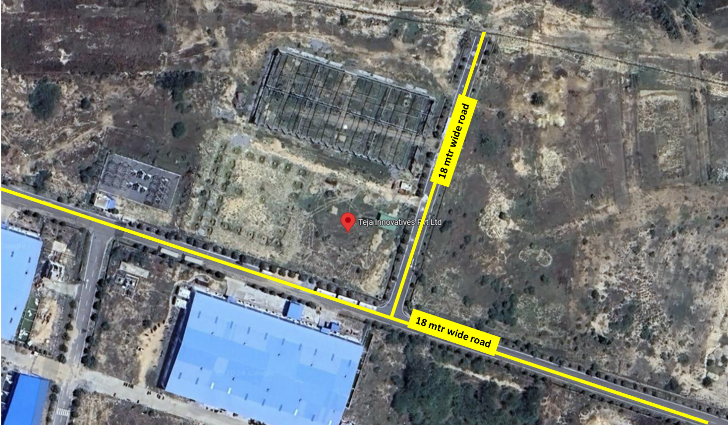

As per observation made during site survey, it was observed that the land parcel is not demarcated yet and no other land development work was observed there.

1. **BUILDING & CIVIL WORKS:** As per copy of consultant approved site plan, only 1 PEB Structure is proposed for construction name as Block-1 with proposed plinth area of 1662.74 sqm. Current status of building & civil work is as follows: -

|  |  |  |  |  |
| --- | --- | --- | --- | --- |
| **S. No.** | **Cost Component** | **Weightage**  **(In %)** | **Work Completion** | **Remarks/Current Status** |
|  | Foundation, Mud Filling & brick wall upto Plinth Beam | 15% | 15% | As per observation made during site survey, Foundation, Mud Filling & brick wall upto Plinth Beam work had been completed.  No construction related work was observed during site survey. |
|  | Plinth Beam Construction | 10% | 10% | As per observation made during site survey, Plinth Beam Construction work had been completed.  No construction related work was observed during site survey. |
|  | Floor Construction  (VDF Flooring & Side walls) | 20% | 0% | No work was observed during site survey. |
|  | Mezzanine Floor | 5% | 0% | No work was observed during site survey. |
|  | PEB shed | 50% | 0% | No work was observed during site survey. |
|  | | **100%** | **25%** |  |

1. **PLANT & MACHINERY AND ERECTION WORK:** As on date of site survey, we didn’t find any lant & Machinery at site.

|  |  |  |
| --- | --- | --- |
| **S. No.** | **Cost Component** | **Remarks/Current Status** |
| 1 | Plant & Machinery | No machine was found at site during survey. |
| 2 | Machine Erection Expenses | -- |

***Disclaimer:***

* 1. *This progress report is stated on the basis of the site visit by the surveyor and we don’t recommend any sort of recommendation in our Certificate.*
  2. *As per physical inspection and observation made during site visit dated 13th December 2024.*
  3. *This certificate doesn’t include any work related to drawing, design, sketch plan, and technical specifications of the machines.*
  4. *Ownership and other legal point of view in respect of the asset is not considered in this report as same is out of scope of this certificate.*
  5. *This certificate is made at the request of the Bank.*

**FOR INTERNAL USE**

|  |  |  |
| --- | --- | --- |
| **FOR R.K ASSOCIATES VALUERS** **& TECHNO ENGINEERING CONSULTANTS (P) LTD.** | | |
| **SURVEYED BY** | **PREPARED BY** | **REVIWED BY** |
| Er. D. Sivaiah | Abhinav Chaturvedi | CE XXXXXXXX |
|  |  |  |

**For R.K Associates Valuers** **& Techno Engineering Consultants (P) Ltd.**

***DEFECT LIABILITY PERIOD - In case of any query/ issue or escalation you may please contact Incident Manager by writing at valuers@rkassociates.org. We ensure 100% accuracy in the Calculations done, Rates adopted and various other data points & information mentioned in the report but still can’t rule out typing, human errors or any other mistakes. In case you find any mistake, variation, discrepancy or inaccuracy in any data point of the report, please help us by bringing all such points into our notice in writing at*** [**valuers@rkassociates.org**](mailto:valuers@rkassociates.org) ***within 30 days of the report delivery, to get these rectified timely, failing which R.K Associates Valuers Techno Engineering Consultants (P) Ltd. won’t be held responsible for any inaccuracy in any manner. Also if we will not hear back anything from you within 30 days, we will assume that report is correct in all respect and no further claim of any sort will be entertained thereafter. We would welcome and appreciate your feedback & suggestions in order to improve our services.***

***COPYRIGHT FORMAT - This report is prepared on the copyright format of R.K Associates Valuers Techno Engineering Consultants (P) Ltd. to serve our clients in the best possible way. Legally no one can copy or distribute this format without prior approval from R.K Associates. It is meant only for the organization as mentioned on the cover page of this report. Distribution or use of this format other than R.K Associates will be seen as unlawful act and necessary legal action can be taken against the defaulter.***

**ANNEXURES**

**SNAPSHOT OF DPR**

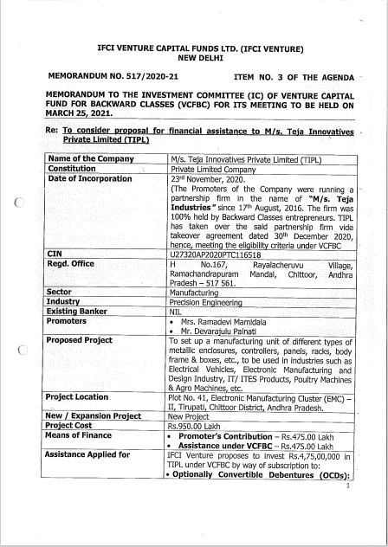

**CA CERTIFICATE DATED 04-03-2024**

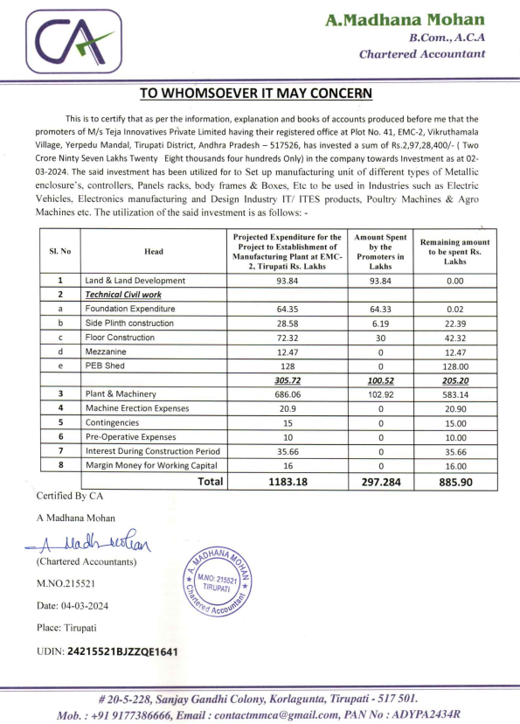

**BUILDING PLAN**

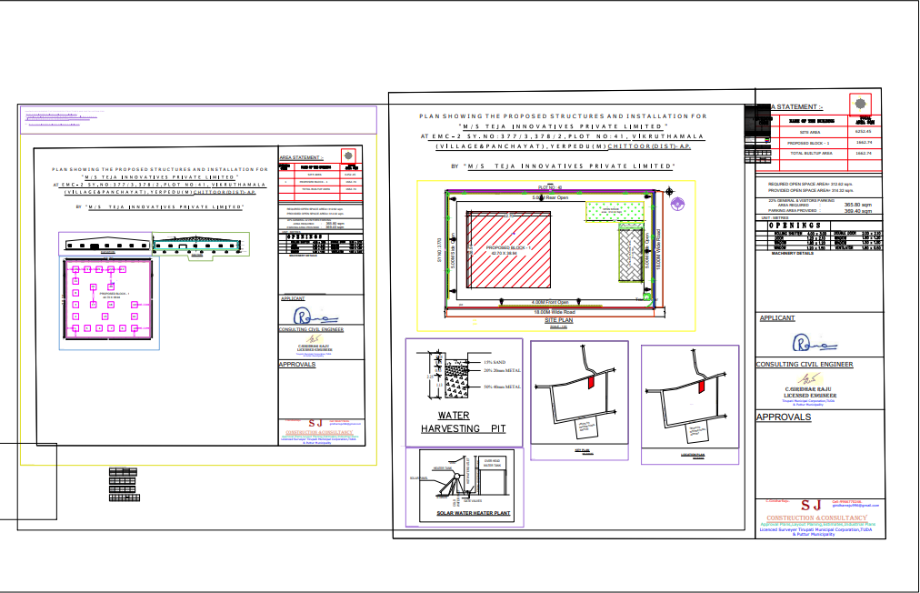

**PHOTOGRAPHS**

|  |  |
| --- | --- |
|  |  |
|  |  |
|  |  |

|  |  |
| --- | --- |
|  |  |
|  |  |
|  |  |