**File No.: VIS (2024-25)-PL620-556-788 Dated: 20.12.2024**

**PHYSICAL PROGRESS REPORT**

**OF**

**M/S. TEJA INNOVATIVES PRIVATE LIMITED**

**SITUATED AT**

**PART OF SURVEY NO. 377/3 AND 378/2. PLOT NO.41, EMC-II, TIRUPATI, VIKRUTHAMALA VILLAGE, YERPEDU MANDAL, CHITTOOR DISTRICT, ANDHRA PRADESH**

**REPORT PREPARED FOR**

**IFCI VENTURE CAPITAL LIMITED**

**16TH FLOOR, IFCI TOWERS, NEHRU PLACE, NEW DELHI**

***\*\*Important - In case of any query/ issue or escalation you may please contact Incident Manager at le@rkassociates.org. We will appreciate your feedback in order to improve our services.***

***NOTE: As per IBA Guidelines please provide your feedback on the report within 15 days of its submission after which report will be considered to be correct.***

***IMPORTANT NOTICE***

***COPYRIGHT FORMAT:*** *This report is prepared on the copyright format of R.K Associates, to serve our clients with the best available information and analysis to facilitate them to take rational business decisions. Legally no one can copy or distribute this format without prior approval from R.K Associates. It is meant only for the advisory/ reference purpose for the organization/s as mentioned on the cover page of this report. Distribution or use of this format by any organization or individual other than R.K Associates will be seen as unlawful act and necessary legal action can be taken against the defaulters.*

*This report is intended for the sole use of the intended recipient/s and contain material that is STRICTLY CONFIDENTIAL AND PRIVATE.*

***DEFECT LIABILITY PERIOD:*** *- In case of any query/ issue or escalation you may please contact Incident Manager: le@rkassociates.org. We try our level best to ensure correctness in the calculations done, rates adopted and various other data points & information mentioned in the report but still can’t rule out typing, human errors or any other mistakes. In case you find any such mistake or inaccuracy in any data point of the report please help us by bringing all such points into our notice immediately or within 15 days of the report delivery in writing, to rectify these timely failing after which R.K Associates won’t be held responsible for any such inaccuracy in any manner. We would highly appreciate your feedback in order to improve our services.*

|  |  |
| --- | --- |
| **PART A** | **REPORT SUMMARY** |

|  |  |  |
| --- | --- | --- |
| **1.** | **Name of Project:** | M/s. Teja Innovatives Private Limited (TIPL) |
| **2.** | **Project Location:** | Part of Survey No. 377/3 and 378/2. Plot No.41, EMC-II, Tirupati, Vikruthamala Village, Yerpedu Mandal, Chittoor District, Andra Pradesh |
| **3.** | **Name of the Borrower:** | M/s Teja Innovatives Private Limited |
| **4.** | **Director’s/Partner’s:** | Mr. Mamidala Ramadevi  Mr. Palnati Devarajulu |
| **5.** | **Prepared for Bank:** | IFCI Venture Capital Limited, 16th Floor, IFCI Towers, Nehru Place, New Delhi |
| **6.** | **LIE Consultant Firm:** | M/s. R.K. Associates Valuers & Techno Engineering Consultants (P) Ltd. |
| **7.** | **Work Order Details** | Via e-mail dated 10th December 2024 |
| **8.** | **Date of Survey:** | 13th December 2024 |
| **9.** | **Date of Report:** | 20th December 2024 |
| **10.** | **Purpose of the Report:** | To provide fair detailed analysis report to the Bank based on the “in-scope points” mentioned below to know the current status of the Project. |
| **11.** | **Scope of the work provided by the Lender:** | 1. Physical Progress Report of Under-construction plant of Precision Engineering manufacturing unit |
| **12.** | **Documents perused for Proposal:** | 1. Building Plan 2. CA Certificate 3. Land Deeds 4. DPR 5. Section Drawing etc. |
| **13.** | **Annexure with the report:** | 1. CA Certificate 2. Copy of building plan 3. Photographs |

|  |  |
| --- | --- |
| **PART B** | **INTRODUCTION** |

1. **ABOUT THE ASSIGNMENT:**

This is a physical progress certificate of the plant captured till 13th December 2024 of manufacturing unit of different types of metallic enclosures, controllers, panels, racks, body frame & boxes, etc., to be used in industries such as Electrical Vehicles, Electronic Manufacturing and Design Industry, IT/ ITES Products, Poultry Machines & Agro Machines etc. setup at Plot No. 41, Electronic Manufacturing Cluster (EMC) – II, Tirupati, Chittoor District, Andhra Pradesh. The Bank has appointed M/S R.K Associates Valuers & Techno Engineering Consultants (P) Ltd. to comment upon physical progress/ status of the project.

This report is prepared for physical progress till 13th December 2024.

1. **PROJECT OVERVIEW:**

M/s Teja Innovative Private Limited is setting up a setting up Precision Engineering manufacturing unit at Part of Survey No. 377/3 and 378/2. Plot No.41, EMC-II, Tirupati, Vikruthamala Village, Yerpedu Mandal, Chittoor District, Andhra Pradesh.

As per copy ofSale Agreement dated 29th July 2020, between Andhra Pradesh Industrial Infrastructure Corporation Limited (APIICL) and M/s Teja Industries, the total allotted land area is 6252.45 sqm. The Sale amount of deed is Rs. 81,90,710/-.

As per copy of consultant approved site plan, only 1 PEB Structure is proposed for construction name as Block-1. Technical specification of same are as follows: -

|  |  |  |
| --- | --- | --- |
| **S. No.** | **Particulars** | **Specifications** |
| 1 | Building Name | Block-1 |
| 2 | Total Floors | Ground Floor |
| 3 | Plinth Area | 1662.74 sqm |
| 4 | Shed Height | Max- 6.00 mtr  Min- 4.00 mtr |
| 5 | Structure Type | Pre-engineering Building |
| 6 | Cost of Civil Work including foundation, Floor, Mezzanine, PEB Shed | Rs. 305.72 Lakh |

As per copy of documents & information provided to us, the plant shall be utilized for manufacturing of precision engineering equipment of different types of metallic enclosures, controllers, panels, racks, body frame & boxes etc. to be used in industries such as Electrical Vehicles, Electronic Manufacturing and Design Industry, IT/ ITES Products, Poultry Machines & Agro Machines etc. The major machines which are proposed to be installed in the plant are CNC Laser Machines, CNC Press brakes, Welding Machines, Electric Oven, DG Set, Air Compressors, Cranes etc.

|  |  |  |
| --- | --- | --- |
| **S. No** | **Cost Component** | **Cost (In Lakh)** |
| 1 | Plant & Machinery | 686.06 |
| 2 | Machine Erection Expenses | 20.9 |
| **Total** | | **706.96** |

1. **PROJECT LOCATION:**

Details about Location of Unit is as below:

|  |  |
| --- | --- |
| **Particulars** | **Description** |
| **Postal Address** | |
| Part of Survey No. 377/3 and 378/2. Plot No.41, EMC-II, Tirupati, Vikruthamala Village, Yerpedu Mandal, Chittoor District, Andra Pradesh | |
| **Location** | |
| The subject property is a part of Industrial Area named as Electronic Manufacturing Cluster (EMC) – II | |
| **Google Coordinates** | |
| Latitude | 13°38'27.8"N |
| Longitude | 79°34'56.3"E |
| **Connectivity Systems** | |
| Road | EMC-II is around 30 km from Tirupati city connected via Tirupati Bypass Road. The project site is currently accessible via a metallic road of ~20 feet wide. |
| Rail | The Nearest Railway station to the subject property is Tirupati Railway Station which is about approximately 30 Km from the Subject Project. |
| Air | The nearest airport to subject location, i.e. Tirupati International Airport, is located approximately 5 kilometres away. |
| **Geographical Conditions on The Site** | |
| Temperature | The maximum temperature is around 40°C while the minimum is 20°C. |
| Rainfall | The average annual rainfall of this area is about 1100 mm. |
| Seismic Zone | The above plant site area falls in Seismic Zone III. |

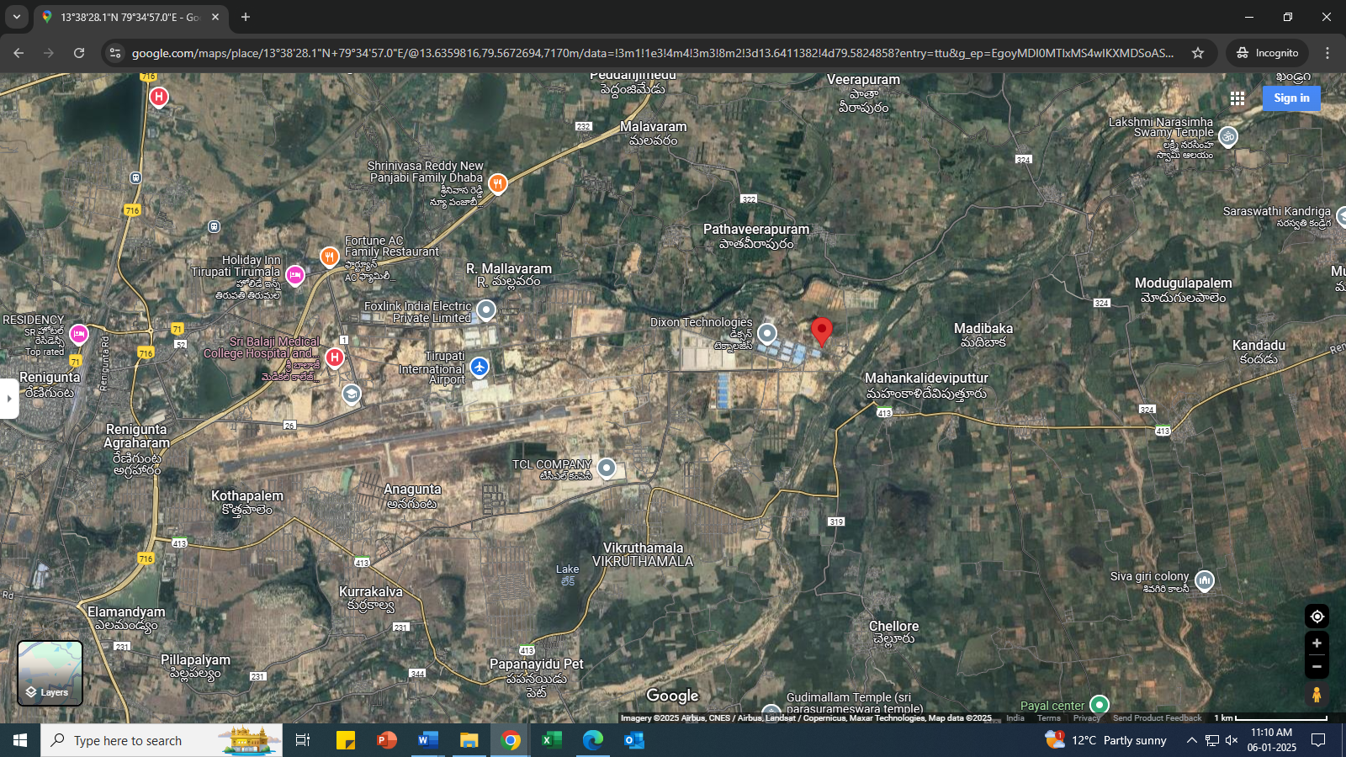

**Source: Google Map**

1. **SCOPE OF WORK DURING PROJECT DURATION:**
2. Project physical status review as on date of Site Survey.
3. **PURPOSE OF THE REPORT:** To provide fair detailed analysis report to the Bank based on the “in-scope points” mentioned above for facilitating them to know the current status of the Project.
4. **METHODOLOGY ADOPTED:**
5. Study of Project Planning documents/ reports to know about the Project.
6. Additional information, data, documents collection from the borrower.
7. Site Inspection.
8. Review and analysis of the documents and information obtained from the borrower and corroborating it with the site inspection status.
9. Information compilation, analysis and reporting.
10. Verification of the bills & invoices have not been done on our end.

|  |  |
| --- | --- |
| **PART C** | **PLANT INFRASTRUCTURE SECTIONS & FACILITY DETAILS WITH**  **ACTUAL PROGRESS** |

1. **LAND AND LAND DEVELOPMENT:** For the purpose of the Project, company has purchased 6252.45 sqm of land in Electronic Manufacturing Cluster (EMC) – II, Tirupati, Chittoor District, Andhra Pradesh. The boundary details of the land are provided in the exhibit below:

|  |  |
| --- | --- |
| **Direction** | **Description** |
| North | Plot No. 40 |
| South | 18 mtr wide road |
| East | 18 mtr wide road |
| West | Sub-station |

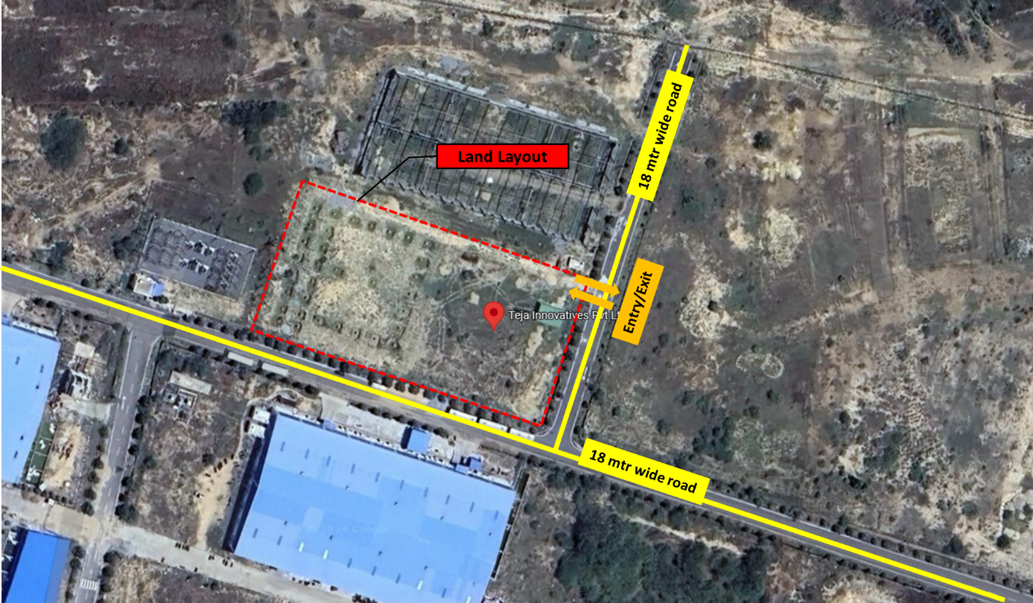

As per observation made during site survey, it was observed that the land parcel is not demarcated yet and no other land development work was observed there.

1. **BUILDING & CIVIL WORKS:** As per copy of consultant approved site plan, only 1 PEB Structure is proposed for construction name as Block-1 with proposed plinth area of 1662.74 sqm. Current status of building & civil work is as follows: -

|  |  |  |  |  |
| --- | --- | --- | --- | --- |
| **S. No.** | **Cost Component** | **Weightage**  **(In %)** | **Work Completion** | **Remarks/Current Status** |
|  | Foundation, Mud Filling & brick wall upto Plinth Beam | 15% | 15% | As per observation made during site survey, Foundation, Mud Filling & brick wall upto Plinth Beam work had been completed.  No in-progress construction was going on at the site during the site survey. |
|  | Plinth Beam Construction | 10% | 10% | As per observation made during site survey, Plinth Beam Construction work had been completed.  No in-progress construction was going on at the site during the site survey. |
|  | Floor Construction  (VDF Flooring & Side walls) | 20% | 0% | No work was observed during site survey. |
|  | Mezzanine Floor | 5% | 0% | No work was observed during site survey. |
|  | PEB shed | 50% | 0% | No work was observed during site survey. |
|  | | **100%** | **25%** |  |

1. **PLANTS/ MACHINERIES & OTHER EQUIPMENTS AND UTILITIES:** As on date of site survey, we didn’t find any Plant & Machinery at site.

|  |  |  |
| --- | --- | --- |
| **S. No.** | **Cost Component** | **Remarks/Current Status** |
| 1 | Plant & Machinery | No machine was found at site during survey. |
| 2 | Machine Erection Expenses | -- |

|  |  |
| --- | --- |
| **PART D** | **PROJECT COST & MEANS OF FINANCE** |

1. **TOTAL PROJECT COST & STATUS OF EXPERNDITURE:** As per copy of CA certificate dated 04-03-2024, the total proposed project cost is as follows: -

|  |  |  |
| --- | --- | --- |
| **S. No** | **Cost Component** | **Proposed Cost (In Lakh)** |
| 1 | Land & Land Development | 93.84 |
| 2 | **Technical Civil Work** |  |
| *a* | *Foundation Expenditure* | *64.35* |
| *b* | *Side Plinth Construction* | *28.58* |
| *c* | *Floor Construction* | *72.32* |
| *d* | *Mezzanine* | *12.47* |
| *e* | *PEB Shed* | *128* |
|  | | **305.72** |
| 3 | Plant & Machinery | 686.06 |
| 4 | Machine Erection Expenses | 20.9 |
| 5 | Contingencies | 15 |
| 6 | Pre-Operative Expenses | 10 |
| 7 | Interest During Construction Period | 35.66 |
| 8 | Margin Money for Working Capital | 16 |
| **Total Project Cost** | | **1183.18** |

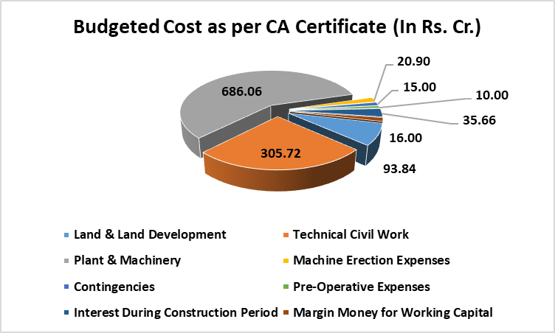

As per CA Certificate dated 04th May 2024, the total investment of the project is Rs. 2476.32 Lacs. Out of which Rs. 2,000.30 Lacs has been spent till 03rd May 2024 and Rs. 476.02 Lacs is yet be paid to different parties. Details of same are as follows: -

|  |  |  |  |
| --- | --- | --- | --- |
| **S. No** | **Cost Component** | **Proposed Cost (In Lakh)** | **Amount Incurred by the Promotor (In Lakh)** |
| 1 | Land & Land Development | 93.84 | 9.84 |
| 2 | **Technical Civil Work** |  |  |
| *a* | *Foundation Expenditure* | *64.35* | *64.33* |
| *b* | *Side Plinth Construction* | *28.58* | *6.19* |
| *c* | *Floor Construction* | *72.32* | *30* |
| *d* | *Mezzanine* | *12.47* | *-* |
| *e* | *PEB Shed* | *128* | *-* |
|  | | **305.72** | **100.52** |
| 3 | Plant & Machinery | 686.06 | 102.09 |
| 4 | Machine Erection Expenses | 20.9 | - |
| 5 | Contingencies | 15 | - |
| 6 | Pre-Operative Expenses | 10 | - |
| 7 | Interest During Construction Period | 35.66 | - |
| 8 | Margin Money for Working Capital | 16 | - |
| **Total Project Cost** | | **1183.18** | **297.284** |

1. **SOURCES OF FINANCE & UTILIZATION OF FUNDS:**

The Project cost mentioned above has been planned to be covered from following resources:

|  |  |
| --- | --- |
| (Amount in Rs. Lakh) | |
| PARTICULARS | **Amount** |
| Equity | 591.59 |
| VCFBC - Equity | 1.00 |
| VCFBC – OCDs | 590.59 |
| TOTAL | **1183.18** |

***Source:*** *As per IFCI Details shared*

|  |  |
| --- | --- |
| **PART E** | **STATUTORY & REGULATORY APPROVALS, CLEARANCES & NOC** |

|  |  |  |  |
| --- | --- | --- | --- |
| Sr. No. | NAME OF LICENSE/ REGISTRATION | DATE OF ISSUE | CURRENT STATUS |
| **ISSUING AUTHORITY** | **LICENCE NO.** |
|  | Building Plan | --- | Not approved by authority |
| C. Giridhar Raju  Licensed Civil Engineer |
|  | CA Certificate | Dated: 04-03-2024 | Obtained |
| A. Madhana Mohan  UDIN: 24215521BJZZQE1641 |
|  | NoC for Raising Loan | --- | Applied for |
|  | A. P. Industrial Infrastructure Corporation | Lr.No.37225/APIIC/Electronic Mfg Cluster-II/Tirupati/2020  Dated 03-08-2021 | Obtained |
|  | Factory License | -- | Pending |
|  | Water Connection | -- | Pending |
|  | Electricity Connection | -- | Pending |
| *Note: The above licenses are only the major licenses obtained by the project proponent and not be considered exhaustive in nature.* | | | |

|  |  |
| --- | --- |
| **PART F** | **DISCLAIMER** |

* + - 1. No employee or member of R.K Associates has any direct/ indirect interest in the Project.
      2. This report is prepared based on the copies of the documents/ information which the Bank/ Borrower has provided to us out of the standard checklist of documents sought from them and further based on our assumptions and limiting conditions. The client/owner and its management/representatives warranted to us that the information they supplied was complete, accurate and true and correct to the best of their knowledge. All such information provided to us has been relied upon in good faith and we have assumed that it is true and correct in all respect. I/We shall not be liable for any loss, damages, cost or expenses arising from fraudulent acts, misrepresentations, or wilful default on part of the owner, borrower, its directors, employee, representative or agents. Verification or cross checking of the documents provided to us from the originals or from any Govt. departments/ Record of Registrar has not been done at our end since this is beyond the scope of our work. If at any time in future, it is found or came to our knowledge that misrepresentation of facts or incomplete or distorted information has been provided to us then this report shall automatically become null & void.
      3. Legal aspects for eg. investigation of title, ownership rights, lien, charge, mortgage, lease, sanctioned maps, verification of documents, etc. have not been done at our end and same has to be taken care by legal expert/ Advocate. It is assumed that the concerned Lender/ Financial Institution has satisfied them with the authenticity of the documents, information given to us and for which the legal verification has been already taken and cleared by the competent Advocate before requesting for this report. I/ We assume no responsibility for the legal matters including, but not limited to, legal or title concerns.
      4. This report is a general analysis of the project based on the scope mentioned in the report. This is not an Audit report, Design document, DPR or Techno feasibility study. All the information gathered is based on the facts seen on the site during survey, verbal discussion & documentary evidence provided by the client and is believed that information given by the borrower is true best of their knowledge.
      5. All observations mentioned in the report is only based on the visual observation and the documents/ data/ information provided by the client. No mechanical/ technical tests, measurements or any design review have been performed or carried out from our side during Project assessment.
      6. Bank/FII should ONLY take this report as an Advisory document from the Financial/ Chartered Engineering firm and its specifically advised to the creditor to cross verify the original documents for the facts mentioned in the report which can be availed from the borrowing borrower directly.
      7. In case of any default in loans or the credit facility extended to the borrowing borrower, R.K Associates shall not be held responsible for whatsoever reason may be and any request for seeking any explanation from the employee/s of R.K Associates will not be entertained at any instance or situation.
      8. The documents, information, data provided to us during the course of this assessment by the client is reviewed only up to the extent required in relation to the scope of the work. No document has been reviewed beyond the scope of the work.
      9. This report only contains general assessment & opinion as per the scope of work evaluated as per the information given in the copy of documents, information, data provided to us and/ and confirmed by the owner/ owner representative to us at site which has been relied upon in good faith. It doesn’t contain any other recommendations of any sort including but not limited to express of any opinion on the suitability or otherwise of entering into any transaction with the borrower.
      10. We have relied on data from third party, external sources & information available on public domain also to conclude this report. These sources are believed to be reliable and therefore, we assume no liability for the truth or accuracy of any data, opinions or estimates furnished by others that have been used in this analysis. Where we have relied on data, opinions or estimates from external sources, reasonable care has been taken to ensure that such data has been correctly extracted from those sources and /or reproduced in its proper form and context, however still we can’t vouch its authenticity, correctness or accuracy.
      11. This Report is prepared by our competent technical team which includes Engineers and financial experts & analysts.
      12. This is just an opinion report and doesn’t hold any binding on anyone. It is requested from the concerned Financial Institution which is using this report for taking financial decision on the project that they should consider all the different associated relevant & related factors also before taking any business decision based on the content of this report.
      13. All Pages of the report including annexures are signed and stamped from our office. In case any paper in the report is without stamp & signature then this should not be considered a valid paper issued from this office.
      14. Though adequate care has been taken while preparing this report as per its scope, but still we can’t rule out typing, human errors, over sightedness of any information or any other mistakes. Therefore, the concerned organization is advised to satisfy themselves that the report is complete & satisfactory in all respect. Intimation regarding any discrepancy shall be brought into our notice immediately. If no intimation is received within 15 (Fifteen) days in writing from the date of issuance of the report, to rectify these timely, then it shall be considered that the report is complete in all respect and has been accepted by the client upto their satisfaction & use and further to which R.K Associates shall not be held responsible in any manner.
      15. Defect Liability Period is **15 DAYS**. We request the concerned authorized reader of this report to check the contents, data and calculations in the report within this period and intimate us in writing if any corrections are required or in case of any other concern with the contents or opinion mentioned in the report. Corrections only related to typographical, calculation, spelling mistakes, incorrect data/ figures/ statement will be entertained within the defect liability period. Any new changes for any additional information in already approved report will be regarded as additional work for which additional fees may be charged. No request for any illegitimate change in regard to any facts & figures will be entertained.
      16. R.K Associates encourages its customers to give feedback or inform concerns over its services through proper channel at valuers@rkassociates.org in writing within 15 days of report delivery. After this period no concern/ complaint/ proceedings in connection with the Financial Feasibility Study Services will be entertained due to possible change in situation and condition of the subject Project.
      17. Our Data retention policy is of **ONE YEAR**. After this period, we remove all the concerned records related to the assignment from our repository. No clarification or query can be answered after this period due to unavailability of the data.
      18. This Lender’s Independent Engineer report is governed by our (1) Internal Policies, Processes & Standard Operating Procedures, (2) Information/ Data/ Inputs given to us by the client and (3) Information/ Data/ Facts given to us by our field/ office technical team. Management of R.K Associates never gives acceptance to any unethical or unprofessional practice which may affect fair, correct & impartial assessment and which is against any prevailing law. In case of any indication of any negligence, default, incorrect, misleading, misrepresentation or distortion of facts in the report then it is the responsibility of the user of this report to immediately or at least within the defect liability period bring all such act into notice of R.K Associates management so that corrective measures can be taken instantly.
      19. R.K Associates never releases any report doing alterations or modifications from pen. In case any information/ figure of this report is found altered with pen then this report will automatically become null & void.

|  |  |  |
| --- | --- | --- |
| **SURVEY ANALYST** | **ENGINEERING ANALYST** | **L1 REVIEWER** |
| Er. D. Sivaiah | Abhinav Chaturvedi | Sr. V. P. Projects |
|  |  |  |

**For**

**R.K. Associates Valuers and Techno Engineering Consultants Pvt. Ltd**

**Place: Noida**

**Date: 20th December 2024**

***DEFECT LIABILITY PERIOD - In case of any query/ issue or escalation you may please contact Incident Manager by writing at valuers@rkassociates.org. We ensure 100% accuracy in the Calculations done, Rates adopted and various other data points & information mentioned in the report but still can’t rule out typing, human errors or any other mistakes. In case you find any mistake, variation, discrepancy or inaccuracy in any data point of the report, please help us by bringing all such points into our notice in writing at valuers@rkassociates.org within 30 days of the report delivery, to get these rectified timely, failing which R.K Associates Valuers Techno Engineering Consultants (P) Ltd. won’t be held responsible for any inaccuracy in any manner. Also, if we will not hear back anything from you within 30 days, we will assume that report is correct in all respect and no further claim of any sort will be entertained thereafter. We would welcome and appreciate your feedback & suggestions in order to improve our services.***

***COPYRIGHT FORMAT - This report is prepared on the copyright format of R.K Associates Valuers Techno Engineering Consultants (P) Ltd. to serve our clients in the best possible way. Legally no one can copy or distribute this format without prior approval from R.K Associates. It is meant only for the organization as mentioned on the cover page of this report. Distribution or use of this format other than R.K Associates will be seen as unlawful act and necessary legal action can be taken against the defaulter***

**ENCLOSURE 1: IMPORTANT DOCUMENTS EXHIBIT**

**SNAPSHOT OF DPR**

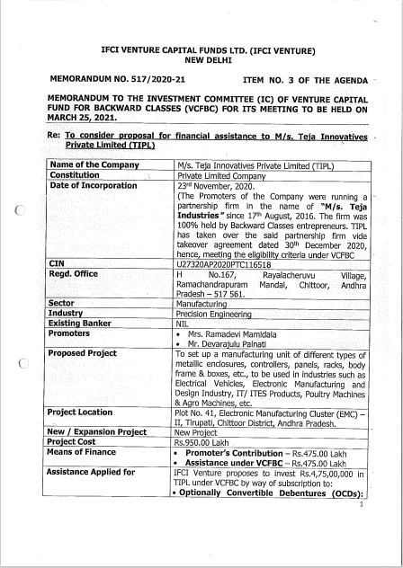

**CA CERTIFICATE DATED 04-03-2024**

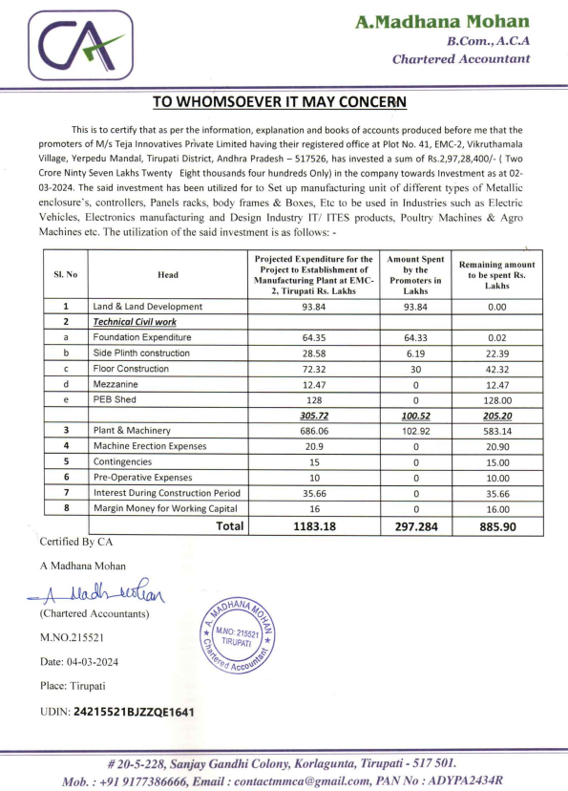

**BUILDING PLAN**

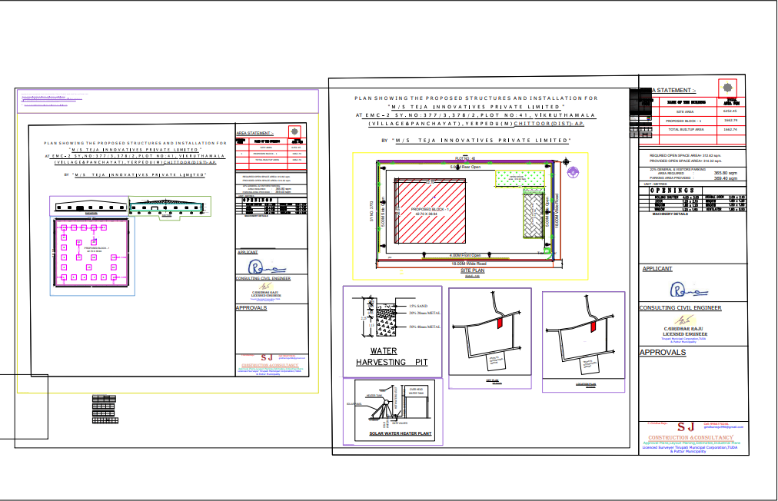

**ENCLOSURE-2: - SITE PHOTOGRAPHS**

|  |  |
| --- | --- |
|  |  |
|  |  |
|  |  |

|  |  |
| --- | --- |
|  |  |
|  |  |
|  |  |