**File No.: VIS (2024-25)-PL628-564-798 Dated: 10-01-2025**

**LENDER’S INDEPENDENT ENGINEER’s REPORT**

**OF**

**410.30 (± 7.5%) KWp GRID CONNECTED ROOF-TOP SOLAR POWER PLANT**

**SET-UP AT**

**M/S SAMSON CONTROLS PRIVATE LIMITED IN D-281, RANJANGAON MIDC, TAL, SHIRUR, DISTRICT-PUNE, MAHARASHTRA**

**DEVELOPER:**

**M/S SAMARITAN SOLAR ENERGY PRIVATE LIMITED**

**REPORT PREPARED FOR**

**STATE BANK OF INDIA, SME UDYOG SADAN,**

**PATPARGANJ INDUSTRIAL AREA, NEW DELHI**

***\*\*Important - In case of any query/ issue or escalation you may please contact Incident Manager***

***at le@rkassociates.org. We will appreciate your feedback in order to improve our services.***

***NOTE: As per IBA Guidelines please provide your feedback on the report within 15 days of its submission after which report will be considered to be correct.***

**IMPORTANT NOTICE**

***COPYRIGHT FORMAT:*** *This report is prepared on the copyright format of R.K Associates to serve our clients with the best possible information and analysis to facilitate them to take rational business decisions. Legally no one can copy or distribute this format without prior approval from R.K Associates. It is meant only for the advisory/ reference purpose for the organization/s as mentioned on the cover page of this report. Distribution or use of this format by any organization or individual other than R.K Associates will be seen as an unlawful act and necessary legal action can be taken against the defaulters.*

*This report is intended for the sole use of the intended recipient/s and contains material that is STRICTLY CONFIDENTIAL AND PRIVATE.*

***DEFECT LIABILITY PERIOD:*** *- In case of any query/ issue or escalation you may please contact Incident Manager at*[*le@rkassociates.org*](mailto:le@rkassociates.org)*.*

*Though adequate care has been taken while preparing this report as per its scope, but still we can’t rule out typing, human errors, over sightedness of any information or any other mistakes. Therefore, the concerned organization is advised to satisfy themselves that the report is complete & satisfactory in all respect. Intimation regarding any discrepancy shall be brought into our notice immediately. If no intimation is received within 15 (Fifteen) days in writing from the date of issuance of the report, to rectify these timely, then it shall be considered that the report is complete in all respect and has been accepted by the client upto their satisfaction & use and further to which R.K Associates shall not be held responsible in any manner.*

|  |  |  |
| --- | --- | --- |
| **TABLE OF CONTENTS** | | |
|  | | |
| **SECTIONS** | **PARTICULARS** | **PAGE NO.** |
| **Part A** | **REPORT SUMMARY** | 03 |
| **Part B** | **INTRODUCTION** | 04 |
|  | 1. Name of the Project | 04 |
| 1. Project Overview | 04 |
| 1. Scope of the Report | 05 |
| 1. Purpose of the Report | 05 |
| **Part C** | **PROJECT DETAILS AND KEY TECHNICAL PARAMETERS** | 06 |
| **Part D** | **CURRENT STATUS OF WORK** | 07 |
| **Part E** | **PROJECT COST & EXPENDITURE** | 09 |
| **Part F** | **OTHER DOCUMENTS & REFERENCES** | 10 |
| **Part G** | **DISCLAIMER** | 12 |

|  |  |
| --- | --- |
| **PART A** | **REPORT SUMMARY** |

|  |  |  |
| --- | --- | --- |
|  | **Name of the Project** | 410.30 (±7.5%) KWp Grid Connected Solar Power Plant |
|  | **Project Location** | M/s Samson Controls Private Limited In D-281, MIDC Ranjangaon, Tal. Shirur, District-Pune, Maharashtra |
|  | **Seller Company** | M/s Samaritan Solar Energy Private Limited |
|  | **Prepared for Organization** | State Bank Of India, SME Udyog Sadan, Patparganj Industrial Area, New Delhi |
|  | **LIE Consultant Firm** | M/s. R.K. Associates Valuers & Techno Engineering Consultants (P) Ltd. |
|  | **Work Oder Details** | Via E-mail dated 24-07-2024 |
|  | **Date of Survey** | 18-12-2024 |
|  | **Date of Report** | 10-01-2025 |
|  | **Details & documents provided by** | Mr. Ankit Malhotra (Sr. Vice President) |
|  | **Report Type** | Lender’sIndependent Engineering Report |
|  | **Purpose of the Report** | To comment upon physical progress of the solar porjects |
|  | **Scope of the Report** | To verify and review the physical progress of the Solar Power Plants set-up/ being set-up by M/s Samaritan Solar Energy Private Limited |
|  | **Documents produced for Perusal** | 1. Copy of Power Purchase Agreements (PPAs) 2. Copy of Plant Layout 3. Copy of PV Syst reports |
|  | **Annexure with the Report** | * Layout Plans * Copy of Invoices |

|  |  |
| --- | --- |
| **PART B** | **INTRODUCTION** |

1. **NAME OF THE PROJECT:** 410.30 (± 7.5%) KWp Grid Connected Solar Power Plant in RESCO Model installed at M/s Samson Controls Private Limited located at D-281, MIDC Ranjangaon, Tal. Shirur, District-Pune, Maharashtra by M/s Samaritan Solar Energy Private Limited.
2. **PROJECT OVERVIEW:** M/s Samaritan Solar Energy Private Limited is into Manufacturing, supplying, installing and distribution of electric power generation using solar energy.

**M/s Samson Controls Private Limited** had signed Power Purchase Agreement (PPAs) with **M/s Kirloskar Solar Technologies Private Limited** for Design, Manufacture, Supply, Erection, Testing and Commissioning including Warranty, Operation & Maintenance of roof-top solar power plant having DC capacity of **410.30 (± 7.5%) KWp for 15 years** of plant operation/ PPA tenure.

The agreement was further novated to MPRNP vide Novation and Assignment Agreement dated 27th December 2023.

Further, **M/s MPRNP Energy Udyog Private Limited has transferred its duties, obligation & liabilities to M/s Samaritan Solar Energy Private Limited through** Novation and Assignment Agreement dated **29th March 2024** which was signed between **M/s MPRNP Energy Udyog Private Limited** and **M/s Samson Controls Private Limited** and **M/s Samaritan Solar Energy Private Limited,** in which Samson has unconditionally agreed to release and discharge the MPRNP from MPRNP's obligations, duties, liabilities and assign and transfer MPRNP's rights and benefits as per the Original Agreement in favour of **Samaritan** (except Operation and Maintenance of the Solar Power Plants by Kirloskar Solar Technologies Private Limited for first two years subject to renewal by Samaritan).

M/s Samaritan Solar Energy Private Limited has approached SBI for credit facility to construct these plant who have in turned appointed M/s R.K Associates Valuers & Techno Engineering Consultants Pvt. Ltd. as Lenders Independent Engineer for a specific scope of work.

***Since, technical & financial feasibility report has been shared previously. Thus, this report is only constitute about physical progress of the projects observed during site survey.***

1. **SCOPE OF THE REPORT:** To verify the physical progress of the Solar Power Plants being set-up by M/s Samaritan Solar Energy Private Limited:-

* *Industry/ sector research and demand & supply trend is out of scope of the report.*
* *Financial feasibility study of the Project is out of scope of the report.*
* *Providing any kind of design report or map is out-of-scope of the report.*
* *Scrutiny of contracts, Agreements and arrangement between the parties from legal perspective is out-of-scope of this report.*
* *Any kind of technical & economic feasibility of the Project is out-of-scope of this Report.*

*All the assessment carried out for the Project is done based on the documents and information provided & physical observation made during site survey. Component wise verification is not carried out.*

1. **PURPOSE OF THE REPORT:**  To provide fair detailed physical progress/analysis report to the Bank based on the “in-scope points” mentioned above.

|  |  |
| --- | --- |
| **PART C** | **PROJECT DETAILS AND KEY TECHNICAL PARAMETERS** |

1. **SOLAR PLANT PROJECT LOCATION:** As per the information and copy of documents shared by the management of the company, details of the subject solar plant locations has been tabulated below:

|  |  |  |  |  |
| --- | --- | --- | --- | --- |
| **S.**  **No.** | **Purchaser** | **Capcity (kWp)** | | **Address** |
| **DC Power** | **AC Power** |
| 1 | Samson Constrols Private Limited | 410.30 | 330.00 | Ranjangaon MIDC, Pune  GPS Coordinates– 24°50'35.3"N 74°35'18.1"E |
| **Total** | | **410.30** | **330.00** |  |

1. **KEY TECHNICAL PARAMETERS:** As per the copy of module layout plan, Technical Parameters & Configuration of the projects like Modules, Inverter, tilt angle, capacity, etc. are tabulated below:

|  |  |  |  |  |  |  |
| --- | --- | --- | --- | --- | --- | --- |
| **S. No.** | **Location** | **Proposed capacity (in KWp)** | **No. of PV Module (in nos.)** | **PV Module Capacity (in Wp)** | **PV Module Mounting Orientation** | **Module Mounting Structure Angle** |
| 1 | Samson Constrols Private Limited | 410.30 | 747 | 550 | Not Known | As per building |

1. **LOCATION MAP: -**

**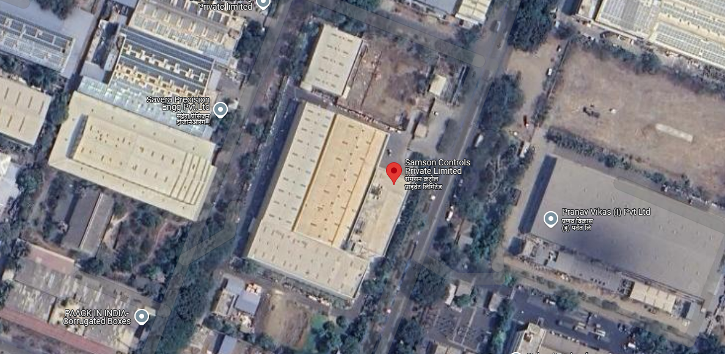**

***The solar panels were installed recently, so they are not yet visible in Google Satellite Imagery.***

|  |  |
| --- | --- |
| **PART D** | **CURRENT STATUS OF WORK** |

|  |  |  |
| --- | --- | --- |
| **S. No.** | **Particulars** | **Remarks/Status** |
|  | Module Structure | Work related to modules structure is Completed. |
|  | Modules | 747 nos. of modules have been installed. (as per information provided) |
|  | Invertors | Installed |
|  | Wiring | Completed |
|  | Metering Panels | Installed |
|  | Operational Status | Operational |

**Notes:**

During the site survey, it was found that the solar plant was operational, with a total of 747 solar modules installed as per the client's information. However, the client did not permit access to the terrace area where the modules were installed.

|  |  |
| --- | --- |
| ***X:\In Progress Files\Deepak Singh\JAN-Mar 2025\VIS(2024-25)-PL628-564-798\site images\TimePhoto_20241218_155639.jpg*** | ***X:\In Progress Files\Deepak Singh\JAN-Mar 2025\VIS(2024-25)-PL628-564-798\site images\TimePhoto_20241218_155641.jpg*** |
| ***X:\In Progress Files\Deepak Singh\JAN-Mar 2025\VIS(2024-25)-PL628-564-798\site images\TimePhoto_20241218_160306.jpg*** | ***X:\In Progress Files\Deepak Singh\JAN-Mar 2025\VIS(2024-25)-PL628-564-798\site images\TimePhoto_20241218_160321.jpg*** |

|  |  |
| --- | --- |
| ***X:\In Progress Files\Deepak Singh\JAN-Mar 2025\VIS(2024-25)-PL628-564-798\site images\TimePhoto_20241218_160345.jpg*** | ***X:\In Progress Files\Deepak Singh\JAN-Mar 2025\VIS(2024-25)-PL628-564-798\site images\TimePhoto_20241218_160410.jpg*** |
| **X:\In Progress Files\Deepak Singh\Jan-Mar 2025\VIS(2024-25)-PL628-564-798 Samaritans Energy\site images\TimePhoto_20241218_160309.jpg** | **X:\In Progress Files\Deepak Singh\Jan-Mar 2025\VIS(2024-25)-PL628-564-798 Samaritans Energy\site images\TimePhoto_20241218_160611.jpg** |
| **X:\In Progress Files\Deepak Singh\Jan-Mar 2025\VIS(2024-25)-PL628-564-798 Samaritans Energy\site images\TimePhoto_20241218_160325.jpg** | **X:\In Progress Files\Deepak Singh\Jan-Mar 2025\VIS(2024-25)-PL628-564-798 Samaritans Energy\site images\TimePhoto_20241218_160328.jpg** |

|  |  |
| --- | --- |
| **PART E** | **PROJECT COST & EXPENDITURE** |

1. **PROJECT COST:** As per details shared by the company, the total project cost for installation of 410.30 KW solar project is Rs. 1.94 Cr. including GST. Component-wise cost break-up shared by the company is as follows

|  |  |  |  |
| --- | --- | --- | --- |
| **S.No.** | **Item** | **Cost/KW**  **(In Rs.)** | **Total EPC Value**  **(In Rs.)** |
| 1 | Solar Panel | 24.50 | 1,00,52,350 |
| 2 | Solar Inverter | 3.37 | 13,82,711 |
| 3 | Structure | 3.00 | 12,30,900 |
| 4 | Cables | 2.00 | 8,20,600 |
| 5 | LT Panel/ACDB | 2.10 | 8,61,630 |
| 6 | BOS / Misc. | 2.50 | 10,25,750 |
|  | I&C | 2.00 | 8,20,600 |
| 8 | Govt Approval & Liasoning | 2.20 | 9,02,660 |
|  |  |  | 1,70,97,201 |
|  |  | \*GST (13.8%) | 23,59,414 |
| **Total Cost of the project (In Rs.)** | |  | **1,94,56,615** |

1. **EXPENDITURE INCURRED:** The break-up of the amount of cost that has been spent in the project as per the data and inovoices provided by the client are as mentioned below:

|  |  |  |  |
| --- | --- | --- | --- |
| **Description** | **Invoice No.** | **Invoice Date** | **Amount in Rs (Including GST)** |
| Solar System Supply & Installation (Cost of material & Installation) | DEL/23-24/093 | 30-03-2024 | 1,29,72,000 |
| Solar System Supply & Installation (Cost of material & Installation) | DEL/24-25/088 | 19-12-2024 | 64,80,000 |
| **TOTAL** | | | **1,94,52,000** |

|  |  |
| --- | --- |
| **PART F** | **OTHER DOCUMENTS & REFERENCES** |

**Layout Plan**

**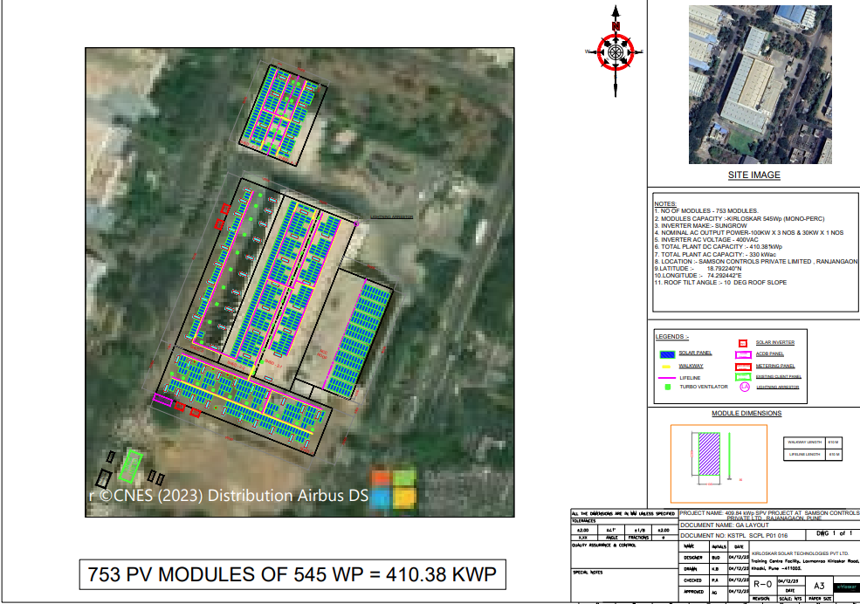**

**Copy of Invoices**

|  |  |
| --- | --- |
|  |  |
|  |  |

|  |  |
| --- | --- |
| **PART G** | **DISCLAIMER** |

* + - 1. No employee or member of R.K Associates has any direct/ indirect interest in the Project.
      2. This report is prepared based on the copies of the documents/ information which the Bank/ Company has provided to us out of the standard checklist of documents sought from them and further based on our assumptions and limiting conditions. All such information provided to us has been relied upon in good faith and we have assumed that it is true and correct in all respect. Verification or cross checking of the documents provided to us has not been done at our end from the originals. If at any time in future, it is found or came to our knowledge that misrepresentation of facts or incomplete or distorted information has been provided to us then this report shall automatically become null & void.
      3. This report is a general analysis of the project based on the scope mentioned in the report. This is not an Audit report, Design document, DPR or Techno-financial feasibility study. All the information gathered is based on the facts seen on the site during survey, verbal discussion & documentary evidence provided by the client and is believed that information given by the company is true best of their knowledge.
      4. All observations mentioned in the report is only based on the visual observation and the documents/ data/ information provided by the client. No mechanical/ technical tests, measurements or any design review have been performed or carried out from our side during Project assessment.
      5. Bank/FII should ONLY take this report as an Advisory document from the Financial/ Chartered Engineering firm and it’s specifically advised to the creditor to cross verify the original documents for the facts mentioned in the report which can be availed from the borrowing company directly.
      6. In case of any default in loans or the credit facility extended to the borrowing company, R.K Associates shall not be held responsible for whatsoever reason may be and any request for seeking any explanation from the employee/s of R.K Associates will not be entertained at any instance or situation.
      7. This Report is prepared by our competent technical team which includes Engineers and financial experts & analysts.
      8. This is just an opinion report and doesn’t hold any binding on anyone. It is requested from the concerned Financial Institution which is using this report for taking financial decision on the project that they should consider all the different associated relevant & related factors also before taking any business decision based on the content of this report.
      9. All Pages of the report including annexures are signed and stamped from our office. In case any paper in the report is without stamp & signature then this should not be considered a valid paper issued from this office.
      10. Though adequate care has been taken while preparing this report as per its scope, but still we can’t rule out typing, human errors, over sightedness of any information or any other mistakes. Therefore, the concerned organization is advised to satisfy themselves that the report is complete & satisfactory in all respect. Intimation regarding any discrepancy shall be brought into our notice immediately. If no intimation is received within 15 (Fifteen) days in writing from the date of issuance of the report, to rectify these timely, then it shall be considered that the report is complete in all respect and has been accepted by the client upto their satisfaction & use and further to which R.K Associates shall not be held responsible in any manner.
      11. Defect Liability Period is **15 DAYS**. We request the concerned authorized reader of this report to check the contents, data and calculations in the report within this period and intimate us in writing if any corrections are required or in case of any other concern with the contents or opinion mentioned in the report. Corrections only related to typographical, calculation, spelling mistakes, incorrect data/ figures/ statement will be entertained within the defect liability period. Any new changes for any additional information in already approved report will be regarded as additional work for which additional fees may be charged. No request for any illegitimate change in regard to any facts & figures will be entertained.
      12. R.K Associates encourages its customers to give feedback or inform concerns over its services through proper channel at le@rkassociates.org in writing within 30 days of report delivery. After this period no concern/ complaint/ proceedings in connection with the Lender’s Independent Engineering Services will be entertained due to possible change in situation and condition of the subject Project.
      13. Our Data retention policy is of **ONE YEAR**. After this period, we remove all the concerned records related to the assignment from our repository. No clarification or query can be answered after this period due to unavailability of the data.
      14. This Lender’s Independent Engineering report is governed by our (1) Internal Policies, Processes & Standard Operating Procedures, (2) Information/ Data/ Inputs given to us by the client and (3) Information/ Data/ Facts given to us by our field/ office technical team. Management of R.K Associates never gives acceptance to any unethical or unprofessional practice which may affect fair, correct & impartial assessment and which is against any prevailing law. In case of any indication of any negligence, default, incorrect, misleading, misrepresentation or distortion of facts in the report then it is the responsibility of the user of this report to immediately or at least within the defect liability period bring all such act into notice of R.K Associates management so that corrective measures can be taken instantly.
      15. R.K Associates never releases any report doing alterations or modifications from pen. In case any information/ figure of this report is found altered with pen then this report will automatically become null & void.

**FOR INTERNAL USE**

|  |  |  |
| --- | --- | --- |
| **FOR R.K ASSOCIATES VALUERS** **& TECHNO ENGINEERING CONSULTANTS (P) LTD.** | | |
| **SURVEYED BY** | **PREPARED BY** | **REVIWED BY** |
| Anit Bhanji | Deepak Kumar Singh | Abhinav Chaturvedi |
|  |  |  |

**For R.K Associates Valuers** **& Techno Engineering Consultants (P) Ltd.**

***DEFECT LIABILITY PERIOD - In case of any query/ issue or escalation you may please contact Incident Manager by writing at valuers@rkassociates.org. We ensure 100% accuracy in the Calculations done, Rates adopted and various other data points & information mentioned in the report but still can’t rule out typing, human errors or any other mistakes. In case you find any mistake, variation, discrepancy or inaccuracy in any data point of the report, please help us by bringing all such points into our notice in writing at*** [**valuers@rkassociates.org**](mailto:valuers@rkassociates.org) ***within 30 days of the report delivery, to get these rectified timely, failing which R.K Associates Valuers Techno Engineering Consultants (P) Ltd. won’t be held responsible for any inaccuracy in any manner. Also if we will not hear back anything from you within 30 days, we will assume that report is correct in all respect and no further claim of any sort will be entertained thereafter. We would welcome and appreciate your feedback & suggestions in order to improve our services.***

***COPYRIGHT FORMAT - This report is prepared on the copyright format of R.K Associates Valuers Techno Engineering Consultants (P) Ltd. to serve our clients in the best possible way. Legally no one can copy or distribute this format without prior approval from R.K Associates. It is meant only for the organization as mentioned on the cover page of this report. Distribution or use of this format other than R.K Associates will be seen as unlawful act and necessary legal action can be taken against the defaulter***