File No.: VIS (2024-25)-PL664-595-833 Dated: 20-01-2025

COST VETTING ASSESSMENT

OF

M/S. ALFA INGOTS PVT. LTD.

SITUATED AT
KHATA NO. 8, KHASRA NO. 264M, VILLAGE - GANGNOLI, PARGANA MANGLORE, TEHSIL LAKSAR, HARIDWAR, UTTARAKHAND

REPORT PREPARED FOR
STATE BANK OF INDIA, SME BRANCH, ROORKEE,
HARIDWAR, UTTARAKHAND

**Important - In case of any query/ issue or escalation you may please contact Incident Manager
at le@rkassociates.org. We will appreciate your feedback in order to improve our services.
NOTE: Please provide your feedback on the report within 15 days of its submission after which report will be considered to be correct

IMPORTANT NOTICE

COPYRIGHT FORMAT: This report is prepared on the copyright format of R.K Associates to serve our clients with the best possible information and analysis to facilitate them to take rational business decisions. Legally no one can copy or distribute this format without prior approval from R.K Associates. It is meant only for the advisory/ reference purpose for the organization/s as mentioned on the cover page of this report. Distribution or use of this format by any organization or individual other than R.K Associates will be seen as an unlawful act and necessary legal action can be taken against the defaulters.

This report is intended for the sole use of the intended recipient/s and contains material that is STRICTLY CONFIDENTIAL AND PRIVATE.

DEFECT LIABILITY PERIOD: - In case of any query/ issue or escalation you may please contact Incident Manager at le@rkassociates.org. We try to ensure maximum accuracy in the calculations done, rates adopted, assumptions taken and various other data points & information mentioned in the report but even still can’t rule out typing, human errors or any other bonafide mistakes. In case you find any such mistake or inaccuracy in any data point of the report, please help us by bringing all such points into our notice immediately or within 15 days of the r0eport delivery in writing, to rectify these timely failing after which R.K Associates won’t be held responsible for any such inaccuracy in any manner. We would highly appreciate your feedback in order to improve our services.
TABLE OF CONTENTS
SECTIONS | PARTICULARS | PAGE NO.
Part A | REPORT SUMMARY | 04
Part B | COST VETTING ASSESSMENT | 05 - 07
 | - DESCRIPTION | 05
 | - CIVIL WORKS | 05 – 07
Part C | PHOTOGRAPHS | 08
Part D | IMPORTANT DOCUMENTS EXHIBIT | 09 – 12
Part E | DISCLAIMER | 13

PART A | REPORT SUMMARY

- DOCUMENT NAME: Cost Vetting Assessment.
- PREPARED FOR: State Bank of India, SME Branch, Roorkee, Haridwar, Uttarakhand.
- BORROWER: M/s Alfa Ingot Pvt. Ltd.
- ASSET TYPE: Civil works.
- ADDRESS OF THE ASSET: M/s Alfa Ingot Pvt. Ltd., Khata No. 8 Khasra No. 264m Village Gangnoli, Pargana Manglore, Tehsil Laksar, Haridwar, Uttarakhand
S. NO. | PARTICULARS | DESCRIPTION
 | Date of Work Order | Via Letter dated 28-10-2024
 | Date of site survey | Not Applicable (It is Cost Vetting Assessment)
 | Documents provided for perusal | Quotation.
 | Project Location | M/s Alfa Ingot Pvt. Ltd., Khata No. 8 Khasra No. 264m Village Gangnoli, Pargana Manglore, Tehsil Laksar, Haridwar, Uttarakhand.
 | Borrowing Company | M/s Alfa Ingot Pvt. Ltd.
 | Type of Assessment | Cost vetting.
 | Scope of Assessment | Cost Vetting of the Civil work
 | Nature of Asset | Civil Work
 | Total Project Cost as informed by the borrower | Rs. 47.69 lakhs (Including GST)  (Including supply and installation as per the List/ quotations / invoices / Cost Estimate provided by the company.)
 | Project Cost as assessed by the consultant | Rs. 38.94 lakhs to Rs. 43.27 lakhs (Including GST)  (Including supply and installation as per the List/ quotations / invoices / Cost Estimate provided by the company.)
 | Total number of pages with Annexure. | 16

PART B | COST VETTING ASSESSMENT

- DESCRIPTION
This is a cost vetting document of the RCC platform with foundation and other civil work for 2 nos. Induction Furnace and 4000KW Powertrak for the Industrial plant located aforesaid address. As per the Quotations and drawing provided, the client proposed to construct the platform and foundation for two furnaces, 4000 KW powertrak. The subject locality is in rural area and adjacent properties are used for industrial and agricultural purposes.
This is only a cost vetting report and does not contain any physical progress of the said work.
- BUILDING & CIVIL WORKS:
The cost involved in the construction of proposed structures and other civil work has been calculated from our analysis and market research. For reference we have considered CPWD DSR 2023 and the calculation is mentioned in table below:

S.  NO. | DESCRIPTION | QTY | AS PER QUOTATIONS |  |  | AS PER RKA WORKING
S.  NO. | DESCRIPTION | QTY | UNIT | Rate  (in INR) | AMOUNT  (Inclusive of GST)  In INR | AS PER CPWD DSR  In INR | AMOUNT  (Inclusive GST)  In INR | Applying 10% discount for adjustment for market price and Industrial structure
1 | Earthwork in excavation in foundations I/C all lead & lift etc. | 70 | M³ | 157.5 | 11,025 | 177.50 | 12,425 | 11,182.50
2 | Concrete with 4cm gauge, brick ballast, fine sand and cement in proportion 1:5:10 in foundation. | 8.47 | M³ | 4028.15 | 34,118 | 6518.60 | 55,213 | 49,691
3 | RCC in footing with cement c/sand 20mm stone agg. In 1:1.5:3. | 17.68 | M³ | 8340.85 | 1,47,466 | 8340.85 | 1,47,466 | 1,32,720
4 | M-150 brick work in 1:6 cement & fine sand mortar in foundation and plinth. | 26.4 | M³ | 4677.25 | 1,23,479 | 6295.15 | 1,66,192 | 1,49,573
5 | Damp proof coarse with one part cement and two parts of coarse sand with water proof powder. | 25.03 | M2 | 192 | 4,806 | 410.85 | 10,284 | 9,255
6 | Earth filling in plinth including supply of earth cartage in 6km. | 476.13 | M³ | 180 | 85,703 | 196.00 | 93,321 | 83,989
7 | M-150 brick work in 1:6 cement & fine sand mortar in super structre wall thickness not to be less than one brick(0.225m) | 54.3 | M³ | 5426.15 | 2,94,640 | 7132.25 | 3,87,281 | 3,48,553
8 | Same as item no. 6 but in 1:4 cement & sand mortar & wall thcikness of half brick(0.115m) | - | M³ | - | - |  | - | -
9 | Indian Sal wood wrought framed for making doors 7 windows choukhats | - | M³ | - | - |  | - | -
10 | Providing and fixing pressed steel door frames confirming to I:S 4351 manufactured from commercial mild steel sheet of 1.25 mm thick i/c hinges jumb,lock jumb,etc. mild steel angle section 50x25mm or base ties of 1.25 mm pressed mild steel welded or rigidly fixed togetherby mechanical means adjustable lugs with split end tail to each jamb i/c steel butt hings 2.5 mm thick with mortar guards. | 33.09 | RM | 377.5 | 12,491 | 455.70 | 15,079 | 13,571
11 | Steel or Iron work such as reinforcement for RCC. I/C its bending & binding,Placing, positioning, strengthning all comp. | 65 | Qtl. | 10710 | 6,96,150 | 10710.00 | 6,96,150 | 6,26,535
12 | Providing and laying RCC work in 1:1.5:3 cement, coarse sand and 10-20 mm gauge stone, for retaining wall, return wall(any thickness)i/c plaster, columns, pires, pillars, abutment etc. Excluding centring, shutring, finincing | 87 | M³ | 10852.95 | 9,44,207 | 8127.80 | 7,07,119 | 6,36,407
13 | 12mm thick plaster in 1:6 cement & fine sand mortar over | 997.22 | M² | 149.45 | 1,49,035 | 333.35 | 3,32,423 | 2,99,181
14 | 6 mm ceiling plaster of mix 1:4 (cement fine sand) | 86.88 | M² | 150 | 13,032 | 300.45 | 26,103 | 23,493
15 | Extra for providing material in cement plaster work in proportion recommended by the manufacturers | - | per bag of cement used | 37.4 | - | - | - | -
16 | S/Fixing marble makrana white in floor and dedo fixed with 1:3 C/M and joint field by white cement with 1:2:4 base comr, I/C grinding and polishing. | 81.38 | M² | 2176.87 | - | - | - | -
17 | 25mm thick cc floor in 1:2:4 cement sand and 10mm graded stone ballast i/c base conc. 1:4:8 and 0.75 m thick | 250 | M² | 353.35 | 88,338 | 383.88 | 95,969 | 86,372
18 | S/Fixing color glazed tile in skirting laid on 1:3 cement plaster | 174.67 | M² | 921 | - | - | - | -
19 | 35mm thick doors & windows shutters paneled & glazed with aluminium fitting.thick shisham wood fully paneled door shutter's I/C aluminium | - | - | - | - | - | - | -
20 | 35mm thick doors & windows shutters paneled & glazed with aluminium fitting.thick shisham wood fully paneled door shutter's I/C aluminium | - | - | - | - | - | - | -
21 | 35 mm thick flush doors & windows shutters i/c stainless steel fitting | 4.75 | M² | 4063 | 19,299 | 3473.85 | 16,501 | 14,851
22 | Provided 12 mm thick fully glazed doors shutters with S.S. fitting. | 9.1 | M² | 7000 | - | 0 | - | -
23 | Fully glazed doors and windows fitting with aluminium frame fitting | - | M² | 5500 | - | 0 | - | -
24 | Kitchen providing and fixing moulded kitchen work etc. | 20.35 | M² | 5915 | - | 0 | - | -
25 | Providing of kitchen electric chimney with highly expert quality, hindware, havells, elica etc. | 1 | per | 15000-30000 | - | 0 | - | -
26 | Extra add labour of fixing chimney | 1 | nos. | 2500 | - | 0 | - | -
27 | Providing and applying plaster of paris putty of 2mm thick over plastered surface to prepare the surface even and smooth complete. | 301.44 | M² | 83.8 | - | 0 | - | -
28 | Finishing walls with water proof cement paint two coats over one priming coat | 186.72 | M² | 57.85 | - | 0 | - | -
29 | False ceiling or POP work | 138 | M² | 1076 | - | 0 | - | -
30 | Two or Three coat of white wash with lime to give an even shade | 0 | M² | 22.05 | - | 0 | - | -
31 | Colour wash two coats over new work with white base | 0 | M² | 30 | - | 0 | - | -
32 | Distempering with oil bond washable distemper of approved brand and manufacture to given an even shade two or more coats over one coat of cement primer over new work. | 578.93 | M² | 210 | 1,21,575 | 185.65 | 1,07,478 | 96,731
33 | Distempering with dry distemper two coats over one coat of primer over new work | 0 | M² | 64 | - | 0 | - | -
34 | Providing and Fixing G.I. pipeline cutting and threading the pipe and making long screw i/c excavation, refilling earth or cutting wall and making good same complete. | 250 |  | 3000 | 7,50,000 | 1000.15 | 2,50,038 | 2,25,034
35 | Painting or varnishing two coats over one coat of primer on new wood work | 73.1 | M² | 84.2 | 6,155 | 170.70 | 12,478 | 11,230
36 | Painting on new steel work | 250 | M² | 150 | 37,500 | 180.85 | 45,213 | 40,691
37 | Fixing rain water pipe of approved quality ac pipe 10cm dia. | 7.92 | RM | 198 | 1,568 | 198.15 | 1,569 | 1,412
38 | Mild steel or iron work such as making railing, gate, grill etc. | 10.29 | Qtl. | 10900 | 1,12,161 | 10710.00 | 1,10,206 | 99,185
39 | Supply and fixing of rolling shutter i/c all supply of material and labour | 17.5 | M² | 850 | 14,875 | 1600.00 | 28,000 | 25,200
40 | Anti-termite treatment | 89.2 | M² | 275 | 24,530 | 279.70 | 24,949 | 22,454
41 | Water proofing treatment | 250 | M² | 55 | 13,750 | 45.00 | 11,250 | 10,125
42 | Wardrobe glass showcase with wooden/ aluminium border. | 0 |  | 3500 | - | 0 | - | -
43 | Mosquito proof wire mess | 0 |  | 300 | - | 0 | - | -
44 | Frame work Centering and Shuttering including strutting propping etc. | 0 |  |  | - | 0 | - | -
A | Footing | 100.28 | M² | 156.6 | 15,704 | 392.15 | 39,325 | 35,392
B | Column | 232.02 | M² | 315.2 | 73,133 | 392.15 | 90,987 | 81,888
C | Beam | 62.36 | M² | 248.5 | 15,496 | 392.15 | 24,454 | 22,009
D | Slab | 290.16 | M² | 286.6 | 83,160 | 392.15 | 1,13,786 | 1,02,408
 |  |  |  |  | - |  | -
TOTAL |  |  |  |  | 38,93,397 |  | 36,21,259 | 32,59,133
 | Add: 10% Electrical |  |  |  | 3,89,340 |  | 2,89,701 | 2,60,731
 | Add: 10% for Int. WS & Sanitary |  |  |  | 3,89,340 |  | 3,25,913 | 2,93,322
 | Add: 2.5% Bringing of cost |  |  |  | 97,335 |  | 90,531 | 81,478
GRAND TOTAL |  |  |  |  | 47,69,411 |  | 43,27,404 | 38,94,664

REMARKS:

- Above DSR Rates are for Foundation and Civil Structure for Furnace and its associated utilities and accordingly relevant discount has been applied to match the market rates for Industrial structure.
- Generally, DSR rates have 10-20% cushion with respect to Market Rates and accordingly adjustments can be made.
- As per our assessment cost may vary from Rs. 38.94 lakhs to Rs. 43.27 lakhs for the above work.
- Cost difference may be there when labour is deployed through local contractor on daily basis Vs engaging EPC contractor and also difference in using concrete mixer at site Vs using of RMC.
PART C | PHOTOGRAPHS

NO PHOTOGRAPHS ARE AVAILABLE BECAUSE COST VETTING IS DONE PURELY ON THE BASIS OF QUOTATIONS

PART D | IMPORTANT DOCUMENT EXHIBIT

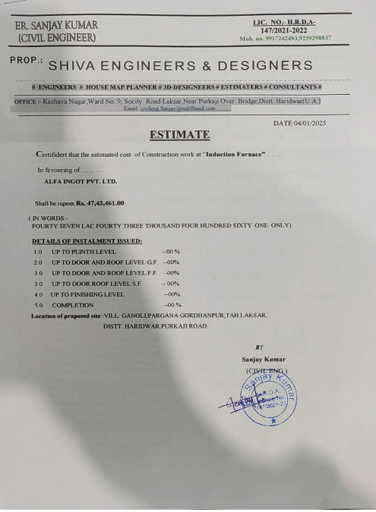
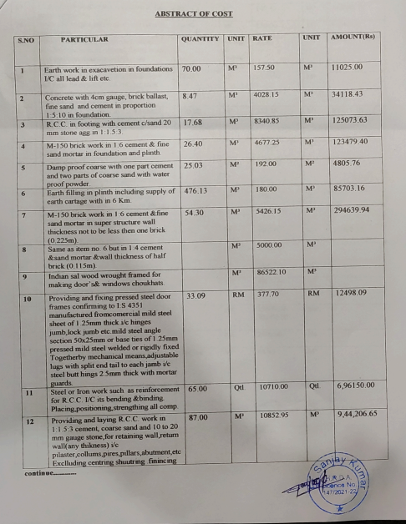

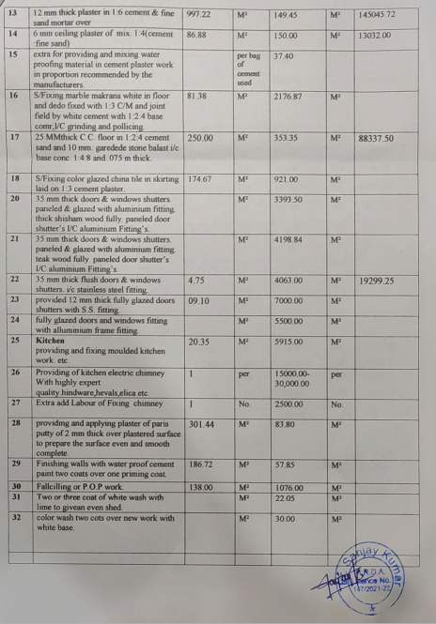

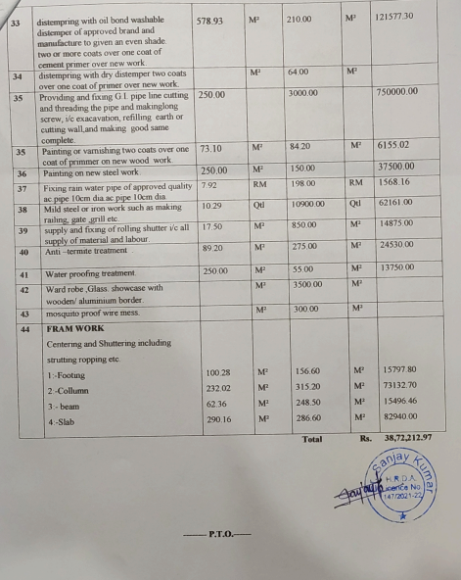
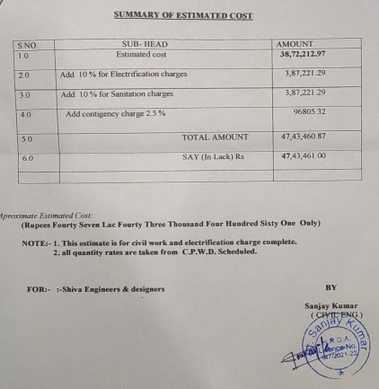
PART E | DISCLAIMER

- We have only received quotations for construction and civil work and no physical verification has been done.
- The client/ owner and its management/ representatives warranted to us that the information they have supplied was complete, accurate and true and correct to the best of their knowledge. All such information provided to us either verbally, in writing or through documents has been relied upon in good faith and we have assumed that it is true & correct without any fabrication or misrepresentation. I/We shall not be held liable for any loss, damages, cost or expenses arising from fraudulent acts, misrepresentations, or willful default on part of the owner, company, its directors, employee, representative or agents.
- Legal aspects for e.g. Investigation of title, ownership rights, lien, charge, mortgage, lease, sanctioned maps, and verification of documents provided to us such as title documents, Map, etc. from any concerned Govt. office etc. have to be taken care by legal expert/ Advocate and same is not done at our end. I/ We assume no responsibility for the legal matters including, but not limited to, legal or title concerns.
- Wherever any details are mentioned in the report in relation to any legal aspect of the property such as name of the owner, leases, etc. is only for illustration purpose and should not be construed as a professional opinion. Legal aspects are out of scope of this report. Details mentioned related to legal aspect are only based on the copy of the documents provided to us and whatever we can interpret as a non-legally trained person. This should be cross validated with a legal expert. We do not vouch any responsibility regarding the same.
- We have relied on the data from third party, external sources & information available on public domain to conclude the valuation. These sources are believed to be reliable and therefore, we assume no liability for the truth or accuracy of any data, opinions or estimates furnished by others that have been used in this analysis. Where we have relied on the data, opinions or estimates from external sources, reasonable care has been taken to ensure that such data is extracted from authentic sources, however we still can’t vouch its authenticity, correctness, or accuracy.
- Documents, information, data including provided to us during the course of this assessment by the client is reviewed only upto the extent required in relation to the scope of the work. No document has been reviewed beyond the scope of the work. These are not reviewed in terms of legal rights for which we do not have expertise. Wherever any information mentioned in this report is mentioned from the documents like owner’s name, etc., it is only for illustration purpose and may not necessarily represent accuracy.
- This cost vetting is done only on the basis of market research and BOQ provided to us by the company and we don’t recommend any sort of recommendation in our Document.
- The estimated cost verification of item to item can’t exactly match as per our vetting due to several market consideration. In some of the items it is lower while in some of the item’s price comes to be higher but on an average the price as per list provided to us falls in the range as confirmed by us.
- There can be variation in the estimated price if the specification & make of any items procured is different from the list provided to us during assessment.
- The estimated cost verification is made based on the third-party information which has been replied upon in good faith.
- Ownership and other legal point of view in respect of the asset is not considered in this report as same is out of scope of this document.
- This document is made at the request of the Bank.

For R.K Associates Valuers & Techno FOR INTERNAL USE Engineering Consultants (P) Ltd. PREPARED BY: Manmohan REVIEWED BY: Anil Kumar

