REPORT FORMAT: CL-1 | Version: 1.0_2018

FILE No.: VIS (2024-25)-PL696-626-865 Date: 22-01-2025

- REPORT NAME: Cost Verification Report for Vehicles which are proposed to be purchased by M/s Snow Way Logistics Pvt. Ltd.
- PREPARED FOR ORGANIZATION: State Bank of India, Agri CPC, Thane, Maharashtra – 400604.
- BORROWER COMPANY’S NAME: M/s Snow Way Logistics Pvt. Ltd.
- ASSET TYPE: Reefer Trucks with Chassis, Container and Refrigeration Unit.
- CURRENT LOCATION OF THE MACHINES: Proposed to be purchased by M/s Snow Way Logistics Pvt. Ltd.
TO WHOM IT MAY CONCERN

S. NO. | PARTICULARS | DESCRIPTION
1. | Date of Survey | Not Applicable
2. | Date of Report | 22-01-2025
3. | Documents provided for perusal | Quotations of the machines
4. | Current Location of the Machines | Not Applicable (Vehicles)
5. | Borrowing Company | M/s Snow Way Logistics Pvt. Ltd.
6. | Type of Asset | Reefer Trucks with Chassis, Container and Refrigeration Unit.
7. | Type of Assessment | Cost Verification
8. | Scope of Assessment | Cost Verification of the new vehicle with accessories which are proposed to be purchased by the company.
9. | Year of Manufacturing | Yet to be purchased
10. | Total Project Cost | Rs. 2,45,46,691 (Total project cost includes only the purchase cost as per the quotations / invoices / purchase orders provided by the company). Including G.S.T.
11. | Current Estimated Market Value | The range of current market rates of such type of machinery & equipment is verified from various suppliers and also from the public domain for the new machinery and equipment’s.  As per quotes received from market and online references, we are of the view that rate range for establishing the machinery of similar kind of machinery are available around Rs. 2.35 crores to Rs. 2.5 crores.  According to our observation, the rate as per the list of machinery and their total purchase price provided to us by the company/ bank are quite reasonable when compared to the rates of similar machines currently prevailing in the market.
12. | Condition of Machines | The machines are yet to be purchased / installed.

OBSERVATIONS:
- We have been provided with the copy of quotation mentioning cost of machines/ equipment by the borrower company.
- As per the information provided by the company officials these machines are proposed to be purchased by M/s Snow Way Logistics Pvt. Ltd.
- We have contacted several dealers for similar items and also did research on the public domain. Accordingly, we have got the quotation from the dealers and found that the price given in the list of quotations provided to us is well within the price range of similar items available in the market and seems to be reasonable.
- In this report, there can be some difference in the cost due to the cost of some factors like model, accessories and taxes etc.
- Also, the cost of any accessories, container like labour cost varies according to the scope of work and it is not possible to calculate exact amount for any fabrication work. So, we have considered the same as mentioned in the quotations provided by the company.
- Based on the information provided by the company (M/s Snow Way Logistics Pvt. Ltd.) and enquiries made by us in the open market and references found on the public domain for similar vehicles and accessories, it is certified that the total market cost for the procurement of similar vehicles and accessories with similar specifications should be around Rs. 2.35 crores to Rs. 2.5 crores and therefore the total purchase price of Rs. 2,45,46,691 /- (Incl. GST) (as per the quotations provided to us by the company) appears to be reasonable.
Disclaimer:
  - This cost vetting is done only on the basis of quotations provided to us by the company and we don’t recommend any sort of recommendation in our Report.
  - The estimated cost verification of item to item can’t exactly match as per our vetting due to several market consideration. In some of the items it is lower while in some of the item’s price comes to be higher but on an average the price as per list provided to us falls in the range as confirmed by us.
  - There can be a variation in the estimated price depending upon the quality of the products used for the manufacturing of the container and accessories.
  - There can be variation in the estimated price if the specification & make of any items procured is different from the list provided to us during assessment.
  - The estimated cost verification is made based on the third-party information which has been replied upon in good faith.
  - The estimated price may vary at the time of actual procurement because of change in prices in the market for such kind of items for which we will not have any control. The cost vetting is only limited to the date of Report issued. We do not assume any responsibility in change of prices of the said items after this date.
  - This report doesn’t include any work related to drawing, design, sketch plan, procurement of the machines.
  - Ownership and other legal point of view in respect of the asset is not considered in this report as same is out of scope of this report.
  - This report is made at the request of the Bank.

For R.K Associates Valuers & Techno FOR INTERNAL USE Engineering Consultants (P) Ltd. TYPED BY: Manmohan REVIEWED BY: Abhinav Chaturvedi

ANNEXURE: - I (COMPARISON LIST)

S. No. | Name | Specifications | Vendor | QTY (in nos.) | Amount shown by company | Market Rate as per RKA
 |  |  |  |  | (Including GST) (INR)
1 | Eicher Pro 3018 Plus M CBC 24ft. BS VI NGB-190 | Wheelbase - 5490 mm , Power - 160 HP, GVW- 18,000 Kg. , Tyre Size - 295/90 R20 | Tholia Motors Private Limited | 5 | 1,46,04,195 | 1,44,24,674
2 | Supply, Installation of 24ft. Long insulated truck body with Supra 1150 Reefer unit | 7.3 m (L) x 2.65 m (W) x 2.9 m (H) with PUF Insulated Reefer container (MS Corrugated Panel), externally in PPGI corrugated form, Internal in 0.5 mm SS sheet with 4mm plywood | Bellmonte Industries Private Limited | 5 | 99,42,496 | 95,34,400
Total |  |  |  |  | 2,45,46,691 | 2,39,59,074

ANNEXURE:- II (QUOTATIONS/ REFERENCES FROM MARKET)
VEHICLES
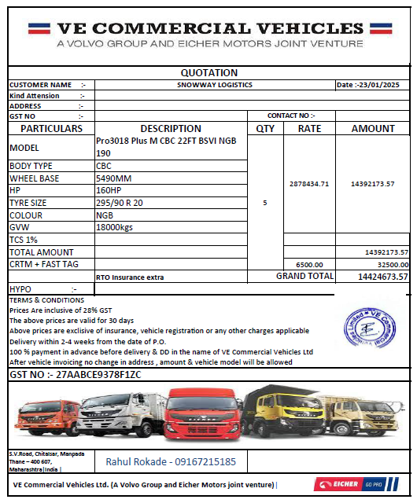

FOR CONTAINER AND REEFER UNIT
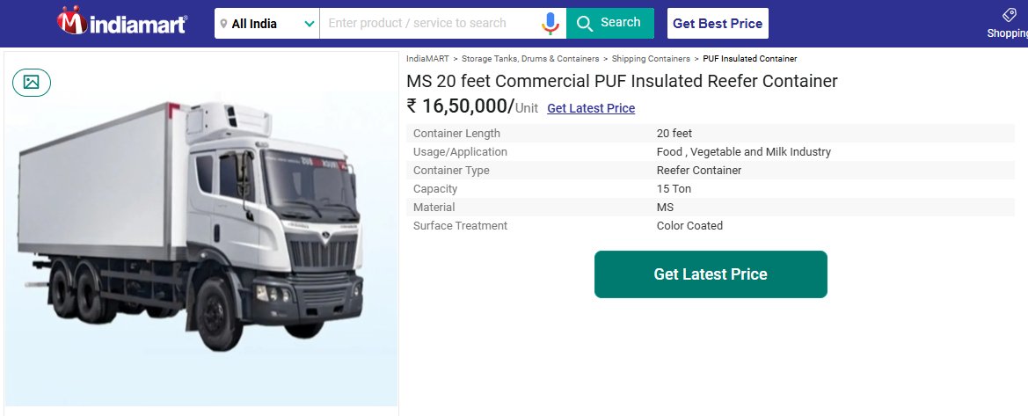

ANNEXURE: - III (DOCUMENTS PROVIDED BY CLIENT)
VEHICLES
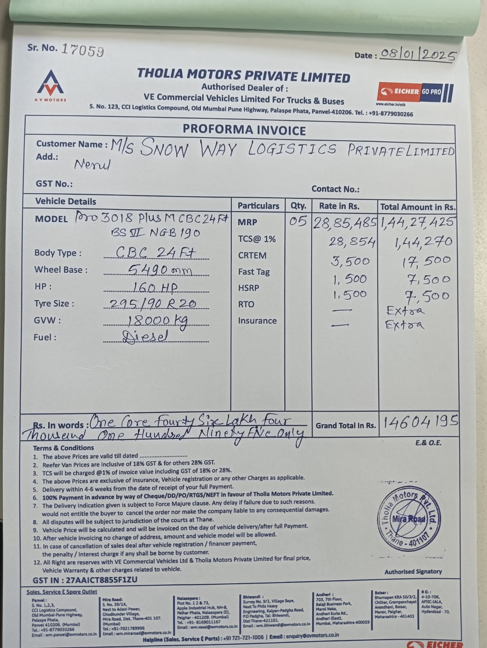

FOR CONTAINER AND REEFER UNIT
