File No.: VIS (2024-25)- PL704-632-871 Dated: 25.02.2025

TECHNO-ECONOMIC VIABILITY STUDY REPORT
OF

THE HUB
(RERA NO. UPRERAPRJ553225)

SETUP BY

JYOTI SUPER CONSTRUCTION AND HOUSING PRIVATE LIMITED

REPORT PREPARED FOR

PUNJAB NATIONAL BANK, MCC-2 BRANCH, MEERUT

**Important - In case of any query/ issue or escalation you may please contact Incident Manager Valuers@rkassociates.org. We will appreciate your feedback in order to improve our services.

NOTE: As per IBA Guidelines please provide your feedback on the report within 15 days of its submission after which report will be considered to be correct

IMPORTANT NOTICE

COPYRIGHT FORMAT: This report is prepared on the copyright format of R. K. Associates Valuers & Techno Engineering Consultants (P) Ltd. (R. K. Associates) to serve our clients with the best possible information and analysis to facilitate them to take rational business decisions. Legally no one can copy or distribute this format without prior approval from R. K. Associates. It is meant only for the advisory/ reference purpose for the organization/s as mentioned on the cover page of this report. Distribution or use of this format or report or any of its content/ information/ data by any organization or individual other than R.K Associates will be seen as an unlawful act and necessary legal action can be taken against the defaulters.
This report is intended for the sole use of the intended recipient/s and contains material that is STRICTLY CONFIDENTIAL AND PRIVATE.

DEFECT LIABILITY PERIOD: In case of any query/ issue or escalation you may please contact Incident Manager at valuers@rkassociates.org. Though adequate care has been taken while preparing this report as per its scope, but still, we can’t rule out typing, human errors, over sightedness of any information or any other mistakes. Therefore, the concerned organization is advised to satisfy themselves that the report is complete & satisfactory in all respect. Intimation regarding any discrepancy shall be brought into our notice immediately. If no intimation is received within 15 (Fifteen) days in writing from the date of issuance of the report, to rectify these timely, then it will be considered that the report is complete in all respect and has been accepted by the client up to their satisfaction & use and further to which R.K Associates shall not be held responsible in any manner.

Part N: R. K. Associates Important Disclaimer and Remarks are integral part of this report and Feasibility assessment is subject to this section. Reader of the report is advised to read all the points mentioned in these sections carefully.

TABLE OF CONTENTS
SECTIONS | PARTICULARS | PAGE NO.
Part A | Report Summary | 4
Part B | Introduction
 | - About the Report | 6
 | - Executive summary | 6
 | - Purpose of the Report | 9
 | - Scope of the Report | 9
 | - Methodology/ Model Adopted | 10
 | - Data Information received from | 10
 | - Documents/ Data Referred | 11
Part C | Company Profile
 | - Company Overview | 12
 | - Shareholding Details | 13
 | - Promoters/Directors Profile | 13
Part D | Technical Feasibility of The Proposed Project
 | - Project Location | 15
 | - Location Map | 15
 | - Land Details | 17
 | - Building & Civil Works | 17
 | - Layout Plan | 21
 | - Site Pictures | 26
 | - Technical Team | 31
 | - Utilities | 31
 | - Site Visit Observation | 31
 | - Conclusion | 32
Part E | Inventory Profile
 | - Introduction | 33
 | - Inventory Category | 34
 | - Marketing, Selling & Distribution Plan | 41
Part F | Project’s Marketing Feasibility | 42
Part G | SWOT Analysis | 49
Part H | Risk Analysis | 51
Part I | Project Cost and Means of Finance | 53
Part J | Project Implementation Schedule | 55
Part K | Statutory Approvals | Licences | NOC | 56
Part L | Project’s Financial Feasibility
 | - Projection of Firm | 58
 | - Graphical Representation of Key Financial Metrics | 61
 | - Revenue Build-Up | 62
 | - Loan Amortization Schedule | 64
 | - Key assumptions & Basics | 65
Part M | Conclusion | 69
Part N | Disclaimer | Remarks | 71

PART A | REPORT SUMMARY

S. NO. | PARTICULAR | DESCRIPTION
 | Name of the Company: | M/s Jyoti Super Construction and Housing Private Limited
 | Address of the Company: | Registered Office: D-371, T/F, Bhagwati Garden Extension, West Delhi, Uttam Nagar, Delhi-110059.  Corporate Office: 7 & 8, Ground Floor, Jyoti super Street, Noor Nagar, Raj Nagar extension, Ghaziabad, Uttar Pradesh - 201017
 | Project Name | The Hub
 | Project Location: | Khasra No. 1181(M) & 1183(M), Village Noor Nagar, Pargana-Loni, Raj Nagar Extension, Tehsil & District- Ghaziabad, Uttar Pradesh - 201017
 | Project Type: | Real Estate Project
 | Project Industry: | Commercial Real Estate
 | Product Type / Deliverables: | Shops, Studio Apartment & Office Space of various sizes and Hotel
 | Report Prepared for Organization: | Punjab National Bank, MCC-2 Branch, Meerut
 | TEV Consultant Firm: | M/s. R.K Associates Valuers & Techno Engineering Consultants (P) Ltd.
 | Report type: | Techno-Economic Viability Report
 | Purpose of the Report: | To assess Project’s Technical and Economic Viability for the purpose of seeking external financial assistance on the Project.
 | Scope of the Report: | To assess, evaluate & comment on Technical and Economic Viability of the Project as per data information provided by the client, independent Industry research and data/ information available on public domain.
 | Date of Report: | 25th February, 2025
 | Documents referred for the Project: | - PROJECT INITIATION DOCUMENTS:  - Financial Projections of the Project  - Statutory Approval Details  - Redevelopment Agreement  - Old Approved Layout and Site Plan  - Sanctioned Modification of Combined FAR  - PROCUREMENT DOCUMENTS:  - Sale Deed for Project Land  - Agreement to Sale for different types of Units  - Loan Repayment Chart  - Implementation Schedule  - STATUTORY APPROVALS, LICENCES & NOCs  - RERA Certificate  - NOC for Height Clearance  - GST Registration Certificate  - MOA  - Provisional Fire NOC
 | Means of Finance: | Equity & Debt (Proposed D/E Ratio: 0.67)
 | Key Financial Indicators: | KEY INDICATORS VALUE  Average DSCR 2.19  Average EBIT Margin 39.30%  Avg. PAT Margin 24.15%  NPV INR 2,983.85 Lakhs  IRR 46.65%
Note: Above financial indicators are based on the financial projections of the project provided by the firm and assessment and analysis of the same done by us.
PART B | INTRODUCTION

- ABOUT THE REPORT:
Techno-Economic Viability Study Report of the proposed real estate development of commercial Space known as “The HUB” situated on Khasra No. 1181(M) & 1183(M), Village Noor Nagar, Pargana-Loni, Raj Nagar Extension, Tehsil & District- Ghaziabad, Uttar Pradesh – 201017 by M/s Jyotisuper Construction and Housing Private Limited.

- EXECUTIVE SUMMARY:
M/s Jyotisuper Construction and Housing Private Limited was incorporated as a private limited company under the provisions of the Indian Companies Act, 1956 on 22nd October 2002. The company had been established for the purpose of developing and sub-dividing real estate into lots. It came under the management of Mr. Uday Veer Singh in year 2004, when he was appointed a director of the company and later in year 2011 Mr. Sushant Chowdhary was appointed as director of the company.
The company is registered at Registrar of companies, Delhi with CIN: U45201DL2002PTC117425 and registered office D-371, T/F, Bhagwati Garden Extension, West Delhi, Uttam Nagar, Delhi-110059. The company is promoted by the directors who appears to be well experience in the construction industry as per the profile shared to us by the client and information available in the public domain about them. Over the past 20 years, the company had Developed 3 residential and commercial projects, transformed over 6 acres of land into vibrant communities which provided homes to over 250 families.
The proposed project “The HUB” (RERA Number: P51900055528) is about development of the commercial space on the land parcel located at Khasra No. 1181(M) & 1183(M), Village Noor Nagar, Pargana - Loni, Raj Nagar Extension, Tehsil & District- Ghaziabad, Uttar Pradesh – 201017 admeasuring 6,145 sq. metres. As per the details shared with us, the company will develop the project on its own by hiring local contractors and mason workers.
Jyoti Super acquired a total land area of 23,373 sq. meters. Of this, 13,010 sq. meters were developed into Jyoti Super Village, which has received its Completion Certificate (CC) and possession has been handed over to buyers. Additionally, 4,214 sq. meters were sold to DBS Infrastructure Private Limited—2,470 sq. meters (Khasra No. 1185) from Jile Singh and 1,744 sq. meters from a parcel originally purchased from Shaurya Buildcon. The remaining ~6,145 sq. meters are allocated the proposed project. (Refer the section “Technical Feasibility of The Proposed Project” in the later part of the report).
The promoters/partners of the firm are linked with the business of construction and thus possess good understanding of construction business. They have a strong presence in all major areas of real estate industry including residential, commercial and malls. The group have successfully developed multiple residential & commercial building in Ghaziabad, Uttar Pradesh. The promoters have maintained sound relations with raw materials and labor suppliers and different government bodies. All of these attributes would assist them in completing the project timely at a lower cost with quality work.
As per the information shared by the client/company, the company had completed various projects in Ghaziabad City. The company had hired seasoned professionals has a combined experience of over 40 years in the real estate industry. Some of the projects completed by the company are listed below:
S. No. | Name of Project | Type | Land Area | No. of Units | Area
1 | Jyoti Super Village | Residential cum commercial | More than 4 Acres | 168 Units Offices | Raj Nagar Extension
2 | Jyoti Super Gardenia | Group Housing project | 4988 sq. mts | 80 Units Flats | Indirapuram
3 | Jyoti Super Street | Commercial | - | 32 Shops | Raj Nagar Extension
As per the details shared with us by the client/company, the proposed project would be consisting of the following types of units:
FLOORS | Type
Shop LGF | 17
Commercial anchors LGF | 5
Shops GF | 29
Commercial Anchor GF | 4
Shops FF | 29
Commercial Anchor FF | 4
Office Units at 4th floor | 56
Office Units at 5th floor | 41
Office Units at 6th floor | 41
Office Units at 7th floor | 65
Studio Apartments at 9th floor | 18
Studio Apartments at 10th floor | 18
Studio Apartments at 11th floor | 18
Studio Apartments at 12th floor | 18
Restaurants at 2nd floor | 2
Banquets | 2
Total | 367
As per the details shared with us, out of the 367 units (admeasuring 2,12,535 sq. ft.), 318 units (admeasuring 1,36,744 sq. ft.) has been sold to the customers amounting to INR 5,328.61 lakhs with INR 2237.31 Lakhs has already been collected from the customers and pending 3091.30 Lakhs will be received after the completion certificate of the project is received. The remaining 49 units (admeasuring 75,820 sq. ft.) are yet to be sold out.
As per the details shared with us, the layout plan of the proposed project had been prepared by Mr. Abhishek Singh (Reg. No. CA/2013/60896). The company had obtained the GDA approval on its initial plan of 14 Floors with reference number 223/M.P./Zone-1/2020-21 (Map Number: MAP20190206144122753). But since, the company had modified the plan reducing it to 12 floors from 14 floors but still utilizing the combined approved FAR as the sanctioned plan. As informed by the company, it has applied for the sanction of the modification made in the plan but it has received the approval for the plan till 3rd floor and the plan for the rest of floors is yet to be approved.
As per data/information provided to us, the firm has obtained some necessary Statutory Approvals/NOC’s such as RERA, Environment Clearance, Airport NOC etc. from the respective authorities. (Refer the section Statutory Approval in the later part of the report).
As per the details shared by the client, the cost of the proposed project from scratch to trial run is being estimated as INR 7,462.50 lakhs, the company had already completed the works amounting to INR 3,839.08 lakhs (including the cost of land) as per the Engineers’ Certificate dated 14.01.2025 shared with us. For the work completed till now, the project had been funded through promoter’s contributions of INR 1,601.77 lakhs and INR 2,237.31 lakhs from advances from customers with respect to the units booked. For the remaining work to be completed amounting to INR 3,623.42 lakhs, the project is proposed to be funded through a term loan of INR 3,000.00 lakhs, INR 300.00 lakhs from promoter’s margin and INR 323.42 lakhs will be from advances from customers with respect to the units booked. (For Project Cost breakup, refer the section “Project Cost and Means of Finance” in the later part of the report).
As per the information shared by the client/company, the boundary wall of the site location has been completed. Apart from that, the structure of the building has been completed as per the details of the modified plan shared with us by the company. During the site survey, we found that that, currently, Plumbing and Fire-Fighting Work has started and is ongoing. (Kindly refer the site pictures captured during the survey attached in the later section of the report).
At present, the company is in discussion with bank to fund the project through a term loan of INR 30.00 Crores. In this regard, Punjab National Bank, MCC-2 Branch, Meerut has appointed R.K. Associates to assess the Techno-Economic Viability of the proposed project at Khasra No. 1181(M) & 1183(M), Village Noor Nagar, Pargana-Loni, Raj Nagar Extension, Tehsil & District- Ghaziabad, Uttar Pradesh - 201017 based on our independent EIC research and information/data provided to us about the project by M/s Jyotisuper Construction and Housing Private Limited.

- PURPOSE OF THE REPORT:
To assess the Techno-Economic Feasibility of the proposed real estate development project to take project funding decision for the same.

- SCOPE OF THE REPORT:
To assess, evaluate & comment on Techno-Economic Feasibility of the proposed real estate development project being developed up by M/s Jyotisuper Construction and Housing Private Limited as per the data/information provided by the client/promoter/stakeholder and our independent EIC research.
NOTES:
- Project status is taken as per the information provided by the company/promoter/stakeholder and independently verified during the site inspection also.
- Scrutiny about the company, background check, credibility, credit worthiness of the company or its promoters is out-of-scope of this report.
- This report is only an opinion in respect to Financial Feasibility of the project as per the future Projections provided by the company and independent analysis done by us and doesn’t contain any recommendations including taking decision on the financial exposure.
- Any verification of the documents/ information from originals/ source is out-of-scope of this report.
- This is not an audit activity of any kind. We have relied upon the data/ information supplied by the company in good faith that it is true and without any fabrication.
- Any review of the existing business of the promoters is out of scope of this report.
- For the purpose of cost estimation of the project, we have referred the Cost Estimation report prepared by the Er. Prateek Tyagi (Licensed Engineer) (Ref. No.: AM 3058762/15052023) appointed by the client/company. However, we have used our organisational expertise in this regard wherever required.
- This is not a Detailed Project Report or Detailed Cost Vetting Report or a detailed design or architecture document. Land and property details mentioned in the report is only for illustration purpose as per the information provided to us by the client. The same doesn’t tantamount for taking any responsibility regarding its legality, ownership and conforming to statutory norms.

- METHODOLOGY/ MODEL ADOPTED:
- Data/Information collection.
- Review of Data/ Information collected related to Techno-Economic Viability study.
- Independent review & assessment of financial projections provided by the company/promoters.
- Review and analysis of the Projections as per the market trends and futuristic growth opportunity of the industry and company.
- Projections of Revenue, P&L, Balance Sheet, Working Capital Schedule, Depreciation Schedule, Loan Schedule as per the inputs given by the company and assessed by us.
- Calculation of key financial indicators and ratio analysis including DSCR, NPV & IRR and payback period of the project.
- Report Compilation and Final Conclusion.

- DATA/ INFORMATION RECEIVED FROM:
All the data/Information has been received from Mr. Abhi Dinesh and the required details about him shown in the below table:
Particulars | Details
Name | Mr. Abhi Dinesh
Company | Jyotisuper Construction and Housing Private Limited
Email Address | jyotisupercons@gmail.com

- DOCUMENTS / DATA REFFERED:
- Financial Projections of the proposed project up to FY 2029.
- Memorandum of Association of the company.
- Director’s Details & Shareholding Pattern.
- Proposed Total project cost.
- Agreement to sell for different types of units.
- Site/Layout Plan.
- Certificates of Statutory approvals/NOCs.
- Survey Report conducted at the site.
- Land Deeds
- Sample Invoices from the suppliers of the project.
- Cost Estimations for civil and construction works.

PART C | COMPANY PROFILE

- COMPANY OVERVIEW:
As per the data/information shared by the client/company, M/s Jyoti Super Construction and Housing Private Limited was incorporated on 22nd October 2002 with CIN: U45201DL2002PTC117425 is a company limited by shares having its Registered Office at D-371, T/F, Bhagwati Garden Extension, West Delhi, Uttam Nagar, Delhi, India-110059. The company was primarily incorporated for the purpose of management of residential and commercial properties. The Permanent Account Number (PAN) of the LLP is AABCJ3395F and GSTIN is 09AABCJ3395F1ZG.
As per the details shared by the client/company, the promoters of the company have proposed to develop a commercial space at Khasra No. 1181(M) & 1183(M), Village Noor Nagar, Pargana-Loni, Raj Nagar Extension, Tehsil & District- Ghaziabad, Uttar Pradesh – 201017. The construction work of the project has been started and is going on in full swing. Below table shows the registration details of the company:
Details of the Company
Particular | Description
Company / LLP Name | M/s JyotiSuper Construction and Housing Private Limited
Date of Incorporation | 22nd October 2002
CIN | U45201DL2002PTC117425
Registration Number | 117425
ROC | ROC – Delhi
Category of Company | Company limited by shares
Subcategory of the Company | Non-government company
Class of Company | Private
Registered Address | D-371, T/F, Bhagwati Garden Extension, West Delhi, Uttam Nagar, Delhi, India-110059.
Authorised Capital (Rs) | 5,00,00,000
Paid up Capital (Rs) | 1,00,00,000
Date of last AGM | 30/09/2024
Date of Balance Sheet | 31/03/2024
Source: As per the data shared by the client and available on the MCA website

- SHAREHOLDING DETAILS:
As per the data available on MCA website, the company is having authorised capital is INR 5,00,00,000 and the paid-up capital is INR 1,00,00,000 on the date of last balance sheet dated 31.03.2024. The shareholding details of the company is mentioned below:
S. No. | Nature of Shareholders | No. of Shares | % Holding
1 | Gunika Sharma | 2,72,500 | 27.25%
2 | Radicon Housing Private Limited | 2,27,500 | 22.75%
3 | Uday Vir Singh | 3,85,000 | 38.50%
4 | Rekha Rani | 25,000 | 2.50%
5 | Sushant Chaudhary | 90,000 | 9.00%
 | TOTAL | 10,00,000 | 100.00%
Source: Data/Information provided by the client.

- KEY PROMOTER’S/DIRECTORS PROFILE:
As per data/information provided by the client about the promoters & directors, below table illustrate the educational & professional experience of the promoters along with the Address, DIN and contact details of M/s Jyotisuper Construction and Housing Private Limited:
S. No. | Name / D.O.B. | Designation/DIN | Address & Contact Details | Appointment Date | Qualifications/Experience
1 | Mr. Uday Vir Singh  (8th May 1965) | Director  DIN: 00071877 | House No. A-3, Sector-30 Noida, Gautam Buddha Nagar, Uttar Pradesh - 201301 | 12th January 2004 | Mr. Uday Vir Singh has more than 30 years’ experience in real estate and has worked with renowned real estate companies.
2 | Mr. Sushant Chaudhary  (3rd July 1991) | Director  DIN: 02842980 | House No. A-3, Sector-30 Noida, Gautam Buddha Nagar, Uttar Pradesh - 201301 | 2nd April 2011 | Mr. Sushant Chaudhary has completed BBA (Amity University), MBA (IMT Ghaziabad), Masters in Real Estate (Finance & Investment) New York University.
Source: Data/ Information provided by the company
To give a brief overview of the background of Directors we have listed down the basic company information as found on public domain in general/ tertiary category research.
(Mr. Udayvir Singh)
S. No. | CIN/Designation | Company Name | Date of Appointment at Current Designation | Date of cessation (if applicable)
1 | U45200DL2008PTC175404  (Director) | Sheoran Infrastructure Private Limited | 14/03/2008 | -
2 | U45200DL2008PTC175415  (Additional Director) | Sheoran Buildcon Private Limited | 12/06/2012 | -
3 | U80903DL2005PTC142911  (Additional Director) | Jyoti Academies Pvt Ltd | 07/05/2007 | -
4 | U45201DL2004PTC129480  (Director) | Jyoti Sarav Priya Constructions Private Limited | 28/09/2004 | -
5 | U45201DL2002PTC117425  (Director) | Jyotisuper Construction and Housing Private Limited | 12/01/2004 | -
6 | U45200DL2006PTC155783  (Director) | SRS Heights Private Limited | 22/11/2006 | 28/12/2007
7 | U45201HR2004PTC103143  (Director) | Jyotisuper Builders Private Limited | 08/09/2004 | 27/11/2008
8 | U45400DL1995PLC069126  (Additional Director) | Keltech Infrastructure Limited | 02/05/2013 | 25/08/2013
9 | U45400DL2010PTC207364  (Director) | Camelot Infra Private Limited | 20/08/2010 | 18/11/2010
Source: Information extracted from MCA & public domain
(Mr. Sushant Chaudhary)
S. No. | CIN/Designation | Company Name | Date of Appointment at Current Designation | Date of cessation (if applicable)
1 | U45201DL2002PTC117425  (Director) | Jyotisuper Construction and Housing Private Limited | 02/04/2011 | -
2 | U45200DL2008PTC175415  (Additional Director) | Sheoran Buildcon Private Limited | 15/01/2010 | -
3 | U45400DL2010PTC207364  (Director) | Camelot Infra Private Limited | 20/08/2010 | 18/11/2010
Source: Information extracted from MCA & public domain

PART D | TECHNICAL FEASIBILITY OF THE PROPOSED PROJECT

- PROJECT LOCATION:
The company proposes to develop a commercial space titled as “The HUB” situated on piece and parcel situated at Khasra No. 1181(M) & 1183(M), Village Noor Nagar, Pargana-Loni, Raj Nagar Extension, Tehsil & District- Ghaziabad, Uttar Pradesh – 201017, which is spread over an area of ~6,145.00 square meters as per the information shared by client/LLP.
The property is having the proximity to the civic amenities such as hospital (Vardan Multispecialty Hospital) is situated ~1.7 km away, school/college (DPS, Rajnagar) is situated ~2.6 km away and market (VVIP Style Mall) is situated ~1.8 km away from the site location. Table: 1 is showing the details of the adjoining properties of the land for plant’s site location and Table: 2 is showing the Connectivity Details of the Proposed Location:
Table: 1 Adjoining Property Details
Location | Details
East | Other Property
West | Residential Colony
North | Ramavatar Tyagi Road (Project Site’s Entry)
South | Jyoti Super Village
The proposed project is having excellent road connectivity, ensuring convenient access for the residents. It is situated in a prime location of Raj Nagar Extension; it enjoys proximity to major arterial roads and highways. Its strategic placement allows for easy accessibility from various parts of the city and surrounding areas. Surrounded by many residential localities with middle to high class of population.
Table: 2 Connectivity Details of the Proposed Location
Connectivity | Details
Rail | Ghaziabad Railway station which is 3.5 km away
Airport | Hindon Airport which is 14.0 km away
Road | Meerut Bypass Road/NH58 Bypass which is 2.8 km away

- LOCATION MAP:
- GOOGLE MAP LOCATION:
The Proposed project located at Khasra No. 1181(M) & 1183(M), Village Noor Nagar, Pargana-Loni, Raj Nagar Extension, Tehsil & District- Ghaziabad, Uttar Pradesh – 201017. Project location would be 28°42'21.5"N and 77°26'05.6"E in Ghaziabad, Uttar Pradesh and the location as per the Google map is attached below with the link.
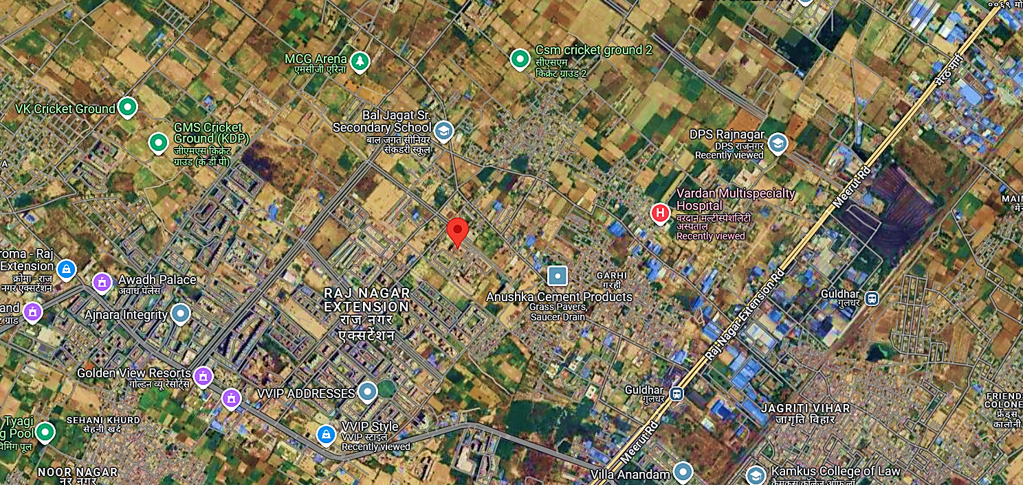

- GOOGLE MAP LAYOUT:
Demarcation of the whole project site with approximate measurement on the Google map are attached below:
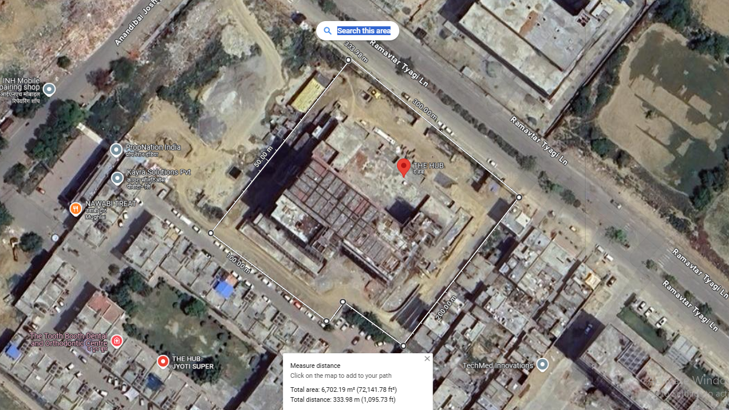
- LAND DETAILS:
For the purpose of developing a commercial space titled as “The HUB” situated on at Khasra No. 1181(M) & 1183(M), Village Noor Nagar, Pargana-Loni, Raj Nagar Extension, Tehsil & District- Ghaziabad, Uttar Pradesh – 201017. The total land is spread over an area of 6,145.00 square meters as per the sale deed and approved layout plan (Initial Plan) provided to us by the company.
The land details purchased by M/s Jyotisuper Construction and Housing Private Limited is shown in the table below:
Deed No. | Date | Amount (Incl. Stamp Duty) | Area | Khasra No. | Seller
7912 | 17-10-2008 | 4,08,25,000.00 | 0.949 | 1181, 1183 | M/s Shaurya Buildcon Private Limited
11526 | 18-11-2011 | 1,92,60,000.00 | 0.1923 | 1183 | Sh. Mahavir Singh
954 | 25-01-2012 | 3,95,90,000.00 | 0.247 | 1185 | Sh. Jile Singh
6685 | 03-09-2008 | 4,08,25,000.00 | 0.949 | 1181, 1183 | M/s Shaurya Builders Private Limited
 | Total | 14,05,00,000.00 | 2.3373
Jyoti Super had purchased a total land area of 23,373 sq. mt. Out of which, 13,010 sq. mt. is utilized for another project of the company named “Jyoti Super Village” which has achieved its CC and the possession has been given to the respective buyers. Apart from that, a land area of 4,214 sq. mt. is sold to DBS Infrastructure Private Limited (2,470 sq. mt. of khasra number 1185 purchased from Sh. Jile Singh and 1,744 sq. mt. from the land parcel purchased from Shaurya Buildcon). Remaining land area of ~6,145 sq. mt. is utilised for the proposed project.
As per the CA Certificate prepared by Rajeev Sharma & Associates dated 08.01.2025 submitted to UPRERA, the cost of land (incl. the acquisition and legal cost) is INR 225.00 Lacs. As per the information shared by the client, the subject land is demarcated with boundary wall, and the same is confirmed by us during the site survey.

- BUILDING & CIVIL WORKS:
As per the information shared by the client/company, M/s Jyotisuper Construction and Housing Private Limited has proposed to develop a commercial space titled as “The HUB”. The total plot area of the land is 6,145.00 square meter as per the details available with us.
According to the shared layout plan, 5% of the total plot area of 6,145 sq. mt. is designated as a green area, amounting to 307.25 sq. mt. This results in a net plot area of 5,837.75 sq. mt. As per the status shared by the client and verified by us during the site visit on 23rd January 2025, the boundary wall of the site location has been completed. Apart from that, the structure of the building has been completed as per the details of the modified plan shared with us by the company. At Present, Plumbing and Fire-Fighting Work has started and is ongoing.
As per the estimated cost of proposed Building & Civil works provided by the client, the proposed cost of construction alongwith the built-up area is shown in the table below:
S. NO. | DESCRIPTION | DETAILING | COSTING= (AREA*COST)/ LUMPSUM | GST APPLICABLE | TOTAL VALUE
1 | Civil Works | Civil Mumty Machine Room, External Inter | 28,76,80,000.00 | 5,17,82,400.00 | 33,94,62,400.00
 |  | Boundary & Compound Wall | 90,50,000.00 | 16,29,000.00 | 1,06,79,000.00
 |  | RWH (Two) | 13,00,000.00 | 2,34,000.00 | 15,34,000.00
 |  | Road Pannels | 43,76,744.00 | 7,87,813.92 | 51,64,557.92
 |  | Kerbstone & Stamp Concreting & Saucerdrain | 1,25,000.00 | 22,500.00 | 1,47,500.00
 |  | External Levelling (Interlock Tiles) | 1,43,350.00 | 25,803.00 | 1,69,153.00
2 | Fire Fighting | Fire Fighting | 21,00,000.00 | 3,78,000.00 | 24,78,000.00
 |  | Fire Alarm & P.A Systems | 25,50,000.00 | 4,59,000.00 | 30,09,000.00
 |  | Core Cutting | 7,50,000.00 | 1,35,000.00 | 8,85,000.00
3 | Electrical | H.T PANNEL WORKS/ (CSS & TRANSFORMER) | 8,05,00,000.00 | 1,44,90,000.00 | 9,49,90,000.00
 |  | L.T PANNEL WORKS
 |  | ELECTRICAL EXTERNAL
 |  | SHOP LIGHTING/FAN
 |  | SHOWROOM LIGHTING
 |  | BANQUET LIGHTING
 |  | BASEMENT 2 LIGHTING
 |  | BASEMENT 1 LIGHTING
 |  | OFFICE SPACE LIGHTING (EACH)
 |  | STUDIO LIGHTING (EACH)
 |  | DG SET INSTALLATION
 |  | HIGH MAST
 |  | BOLLARD LIGHTS (G.F. + S.F.)
4 | HVAC | 2ND BASEMENT | 68,77,580.00 | 12,37,964.40 | 81,15,544.40
 |  | 1ST BASEMENT | 27,24,000.00 | 4,90,320.00 | 32,14,320.00
5 | Plumbing | CPVC/PVC/AAL LINING | 2,70,00,000.00 | 48,60,000.00 | 3,18,60,000.00
 |  | BASINWARES
 |  | C.P FITTINGS
 |  | CORE CUTTING
 |  | BORE
6 | STP/WTP | Sewage Treatment | 35,00,000.00 | 6,30,000.00 | 41,30,000.00
 |  | Water Treatment | 18,00,000.00 | 3,24,000.00 | 21,24,000.00
7 | Steel Railing/Ms Railing | LGF-Glass-Baluster | 32,00,000.00 | 5,76,000.00 | 37,76,000.00
 |  | Gf-Glass-Baluster
 |  | F.F-Glass Baluster
 |  | Second Floor-M.S. | 16,64,000.00 | 2,99,520.00 | 19,63,520.00
 |  | 3rd Floor-Front Glass
 |  | 4th Floor-Front Glass | 16,64,000.00 | 2,99,520.00 | 19,63,520.00
 |  | 5th Floor-Front Glass | 16,64,000.00 | 2,99,520.00 | 19,63,520.00
 |  | 6th -Front Glass | 16,64,000.00 | 2,99,520.00 | 19,63,520.00
 |  | 7th-Front Glass | 16,64,000.00 | 2,99,520.00 | 19,63,520.00
 |  | 8th-Front Glass | 16,64,000.00 | 2,99,520.00 | 19,63,520.00
 |  | 9th-Front Glass | 16,64,000.00 | 2,99,520.00 | 19,63,520.00
 |  | 10th-Front Glass | 16,64,000.00 | 2,99,520.00 | 19,63,520.00
 |  | 11th-Front Glass | 16,64,000.00 | 2,99,520.00 | 19,63,520.00
 |  | 12th-Front Glass | 16,64,000.00 | 2,99,520.00 | 19,63,520.00
 |  | 2nd Basement To 12th To Terrace | 16,64,000.00 | 2,99,520.00 | 19,63,520.00
8 | Flooring | External Granite
 |  | G.F. | 6,45,750.00 | 1,16,235.00 | 7,61,985.00
 |  | F.F. | 6,45,750.00 | 1,16,235.00 | 7,61,985.00
 |  | S.F-Terrace | 6,45,750.00 | 1,16,235.00 | 7,61,985.00
 |  | Shop Flooring (Per Shop) | 30,60,000.00 | 5,50,800.00 | 36,10,800.00
 |  | Banquet Flooring-G.F. | 24,00,000.00 | 4,32,000.00 | 28,32,000.00
 |  | Banquet Flooring-F.F. | 24,00,000.00 | 4,32,000.00 | 28,32,000.00
 |  | LGF Hyper Flooring | 5,10,000.00 | 91,800.00 | 6,01,800.00
 |  | S.F-Club | 24,00,000.00 | 4,32,000.00 | 28,32,000.00
 |  | 3rd Service Floor | 16,32,000.00 | 2,93,760.00 | 19,25,760.00
 |  | 4th To 7th Floor | 57,12,000.00 | 10,28,160.00 | 67,40,160.00
 |  | 8th Service Floor | 14,28,000.00 | 2,57,040.00 | 16,85,040.00
 |  | 9th To 12th Floor | 12,24,000.00 | 2,20,320.00 | 14,44,320.00
9 | Paint Work | Internal | 99,00,000.00 | 17,82,000.00 | 1,16,82,000.00
 |  | External | 15,98,519.34 | 2,87,733.48 | 18,86,252.82
10 | UPVC Work/Aluminium | 4th Floor To 7th Floor (Balcony + Entry) | 71,68,000.00 | 12,90,240.00 | 84,58,240.00
 |  | 9th Floor To 12th Floor (Balcony) | 19,45,600.00 | 3,50,208.00 | 22,95,808.00
11 | False Ceiling | Banquet G.F. | 18,00,000.00 | 3,24,000.00 | 21,24,000.00
 |  | Banquet F.F. | 18,00,000.00 | 3,24,000.00 | 21,24,000.00
 |  | GF Double Height | 3,00,000.00 | 54,000.00 | 3,54,000.00
 |  | GF+FF+LGF Corridors | 7,55,600.00 | 1,36,008.00 | 8,91,608.00
 |  | 4th Floor To 7th Floor (Common Areas) | 18,10,328.83 | 3,25,859.19 | 21,36,188.02
 |  | 9th Floor To 12th Floor (Common Areas) | 9,30,044.16 | 1,67,407.95 | 10,97,452.11
 |  | Dummy Walls (Gypsum Walls) | 6,00,000.00 | 1,08,000.00 | 7,08,000.00
12 | Ms/Fabrication | Rolling Shutter | 21,60,600.00 | 3,88,908.00 | 25,49,508.00
 |  | Hanging Garden, Society Side | 28,41,812.16 | 5,11,526.19 | 33,53,338.35
13 | Air Conditioning | Cooper Wiring for Shops | 16,20,000.00 | 2,91,600.00 | 19,11,600.00
 |  | Banquet G.F. | 25,00,000.00 | 4,50,000.00 | 29,50,000.00
 |  | Banquet F.F.
 |  | Office 4th & 8th Floor (VRF) | 52,00,000.00 | 9,36,000.00 | 61,36,000.00
 |  | Office 5th & 6th Floor (Single Unit Each) | 25,20,000.00 | 7,05,600.00 | 32,25,600.00
14 | Ducting & Smoke Management | Ducting For Restaurants | 22,00,000.00 | 3,96,000.00 | 25,96,000.00
 |  | Ducting For STP
15 | Beautification | ACP Sheets Coverage of Front Columns | 20,00,000.00 | 3,60,000.00 | 23,60,000.00
16 | Lift And Escalator | LIFT | 1,11,86,440.68 | 20,13,559.32 | 1,32,00,000.00
 |  | Escalator Civil Works | 5,00,000.00 | 90,000.00 | 5,90,000.00
17 | Soil Filling | Dumping Of Soil | 13,72,881.36 | 2,47,118.64 | 16,20,000.00
18 | Paper Work/ Docs | POLLUTION (CTE & CTO) | - | - | -
 |  | Water Control Board (Borewell)
 |  | GDA EDC Charges
 |  | GDA Compounding Charges
 |  | FIRE NOC
19 | Swimming Pool |  | 35,00,000.00 | 6,30,000.00 | 41,30,000.00
20 | CCTV |  | 30,00,000.00 | 5,40,000.00 | 35,40,000.00
21 | Mechanical Parking |  | 63,00,000.00 | 11,34,000.00 | 74,34,000.00
22 | Beautification Green Area |  | 12,80,000.00 | 2,30,400.00 | 15,10,400.00
 | TOTAL |  | 55,14,73,750.53 | 9,95,17,275.09 | 65,09,91,025.62
As per the above table, the estimated cost of the Building & Civil works is ~INR 6500.00 crores. The estimated cost of the Building & Civil works has been provided to us by the client which has been prepared by Er. Prateek Tyagi (Ref: Licensed Engineer, License No. AM 3058762/15052023).
As a TEV consultant, the estimated Building & Civil works cost has been verified independently by us, the Cumulative Construction cost per Sq. Ft. built up area is INR 2980, which we have found the cost to be reasonable & in the permissible range (+/- 5%) while it may change as per specifications & material brand.
As per the Engineers’ Certificate dated 12th January 2025, the company has completed the work of INR 3,614.08 Lakhs, out of the INR 7,200.00 lakhs (including the cost of construction and project clearance fees).

- LAYOUT PLAN:
As per the information shared by the client/company, the company had received the sanction on its layout plan on 9th October 2020, but since then the company has modified its building plan reducing it to 12 floors from 14 floors but still utilizing the combined approved FAR as the sanctioned plan. As per the data received, the company has received the approval for the modification made in the plan dated 15.02.2025. However, for the purpose of better understanding we have shown the old layout plan and the sanctioned modification of combined FAR below:

OLD APPROVED LAYOUT PLAN:
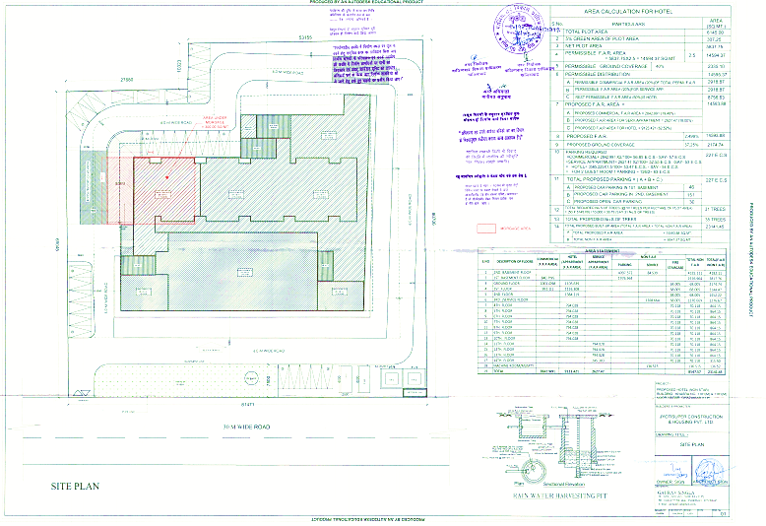
SANCTIONED COMPOUNDING DRAWINGS
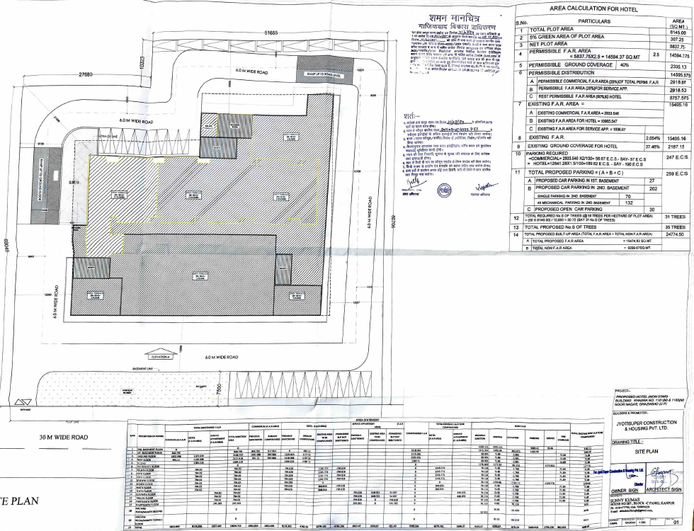
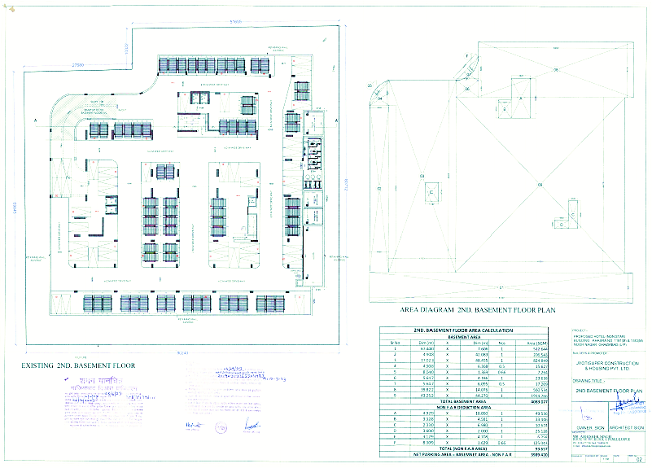
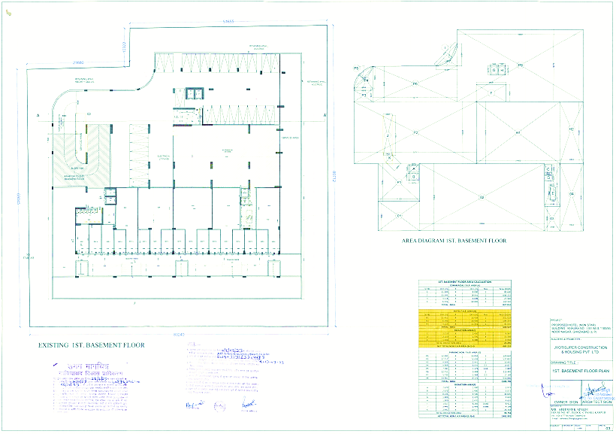

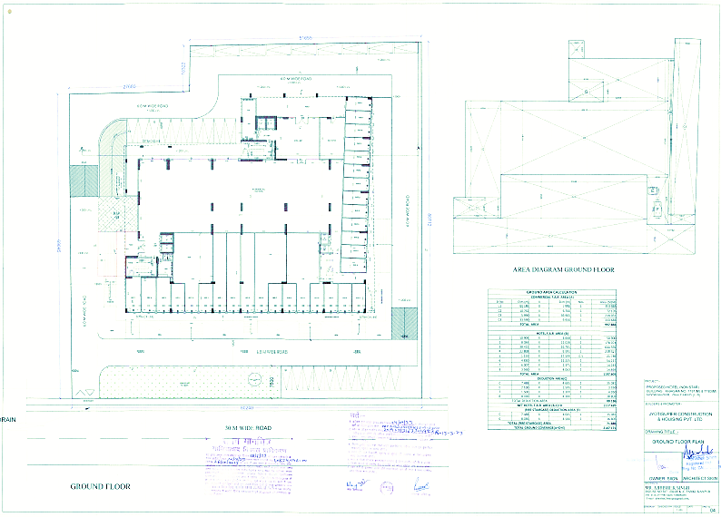
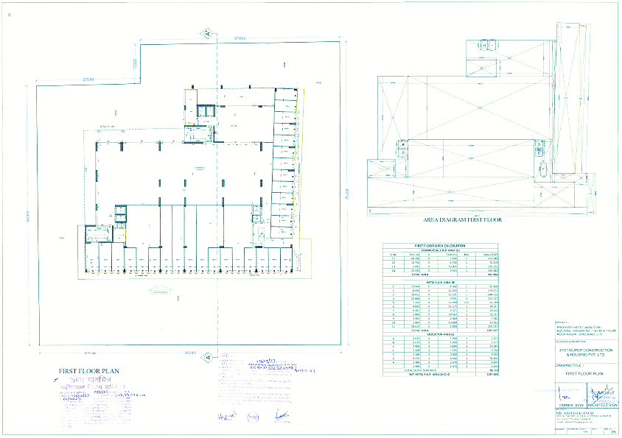
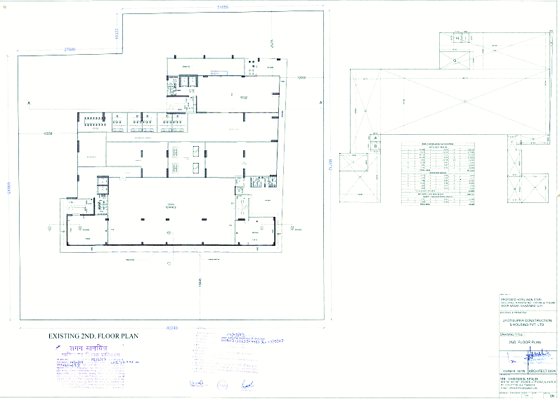
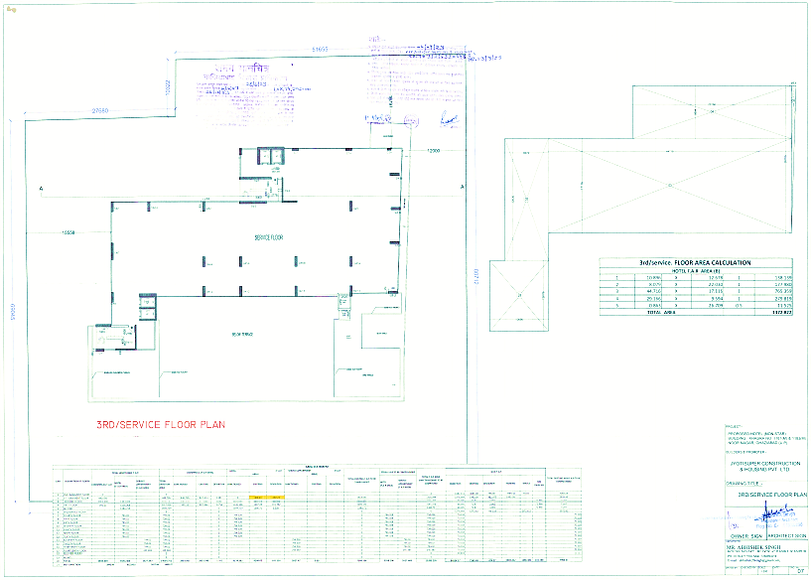
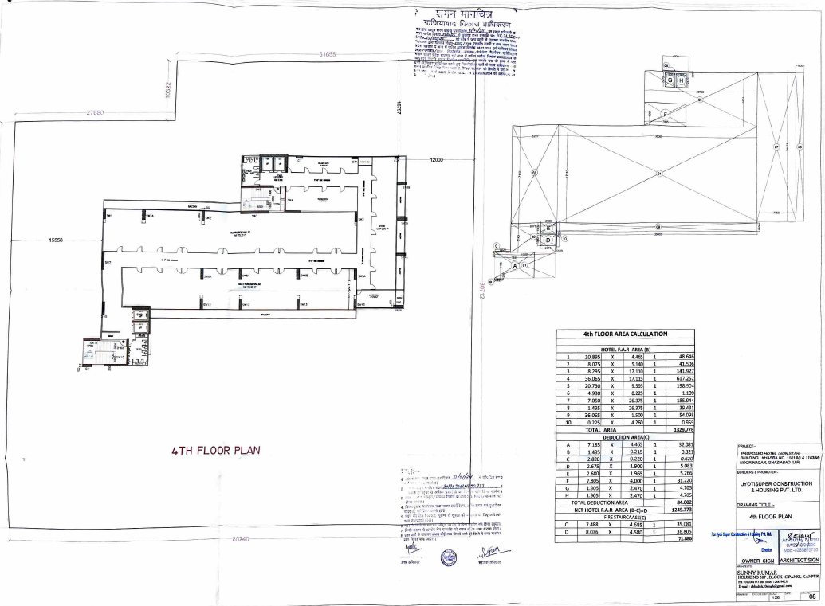
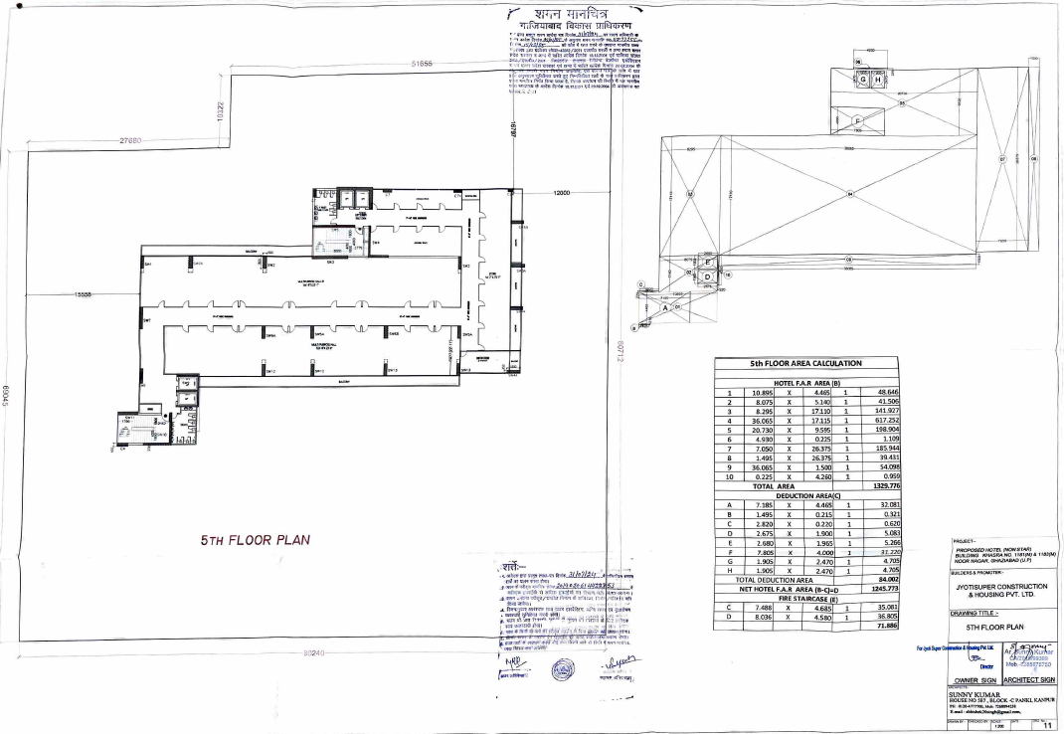
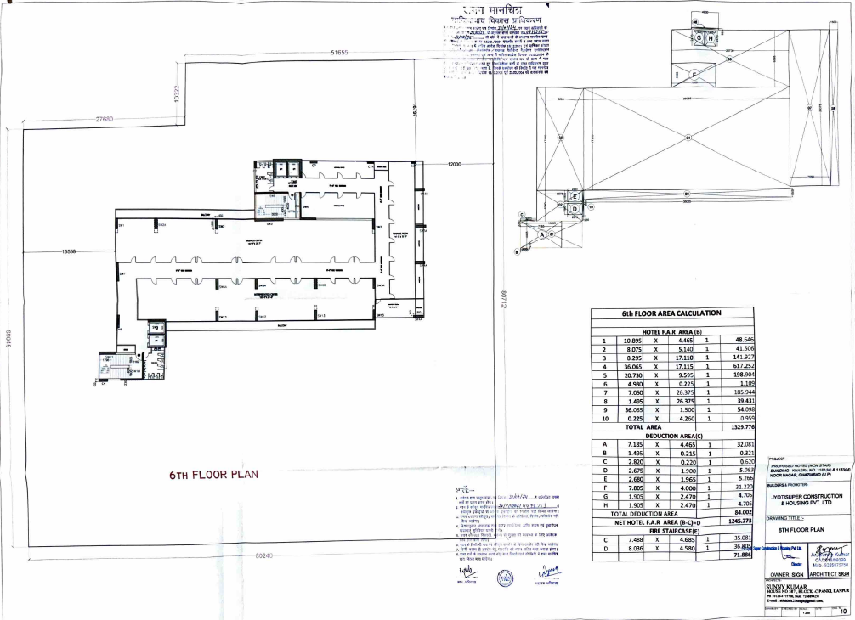
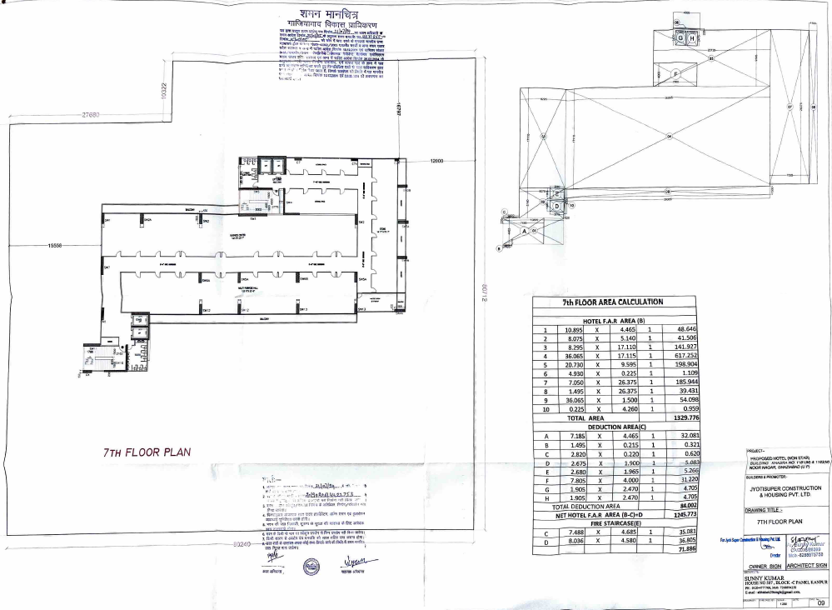
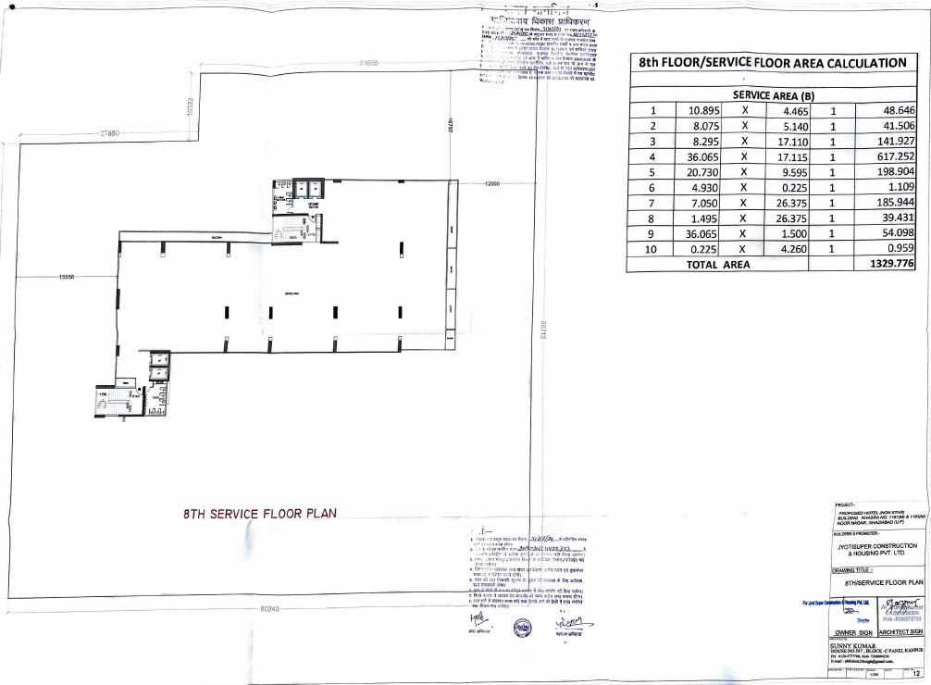
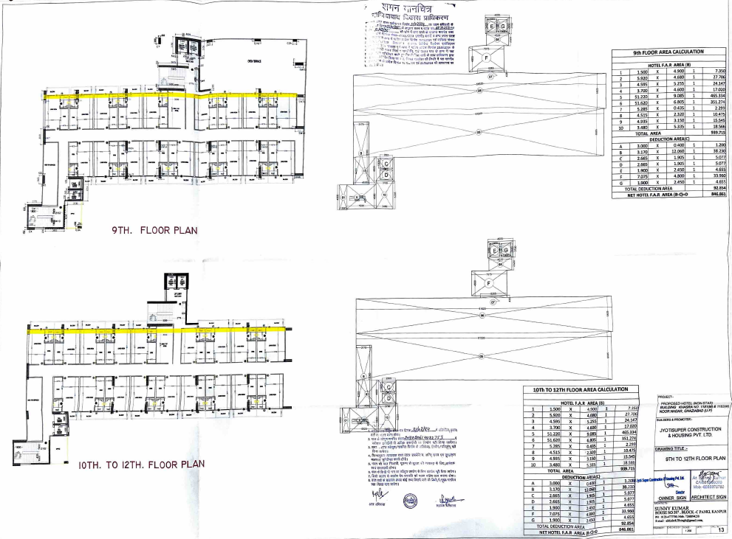
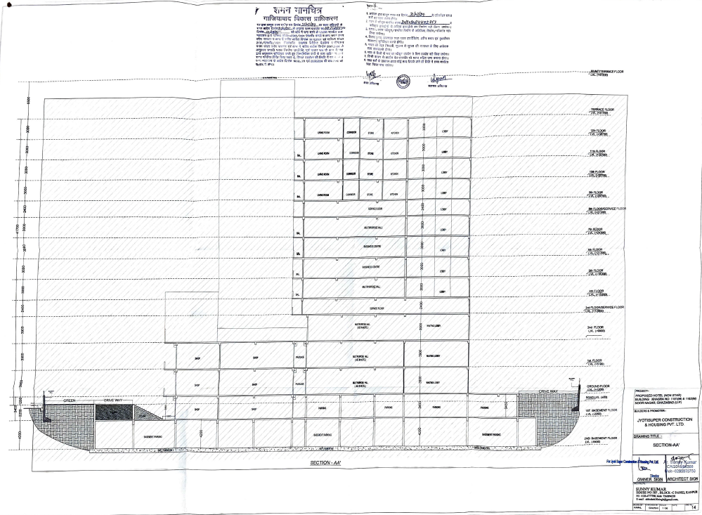
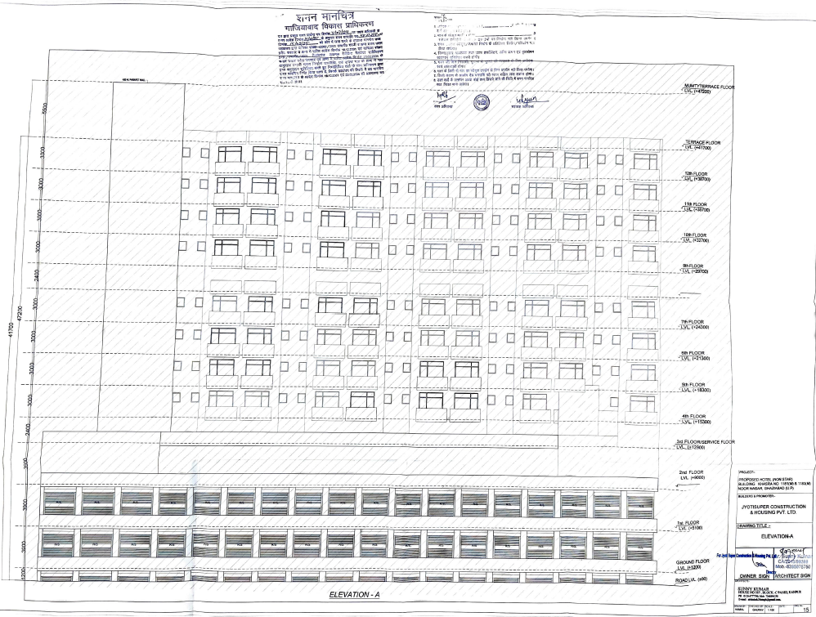

- SITE PICTURES:
Site pictures were captured during the site survey on 23rd January 2025, for reference few of the pictures are attached below:
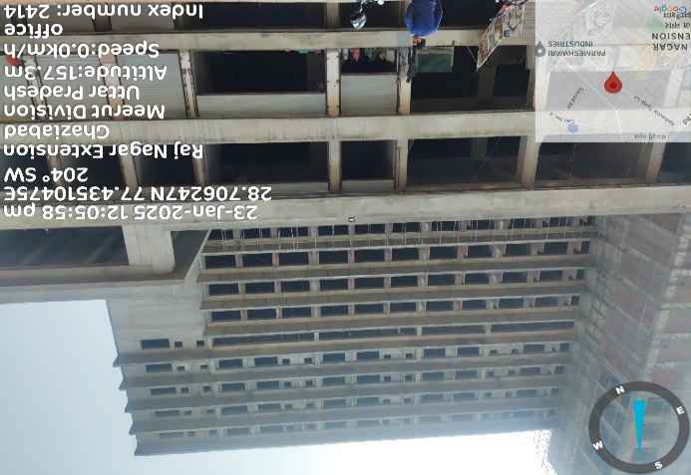 | 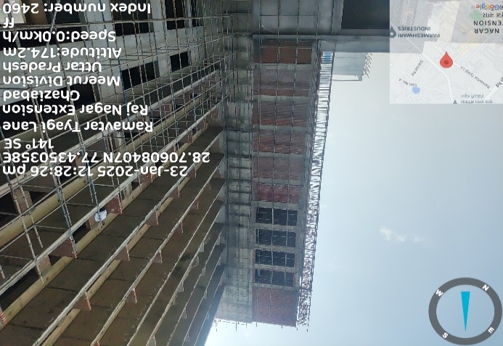
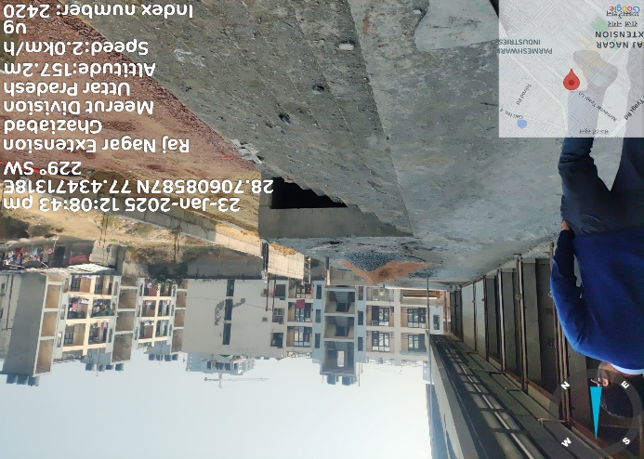 | 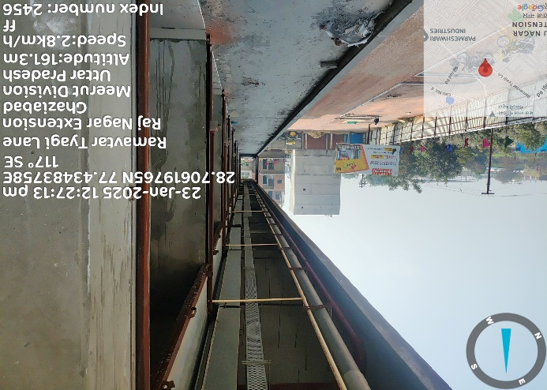
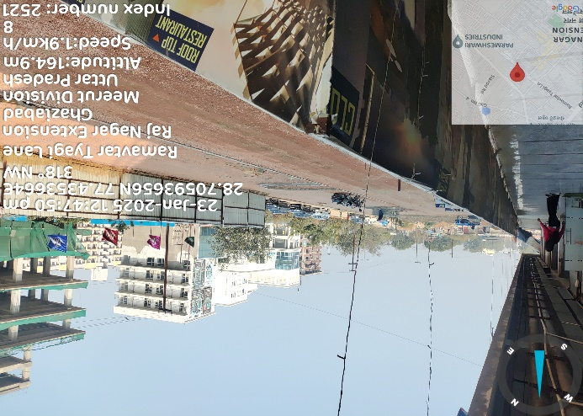 | 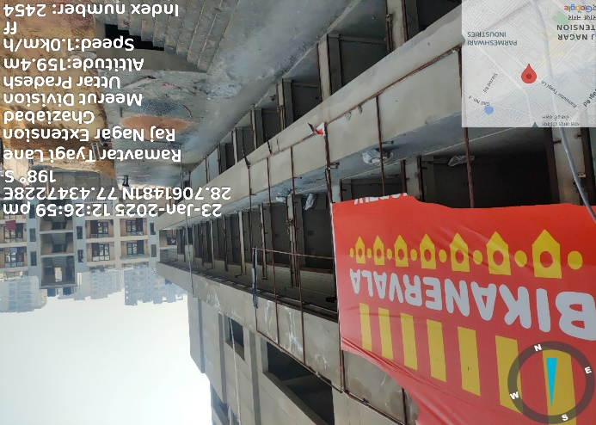
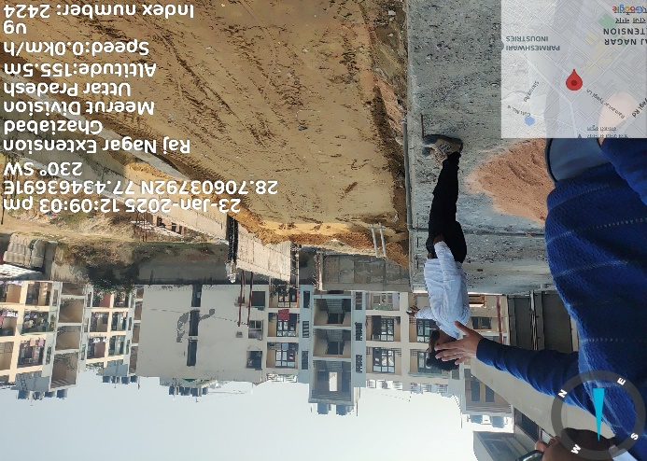 | 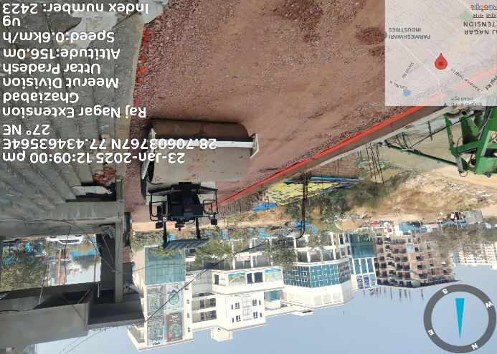
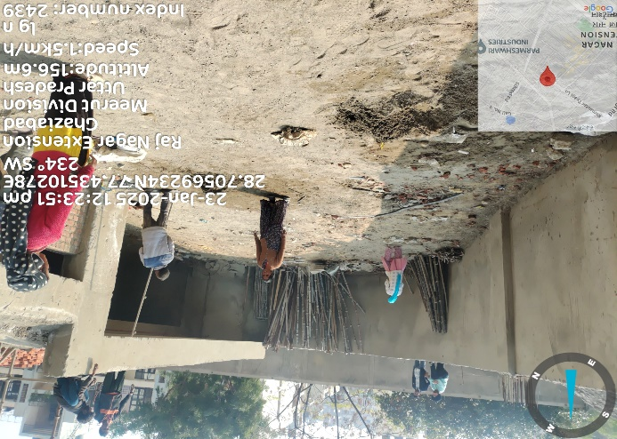 | 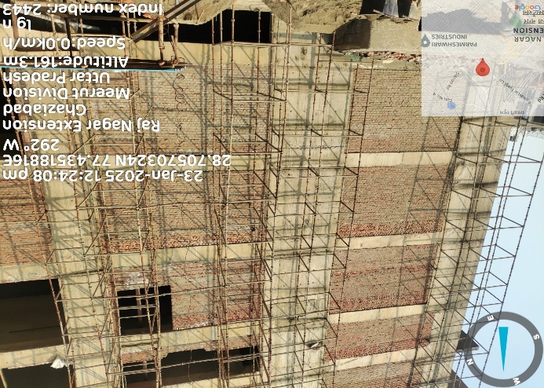
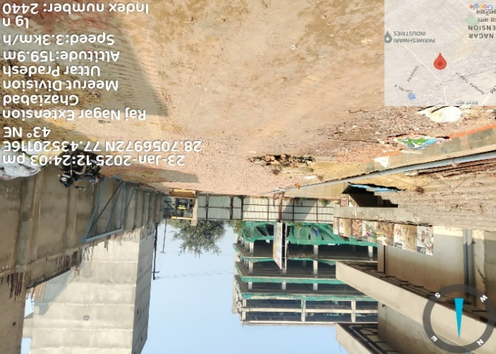 | 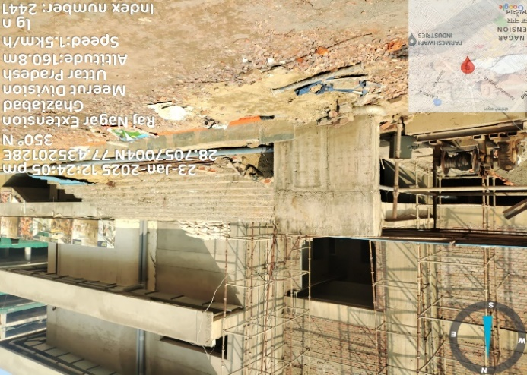
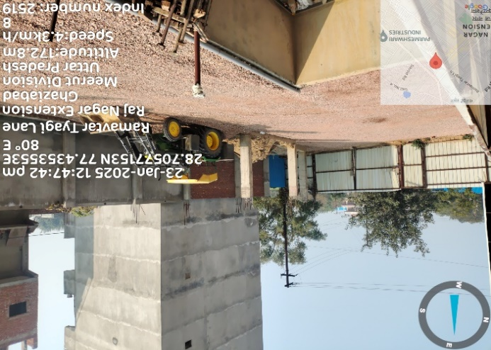 | 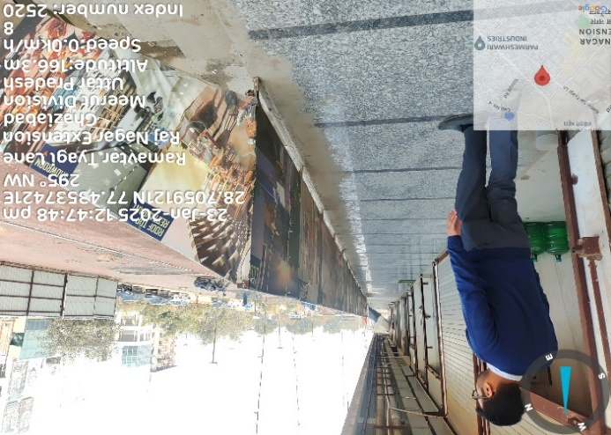
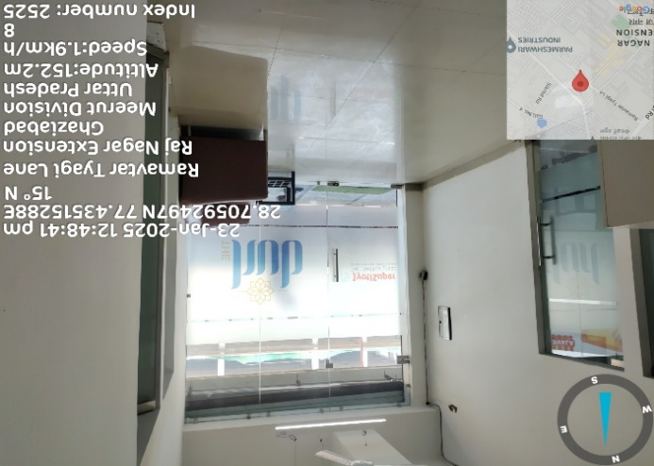 | 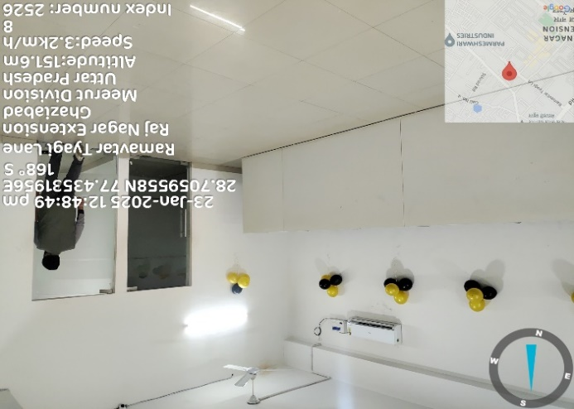
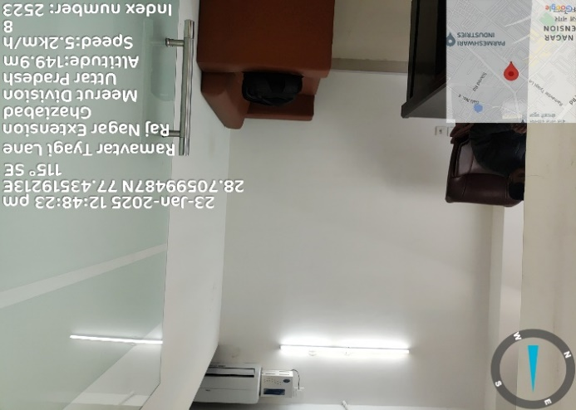 | 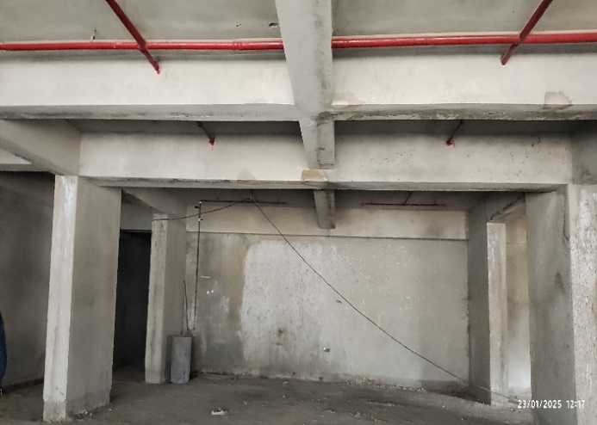
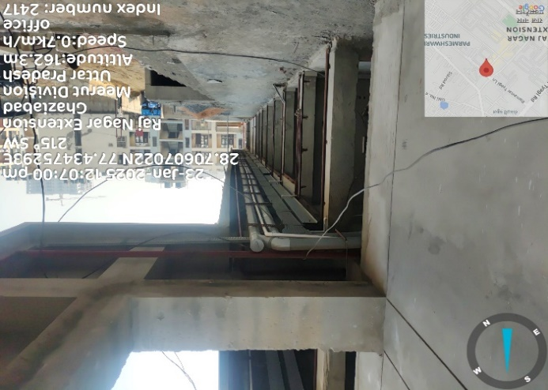 | 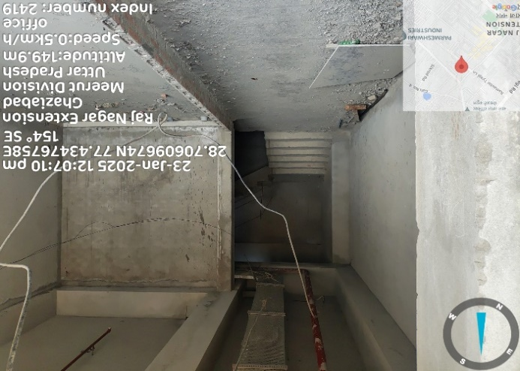
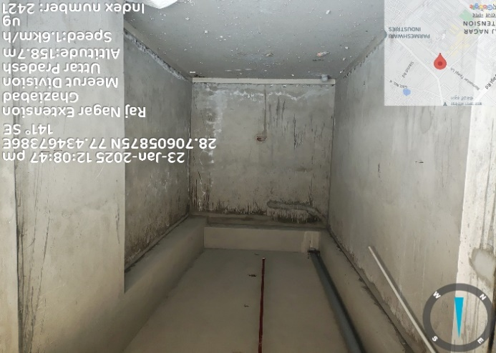 | 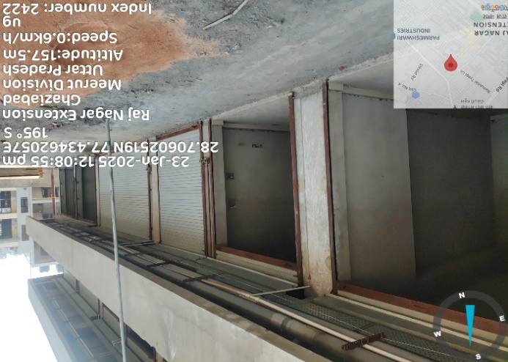
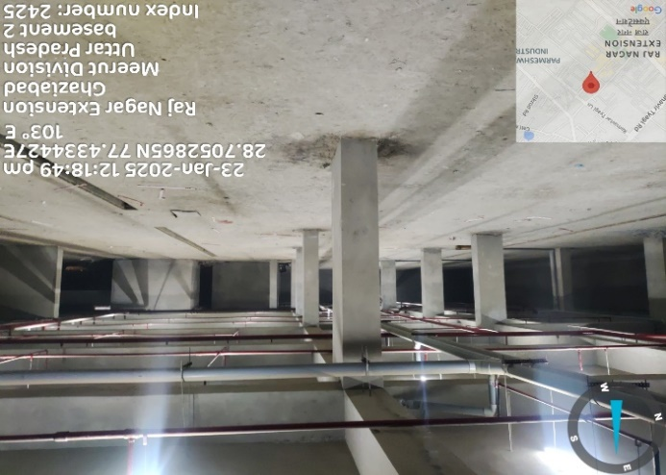 | 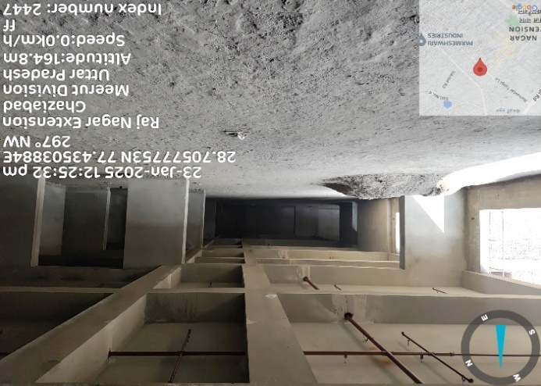
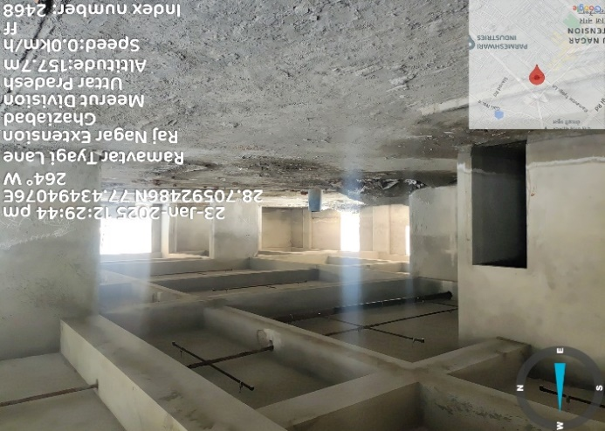 | 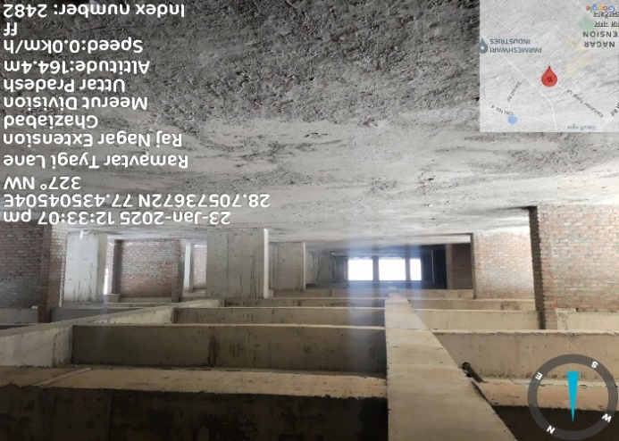
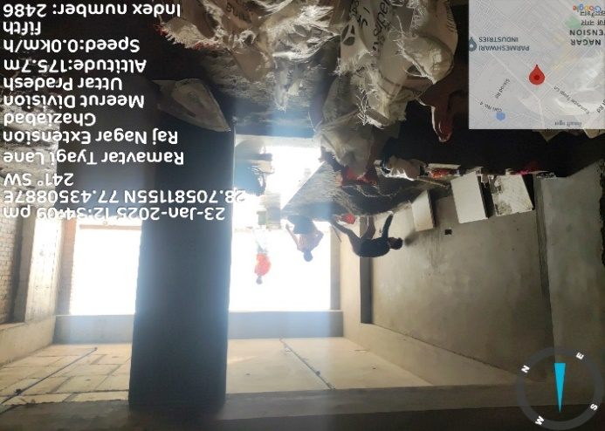 | 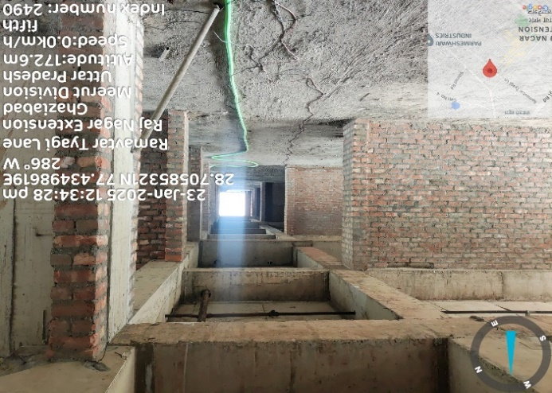
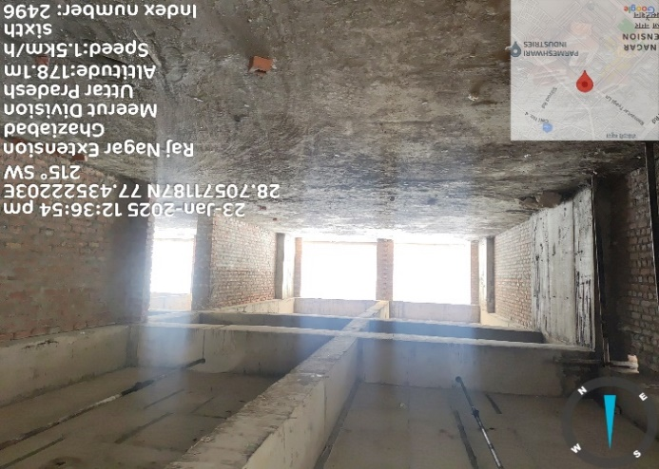 | 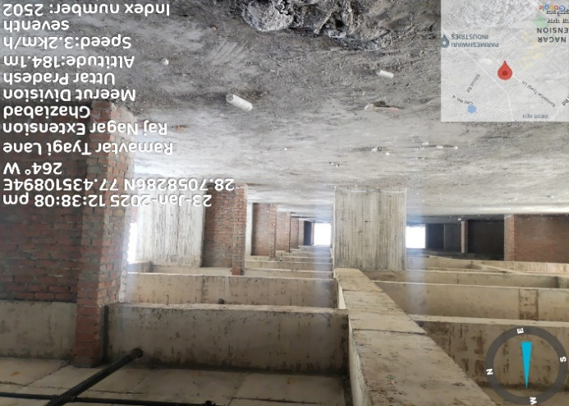
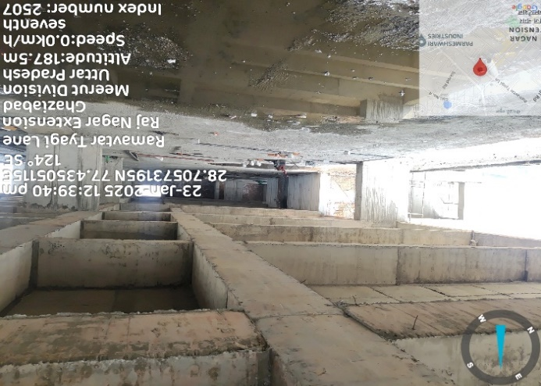 | 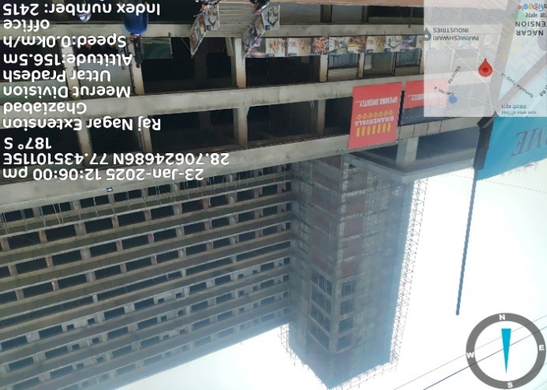
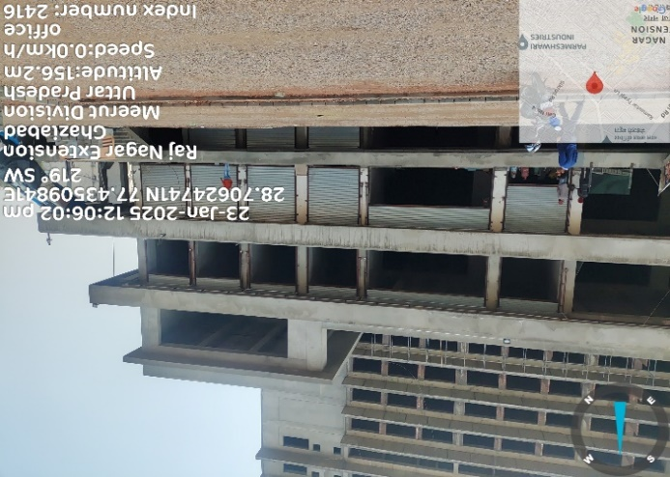 | 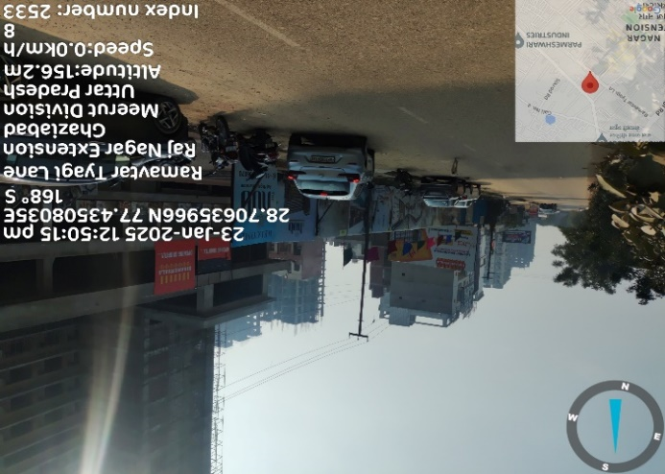

- TECHNICAL TEAM:
As per the data/information shared by the company, it has employed highly qualified and experienced professionals who are working on this project.
- Engineers: The company has B.Tech civil Engineers with experience of more than 15 years as professional managers and 7 diploma civil Engineers working as site Engineers.
- Accountant: The company has a qualified CA on its payroll and also has appointed very highly quality CA firms and company secretary for proper maintenance and upkeep of its financial records.
- Environmental agencies: The company has also appointed environment firm to follow and upkeep with all the environmental clearances and compliances under the supervision of Environmentalists.

- UTILITIES: Details of Water, Electricity and other utilities are describing as below:
- Water: As per information shared by the client, currently the company has obtained CTE from UPPCB (Ref: 196278/UPPCB/Ghaziabad(UPPCBRO)/CTE/GHAZIABAD/2023, dated 07.12.2023), which mentioned the daily water requirement of 100 KL/Day. The company has applied for the NOC for the Ground water extraction but has not received the NOC for the same.
- Electricity: As per the information shared by the client, the company has already obtained a sanction of 2228 KW power load from Pashchimanchal Vidyut Vitran Nigam Limited (PVVNL).

- SITE VISIT OBSERVATION:
As per the information shared by the client, the subject land is demarcated with boundary wall, which is verified by us during the site survey on 23rd January 2025.
The project is located in Raj Nagar Extension and comprises of commercial space. The structural work of the project has been completed. There are some changes in structure as per sanctioned plan but major changes have been compounded and the other changes are being compounded as discussed with owner. The site is surrounded by multiple residential and commercial projects, indicating a developing and suitable location for the project. During the site survey, we found that, currently, Plumbing and Fire-Fighting Work has started and is ongoing.

- CONCLUSION:
The estimated and projected cost of proposed finalized capital assets seems proper and justifiable. Based on the comprehensive analysis done by R K Associates involving the operational parameters like amenities offered are crucial for the project, and the discussions with the management alongwith the site visit, the proposed project is considered to be technically feasible in our opinion. Timely procurement of various statutory approvals, agreements as required for constructing the project and achieving various cost and time milestones envisaged also remains critical for the project’s viability.
PART E | INVENTORY PROFILE

- INTRODUCTION:
The proposed project “The HUB” is about development of the commercial space at Khasra No. 1181(M) & 1183(M), Village Noor Nagar, Pargana-Loni, Raj Nagar Extension, Tehsil & District- Ghaziabad, Uttar Pradesh – 201017. The project is envisaged to house 367 units of different sizes on 6145 sq. mt. plot of land in Raj Nagar Extension, Ghaziabad. It will also support MSMEs to create more job opportunities in the employment-intensive gems and jewellery sector.
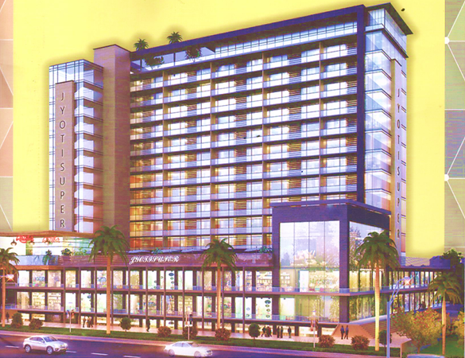
PROJECT’S HIGHLIGHTS:
- GDA Approved and RERA registrered project on Freehold Land.
- Well Planned Product Mix for High Footfall.
- Anchor Store available with Premium Entry.
- Ample Car Parking Space
- Advanced Integrated Building Management System with Controlled Access
- Renowned Schools like DPS and GD Goenka in close vicinity.
- Only commercial project in Raj Nagar Extension with self-sustainable footfall of approximately 2,000 people per day.
- 5 High Speed Elevators.
- INVENTORY CATEGORY:
M/s Jyotisuper Construction and Housing Private Limited has proposed their portfolio of inventories under following categories as described below:
FLOORS | No. of Units | Total Area
Shop LGF | 17 | 7,481
Commercial anchors LGF | 5 | 9,015
Shops GF | 29 | 12,161
Commercial Anchor GF | 4 | 7,403
Shops FF | 29 | 12,161
Commercial Anchor FF | 4 | 7,403
Office Units at 4th floor | 56 | 13,748
Office Units at 5th floor | 41 | 18,000
Office Units at 6th floor | 41 | 18,000
Office Units at 7th floor | 65 | 15,623
Studio Apartments at 9th floor | 18 | 12,835
Studio Apartments at 10th floor | 18 | 12,835
Studio Apartments at 11th floor | 18 | 12,835
Studio Apartments at 12th floor | 18 | 12,835
Restaurants at 2nd floor | 2 | 4,200
Banquets | 2 | 36,000
TOTAL | 367 | 2,12,535

- LOWER GROUND FLOOR:
Retail shops and commercial anchor spaces under commercial use have been proposed on the Lower Ground Floor. The built-up area summary and layout plan of the Lower Ground Floor are shown below:
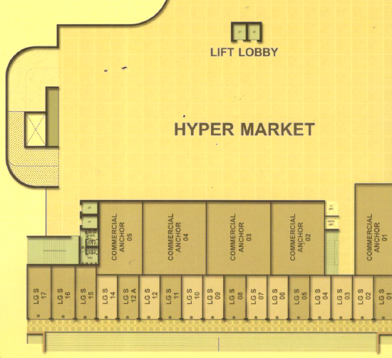
Source: Data/Information provided by the client
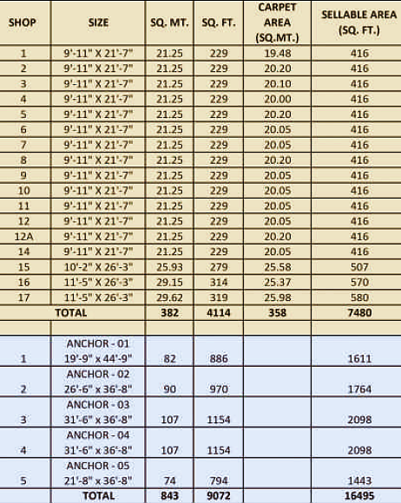
Source: Data/Information provided by the client

- GROUND FLOOR:
Retail shops and commercial anchor spaces under commercial use have been proposed on the Ground Floor. The built-up area summary and layout plan of the Ground Floor are shown below:
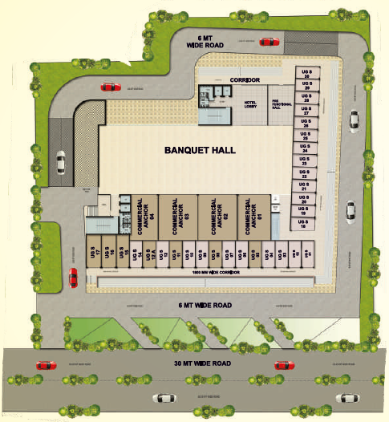
Source: Data/Information provided by the client
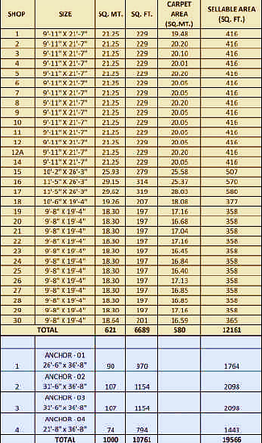
Source: Data/Information provided by the client

- FIRST FLOOR:
Retail shops and commercial anchor spaces under commercial use have been proposed on the First Floor. The built-up area summary and layout plan of the First Floor are shown below:
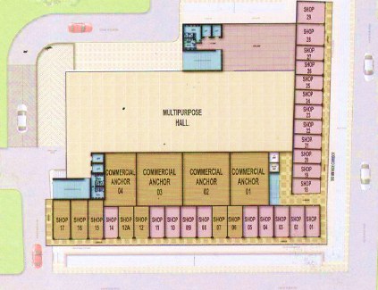
Source: Data/Information provided by the client
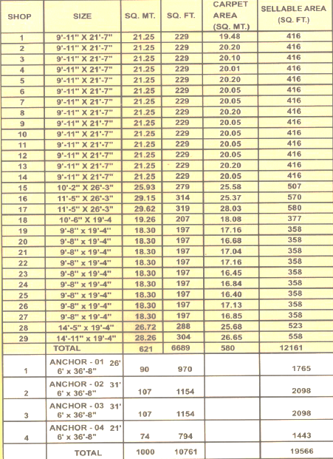
Source: Data/Information provided by the client
- SECOND FLOOR:
As per the information provided to us, Second Floor would have a Multipurpose Hall, Bar & Restaurants, Snooker & Pool Room, Cards Room, Gymnasium, Spa, Aerobics & Yoga Room and All weather indoor swimming pool. The layout plan of the Second Floor is shown below:
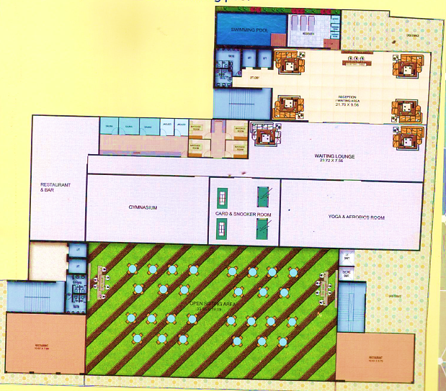
Source: Data/Information provided by the client
- FOURTH & SEVENTH FLOOR:
Fourth and Seventh Floor of the proposed project would have office units. The built-up area summary and layout plan of the Fourth & Seventh Floor are shown below:
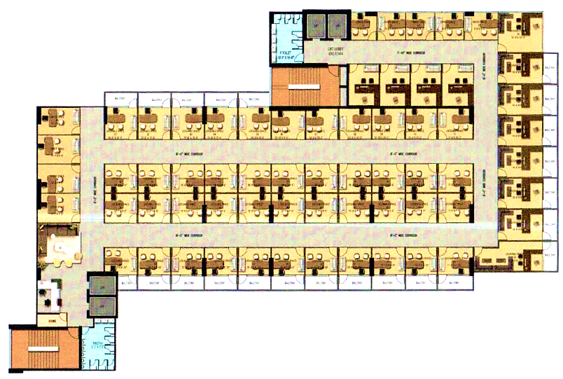
Source: Data/Information provided by the client
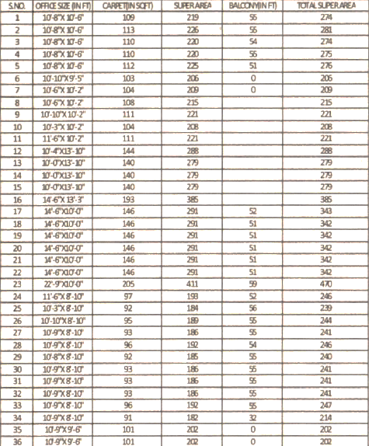
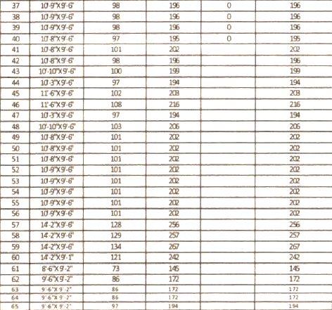
Source: Data/Information provided by the client

- FIFTH & SIXTH FLOOR:
Fifth and Sixth Floor of the proposed project would have office units. The built-up area summary and layout plan of the Fifth & Sixth Floor are shown below:
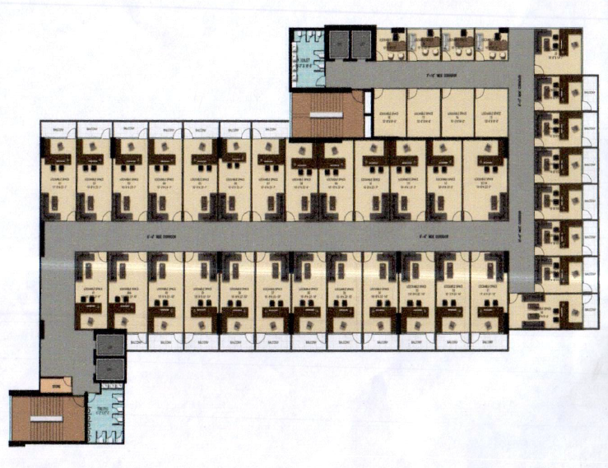
Source: Data/Information provided by the client

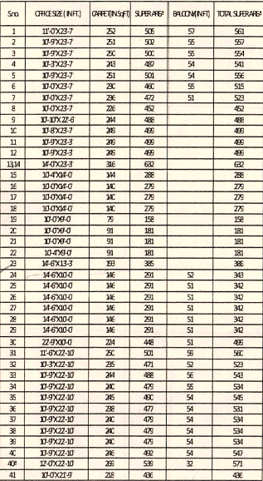
Source: Data/Information provided by the client
- NINETH TO TWELFTH FLOOR:
The floors from Nineth to Twelfth will contain Business Suites. The built-up area summary and layout plan of the Fifth & Sixth Floor is shown below:
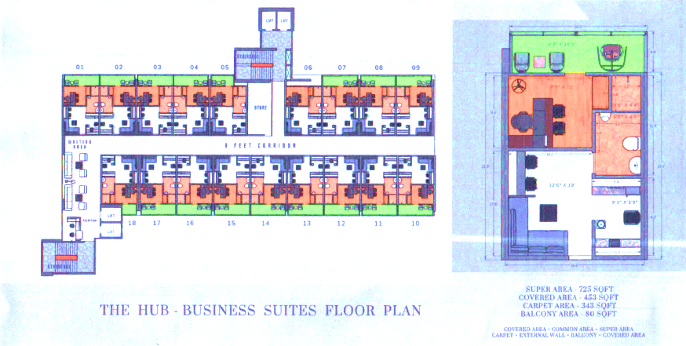
Source: Data/Information provided by the client
- AMENITIES/FACILITIES:
The following facilities are being proposed to be provided in the project:
  - Kid’s Play Area
  - Waiting Area
  - Open Terrace
  - Billiards, T.T. Room
  - Reception / Waiting Area
  - Gymnasium
  - Restaurant
  - Multipurpose Hall
  - Dedicated Service Floor on the 3rd Floor & 8th Floor

- MARKETING, SELLING & DISTRIBUTION PLAN:
Jyotisuper already has plans to enhance the marketing and sales strategy for their remaining units through a comprehensive approach. The strategy focuses on targeting two primary groups: prospective buyers interested in commercial space in Raj Nagar Extension (Ghaziabad), and investors seeking viable real estate opportunities. To facilitate this effort, the company can hire a specialized marketing agency selected for their expertise in real estate sales and marketing. The agency will operate on a commission basis, earning a percentage from each units sold, ensuring mutual alignment of interests.
As per the discussion with the client/company, it will include strategic placement of banner advertisements in high-traffic areas and the distribution of marketing collaterals such as flyers and brochures in key locations. The sales team can also host regular open houses and personalized tours to showcase the units, while transparent pricing and flexible payment options will facilitate seamless negotiations and transactions. Customer feedback can also be actively solicited to refine strategies and enhance customer satisfaction. Continuous adaptation based on market trends, competitor analysis, and performance metrics will ensure ongoing improvement and alignment with sales objectives.
In conclusion, given the current demand in the commerical real estate sector and the marketing strategy outlined by Jyotisuper Construction and Housing Private Limited, the company is well-positioned to effectively market its proposed commercial project without significant challenges. By using a dedicated agency and utilizing diverse marketing channels, Jyotisuper aims to achieve their sales objectives while maintaining a strong market presence in the real estate sector.
PART F | PROJECT’S MARKETING FEASIBILITY

- INTRODUCTION:
The Construction industry in India consists of the Real estate as well as the Urban development segment. The Real estate segment covers residential, office, retail, hotels and leisure parks, among others. While Urban development segment broadly consists of sub-segments such as Water supply, Sanitation, Urban transport, Schools, and Healthcare.
The Indian infrastructure (construction) and real estate industry is playing key role in the nation’s progress towards achieving the status of ‘developed nation’ from a ‘developing nation’. An ambitious program of infrastructure investment has been evolved for strengthening and consolidating recent infrastructure and real estate related initiatives. To supplement the estimates of Gross Capital Formation in infrastructure, the Planning Commission has made projections of public-private investments in each sector, basing these on a detailed review of sectoral trends and projected expenditures.
The Indian real estate sector plays a significant role in the country's economy, which is second only to agriculture in terms of employment generation and contributes heavily towards the gross domestic product (GDP). The real estate sector comprises four sub sectors - housing, retail, hospitality, and commercial. About five per cent of the country's GDP is contributed to by the housing sector. The construction sector in India represents a dynamic and crucial component of the economy, with substantial opportunities for growth and development driven by infrastructure investments, urbanization, and rising demand across residential, commercial, and industrial segments.
Benefiting from swift urbanization, strong demographic trends, and growing income levels, the Indian real estate sector has garnered significant investment in recent years. The construction industry stands third among 14 key sectors regarding its direct, indirect, and induced effects on the broader economy.

- MARKET SIZE:
The real estate sector in India is projected to expand significantly, reaching a market size of US$ 1 trillion by 2030, up from US$ 200 billion in 2021. By 2025, it is anticipated to contribute 13% to the country’s GDP. Growth is evident across retail, hospitality, and commercial real estate segments, crucial for meeting India's burgeoning infrastructure demands. India's real estate sector is forecasted to grow to US$ 5.8 trillion by 2047, elevating its GDP contribution from the current 7.3% to 15.5%. This expansion underscores the sector's pivotal role in India's economic landscape, driven by increasing urbanization, infrastructure development, and evolving consumer needs.
During the fiscal year 2022-23, India's residential property market experienced remarkable growth, achieving a record-high home sales value of Rs. 3.47 lakh crore (US$ 42 billion). This marked an impressive 48% year-on-year increase. Concurrently, the volume of sales showed significant expansion, with 379,095 units sold, reflecting a robust 36% increase over the previous period.
In the Interim Budget for 2024-25, the capital investment outlay for infrastructure has been raised by 11.1% to Rs. 11.11 lakh crore (US$ 133.86 billion), equivalent to 3.4% of GDP. Specifically, the Interim Budget for 2023-24 allocated Rs. 2.55 lakh crore (US$ 30.72 billion) for Railways, reflecting a 5.8% increase from the previous year.
Initially comprising 6,835 projects, the National Infrastructure Pipeline (NIP) has expanded to encompass 9,142 projects across 34 sub-sectors, as reported. Currently, 2,476 projects are in the development phase, collectively representing an estimated investment of US$ 1.9 trillion. Notably, nearly half of these projects pertain to the transportation sector, with 3,906 projects specifically focusing on roads and bridges.

- REAL ESTATE PROJECTS IN RAJ NAGAR EXTENSION
Raj Nagar Extension, located in Ghaziabad, Uttar Pradesh, has become a rapidly developing hub in the National Capital Region (NCR) due to its strategic location, affordable property prices, and robust infrastructure development. Raj Nagar Extension's proximity to major hubs like Noida, Greater Noida, and Indirapuram makes it a favourable location for retail stores, office spaces, and service-oriented businesses. The ongoing expansion of metro connectivity is expected to further enhance accessibility, making it a key area for both residential and commercial real estate.
Raj Nagar Extension has enticed several real estate developers for their portfolio expansion due to its strategic location. Excellent connectivity to Delhi, Noida and Greater Noida coupled with constantly improving social and physical infrastructure and affordable property prices has made Raj Nagar Extension one of the most sought after residential destinations in Ghaziabad. The region surely holds a strong growth potential due to constant infrastructure upgrades and improving connectivity. Also, it offers relatively cheaper property options compared to other prominent micro Ready-to-move-in projects and projects nearing completion to witness positive traction in the future time periods markets of Ghaziabad such as Indirapuram, Vasundhara and Vaishali.
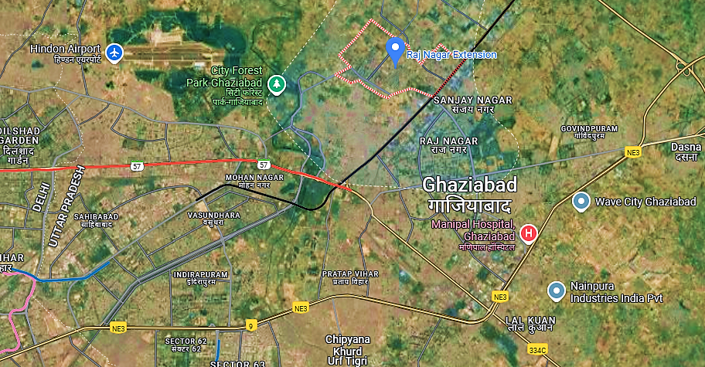
One of the standout features of Raj Nagar Extension is its land acquisition model. Developers directly purchase land from landowners, ensuring the land is free from litigation, which significantly reduces legal risks and increases the area’s appeal for investment. This litigation-free land acquisition approach has helped build confidence among investors and developers.
In terms of infrastructure, Raj Nagar Extension has seen significant improvements in recent years. The extension of NH-58, better road networks, and improvements in utilities such as water supply and sewage systems have made the region increasingly livable. Additionally, the anticipated metro extension will further enhance the area's connectivity, making it even more desirable for homebuyers and businesses alike.
The real estate market in Raj Nagar Extension is seeing considerable growth, particularly in residential projects. Developers are offering a variety of housing options ranging from budget apartments to mid-range properties, with modern amenities and improved infrastructure. Commercial development is also on the rise, driven by the growing population and demand for retail spaces. Property prices in the region remain lower compared to other NCR areas like Noida and Greater Noida, making it an attractive choice for first-time homebuyers and investors looking for affordable options with strong potential for appreciation.
Raj Nagar Extension presents a highly promising real estate market, driven by its strategic location, affordable property prices, and robust infrastructure development. It is an attractive option for investors and homebuyers, especially with its relatively low-cost entry points compared to other NCR regions. While the market has strong growth potential, stakeholders should keep an eye on market saturation and infrastructure developments to fully capitalize on the area’s opportunities.

- RECENT INVESTMENTS/ DEVELOPMENTS:
Indian real estate sector has witnessed high growth in the recent times with rise in demand for office as well as residential spaces. The Private Equity Investments in India’s real estate sector, stood at US$ 4.2 billion in 2023. The Private Equity Investments in India’s real estate sector, stood at US$ 3.4 billion in 2022. India’s real estate sector saw a three-fold increase in foreign institutional inflows, worth US$ 26.6 billion during 2017-2022. Construction is the third-largest sector in terms of FDI inflow. FDI in the sector (including construction development & activities) stood at US$ 58.5 billion from April 2000-September 2023. Some of the major investments and developments in this sector are as follows:
- On June 2024, Nisus Finance has invested over Rs 155 crore in a late-stage affordable housing project by Dharmadev Group in Surat, Gujarat.
- Signature Global buys 3.8-acre land in Sector 37D of Dwarka Expressway, Gurugram
- Foreign investors pump around US$ 4 billion yearly into Indian real estate, with a 20% YoY increase in foreign inflows in 2023.
- Inflows in the construction (infrastructure) activities is one of the leading recipients of FDI in the country with $33 billion (Apr 2000 to Dec 2023).
- In India's top eight cities, housing prices rose 7% year-over-year due to strong housing demand supported by persistent purchaser demand and steady borrowing rates.
- Real estate firm Sattva Group, backed by American investment firm Blackstone Inc., plans to invest ₹12,000-14,000 crore in the next 2-3 years developing commercial office, residential, and hotel projects.

- GOVERNMENT INITIATIVES:
Government of India along with the governments of respective States has taken several initiatives to encourage development in the sector. The Smart City Project, with a plan to build 100 smart cities, is a prime opportunity for real estate companies. Below are some of the other major Government initiatives:
- 100% Foreign direct investment in the construction industry in India under automatic route is permitted in completed projects for operations and management of townships, malls/shopping complexes, and business constructions.
- 100% Foreign direct investment in the construction industry is allowed under the automatic route for urban infrastructures such as urban transport, water supply, sewerage, and sewage treatment.
- In the 2024-25 interim Budget, Finance Minister Nirmala Sitharaman announced a boost for India's affordable housing sector by adding 2 crores more houses to the flagship scheme PMAY-U.
- In the Union Budget 2023-24, the Finance Ministry announced a commitment of Rs. 79,000 crore (US$ 9.64 billion) for PM Awas Yojana, which represents a 66% increase compared to last year.
- As of December 31, 2022, India had formally approved 425 SEZs, and as of January 2023, 270 SEZs are operational. Most special economic zones (SEZs) are in the IT/ BPM sector.
- An Affordable Housing Fund (AHF) is set up via National Housing Bank (NHB) with an initial amount of around 1 The Central government has increased its capital expenditure (capex) allocation to US$ 133.9 billion (Rs. 11.11 trillion) for the fiscal year beginning April 1, 2024, with a focus on advancing India's infrastructure, as part of a strategic move to stimulate economic growth. An increase of 11.1% from the previous year, the FY25 interim budget allots US$ 133.9 billion (Rs. 11.11 trillion) for capital expenditures, or 3.4% of GDP.
The Government launched 10 key policies for the real estate sector:
- Real Estate Regulatory Act (RERA)
- Benami Transactions Act
- Boost to affordable housing construction
- Interest subsidy to home buyers
- Change in arbitration norms
- Service tax exemption
- Dividend Distribution Tax (DDT) exemption
- Goods and Services Tax (GST)
- PR for foreign investors
According to Savills India, real estate demand for data centres is expected to increase by 15-18 million sq. ft. by 2025. Demand for residential properties has surged due to increased urbanisation and rising household income. India is among the top 10 price appreciating housing markets internationally. Organised retail real estate stock is expected to increase by 28% to 82 million sq. ft. by 2023.
Rising international real estate development is expected to provide potential growth opportunity to the Indian market. For example, an MoU signed between J&K and the Government of Dubai (in October 2021) for the development of real estate projects (such as industrial parks, IT towers and super specialty hospitals) is expected to boost growth in the union territory. Private market investor, Blackstone, which has significantly invested in the Indian real estate sector (worth Rs. 3.8 lakh crore (US$ 50 billion), is seeking to invest an additional Rs. 1.7 lakh crore (US$ 22 billion) by 2030.

- ROAD AHEAD:
The outlook on domestic residential real industry remains stable for the near term with resilience demonstrated by the industry post Covid in terms of launches across various price points and geographies with effective net inventory absorption given the inherent remunerative and safe nature of the asset class resulting in lean inventory levels, a trend which is expected to continue in near term supported by nuclearization of families, favourable interest rate and financing regime.
The Securities and Exchange Board of India (SEBI) has granted approval for the Real Estate Investment Trust (REIT) platform, enabling all types of investors to participate in the Indian real estate market. This move is expected to unlock a substantial opportunity valued at Rs. 1.25 trillion (US$ 19.65 billion) in the coming years.
Responding to a more informed consumer base and global trends, Indian real estate developers have undergone a significant transformation. They have transitioned from family-owned businesses to professionally managed enterprises. Developers are now focusing on managing multiple projects across different cities more efficiently. To achieve this, they are implementing centralized processes for sourcing materials, organizing manpower, and recruiting skilled professionals in project management, architecture, and engineering.
These changes underscore the maturation of the Indian real estate sector, with developers embracing modern practices and leveraging initiatives like the REIT platform to attract investments and drive sectoral growth. The current shortage of housing in urban areas was estimated to be ~10 million units. An additional 25 million units of affordable housing are required by 2030 to meet the growth in the country’s urban population.
India's Infrastructure forms an integral part of the country's economic ecosystem. There has been a significant shift in the industry that is leading to the development of world-class facilities across the country in the areas of roads, waterways, railways, airports, and ports, among others. The country-wide smart cities programmes have proven to be industry game-changers. Given its critical role in the growth of the nation, the infrastructure sector has experienced a tremendous boom because of India's necessity and desire for rapid development. The expansion has been aided by urbanisation and an increase in foreign investment in the sector.
The infrastructure sector has become the biggest focus area for the Government of India. India and Japan have joined hands for infrastructure development in India's Northeast states and are also setting up an India-Japan Coordination Forum for development of Northeast to undertake strategic infrastructure projects for the region.
India being a developing nation is set to take full advantage of the opportunity for the expansion of the infrastructure sector, and it is reasonable to conclude that India's infrastructure has a bright future ahead of it.

- CONCLUSION
Given its advantageous geographical location, India's real estate market, particularly in Delhi NCR, is expected to grow significantly. The optimism stems from several factors such as the presence of well-known universities bringing students and professionals with them thereby resulting in an increased demand for housing as well as associated facilities. Also, a strong economic base, notably in Delhi NCR offers job prospects and higher incomes which together with ongoing urbanization trends and a burgeoning middle class increase the requirement for various types of buildings. These educational, economic and social matters serve together to provide a dynamic atmosphere that supports real estate projects enabling substantial returns within these regions.

PART G | SWOT ANALYSIS

SWOT ANALYSIS
STRENGTHS | - Location Advantage: Raj Nagar Extension, situated alongside National Highway 58 (NH58) in Ghaziabad, stands as a highly sought-after residential and commercial locality, known for its proximity to the Hindon Airport, RRTS, and the upcoming international cricket stadium, along with the availability of vast open spaces, make it an attractive location for real estate investment. The area is well-served by the Rapid Metro and Delhi Metro, providing convenient access to various parts of the city.  - Experienced Developers: Promoters are having several years of experience in the same line of business & industry as the company had developed several high-end to medium-end projects.  - Strong Network: The Company has built established relationships with key contractors, suppliers, and financial institutions, providing a solid foundation for smooth operations and growth. These strong connections enable better access to resources, timely project execution, and favourable financial terms, giving the business a competitive advantage in the market.  - Investment Potential: Delhi NCR's real estate market offers substantial investment opportunities due to its high returns and potential for appreciation, attracting both domestic and international investors. Ghaziabad is hosting numerous residential societies, financial institutions, educational institutions and industrialists. This economic activity drives demand for both commercial and residential properties.
WEAKNESSES | - Higher Initial Funding Requirement: The commercial project requires significant upfront investment, including acquisition costs, Project Clearing expenses, and construction expenses, which could impact profitability.  - Regulatory Challenges: Delays in obtaining permits or meeting zoning requirements can extend project timelines and increase costs.  - Timeline Constraints: Project timelines may be vulnerable to delays caused by weather conditions, labour shortages, or logistical challenges which can stall progress and increase carrying costs. Fluctuations in the prices of raw materials, and labour can significantly impact profit margins, especially for companies with limited pricing power.
OPPORTUNITIES | - Market Growth: The real estate market in the area is experiencing growth, presenting an opportunity to capitalize on rising property values and demand.  - Community Revitalization: The commercial project can contribute to the overall revitalization and improvement of the neighbourhood, potentially attracting additional investments and amenities.  - Rental Income: As the units are suitable for rental purposes, there may be an opportunity to generate stable rental income in a high-demand rental market.  - Growing Demand for Commercial Space: Increasing population, urbanization trends, or demographic shifts leading to higher demand for commercial properties.
THREATS | - Increasing Competition: Increased competition from other developers in the same market can lead to price wars or lower occupancy rates. New entrants offering similar amenities at lower prices could divert potential tenants or buyers away from the project.  - Economic Downturns: Decline in the economy can influence customers' spending habits, potentially reducing demand for luxury condominiums during an economic recession can impact sales projections and investor returns. It can affect funding availability and project profitability.  - Force Majeure: Natural disasters such as hurricanes, earthquakes, or floods can affect construction timelines and increase insurance premiums.

PART H | RISK ANALYSIS

Risk | Impact | Description
Time Overrun | Medium | - Although the management is determined to complete the project as per the decided milestones, any delay due to factors not in control of the company/ management can affect the cash flows to that extent.  - Delay in the construction of the project due to the competency of contractors can be mitigated by verifying the organizational capabilities and site organization during the selection process. By supervising and regular follow-up of the level of construction achieved by the project and by day- to-day management of availability and requirements of material land resources.
Cost Overrun | Medium | - It is assumed the total project cost will be to the tune of INR ~74.25 Cr. Any unwarranted increase due to higher inflation, regulatory requirements, competition etc. may increase the said project costs.  - Risk related to inflation and interest rate fluctuations can be mitigated by adhering to the project timelines.
Operational Risk | Medium | - Risk related to cash flow management of the project will be mitigated by obtaining funding from the Banks/ Financial institutions for the implementation of the project. A suitable Trust and Retention Account (TRA) can also be maintained.  - Significant portion of funds available comes through internal accruals. This risk can be mitigated by early engagement for project awareness amongst the public/prospective buyers which can be seen by the advance booking status of the project.  - The group has developed projects in the region of Ghaziabad, Uttar Pradesh and do have sufficient experience in the field of real estate development. To mitigate this risk the company has hired local architects, engineers who have experience of this sector in the city as informed by the client. In future, the company can also hire professionals in the future as and when the need arises.
Regulatory Issues | Medium | - Risk of delay in various approvals that are required from various state, local development and municipal agencies can be mitigated by the company by obtaining requisite planning and construction approvals requires extensive liasioning with various Government Authorities. The company is better suited to obtain requisite approvals and clearances to mitigate the delay of approval risk. Therefore, one of the key components of the scope of work of company is to obtain requisite planning and building approvals for the complete land parcel.
Force Majeure | Medium | - The Force Majeure risk has to be borne by all the stakeholders as it is beyond control of them. There would be detailed provisions in the development agreement on the conditions that would be triggering the force majeure clauses by any stakeholder. Suitable insurance cover would be obtained for insurable force majeure events.

PART I | PROJECT COST AND MEANS OF FINANCE

As per data/information provided by the company/client, category wise proposed project cost is shown in the below table:
(INR Lakhs)
Total Project Cost (TPC)
S. No. | Particulars | Completed | Pending | Total
1 | Land Cost | 225.00 | - | 225.00
2 | Project Clearance Fees | 328.74 | 371.26 | 700.00
3 | Cost of Development and Construction | 3,285.34 | 3,214.66 | 6,500.00
4 | Contingencies Expenses | - | 37.50 | 37.50
 | TOTAL PROJECT COST | 3,839.08 | 3,623.42 | 7,462.50
MEANS OF FINANCE
S. No. | Particulars | Completed | Pending | Total
1 | Promoters’ Contribution | 1,601.77 | 300.00 | 1,901.77
2 | Advances from Customers | 2,237.31 | 323.42 | 2,560.73
3 | Term Loan from Bank | - | 3,000.00 | 3,000.00
 | TOTAL | 3,839.08 | 3,623.42 | 7,462.50
Source: Data/Information provided by the company.
Notes:
- The project “The HUB” is situated on piece and parcel situated at Khasra No. 1181(M) & 1183(M), Village Noor Nagar, Pargana-Loni, Raj Nagar Extension, Tehsil & District- Ghaziabad, Uttar Pradesh – 201017. As per the CA Certificate prepared by Rajeev Sharma & Associates dated 08.01.2025 submitted to UPRERA, the cost of land (incl. the acquisition and legal cost) is INR 225.00 Lacs. Thus, the cost allocated to the land is INR 2.25 Crores for the proposed project which is spread over an area of ~6,145 sq. mts. as per the layout plan.
- As per the details shared by the client/company, the break-up of Project Clearance Fees of INR 700 lakhs is shown in the table below:
Particulars | Amount
Pollution (CTE & CTO) | INR 1,00,000.00
Water Control Board (Borewell) | INR 50,000.00
GDA EDC Charges | INR 4,20,00,000
GDA Compounding Charges | INR 2,80,00,000
Fire NOC | INR 1,00,000
Total Project Clearance Fees | INR 7,02,50,000
Total Project Clearance Fees | INR 700 Lakhs (Approx.)

- The cost of construction has been estimated at INR 6,500.00 Lakhs, including development of all units of different sizes. The estimated cost of the Building & Civil works is shared to us by the client/company. It is to be noted here that the cost vetting of the proposed expansion project is out of scope of this report. However, as a TEV consultant, the estimated Building & Civil works cost has been verified independently by us, which we found in the permissible range.
- Contingency cost of INR 37.50 Lakhs (~0.50% of Hard Cost) has been considered based on general assumption and professional experience.
- For the total project cost of INR 7,462.50 lakhs, the company had already completed the works amounting to INR 3,839.08 lakhs (including the cost of land) as per the Engineers’ Certificate dated 14.01.2025 shared with us. For the work completed till now, the project had been funded through promoter’s contributions of INR 1,601.77 lakhs and INR 2,237.31 lakhs from advances from customers with respect to the units booked. For the remaining work to be completed amounting to INR 3,623.42 lakhs, the project is proposed to be funded through a term loan of INR 3,000.00 lakhs, INR 300.00 lakhs from promoter’s margin and INR 323.42 lakhs will be from advances from customers with respect to the units booked.

PART J | PROJECT IMPLEMENTATION SCHEDULE

Below is the tabulated presentation of the status of the project showing expected duration shared by the client/company:
Activity | Status
Redevelopment Agreement | Completed
Possession of Land | Owned
Demolition of Old Buildings | 80% Completed
Development of land | Completed
Compound Wall | Civil Work Completed
Construction Works | Owned

Particular | Date of Commencement | Date of Completion
Plinth Area | 12-12-2019 | 18-11-2024
RCC work | 02-02-2019 | 18-11-2024
Brick Masonry Work | 01-04-2022 | 01-04-2025
Inside Plaster | 01-02-2023 | 01-06-2025
Exterior Plaster | 01-08-2023 | 01-04-2025
Flooring | 01-03-2024 | 01-06-2025
Internal passage flooring work | 01-03-2024 | May-25
Electrical work | 04-06-2024 | 01-06-2025
Plumbing/ Sanitation work | 24-12-2024 | 01-07-2025
Arrangement of Power & Electrification | 01-01-2025 | 01-07-2025
Door & Windows installation | 01-05-2025 | 01-07-2025
Water & Drainage | 24-12-2024 | 01-04-2025
Inside Painting | 01-02-2025 | 01-07-2025
Outside Paint | 01-02-2025 | 01-06-2025
Common Development | 01-09-2024 | 01-09-2025
Elevation & Finishing work | 01-03-2024 | 01-07-2025
Completion of Project |  | 01-07-2025
Notes:
- Schedule has been made as per feasibility to achieve different milestones.
- Achievement of Milestone will depend on sanction of term loan as per proposed timeline.
- As per this timeline, the expected C.O.D will be 1st July 2025.

PART K | STATUTORY APPROVALS | LICENCES | NOC
As per the information provided by the client below is the list of Approvals required for the proposed project:
S. No. | Name Of License/ Registration  Issuing Authority | Purpose | Licence No. With Date | Current Status
1. | Certificate of Incorporation | RoC registration | U45201DL2002PTC117425 | Completed
 | Asst. ROC, NCT of Delhi & Haryana |  | 22nd October 2002
2. | Consent to Establish |  | 196278/UPPCB/Ghaziabad(UPPCBRO)/CTE/GHAZIABAD/2023 | Received
 | Uttar Pradesh Pollution Control Board (UPPCB) |  | 7th December 2023
3. | Approval of Building / Site Plans | Grant of approval on building plans | 20190206144122753 | Received
 | Ghaziabad Development Authority (GDA) |  | Initial Approval Date: 09.10.2020  Modification Approval Date: 15.02.2025
4. | RERA Registration |  | UPRERAPRJ553225 | Received
 | Uttar Pradesh Real Estate Regulatory Authority |  | Valid From: 16th February 2021  Valid Upto: 8th June 2025
5. | Height Clearance NOC | NOC for Height Clearance | SAFD/NORTH/B/111120/510156 | Received
 | Airports Authority of India |  | Valid From: 18th November 2020  Valid Upto: 16th November 2028
6. | NOC for fire-fighting (Prov.) | NOC under firefighting scheme | UPFS/2020/17345/GZB/GHAZIABAD/1317/DD | Received
 | Fire Service, Uttar Pradesh |  | 17th February 2020
7. | Approval for Ground Water Extraction | NOC for Water Extraction | - | Applied For
 | Uttar Pradesh Ground Water Authority (UPGWD)
8. | Power load sanction / Electric connection | For Power load sanction | 8839 | Received
 | Pashchimanchal Vidyut Vitran Nigam Limited |  | 16th August 2023
9. | Environmental Clearance | Environmental clearance (EC) certificate for the project | 789/Parya/SEAC/6065/2020 | Received
 | Directorate of Environment, U.P. |  | 4th March, 2021
10. | GST Registration |  | 09AABCJ3395F1ZG | Received
 | Goods & Service Tax, CBIC, Government of India |  | 1st July 2017

Observations & Comments:
- The company has obtained preliminary statutory clearances and approvals except those which are mentioned as in Process or Pending above.
- Above is the only illustration of the major approvals sought or to be sought by the company. It should not be construed as the exhaustive list and in case any approval is missed to be mentioned then it is the sole responsibility of the company to keep the project compliant with the necessary statutory approvals/ NOCs.
- *On 9th October 2020, the company had obtained the GDA approval on its initial plan of 14 Floors with reference number 223/M.P./Zone-1/2020-21 (Map Number: MAP20190206144122753). But since, the company had modified the plan reducing it to 12 floors from 14 floors but still utilizing the combined approved FAR as the sanctioned plan. As per the data received, the company has received the approval for the modification made in the plan dated 15.02.2025.

PART L | PROJECT’S FINANCIAL FEASIBILITY

- PROJECTIONS OF THE FIRM:
The projections of the proposed project are done from FY 2024-25 to FY 2028-29 based on the revenue generation capacity by selling the real estate space and total expected expenses are shown as below:
- PROJECTED PROFIT & LOSS ACCOUNT:
Below table shows the Projected Profit & Loss Account of the proposed project “The HUB” developed by M/s Jyotisuper Construction and Housing Private Limited from the period FY 2024-25 to FY 2028-29.
(INR Lakhs)
Particulars | Mar-2025 | Mar-2026 | Mar-2027 | Mar-2028 | Mar-2029
Sales Revenue | - | 5,139.19 | 3,104.41 | 2,435.32 | 2,029.43
Cost of Construction
Land Cost | 225.00 | - | - | - | -
Construction cost | 5,048.45 | 2,151.55 | - | - | -
Contingency Cost | - | 37.50 | - | - | -
Admin & Selling Expenses | 33.56 | - | - | - | -
Total | 5,307.01 | 2,189.05 | - | - | -
Add: Opening Work in Progress | - | 5,307.01 | 4,584.42 | 2,633.54 | 1,197.07
Less: Closing Work in Progress | 5,307.01 | 4,584.42 | 2,633.54 | 1,197.07 | -
Total Cost of Construction Recognised | - | 2,911.64 | 1,950.87 | 1,436.48 | 1,197.07
Admin & Selling Expenses | - | 43.53 | 46.57 | 36.53 | 30.44
Total Cost | - | 2,955.17 | 1,997.44 | 1,473.01 | 1,227.51
EBIT | - | 2,184.02 | 1,106.98 | 962.31 | 801.92
Interest cost | 12.50 | 295.14 | 237.50 | 137.50 | 38.19
Profit before Tax | (12.50) | 1,888.88 | 869.48 | 824.81 | 763.73
Tax | - | 550.04 | 253.19 | 240.18 | 222.40
Profit after Tax | (12.50) | 1,338.84 | 616.28 | 584.62 | 541.33
Above Projected P & L is built as per the revenue and cost recognition in which the recognised cost has been considered from FY 2025-26 since the revenue has been recognised from FY 2025-26. Till 1st July 2025, the construction costs incurred including the IDC, Admin Cost and Land Clearance Costs have been capitalised as per the relevant guidelines and standards (IAS/IFRS). Tax rate has been considered as per the information provided by the client/bank.

- PROJECTED BALANCE SHEET:
Below table shows the Projected Balance Sheet of the proposed project “The HUB” developed by M/s Jyotisuper Construction and Housing Private Limited from the period FY 2024-25 to FY 2028-29.
(INR Lakhs)
Particulars | Mar-2025 | Mar-2026 | Mar-2027 | Mar-2028 | Mar-2029
EQUITY & LIABILITIES
Promoter's Contribution | 1,601.77 | 1,601.77 | 1,601.77 | 1,601.77 | 1,601.77
Additional Promoter's Equity | - | 300.00 | 300.00 | 300.00 | 300.00
Reserve & Surplus | (12.50) | 1,326.34 | 1,942.63 | 2,527.25 | 3,068.58
Total Equities | 1,589.27 | 3,228.11 | 3,844.40 | 4,429.02 | 4,970.35
Liabilities
Secured Borrowing | 1,500.00 | 2,916.67 | 1,916.67 | 916.67 | -
Advance from Customers | 2,237.31 | - | - | - | -
Provision for Taxes | - | 550.04 | 803.23 | 1,043.42 | 1,265.82
Total Liabilities | 3,737.31 | 3,466.71 | 2,719.90 | 1,960.09 | 1,265.82
TOTAL EQUITIES & LIABILITIES | 5,326.58 | 6,694.82 | 6,564.30 | 6,389.10 | 6,236.17
ASSETS
Non-Current Assets
Gross Block | 0.00 | 0.00 | 0.00 | 0.00 | 0.00
Less: Depreciation | 0.00 | 0.00 | 0.00 | 0.00 | 0.00
Net Block | 0.00 | 0.00 | 0.00 | 0.00 | 0.00
Investments | 0.00 | 0.00 | 0.00 | 0.00 | 0.00
Total Non-Current Assets | 0.00 | 0.00 | 0.00 | 0.00 | 0.00
Current Assets
Stock | 5,307.01 | 4,584.42 | 2,633.54 | 1,197.07 | -
Cash and Bank Balances | 19.57 | 2,110.40 | 3,930.75 | 5,192.04 | 6,236.17
Total Current Assets | 5,326.58 | 6,694.82 | 6,564.30 | 6,389.10 | 6,236.17
TOTAL ASSETS | 5,326.58 | 6,694.82 | 6,564.30 | 6,389.10 | 6,236.17

- PROJECTED CASH FLOW STATEMENT:
Below table shows the Projected Cash Flow Statement of the proposed project “The HUB” developed by M/s Jyotisuper Construction and Housing Private Limited from the period FY 2024-25 to FY 2028-29.
(INR Lakhs)
Particulars | Till Mar-2025 | Mar-2026 | Mar-2027 | Mar-2028 | Mar-2029
INFLOWS
Sales | 2,237.31 | 2,901.88 | 3,104.41 | 2,435.32 | 2,029.43
TOTAL COLLECTION | 2,237.31 | 2,901.88 | 3,104.41 | 2,435.32 | 2,029.43
% Sold | 17.61% | 22.83% | 24.43% | 19.16% | 15.97%
OUTFLOWS
Land Cost | 225.00 | - | - | - | -
Construction cost | 5,048.45 | 2,151.55 | - | - | -
Contingency Cost | - | 37.50 | - | - | -
Admin & Selling Expenses | 33.56 | 43.53 | 46.57 | 36.53 | 30.44
TOTAL COST | 5,307.01 | 2,232.58 | 46.57 | 36.53 | 30.44
% Cost | 69.34% | 29.17% | 0.61% | 0.48% | 0.40%
Net Operating Cash Flows | (3,069.70) | 669.30 | 3,057.85 | 2,398.79 | 1,998.99
Promoter Contribution | 1,601.77 | 300.00 | - | - | -
Construction loan inflow | 1,500.00 | 1,500.00 | - | - | -
Interest on construction loan | 12.50 | 295.14 | 237.50 | 137.50 | 38.19
Repayment of construction loan | - | 83.33 | 1,000.00 | 1,000.00 | 916.67
Net Cash Flows | 19.57 | 2,090.83 | 1,820.35 | 1,261.29 | 1,044.13
CASH BALANCE
Opening | - | 19.57 | 2,110.40 | 3,930.75 | 5,192.04
Increase / (Decrease) | 19.57 | 2,090.83 | 1,820.35 | 1,261.29 | 1,044.13
Closing | 19.57 | 2,110.40 | 3,930.75 | 5,192.04 | 6,236.17

- ESTIMATED KEY FINANCIAL METRICS: For revenue earning & recognition period:
Particulars | Mar-2026 | Mar-2027 | Mar-2028 | Mar-2029
EBITDA Margin | 42.50% | 35.66% | 39.51% | 39.51%
Net Profit Margin | 26.05% | 19.85% | 24.01% | 26.67%
Times Interest Earned (EBIT/Interest Exp.) | 7.40 | 4.66 | 7.00 | 21.00
Interest Coverage Ratio | 2.27 | 12.88 | 17.45 | 52.34
Return on Equity | 83.59% | 38.48% | 36.50% | 33.80%

- NET PRESENT VALUE (NPV) & INTERNAL RATE OF RETURN (IRR):
Particulars | Mar-2025 | Mar-2026 | Mar-2027 | Mar-2028 | Mar-2029
Unlevered Cash Flow | (3,069.70) | 669.30 | 3,057.85 | 2,398.79 | 1,998.99
Discount Rate | 11.33%
Discount Period | 0.17 | 1.17 | 2.17 | 3.17 | 4.17
Discount Factor | 0.98 | 0.88 | 0.79 | 0.71 | 0.64
PV of Cash Flow | (3,015.26) | 590.51 | 2,423.20 | 1,707.41 | 1,277.99
NPV | INR 2,983.85 Lakhs
IRR | 46.65%

Calculation of Discount Rate
Component | Amount (In Lakhs) | Weight | Cost | Weighted Cost
Equity | 4,462.50 | 59.80% | 11.68% | 6.98%
Debt | 3,000.00 | 40.20% | 10.00% | 2.85%
WACC |  |  |  | 9.83%
Company Risk Premium |  |  |  | 1.50%
Appropriate Discount Rate |  |  |  | 11.33%
* Nifty 50 returns CAGR in the last 10 years is assumed as Cost of Equity (Ref: NSE website)

- DEBT SERVICE COVERAGE RATIO (DSCR):
(INR Lakhs except DSCR)
Particulars | Mar-2026 | Mar-2027 | Mar-2028 | Mar-2029 | Total
Net Operating Cash Flow | 669.30 | 3057.85 | 2398.79 | 1998.99 | 8124.93
Total Inflow | 669.30 | 3057.85 | 2398.79 | 1998.99 | 8124.93
Instalment of T/L | 83.33 | 1000.00 | 1000.00 | 916.67 | 3000.00
Int. on Term Loan | 295.14 | 237.50 | 137.50 | 38.19 | 708.33
Total Outflow | 378.47 | 1237.50 | 1137.50 | 954.86 | 3708.33
D.S.C.R. | 1.77 | 2.47 | 2.11 | 2.09 | 2.19
Average D.S.C.R. | 2.19

- SENSITIVITY ANALYSIS:
The proposed project is found comparatively more sensitive with respect to the revenue, than the cost of raw material and any surge in the interest rate. Sensitivity analysis of the project with respect to 5% & 10% decrease in the revenue, 5% & 10% increase in the cost of construction and 1% increment in the proposed interest rate has been shown in the below table:

Sensitivity Analysis of D.S.C.R.
S. No. | Particular | Average D.S.C.R.
 | As a Base Case | 2.19
 | If the projected revenue decreased by 5% | 2.09
 | If the projected revenue decreased by 10% | 1.95
 | If the projected Total Cost of construction increased by 5% | 2.16
 | If the projected Total Cost of construction increased by 10% | 2.13
 | If interest rate is increased by 1% | 2.15

- GRAPHICAL REPRESENTATION OF KEY FINANCIAL METRICS:
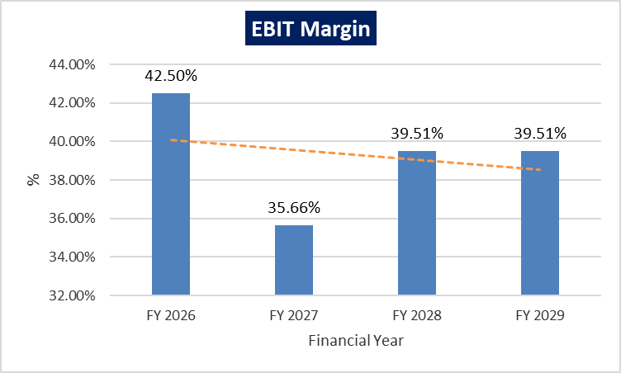 | 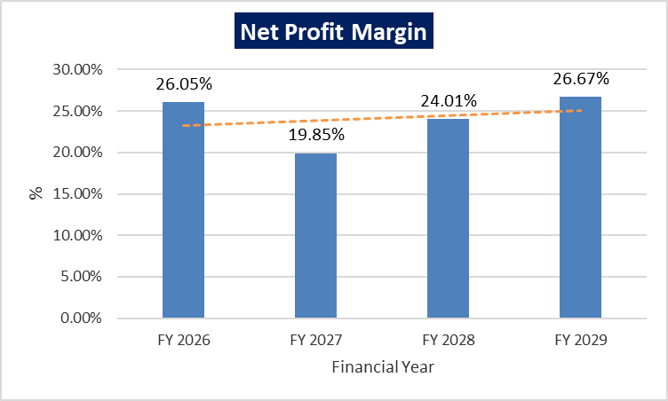
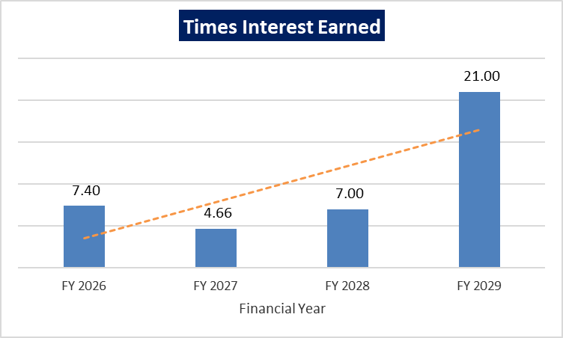 | 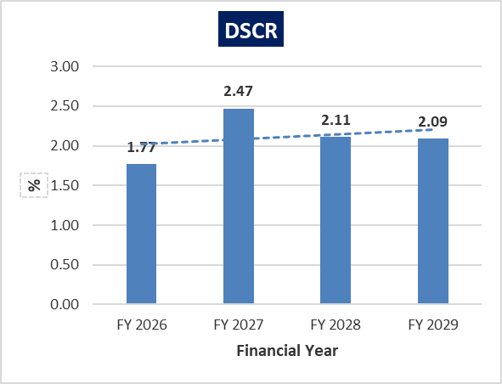
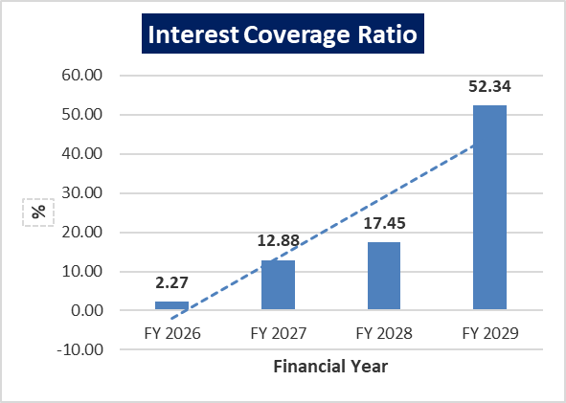 | 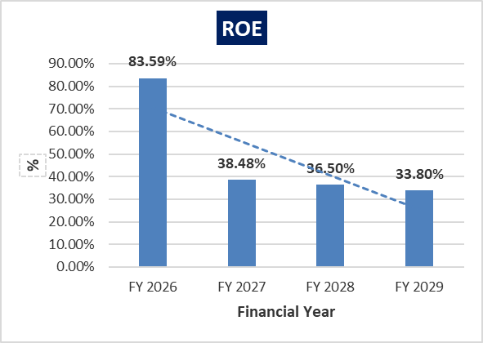

- REVENUE BUILD-UP
The analysis is based on assumptions with regards to current financial environment, construction period, sales phasing whereas at the time of actual implementation the situation might be different altogether. However, it is pertinent to note that the assumptions may vary, and any different assumption may produce different financial results. Below tables summarizes the potential revenue streams and the expected revenue collection:
FLOORS | No of Units | Total Area | Unit Sold | Area Sold (In Sq. Ft) | Amount Received (In Lacs) | Amount Pending (In Lacs) | Units Unsold | Area Unsold (In Sq. Ft) | Rate (In INR) Per Sq. Ft. | Expected Revenue From Unsold Revenue (In Lacs) | Total Revenue to be received (In Lacs) | Total Revenue Earned (In Lacs)
 |  | (A.) | (B.) | (C.) | (D.) | (E.) | (F.) | (G) | (H) | (I = G*H) | (J=E+I) | (K=D+J)
Commercial Space
Shop LGF | 17 | 7,481 | 10 | 4,569 | 116.53 | 201.43 | 7 | 2,912 | 21,000.00 | 611.52 | 812.95 | 929.48
Commercial anchors LGF | 5 | 9,015 | 1 | 1,443 | - | 63.95 | 4 | 7,572 | 10,000.00 | 757.20 | 821.15 | 821.15
Shops GF | 29 | 12,161 | 25 | 10,497 | 319.02 | 508.81 | 4 | 1,664 | 22,000.00 | 366.08 | 874.89 | 1,193.91
Commercial Anchor GF | 4 | 7,403 | 2 | 3,207 | - | 93.59 | 2 | 4,196 | 11,000.00 | 461.56 | 555.15 | 555.15
Shops FF | 29 | 12,161 | 16 | 6,320 | 161.61 | 352.17 | 13 | 5,841 | 15,000.00 | 876.15 | 1,228.32 | 1,389.93
Commercial Anchor FF | 4 | 7,403 | 0 | - | - | - | 4 | 7,403 | 8,000.00 | 592.24 | 592.24 | 592.24
Office Units at 4th floor | 56 | 13,748 | 56 | 13,748 | 251.00 | 271.55 | 0 | - |  | - | 271.55 | 522.55
Office Units at 5th floor | 41 | 18,000 | 38 | 16,472 | 226.71 | 315.49 | 3 | 1,557 | 6,000.00 | 93.42 | 408.91 | 635.62
Office Units at 6th floor | 41 | 18,000 | 34 | 14,250 | 223.56 | 250.13 | 7 | 3,750 | 6,000.00 | 225.00 | 475.13 | 698.69
Office Units at 7th floor | 65 | 15,623 | 65 | 15,623 | 284.32 | 276.65 | 0 | - |  | - | 276.65 | 560.97
Studio Apartments at 9th floor | 18 | 12,835 | 17 | 12,110 | 147.10 | 214.28 | 1 | 725 | 5,500.00 | 39.88 | 254.16 | 401.26
Studio Apartments at 10th floor | 18 | 12,835 | 18 | 12,835 | 151.43 | 196.66 | 0 | - |  | - | 196.66 | 348.09
Studio Apartments at 11th floor | 18 | 12,835 | 18 | 12,835 | 163.04 | 176.74 | 0 | - |  | - | 176.74 | 339.78
Studio Apartments at 12th floor | 18 | 12,835 | 18 | 12,835 | 192.99 | 169.85 | 0 | - |  | - | 169.85 | 362.84
Restaurants at 2nd floor | 2 | 4,200 | 0 | - | - | - | 2 | 4,200 | 8,350.00 | 350.70 | 350.70 | 350.70
Banquets | 2 | 36,000 | 0 | - | - | - | 2 | 36,000 | 8,350.00 | 3,006.00 | 3,006.00 | 3,006.00
Total | 367 | 2,12,535 | 318 | 1,36,744 | 2237.31 | 3091.3 | 49 | 75,820 |  | 7,379.75 | 10,471.05 | 12,708.36
The Projected revenue to be received from the balance remuneration (i.e., INR 30.91 crores) of units already sold (i.e., 318), can be demanded by the company, once it attains its occupation certificate after completing the work. Based on the assumptions and data provided by the management, balance remuneration can be realized as follows:
S. No. | Projected Year | Percentage of remuneration realized | Amount of remuneration realized (In Lakhs)
1 | By the end FY 2025-2026 | 70% | 2,163.91
2 | By the end FY 2026-2027 | 30% | 927.39
 | Total | 100% | 3,091.30
The Projected revenue to be received from units unsold is assumed to be realized gradually in next 4 years, upon sale of these units. We have assumed that, in initial year units sold will be less, as company will be focused on acquiring loan and completing its work. But this sale will gain its pace in 2nd and 3rd year, as company main focus shall be on marketing of these units. These Projections can be seen as follows:
S. No. | Projected sale of units | Percentage of units sold | Approx. No. of units sold | Approx. Amount of remuneration Realized (in lakhs)
 |  |  |  | FY 2025-26 | FY 2026-27 | FY 2027-28 | FY 2028-29
1 | 1st Lot | 15% | 7 | 332.09 | 553.48 | 221.39 | -
2 | 2nd Lot | 55% | 27 | 405.89 | 1,623.54 | 1,217.66 | 811.77
3 | 3rd Lot | 30% | 15 | - | - | 996.27 | 1,217.66
 | Total | 100% | 49 | 737.97 | 2,177.02 | 2,435.32 | 2,029.43
 | Grand Total |  |  | 7,379.75
Based on the assumptions and data provided by the management, amount from unsold units can be realized as follows:
S. No. | Projected sale of units | FY 2025-26 | FY 2026-27 | FY 2027-28 | FY 2028-29
1 | 1st Lot | 30% | 50% | 20% | -
2 | 2nd Lot | 10% | 40% | 30% | 20%
3 | 3rd Lot | - | - | 45% | 55%

- LOAN AMORTIZATION SCHEDULE:
- DETAILS OF TERM LOAN

PARTICULARS | DETAILS
Total loan amount | INR 3,000.00 Lakhs
Rate of Interest Used for Calculation | 10.00%
1st Disbursement | March 2025
IDC Start & End Month | March 2025 – June 2025
IDC Period (construction period) | 4 Months
Moratorium Period | 12 Months (Till February 2026)
COD | 1st July 2025
Repayment Start | March 2026
Repayment End | February 2029
Repayment Period | 36 Months
Total Period | 48 Months
- REPAYMENT SCHEDULE
(INR Lakhs)
Financial Year (FY) | Mar-25 | Mar-26 | Mar-27 | Mar-28 | Mar-29
Opening Balance | 0.00 | 1,500.00 | 2,916.67 | 1,916.67 | 916.67
Disbursement | 1,500.00 | 1,500.00 | 0.00 | 0.00 | 0.00
Repayment | 0.00 | 83.33 | 1000.00 | 1000.00 | 916.67
Closing balance | 1,500.00 | 2,916.67 | 1,916.67 | 916.67 | -
Interest | 0.00 | 224.31 | 237.50 | 137.50 | 38.19
IDC | 12.50 | 70.83 | 0.00 | 0.00 | 0.00
TL Interest | 12.50 | 295.14 | 237.50 | 137.50 | 38.19
Note: Interest during Construction (IDC) is assumed to be paid from March 2025 to June 2025 by the company @ 10.00%. As per the information provided by the company, the promoters/company will pay the IDC from its own sources such as cash accruals from the project. Hence, as requested by the client, it is not included in the cost of the project.

- KEY ASSUMPTIONS & BASIS:
S. No. | Item | Assumptions and Basis
 | General | - The projections of the firm are done for the period from FY 2024-25 to FY 2028-29 (5 years) to cover the term loan period.  - We have considered Revenue and cost recognition-based model while making the future financial projections.
 | Pricing (Average Selling Price per sq. ft.) | - As per data/information shared by the client, the company will be selling Shops, Anchor Shops, Office Space, Studio Apartments, Restaurant and Banquet Halls in terms of super area.  Type of Units Rate (per Sq. Ft.)  Shops 15,000 to 22,000  Commercial Anchor Shops 8,000 to 11,000  Office Units 6,000  Studio Apartments 5,500  Restaurants 8,350  Banquets 8,350  - As per secondary and tertiary research, industry trend and pricing offered in the nearby societies and data/information available in public domain, we found that the price per sq. ft. to be reasonable and on conservative side and is in the line with market trends.  - Factors such as prominent location, experience of promoters, latest data in public domain, information collected during survey, peers pricing has been considered to decide the said prices of proposed units.  References:  https://www.99acres.com/shop-for-sale-in-raj-nagar-extension-ghaziabad-616-sq-ft-spid-B80029875  https://www.99acres.com/shop-for-sale-in-raj-nagar-extension-ghaziabad-100-sq-ft-r4-spid-L65437016  https://www.99acres.com/shop-for-sale-in-emenox-brave-hearts-plaza-raj-nagar-extension-ghaziabad-378-sq-ft-spid-V79323373  https://www.99acres.com/shop-for-sale-in-the-grand-plaza-raj-nagar-extension-ghaziabad-450-sq-ft-spid-R79735369  https://www.99acres.com/coworking-space-for-sale-in-jyotisuper-the-hub-raj-nagar-extension-ghaziabad-345-sq-ft-spid-V79990331  https://www.99acres.com/bare-shell-office-space-for-sale-in-raj-nagar-extension-ghaziabad-502-sq-ft-spid-O80551123
 | Revenue Build up | - Total income for the financial years during the forecasted period will be generating from selling of Shops, Anchor Shops, Office Space, Studio Apartments, Restaurant and Banquet Halls.  - The company had already sold 318 units out of the total 367 units. The Projected revenue to be received from the balance remuneration (i.e., 30.91 crores) of units already, can be demanded by the company, once it attains its occupation certificate after completing the work.  - The Projected revenue to be received from unsold 49 units is assumed to be realized gradually in next 4 years, upon sale of these units. We have assumed that, in initial year units sold will be less, as company will be focused on acquiring loan and completing its work. But this sale will gain its pace in 2nd and 3rd year, as company main focus shall be on marketing of these units.
 | Expenses | - The proposed project's total construction cost is approx. INR 6,500.00 Lakhs. Out of this, INR 3614.08 Lakhs (including the project clearance fees) has already incurred by the company as per the details shared with us.  - As per the details shared by the client/company, the company will incur project clearance fees of ~INR 700.00 Lakhs which includes, Pollution (CTE & CTO), Water Control Board (Borewell), GDA EDC Charges, GDA Compounding Charges & Fire NOC.  - Contingency cost of INR 37.50 Lakhs (~0.50% of Hard Cost) has been considered based on general assumption and professional experience.
 | Term Loan | - For the total project cost of INR 7,462.50 lakhs, the company had already completed the works amounting to INR 3,839.08 lakhs (including the cost of land) as per the Engineers’ Certificate dated 14.01.2025 shared with us. For the work completed till now, the project had been funded through promoter’s contributions of INR 1,601.77 lakhs and INR 2,237.31 lakhs from advances from customers with respect to the units booked.  - For the remaining work to be completed amounting to INR 3,623.42 lakhs, the project is proposed to be funded through a term loan of INR 3,000.00 lakhs, INR 300.00 lakhs from promoter’s margin and INR 323.42 lakhs will be from advances from customers with respect to the units booked.  - As per the details shared with us, the project is scheduled to be achieving the COD on 1st July 2025. The loan repayment period will be 36 months, i.e., from March 2026 to February 2029. The interest rate is considered as 10.00% as per the latest information provided by the client/company for the whole period of the term loan.  - The tenure of the loan will be 48 Months in which first repayment will be made in FY 2026-27.

Conclusion:
      - DSCR, EBITDA and Net Profit margin are positive in all the projected relevant years. The Project has achieved DSCR of more than 1 during the loan repayment period.
      - Average DSCR, EBIT margin, Net Profit margin is 2.19, 39.30%, and 24.15% respectively during the estimated period. The Project is having a positive NPV and IRR of INR 2,983.85 Lakhs and 46.65% respectively at the base cases while it may vary with changes in the assumptions & micro and macro-economic trends considered as on date.
      - Based on the above key financial ratios of the project during the forecast period for the proposed project shows that the project looks financially and economically viable if the Project company & promoters are able to maintain sales phasing, revenue and also able to contain cost as assumed above. However, the above-mentioned projections are calculated on the basis of the plan shared by the client/company. If the company differs from the approved plan during the implementation, the projections may differ resulting to altered concluded viability.
PART M | CONCLUSION

Based on the technological, economic and market analysis done above, various Industry assumptions taken, pricing to be adopted by the company, the Project appears to be Techno-commercially viable subject to the risks, threats, weaknesses, limitations of the services and equipment as detailed previously.
As per financial projections for the estimated period, Average DSCR, Average EBIT Margin and Average Net Profit Margin of the project are 2.19, 39.30% and 24.15% respectively, where higher DSCR is the indicator of the project capability to pay out its outstanding debt and EBITDA margin shows the capability of the project to generate the operating profits over the forecasted period. The proposed facility is having a positive NPV and IRR as INR 2,983.85 Lakhs and 46.65% respectively. While it is not avoidable that the future projections may change in the upcoming years due to various factors impacting the operation, managerial, financial efficiency and economies of scale of the project.
It would be depending on the management’s capability in future that how efficiently the company adopts marketing and advertisement strategy, supply chain and carry out inventory & resource management to achieve higher profitability. After considering the demand and supply of the commercial units in the region of Raj Nagar Extension, Ghaziabad and financial analysis of the project based on the assumptions taken over the projected period, it appears reasonable to comment that the proposed project is ““Technically, Economically & Commercially” viable subject to current assumptions considered and occurring the same in the upcoming years same as the forecasted period which is dependent on the sincerity and efforts of the management and various micro and macroeconomic & industry situation.
We have tried our level best to analyse the Project techno-economic feasibility of the Project based on the industry research, Project information and various futuristic assumption taken within the limitations and challenges came in front of us. However, achieving the financial milestones depends on the ability, sincerity and efforts of the company, promoters and its key management to maintain the projected revenue level Y-o-Y basis keeping the fact in mind that the project is found sensitive with respect to the down side fluctuation in the revenue.
Declaration | - The undersigned does not have any direct/indirect interest in the above property/project/company.  - The information furnished herein is true and correct to the best of our knowledge, logical and scientific assumptions.  - This TEV Report is carried out by our Financial Analyst team on the request from Punjab National Bank, MCC-2 Branch, Meerut.  - Meeting of Financial projections will be subject to the market & economy stability factors, judicious business operations and proper & timely implementation of the project and putting proper plan for achieving high productivity, efficiency and achieving cost saving benefits to increase profitability.  - We have submitted TEV report to the client.
Number of Pages in the Repost | 82
Enclosed Documents | Disclaimer & Remarks 71-74
Place | Noida
Date | 25th February 2025

FOR ON BEHALF OF
M/S. R.K. ASSOCIATES VALUER & TECHNO ENGINEERING CONSULTANTS PVT. LTD.
SURVEYED BY | PREPARED BY | REVIEWED BY
Mr. Atul Gola | Mr. Rachit Gupta | Mr. Gaurav Kumar

PART N | DISCLAIMER | REMARKS

      - No employee or member of R.K Associates has any direct/ indirect interest in the Project.
      - This report is prepared based on the copies of the documents/ information which the Bank/ Company has provided to us out of the standard checklist of documents sought from them and further based on our assumptions and limiting conditions. The client/owner and its management/representatives warranted to us that the information they supplied was complete, accurate and true and correct to the best of their knowledge. All such information provided to us has been relied upon in good faith and we have assumed that it is true and correct in all respect. I/We shall not be liable for any loss, damages, cost or expenses arising from fraudulent acts, misrepresentations, or wilful default on part of the owner, company, its directors, employee, representative or agents. Verification or cross checking of the documents provided to us from the originals or from any Govt. departments/ Record of Registrar has not been done at our end since this is beyond the scope of our work. If at any time in future, it is found or came to our knowledge that misrepresentation of facts or incomplete or distorted information has been provided to us then this report shall automatically become null & void.
      - Legal aspects for e.g., investigation of title, ownership rights, lien, charge, mortgage, lease, sanctioned maps, verification of documents, etc. have not been done at our end and same has to be taken care by legal expert/ Advocate. It is assumed that the concerned Lender/ Financial Institution has satisfied them with the authenticity of the documents, information given to us and for which the legal verification has been already taken and cleared by the competent Advocate before requesting for this report. I/ We assume no responsibility for the legal matters including, but not limited to, legal or title concerns.
      - This report is a general analysis of the project based on the scope mentioned in the report. This is not an Audit report, Design document, DPR or Techno feasibility study. All the information gathered is based on the facts seen on the site during survey, verbal discussion & documentary evidence provided by the client and is believed that information given by the company is true best of their knowledge.
      - This Techno Economic-Viability study is prepared based on certain futuristic assumption which are intra dependent on economic, market and sectorial growth condition in future and socio-economic, socio-political condition at macro and micro level.
      - Meeting of assumption and financial ratio will entirely depend on the sincerity and efforts of the company, promoters and its key managerial performance.
      - All observations mentioned in the report is only based on the visual observation and the documents/ data/ information provided by the client. No mechanical/ technical tests, measurements or any design review have been performed or carried out from our side during Project assessment.
      - This report has been diligently prepared by our techno-financial team to the best of their ability. However, it's important to note that the recommendations provided in this Total Economic Viability (TEV) assessment do not imply an endorsement, validation, or certification of the accuracy or completeness of the disclosed information by the involved stakeholders. Furthermore, we do not claim or endorse that the opinions presented herein are the sole best course of action for decision-makers to follow. There may exist additional approaches and inputs that have not been covered within this report or fall outside the scope of this report.
      - Bank/FII should ONLY take this report as an Advisory document from the Financial/ Chartered Engineering firm and its specifically advised to the creditor to cross verifies the original documents for the facts mentioned in the report which can be availed from the borrowing company directly.
      - In case of any default in loans or the credit facility extended to the borrowing company, R.K Associates shall not be held responsible for whatsoever reason may be and any request for seeking any explanation from the employee/s of R.K Associates will not be entertained at any instance or situation.
      - The documents, information, data provided to us during the course of this assessment by the client are reviewed only up to the extent required in relation to the scope of the work. No document has been reviewed beyond the scope of the work.
      - This report only contains general assessment & opinion as per the scope of work evaluated as per the information given in the copy of documents, information, data provided to us and/ and confirmed by the owner/ owner representative to us at site which has been relied upon in good faith. It doesn’t contain any other recommendations of any sort including but not limited to express of any opinion on the suitability or otherwise of entering into any transaction with the borrower.
      - We have relied on data from third party, external sources & information available on public domain also to conclude this report. These sources are believed to be reliable and therefore, we assume no liability for the truth or accuracy of any data, opinions or estimates furnished by others that have been used in this analysis. Where we have relied on data, opinions or estimates from external sources, reasonable care has been taken to ensure that such data has been correctly extracted from those sources and /or reproduced in its proper form and context, however still we can’t vouch its authenticity, correctness or accuracy.
      - This Report is prepared by our competent technical team which includes Engineers and financial experts & analysts.
      - This is just an opinion report and doesn’t hold any binding on anyone. It is requested from the concerned Financial Institution which is using this report for taking financial decision on the project that they should consider all the different associated relevant & related factors also before taking any business decision based on the content of this report.
      - All Pages of the report including annexure are signed and stamped from our office. In case any paper in the report is without stamp & signature then this should not be considered a valid paper issued from this office.
      - Though adequate care has been taken while preparing this report as per its scope, but still we can’t rule out typing, human errors, over sightedness of any information or any other mistakes. Therefore, the concerned organization is advised to satisfy themselves that the report is complete & satisfactory in all respect. Intimation regarding any discrepancy shall be brought into our notice immediately. If no intimation is received within 15 (Fifteen) days in writing from the date of issuance of the report, to rectify these timely, then it shall be considered that the report is complete in all respect and has been accepted by the client up to their satisfaction & use and further to which R.K Associates shall not be held responsible in any manner.
      - Defect Liability Period is 15 DAYS. We request the concerned authorized reader of this report to check the contents, data and calculations in the report within this period and intimate us in writing if any corrections are required or in case of any other concern with the contents or opinion mentioned in the report. Corrections only related to typographical, calculation, spelling mistakes, incorrect data/ figures/ statement will be entertained within the defect liability period. Any new changes for any additional information in already approved report will be regarded as additional work for which additional fees may be charged. No request for any illegitimate change in regard to any facts & figures will be entertained.
      - R.K Associates encourages its customers to give feedback or inform concerns over its services through proper channel at valuers@rkassociates.org in writing within 15 days of report delivery. After this period no concern/ complaint/ proceedings in connection with the Techno- Economic Viability Study Services will be entertained due to possible change in situation and condition of the subject Project.
      - Our Data retention policy is of ONE YEAR. After this period, we remove all the concerned records related to the assignment from our repository. No clarification or query can be answered after this period due to unavailability of the data.
      - This Techno Economic Viability Study report is governed by our (1) Internal Policies, Processes & Standard Operating Procedures, (2) Information/ Data/ Inputs given to us by the client and (3) Information/ Data/ Facts given to us by our field/ office technical team. Management of R.K Associates never gives acceptance to any unethical or unprofessional practice which may affect fair, correct & impartial assessment and which is against any prevailing law. In case of any indication of any negligence, default, incorrect, misleading, misrepresentation or distortion of facts in the report then it is the responsibility of the user of this report to immediately or at least within the defect liability period bring all such act into notice of R.K Associates management so that corrective measures can be taken instantly.
      - R.K Associates never releases any report doing alterations or modifications from pen. In case any information/ figure of this report is found altered with pen then this report will automatically become null & void.
      - If this report is prepared for the matter under litigation in any Indian court, no official or employee of R.K Associates will be under any obligation to give in person appearance in the court as a testimony. For any explanation or clarification, only written reply can be submitted on payment of charges by the plaintiff or respondent which will be 10% of the original fees charged where minimum charges will be Rs. 15,000/.

EXTRACTS OF IMPORTANT STATUTORY APPROVALS PROVIDED BY THE CLIENT

