**File No.: VIS (2024-25)-PL716-643-888 Dated: 22.01.2025**

**LENDER’S INDEPENDENT ENGINEER REPORT (4nd)**

**(FOR QUARTER DECEMBER 2024)**

**OF**

**CHAUDHERY CHEESE PLANT**

**SITUATED AT**

**MOUJA -KOHLI, TEHSIL-ADAMPUR, DISTRICT-HISAR, HARYANA**

**IMPLEMENTED BY**

**M/S CHOUDHERY CHEESE BAZAR PVT. LTD. (CCBPL)**

**REPORT PREPARED FOR**

**STATE BANK OF INDIA, RMSME COMMERCIAL BRANCH, JANPATH**

***\*\*Important - In case of any query/ issue or escalation you may please contact Incident Manager at le@rkassociates.org. We will appreciate your feedback in order to improve our services.***

***NOTE: As per IBA Guidelines please provide your feedback on the report within 15 days of its submission after which report will be considered to be correct.***

|  |  |  |
| --- | --- | --- |
| **TABLE OF CONTENTS** | | |
| **SR. NO.** | **DESCRIPTION** | **PAGE NO.** |
| **PART A** | **Report Summary** | **04** |
| **PART B** | **Introduction** | **05** |
|  | 1. The Project | **05** |
|  | 1. Location of the Project | **03** |
|  | 1. Project Overview | **06** |
|  | 1. Scope of the Project During Project Duration | **08** |
|  | 1. Purpose of the Report | **08** |
|  | 1. Methodology Adopted | **08** |
| **PART C** | **Infrastructure Sections & Facility Details with Actual Progress** | **09** |
|  | 1. Land & Building & Civil works Details | **09** |
|  | 1. Machinery and Equipment | **09** |
| **PART D** | **Project Consultants, Contractors & Suppliers** | **18** |
| **PART E** | **Project Cost and Means of Finance** | **19** |
|  | 1. Cost of Project | **19** |
|  | 1. Current Status and Total Expenditure Incurred till Date | **20** |
|  | 1. Sources of Finance & Utilization of Funds | **23** |
| **PART F** | **Statutory & Regulatory Approvals, Clearances & NOC** | **24** |
| **PART G** | **Project Schedule & Current Status** | **25** |
| **PART H** | **Disclaimer** | **26** |
| **PART I** | **Enclosure** | **30** |
| **PART I** | **Photographs** | **42-44** |

# 

**IMPORTANT NOTICE**

***COPYRIGHT FORMAT:*** *This report is prepared on the copyright format of R.K Associates, to serve our clients with the best available information and analysis to facilitate them to take rational business decisions. Legally no one can copy or distribute this format without prior approval from R.K Associates. It is meant only for the advisory/ reference purpose for the organization/s as mentioned on the cover page of this report. Distribution or use of this format by any organization or individual other than R.K Associates will be seen as unlawful act and necessary legal action can be taken against the defaulters.*

*This report is intended for the sole use of the intended recipient/s and contain material that is STRICTLY CONFIDENTIAL AND PRIVATE.*

***DEFECT LIABILITY PERIOD:*** *- In case of any query/ issue or escalation you may please contact Incident Manager: le@rkassociates.org. We try our level best to ensure correctness in the calculations done, rates adopted and various other data points & information mentioned in the report but still can’t rule out typing, human errors or any other mistakes. In case you find any such mistake or inaccuracy in any data point of the report please help us by bringing all such points into our notice immediately or within 15 days of the report delivery in writing, to rectify these timely failing after which R.K Associates won’t be held responsible for any such inaccuracy in any manner. We would highly appreciate your feedback in order to improve our services.*

|  |  |
| --- | --- |
| **PART A** | **REPORT SUMMARY** |

|  |  |  |  |  |
| --- | --- | --- | --- | --- |
|  | | **Name of Project:** | | Choudhery Cheese Bazar |
|  | | **Project Location:** | | Mouja - Kohli, Tehsil - Adampur, district-Hisar, Haryana |
|  | | **Name of the Borrower:** | | M/s Choudhery Cheese Bazar Pvt. Ltd. |
|  | | **Regd. Address of the Borrower:** | | Regd. Office: E-038, Site B, Surajpur Industrial Area, Greater Noida, Gautam Budh Nagar, Uttar Pradesh, 201308 |
|  | | **Director’s/Partner’s:** | | * Mr. Asheesh Choudhery * Mrs. Akansha Choudhery * Mrs. Asha Choudhery   *Source: TEV report* |
|  | | **Prepared for Bank:** | | State Bank of India, RMSME Commercial Branch, Janpath |
|  | | **LIE Consultant Firm:** | | M/s. R.K. Associates Valuers & Techno Engineering Consultants (P) Ltd. |
|  | | **Date of Survey:** | | 2nd January 2025 |
|  | | **Date of Report:** | | 22nd January 2025 |
|  | | **Purpose of the Report:** | | To provide fair detailed analysis report to the Bank based on the “in-scope points” mentioned below to know Project progress. |
|  | | **Scope of the work provided by the Lender:** | | 1. Periodic Project physical status review 2. Periodic review of expenditure of the Project based on the expenditure Invoices/ Bills provided by the company |
|  | | **Documents perused for Proposal:** | | 1. TEV Report 2. CA Certificate 3. Copy of work orders 4. Copy of Invoices for expenses incurred 5. Property Title Documents 6. Plant Layout 7. Other approvals |
|  | | **Annexure with the report:** | | 1. Copies of Project Statutory approvals 2. CA Certificate 3. Site/Plot Plan |
| **PART B** | | **INTRODUCTION** | | |

1. **THE PROJECT:** This is a green field Cheese Manufacturing of proposed 40 Ton/ day being setup by M/s Choudhery Cheese Bazar Pvt. Ltd. At Mouja - Kohli, Tehsil - Adampur, District-Hisar, Haryana for the production of the following:

* Cheese Manufacturing Facilities – ~12,375 MT/ Year
* By-Products (ghee, curd & whey powder) – 7500 MT/ Year.

The proposed unit will mainly include the following facilities:

* Cold Storage & Insulation Panels
* Milk Procurement
* Milk Reception
* Milk Processing
* Cheese Equipment
* Whey Equipment
* Cheese Process
* Ghee
* Paneer
* Curd
* Laboratory Instrument

1. **PROJECT LOCATION:**

|  |  |
| --- | --- |
| **Particulars** | **Description** |
| **Location/ Address** | |
| Mouja - Kohli, Tehsil - Adampur, District-Hisar, Haryana | |
| **Google Coordinates** | |
| 29°15'49.5"N 75°30'30.1"E | |
| **Connectivity Systems** | |
| **Road:** The plant is situated approx. 16 km. from the Hisar highway and is accessible via 20 feet wide internal road. Moreover, it is positioned near the Adampur market.  **Rail:** The nearest major railway station from subject property is the Bhattu Railway Station and Big railway station is Hisar railway station which is approx. 20 Km from the subject property.  **Air:** The nearest airport to subject location is Indira Gandhi International Airport in Delhi, which is at a distance of approximately 200-210 kilometres, depending on the route taken. | |

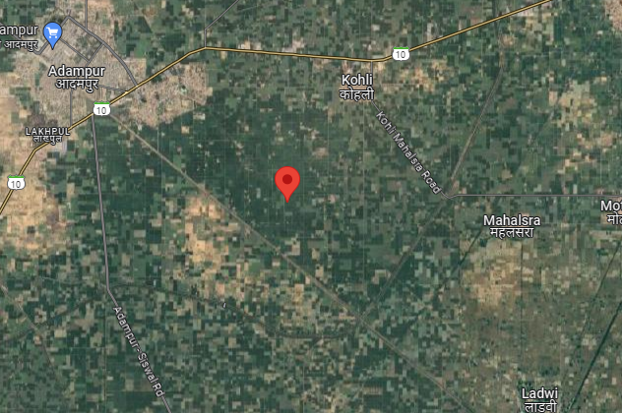**Figure: Location of property**

**Source: Google map**

1. **PROJECT OVERVIEW:** M/s Choudhery Cheese Bazar Pvt. Ltd. is setting up a new production facility in Mouja - Kohli, Tehsil - Adampur, District- Hisar, Haryana. The subject Plant is proposed to manufacture ~12,375 MT/year of Mozarella, Cheddar, Processed & Cottage cheese etc. and 7500 MT/year of by-products like ghee and curd as per the below installed capacity and product mix:

|  |  |
| --- | --- |
| **Product** | **Capacity/MT** |
| Mozzarella Cheese | 6,000.00 |
| Cheddar Cheese | 1,500.00 |
| Processed Cheese & Dips | 1,875.00 |
| College Cheese Paneer' | 3,000.00 |
| Curd (Yogurt) Dahi | 1,500.00 |
| Ghee | 600.00 |
| DM 40 | 5,400.00 |
| **Total** | **19,875.00** |

As per TEV report, M/s. Choudhery Cheese Bazar Private Limited (CCBPL) has been in the dairy business since 1986. Founded by Shri. Asheesh Choudhery and Smt. Akansha Choudhery, the company started in New Delhi on July 3rd, 2001. They developed their own production facilities at Surajpur, Greater Noida in 2011. The company sells its products with brand names as "Choudhery’s Cheese Bazar" and "Anandam".

Total Project cost is estimated at Rs. 72.48 crore which comprises of Land, Buildings, Plant and Machinery, and utilities. Break-up the Project cost is further detailed in later section of the report. Funding for the project is planned through Rs. 44.80 crore Rupee Term Loan from Bank, Rs.18.45 crore from promoter contributions, and a grant of Rs. 9.23 crore from the Ministry of Food Processing Industries (MOFPI).

The Company has obtained quotation from M/s Food and Biotech Engineers India P. Limited for purchase of Plant & Machinery and other equipment. The Plant will have dairy processing, laboratory equipment, utilities such as power/steam generation and distribution, RO and water softening plant, air compressor, ETP (Effluent Treatment Plant), CIP (Clean-in-Place system), milk tankers, and miscellaneous assets. The total estimated cost for the core plant and machinery, including other equipment and installation, amounts to Rs. 55.29 crore.

The company started work on the project in December 2023. As per the latest site inspection carried out on 02 January 2024, the plant is expected to achieve COD in March 2025. However, the COD will be extended further due to delays caused by rain.

Company has already obtained Pollution NOC on the Project. Other approvals such as Building Plan, Fire NOC and others are yet to come. For the purpose of the construction

As per the latest site inspection carried out on 2nd January 2024, boundary wall of the site is completed, Security Block work is in progress, shed work of Utility area, Refrigeration Machine section, RO & Air compressor section, PCC & APFC Panel section is completed except Boiler area. The shed portion of the main building is completed excluding the dryer section and evaporator section, while the rest of the portion is a work in progress. Major machines have arrived on site, including the dryer, condenser, air compressor, refrigeration machine, RO Plant & Water Softening Plant, cheese-making machine, Homogenizer, Silos 30 KL, Bio-Mass Boiler, CIP (Cleaning in Process), Cream Pasteuizer, Milk Pasteuizer and dryer calandria etc.

State Bank of India, Commercial Branch, Janpath, New Delhi has sanctioned RTL to the company and Bank has appointed us to know the periodic progress of the project.

1. **SCOPE OF WORK DURING PROJECT DURATION:**
2. Periodic Project physical status review.

*Project cost verification is out of scope of work and has been referred from the TEV Report.*

1. **PURPOSE OF THE REPORT:** To provide fair detailed analysis report to the Bank based on the “in-scope points” mentioned above to know Project progress.
2. **METHODOLOGY ADOPTED:**
3. Study of Project Planning documents/ reports to know about the Project.
4. Additional information, data, documents collection from the borrower.
5. Site Inspection.
6. Review and analysis of the documents and information obtained from the borrower and corroborating it with the site inspection status.
7. Information compilation, analysis and reporting.

|  |  |
| --- | --- |
| **PART C** | **INFRASTRUCTURE DETAILS OF THE PROJECT & CURRENT STATUS** |

1. **LAND:** The Company has acquired 10.66 acres of land at Mouja -Kohli, Tehsil Adampur, District-Hisar, and Haryana for the proposed project. As per the copy of the deed provided to us, it is a freehold land which is purchased and registered in the name of Choudhery Cheese Bazar Pvt. Ltd. The total cost estimated for Land and its development is Rs. 3.80 Cr. as per documents provided to us by the client/bank.

|  |  |  |  |  |  |
| --- | --- | --- | --- | --- | --- |
| **S No.** | **Village** | **Kathi No.** | **Khasra No.** | **Seller** | **Extent of land** |
| 1 | Siswal | 245/316 | 40 / /1 / 2 (6-13), 2 /2 (7-0), 3/2 (7-3), 8 (8-0), 9(8-0), 10 (7-8), 13 (8-0), 18/1 (2-6) | Bimla | 54 Kanal 10 Marla |
| 2 | Siswal | 246/317 | 140 / /11 (7-8), 12 (8-0), 19 (8-0),20 (7-8) | Bimla | 30 Kanal 16 Marla |
| **Total** | | | | | **85 Kanal 6 Marla** |

1. **BUILDING & CIVIL WORKS:** The company has planned to construct the following buildings:

* PEB Building (for process area, packaging area, storage of finished products and utility block etc.)
* Administrative building (conventional RCC beam and column structure)
* Cold Storage & Insulation Panels (The thermal insulation all around the superstructure of the proposed cold storages at their respective temperatures as per the process.

**SUMMARY OF BUILDINGS**

|  |  |  |  |  |
| --- | --- | --- | --- | --- |
| **S No.** | **Description** | **Proposed Area (Sq.mt.)** | **Progress as on site visit 23/08/2024** | **Progress as on site visit 02/01/2025** |
| 1 | Main Building | 15,276 | * The shed portion of the main building, excluding the dryer section and evaporator section is completed. * The columns of the steel structure are erected and the GI shed for the dryer section and evaporator section is completed. | * The shed portion of the main building, excluding the dryer section and evaporator section is completed. * The columns of the steel structure are erected and the GI shed for the dryer section and evaporator section is completed. |
| 2 | Utilities | 1,236 | Columns of steel structure is erected and covering by GI shed is remaining. | The shed work is completed |
| 3 | Toilet | 80 | Work not yet started | Work not yet started |
| 4 | Boiler | 480 | Columns work is done | Columns of steel structure is erected and covering by GI shed is remaining. |
| 5 | Security Block | 37 | Work not yet started | Work is in progress |
| 6 | Administrative block | 180 | Work not yet started | Work not yet started |

**MAIN PLANT AREA AND UTILITY BLOCK (PEB BUILDING)**

|  |  |  |  |  |  |
| --- | --- | --- | --- | --- | --- |
| **S No.** | **Building Name** | **Area** | **Level/Floors** | **Progress as on site visit 23/08/2024** | **Progress as on site visit 02/01/2025** |
| 1 | Dryer section | 20.4Mtr X 17.7Mtr | 0.0MLVL to 21.0MLVL / 5 floors | Columns of steel structure is erected and covering by GI shed is balance | Columns of steel structure is erected and covering by GI shed is balance |
| 2 | Evaporator section | 20.4Mtr X 9.27Mtr | 0.0MLVL to 21.0MLVL / 3 floors | Columns of steel structure is erected and covering by GI shed is balance | Columns of steel structure is erected and covering by GI shed is balance |
| 3 | Whey Process/Crystallization section | 20.4Mtr X 21.38Mtr | 0.0MLVL to 5.2MLVL / 1 floors | Shed portion is completed  Shed portion is completed | Shed portion is completed  Shed portion is completed |
| 4 | Butter section | 8.98Mtr X 12.93 Mtr | 0.0MLVL to 5.2MLVL / 1 floors |
| 5 | Ghee section | 8.98Mtr X 38.22Mtr | 0.0MLVL to 5.2MLVL / 1 floors |
| 6 | Grater, Emulsifier, Stabilzer, Ingredient room | 13.5Mtr X 11.88Mtr | 0.0MLVL to 5.2MLVL / 1 floors |
| 7 | Processing Kettle | 13.5Mtr X 9.99Mtr | 0.0MLVL to 5.2MLVL / 1 floors |
| 8 | Process cheese Packing Room | 13.5Mtr X 16.55Mtr | 0.0MLVL to 5.2MLVL / 1 floors |
| 9 | Process cheese Stacking Room | 13.5Mtr X 12.77Mtr | 0.0MLVL to 5.2MLVL / 1 floors |
| 10 | Dahi production area | 13.3Mtr X 21.6Mtr | 0.0MLVL to 5.2MLVL / 1 floors |
| 11 | Dahi filling & packing area | 13.3Mtr X 29.5Mtr | 0.0MLVL to 5.2MLVL / 1 floors |
| 12 | Paneer production area | 19.7Mtr X 21.6Mtr | 0.0MLVL to 5.2MLVL / 1 floors |
| 13 | Paneer cutting & packing area | 19.7Mtr X 29.5Mtr | 0.0MLVL to 5.2MLVL / 1 floors |
| 14 | Mozzarella & Natural Cheese | 27.79Mtr X 51.88Mtr | 0.0MLVL to 5.2MLVL / 1 floors |
| 15 | CIP section | 15.2Mtr X 12.3Mtr | 0.0MLVL to 5.2MLVL / 1 floors |
| 16 | Milk process & storage section | 31Mtr X 12.3Mtr | 0.0MLVL to 5.2MLVL / 1 floors |
| 17 | Secondary Packaging | 93.6Mtr X 18Mtr | 0.0MLVL to 3.0MLVL / 1 floors |
| 18 | Packaging material store room | 96Mtr X 18Mtr | 3.0MLVL to 7.0MLVL / 1 floors |
| 19 | Milk lab | 6.6Mtr X 4.5Mtr | 0.0MLVL to 5.2MLVL / 1 floors |
| 20 | Purchase Office | 5.5Mtr X 2.7Mtr | 0.0MLVL to 5.2MLVL / 1 floors |
| 21 | Cold rooms & Storage area | 108.65Mtr X 30.77Mtr | 0.0MLVL to 5.2MLVL / 1 floors |
| 22 | MCC room | 10.2Mtr X 12.3Mtr | 0.0MLVL to 5.2MLVL / 1 floors |
| 23 | Scada room | 4.8Mtr X 12.3Mtr | 0.0MLVL to 5.2MLVL / 1 floors |
| 24 | ETP | 12.48Mtr X 47Mtr | 0.0MLVL to 6.0MLVL / 1 floors |

**ADMINISTRATIVE BUILDING & OTHER BLOCKS**

|  |  |  |  |  |  |
| --- | --- | --- | --- | --- | --- |
| **S No.** | **Building name** | **Area** | **Level/Floors** | **Progress as on site visit 23/08/2024** | **Progress as on site visit 02/01/2025** |
| 1 | Administrative block | 20 Mtr X 9 Mtr | Ground Floor | Work not yet started | Work not yet started |
| 2 | Engg Store & Workshop | 11 Mtr x 13 Mtr | Ground Floor | Work not yet started | Work not yet started |
| 3 | Canteen | 11.5 Mtr x 7.7 Mtr | Ground Floor | Work not yet started | Work not yet started |
| 4 | DG Shed | 11.5 Mtr x 7.8 Mtr | Ground Floor | Work not yet started | Work not yet started |
| 5 | Toilet | 8 Mtr x 13 Mtr | Ground Floor | Work not yet started | Work not yet started |
| 6 | Boiler section | 18Mtr X 27Mtr | 0.0MLVL to 17.0MLVL / 1 floors | Column work is completed | Columns of steel structure is erected and covering by GI shed is balance |
| 7 | Refrigeration Machine room | 11.54Mtr X 24Mtr | 0.0MLVL to 6.0MLVL / 1 floors | Work not yet started | Shed Work is completed |
| 8 | RO & Air compressor section | 11.54Mtr X 8Mtr | 0.0MLVL to 6.0MLVL / 1 floors | Columns of steel structure is erected and covering by GI shed is balance | Shed Work is completed |
| 9 | PCC & APFC Panel room | 11.54Mtr X 10Mtr | 0.0MLVL to 6.0MLVL / 1 floors | Work not yet started | Shed Work is completed |

**COLD STORAGE & INSULATION PANELS**

|  |  |  |  |  |
| --- | --- | --- | --- | --- |
| **S No.** | **Description** | **Proposed Area**  **(Sq.mt.)** | **Progress as on site visit 23/08/2024** | **Progress as on site visit 02/01/2025** |
| 1 | Puff Panel for Dairy Building Width 105m x Height 7.5m x 4 Nos. Panel | 3,150 | Completed | Completed |
| 2 | Puff Panel for Dairy Building Length 115m x Height 7.5m x 8 Nos. Panel | 6,600 | Completed | Completed |
| 3 | Puff Panel for Dairy Building Ceiling 115m Length x 105m Width | 12,075 | Completed | Completed |
| 4 | Puff Panel for Hygiene Station 10m Length x 10m Width | 2,000 | Work not yet started | Completed |
| 5 | Flooring & Civil Work 80m Length x 105 Width | 8,400 | Work In progress | Work In progress |

1. **PLANT/ MACHINERIES & OTHER EQUIPMENT AND UTILITIES**: The total amount envisaged against the purchase of Plant and Machinery amounts to Rs.5666.00 Lakh out of which as per CA Certificate having UDIN No.24515969BKAKMD4200, expenditure incurred till 30th September 2024 is Rs. 3263.64 Lakh.

**SUMMARY OF PLANT & MACHINERY & OTHER ASSETS**

|  |  |  |
| --- | --- | --- |
| **SUMMARY PLANT & MACHINERY** | | |
| **S No.** | **Particulars** | **Basic Cost Rs. Lakhs (incl. GST)** |
| 1 | Plant & Machinery | 4,627.96 |
| 2 | Laboratory Ware, Equipments & Instruments Cost Break-up | 59.00 |
| 3 | Power | 368.75 |
| 4 | Steam Requirement | 107.38 |
| 5 | RO Plant & Water Softening Plant | 59.00 |
| 6 | Air Compressor | 35.40 |
| 7 | ETP | 70.80 |
| 8 | CIP (Cleaning in Process) | 59.00 |
| 9 | Milk Tankers | 141.60 |
| 10 | Misc. Assets | 141.60 |
|  | **Total** | **5,670.49** |

**MAIN EQUIPMENT**

|  |  |  |  |  |  |
| --- | --- | --- | --- | --- | --- |
| **S. No:** | **Item** | **Quantity** | **Approved/ Not Approved by MOFPI** | **Progress as on site visit 23/08/2024** | **Progress as on site visit 02/01/2025** |
| **A** | **Milk Procurement** | | |  |  |
| 1 | Bulk coolers, 2000 KL Cap | 40 | Not approved | Yet to arrive on site | Yet to arrive on site |
| 2 | Computerized Milk Weighment & Testing | 40 | Yet to arrive on site |
| **B** | **Milk Reception** | | |  |  |
| 1 | Thermisor cap 25 KL/hr ho deg.C/ 15 Sec | 1 | Approved | Yet to arrive on site | Yet to arrive on site |
| 2 | Weigh Bridge | 1 | Arrived |
| 3 | Storage Silos 60 KL | 3 | Arrived |
| **C** | **Milk Processing** | | |  |  |
| 1 | Milk Pasteuizer 25 KL/hr | 1 | Approved | Yet to arrive on site | Arrived |
| 2 | Bactofuge 25 KL/hr - Used for cheese | - | Yet to arrive on site | Yet to arrive on site |
| 3 | Milk Separator 25 KL/hr | 1 | Yet to arrive on site | Arrived |
| 4 | Cream Pasteuizer 3 KL/hr | 1 | Yet to arrive on site | Arrived |
| 5 | Chilled Water | 1 | Yet to arrive on site | Yet to arrive on site |
| 6 | Storage Silos 60 KL (PMT) | 4 | Partial equipment arrived | Arrived |
| 7 | Cream Silos 5 KL | 2 | Yet to arrive on site | Arrived |
| 8 | Homogenizer | 1 | Yet to arrive on site | Arrived |
| **D** | **Cheese Equipments** | | |  |  |
| 1 | Double 'O' Vats cap.15000/16000 | 3 | Approved | Yet to arrive on site | Arrived |
| 2 | Finishing Vats, cap 10 KL | 3 | Arrived and Installed |
| 3 | Cooking and Stretching 2.0/2.5 HT.batch stream | 1 | Arrived |
| 4 | Drum Moulder for 2.5 HT | 1 | Yet to arrive on site |
| 5 | Dry Salter Suitable | 1 | Yet to arrive on site |
| 6 | Water Doser Suitable | - | Yet to arrive on site |
| 7 | Cooling Vat 1 set | 1 | Arrived and Installed |
| 8 | Drying room at 2 deg. C | 1 | Arrived |
| 9 | Dicer cap. 2.0 MT/hr | 1 | Yet to arrive on site |
| 10 | Sifter Suitable | 1 | Yet to arrive on site |
| 11 | Tumbler Suitable | 1 | Yet to arrive on site |
| 12 | Anticaking Agent Doser | 1 | Yet to arrive on site |
| 13 | Conveyor 1 set | 1 | Yet to arrive on site |
| 14 | FFS Machine 2 MT/hr | 1 | Yet to arrive on site |
| 15 | Multivac Double Decker | 1 | Yet to arrive on site |
| 16 | Set of conveyors with metal detector | 1 | Yet to arrive on site |
| 17 | Maturing room cold storage | 1 | Yet to arrive on site |
| 18 | Blast Freezer cold storage | 1 | Arrived |
| 19 | Cold Store Deep Freezer | 1 | Arrived |
| 20 | Presses for 20kg block cheddar | 1 | Yet to arrive on site |
| 21 | Cheese Hoop | 1 | Yet to arrive on site |
| 22 | Maturing Cold Storage Cheddar | 1 |  | Yet to arrive on site |
| **E** | **Whey Equipments** | | |  |  |
| 1 | AZO Filter | 1 | Approved | Yet to arrive on site | Yet to arrive on site |
| 2 | Whey Pasteurizer 25 KL/hr | 1 | Yet to arrive on site | Yet to arrive on site |
| 3 | Whey Separator 25 KL/hr | 1 | Yet to arrive on site | Yet to arrive on site |
| 4 | Whey Clarifier 25 KL/hr | 1 | Yet to arrive on site | Yet to arrive on site |
| 5 | Nano Filtration 20 KL/hr | 1 | Yet to arrive on site | Yet to arrive on site |
| 6 | Nano Polisher 20 KL/hr | 1 | Yet to arrive on site | Yet to arrive on site |
| 7 | Suitable Evaporator | 1 | Yet to arrive on site | Arrived |
| 8 | Crystallization | 1 | Yet to arrive on site | Arrived |
| 9 | Silos 60 KL | 2 | Yet to arrive on site | Arrived |
| 10 | Ultra Filterator 20 KL/hr for WPC 80 | - | Yet to arrive on site | Yet to arrive on site |
| **F** | **Cheese Process** | | |  |  |
| 1 | Grater | 1 | Approved | Yet to arrive on | Yet to arrive on |
| 2 | Processing Kettle 80 Ltr | 1 | Yet to arrive on | Yet to arrive on |
| 3 | Block Filling Ceka Pollatiner | 1 | Yet to arrive on | Yet to arrive on |
| 4 | Slice IWS | - | Yet to arrive on | Yet to arrive on |
| 5 | Portion Machine (80-100 portion/min) | 1 | Yet to arrive on | Yet to arrive on |
| 6 | Filling Machine for Tubs | 1 | Yet to arrive on | Arrived |
| 7 | Filling Machine for Bottle | 1 | Yet to arrive on | Arrived |
| 8 | Cold Storage | 1 | Yet to arrive on | Arrived |
| 9 | Homogenizer 1000-1500 KL/hr | 1 | Yet to arrive on | Arrived |
| 10 | Pumps | 1 | Partial equipment arrived | Partial equipment arrived |
| **G** | **Ghee** | | |  |  |
| 1 | Cream Concentrator 1.5-2 KL/hr capacity | 1 | Approved | Yet to arrive on site | Partial equipment arrived |
| 2 | Ghee Kettle Cap - 1 MT | 2 |
| 3 | Ghee Kalrifier 1 MT/hr | 1 |
| 4 | Ghee Filling Machine in Jars | 1 |
| 5 | Ghee Pouch Filling | 1 |
| **H** | **Paneer** | | |  |  |
| 1 | Silos 30 KL | 2 | Approved | Yet to arrive on site | Partial equipment arrived |
| 2 | Milk Pumps (10 KL/ hr) | 1 | Yet to arrive on site | Partial equipment arrived |
| 3 | PHE cap 3000 ltr/hr 6 deg.C to 90 deg.C | 1 | Yet to arrive on site | Yet to arrive on site |
| 4 | Milk Storage Tank (3 KL) | 3 | Yet to arrive on site | Arrived |
| 5 | Pumps with VFD (10 KL/ hr) | 1 | Partial equipment arrived | Partial equipment arrived |
| 6 | Alpma equipment | 1 | Yet to arrive on site | Yet to arrive on site |
| 7 | Moulds with lids | 40 | Yet to arrive on site | Yet to arrive on site |
| 8 | Roler conveyor | 1 | Yet to arrive on site | Yet to arrive on site |
| 9 | Presses | 1 | Yet to arrive on site | Yet to arrive on site |
| 10 | Water cooling | 1 | Yet to arrive on site | Yet to arrive on site |
| 11 | PHE for cold water (10 KL/ hr) | 1 | Yet to arrive on site | Yet to arrive on site |
| 12 | Milk Pumps | 1 | Partial equipment arrived | Partial equipment arrived |
| 13 | Whey Storage Silos (30 KL) | 3 | Yet to arrive on site | Yet to arrive on site |
| 14 | Acid Tank System (2 KL) | 2 |  | Yet to arrive on site | Yet to arrive on site |
| 15 | SS Pipes & fittings | 1 | Yet to arrive on site | Yet to arrive on site |
| 16 | Multivac Thermo Forming Machine R225 | 1 | Yet to arrive on site | Yet to arrive on site |
| 17 | Howbart slicer | 2 | Yet to arrive on site | Yet to arrive on site |
| 18 | Electrical | 1 | Yet to arrive on site | Yet to arrive on site |
| 19 | Thermisation | 1 | Yet to arrive on site | Yet to arrive on site |
| 20 | Cold Storage plus | 1 | Yet to arrive on site | Yet to arrive on site |
| 21 | Cold storage deep | 1 | Yet to arrive on site | Yet to arrive on site |
| 22 | Multivac small vacuum packaging | 1 | Yet to arrive on site | Yet to arrive on site |
| 23 | Misc | 1 | Yet to arrive on site | Yet to arrive on site |
| **I** | **Dahi** | | |  |  |
| 1 | PHE cap 3000 ltr/hr 6 deg.C to 90 deg.C | 1 | Approved | Yet to arrive on site | Yet to arrive on site |
| 2 | Culture tank 5000 KL | 2 | Yet to arrive on site |
| 3 | Filing machine | 1 | Partial equipment arrived |
| 4 | Incubation room 1 set | 1 | arrived |
| 5 | Cold storage 1 set | 1 | Yet to arrive on site |
| 6 | Trolleys | 10 | Partial equipment arrived |

**LABORATORY WARE, EQUIPMENTS & INSTRUMENTS**

|  |  |  |  |  |  |  |  |
| --- | --- | --- | --- | --- | --- | --- | --- |
| **S. No:** | **Equipment** | | **Quantity** | **Approved / Not Approved by MoFPI** | | **Progress as on site visit 23/08/2024** | **Progress as on site visit 02/01/2025** |
| **I** | **General Equipments** |  | | |  | |  |
| 1 | Laboratory Glass Ware | | Lot | Not Approved | | Yet to arrive on site | Yet to arrive on site |
| 2 | Laboratory Chemical Reagents | | Lot |
| **II** | **Laboratory Equipments** |  | | |  | |  |
| 1 | Analytical Balance Top-loading automatic | | 1 | Not Approved | | Yet to arrive on site | Yet to arrive on site |
| 2 | Analytical Balance Dhona type Manual | | 2 |
| 3 | Moisture Oven-Air circulation Fan | | 2 |
| 4 | Mufle Furnace 0 deg. To 96 deg.C | | 1 |
| 5 | Soxhelt extraction set 6 packets | | 1 |
| 6 | Refractor-meter | | 2 |
| 7 | Moisture Balance Meter | | 2 |
| 8 | pH Meter | | 2 |
| 9 | Thickness guage tester (.001 LC) | | 2 |
| 10 | T.L.C. Kit | | 2 |
| 11 | Ultra Voilet Kit | | 1 |
| 12 | Microscope | | 2 |
| **III** | **Sophisticated Modern Equipments** | | | | | |  |
| 1 | U.V. Visible Spectophotometer | | 1 | Not Approved | | Yet to arrive on site | Yet to arrive on site |
| 2 | Gas Chromatograph | | 1 |
| 3 | Flame Photometer | | 1 |
| 4 | Bomb Calorimeter | | 1 |
| 5 | Polarimeter | | 1 |
| 6 | HPLC | | 1 |
| **IV** | **Microbiology Testing Facilities** | | | | | |  |
| 1 | Laminar Flow | | 1 | Not Approved | | Yet to arrive on site | Yet to arrive on site |
| 2 | Colony Counter, Digital | | 2 |
| 3 | BOD Incubator | | 2 |
| 4 | Autoclave | | 1 |
| 5 | Centrifuge | | 1 |

**POWER UTILITIES**

|  |  |  |  |  |  |
| --- | --- | --- | --- | --- | --- |
| **S. No:** | **Equipment** | **Quantity** | **Approved / Not Approved by MoFPI** | **Progress as on site visit 23/08/2024** | **Progress as on site visit 02/01/2025** |
| **A** | **33 KV Sub-Station (Refer SLD)** | | |  |  |
| 1 | 2.0 MVA, 33 KV/ 433V Transformer | 2 No. | Not Approved | Yet to arrive on site | Partial equipment arrived |
| 2 | 33 KV, Vacuum Circuit Breaker (VCB) | 1 No. | Yet to arrive on site |
| 3 | 30 KV, Lightening Arrestor (LAS) | 2 Set | Yet to arrive on site |
| 4 | 33 KV, TP Isolators | 2 Nos. | Yet to arrive on site |
| 5 | RTCC Panel | 1 No. | Yet to arrive on site |
| 6 | 110 V Battery with Charger | 1 No. | Yet to arrive on site |
| 7 | PCCs, MCC, MDB,SDB | 1 Nos. | Partial equipment arrived |
| 8 | 3200 A, TPN Bus Duct | 15 Mtrs. | Yet to arrive on site |
| 9 | 1250 A, TPN Bus Duct | 3 Mtrs. | Yet to arrive on site |
| 10 | 1000A, TPN Bus Duct | 10 Mtrs. | Yet to arrive on site |
| 11 | 700 KVAR Capacitors with control panel | 2 Nos. | Yet to arrive on site |
| 12 | Steel Structures | Lot | Yet to arrive on site |
| 13 | Control cables | Lot | Yet to arrive on site |
| 14 | Earthing System | Lot | Yet to arrive on site |
| 15 | Misc. | --- | Yet to arrive on site |
| **B** | **D.G. Set for Emergency Power to PCC 2 NOS. 500 KVA + 1NO 125KVA DG Set with Control Panel** | 2 Nos. | Approved |  |  |
| 1 | 11 KV, XLPE Cables for a total load for 4000 KVA, entire localized load centres |  | Yet to arrive on site | Yet to arrive on site |
| 2 | Internal Electrification |  |
| 3 | External Electrification |  |

**EQUIPMENT TO GENERATE AND DISTRIBUTE PROCESS STEAM**

|  |  |  |  |  |  |
| --- | --- | --- | --- | --- | --- |
| **S. No:** | **Equipment** | **Quantity** | **Approved / Not Approved by MoFPI** | **Progress as on site visit 23/08/2024** | **Progress as on site visit 02/01/2025** |
| **A** | **Bio-Mass Boiler With Standard Components** |  | |  |  |
| 1 | Bio-mass based boiler of capacity 12,000 Kg/hr of saturated steam @ 10.50 Bar including standard components like ID & FD  Fan, motors and mounting /fittings etc. | 1 | Not Approved | Yet to arrive on site | Arrived and Installation work in progress |
| 2 | Air Pre-heater | 1 |
| 3 | Dust Collector | 1 |
| **B** | **Essential accessories, erection & commissioning and certification of Boiler** |  |  |  |  |
| 1 | Chimney complete with ladder, lightening arrestor including ducting to connect it with boiler and canvas duct for FD fan | 1 | Not Approved | Yet to arrive on site | Arrived and Installation work in progress |
| 2 | Complete feed water system including a tank of 30 kL, structure for staging and all valves, fittings etc. | 1 | Arrived and Installation work in progress |
| 3 | Steam system including Pressure Reducing Station, main header with all standard fittings and mountings etc. | 2 | Arrived and Installation work in progress |
| 4 | Miscellaneous items like support structure of ducts, boiler operation platform, foundation bolts, refractory lining etc. | LOT | Arrived and Installation work in progress |
| 5 | IBR approval | 1 | Arrived and Installation work in progress |
| 6 | Steam distribution piping from boiler house to use points | LOT | Arrived and Installation work in progress |

**OTHER MISCELLANEOUS ITEMS (NOT APPROVED BY MOFPI)**

|  |  |  |  |  |  |
| --- | --- | --- | --- | --- | --- |
| **S. No:** | **Equipment** | **Quantity** | **Approved / Not Approved by MoFPI** | **Progress as on site visit 23/08/2024** | **Progress as on site visit 02/01/2025** |
| 1 | RO Plant & Water Softening Plant | 1 | Not Approved | Yet to arrive on site | Arrived and Installed |
| 2 | Air Compressor | 1 | Not Approved | Arrived | Arrived |
| 3 | ETP | 1 | Not Approved | Yet to arrive on site | Yet to arrive on site |
| 4 | CIP (Cleaning in Process) | 1 | Not Approved | Yet to arrive on site | Arrived and Installed |

***Source: TEV report provided to us.***

**MILK TANKERS**

|  |  |  |  |  |  |  |
| --- | --- | --- | --- | --- | --- | --- |
| **S. No:** | **Equipment** | **Capacity(KL)** | **Quantity** | **Approved / Not Approved by MOFPI** | **Progress as on site visit 23/08/2024** | **Progress as on site visit 02/01/2025** |
| 1 | Reefer Vans | 18 | 4 | Approved | Yet to arrive on site | Yet to arrive on site |

***Source: TEV report provided to us.***

**MILK CHILLING CENTRE**

The company proposes to set up 10 Chilling centres to procure milk. Each Chilling center will have 4 Nos of 2KL tank along with all the necessary equipment to make the milk portable for transport and further processing.

**NOTE:**

1. The above is the proposed and estimated Machineries as mentioned in TEV Report. However in actual this may vary at the time of order.
2. In the LIE Report we will be matching the machines from the actual Bills/ Invoices.

|  |  |
| --- | --- |
| **PART D** | **PROJECT CONSULTANTS, CONTRACTORS & SUPPLIERS** |

According to the company representative, and the details obtained from the Invoices and TEV report, there are some contractor/Suppliers appointed for different works. Details of the same has been shown in table below:

|  |  |  |
| --- | --- | --- |
| **PROJECT CONSULTANTS, CONTRACTORS & SUPPLIERS** | | |
| **S. No.** | **Contractor / Suppliers name** | **Work Assigned** |
|  | M/s PAN INDIA Construction | Architect & civil construction |
|  | M/s Food & Biotech Engineers (Inida) Pvt. Ltd. | Milk processing Section, Cream processing Section, Curd/Chhach/Lassi processing section, Whey Cooling Section |
|  | M/s Urjex Boilers Pvt. Ltd. | 8 Ton & 4 Ton Boilers |
|  | M/s Multivac laraon India Pvt. Ltd. | Packing Machine |
|  | M/s Uttam Enviro Tech Engineers Pvt. Ltd | Sewage Treatment Plant |
|  | M/s Fill pack | Press Machine, Single Head Mould, panner Mould, Double Matka Filling machine, Sealing Machine |
|  | Sahiba Fabrication | SS304 vertical milk storage fabrication, Mil storage silos cap. 60KL, SS316 Brine tank length 25 Mtr, Milk procurement bulk Coolers |
|  | Dima SRL | Batch Steam cooler, Mozzarella drum moulding machine |
|  | FAM NV | FAM cutting machine |
|  | Tech-N-Tech Engineers | SS304 ERW Pipe Fabrication, Air Reciever tank 1 M3, Innova valves, Tanker unloading pump, Curd transfer pump, Whey transfer pump centrifugal., |
|  | Prefect Fabricators | Labour for Roof sheet, vertical sheet, all corner and accessories, painting work |
|  | Mittal Machinery Store | End cup, Wires, Sheets, adaptors, motors, Nippals. |
|  | Balaji Packaging Machines | Fully automatic Linear carbon packing machine, four packet pressure conveyor. |
|  | NVS Industries | Bulk Concentrated acid tank, Dosing tank, lye solution tank, water tank, Recuperation tank. |

*Source: Compiled from the Invoices/ Bills provided by the company*

**Note:**

1. The above information of suppliers/ contractors is extracted from the Invoices/ Bills provided to us. However Contract agreements/ purchase orders placed for the same were not made available to us to check terms of engagement.

|  |  |
| --- | --- |
| **PART E** | **PROJECT COST & MEANS OF FINANCE** |

1. **TOTAL PROJECT COST:** As per TEV Report, the total Project cost is estimated below amounting to Rs.72.48 Cr. Breakage of the same has been shown in tabular and graphical form below:

|  |  |
| --- | --- |
| **Particulars** | **Amount** |
| Land Cost & site development | 3.80 Cr. |
| Technical Civil works | 6.66 Cr. |
| Plant & Machinery | 55.29 Cr. |
| Computers and other assets | 1.42 Cr. |
| Preoperative expenses (incl. IDC) | 3.69 Cr. |
| Contingency @ 2.7% | 1.62 Cr. |
| **TOTAL** | **72.48 Cr.** |

*Source: TEV Report*

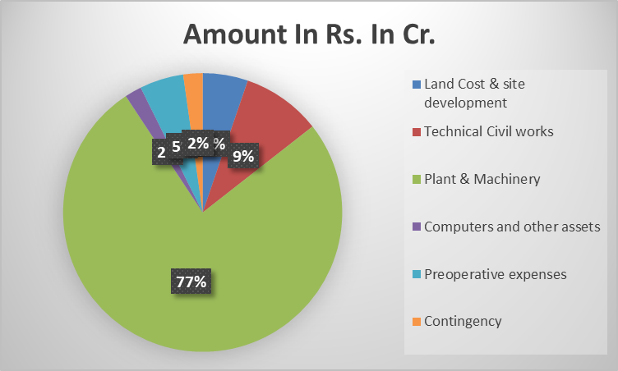

|  |  |  |
| --- | --- | --- |
| **PLANT & MACHINERY (SUMMARY INCLUDING GST)** | | |
| **S No.** | **Particulars** | **Basic Cost Rs. Lakhs (incl. GST)** |
| 1 | Plant & Machinery | 4,627.96 |
| 2 | Laboratory Ware, Equipments & Instruments Cost Break-up | 59.00 |
| 3 | Power | 368.75 |
| 4 | Steam Requirement | 107.38 |
| 5 | RO Plant & Water Softening Plant | 59.00 |
| 6 | Air Compressor | 35.40 |
| 7 | ETP | 70.80 |
| 8 | CIP (Cleaning in Process) | 59.00 |
| 9 | Milk Tankers | 141.60 |
| 10 | Misc. Assets | 141.60 |
|  | **Total** | **5,670.49** |

*\*Component/ section wise breakup of the proposed Plant & Machinery is annexed with the report as given in the TEV Report.*

1. **CURRENT STATUS & TOTAL EXPENDITURE INCURRED TILL DATE:** M/s. Anupam Parashar & Co., Chartered Accountants, having registered office at N-10, 3rd floor, Greater Kailash-1 New Delhi-100048, has issued a certificate dated 31.12.2024 in respect of the Investment in Building and Plant and machinery Equipment. Expenditure along with present status of the each segment is given below:

|  |  |  |  |  |  |
| --- | --- | --- | --- | --- | --- |
| **Sr. No.** | **Particulars** | **Proposed**  **(In Rs. in Lakh.)** | **Expenditure shown by company till 31/12/2024**  **As per CA Cert.**  **(In Rs. in Lakh.)** | **Amount as per LIE**  **(In Rs. in Lakh.)** | **Remarks** |
|  | Land/ development Charges | 380.00 | 361.74 | 343.52 | 1. Rs.343.52 lakhs is spent in land purchase with stamp duty (as per the value mentioned in the sale deed). 2. The cost considered does not include the site development charges as the breakup of the same is not given. |
|  | Civil work – Technical Civil works & Other civil work | 666.00 | 1478.24 | 1518.15 | 1. The cost assessment for building and civil works is done in accordance with the benchmark or market cost, as per the percentage of work completed as on 02/01/2025. For detailed calculation please refer to Table No. 1 below. 2. Material/ Inventory lying at site is not considered in this cost. 3. Any advances paid to the parties for which work is not completed are not captured in the above assessment which may have been included in the CA Certificate. This may be one of the reasons for difference in CA certificate and our assessment. 4. It is also to be noted that CA Certificate is dated: 31/12/2024, whereas the LIE assessment is based on the survey done on 02/01/2025. |
|  | Plant & Machineries | 5666.00 | 4239.12 | ---- | 1. Some Plant and Machineries or equipment have been arrived. 2. As per CA Certificate 4239.12 Lacs has been spent on P&M. 3. As informed to us by the company, only advance amount has been paid to suppliers and vendors as listed in Table 2 below which is reflected in CA certificate. |
|  | Other | 536.00 | 404.63 | Nil | Since breakup was not available thus, we have not commented on this item. |
|  | **TOTAL** | **Rs.7248.00** | **Rs.6483.73** | **-----** | **---** |

**TABLE 01**

|  |  |  |  |  |  |  |  |  |
| --- | --- | --- | --- | --- | --- | --- | --- | --- |
| **S. No.** | **Particulars** | **Floor** | **Type of Structure** | **Area (In Sq.ft.)** | **Height (in ft.)** | **Plinth Area Rate  (In sq.ft.)** | **Value assessed** | **Remark** |
| 1 | Laundry | Ground | Shed | 1,292 | 20 | 600 | 7,75,001 | Market rate |
| 2 | Engg. Store | Ground | Shed | 1,292 | 20 | 600 | 7,75,001 | Market rate |
| 3 | Workshop | Ground | Shed | 1,292 | 20 | 600 | 7,75,001 | Market rate |
| 4 | RO Area | Ground | Shed | 1,938 | 20 | 600 | 11,62,501 | Market rate |
| 5 | Refrigeration | Ground | Shed | 2,583 | 20 | 600 | 15,50,002 | Market rate |
| 6 | Air Compressor | Ground | Shed | 1,292 | 20 | 600 | 7,75,001 | Market rate |
| 7 | Main Building except dryer area & evaporator area | Ground | Shed | 1,56,399 | 20 | 850 | 13,29,39,547 | Market rate |
| 8 | Dryer Area | Ground plus Four | columns of steel structure is erected and covering by GI shed is balance | 5,239 | 80 | 600 | 31,43,471 | Market rate |
| 9 | evaporator area | Ground plus Two | columns of steel structure is erected and covering by GI shed is balance | 3,124 | 80 | 600 | 18,74,407 | Market rate |
| 10 | Boiler Section | Ground | columns of steel structure is erected and covering by GI shed is balance | 5,167 | 80 | 600 | 31,00,003 | Market rate |
| **Total** | | | | **1,79,617** |  |  | **14,68,69,934** |  |

|  |  |  |  |  |  |  |  |
| --- | --- | --- | --- | --- | --- | --- | --- |
| **S NO.** | **Description** | **Quantity** | **Unit** | **Type of structure** | **Rate per unit** | **Value assessed** | **Remark** |
| 1 | Boundary Wall | 18,377.39 | sq. ft. | Precast | 100 | 18,37,739 | Market rate |
| Brick work | 686.00 | RMT | Brickwork | 4500 | 30,87,000 | Market rate |
| Columns in Brickwork | 1.12 | Cum | R.C.C | 8340.85 | 9,339 | CPWD DSR 2023 vol-1, ref-4.1.2 |
| Steel in Columns | 131.85 | KG | TMT Bars | 80 | 10,548 | Market rate |
| **Total** | | | | | | **49,44,626** |  |

**Comments/ Note:**

1. Civil works cost assessment is done only as per the current physical status of the Project.
2. Any kind of advance amount of loose material lying on site is not captured in above assessment.
3. In Civil works cost assessment, area/ quantity is taken from site survey.
4. During site inspection some sample measurements were done and accordingly the quantity has been estimated accordingly.
5. For Civil work cost expenditure assessment CPWD DSR 2023 for scheduled items and market rates for non-scheduled items are considered.

**TABLE 2**

**BREAK UP OF EXPENDITURE SHOWN IN PLANT & MACHINERY**

|  |  |  |  |  |  |  |
| --- | --- | --- | --- | --- | --- | --- |
| **Sl. No.** | **Invoice No.** | **Invoice Date** | **Vendor Name** | **Amount** | **Advances** | **Remarks** |
| 1 | 18/23-24 | 24-11-2023 | Sahiba Fabrication | 7,12,32,000 | 2,13,69,600 | 30% Advance against PI No.18/23-24 70% after delivery |
| 2 | 18-1/23-24 | 24-11-2023 | Sahiba Fabrication |
| 3 | 18-2/23-24 | 24-11-2023 | Sahiba Fabrication |
|  | HR/23-24/005 | 24-11-2023 | Sahiba Fabrication | 3,58,40,000 | 1,43,36,000 | 40% Advance |
| 5 | 5450050306 | 16-01-2024 | Multivac | 61,36,000 | 15,60,000 | 30% Advance against PI No. 5450050306 40% Before delivery, 20% after Delivery, 10% after installation |
| 6 | 187 | 12-11-2023 | Dima | 2,44,56,344 | 97,82,806 | 100% Advance has been made |
| 7 | FBE/CCBPE/2023-2024 | 15-02-2024 | Food & Biotech Engineer | 15,93,00,000 | 5,40,00,000 | 40% advance against PI No. (FBE/CCBPE/2023-2024) 60% after Delivery |
| 5 | 2008960 | 23-02-2024 | FAM NV | 52,92,013 | 15,87,560 | 30% advance made |
| 8 | 10 | 05-12-2023 | Ashish Technical pvt. ltd | 64,96,000 | 38,97,600 | 60 % Advance & 40% Before Dispatch |
| 9 | 531 | 15-02-2024 | Frick India ltd | 4,54,30,000 | 1,15,50,000 | 30% advance against PI No. (531) 70% after delivery |
| 10 | 131 | 17-02-2024 | Green-Tech India | 57,23,000 | 19,40,000 | 40% advance made |
| 11 | 325 | 19-02-2024 | Uttam Enviro tech engineers pvt. Ltd. | 64,90,000 | 27,50,000 | 40% Advance has been made |
| 12 | 230 | 28-02-2024 | Urjex Boiler pvt.ltd. | 1,41,60,000 | 49,56,000 | 40% advance made |
| 13 | 2402008 | 29-02-2024 | PPml ltd | 24,000 | 24,000 | 100% Advance has been made |
| 14 | 101 | 19-03-2024 | Fillpack | 82,60,000 | 28,00,000 | 40% advance |
| 15 | bpm/2324/629 | 22-03-2024 | Balaji Packing machine | 10,62,000 | 5,31,000 | 50% advance aginst PI No. (bpm/2324/629) 50% after Delivery |
| 16 | PI_240308 | 21-03-2024 | NVS Industries | 63,72,000 | 16,20,000 | 30% advance PI No. (PI_240308) 70% after Delivery |
| 17 | PI/23-24/0082 | 22-03-2024 | Tech-N-Tech Engineers | 3,34,05,800 | 1,41,55,000 | 50% advance against PI No. (PI/23-24/0082) 50% after Delivery |
| 18 | 686 | 30-12-2023 | M/s mittal Machinery Store | 26,267 | 26,267 | 100% Advance has been made |
| 19 | 685 | 30-12-2023 | M/s mittal Machinery Store | 49,501 | 49,501 | 100% Advance has been made |
| 20 | 741 | 21-12-2023 | M/s mittal Machinery Store | 3,280 | 3,280 | 100% Advance has been made |
| 21 | AIS/23-24/1162 | 05-03-2024 | Advance Iron & Steel Company | 4,39,928 | 4,39,928 | 100% Advance has been made |
| 22 | AIS/23-24/1189 | 14-03-2024 | Advance Iron & Steel Company | 2,17,002 | 2,17,002 | 100% Advance has been made |
| 23 | PSINV-23-04913 | 05-03-2024 | KL Steels Pvt Ltd | 15,91,703 | 15,91,703 | 100% Advance has been made |
| 25 | PSINV-23-04923 | 06-03-2024 | KL Steels Pvt Ltd | 17,85,934 | 17,85,934 | 100% Advance has been made |
| 27 | PSINV-23-05107 | 18-03-2024 | KL Steels Pvt Ltd | 16,82,789 | 16,82,789 | 100% Advance has been made |
| 28 | PSINV-23-05108 | 18-03-2024 | KL Steels Pvt Ltd | 2,03,626 | 2,03,626 | 100% Advance has been made |
| 29 | G/2023-24/5422 | 20-02-2024 | Shri Rathi Steel Ltd | 14,16,788 | 14,16,788 | 100% Advance has been made |
| 30 | G/2023-24/6001 | 17-03-2024 | Shri Rathi Steel Ltd | 11,57,917 | 11,57,917 | 100% Advance has been made |
| 31 | FBE/24-25/139 | 10-06-2024 | Food & Biotech Engineer(India) Pvt. Ltd. | 29,21,680 | 29,21,680 | 100% Advance has been made |
| 32 | FBE/24-25/140 | 10-06-2024 | Food & Biotech Engineer(India) Pvt. Ltd. | 47,24,720 | 47,24,720 | 100% Advance has been made |
| 33 | FBE/24-25/153 | 14-06-2024 | Food & Biotech Engineer(India) Pvt. Ltd. | 50,74,000 | 50,74,000 | 100% Advance has been made |
| 34 | FBE/24-25/162 | 20-06-2024 | Food & Biotech Engineer(India) Pvt. Ltd. | 1,74,224 | 1,74,224 | 100% Advance has been made |
| 35 | FBE/24-25/163 | 20-06-2024 | Food & Biotech Engineer(India) Pvt. Ltd. | 27,02,540 | 27,02,540 | 100% Advance has been made |
| 36 | INE/24-25/0314 | 07-08-2024 | Frick India ltd | 35,40,000 | 35,40,000 | 100% Advance has been made |
| 37 | INE/24-25/0315 | 07-08-2024 | Frick India ltd | 49,56,000 | 49,56,000 | 100% Advance has been made |
| 38 | INE/24-25/0316 | 07-08-2024 | Frick India ltd | 34,75,100 | 34,75,100 | 100% Advance has been made |
| 39 | INN/24-25/0463 | 07-08-2024 | Frick India ltd | 14,75,000 | 14,75,000 | 100% Advance has been made |
| 40 | INN/24-25/0464 | 07-08-2024 | Frick India ltd | 4,01,200 | 4,01,200 | 100% Advance has been made |
| 41 | INN/24-25/0336 | 17-08-2024 | Frick India ltd | 38,35,000 | 38,35,000 | 100% Advance has been made |
| 42 | TNT/24-25/0192 | 12-08-2024 | Tech-N-Tech Engineers | 23,46,509 | 23,46,509 | 100% Advance has been made |
| 43 | INN/24-25/0255 | 12-07-2024 | Frick India ltd | 24,07,200 | 24,07,200 | 100% Advance has been made |
| 44 | CCB-HR/24-25/045 | 01-10-2024 | Bnal Prefabs Pvt. Ltd. | 10,74,721 | 10,74,721 | 100% Advance has been made |
| 45 | CCB-HR/24-25/045 | 01-10-2024 | Bnal Prefabs Pvt. Ltd. | 10,72,557 | 10,72,557 | 100% Advance has been made |
| 46 | CCB-HR/24-25/045 | 01-10-2024 | Bnal Prefabs Pvt. Ltd. | 9,35,542 | 9,35,542 | 100% Advance has been made |
| 47 | CCB-HR/24-25/045 | 01-10-2024 | Bnal Prefabs Pvt. Ltd. | 4,41,730 | 4,41,730 | 100% Advance has been made |
| 48 | CCB-HR/24-25/045 | 01-10-2024 | Bnal Prefabs Pvt. Ltd. | 5,53,072 | 5,53,072 | 100% Advance has been made |
| 49 | TNT/24-25/0278 | 01-10-2024 | Tech-N-Tech Engineers | 1,96,66,392 | 1,96,66,392 | 100% Advance has been made |
| 50 | TNT/24-25/026 | 01-10-2024 | Tech-N-Tech Engineers | 1,96,66,392 | 1,96,66,392 | 100% Advance has been made |
| 51 | CCB-HR/24-25/053 | 01-10-2024 | Secured Engineers Pvt. Ltd. | 4,86,839 | 4,86,839 | 100% Advance has been made |
| 52 | CCB-HR/24-25/045 | 02-10-2024 | Bnal Prefabs Pvt. Ltd. | 8,27,804 | 8,27,804 | 100% Advance has been made |
| 53 | CCB-HR/24-25/045 | 02-10-2024 | Bnal Prefabs Pvt. Ltd. | 7,70,743 | 7,70,743 | 100% Advance has been made |
| 54 | CCB-HR/24-25/045 | 02-10-2024 | Bnal Prefabs Pvt. Ltd. | 6,72,343 | 6,72,343 | 100% Advance has been made |
| 55 | CCB-HR/24-25/026 | 03-10-2024 | Tech-N-Tech Engineers | 22,81,908 | 22,81,908 | 100% Advance has been made |
| 56 | CCB-HR/24-25/045 | 04-10-2024 | Bnal Prefabs Pvt. Ltd. | 4,39,729 | 4,39,729 | 100% Advance has been made |
| 57 | CCB-HR/23-24/001 | 05-10-2024 | Sahiba Fabrication | 45,27,527 | 45,27,527 | 100% Advance has been made |
| 58 | 89/24-25 | 05-10-2024 | Sahiba Fabrication | 45,27,527 | 45,27,527 | 100% Advance has been made |
| 59 | UBPL/24-25/207 | 06-10-2024 | Urjex Boiler pvt.ltd. | 12,11,860 | 12,11,860 | 100% Advance has been made |
| 60 | UBPL/24-25/208 | 06-10-2024 | Urjex Boiler pvt.ltd. | 12,15,400 | 12,15,400 | 100% Advance has been made |
| 61 | CCB-HR/24-25/054 | 07-10-2024 | Bnal Prefabs Pvt. Ltd. | 5,82,147 | 5,82,147 | 100% Advance has been made |
| 62 | 24-25/364 | 08-10-2024 | Crown Sales | 2,84,969 | 2,84,969 | 100% Advance has been made |
| 63 | INN/24-25/0648 | 09-10-2024 | Frick India ltd | 10,20,268 | 10,20,268 | 100% Advance has been made |
| 64 | CCB-HR/23-24/001 | 10-10-2024 | Sahiba Fabrication | 45,27,528 | 45,27,528 | 100% Advance has been made |
| 65 | CCB-HR/23-24/001 | 10-10-2024 | Sahiba Fabrication | 1,38,57,275 | 1,38,57,275 | 100% Advance has been made |
| 66 | NVS/24-25/29 | 13-10-2024 | NVS Industries | 12,50,800 | 12,50,800 | 100% Advance has been made |
| 67 | 24-25/375 | 14-10-2024 | Crown Sales | 11,86,971 | 11,86,971 | 100% Advance has been made |
| 68 | MDVP/24-25/031 | 14-10-2024 | MDVP International Pvt. Ltd. | 1,18,00,000 | 1,18,00,000 | 100% Advance has been made |
| 69 | NVS/24-25/30 | 14-10-2024 | NVS Industries | 12,50,800 | 12,50,800 | 100% Advance has been made |
| 70 | INE/24-25/0478 | 14-10-2024 | Frick India ltd | 25,32,752 | 25,32,752 | 100% Advance has been made |
| 71 | INE/24-25/0666 | 14-10-2024 | Frick India ltd | 8,35,796 | 8,35,796 | 100% Advance has been made |
| 72 | 2339 | 15-10-2024 | Bnal Prefabs Pvt. Ltd. | 5,72,348 | 5,72,348 | 100% Advance has been made |
| 73 | FBW/24-25/332 | 16-10-2024 | Food & Biotech Engineer(India) Pvt. Ltd. | 32,26,984 | 32,26,984 | 100% Advance has been made |
| 74 | FBW/24-25/334 | 17-10-2024 | Food & Biotech Engineer(India) Pvt. Ltd. | 50,79,074 | 50,79,074 | 100% Advance has been made |
| 75 | NVS/24-25/31 | 17-10-2024 | NVS Industries | 9,33,380 | 9,33,380 | 100% Advance has been made |
| 76 | 102/24-25 | 22-10-2024 | Sahiba Fabrication | 23,48,452 | 23,48,452 | 100% Advance has been made |
| 77 | 101/24-25 | 22-10-2024 | Sahiba Fabrication | 23,48,452 | 23,48,452 | 100% Advance has been made |
| 78 | 100/24-25 | 22-10-2024 | Sahiba Fabrication | 23,48,452 | 23,48,452 | 100% Advance has been made |
| 79 | CCB-HR/23-24/053 | 22-10-2024 | Secured Engineers Pvt. Ltd. | 2,60,081 | 2,60,081 | 100% Advance has been made |
| 80 | NVS/24-25/36 | 28-10-2024 | NVS Industries | 11,19,820 | 11,19,820 | 100% Advance has been made |
| 81 | 2216 | 04-10-2024 | Bnal Prefabs Pvt. Ltd. | 1,84,223 | 1,84,223 | 100% Advance has been made |
| 82 | 2197 | 02-10-2024 | Bnal Prefabs Pvt. Ltd. | 80,842 | 80,842 | 100% Advance has been made |
| 83 | 24-25/404 | 30-10-2024 | Crown Sales | 9,35,859 | 9,35,859 | 100% Advance has been made |
| 84 | 24-25/322 | 13-09-2024 | Crown Sales | 21,488 | 21,488 | 100% Advance has been made |
| 85 | 24-25/410 | 05-11-2024 | Crown Sales | 19,29,619 | 19,29,619 | 100% Advance has been made |
| 86 | TNT/24-25/0322 | 06-11-2024 | Tech-N-Tech Engineers | 2,09,964 | 2,09,964 | 100% Advance has been made |
| 87 | 24-25/413 | 17-11-2024 | Crown Sales | 11,38,465 | 11,38,465 | 100% Advance has been made |
| 88 | FBE/24-25/352 | 08-11-2024 | Food & Biotech Engineer(India) Pvt. Ltd. | 12,10,710 | 12,10,710 | 100% Advance has been made |
| 90 | GT/73 | 17-11-2024 | Ripon Weighing System | 9,40,000 | 9,40,000 | 100% Advance has been made |
| 91 | TNT/24-25/0332 | 17-11-2024 | Tech-N-Tech Engineers | 1,02,245 | 1,02,245 | 100% Advance has been made |
| 92 | 24-25/422 | 19-11-2024 | Crown Sales | 8,95,535 | 8,95,535 | 100% Advance has been made |
| 93 | 13578 | 20-11-2024 | Uttam Enviro tech engineers pvt. Ltd. | 16,77,296 | 16,77,296 | 100% Advance has been made |
| 94 | 24-25/434 | 26-11-2024 | Crown Sales | 8,91,773 | 8,91,773 | 100% Advance has been made |
| 95 | FBE/24-25/380 | 27-11-2024 | Food & Biotech Engineer(India) Pvt. Ltd. | 52,98,393 | 52,98,393 | 100% Advance has been made |
| 96 | UBPL/24-25/261 | 29-11-2024 | Urjex Boiler pvt.ltd. | 42,00,800 | 42,00,800 | 100% Advance has been made |
| 97 | 3133 | 11-12-2024 | Bnal Prefabs Pvt. Ltd. | 8,82,726 | 8,82,726 | 100% Advance has been made |
| 98 | 3134 | 12-12-2024 | Bnal Prefabs Pvt. Ltd. | 7,92,910 | 7,92,910 | 100% Advance has been made |
| 99 | 3150 | 14-12-2024 | Bnal Prefabs Pvt. Ltd. | 8,62,295 | 8,62,295 | 100% Advance has been made |
| 100 | 34-25/471 | 14-12-2024 | Crown Sales | 10,29,124 | 10,29,124 | 100% Advance has been made |
| 101 | FT/NK/90/24-25 | 12-12-2024 | Fillpack | 82,63,260 | 82,63,260 | 100% Advance has been made |
| 102 | 15 | 18-12-2024 | Amar Enterprises & Consultant | 6,79,452 | 6,79,452 | 100% Advance has been made |
| 103 | NVS/24-25/46 | 21-12-2024 | NVS Industries | 6,37,200 | 6,37,200 | 100% Advance has been made |
| 104 | FBE/24-25/410 | 23-12-2024 | Food & Biotech Engineer(India) Pvt. Ltd. | 1,54,50,590 | 1,54,50,590 | 100% Advance has been made |
| 105 | FBE/24-25/480 | 23-12-2024 | Food & Biotech Engineer(India) Pvt. Ltd. | 38,15,211 | 38,15,211 | 100% Advance has been made |
| 106 | ESTS/2024-25/005 | 23-12-2024 | ESTS Power Transformer Pvt. Ltd. | 28,37,900 | 28,37,900 | 100% Advance has been made |
| 107 | 56/2425 | 24-12-2024 | Teternity Infocom Pvt. Ltd. | 11,62,300 | 11,62,300 | 100% Advance has been made |
| 108 | INN/24-25/0791 | 13-11-2024 | Frick India ltd | 9,78,704 | 9,78,704 | 100% Advance has been made |
| 109 | INE/24-25/0791 | 27-12-2024 | Frick India ltd | 9,55,800 | 9,55,800 | 100% Advance has been made |
| 110 | INN/24-25/0791 | 19-12-2024 | Frick India ltd | 3,95,279 | 3,95,279 | 100% Advance has been made |
| 111 | INN/24-25/0791 | 26-12-2024 | Frick India ltd | 1,57,333 | 1,57,333 | 100% Advance has been made |
| 112 | INN/24-25/0779 | 26-12-2024 | Frick India ltd | 10,62,000 | 10,62,000 | 100% Advance has been made |
| 113 | INE/24-25/0724 | 14-12-2024 | Frick India ltd | 7,67,000 | 7,67,000 | 100% Advance has been made |
| 114 | MDVP/24-25/040 | 28-12-2024 | MDVP International Pvt. Ltd. | 73,63,200 | 73,63,200 | 100% Advance has been made |
| 115 | 117/24-25 | 28-12-2024 | Sahiba Fabrication | 35,10,736 | 35,10,736 | 100% Advance has been made |
| 116 | FBE/24-25/416 | 28-12-2024 | Food & Biotech Engineer(India) Pvt. Ltd. | 47,54,250 | 47,54,250 | 100% Advance has been made |
| 117 | GT/24-25/Invoice/188 | 28-12-2024 | Green-Tech Sustainable Automation LLP | 58,37,460 | 58,37,460 | 100% Advance has been made |
| **Total** | | | | **67,59,37,442** | **39,31,17,851** |  |

***Source: As per Bills/ Invoice provided by the company***

**Comment/Note:**

1. All the details mentioned above in the table no.2 were taken from the copy of invoices/P.O provided to us by client/banker.
2. Certain smaller components of large machinery units have been delivered to the site. However, due to the lack of sufficient details in the provided invoice, it is challenging to determine their individual values. Therefore, these smaller components will not be assessed in this quarter's LIE report.
3. **SOURCES OF FINANCE & UTILIZATION OF FUNDS:**

The Project cost mentioned above has been planned to be covered from following resources:

|  |  |
| --- | --- |
| (Amount in Rs. Crore) | |
| PARTICULARS | **AMOUNT** |
| Promoter’s Contribution (Equity) | **18.45** |
| Grant from MFPI | **9.23** |
| Term Loan (Debt) | **44.80** |
| TOTAL | **72.48** |

***Source:*** *As per TEV report provided.*

|  |  |
| --- | --- |
| **PART F** | **STATUTORY & REGULATORY APPROVALS, CLEARANCES & NOC** |

|  |  |  |  |  |
| --- | --- | --- | --- | --- |
| Sr. No. | NAME OF LICENSE/ REGISTRATION | PURPOSE | DATE OF ISSUE | CURRENT STATUS |
| **ISSUING AUTHORITY** | **LICENCE NO.** |
|  | Change of Land Use Certificate (CLU) | Change in land use | Memo No. NOC-8493A/HR/STP/1368/2022  Dated:25/05/2022 | Obtained |
|  | Building Plan Approval | Approval of building plans | --- | To be obtained |
| 1. 2. | Pollution Certificate | Consent to establish new unit | No. HSPCB/Consent/ : 313095324HISCTE33626421  Dated:02/02/2024 | Obtained |
| Haryana State Pollution Control Board |
|  | Electricity Connection | --- | --- | To be obtained |
|  | Fire NOC | --- | --- | To be obtained |
|  | Letter by block development and Panchayat officer, Adampur | --- | --- | Obtained |
|  | FSSAI | Food License | License Number: 12721999000010 | Obtained  (Only for 650 tones/ year) |
|  | Layout plan by Sarpanch Gram Panchayat, Kohli | --- | Dated:26/09/2023 | Obtained |
| *Observations & Comments:*   1. *All the Above mentioned approvals and licenses is as per the documents provided by the client/bank.* 2. *FSSAI license has been currently taken only for 650 tones/ year for different types of cheese, butter and ghee. However the installed capacity proposed is of ~12,375 MT/ Year of Cheese Manufacturing and 7500 MT/ Year of By-Products (ghee, curd & whey powder). Company would have to take additional capacity FSSAI approval before COD.* 3. *Above the major approvals & NOCs as provided by the client and are not exclusive.* | | | | |

|  |  |
| --- | --- |
| **PART G** | **PROJECT SCHEDULE & CURRENT STATUS** |

|  |  |  |  |  |
| --- | --- | --- | --- | --- |
| **IMPLEMENTATION SCHEDULE OF M/S CHOUDHERY CHEESE BAZAR PVT. LTD.** | | | | |
| **S. No.** | **Particular** | **Commencement** | **Completion** | **Current Status** |
|  | Building and Civil Works | September 2023 | April 2024 | * The shed portion of the main building, excluding the dryer section and evaporator section is completed. * The columns of the steel structure are erected, and the GI shed for the dryer section and evaporator section is completed. * For more details refer Table 1 above. |
|  | Placement of orders for Plant & Machineries and Utilities | February 2024 | April 2024 | Already Started.  Quotations have been invited for major equipment and orders |
|  | Installation of utilities | March 2024 | May 2024 | Although it has not started yet, some plants, machinery, and equipment have already arrived. |
|  | COD | August 2024 | | Likely to be achieved by March, 2025 |

**NOTE:**

1) All the information mentioned above were taken from the implementation Schedule provided to us by bank.

|  |  |
| --- | --- |
| **PART H** | **DISCLAIMER** |

* + - 1. No employee or member of R.K Associates has any direct/ indirect interest in the Project.
      2. This report is prepared based on the copies of the documents/ information which the Bank/ Borrower has provided to us out of the standard checklist of documents sought from them and further based on our assumptions and limiting conditions. The client/owner and its management/representatives warranted to us that the information they supplied was complete, accurate and true and correct to the best of their knowledge. All such information provided to us has been relied upon in good faith and we have assumed that it is true and correct in all respect. I/We shall not be liable for any loss, damages, cost or expenses arising from fraudulent acts, misrepresentations, or wilful default on part of the owner, borrower, its directors, employee, representative or agents. Verification or cross checking of the documents provided to us from the originals or from any Govt. departments/ Record of Registrar has not been done at our end since this is beyond the scope of our work. If at any time in future, it is found or came to our knowledge that misrepresentation of facts or incomplete or distorted information has been provided to us then this report shall automatically become null & void.
      3. Legal aspects for eg. investigation of title, ownership rights, lien, charge, mortgage, lease, sanctioned maps, verification of documents, etc. have not been done at our end and same has to be taken care by legal expert/ Advanceocate. It is assumed that the concerned Lender/ Financial Institution has satisfied them with the authenticity of the documents, information given to us and for which the legal verification has been already taken and cleared by the competent Advanceocate before requesting for this report. I/ We assume no responsibility for the legal matters including, but not limited to, legal or title concerns.
      4. This report is a general analysis of the project based on the scope mentioned in the report. This is not an Audit report, Design document, DPR or Techno feasibility study. All the information gathered is based on the facts seen on the site during survey for the quarter ending December 2024, verbal discussion & documentary evidence provided by the client and is believed that information given by the borrower is true best of their knowledge.
      5. All observations mentioned in the report is only based on the visual observation and the documents/ data/ information provided by the client. No mechanical/ technical tests, measurements or any design review have been performed or carried out from our side during Project assessment.
      6. Bank/FII should ONLY take this report as an Advanceisory document from the Financial/ Chartered Engineering firm and its specifically Advanceised to the creditor to cross verify the original documents for the facts mentioned in the report which can be availed from the borrowing borrower directly.
      7. In case of any default in loans or the credit facility extended to the borrowing borrower, R.K Associates shall not be held responsible for whatsoever reason may be and any request for seeking any explanation from the employee/s of R.K Associates will not be entertained at any instance or situation.
      8. The documents, information, data provided to us during the course of this assessment by the client is reviewed only upto the extent required in relation to the scope of the work. No document has been reviewed beyond the scope of the work.
      9. This report only contains general assessment & opinion as per the scope of work evaluated as per the information given in the copy of documents, information, data provided to us and/ and confirmed by the owner/ owner representative to us at site which has been relied upon in good faith. It doesn’t contain any other recommendations of any sort including but not limited to express of any opinion on the suitability or otherwise of entering into any transaction with the borrower.
      10. We have relied on data from third party, external sources & information available on public domain also to conclude this report. These sources are believed to be reliable and therefore, we assume no liability for the truth or accuracy of any data, opinions or estimates furnished by others that have been used in this analysis. Where we have relied on data, opinions or estimates from external sources, reasonable care has been taken to ensure that such data has been correctly extracted from those sources and /or reproduced in its proper form and context, however still we can’t vouch its authenticity, correctness or accuracy.
      11. This Report is prepared by our competent technical team which includes Engineers and financial experts & analysts.
      12. This is just an opinion report and doesn’t hold any binding on anyone. It is requested from the concerned Financial Institution which is using this report for taking financial decision on the project that they should consider all the different associated relevant & related factors also before taking any business decision based on the content of this report.
      13. All Pages of the report including annexures are signed and stamped from our office. In case any paper in the report is without stamp & signature then this should not be considered a valid paper issued from this office.
      14. Though adequate care has been taken while preparing this report as per its scope, but still we can’t rule out typing, human errors, over sightedness of any information or any other mistakes. Therefore, the concerned organization is Advanceised to satisfy themselves that the report is complete & satisfactory in all respect. Intimation regarding any discrepancy shall be brought into our notice immediately. If no intimation is received within 15 (Fifteen) days in writing from the date of issuance of the report, to rectify these timely, then it shall be considered that the report is complete in all respect and has been accepted by the client upto their satisfaction & use and further to which R.K Associates shall not be held responsible in any manner.
      15. Defect Liability Period is **15 DAYS**. We request the concerned authorized reader of this report to check the contents, data and calculations in the report within this period and intimate us in writing if any corrections are required or in case of any other concern with the contents or opinion mentioned in the report. Corrections only related to typographical, calculation, spelling mistakes, incorrect data/ figures/ statement will be entertained within the defect liability period. Any new changes for any additional information in already approved report will be regarded as additional work for which additional fees may be charged. No request for any illegitimate change in regard to any facts & figures will be entertained.
      16. R.K Associates encourages its customers to give feedback or inform concerns over its services through proper channel at valuers@rkassociates.org in writing within 15 days of report delivery. After this period no concern/ complaint/ proceedings in connection with the Financial Feasibility Study Services will be entertained due to possible change in situation and condition of the subject Project.
      17. Our Data retention policy is of **ONE YEAR**. After this period, we remove all the concerned records related to the assignment from our repository. No clarification or query can be answered after this period due to unavailability of the data.
      18. This Lender’s Independent Engineer report is governed by our (1) Internal Policies, Processes & Standard Operating Procedures, (2) Information/ Data/ Inputs given to us by the client and (3) Information/ Data/ Facts given to us by our field/ office technical team. Management of R.K Associates never gives acceptance to any unethical or unprofessional practice which may affect fair, correct & impartial assessment and which is against any prevailing law. In case of any indication of any negligence, default, incorrect, misleading, misrepresentation or distortion of facts in the report then it is the responsibility of the user of this report to immediately or at least within the defect liability period bring all such act into notice of R.K Associates management so that corrective measures can be taken instantly.
      19. R.K Associates never releases any report doing alterations or modifications from pen. In case any information/ figure of this report is found altered with pen then this report will automatically become null & void.

|  |  |  |
| --- | --- | --- |
| **FOR R.K. ASSOCIATES VALUERS AND TECHNO ENGINEERING CONSULTANTS PVT. LTD.** | | |
| **SURVEY ANALYST** | **ENGINEERING ANALYST** | **REVIEWER** |
| Nischay Gautam & Atul Gola | Nischay Gautam | Sr. VP Projects |
|  |  |  |

**Place: Noida**

**Date: 22nd Jan 2025**

***DEFECT LIABILITY PERIOD - In case of any query/ issue or escalation you may please contact Incident Manager by writing at valuers@rkassociates.org. We ensure 100% accuracy in the Calculations done, Rates adopted and various other data points & information mentioned in the report but still can’t rule out typing, human errors or any other mistakes. In case you find any mistake, variation, discrepancy or inaccuracy in any data point of the report, please help us by bringing all such points into our notice in writing at valuers@rkassociates.org within 30 days of the report delivery, to get these rectified timely, failing which R.K Associates Valuers Techno Engineering Consultants (P) Ltd. won’t be held responsible for any inaccuracy in any manner. Also, if we will not hear back anything from you within 30 days, we will assume that report is correct in all respect and no further claim of any sort will be entertained thereafter. We would welcome and appreciate your feedback & suggestions in order to improve our services.***

***COPYRIGHT FORMAT - This report is prepared on the copyright format of R.K Associates Valuers Techno Engineering Consultants (P) Ltd. to serve our clients in the best possible way. Legally no one can copy or distribute this format without prior approval from R.K Associates. It is meant only for the organization as mentioned on the cover page of this report. Distribution or use of this format other than R.K Associates will be seen as unlawful act and necessary legal action can be taken against the defaulter***

**ENCLOSURE 1: IMPORTANT DOCUMENTS EXHIBIT**

**DOCUMENT-1: CA CERTIFICATE DATED 31/12/2024**

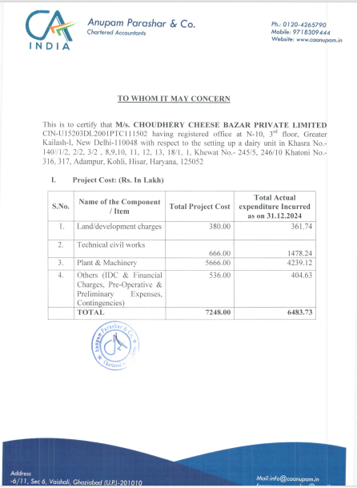

**DOCUMENT-2: MEANS OF FINANCE DATED 31/12/2024**

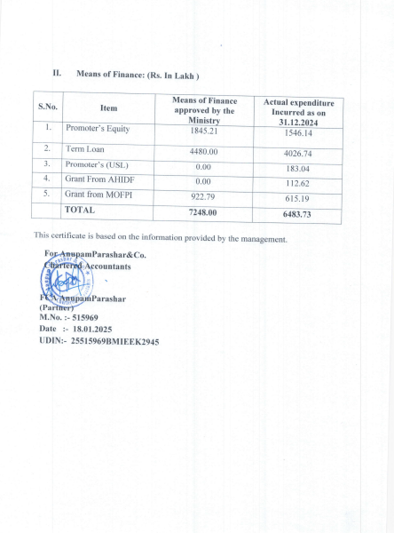

**DOCUMENT- 3: PLANT LAYOUT PLAN**

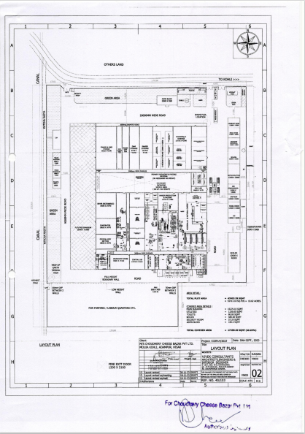

**DOCUMENT- 4: POLLUTION CERTIFICATE**

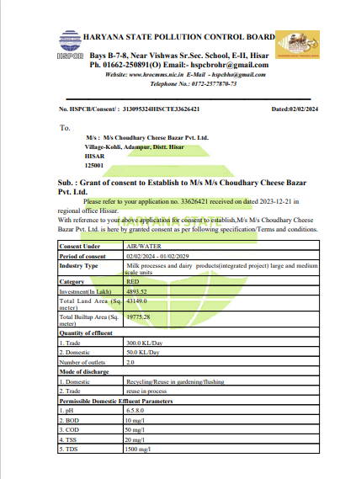

**DOCUMENT- 5: LETTER BY BLOCK DEVELOPMENT AND PANCHAYAT OFFICER, ADAMPUR**

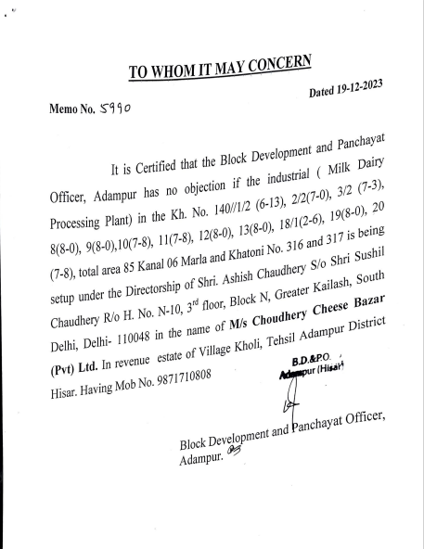

**DOCUMENT- 6: CHANGE OF LAND (CLU)**

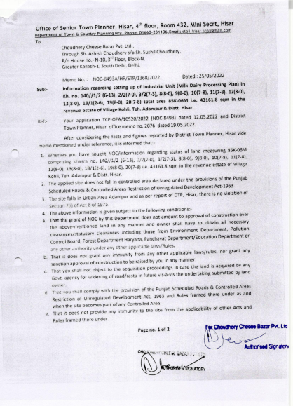

**DOCUMENT- 7: SALE DEED**

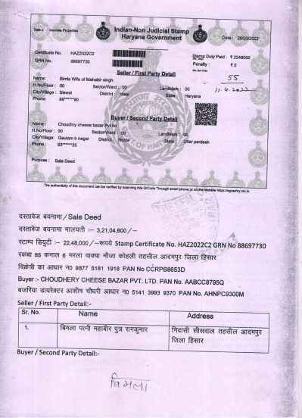

**PLANT & MACHINERY BREAKUP (AS PER TEV)**

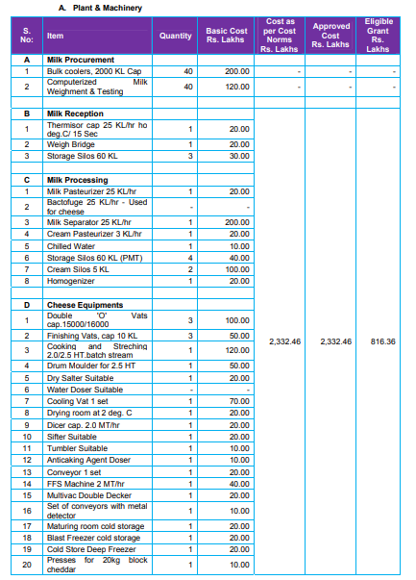

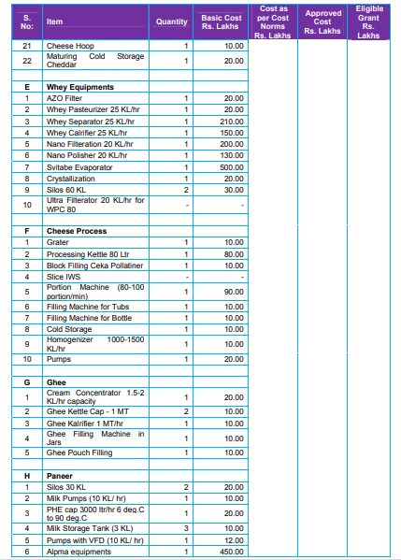

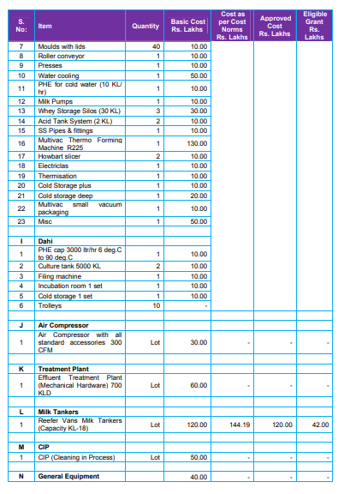

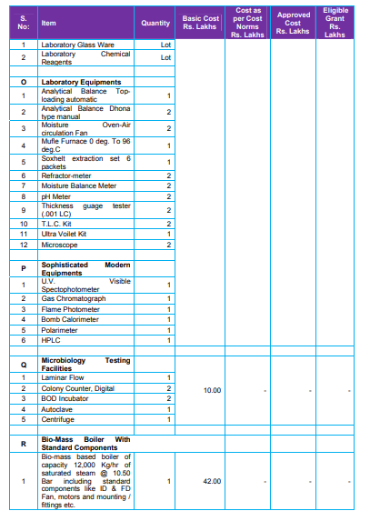

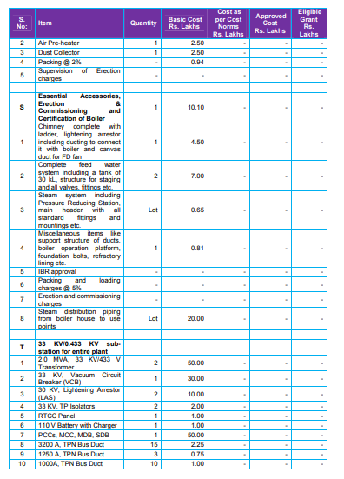

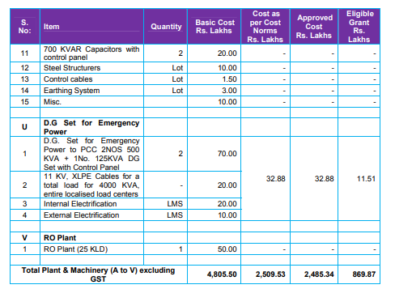

**ENCLOSURE 3: PHPTOGRAPHS OF PROPERTY**

|  |  |
| --- | --- |
|  |  |
|  |  |
|  |  |

|  |  |
| --- | --- |
|  |  |
|  |  |
|  |  |

|  |  |
| --- | --- |
|  |  |
|  |  |
|  |  |