**File No.: VIS (2024-25)-PL759-683-933 Dated: 21.02.2025**

**TECHNO-ECONOMIC VIABILITY**

**STUDY REPORT**

**OF**

**TOUGHENED GLASS MANUFACTURING UNIT (20,000 MTPA)**

**SETUP BY**

**M/S SSRM GLASSES PRIVATE LIMITED**

**A-196, SECTOR-20, NOIDA, GAUTAM BUDDHA NAGAR, GAUTAM BUDDHA NAGAR, UTTAR PRADESH, INDIA, 201301**

**REPORT PREPARED FOR**

**PNB MCC, 1ST FLOOR, PLOT NO. 18 LAJPAT NAGAR, SCHEME-2 ALWAR-301001**

***\*\*Important - In case of any query/ issue or escalation you may please contact Incident Manager Valuers@rkassociates.org***. ***We will appreciate your feedback in order to improve our services.***

***NOTE: As per IBA Guidelines please provide your feedback on the report within 15 days of its submission after which report will be considered to be correct***

**IMPORTANT NOTICE**

***COPYRIGHT FORMAT:*** *This report is prepared on the copyright format of R. K. Associates Valuers & Techno Engineering Consultants (P) Ltd. (R. K. Associates) to serve our clients with the best possible information and analysis to facilitate them to take rational business decisions. Legally no one can copy or distribute this format without prior approval from R. K. Associates. It is meant only for the advisory/ reference purpose for the organization/s as mentioned on the cover page of this report. Distribution or use of this format or report or any of its content/ information/ data by any organization or individual other than R.K Associates will be seen as an unlawful act and necessary legal action can be taken against the defaulters.*

*This report is intended for the sole use of the intended recipient/s and contains material that is* ***STRICTLY CONFIDENTIAL AND PRIVATE.***

***DEFECT LIABILITY PERIOD:****In case of any query/ issue or escalation you may please contact Incident Manager at valuers@rkassociates.org. Though adequate care has been taken while preparing this report as per its scope, but still we can’t rule out typing, human errors, over sightedness of any information or any other mistakes. Therefore, the concerned organization is advised to satisfy themselves that the report is complete & satisfactory in all respect. Intimation regarding any discrepancy shall be brought into our notice immediately. If no intimation is received within 15 (Fifteen) days in writing from the date of issuance of the report, to rectify these timely, then it will be considered that the report is complete in all respect and has been accepted by the client up to their satisfaction & use and further to which R.K Associates shall not be held responsible in any manner.*

***Part O: R. K. Associates Important Disclaimer and Remarks*** *are integral part of this report and Feasibility assessment is subject to this section. Reader of the report is advised to read all the points mentioned in these sections carefully.*

|  |  |  |
| --- | --- | --- |
| **TABLE OF CONTENTS** | | |
|  | | |
| **SECTIONS** | **PARTICULARS** | **PAGE NO.** |
| **Part A** | Report Summary | 4 |
| **Part B** | **INTRODUCTION** |  |
| 1. About the Report | 6 |
| 1. Executive summary | 6 |
| 1. Purpose of the Report | 7 |
| 1. Scope of the Report | 8 |
| 1. Methodology/ Model Adopted | 8 |
| 1. Data Information received from | 9 |
| 1. Documents/ Data Referred | 9 |
| **Part C** | **Company Profile** |  |
| 1. Company Overview | 10 |
| 1. Key Promoters/Directors Profile | 11 |
| **Part D** | **Proposed Unit’s Infrastructure Details** |  |
| 1. Proposed Plant Location | 14 |
| 1. Google Map Location | 15 |
| 1. Layout Plan | 16 |
| 1. Land Details | 18 |
| 1. Site pictures | 19 |
| 1. Building & Civil Works | 21 |
| 1. Plant and Machinery/ Equipment details | 23 |
| 1. Utilities | 24 |
| **Part E** | **Project Technical details** |  |
| 1. Capacity of Proposed Toughened Glass Unit | 26 |
| 1. Production process of Toughened Glass | 26 |
| 1. Process Flow Chart of Proposed Toughened Glass Unit | 27 |
| 1. Technical Specification of the Proposed Toughened Glass Plant | 28 |
| 1. Technology Used | 34 |
| 1. Technological Assessment | 35 |
| 1. Manpower | 36 |
| 1. Government Support for the Project | 37 |
| **Part F** | **Product Profile** |  |
| 1. Introduction | 38 |
| 1. Product Category | 38 |
| 1. Pricing Strategy | 41 |
| 1. Marketing, Selling & Distribution Plan | 42 |
| **Part G** | **Raw Material Analysis** | 43 |
| **Part H** | **Industry Overview & Analysis** | 47 |
| **Part I** | **SWOT Analysis** | 52 |
| **Part J** | **Project Cost and Means of Finance** | 54 |
| **Part K** | **Project Implementation Schedule** | 57 |
| **Part L** | **Statutory Approvals | Licences | NOC** | 59 |
| **Part M** | **Company’s Financial Feasibility** | 61 |
| **Part N** | **Conclusion** | 84 |
| **Part O** | **Disclaimer | Remarks** | 86 |

|  |  |
| --- | --- |
| **PART A** | **REPORT SUMMARY** |

|  |  |  |
| --- | --- | --- |
| S. No. | PARTICULAR | DESCRIPTION |
|  | **Name of the Company:** | M/s SSRM Glasses Private Limited |
|  | **Registered Address:** | A-196, Sector-20, Noida, Gautam Buddha Nagar, Gautam Buddha Nagar, Uttar Pradesh, India, 201301 |
|  | **Project Name** | 20000 M.T. of Glass Toughening p.a. |
|  | **Project Location:** | Plot No. SP5- 172 , Ghilot Industrial Area, Rajasthan- 301706 |
|  | **Project Type:** | Manufacturing of Toughened glass if al Kinds |
|  | **Project Industry:** | Glass Industry |
|  | **Product Type / Deliverables:** | Toughened Glass, Sound Proof, Safety Glass, DGU Glass etc.) |
|  | **Report Prepared for Organization:** | SSRM Glasses Private Limited |
|  | **TEV Consultant Firm:** | M/s. R.K Associates Valuers & Techno Engineering Consultants (P) Ltd. |
|  | **Report type:** | Techno-EconomicViability Report |
|  | **Purpose of the Report:** | To assess Technical & Economic Viability for the purpose of seeking external financial assistance to start a Project. |
|  | **Scope of the Report:** | To assess, evaluate & comment on Technical, Economical & Commercial Viability of the Project as per data information provided by the client, independent Industry research and data/ information available on public domain. |
|  | **Date of Report:** | 21st February 2025 |
|  | **Documents referred for the Project:** | 1. **PROJECT INITIATION DOCUMENTS:** 2. Project Report 3. Financial Projections of the Project 4. Project proposed Schedule 5. Statutory Approval Details 6. Layout and Master Plan 7. **PROCUREMENT DOCUMENTS:** 8. List of Plant & Machinery along with acquisition costs for the same 9. Major Existing Customer Line 10. List of Expected Raw material Supplier 11. Process Flow Chart 12. Sanction/proposed map of the sites 13. Lease/Sale deeds of the Land 14. **STATUTORY APPROVALS, LICENCES & NOCs** 15. MSME UDYAM Registration Certificate 16. Pollution Control Application/Certificates |
|  | **Means of Finance:** | Equity & Debt (D/E Ratio 0.26 TPC) |
|  | **Key Financial Indicators:** | |  |  | | --- | --- | | **Key Indicators** | **Value** | | **Average DSCR** | 3.94 | | **Average EBITDA Margin** | 16.71% | | **Avg. PAT Margin** | 9.63% | | **NPV & IRR** | INR 32.16 Cr. & 21.93% | | **Payback Period** | 4.34 years | |

**Note**: *Above financial indicators are based on the financial projections of the proposed project provided by the firm and assessment and analysis of the same done by us.*

|  |  |
| --- | --- |
| **PART B** | **INTRODUCTION** |

1. **ABOUT THE REPORT:**

This is a Techno-Economic Viability Study Report of the proposed toughened glass plant (2000 M.T. of glass toughening per annum) at Plot No. SP5- 172, Ghilot Industrial Area, Rajasthan- 301706, setup by M/sSSRM Glasses Private Limited.

1. **EXECUTIVE SUMMARY:**

M/s SSRM Glasses Private Limited, established on 5th August 2022 under the Company’s Act, 2013 as per the certificate of incorporation shared by the client for the establishment for the manufacturing of toughened glass, DGU Glass, Tinted & reflective glasses, Bevelled Glass, Laminated glass, reflected Glass etc.

The company is promoted by Mr. Rahul Priyadarshi and Capt. Satyam Somyadarshi, who are brothers and come from a business-oriented family. Additionally, Mr. Ram Kishan Singh, another promoter, has been involved in the operations of M/s Swastik Tuffglass Private Limited since 2016. The existing glass toughening capacity of M/s Swastik Tuffglass Private Limited is 5,000 MT per annum. M/s Swastik Tuffglass Private Limited generates annual revenue of approximately INR 12 crores, with a net profit of around INR 33 lakhs, representing roughly 3% of its revenue. The company has demonstrated consistent profitability.

Due to higher demand of toughened glass in various industries, installed capacity of M/s Swastik Tuffglass Private Limited of 5,000 MT per annum is exhausted. To meet the market demand, one of the promoter of M/s Swastik Tuffglass Private Limited Mr. Mr. Ram Kishan Singh has tie up with new promoters Mr. Rahul Priyadarshi and Capt. Satyam Somyadarshi to set up a new 20000 MTPA capacity unit in Gilhot, Rajasthan through newly formed M/s SSRM Glasses Private Limited.

M/s SSRM Glasses Private Limited has proposed to set up the plant at Plot No. SP5- 172, Ghilot Industrial Area, Rajasthan, for the production of 20,000 MT (67 MT)/ Day of Toughened Glass. The toughened glass plant is proposed to be setup with total investment of INR 44.87 Crores.

M/s SSRM Private Limited has lease 4.94 acres industrial land from RIICO Limited on 04th May, 2023 for consideration of INR 7,53,93,379 and total stamp duty of INR 14,70,171. As per the information provided by the company, it has paid Rs.4.8 Crore out of the total consideration and for the remaining consideration of Rs. 2.73 Crores the same will be paid in instalments along with the interest of 8.00% p.a. which costs INR 0.32 Crores of the whole period. Below is the table showing as the total cost of the land:

As shown in the below table, the cost of the proposed project from scratch to trial run is being estimated as INR 45.21 Crores, which is proposed to be funded through promoter’s margin of INR 30.19 Crores and bank loan of INR 15.02 Crores. Working capital requirements will be met through a WC loan of INR 10.00 Crores. Project cost breakup is shown in later section of the report.

As per data/information provided to us, the company has to obtain some Statutory Approvals/NOC’s such as GST Certificate, ESI/PF, Import License, pollution clearance, firefighting licence etc. from the respective authorities *(Refer the section Statutory Approval in the later part of the report).*

During the site visit, we found that the proposed land has been demarcated and work on the Project has been started. As per informed by client, land development work has already completed. (*Kindly refer the site pictures captured during the survey attached in the later section of the report).*

As per the data/information provided by client, the plant needs about 1500 KVA of power and 2000 Litre per day for processing & 4000 Litre other than processing. Full requirement of water will be met by local bodies/State Government. Various means as allowed by the state authorities shall be adopted to fulfil the requirements of water for the unit.

At present, the company is in discussion with bank to fund the project through a term loan of INR 15.02 Crores. In this regard SSRM Glasses Private Limited has appointed R.K. associates to assess the Techno-Economic Viability of the proposed Glass Toughening plant at Plot No. SP5- 172, Ghilot Industrial Area, Rajasthan- 301706. The company plans to achieve the financial closure by February, 2025 (expected).

1. **PURPOSE OF THE REPORT:** To assess Project’s Technical and Financial Feasibility for lender’s requirement.
2. **SCOPE OF THE REPORT:** To only assess, evaluate & comment on Technical & Financial Feasibility of the proposed toughened glass plant being set up by M/s SSRM Glasses Pvt Ltd as per the information provided by the company.

***NOTES:***

* *Project status is taken as per the Site inspection carried out by our survey team.*
* *Scrutiny about the company, background check, and credibility, credit worthiness of the company or its promoters is out-of-scope of this report.*
* *Any verification of the documents/ information from originals/ source is out-of-scope of this report.*
* *This report is only an opinion in respect to Technical and Financial Feasibility of the project as per the future Projections provided by the firm and independent analysis done by us and doesn’t contain any recommendations including taking decision on the loan or any other financial exposure.*
* *This is not an audit activity of any kind. We have relied upon the data/ information shared by the company in good faith.*
* *Any review of the existing business of the promoters is out of scope of this report.*
* *Detailed cost estimation or detailed cost vetting is out of scope of the project.*
* *This is not a Detailed Project Report or a detailed design or architecture document. Land and property details mentioned in the report is only for illustration purpose as per the information provided to us by the client. The same doesn’t tantamount for taking any responsibility regarding its legality, ownership and conforming to statutory norms.*

1. **METHODOLOGY/ MODEL ADOPTED:**
2. Data/ Information collection.
3. Review of Data/ Information collected related to TEV study.
4. Independent review & assessment of technology used and financial projections provided by the company.
5. Projections of Revenue, P&L, Balance Sheet, Working Capital Schedule, Depreciation Schedule, Loan Schedule as per the inputs given by the company and assessed by us
6. Calculation of key financial indicators and ratio analysis including DSCR, NPV & IRR and payback period of the project.
7. Report compilation and Final conclusion.
8. **DATA/ INFORMATION RECEIVED FROM:** All the data/Information has been received from Mr. Rahul Priyadarshi (Promoter) and the required details about him shown in the below table:

| **Particulars** | **Details** |
| --- | --- |
| Designation | Promoter |
| Company | M/s SSRM Glasses Pvt Ltd |
| Email Address | [rahulpriyadarshi82@gmail.com](mailto:rahulpriyadarshi82@gmail.com) |
| Contact No. | +91- 8800882488 |

1. **DOCUMENTS / DATA REFFERED:**
2. Detailed Project Report and Promoters Profile
3. Financial Projections of the proposed Toughened Glass Project.
4. Production flow chart,
5. Product profile along with Pricing Strategy etc.
6. List of expected Raw Material Suppliers.
7. Selling, Marketing & Distribution Plan, LOI with the OMC.
8. Approved Sit/Layout Plan, Sale/Lease deed of the land
9. Contract agreement with EPC consultant along with details of Plant & Machinery.
10. Certificates of Statutory approvals/NOC’s.
11. Survey Report conducted at the site.

|  |  |
| --- | --- |
| **PART C** | **COMPANY PROFILE** |

1. **COMPANY OVERVIEW:**

As per certificate of incorporation shared by the client/company, M/s SSRM Glasses Pvt Ltd was incorporated on August 5, 2022 as per the Companies Act, 2013 as an unlisted company limited by shares. As per Memorandum of Association (MoA), the company is incorporated with the objective To carry on the business of manufacturers, dealers, importers, exporters, designers of toughened-glass, safety glass, and all kinds of automobile glass, silvered sheet, float and plate glass, lead mirrors, gold mirrors, welding glass, coloured glass, decorative glass, icy-flowered glass, laminated fibre glass, glass wood, glass-bricks, glass insulating units, glass doors and fittings and acrylic plastic sheet.. Below table shows the incorporation details of the company:

|  |  |
| --- | --- |
| **Incorporation Details of the Company** | |
| **Particular** | **Description** |
| **Company / LLP Name** | M/s SSRM Glasses Pvt Ltd |
| **Date of Incorporation** | 5th August 2022 |
| **CIN** | U26109UP2022PTC168815 |
| **Company Category** | Unlisted Company limited by Share |
| **Company Subcategory** | Non-govt. company |
| **ROC** | Kanpur |
| **Registered Address** | A-196, Sector-20, Noida, Gautam Buddha Nagar, Gautam Buddha Nagar, Uttar Pradesh, India, 201301 |
| **Authorized Capital** | INR 10,00,000/- |
| **Paid up Capital** | INR 1,00,000/- |

The company is categorised as micro enterprise with Udyam Registration Number *UDYAM-UP-28-0144964.* In this company, promoters have decided to set up this proposed 20000 MTPA toughened glass unit.

1. **KEY PROMOTER’S/DIRECTORS PROFILE:**

Mr. Rahul Priyadarshni, Capt. Satyam Somyadarshi and Mr. Ram Kishan Singh are the promoters of the company and Mrs. Somya Somyadarshi, and Kumari Tripti Gautam are directors of M/s SSRM Glasses Private Limited along with Mr. Ram Kishan Singh.

As per data/information provided to us, below table illustrate the educational & professional experience of the promoters along with the DIN and contact details:

|  |  |  |  |  |  |
| --- | --- | --- | --- | --- | --- |
| 1. **Directors/Promoters Details** | | | | |  |
| **Name** | **DIN** | **Age** | **Address** | **Designation** | **Contact Details** |
| **Mr. Ram Kishan Singh** | 02019751 | 54 years | H-91, Sector 9, Noida- 201301 | Director & Promoter | +91-8130332449 |
| **Mrs. Shweta Priyadarshi** | 09697958 | 40 Years | C/O Rahul Priyadarshi- A 196, Sector 20 Noida, 201301 | Director | +91-9818188185 |
| **Kumari Tripti Gautam** | 09697959 | 29 years | C/O Satyam Somyadarshi- A 196, Sector 20 Noida, 201301 | Director | +91-8586002587 |
| 1. **Education & Experience of Directors** | | | | | |
| **Mr. Ram Kishan Singh** | * Mr. Ram Kishan Singh was appointed as Director on August 5, 2022. * He holds a Higher Secondary School qualification and possesses extensive industry experience. * As per the information provided by the client, Mr. Ram Kishan Singh is the owner of Shiv Aluminium & Glasses, a business established in 2002, specializing in glass products, aluminium panels, doors & windows, laminated glass, and glass processing machine manufacturing. * Currently, he serves as both the Promoter and Director of SSRM Glasses Private Limited. * With an impressive 30 years of experience in management, Mr. Singh is a highly respected figure in business and financial circles. He hails from a well-established family with diverse business interests, including mutual funds, industrial activities, and construction projects. * Previously, he was a Designated Partner at Shree Swastik Tuff Glass LLP from September 9, 2015, to July 14, 2020. The company specialized in glass, toughened glass, and associated glass processing, including double glass units. * Through his vast experience and leadership, Mr. Ram Kishan Singh continues to contribute significantly to the industry and business growth. | | | | |
| **Mrs. Shweta Priyadarshi** | * According to the information provided by the client, she holds a Bachelor of Science (B.Sc.) degree in Botany, demonstrating a strong academic foundation in biological sciences. In addition, she has earned a Postgraduate Diploma in Human Resource Management, equipping her with expertise in workforce management, organizational behaviour, and strategic HR planning. Furthermore, she has successfully completed a 15-month Diploma in Professional Accounts, enhancing her proficiency in financial management, accounting principles, and business operations. * Mrs. Shweta Priyadarshi is also the wife of Mr. Rahul Priyadarshi, who serves as the promoter of SSRM Glasses Private Limited. Through her diverse educational background and association with the company’s promoter, she brings valuable knowledge and leadership to the organization. | | | | |
| **Kumari Tripti Gautam** | * Kumari Tripti Gautam was appointed as Director on August 5, 2022. * According to the information provided by the client, she is an alumnus of Amity University Noida and Pearl Academy, showcasing a strong academic background in her field. * She began her professional journey as a Brand Executive at Flipkart and later worked as a Catalogue Specialist at Amazon, gaining valuable experience in e-commerce, branding, and product management. * Additionally, she has been associated with Shiv Aluminium & Glasses, where she contributed to both design and human resources, further expanding her expertise in business operations and organizational management. | | | | |
| Education & Experience of other Promoters | | | | | |
| **Mr. Rahul Priyadarshi** | * M/s SSRM Glasses Private Limited has been promoted by Mr. Rahul Priyadarshi. * As per the information provided by the client, Mr. Rahul Priyadarshi is an alumnus of BITS Pilani, where he earned a Bachelor's degree in Engineering (Marine). He further enhanced his expertise by pursuing an MBA in Oil & Gas, Port & Shipping Management. * He began his professional journey in 2002, specializing in the technical management of LNG, LPG, and oil tanker vessels. With a career spanning over 23 years, he has gained extensive experience in the industry, demonstrating strong leadership and technical acumen. | | | | |
| **Capt. Satyam Somyadarshi** | * M/s SSRM Glasses Private Limited has been promoted by Mr. Satyam Priyadarshi, who is also the brother of Mr. Rahul Priyadarshi. * According to the information provided by the client, Mr. Satyam Priyadarshi is an alumnus of DPS Noida and was a school gold medallist. * He holds a Bachelor’s degree in Business Administration (BBA) and possesses a Commercial Pilot License (ATPL). * Currently, he serves as a Senior Captain and Mentor at IndiGo, bringing over seven years of experience in this role. In total, he has amassed more than 14 years of commercial flying experience. * Additionally, he has previously worked with TATA, further enriching his professional background. | | | | |

***Source:*** *Data/ Information provided by the company*

|  |  |
| --- | --- |
| **PART D** | **PROPOSED INFRASTRUCTURE DETAILS** |

1. **PROPOSED PLANT LOCATION:**

The proposed toughened Glass plant of will be set up by M/s SSRM Glasses Private Limited at Plot No. SP5-172, Ghilot Industrial Area, Rajasthan-301706 which is spread over an area of 2.00 hectare (20,000 Square meter) as per the lease deed provided to us by the company.

The Site is located at Ghilot Industrial Area, Rajasthan, which is a fully developed Industrial area and export promotion zone. It is adjacent to the Capital Region of Delhi, where all the facilities for Industrial Glass related businesses are available. Since it is a developed zone, the infrastructure facilities like, roads, water, electricity, and communication facilities are readily available. Thus, the proposed site is situated in a well-connected and Industrial area and export promotion zone.

During the site visit we found that the demarcation and boundary wall of the property is completed. The property is having the proximity to the civic amenities such as hospital is situated ~5 km away and market is situated ~3 km away from the proposed plant location.

Table: 1 is showing the details of the adjoining properties of the land for proposed Toughened Glass plant and Table: 2 is showing the Connectivity Details of the Proposed Location:

| **Table: 1 Adjoining Property Details** | |
| --- | --- |
| **Location** | **Details** |
| East | Other Industrial Land |
| West | Industrial RICO Road |
| North | SP5-173 |
| South | SP5-171 |

| **Table: 2 Connectivity Details of the Proposed Location** | |
| --- | --- |
| **Connectivity** | **Details** |
| Road | Delhi- Jaipur Highway (6 Lane) - ~8 km away |
| Rail | Kund Railway Junction - ~11.20 km away |
| Airport | Indira Gandhi Internation Airport – Delhi - ~113 km away |

1. **LOCATION MAP:**
2. **Google Map Location**: The Glass Toughened Glass plant is proposed to be commissioned at Plot No. SP5-172, Ghilot Industrial Area, Rajasthan 301706 with GPS coordinates 28°04'01.1" North and 76°24'00.4" East as per the Google map attached below:

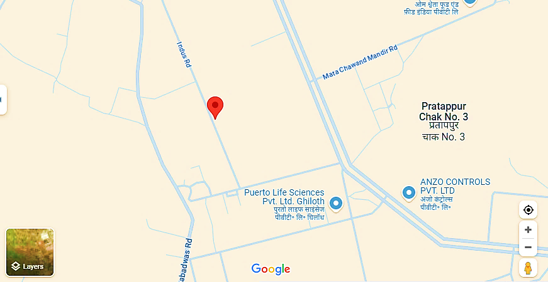

1. **Google Map Layout:** Demarcation of the land with approximate measurement on the Google map is attached in the below picture:

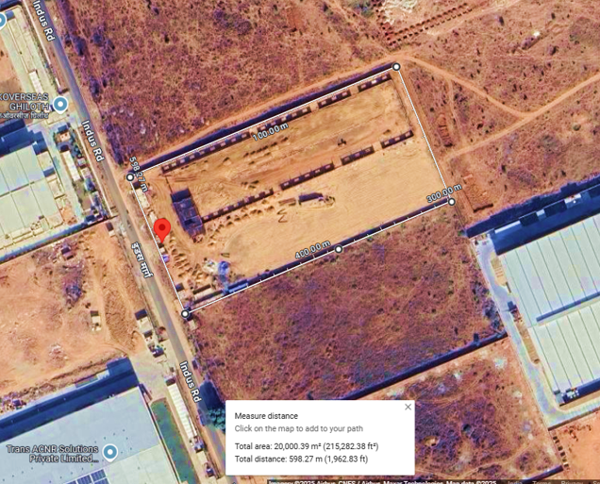

1. **LAYOUT PLAN:**

As per the data/information provided by the client/Company, the layout plan has been prepared by the architect (Ref: Atul Vasisht on 16th January, 2025). For reference, layout plan provided by company has been attached below:

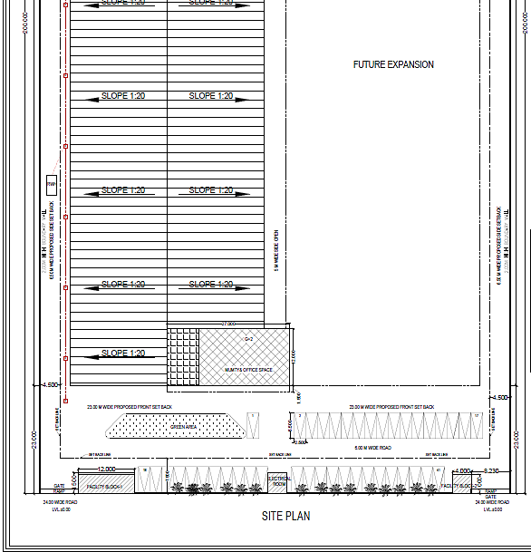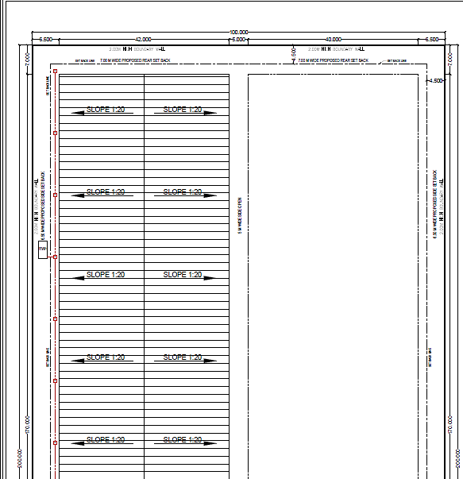

The layout plan, approved by architect Atul Vasisht (CA/2017/89450), designates a total land area of 20,000 SQM. The permissible Floor Area Ratio (F.A.R) is 160%, allowing a total built-up area of 32,000 SQM. According to the approved plan:

* The proposed covered area on the ground floor is 7,295.200 SQM.
* The total working shed will occupy 7,207.200 SQM.
* The first and second floors will have a combined area of 324 SQM.
* The Mumty is proposed to cover 231.600 SQM.

The other sections of the layout plan are given below-

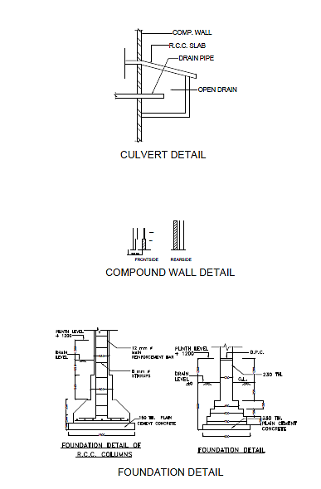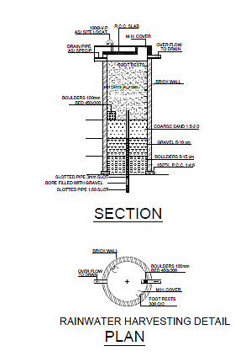

**DOORS & WINDOW SCHEDULE OF THE LAYOUT PLAN-**

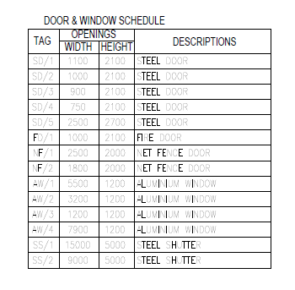

1. **LAND DETAILS:**

As per the lease deed executed dated 04th May 2023, M/s SSRM Glasses Private Limited has acquired a 2.00-hectare (20,000 Sq. Mt.) land at Plot No SP5-172 RICO Industrial Area Ghilot Tehsil Neemrana, Rajasthan.

The lease agreement made on the 27th April 2023 between Rajasthan Industrial Development & Investment Corporation Limited (RIICO), Jaipur, A Public Limited company incorporated under the Companies Act 1956, having its registered office at Udyog Bhawan, Tilak Marg, Jaipur (Rajasthan: India) -302005.

The state of Rajasthan Government handed over the land to the lessor for the purpose of setting up of Industrial Area/Special Parks. The lessor has agreed to demise and the lessee has agreed to take on lease, the plot No. SP5-172 in the industrial area Ghilot situated at Tehsil Neemrana District Alwar on the terms & conditions of the allotment letter No SSRM/GHT/1563-1567 dated 13.09.2022 issued by the lessor. The lessor has handed over physical possession of the said demised land to the lessee on 11.10.2022 and lessee has the full rights as per the lease deed.

As per the lease deed the proposed land is RIICO in INR 7.67 Crores including stamp duty for 99 years from 13th September 2022. As per the information provided by the company, it has paid INR.4.80 Crore out of the total consideration and for the remaining consideration of Rs. 2.73 Crores the same will be paid in instalments along with the interest of 8% p.a. which costs INR 0.32 Crores of the whole period.

The payment of INR 1.82 Crores made by lessee towards the annual economic rent and 25% amount of premium of the demised land and further agreeing by the lessee to make payment of balance amount of premium INR 5.72 Crores. The lease deed has been executed for 99 years from 13.09.2022.

During the site visit on 09th February 2025, we found that the land has been demarcated and the approach industrial road which connects to the main road is road of 15 ft. wide. Further Delhi-Jaipur Highway (6 Lane) is 8 km away from the proposed plant location.

1. **SITE PICTURES:**

Site pictures were captured during the site survey on 09th February 2025, for reference few of the pictures are attached below:

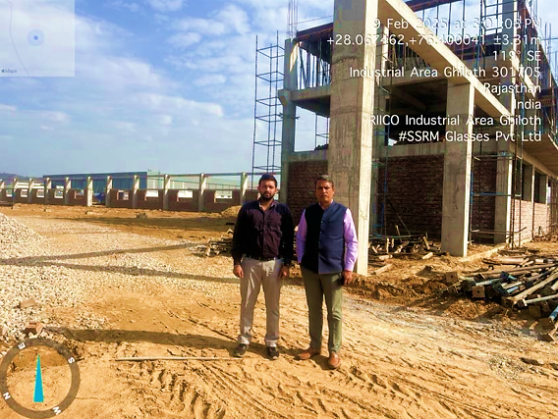

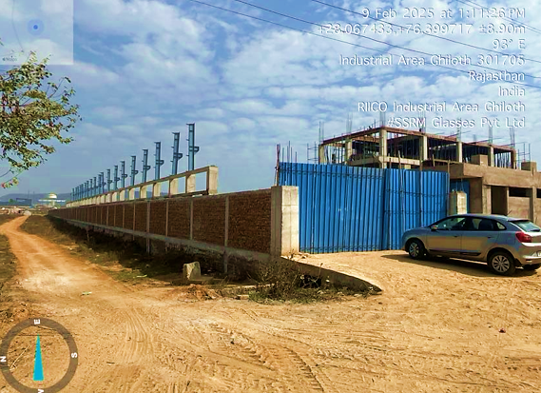

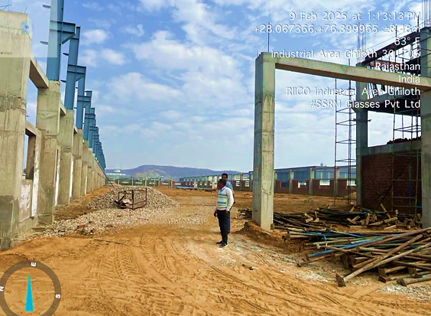

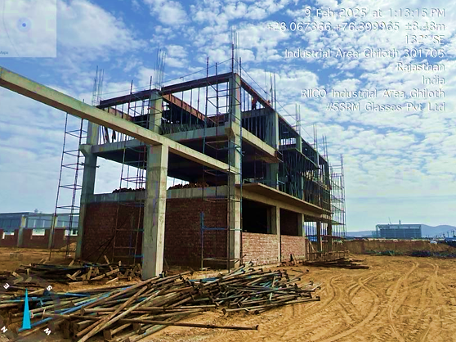

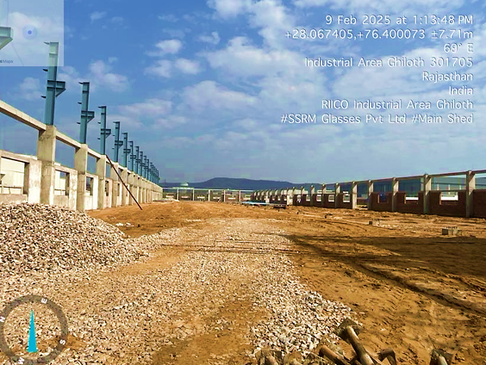

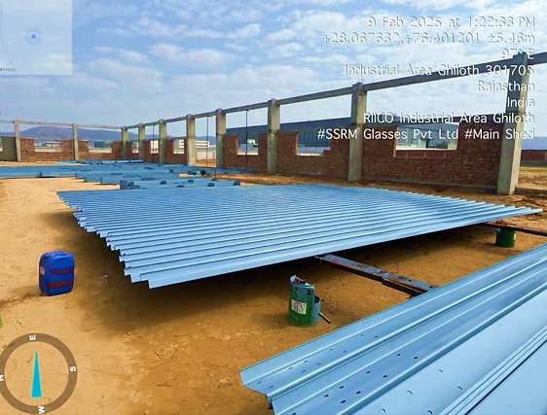

1. **BUILDING & CIVIL WORKS:**

As per the information provided by client the construction work of Toughening Glass Plant has been commenced on 01st April, 2024 and it is expected to complete its working shed on 31st July, 2025. Work of installation of Plant & Machinery will be completing on 31st January, 2026. Further it is expected that the operations will be commenced from 01st October, 2025.

According to the layout plan, provided by company the plant would be spreading over an area of 8174.80Sq. Mt. However, during the site visit it was observed that the plant is under work in progress stage and as per client commencement date will be 1st February, 2026. Detailed bifurcation of the proposed Building & Civil works has been shown in the below table along with the estimated cost:

|  |  |  |  |
| --- | --- | --- | --- |
| **S. No.** | **Particulars** | **Area** |  |
| **Area Statement** | | | **Units** |
| 1 | Total Plot Area | 20,000.00 | SQM |
| 2 | Permissible F.A.R @ 160% | 32,000.00 | SQM |
| 3 | Total proposed Covered Area at Ground Floor | 7,295.00 | SQM |
| 4 | Achieved F.A.R | 8,174.80 | SQM |
| 5 | Building Area | 14.644 | M |
| **Proposed Building Statement** | | |  |
| **Code** | **Block** | **Area** | **F.A.R** |
| **A** | **Working Hall Block** |  | **8086.80** |
| 1 | Working Shed | 7207.200 |  |
| 2 | First Floor | 324.200 |  |
| 3 | Second Floor | 324.200 |  |
| 4 | Mumty | 231.600 |  |
| B | **Facility Block-1** | | **72.00** |
| 1 | Guard Room, Time Office, Toilet ELEC Room | 72.00 |  |
| **C** | **Facility Block -1** | | **16.00** |
| 1 | Guard Room, Toilet | 16.00 |  |

***Sources****: Data/Information provided by the client.*

As per internal cost assessment of proposed building & civil work done by us, the estimated cost of building & civil works for the proposed plant is as follows:

|  |  |  |  |  |  |  |  |  |  |
| --- | --- | --- | --- | --- | --- | --- | --- | --- | --- |
| **M/S. SSRM GLASSES PVT.LTD.** | | | | | | | | | |
| **S.no.** | **Building Description** | **Height  (mtr.)** | **Type of Structure** | **Proposed Covered area (in sq.mtr)** | **Covered area  (in sq ft)** | **Area Rate  (INR per sq feet)** | **Estimated Cost** | **Proposed Cost As per the Project Report** | **Remark** |
| 1 | Working Shed | ~10 | GI Shed | 6883.2 | 74,090 | 1,200 | 8,89,08,092 | 10.38 Crore | Seems to be inline |
| 2 | Office Building (Ground Floor) | ~4.2 | RCC | 324 | 3,488 | 1,500 | 52,31,255 | Seems to be inline |
| 3 | Office Building (First Floor) | ~3.4 | RCC | 324 | 3,488 | 1,500 | 52,31,255 | Seems to be inline |
| 4 | Office Building (Second Floor) | ~3.4 | RCC | 324 | 3,488 | 1,500 | 52,31,255 | Seems to be inline |
| 5 | Mumty & M Room at Terrace | ~2.850 | RCC | 231.6 | 2,493 | 1,200 | 29,91,503 | Seems to be inline |
| 6 | Facility Block-1(Guard Room, Time Office & Toilet) | ~3 | RCC | 72 | 775 | 1,400 | 10,85,001 | Seems to be inline |
| 7 | Facility Block-2 (Guard Room) | ~3 | RCC | 16 | 172 | 1,400 | 2,41,111 | Seems to be inline |
| **Total** | | | | **7,531** | **81,065** |  | **10,89,19,474** | **10.38** |  |
| ***Remarks:*** | | | | | | | | | |
| 1. *All the details pertain to the building area statement such as area, floor, etc. has been taken as per the layout plan provided by the client.* | | | | | | | | | |
| 1. *The building was is Work in Progress stage during the site survey observation. This estimation is done as per the proposed area mentioned in the layout plan.* | | | | | | | | | |
| 1. *In layout plan Office building GF area is considered under working shed itself but as both of the structure have different type of construction so I have excluded the area of GF from working shed and done the estimation separately.* | | | | | | | | | |
| 1. *The proposed cost is taken from project report provided by client and there is no bifurcation of it or any cost estimation, so we have taken this figure as cost of construction for all constructions sheds, Buildings mentioned in the layout plan provided but the company and compared the same with our estimated cost.* | | | | | | | | | |

As per the above table, the estimated cost of the Building & Civil works is ~INR 10.89 Crores including applicable 12% GST. However, as a TEV consultant, the estimated Building & Civil works cost has been verified independently by us, which we found reasonable & in the permissible range also the cost may change as per specifications & material brand.

1. **PLANT & MACHINERY/ EQUIPMENTS DETAILS:**

|  |  |  |  |
| --- | --- | --- | --- |
| **S.NO** | **MACHINERY NAME** | **USD** | **Price (INR)** |
| 1 | CUTTING TABLE (LOAD+CUT+BREAK) | 90,000.00 | 78,30,000 |
| 2 | DOUBLE EDGER COMPLETE LINE WITH TRANSFER AND DETECTION TABLE | 1,60,000.00 | 1,39,20,000 |
| 3 | SEAMER- 4 SIDES | 52,000.00 | 45,24,000 |
| 4 | TEMPERING FURNCE | 3,88,000.00 | 3,37,56,000 |
| 5 | WASHING- AS PER REQUIREMENT | 58,000.00 | 50,46,000 |
| 6 | IG LINE | 1,60,000.00 | 1,39,20,000 |
| 7 | TRANSFER TABLE+ RACK | 25,000.00 | 21,75,000 |
| 8 | LAMINATION | 2,20,000.00 | 1,91,40,000 |
| 9 | CNC GLASS DRILL MACHINE, OTHER DRILL M/C | 80,000.00 | 69,60,000 |
| 10 | WATER TREATMENT PLANT | 35,115.65 | 30,55,062 |
| 11 | LOADING ROBOT | 20,000.00 | 17,40,000 |
| 12 | SINGLE EDGER+ BEVELLING | 25,000.00 | 21,75,000 |
| 13 | CABLE | 33,000.00 | 28,71,000 |
| 14 | LIGHTING | 21,000.00 | 18,27,000 |
| 15 | TRANSPORT / FREIGHT | 60,000.00 | 52,20,000 |
| 16 | HEAT SOAK | 41,000.00 | 35,67,000 |
| 17 | ERP SOFTWARE | 20,000.00 | 17,40,000 |
| 18 | OFFICE FURNUTURE | 30,000.00 | 26,10,000 |
| 19 | FORK LIFT | 11,000.00 | 9,57,000 |
| 20 | COOLING TOWER | 4,000.00 | 3,48,000 |
| 21 | GLASS TESTING TOOLS | 10,000.00 | 8,70,000 |
|  | **Total** | **15,43,115.65** | **13,42,51,061.55** |
| 22 | CUSTOMS & GST-30% |  | 4,02,75,318 |
| 23 | OVERHEAD GANTRY CRANE | - | 83,52,000 |
| 24 | TRANSFORMER | - | 34,80,000 |
| 25 | METER+ ACB+ DIST BOARD |  | 60,90,000 |
| 26 | FIRE FIGHTING | - | 34,80,000 |
| 27 | AIR COMPRESSOR+DRYER+FILTER | - | 17,40,000 |
| 28 | AIR BOTTLE | - | 4,35,000 |
| 29 | MISC, VALVE, PIPELINE ETC |  | 4,35,000 |
| 30 | GENERATOR | - | 18,27,000 |
|  | **Grand Total** | **15,43,115.65** | **20,03,65,380.02** |

*(Sources: As per information provided by client)*

Thus, the estimated cost for plant & machinery will be ~INR 20.03 Crore including the applicable custom of 30%. The estimated cost of the Plant & Machinery has been provided to us by the client as per the quotation received from the prospective supplier. As client/company has provided the estimated cost and based on that estimation the overall cost falls within the permissible range.

As per the quotation provided by company, prospective supplierswill be supplying all the required Plant & Machinery and equipment excluding miscellaneous assets as per scope of work of the agreement. As per our assessment, the total cost of plant & machinery would be ranging from INR 18 Crore to INR 20 Crores. Further, quotations of few plant & machineries such as overhead gantry crane, transformer, meter, fire-fighting, Air compressor, air bottle, generator and miscellaneous assets has not been provided to us by the client and estimated cost of these machineries are found in the line with market rates.

As a TEV consultant the cost of major plant & machinery has been verified by us independently, which we found reasonable & in the permissible range although the cost may change as per specifications & brand.

1. **UTILITIES:** Details of Water, Electricity and other utilities are describing as below:
2. **WATER:**

Company has taken the Water Connection from Rajasthan State Industrial Development & Investment Corporation Ltd (RIICO) of immediate release 25mm /1” size water connection on 30.01.2025 via letter no 2162.

The total requirement of water in the Unit has been estimated at 2000 Liter per day for the processing and 4000 Liter per day for staff. Full requirement of water will be met by local bodies/State Government. Various means as allowed by the state authorities shall be adopted to fulfil the requirements of water for the unit.

It is proposed to provide storage of water for over three days requirement i.e. storage for 1.50 lacs litters of water. The total volume of the storage tanks would therefore be 750 M3. The storage provided shall be as follow:

|  |  |
| --- | --- |
| **Expected Water Consumption** | |
| **Particular** | **Quantity** |
| Raw Water Storage Compartments | 2*0.25: 5.00 million Liters |
| Treated Water Storage Compartments | 1*.15: 0.15 million Liters |
| Software Water Storage Compartments | 1*0.10: 0.10 million Liters |
| **Total** | **0.75 million Liters** |

***Source:*** *Data/information provided by the client*

1. **ELECTRICITY:**

Based on the data provided by the client, the company has applied for a power load sanction of 1500 KVA. The estimated total connected load requirement is 1500 KVA, with a running load of 500 KVA. The expected daily power consumption is 16,000 units. The electrical system will be independently earthed for various networks, including lighting, air-conditioning, EPABX/fax systems, and computers.

Additionally, a SYSTIMAX SCS structural cabling system will be installed to support various automation services, such as fire alarms, public address systems, communication and security systems, CCTV, and data, voice, and imaging requirements. It is proposed to install 3 DG sets of 1000 KVA each.

|  |  |
| --- | --- |
| **PART E** | **PROJECT TECHNICAL DETAILS** |

1. **CAPACITY OF THE PROPOSED TOUGHENED GLASS UNIT:**

The proposed toughened glass plant will have a designed capacity of 20,000 MT per annum, processing approximately 60 MT per day. According to the company, around 5% of the total glass production is considered waste; however, this waste is charged to customers. Furthermore, the glass waste (glass crush) will be sold.

1. **PRODUCTION PROCESS OF TOUGHENED GLASS:**

**OVERVIEW:**

Toughened glass acquires a degree of strength for excess of the strength of normal glass sheet or plate glass, which if broken shatters into small and comparatively harmless pieces. It is claimed that the resistance to mechanical stock of toughened plate glass is 4 to 5 times more than that of ordinary plate glass. A toughened glass has better resistance to the vibration, mechanical shock and abrasion.

The process of making toughened glass involves several steps. First, workers cut the glass to the correct dimensions. Subsequently, the glass is subjected to a tempering process, which entails raising its temperature to a high point and rapidly bringing it down with cold air blasts. Strengthened glass is a result of internal stresses created during this process.

* **Process of Manufacture-**

The glass plate is heated to a temperature above its softening point and then subjected to rapid cooling. The glass is suddenly chilled and in this process contracts towards the core. It stretches until it has solidified and is no longer able to contract further at this stage the core is still soft. It contracts against restrained exercise by the solidified upper layer of the glass. This compression is responsible for the strength of the glass sheet, which is limited to about 20,000 lb/sq. Inch. Thus, it is highly stressed and the resultant force is able to nullify the external impact.

The intensity of the stresses depends on the rate of cooling, co-efficient of expansion, thermal conductivity of the glass, its specific heat, elasticity, and certain other physical properties.

* **Toughening Process-**

The raw plate glass sheet which is free from waviness, distortion etc., is cut to required size and shape and then all the edges are ground and polished as per end use of the product. This is called edge grinding and polishing and is very important for toughening because it will lead to breakages during process. No glass sheet can be toughened without edge grinding and polishing.

* **Washing and Drying**

After the edge grinding and polishing the glass sheets are washed manually or by machine and then dried. The glass sheets are fed into the furnace (Electrically operated). The sheets are kept in the furnace above its softening point, which varies according to the composition of glass. After attaining required temperature, the glass sheets are removed out of the furnace and placed in the air blowing quenching boxes for 20 to 25 seconds. After quenching glass sheet is toughened. For bend glass toughening, the glass sheets pass through a set of dies (as per shape) after furnace and then to the quenching boxes.

(Reference- [*https://www.techno-preneur.net/technology/project-profiles/glass/toughene.html*](https://www.techno-preneur.net/technology/project-profiles/glass/toughene.html)*)*

1. **PROCESS FLOW CHART OF THE PROPOSED TOUGHENED GLASS PLANT:**

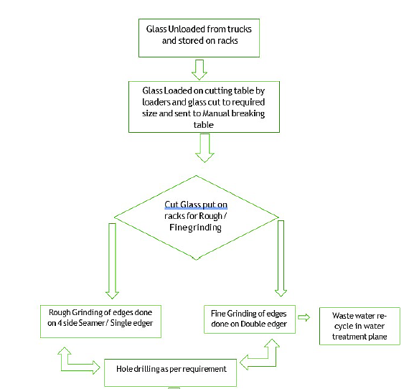

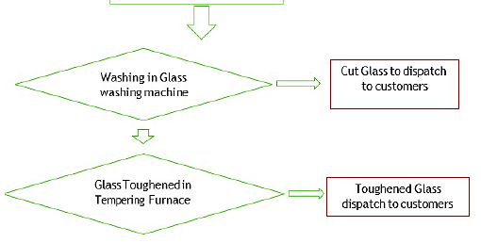

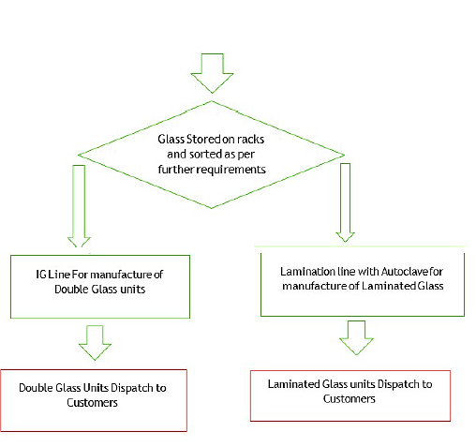

1. **TECHNICAL SPECIFICATIONS OF THE PROPOSED TOUGHENED GLASS PLANT:**

Technical specification of the proposed Toughened Glass plant is presented in the below table:

|  |  |  |  |
| --- | --- | --- | --- |
| **Toughened Glass Plant Technical Specification** | | | |
| **S. No.** | **Machinery Name** | **Size of Glass** | **Approx size of Machine** |
| 1 | CUTTING TABLE (LOAD+CUT+BREAK) | 6.1M X 3.3M | Total- 8m x 27.5 m,LOAD-L-13.8M,W-8M, H-1M CUT- L-7.2M, W- 3.7M, H-1M, BREAK- L-6.5M, W-3.7 M. H-1M |
| 2 | DOUBLE EDGER COMPLETE LINE WITH TRANSFER AND DETECTION TABLE | 6M X 3M | L Shaped- L- 14.5M, W-7M AND L-18M X 5M STRAIGHT- L-34M, W- 7M , |
| 3 | SEAMER- 4 SIDES | 4M X 3M | L- 8m , w- 5.5m |
| 4 | TEMPERING FURNCE | 6M X 3M | L-30M, W-11M, H-4.5M (BLOWER ON GROUND) |
| 5 | WASHING- AS PER REQUIREMENT | 6M X 3M | Total - W- 7m L- 11m (W-7M L-4m+ I/P TABLE- W 6.5m L-3.5 m,O/P table- W-6.5m, L- 3.5M) |
| 6 | IG LINE | 2.8M X 5M | Total - L- 56 m, W- 5m, L-35M B- 3.2 M H- 3.9M |
| 7 | AUTOMATIC ALUMINIUM SPACER BENDING MACHINE | - | L-10.3M B-2.5 M H- 3.7M |
| 8 | DESSICANT AUTOMATIC FILLING MACHINE | - | L-0.9M, W-1.2M H-3.6M |
| 9 | BUTYL EXTRUDER MACHINE | - | L- 3M, W- 0.7M, H-1.23M |
| 10 | INSULATING GLASS SEALING ROBOT | - | L-11m, W-2.5m , H-3.5m |
| 11 | TRANSFER TABLE+ Rack | AS PER REQIREMENT |  |
| 12 | LAMINATION | 6M X 3M | Toal- L- 72m , W- 10.5m, L- 56M , W-10.5M plus L-15.5m W-8M |
| 13 | AUTO CLAVE | 6M X 3M | L- 17M, W- 10M |
| 14 | CNC GLASS DRILL MACHINE | 1m x 2.5m | L -7.5 x 3.5m |

As per the data/information provided to us by the client/company, major component of the proposed Toughened Glass plant are as follows:

1. **CUTTING TABLE:**

The cutting table features an Automatic Glass Loading Machine, designed to efficiently lift glass from the shelf, rotate it to a horizontal position, and transport it to the cutting machine or other designated work areas. The cutting machine utilizes high-performance German industrial hardware and a German industrial control system, ensuring exceptional stability, reliability, and longevity. The cutting accuracy is precise, delivering clean edges that reduce wear on the grinding wheel during the edging process, which not only lowers production costs but also accelerates grinding speed, enhancing both quality and productivity.

The laser marking bridge is equipped with a dual-drive system, offering exceptional diagonal accuracy of ≤0.5mm. It can be quickly and easily adjusted, ensuring perfect alignment for smooth edging and seamless installation of the final product. This system also supports marking various customer logos, 3C certifications, and other custom shapes and patterns, including diagonal and special-shaped markings, all within the same layout.

1. **DOUBLE EDGER:**

The Glass Double Edging Machine is ideal for processing two edges of furniture glass, architectural glass, electrical appliance glass, and more. It is designed for high-speed operation, delivering superior brightness and a polished finish on glass edges. The machine features a high-precision transmission structure, incorporating two linear guide bars and dual ball bearing guide screws.

It is equipped with a PLC control system and an intuitive touch screen interface, along with a variable frequency speed control system, making it highly efficient for large-volume fine grinding and edging of glass.

The machine utilizes a double-deck turning table with bilateral glass edge grinding (right-angle arrangement) at the centre of the directional control unit. The transmission device is organized into two layers, with the bottom and top layers operating in perpendicular directions. The glass enters through the feed end, where it is first processed by the initial glass double straight-edge grinding unit.

Following this, the glass is automatically turned 90 degrees at the reversing station and fed into the second set of glass double straight-edge grinders to complete the edging process on the remaining two sides. All movements are controlled by the first double edger unit, eliminating the need for manual assistance.

1. **AUTOMATIC LAMINATED GLASS PRODUCTION LINE:**

|  |  |
| --- | --- |
| **PRODUCTION LINE OVERVIEW** | |
| Automatic Lamination glass production line LWDY-3000 | |
| Max glass in auto model | **3m x 4m** |
| Max glass in manual model | 3m x 6m |
| Min glass size | 350mm x 400mm |
| Glass thickness range | 6mm - 80mm (Special requirements can be customized） |
| Type of glass processed | Tempered Glass, Non-Tempered Glass |
| The type of applicable film | PVB, SGP |
| Overall dimension | L50m x 6m x H4m |
| Running speed | 6.5m/min , 20m/min, 3.5m/min (VF control) |
| Estimated capacity in 8h | 1000-2000sqm ( 2.5m x 4m, 4mm/5mm/6mm, Temper glass ) |
| Total power | 240kw |
| Power supply standard | 415V 50Hz 3P 4L ( 3L + N) |

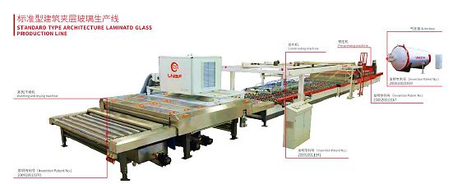

|  |  |  |  |
| --- | --- | --- | --- |
| **Technical Specifications** | | | |
| **S. No.** | **Name of Machinery** | **Model** | **Specifications** |
| 1 | Washing Machine | QXJ/30 | * Low-E washing standard * 3 pairs of brush rolls * 2pairs of air knives * High cleanliness type |
| 2 | Position Table | DW/3040 | * Automatic position * Dual PV and mechanical * Both sides shield wrap |
| Ex-tending table | KH/3040 | * Extending style * Expansion scope 1.7-2.5m * Both sides shield wrap |
| Suction hanger | ZDXP3040 | * Accuracy <0.5mm * Gear and rack transmission * Panasonic servo control |
| PVB storage | DPVB30 - 3 | * 3 PVB store * Motors drive unrolling |
| Transfer table B | GD/3040 | * Siemens VF control |
| 3 | Press | PY/30 | * 1+3 ovens * Top convection * IR heaters * Nip roll D = 440mm |
| 4 | Tilting table | FPT/3060 | * Max glass 3m x 6m * Single arm * Without sucker cup * Main function: tilting glass |
| 5 | Autoclave | GYF/3560 | * Body standard: GB * Max glass: 3m x 6m * Double top convection * With camera video * With vacuum connectors * Partition cooling pipe * IR heaters |

This machine consists of several key components, including the grinding system, transmission system, water system, electrical system, and safety system, all working together in harmony. The entire process is driven by an advanced automation control system, ensuring stable and reliable performance.

The machine features a four-head grinding system, with each head equipped with a four-wheel configuration. The wheels are uniquely designed for durability and cost-effectiveness.

The feeding section is made up of a rack, transfer rollers, position wheels, a transfer servo motor, and a transmission caster lift system. The frame is constructed from industrial-grade aluminium, and the caster lift system makes glass loading and positioning both easy and precise.

The main body of the machine includes the roller system, conveyor system, grinding system, electrical system, and rack. The rack is welded from high-quality profiles and undergoes annealing and precision machining to ensure stability and accuracy. Parts of the grinding head are made from imported aluminium plates, precision-machined using advanced CNC tools. The electrical components are sourced from top-tier manufacturers to guarantee long-lasting performance and reliability of the machine.

1. **AUTOMATIC INSULATING GLASS LINE: Model: HJ-LINE-IP-GF-2540**

It is a vertical insulating glass production line for the manufacture of dual-sealed insulating glass units with automatic operations. Specifications as follows:

|  |  |  |
| --- | --- | --- |
| **Technical Specification** | | |
| **S. No.** | **Particulars** | **Technical Parameter** |
| 1 | Max size | 2500*4000 mm with gas filling & 3~4 side step glass; |
| 2 | Min Size | 300*450 mm |
| 3 | Thickness of insulating glass unit | 12- 60 mm; 12-80mm(Optional) |
| 4 | Single Glass thickness | 3- 25 mm |
| 5 | Spacer width | 6-24mm (Pressure coefficient>50N/cm) |
| 6 | Sealing depth | 2-20mm |
| 7 | Max suction thickness | 15mm; optional for 20mm or more |
| 8 | Glass types | Float glass, tempered glass, laminated glass, specific patterned glass |
| 9 | Electrical connection | 3P 380 V/1P+N 240 V 50 Hz 45kW (max) ; ground connection: N+PE |
| 10 | Weight capacity | 300Kg/m, 1500Kg/pcs |
| 11 | Compressed air supply | 0.7MPa; 3ppm; —20°C (water 1070mg/m³) |

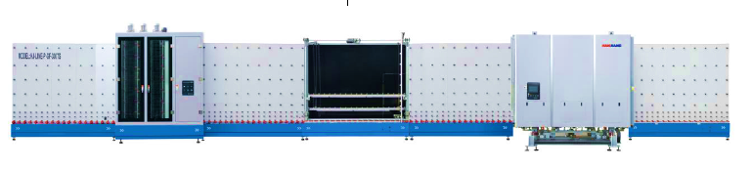

*(****Source****: As per information provided by client)*

1. **AUTO GLASS STORAGE RACKS:**

|  |  |  |
| --- | --- | --- |
| **S. No.** | **Particulars** | **Technical Parameters** |
| 1 | Voltage | 3p 415V 50Hz |
| 2 | Rack size | 3000 x 6000 mm |
| 3 | Max. Loading weight | 800 KG/rack |
| 4 | Power | 0.75 Kw |
| 5 | Ssupporting plate usage width: | 200 mm |
| 6 | Rack Quantity | 12 pcs per set |

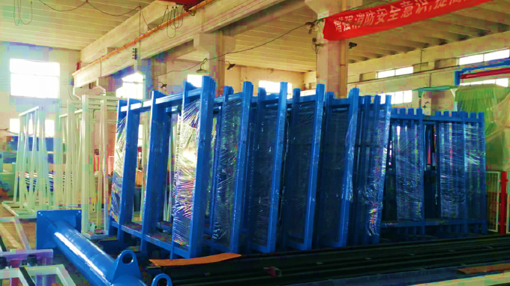

1. **TECHNOLOGY USED:**
2. **TECHNOLOGICAL ASPECT:**

* **Process of manufacture:**

The glass plate is heated to a temperature above its softening point and then subjected to rapid cooling. The glass is suddenly chilled and in this process contracts towards the core. It stretches until it has solidified and is no longer able to contract further at this stage the core is still soft. It contracts against restrained exercise by the solidified upper layer of the glass. This compression is responsible for the strength of the glass sheet, which is limited to about 20,000 lb/sq. Inch. Thus, it is highly stressed and the resultant force is able to nullify the external impact. The intensity of the stresses depends on the rate of cooling, co-efficient of expansion, thermal conductivity of the glass, its specific heat, elasticity, and certain other physical properties.

* **Toughening Process:**

The raw plate glass sheet which is free from waviness, distortion etc., is cut to required size and shape and then all the edges are ground and polished as per end use of the product. This is called edge grinding and polishing and is very important for toughening because it will lead to breakages during process. No glass sheet can be toughened without edge grinding and polishing.

* **Washing and Drying:**

After the edge grinding and polishing the glass sheets are washed manually or by machine and then dried. The glass sheets are fed into the furnace (Electrically operated). The sheets are kept in the furnace above its softening point, which varies according to the composition of glass. After attaining required temperature, the glass sheets are removed out of the furnace and placed in the air blowing quenching boxes for 20 to 25 seconds. After quenching glass sheet is toughened. For bend glass toughening, the glass sheets pass through a set of dies (as per shape) after furnace and then to the quenching boxes

* **Testing:**

After toughening all the sheet glasses are passed through the polariscope inspection.

* **Quality Control and Standards-** As per Bureau of Indian Standards (BIS) document that specifies the requirements for toughened safety glasses used in various industries like ship windows, offices and general purposes. Some of the standards are as follows-
* IS 2553:1971
* IS 6180:1971
* IS 6640:1972

1. **LATEST TECHNOLOGY/TECHNOLOGICAL ASSESSMENT:**

The latest technologies used to manufacture toughened glass include furnaces, quenching chambers, and air blowing boxes.

**Manufacturing process**

* Glass sheets are polished and washed
* Sheets are fed into an electrically operated furnace
* Sheets are heated above their softening point
* Sheets are removed from the furnace and placed in air blowing quenching boxes
* The glass sheets are toughened

**Factors affecting the process**

* **The specific heat-** Toughened glass is made by heating glass to over 650°C (1200°F) and then rapidly cooling it with air blasts
* **The rate of cooling-.** The rapid cooling rate, also known as quenching, is critical to the process of toughening glass.  The temperature at the air inlet of the tempering furnace drops to -20°C to complete the quenching process; the fan continues to send air at the original air supply speed for 40-50 seconds to complete the quenching stage; the fan sends air at the original air supply speed for slow cooling 3 Minutes, the glass is taken out from the tempering furnace to obtain thin tempered glass. <https://patents.google.com/patent/CN102976597A/en>
* **The coefficient of expansion-** The coefficient of linear expansion (CLTE) of toughened glass is less than or equal to 5 x 10^-6 per kelvin

**Thus, as per the above technical assessment, M/S SRM glasses Pvt Ltd is using the appropriate furnace (650 Degree Celsius) and Water cooling is adopted, which adopts segmented independent control, and the cooling speed is increased by 40% compared with the traditional cooling mode. It can save at least 20% in running time. It can be commented positively that the plant will be running smoothly. Technology & specification of the plant are matching with the need to run the plant smoothly and achieve the economies of scale.**

1. **MANPOWER:**

As per information shared by the client/.company,an estimate of manpower requirement allowing for leave, absentecism, sickness and holidays for smooth and for efficient operation of different sections of the plant including its administrative and commercial departments, has been prepared based on technical and management ground primarly to indicate the order of manpower requirement.

In estimating the manpower requirement, a proper ratio between the administrative, managerial, supervisory staff has been maintained with a view to affording proper industrial and professional management at various levels. The basic structure of the manpower will require the following kind of resources to opearte the plant 16*7 for 300 days a year:

In estimation of the expense of salary company has provide the details of the similar industry having capacity of 5000 MT per annum. Therefore we have estimated the expense proportionately.

|  |  |
| --- | --- |
| **Particulars** | **Amount (Per Annum)**  **(INR in Crores)** |
| Salary & Wages (A) | 1.04 |
| Staff Welfare Expense (B) | 0.062 |
| Contribution to PF | 0.097 |
| 50% reimbursement as per RIIPS Policy | 0.049 |
| **Net Contribution to PF (C )** | **0.049** |
| **Total (A+B+C)** | **1.15** |
| Total expense of salary of proposed plant on 90% capacity | **4.60** |
| Less- 5% of total expense as proposed plant is semi-automatic | **0.23** |
| **Net Salary & wages expenses** | **4.36** |

***Source:*** *Data/information provided by the client.*

Company has proposed to deploy 50 human resources initially, which will increased to 100 human resources as incraese in the capacity of the plant for the proposed Toughened glass plant which is in permissible range as per the standard benchmark of the industry.

1. **GOVERNMENT SUPPORT FOR THE PROJECT:**

The Rajasthan government has introduced various incentives and exemptions for Micro, Small & Medium Enterprises (MSMEs) under the Rajasthan Investment Promotion Scheme (RIPS) to encourage industrial growth. The key benefits include:

1. **Electricity Duty Exemption** – Exemption of INR 0.40 per kWh for up to 7 years.
2. **Employer Contribution Support** – 50% reimbursement of the employer’s contribution towards EPF or ESI for 7 years.
3. **Interest Subsidy** – 3% annual interest subvention on loans ranging from INR 10 Crores to INR 15 Crores for a period of 7 years.
4. **Investment Subsidy** – 75% reimbursement of State Tax (GST) paid and deposited for 10 years from the commencement of commercial production.

These incentives aim to reduce operational costs, support employment generation, and encourage capital investment, making Rajasthan a favorable destination for MSME growth and development. (References: [*https://legalman.in/rips-2024/*](https://legalman.in/rips-2024/) )

|  |  |
| --- | --- |
| **PART F** | **PRODUCT PROFILE** |

1. **INTRODUCTION:**

Toughened glass acquires a degree of strength for excess of the strength of normal glass sheet or plate glass, which if broken shatters into small and comparatively harmless pieces. It is claimed that the resistance to mechanical stock of toughened plate glass is 4 to 5 times more than that of ordinary plate glass. A toughened glass has better resistance to the vibration, mechanical shock and abrasion.

Toughend Glass has to pass the following important tests :

* Transfer strength test on sheets on simply supplied (Modules of rupture and electricity)
* Impact test: By following weight on sheets supported on two wooden battens
* Impact by falling weight on sheet evenly bedded (on putty)
* Impact by falling weight on edge of sheet
* Repeated twisting tests
* Sand blast abrasion
* Thermal tests

Because of the strength and other specific physical properties mentioned above, it finds applications in the following fields:  
i. Automobile : Cars, trucks, industry buses, tempos etc.  
ii. Railways : Coaches  
iii. Defence : Fleets, vehicles factory  
iv. Commercial : Hotels, shops complex  
v. Air ports : Doors

1. **PRODUCT CATEGORY:**
2. **TOUGHENED GLASS:**

Toughened / Tempered glass is a safety glass that has undergone processes of controlled thermal treatment to increase its strength. It is made from annealed glass that has been heated to approximately 650⁰C and then rapidly cooled, making it significantly stronger than ordinary glass.

Due to the increased heat treatment and rapid cooling of the glass, the treatment produces different physical properties. This results in compressive stress on the surface and improved bending strength of the glass. Before toughening, the glass must be cut to the correct size or pressed to shape.

**Charastristics of Toughened Glass**

* After toughening, glass can neither be cut, nor altered.
* Toughening does not alter the basic characteristics of glass - like light transmission or solar heat reflection. Toughened glass is known to have a higher thermal strength, with the ability to withstand temperatures up to 250°C.
* Toughened glass is difficult to break but in the event of a breakage, it disintegrates into small, harmless blunt piece

**Source**: [https://in.saint-gobain-glass.com/knowledge-center/toughened-glass#](https://in.saint-gobain-glass.com/knowledge-center/toughened-glass)

1. **DGU GLASS:**

A Double Glazing Unit, also known as an Insulated Glass Unit (IGU), is a combination of two or more glass panes separated by a spacer and sealed to form an airtight unit. The space between the glass panes is typically filled with air or an insulating gas, such as argon or krypton. The purpose of this construction is to create a barrier that reduces heat transfer, sound transmission, and condensation.

DGU glass can offer protection against harmful ultraviolet (UV) radiation. The multiple glass layers help to filter out a significant portion of UV rays, which can fade furniture, fabrics, and artwork over time. This protection not only preserves the aesthetic appeal of interiors but also helps to safeguard occupants from UV-related health risks.

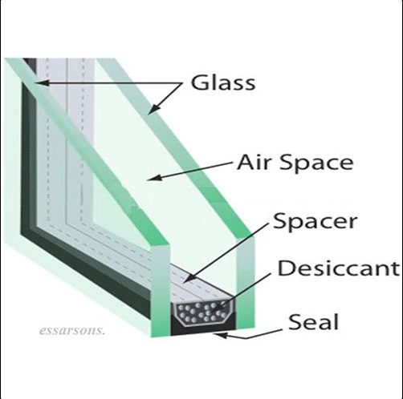

|  |  |
| --- | --- |
| **Elemental Composition Of DGU Glass** | |
| Glass Lites | An IGU consists of at least two panes (or lites) of glass. Although IGUs generally use monolithic glass, other types of coated and laminated glasses may be used, depending on the application to enhance the performance of the unit |
| Frame | To remove the moisture within the IGU, desiccants are used. The different types of desiccants are silica, molecular sieve and zeolites. The desiccants should be able to absorb water and hydrocarbons, not absorb krypton, argon or other thermal performance gases and should not contain pre-absorbed nitrogen. |
| Desiccant | Frame is the spacer bar that is used to separate the two glass lites in an IGU. It is usually made of aluminium and filled with desiccant. It is responsible for holding the unit together, providing thickness and mechanical resistance, and ensuring optimum performance of the unit |
| Sealant | Sealants are integral to manufacturing insulating glass because of their efficiency, ease of handling, eco-friendliness and safety. They are known for their adhesion, elasticity and durability. They also have a good cure profile, with low moisture vapour transmission rates. |
| Filling | There are three different types of IGUs based on the type of gas filled between the glass lites. The most commonly used type is the regular IGU with no filling - it has dry air inside. The second type is the one with inert gas filling. Inert gases such as argon, krypton, and xenon are used as a filling in this type of IGU. They are more efficient than dry air, but expensive. The third type of IGU is where vacuum exists between the glass lites. The formula used to calculate the amount of gas to be filled into the IGU is: Height (cm) x Length (cm) x ID (mm) x 0.001 = Number of Litres (x) Number of Litres (X) x 1.5 = Number of Litres of gas required per window |

1. **LAMINATED GLASS:**

The most impressive aspect of laminated glass is that it does not easily break when pressure is applied and does not lose its shape either. Hence it is suitable for high-traffic areas like busy walkways, public facilities, larger surfaces etc. The durability of this shatterproof glass guarantees its integrity even in extreme conditions like severe weather or accidents, ensuring it remains intact.

1. **PRICING STRATEGY:**

As per the data/information provided by the client, the company has provided the sample invoices of sale and selling price has been estimated on the following provided sample prices of various type of glasses-

|  |  |
| --- | --- |
| **Particulars** | **Selling Price (INR/SQM without GST)** |
| 8 MM ST 136 Toughened Glass | 1,435.00 |
| 5 mm Insulated Glass or DGU Glass | 1,744.00 |
| Float Glass 8 MM Clear flat toughened polish grinding | 1,076.00 |
| Float Glass 12 MM | 1,485.00 |
| Laminated Glass | 3,552.00 |

As per the current market scenario and as per our tertiary research on the industry trends, we found that the average price per SQM ranges from INR 1300 per SQM to INR 1680 Per SQM for more 8 MM ST 136 Toughened Glass depending on the quality and specification of the product. 5 mm Insulated Glass or DGU Glass INR 2045 INR Per SQM to 2260 per SQM. Float Glass 8 MM INR 970 Per SQM to INR 1237 Per SQM. Laminated Glass of INR 3444 Per SQM to INR 3767 per SQM. Further escalation on selling price has been estimated at 2.50% per annum. The selling price of Crush of glass (Crushed glass) is considered on conservative side as INR 8.00/kg.

**References:**

<https://www.guptaglassenterprises.com/toughened-glass.html>

<https://www.indiamart.com/proddetail/8mm-toughened-clear-glass-2853897230548.html?pos=19&kwd=st%20136%20toughened%20glass&tags=A||||9839.57|Price|product|||TS|rsf:highmct-|-res:RC5|ktp:N0|stype:attr=1|mtp:G|isu:1|wc:6|qr_nm:splt-gd|com-cf:nl|ptrs:na|mc:39959|cat:498|qry_typ:P|lang:en|cs:9079|v=4|r=5>

<https://www.birkanengg.co.in/?pos=1&kwd=insulated%20glass&tags=A||||8785.791|Price|product|||SSlc|rsf:gd-|-res:RC3|ktp:N0|stype:attr=1|mtp:G|isu:1|wc:4|qr_nm:gd|com-cf:nl|ptrs:na|mc:10209|cat:379|qry_typ:P|lang:en|flavl:0|cs:9193|v=4>

<https://www.tradeindia.com/products/insulating-glass-c3661854.html>

<https://www.guptaglassenterprises.com/window-glass.html#tinted-float-glass>

<https://www.indiamart.com/proddetail/25-52mm-tempered-laminated-glass-25-52mm-toughened-laminated-glass-2852568843297.html?pos=11&kwd=laminated%20glass&tags=A||||8210.732|Price|product|||LSnp|rsf:gd-|-qr_nm:gd|res:RC4|com-cf:nl|ptrs:na|ktp:N0|mc:1005|stype:attr=1|cat:498|mtp:G|qry_typ:P|lang:en|wc:2|cs:8057|v=4|r=4>

<https://www.tradeindia.com/manufacturers/laminated-toughened-glass.html>

1. **MARKETING, SELLING & DISTRIBUTION PLAN:**

Company deals in various type of glasses like toughened glass, DGU glass, Insulated glass, Laminated glass which are used in different sectors which are as follows-

* Real Estate & Construction: Builders, architects, interior designers, and contractors.
* Retail & Commercial Spaces: shopping malls, office buildings, and showrooms.

The company has strong relationships with leading builders and reputable entities in the glass industry, such as Asahi India Glass, ensuring a steady flow of orders for glass toughening. It is proposing to collaborate with architects, interior designers, and real estate firms to include your products in their projects.

A key Unique Selling Proposition (USP) of the company is its ability to manufacture large-size toughened glass, surpassing standard dimensions available in the market. This capability positions the company as a preferred choice for projects requiring oversized glass solutions.

The company has proposed to offer competitive bulk pricing for large projects and will provide customized solutions at different price points. Company has the model of B 2 B sales and also will plan to expand its market share in retail sector as well.

The company will create a professional website showcasing product categories, technical specifications, case studies, and testimonials and also plan to advertisement through social media platform to target architects, builders, and interior designers with engaging visual content.

|  |  |
| --- | --- |
| **PART G** | **RAW MATERIAL ANALYSIS** |

1. **INTRODUCTION:**

The primary raw material for toughened glass is plain sheet glass which is typically made from a mixture of silica sand, soda ash, and limestone, essentially the same raw materials used to create regular glass, but carefully selected for high quality to undergo the toughening process; this sheet glass is then heated and rapidly cooled to achieve its enhanced strength properties. This is available in India from large companies such as Ashahi India Glass Ltd., Saint-Gobain India, Hindustan National Glass & Industries Ltd. etc.

1. **RAW MATERIAL DETAILS:**

The company utilizes various types of glass and enhances their durability by subjecting them to controlled thermal or chemical treatments, resulting in toughened glass that is significantly stronger than standard glass. These processes improve the glass’s resistance to impact, temperature fluctuations, and mechanical stress, making it ideal for diverse applications.

Glass sheets serve as the primary raw material, accounting for approximately 95% to 98% of the total materials used in the production process. Due to their high composition percentage, the quality and specifications of these sheets play a crucial role in determining the overall performance and reliability of the final toughened glass products.

1. **Reflective glass-** Ordinary glass allows nearly 80% of visible light, heat and ultraviolet radiation to pass through without being absorbed or reflected. This results in soaring energy costs and discomfort for the building's occupants. Reflective glass allows optimum natural daylight through, thereby improving occupants' health and well-being. It also reduces the energy used in artificial lighting, resulting in significant savings in electricity costs and also block UV-rays.

The company requires reflective glass in various sizes, such as 8mm, 10mm, and 12mm, depending on customization requirements. These glasses will undergo a toughening process to enhance their strength, durability, and safety, making them suitable for various applications.

1. **Clear Glass-** Clear glass is a transparent, colorless material widely used in windows, doors, and furniture. It allows maximum light transmission, providing unobstructed views and a strong strength-to-weight ratio. Its ability to let in natural light helps improve energy efficiency. The company enhances the glass through controlled thermal or chemical treatments, significantly increasing its strength compared to standard glass**.**
2. **Other Raw Materials-**

* **IG Sealant JS 988S+Part A (Resin) & Part B (Catalyst)-** This is a two-part insulating glass sealant system consisting of Part A (Resin) and Part B (Catalyst). When mixed, these components create a durable and flexible sealant that enhances the structural integrity and airtightness of insulated glass units (IGUs). It provides excellent adhesion, weather resistance, and long-term durability, ensuring the IGUs remain sealed against moisture and temperature fluctuations.
* **Natergy Molecular Sieve (0.5-0.9 MM)-** This desiccant material is essential for insulating glass production. It effectively absorbs moisture and prevents condensation inside the IGU, maintaining clarity and preventing fogging. The 0.5-0.9 mm particle size ensures optimal absorption capacity and enhances the longevity of the IGU.
* **JS 900 IG Primary Butyl Sealant-** This is a primary sealant used in the production of IGUs, primarily applied along the spacer bars. It offers excellent adhesion and acts as a moisture barrier, preventing gas leakage and enhancing the overall thermal insulation performance of the unit. It also ensures a strong bond between the glass panes and the spacer system.

These raw materials play a crucial role in ensuring the durability, energy efficiency, and performance of insulated glass units.

1. **AVAILABILITY OF RAW MATERIAL:**

As per data information provided by the client, the promoters have established a strong network of suppliers, customers through their existing business. This network can be leveraged for sourcing raw materials, securing sales contracts, and establishing strategic partnerships. Their existing relationships in the industry will facilitate smooth operations and market penetration.

The company has long standing relationship with its suppliers thereby ensuring timely supply of key raw materials. Following are the few suppliers-

|  |  |  |
| --- | --- | --- |
| **S.No** | **Supplier’s Name** | **Address** |
|  | Shiv Aluminium & Glass | H-91, Noida Sector 9, Noida - 201301 (Near Harola Market) |
|  | Join Leader Chemtech Private Limited | 103, F.i.e, Chaudhary Charan Singh Marg, Patparganj Industrial Area, Patparganj, Delhi, 110092 |
|  | Ridhi Sidhi Glasses India Private Limited | E217-217A, RIICO Industrial Area, Jhotwara Extension, Sarna Dungar, Baori, Jaipur - 302012, Rajasthan, India |
|  | Rajasthan Aluminium and Glass House | Station Rd, near HDFC Bank, Alwar, Rajasthan 301001 |

*Source: As per information shared by client*

1. **PRICING:**

|  |  |  |
| --- | --- | --- |
| **S. No.** | **Raw Material** | **INR/SQM** |
| 1 | 8 MM reflective glass | 1080.00 |
| 2 | Clear Glass | 400.00 |
| 3 | 5 MM Clear Glass 240*3660 | 250.00 |
| 4 | 12 MM clear Glass 2660*3660 | 648.00 |
| 5 | 10 MM Clear Glass 2440*3660 | 540.00 |
| **Other Raw Materials** | | |
| 1 | IG Sealant JS 988S+Part A Fresin | 192.47 INR/KG |
| 2 | IG Sealant JS 988S+Part B Catalyst | 574.71 INR/KG |
| 3 | Natergy Molecular Seive 0.5-0.9 MM | 121.58 INR/KG |
| 4 | JS 900 IG Primary Buty Sealant | 495.00 INR/KG |

*Source: As per information shared by client*

As per the current market scenario and as per our tertiary research on the industry trends, we found that the average price per are as follows-

|  |  |  |  |
| --- | --- | --- | --- |
| **Glass Type** | **Price Range (INR per SQM)** | **Key Factors Affecting Price** | **Usage Applications** |
| Reflective glass | ₹753 - ₹1,500 | Thickness, strength, heat resistance, and customization | High-rise buildings, facades, furniture, shower enclosures |
| |  | | --- | |  |   Clear Glass | ₹500 - ₹600 | Raw material cost, availability, and processing | Basic glazing, interior partitions, windows, decorative purposes |
| IG Sealant | ₹250 - ₹600 | Brand, adhesion quality, durability | Double-glazed glass, insulation improvement |
| Natergy Molecular Sieve | ₹115 - ₹160 | Purity, absorption efficiency, and supplier pricing | Prevents moisture in insulated glass units |

The variation in pricing influenced by factors like demand, raw material costs, and processing techniques and nature of the glass industry, with prices varying based on quality, market demand, and raw material availability

**References:**

1. <https://www.indiamart.com/proddetail/blue-reflective-glass-2849511081191.html?srsltid=AfmBOoqbT9_2e8hdEYlpNV_7XLzGiCNFOzGTl0ZRruYWGsRmhpjrhIjR>
2. <https://www.tradeindia.com/products/reflective-glass-c8567212.html>
3. <https://www.indiamart.com/proddetail/clear-glass-24521591091.html?pos=3>
4. <https://www.indiamart.com/proddetail/molecular-sieve-2853491866033.html?srsltid=AfmBOopHLPGYLziJ06B_F3ggDFxjCLjiG8VAWAdyWOe6orqjdjv-nDZb>

|  |  |
| --- | --- |
| **PART H** | **INDUSTRY OVERVIEW** |

1. **INTRODUCTION:**

**History of Glass in India-** It is said that Glass was discovered by the Syrians 5000-7000 years ago, reaching Egypt around 2000 BCE and then to Rome, from where it spread across Europe and the world. Historically, Firozabad is popularly known as the “Glass City of India”, where production of glass started back in the 17th Century. It remained a cottage industry till the early 20th century. The first glass plant was set up in August 1908 by Lokmanaya Balgangadhar Tilak at Talegaon, Maharashtra. There has been steady progress since independence in 1947.

HNG (1946), AGI (1972), Piramal Glass (1984), Asahi (1987) and Saint Gobain (2000) started their glass operations.

Indian GDP was growing at ~8% CAGR till 2016. The government aimed for a USD 5 Trillion Economy by 2024, but this has been hit by the COVID-19 Pandemic. The economy is expected to contract by 4.5% for the year 2020-21 owing to lockdowns to contain the spread of COVID-19. India expects a V-Shaped Recovery in the year 2021.

The global tempered glass market was valued at USD 50 billion in 2022 and grew at a CAGR of 6% from 2023 to 2032. The market is expected to reach USD 89.54 billion by 2032, with the largest improvements expected in developed countries in Europe and North America. In particular, rebounds in building construction activity in many countries in these regions will support rising demand for flat glass in architectural applications. The increasing demand for consumer electricals and electronics will drive the growth of the global tempered glass market.

Tempered Glass is also called toughened Glass. It is a kind of safety glass that has undergone carefully regulated chemical and thermal processing, strengthening it and making it safer, stronger and more durable than regular Glass. Annealed Glass can be thermally tempered to create tempered Glass. Tempered Glass also has high-temperature resistance. Tempered Glass is less likely to cause significant injuries when it breaks because it shatters into little cubes when it does. Following is the segment wise Indian Market of Glass Industry-

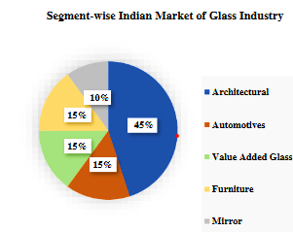

1. **POTENTIAL AND EXPANSION:**

The toughened glass market has been witnessing significant growth in recent years, driven by increased demand from various industries such as construction, automotive, and electronics. The global market for toughened glass was valued at approximately $50 billion in 2024, with a projected compound annual growth rate (CAGR) of 6.5% from 2024 to 2032. This growth can be attributed to rising consumer awareness concerning safety features and design aesthetics, along with stricter building codes and regulations promoting the use of safety glass.

Additionally, the architectural sector is increasingly adopting toughened glass for facades, windows, and roofs, as it provides energy efficiency and durability while enhancing the building's visual appeal. The automotive industry is also a significant contributor, utilizing toughened glass for windshields and side windows, owing to its lightweight and shatter-resistant properties that improve vehicle safety.

In future the toughened glass market is expected to witness further innovations in manufacturing techniques, expanding its applications across various sectors. The market is anticipated to reach around $70 billion by 2032. This positive outlook can be attributed to technological advancements such as smart glass, which can adjust its opacity and thermal properties, leading to enhanced energy efficiency in buildings. Furthermore, the increasing trend towards sustainable construction practices is likely to boost the demand for recycled and eco-friendly toughened glass products.

The emergence of smart cities and the Internet of Things (IoT) is also predicted to propel the toughened glass market forward. The integration of toughened glass in smart buildings, where it can be used in automated windows and security systems, is expected to contribute significantly to the market's expansion. Moreover, investments in green buildings and infrastructure in developing economies are likely to create new business opportunities within the toughened glass sector.

In summary, the toughened glass market is on a promising growth trajectory, with strong demand across various industries bolstered by advancements in technology and a focus on sustainability. The projected market size reflects optimism about the material's versatility and application potential in both current and emerging markets.

1. **MARKET OVERVIEW:**

The global flat glass market is estimated at approximately 62 million tons annually (equivalent to 208 thousand tons per day) and is growing at a 6% annual rate.

India contributes about 0.19% of global flat glass production, with a total industry size of 110 thousand tons per month. The per capita consumption of flat glass in India is 0.7 kg, significantly lower than in developed countries, where it ranges between 8 to 10 kg per person.

India imports around 15,000 metric tons (MT) of clear glass per month, while total glass imports, including coloured glass, amount to approximately 35,000 MT per month.

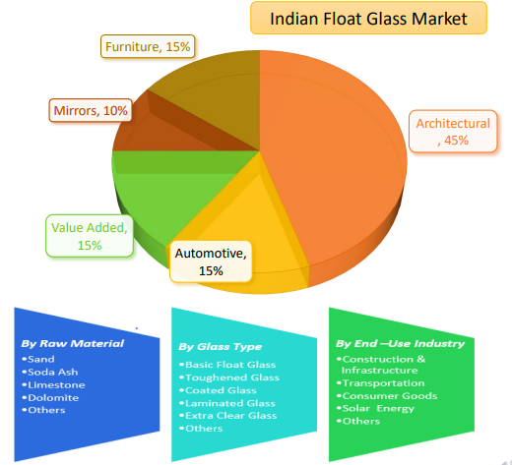

1. **CHALLENGES:**

Despite a significant growth potential, glass manufacturing industry faces several challenges and issues that can impact production, profitability, and growth. Some of the common challenges faced by the industry include higher cost of raw material, low per capita glass container consumption, competition and innovation pressure, mining issues and delayed leases and the need to adopt sustainable practices. Below are the challenges:

1. **High Initial Investment & Manufacturing Costs-** Setting up a toughened glass plant requires significant investment in high-end furnaces, precision cutting equipment, and quality control mechanisms to ensure durability and safety standards. The high energy consumption involved in the heating and rapid cooling processes, primarily relying on electricity and gas, further increases operational costs. Additionally, the regular maintenance of toughening furnaces and other specialized machinery is not only expensive but also essential for maintaining efficiency and minimizing production downtime, which directly impacts overall profitability.
2. **Raw Material Price Fluctuations-**The cost of plain sheet glass, the primary raw material for toughened glass, fluctuates due to market variations and supply chain issues affecting key ingredients like silica sand, soda ash, and limestone. Additionally, the industry's dependence on imports for high-quality coated or specialty glass further increases production costs, making pricing unstable.
3. **Energy Consumption & Environmental Concerns-** Toughened glass production involves high energy consumption, leading to increased carbon footprint.
4. **Slow Adoption of Advanced Glass Technologies**- Indian consumers and builders prioritize cost over technology, leading to slow adoption of Low-E glass, UV-protected glass, and smart glass. Lack of awareness about the benefits of toughened glass in energy efficiency and safety
5. **CONCLUSION:**

The toughened glass market is on a strong growth trajectory, driven by rising demand in construction, automotive, and electronics industries. Increasing safety regulations, energy efficiency requirements, and technological advancements have significantly boosted the adoption of toughened glass worldwide. Innovations such as smart glass, sustainable manufacturing practices, and integration into smart buildings are expected to further enhance market expansion.

Additionally, the growing focus on green construction and infrastructure development in emerging economies presents new business opportunities. With a projected market value of $70 billion by 2032, the industry is poised for continued innovation and widespread application, reinforcing its critical role in modern architecture, transportation, and technology.

|  |  |
| --- | --- |
| **PART I** | **SWOT ANALYSIS** |

|  |  |
| --- | --- |
| **SWOT ANALYSIS** | |
| **STRENGTHS** | * **Strategic Location:** The Site is located at Ghilot Industrial Area, Rajasthan, which is a fully developed Industrial area and export promotion zone. It is adjacent to the Capital Region of Delhi, where all the facilities for Industrial Glass related businesses are available. Since it is a developed zone, the infrastructure facilities like, roads, water, electricity, and communication facilities are readily available. The proposed project in GHILOT, RAJASTHAN is in prime location. * **Growing Demand:** Increasing construction activities globally drive the demand for high-quality glass products like toughened glass. * **Versatility-** Can be customized in size, shape, and thickness to fit various design needs across different industries * **Government Support:** The project will be entitled to avail incentives from Rajasthan Investment Promotion Scheme (RIPS) like interest Subvention of 3% p.a., reimbursement of 50% provident fund contribution for 7 years and exemption from electricity duty for 7 years. * **Technology:** The proposed plant (Semi-Automatic) will be commissioned * **Manufacturing Experience:** Promoters are having experience in business of toughened glass. * **Leverage Existing Entity for Growth –** One of the promoters has established relationships with the existing entity, which will provide a strategic advantage for the proposed unit. This experience will help in building a strong customer base and securing reliable suppliers, ensuring a smooth business expansion. |
| **WEAKNESSES** | * **CAPEX:** The proposed toughened glass plant would be set up by a high initial investment, in which approx. 50% capital would be required for plant & machinery. * **Raw Material:** In the glass toughening plant the major cost is raw material which is approx. 70% of the total expenses. * **Production Cost:** The manufacturing process of toughened glass can be relatively expensive due to specialized equipment and high-temperature heat treatment. |
| **OPPORTUNITIES** | * **Emerging demand/Markets:** Expansion into new markets with growing construction sectors like Asia and Africa and Development of high-performance solar panels utilizing toughened glass. * **Expansion Potential:** The Company is having the plan to expand its business in future of toughened glass by expanding its capacity. * **Government Support:** The project can benefit from government initiatives and policies aimed at promoting the state Rajasthan |
| **THREATS** | * **Competition from Alternatives:** Substitute materials like plastic and composite panels could pose challenges due to potential cost advantages. * **Technological Advancements:** New glass technologies with superior properties could disrupt the market. |

|  |  |
| --- | --- |
| **PART J** | **PROJECT COST AND MEANS OF FINANCE** |

As per data/information shared by the client, the proposed Toughening glass plant proposed to be commissioned by making an investment of INR 45.21 Crores as shown in the below table along with Means of finance:

|  |  |  |
| --- | --- | --- |
| **Total Project Cost** | | |
| **S. No.** | **Capital Cost Head** | **Amount (INR in Crores)** |
| 1 | Land Cost | 8.01 |
| 2 | Building & Civil Works including land development & Boundary Wall | 10.89 |
| 3 | Plant & Machinery | 20.03 |
| 4 | Office Equipment & Accessories | 1.00 |
| 5 | Working Capital Margin | 3.50 |
| 6 | Preliminary Expenses | 0.00 |
| 7 | Interest of Pre-operation period | 1.38 |
| 8 | **Sub Total** | **44.81** |
| 9 | Contingencies at ~1.0% of Total Hard Cost | 0.40 |
|  | **Grand Total (TPC)** | **45.21** |
| **Means of Finance** | | |
| **S. No.** | **Particular** | **Amount (INR)** |
| 1 | Promoter's Capital | 0.01 |
|  | Promoter's capital during FY 2025-26 | 1.99 |
| 2 | Unsecured Loan | 28.19 |
| 3 | Term Loan | 15.02 |
|  | **Sub Total** | **45.21** |
|  | CC Loan | 10.00 |
|  | **Total Loan** | **₹ 55.21** |

***Source:*** *Data/Information provided by the company.*

**Notes:**

1. As per the shared lease deed, a 4.94 -acre (20,000 Sq. Mt.) land has been leased by the company at Plot No. SP5-172 RIICO Industrial Area Ghiloth Tehsil Neemrana, Rajasthan from RIICO Limited of INR 7.54 (excluding all other charges) through an executed deed on 04th May 2023.
2. According to the information provided by the client, the company has applied to the Electricity Distribution Division (EDD), Rajasthan for the sanctioning of a 1500 KVA power connection.
3. The estimated cost of the Building & Civil works is ~INR 10.89 Crores including applicable 12% GST. Following are the details of the building & civil works-

|  |  |  |  |  |  |  |  |
| --- | --- | --- | --- | --- | --- | --- | --- |
| **S.no.** | **Building Description** | **Height  (mtr.)** | **Type of Structure** | **Proposed Covered area (in sq.mtr)** | **Covered area  (in sq ft)** | **Area Rate  (INR per sq feet)** | **Estimated Cost** |
| 1 | Working Shed | ~10 | GI Shed | 6883.2 | 74,090 | 1,200 | 8,89,08,092 |
| 2 | Office Building (Ground Floor) | ~4.2 | RCC | 324 | 3,488 | 1,500 | 52,31,255 |
| 3 | Office Building (First Floor) | ~3.4 | RCC | 324 | 3,488 | 1,500 | 52,31,255 |
| 4 | Office Building (Second Floor) | ~3.4 | RCC | 324 | 3,488 | 1,500 | 52,31,255 |
| 5 | Mumty & M Room at Terrace | ~2.850 | RCC | 231.6 | 2,493 | 1,200 | 29,91,503 |
| 6 | Facility Block-1(Guard Room, Time Office & Toilet) | ~3 | RCC | 72 | 775 | 1,400 | 10,85,001 |
| 7 | Facility Block-2 (Guard Room) | ~3 | RCC | 16 | 172 | 1,400 | 2,41,111 |
| **TOTAL** | | | | **7,531** | **81,065** |  | **10,89,19,474** |

However, as a TEV consultant, the estimated Building & Civil works cost has been verified independently by us, which we found in the permissible range.

1. The estimated cost for plant & machinery will be ~INR 20.03 Crores including the applicable GST of 12%. However, as a TEV consultant the cost of major plant & machinery has been verified by us independently, which we found reasonable & in the permissible range also the cost may change as per specifications & brand.
2. As per the information provided by the client/company, the estimated cost of **miscellaneous assets** is **INR 1 Crore**. These assets primarily include **office equipment and accessories** necessary for setting up and operating the proposed unit efficiently.
3. Contingency cost of INR 40 lakhs (~1% of TPC) has been considered based on general assumption and professional experience. Interest during implementation period will be paid from March 2025 by the company @ 11.00%.
4. The project is proposed to be funded through a term loan of INR 15.02 crores and promoter’s margin of INR 30.19 crores. Further, as per the working capital assessment, the working capital will require ~ INR 14.01 Crores, which will be funded through WC loan of INR 10.00 Crores and promoters’ margin of INR 3.50 Crores (~25% of required WC in the first full operational year).
5. Thus, INR 67.81 Crores per Metric Ton is the capex of proposed toughened glass unit including IDC, Contingencies and working capital margin.

As per our territory research and data/information available in public domain, we found that per metric ton cost for setting up a toughened glass unit ranges from approx. INR 45 lakh per metric ton to INR 50 lakhs per metric ton generally.

**Reference-**

<https://www.entrepreneurindia.co/project-and-profile-details/Toughened%20Glass>

|  |  |
| --- | --- |
| **PART K** | **PROJECT IMPLEMENTETION SCHEDULE** |

The proposed Toughening glass unit is expected to achieve its C.O.D till 31st January, 2026, as per the proposed implementation schedule shown in the table below:

|  |  |  |  |  |
| --- | --- | --- | --- | --- |
| **S. No.** | **Particulars** | **Activity** | **Expected completion date** | **Status** |
|  | Land | Land Procurement | 04th May, 2023 | Industrial Land Has been leased from RIICO Limited on 04.05.2023 |
| Land Development | April 2024 | Development of land has been started in April 2024 |
|  | Sanction of Rupee Term Loan | Sanction of Rupee Term Loan | 28th February 2025 | Pending |
|  | Building & Civil Works | Soil Filling | September, 2024 | Completed |
| Appointment of Architect | - | Completed |
| Building Plan Sanction | 24th January, 2025 | Completed, subject to minor rectifications |
| Shed Civil Work | January, 2025 | Completed |
| Office Building | July, 2025 | 50% of work completed |
| Shed Erection | April, 2025 | In Process |
|  | Plant & Machinery | Finalization of P&M suppliers | - | Pending |
| Orders to P&M suppliers | - | Completed |
| Arrival of P&M | August, 2025 | Pending |
| Installation of P&M | December, 2025 | Pending |
|  | Statutory Approvals, registrations & NOCs | From the respective authorities | 20th January, 2026 | Pending |
|  | Finishing & Trail Run | Informed by client | 31st January, 2026 | Pending  (Post C.O.D approval) |
|  | Commercial Operation Date | Informed by client | 31st January, 2026 | Pending |

**Notes:**

1. Schedule has been made as per feasibility to achieve different milestones.
2. Achievement of Milestone will depend on sanction of term loan as per proposed timeline.
3. For current status of statutory approvals, kindly refer the “Section L” of this report.
4. As per this timeline, the expected C.O.D will be 31st January, 2026.

|  |  |
| --- | --- |
| **PART L** | **STATUTORY APPROVALS | LICENCES | NOC** |

As shown in the below table along with current status, following major approvals are required. However, the list is not exhaustive and State/District Authorities may be approached for further clearances required (if any):

|  |  |  |  |
| --- | --- | --- | --- |
| **S. No.** | **REQUIRED APPROVALS** | **DATE**  **REFERENCE NO.** | **STATUS**  (Approved/ Applied For/ Pending) |
|  | Certificate of Incorporation  *Ministry of Corporate Affairs, Government of India* | 5th August, 2022  CIN: U26109UP2022PTC168815 | Approved |
|  | Change of land use | - | Not Applicable |
|  | Labour Licence  Registration & grant of license under The Factories Act, 1948 *Department of Labour, Uttarakhand* | - | Pending |
|  | Building and civil works Plan Sanction Approval  *Concerned local development authority* | January, 2023 | Approved, subject to minor rectifications |
|  | Consent to Establish under Air (Prevention and Control of Pollution) Act, 1981 & Water (Prevention and Control of Pollution) Act, 1974  *Uttarakhand Pollution Control Board* | - | Pending, will be taken before production |
|  | Trade Licence |  |  |
|  | Udyam Registration Certificate (MSME) | 30th January, 2025  UDYAM-UP-28-0144964 | Approved |
|  | Import Licence | - | Pending- Shall be taken before production |

***Observation Note:***

1. Above is the only illustration of the major approvals sought or to be sought by the company. It should not be construed as the exhaustive list and in case any approval is missed to be mentioned then it is the sole responsibility of the company to keep the unit compliant with the necessary statutory approvals/ NOCs.
2. The company is not required to obtain a Change of Land Use (CLU) as it has leased industrial land directly from Rajasthan Industrial Development & Investment Corporation (RIICO) Limited.

|  |  |
| --- | --- |
| **PART M** | **COMPANY’S FINANCIAL FEASIBILITY** |

1. **PROJECTIONS OF THE FIRM:**

The financial projections of the project are prepared from FY 2025-26 to FY 2034-35 based on the expected COD and loan tenor as per the best practice in industry to assess the financial feasibility of the project are elaborated below:

1. **PROJECTED PROFIT & LOSS ACCOUNT:**

***(INR Crores)***

|  |  |  |  |  |  |  |  |  |  |  |
| --- | --- | --- | --- | --- | --- | --- | --- | --- | --- | --- |
| **Financial Year** | **FY 2026** | **FY 2027** | **FY 2028** | **FY 2029** | **FY 2030** | **FY 2031** | **FY 2032** | **FY 2033** | **FY 2034** | **FY 2035** |
| **Months** | ***2*** | ***12*** | ***12*** | ***12*** | ***12*** | ***12*** | ***12*** | ***12*** | ***12*** | ***12*** |
| % Capacity Utilization | 30% | 40% | 50% | 60% | 65% | 70% | 75% | 80% | 85% | 90% |
| Escalation rate | 2.50% | 2.50% | 2.50% | 2.50% | 2.50% | 2.50% | 2.50% | 2.50% | 2.50% | 2.50% |
| Sale of Toughened Glasses | 7.51 | 61.55 | 78.86 | 97.00 | 107.71 | 118.90 | 130.57 | 142.76 | 155.48 | 168.74 |
| Revenue from Crushed Glass | 0.04 | 0.32 | 0.40 | 0.48 | 0.52 | 0.56 | 0.60 | 0.64 | 0.68 | 0.72 |
| Interest Subvention (Fron RIPS) | 0.08 | 0.43 | 0.39 | 0.34 | 0.29 | 0.24 | 0.19 | 0.00 | 0.00 | 0.00 |
| **Gross Annual Sale (A)** | **7.55** | **61.87** | **79.26** | **97.48** | **108.23** | **119.46** | **131.17** | **143.40** | **156.16** | **169.46** |
| 1. Raw Material | 5.28 | 43.31 | 55.48 | 68.24 | 75.76 | 83.62 | 91.82 | 100.38 | 109.31 | 118.62 |
| 2. Power | 0.08 | 0.62 | 0.79 | 0.97 | 1.08 | 1.19 | 1.31 | 1.43 | 1.55 | 1.69 |
| 3. Salary & wages | 0.24 | 1.72 | 2.26 | 2.85 | 3.24 | 3.67 | 4.12 | 4.62 | 5.15 | 5.73 |
| 4. Repair & Maintenance | 0.00 | 0.32 | 0.33 | 0.35 | 0.37 | 0.39 | 0.40 | 0.43 | 0.45 | 0.47 |
| 5.Insurance Expense | 0.62 | 0.59 | 0.57 | 0.54 | 0.51 | 0.48 | 0.45 | 0.43 | 0.40 | 0.37 |
| 3. Depreciation | 0.30 | 1.85 | 1.85 | 1.85 | 1.85 | 1.85 | 1.85 | 1.85 | 1.85 | 1.85 |
| **Total Cost of Production** | **6.74** | **50.34** | **63.93** | **78.29** | **86.97** | **96.12** | **105.77** | **115.94** | **126.67** | **138.00** |
| Add: Opening Stock in Process | 0.00 | 1.36 | 2.20 | 2.81 | 3.46 | 3.84 | 4.24 | 4.66 | 5.09 | 5.54 |
| Sub-Total | 6.74 | 51.70 | 66.13 | 81.10 | 90.43 | 99.96 | 110.01 | 120.60 | 131.76 | 143.54 |
| Less: Closing Stock in Process | 1.36 | 2.20 | 2.81 | 3.46 | 3.84 | 4.24 | 4.66 | 5.09 | 5.54 | 6.02 |
| Sub-Total | 5.38 | 49.50 | 63.31 | 77.64 | 86.59 | 95.72 | 105.35 | 115.50 | 126.22 | 137.52 |
| Add: Opening Stocks of Finished Goods | 0.00 | 0.26 | 0.41 | 0.53 | 0.65 | 0.72 | 0.80 | 0.87 | 0.96 | 1.04 |
| Sub-Total | 5.38 | 49.76 | 63.72 | 78.17 | 87.24 | 96.44 | 106.15 | 116.38 | 127.17 | 138.56 |
| Less: Closing stocks of Finished Goods | 0.26 | 0.41 | 0.53 | 0.65 | 0.72 | 0.80 | 0.87 | 0.96 | 1.04 | 1.13 |
| **Total Cost of Sales** | **5.12** | **49.34** | **63.20** | **77.52** | **86.51** | **95.65** | **105.27** | **115.42** | **126.13** | **137.43** |
| Selling, General & administration Expenses | 0.47 | 3.89 | 4.98 | 6.12 | 6.80 | 7.50 | 8.24 | 9.01 | 9.81 | 10.64 |
| Preliminary Expenses written off | 0.00 | 0.00 | 0.00 | 0.00 | 0.00 | 0.00 | 0.00 | 0.00 | 0.00 | 0.00 |
| **Total Expenses (B)** | **5.60** | **53.23** | **68.17** | **83.64** | **93.31** | **103.15** | **113.51** | **124.43** | **135.94** | **148.08** |
| **EBIT (A-B)** | **1.95** | **8.64** | **11.09** | **13.84** | **14.92** | **16.31** | **17.66** | **18.97** | **20.22** | **21.38** |
| Interest on term loan | 0.28 | 1.58 | 1.42 | 1.23 | 1.05 | 0.87 | 0.68 | 0.50 | 0.32 | 0.12 |
| Interest on working capital | 0.14 | 1.10 | 1.10 | 1.10 | 1.10 | 1.10 | 1.10 | 1.10 | 1.10 | 1.10 |
| Interest on Unsecured loan | 0.00 | 0.00 | 0.00 | 0.00 | 0.00 | 0.00 | 0.00 | 0.00 | 0.00 | 0.00 |
| **Profit before Tax** | **1.53** | **5.96** | **8.57** | **11.51** | **12.77** | **14.34** | **15.88** | **17.37** | **18.80** | **20.16** |
| Extraordinary income | 0.08 | 0.43 | 0.39 | 0.34 | 0.29 | 0.24 | 0.19 | 0.00 | 0.00 | 0.00 |
| **Profit before Tax** | **1.61** | **6.39** | **8.96** | **11.84** | **13.06** | **14.58** | **16.07** | **17.37** | **18.80** | **20.16** |
| Tax | 0.33 | 1.09 | 1.97 | 3.05 | 3.53 | 4.08 | 4.61 | 4.78 | 4.97 | 5.14 |
| **Profit after Tax (PAT)** | **1.28** | **5.30** | **6.99** | **8.80** | **9.53** | **10.50** | **11.46** | **12.60** | **13.83** | **15.03** |

1. **PROJECTED BALANCE SHEET:**

Below table shows the Projected Balance Sheet of the proposed Toughened Glass project from the period FY 2025-26 to FY 2034-35. FY 2026 would be the implementation period of the project:

***(INR Crore)***

|  |  |  |  |  |  |  |  |  |  |  |  |  |
| --- | --- | --- | --- | --- | --- | --- | --- | --- | --- | --- | --- | --- |
| **Financial Year** | **31-Mar-25** | **31-Jan-26** | **31-Mar-26** | **31-Mar-27** | **31-Mar-28** | **31-Mar-29** | **31-Mar-30** | **31-Mar-31** | **31-Mar-32** | **31-Mar-33** | **31-Mar-34** | **31-Mar-35** |
| **Months** | **Constr. 1M** | **Constr.10M** | ***2M*** | ***12M*** | ***12M*** | ***12M*** | ***12M*** | ***12M*** | ***12M*** | ***12M*** | ***12M*** | ***12M*** |
| **Liabilities** | | | | | | | | | | | | |
| Equity | 0.01 | 2.00 | 2.00 | 2.00 | 2.00 | 2.00 | 2.00 | 2.00 | 2.00 | 2.00 | 2.00 | 2.00 |
| Reserve & Surplus | 0.00 | 0.00 | 1.28 | 6.59 | 13.58 | 22.37 | 31.90 | 42.40 | 53.87 | 66.46 | 80.29 | 95.32 |
| Secured Loan | 7.51 | 14.99 | 13.66 | 11.99 | 10.32 | 8.65 | 6.98 | 5.31 | 3.64 | 1.98 | 0.00 | 0.00 |
| Unsecured loan | 24.69 | 24.69 | 28.19 | 28.19 | 28.19 | 28.19 | 28.19 | 28.19 | 28.19 | 28.19 | 28.19 | 28.19 |
| **Current Liabilities** | | | | | | | | | | | | |
| Trade Payables | 0.00 | 0.00 | 1.52 | 2.44 | 3.13 | 3.85 | 4.27 | 4.72 | 5.19 | 5.68 | 6.19 | 6.73 |
| Term liabilities payable within one year | 0.00 | 0.03 | 1.34 | 1.67 | 1.67 | 1.67 | 1.67 | 1.67 | 1.67 | 1.67 | 1.98 | 0.00 |
| CC Limit | - | - | 10.00 | 10.00 | 10.00 | 10.00 | 10.00 | 10.00 | 10.00 | 10.00 | 10.00 | 10.00 |
| Other Current Liabilities | 0.00 | 0.00 | 0.00 | 0.00 | 0.00 | 0.00 | 0.00 | 0.00 | 0.00 | 0.00 | 0.00 | 0.00 |
| **Total Equity & Liabilities** | **32.21** | **41.71** | **57.98** | **62.87** | **68.88** | **76.73** | **85.02** | **94.30** | **104.56** | **115.98** | **128.65** | **142.23** |
| **Gross Assets** | | | | | | | | | | | | |
| Land | 8.01 | 8.01 | 8.01 | 8.01 | 8.01 | 8.01 | 8.01 | 8.01 | 8.01 | 8.01 | 8.01 | 8.01 |
| Building & Civil works | 11.50 | 11.50 | 11.50 | 11.50 | 11.50 | 11.50 | 11.50 | 11.50 | 11.50 | 11.50 | 11.50 | 11.50 |
| Plant & Machinery | 11.65 | 21.15 | 21.15 | 21.15 | 21.15 | 21.15 | 21.15 | 21.15 | 21.15 | 21.15 | 21.15 | 21.15 |
| Office Equipment & Accessories | 1.06 | 1.06 | 1.06 | 1.06 | 1.06 | 1.06 | 1.06 | 1.06 | 1.06 | 1.06 | 1.06 | 1.06 |
| **Total Gross Block** | **32.21** | **41.71** | **41.71** | **41.71** | **41.71** | **41.71** | **41.71** | **41.71** | **41.71** | **41.71** | **41.71** | **41.71** |
| Depreciation | 0.00 | 0.00 | 0.30 | 2.15 | 4.00 | 5.85 | 7.70 | 9.55 | 11.40 | 13.25 | 15.10 | 16.95 |
| **Net Block** | **32.21** | **41.71** | **41.41** | **39.56** | **37.71** | **35.86** | **34.01** | **32.16** | **30.31** | **28.46** | **26.61** | **24.76** |
| Trade Receivables | 0.00 | 0.00 | 7.67 | 12.37 | 15.85 | 19.50 | 21.65 | 23.89 | 26.23 | 28.68 | 31.23 | 33.89 |
| Inventories | 0.00 | 0.00 | 2.53 | 4.07 | 5.22 | 6.42 | 7.13 | 7.86 | 8.64 | 9.44 | 10.28 | 11.16 |
| Cash & Cash Equivalent | 0.00 | 0.00 | 6.38 | 6.86 | 10.10 | 14.96 | 22.24 | 30.39 | 39.38 | 49.40 | 60.53 | 72.43 |
| **Current Assets** | **0.00** | **0.00** | **16.58** | **23.31** | **31.17** | **40.87** | **51.01** | **62.14** | **74.25** | **87.52** | **102.04** | **117.47** |
| MAT Credit Entitlement | 0.00 | 0.00 | 0.00 | 0.00 | 0.00 | 0.00 | 0.00 | 0.00 | 0.00 | 0.00 | 0.00 | 0.00 |
| **Total Assets** | **32.21** | **41.71** | **57.98** | **62.87** | **68.88** | **76.73** | **85.02** | **94.30** | **104.56** | **115.98** | **128.65** | **142.23** |

1. **PROJECTED CASH FLOW STATEMENT:**

***(INR Crore)***

|  |  |  |  |  |  |  |  |  |  |  |  |  |
| --- | --- | --- | --- | --- | --- | --- | --- | --- | --- | --- | --- | --- |
| **Financial Year** | **31-Mar-25** | **31-Jan-26** | **31-Mar-26** | **31-Mar-27** | **31-Mar-28** | **31-Mar-29** | **31-Mar-30** | **31-Mar-31** | **31-Mar-32** | **31-Mar-33** | **31-Mar-34** | **31-Mar-35** |
| **Particulars** | **Constr. 1M** | **Constr. 10M** | **2 M** | **12 M** | **12 M** | **12 M** | **12 M** | **12M** | **12M** | **12 M** | **12 M** | **12 M** |
| **A. Source Of Fund** | | | | | | | | | | | | |
| Net Profit | 0.00 | 0.00 | 1.28 | 5.30 | 6.99 | 8.80 | 9.53 | 10.50 | 11.46 | 12.60 | 13.83 | 15.03 |
| Increase in Equity / Share Capital | 0.01 | 1.99 | 0.00 | 0.00 | 0.00 | 0.00 | 0.00 | 0.00 | 0.00 | 0.00 | 0.00 | 0.00 |
| Increase in Unsecured Loan | 24.69 | 0.00 | 3.50 | 0.00 | 0.00 | 0.00 | 0.00 | 0.00 | 0.00 | 0.00 | 0.00 | 0.00 |
| Increase in TL | 7.51 | 7.51 | 0.00 | 0.00 | 0.00 | 0.00 | 0.00 | 0.00 | 0.00 | 0.00 | 0.00 | 0.00 |
| Increase in CC Limit | 0.00 | 0.00 | 10.00 | 0.00 | 0.00 | 0.00 | 0.00 | 0.00 | 0.00 | 0.00 | 0.00 | 0.00 |
| Depreciation | 0.00 | 0.00 | 0.30 | 1.85 | 1.85 | 1.85 | 1.85 | 1.85 | 1.85 | 1.85 | 1.85 | 1.85 |
| Trade payables | - | - | 1.52 | 0.92 | 0.69 | 0.72 | 0.43 | 0.45 | 0.47 | 0.49 | 0.51 | 0.53 |
| **TOTAL** | **32.21** | **9.50** | **16.61** | **8.07** | **9.53** | **11.37** | **11.81** | **12.80** | **13.78** | **14.94** | **16.19** | **17.41** |
| **B.** **Application Of Funds** | | | | | | | | | | | | |
| Capital Expenses | 32.21 | 9.50 | 0.00 | 0.00 | 0.00 | 0.00 | 0.00 | 0.00 | 0.00 | 0.00 | 0.00 | 0.00 |
| Decrease in Term Loan | 0.00 | 0.00 | 0.03 | 1.34 | 1.67 | 1.67 | 1.67 | 1.67 | 1.67 | 1.67 | 1.67 | 1.98 |
| Trade Receivable | 0.00 | 0.00 | 7.67 | 4.70 | 3.48 | 3.64 | 2.15 | 2.25 | 2.34 | 2.45 | 2.55 | 2.66 |
| Inventory | 0.00 | 0.00 | 2.53 | 1.55 | 1.14 | 1.20 | 0.71 | 0.74 | 0.77 | 0.80 | 0.84 | 0.88 |
| Other Current Assets | 0.00 | 0.00 | 0.00 | 0.00 | 0.00 | 0.00 | 0.00 | 0.00 | 0.00 | 0.00 | 0.00 | 0.00 |
| Other Non-Current Assets | 0.00 | 0.00 | 0.00 | 0.00 | 0.00 | 0.00 | 0.00 | 0.00 | 0.00 | 0.00 | 0.00 | 0.00 |
| **TOTAL** | **32.21** | **9.50** | **10.23** | **7.58** | **6.29** | **6.51** | **4.53** | **4.65** | **4.78** | **4.92** | **5.06** | **5.51** |
| Opening Balance | 0.00 | 0.00 | 0.00 | 6.38 | 6.86 | 10.10 | 14.96 | 22.24 | 30.39 | 39.38 | 49.40 | 60.53 |
| Net Surplus/ Deficit | 0.00 | 0.00 | 6.38 | 0.49 | 3.24 | 4.86 | 7.28 | 8.15 | 9.00 | 10.02 | 11.13 | 11.90 |
| **Closing cash & cash equivalent** | **0.00** | **0.00** | **6.38** | **6.86** | **10.10** | **14.96** | **22.24** | **30.39** | **39.38** | **49.40** | **60.53** | **72.43** |

1. **KEY FINANCIAL RATIO:**

|  |  |  |  |  |  |  |  |  |  |  |
| --- | --- | --- | --- | --- | --- | --- | --- | --- | --- | --- |
| **YEAR** | **FY 2026** | **FY 2027** | **FY 2028** | **FY 2029** | **FY 2030** | **FY 2031** | **FY 2032** | **FY 2033** | **FY 2034** | **FY 2035** |
| **EBITDA Margin %** | 29.82% | 16.96% | 16.32% | 16.10% | 15.49% | 15.20% | 14.88% | 14.52% | 14.13% | 13.71% |
| **Average** | ***16.71%*** | | | | | | | | | |
| **EBIT Margin %** | 25.84% | 13.97% | 13.99% | 14.20% | 13.79% | 13.65% | 13.47% | 13.23% | 12.95% | 12.62% |
| **Average** | ***14.77%*** | | | | | | | | | |
| **PAT Margin %** | 17.00% | 8.57% | 8.82% | 9.03% | 8.81% | 8.79% | 8.74% | 8.78% | 8.86% | 8.87% |
| **Average** | ***9.63%*** | | | | | | | | | |
| **Revenue Growth %** | *-* | 719.89% | 28.11% | 22.98% | 11.03% | 10.37% | 9.81% | 9.32% | 8.89% | 8.52% |
| **Average** | ***13.63%*** | | | | | | | | | |

1. **GRAPHICAL REPRESENTATION OF KEY RATIOS:**
2. **ESTIMATED KEY FINANCIAL METRICS:**

**DEBT SERVICE COVERAGE RATIO (DSCR)**

***(INR Crores)***

|  |  |  |  |  |  |  |  |  |  |  |
| --- | --- | --- | --- | --- | --- | --- | --- | --- | --- | --- |
| **Particular** | **FY 2026** | **FY 2027** | **FY 2028** | **FY 2029** | **FY 2030** | **FY 2031** | **FY 2032** | **FY 2033** | **FY 2034** | **FY 2035** |
| **Months** | **2M** | **12M** | **12M** | **12M** | **12M** | **12M** | **12M** | **12M** | **12M** | **12M** |
| PAT (Profit After Tax) | 1.28 | 5.30 | 6.99 | 8.80 | 9.53 | 10.50 | 11.46 | 12.60 | 13.83 | 15.03 |
| Depreciation+ Preliminary Exp. Written off | 0.30 | 1.85 | 1.85 | 1.85 | 1.85 | 1.85 | 1.85 | 1.85 | 1.85 | 1.85 |
| Interest on term loan | 0.28 | 1.58 | 1.42 | 1.23 | 1.05 | 0.87 | 0.68 | 0.50 | 0.32 | 0.12 |
| Interest on CC Loan | 0.14 | 1.10 | 1.10 | 1.10 | 1.10 | 1.10 | 1.10 | 1.10 | 1.10 | 1.10 |
| **Subtotal** | **2.00** | **9.83** | **11.36** | **12.98** | **13.53** | **14.32** | **15.09** | **16.05** | **17.10** | **18.09** |
| Interest on term loan | 0.28 | 1.58 | 1.42 | 1.23 | 1.05 | 0.87 | 0.68 | 0.50 | 0.32 | 0.12 |
| Interest on CC | 0.14 | 1.10 | 1.10 | 1.10 | 1.10 | 1.10 | 1.10 | 1.10 | 1.10 | 1.10 |
| Loan Repayment | 0.03 | 1.34 | 1.67 | 1.67 | 1.67 | 1.67 | 1.67 | 1.67 | 1.67 | 1.98 |
| **Subtotal** | **0.44** | **4.02** | **4.19** | **4.00** | **3.82** | **3.64** | **3.45** | **3.27** | **3.09** | **3.19** |
| **DSCR** | **4.50** | **2.45** | **2.71** | **3.24** | **3.54** | **3.94** | **4.37** | **4.91** | **5.54** | **5.67** |

The

1. **ANALYSIS OF D.S.C.R:**

Proposed project is found comparatively more sensitive with respect to the revenue, than the cost of raw material and any surge in the interest rate. Sensitivity analysis of the project with respect to 5% decrease in the revenue, 5% increase in the cost of raw material and 2% increment in the proposed interest rate has been shown in the below table:

|  |  |  |  |
| --- | --- | --- | --- |
| **Sensitivity Analysis of D.S.CR** | | |  |
| **S. No.** | **Particular** | **Average D.S.C.R** | **Max. D.S.C.R** |
| 1 | If the projected revenue decreased by 5% | 2.81 | 3.95 |
| 2 | If the projected Cost of raw material increase by 5% | 3.16 | 4.36 |
| 3 | If interest rate is increased by 2% | 3.63 | 5.32 |

1. **NPV,IRR AND PAYBACK PERIOD OF THE PROJECT:**

***(INR Crores)***

|  |  |  |  |  |  |  |  |  |  |  |  |  |
| --- | --- | --- | --- | --- | --- | --- | --- | --- | --- | --- | --- | --- |
| **Free Cash Flow for the project** | | | | | | | | | | | | |
| **Particulars** | **31-Mar-25** | **31-Jan-26** | **31-Mar-26** | **31-Mar-27** | **31-Mar-28** | **31-Mar-29** | **31-Mar-30** | **31-Mar-31** | **31-Mar-32** | **31-Mar-33** | **31-Mar-34** | **31-Mar-35** |
| **Months** | **1M** | **10M** | **2M** | **12M** | **12M** | **12M** | **12M** | **12M** | **12M** | **12M** | **12M** | **12M** |
| EBIT | 0.00 | 0.00 | 1.95 | 8.64 | 11.09 | 13.84 | 14.92 | 16.31 | 17.66 | 18.97 | 20.22 | 21.38 |
| Less: Taxes | 0.00 | 0.00 | 0.33 | 1.09 | 1.97 | 3.05 | 3.53 | 4.08 | 4.61 | 4.78 | 4.97 | 5.14 |
| Add: Depreciation & Amortisation | 0.00 | 0.00 | 0.30 | 1.85 | 1.85 | 1.85 | 1.85 | 1.85 | 1.85 | 1.85 | 1.85 | 1.85 |
| **NOPAT** | **0.00** | **0.00** | **1.92** | **9.40** | **10.97** | **12.65** | **13.24** | **14.08** | **14.91** | **16.05** | **17.10** | **18.09** |
| +/- WCC | 0.00 | 0.00 | 8.68 | 5.33 | 3.94 | 4.12 | 2.43 | 2.54 | 2.65 | 2.76 | 2.88 | 3.00 |
| Capex | 32.21 | 9.50 | 0.00 | 0.00 | 0.00 | 0.00 | 0.00 | 0.00 | 0.00 | 0.00 | 0.00 | 0.00 |
| **Free Cash Flow to Firm (FCFF)** | **-32.21** | **-9.50** | **-6.76** | **4.07** | **7.04** | **8.52** | **10.81** | **11.54** | **12.26** | **13.29** | **14.22** | **15.09** |
| **Discount Period** | 0.00 | 0.00 | 0.17 | 1.17 | 2.17 | 3.17 | 4.17 | 5.17 | 6.17 | 7.17 | 8.17 | 9.17 |
| **Discount Factor** | 1.00 | 1.00 | 0.98 | 0.86 | 0.76 | 0.67 | 0.59 | 0.52 | 0.46 | 0.40 | 0.35 | 0.31 |
| **PV Of FCFF** | -32.21 | -9.50 | -6.61 | 3.51 | 5.35 | 5.71 | 6.38 | 6.00 | 5.62 | 5.36 | 5.05 | 4.73 |
| **TV** |  |  |  |  |  |  |  |  |  |  |  | 127.65 |
| **PV Of TV** |  |  |  |  |  |  |  |  |  |  |  | 39.98 |
| **FCFF+TV** | -32.21 | -9.50 | -6.76 | 4.07 | 7.04 | 8.52 | 10.81 | 11.54 | 12.26 | 13.29 | 14.22 | 142.74 |
| **PV(FCFF+TV)** | **-32.21** | **-9.50** | **-6.61** | **3.51** | **5.35** | **5.71** | **6.38** | **6.00** | **5.62** | **5.36** | **5.05** | **44.71** |

|  |  |  |
| --- | --- | --- |
| **Key Input for NPV & IRR** | | |
| **S. No.** | **Key Input** | **Description** |
|  | Nifty 50 Returns (CAGR) in the Last Years | 12.60% *(*[*https://www.niftyindices.com/market-data/return-profile*](https://www.niftyindices.com/market-data/return-profile)*)* |
|  | Company Risk Premium | 1% |
|  | Discount Rate | 13.60% |
|  | Perpetual Growth Rate | 1.50% |
| **NPV** | | **INR 32.16 Crores** |
| **IRR** | | **21.93%** |

|  |  |  |
| --- | --- | --- |
| **Payback Period of the Project** | | |
| **Financial Year** | **Cash Accrual** | **Accumulated Cash Accrual** |
| Mar-26 | 1.58 | 1.58 |
| Mar-27 | 7.15 | 8.74 |
| Mar-28 | 8.84 | 17.58 |
| Mar-29 | 10.65 | 28.22 |
| Mar-30 | 11.38 | 39.60 |
| Mar-31 | 12.35 | 51.95 |
| Mar-32 | 13.31 | 65.26 |
| Mar-33 | 14.45 | 79.71 |
| Mar-34 | 15.68 | 95.39 |
| Mar-35 | 16.88 | 112.27 |
| **Total** | **112.27** |  |
| **TPC** | **INR 41.47 Crores** | |
| **Payback Period** | **4.34 Years** | |

Thus, the project will be having a payback period of **4.34** **years** and NPV & IRR of the project as on COD will **INR 32.16 Crore** & **21.93%** respectively, which indicates worthiness of the project.

1. **OTHER FINANCIAL RATIOS:**

|  |  |  |  |  |  |  |  |  |  |  |
| --- | --- | --- | --- | --- | --- | --- | --- | --- | --- | --- |
| **Financial Year** | **31-Mar-**  **26** | **31-Mar-**  **27** | **31-Mar-**  **28** | **31-Mar-**  **29** | **31-Mar-**  **30** | **31-Mar-**  **31** | **31-Mar-**  **32** | **31-Mar-**  **33** | **31-Mar-**  **34** | **31-Mar-**  **35** |
| **Return On Sale (%)** | 17.00% | 8.57% | 8.82% | 9.03% | 8.81% | 8.79% | 8.74% | 8.78% | 8.86% | 8.87% |
| **Return On Capital (%)** | 4.32% | 17.72% | 20.50% | 22.61% | 21.60% | 20.93% | 20.14% | 19.24% | 18.30% | 17.04% |
| **Return On Investment** | 4.25% | 17.56% | 23.16% | 29.14% | 31.57% | 34.78% | 37.96% | 41.73% | 45.81% | 49.78% |
| **Return On Net Worth** | 4.08% | 14.42% | 15.97% | 16.74% | 15.35% | 14.46% | 13.64% | 13.03% | 12.52% | 11.97% |
| **Fixed Assets Coverage** | 4.55 | 5.74 | 6.78 | 7.99 | 9.15 | 10.77 | 13.51 | 20.08 | 0.00 | 0.00 |
| **Interest Coverage Ratio** | 5.41 | 3.91 | 5.14 | 6.72 | 7.80 | 9.23 | 10.94 | 13.01 | 15.57 | 19.09 |
| **Current Ratio** | 6.71 | 6.75 | 6.74 | 6.74 | 6.73 | 6.72 | 6.72 | 6.71 | 6.70 | 6.70 |
| **TOL / TNW** | 5.03 | 1.87 | 0.97 | 0.58 | 0.38 | 0.26 | 0.19 | 0.14 | 0.10 | 0.07 |
| **Debt - Equity Ratio** | 0.50 | 0.45 | 0.40 | 0.34 | 0.29 | 0.23 | 0.18 | 0.12 | 0.07 | 0.00 |

1. **BREAK-EVEN ANALYSIS:**

***(INR Crores)***

|  |  |  |  |  |  |  |  |  |  |  |
| --- | --- | --- | --- | --- | --- | --- | --- | --- | --- | --- |
| **Financial Year** | **31-Mar-26** | **31-Mar-27** | **31-Mar-28** | **31-Mar-29** | **31-Mar-30** | **31-Mar-31** | **31-Mar-32** | **31-Mar-33** | **31-Mar-34** | **31-Mar-35** |
| **Months** | **2M** | **12M** | **12M** | **12M** | **12M** | **12M** | **12M** | **12M** | **12M** | **12M** |
| Sales | 7.55 | 61.87 | 79.26 | 97.48 | 108.23 | 119.46 | 131.17 | 143.40 | 156.16 | 169.46 |
| Variable Expenses | 5.82 | 47.89 | 61.51 | 75.90 | 84.61 | 93.79 | 103.46 | 113.66 | 124.42 | 135.77 |
| Contribution | **1.73** | **13.98** | **17.75** | **21.58** | **23.62** | **25.67** | **27.71** | **29.74** | **31.73** | **33.68** |
| Fixed Expenses | 1.40 | 6.33 | 7.39 | 8.51 | 9.16 | 9.83 | 10.54 | 11.28 | 12.06 | 12.86 |
| Profit / PBT | 0.33 | 7.65 | 10.36 | 13.07 | 14.47 | 15.84 | 17.17 | 18.46 | 19.68 | 20.82 |
| **PV RATIO** | **22.89%** | **22.59%** | **22.39%** | **22.14%** | **21.83%** | **21.49%** | **21.13%** | **20.74%** | **20.32%** | **19.88%** |
| BEP Sales | 6.10 | 28.01 | 33.02 | 38.43 | 41.95 | 45.76 | 49.90 | 54.40 | 59.32 | 64.71 |
| **BEP%** | **80.78%** | **45.27%** | **41.65%** | **39.43%** | **38.76%** | **38.31%** | **38.04%** | **37.94%** | **37.99%** | **38.19%** |

1. **TERM LOAN INPUTS:**

|  |  |
| --- | --- |
| **Term Loan Repayment Inputs** | |
| **Total loan amount** | INR 15.02 Crores |
| **Rate of Interest** | 11.00% |
| **1st Disbursement** | 28-02-2025 |
| **Implementation period Start & End Month** | March-25 to Jan- 26 |
| **Implementation Period (Pre-operation period period)** | 11 Month |
| **Commencement /Operation Start** | Feb-26 |
| **Moratorium Start & End Month (only interest to pay)** | March 2025 to Feb. 2026 |
| **Moratorium Period after COD** | 1 Month |
| **Repayment Start** | March-26 |
| **Repayment End** | March-35 |
| **Repayment Period** | 109 Months |

***(INR Crores)***

|  |  |  |  |  |  |  |  |  |  |  |  |  |
| --- | --- | --- | --- | --- | --- | --- | --- | --- | --- | --- | --- | --- |
| **Financial Year (FY)** | **31-Mar-**  **25** | **31-Jan-**  **26** | **31-Mar-**  **26** | **31-Mar-**  **27** | **31-Mar-**  **28** | **31-Mar-**  **29** | **31-Mar-**  **30** | **31-Mar-**  **31** | **31-Mar-**  **32** | **31-Mar-**  **33** | **31-Mar-**  **34** | **31-Mar-**  **35** |
| **Months** | ***1M*** | ***10M*** | ***2M*** | ***12M*** | ***12M*** | ***12M*** | ***12M*** | ***12M*** | ***12M*** | ***12M*** | ***12M*** | ***12M*** |
| Op. Bal | 0.00 | 7.51 | 15.02 | 14.99 | 13.66 | 11.99 | 10.32 | 8.65 | 6.98 | 5.31 | 3.64 | 1.98 |
| Disbursement | 7.51 | 7.51 | 0.00 | 0.00 | 0.00 | 0.00 | 0.00 | 0.00 | 0.00 | 0.00 | 0.00 | 0.00 |
| Rep. | 0.00 | 0.00 | 0.03 | 1.34 | 1.67 | 1.67 | 1.67 | 1.67 | 1.67 | 1.67 | 1.67 | 1.98 |
| Closing balance | 7.51 | 15.02 | 14.99 | 13.66 | 11.99 | 10.32 | 8.65 | 6.98 | 5.31 | 3.64 | 1.98 | 0.00 |
| Interest | 0.07 | 1.31 | 0.28 | 1.58 | 1.42 | 1.23 | 1.05 | 0.87 | 0.68 | 0.50 | 0.32 | 0.12 |
| Interest during Pre- Operation Period | 0.07 | 1.31 | 0.00 | 0.00 | 0.00 | 0.00 | 0.00 | 0.00 | 0.00 | 0.00 | 0.00 | 0.00 |
| **TL Interest** | **0.00** | **0.00** | **0.28** | **1.58** | **1.42** | **1.23** | **1.05** | **0.87** | **0.68** | **0.50** | **0.32** | **0.12** |

1. **DEPRECIATION SCHEDULE (STRAIGHT LINE METHOD):**

***(INR Crores)***

|  |  |  |  |  |  |  |  |  |  |  |  |  |
| --- | --- | --- | --- | --- | --- | --- | --- | --- | --- | --- | --- | --- |
| **Financial Year (FY)** | **31-Mar-25** | **31-Jan-26** | **31-Mar-26** | **31-Mar-27** | **31-Mar-28** | **31-Mar-29** | **31-Mar-30** | **31-Mar-31** | **31-Mar-32** | **31-Mar-33** | **31-Mar-34** | **31-Mar-35** |
| Land | 8.01 | 8.01 | 8.01 | 8.01 | 8.01 | 8.01 | 8.01 | 8.01 | 8.01 | 8.01 | 8.01 | 8.01 |
| **Depreciation - Land** | **-** | **-** | **0.00** | **0.00** | **0.00** | **0.00** | **0.00** | **0.00** | **0.00** | **0.00** | **0.00** | **0.00** |
| Building & Civil Works | 11.50 | 11.50 | 11.50 | 11.50 | 11.50 | 11.50 | 11.50 | 11.50 | 11.50 | 11.50 | 11.50 | 11.50 |
| **Depreciation Building & Civil Works** | **-** | **-** | **0.06** | **0.36** | **0.36** | **0.36** | **0.36** | **0.36** | **0.36** | **0.36** | **0.36** | **0.36** |
| Plant & Machinery | 21.15 | 21.15 | 21.15 | 21.15 | 21.15 | 21.15 | 21.15 | 21.15 | 21.15 | 21.15 | 21.15 | 21.15 |
| **Depreciation Plant & Machinery** | **-** | **-** | **0.22** | **1.39** | **1.39** | **1.39** | **1.39** | **1.39** | **1.39** | **1.39** | **1.39** | **1.39** |
| Office Equipment & Accessories | 1.06 | 1.06 | 1.06 | 1.06 | 1.06 | 1.06 | 1.06 | 1.06 | 1.06 | 1.06 | 1.06 | 1.06 |
| **Depreciation Office Equipment & Accessories** | **-** | **-** | **0.02** | **0.10** | **0.10** | **0.10** | **0.10** | **0.10** | **0.10** | **0.10** | **0.10** | **0.10** |
| **Total SLM Depreciation** | **0.00** | **0.00** | **0.30** | **1.85** | **1.85** | **1.85** | **1.85** | **1.85** | **1.85** | **1.85** | **1.85** | **1.85** |

1. **WORKING CAPITAL REQUIREMENT:**

***(INR Crores)***

|  |  |  |  |  |  |  |  |  |  |  |
| --- | --- | --- | --- | --- | --- | --- | --- | --- | --- | --- |
| **Financial Year (FY)** | **31-Jan-26** | **31-Mar-26** | **31-Mar-27** | **31-Mar-28** | **31-Mar-29** | **31-Mar-30** | **31-Mar-31** | **31-Mar-32** | **31-Mar-33** | **31-Mar-34** |
| **Months** | **6M** | **12M** | **12M** | **12M** | **12M** | **12M** | **12M** | **12M** | **12M** | **12M** |
| Net Working Capital | **8.68** | **14.01** | **17.95** | **22.07** | **24.50** | **27.03** | **29.68** | **32.44** | **35.32** | **38.32** |
| Working Capital Margin @ 25% | 2.17 | 3.50 | 4.49 | 5.52 | 6.12 | 6.76 | 7.42 | 8.11 | 8.83 | 9.58 |
| Working Capital Required | 6.51 | 10.51 | 13.46 | 16.55 | 18.37 | 20.27 | 22.26 | 24.33 | 26.49 | 28.74 |
| ***CC loan*** | **6.51** | **10.00** | **10.00** | **10.00** | **10.00** | **10.00** | **10.00** | **10.00** | **10.00** | **10.00** |

1. **KEY ASSUMPTIONS & BASIS:**

|  |  |  |
| --- | --- | --- |
| **S. No.** | **Item** | **Assumptions and Basis** |
|  | **General** | * 1. The projections of the firm are done for the period from FY 2026 to FY 2035, 10 years, to cover the term loan period as per the information provided by company. It is assumed that the plant will be achieving COD on 31st January, 2026.   2. We have considered both Revenue & cost-based model (top to bottom approach) while making the future financial projections.   3. Revenue modelling and expense modelling has been done based on the capacity utilization during the respective year and the price of raw material is based on the sample invoices provided by the company. |
|  | **Revenue Build up** | * 1. The plant is assumed to be operational for 300 days for 16 hours in 2 shifts annually as informed by client.   2. Company will be generating the revenue by selling Toughened glass, Laminated Glass, DGU glass, Float glass etc. Below table shows the Revenue of the company @90% capacity utilization:  |  |  |  |  | | --- | --- | --- | --- | | **Revenue @90% capacity** | | | | | **Products** | **Unit Price** | **Annual Quantity** | **Amount (INR Crores))** | | Sale of 8mm Toughened glass | 1792.12  INR/SQM | 2,59,065 SQM | 46.43 | | Sale of insulated 5mm glass | 2178  INR/SQM | 4,14,504 SQM | 90.28 | | Sale of 12mm float glass | 1855  INR/SQM | 1,72,710 SQM | 32.03 | | Revenue from Crushed glass | 8 INR/KG | 9,00,000 | 0.72 | | **Total Revenue (INR)** | | | **169.46** |  * 1. Thus, the company is expected to generate INR 169.46 Crores (@ 90% Capacity Utilization) in FY 2035.   2. Based on the forecasting, the company is achieving an average revenue growth rate of 13.63% Y-o-Y basis from FY 2025-26 due to a 2.50% escalation assumed in the selling price during the forecasted period and increase in the plant capacity utilization Y-o-Y basis. |
|  | **Pricing (Average Price Per Unit)** | * 1. Proposed selling price per unit of toughened glass and Crushed glass are shown in the below table:  |  |  | | --- | --- | | **Selling price per unit** | | | **Products** | **Unit prices** | | Sale of 8mm Toughened glass | 1792.12 INR/SQM | | Sale of insulated 5mm glass | 2178 INR/SQM | | Sale of 12mm float glass | 1855 INR/SQM | | Revenue from Crushed glass | 8 INR/KG |  * 1. Selling price of the proposed products are considered based on the recent bills/invoices of existing unit shared by the company. Further, as per tertiary research done by us, we found that the Unit price per Sq. Mt. considered by the client are in the line with market trends. Few references are as follows:   <https://www.guptaglassenterprises.com/toughened-glass.html>  <https://www.indiamart.com/proddetail/8mm-toughened-clear-glass-2853897230548.html?pos=19&kwd=st%20136%20toughened%20glass&tags=A||||9839.57|Price|product|||TS|rsf:highmct-|-res:RC5|ktp:N0|stype:attr=1|mtp:G|isu:1|wc:6|qr_nm:splt-gd|com-cf:nl|ptrs:na|mc:39959|cat:498|qry_typ:P|lang:en|cs:9079|v=4|r=5>  <https://www.birkanengg.co.in/?pos=1&kwd=insulated%20glass&tags=A||||8785.791|Price|product|||SSlc|rsf:gd-|-res:RC3|ktp:N0|stype:attr=1|mtp:G|isu:1|wc:4|qr_nm:gd|com-cf:nl|ptrs:na|mc:10209|cat:379|qry_typ:P|lang:en|flavl:0|cs:9193|v=4>  <https://www.tradeindia.com/products/insulating-glass-c3661854.html>   * 1. As per the information provided by the company, the other product which is waste of glass (crushed glass), which is being sold in the current market at INR 8.00 per Kg. However, it has also informed that it charged from the customer for the whole glass. Further for the purpose of reference, company has provided the sample invoice of sale of crushed glass.   2. An escalation factor of 2.50% has been considered in the prices of the sellable products during the forecasted periods considering the micro and macro-economic factors. |
|  | **Capacity Utilization** | * 1. As per the data/information provided by the client, the proposed toughened glass plant will be commissioned with a Design capacity of 20,000 MT per annum, which will be operating as follows:  |  |  | | --- | --- | | **Particulars** | **% of capacity Utilization** | | Capacity Utilization in first year | 30% | | Capacity Utilization in second year | 40% | | Capacity Utilization in third year | 50% | | Capacity Utilization in fourth year | 60% | | Capacity Utilization in fifth year | 65% | | Capacity Utilization in sixth year | 70% | | Capacity Utilization in seventh year | 75% | | Capacity Utilization in eighth year | 80% | | Capacity Utilization in ninth year | 85% | | Capacity Utilization in tenth year | 90% |  * 1. We have assumed 90% capacity utilisation of the plant from tenth year & onwards. |
|  | **Capital Expenditure** | * 1. As per the data/information provided by the client, Company has leased the land at Ghilot Rajasthan of INR 8.01 Crores including Stamp duty charges, interest on unpaid amount.   2. The estimated cost of the Building & Civil works is ~INR 10.89 Crores including land development & boundary wall with applicable 12% GST. However, as a TEV consultant, the estimated Building & Civil works cost has been verified independently by us and found in the permissible range.   3. The cost of Plant & Machinery has been considered as per the quotations shared by the Company. The estimated cost for plant & machinery will be ~INR 20.03 Crores including the applicable GST of 12%. However, as a TEV consultant the cost of major plant & machinery has been verified by us independently, which we found in the permissible range. The details of the cost are mentioned in the report above.   4. Estimated cost of miscellaneous assets like office equipment’s would be ~INR 1.0 Crore. Preliminary & Pre-Operative Expenses has been taken as lump sum basis, based on the time period of implementation   5. Contingency cost of INR 0.40 lakhs (~1% of TPC) has been considered based on general assumption. Interest during implementation will be paid from March 2025 by the company @ 11.00%.   6. Hence, INR 1.38 lakh is the cost of interest during implementation and total cost of the plant is INR 45.21 crores including working capital margin including INR 3.50 Crores.   7. Thus, INR 67.81 Crores per Metric Ton is the capex of proposed toughened glass unit including IDC, Contingencies and working capital margin.   AS per our territory research and data/information available in public domain, we found that per metric ton cost for setting up a toughened glass unit ranges from approx. INR 45 lakh per metric ton to INR 50 lakhs per metric ton generally.  **Reference-**[https://www.entrepreneurindia.co/project-and-profile details/Toughened%20Glass](https://www.entrepreneurindia.co/project-and-profile%20details/Toughened%20Glass) |
|  | **Expenses** | * 1. The cost of the raw material as per the sample invoices provided by company has been shown in the below table:  |  |  |  |  | | --- | --- | --- | --- | | **Raw material Cost @ 100% capacity** | | | | | **Raw Material** | **INR/SQM** | **Annual Quantity** | **Amount INR** | | 8 MM reflective glass | 1080 | 6667 SQM | 72,00,000 | | Clear Glass | 400 |  |  | | 5 MM Clear Glass 240*3660 | 250 |  |  | | 12 MM clear Glass 2660*3660 | 648.00 |  |  | | 10 MM Clear Glass 2440*3660 | 540.00 |  |  | | **Average Price of Clear Glass** | **594.00** | **6667 SQM** | **39,60,198** | | IG Sealant JS 988S+Part A Fresin | 192.47 INR/KG |  |  | | IG Sealant JS 988S+Part B Catalyst | 574.71 INR/KG |  |  | | Natergy Molecular Seive 0.5-0.9 MM | 121.58 INR/KG |  |  | | JS 900 IG Primary Butyl Sealant | 495.00 INR/KG |  |  | | **Average price of other raw material** | **345.94 INR/KG** |  |  |  * 1. The above price of raw material is based on the sample invoices provided by company. However, we have assumed an average cost of raw material approx. 70% of the revenue based on the historical trends as per latest audited financials of existing unit shared by the company.   2. As per our tertiary research and data available in the public domain, we found the unit rates are in the permissible range. Escalation of 5% is considered during forecasted period.   3. As per information provided by the client, estimated consumption of the power will be 16000 Kwh. As per information available on Rajasthan power corporation ltd website, the applicable per unit charges will INR 8.95 per Kwh and exemption from electricity duty of INR 0.40 per Kwh granted as per Rajasthan Investment Promotion Scheme (RIPS) policy. Therefore, the electricity rate comes out INR 8.55 per Kwh. Thus, the annual electricity expenses would be INR 1.72 Crores in initial year and will increase according to the increment in capacity utilization. An escalation rate of 5% is assumed on it.   4. As per the information provided by client/company it has proposed to deploy 50 human resources initially, which will increased to 100 human resources as incraese in the capacity of the plant for the proposed Toughened glass plant which is in permissible range as per the standard benchmark of the industry. A 10% escalation rate has been considered during the forecasted period, on the salary & wages of the proposed manpower.   5. As per the information provided by client/company, repair & maintenance cost has been assumed to be 1.50% of gross block from 2nd year operation as in the first year the plant & machinery are under warranty. Further 5% escalation has been provided per year in repair & maintenance expenses   6. Insurance expense has been assumed @1.50% p.a. of net block.   7. We have assumed Selling, General & Administration Expense @ 6.28% of the revenue which is average of 3 years forecasted as per information provided by company. |
|  | **Partial Loan** | * 1. The project is proposed to be funded through a term loan of INR 15.02 crore and promoter’s margin of INR 30.19 crores.   2. The tenure of the loan will be 10 years from March 2025 to March 2035 post COD, i.e., 31st January,2026 the next 2 months will be considered as moratorium period. As per discussion with company, Interest rate has been considered as 11.00%.   3. Further, as per the working capital assessment, the working capital will be required ~INR 14.01 Crore, which will be funded through WC loan of INR 10.00 Crore and promoters margin of INR ~3.50 Crores (~25% of required WC in the first full operational year). |

**Key Findings:**

* + - 1. Average DSCR, EBIDTA margin, EBIT margin is 3.94, 16.71%, and 14.77% respectively during the estimated period.
      2. The company is having a positive NPV and IRR as on COD, of INR 32.16 Crore and 21.93% respectively at the base cases while it may vary with changes in the assumptions & micro and macro-economic trends considered as on date.
      3. The proposed project is having a payback period of 4.34 years.
      4. Based on the above key financial ratios of the proposed Project during the forecasted period shows that the project appears financially viable if the promoters of the project are able to maintain assumed capacity utilization, revenue and can contain cost as assumed above in the calculation.

|  |  |
| --- | --- |
| **PART N** | **CONCLUSION** |

Based on the technological, economic and market analysis done above, various assumptions of sectoral trends taken, product pricing to be adopted by the company, the Project appears to be Techno-commercially viable subject to the risks, threats, weaknesses, limitations of the product as detailed previously.

As per financial projections for the estimated period, **Average DSCR, EBITDA Margin and EBIT Margin** of the project are is **3.94, 16.71%, and 14.77%** respectively, where higher DSCR is the indicator of the project capability to pay out its outstanding debt and EBITDA margin shows the capability of the project to generate the operating profits over the forecasted period. Also the project is having the payback period of **4.34 Years** in the line with sectoral trends.

The proposed Toughened Glass Project is having a positive **NPV and IRR** as **INR 32.16 Crore** and **21.93%** respectivelyat a 90% capacity utilization as the industry is expectedly growing at a CAGR of 6.00% during the forecasted period. While it is not avoidable that the future projections may change in the upcoming years due to various factors impacting the operation, managerial, financial efficiency and economies of scale of the project.

While it would be depending on the management’s capability in future that how efficiently company adopts marketing and advertisement strategy, supply chain and carry out inventory & resource management to achieve higher profitability. After considering the foreseen demand of the Toughened Glass and other products domestically and globally, financial analysis of the project based on the assumptions taken over the projected period, it appears reasonable to comment that the proposed project is “**Technically and Economically”** Viable subject to current assumptions considered and occurring the same in the upcoming years same as the forecasted period which is dependent on the sincerity and efforts of the management and various micro and macroeconomic & industry situation.

We have tried our level best to analyse the Project techno-economic feasibility of the Project based on the industry research, Project information and various futuristic assumption taken within the limitations and challenges came in front of us. However, achieving the financial milestones depends on the ability, sincerity and efforts of the company, promoters and its key management to maintain the projected revenue level Y-o-Y basis keeping the fact in mind that the project is found sensitive with respect to the down side fluctuation in the revenue.

|  |  |
| --- | --- |
| **Declaration** | 1. The undersigned does not have any direct/indirect interest in the above property/project/Company. 2. The information furnished herein is true and correct to the best of our knowledge, logical and scientific assumptions. 3. This TEV Report is carried out by our Financial Analyst team on the request PNB, MCC Branch Alwar-301001 4. Meeting of Financial projections will be subject to the market & economy stability factors, judicious business operations and proper & timely implementation of the project and putting proper plan for achieving high productivity, efficiency and achieving cost saving benefits to increase profitability. 5. We have submitted PNB, MCC Branch Alwar-301001. |
| **Number of Pages in the Repost** | 92 |
| **Enclosed Documents** | Disclaimer & Remarks 74-77 |
| **Place** | Noida |
| **Date** | 21st February, 2025 |

|  |  |  |
| --- | --- | --- |
| **FOR ON BEHALF OF**  **M/S. R.K. ASSOCIATES VALUER & TECHNO ENGINEERING CONSULTANTS PVT. LTD.** | | |
| **SURVEYED BY** | **PREPARED BY** | **REVIEWED BY** |
| **Mr. Rajat Kumar Chaudhary** | **Ms. Shivani** | **Mr. Gaurav Kumar** |
|  |  |  |

|  |  |
| --- | --- |
| **PART O** | **DISCLAIMER | REMARKS** |

* + - 1. No employee or member of R.K Associates has any direct/ indirect interest in the Project.
      2. This report is prepared based on the copies of the documents/ information which the Bank/ Company has provided to us out of the standard checklist of documents sought from them and further based on our assumptions and limiting conditions. The client/owner and its management/representatives warranted to us that the information they supplied was complete, accurate and true and correct to the best of their knowledge. All such information provided to us has been relied upon in good faith and we have assumed that it is true and correct in all respect. I/We shall not be liable for any loss, damages, cost or expenses arising from fraudulent acts, misrepresentations, or wilful default on part of the owner, company, its directors, employee, representative or agents. Verification or cross checking of the documents provided to us from the originals or from any Govt. departments/ Record of Registrar has not been done at our end since this is beyond the scope of our work. If at any time in future, it is found or came to our knowledge that misrepresentation of facts or incomplete or distorted information has been provided to us then this report shall automatically become null & void.
      3. Legal aspects for e.g. investigation of title, ownership rights, lien, charge, mortgage, lease, sanctioned maps, verification of documents, etc. have not been done at our end and same has to be taken care by legal expert/ Advocate. It is assumed that the concerned Lender/ Financial Institution has satisfied them with the authenticity of the documents, information given to us and for which the legal verification has been already taken and cleared by the competent Advocate before requesting for this report. I/ We assume no responsibility for the legal matters including, but not limited to, legal or title concerns.
      4. This report is a general analysis of the project based on the scope mentioned in the report. This is not an Audit report, Design document, DPR or Techno feasibility study. All the information gathered is based on the facts seen on the site during survey, verbal discussion & documentary evidence provided by the client and is believed that information given by the company is true best of their knowledge.
      5. This Techno Economic-Viability study is prepared based on certain futuristic assumption which are intra dependent on economic, market and sectorial growth condition in future and socio-economic, socio-political condition at macro and micro level.
      6. Meeting of assumption and financial ratio will entirely depend on the sincerity and efforts of the company, promoters and its key managerial performance.
      7. All observations mentioned in the report is only based on the visual observation and the documents/ data/ information provided by the client. No mechanical/ technical tests, measurements or any design review have been performed or carried out from our side during Project assessment.
      8. This report has been diligently prepared by our techno-financial team to the best of their ability. However, it's important to note that the recommendations provided in this Total Economic Viability (TEV) assessment do not imply an endorsement, validation, or certification of the accuracy or completeness of the disclosed information by the involved stakeholders. Furthermore, we do not claim or endorse that the opinions presented herein are the sole best course of action for decision-makers to follow. There may exist additional approaches and inputs that have not been covered within this report or fall outside the scope of this report.
      9. Bank/FII should **ONLY** take this report as an Advisory document from the Financial/ Chartered Engineering firm and its specifically advised to the creditor to cross verifies the original documents for the facts mentioned in the report which can be availed from the borrowing company directly.
      10. In case of any default in loans or the credit facility extended to the borrowing company, R.K Associates shall not be held responsible for whatsoever reason may be and any request for seeking any explanation from the employee/s of R.K Associates will not be entertained at any instance or situation.
      11. The documents, information, data provided to us during the course of this assessment by the client are reviewed only up to the extent required in relation to the scope of the work. No document has been reviewed beyond the scope of the work.
      12. This report only contains general assessment & opinion as per the scope of work evaluated as per the information given in the copy of documents, information, data provided to us and/ and confirmed by the owner/ owner representative to us at site which has been relied upon in good faith. It doesn’t contain any other recommendations of any sort including but not limited to express of any opinion on the suitability or otherwise of entering into any transaction with the borrower.
      13. We have relied on data from third party, external sources & information available on public domain also to conclude this report. These sources are believed to be reliable and therefore, we assume no liability for the truth or accuracy of any data, opinions or estimates furnished by others that have been used in this analysis. Where we have relied on data, opinions or estimates from external sources, reasonable care has been taken to ensure that such data has been correctly extracted from those sources and /or reproduced in its proper form and context, however still we can’t vouch its authenticity, correctness or accuracy.
      14. This Report is prepared by our competent technical team which includes Engineers and financial experts & analysts.
      15. This is just an opinion report and doesn’t hold any binding on anyone. It is requested from the concerned Financial Institution which is using this report for taking financial decision on the project that they should consider all the different associated relevant & related factors also before taking any business decision based on the content of this report.
      16. All Pages of the report including annexure are signed and stamped from our office. In case any paper in the report is without stamp & signature then this should not be considered a valid paper issued from this office.
      17. Though adequate care has been taken while preparing this report as per its scope, but still we can’t rule out typing, human errors, over sightedness of any information or any other mistakes. Therefore, the concerned organization is advised to satisfy themselves that the report is complete & satisfactory in all respect. Intimation regarding any discrepancy shall be brought into our notice immediately. If no intimation is received within **15 (Fifteen) days** in writing from the date of issuance of the report, to rectify these timely, then it shall be considered that the report is complete in all respect and has been accepted by the client up to their satisfaction & use and further to which R.K Associates shall not be held responsible in any manner.
      18. Defect Liability Period is **15 DAYS**. We request the concerned authorized reader of this report to check the contents, data and calculations in the report within this period and intimate us in writing if any corrections are required or in case of any other concern with the contents or opinion mentioned in the report. Corrections only related to typographical, calculation, spelling mistakes, incorrect data/ figures/ statement will be entertained within the defect liability period. Any new changes for any additional information in already approved report will be regarded as additional work for which additional fees may be charged. No request for any illegitimate change in regard to any facts & figures will be entertained.
      19. R.K Associates encourages its customers to give feedback or inform concerns over its services through proper channel at **valuers@rkassociates.org** in writing within **15 days** of report delivery. After this period no concern/ complaint/ proceedings in connection with the Techno- Economic Viability Study Services will be entertained due to possible change in situation and condition of the subject Project.
      20. Our Data retention policy is of **ONE YEAR**. After this period, we remove all the concerned records related to the assignment from our repository. No clarification or query can be answered after this period due to unavailability of the data.
      21. This Techno Economic Viability Study report is governed by our (1) Internal Policies, Processes & Standard Operating Procedures, (2) Information/ Data/ Inputs given to us by the client and (3) Information/ Data/ Facts given to us by our field/ office technical team. Management of R.K Associates never gives acceptance to any unethical or unprofessional practice which may affect fair, correct & impartial assessment and which is against any prevailing law. In case of any indication of any negligence, default, incorrect, misleading, misrepresentation or distortion of facts in the report then it is the responsibility of the user of this report to immediately or at least within the defect liability period bring all such act into notice of R.K Associates management so that corrective measures can be taken instantly.
      22. R.K Associates never releases any report doing alterations or modifications from pen. In case any information/ figure of this report is found altered with pen then this report will automatically become **null & void**.
      23. If this report is prepared for the matter under litigation in any Indian court, no official or employee of R.K Associates will be under any obligation to give in person appearance in the court as a testimony. For any explanation or clarification, only written reply can be submitted on payment of charges by the plaintiff or respondent which will be 10% of the original fees charged where minimum charges will be Rs. 15,000/.

**EXTRACTS OF IMPORTANT STATUTORY APPROVALS PROVIDED BY THE CLIENT**

