**REPORT FORMAT:** V-L2 (L&B) | Version: 9.0_2019

**FILE NO. RKA/FY20-21/400 DATED:31/12/2020**

**VALUATION ASSESSMENT**

**OF**

**INDUSTRIAL PROPERTY**

**SITUATED AT**

**HADBAST NO. 487, KHASRA NO. 36/14/2, 16, 17/1, 23/2, 24, 25, 37/21, 22/1, 22/2, 23, 24, 25, 25/1, UNIT-01 OF ISGEC HEAVY ENGINEERING LIMITED, VILLAGE- RATTANGARH, TEHSIL- RADAUR, DISTRICT- YAMUNA NAGAR, HARYANA**

**APPLICANT**

**M/S. ISGEC HEAVY ENGINEERING LIMITED**

**A/C: M/S. ISGEC HEAVY ENGINEERING LIMITED**

**REPORT PREPARED FOR**

**STATE BANK OF INDIA, OVERSEAS BRANCH, JAVAHAR VYAPAR BHAWAN, NEW DELHI.**

***\*\*Important - In case of any query/ issue/ concern or escalation you may please contact Incident Manager @ valuers@rkassociates.org. We will appreciate your feedback in order to improve our services.***

***Valuation TOR is available at*** [***www.rkassociates.org***](http://www.rkassociates.org) ***for reference.***

***NOTE: As per IBA Guidelines please provide your feedback on the report within 15 days of its submission after which report will be considered to be correct.***

|  |
| --- |
| **VALUATION ASSESSMENT AS PER SBI FORMAT** |

|  |  |
| --- | --- |
| Name & Address of Branch: | State Bank of India, Overseas Branch, Javahar Vyapar Bhawan, New Delhi |
| Name of Customer (s)/ Borrower Unit | M/s. ISGEC Heavy Engineering Limited |

|  |  |  |  |  |  |  |  |
| --- | --- | --- | --- | --- | --- | --- | --- |
| **I.** | **GENERAL** | | | | | | |
|  | Purpose for which the valuation is made | | | For Periodic Revaluation of the mortgaged asset. | | | |
|  |  | Date of inspection | | 10/11/2020 | | | |
|  | Date on which the valuation is made | | 31/12/2020 | | | |
| List of documents produced for perusal | | | | **Documents Requested** | **Documents Provided** | | **Documents Reference No.** |
| Total **06** documents requested. | Total **05** documents provided. | | **05** |
| Copy of TIR | Copy of TIR | | By Advocate Mr. V.P.S Trehan  Dated: 21/05/2018 |
| Property Title Documents | Copy of approved map | | Memo No. 1301  Dated 16.01.2014 |
| Approved Map | Sale Deed | | Deed No. 460  Dated: 19/04/2012 |
| Change of land use certificate. | Electricity Bill | | Dated 17/09/2020 |
| Last Paid Electricity Bill | Copy of CLU Certificate | | Memo No. Y-532-JE(B)-2010/2416  Dated: 05/04/2010 |
| Last Paid Municipal Tax Receipt. | Not provided. | | Not Provided |
| Factory License & relevant Noc’s | Not provided. | | Not Provided |
|  | Name of the owner/s | | | M/s. ISGEC Heavy Engineering Limited | | | |
| Address and Phone no. of the owner/s | | | Corporate Office: A-4, Sector 24, Noida - 201 301, U.P., India  Regd. Office: Radaur Road, Yamunanagar - 135001, Haryana, India | | | |
|  | Brief description of the property | | | The subject property is an industrial land & building situated at the aforesaid address and belonging to Ms. ISGEC Heavy Engineering Limited  **About the Project**  The subject project is used for the manufacturing of Heavy Engineering Products .All the facilities for the same is lying within the factory premises. The various operations for the manufacturing of the finished product includes Forming, Machining, Welding, Heat Treatment, Radiography, Testing, Codes & Standard.  As per the scope of work, this Valuation report is prepared for the project Land & Building located the aforesaid address based on the copies of the documents and the information provided by the client which has been relied upon in good faith.  **Land Requirement**  For setting up the industrial unit the company has purchased land admeasuring 70 Kanal 16 Marla which is equivalent to 8.55 acres/42,834 sq.yds (35814.80 sq.mtr.). As per the copy of Change of Land Use (CLU) certificate & approved layout plan, Out of the total land company has obtained CLU for 30711.20 sq.mtr and rest of the land area (i.e. 5103.18 sq.mtr.) falling under Green belt and road widening.  The subject property is an industrial unit in the name of Ms. ISGEC Heavy Engineering Limited. As mentioned in the copy of sale deed provided to us by the client the subject land is already converted & permissible for industrial purpose and the same has been considered for the purpose of this valuation.  **Building and Civil Work**  The subject property comprises of various civil structures. We have verified these structures from the copy of approved map provided to us details of the same attached below for reference purpose:-    As per our visual observation the building seems to be in well maintained condition.  **Location**  This location is out of municipal limits and falls under Gram Panchayat. Project location is good located on main road Saharanpur to Kurushetra.Road.  As per the copy of sale deed and copy of title investigation report, the tehsil of the subject property is Jagadhari but during our site survey and discussion with company official, the tehsil of Rattangarh Village is changed and now it’s comes under Radaur Tehsil. Therefore, in our Valuation report we have mentioned the property tehsil name as Radaur.  This report only contains general assessment & opinion on the Guideline Value and the indicative, estimated Market Value of the property found on as-is-where basis on site for which the Bank/ customer has shown & asked us to conduct the Valuation for which photographs is also attached with the report. No legal aspects in terms of ownership or any other legal aspect is taken into consideration. It doesn’t contain any due-diligence other than the valuation assessment of the property shown to us on site. Information/ data/ documents given to us by Bank/ client has been relied upon in good faith. This report doesn’t contain any other recommendations of any sort. | | | |
|  | Location of property | | | | | | |
|  | Plot No. / Survey No. | | Hadbast No. 487, Khasra No. 36/14/2, 16, 17/1, 23/2, 24, 25, 37/21, 22/1, 22/2, 23, 24, 25, 25/1 | | | |
|  | Door No. | | NA | | | |
|  | T. S. No. / Village | | Village - Ratangarh | | | |
|  | Ward / Taluka | | Radaur  *(Earlier Rattangarh Village comes under Jagadhari Tehsil but present the subject village comes under Radaur Tehsil)* | | | |
|  | Mandal / District | | Yamuna Nagar | | | |
|  | Date of issue and validity of layout of approved map / plan | | Memo No. 1301  Dated 16.01.2014 | | | |
|  | Approved map / plan issuing authority | | DTCP, Haryana | | | |
|  | Whether genuineness or authenticity of approved map / plan is verified | | Genuineness of the approved map is not authenticated by us. But the document provided have a stamp from the concerned authority over it. | | | |
|  | Any other comments by our empanelled Valuers on authenticity of approved plan | | Building structures has been verified as per the copy of approved map provided to us. | | | |
|  | Postal address of the property | | | Unit-1, M/s. ISGEC Heavy Engineering Limited. , Village Ratngarh, District Uttar Pradesh. | | | |
|  |  | City / Town | | Village Ratangarh | | | |
|  | Residential Area | | NA | | | |
|  | Commercial Area | | NA | | | |
|  | Industrial Area | | NA | | | |
|  | Classification of the area | | | | | | |
|  | High / Middle / Poor | | Middle | | | |
|  | Urban / Semi Urban / Rural | | Rural | | | |
|  | Coming under Corporation limit/ Village Panchayat / Municipality | | | Village Panchayat | | | |
|  | Whether covered under any State / Central Govt. enactments (e.g. Urban and Ceiling Act) or notified under agency area / scheduled area / cantonment area | | | No, as per general information available on public domain. | | | |
|  | In case it is an agricultural land, any conversion to house site plots is contemplated | | | Yes, Agricultural to Industrial Use | | | |
|  | **Boundaries of the property** | | | | | | |
| Are Boundaries matched | | | Yes from the available documents | | | |
| **Directions** | | **As per Sale Deed/TIR** | | | **Actual found at Site** | |
| North | | NA | | | Agricultural land | |
| South | | NA | | | Agricultural land | |
| East | | NA | | | Agricultural land/ Road | |
| West | | NA | | | Saharanpur Kurukshetra Road | |
| 14.1 | **Dimensions of the site** | | **A** | | | **B** | |
| **As per the Deed/ Approved Map** | | | **Actuals** | |
| North | | 348.56 mtr. | | | 350.00 mtr. | |
| South | | 486.50 mtr. | | | 488.25 mtr. | |
| East | | 82.00 mtr. | | | 85.69 mtr. | |
| West | | 150 mtr. | | | 146.87 mtr. | |
| 14.2 | Latitude, Longitude & Co-ordinates of Industrial Unit | | | 30°04'22.1"N 77°11'57.8"E | | | |
| 15. | Extent of the site | | | 70 Kanal 16 Marla (35814.80 sq.mtr./ 8.85 Acres) | | | |
| 16. | Extent of the site considered for valuation (least of 14 A & 14 B) | | | 30711.20 sq.mtr.  (Excluding 5103.18 sq.mtr. of land area falls under road widening) | | | |
| 17. | Whether occupied by the owner / tenant? | | | No | | | |
| If occupied by tenant, since how long? | | | Not Applicable | | | |
| Rent received per month. | | | Not Applicable | | | |

|  |  |  |  |
| --- | --- | --- | --- |
| **II.** | **CHARACTERISTICS OF THE SITE** | | |
|  | Classification of locality | | Rural area |
|  | Development of surrounding areas | | Rural area no significant development is there. |
|  | Possibility of frequent flooding / sub-merging | | No. |
|  | Feasibility to the Civic amenities like school, hospital, bus stop, market etc. | | No. |
|  | Number of Floors | | Ground Floor |
|  | Type of Structure | | GI Shed mounted on Prefabricated Iron Truss & RCC load bearing structure on pillar beam column and 9" brick walls |
|  | Type of use to which it can be put | | Industrial. |
|  | Any usage restriction | | No |
|  | Is plot in town planning approved layout? | | Yes |
|  | Corner plot or intermittent plot? | | Intermittent plot |
|  | Road facilities | | Available |
|  | Type of road available at present | | Bituminous road |
|  | Width of road – is it below 20 ft. or more than 20 ft. | | Approx. 80 feet wide road |
|  | Is it a land – locked land? | | No |
|  | Water potentiality | | Available |
|  | Underground sewerage system | | Yes |
|  | Is power supply available at the site? | | Yes |
|  | Advantage of the site | | |
|  | Land size | Suitable for mid-scale industries |
|  | Approach road | Located on main road. |
|  | Special remarks, if any, like threat of acquisition of land for public service purposes, road widening or applicability of CRZ provisions etc. (Distance from sea-coast / tidal level must be  incorporated) | | No |

|  |  |
| --- | --- |
| **PART B** | **VALUATION OF LAND** |

|  |  |  |
| --- | --- | --- |
|  | Size of Plot | 30711.20 sq.mtr.  (Excluding 5103.18 sq.mtr. of land area falls under road widening) |
| North & South | NA |
| East & West | NA |
|  | Total extent of the plot | 30711.20 sq.mtr.  (Excluding 5103.18 sq.mtr. of land area falls under road widening) |
| Area adopted on the basis of | Property documents only |
| Remarks & observations, if any | As per the copy of approved layout plan and CLU certificate, Out of the total land area (i.e. 70 Kanal 16 Marla (42834.00 sq.yds/ 8.85 Acres/ 35814.80 sq.mtr.), the company has obtained CLU certificate only for the 30711.20 sq.mtr./ 7.58 Acres land area and rest of the land area (i.e 5103.18 sq.mtr.) falls under road widening. Therefore, for the Valuation assessment we have taken land area as per the copy of CLU certificate. |
|  | Prevailing market rate (Along with details /reference of at least two latest deals/transactions with respect to adjacent properties in the areas) | Name :- Mrs. Shashi Dureja  Mob. No. :- 9813665565  Location :- On Saharanpur road  Rate Price informed: - Rs. 1 Crore for land agricultural land parcels on main road.  *As per our discussion with the property dealers, we came to know that during this Covid Pandemic period there is virtually no enquiry either for sale or for purchase of any property and virtually no sale/ purchase is taking place since the Pandemic started. The real estate market is facing a very critical and uncertain phase. But according to these property dealers the rates quoted by them currently are for the Pre-Pandemic phase. According to them, because of the economic slowdown, losses suffered by businessmen, the loss of jobs or cuts in salaries of the salaried class and also the natural tendency of the people to conserve available liquidity instead of locking it up in an illiquid asset like property or other fixed assets during such economic prolonged, uncertain and distressful times. The demand for properties is expected to fall very significantly in the immediate aftermath of Covid Pandemic. The same is the opinion of a number of reputed real estate consultants who have released their reports on the likely impact on the Real Estate scenario because of disruption caused by the Covid-19 to the economy. In the opinion of all these, the rates of Real Estate are expected to fall at least 10%-15% or even 20% after lockdown is over. But the actual position would be known only once the equilibrium sets in in the real estate market after the Pandemic subsides.*  *No authentic last two transactions details could be known. However prospective transaction details as per information available on public domain and gathered during site survey is mentioned above. Valuation Assessment Factors of the report and the screenshots of the references are annexed in the report for reference.* |
|  | Guideline rate obtained from the Registrar’s office (an evidence thereof to be enclosed) | **Rates adopted for Non- Agricultural** - Rs.2,500/- per sq.mtr  **Guideline value:** Rs.7,67,78,000/-  **Rates adopted for Agricultural** - Rs.50,00,000/- per acres  **Guideline value:** Rs.3,79,44,387/-  These circle rates gives only the indicative values. However, actually this value has no reference to the real market transaction value which is much less for this kind of land considering the land used for Industrial purpose comparing it with non-agricultural land. Hence no reference can be derived out of the Circle Guideline Value. |
|  | Assessed / adopted rate of valuation | Base Rate= Rs.82,00,000/- per acre |
|  | Estimated value of land **(A)** | **Rs.6,79,96,341/-**  Refer to the sheet attached below. |

|  |  |
| --- | --- |
|  | **VALUATION OF LAND**  *Applicable* |

**Circle Rate Value:** Circle rate of the land is calculated based on *“****Collector rate assessment list year 2020-21”*** guidelines issued by Stamp & Registration department of Distt- Yamunanagar, Tehsil- Radaur, Haryana. In the procedure of assessment following points are taken into consideration:

1. This Project Land is used for Industrial purpose. The circle rates are given for the Agricultural and Non-Agricultural Land only. No Circle rate is given for Industrial Lands in these specific villages where these lands exist. Hence, we have shown the Circle rates for the Agricultural Lands and Non-Agricultural Land only for the reference purpose. Copy of the guideline is annexed with the report for reference.
2. The current ongoing Circle Rates of Agricultural lands located in Village Rattangarh is Rs.50,00,000/- per acres, for agricultural land which gives a total of about **Rs.3.80 cr.** value to the Land.
3. The current ongoing Circle Rates of Non-Agricultural lands located in Village Rattangarh is Rs.2,500/- per sq. mtr. for non-agricultural land which gives a total of about **Rs.7.68 Cr.** value to the Land.
4. Therefore, these circle rates gives only the indicative values. However, actually this value has no reference to the real market transaction value which is much less for this kind of land considering the land used for Industrial purpose comparing it with non-agricultural land. Hence no reference can be derived out of the Circle Guideline Value.

**Fair Market Rate Value:** Market Value of this Project land would be the value which any new promoters company will be spending the amount in procuring the equal measurement of the land parcel if it wants to setup a similar plant today at the same or similar location.

Hence Market value of the land is assessed based on the significant local enquiries, reference of historical sales comparable searched by our team and making rational factors of adjustment on it based on current market situation & condition. In the procedure of assessment following points are taken into consideration:

1. Significant recent sales comparable & market rate enquiries were made from local villagers, village tehsildar & land property dealers of the village where major land is acquired.

* Name :- Mrs. Shashi Dureja

Mob. No. :- 9813665565

Location: - On Saharanpur road.

Rate Price informed: - Rs.1 Crore for land agricultural land parcels on main road.

Remarks: As per our discussion with the property dealers & habitants of subject location we came to know that rates for agricultural land on main Saharanpur road varies within the range of Rs. 1.0 Crore to Rs.1.20 Crore depending upon the various attributes of the land which should be negotiable at the time of sale/ purchase.

* Local Inhabitant: According to him, the asking price of land is averagely ranging from 90 Lakhs to 1.20 Cr. per acre. The demand of the land on state highway is good due to well connectivity.

1. During our micro market survey and discussion with local property dealers we came to know following information:

* The subject property is located adjacent to main State highway (Saharanpur- Kurukshetra Road) in Village- Rattangarh, District- Yamunagar.
* The demand of the land in this locality is good as per the supply.
* The size of land parcel is very large and being used for the industrial purpose.
* The frontage of the subject plot is very less as compared to the depth of the subject plot.
* The demand of the subject land would be less because of the shape and frontage to depth ratio of the plot.

1. Based on the above available data/ information, law of average is taken on the complete land to reach out the value of plant land in current times if it is acquired now.
2. In our opinion applying the law of average for such a large land parcel below mentioned rates would be reasonable for such large land after considering shape and frontage depth ratio of the land.
3. Hence considering all the factors like demand, present economic condition of industry and prevailing market rate with in the vicinity of plant, we are of the opinion that market rate as Rs.82,00,000/- per acres will be ideal for the project land.
4. In addition to this basic rate premium charges are added as mentioned below on the basis of the location and purpose of the land:

* Around 5% premium is added for Non- agricultural land.
* Land development and site levelling.



|  |  |
| --- | --- |
| **PART C** | **VALUATION OF BUILDING** |

|  |  |  |  |
| --- | --- | --- | --- |
|  | Technical details of the building | | Construction done using professional contractor workmanship based on architect plan |
|  | Type of Building (Residential / Commercial/ Industrial) | Industrial |
|  | Type of construction (Load bearing / RCC/ Steel Framed) | GI shed mounted on iron pillars, trusses frame structure & RCC load bearing structure on pillar beam column and 9" brick walls |
|  | Year of construction | Year- 2007, 2012 & 2014 |
|  | Number of floors and height of each floor including basement, if any | Ground plus 2 Floors |
|  | Plinth area floor-wise | Please refer to the attached sheet |
|  | Condition of the building | Average |
| 1. Interior Finishing | | Neatly plastered and putty coated walls. |
| 1. Exterior Finishing | | Aluminium composite panel cladding |
|  | Status of Building Plans/ Maps | | Sanctioned by competent authority |
|  |  | Date of issue and validity of layout of approved map / plan | Memo No. 1301  Dated 16.01.2014 |
|  | Is Building as per approved Map | Yes. |
|  | Whether genuineness or authenticity of approved map / plan is verified | Genuineness of the approved map is not authenticated by us. But the document provided have a stamp from the concerned authority over it. |
|  | Any other comments by our empaneled values on authentic of approved plan | None |
|  | Details of alterations/ deviations/ illegal construction/ encroachment noticed in the structure from the original approved plan | None, as per visual observation |

|  |  |  |  |  |
| --- | --- | --- | --- | --- |
|  | **SPECIFICATIONS OF CONSTRUCTION (FLOOR-WISE) IN RESPECT OF** | | | |
| **S.No.** | **Description** | | **Ground floor** | **Other floors** |
|  | Foundation | | RCC | RCC |
|  | Basement | | NA | NA |
|  | Superstructure | | RCC & GI Shed | RCC & GI Shed |
|  | Joinery / Doors & Windows (please furnish details about size of frames, shutters, glazing, fitting etc. and specify the species of timber) | | Aluminum flushed doors & windows | Aluminum flushed doors & windows |
|  | RCC works | | Yes | Yes |
|  | Plastering | | Yes | Yes |
| 1. Yes | Flooring, Skirting, dadoing | | Yes | Yes |
|  | Special finish as marble, granite, wooden paneling,grills, etc | | No | No |
| 1. ` | Roofing including weather proof course | | Yes | Yes |
|  | Drainage | | Yes | Yes |
| **S.No.** | **Description** | | **Ground floor** | **Other floors** |
|  | Compound wall | | Yes | Yes |
| Height | | 10 to 25 feet | 10 feet |
| Length | | No information available | No information available |
| Type of construction | | Please refer to the attached sheet | Please refer to the attached sheet |
|  | Electrical installation | | | |
| Type of wiring | | Not in the scope of this report. | Not in the scope of this report. |
| Class of fittings (superior / ordinary / poor) | | Not in the scope of this report. | Not in the scope of this report. |
| Number of light points | | Not in the scope of this report. | Not in the scope of this report. |
| Fan points | | Not in the scope of this report. | Not in the scope of this report. |
| Spare plug points | | Not in the scope of this report. | Not in the scope of this report. |
| Any other item | | No | No |
|  | Plumbing installation | | | |
|  | No. of water closets and their type | Not in the scope of this report. | Not in the scope of this report. |
|  | No. of wash basins | Not in the scope of this report. | Not in the scope of this report. |
|  | No. of urinals | Not in the scope of this report. | Not in the scope of this report. |
|  | No. of bath tubs | Not in the scope of this report. | Not in the scope of this report. |
|  | Water meter, taps, etc. | Not in the scope of this report. | Not in the scope of this report. |
|  | Any other fixtures | No | No |

|  |  |
| --- | --- |
| **PART D** | **EXTRA ITEMS** |

|  |  |  |
| --- | --- | --- |
|  | Portico | NA |
|  | Ornamental front door | NA |
|  | Sit out/ Verandah with steel grills | NA |
|  | Overhead water tank | NA |
|  | Extra steel/ collapsible gates | NA |
|  | **Total (C)** | **NA** |

|  |  |
| --- | --- |
| **PART E** | **AMENITIES** |

|  |  |  |
| --- | --- | --- |
|  | Wardrobes | NA |
|  | Glazed tiles | NA |
|  | Extra sinks and bath tub | NA |
|  | Marble / Ceramic tiles flooring | NA |
|  | Interior decorations | NA |
|  | Architectural elevation works | NA |
|  | Paneling works | NA |
|  | Aluminum works | NA |
|  | Aluminum hand rails | NA |
|  | False ceiling | NA |
|  | **Total (D)** | **NA** |

|  |  |
| --- | --- |
| **PART F** | **MISCELLANEOUS** |

|  |  |  |
| --- | --- | --- |
|  | Separate toilet room | NA |
|  | Separate lumber room | NA |
|  | Separate water tank/ sump | NA |
|  | Trees, gardening | NA |
|  | **Total (E)** | **NA** |

|  |  |
| --- | --- |
| **PART G** | **SERVICES** |

|  |  |  |
| --- | --- | --- |
|  | Water supply arrangements | NA |
|  | Drainage arrangements | NA |
|  | Compound wall | Considered into building sheet |
|  | C. B. deposits, fittings etc. | NA |
|  | Pavement | Considered into building sheet |
|  | **Total (F)** | Considered into building sheet |



|  |  |
| --- | --- |
| **PART H** | **CONSOLIDATED VALUATION ASSESSMENT OF THE INDUSTRY** |

|  |  |  |  |
| --- | --- | --- | --- |
| **S.No.** | **Particulars** | **Govt. Circle/ Guideline Value** | **Indicative & Estimated Prospective Fair Market Value** |
|  | Land (A) | **Rs.3,79,44,387/-**  **(For Agricultural Land)** | **Rs.6,79,96,341/-** |
|  | Structure Construction Value (B) (B) | No information available. | **Rs.14,05,19,224/-** |
|  | Extra Items (C) | **----** | **----** |
|  | Amenities (D) | **----** | **----** |
|  | Miscellaneous (E) | **----** | **----** |
|  | Services (F) | **----** | **----** |
|  | **Total Add (A+B+C+D+E+E+F)** | **Rs.3,79,44,387/-**  **(For Agricultural Land)** | **Rs.20,85,15,565/-** |
|  | Additional Premium if any | **----** | **----** |
| Details/ Justification | **----** | **----** |
|  | Deductions charged if any | **----** | **----** |
| Details/ Justification | **----** | **----** |
|  | **Total Indicative & Estimated Prospective Fair Market Value#** | **----** | **Rs.20,85,15,565/-** |
|  | **Rounded Off** | **----** | **Rs.20,85,00,000/-** |
|  | **Expected Realizable Value^** (@ ~15% less) | ---- | **Rs.17,72,25,000/-** |
|  | **Expected Forced Distress Sale Value\*** (@ ~25% less) | ---- | **Rs.15,63,75,000/-** |
|  | Valuation of structure for Insurance purpose | **NA** | **NA** |

***(RUPEES TWENTY CRORE EIGHTY FIVE LAKHS ONLY)***

|  |  |  |
| --- | --- | --- |
|  | **Justification for more than 20% difference in Market & Circle Rate** | Circle rates are determined by the District administration as per their own theoretical internal policy and Market rates are adopted based on current practical market dynamics which is explained clearly in Valuation Assessment Factors |
|  | **Concluding comments & Disclosures if any** | 1. This Valuation report is prepared based on the copies of the documents/ information which interested organization or customer could provide to us out of the standard checklist of documents sought from them and further based on our assumptions and limiting conditions. All such information provided to us has been relied upon in good faith and we have assumed that it is true and correct. 2. Legal aspects for eg. Investigation of title, ownership rights, lien, charge, mortgage, lease, verification of documents from originals, etc. has to be taken care by legal experts/ Advocates. 3. This report only contains technical & market information which came to knowledge during course of the assignment. It doesn’t contain any recommendations. 4. This report is prepared following our Standard Operating Procedures & Best Practices, Limitations, Conditions, Remarks, Important Notes, Valuation TOR. |

|  |  |  |  |  |  |
| --- | --- | --- | --- | --- | --- |
|  | **DECLARATION BY VALUER FIRM** | | | | |
|  | As a result of my appraisal and analysis, it is my considered opinion that the present fair market value of the above property in the prevailing condition with aforesaid specifications is **Rs.20,85,00,000/- Rs. Twenty Crore Eighty Five Lakhs only)**. The Realizable value of the above property is **Rs.17,72,25,000/- (Rupees Seventeen Crore Seventy Two Lakhs Twenty Five Thousand only).** The book value of the above property as of xxxxx is Rs. xxxx (Rupees xxxx only) and the distress value Rs. **Rs.15,63,75,000/- (Rupees Fifteen Crore Sixty Three Lakhs Seventy Five Thousand only).** | | | | |
|  | **Name & Address of Valuer company** | M/s R.K. Associates Valuers & Techno Engineering Consultants Pvt. Ltd. D-39, 2nd Floor, Red FM Road, Sector 2, Noida, Uttar Pradesh 201301 | | | |
|  | **Enclosed Documents** | **S.No** | **Documents** | | **No. of Pages** |
|  | General Details | | 00 |
|  | Screenshot of the price trend references of the similar related properties available on public domain | | 01 |
|  | Google Map | | 00 |
|  | Photographs | | 04 |
|  | Copy of Circle Rate | | 01 |
|  | Survey Summary Sheet | | 02 |
|  | Valuer’s Remark | | 02 |
|  | Copy of relevant papers from the property documents referred in the Valuation | | 04 |
|  | **Total Number of Pages in the Report with Enclosures** | 34 | | | |
|  | **Engineering Team worked on the report** | ***SURVEYED BY:*** *AE Praveen Sharma* | |  | |
| ***PREPARED BY:*** *SE Gaurav Sharma* | |  | |
| ***REVIEWED BY: HOD Valuations*** | |  | |

|  |  |  |
| --- | --- | --- |
|  | **DECLARATION BY BANK** | |
|  | The undersigned has inspected the property detailed in the Valuation Report dated on . We are satisfied that the fair and reasonable market value of the property is Rs. ( Rs. only). | |
|  | Name of Bank of Manager |  |
|  | Name of Branch |  |
|  | Signature |  |

**ENCLOSURE: I- ASSUMPTIONS | REMARKS | LIMITING CONDITIONS**

|  |  |
| --- | --- |
|  | Qualification in TIR/Mitigation Suggested, if any: **Can’t comment since not a legal expert.** |
|  | Is property SARFAESI compliant: ***Yes*** |
|  | Whether property belongs to social infrastructure like hospital, school, old age home etc.:***No*** |
|  | Whether entire piece of land on which the unit is set up / property is situated has been mortgaged or to be mortgaged: ***Yes*** |
|  | Details of last two transactions in the locality/area to be provided, if available: ***Information couldn’t be found.*** |
|  | Any other aspect which has relevance on the value or marketability of the property: This report is prepared following our standard operating procedures & best practices, limitations, conditions, remarks, Important Notes, Valuation TOR. |
| 1. This Valuation report is prepared based on the copies of the documents/ information which interested organization or customer could provide to us out of the standard checklist of documents sought from them and further based on our assumptions and limiting conditions. All such information provided to us has been relied upon in good faith and we have assumed that it is true and correct. Verification or cross checking of the copy of the documents provided to us from the originals has not been done at our end. |
| 1. Legal aspects for eg. investigation of title, ownership rights, lien, charge, mortgage, lease, etc. are not considered in this report. It is assumed and taken into account that the concerned Bank/ Financial Institution has got the legal verification cleared by the competent Advocate while requesting for the Valuation report. |
| 1. Value varies with the Purpose/ Date/ Condition prevailing in the market. We recommend not to refer the Value of the asset given in this report if any of these points are different from the one mentioned aforesaid in the Report. We also recommend that the indicative estimated Value in the Valuation Report holds good only upto the period of 3 months from the date of Valuation. |

**R.K ASSOCIATES IMPORTANT NOTES**

***DEFECT LIABILITY PERIOD****- In case of any query/ issue or escalation you may please contact Incident Manager by writing at valuers@rkassociates.org. We try our level best to ensure maximum accuracy in the Calculations done, Rates adopted and various other data points & information mentioned in the report but still can’t rule out typing, human errors or any other mistakes. In case you find any mistake, variation, discrepancy or inaccuracy in any data point of the report, please help us by bringing all such points into our notice in writing at* [*valuers@rkassociates.org*](mailto:valuers@rkassociates.org) *within 30 days of the report delivery, to get these rectified timely, failing which R.K Associates won’t be held responsible for any inaccuracy in any manner. Also if we will not hear back anything from you within 30 days, we will assume that report is correct in all respect and no further claim of any sort will be entertained thereafter. We would welcome and appreciate your feedback & suggestions in order to improve our services.*

*Our* ***DATA RETENTION POLICY*** *is of* ***ONE YEAR****. After this period we remove all the concerned records related to the assignment from our repository. No clarification or query can be answered after this period due to unavailability of the data.*

***COPYRIGHT FORMAT*** *- This report is prepared on the copyright format of R.K Associates to serve our clients in the best possible way. Legally no one can copy or distribute this format without prior approval from R.K Associates. It is meant only for the organization as mentioned on the cover page of this report. Distribution or use of this format other than R.K Associates will be seen as unlawful act and necessary legal action can be taken against the defaulters.*

***IF REPORT IS USED FOR BANK/ FIs***

***NOTE:*** *As per IBA Guidelines in case the valuation report submitted by the valuer is not in order, the banks / FIs shall bring the same to the notice of the valuer within 15 days of submission for rectification and resubmission. In case no such communication is received, it shall be presumed that the valuation report has been accepted.*

***At our end we have not verified the authenticity of any documents provided to us. Bank is advised to verify the genuineness of the property documents before taking any credit decision.***

**ENCLOSURE: II- REFERENCES ON PRICE TREND OF THE SIMILAR RELATED PROPERTIES AVAILABLE ON PUBLIC DOMAIN**

**No specific price trend is available on public domain.**

**ENCLOSURE: III – GOOGLE MAP LOCATION**

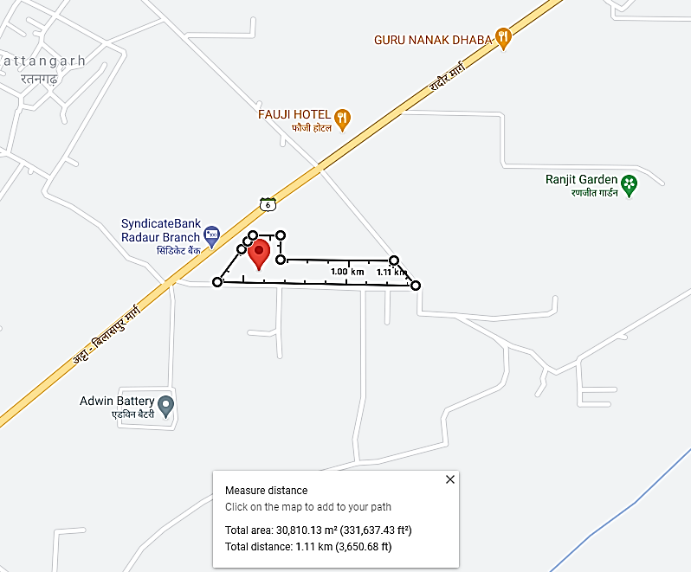

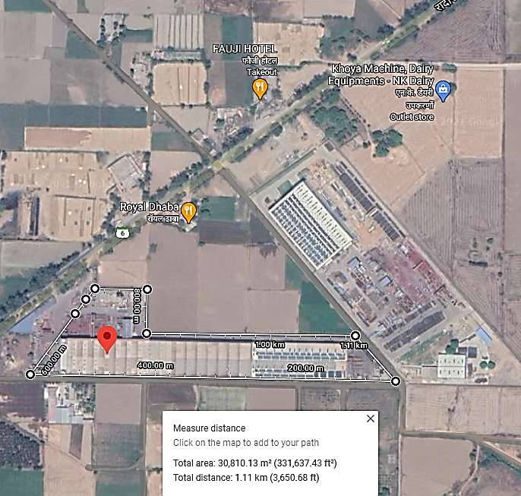

**ENCLOSURE: IV – PHOTOGRAPHS OF THE PROPERTY**

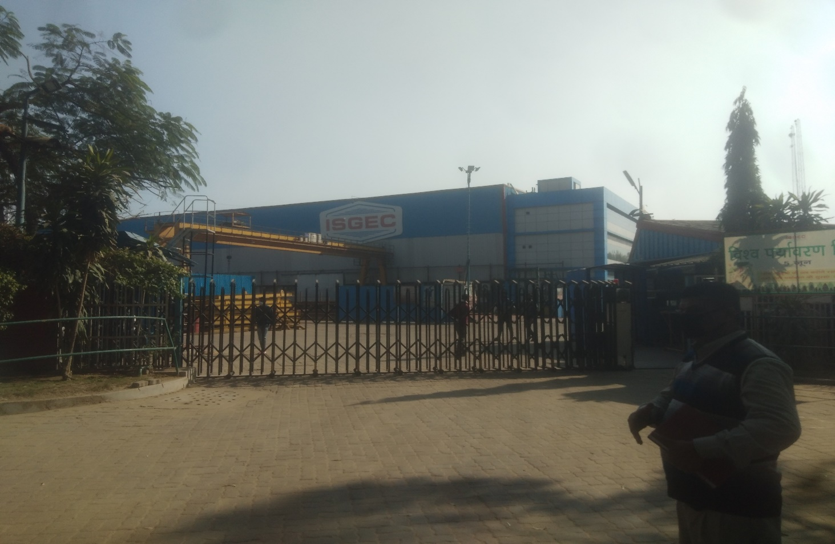

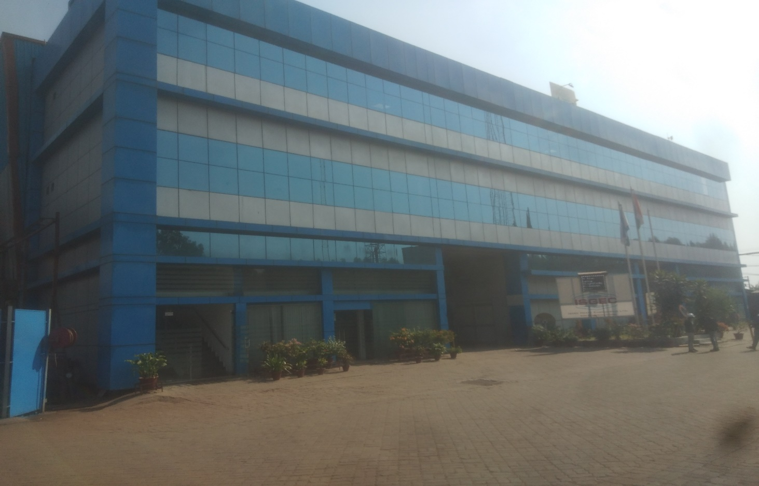

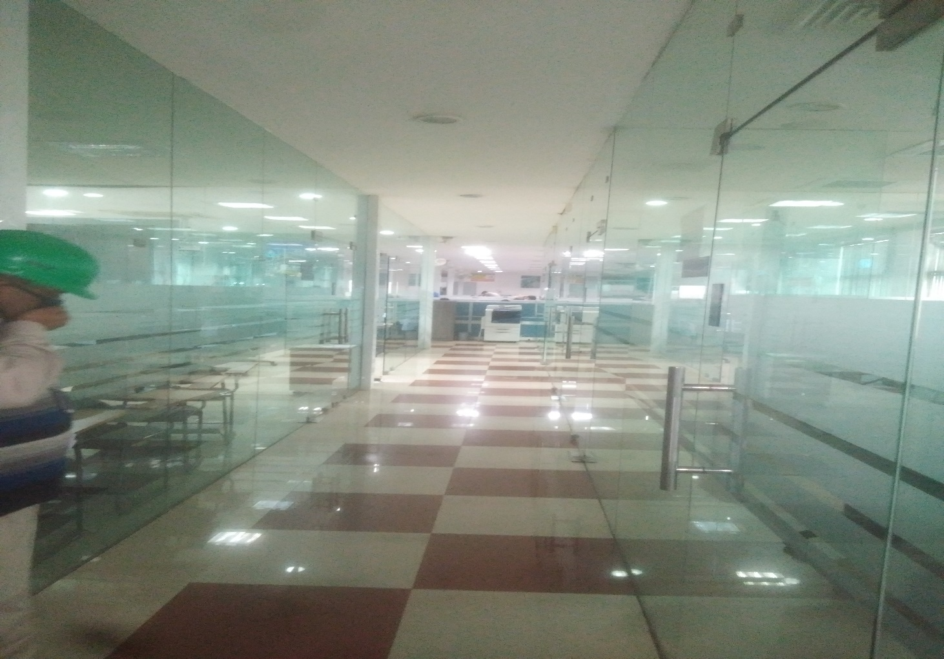

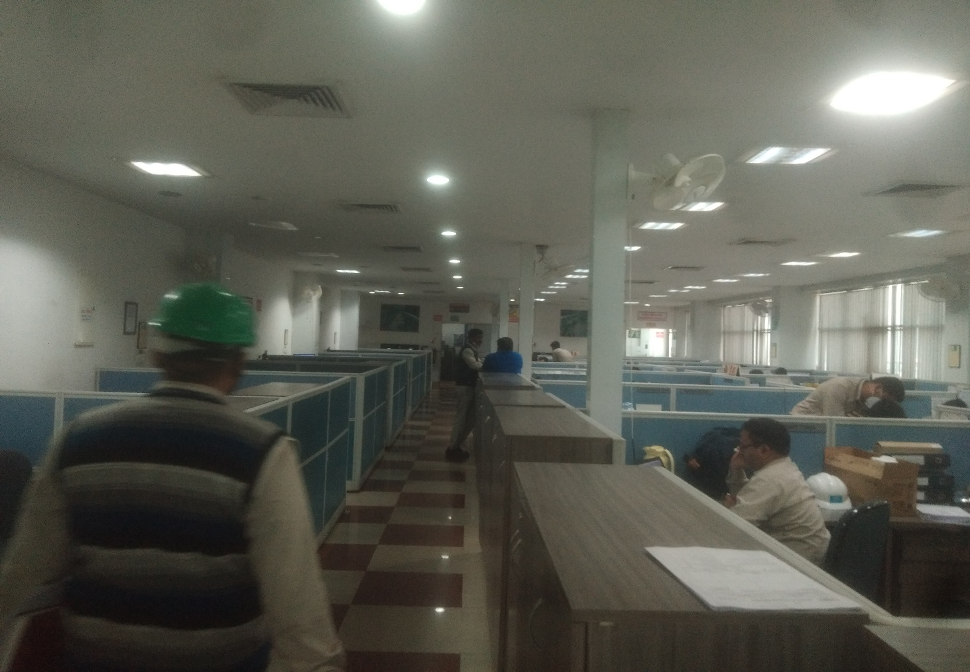

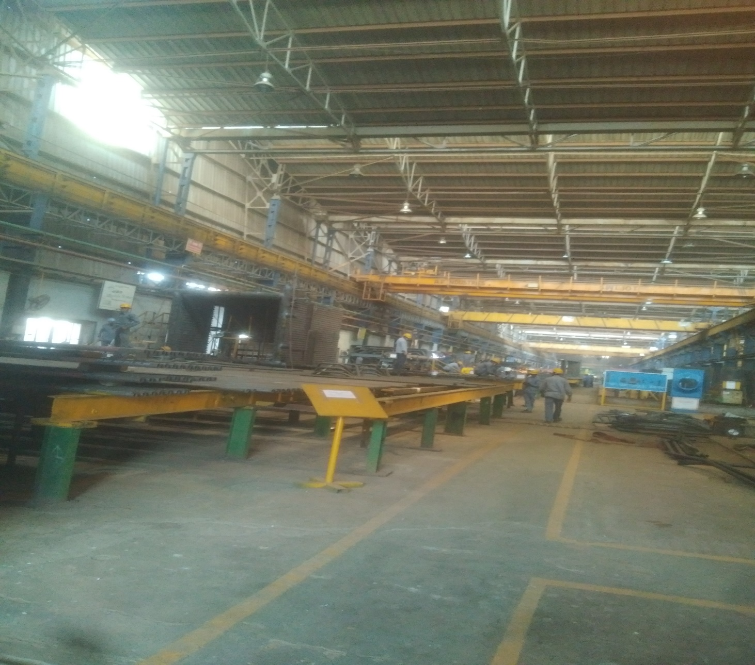

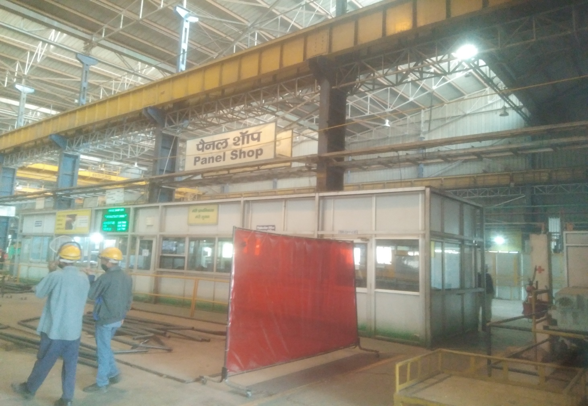

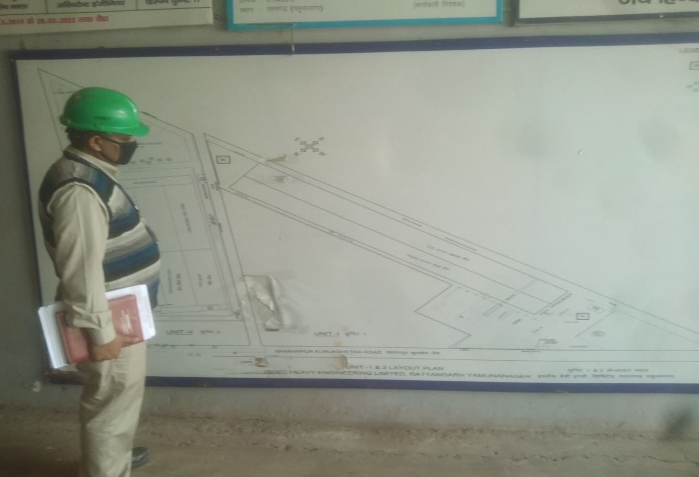

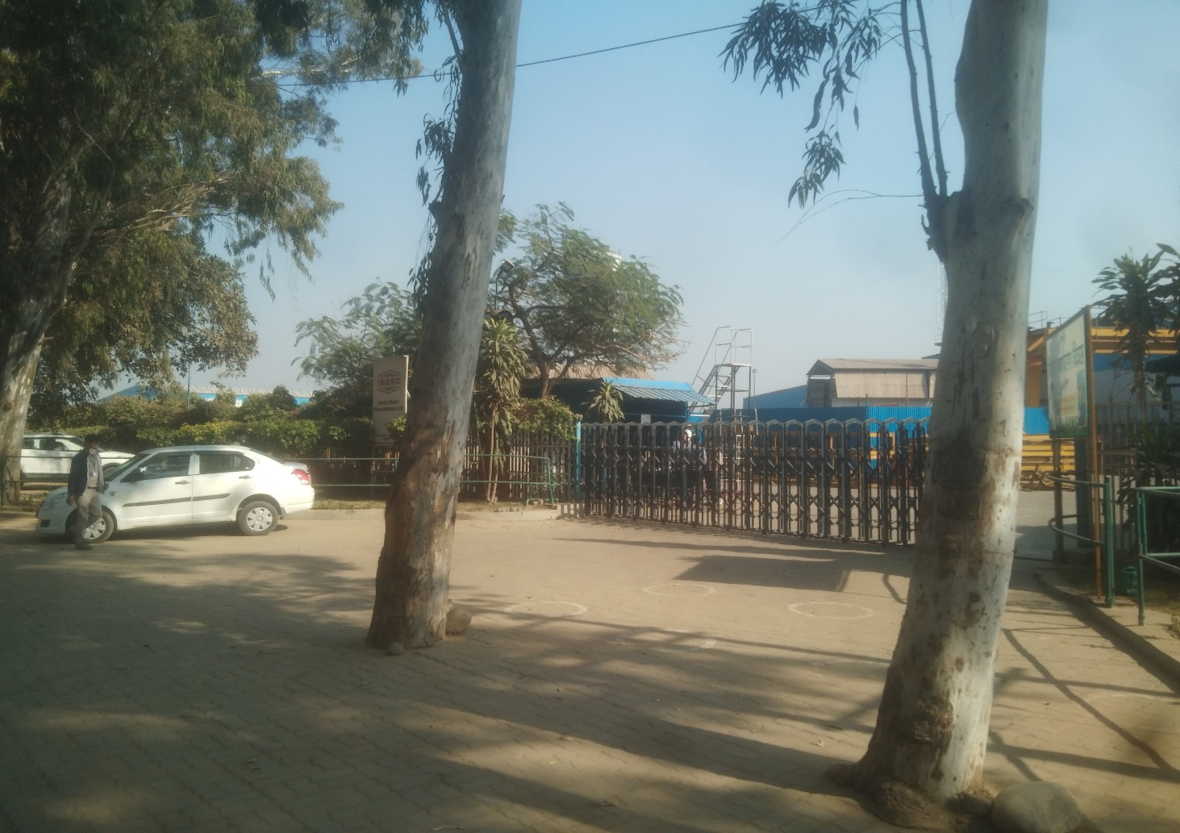

**ENCLOSURE: V– COPY OF CIRCLE RATE**

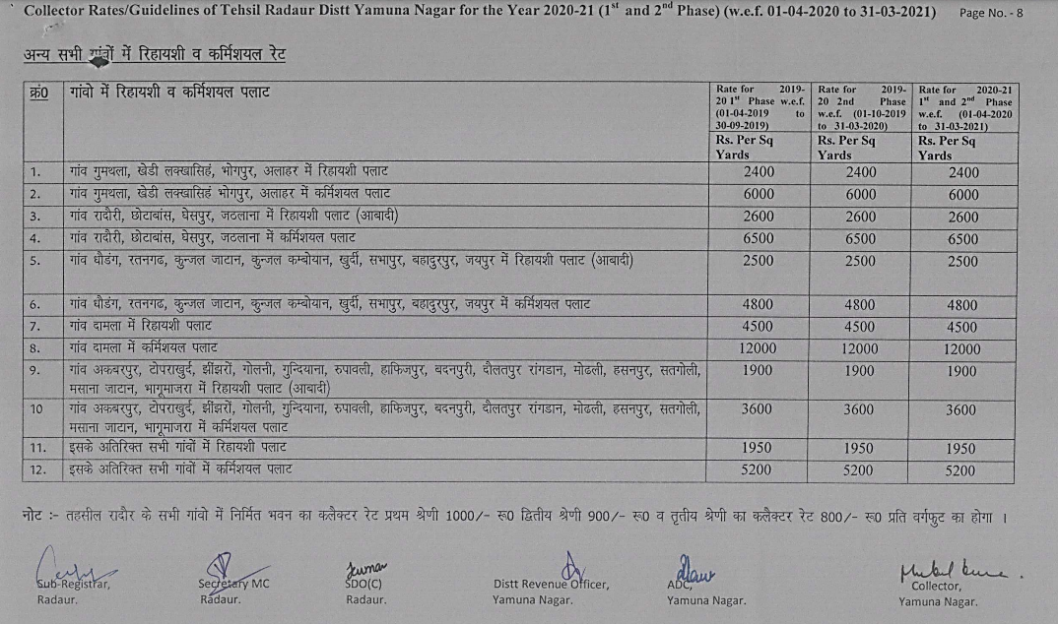

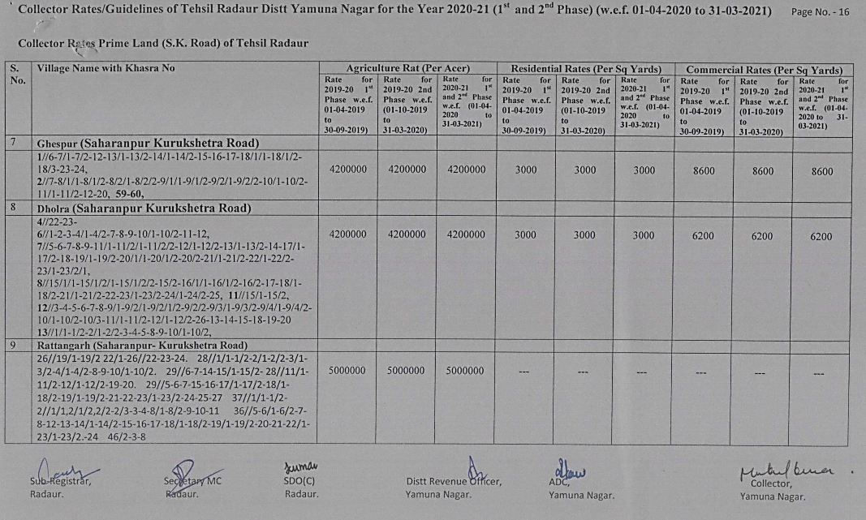

**ENCLOSURE: VI – VALUER’S REMARKS**

|  |  |
| --- | --- |
|  | This Valuation report is prepared based on the copies of the documents/ information which interested organization or customer could provide to us out of the standard checklist of documents sought from them and further based on our assumptions and limiting conditions. All such information provided to us has been relied upon in good faith and we have assumed that it is true and correct. Verification or cross checking of the documents provided to us from the originals has not been done at our end. |
|  | Legal aspects for eg. investigation of title, ownership rights, lien, charge, mortgage, lease, verification of documents, etc. have to be taken care by legal expert/ Advocate and same are not done at our end. It is assumed that the concerned Lender/ Financial Institution has asked for the valuation of that property for which the legal verification has been already taken and cleared by the competent Advocate before requesting for the Valuation report. |
|  | Analysis and conclusions adopted in the report are limited to the reported assumptions, conditions and information came to our knowledge during the course of the work. |
|  | Value varies with the Purpose/ Date/ Condition prevailing in the market. We recommend not to refer the indicative & estimated prospective Value of the asset given in this report if any of these points are different from the one mentioned aforesaid in the Report. We also recommend that the indicative estimated Value in the Valuation Report holds good only upto the period of 3 months from the date of Valuation. |
|  | This report is having limited scope as per its fields & format to provide only the general basic idea of the value of the property prevailing in the market based on the documents/ data/ information provided by the client. The suggested indicative prospective estimated value should be considered only if transaction is happened as free market transaction. |
|  | This Valuation report is prepared based on the facts of the property on the date of the survey. It is a well-known fact that the market value of any asset varies with time & socio-economic conditions prevailing in the country. In future property Market may go down, property conditions may change or may go worse, Property reputation may differ, Property vicinity conditions may go down or become worse, Property market may change due to impact of Govt. policies or effect of World economy, Usability prospects of the property may change, etc. Hence before financing, Banker/ FI should take into consideration all such future risk and should loan conservatively to keep the advanced money safe in case of the downward trend of the property value. |
|  | Valuation of the same asset/ property can fetch different values in different situations. For eg. Valuation of a running/ operational shop/ hotel/ factory will fetch better value and in case of closed shop/ hotel/ factory it will have considerable lower value. Similarly an asset sold directly by an owner in the market will fetch better value and if the same asset/ property is sold by any financer due to encumbrance on it will fetch lower value. Hence before financing, Banker/ FI should take into consideration all such future risks and should loan conservatively to keep the advanced money safe in case of any such situation. |
|  | Getting cizra map or coordination with revenue officers for site identification is not done at our end. |
|  | Valuation is done for the property identified to us by the owner/ owner representative. At our end we have just cross verified the identification of the property with reference to the documents produced for perusal. Method by which identification of the property is carried out is also mentioned in the report clearly. Responsibility of identifying the correct property to the Valuer/ its authorized surveyor is solely of the client/ owner for which Valuation has to be carried out. It is requested from the Bank to cross check from their own records/ information if this is the same property for which Valuation has to be carried out to ensure that owner has not misled the Valuer company or misrepresented the property due to any vested interest. |
|  | In India more than 70% of the geographical area is lying under rural/ remote/ non municipal/ unplanned area where the subject property is surrounded by vacant lands having no physical demarcation or having any display of property survey or municipal number / name plate on the property clearly. Even in old locations of towns, small cities & districts where property number is either not assigned or not displayed on the properties clearly and also due to the presence of multiple/ parallel departments due to which ownership/ rights/ illegal possession/ encroachment issues are rampant across India and due to these limitations at many occasions it becomes tough to identify the property with 100% surety from the available documents, information & site whereabouts and thus chances of error, misrepresentation by the borrower and margin of chances of error always persists in such cases. To avoid any such chances of error it is advised to the Bank to engage municipal/ revenue department officials to get the confirmation of the property to ensure that the property shown to Valuer/ Banker is the same as for which documents are provided. |
|  | If this Valuation Report is prepared for the Flat/ dwelling unit situated in a Group Housing Society or Integrated Township then approvals, maps of the complete group housing society/ township is out of scope of this report and this report will be made for the specific unit based on the assumption that complete Group Housing Society/ Integrated Township must be approved in all respect.. |
|  | Due to fragmented & frequent change in building/ urban planning laws/ guidelines from time to time, different laws/ guidelines between regions/ states and no strict enforceability of Building Bye-Laws in India specially in non-metro and scale b & c cities & Industrial areas, property owners many times extend or make changes in the covered area/ layout from the approved/ applicable limits. There are also situations where properties are decades old when there was no formal Building Bye-Laws applicable when the construction must have been done. Due to such discrete/ unplanned development in many regions sometimes it becomes tough to determine the exact lawful situation on ground for the Valuer. In case nothing specific is noted on the covered built-up area considered in the Valuation Report, the covered area present on the site as per site survey will be considered in the Valuation. |
|  | Valuation is a subjective field and opinion may differ from consultant to consultant. To check the right opinion, it is important to evaluate the methodology adopted and various data point/ information/ factors/ assumption considered by the consultant which became the basis for the Valuation report before reaching to any conclusion. |
|  | Value analysis of any asset cannot be regarded as an exact science and the conclusions arrived at in many cases will, of necessity, be subjective and dependent on the exercise of individual judgment. Given the same set of facts and using the same assumptions, expert opinions may differ due to the number of separate judgment decisions, which have to be made. Therefore, there can be no standard formula to establish an indisputable exchange ratio. In the event of a transaction, the actual transaction value achieved may be higher or lower than our indicative analysis of value depending upon the circumstances of the transaction. The knowledge, negotiability and motivations of the buyers and sellers and the applicability of a discount or premium for control will also affect actual price achieved. Accordingly, our indicative analysis of value will not necessarily be the price at which any agreement proceeds. The final transaction price is something on which the parties themselves have to agree. However our Valuation analysis can definitely help the stakeholders to make them informed and wise decision about the Value of the asset and can help in facilitating the arm’s length transaction. |
|  | This report is prepared on the RKA V-L1 (Basic) Valuation format as per the client requirement and scope of work. This report is having limited scope as per its fields & format to provide only the general estimated & indicative basic idea of the value of the property prevailing in the market based on the information provided by the client. No detailed analysis, audit or verification has been carried out of the subject property. |
|  | This is just an opinion report and doesn’t hold any binding on anyone. It is requested from the concerned Client/ Bank/ Financial Institution which is using this report for mortgaging the property that they should consider all the different associated relevant & related factors & risks before taking any business decision based on the content of this report. |
|  | All Pages of the report including annexures are signed and stamped from our office. In case any paper in the report is without stamp & signature then this should not be considered a valid paper issued from this office. |
|  | Defect Liability Period is **30 DAYS**. We request the concerned authorized reader of this report to check the contents, data and calculations in the report within this period and intimate us in writing if any corrections are required or in case of any other concern with the contents or opinion mentioned in the report. Corrections only related to typographical, calculation, spelling mistakes will be entertained within the defect liability period. No request for any illegitimate value revision, date change or any other change will be entertained other than the one mentioned above. |
|  | R.K Associates encourages its customers to give feedback or inform concerns over its services through proper channel at [**valuers@rkassociates.org**](mailto:valuers@rkassociates.org) in writing within 30 days of report delivery. After this period no concern/ complaint/ proceedings in connection with the Valuation Services can be entertained due to possible change in situation and condition of the property. |
|  | Our Data retention policy is of **ONE YEAR**. After this period we remove all the concerned records related to the assignment from our repository. No clarification or query can be answered after this period due to unavailability of the data. |
|  | This Valuation report is governed by our (1) Internal Policies, Processes & Standard Operating Procedures, (2) R.K Associates Quality Policy, (3) Valuation & Survey Best Practices Guidelines formulated by management of R.K Associates, (4) Information input given to us by the customer and (4) Information/ Data/ Facts given to us by our field/ office technical team. Management of R.K Associates never gives acceptance to any unethical or unprofessional practice which may affect fair, correct & impartial assessment and which is against any prevailing law. In case of any indication of any negligence, default, incorrect, misleading, misrepresentation or distortion of facts in the report then it is the responsibility of the user of this report to immediately or atleast within the defect liability period bring all such act into notice of R.K Associates management so that corrective measures can be taken instantly. |
|  | R.K Associates never releases any report doing alterations or modifications by pen. In case any information/ figure of this report is found altered with pen then this report will automatically become null & void. |