**REPORT FORMAT:** CL-1 | Version: 1.0_2018

# FILE No.: VIS(2024-25)-PL767-691-944 Date: 18-02-2025

* ***REPORT* NAME:** *Cost Verification Report for machines which are proposed to be installed at Khasra no 96/2, 99/3 Village Sarai, District: Haridwar, Uttarakhand-249404*
* ***PREPARED FOR ORGANIZATION:*** *State Bank of India, SME Branch, Ranipur, Haridwar, Uttarakhand*
* ***BORROWER COMPANY’S NAME:*** *M/s Well Fine Technology Pvt Ltd.*
* ***ASSET TYPE****: Machineries for PET bottles manufacturing and Pet Bottle Water filling, and labelling of Pet bottles*
* ***CURRENT LOCATION OF THE MACHINES****: Proposed to be installed at Khasra no 96/2, 99/3 Village Sarai, District: Haridwar, Uttarakhand-249404.*

**TO WHOM IT MAY CONCERN**

|  |  |  |
| --- | --- | --- |
| **S. NO.** | **PARTICULARS** | **DESCRIPTION** |
| 1. | Date of Survey | Not Applicable |
| 2. | Date of Report | 18-02-2025 |
| 3. | Documents provided for perusal | Quotations of the machines |
| 4. | Current Location of the Machines | Khasra no 96/2, 99/3 Village Sarai, District: Haridwar, Uttarakhand-249404 |
| 5. | Borrowing Company | M/s Well Fine Technology Pvt Ltd. |
| 6. | Type of Asset | Pet bottle manufacturing and water filling machines. |
| 7. | Type of Assessment | Cost Verification |
| 8. | Scope of Assessment | Cost Verification of the new equipment which are proposed to be purchased and installed by the company |
| 9. | Year of Manufacturing | Yet to be purchased |
| 10. | Total Project Cost | **Rs. 80,60,129 /-** (*Total project cost includes only the purchase cost as per the quotations / invoices / purchase orders provided by the company)*. ***Excluding G.S.T.*** |
| 11. | Current Estimated Market Value | The range of current market rates of such type of machinery & equipment is verified from various suppliers and also from the public domain for the new machinery and equipment’s.  As per quotes received from market and online references, we are of the view that rate range for establishing the machinery of similar kind of machinery are available around **Rs. 90 Lakhs to Rs. 110 Lakhs**  According to our observation, the rate as per the list of machinery and their total purchase price provided to us by the company/ bank are quite reasonable when compared to the rates of similar machines currently prevailing in the market. |
| 12. | Condition of Machines | The machines are yet to be purchased / installed. |

**OBSERVATIONS:**

1. We have been provided with the copy of quotation mentioning cost of machines/ equipment by the borrower company.
2. As per the information provided by the company officials these machines are proposed to be installed at *Khasra no 96/2, 99/3 Village Sarai, District: Haridwar, Uttarakhand-249404.*
3. We have contacted several suppliers for similar items and also did research on the public domain. Accordingly, we have got the quotation from the suppliers and found that the price given in the list of quotations provided to us is well within the price range of similar items available in the market and seems to be reasonable.
4. In this report, there can be some difference in the cost of some of the machines due to the cost of some of the auxiliary equipment and accessories.
5. Also, the installation cost of any equipment like labour cost varies according to the scope of work and it is not possible to calculate exact amount for any fabrication work. So, we have considered the same as mentioned in the quotations provided by the company.
6. Based on the information provided by the company (M/s. Maruti Machines Pvt Ltd.) and enquiries made by us in the open market and references found on the public domain for similar machines/equipment, it is certified that the total market cost for the procurement of similar type of machines of similar specifications should be around **Rs. 90 Lakhs to Rs. 1.10 crore** and therefore the total purchase price of **Rs. 80,60,129/- (Excl. GST)** (as per the quotations provided to us by the company) appears to be little bit on the lower side as compared to the quotations provided to us from other suppliers/ manufactures.

***Disclaimer:***

* 1. *We can’t comment about the current status of machines whether these are purchased, installed or in transit. This cost vetting is done only on the basis of quotations provided to us by the company and we don’t recommend any sort of recommendation in our Report.*
  2. *The estimated cost verification of item to item can’t exactly match as per our vetting due to several market consideration. In some of the items it is lower while in some of the item’s price comes to be higher but on an average the price as per list provided to us falls in the range as confirmed by us.*
  3. *There can be variation in the estimated price if the specification & make of any items procured is different from the list provided to us during assessment.*
  4. *The estimated cost verification is made based on the third-party information which has been replied upon in good faith.*
  5. *The estimated price may vary at the time of actual procurement because of change in prices in the market for such kind of machinery/items for which we will not have any control. The cost vetting is only limited to the date of Report issued. We do not assume any responsibility in change of prices of the said machinery/items after this date.*
  6. *This report doesn’t include any work related to drawing, design, sketch plan, procurement of the machines.*
  7. *Ownership and other legal point of view in respect of the asset is not considered in this report as same is out of scope of this report.*
  8. *This report is made at the request of the Bank.*

**For R.K Associates Valuers** **& Techno** **FOR INTERNAL USE Engineering Consultants (P) Ltd. *TYPED BY: Anuj Sharma*** ***REVIEWED BY: Abhinav Chaturvedi***

# ANNEXURE: - I (COMPARISON LIST)

| **Well Fine Technology** | | | | | | | |
| --- | --- | --- | --- | --- | --- | --- | --- |
| **Sl. No.** | **Machine Name** | **Details** | **KW** | **Capacity** | **Qty.** | **Cost as per Client** | **RKA Working** |
| 1 | Fully Automatic Pet Blowing Machine | 1 litre, 4 cavity with autoloader, without online system, 50 ml to 1000 ml-3200-3500 BPH | - | - | 1 | 19,50,000 | 48,50,000 |
|
| 2 | High Pressure Air Compressor | 18.60 KW | - | - | 1 | 4,00,000 |
| 3 | Screw Air Compressor | 11.20 KW | - | - |  | 3,40,000 |
| 4 | Water Chiller | 5 TR | - | - |  | 3,00,000 |
| 5 | Air Dryer | - | - | - | 2 | 2,00,000 |
| 6 | Inline Pre Filter and After Filter | - | - | - | 2 | 24,000 |
| 7 | High Pressure Inline filter, after filter and carbon filter | - | - | - | 3 | 36,000 |
| 8 | Mould | 200 ml 4 cavity | - | - | 1 | 40,000 | 95,000 |
| 9 | Mould | 500 ml 4 cavity | - | - | 1 | 45,000 | 1,33,800 |
| 10 | Mould | 1 ltr 4 cavity | - | - | 1 | 55,000 | 1,87,800 |
| 11 | Water processing | FRP RO complete with high pressure pump, vessel, vesssel, hydonatic membrane, control panel, Ip, hp, switch, pressure kauge | 3 Kw | 5000 ltr | 1 | 5,00,000 | 12,29,000 |
| 12 | 1 litre Mineral water machine (60 BPM) for 1 ltr | Automatic Rinsing/Filling/ Capping (Trio-block) Machine, for mineral water & sport cap capper model 12x12x4 Full Neck Holding filling for 200 ml upto 1000 ml | - | 3600 BPH | 1 | 11,00,000 | 12,50,000 |
| Accessories | 1.5 mt Air conveyor system | 1.5 | 3600 BPH | 1 set |
| 5 mtr Inter mediate bottle conveyor system, single track | 1 | 3600 BPH | 1 lot |
| 1 no. filled bottle inspection |  | 3600 BPH | 1 set |
| Bottle label shrink machine |  | 3600 BPH | 1 set |
| 13 | Water Storage tank | - | 1 set | 5000 ltr | 1 set | 8,00,000 | 1,40,000 |
| 14 | Automatic web sealer with shrink | - | - | - |  | 6,00,000 | - |
| 15 | Automatic BOPP Hot Melt Pet Bottle Labelling Machine (1 Ltr), With bottle conveyor | - | - | - | 1 | 14,00,000 | 24,50,000 |
| 16 | Change part (500 ml) Star, Guide, Label Drum | - | - | - | 1 | 50,000 | 1,50,000 |
| 17 | Change part (200 ml) Star, Guide, Label Drum | - | - | - | 1 | 50,000 |
| 18 | Domino make Ax 130i Standard with all accessories | - | - | - |  | 1,70,129 | 1,94,748 |
| **Total Cost (Rs.)** | | | | | | **80,60,129** | **1,06,80,348** |

# ANNEXURE:- II (QUOTATIONS/ REFERENCES FROM MARKET)

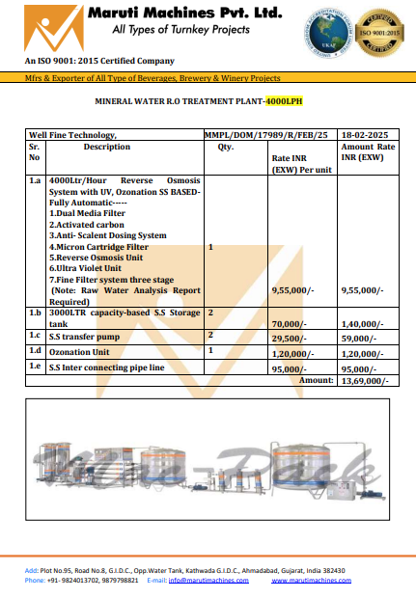

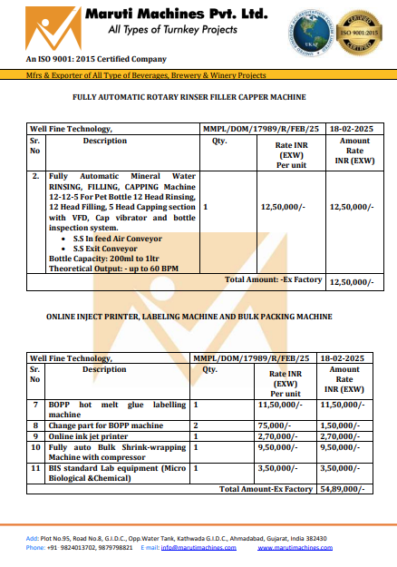

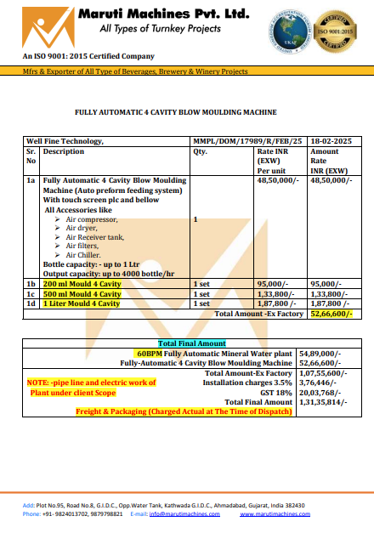

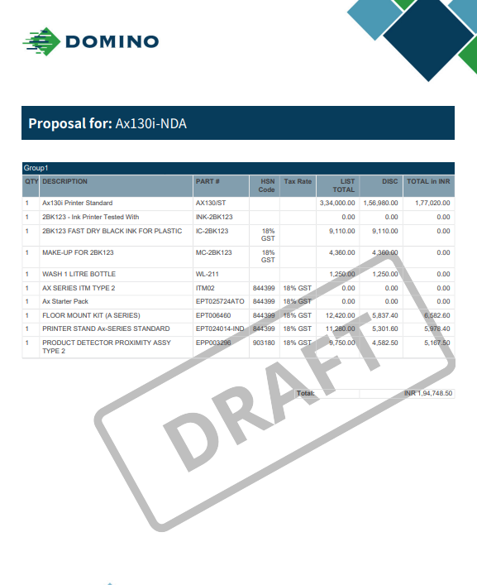

# ANNEXURE: - III (DOCUMENTS PROVIDED BY CLIENT)

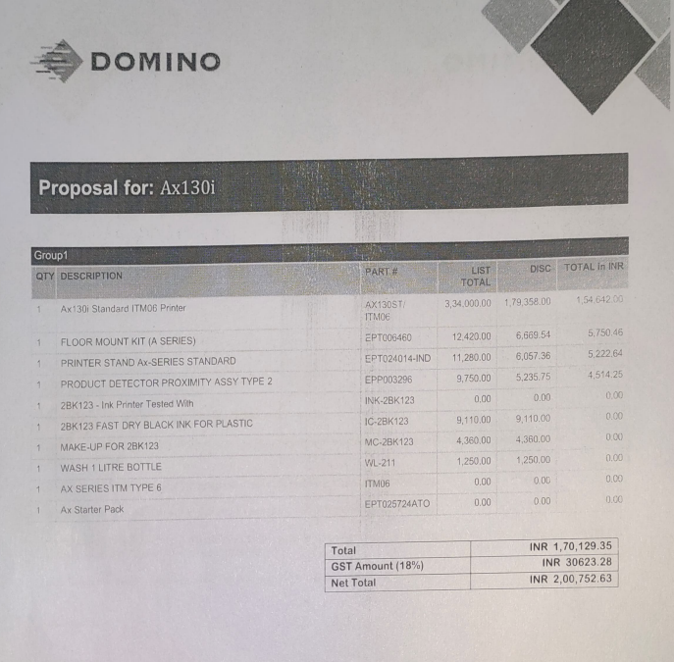

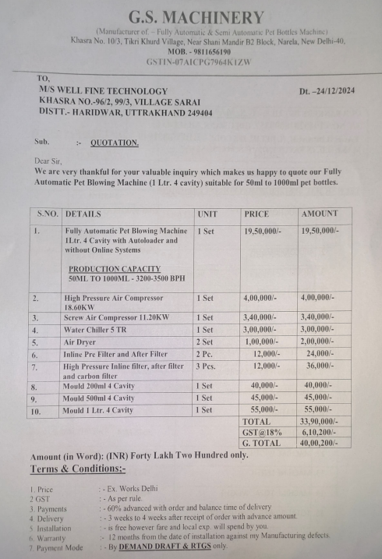

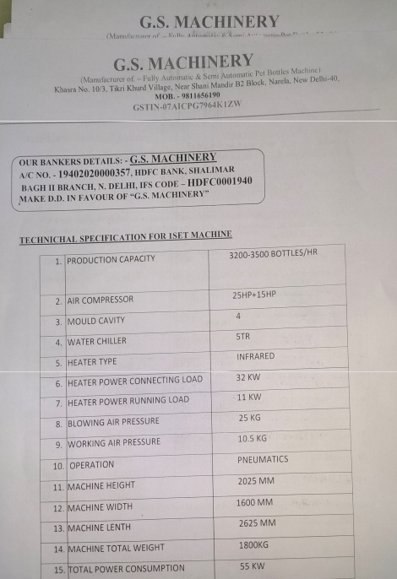

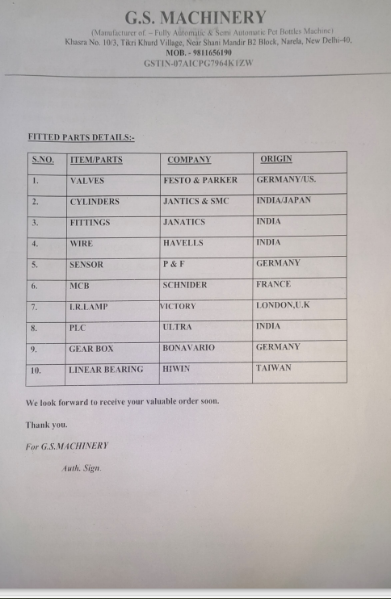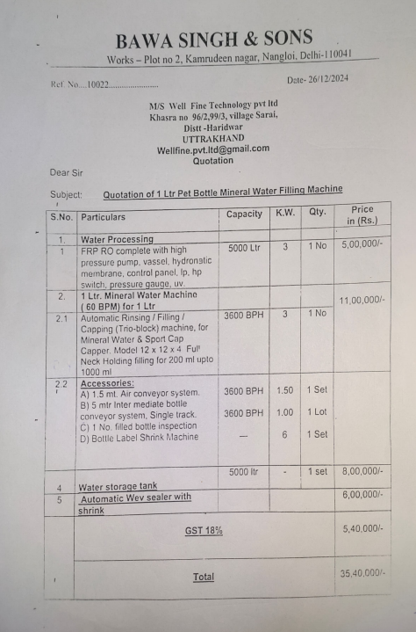

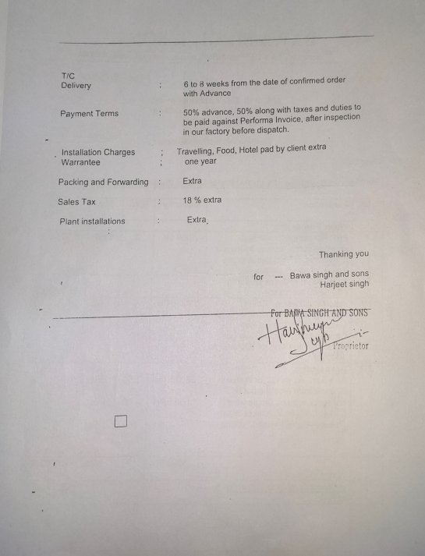

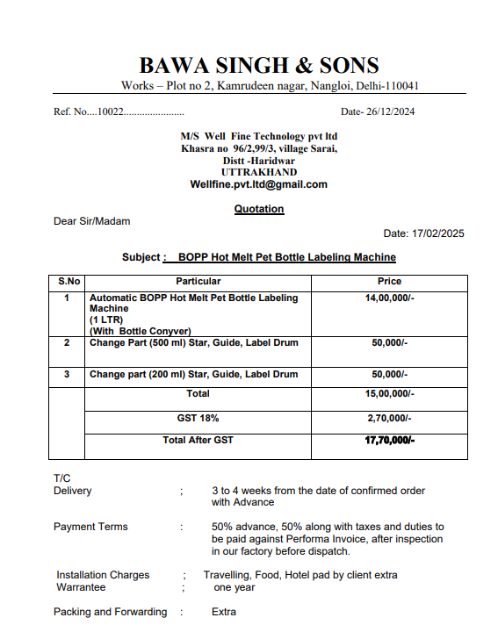

**Online References:**

