REPORT FORMAT: V-L4 (RKA - Medium) | Version: 11.0_2022

CASE NO.: VIS (2024-25)-PL770-694-948 DATED: 19/02/2025

VALUATION REPORT

OF

NATURE OF ASSETS | PLANT & MACHINERY
CATEGORY OF ASSETS | INDUSTRIAL
TYPE OF ASSETS | INDUSTRIAL PLANT & MACHINERY

SITUATED AT
PLOT NO- 3, SECTOR-8A, IIE, SIDCUL, HARIDWAR, UTTARAKHAND

REPORT PREPARED FOR
M/S AGRIBOARD INDUSTRIES LLP

**Important - In case of any query/ issue/ concern or escalation you may please contact Incident Manager @ valuers@rkassociates.org. We will appreciate your feedback in order to improve our services.
NOTE: As per IBA Guidelines please provide your feedback on the report within 15 days of its submission after which report will be considered to be accepted & correct.
Valuation Terms of Services & Valuer’s Important Remarks are available at www.rkassociates.org for reference.

PART A | SNAPSHOT OF THE ASSET/ PROPERTY UNDER VALUATION
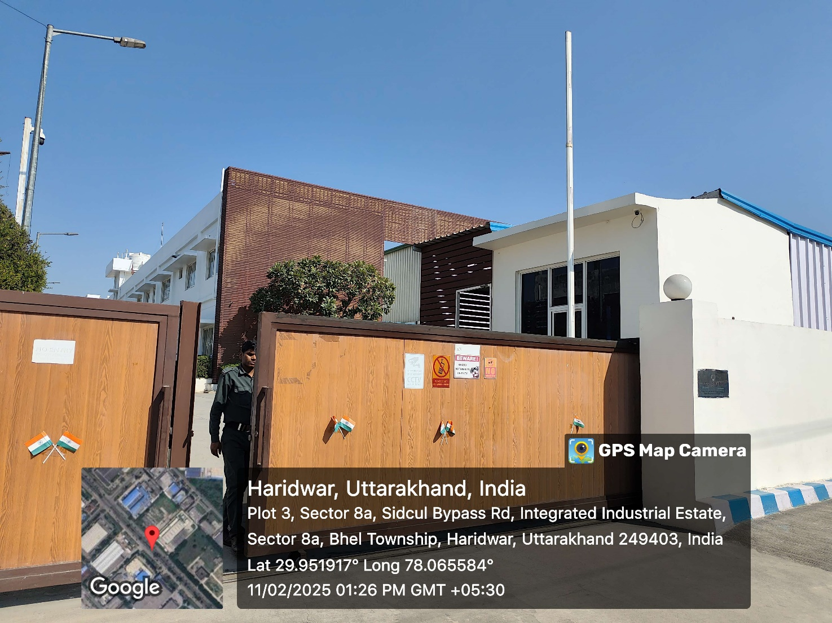
SITUATED AT
PLOT NO- 3, SECTOR-8A, IIE, SIDCUL, HARIDWAR, UTTARAKHAND

PART B | SUMMARY OF THE VALUATION REPORT

S.NO. | CONTENTS | DESCRIPTION
 | GENERAL DETAILS
 | Report prepared for | M/s Agriboard Industries LLP
 | Work Order No. & Date | Via e-mail dated 11-02-2025
 | Name of Borrower unit | M/s Agriboard Industries LLP
 | Name of Property Owner | M/s Agriboard Industries LLP (As per Invoices provided to us)
 | Address & Phone Number of the owner | Plot No- 3, Sector-8A, IIE, SIDCUL, Haridwar, Uttarakhand
 | Type of the Assets | Industrial Plant & Machinery
 | Type of Valuation Report | Industrial Plant & Machinery
 | Report Type | Plain Asset Valuation
 | Date of Inspection of the Property | 11 February 2025
 | Date of Valuation Assessment | 19 February 2025
 | Date of Valuation Report | 19 February 2025
 | Property Shown By | Name |  | Relationship with Owner |  | Contact Number
 |  | Mr. Harsh Sharma |  | Representative |  | +91 80774 55424
 | Purpose of the Valuation | For personal information purpose
 | Scope of the Report | Non binding opinion on the assessment of Plain Physical Asset Valuation of the property identified to us by bank's representative.
 | Out-of-Scope of Report | - Verification of authenticity of documents from originals or cross checking from any Govt. deptt. is not done at our end.  - Legal aspects & rights of the Plant & Machinery are out-of-scope of this report.  - Inventorization of Asset is out of scope of work.  - Componentization of Plant & Machinery is out of scope of this report.  - Verification and Ownership of the land on which assets are situated is out of scope.  - Identification of the Plant & Machinery Improvements is only limited to cross verification of major items.  - Technical/ mechanical/ operational testing of the Plant & Machinery is out-of-scope of the report.  - Comment/ determination on technological aspect is out of scope of this report.  - Any kind of process design is out of scope of the report.
 | Documents provided for perusal | Documents Requested |  | Documents Provided | Documents Reference No.
 |  | Total 04 Documents requested. |  | Total 01 Document provided. | Total 01 Document provided.
 |  | Copy of FAR |  | None | ---
 |  | Capacity Utilization |  | None | ---
 |  | Copy of Invoices |  | Copy of Invoices | Refer to the invoices attached below
 |  | Last paid Electricity Bill |  | None | ---
 | Identification of the property |  | Cross checked from the name of items mentioned in the machine list.
 |  |  | Identified by the company’s representative

 | VALUATION SUMMARY
 | Total Prospective Fair Market Value | Rs.3,06,00,000/-
 | Total Expected Realizable/ Fetch Value | Rs.2,60,10,000/-
 | Total Expected Distress/ Forced Sale Value | Rs.2,29,50,000/-

 | ENCLOSURES
 | Part A | Snapshot of The Asset/ Property Under Valuation
 | Part B | Summary of the Valuation Report
 | Part C | Characteristics Description of The Asset
 | Part D | Characteristics Description of Plant/ Machinery
 | Part E | Procedure Of Valuation Assessment
 | Enclosure-I | Google Map Location
 | Enclosure-II | Photographs of the Assets
 | Enclosure-III | Important Documents
 | Enclosure-IV | Annexure: Declaration-Cum-Undertaking
 | Enclosure-V | Annexure: Model Code of Conduct for Valuers
 | Enclosure-VI | Valuer’s Important Remarks

PART C | CHARACTERISTICS DESCRIPTION OF THE ASSET

 | BRIEF DESCRIPTION OF THE PROPERTY/ASSETS UNDER VALUATION
This valuation report is prepared for the Plant & Machinery and other miscellaneous assets of M/s Agriboard Industries LLP situated at the aforesaid address having total Invoice Value of Rs. 6,32,20,651/-. These machines/assets were purchased from in between year 2017 to 2021.
We are unable to tally the figures of Gross block and net block as we have not been provided with audited financials / last audited balance sheet from company’s end. The subject plant is in manufacturing of Plyboard. The plant was commissioned in year 2018. As per information provided during site survey, the plant was not operational from the last 3-4 months.
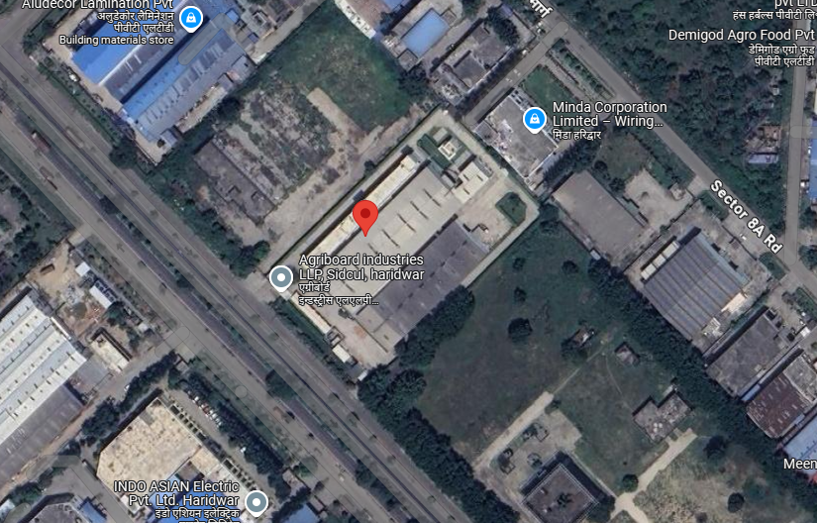
Screenshot of the Google satellite view of the subject location
As per information shared during site survey, the plant was commissioned by M/s Agriboard Industries LLP in 2018 and was into of manufacturing of Plyboards. The plant has different machines. however, a list of the same has been attached below:
Sl. No | Patry Name | Invoice No. | Invoice Date | Description | Quantity | Total Amount  (after GST) (In Rs.)
1 | Prima Automation (India) Pvt. Ltd. | GL / 555 | 20-07-2018 | Cell - 3 (Extruder Chute Feed System and Ovens) | 1 | 1,09,74,000
2 |  | GL / 527 | 18-07-2018 | Control Panel for Agriboard Machine | 1 | 55,46,000
3 |  | GL/552 | 20-07-2018 | FT45- FT style actuator, 4 5" frame, 18 - 18' stroke, 20 - 20mm lead | 5 | 51,33,590
4 |  | GL / 714 | 22-08-2018 | Cell 4 (Paper Application or Board & Tracked Cooling System) | 1 | 42,18,500
5 |  | GL / 771 | 04-09-2018 | Cell - 4B | 1 | 40,71,000
6 |  | GL/552 | 20-07-2018 | Statl current 71 00A, Flated current 55 00 A, Stat torque 66 40 tlm | 3 | 23,97,465
7 |  | GL/552 | 20-07-2018 |  | 3 | 23,97,465
8 |  | GL / 528 | 18-07-2018 | Cell - 2 (Conveyor 2 with steam conditioning box) | 1 | 16,52,000
9 |  | GL / 723 | 24-08-2018 | Additional machine automation with control panels (Hardware + Software + Sensors) | 1 | 15,24,560
10 |  | GL / 723 | 24-08-2018 |  | 1 | 15,24,560
11 |  | GL/551 | 20-07-2018 | Flfe Guides | 2 | 15,22,200
12 |  | GL / 692 | 17-08-2018 | Cell-7 Air Table Assembly and scissor Lift | 1 | 12,80,300
13 | Jyoti Industries | 170 | 25-02-2021 | End Capping Machine | 1 | 12,09,500
14 | Prima Automation (India) Pvt. Ltd. | GL / 553 | 20-07-2018 | Additional items in Cell-3 | 1 | 10,50,200
15 | RV Technoproducts Pvt. Ltd. | RVTPL 2019-20/ 008 | 30-06-2019 | Three Wing Anchor with Disperser 50 Gallons | 1 | 8,26,000
16 |  | RVTPL2019-20/008 | 30-06-2019 |  | 1 | 8,26,000
17 | Techflow Enterprises Pvt. Ltd. | T0241 | 05-08-2020 | Dust Collection System | 1 | 7,43,400
18 | Prima Automation (India) Pvt. Ltd. | GL/717 | 22-08-2018 | Cell 6 (Power Roller , Weghing & Labelling system ) Except printer | 1 | 7,31,600
19 |  | GL/1353 | 18-12-2018 | Pullcord switches, Cables, Cable Trays, Conduits & Endges between cells | 1 | 6,63,337
20 |  | GL / 528 | 18-07-2018 | Cell - 0 (Conveyor - 0) | 1 | 6,49,000
21 | Shakumbari Automobiles (P) Ltd. | 007/VSL/17000603 | 14-12-2017 | Price of one Maruti Dzire VSI-DRR4CD2 | 1 | 6,32,223
22 | RV Technoproducts Pvt. Ltd. | RVTPL 2019-20/ 008 | 30-06-2019 | Semi-Automated Final Product Filling with PLC | 1 | 6,13,600
23 |  | RVTPL2019-20/008 | 30-06-2019 |  | 1 | 6,13,600
24 |  | RVTPL 2019-20/ 008 | 30-06-2019 | Automated Raw material filling sysmt with PLC | 1 | 6,07,700
25 |  | RVTPL2019-20/008 | 30-06-2019 |  | 1 | 6,07,700
26 | Prima Automation (India) Pvt. Ltd. | GL/689 | 17-08-2018 | Ink Jet Printer Model 9030, 20MM Height Barcode Printing capable, Intigration capaable with photo | 1 | 5,92,360
27 |  | GL / 529 | 18-07-2018 | Cell - 1 ( Conveyor 1) | 1 | 5,31,000
28 | Kaeser Compressors | PI1000016690 | 22-10-2018 | Rotary Screw Compressor | 1 | 5,25,100
29 | Fair Energy Solutions | FES/2019-20/002 | 03-04-2019 | Chimney(KG) | 5847 | 5,17,460
30 | Prima Automation (India) Pvt. Ltd. | GL/576 | 18-07-2019 | Cell components pullcord switches cables, cable trays conduits and bridges between cells | 1 | 4,99,972
31 |  | GL/725 | 24-08-2018 | Cell 5 Sxd | 1 | 4,83,800
32 |  | GL/691 | 17-08-2018 | Ear Servo-Non Isolated-250 KVA-Oil Cooled | 1 | 4,83,175
33 |  | GL/552 | 20-07-2018 | Encoder cable , ULICSA SPEEDTECYLE, 100M LENGTH 12 PO CON23 | 5 | 3,89,990
34 |  | GL/552 | 20-07-2018 | Power Cable for Servo Motor ……. .. 10 M Length, 21 sq. mm | 5 | 3,89,990
35 | RWT India Pvt. Ltd. | 18-19/900 | 26-03-2019 | Wate Softening Plant | 1 | 3,54,000
36 | Jyoti Industries | 170 | 25-02-2021 | End Capping Machine | 1 | 2,53,700
37 | Jyoti Industries | 170 | 25-02-2021 | End Capping Machine | 1 | 2,47,800
38 | G E Projects | GEP/18-19/180 | 27-03-2019 | Secondary Pipeling System | 1 | 2,45,865
39 | Prima Automation (India) Pvt. Ltd. | GL/724 | 24-08-2018 | Connector Motor Feedback, D-Shell/ Term Block, 15 Pin, Catalogue no. 2090K6KD15m, Kinetix 6000 Low Profile | 1 | 2,31,280
40 | Ross Boiler | 145 | 21-08-2018 | Pressure Rducing Station | 1 | 3,48,100
41 | G E Projects | GEP/18-19/180 | 27-03-2019 | LPG Vaporiger …….. Kg/HR | 1 | 2,18,300
42 | Prima Automation (India) Pvt. Ltd. | GL/ 1811 | 04-03-2019 | VFD Control Panel 2.2 KW/3 HP | 1 | 2,07,833
43 | Jyoti Industries | 170 | 25-02-2021 | End Capping Machine | 1 | 2,06,500
44 | G E Projects | GEP/18-19/180 | 27-03-2019 | Gas Detection System - 499T Uniphos | 1 | 1,77,000
45 | Prima Automation (India) Pvt. Ltd. | GS/61 | 17-08-2018 | automation control hardware (OEM Product support 24x7x365, 2-3 Total Engineers | 1 | 1,61,223
46 | Technokraft Marketing LLP | 1326/2019-20 | 04-12-2019 | 2H2S433 55 KW 4P B3 BBL Motor , L1912950 | 1 | 1,50,332
47 | Prima Automation (India) Pvt. Ltd. | GL/690 | 17-08-2018 | Ear Servo- 75KVA-Non Isolated Air Cooled | 1 | 1,35,700
48 | Agriboard Industries LLP | 1824 | 19-03-2019 | Box 90 + ratio 60- 90 B S Gear Boxes | 5 | 1,27,735
49 | Prima Automation (India) Pvt. Ltd. | GL / 529 | 18-07-2018 | Control Cabin with Legs & Staircase | 1 | 2,24,200
50 | Dikay -E Services | DES/GST/010 | 13-02-2019 | Economizer at Boiler Exhaust Gas Stream | 1 | 1,05,728
51 | Technokraft Marketing LLP | 124/ 2020-21 | 19-06-2020 | 2H22S433CR 37 KW 4P B3 BBL Motor , L2003565 | 1 | 1,00,772
52 | RV Technoproducts Pvt. Ltd. | RVTPL 2019-20/ 008 | 30-06-2019 | Final Product PVC Bucket | 1 | 94,400
53 |  | RVTPL2019-20/008 | 30-06-2019 | Final Product PVC Bucket | 1 | 94,400
54 | Fair Energy Solutions | FES/2019-20/053 | 22-05-2019 | Piping Material | 1 | 90,186
55 | Prima Automation (India) Pvt. Ltd. | GL/1361 | 09-12-2019 | Cell No.-3 VFD Panel, Qty#13 No. | 1 | 85,550
56 |  | GL/1089 | 27-10-2018 | Fabrication & Painting of Extension frame for cell-3 | 1 | 1,05,610
57 |  | GS/61 | 17-08-2018 | HMI Software Product suport 24x7x365……….810-DC24HMICOM | 1 | 82,600
58 | G E Projects | GEP/18-19/180 | 27-03-2019 | Pressure Reducing Stat…. | 1 | 84,960
59 | Prima Automation (India) Pvt. Ltd. | GL/ 1824 | 07-03-2019 | AC for Cell 3 Panel | 1 | 58,240
60 | G E Projects | GEP/18-19/180 | 27-03-2019 | Lot Manifold-10 Cylinders - 25mm LPG Lot system | 2 | 49,560
61 | G E Projects | GEP/18-19/180 | 27-03-2019 | Yard Piping & Instrument | 1 | 46,775
62 | Agriboard Industries LLP | 1824 | 19-03-2019 | 1.5 KW - 2 HP - 4 P - B 5 AC MOTOR | 5 | 40,710
63 | Prima Automation (India) Pvt. Ltd. | GS/61 | 17-08-2018 | Drives control hardware (OEM) product support 24x7x365, 2-3 total engineers | 1 | 39,554
64 |  | GS/61 | 17-08-2018 | Motion control hardware (OEM) product support 24x7x365, 2-3 total engineers | 1 | 32,422
65 | G E Projects | GEP/18-19/180 | 27-03-2019 | Fire Fighting System | 1 | 30,680
66 | G E Projects | GEP/18-19/180 | 27-03-2019 | Lot Adaptor | 20 | 29,500
67 | Dikay -E Services | DES/GST/010 | 13-02-2019 | Economizer at Thermic Fluid Exhaust Gas Stream | 1 | 79,650
68 | RV Technoproducts Pvt. Ltd. | RVTPL 2019-20/ 008 | 30-06-2019 | Spare Parts | 1 | 17,700
69 | G E Projects | GEP/18-19/180 | 27-03-2019 | Lot Cylinde - …………….. | 20 | 15,340
70 | G E Projects | GEP/18-19/180 | 27-03-2019 | Lot Ball Valve C/M - 15MM | 20 | 14,160
71 | G E Projects | GEP/18-19/180 | 27-03-2019 | Non Return Valve C/M - 20MM | 20 | 12,980
72 | Ross Boiler | 145 | 21-08-2018 | Steam Boiler Model RSR 1000G | 1 | 12,93,280
73 | RV Technoproducts Pvt. Ltd. | RVTPL2019-20/008 | 30-06-2019 | Spare Parts | 1 | 17,700
74 | Ross Boiler | 145 | 21-08-2018 | Thermic Fluid Heater | 1 | 8,80,280
Total |  |  |  |  |  | 6,32,20,651

As per information received during site survey, we came to know the machines non-operational from ~3-4 months. The ownership and the land verification of the location has not been done by us, only the machines included in the Invoices provided to us has been considered for the assessment.

In case of discrepancy in the address mentioned in the property documents and the property shown to us at the site due to change in zoning or administrative level at the site or client misled the valuer by providing the fabricated document, the valuation should be considered of the property shown to us at the site of which the photographs are also attached. Our responsibility will be only related to the valuation of the property shown to us on the site and not regarding matching from the documents or searching the property from our own. Banker to verify from district administration/ tehsil level the identification of the property if it is the same matching with the document pledged.
This report only contains general assessment & opinion on the Guideline Value and the indicative, estimated Market Value of the property found on as-is-where basis on site for which the Bank/ customer has shown & asked us to conduct the Valuation for which photographs is also attached with the report. No legal aspects in terms of ownership or any other legal aspect is taken into consideration. It doesn’t contain any due-diligence other than the valuation assessment of the property shown to us on site. Information/ data/ documents given to us by Bank/ client has been relied upon in good faith. This report doesn’t contain any other recommendations of any sort.
 | LOCATION CHARACTERISTICS OF THE PROPERTY
 | Nearby Landmark | Cello houseware PVT Ltd. Plant
 | Postal Address of the Property | Plot No- 3, Sector-8A, IIE, SIDCUL, Haridwar, Uttarakhand
 | Independent access/ approach to the property | Clear independent access is available
 | Google Map Location of the Property with a neighborhood layout map | Enclosed with the Report
 |  | Coordinates or URL: 29°57'07.7"N 78°03'58.2"E
 | Description of adjoining property | Industrial
 | Plot No/ Survey No. | Plot No - 3
 | Village/ Zone | Sector-8A
 | Sub registrar | Haridwar
 | District | Haridwar
 | City Categorization | Scale-B City |  | Urban developing
 | Characteristics of the locality | Ordinary |  | Within Industrial area
 | Property location classification | Good location within locality | Road Facing |  |  | Near to Highway
 | Property Facing | West Facing
 | Details of the roads abutting the property
 | - Main Road Name & Width | SIDCUL Bypass Road |  |  | Approx. 24 mtr. wide
 | - Front Road Name & width | Sector Road |  |  | Approx. 18 mtr. wide
 | - Type of Approach Road | Bituminous Road
 | - Distance from the Main Road | ~500 mtr
 | Is property clearly demarcated by permanent/ temporary boundary on site | Yes demarcated properly
 | Is the property merged or colluded with any other property | No, it is an independent single bounded property
 |  | ---

PART D | CHARACTERISTICS DESCRIPTION OF PLANT/ MACHINERY

S.NO. |  | CONTENTS | DESCRIPTION
 | TECHNICAL DESCRIPTION OF THE PLANT/ MACHINERY
 | Nature of Plant & Machinery |  |  | Manufacturing of Plyboards
 | Size of the Plant |  |  | - Small scale Plant
 | Type of the Plant |  |  | - Semi Automatic
 | Year of Installation/ Commissioning/ COD (Commercial Operation Date) |  |  | - ~ 2018
 | Production Capacity |  |  | No information provided
 | Capacity at which Plant was running at the time of Survey |  |  | Not operational
 | Number of Production Lines |  |  | 01
 | Condition of Machines |  |  | Good.
 | Status of the Plant |  |  | Non-operational
 | Products Manufactured in this Plant |  |  | Boards
 | Recent maintenance carried out on |  |  | NA, Since plant is not operational.
 | Recent upgradation, improvements if done any |  |  | None
- s | Total Gross Block & Net Block of Assets |  |  | Gross Block |  | Net Block
 |  |  |  | Rs.6,32,20,651/-  (Invoice Value) |  | Not provided in the list
 | Any other Details if any |  |  | The plant was commissioned by M/s Agriboard Industries LLP. in 2018.  The subject plant is into business of manufacturing of Plyboards. The plant has machines such as Control Panel for Agriboard Machine, Cell - 3 (Extruder Chute Feed System and Ovens) and End Capping Machine etc.  As per information received during site survey, we came to know the machines are non-operational from the last 3-4 machines and machines are in average condition. The ownership and the land verification of the location has not been done by us, only the machines included in the inventory provided to us has been considered for the assessment.
 | MANUFACTURING PROCESS
 | Not shared
 | TECHNOLOGY TYPE/ GENERATION USED AND TECHNOLOGICAL COLLABORATIONS IF ANY
 | - Technology Type/ Generation Used in this Plant |  |  |  | ---
 | Technological Collaborations If Any |  |  |  | - No
 | Current Technology used for this Industry in Market |  |  |  | - ---
 | RAW MATERIALS REQUIRED & AVAILABILITY
 | Type of Raw Material |  |  |  | No information provided with us.
 | Availability |  |  |  | NA
 | AVAILABILITY & STATUS OF UTILITIES
 | Power/ Electricity |  |  |  | Available
 | Water |  |  |  | Available
 | Road/ Transport |  |  |  | Available
 | COMMENT ON AVAILABILITY OF LABOUR
 | Availability |  |  |  | Appears to be easily & adequately available.
 | Number of people working in the Factory |  |  |  | None, since plant is not operational.
 | SALES TRANSACTIONAL PROSPECTS OF SUCH PLANTS/ MACHINERY
 | On-going concern basis
 | Reason: This is a Small scale Plant and all are general used machines which can be used in similar industry and cost of dismantling and transporation will not be very high. So, sale of machinery is through strategic sale to the players who are already into same or similar Industry.
 | DEMAND OF SUCH PLANT & MACHINERY IN THE MARKET
 | Appears to be moderate as per general information available in public domain.
 | SURVEY DETAILS
 | Plant has been surveyed by our Engineering Team on dated 11/02/2025.
 | Site inspection was done in the presence of Owner's representative Mr. Harsh Sharma who was available to furnish any specific detail about the Plant & Machinery.
 | Our team examined & verified the machines and utilities from the Invoices provided to us.
 | Plant was found to be non-operational at the time of survey.
 | Condition of the machines is checked through visual observation only. No technical/ mechanical/ operational testing has been carried out to ascertain the condition and efficiency of machines.
 | Site Survey has been carried out on the basis of the physical existence of the assets rather than their technical expediency.
 | As on date of site survey, it was informed that the plant was not operational from 3-4 months. Conditions of all the machines were average.

PART E | PROCEDURE OF VALUATION ASSESSMENT – PLANT & MACHINERY

 | GENERAL INFORMATION
 | Important Dates | Date of Inspection of the Property |  | Date of Valuation Assessment | Date of Valuation Report
 |  | 11 February 2025 |  | 19 February 2025 | 19 February 2025
 | Client | M/s Agriboard Industries LLP
 | Intended User | M/s Agriboard Industries LLP
 | Intended Use | To know the general idea on the market valuation trend of the property as per free market transaction. This report is not intended to cover any other internal mechanism, criteria, and considerations of any organization as per their own need, use & purpose.
 | Purpose of Valuation | For personal information purpose
 | Scope of the Assessment | Non binding opinion on the assessment of Plain Physical Asset Valuation of the property identified to us by bank's representative.
 | Restrictions | This report should not be referred for any other purpose, by any other user and for any other date other then as specified above.
 | Identification of the Assets |  | Cross checked from the name of the machines mentioned in the FAR/ Inventory list name plate displayed on the machine
 |  |  | Identified by the company's representative
 | Type of Survey conducted | Full survey (inside-out with verification & photographs).

 | ASSESSMENT FACTORS
 | Nature of the Valuation | Fixed Assets Valuation
 | Nature/ Category/ Type/ Classification of Asset under Valuation | Nature |  |  | Category |  |  | Type
 |  | PLANT & MACHINERY |  |  | INDUSTRIAL |  |  | INDUSTRIAL PLANT & MACHINERY
 |  | Classification |  |  | Only business use asset
 | Type of Valuation (Basis of Valuation as per IVS) | Primary Basis |  | Fair Market Value
 |  | Secondary Basis |  | On-going concern basis
 | Present market state of the Asset assumed (Premise of Value as per IVS) | Under Normal Marketable State
 |  | Reason: Asset under free market transaction state
 | Physical Infrastructure availability factors of the locality | Water Supply | Sewerage/ Sanitation system |  |  |  | Electricity |  | Road and Public Transport connectivity
 |  | Yes | Underground |  |  |  | Yes |  | Easily available
 |  | Availability of other public utilities nearby |  |  |  |  | Availability of communication facilities
 |  | Transport, Market, Hospital etc. are not available in close vicinity |  |  |  |  | Major Telecommunication Service Provider & ISP connections are available
 | Neighborhood amenities | Good
 | Any New Development in surrounding area | None |  |  |  | ---
 | Any specific advantage/ drawback in the plant and machines | Plant is not operational since last 3-4 months.
 | Machines overall usability/ utility Factor | Normal
 | Best Sale procedure to realize maximum Value (in respect to Present market state or premise of the Asset as per point (iv) above) | Fair Market Value
 |  | Free market transaction at arm's length wherein the parties, after full market survey each acted knowledgeably, prudently and without any compulsion.
 | Hypothetical Sale transaction method assumed for the computation of valuation | Fair Market Value
 |  | Free market transaction at arm's length wherein the parties, after full market survey each acted knowledgeably, prudently and without any compulsion.
 | Approach & Method of Valuation Used | Approach of Valuation |  |  |  |  | Method of Valuation
 |  | Cost Approach |  |  |  |  | Depreciated Replacement Cost Method
 | Type of Source of Information | Level 3 Input (Tertiary)
 | Any other aspect which has relevance on the value or marketability of the machines | The marketability for the machines depends upon the industry outlook, make, market condition, raw material, maintenance, raw material, usability, capacity.  This Valuation report is prepared based on the facts of the assets & market situation on the date of the survey. It is a well-known fact that the market value of any asset varies with time & socio-economic conditions prevailing in the region/ country. In future assets market may go down, asset conditions may change or may go worse, plant vicinity conditions may go down or become worse, plant market may change due to impact of Govt. policies or effect of domestic/ world economy, usability prospects of the Plant may change, etc. Hence before financing, Banker/ FI should take into consideration all such future risk while financing.
 | Basis of computation & working
Main Basis:

- Basic Methodology: For arriving at fair market value of P&M & other fixed assets our engineering team has rationally applied the ‘cost approach (depreciated replacement cost)’. The fair market value of Plant & Machinery on the date of valuation is its cost of reproduction & commissioning on that date less the depreciation & other deterioration deductions (Technological, Economic, Functional obsolescence) or additions for good maintenance from the date of commissioning of the machinery to the date of its valuation.
- Core P&M Asset Valuation is done keeping in mind various factors like technology used, machines availability, its condition, average age, maintenance & service and parts replacement availability of the machines and more importantly demand in the market.
- Main Machinery of this Plant are specific purpose machines.
- No Fixed Asset Register or Inventory sheet has been provided to us. For the date of valuation and purchase cost, Copy of Invoives has been referred, provided to us by the Bank/ client. However, as per scope of work defined by the bank only Plant & Machinery and Other Movable Assets are considered for valuation purpose. However Valuation has been done independently.
- For calculating Replacement Cost of the machines as on date, Whole Sale Price Index (WPI) is used issued by Department Economic Advisor, Govt. of India.
- For evaluating depreciation, Guidelines and Industry & institutional standards are used for ascertaining useful life of different types of machines are followed.
- No further obsolescence/ deterioration or maintenance factor has been applied on the Depreciated Replacement Cost (DRC) since the Depreciated Replacement Cost (DRC) looks to be in line with the estimated Prospective Fair Market Value.
- Underline assumption for the evaluation of this Plant & Machinery is that this complete Plant can be sold as a whole by dismantling it.
- Valuation of the asset is done as found on as-is-where basis on the site as identified to us by client/ owner/ owner representative during site inspection by our engineer/s unless otherwise mentioned in the report.
- The valuation of the Plant/Machinery has been done considering each machines and their auxillary components for small scale plants or limited no. of machines available at the site.
- Consolidated valuation sheet of Plant & Machinery and other asset items are mentioned below with depreciated current market value as per different category of the machines/assets cumulated together. The cost of equipment considered from P&M List doesn't includes Pre-operative, Finance, and IDC Charges etc. The capitalized/ purchase cost of machinery considered from P&M List (Extracted from copy of Invoices provided with us) consists of final commissioning of machines does not includes freight, insurance, etc.
- Machine wise Depreciated Replacement Cost is calculated only for the purpose of calculation and is shown for illustration purpose only. However, this may differ & vary individually in the market and the valuation as a whole to be considered.

Other Basis:

- Analysis and conclusions adopted in the report are limited to the reported assumptions, conditions and information came to our knowledge during the course of the work and based on the Standard Operating Procedures, Best Practices, Caveats, Limitations, Conditions, Remarks, Important Notes, Valuation TOR and definition of different nature of values.
- The indicative value has been suggested based on the prevailing market rates that came to our knowledge during secondary & tertiary market research and is not split into formal & informal payment arrangements. Most of the deals takes place which includes both formal & informal payment components. Deals which take place in complete formal payment component may realize relatively less actual transaction value due to inherent added tax, stamp registration liabilities on the buyer.
- Secondary/ Tertiary costs related to asset transaction like Installation, maintenance and Logistics costs pertaining to the sale/ purchase of the assets are not considered separately while assessing the indicative estimated Market Value and is assumed to be included in the Cost of capitalization provided by the client.
- The condition assessment and the estimation of the residual economic life of the machinery and assets are only based on the visual observations and appearance found during the site survey. We have not carried out any physical tests to assess the working and efficiency of the machines and assets.
- Any kind of unpaid statutory, utilities, lease, interest or any other pecuniary dues on the asset or on its owners has not been factored in the Valuation.
- Valuation is done for the asset found on as-is-where basis which owner/ owner representative/ client/ bank has shown to us on site of which some reference has been taken from the information/ data given in the copy of documents provided to us which have been relied upon in good faith and we have assumed that it to be true and correct.
- This is just the fixed asset valuation of the project based on the cost & market approach methodologies considering the utility of the asset for the business & the company as on-ongoing concern basis. This Valuation shall not be construed as the transactional value of the Project which may be determined through Enterprise/ Business Valuation based on Income approach methodologies
 | ASSUMPTIONS
- Documents/ Information/ Data provided by the client/ property owner or his representative both written & verbally is true and correct without any fabrication and has been relied upon in good faith.
- The assets and interests therein have been valued free and clear of any liens or encumbrances unless stated otherwise. No hidden or apparent conditions regarding the subject assets or their ownership are assumed to exist. No opinion of title is rendered in this report and a good title is assumed unless stated otherwise.
- It is assumed that the concerned Lender/ Financial Institution has asked for the valuation of that property after satisfying the authenticity of the documents given to us and for which the legal verification has been already taken and cleared by the competent Advocate before requesting for the Valuation report. I/ We assume no responsibility for the legal matters including, but not limited to, legal or title concerns.
- Payment condition during transaction in the Valuation has been considered on all cash basis which includes both formal & informal payment components as per market trend.
- Sale transaction method of the asset is assumed as Free market transaction without any compulsion unless otherwise mentioned while assessing Indicative & Estimated Fair Prospective Market Value of the asset unless otherwise stated.
 | SPECIAL ASSUMPTIONS
 | None
 | LIMITATIONS
 | Since the copy of the FAR and the last audited balance sheet was not provided, the valuation assessment has been carried out based on the machine Invoices provided with us.

PLANT & MACHINERY VALUATION SUMMARY
S. No. | Particulars | Invoices Values  (In Rs.) | Gross Current Replacement Cost  (In Rs.) | Estimated Fair Market Value (In Rs.)
1 | Machine Invoices | 6,32,20,651 | 7,41,58,450 | 3,06,05,186
TOTAL |  | 6,32,20,651 | 7,41,58,450 | 3,06,05,186
Notes: -
      - Asset like Plant & Machinery and other related equipment pertaining to M/s Agriboard Industries LLP, Located at Plot No- 3, Sector-8A, IIE, Sidcul, Haridwar, Uttarakhand are considered in this section of valuation report.
      - During the site visit, the machines are non-operational. Our engineering visited the site and manually inspected the machines and equipment on the basis of their physical existence not on the basis technical.
      - For evaluating useful life of assets, chart of Companies Act-2013 and generally accepted market standards are referred in this assessment to reach the final economical life of a particular asset.
      - During the site visit conducted by our engineering team on 11/02/2025, the plant was physically inspected by our team. Different sections set up inside were visually inspected. As per the information available in the public domain, such industries have a useful life of 5-12 years.
      - Rate of Inflation has been assessed with the help of price indices of commodities. Price indices have been referred from the Office of Economic Advisor (Government of India). Further Inflation in respective commodity has been evaluated and applied to the respective capitalization cost to reach its Gross current reproduction Cost and further depreciation in respective commodity has been applied to the respective Gross current reproduction Cost to derive the Fair Market Value.

3. | CONSOLIDATED VALUATION ASSESSMENT OF THE ASSET
S. No. | Particulars | Invoice Value | Indicative & Estimated Prospective Fair Market Value
 | Plant & Machinery and Leasehold Improvements Value | Rs. 6,32,20,651/- | Rs.3,06,05,186/-
 | Additional Premium if any | --- | ---
 | Details/ Justification | --- | ---
 | Deductions charged if any | --- | ---
 | Details/ Justification | --- | ---
 | Total Indicative & Estimated Prospective Fair Market Value | --- | Rs.3,06,05,186/-
 | Rounded Off | --- | Rs.3,06,00,000/-
 | Indicative & Estimated Prospective Fair Market Value in words | --- | Rupees three Crore twenty Lakh Only
 | Expected Realizable Value (@ ~15% less) | --- | Rs.2,60,10,000/-
 | Expected Distress Sale Value (@ ~25% less) | --- | Rs.2,29,50,000/-
 | Percentage difference between Book Value and Fair Market Value | ---
 | Concluding Comments/ Disclosures if any
- We are independent of client/ company and do not have any direct/ indirect interest in the property.
- This valuation has been conducted by R.K Associates Valuers & Techno Engineering Consultants (P) Ltd. and its team of experts.
- This Valuation is done for the property found on as-is-where basis as shown on the site by the Bank/ customer of which photographs is also attached with the report.
- Reference of the property is also taken from the copies of the documents/ information which interested organization or customer could provide to us out of the standard checklist of documents sought from them and further based on our assumptions and limiting conditions. All such information provided to us has been relied upon in good faith and we have assumed that it is true and correct. However, we do not vouch the absolute correctness of the property identification, exact address, physical conditions, etc. based on the documents provided to us since property shown to us may differ on site Vs as mentioned in the documents or incorrect/ fabricated documents may have been provided to us.
- Legal aspects for eg. investigation of title, ownership rights, lien, charge, mortgage, lease, verification of documents from originals or from any Govt. department, etc. has to be taken care by legal experts/ Advocates and same has not been done at our end.
- The valuation of an asset is an estimate of the worth of that asset which is arrived at by the Valuer in his expert opinion after factoring in multiple parameters and externalities. This may not be the actual price of that asset and the market may discover a different price for that asset.
- This report only contains opinion based on technical & market information which came to our knowledge during the course of the assignment. It doesn’t contain any recommendations.
- This report is prepared following our Standard Operating Procedures & Best Practices and will be subject to Limitations, Conditions, Valuer’s Remarks, Important Notes, Valuation TOS and basis of computation & working as described above.
- The use of this report will become valid only after payment of full fees as per the Payment Terms. Using this report or any part content created in this report without payment of charges will be seen as misuse and unauthorized use of the report.
 | IMPORTANT KEY DEFINITIONS
Fair Value suggested by the competent Valuer is that prospective estimated amount in his expert & prudent opinion of the subject asset/ property without any prejudice after he has carefully & exhaustively evaluated the facts & information came in front of him or which he could reasonably collect during the course of the assessment related to the subject asset on an as-is, where-is basis in its existing conditions, with all its existing advantages & disadvantages and its potential possibilities which is just & equitable at which the subject asset/ property should be exchanged between a willing buyer and willing seller at an arm’s length transaction in an open & unrestricted market, in an orderly transaction after proper marketing, wherein the parties, each acted knowledgeably, prudently without any compulsion on the date of the Valuation.
Fair Value without using the term “Market” in it describes that the value suggested by the Valuer may not mandatorily follow or may not be in complete consonance to the established Market in his expert opinion. It may or may not follow market dynamics. But if the suggested value by the valuer is not within the prevailing Market range or is assessed for an asset is located in an un-established Market then the valuer will give reasonable justification & reasoning that for what reasons the value suggested by him doesn’t follow the prevailing market dynamics.
Fair Market Value suggested by the competent Valuer is that prospective estimated amount in his expert & prudent opinion of the subject asset/ property without any prejudice in consonance to the Market dynamics after he has carefully & exhaustively evaluated the facts & information came in front of him or which he could reasonably collect during the course of assessment related to the subject asset on an as-is, where-is basis in its existing conditions, with all its existing advantages & disadvantages and its potential possibilities which is just & equitable at which the subject asset/ property should be exchanged between a willing buyer and willing seller at an arm’s length transaction in an open & unrestricted market, in an orderly transaction after proper marketing, wherein the parties, each acted knowledgeably, prudently without any compulsion on the date of the Valuation.
Here the words “in consonance to the established Market” means that the Valuer will give opinion within the realms & dynamics of the prevailing market rates after exhaustively doing the micro market research. However due to the element of “Fair” in it, valuer will always look for the factors if the value should be better than the market realms which is just & equitable backed by strong justification and reasoning.
Market Value suggested by the competent Valuer is that prospective estimated amount which is average price of the similar comparable assets prevailing in an open & established market during the near period of the date of valuation at which the subject asset/ property should be exchanged between a willing buyer and willing seller on an as-is, where-is basis in its existing conditions, with all its existing advantages & disadvantages and its potential possibilities at an arm’s length transaction in an open, established & unrestricted market, in an orderly transaction, wherein the parties, each acted without any compulsion on the date of the Valuation.
Using the term “Market Value” without “Fair” omits the elements of proper marketing, acting knowledgeably & prudently.
Market and market participants can be sentimental, inclined towards the transaction without the element of complete knowledge & prudence about facts or due diligence of the asset therefore “each acted knowledgeably, prudently” has been removed from the marker Value definition.
 | Realizable Value is that minimum prospective estimated value of the asset/ property which it may be able to fetch at the time of actual property transaction factoring in the element of discount due to the prospects of deep negotiations between the buyer & seller when the parties in-principally find Fair Market Value reasonable and sits together to close the deal and the transaction across the table. Discount percentage on the Fair Market Value due to negotiation will depend on the nature, size, various salability prospects of the subject asset, the needs of the buyer & the seller and kind of payment terms. In some of the cases Realizable and Fair Market Value may also be equal.
 | Distress Sale Value* is that value when the property is attached with any process such as mortgaged financing, financial or operational dues which is under any stress condition or situation and the stakeholders are under process of finding resolution towards it to save the property from being attached to a formal recovery process. In this type of sale, minimum fetch value assessed will always be less than the estimated Fair Market Value where the discount of percentage will depend upon various circumstances and factors such as nature, size, salability prospects of the property and kind of encumbrance on the property. In this type of sale, negotiation power of the buyer is always more than the seller and eagerness & pressure of selling the property will be more on the seller than the buyer.
 | Liquidation Value is the amount that would be realized when an asset or group of assets are sold due to any compulsion or constraints such as in a recovery process guided by statute, law or legal process, clearance sale or any such condition or situation thereof where the pressure of selling the asset/ property is very high to realize whatever maximum amount can be from the sale of the assets in a limited time for clearance of dues or due to closure of business. In other words, this kind of value is also called as forced sale value.
Difference between Cost, Price & Value: Generally, these words are used and understood synonymously. However, in reality each of these has a completely different meaning, premise and also having different definitions in professional & legal terms. Therefore, it is our professional responsibility to describe the definitions of these words to avoid ambiguity & confusion in the minds of the user of this report.
The Cost of an asset represents the actual amount spend in the construction/ actual creation of the asset.
The Price is the amount paid for the procurement of the same asset.
The Value is defined as the present worth of future rights in the property/ asset and is a hypothetical or notional price that buyers and sellers are most likely to conclude for a good or service. Value is not a fact, but an estimate of the likely price to be paid for a good or service at a given time in accordance with a particular definition of value.
Therefore, in actual for the same asset/ property, cost, price & value remain different since these terms have different usage & meaning.
Enclosures with the Report:

- Enclosure: I- Google Map
- Enclosure: II- Photographs of the property
- Enclosure: III- Important documents exhibit
- Enclosure: IV- Valuer’s Important Remarks

IMPORTANT NOTES

DEFECT LIABILITY PERIOD - In case of any query/ issue or escalation you may please contact Incident Manager by writing at valuers@rkassociates.org. We try our level best to ensure maximum accuracy in the Calculations done, Rates adopted and various other data points & information mentioned in the report but still can’t rule out typing, human errors, assessment or any other mistakes. In case you find any mistake, variation, discrepancy or inaccuracy in any data point mentioned in the report, please help us by bringing all such points into our notice in writing at valuers@rkassociates.org within 30 days of the report delivery, to get these rectified timely, failing which R.K Associates shouldn’t be held responsible for any inaccuracy in any manner. Also, if we do not hear back anything from you within 30 days, we will assume that the report is correct in all respect and no further claim of any sort will be entertained thereafter. We would welcome and appreciate your feedback & suggestions in order to improve our services.

Our DATA RETENTION POLICY is of ONE YEAR. After this period we remove all the concerned records related to the assignment from our repository. No clarification or query can be answered after this period due to unavailability of the data.

COPYRIGHT FORMAT - This report is prepared on the copyright format of R.K Associates to serve our clients in the best possible way. Legally no one can copy or distribute this format without prior approval from R.K Associates. It is meant only for the organization as mentioned on the cover page of this report. Distribution or use of this format or any content of this report wholly or partially other than R.K Associates will be seen as unlawful act and necessary legal action can be taken against the defaulters.

IF REPORT IS USED FOR BANK/ FIs
NOTE: As per IBA Guidelines in case the valuation report submitted by the valuer is not in order, the banks / FIs shall bring the same to the notice of the valuer within 15 days of submission for rectification and resubmission. In case no such communication is received, it shall be presumed that the valuation report has been accepted.

At our end we have not verified the authenticity of any documents provided to us. Bank is advised to verify the genuineness of the property documents before taking any credit decision.

Valuation Terms of Services & Valuer’s Important Remarks are available at www.rkassociates.org for reference.

SURVEY ANALYST | VALUATION ENGINEER | L1/ L2 REVIEWER
Deepak Joshi | Nischay Gautam | Abhinav Chaturvedi

ENCLOSURE: I – GOOGLE MAP LOCATION

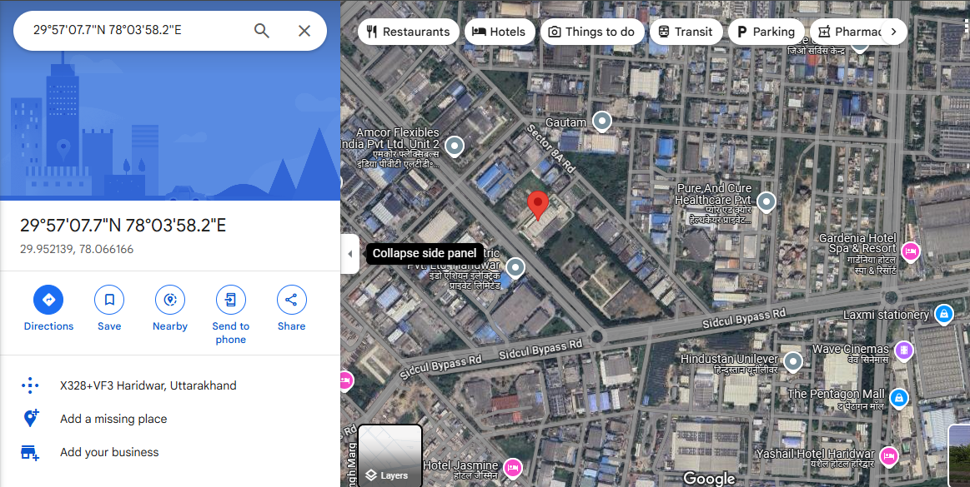
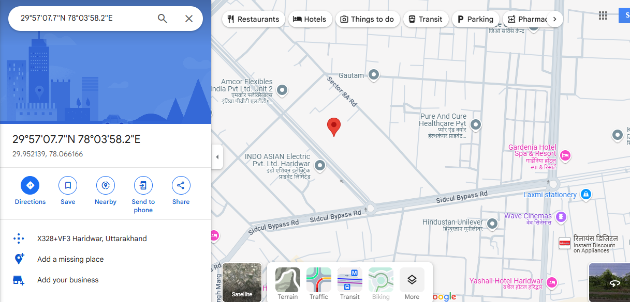

ENCLOSURE: II– PHOTOGRAPHS OF THE PROPERTY

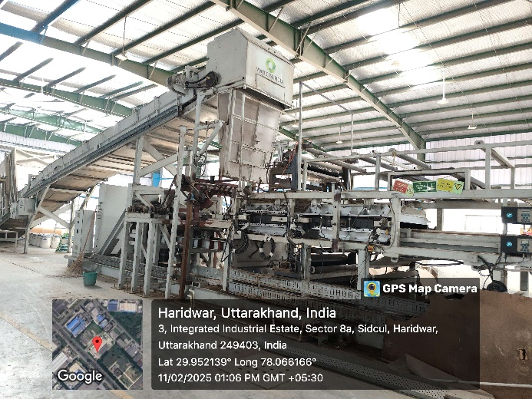 | 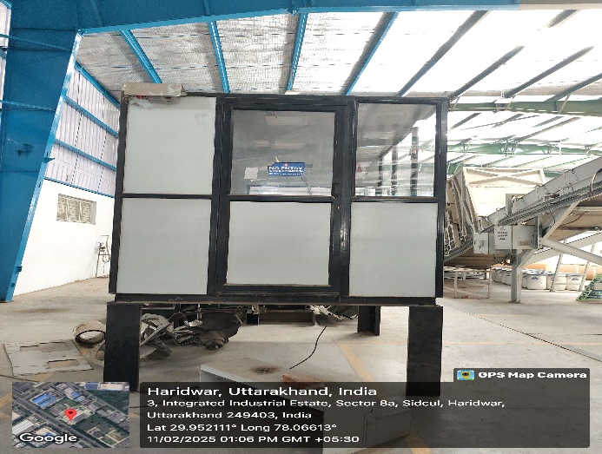
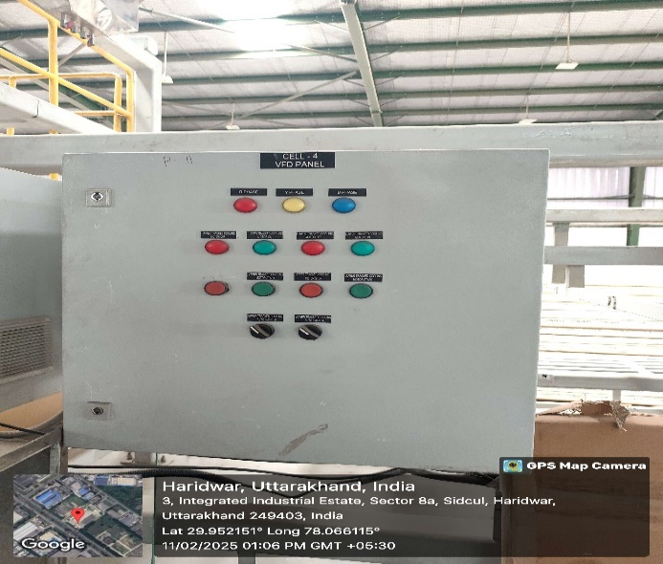 | 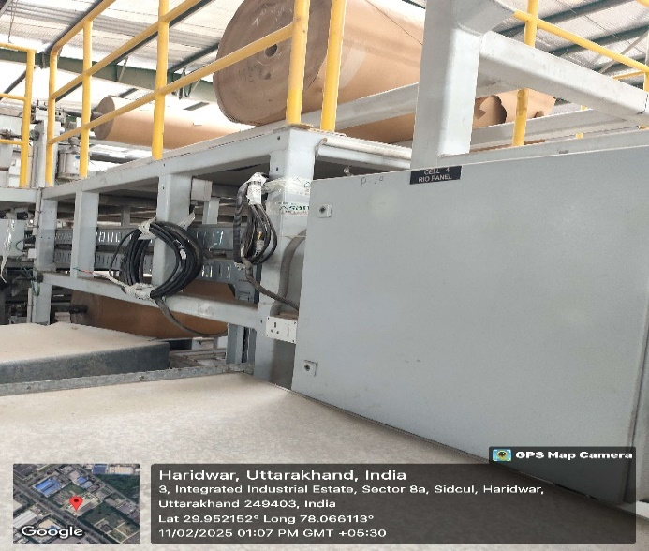
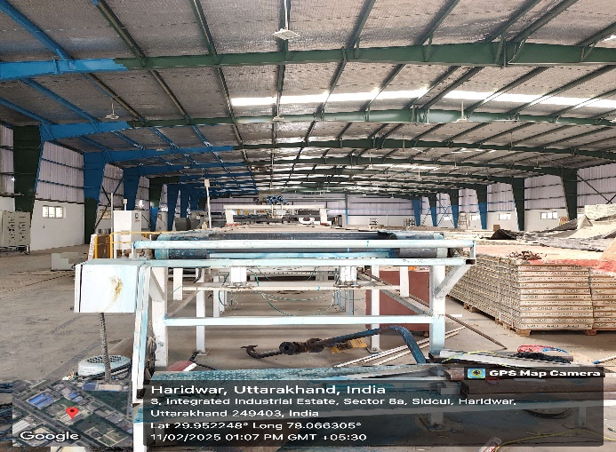 | 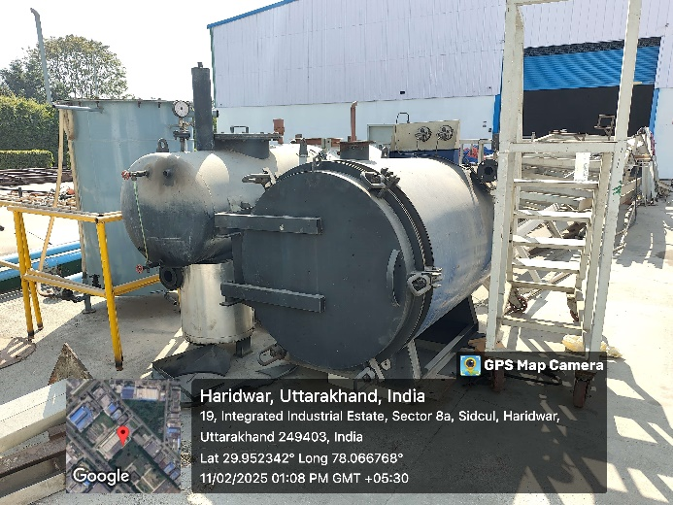
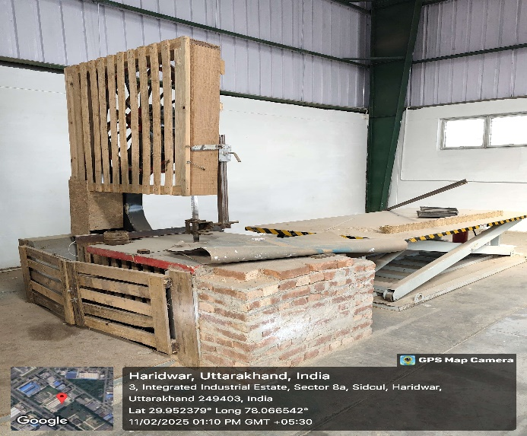 |  | 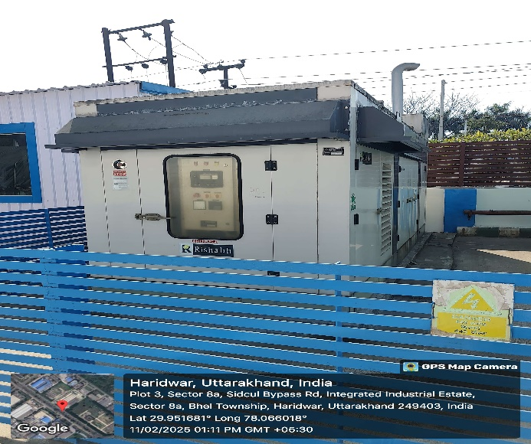
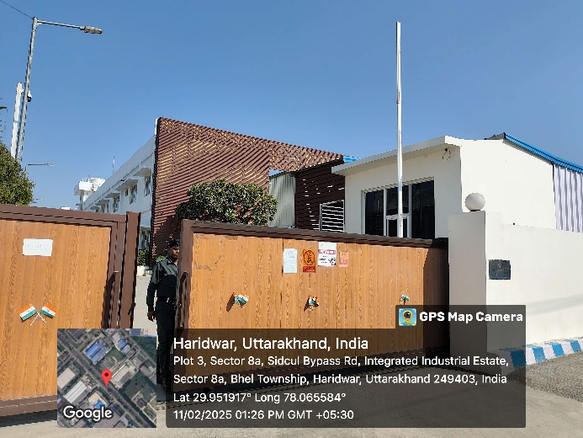 |  | 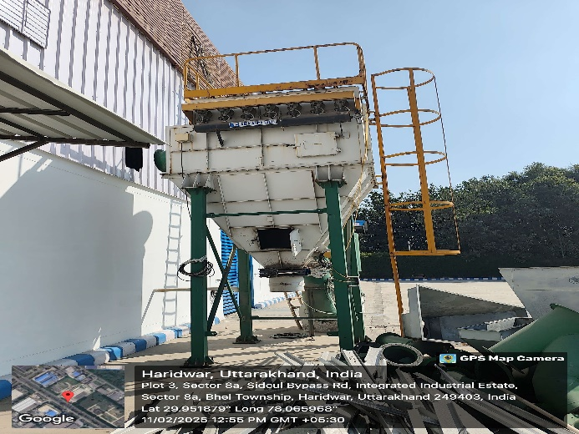
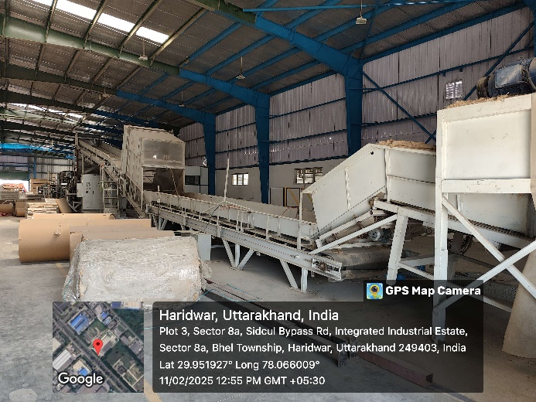 |  | 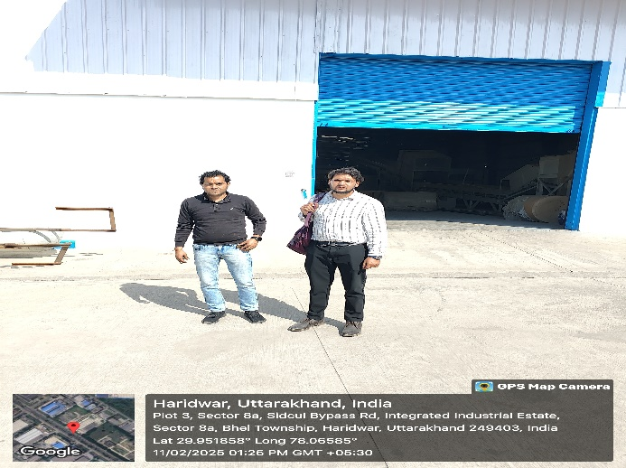

ENCLOSURE: III – IMPORTANT DOCUMENTS

Annexure I
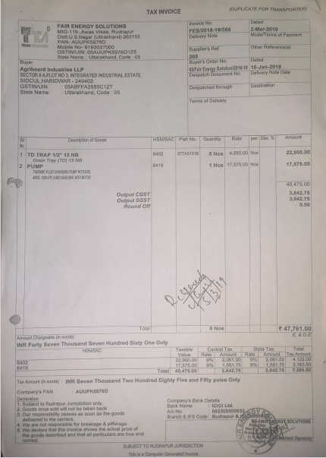

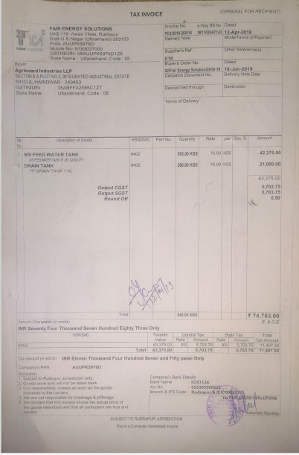

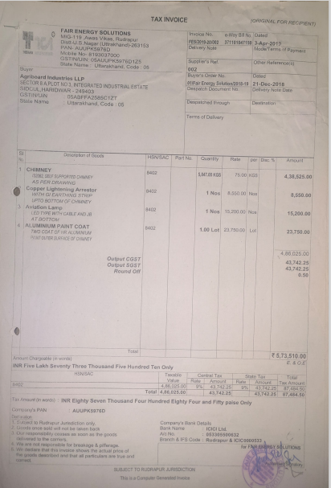

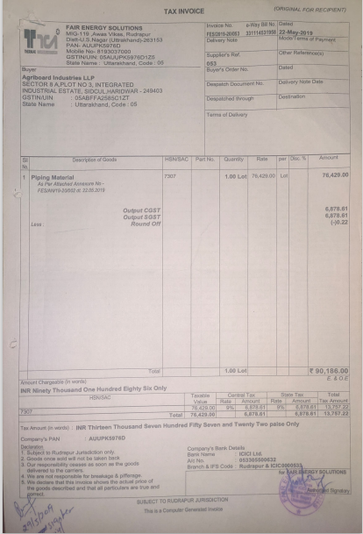

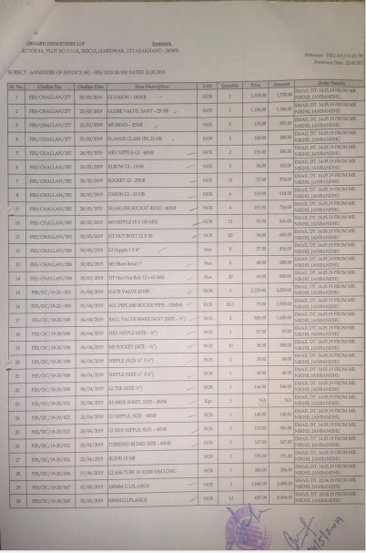
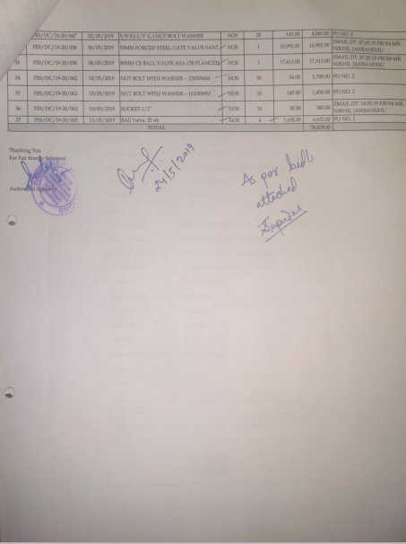
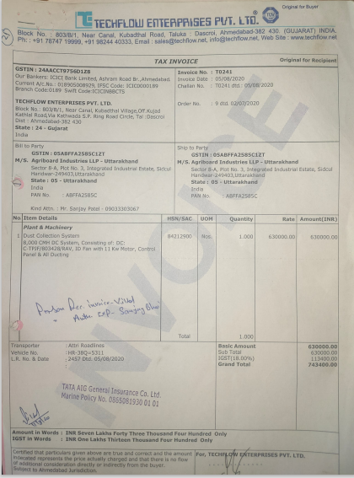
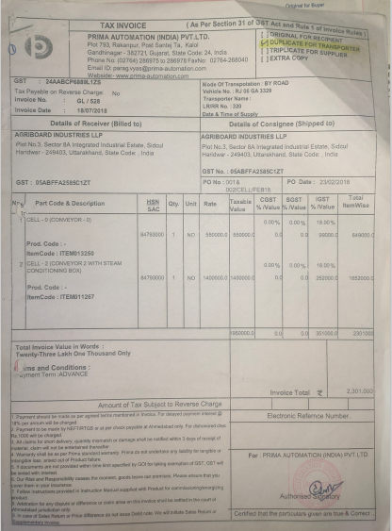
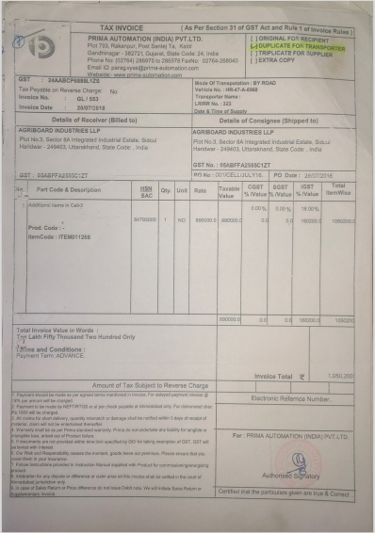
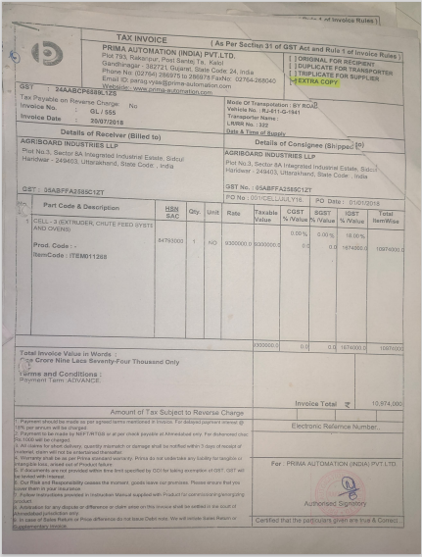
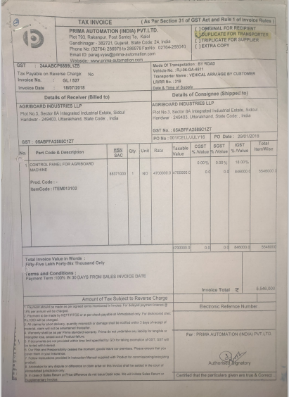
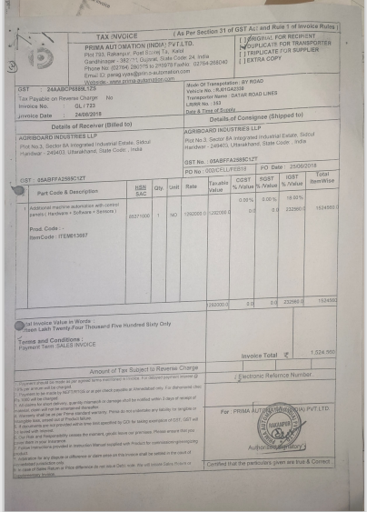
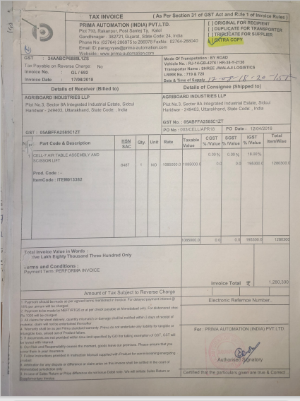
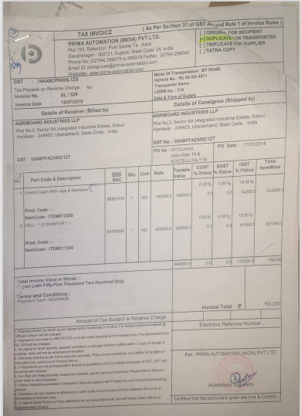
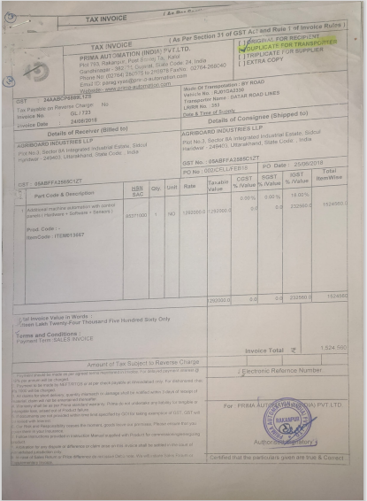
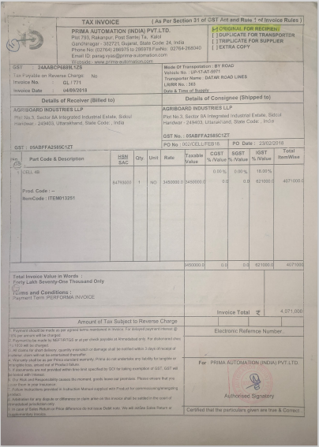
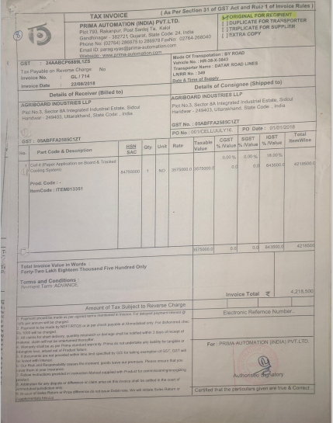
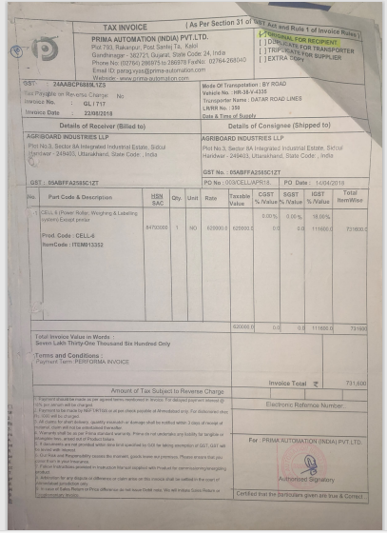
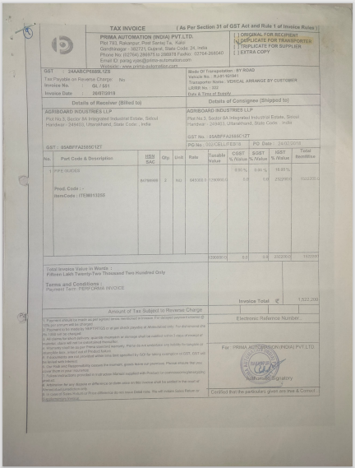

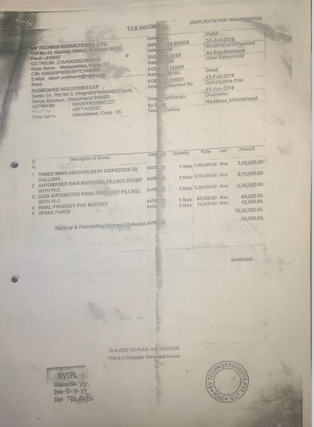

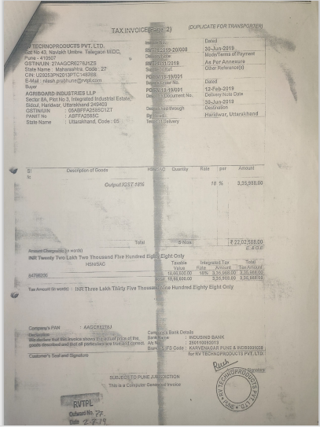

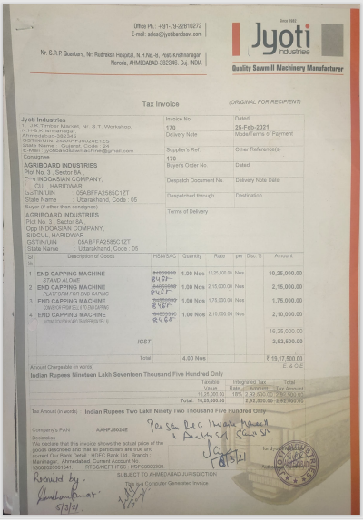

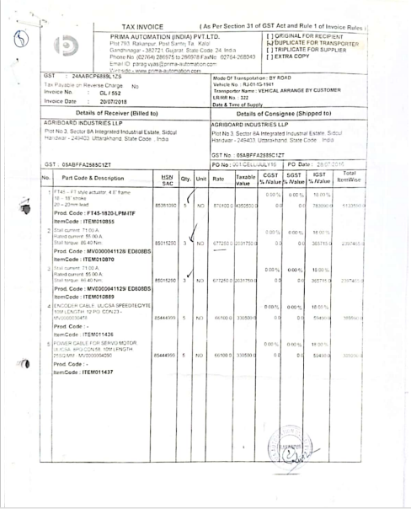

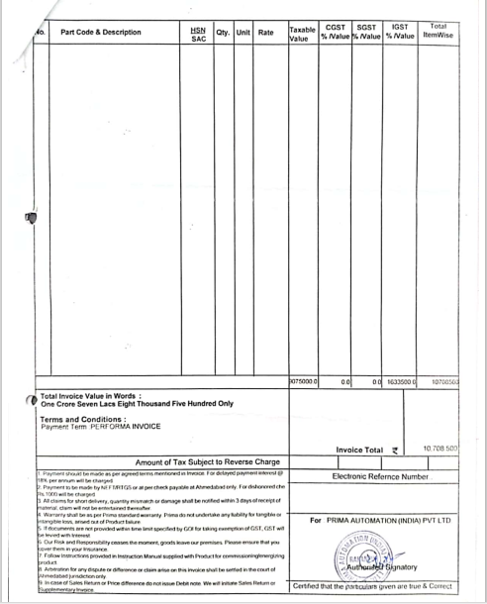

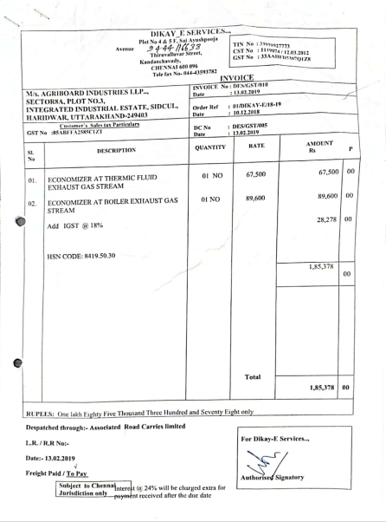

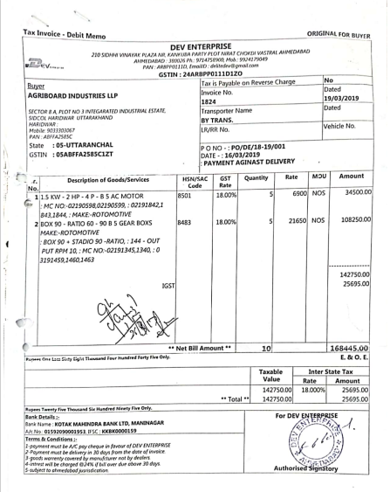
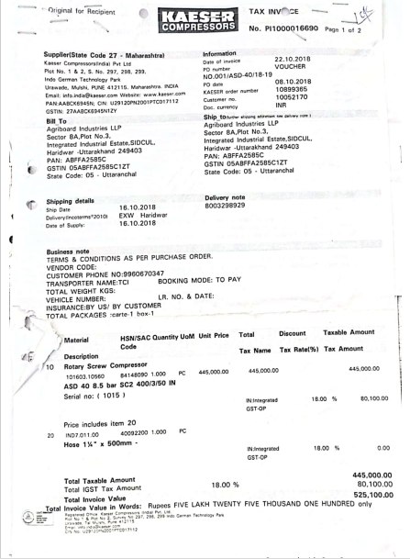
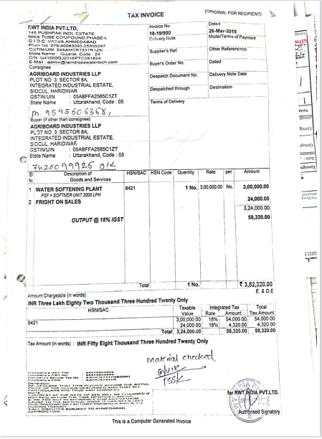

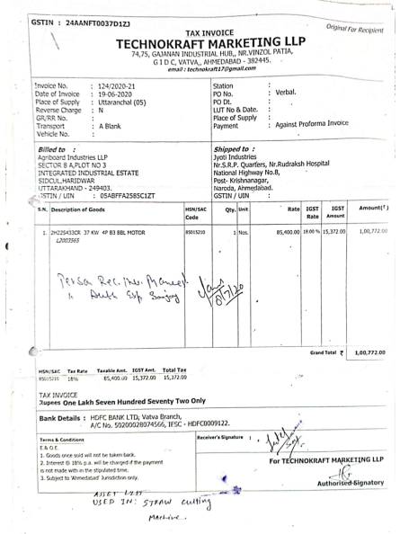
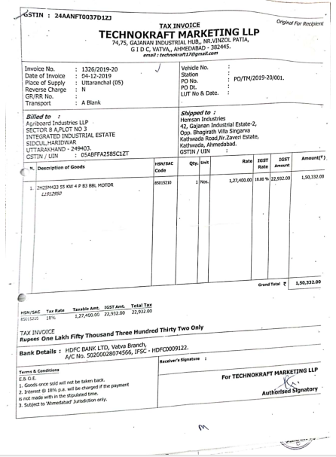

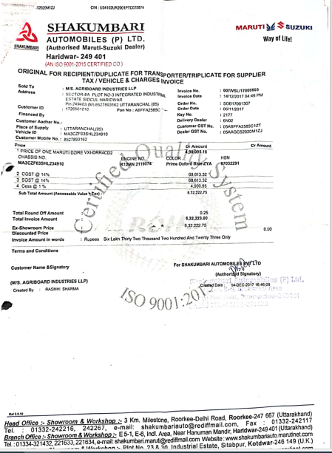
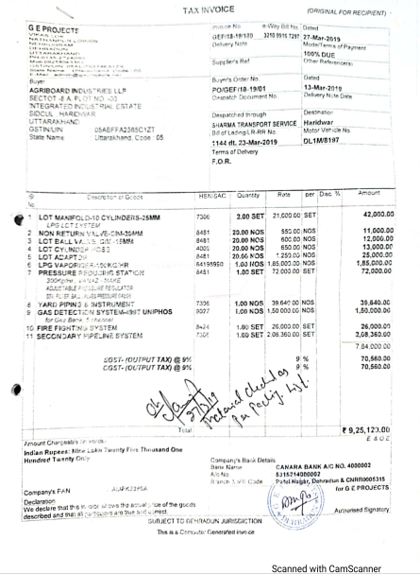

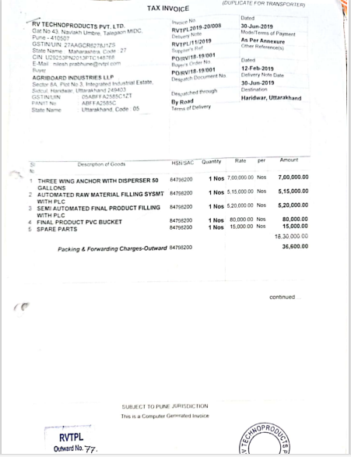
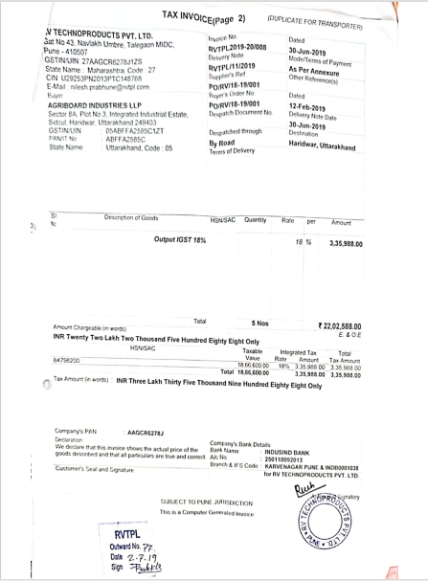

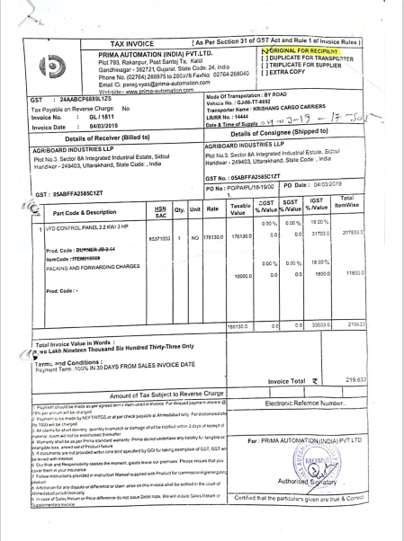
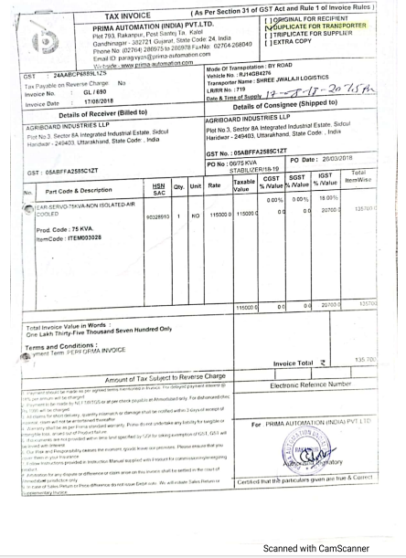
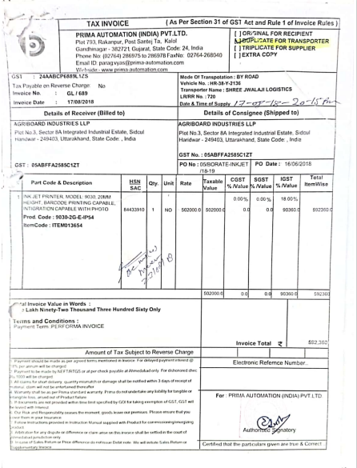
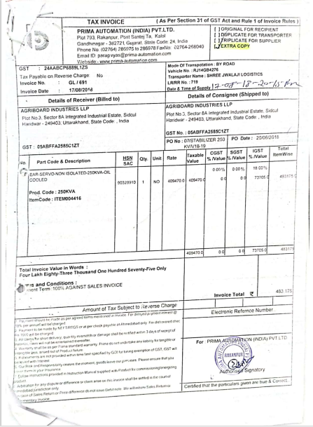
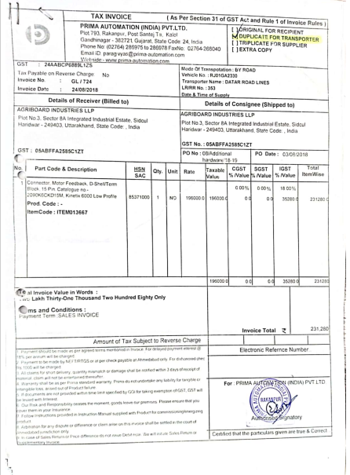
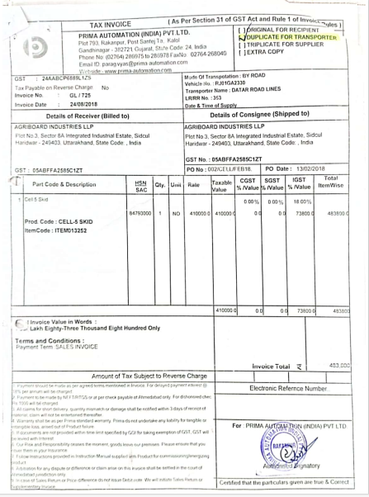
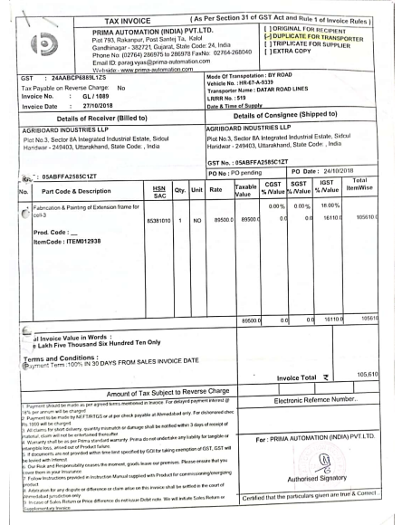
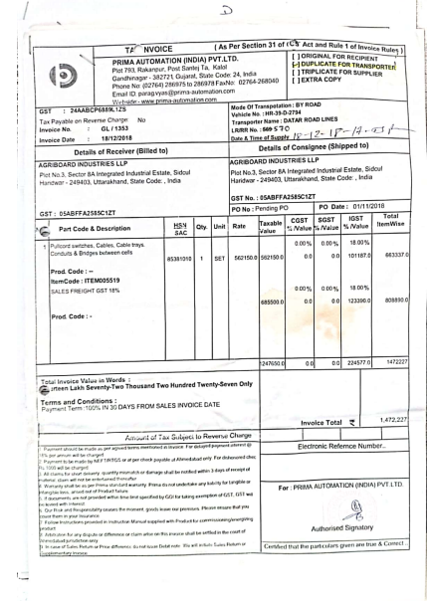

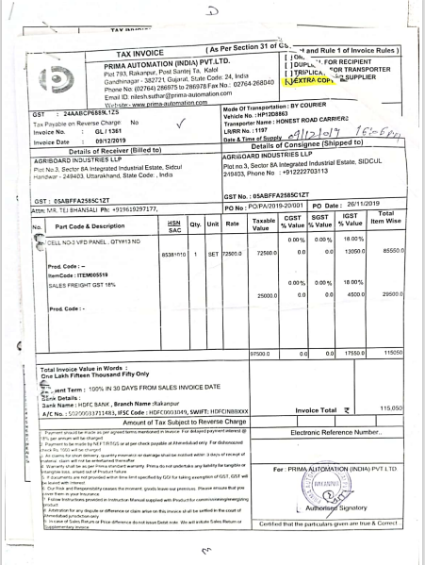

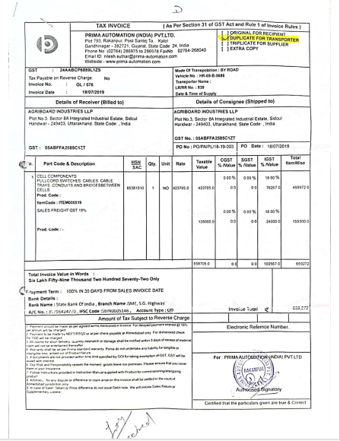
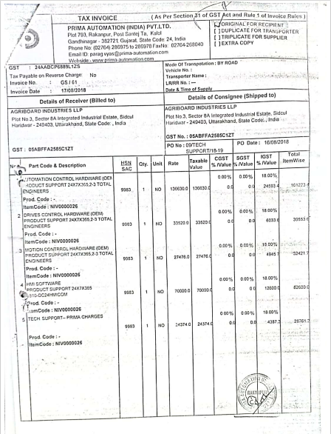

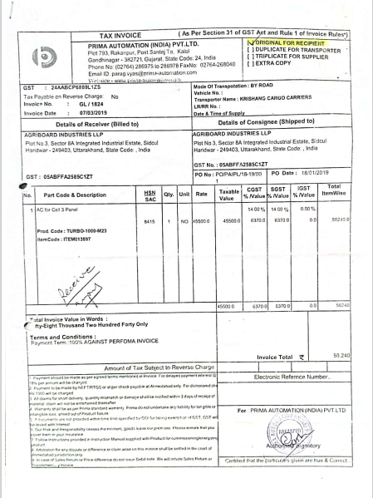

ENCLOSURE: IV – VALUATION COMPUTATION OF PLANT & MACHINERY

Sl. No | Patry Name | Invoice No. | Invoice Date | Description | Quantity | Total Amount  (after GST)  (In Rs.) | Gross Currant Replacement Cost | Estimated Fair Market Value | Realizable Value
1 | Prima Automation (India) Pvt. Ltd. | GL / 555 | 20-07-2018 | Cell - 3 (Extruder Chute Feed System and Ovens) | 1 | 1,09,74,000 | 1,29,43,185 | 74,23,841 | 63,10,265
2 | Prima Automation (India) Pvt. Ltd. | GL / 527 | 18-07-2018 | Control Panel for Agriboard Machine | 1 | 55,46,000 | 65,41,179 | 32,86,943 | 27,93,901
3 | Prima Automation (India) Pvt. Ltd. | GL/552 | 20-07-2018 | FT45- FT style actuator, 4 5" frame, 18 - 18' stroke, 20 - 20mm lead | 5 | 51,33,590 | 60,54,766 | 30,42,520 | 25,86,142
4 | Prima Automation (India) Pvt. Ltd. | GL / 714 | 22-08-2018 | Cell 4 (Paper Application or Board & Tracked Cooling System) | 1 | 42,18,500 | 49,62,049 | 25,24,442 | 21,45,776
5 | Prima Automation (India) Pvt. Ltd. | GL / 771 | 04-09-2018 | Cell - 4B | 1 | 40,71,000 | 47,71,387 | 24,57,264 | 20,88,675
6 | Prima Automation (India) Pvt. Ltd. | GL/552 | 20-07-2018 | Statl current 71 00A, Flated current 55 00 A, Stat torque 66 40 tlm | 3 | 23,97,465 | 28,76,958 | 2,87,696 | 2,44,541
7 | Prima Automation (India) Pvt. Ltd. | GL/552 | 20-07-2018 | Statl current 71 00A, Flated current 55 00 A, Stat torque 66 40 tlm | 3 | 23,97,465 | 28,76,958 | 2,87,696 | 2,44,541
8 | Prima Automation (India) Pvt. Ltd. | GL / 528 | 18-07-2018 | Cell - 2 (Conveyor 2 with steam conditioning box) | 1 | 16,52,000 | 19,48,436 | 9,79,089 | 8,32,226
9 | Prima Automation (India) Pvt. Ltd. | GL / 723 | 24-08-2018 | Additional machine automation with control panels (Hardware + Software + Sensors) | 1 | 15,24,560 | 17,93,277 | 9,12,330 | 7,75,480
10 | Prima Automation (India) Pvt. Ltd. | GL / 723 | 24-08-2018 | Additional machine automation with control panels/( Jardware + Software + Sensors) | 1 | 15,24,560 | 17,93,277 | 9,12,330 | 7,75,480
11 | Prima Automation (India) Pvt. Ltd. | GL/551 | 20-07-2018 | Flfe Guides | 2 | 15,22,200 | 17,95,345 | 9,02,161 | 7,66,837
12 | Prima Automation (India) Pvt. Ltd. | GL / 692 | 17-08-2018 | Cell-7 Air Table Assembly and scissor Lift | 1 | 12,80,300 | 15,05,964 | 7,66,159 | 6,51,235
13 | Jyoti Industries | 170 | 25-02-2021 | End Capping Machine | 1 | 12,09,500 | 12,28,433 | 6,68,728 | 5,68,419
14 | Prima Automation (India) Pvt. Ltd. | GL / 553 | 20-07-2018 | Additional items in Cell-3 | 1 | 10,50,200 | 12,38,649 | 6,22,421 | 5,29,058
15 | RV Technoproducts Pvt. Ltd. | RVTPL 2019-20/ 008 | 30-06-2019 | Three Wing Anchor with Disperser 50 Gallons | 1 | 8,26,000 | 9,54,424 | 5,45,215 | 4,63,433
16 | RV Technoproducts Pvt. Ltd. | RVTPL2019-20/008 | 30-06-2019 | Three wing Anchor with Disperser 50 Gallons | 1 | 8,26,000 | 9,56,534 | 47,827 | 40,653
17 | Techflow Enterprises Pvt. Ltd. | T0241 | 05-08-2020 | Dust Collection System | 1 | 7,43,400 | 8,55,204 | 4,17,447 | 3,54,830
18 | Prima Automation (India) Pvt. Ltd. | GL/717 | 22-08-2018 | Cell 6 (Power Roller , Weghing & Labelling system ) Except printer | 1 | 7,31,600 | 8,60,551 | 2,26,433 | 1,92,468
19 | Prima Automation (India) Pvt. Ltd. | GL/1353 | 18-12-2018 | Pullcord switches, Cables, Cable Trays, Conduits & Endges between cells | 1 | 6,63,337 | 9,14,989 | 2,39,517 | 2,03,590
20 | Prima Automation (India) Pvt. Ltd. | GL / 528 | 18-07-2018 | Cell - 0 (Conveyor - 0) | 1 | 6,49,000 | 8,34,731 | 83,473 | 70,952
21 | Shakumbari Automobiles (P) Ltd. | 007/VSL/17000603 | 14-12-2017 | Price of one Maruti Dzire VSI-DRR4CD2 | 1 | 6,32,223 | 7,38,856 | 2,58,969 | 2,20,124
22 | RV Technoproducts Pvt. Ltd. | RVTPL 2019-20/ 008 | 30-06-2019 | Semi Automated Final Product Filling with PLC | 1 | 6,13,600 | 7,40,304 | 1,05,493 | 89,669
23 | RV Technoproducts Pvt. Ltd. | RVTPL2019-20/008 | 30-06-2019 | Semi Automated Final Product Filling with PLC | 1 | 6,13,600 | 7,09,001 | 2,53,025 | 2,15,071
24 | RV Technoproducts Pvt. Ltd. | RVTPL 2019-20/ 008 | 30-06-2019 | Automated Raw material filling sysmt with PLC | 1 | 6,07,700 | 7,33,185 | 1,04,479 | 88,807
25 | RV Technoproducts Pvt. Ltd. | RVTPL2019-20/008 | 30-06-2019 | Automated Raw Material Filling Sysmt with PLC | 1 | 6,07,700 | 7,02,183 | 2,50,592 | 2,13,003
26 | Prima Automation (India) Pvt. Ltd. | GL/689 | 17-08-2018 | Ink Jet Printer Model 9030, 20MM Height Barcode Printing capable, Intigration capaable with photo | 1 | 5,92,360 | 5,92,360 | 29,618 | 25,175
27 | Prima Automation (India) Pvt. Ltd. | GL / 529 | 18-07-2018 | Cell - 1 ( Conveyor 1) | 1 | 5,31,000 | 6,82,962 | 68,296 | 58,052
28 | Kaeser Compressors | PI1000016690 | 22-10-2018 | Rotary Screw Compressor | 1 | 5,25,100 | 5,71,347 | 1,61,049 | 1,36,891
29 | Fair Energy Solutions | FES/2019-20/002 | 03-04-2019 | Chimney(KG) | 5847 | 5,17,460 | 6,18,871 | 2,91,179 | 2,47,502
30 | Prima Automation (India) Pvt. Ltd. | GL/576 | 18-07-2019 | Cell components pullcord switches cables, cable trays conduits and bridges between cells | 1 | 4,99,972 | 5,77,706 | 2,11,585 | 1,79,847
31 | Prima Automation (India) Pvt. Ltd. | GL/725 | 24-08-2018 | Cell 5 Sxd | 1 | 4,83,800 | 5,69,074 | 1,49,738 | 1,27,277
32 | Prima Automation (India) Pvt. Ltd. | GL/691 | 17-08-2018 | Ear Servo-Non Isolated-250 KVA-Oil Cooled | 1 | 4,83,175 | 5,94,676 | 59,468 | 50,547
33 | Prima Automation (India) Pvt. Ltd. | GL/552 | 20-07-2018 | Encoder cable , ULICSA SPEEDTECYLE, 100M LENGTH 12 PO CON23 | 5 | 3,89,990 | 4,67,988 | 46,799 | 39,779
34 | Prima Automation (India) Pvt. Ltd. | GL/552 | 20-07-2018 | Power Cable for Servo Motor ……. .. 10 M Length, 21 sq. mm | 5 | 3,89,990 | 4,60,626 | 23,031 | 19,577
35 | RWT India Pvt. Ltd. | 18-19/900 | 26-03-2019 | Wate Softening Plant | 1 | 3,54,000 | 4,22,316 | 1,38,836 | 1,18,011
36 | Jyoti Industries | 170 | 25-02-2021 | End Capping Machine | 1 | 2,53,700 | 2,57,671 | 1,40,270 | 1,19,229
37 | Jyoti Industries | 170 | 25-02-2021 | End Capping Machine | 1 | 2,47,800 | 2,51,679 | 1,37,008 | 1,16,457
38 | G E Projects | GEP/18-19/180 | 27-03-2019 | Secondary Pipeling System | 1 | 2,45,865 | 3,13,617 | 32,930 | 27,990
39 | Prima Automation (India) Pvt. Ltd. | GL/724 | 24-08-2018 | Connector Motor Feedback, D-Shell/ Term Block, 15 Pin, Catalogue no. 2090K6KD15m, Kinetix 6000 Low Profile | 1 | 2,31,280 | 2,72,244 | 13,612 | 11,570
116 | Ross Boiler | 145 | 21-08-2018 | Pressure Rducing Station | 1 | 3,48,100 | 4,02,222 | 1,05,835 | 89,959
41 | G E Projects | GEP/18-19/180 | 27-03-2019 | LPG Vaporiger …….. Kg/HR | 1 | 2,18,300 | 2,52,986 | 12,649 | 10,752
42 | Prima Automation (India) Pvt. Ltd. | GL/ 1811 | 04-03-2019 | VFD Control Panel 2.2 KW/3 HP | 1 | 2,07,833 | 2,12,632 | 61,973 | 52,677
43 | Jyoti Industries | 170 | 25-02-2021 | End Capping Machine | 1 | 2,06,500 | 2,09,733 | 1,14,173 | 97,047
44 | G E Projects | GEP/18-19/180 | 27-03-2019 | Gas Detection System - 499T Uniphos | 1 | 1,77,000 | 2,10,887 | 11,657 | 9,909
45 | Prima Automation (India) Pvt. Ltd. | GS/61 | 17-08-2018 | ….utomation control hardware (OEM Product support 24x7x365, 2-3 Total Engineers | 1 | 1,61,223 | 1,92,949 | 9,647 | 8,200
46 | Technokraft Marketing LLP | 1326/2019-20 | 04-12-2019 | 2H2S433 55 KW 4P B3 BBL Motor , L1912950 | 1 | 1,50,332 | 1,69,765 | 8,488 | 7,215
47 | Prima Automation (India) Pvt. Ltd. | GL/690 | 17-08-2018 | Ear Servo- 75KVA-Non Isolated Air Cooled | 1 | 1,35,700 | 1,67,015 | 16,702 | 14,196
48 | Agriboard Industries LLP | 1824 | 19-03-2019 | Box 90 + ratio 60- 90 B S Gear Boxes | 5 | 1,27,735 | 1,52,481 | 7,624 | 6,480
40 | Prima Automation (India) Pvt. Ltd. | GL / 529 | 18-07-2018 | Control Cabin with Legs & Staircase | 1 | 2,24,200 | 2,63,717 | 66,918 | 56,881
49 | Dikay -E Services | DES/GST/010 | 13-02-2019 | Economizer at Boiler Exhaust Gas Stream | 1 | 1,05,728 | 1,24,700 | 35,111 | 29,844
51 | Technokraft Marketing LLP | 124/ 2020-21 | 19-06-2020 | 2H22S433CR 37 KW 4P B3 BBL Motor , L2003565 | 1 | 1,00,772 | 1,13,706 | 11,806 | 10,036
52 | RV Technoproducts Pvt. Ltd. | RVTPL 2019-20/ 008 | 30-06-2019 | Final Product PVC Bucket | 1 | 94,400 | 1,11,069 | 5,553 | 4,720
53 | RV Technoproducts Pvt. Ltd. | RVTPL2019-20/008 | 30-06-2019 | Final Product PVC Bucket | 1 | 94,400 | 1,01,807 | 5,090 | 4,327
54 | Fair Energy Solutions | FES/2019-20/053 | 22-05-2019 | Piping Material | 1 | 90,186 | 1,16,586 | 15,156 | 12,883
55 | Prima Automation (India) Pvt. Ltd. | GL/1361 | 09-12-2019 | Cell No.-3 VFD Panel, Qty#13 No. | 1 | 85,550 | 87,525 | 33,305 | 28,309
50 | Prima Automation (India) Pvt. Ltd. | GL/1089 | 27-10-2018 | Fabrication & Painting of Extension frame for cell-3 | 1 | 1,05,610 | 1,23,448 | 29,872 | 25,391
57 | Prima Automation (India) Pvt. Ltd. | GS/61 | 17-08-2018 | HMI Software Product suport 24x7x365……….810-DC24HMICOM | 1 | 82,600 | 84,009 | 4,200 | 3,570
56 | G E Projects | GEP/18-19/180 | 27-03-2019 | Pressure Reducing Stat…. | 1 | 84,960 | 99,666 | 32,765 | 27,850
59 | Prima Automation (India) Pvt. Ltd. | GL/ 1824 | 07-03-2019 | AC for Cell 3 Panel | 1 | 58,240 | 59,585 | 17,366 | 14,762
61 | G E Projects | GEP/18-19/180 | 27-03-2019 | Lot Manifold-10 Cylinders - 25mm LPG Lot system | 2 | 49,560 | 57,435 | 2,872 | 2,441
62 | G E Projects | GEP/18-19/180 | 27-03-2019 | Yard Piping & Instrument | 1 | 46,775 | 59,665 | 3,298 | 2,803
63 | Agriboard Industries LLP | 1824 | 19-03-2019 | 1.5 KW - 2 HP - 4 P - B 5 AC MOTOR | 5 | 40,710 | 47,678 | 2,384 | 2,026
64 | Prima Automation (India) Pvt. Ltd. | GS/61 | 17-08-2018 | Drives control hardware (OEM) product support 24x7x365, 2-3 total engineers | 1 | 39,554 | 47,337 | 2,367 | 2,012
65 | Prima Automation (India) Pvt. Ltd. | GS/61 | 17-08-2018 | Motion control hardware (OEM) product support 24x7x365, 2-3 total engineers | 1 | 32,422 | 38,802 | 1,940 | 1,649
66 | G E Projects | GEP/18-19/180 | 27-03-2019 | Fire Fighting System | 1 | 30,680 | 35,814 | 1,791 | 1,522
67 | G E Projects | GEP/18-19/180 | 27-03-2019 | Lot Adaptor | 20 | 29,500 | 35,148 | 1,943 | 1,651
58 | Dikay -E Services | DES/GST/010 | 13-02-2019 | Economizer at Thermic Fluid Exhaust Gas Stream | 1 | 79,650 | 92,771 | 26,121 | 22,203
73 | RV Technoproducts Pvt. Ltd. | RVTPL 2019-20/ 008 | 30-06-2019 | Spare Parts | 1 | 17,700 | 20,690 | - | -
77 | G E Projects | GEP/18-19/180 | 27-03-2019 | Lot Cylinde - …………….. | 20 | 15,340 | 17,777 | 889 | 756
78 | G E Projects | GEP/18-19/180 | 27-03-2019 | Lot Ball Valve C/M - 15MM | 20 | 14,160 | 15,365 | 5,051 | 4,294
79 | G E Projects | GEP/18-19/180 | 27-03-2019 | Non Return Valve C/M - 20MM | 20 | 12,980 | 14,084 | 4,630 | 3,936
116 | Ross Boiler | 145 | 21-08-2018 | Steam Boiler Model RSR 1000G | 1 | 12,93,280 | 13,62,478 | 5,59,297 | 4,75,403
74 | RV Technoproducts Pvt. Ltd. | RVTPL2019-20/008 | 30-06-2019 | Spare Parts | 1 | 17,700 | 20,452 | - | -
116 | Ross Boiler | 145 | 21-08-2018 | Thermic Fliud Heater | 1 | 8,80,280 | 10,53,501 | 2,77,203 | 2,35,622
 | Total |  |  |  |  | 6,32,20,651 | 7,41,58,450 | 3,06,05,186 | 2,60,14,408

ENCLOSURE V: ANNEXURE: DECLARATION-CUM-UNDERTAKING

- Persons worked on this report are citizen of India.
- No employee or member of R.K Associates has any direct/ indirect interest in the property or become so interested at any time during a period of three years prior to our appointment as valuer or three years after the valuation of assets was conducted by us.
- The information furnished in our valuation report dated 19/2/2025 is true and correct to the best of our knowledge and belief and we have made an impartial and true valuation of the property.
- Our authorized Engineer/ surveyor Mr. Deepak Joshi have personally inspected the property on 11/2/2025 the work is not subcontracted to any other valuation firm and is carried out by us.
- We have not been depanelled/ delisted by any other bank and in case any such depanelment by other banks during my empanelment with you, we will inform you within 3 days of such depanelment.
- We have not been removed/ dismissed from service/employment earlier.
- We have not been convicted of any offence and sentenced to a term of imprisonment.
- Company is not found guilty of misconduct in professional capacity.
- Persons worked on this report are not declared to be unsound mind.
- Company is not undischarged bankrupt or has not applied to be adjudicated as a bankrupt.
- Company is not an undischarged insolvent.
- No penalty is levied under section 271J of Income-tax Act, 1961 (43 of 1961) and time limit for filing appeal before Commissioner of Income tax (Appeals) or Income-tax Appellate Tribunal, as the case may be has expired, or such penalty has been confirmed by Income-tax Appellate Tribunal, and five years have not elapsed after levy of such penalty.
- Company is not been convicted of an offence connected with any proceeding under the Income Tax Act 1961, Wealth Tax Act 1957 or Gift Tax Act 1958 and
- Our PAN Card number/ GST number as applicable is AAHCR0845G/ 09AAHCR0845G1ZP.
- We undertake to keep you informed of any events or happenings which would make us ineligible for empanelment as a valuer.
- We have not concealed or suppressed any material information, facts and records and we have made a complete and full disclosure.
- We have read the Handbook on Policy, Standards and procedure for Real Estate Valuation, 2009 of the IBA and has tried to apply the “Standards” enshrined for valuation in the Part-B of the above handbook to the best of our ability as much as practically possible in the limited time available.
- We have read the International Valuation Standards (IVS) and the report submitted to the Bank for the respective asset class and has tried to apply the “Standards” as enshrined for valuation in the IVS in “General Standards” and “Asset Standards” as applicable to the best of our ability as much as practically possible in the limited time available.
- Procedures and standards adopted in carrying out the valuation and is mentioned in Part-D of the report which may have certain departures to the said IBA and IVS standards in order to provide better, just & fair valuation.
- We abide by the Model Code of Conduct for empanelment of valuer in the Bank.
- The authorized Engineers of the company who has worked on the assignment has signed this valuation report.
- The work is taken on the instructions of the Bank.
- Further, we hereby provide the following information.

S. No. | Particulars | Valuer comment
 | Background information of the asset being valued | The valuation report is prepared for the Plant & Machinery owned by M/s. Agriboard Industries LLP situated at the aforesaid address is considered for valuation as found on as-is-where basis which owner/ owner representative/ client/ bank has shown/ identified to us on the site physically unless otherwise mentioned in the report of which some reference has been taken from the information/ data given in the copy of documents provided to us and informed verbally or in writing.
 | Purpose of valuation and appointing authority | Please refer to Part-D of the Report.
 | Identity of the experts involved in the valuation | Survey Analyst: Er. Nischay Gautam  Valuation Engineer: Er. Nischay Gautam  L1/ L2 Reviewer: Er. Abhinav Chaturvedi
 | Disclosure of valuer interest or conflict, if any | No relationship with the borrower and no conflict of interest.
 | Date of appointment, valuation date and date of report | Date of Appointment: | 11/2/2025
 |  | Date of Survey: | 11/2/2025
 |  | Valuation Date: | 19/2/2025
 |  | Date of Report: | 19/2/2025
 | Inspections and/ or investigations undertaken | Yes, by our authorized Survey Engineer Mr. Deepak Joshi on 11/2/2025. Property was shown and identified by Mr. Harsh Sharma (+91-8077455424)
 | Nature and sources of the information used or relied upon | Please refer to Part-D of the Report. Level 3 Input (Tertiary) has been relied upon.
 | Procedures adopted in carrying out the valuation and valuation standards followed | Please refer to Part-D of the Report.
 | Restrictions on use of the report, if any | Value varies with the Purpose/ Date/ Market & Asset Condition & Situation prevailing in the market. We recommend not to refer the indicative & estimated prospective Value of the asset given in this report if any of these points are different from the one mentioned aforesaid in the Report.  This report has been prepared for the purposes stated in the report and should not be relied upon for any other purpose. Our client is the only authorized user of this report and is restricted for the purpose indicated in this report. I/we do not take any responsibility for the unauthorized use of this report.  During the course of the assignment, we have relied upon various information, data, documents in good faith provided by Bank/ client both verbally and in writing. If at any point of time in future it comes to knowledge that the information given to us is untrue, fabricated, misrepresented then the use of this report at very moment will become null & void.  This report only contains general assessment & opinion on the indicative, estimated Market Value of the property for which Bank has asked to conduct the Valuation for the asset as found on as-is-where basis which owner/ owner representative/ client/ bank has shown/ identified to us on the site unless otherwise mentioned in the report of which some reference has been taken from the information/ data given in the copy of documents provided to us and informed verbally or in writing which has been relied upon in good faith. It doesn’t contain any other recommendations of any sort including but not limited to express of any opinion on the suitability or otherwise of entering into any transaction with the borrower.  This report is not a certification of ownership or survey number/ property number/ Khasra number which are merely referred from the copy of the documents provided to us.
 | Major factors that were taken into account during the valuation | Please refer to Part A, B & C of the Report.
 | Major factors that were not taken into account during the valuation | Please refer to Part A, B & C of the Report.
 | Caveats, limitations and disclaimers to the extent they explain or elucidate the limitations faced by valuer, which shall not be for the purpose of limiting his responsibility for the valuation report. | Please refer to Part E of the Report and Valuer’s Important Remarks enclosed herewith.

Date: 19/2/2025
Place: Noida

Signature

(Authorized Person of R.K Associates Valuers & Techno Engg. Consultants (P) Ltd.)

ENCLOSURE V: ANNEXURE: MODEL CODE OF CONDUCT FOR VALUERS

Integrity and Fairness
- A valuer shall, in the conduct of his/its business, follow high standards of integrity and fairness in all his/its dealings with his/its clients and other valuers.
- A valuer shall maintain integrity by being honest, straightforward, and forthright in all professional relationships.
- A valuer shall endeavor to ensure that he/it provides true and adequate information and shall not misrepresent any facts or situations.
- A valuer shall refrain from being involved in any action that would bring disrepute to the profession.
- A valuer shall keep public interest foremost while delivering his services.

Professional Competence and Due Care
- A valuer shall render at all times high standards of service, exercise due diligence, ensure proper care and exercise independent professional judgment.
- A valuer shall carry out professional services in accordance with the relevant technical and professional standards that may be specified from time to time.
- A valuer shall continuously maintain professional knowledge and skill to provide competent professional service based on up-to-date developments in practice, prevailing regulations/guidelines and techniques.
- In the preparation of a valuation report, the valuer shall not disclaim liability for his/its expertise or deny his/its duty of care, except to the extent that the assumptions are based on statements of fact provided by the company or its auditors or consultants or information available in public domain and not generated by the valuer.
- A valuer shall not carry out any instruction of the client in so far as they are incompatible with the requirements of integrity, objectivity and independence.
- A valuer shall clearly state to his client the services that he would be competent to provide and the services for which he would be relying on other valuers or professionals or for which the client can have a separate arrangement with other valuers.

Independence and Disclosure of Interest
- A valuer shall act with objectivity in his/its professional dealings by ensuring that his/its decisions are made without the presence of any bias, conflict of interest, coercion, or undue influence of any party, whether directly connected to the valuation assignment or not.
- A valuer shall not take up an assignment if he/it or any of his/its relatives or associates is not independent in terms of association to the company.
- A valuer shall maintain complete independence in his/its professional relationships and shall conduct the valuation independent of external influences.
- A valuer shall wherever necessary disclose to the clients, possible sources of conflicts of duties and interests, while providing unbiased services.
- A valuer shall not deal in securities of any subject company after any time when he/it first becomes aware of the possibility of his/its association with the valuation, and in accordance with the Securities and Exchange Board of India (Prohibition of Insider Trading) Regulations, 2015 or till the time the valuation report becomes public, whichever is earlier.
- A valuer shall not indulge in “mandate snatching or offering” convenience valuations” in order to cater to a company or client’s needs.
- As an independent valuer, the valuer shall not charge success fee.
- In any fairness opinion or independent expert opinion submitted by a valuer, if there has been a prior engagement in an unconnected transaction, the valuer shall declare the association with the company during the last five years.

Confidentiality
- A valuer shall not use or divulge to other clients or any other party any confidential information about the subject company, which has come to his/its knowledge without proper and specific authority or unless there is a legal or professional right or duty to disclose.

Information Management
- A valuer shall ensure that he/ it maintains written contemporaneous records for any decision taken, the reasons for taking the decision, and the information and evidence in support of such decision. This shall be maintained so as to sufficiently enable a reasonable person to take a view on the appropriateness of his/its decisions and actions.
- A valuer shall appear, co-operate and be available for inspections and investigations carried out by the authority, any person authorised by the authority, the registered valuers organization with which he/it is registered or any other statutory regulatory body.
- A valuer shall provide all information and records as may be required by the authority, the Tribunal, Appellate Tribunal, the registered valuers organization with which he/it is registered, or any other statutory regulatory body.
- A valuer while respecting the confidentiality of information acquired during the course of performing professional services, shall maintain proper working papers for a period of three years or such longer period as required in its contract for a specific valuation, for production before a regulatory authority or for a peer review. In the event of a pending case before the Tribunal or Appellate Tribunal, the record shall be maintained till the disposal of the case.

Gifts and hospitality.
- A valuer or his/its relative shall not accept gifts or hospitality which undermines or affects his independence as a valuer.
Explanation: For the purposes of this code the term ‘relative’ shall have the same meaning as defined in clause (77) of Section 2 of the Companies Act, 2013 (18 of 2013).
- A valuer shall not offer gifts or hospitality or a financial or any other advantage to a public servant or any other person with a view to obtain or retain work for himself/ itself, or to obtain or retain an advantage in the conduct of profession for himself/ itself.

Remuneration and Costs.
- A valuer shall provide services for remuneration which is charged in a transparent manner, is a reasonable reflection of the work necessarily and properly undertaken, and is not inconsistent with the applicable rules.
- A valuer shall not accept any fees or charges other than those which are disclosed in a written contract with the person to whom he would be rendering service.

Occupation, employability and restrictions.

- A valuer shall refrain from accepting too many assignments, if he/it is unlikely to be able to devote adequate time to each of his/ its assignments.
- A valuer shall not conduct business which in the opinion of the authority or the registered valuer organisation discredits the profession.

Miscellaneous

- A valuer shall refrain from undertaking to review the work of another valuer of the same client except under written orders from the bank or housing finance institutions and with knowledge of the concerned valuer.
- A valuer shall follow this code as amended or revised from time to time

Signature of the Authorized Person: ________________
Name of the Valuation company: R.K Associates Valuers & Techno Engg. Consultants (P) Ltd.
Address of the Valuer: D-39, Sector-2, Noida-201301
Date: 19/2/2025
Place: Noida
ENCLOSURE: VI – VALUER’S IMPORTANT REMARKS

Valuation is done for the asset found on as-is-where basis which owner/ owner representative/ client/ bank has shown/ identified to us on the site unless otherwise mentioned in the report of which some reference has been taken from the information/ data given in the copy of documents provided to us and informed verbally or in writing out of the standard checklist of documents sought from the client & its customer which they could provide within the reasonable expected time out of the standard checklist of documents sought from them and further based on certain assumptions and limiting conditions. The information, facts, documents, data which has become primary basis of the report has been supplied by the client which has been relied upon in good faith and is not generated by the Valuer.
The client/ owner and its management/ representatives warranted to us that the information they have supplied was complete, accurate and true and correct to the best of their knowledge. All such information provided to us either verbally, in writing or through documents has been relied upon in good faith and we have assumed that it is true & correct without any fabrication or misrepresentation. I/We shall not be held liable for any loss, damages, cost or expenses arising from fraudulent acts, misrepresentations, or willful default on part of the owner, company, its directors, employee, representative or agents.
Legal aspects for eg. Investigation of title, ownership rights, lien, charge, mortgage, lease, sanctioned maps, and verification of documents provided to us such as title documents, Map, etc. from any concerned Govt. office etc. have to be taken care by legal expert/ Advocate and same is not done at our end. It is assumed that the concerned Lender/ Financial Institution has asked for the valuation of that property after satisfying the authenticity of the documents given to us for which the legal verification has been already taken and cleared by the competent Advocate before requesting for the Valuation report. I/ We assume no responsibility for the legal matters including, but not limited to, legal or title concerns.
In the course of the valuation, we were provided with both written and verbal information. We have however, evaluated the information provided to us through broad inquiry, analysis and review but have not carried out a due diligence or audit of the information provided for the purpose of this engagement. Our conclusions are based on the assumptions and other information provided to us by the client during the course of the assessment.
Getting cizra map or coordination with revenue officers for site identification is a separate activity and is not part of the Valuation services and same has not been done in this report unless otherwise stated.
Wherever any details are mentioned in the report in relation to any legal aspect of the property such as name of the owner, leases, etc. is only for illustration purpose and should not be construed as a professional opinion. Legal aspects are out of scope of this report. Details mentioned related to legal aspect are only based on the copy of the documents provided to us and whatever we can interpret as a non-legally trained person. This should be cross validated with a legal expert. We do not vouch any responsibility regarding the same.
We have made certain assumptions in relation to facts, conditions & situations affecting the subject of, or approach to this exercise that has not been verified as part of the engagement rather, treated as “a supposition taken to be true”. If any of these assumptions prove to be incorrect then our estimate on value will need to be reviewed.
This is just an opinion report based on technical & market information having general assessment & opinion on the indicative, estimated Market Value of the property for which Bank has asked to conduct the Valuation. It doesn’t contain any other recommendations of any sort including but not limited to express of any opinion on the suitability or otherwise of entering into any transaction with the borrower.
We have relied on the data from third party, external sources & information available on public domain to conclude the valuation. These sources are believed to be reliable and therefore, we assume no liability for the truth or accuracy of any data, opinions or estimates furnished by others that have been used in this analysis. Where we have relied on the data, opinions or estimates from external sources, reasonable care has been taken to ensure that such data is extracted from authentic sources, however we still can’t vouch its authenticity, correctness, or accuracy.
Analysis and conclusions adopted in the report are limited to the reported assumptions, conditions and information came to our knowledge during the course of the work and based on the Standard Operating Procedures, Best Practices, Caveats, Limitations, Conditions, Remarks, Important Notes, Valuation TOR and definition of different nature of values.
Value varies with the Purpose/ Date/ Asset Condition & situation/ Market condition, demand & supply, asset utility prevailing on a particular date/ Mode of sale. The indicative & estimated prospective Value of the asset given in this report is restricted only for the purpose and other points mentioned above prevailing on a particular date as mentioned in the report. If any of these points are different from the one mentioned aforesaid in the Report then this report should not be referred.
Our report is meant ONLY for the purpose mentioned in the report and should not be used for any other purpose. The Report should not be copied or reproduced for any purpose other than the purpose for which it is prepared for. I/we do not take any responsibility for the unauthorized use of this report.
We owe responsibility only to the authority/client that has appointed us as per the scope of work mentioned in the report. We will not be liable for any losses, claims, damages or liabilities arising out of the actions taken, omissions or advice given by any other person. In no event shall we be liable for any loss, damages, cost or expenses arising in any way from fraudulent acts, misrepresentations or willful default on part of the client or companies, their directors, employees or agents.
This report is having limited scope as per its fields & format to provide only the general basic idea of the value of the property prevailing in the market based on the site inspection and documents/ data/ information provided by the client. The suggested indicative prospective estimated value should be considered only if transaction is happened as free market transaction.
The sale of the subject property is assumed to be on an all cash basis. Financial arrangements would affect the price at which the property may sell for if placed on the market.
The actual realizable value that is likely to be fetched upon sale of the asset under consideration shall entirely depend on the demand and supply of the same in the market at the time of sale.
While our work has involved an analysis & computation of valuation, it does not include detailed estimation, design/ technical/ engineering/ financial/ structural/ environmental/ architectural/ compliance survey/ safety audit & works in accordance with generally accepted standards of audit & other such works. The report in this work in not investigative in nature. It is mere an opinion on the likely estimated valuation based on the facts & details presented to us by the client and third party market information came in front of us within the limited time of this assignment, which may vary from situation to situation.
Where a sketched plan is attached to this report, it does not purport to represent accurate architectural plans. Sketch plans and photographs are provided as general illustrations only.
Documents, information, data including title deeds provided to us during the course of this assessment by the client is reviewed only upto the extent required in relation to the scope of the work. No document has been reviewed beyond the scope of the work. These are not reviewed in terms of legal rights for which we do not have expertise. Wherever any information mentioned in this report is mentioned from the documents like owners name, etc., it is only for illustration purpose and may not necessary represent accuracy.
The report assumes that the borrower/company/business/asset complies fully with relevant laws and regulations applicable in its area of operations and usage unless otherwise stated, and that the companies/business/assets is managed in a competent and responsible manner. Further, as specifically stated to the contrary, this report has given no consideration to matters of a legal nature, including issues of legal title and compliance with relevant laws, and litigations and other contingent liabilities that are not recorded/reflected in the documents/ details/ information/ data provided to us.
This valuation report is not a qualification for accuracy of land boundaries, schedule (in physical terms), dimensions & identification. For this land/ property survey report can be sought from a qualified private or Govt. surveyor.
This Valuation report is prepared based on the facts of the property on the date of the survey. Due to possible changes in market forces, socio-economic conditions, property conditions and circumstances, this valuation report can only be regarded as relevant as at the valuation date. Hence before financing, Banker/ FI should take into consideration all such future risk and should loan conservatively to keep the advanced money safe in case of the downward trend of the property value.
Valuation of the same asset/ property can fetch different values under different circumstances & situations. For eg. Valuation of a running/ operational shop/ hotel/ factory will fetch better value and in case of closed shop/ hotel/ factory it will have considerable lower value. Similarly, an asset sold directly by an owner in the open market through free market transaction then it will fetch better value and if the same asset/ property is sold by any financer due to encumbrance on it, will fetch lower value. Hence before financing, Lender/ FI should take into consideration all such future risks while financing and take decision accordingly.

Valuation is done for the property identified to us by the owner/ owner representative. At our end we have just visually matched the land boundaries, schedule (in physical terms) & dimensions of the property with reference to the documents produced for perusal. Method by which identification of the property is carried out is also mentioned in the report clearly. Responsibility of identifying the correct property to the Valuer/ its authorized surveyor is solely of the client/ owner for which Valuation has to be carried out. It is requested from the Bank to cross check from their own records/ information if this is the same property for which Valuation has to be carried out to ensure that owner has not misled the Valuer company or misrepresented the property due to any vested interest. Where there is a doubt about the precision position of the boundaries, schedule, dimensions of site & structures, it is recommended that a Licensed Surveyor be contacted.
In India more than 70% of the geographical area is lying under rural/ remote/ non municipal/ unplanned area where the subject property is surrounded by vacant lands having no physical demarcation or having any display of property survey or municipal number / name plate on the property clearly. Even in old locations of towns, small cities & districts where property number is either not assigned or not displayed on the properties clearly and also due to the presence of multiple/ parallel departments due to which ownership/ rights/ illegal possession/ encroachment issues are rampant across India and due to these limitations at many occasions it becomes tough to identify the property with 100% surety from the available documents, information & site whereabouts and thus chances of error, misrepresentation by the borrower and margin of chances of error always persists in such cases. To avoid any such chances of error it is advised to the Bank to engage municipal/ revenue department officials to get the confirmation of the property to ensure that the property shown to Valuer/ Banker is the same as for which documents are provided.
If this Valuation Report is prepared for the Flat/ dwelling unit situated in a Group Housing Society or Integrated Township then approvals, maps of the complete group housing society/ township is out of scope of this report and this report will be made for the specific unit based on the assumption that complete Group Housing Society/ Integrated Township and the subject unit must be approved in all respect.
Due to fragmented & frequent change in building/ urban planning laws/ guidelines from time to time, different laws/ guidelines between regions/ states and no strict enforceability of Building Bye-Laws in India specially in non-metro and scale b & c cities & Industrial areas, property owners many times extend or make changes in the covered area/ layout from the approved/ applicable limits. There are also situations where properties are decades old when there was no formal Building Bye-Laws applicable the time when the construction must have been done. Due to such discrete/ unplanned development in many regions sometimes it becomes tough for the Valuer to determine the exact lawful situation on ground. Unless otherwise mentioned in the report, the covered area present on the site as per site survey will be considered in the Valuation.
Area of the large land parcels of more than 2500 sq.mtr or of uneven shape in which there can be practical difficulty in sample measurement, is taken as per property documents which has been relied upon unless otherwise stated.

Drawing Map, design & detailed estimation of the property/ building is out of scope of the Valuation services.
Valuation is a subjective field and opinion may differ from consultant to consultant. To check the right opinion, it is important to evaluate the methodology adopted and various data point/ information/ factors/ assumption considered by the consultant which became the basis for the Valuation report before reaching to any conclusion.
Although every scientific method has been employed in systematically arriving at the value, there is, therefore, no indisputable single value and the estimate of the value is normally expressed as falling within a likely range.
Value analysis of any asset cannot be regarded as an exact science and the conclusions arrived at in many cases will, of necessity, be subjective and dependent on the exercise of individual judgment. Given the same set of facts and using the same assumptions, expert opinions may differ due to the number of separate judgment decisions, which have to be made. Therefore, there can be no standard formula to establish an indisputable exchange ratio. In the event of a transaction, the actual transaction value achieved may be higher or lower than our indicative analysis of value depending upon the circumstances of the transaction. The knowledge, negotiability and motivations of the buyers and sellers, demand & supply prevailing in the market and the applicability of a discount or premium for control will also affect actual price achieved. Accordingly, our indicative analysis of value will not necessarily be the price at which any agreement proceeds. The final transaction price is something on which the parties themselves have to agree. However, our Valuation analysis can definitely help the stakeholders to take informed and wise decision about the Value of the asset and can help in facilitating the arm’s length transaction.
This Valuation is conducted based on the macro analysis of the asset/ property considering it in totality and not based on the micro, component, or item wise analysis. Analysis done is a general assessment and is not investigative in nature.
This report is prepared on the RKA V-L1 (Basic) Valuation format as per the client requirement and scope of work. This report is having limited scope as per its fields & format to provide only the general estimated & indicative basic idea of the value of the property prevailing in the market based on the information provided by the client. No detailed analysis, audit or verification has been carried out of the subject property. There may be matters, other than those noted in this report, which might be relevant in the context of the transaction and which a wider scope might uncover.
This is just an opinion report and doesn’t hold any binding on anyone. It is requested from the concerned Client/ Bank/ Financial Institution which is using this report for mortgaging the property that they should consider all the different associated relevant & related factors & risks before taking any business decision based on the content of this report.
All Pages of the report including annexures are signed and stamped from our office. In case any paper in the report is without stamp & signature then this should not be considered a valid paper issued from this office.
As per IBA Guidelines & Bank Policy, in case the valuation report submitted by the valuer is not in order, the banks / FIs shall bring the same to the notice of the valuer within 15 days of submission for rectification and resubmission. In case no such communication is received, it shall be presumed that the valuation report has been accepted.
Defect Liability Period is 15 DAYS. We request the concerned authorized reader of this report to check the contents, data, information, and calculations in the report within this period and intimate us in writing at valuers@rkassociates.org within 15 days of report delivery, if any corrections are required or in case of any other concern with the contents or opinion mentioned in the report. If no intimation is received within 15 (Fifteen) days in writing from the date of issuance of the report, then it shall be considered that the report is complete in all respect and has been accepted by the client upto their satisfaction & use and further to which R.K Associates shall not be held responsible in any manner. After this period no concern/ complaint/ proceedings in connection with the Valuation Services will be entertained due to possible change in situation and condition of the property.
Though adequate care has been taken while preparing this report as per its scope, but still we can’t rule out typing, human errors, over sightedness of any information or any other mistakes. Therefore, the concerned organization is advised to satisfy themselves that the report is complete & satisfactory in all respect. Intimation regarding any discrepancy shall be brought into our notice immediately. If no intimation is received within 15 (Fifteen) days in writing from the date of issuance of the report, to rectify these timely, then it shall be considered that the report is complete in all respect and has been accepted by the client upto their satisfaction & use and further to which R.K Associates shall not be held responsible in any manner.
Our Data retention policy is of ONE YEAR. After this period we remove all the concerned records related to the assignment from our repository. No clarification or query can be answered after this period due to unavailability of the data.
This Valuation report is governed by our (1) Internal Policies, Processes & Standard Operating Procedures, (2) R.K Associates Quality Policy, (3) Valuation & Survey Best Practices Guidelines formulated by management of R.K Associates, (4) Information input given to us by the customer and (4) Information/ Data/ Facts given to us by our field/ office technical team. Management of R.K Associates never gives acceptance to any unethical or unprofessional practice which may affect fair, correct & impartial assessment and which is against any prevailing law. In case of any indication of any negligence, default, incorrect, misleading, misrepresentation or distortion of facts in the report then we request the user of this report to immediately or atleast within the defect liability period to bring all such act into notice of R.K Associates management so that corrective measures can be taken instantly.
R.K Associates never releases any report doing alterations or modifications by pen. In case any information/ figure of this report is found altered with pen then this report will automatically become null & void.
We are fully aware that based on the opinion of value expressed in this report, we may be required to give testimony or attend court / judicial proceedings with regard to the subject assets, although it is out of scope of the assignment, unless specific arrangements to do so have been made in advance, or as otherwise required by law. In such event, the party seeking our evidence in the proceedings shall bear the cost/professional fee of attending court / judicial proceedings and my / our tendering evidence before such authority shall be under the applicable laws.
The final copy of the report shall be considered valid only if it is in hard copy on the company’s original letter head with proper stamp and sign on it of the authorized official upon payment of the agreed fees. User shall not use the content of the report for the purpose it is prepared for only on draft report, scanned copy, email copy of the report and without payment of the agreed fees. In such a case the report shall be considered as unauthorized and misused.

