File No.: VIS (2024-25)-PL783-707-974 Dated: 05.03.2025

TECHNO-ECONOMIC VIABILITY
STUDY REPORT

OF

7,200 M3/DAY BIO GAS PRODUCING PLANT 2,500 KG PER DAY BIO CBG CAPACITY

SETUP BY

M/S BLUELEO ENERGY PRIVATE LIMITED

REPORT PREPARED FOR

M/S BLUELEO ENERGY PVT LTD, VILLA-589, MY HOME ANKURA, TELLAPUR, RC PURAM, SANGAREDDY, TELLAPUR, MEDAK, RAMACHANDRAPURAM, TELANGANA, INDIA-502032

**Important - In case of any query/ issue or escalation you may please contact Incident Manager Valuers@rkassociates.org. We will appreciate your feedback in order to improve our services.

NOTE: As per IBA Guidelines please provide your feedback on the report within 15 days of its submission after which report will be considered to be correct.

IMPORTANT NOTICE

COPYRIGHT FORMAT: This report is prepared on the copyright format of R. K. Associates Valuers & Techno Engineering Consultants (P) Ltd. (R. K. Associates) to serve our clients with the best possible information and analysis to facilitate them to take rational business decisions. Legally no one can copy or distribute this format without prior approval from R. K. Associates. It is meant only for the advisory/ reference purpose for the organization/s as mentioned on the cover page of this report. Distribution or use of this format or report or any of its content/ information/ data by any organization or individual other than R.K Associates will be seen as an unlawful act and necessary legal action can be taken against the defaulters.
This report is intended for the sole use of the intended recipient/s and contains material that is STRICTLY CONFIDENTIAL AND PRIVATE.

DEFECT LIABILITY PERIOD: In case of any query/ issue or escalation you may please contact Incident Manager at valuers@rkassociates.org. Though adequate care has been taken while preparing this report as per its scope, but still we can’t rule out typing, human errors, over sightedness of any information or any other mistakes. Therefore, the concerned organization is advised to satisfy themselves that the report is complete & satisfactory in all respect. Intimation regarding any discrepancy shall be brought into our notice immediately. If no intimation is received within 15 (Fifteen) days in writing from the date of issuance of the report, to rectify these timely, then it will be considered that the report is complete in all respect and has been accepted by the client up to their satisfaction & use and further to which R.K Associates shall not be held responsible in any manner.

Part O: R. K. Associates Important Disclaimer and Remarks are integral part of this report and Feasibility assessment is subject to this section. Reader of the report is advised to read all the points mentioned in these sections carefully.

TABLE OF CONTENTS
SECTIONS | PARTICULARS | PAGE NO.
Part A | Report Summary
Part B | INTRODUCTION
Part B | - About the Report
Part B | - Executive summary
Part B | - Purpose of the Report
Part B | - Scope of the Report
Part B | - Methodology/ Model Adopted
Part B | - Data Information received from
Part B | - Documents/ Data Referred
Part C | Company Profile
Part C | - Company Overview
Part C | - Promoters/Directors Profile
Part D | Proposed Unit’s Infrastructure Details
Part D | - Proposed Plant Location
Part D | - Google Map Location
Part D | - Layout Plan
Part D | - Land Details
Part D | - Site pictures
Part D | - Building & Civil Works
Part D | - Plant and Machinery/ Equipment details
Part D | - Miscellaneous Assets
Part D | - Utilities
Part E | Project Technical details
Part E | - Capacity of Proposed Bio CNG Plant
Part E | - Process Description
Part E | - Basic Architecture: Flow Chart Of The Bio CNG Plant
Part E | - Technical Specification of the Proposed CBG Facility
Part E | - Technology Used
Part E | - Technological Assessment
Part E | - Effluent Treatment and Abetment
Part E | - Testing Standards For Production
Part E | - Manpower
Part F | Product Profile
Part F | - Introduction
Part F | - Product Category
Part F | - Pricing Strategy
Part F | - Marketing, Selling & Distribution Plan
Part G | Feedstock Analysis & Supply
Part H | Industry Overview & Analysis
Part I | SWOT Analysis
Part J | Project Cost and Means of Finance
Part K | Project Schedule
Part L | Statutory Approvals | Licences | NOC
Part M | Company’s Financial Feasibility
Part N | Conclusion
Part O | Disclaimer | Remarks

PART A | REPORT SUMMARY

S. No. | PARTICULAR | DESCRIPTION
 | Name of the Company: | M/s Blueleo Energy Private Limited
 | Registered Address: | Villa-589, My Home Ankura, Tellapur, Rc Puram, Sangareddy, Tellapur, Medak, Ramachandrapuram, Telangana, India-502032.
 | Project Name | 2,500 Kg per day Bio CNG generating plant.
 | Project Location: | Survey No. 685/ part, 686/part, Village-Kasala, District: Sangareddy, Telangana
 | Project Type: | Bio CNG generating plant along with Biomass Pellets (Briquettes)
 | Project Industry: | Renewable Energy
 | Product Type / Deliverables: | Bio CNG and Biomass Pellets (Briquettes)
 | Report Prepared for Organization: | M/s Blueleo Energy Private Limited
 | TEV Consultant Firm: | M/s. R.K Associates Valuers & Techno Engineering Consultants (P) Ltd.
 | Report type: | Techno-Economic Viability Report
 | Purpose of the Report: | To assess Technical & Economic Viability for the purpose of seeking external financial assistance to start a green field Project.
 | Scope of the Report: | To assess, evaluate & comment on Technical, Economical & Commercial Viability of the Project as per data information provided by the client, independent Industry research and data/ information available on public domain.
 | Date of Report: | 5th March 2025
 | Documents referred for the Project: | - PROJECT INITIATION DOCUMENTS:  - Project Report  - Financial Projections of the Project  - Project Proposed Schedule  - Statutory Approval Details  - PROCUREMENT DOCUMENTS:  - List of Plant & Machinery along with acquisition costs for the same  - Process Flow Chart  - Lease/Sale deeds of the Land  - LOI with IOCL  - Agreement with Raw Material Supplier  - STATUTORY APPROVALS, LICENCES & NOCs  - NALA Conversion  - LOI with IOCL  - MOA and AOA of the company  - GST Certificate
 | Means of Finance: | Equity & Debt (D/E Ratio 2.33 TPC)
 | Key Financial Indicators:
  Key Indicators | Value
  Average DSCR | 5.60
  Average EBITDA Margin | 62.88%
  Avg. PAT Margin | 39.13%
  NPV & IRR | INR 15.81 Cr. & 46.69%
  Payback Period | 2.96 years
Note: Above financial indicators are based on the financial projections of the proposed project provided by the firm and assessment and analysis of the same done by us.

PART B | INTRODUCTION

- ABOUT THE REPORT:
This is a Techno-Economic Viability Study Report of the proposed compressed biogas plant (Bio-CNG, 2,500 kg/day) at Survey No. 685/ part, 686/part, Village-Kasala, District: Sangareddy, Telangana, setup by M/s Blueleo Energy Private Limited.

- EXECUTIVE SUMMARY:
M/s Blueleo Energy Private Limited, established on 21st August 2023 under the Company’s Act, 2013 as per the certificate of incorporation shared by the client for the establishment of Waste to Energy Management based on the waste and residual organic substances from Urban, Industrial and Agricultural activities of Rural INDIA, such as Municipal Waste, Farm Residue, Vegetable Food Waste, Cattle Dung, Sugarcane Press mud, Napier Grass etc.,
The company have conceived this Project to reap out the growing demand of Bio-CNG in the transport sector due to the phased mandatory blending of compressed biogas (CBG) in compressed natural gas (CNG) which has been announced by the Government of India in the recent Interim budget of FY 2024-25. The subject project is part of the Govt. initiative “Swachh Bharat Abhiyan” and for providing green energy.
Ministry of Petroleum & Natural Gas, Government of India (MoP&NG), in furtherance of guidelines dated 03.02.2014 and 20.08.2014 (as amended), has vide letters No. L-16022/05/2020-GP-I (E-35118) dated 09.04.2021, 26.10.2021 and 26.10.2023 issued policy guidelines for synchronisation of CBG produced by plants under SATAT scheme in the CGD network wherein GAIL has been mandated to operationalise the CBG-CGD Synchronisation Scheme and supply Biogas/CBG co-mingled with domestic gas at Uniform Base Price (UBP) to CGD entities for use in CNG (T) &and PNG (D) segments of CGD network. Moreover, the government has a set a target of 5% FY28-29, following a carrot-and-stick approach to incentivize CGD company to offtake biogas.
M/s Blueleo Energy Private Limited has proposed to set up this Greenfield project at Kasala, Sangareddy in Telangana, for the production of 2,500 Kg (7,200 M3)/ Day of Bio-CNG (compressed biogas) along with 12 Ton/day of Biomass Pellets (Briquettes) which will be sold as value added by-products. The Bio-CNG plant is proposed to be setup with total investment of INR 8.37 Crores.

Proposed Biogas Plant Capacity
Sr. No. | PARTICUALR | Capacity | Unit
1 | Biogas Plant Generation | 7,200 | M3/Day
2 | Bio-CNG Plant Capacity | 2,500 | kg/Day
3 | Biomass Pellets (Briquettes) Capacity | 12,000 | Kg/day
Source: DPR/data/information provided by the company
The project will benefit from a new mandate from the Indian government, Compressed Biogas Blending Obligation (CBO), which requires 5% of all compressed natural gas (“CNG”) in City Gas Distribution networks (“CGD”) to be Compressed biogas (“CBG”). The government is also aiming to increase the quantity of natural gas in its energy mix up to 15% by 2030, and the natural gas price is regulated by a gap and collar, with CBG sold at a premium above the natural gas price.
For the sale of the produced CBG, the company has already secured a purchase agreement/ LOI from Indian Oil Corporation limited under SATAT initiative to promote Compressed Bio-Gas as an alternative, green transport fuel. (Ref No.: Indian Oil/SATAT/01/3961 Date: 01.01.2025).
The project is proposed to be commissioned based on the KVIC Floating Dome Model with Thermophilic bio-methanation technology, which will be a semi-automatic. As per the information shared by the company, they have planned to execute the project on their own as the company has successfully developed an 80 Kg Bio-CNG Plant for R&D purposes in the state of Telangana.
The plant will use approximately 18,000 tons of Napier Grass – contributing to wealth generation for the local community while at the same time being a part of the solution to the problems of import dependence for India’s energy needs. For the procurement of the Raw Material, the company has signed a long-term supply agreement with Mr. G. Vijay Bhashkar Reddy (Individual Farmer) on 6th April 2024 to supply atleast 50 ton of Napier Grass per day.
As per the data/information provided by the client/Company, the layout plan is under preparation at the time of preparation of this report. We recommend the bank/financial institution to procure the approved layout plan from the company before disbursement of the loan.
As shown in the below table, the cost of the proposed project from scratch to trial run is being estimated as INR 8.37 Crores, which is proposed to be funded through Promotor’s Equity of INR 0.01 Crore, Unsecured Loan from promoters of INR 2.50 Crores and bank loan of INR 5.86 Crores. Project cost breakup is shown in later section of the report.
As per the lease deed shared by the client/company, the promoters have leased a total of 2 Acre and 22 Guntas (~2.5 Acres) of land through two separate leases of adjoining land at Survey No. 685/ part, 686/part, Village-Kasala, District: Sangareddy, Telangana. This land has been leased out in the name of the company for 15 years with an option of with an option of renewal at the end of lease as per the shared lease deed executed on 23rd September 2024, for setting up the proposed Bio-CNG plant.
As per the information shared by the client/company, due to the presence of a high-tension electricity line over a portion of the land, the Nala conversion for the proposed Bio-CNG plant has been approved by the Tahsildar, Hathnoora Mandal, District Sangareddy, on February 21, 2025, for a total area of 2 Acres and 14 Guntas out of the total land parcel of 2 Acres and 22 Guntas.
As per data/information provided to us, the company has yet to obtain Statutory Approvals/NOC’s such as Pollution Certificate, PESO, Sanctioned Map approval, Fire NOC etc. from the respective authorities, which will be applied in a single-window clearance system (TS-IPASS) as per Telangana State. (Refer the section Statutory Approval in the later part of the report).
During the site visit, we found that the proposed land is a vacant land which is not demarcated and work on the Project has not been started yet. As per informed by client, land development work will start soon. (Kindly refer the site pictures captured during the survey attached in the later section of the report).
The plant needs about 200 KVA of power and 100 KL/ day of water to meet process energy requirement. Currently, the company is in the process to apply for power load connection and ground water extraction approval. Company has planned to achieve the C.O.D by 1st October 2025.
At present, the company is in discussion with multiple financial institutions to fund the project through a term loan of INR 5.86 crores. In this regard M/s Blueleo Energy Private Limited has appointed R.K. associates to assess the Techno-Economic Viability of the proposed Bio-CNG production plant at Survey No. 685/ part, 686/part, Village-Kasala, District: Sangareddy, Telangana. The company plans to achieve loan approval by March 2025 and the financial closure by April, 2025 (expected).

- PURPOSE OF THE REPORT:
To assess Project’s Technical and Financial Feasibility for lender’s requirement.

- SCOPE OF THE REPORT:
To only assess, evaluate & comment on Technical & Financial Feasibility of the proposed Bio-CNG generating plant being set up by M/s Blueleo Energy Private Limited as per the information provided by the company.

NOTES:
- Project status is taken as per the Site inspection carried out by our survey team.
- Scrutiny about the company, background check, and credibility, credit worthiness of the company or its promoters is out-of-scope of this report.
- Any verification of the documents/ information from originals/ source is out-of-scope of this report.
- This report is only an opinion in respect to Technical and Financial Feasibility of the project as per the future Projections provided by the firm and independent analysis done by us and doesn’t contains any recommendations including taking decision on the loan or any other financial exposure.
- This is not an audit activity of any kind. We have relied upon the data/ information shared by the company in good faith.
- Detailed cost estimation or detailed cost vetting is out of scope of the project.
- This is not a Detailed Project Report or a detailed design or architecture document. Land and property details mentioned in the report is only for illustration purpose as per the information provided to us by the client. The same doesn’t tantamount for taking any responsibility regarding its legality, ownership and conforming to statutory norms.
- Any review of the existing business of the promoters is out of scope of this report.

- METHODOLOGY/ MODEL ADOPTED:
- Data/ Information collection.
- Review of Data/ Information collected related to TEV study.
- Independent review & assessment of technology used and financial projections provided by the company.
- Projections of Revenue, P&L, Balance Sheet, Working Capital Schedule, Depreciation Schedule, Loan Schedule as per the inputs given by the company and assessed by us
- Calculation of key financial indicators and ratio analysis including DSCR, NPV & IRR and payback period of the project.
- Report compilation and Final conclusion.

- DATA/ INFORMATION RECEIVED FROM:
All the data/Information has been received from Mr. Nanin Kumar and the required details about him shown in the below table:

Particulars | Details
Designation | Additional Director
Company | Blueleo Energy Private Limited
Email Address | nanin@blueleo.in
Contact No. | +91-9381564886

- DOCUMENTS / DATA REFFERED:
- Detailed Project Report and Promoters Profile.
- Financial Projections of the proposed Bio CNG generating project.
- Product profile along with Pricing Strategy etc.
- Long term Raw Material Supply agreement with Mr. G. Vijay Bhashkar Reddy (Individual Farmer)
- Individual Farmer.
- LOI with the OMC
- Sale/Lease deed of the land.
- Survey Report conducted at the site.

PART C | COMPANY PROFILE

- COMPANY OVERVIEW:
As per certificate of incorporation shared by the client/company, M/s Blueleo Energy Private Limited was incorporated on August 21, 2023 as per the Companies Act, 2013 as an unlisted company limited by shares. The company is registered as a Private Limited Company in the state of Telangana. The registered office is located at Villa-589, My Home Ankura, Tellapur, RC puram, Sangareddy, Tellapur, Medak, Ramachandrapuram, Telangana, India- 502032. Below table shows the incorporation details of the company:
Incorporation Details of the Company
Particular | Description
Company Name | M/s Blueleo Energy Private Limited
Date of Incorporation | 21st August 2023
CIN | U20111TS2023PTC176291
Company Category | Company limited by Shares
Company Subcategory | Non-government company
ROC | Hyderabad
Registered Address | Villa-589, My Home Ankura, Tellapur, RC puram, Sangareddy, Tellapur, Medak, Ramachandrapuram, Telangana, India- 502032.
Authorized Capital | INR 15,00,000/-
Paid up Capital | INR 1,00,000/-
Date of Last AGM | 30/09/2024
Date of Balance Sheet | 31/03/2024
Source: As per the data shared by the client and available on the MCA website
In this company, the promoters have proposed to setup 2,500 Kg/ day of Bio-CNG (compressed biogas) along with 12,000 TPD of Biomass Pellets (Briquettes).

- SHAREHOLDING DETAILS:
As per the data available on MCA website, the company is having authorised capital is INR 15,00,000 and the paid-up capital is INR 1,00,000 on the date of last balance sheet dated 31.03.2024. The shareholding details of the company is mentioned below:
S. No. | Nature of Shareholders | No. of Shares | % Holding
1 | Nanin Kumar Gorrepati | 3,000 | 30.00%
2 | Devulapally Aditya Narasimha Revanth | 3,000 | 30.00%
3 | Uday Kiran Gorrepati | 3,000 | 30.00%
4 | Gorrepati Narasimha Rao | 1,000 | 10.00%
 | TOTAL | 10,000 | 100.00%
Source: Data/Information provided by the client.

- KEY PROMOTER’S/DIRECTORS PROFILE:
Mr. Gorrepati Narasimha Rao, Mr. Nanin Kumar Gorrepati, Mr. Udaykiran Gorrepati and Mr. Devulapally Aditya Narasimha Revanth are the directors of M/s Blueleo Energy Private Limited as per information available on MCA. As per data/information provided by the client about the promoters & directors, below table illustrate the educational & professional experience of the promoters:
- Directors/Promoters Details
S. No. | Name |  | DIN | Age | Designation
1. | Mr. Gorrepati Narasimha Rao |  | 07672946 | 61 | Additional Director
2. | Mr. Nanin Kumar Gorrepati |  | 10402279 | 34 | Additional Director
3. | Mr. Udaykiran Gorrepati |  | 10773607 | 38 | Additional Director
4. | Mr. Devulapally Aditya Narasimha Revanth |  | 08822707 | 27 | Director
- Education & Experience
Mr. Gorrepati Narasimha Rao |  | - Appointed as an Additional Director on 11th September 2024.  - As per the data shared by the client, Mr. Gorrepati Narasimha Rao has over 35 years of experience in Agri-related fertilizer, Market yard business, Granite Industries, Real estate etc.
Mr. Nanin Kumar Gorrepati |  | - Appointed as Additional Director on 11th September 2024.  - As per the data shared by the client, Mr. Nanin Kumar Gorrepati is a B. Tech Graduate and has over 7 years of experience in Railway works, Real estate, Marketing & Brand Building, etc. He has been involved in the CBG industry for the past 1 year.
Mr. Udaykiran Gorrepati |  | - Appointed as Additional Director on 11th September 2024.  - As per the data shared by the client, Mr. Udaykiran Gorrepati is a B. Tech Graduate and has over 10 years of experience in Roadways, Railway works, Real estate, Supply chain Management, etc.
Mr. Devulapally Aditya Narasimha Revanth |  | - Appointed as Director on 21st August 2023.  - As per the data shared by the client, Mr. Devulapally Aditya Narasimha Revanth is a B. Tech Graduate and has a 5 years’ experience in biogas field.
Source: Data/ Information provided by the company
Below tables shows the information of the companies/LLPs with which each Director is associated with to give a basic background detail of the promoters as found on public domain in general/ tertiary category research.
(MR. GORREPATI NARASIMHA RAO; DIN: 07672946)
S. No | Company Name  (CIN/FCRN) | Designation | Original Date of Appointment | Date Of Appointment at Current Designation | Date of Cessation
1 | Blueleo Energy Private Limited (U20111TS2023PTC176291) | Additional Director | 11/09/2024 | 11/09/2024 | -
2 | Nidhinikshepa Chits Private Limited (U65999TG2016PTC113548) | Director | 20/12/2016 | 20/12/2016 | -
Source: Information extracted from MCA website & public domain
(MR. NANIN KUMAR GORREPATI; DIN: 10402279)
S. No | Company Name  (CIN/FCRN) | Designation | Original Date of Appointment | Date Of Appointment at Current Designation | Date of Cessation
1 | Blueleo Energy Private Limited (U20111TS2023PTC176291) | Additional Director | 11/09/2024 | 11/09/2024 | -
2 | Nidhinikshepa Chits Private Limited (U65999TG2016PTC113548) | Director | 20/12/2016 | 20/12/2016 | -
3 | Smartgo Prop LLP (ACK-1123) | Designated Partner | - | 25/10/2024 | -
4 | Sai Tharj Infra LLP (ACJ-3060) | Designated Partner | - | 04/09/2024 | -
Source: Information extracted from MCA website & public domain
(MR. UDAYKIRAN GORREPATI; DIN: 10773607)
S. No | Company Name  (CIN/FCRN) | Designation | Original Date of Appointment | Date Of Appointment at Current Designation | Date of Cessation
1 | Blueleo Energy Private Limited (U20111TS2023PTC176291) | Additional Director | 11/09/2024 | 11/09/2024 | -
Source: Information extracted from MCA website & public domain

(MR. DEVULAPALLY ADITYA NARASIMHA REVANTH; DIN: 08822707)
S. No | Company Name  (CIN/FCRN) | Designation | Original Date of Appointment | Date Of Appointment at Current Designation | Date of Cessation
1 | Blueleo Energy Private Limited (U20111TS2023PTC176291) | Director | 21/08/2023 | 21/08/2023 | -
2 | Competence Centre for Renewable Energy Innovations and Applied Sciences (U74999TG2017NPL113966) | Director | 12/12/2021 | 12/12/2021 | -
3 | Bia Green Private Limited (U40106CH2022PTC044255) | Director | - | 17/03/2022 | 12/12/2024
4 | RABL Energy (India) Private Limited (U11100HR2021PTC094058) | Director | - | 26/03/2021 | 29/01/2024
Source: Information extracted from MCA website & public domain

PART D | PROPOSED INFRASTRUCTURE DETAILS

- PROPOSED PLANT LOCATION:
The proposed Bio-CNG generating plant will be set up by M/s Blueleo Energy Private Limited at Survey No. 685/ part, 686/part, Village-Kasala, District: Sangareddy, Telangana, setup by M/s Blueleo Energy Private Limited, which is spread over an area of 2 Acres and 22 Guntas (i.e., ~2.52 Acres) as per both the lease deeds provided to us by the company.
The location of the plant is in the well-known agricultural area of Telangana, where accessibility of agricultural land for cultivating the Napier Grass is sufficient. Availability of the required raw material is the advantage of the proposed location as many agricultural farms are situated near by the proposed site location.
During the site visit we found that the property is merged with adjacent plots and not demarcated till the date of survey done by us. The property is having the proximity to the civic amenities such as hospital is situated ~14 km away, school is situated ~6 km away and market is situated ~6 km away from the proposed plant location.
Table: 1 is showing the details of the adjoining properties of the land for proposed CBG plant and Table: 2 is showing the Connectivity Details of the Proposed Location:
Table: 1 Adjoining Property Details
Location | Details
East | Vacant Agricultural Land
West | Mud Road (Current Entry Point)
North | Vacant Agricultural Land (Proposed Entry Point)
South | Vacant Agricultural Land

Table: 2 Connectivity Details of the Proposed Location
Connectivity | Details
Road | Sangareddy-Narsapur Road - ~5.4 km away
Rail | Nagalapalli Railway Station - ~44.5 km away
Airport | Rajiv Gandhi International Airport - ~76.6 km away

- LOCATION MAP:
- Google Map Location: The Bio-CNG plant is proposed to be commissioned at Survey No. 685/ part, 686/part, Village-Kasala, District: Sangareddy, Telangana with GPS coordinates 17°42'32.4" North and 78°09'52.6" East as per the Google map attached below:
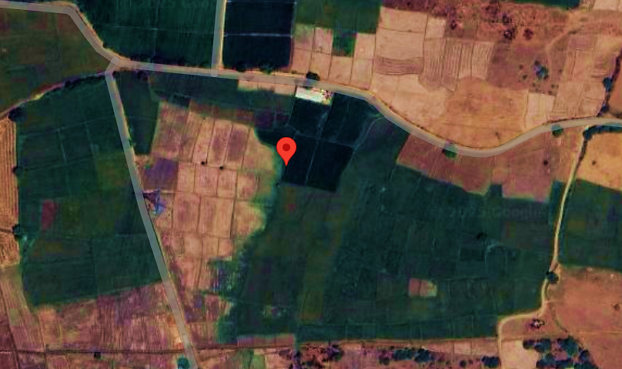
- Google Map Layout: Demarcation of the land with approximate measurement on the Google map is attached in the below picture:
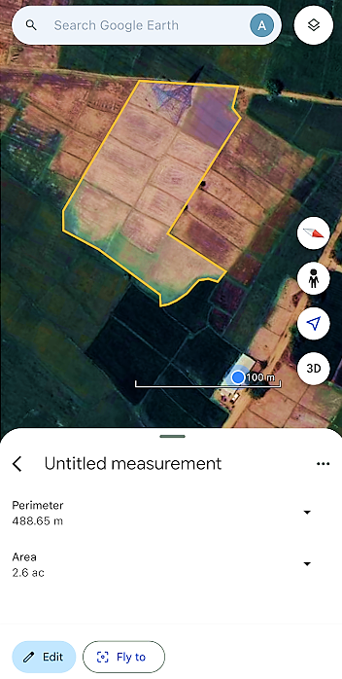
- LAYOUT PLAN:
As per the data/information provided by the client/Company, the layout plan is under preparation at the time of preparation of this report. We recommend the bank/financial institution to procure the approved layout plan from the company before disbursement of the loan.

- LAND DETAILS:
As per the lease deeds shared by the client/company, the promoters have leased 2 Acres and 22 Guntas (i.e., ~2.52 Acres) at Survey No. 685/ part, 686/part, Village-Kasala, District: Sangareddy, Telangana. This land has been leased out in the name of the company for 15 years with an option of with an option of renewal at the end of lease as per the shared lease deed executed on 23rd September 2024, for setting up the proposed Bio-CNG plant.
As per the information shared by the client/company, due to the presence of a high-tension electricity line over a portion of the land, the Nala conversion for the proposed Bio-CNG plant has been approved by the Tahsildar, Hathnoora Mandal, District Sangareddy, on February 21, 2025, for a total area of 2 Acres and 14 Guntas out of the total land parcel of 2 Acres and 22 Guntas.
During the site visit on 1st March 2025, we found it as a vacant land which was merged with the adjacent plots. The current access to the property is from the west side via a kuccha road approximately 12-15 feet wide. As per the company's information, a new entry is proposed from the north side of the property. However, during the site visit, we found that the property doesn’t have access route from the north side. The company is actively engaging with landowners to secure a passageway by leasing the land between the project site and the approach road, which is approximately 455 meters away. At the time of site visit, we found that the proposed land is not demarcated and work on the Project has not been started yet. As per informed by client, land development work will start soon.

- SITE PICTURES:
Site pictures were captured during the site survey on 1st March 2025, for reference few of the pictures are attached below:
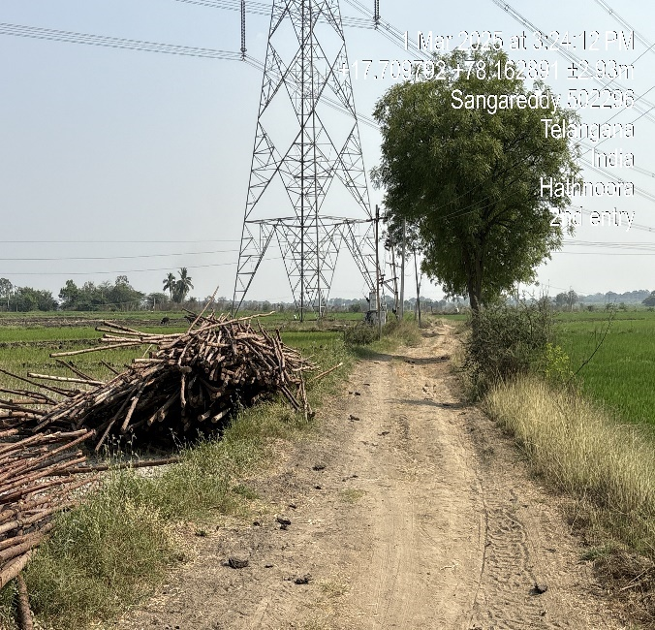 | 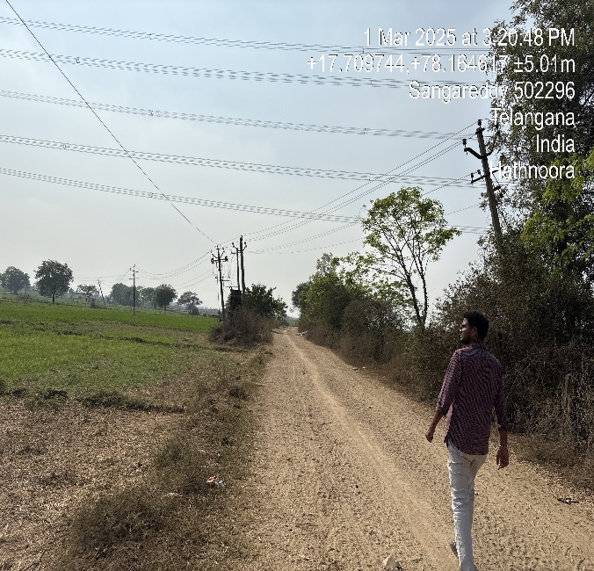
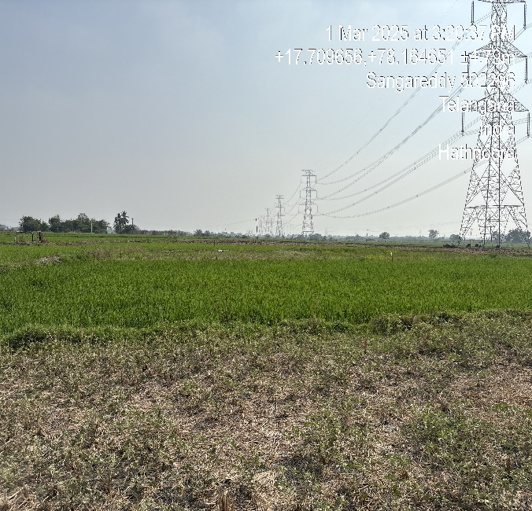 | 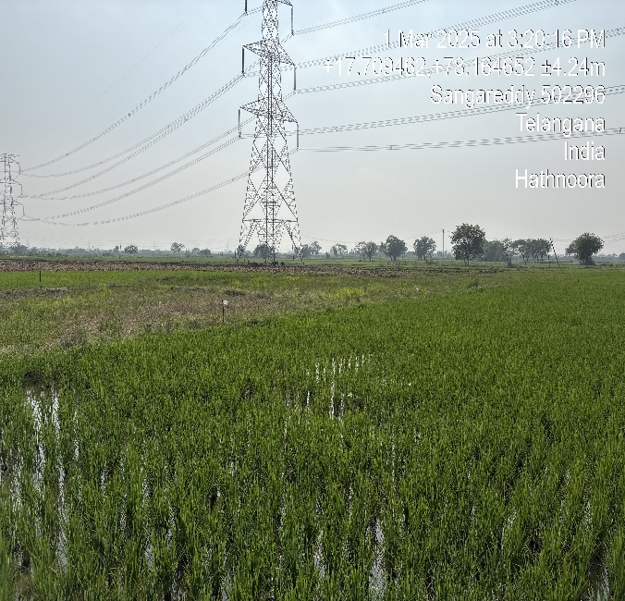
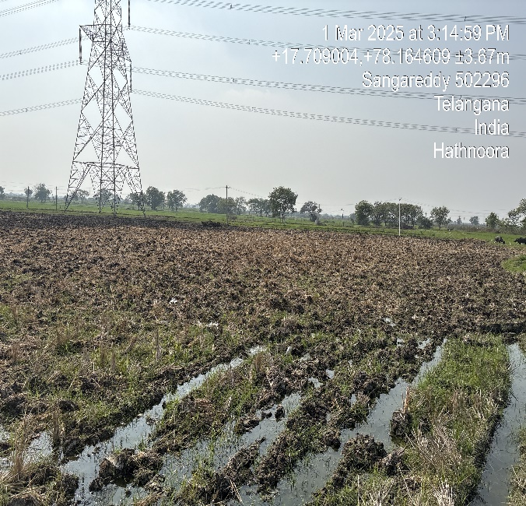 | 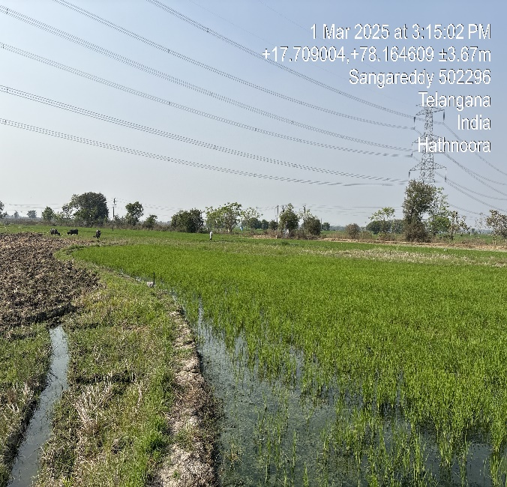
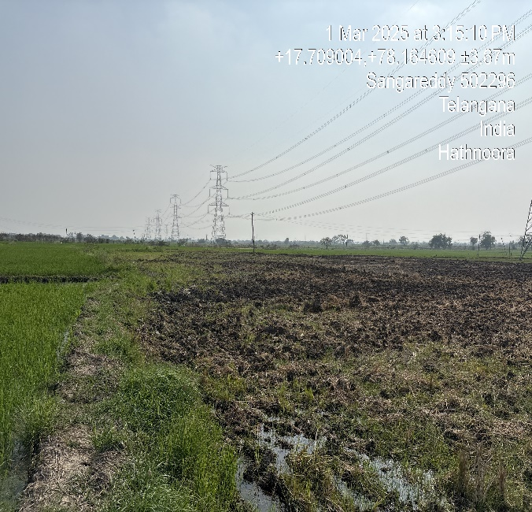 | 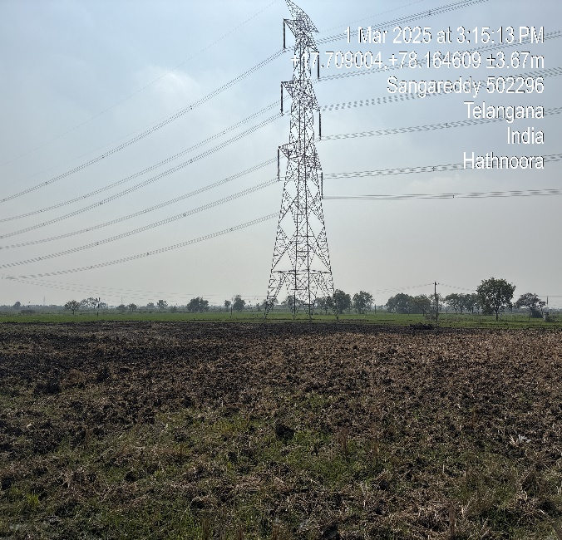
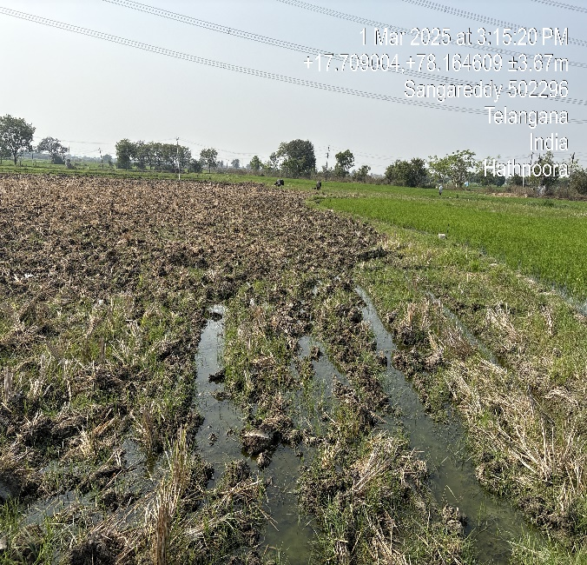 | 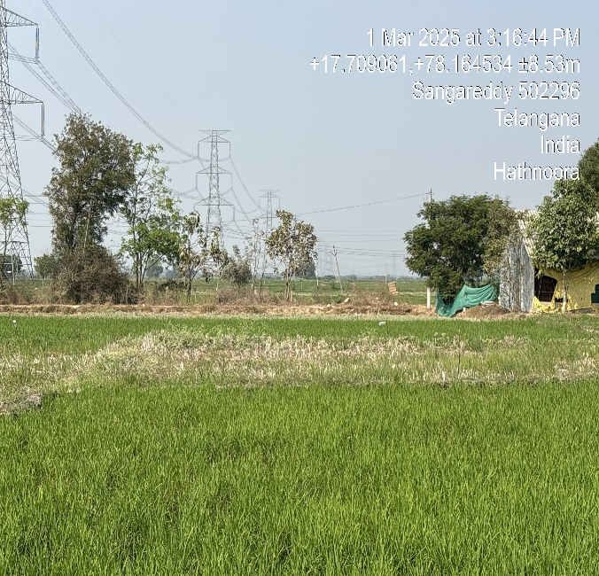
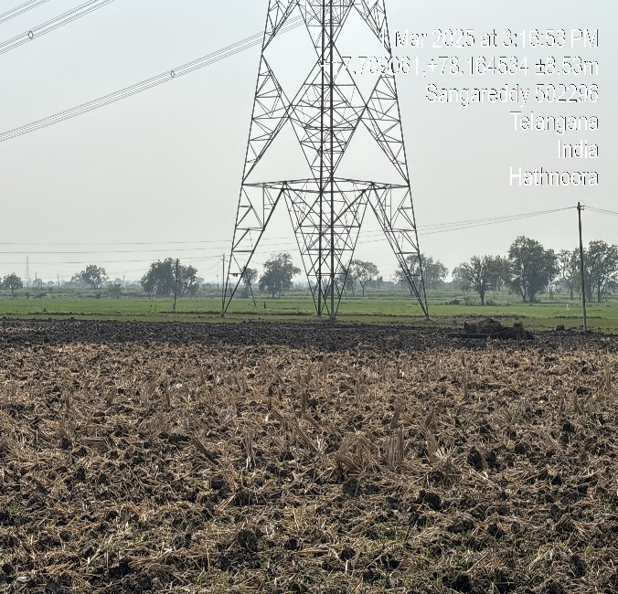 | 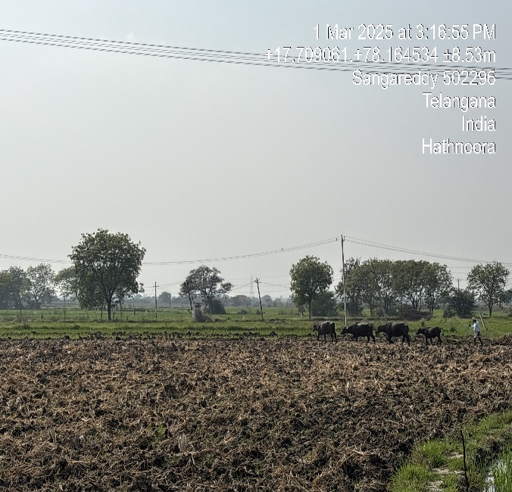
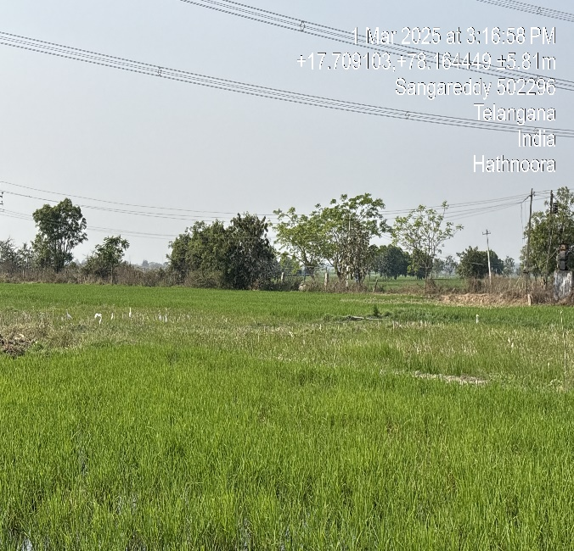 | 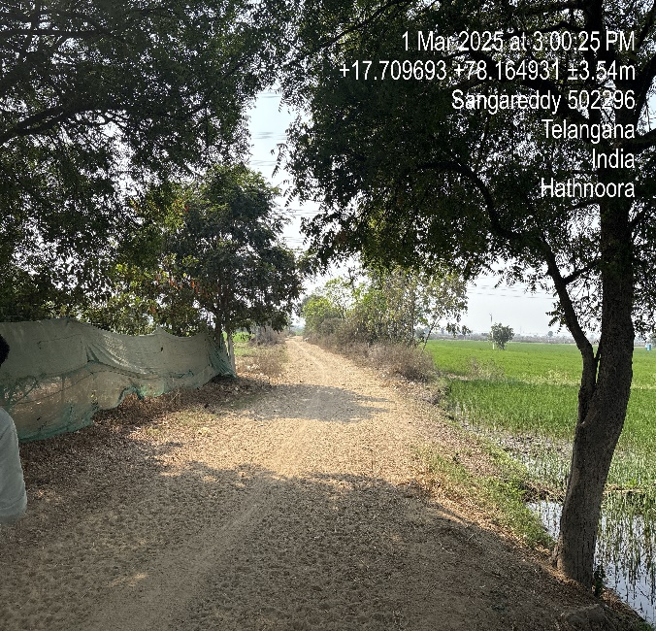
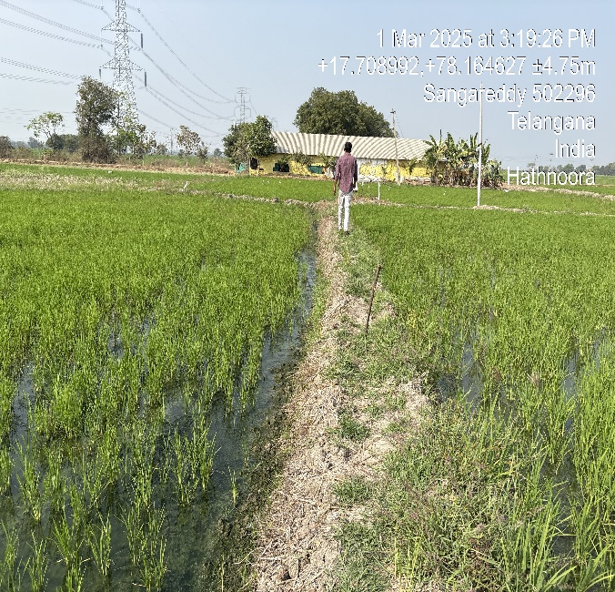 | 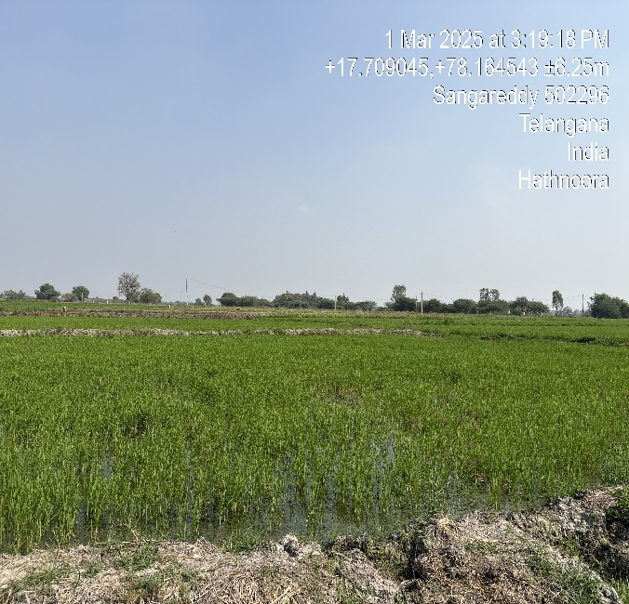

- BUILDING & CIVIL WORKS:
The Bio-CNG generating facility is proposed to be commissioned by the company itself. Detailed bifurcation of the scope of work for the proposed Building & Civil works alongwith the cost has been shown in the below table:
S. No. | Item | Specifications | Expected Landing Price
1 | Water Storage Tank | 20K LITERS, 5 RS PER LITER, 500 LPM WATER PUMP | 1,56,000
2 | Sheds (Feed Preparation) | 2500 SFT 4 SIDE OPEN SHED | 5,20,000
3 | Pre-Treatment Chamber | 600 M3 VOLUME, 230MM BRICK WALL | 3,74,400
4 | Excavation | HITACHI 200 & JCB FOR LEASE | 20,80,000
5 | Digesters | 2400 M3 *3 DIGESTERS | 1,30,28,080
6 | Digester In & Out Piping | CEMENT PIPES FOR DIGESTERS 24 INCH DIA | 5,19,480
7 | Effluent Tanks | 600 M3 VOLUME | 3,74,400
8 | Shed (Gas Upgradation) | 5000 SFT 4 SIDE OPEN | 10,40,000
9 | Solid Liquid Separator Foundation | CONCRETE FOUNDATION - 8*4*3 FEET | 2,07,917
10 | Briquettes Foundation | 13*4*6* FEET DEEP CONCRETE | 3,12,000
11 | Liquid Storage Pit | 300 M3 BRICKLESS POND TYPE PIT | 3,10,149
12 | Shed (Effluent Handling) | 1500 SFT 4 SIDE OPEN | 3,12,000
13 | Pulveriser Foundation |  | 1,06,080
14 | HDPE Piping |  | 3,39,976
15 | Mixing Chamber |  | 3,74,400
16 | Weighing Bridge |  | 2,37,120
17 | HT Line |  | 25,00,000
18 | Compound Works |  | 13,00,000
19 | Land Levelling |  | 1,50,000
20 | Approach Road Repair |  | 3,00,000
21 | Pre- Fab Office Container |  | 3,50,000
22 | Office Buildings |  | 5,00,000
23 | Labour Colony |  | 10,00,000
TOTAL |  |  | 2,63,92,002
Source: Data/Information provided by the client.
According to the details received by us, the estimated cost for Building & Civil works is approximately INR 2.64 crores, inclusive of applicable GST.

- PLANT & MACHINERY/ EQUIPMENTS DETAILS:
As per the data/information shared by the client/company, the company is expected to execute the development of the plant (engineering, procurement, installation & commissioning), all the machines/equipments would be directly procured by the Developer. Detailed bifurcation of the proposed Plant & Machinery as shared by the client/company has been shown in the below table along with the estimated cost:
S. NO. | ITEM | TOTAL AMOUNT | VENDOR DETAILS | SPECIFICATIONS | EXPECTED LANDING PRICE
1 | Crop Harvester | 54,00,000 | YLP Tractors | 5 MT/ HOUR, 50 HP, NEW HOLAND MAKE | 56,16,000
2 | Pulveriser | 6,98,000 | Sana Industries | 40 HP, 3MT/HR, 3 MM PARTICULATE SIZE | 7,25,920
3 | Slurry Pumps | 12,33,000 | Sujal Engineering | 637 M3/HR, 75 HP, 100 M HORIZOTAL HEAD | 12,82,320
4 | Mixing Chamber | 1,40,000 | Self-Execution | 600 M3 VOLUME WITH 5 HP AGITATOR | 1,45,600
5 | Conveyer System | 5,00,000 | Self-Execution | 5 HP SCREW CONVEYOR | 5,20,000
6 | HDPE Piping | 2,73,100 | Nagarjuna Polymers | 700 MTR LENGTH, 160 MM DIA, PN6 | 2,84,024
7 | Misc | 5,00,000 | Self-Execution | UN PLANNED IN SEGMENT | 5,20,000
8 | Weighing Bridge | 4,72,000 | VSM Industries (Weitrans) | 40 MT, 7.5*3 METERS IN SIZE | 4,90,880
9 | Domes | 1,16,01,443 | Self-Execution | 9.2 RADIUS, 3 MM SHEET THICKNESS | 1,20,65,501
10 | Biogas Piping | 2,00,000 | Self-Execution | GI/ MS PIPING | 2,08,000
11 | Recirculation Pumps | 7,50,000 | Sujal Engineering | 100 M3/HR, 15 HP, 25M HEAD | 7,80,000
12 | Limit Switches & Valves | 2,00,000 | Self-Execution | FLOATING TYPE WITH RELAY MODULE | 2,08,000
13 | H2s Removal System | 1,75,000 | Self-Execution | FERROUS OXIDE BASED | 1,82,000
14 | Water Scrubbing System | 6,45,000 | Self-Execution | 500 M3/HR WATER BASED | 6,70,800
15 | Amine Scrubbing System | 36,00,000 | Self-Execution | 500 M3/HR MEA BASED C02 ABSORBER | 37,44,000
16 | Eps System | 32,00,000 | Self-Execution | 500 M3 /HR | 33,28,000
17 | Automation | 7,00,000 | Self-Execution | PLANT AUTOMATION | 7,28,000
18 | Electrical Panels | 8,00,000 | Self-Execution | MACHINERY CONTROLLERS | 8,32,000
19 | Fire Suppression System | 5,00,000 | Ss Enterprises | 10 KG ABC MODULAR TYPE | 5,20,000
20 | Misc. | 10,00,000 | Self-Execution | UN PLANNED IN SEGMENT | 10,40,000
21 | Gas Analyzer | 12,00,000 | Diya Techno Solutions | PRE AND POST ONLINE CH4, CO2 VOLUME ANALYZER | 12,48,000
22 | Odoriser Tank | 1,20,000 | Self-Execution | MERCEPTAN BASED CHEMICAL DOPER | 1,24,800
23 | 250 Bar Compressor | 74,00,000 | Industrial Compressors and Cryo Pumps Limited | 250 KG / SQ CM, 125 M3 /HR FLOW RATE | 76,96,000
24 | Cascades | 36,00,000 | Balaji Enterprises | 3000 WATER LITERS | 37,44,000
25 | Misc | 10,00,000 | Self-Execution | UN PLANNED IN SEGMENT | 10,40,000
26 | Solid Liquid Separator | 5,50,000 | Vrinda Industries | 1 MT/HR CAPACITY, 7.5 HP | 5,72,000
27 | Briquettes Machine | 28,00,000 | Sree Engineering Works | 90MM, 1500 KG/HR, 75 HP | 29,12,000
 | TOTAL |  |  |  | 5,12,27,845
Source: Data/information provided by the client.
The cost of Plant & Machinery has been considered as per the data/information shared by the client/company. The estimated cost for plant & machinery will be ~INR 5.12 crores including GST.

- UTILITIES: Details of Water, Electricity and other utilities are described as below:
- WATER:
During the site inspection, we have found that the underground water is available at the project site. Company has yet to take the "No Objection Certificate" for groundwater extraction from the concerned authorities. Water facilities from Manjira River via pipeline is also available which is just ~700 m from the project site. The total requirement of the plant will be ~100 KL per day.
- ELECTRICITY:
As per the data/information provided to us by the client, Company is yet to apply for sanction of power load of 200 KVA. The estimated power requirement would be ~1624.8 Kwh per day to run the plant.

PART E | PROJECT TECHNICAL DETAILS

- CAPACITY OF THE PROPOSED BIO-CNG UNIT:
This Bio-CNG generating plant is proposed to be set up with a designed raw biogas generation capacity of 7,200 M3/Day to generate the 2,500 kg/day Bio-CNG along with 12,000 Kg/Day of Biomass Pellets (Briquettes) as illustrated in the below table:
Capacity of the proposed Bio-CNG plant
Particular | Capacity
Raw Biogas Plant Generation | 7,200 M3/Day
Bio-CNG Plant Capacity | 2,500 kg/Day
Biomass Pellets (Briquettes) Capacity | 12,000 Kg/Day
Source: Data/information provided by the client.

- PRODUCTION PROCESS OF BIO CNG (CBG):
Biogas is commercially produced by a process called anaerobic digestion. The process involves breakdown of organic waste materials such as animal waste, food waste and industrial sludge to produce biogas and digestate. The latter is further treated to be used as a fertilizer. Anaerobic digestion process is carried out in a sealed, oxygen-free tank, also called an anaerobic digester.
The KVIC Floating Dome Model is a time-tested and widely adopted biogas technology designed for decentralized energy production. When integrated with thermophilic bio-methanation technology, it significantly enhances biogas yield, digestion efficiency, and process stability. The key stages of the process are as follows:
- Feedstock Preparation and Loading
- The primary feedstock, such as Napier grass, agricultural residues, and organic waste, is chopped into smaller pieces to increase surface area and improve digestion.
- The prepared biomass is mixed with water or recycled digestate to form a homogeneous slurry before being fed into the digester.
- Anaerobic Digestion in KVIC Floating Dome Digester
- The slurry enters the KVIC Floating Dome Digester, a sealed chamber where thermophilic bacteria break down organic matter in an oxygen-free environment.
- The process operates at an optimal temperature of 50-55°C, maintained using heat recovery systems or external heating mechanisms, ensuring rapid microbial activity and enhanced biogas production.
- The floating gas holder dome moves up and down based on gas accumulation, automatically regulating pressure and ensuring a steady gas supply.
- Biogas Purification & Upgrading Process

Step 1: Hydrogen Sulfide (H₂S) Removal
- Method: Iron-based scrubbers or activated carbon filters.
- Efficiency: Reduces H₂S to <20 ppm.

Step 2: Water Scrubbing (CO₂ & Impurities Removal)
- Process: High-pressure water absorption removes CO₂ and other contaminants.
- Efficiency: Lowers CO₂ levels to ~10%.

Step 3: Amine Scrubbing (Further CO₂ Reduction)
- Technology: Uses proprietary amine solutions for selective CO₂ removal.
- Efficiency: Achieves CO₂ levels ≤ 3%.

Step 4: Proprietary Biogas Upgrading Technology
- Custom-designed process for final methane enhancement.
- Enhances methane content to ≥ 93% with improved calorific value.
- Ensures Bio-CNG meets IS 16087:2016 standards for automotive and industrial use.
- Gas Collection and Storage
- The generated biogas (primarily methane and CO₂) is collected within the floating dome, allowing easy extraction and utilization.
- The gas is then purified using an Electro dialysis purification system or other upgrading technologies to separate biomethane from CO₂ and impurities.
- The purified biomethane is compressed to 250 bar for storage and distribution in Cascaded high-pressure vessels and supplied to CNG outlets.
- Effluent Treatment and Nutrient Recovery
- The remaining digestate undergoes solid-liquid separation, where:
  - Liquid effluent is aerated and reused for irrigation in Napier farms, enriching soil fertility.
  - Solid residues are solar-dried and processed into briquettes, serving as a renewable biomass fuel.
- Sustainable Utilization and Zero-Waste Approach
- The KVIC model ensures zero waste discharge, as all by-products, including biogas, organic fertilizers, and briquettes, are fully utilized.
- The closed-loop system enhances resource efficiency, reduces dependence on fossil fuels, and promotes environmentally sustainable energy production.
By integrating the KVIC Floating Dome Model with thermophilic bio-methanation technology, biogas production becomes more efficient, cost-effective, and environmentally friendly, making it an ideal choice for rural energy solutions and decentralized waste management.

- PROCESS FLOW CHART OF THE PROPOSED BIO-CNG PLANT:
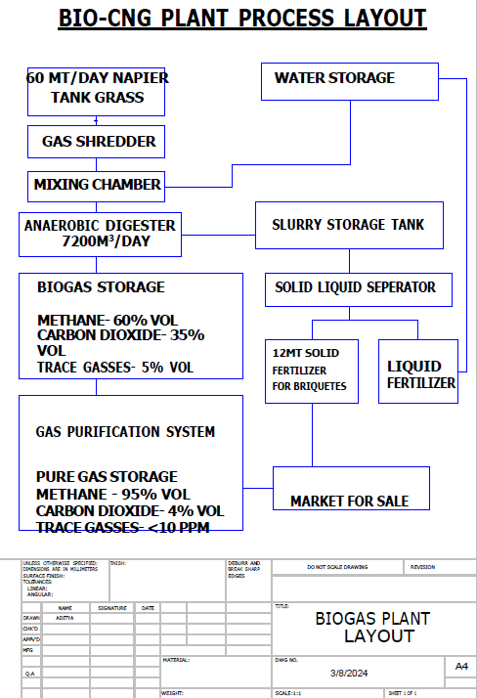
Source: Data shared by client

- TECHNICAL SPECIFICATIONS OF THE PROPOSED BIO-CNG PLANT:
As per the data/information provided by the client, below table shows the technical specification of the proposed Bio CBG generating plant:
      - Feed Preparation:
S. NO. | ITEM | DESCRIPTION
1 | Crop Harvester | 10MT /HR
2 | Pulveriser | 6 MT/HR
3 | Slurry Pumps | 1200 M3/HR
4 | Water Storage Tank | 20K Litres, 500 LPM Water Pump
5 | Mixing Chamber | 600 M³ Volume
6 | Conveyer System | Screw Conveyer
7 | HDPE Piping | 700 MTR
8 | Weighing Bridge | 40 TONS CAPACITY
      - Biogas Portion
S.NO | ITEM | DESCRIPTION
1 | Pre- Treatment Chamber | 600 M3
2 | Digesters | 7200 M3
3 | Domes | 3 NOS
4 | In & Out Piping | Cement Pipes
5 | Effluent Tanks | 600M3
6 | Biogas Piping | MS / GI Piping
7 | Recirculation Pumps | 100 M3 /HR
8 | Limit Switches & Valves | LPS
      - Gas Upgradation:
S.NO | ITEM | DESCRIPTION
1 | H2S Removal System | Ferrous Oxide Based
2 | Water Scrubbing System | 500 M3/HR
3 | Amine Scrubbing System | 500 M3/HR
4 | EPS System | 250 M3/HR
5 | Fire Suppression System | C02 /Water Based
      - Gas Bottling & Storage
S.NO | ITEM | DESCRIPTION
1 | Odorizer Tank | Mercaptan Based
2 | 250 Bar Compressor | 250 M3/HR * 2 Units
3 | Cascades | 3* 3000 Water Litres
      - Effluent Handling
S.NO | ITEM | DESCRIPTION
1 | Solid Liquid Separator | 1 MT /HR
2 | Briquette Machine | 1.5 MT/HR

- TECHNOLOGY USED:
The project is proposed to be commissioned based on the KVIC Floating Dome Model with Thermophilic bio-methanation technology, which will be a semi-automatic. As per the information shared by the company, they have planned to execute the project on their own as the company has successfully developed a 80 Kg Bio-CNG Plant for R&D purposes in the state of Telangana.
PROPOSED TECHNOLOGY:
The Khadi and Village Industries Commission (KVIC) Floating Dome Digester is a proven and widely adopted biogas technology in India, particularly for decentralized biogas production. It offers a cost-effective and efficient solution for sustainable energy generation. When combined with thermophilic bio-methanation, it offers higher efficiency, reduced retention time, and increased gas yield compared to conventional mesophilic digesters.
KEY FEATURES:
- Floating Dome Design: The gas holder (dome) moves vertically based on gas production, ensuring automatic pressure regulation and efficient gas collection.
- Optimized Temperature Control: A built-in temperature regulation system maintains ideal digestion conditions, enhancing microbial activity and ensuring consistent gas production.
- Slurry Recirculation System: Integrated pumps continuously recirculate slurry, preventing sediment buildup at the bottom and reducing manual desilting efforts.
- Rotating Dome with Welded Paddles: Designed to enable manual slurry mixing at intervals, eliminating the need for expensive mechanical agitators while ensuring uniform digestion.
- Scum Prevention Mechanism: Regular mixing prevents scum formation, avoiding blockages that could hinder gas release and system efficiency.
- Energy-Efficient Operation: The absence of mechanical agitators minimizes electricity consumption, maintenance costs, and operational complexities.
- High Gas Yield & Efficiency: Optimized slurry mixing enhances the digestion process, ensuring continuous and increased biogas production.
- Simplicity & Cost-Effectiveness: The model is easy to construct, operate, and maintain, making it ideal for reliable, breakdown-free applications in both rural and urban settings.
The KVIC Floating Dome Model with Thermophilic Bio-Methanation Technology is a cost-effective, high-efficiency solution for CBG production. It is best suited for agro-waste-based biogas plants where simplicity, affordability, and sustainability are key considerations.

- LATEST TECHNOLOGY/TECHNOLOGICAL ASSESSMENT:
The KVIC Floating Dome Model with Thermophilic Bio-Methanation Technology is a cost-effective and reliable approach for CBG production, particularly suited for small to medium-scale operations. Compared to modern technologies like Continuous Stirred-Tank Reactors (CSTR), Plug Flow Digesters, and Dry Anaerobic Digestion, the KVIC model offers lower capital and operational costs, simplicity in design, and minimal mechanical components, making it ideal for rural and decentralized applications. The following table compares KVIC technology with some of the latest CBG production technologies:
Parameter | KVIC Floating Dome Model (Thermophilic Bio-Methanation) | CSTR (Continuous Stirred-Tank Reactor) | Plug Flow Digester | Dry Anaerobic Digestion
Process Type | Semi-continuous batch digestion | Continuous digestion with stirring | Continuous flow process | Batch-wise solid-state digestion
Temperature Range | Thermophilic (50-55°C) | Mesophilic (35-40°C) or Thermophilic (50-55°C) | Mesophilic (35-40°C) | Thermophilic (50-55°C)
Feedstock Suitability | Best for Napier grass, cattle dung, agro-waste | Flexible – food waste, agro-waste, MSW, industrial waste | Suitable for fibrous biomass (agro-waste, Napier grass) | Best for high-solid feedstocks (organic MSW, agro-residues)
Gas Holder Mechanism | Floating dome that moves based on gas production | Fixed dome or external gas storage system | Fixed dome | No dome; gas extracted through pipes
Gas Yield Efficiency | Moderate (~50-60% CH₄ content before purification) | High (~60-70% CH₄ content before purification) | Moderate (~55-65% CH₄ content before purification) | High (~65-75% CH₄ content before purification)
Hydraulic Retention Time (HRT) | ~20-25 days | ~15-25 days | ~25-30 days | ~25-30 days
Capital Cost | Low (~INR 3-5 Crore per ton CBG capacity) | High (~INR 5-7 Crore per ton CBG capacity) | Moderate (~INR 4-6 Crore per ton CBG capacity) | High (~INR 6-8 Crore per ton CBG capacity)
Operational Complexity | Low (Simple design, manual mixing) | Moderate-High (Requires mechanical stirring and process control) | Moderate (Minimal mechanical mixing) | High (Advanced process control required)
Scalability | Small to medium-scale | Large-scale (Industrial applications) | Medium to large-scale | Large-scale (Industrial applications)
Slurry Management | Requires separation for liquid fertilizer and briquettes | Advanced solid-liquid separation systems | Similar to KVIC model | Produces dry digestate, easier handling
Automation | Low (manual mixing and gas collection) | High (automated feeding, gas upgrading) | Moderate (semi-automated) | High (fully automated with controlled process conditions)
Best Use Case | Rural biogas plants, community-scale projects | Large-scale CBG plants, industrial setups | Dairy farms, sugar mills, agro-based industries | MSW-based biogas plants, high-solid waste processing
The choice of technology depends on the feedstock availability, project scale, investment capacity, and operational complexity. The KVIC Floating Dome Model remains a viable choice for low-cost and small-to-medium-scale CBG production, whereas CSTR and dry digestion technologies are preferred for industrial-scale CBG plants with higher efficiencies and automation levels.
Based on the above technical assessment, M/s Blueleo Energy Pvt Ltd has opted for a traditional yet well-recognized technology that is currently in use in the market. The chosen technology appears suitable for the intended operations, and the plant is expected to function effectively. While the specifications align with the requirements for smooth operation and scalability, the overall performance will depend on factors such as operational efficiency, maintenance, and feedstock management.

- EFFLUENT TREATMENT AND ABETMENT:
The effluent treatment process in a Napier grass-based biogas plant incorporates an efficient solid-liquid separation system, utilizing decanters or screw presses to optimize resource recovery. The liquid effluent undergoes aeration before being repurposed for irrigation in Napier farms, contributing to nutrient recycling and sustainable agricultural practices. Meanwhile, the separated solids are subjected to solar drying, allowing for natural moisture evaporation. Once adequately dried, these solids are further processed into briquettes, serving as an environmentally friendly alternative fuel source. This zero-waste approach maximizes both energy recovery and soil enrichment, reinforcing a circular economy within the biogas production cycle.

- TESTING STANDARDS FOR PRODUCTION:
In India, the testing standards for Compressed Biogas (CBG) are primarily governed by the Bureau of Indian Standards (BIS), Ministry of New and Renewable Energy (MNRE), and other regulatory bodies. The key standard for CBG is IS 16087:2016, which specifies the quality requirements for biogas used as a fuel. Below are the main parameters and standards applicable to CBG in India:
Bio-CNG:
- Gas Composition Analysis: Methane (≥ 93%), CO₂ (< 4%), H₂S (< 50 ppm) as per IS 16087:2016.
- Calorific Value Testing: Should meet 52,000-55,000 kJ/kg for vehicular and industrial use.
- Moisture & Impurity Removal: Compliance with ISO 15403-1 for pipeline injection and engine safety.
- Compression & Storage: PESO-approved cylinder pressure testing and safety standards.
Briquettes:
- Moisture Content: Should be below 10% for optimal combustion efficiency.
- Calorific Value: Typically 3,500-4,500 kcal/kg, tested per ASTM D5865.
- Ash Content & Density: Should meet BIS 13574:2021 for biomass briquettes.
- Durability & Strength: Drop test and compressive strength evaluation for transport stability.
As per communicated by client, company will be having a quality control Laboratory, wherein, they check the entire range on defined parameters like design, quality and finish. The unit is proposed to be equipped with all the essential tools, machine, and technology in order to ensure the production quality as per the standard benchmark.

- MANPOWER:
As per information shared by the client/.company, an estimate of manpower requirement allowing for leave, absentecism, sickness and holidays for smooth and for efficient operation of different sections of the plant including its administrative and commercial departments, has been prepared based on technical and management ground primarly to indicate the order of manpower requirement.
In estimating the manpower requirement, a proper ratio between the administrative, managerial, supervisory and shop foor staff has been maintained with a view to affording proper industrial and professional management at various levels. The basic structure of the manpower will require the following kind of resources to opearte the plant 24*7 for 300 days a year:
Proposed Manpower details along with Cost (INR)
Type of personnel | Quantity | Type of skill | Average Monthly Salary
Plant Manager | 1 | High Skilled | 50,000
Accountant | 1 | Skilled | 25,000
Supervisor | 1 | Semi-Skilled | 20,000
Pulveriser operator | 2 | Semi-skilled | 20,000
Weighing bridge operator | 2 | Semi-skilled | 20,000
Feeding operator | 1 | Semi-skilled | 18,000
Un skilled helper | 2 | Unskilled | 15,000
EPS operator | 1 | Skilled | 25,000
Electrician | 2 | Skilled | 20,000
Input material handling labour | 2 | Unskilled | 15,000
Briquets handing labour | 2 | Unskilled | 15,000
Un skilled material loaders | 2 | Unskilled | 15,000
Other Sub Staff | 2 | Unskilled | 15,000
Total | 21
Source: Data/information provided by the client.
Company has proposed to deploy 21 human resources initially, which comes out with 8.5 workers per ton for the proposed Bio-CNG generating plant which is in permissible range as per the standard benchmark of the industry.
(Ref: https://pib.gov.in/PressReleasePage.aspx?PRID=1868887) The Sangrur CBG Plant shall provide direct employment to 390 and indirect employment to 585 people. This is a 33TPD capcity plant, thus it comes out with ~12 workers per ton.

PART F | PRODUCT PROFILE

- INTRODUCTION:
CBG has calorific value and other properties similar to CNG and hence can be utilized as green renewable automotive fuel. Thus it can replace CNG in automotive, industrial and commercial areas. Ministry of Road Transport and Highways, Government of India had permitted usage of bio-compressed natural gas (bio- CNG) for motor vehicles as an alternate composition of the compressed natural gas (CNG).
The compressed biogas, or Bio-CNG, is likely to play a crucial role in promoting India’s transition to a sustainable energy ecosystem. Bio-CNG is a green renewable automobile fuel with calorific value and other qualities similar to compressed natural gas (CNG).

- PRODUCT CATEGORY:
- BIO CNG:
The proposed plant will be generating 2,500 Kg/ day of Bio-CNG which has a gross calorific value of •~52,000 kJ/kg (12,400 kcal/kg). Methane is the most valuable component under the aspect of using biogas as a fuel; the other components do not contribute to the calorific value and thus are "washed out" in the purification plants in order to obtain a gas with almost ≥ 93% CH₄. Methane is the flammable compound in biogas. Composition of the purified Bio-CNG has been shown in the below table:
Purified Biogas (Bio-CNG) Specifications
Ingredient | Value
Methane (CH₄) | ≥ 93%
Carbon Dioxide (CO₂) | ≤ 3%
Hydrogen Sulfide (H₂S) | < 20 ppm
Oxygen (O₂) | < 0.5%
Nitrogen (N₂) | < 1%
Moisture Content | < 0.015 g/m³
Source: Data/information provided by the client.
Bio-CNG, a clean and renewable fuel, has vast potential in India. It can be a supplement to petroleum products, if used in compressed form in the cylinders. Biogas originates from bacteria in the process of biodegradation of organic material under anaerobic conditions.
Bio CNG is having the applicability in various Industries and used as Automobiles Fuel. It is capable to be used in Canteens, Restaurant, Hotels, Sweet shop, Dhabas etc.
Equivalent Quantity Of Fuel For 1 Cu M Of Biogas
Equivalent | Value
Biogas | 1.00 M³
Kerosene | 0.620 Liter
Fire wood | 3.474 Kg
Charcoal | 1.458 Kg
Butane | 0.433 Kg
LPG | 0.456 Kg
Electricity | 1.5 Kwh
As per the data shared by the client, the produced CBG will have a calorific value of approximately 52,000 kJ/kg (12,400 kcal/kg), ensuring significant energy output per unit mass. With a density of around 0.72 kg/m³, the gas maintains an efficient combustion profile. For storage and transportation, the gas is typically compressed to a pressure range of 200-250 bar, facilitating safe and efficient handling. Additionally, the Wobbe Index falls within the range of 45-52 MJ/m³, indicating high interchangeability with other fuel gases without requiring major equipment modifications. The flame temperature reaches approximately 1,960°C, ensuring efficient thermal energy utilization in various industrial and commercial applications.
- BIOMASS PELLETS (BRIQUETTES):
The plant has a capacity to produce 12,000 Kg/ day of Biomass Pellets (Briquettes). The material drawn from the digester is called sludge, or effluent., which is rich in nutrients (ammonia, phosphorus, potassium, and more than a dozen trace elements) and is an excellent soil conditioner.
Quality of Briquettes: Briquettes derived from organic biomass offer high calorific value and energy efficiency, making them an eco-friendly and sustainable alternative to conventional fossil fuels. These briquettes have a Carbon-to-Nitrogen (C:N) ratio between 12:1 to 16:1, ensuring optimal combustion properties and minimal emissions. They are a rich source of carbon, which enhances burning efficiency and heat output.
Elemental Composition of Briquettes
Calcium (Ca) | 1-3 %
Carbon (C) | 35-50%
Magnesium (Mg) | 0.2-1.5%
Sulphur (S) | 0.2-1%
Nitrogen (N) | 1.5-4%
Phosphorous (P) | 0.5-2%
Potassium (K) | 1-5%
One ton of briquettes provides a higher energy yield compared to traditional firewood or coal, making them a cost-effective and sustainable fuel alternative. The presence of microelements such as zinc (Zn), copper (Cu), and manganese (Mn) in the original biomass material remains in the briquette ash, which can be reused as a soil enhancer for agricultural purposes.
Briquettes are widely used as a renewable fuel in industrial, commercial, and domestic applications due to their high energy density and low ash content.
Application of organic manure
Application | Usage (Kg/Unit) | Time of application
Industrial Boilers & Power Plants | 400-800 Kg/Unit | Continuous Feed
Domestic Heating (Stoves & Fireplaces) | 5-10 Kg per Use | As Required
Commercial Cooking & Food Processing | 200-400 Kg/Day | Based on Demand
Brick Kilns & Other Industrial Uses | Bulk Supply | Continuous Feed
To maintain the efficiency of briquettes, proper storage is crucial. They should be kept in a dry and well-ventilated area to prevent moisture absorption, which could reduce their burning efficiency. Storing them in covered stacks ensures a longer shelf life and optimal thermal performance for diverse energy applications.

- PRICING STRATEGY:
As per the data/information provided by the client, LLP has already signed a LOI with Indian Oil Corporation Ltd on 1st January 2025. (Ref No. - Indian Oil/SATAT/01/3961). The current selling rate of CNG at OMC outlets in Hyderabad, Telangana is around INR 96.00/kg. (https://www.goodreturns.in/cng-price-in-hyderabad.html/), however the procurement price of Bio-CNG from Indian Oil as per the SATAT Scheme is around @INR 74.29 per kg without GST. “CBG Pricing Circular- SATAT Scheme” is attached below for reference:
As of November 2024, the Ministry of Power has established benchmark prices for biomass pellets to promote sustainable energy practices in thermal power plants across various regions in India. For the Western Region, which includes states like Maharashtra and Gujarat, the benchmark price for non-torrefied biomass pellets is set at ₹2.24 per 1,000 kcal. These pellets are required to have a moisture content below 14% and a Gross Calorific Value (GCV) between 2,800 to 4,000 kcal/kg. This pricing structure is effective from November 8, 2023, for a period of one year, and excludes Goods and Services Tax (GST) and transportation costs at the pellet manufacturing plant site. For the Northern Region, excluding the National Capital Region (NCR), the benchmark price has been determined at ₹2.27 per 1,000 kcal under similar conditions. (Source: energy.economictimes.indiatimes.com)
Specific benchmark prices for biomass pellets in the Southern Region, including Telangana and its capital Hyderabad, have not been explicitly outlined in the available sources. However, local market data indicates that biomass pellets in Hyderabad are available at approximately ₹17 per kilogram. (Source: tradeindia.com)
This price point is higher than the benchmark prices set for other regions, which may be attributed to factors such as higher calorific value, local market demand, production costs, and supply chain logistics. For biomass pellets with a GCV of 4,800 kcal/kg, the price can be calculated based on the benchmark rates. Using the Northern Region's rate of ₹2.27 per 1,000 kcal, the price per kilogram would be approximately ₹10.90 (₹2.27 × 4.8).
The selling price of Bio-CNG is considered on conservative side as INR 74.29/kg. The selling rate of Biomass Pellets (Briquettes) is assumed as INR 8.00 per kg on conservative side.

- MARKETING, SELLING & DISTRIBUTION PLAN:
- BIO CNG:
The Bio-CNG produced has to be sold to Indian Oil Corporation Ltd stations situated within 25-75 km, for which the company have already secured a purchase agreement/LOI (Ref No. - Indian Oil/SATAT/01/3961, Date: 1st Jan 2025).

- ORGANIC FERTILIZER:
The by-product of the biogas generation process is high-calorific biomass briquettes, which serve as an efficient and eco-friendly alternative to conventional fossil fuels. As informed by the client, these biomass briquettes are in high demand as a sustainable fuel source for industrial and commercial applications, including boilers, kilns, and power plants. The briquettes are to be directly marketed through appropriate distribution channels and assumed to be sold at a competitive price of INR 8.00/Kg, ensuring both economic and environmental benefits for end users.
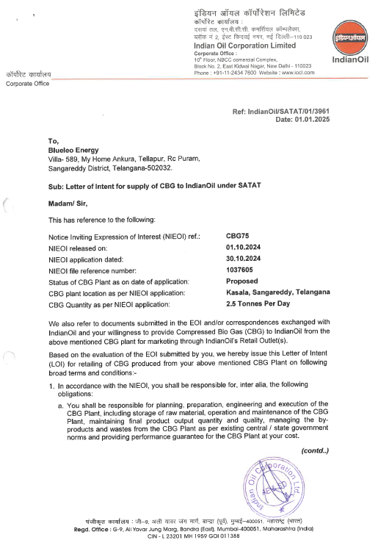

PART G | FEEDSTOCK ANALYSIS

- INTRODUCTION:
Bio-Methane from Anaerobic Digesters (AD): Anaerobic processes could either occur naturally or in a controlled environment such as a biogas plant. Organic waste such as livestock manure and various types of bacteria are put in an airtight container called digester so the process could occur. Depending on the waste feedstock and the system design, biogas is typically 55 to 60 percent pure methane. The state-of- the-art systems report producing biogas that is more than 95 percent pure methane.
The primary component of an AD system is the anaerobic digester, a waste vessel containing bacteria that digest the organic matter in waste streams under controlled conditions to produce Bio-methane. As an effluent, AD yields nearly all of the liquid that is fed to the digester. This remaining fluid consists of mostly water and is recycled to flush manure from the swine building to the digester.
Approximate Quantity Required for Generation of One M³ Biogas
S. No. | Substance | Quantity (Kg)
1 | Cattle Dung | 20
2 | Paddy Straw | 4
3 | Napier grass | 8
4 | Poultry Waste | 8
5 | Horse/ Mule/ Elephant Dung | 12-15
6 | Food waste: Pre and post cooked leftover food from households, hotels and canteens. | 10-12
7 | Green waste (vegetable market waste): Vegetable Refuses from Vegetable Markets or kitchens. | 10-12
8 | Paddy straw/ wheat straw/ mushroom spent waste: Lawn cuttings, leafy biomass, dried flowers, finely chopped and ground straw or bagasse. | 5-8
9 | De-oiled rice bran | 3-4
10 | De-oiled seed cake (Pongamia/ Jatropha) | 3-4
11 | Segregated municipal solid waste (biodegradable) | 12-15
12 | Slaughter house waste | 5-10

Approximate Required Quantities of the Substances (Alone)
Sr. No. | Item | Daily Required Quantity (Ton)
1 | Agriculture Products (Rice Stubble, Napier Grass etc.) | 100-110
2 | Poultry Droppings | 98-100
3 | Food Waste | 175-180
4 | Paddy Straw | 130-150
Combination of any of these mentioned above can also work in proportionate quantity. However, as per feed stock analysis the CBG plant will be using the following Combination of Raw Materials, while it should be noted that the feed stock quantity may very base on dry matter and volatile matter available in the below mention combination of feed stock:
Proposed Combination of Raw material
S. No. | Item | Daily Input Quantity (Ton)
1 | Napier Grass | ~60

- NAPIER GRASS:
Napier grass, also known as elephant grass, is a productive and versatile forage grass native to Africa and Southeast Asia. Napier Grass is an ideal substrate for biogas Production. In India, the reported annual production yield of Napier grass ranges from 150-200 tonnes per acre per year, which is significantly higher (25-35 tonnes per hectare) compared to other energy grasses like miscanthus and switchgrass.
Composition of Super Napier grass
Parameters, % | Fresh, % | Dry Matter, %
Crude Protein, % | 1.21 | 8.12
Crude Fibre, % | 5.37 | 36.02
Crude Fat, % | 10.12 | 67.87
Moisture, % | 85.09 | -
Ash, % | 1.01 | 6.77
Neutral Detergent Fibre, % | 10.2 | 68.41
Napier grass is categorised as lignocellulosic biomass, with its carbohydrate composition typically consisting of 35-39 per cent cellulose, 19-23% xylan and 15-19% lignin on a dry mass basis. With an energy output-to-input ratio of approximately 25:1, it emerges as one of the most promising energy crops.
Studies have shown that Napier Grass has a high methane yield due to higher cellulose and crude protein, making it an efficient source of Bio-CNG with the potential for significant energy output. The cultivation of Super Napier stick seed grows very easy and fast and get the height of 6 feet in 30 days. This fast-growing perennial grass can reach a height of 10-15 feet and can be harvested 5-6 times annually.
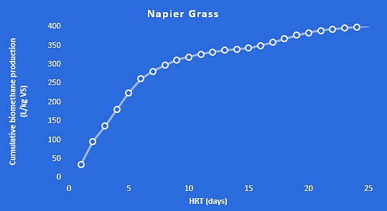
Napier grass, also known as elephant grass, is a productive and versatile forage grass native to Africa and Southeast Asia. Due to its high yield, it is widely used as feed for livestock and in bioenergy applications. While it may be a relatively new energy crop in India, Thai farmers have been cultivating it for over 30 years, with more than 130 varieties. This fast-growing perennial grass can reach a height of 10-15 feet and can be harvested 5-6 times annually.
The first harvest occurs four months after planting, followed by subsequent harvests every two months for up to seven years. Napier grass is categorised as lignocellulosic biomass, with its carbohydrate composition typically consisting of 35-39 per cent cellulose, 19-23 per cent xylan and 15-19 per cent lignin on a dry mass basis. With an energy output-to-input ratio of approximately 25:1, it emerges as one of the most promising energy crops for the creation of cost-effective and efficient bioenergy systems.
In India, the reported annual production yield of Napier grass ranges from 150-200 tonnes per acre per year, which is significantly higher (25-35 tonnes per hectare) compared to other energy grasses like miscanthus and switchgrass. However, there are specific varieties that have shown even higher yields. Few microbiologists and farmer, achieved biomass productivity of 350-400 tonnes per acre per year by cultivating a hybrid variety called Super Napier in Maharashtra's Gondia district.
Through experiments, it was discovered that with a 24-hour microbial pre-treatment, 100 kgs of the grass yielded 6 kgs. of biogas, which had a 62.3 per methane content. Alternatively, when the same feedstock underwent a 24-hour pre-treatment with 1 per cent Noah, a slightly higher yield of 6.5 kg of biogas with 61.5 per cent methane content was obtained.
Another crucial factor to consider is the operational intricacies of a CBG plant exclusively reliant on Napier grass. Numerous laboratory-scale studies have demonstrated that co-digestion, involving a combination of Napier grass with cow dung or food waste, results in higher yields compared to using Napier grass alone.
Moreover, it is essential to note that Napier grass is a warm-season grass and undergoes dormancy during the winter months. To ensure an uninterrupted supply of feedstock throughout the year for the CBG plant, it is vital to have alternative feedstock options available during the winter season.
There are many Operational and under construction plants using Napier Grass as Raw material in India such as Maruti Suzuki India Limited, Manesar Unit – Food waste or Napier Grass as Raw Material, GPS Renewable – Multiple Bio-CNG projects with 150 TPD Agri-residue including paddy straw, Napier grass for Reliance Industries, producing an output of 18 to 20 TPD of Bio-CNG per day and Gruner Renewable Energy – Multiple Bio-CNG projects worth of Rs. 1500 Cr on Agri-residue including paddy straw, Napier grass.

- AVAILABILITY OF RAW MATERIAL:
As per the feedstock analysis and the data/information provided by client, plant will require ~50-60 tons per day Napier Grass to produce the 2.50-ton Bio-CNG per day.
The plant will use approximately 18,000 tons of Napier Grass – contributing to wealth generation for the local community while at the same time being a part of the solution to the problems of import dependence for India’s energy needs. For the procurement of the Raw Material, the company has signed a long-term supply agreement with Mr. G. Vijay Bhashkar Reddy (Individual Farmer) on 6th April 2024 to supply atleast 50 ton of Napier Grass per day.

- PRICING:
Pricing of the raw material i.e., Napier Grass is considered as per the long-term supply agreement. According to the terms & conditions stated in the agreement, Mr. G. Vijay Bhashkar Reddy will supply a minimum of 50 MT of Napier Grass per day as per the specifications and in the manner as mutually agreed between the parties. Mr. Reddy is responsible to cultivate and supply Napier Grass to the company for the purpose of Gas Production and its derivatives with a rate of INR 0.54 per kg with an increment of 5% every 3 years.

PART H | INDUSTRY OVERVIEW

- INTRODUCTION:
Bio-CNG is considered a renewable fuel and has also been proven to reduce the emission of greenhouse gasses when used as a transport fuel. Bio-CNG, derived from the filtration of biogas, is also referred to as Compressed Biogas (CBG) and bio-methane. It is derived from biogas after removing impurities like carbon dioxide and hydrogen sulphide. As per the details available on Gobardhan Portal (https://gobardhan.co.in/), approx. 118 CBG/Bio CNG plants are completed and functional in 187 districts and 201 CBG/ Bio CNG plants are under construction at present.
Bio-CNG plants get financial and other incentives from the Union government under the Sustainable Alternative towards Affordable Transport (SATAT) Scheme. The scheme, launched in 2018, supports the establishment and expansion of bio-CNG plants that use waste to produce biofuel. Under the scheme, the Union government plans to establish a total of 5,000 bio-CNG plants in India by the end of FY 2025.
- POTENTIAL AND EXPANSION:
In India, around 70 percent of the sugarcane is produced by three major states – Uttar Pradesh, Maharashtra, and Karnataka. India produces, on an average, over 300 million metric tonnes of sugarcane per year. Around 3.5 percent of this, can be the amount of press mud produced. At this rate, India has the potential to produce around 10 million metric tonnes of press mud/filter cake per year that could be diverted for producing bio-CNG.
Indian sugar industry while crushing around 300 million tonnes of sugarcane and producing about 10 million tonnes of press mud annually can offer compressed bio-methane/bio-CNG to the extent of 0.4 million metric tonnes .
Feedstock | Pan India accessible amount (TPD) | Biogas potential per ton (kg) | Bio-CNG potential per ton (kg) | Pan India CBG potential (TPD)
Urban food waste, fruit and vegetable | 50,000 | 75 | 40 | 2,000
Poultry litter | 1,00,000 | 100 | 60 | 6,000
Press mud | 1,00,000 | 150 | 80 | 8,000
Total |  |  |  | 16,000
The Bio-CNG potential in India is estimated at 62 million metric tonnes (MMT) per annum, out of which the Sustainable Alternative towards Affordable Transportation (SATAT) scheme aims to tap 15 MMT. India biogas market is expected to grow from $1.47 billion in 2022 to $2.25 Billion in 2029 at a CAGR of 6.3% during the forecasted period.
The sector is about to attract over USD 2 Billion investment in the next 5-7 years under its SATAT scheme, the govt. announced an ambitious plan of touching 15 million metric ton per annum, which is roughly 40,000 ton per Day.
Demand for alternative fuel vehicles in India is on the upswing and clearly seen in the increasing sales of CNG-powered vehicles. Given the favourable price arbitrage of CNG versus petrol and diesel, retail sales of CNG vehicles, across four sub-segments, crossed the 650,000-unit mark for the first time in a fiscal in FY2023. Cumulative sales of 660,153 units (see data table below) translate into strong double-digit YoY growth of 46% (FY2022: 451,552 units). (Ref.: https://www.autocarpro.in/analysis-sales/cng-vehicle-sales-surge-by-46-to-over-650000-units-in-fy2023-114656).
CNG passenger vehicles (PVs), with 318,752 units, account for 48% of the total retail sales in FY2023 and surged by 40.71% year on year (FY2022: 226,547 units) and took an 8.80% share of overall retail sales of 36,20,039 PVs in India.
- CHALLENGES:
The GOI has formulated various policies and schemes to promote and mitigate challenges associated with the Bio-CNG sector. There are still some operational and technological challenges such as sensitivity towards biomass quality, biogas upgradation process among others which are impeding the uptake of Bio-CNG projects. Below table shows the challenges:
Feedstock Availability | Quality of Feedstock (including multiple feedstocks) | Technology Challenges | Bio-CNG and by- products' Market Challenges | Financing, and Implementation Challenges
- No formal market for trading of feedstock  - Uncertainty of long-term regular supply of feedstock  - Demand supply mismatch - requirement of large storage facility  - Unorganized biomass value chain – lack of suﬃcient collection, processing and transportation facility | - Variation in quality of feedstock throughout the year  - Some projects are designed to take multiple feedstock – optimal operation is a challenge and may also aﬀect the quantity and quality of Bio-CNG  - Source segregation is important – receiving non-segregated waste is an operational challenge | - Technologies are sensitive to the quality of feedstock – slight change in feedstock quality will signiﬁcantly impact the Bio-CNG production rate  - Capital intensive technologies high upfront project cost | - Year-on-year variation in feedstock price – established feedstock pricing mechanism is required.  - Base price of Bio-CNG should be linked with feedstock cost variation mitigates the economic viability risks  - Create market demand for by- products such as Bio manure etc. | - There are schemes by public sector banks to ﬁnance Bio-CNG project, but less private sector banks are ﬁnancing Bio-CNG project that too at high cost of debt.  - Lack of access to infrastructure i.e. road network and CGD network near project sites.  - Large set of approvals are required from PESO, pollution control board, MNRE - subsidy disbursement etc.

- GOVERNMENT INITIATIVES:
- Government has announced the phased mandatory blending of compressed biogas (CBG) in compressed natural gas (CNG) for transportation and piped natural gas (PNG) for domestic purposes in the latest interim budget for FY 2024-25.
- The government has increasingly focused on the production of compressed biogas in India. It is currently aiming to set up 5,000 CBG plants by FY25 under SATAT.
- Under Waste To Energy Programme, MNRE is providing the subsidy of INR 4.0 Cr per 4800 kg/day for Bio CNG generation from new biogas plant and INR 3.0 Cr per 4800 kg/day for Bio CNG generation from existing Biogas plant, while the maximum CFA of INR 10.0 Cr/project for both cases.
- GOBARDHAN: Ministry of Drinking Water and Sanitation, Financial assistance of INR 50 lakh per district is available for setting up model GOBARDHAN projects. SATAT Scheme OF MoPNG for encouraging OMCS's to issuance of LOI to the producers.
- Eight Biogas Development and Training Centres (BDTCs) have been established at India’s premier Institutions to provide Technical Assistance, R & D, Testing and Validation of New Biogas Models / Designs, field inspections of biogas plants, and training and skill development.
- Government of Uttar Pradesh is providing the subsidy of INR 75 lac / Ton under the provision of UP Bio Energy Policy 2022 and benefit up to INR 2.0 Cr from Agriculture Infrastructure Fund (AIF) – Circular dated 27th Oct. 2020.
- Market Development Assistance (MDA) for Promotion of Organic Fertilizers @ Rs. 1500 / Ton to CBG Plants.

- CONCLUSION:
The business of bio CNG gases is in high demand because it is a clean and renewable source of energy. Additionally, it is more cost-effective than traditional sources of energy, and it can be used to power a variety of vehicles. Bio CNG gas is also a versatile fuel that can be used in a variety of applications.
Though there are a few reasons for this increase in demand, the primary one seems to be that environmentalism is becoming more and more popular. As people become more aware of the damaging effects that traditional forms of energy have on the environment, they are searching for alternatives that are cleaner and renewable.
India biogas market is expected to grow from $1.47 billion in 2022 to $2.25 Billion in 2029 at a CAGR of 6.3% in forecast period, 2022-2029. Bio CNG gas is one such alternative, and its popularity is only increasing as time goes on. Bio CNG can be produced from a variety of organic materials, making it a sustainable choice for energy production. Additionally, bio CNG produces fewer emissions than traditional fossil fuels, making it a more environmentally-friendly option. Finally, bio CNG is becoming increasingly cost-competitive as technology advances and production methods improve.

PART I | SWOT ANALYSIS

SWOT ANALYSIS
STRENGTHS | - Strategic Location: The project is situated in Sangareddy, Telangana, several agricultural lands are situated near by the location of the proposed Bio CNG plant ensures the availability of Napier Grass.  - Growing Demand: Due to renewable source of energy, demand for Bio-CNG is expected to grow at a CAGR of ~6 % in the upcoming years.  - LOI: The produced Bio CNG will be supplied to IOCL as per the LOI issued by OMC under SATAT scheme, which is an effortless avenue for the project to generate the revenue. (Ref No. - Indian Oil/SATAT/01/3961, Date: 1st Jan 2025).  - Government Support: The project will be entitled to avail incentives of ~INR 2.08 Cr (INR 4.0 Cr per 4800 kg/day) for Bio CNG generation from new biogas plant, Under Waste to Energy Programme of Ministry of New and Renewable Energy.  - Technology: The proposed plant (Semi-Automatic) will be commissioned with KVIC Floating Dome Model with Thermophilic bio-methanation technology, which is a proven technology empirically.
WEAKNESSES | - CAPEX: The proposed Bio CNG plant would be set up by a high initial investment, in which more than 70% capital would be required for plant & machinery.  - Infrastructure Requirements: The project's power load and water consumption are significant, and ensuring uninterrupted power supply and adequate water resources may pose challenges. However, Manjira River is ~700m away ensuring enough water supply.  - Raw Material Market: There is no any formal market for raw material, leading to establish a feedstock pricing mechanism. However, the company has a Long-term Raw Material Supply Agreement with a FPO.
OPPORTUNITIES | - Increasing Alternate fuel’s Demand: As the transportation industry is expanding, there will be an organic demand for Bio CNG/CBG as an alternate fuel due to mandatory blending of compressed biogas (CBG) in compressed natural gas (CNG) for transportation.  - Expansion Potential: The Company is having the plan to expand its business in future for manufacturing Bio LNG for exports in foreign countries with huge demand potential.  - Government Support: The project can benefit from government initiatives and policies aimed at promoting the Bio CNG production to achieve Net Zero target by 2070.
THREATS | - Fluctuating Raw Material Prices: With the increasing demand of Napier Grass, the prices are increasing.  - Economic Factors: Profitability of the project may hamper due to any blockage of Napier Grass.  - Dependency on LOI: Any breach of the Offtake Purchase agreement with OMC, the company may require to search the new approach to sell its production in the market.

PART J | PROJECT COST AND MEANS OF FINANCE
As per data/information shared by the client, the proposed Bio CNG generating project is proposed to be commissioned by making an investment of INR 8.37 Crores as shown in the below table along with Means of finance:
Total Project Cost
S. No. | Capital Cost Head | Amount (INR Crore)
1 | Building & Civil Works | 2.64
2 | Plant & Machinery | 5.12
3 | Interest During Construction (IDC) | 0.22
4 | Contingencies (5% of Item 1-2) | 0.39
 | TOTAL | 8.37
Means of Finance
S. No. | Particular | Amount (INR Crore)
1 | Promoters’ Equity | 0.01
2 | Unsecured Loan from Promoters | 2.50
3 | Loan from Banks | 5.86
 | TOTAL | 8.37
Source: Data/Information provided by the company.
Notes:
- As per the lease deeds shared by the client/company, the promoters have leased 2 Acres and 22 Guntas (i.e., ~2.52 Acres) at Survey No. 685/ part, 686/part, Village-Kasala, District: Sangareddy, Telangana. This land has been leased out in the name of the company for 15 years with an option of with an option of renewal at the end of lease as per the shared lease deed executed on 23rd September 2024, for setting up the proposed Bio-CNG plant.
- As per the data/information received from the company/client, the estimated cost of the Building & Civil works is ~INR 2.64 crores including applicable GST.
- The cost of Plant & Machinery has been considered as per the data/information shared by the client/company. The estimated cost for plant & machinery will be ~INR 5.12 crores including GST.
- Contingency cost of INR 0.39 crores (~5% of Civil Works and Plant & Machinery) has been considered based on general assumption and professional experience. Interest during Construction will be paid from April 2025 by the company @ 10%.
- For the total project cost of INR 8.37 Crores, Promotor’s Equity of INR 0.01 Crore, Unsecured Loan from promoters of INR 2.50 Crores and bank loan of INR 5.86 crores.
- Thus, ~INR 3.35 Crore per ton including GST, IDC & contingency expenses considering the fact that the plant would be commissioned by the company itself from scratch to the successful trial run and the cost of setting up the plant is taken as per the data/information/quotations provided by the client/company.
However, as a TEV consultant we have verified the all the major costs which we found reasonable & in the permissible range with reference to the reasoning shared by the company which is mentioned above and as per the tertiary research done by us, data/information available in the public domain and information provided by the third-party consultants/vendors. (Ref: https://pib.gov.in/PressReleasePage.aspx?PRID=1868887).
Asia's largest Compressed Bio Gas (CBG) plant inaugurated in Sangrur on 18th Oct 2022 by Ministry of Petroleum & Natural Gas. The Plant was commissioned with an FDI investment of ~INR 220 crores, which is spread over an area of 20 acres. The installed capacity of the plant is 33 TPD. The capital expenditure of the plant is ~INR 6.67 Crore per ton. Some of the other references are shown in the below table:

Reference for Bio Gas Plant
S. No. | Name of the Company | Contact Details | Remarks
 | Mahindra group | https://www.thehindu.com/news/cities/chennai/Mahindra-City-gets-bio-CNG-plant/article13978460.ece | - 400 kg/day plant capacity of Mahindra group plant in Chengalpattu, Tamil Nadu setting up cost is estimated around Rs. 1.6 crore which comes out to be around Rs. 4 Crore per MT
 | The Global Green Growth Institute, GGGI India | nishant.bhardwaj@gggi.org | - As per information provided by GGGI, the capital expenditure (CAPEX) for a typical 8-10 TPD Bio-CNG plant varies from INR 32-50 Crore which varies based on the type of biomass feedstock and technology deployed.  - It has been estimated that the plant and machinery costs contribute ~76% of CAPEX. (Excluding preliminary and pre-operative expenses and excluding all other costs such as engineering, consultancy, installation costs etc. i.e., EPC Costs)
 | Ministry of New & Renewable energy | MNRE | - The economics of a CBG plant can vary depending on various factors such as the scale of the plant, technology used, feedstock cost, government incentives and market demand for CBG.  - ~INR 20-25 crore is the cost of installing a 5 TPD capacity CBG plant, while ~75-80% of the CAPEX cost is for purchasing plant machinery.
 | Other Vendors | On the public domain | - KVIC Floating Dome Bio-Methanation Technology which is flexible for all types of organic wastes including mixed wastes. Capital cost for this technology is approximately INR 3-5 Crore per ton including all the costs from scratch to successful trial run.

PART K | PROJECT IMPLEMENTETION SCHEDULE

The proposed Bio CNG generating unit is expected to achieve its C.O.D till 1st October 2025, as per the proposed implementation schedule shown in the table below:
S. No. | Particulars | Activity | Expected Completion Date | Status
 | Land | Land Procurement
 | Land | Land Lease registration | Completed | Both Land lease registration and NALA (Non-Agri Land) process completed
 | Building & Civil Works | Appointment of Architect | March 2025 | Under process
 | Building & Civil Works | Building Plan Preparation | March 2025 | Under process
 | Building & Civil Works | Building Plan Sanction | March 2025 | Under process
 | Building & Civil Works | Appointment of Civil contractor/ developer | April 2025 | Under process
 | Building & Civil Works | Building & Civil Works completion | July 2025 | Yet to start
 | Plant & Machinery | Finalization of P&M suppliers | Suppliers Finalized | Quotations obtained
 | Plant & Machinery | Orders to P&M suppliers | April 2025 | Under process
 | Plant & Machinery | Arrival of P&M | June 2025 | Under planning
 | Plant & Machinery | Installation of P&M | July 2025 | Under planning
 | Plant & Machinery | Utility Installation | July 2025 | Under planning
 | Statutory Approvals, registrations & NOCs | From the respective authorities | August 2025 | Under Process
 | Finishing & Trail Run | Informed by client | 4th week of August 2025 | Scheduled
 | Commercial Operation Date | Informed by client | 1st October 2025 | Scheduled

Notes:
- Schedule has been made as per feasibility to achieve different milestones.
- Achievement of Milestone will depend on sanction of term loan as per proposed timeline.
- For current status of statutory approvals, kindly refer the “Section L” of this report.
- As per this timeline, the expected C.O.D will be 1st October 2025.

PART L | STATUTORY APPROVALS | LICENCES | NOC

As shown in the below table along with current status, following major approvals are required. However, the list is not exhaustive and State/District Authorities may be approached for further clearances required (if any):
S. No. | Name Of License/ Registration  Issuing Authority | Purpose | Licence No. With Date | Current Status
1. | Certificate of Incorporation | RoC registration | U20111TS2023PTC176291 | Completed
1. | Ministry of Corporate Affairs, Government of India | RoC registration | 21st August 2023 | Completed
2. | Land conversion to Industrial/Non agriculture | NALA Conversion | 2500015292 & 2500107341 | Approved
2. | Tahsildar & Jt. Sub Registrar Office, Hathnoor, Telangana | NALA Conversion | 21st February 2025 | Approved
3. | Approval of Building / Site Plans | Grant of approval on building plans | - | Yet to Apply
3. | HUD & Dept. of Labour | Grant of approval on building plans | - | Yet to Apply
4. | Consent to Establish under Air (Prevention and Control of Pollution) Act, 1981 & Water (Prevention and Control of Pollution) Act, 1974 | NOC for CTE | - | Yet to Apply
4. | Telangana Pollution Control Board | NOC for CTE | - | Yet to Apply
5. | NOC for fire-fighting | NOC under firefighting scheme | - | Yet to Apply
5. | Fire Dept., Telangana | NOC under firefighting scheme | - | Yet to Apply
6. | Ground Water Permission | NOC for Water Extraction | - | Yet to Apply
6. | CGWA Telangana | NOC for Water Extraction | - | Yet to Apply
7. | Power load sanction / Electric connection | For Power load sanction | - | Yet to Apply
7. | TSSPDCL | For Power load sanction | - | Yet to Apply
8. | GOBARdhan Registration Certificate |  | - | Yet to Apply
9. | Petroleum & Explosives Safety Organisation (PESO) |  | - | Yet to Apply
9. | Ministry of Commerce & Industry, Government of India |  | - | Yet to Apply

Observation Note:
- The company has leased 2 Acres and 22 Guntas (~2.52 Acres) at Survey No. 685/part, 686/part, Village-Kasala, District Sangareddy, Telangana, for 15 years with a renewal option, as per the lease deed executed on 23rd September 2024, for the proposed Bio-CNG plant. The Nala conversion for 2 Acres and 14 Guntas was approved by the Tahsildar, Hathnoora Mandal, on February 21, 2025. However, conversion was restricted for the portion under a high-tension electricity line, where construction is prohibited.
- The current access to the property is from the west side via a kuccha road approximately 12-15 feet wide. As per the company's information, a new entry is proposed from the north side of the property. However, during the site visit, we found that the property doesn’t have access route from the north side. The company is actively engaging with landowners to secure a passageway by leasing the land between the project site and the approach road, which is approximately 455 meters away.
- As informed by the client/company, all the approvals will be applied in a single-window clearance system (TS-IPASS) as per Telangana State.
- Above is the only illustration of the major approvals sought or to be sought by the company. It should not be construed as the exhaustive list and in case any approval is missed to be mentioned then it is the sole responsibility of the company to keep the unit compliant with the necessary statutory approvals/ NOCs.

PART M | COMPANY’S FINANCIAL FEASIBILITY

- PROJECTIONS OF THE FIRM:
The financial projections of the project are prepared from FY 2025-26 to FY 2035-36 based on the expected COD and loan tenor as per the best practice in industry to assess the financial feasibility of the project are elaborated below:
- PROJECTED PROFIT & LOSS ACCOUNT:
(INR Crores, unless mentioned otherwise)
Particulars | Units | FY 2026 | FY 2027 | FY 2028 | FY 2029 | FY 2030 | FY 2031
Particulars | Year | 1 | 2 | 3 | 4 | 5 | 6
Particulars | Months | 6 | 12 | 12 | 12 | 12 | 12
Capacity Utilisation |  | 70% | 80% | 90% | 100% | 100% | 100%
Revenue
Operational Revenues |  | 2.99 | 7.01 | 8.18 | 9.42 | 9.77 | 10.14
Other Income |  | 0.00 | 0.06 | 0.12 | 0.18 | 0.30 | 0.48
Total Income |  | 2.99 | 7.07 | 8.30 | 9.60 | 10.07 | 10.62
Expenses
Raw Material |  | 0.49 | 0.97 | 1.02 | 1.02 | 1.02 | 1.07
Change in Inventories |  | -0.01 | -0.01 | 0.00 | 0.00 | 0.00 | 0.00
Lease Rental |  | 0.03 | 0.03 | 0.03 | 0.03 | 0.03 | 0.03
Power & Fuel |  | 0.22 | 0.45 | 0.47 | 0.48 | 0.49 | 0.51
Salary & Wages |  | 0.24 | 0.54 | 0.59 | 0.65 | 0.72 | 0.79
Biomass Pellet Processing Cost |  | 0.29 | 0.67 | 0.77 | 0.89 | 0.91 | 0.94
Repair & Maintenance |  | 0.02 | 0.04 | 0.05 | 0.05 | 0.05 | 0.05
Insurance expenses |  | 0.02 | 0.02 | 0.02 | 0.02 | 0.02 | 0.01
Depreciation |  | 0.22 | 0.45 | 0.45 | 0.45 | 0.45 | 0.45
Cost of Sales |  | 1.53 | 3.17 | 3.40 | 3.59 | 3.69 | 3.86
Selling, General & administration Expenses |  | 0.23 | 0.54 | 0.63 | 0.72 | 0.75 | 0.78
Total Expenses |  | 1.76 | 3.71 | 4.03 | 4.31 | 4.44 | 4.63
EBIT |  | 1.23 | 3.36 | 4.27 | 5.29 | 5.63 | 5.98
Interest on term loan |  | 0.29 | 0.56 | 0.50 | 0.44 | 0.38 | 0.32
Profit before Taxes (PBT) |  | 0.94 | 2.81 | 3.77 | 4.86 | 5.25 | 5.66
Tax |  | 0.26 | 0.78 | 1.05 | 1.35 | 1.46 | 1.57
Profit after Taxes (PAT) |  | 0.68 | 2.03 | 2.72 | 3.50 | 3.79 | 4.09
(Continued)

(INR Crores, unless mentioned otherwise)
Particulars | Units | FY 2032 | FY 2033 | FY 2034 | FY 2035 | FY 2036
Particulars | Year | 7 | 8 | 9 | 10 | 11
Particulars | Months | 12 | 12 | 12 | 12 | 12
Capacity Utilisation |  | 100% | 100% | 100% | 100% | 100%
Revenue
Operational Revenues |  | 10.51 | 10.91 | 11.31 | 11.74 | 12.18
Other Income |  | 0.72 | 0.96 | 1.20 | 1.44 | 1.68
Total Income |  | 11.23 | 11.87 | 12.51 | 13.18 | 13.86
Expenses
Raw Material |  | 1.07 | 1.07 | 1.13 | 1.13 | 1.13
Change in Inventories |  | 0.00 | 0.00 | 0.00 | 0.00 | 0.00
Lease Rental |  | 0.03 | 0.03 | 0.03 | 0.03 | 0.03
Power & Fuel |  | 0.52 | 0.54 | 0.56 | 0.57 | 0.59
Salary & Wages |  | 0.87 | 0.95 | 1.05 | 1.15 | 1.27
Biomass Pellet Processing Cost |  | 0.97 | 1.00 | 1.03 | 1.06 | 1.09
Repair & Maintenance |  | 0.06 | 0.06 | 0.06 | 0.06 | 0.07
Insurance expenses |  | 0.01 | 0.01 | 0.01 | 0.01 | 0.01
Depreciation |  | 0.45 | 0.45 | 0.45 | 0.45 | 0.45
Cost of Sales |  | 3.98 | 4.12 | 4.31 | 4.47 | 4.64
Selling, General & administration Expenses |  | 0.80 | 0.83 | 0.86 | 0.89 | 0.92
Total Expenses |  | 4.79 | 4.95 | 5.18 | 5.36 | 5.56
EBIT |  | 6.45 | 6.92 | 7.34 | 7.82 | 8.30
Interest on term loan |  | 0.26 | 0.21 | 0.15 | 0.09 | 0.03
Profit before Taxes (PBT) |  | 6.18 | 6.71 | 7.19 | 7.73 | 8.27
Tax |  | 1.72 | 1.87 | 2.00 | 2.15 | 2.30
Profit after Taxes (PAT) |  | 4.46 | 4.84 | 5.19 | 5.58 | 5.97

- PROJECTED BALANCE SHEET:
Below table shows the Projected Balance Sheet of the proposed Bio CNG generating project from the period FY 2025-26 to FY 2035-36.
(INR Crores)
Year Ending | 30-Sep-25 | 31-Mar-26 | 31-Mar-27 | 31-Mar-28 | 31-Mar-29 | 31-Mar-30
Year Counter | 0 | 1 | 2 | 3 | 4 | 5
Months Counter | 6 | 6 | 12 | 12 | 12 | 12
LIABILITIES
Equity | 0.01 | 0.01 | 0.01 | 0.01 | 0.01 | 0.01
Reserve & Surplus |  | 0.68 | 2.70 | 5.43 | 8.93 | 12.72
Unsecured Loan (Quasi Equity) | 2.50 | 2.50 | 2.50 | 2.50 | 2.50 | 2.50
Secured Loan | 5.86 | 5.27 | 4.69 | 4.10 | 3.52 | 2.93
CURRENT LIABILITIES
Trade Payables | 0.00 | 0.04 | 0.08 | 0.08 | 0.08 | 0.08
Term liabilities payable within one year | 0.00 | 0.59 | 0.59 | 0.59 | 0.59 | 0.59
Other Current Liabilities (Tax Prov.) | 0.00 | 0.00 | 0.00 | 0.00 | 0.00 | 0.00
Total | 8.37 | 9.09 | 10.57 | 12.71 | 15.63 | 18.83
ASSETS
Building & Civil works | 2.85 | 2.85 | 2.85 | 2.85 | 2.85 | 2.85
Plant & Machinery | 5.52 | 5.52 | 5.52 | 5.52 | 5.52 | 5.52
Total Gross Block | 8.37 | 8.37 | 8.37 | 8.37 | 8.37 | 8.37
Depreciation | 0.00 | 0.22 | 0.67 | 1.12 | 1.58 | 2.03
Net Block | 8.37 | 8.15 | 7.70 | 7.25 | 6.79 | 6.34
Other Non-Current Assets | 0.00 | 0.00 | 1.00 | 2.00 | 3.00 | 5.00
Total Non-Current Assets | 8.37 | 8.15 | 8.70 | 9.25 | 9.79 | 11.34
CURRENT ASSETS
Trade Receivables | 0.00 | 0.37 | 0.86 | 1.01 | 1.16 | 1.20
Inventories | 0.00 | 0.01 | 0.01 | 0.01 | 0.01 | 0.01
Cash & Cash Equivalent | 0.00 | 0.56 | 0.99 | 2.44 | 4.66 | 6.27
Total Current Assets | 0.00 | 0.94 | 1.87 | 3.46 | 5.83 | 7.49
TOTAL | 8.37 | 9.09 | 10.57 | 12.71 | 15.63 | 18.83
(Continued)

(INR Crores)
Year Ending | 31-Mar-31 | 31-Mar-32 | 31-Mar-33 | 31-Mar-34 | 31-Mar-35 | 31-Mar-36
Year Counter | 6 | 7 | 8 | 9 | 10 | 11
Months Counter | 12 | 12 | 12 | 12 | 12 | 12
LIABILITIES
Equity | 0.01 | 0.01 | 0.01 | 0.01 | 0.01 | 0.01
Reserve & Surplus | 16.81 | 21.27 | 26.11 | 31.30 | 36.88 | 42.85
Unsecured Loan (Quasi Equity) | 2.50 | 2.50 | 2.50 | 2.50 | 2.50 | 2.50
Secured Loan | 2.34 | 1.76 | 1.17 | 0.59 | 0.00 | 0.00
CURRENT LIABILITIES
Trade Payables | 0.09 | 0.09 | 0.09 | 0.09 | 0.09 | 0.09
Term liabilities payable within one year | 0.59 | 0.59 | 0.59 | 0.59 | 0.59 | 0.00
Other Current Liabilities (Tax Prov.) | 0.00 | 0.00 | 0.00 | 0.00 | 0.00 | 0.00
Total | 22.34 | 26.21 | 30.47 | 35.08 | 40.07 | 45.45
ASSETS
Building & Civil works | 2.85 | 2.85 | 2.85 | 2.85 | 2.85 | 2.85
Plant & Machinery | 5.52 | 5.52 | 5.52 | 5.52 | 5.52 | 5.52
Total Gross Block | 8.37 | 8.37 | 8.37 | 8.37 | 8.37 | 8.37
Depreciation | 2.48 | 2.93 | 3.38 | 3.84 | 4.29 | 4.74
Net Block | 5.89 | 5.44 | 4.99 | 4.53 | 4.08 | 3.63
Other Non-Current Assets | 8.00 | 12.00 | 16.00 | 20.00 | 24.00 | 28.00
Total Non-Current Assets | 13.89 | 17.44 | 20.99 | 24.53 | 28.08 | 31.63
CURRENT ASSETS
Trade Receivables | 1.25 | 1.30 | 1.34 | 1.39 | 1.45 | 1.50
Inventories | 0.01 | 0.01 | 0.01 | 0.02 | 0.02 | 0.02
Cash & Cash Equivalent | 7.18 | 7.46 | 8.13 | 9.14 | 10.53 | 12.31
Total Current Assets | 8.45 | 8.77 | 9.48 | 10.55 | 11.99 | 13.82
TOTAL | 22.34 | 26.21 | 30.47 | 35.08 | 40.07 | 45.45
- PROJECTED CASH FLOW STATEMENT:
(INR Crores)
Year Ending (INR Crore) | 30-Sep-25 | 31-Mar-26 | 31-Mar-27 | 31-Mar-28 | 31-Mar-29 | 31-Mar-30
Year Counter | 0 | 1 | 2 | 3 | 4 | 5
Months Counter | 6 | 6 | 12 | 12 | 12 | 12
A. SOURCE OF FUND
Net Profit | 0.00 | 0.68 | 2.03 | 2.72 | 3.50 | 3.79
Increase in Equity / Share Capital/USL | 0.01 | 0.00 | 0.00 | 0.00 | 0.00 | 0.00
Increase in Unsecured Loan | 2.50 | 0.00 | 0.00 | 0.00 | 0.00 | 0.00
Increase in TL | 5.86 | 0.00 | 0.00 | 0.00 | 0.00 | 0.00
Depreciation | 0.00 | 0.22 | 0.45 | 0.45 | 0.45 | 0.45
Trade payables |  | 0.04 | 0.04 | 0.00 | 0.00 | 0.00
Total | 8.37 | 0.94 | 2.52 | 3.18 | 3.96 | 4.24
B. APPLICATION OF FUNDS
Capital Expenses | 8.37 | 0.00 | 0.00 | 0.00 | 0.00 | 0.00
Decrease in Term Loan | 0.00 | 0.00 | 0.59 | 0.59 | 0.59 | 0.59
Trade Receivable | 0.00 | 0.37 | 0.50 | 0.14 | 0.15 | 0.04
Inventory | 0.00 | 0.01 | 0.01 | 0.00 | 0.00 | 0.00
Other Non-Current Assets | 0.00 | 0.00 | 1.00 | 1.00 | 1.00 | 2.00
Prelim. Expenses | 0.00 | 0.00 | 0.00 | 0.00 | 0.00 | 0.00
Total | 8.37 | 0.38 | 2.09 | 1.73 | 1.74 | 2.63
Opening Balance | 0.00 | 0.00 | 0.56 | 0.99 | 2.44 | 4.66
Net Surplus/ Deficit | 0.00 | 0.56 | 0.43 | 1.45 | 2.22 | 1.61
Cumulative Balance | 0.00 | 0.56 | 0.99 | 2.44 | 4.66 | 6.27
(Continued)

(INR Crores)
Year Ending (INR Crore) | 31-Mar-31 | 31-Mar-32 | 31-Mar-33 | 31-Mar-34 | 31-Mar-35 | 31-Mar-36
Year Counter | 6 | 7 | 8 | 9 | 10 | 11
Months Counter | 12 | 12 | 12 | 12 | 12 | 12
A. SOURCE OF FUND
Net Profit | 4.09 | 4.46 | 4.84 | 5.19 | 5.58 | 5.97
Increase in Equity / Share Capital/USL | 0.00 | 0.00 | 0.00 | 0.00 | 0.00 | 0.00
Increase in Unsecured Loan | 0.00 | 0.00 | 0.00 | 0.00 | 0.00 | 0.00
Increase in TL | 0.00 | 0.00 | 0.00 | 0.00 | 0.00 | 0.00
Depreciation | 0.45 | 0.45 | 0.45 | 0.45 | 0.45 | 0.45
Trade payables | 0.00 | 0.00 | 0.00 | 0.00 | 0.00 | 0.00
Total | 4.54 | 4.91 | 5.30 | 5.65 | 6.03 | 6.42
B. APPLICATION OF FUNDS
Capital Expenses | 0.00 | 0.00 | 0.00 | 0.00 | 0.00 | 0.00
Decrease in Term Loan | 0.59 | 0.59 | 0.59 | 0.59 | 0.59 | 0.59
Trade Receivable | 0.04 | 0.05 | 0.05 | 0.05 | 0.05 | 0.05
Inventory | 0.00 | 0.00 | 0.00 | 0.00 | 0.00 | 0.00
Other Non-Current Assets | 3.00 | 4.00 | 4.00 | 4.00 | 4.00 | 4.00
Prelim. Expenses | 0.00 | 0.00 | 0.00 | 0.00 | 0.00 | 0.00
Total | 3.63 | 4.63 | 4.63 | 4.64 | 4.64 | 4.64
Opening Balance | 6.27 | 7.18 | 7.46 | 8.13 | 9.14 | 10.53
Net Surplus/ Deficit | 0.91 | 0.28 | 0.66 | 1.01 | 1.39 | 1.78
Cumulative Balance | 7.18 | 7.46 | 8.13 | 9.14 | 10.53 | 12.31

- KEY FINANCIAL RATIO:
YEAR | FY 2026 | FY 2027 | FY 2028 | FY 2029 | FY 2030 | FY 2031
EBITDA Margin % | 48.52% | 54.42% | 57.77% | 60.99% | 62.25% | 63.48%
EBIT Margin % | 41.17% | 47.97% | 52.24% | 56.19% | 57.62% | 59.02%
PAT Margin % | 22.65% | 28.89% | 33.31% | 37.19% | 38.78% | 40.30%
Revenue Growth Rate | - | 134.38% | 16.65% | 15.22% | 3.71% | 3.72%
(Continue)
YEAR | FY 2032 | FY 2033 | FY 2034 | FY 2035 | FY 2036 | Average
EBITDA Margin % | 65.61% | 67.56% | 68.86% | 70.43% | 71.84% | 62.88%
EBIT Margin % | 61.31% | 63.42% | 64.86% | 66.58% | 68.13% | 58.05%
PAT Margin % | 42.44% | 44.42% | 45.88% | 47.52% | 49.00% | 39.13%
Revenue Growth Rate | 3.73% | 3.73% | 3.74% | 3.75% | 3.76% | 19.24%

- GRAPHICAL REPRESENTATION OF KEY RATIOS:
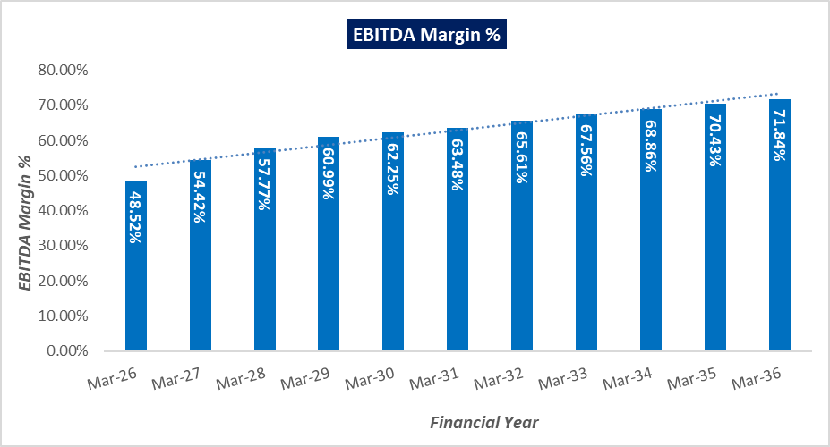
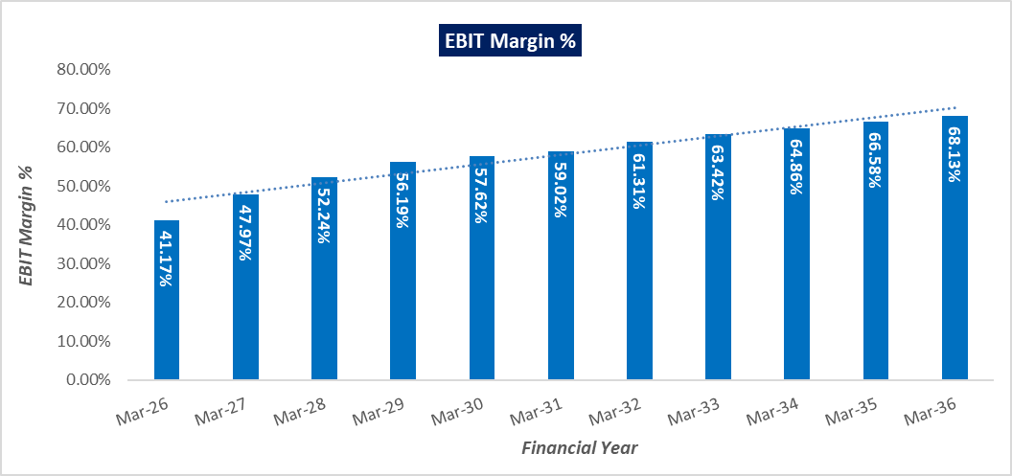
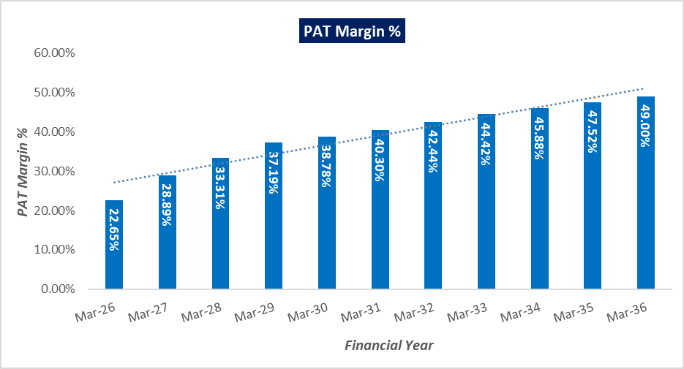

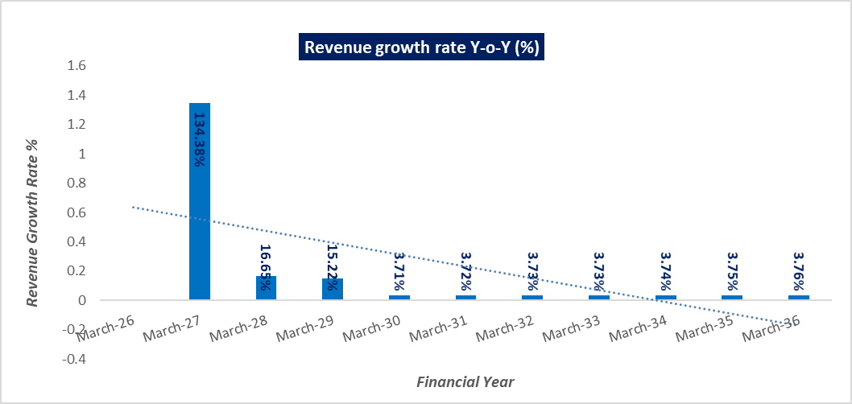
- ESTIMATED KEY FINANCIAL METRICS:
DEBT SERVICE COVERAGE RATIO (DSCR)
Particulars | FY26 |  | FY27 | FY28 | FY29 | FY30 | FY31 | FY32 | FY33 | FY34 | FY35 | FY36 | Total
Cash accrual | 0.90 |  | 2.48 | 3.18 | 3.96 | 4.24 | 4.54 | 4.91 | 5.30 | 5.64 | 6.03 | 6.42 | 47.59
Interest on term loan | 0.29 |  | 0.56 | 0.50 | 0.44 | 0.38 | 0.32 | 0.26 | 0.21 | 0.15 | 0.09 | 0.03 | 3.22
Subtotal | 1.19 |  | 3.03 | 3.67 | 4.40 | 4.62 | 4.86 | 5.18 | 5.50 | 5.79 | 6.12 | 6.45 | 50.81
Interest on term loan | 0.29 |  | 0.56 | 0.50 | 0.44 | 0.38 | 0.32 | 0.26 | 0.21 | 0.15 | 0.09 | 0.03 | 3.22
Loan Repayment | 0.00 |  | 0.59 | 0.59 | 0.59 | 0.59 | 0.59 | 0.59 | 0.59 | 0.59 | 0.59 | 0.59 | 5.86
Subtotal | 0.29 |  | 1.14 | 1.08 | 1.03 | 0.97 | 0.91 | 0.85 | 0.79 | 0.73 | 0.67 | 0.62 | 9.08
DSCR | 4.06 |  | 2.66 | 3.39 | 4.29 | 4.78 | 5.35 | 6.09 | 6.96 | 7.91 | 9.08 | 10.48 | 5.60
Average D.S.C.R. |  | 5.60
Max. D.S.C.R. |  | 10.48

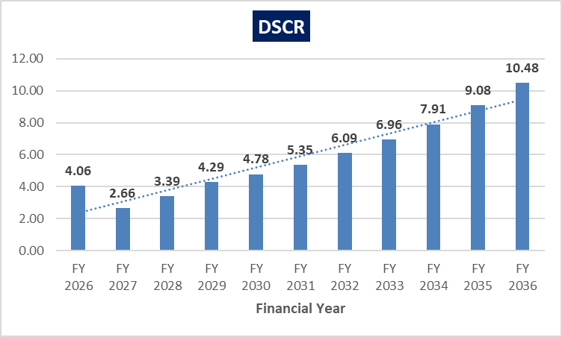

- SENSITIVITY ANALYSIS OF D.S.C.R:
The proposed project is found comparatively more sensitive with respect to the revenue, than the cost of raw material and any surge in the interest rate. Sensitivity analysis of the project with respect to 5% decrease in the revenue, 5% increase in the cost of raw material, 2% increment in the proposed interest rate and 5% decrease in generation has been shown in the below table:

Sensitivity Analysis of D.S.CR
S. No. | Particular | Average D.S.C.R | Max. D.S.C.R
 | If the projected revenue decreased by 5% | 5.18 | 9.77
 | If the projected Cost of raw material increased by 5% | 5.55 | 10.42
 | If interest rate is increased by 2% | 5.22 | 10.33
 | If the generation is decreased by 5% | 5.25 | 9.89
- NPV,IRR AND PAYBACK PERIOD OF THE PROJECT:
(INR Crores)
Particulars | Sep-25 | Mar-26 | Mar-27 | Mar-28 | Mar-29 | Mar-30 | Mar-31 | Mar-32 | Mar-33 | Mar-34 | Mar-35 | Mar-36
EBIT | 0.00 | 1.23 | 3.36 | 4.27 | 5.29 | 5.63 | 5.98 | 6.45 | 6.92 | 7.34 | 7.82 | 8.30
Less: Taxes | 0.00 | 0.34 | 0.94 | 1.19 | 1.47 | 1.57 | 1.66 | 1.79 | 1.92 | 2.04 | 2.17 | 2.31
Add: Depreciation & Amortisation | 0.00 | 0.22 | 0.45 | 0.45 | 0.45 | 0.45 | 0.45 | 0.45 | 0.45 | 0.45 | 0.45 | 0.45
NOPAT | 0.00 | 1.11 | 2.88 | 3.54 | 4.27 | 4.52 | 4.77 | 5.10 | 5.44 | 5.75 | 6.09 | 6.44
Increase/(Decrease) in working capital |  | -0.34 | -0.46 | -0.14 | -0.15 | -0.04 | -0.04 | -0.05 | -0.05 | -0.05 | -0.05 | -0.05
Capex | -8.37 | 0.00 | 0.00 | 0.00 | 0.00 | 0.00 | 0.00 | 0.00 | 0.00 | 0.00 | 0.00 | 0.00
Free Cash Flow to Firm (FCFF) | -8.37 | 0.77 | 2.42 | 3.40 | 4.12 | 4.47 | 4.73 | 5.06 | 5.40 | 5.70 | 6.04 | 6.39
Terminal Value |  |  |  |  |  |  |  |  |  |  |  | 78.68
FCFF + TV | -8.37 | 0.77 | 2.42 | 3.40 | 4.12 | 4.47 | 4.73 | 5.06 | 5.40 | 5.70 | 6.04 | 85.07
WACC | 10.28%
Terminal Growth Rate | 2.00%
NPV | INR 15.81 Crores
IRR | 46.69%

Calculation of Discount Rate
Particulars | Weight | Cost | Weighted Cost
Equity | 30.00% | 10.77% | 3.23%
Debt | 70.00% | 10.00% | 5.05%
Total |  |  | 8.28%
Company Risk Premium |  |  | 2.00%
Appropriate Discount Rate |  |  | 10.28%

Payback Period of the Project
Financial Year | Cash Accrual | Accumulated Cash Accrual
FY 2026 | 0.90 | 0.90
FY 2027 | 2.48 | 3.38
FY 2028 | 3.18 | 6.55
FY 2029 | 3.96 | 10.51
FY 2030 | 4.24 | 14.75
FY 2031 | 4.54 | 19.29
FY 2032 | 4.91 | 24.20
FY 2033 | 5.30 | 29.50
FY 2034 | 5.64 | 35.14
FY 2035 | 6.03 | 41.17
FY 2036 | 6.42 | 47.59
TPC | INR 8.37 Crores
Payback Period | 2.96 Years
Thus, the project will be having a payback period of 2.96 years and NPV & IRR of the project as on COD will INR 15.81 Crores & 46.69% respectively from C.O.D to loan repayment period, which indicates worthiness of the project.
- OTHER FINANCIAL RATIOS:
Particulars | FY 2026 | FY 2027 | FY 2028 | FY 2029 | FY 2030
Return on Capital employed (%) | 14.55% | 33.97% | 35.49% | 35.40% | 31.00%
Return on Net Worth (%) | 21.25% | 38.85% | 34.32% | 30.63% | 24.88%
DSCR | 4.06 | 2.66 | 3.39 | 4.29 | 4.78
ISCR | 4.20 | 6.04 | 8.58 | 12.05 | 14.79
Fixed Asset Coverage Ratio | 1.04 | 1.29 | 1.66 | 2.20 | 2.86
Current Ratio | 9.42 | 11.06 | 12.20 | 14.02 | 14.53
TOL/TNW | 1.85 | 1.03 | 0.60 | 0.37 | 0.24
Debt to Equity Ratio | 1.84 | 1.01 | 0.59 | 0.36 | 0.23
(Continue)
Particulars | FY 2031 | FY 2032 | FY 2033 | FY 2034 | FY 2035 | FY 2036
Return on Capital Employed (%) | 27.62% | 25.24% | 23.21% | 21.33% | 19.84% | 18.29%
Return on Net Worth (%) | 21.15% | 18.76% | 16.92% | 15.35% | 14.16% | 13.16%
DSCR | 5.35 | 6.09 | 6.96 | 7.91 | 9.08 | 10.48
ISCR | 18.56 | 24.45 | 33.73 | 50.10 | 88.93 | 283.28
Fixed Asset Coverage Ratio | 3.68 | 4.70 | 5.98 | 7.59 | 9.65 | 12.50
Current Ratio | 14.36 | 14.88 | 15.43 | 15.26 | 15.82 | 16.40
TOL/TNW | 0.16 | 0.10 | 0.06 | 0.04 | 0.02 | 0.00
Debt to Equity Ratio | 0.15 | 0.10 | 0.06 | 0.03 | 0.01 | 0.00

- BREAK-EVEN ANALYSIS:
(INR Crores)
Particulars | FY 2026 | FY 2027 | FY 2028 | FY 2029 | FY 2030
TOTAL SALES | 2.99 | 7.01 | 8.18 | 9.42 | 9.77
LESS: VARIABLE COST | 1.24 | 2.62 | 2.85 | 3.04 | 3.14
CONTRIBUTION | 1.75 | 4.39 | 5.33 | 6.39 | 6.63
TOTAL FIXED COST | 0.81 | 1.64 | 1.67 | 1.71 | 1.68
Profit / PBT | 0.94 | 2.75 | 3.65 | 4.68 | 4.95
PV RATIO | 58.61% | 62.58% | 65.14% | 67.77% | 67.84%
BEP Sales | 1.39 | 2.62 | 2.57 | 2.52 | 2.48
BEP% | 46.47% | 37.40% | 31.40% | 26.79% | 25.33%

(Continue)
Particulars | FY 2031 | FY 2032 | FY 2033 | FY 2034 | FY 2035 | FY 2036
TOTAL SALES | 10.14 | 10.51 | 10.91 | 11.31 | 11.74 | 12.18
LESS: VARIABLE COST | 3.31 | 3.43 | 3.56 | 3.76 | 3.91 | 4.07
CONTRIBUTION | 6.83 | 7.08 | 7.34 | 7.56 | 7.83 | 8.11
TOTAL FIXED COST | 1.65 | 1.62 | 1.59 | 1.57 | 1.54 | 1.52
Profit / PBT | 5.18 | 5.46 | 5.75 | 5.99 | 6.29 | 6.59
PV RATIO | 67.37% | 67.37% | 67.34% | 66.80% | 66.70% | 66.56%
BEP Sales | 2.45 | 2.41 | 2.37 | 2.34 | 2.31 | 2.28
BEP% | 24.15% | 22.89% | 21.69% | 20.72% | 19.69% | 18.72%

- TERM LOAN INPUTS:
Term Loan Repayment Inputs
Total loan amount | INR 5,85,88,536.12
Rate of Interest | 10.00%
1st Disbursement | April-25
IDC Start & End Month | April-25 to September-25
IDC Period (construction period) | 6 Months
Commencement /Operation Start | October-25
Moratorium Start & End Month (only interest to pay) | April 2025 to March 2026
Repayment Start | April 2026
Repayment End | March 2036
Repayment Period | 120 Months

(INR Crores)
YEAR/ASSET HEAD | 2026 | 2027 | 2028 | 2029 | 2030 | 2031 | 2032 | 2033 | 2034 | 2035 | 2036
Opening Balance | - | 5.86 | 5.27 | 4.69 | 4.10 | 3.52 | 2.93 | 2.34 | 1.76 | 1.17 | 0.59
Disbursement | 5.86 | - | - | - | - | - | - | - | -
Repayment | - | 0.59 | 0.59 | 0.59 | 0.59 | 0.59 | 0.59 | 0.59 | 0.59 | 0.59 | 0.59
Closing balance | 5.86 | 5.27 | 4.69 | 4.10 | 3.52 | 2.93 | 2.34 | 1.76 | 1.17 | 0.59 | 0.00
Interest | 0.29 | 0.56 | 0.50 | 0.44 | 0.38 | 0.32 | 0.26 | 0.21 | 0.15 | 0.09 | 0.03
IDC | 0.22 | - | - | - | - | - | - | - | -
Term Loan Interest | 0.51 | 0.56 | 0.50 | 0.44 | 0.38 | 0.32 | 0.26 | 0.21 | 0.15 | 0.09 | 0.03

- DEPRECIATION SCHEDULE (STRAIGHT LINE METHOD):
(INR Crores)
YEAR/ASSET HEAD | 2026 | 2027 | 2028 | 2029 | 2030
Building | 2.85 | 2.85 | 2.85 | 2.85 | 2.85
SLM Depreciation - Build | 0.05 | 0.09 | 0.09 | 0.09 | 0.09
Plant & Machinery | 5.52 | 5.52 | 5.52 | 5.52 | 5.52
SLM Depreciation - P&M | 0.17 | 0.36 | 0.36 | 0.36 | 0.36
Total SLM Depreciation | 0.22 | 0.45 | 0.45 | 0.45 | 0.45

(Continue)
YEAR/ASSET HEAD | 2031 | 2032 | 2033 | 2034 | 2035 | 2036
Building | 2.85 | 2.85 | 2.85 | 2.85 | 2.85 | 2.85
SLM Depreciation - Build | 0.09 | 0.09 | 0.09 | 0.09 | 0.09 | 0.09
Plant & Machinery | 5.52 | 5.52 | 5.52 | 5.52 | 5.52 | 5.52
SLM Depreciation - P&M | 0.36 | 0.36 | 0.36 | 0.36 | 0.36 | 0.36
Total SLM Depreciation | 0.45 | 0.45 | 0.45 | 0.45 | 0.45 | 0.45
- KEY ASSUMPTIONS & BASIS:
S. No. | Item | Assumptions and Basis
 | General | - The projections of the firm are done for the period from FY 2026 to FY 2036, 11 years, to cover the term loan period as per the industry best practices. It is assumed that the plant will be achieving COD on 1st October 2026.  - We have considered both Revenue & cost based model (top to bottom approach) while making the future financial projections.  - Revenue modelling has been done based on required production as per the LOI with the IOCL. Expense modelling has been done based on the capacity utilization during the respective year except for the raw material which is considered based on raw material ratio and its price as per the agreement with the seller.
 | Revenue Build up | - The plant is assumed to be operational for 300 days for 24 hours annually.  - Company will be generating the revenue by selling 2.5TPD Bio-CNG to IOCL as per LOI issued by the OMC on 1st Jan 2025 and by-products (Briquettes). Below table shows the Revenue of the company @70% capacity utilization in the first operational year:  - Thus, the company is expected to generate INR 2.99 Crores (@ 70% Capacity Utilization) in the initial year. Further it is expected to increase up to INR 12.18 Crores till FY 2035-36 (@ 100% Capacity Utilization).  - Based on the forecasting, the company is achieving an average revenue growth rate of 3% Y-o-Y basis from FY 2025-26 due to a 3% escalation assumed in the selling price during the forecasted period.  - For the purpose of this exercise, we have assumed that the excess cash available with company will be deposited in fixed deposits with bank. We have assumed the company would earn the interest income on this deposit @ 6% annually.
  Revenue @70% capacity
  Products | Unit Price | Annual Quantity  (KG) | Amount (INR Cr.)
  Sale of Bio-CNG | INR 74.29/Kg | 2,65,446 | 1.97
  Revenue – Briquettes | INR 8.00/Kg | 13,27,083 | 1.02
  Total Revenue (INR) |  |  | 2.99
 | Pricing (Average Price Per Unit) | - Proposed selling price per unit of CBG and by products are shown in the below table:  - The Bio-CNG produced has to be sold to Indian Oil Corporation Ltd stations situated within 25-75 km, for which the company have already secured a purchase agreement/LOI (Ref No. - Indian Oil/SATAT/01/3961, Date: 1st Jan 2025), the procurement price of Bio-CNG from Indian Oil as per the SATAT Scheme is around @INR 74.29 per kg without GST.  - The by-product of digestate is called Biomass Pellets (Briquettes), which is being sold in the current market at INR 8.00 per kg.  - For biomass pellets with a GCV of 4,800 kcal/kg, the price can be calculated based on the benchmark rates. Using the Northern Region's rate of ₹2.27 per 1,000 kcal, the price per kilogram would be approximately ₹10.90 (₹2.27 × 4.8).  - The selling price of Bio-CNG is considered on conservative side as INR 74.29/kg (excluding compression charges @ INR 2/Kg). The selling rate of Biomass Pellets (Briquettes) is assumed as INR 8.00 per kg on conservative side.  - An escalation factor of 3% has been considered in the prices of the sellable products during the forecasted periods considering the micro and macro-economic factors.
  Selling price per unit
  Products | Unit prices
  Selling price of Bio-CNG | INR 74.29 per kg
  Selling price of Briquettes | INR 8.00 per kg
 | Capacity Utilization | - The proposed CBG generating plant will be commissioned which will be operating at 100% (7,200 M3/Day) of the designed capacity to generate 2,500 Kg Bio-CNG per day as per tripartite agreement under CBG-CGD Synchronisation Scheme under SATAT initiative.  - We have assumed 70% capacity utilization in the first operational year (FY 2025-26), then 80% and 90% for the next two years and 100% capacity utilisation from the FY 2028-29 till the end of the projected period, since 2,500 kg Bio CNG has to be supplied by the company.
 | Capital Expenditure | - The estimated cost of the Building & Civil works is ~INR 2.64 Crores including GST.  - The cost of Plant & Machinery has been considered as per the data/information shared by the client/company. The estimated cost for plant & machinery will be ~INR 5.12 crores including GST.  - Pre-Operative Expenses has been taken as per the data/information shared by the company/client, based on the time period of construction and estimate of company’s resources involvement during this time in supervision & monitoring of the construction as INR 3.33 crores.  - Contingency cost of INR 0.39 crores (~5.00% of TPC) has been considered based on general assumption. Interest during Construction will be paid from April 2025 till September 2025 by the company @ 10.00%.  - Hence, INR 3.35 Crore per ton including GST, transportation IDC, pre-operative and preliminary expenses etc. will be the capex for this proposed plant which we found in the line with industrial and sectoral benchmarks considering the fact that the plant would be commissioned by the company itself from scratch to the successful trial run and the cost of setting up the plant is taken as per the data/information/quotations provided by the client/company. (Reference: As per Ministry of New and Renewable energy, the approx. CAPEX of installing a 5 TPD capacity CBG plant is estimated between INR 20-25 crore and ~75 80% of the CAPEX cost is for purchasing plant machinery).
 | Expenses | - The cost of the raw material @ 100% capacity has been shown in the below table:  - As per our tertiary research and data available in the public domain, we found the unit rate are in the permissible range. Escalation of 5% is considered every 3 years during forecasted period as per the long-term supply agreement with the farmer.  - Biomass Pellets (Briquettes) Processing and Packaging charges are considered as INR 2.25 and INR 0.40 respectively per kg of Briquettes produced during the year. An annual escalation rate of 3% has been considered.  - As per information provided by the client, estimated annual consumption of the power will be 4,87,440 Kwh. As per information available on the public domain and data shared by client, the applicable per unit charges will INR 9 per Kwh. An escalation rate of 3% is assumed on it.  - A 10% escalation rate has been considered during the forecasted period, on the salary & wages of the proposed manpower.  - Land has been procured for 15 years (with an option of renewal at the end of 15 years) on an annual lease rental of INR 2,99,988/annum through an executed lease deed on 23rd September 2024 with an annual escalation rate of 5% every 3 years.  - Cost for Transportation, Marketing & Selling Expenses, Overhead Expenses and Other Manufacturing Expenses are each considered as 1.5% of Operational Revenue respectively.  - The cost of Insurance is assumed as 0.25% of Net Block. Insurance covers CBG Plant and Facilities.  - Repair & Maintenance has been assumed @0.50% of the gross block and an annual escalation rate of 5% has been considered.
  Raw material Cost @ 100% capacity
  Raw Material | INR/Kg | Annual Quantity (TPA) | Amount INR Crore
  Napier Grass including Transportation | 0.54 | 18,000 | 0.97
  Total | INR 0.97 Crore
 | Partial Loan | - The project is proposed to be funded through a term loan of INR 5.86 crore, Promoter’s Equity of INR 0.01 Crore and unsecured loan from promoters of INR 2.50 crores.  - The tenure of the loan will be 11 years from April 2025 to March 2036. The repayment period of the loan will be 120 months after moratorium period of 12 months. As per discussion with client, Interest rate has been considered as 10.00%.

Key Findings:
      - Average DSCR, EBIDTA margin, EBIT margin is 5.60, 62.88%, and 58.05% respectively during the estimated period.
      - D.S.C.R of the proposed Bio CBG plant is found highly sensitive with respect to any downside fluctuation in the projected revenue.
      - The project is having a positive NPV and IRR of INR 15.81 Crores and 46.69% respectively from C.O.D. to loan repayment period while it may vary with changes in the assumptions & micro and macro-economic trends considered as on date.
      - The proposed project is having a payback period of 2.96 years.
      - Based on the above key financial ratios of the proposed Project during the forecasted period shows that the project appears financially viable if the promoters of the project are able to maintain assumed capacity utilization, revenue and can contain cost as assumed above in the calculation.

PART N | CONCLUSION

Based on the technological, economical and market analysis done above, various assumptions of sectoral trends taken, product pricing to be adopted by the company, the Project appears to be Techno-commercially viable subject to the risks, threats, weaknesses, limitations of the product as detailed previously.
As per financial projections for the estimated period, Average DSCR, EBITDA Margin and EBIT Margin of the project are 5.60, 62.88%, and 58.05% respectively, where higher DSCR is the indicator of the project capability to pay out its outstanding debt and EBITDA margin shows the capability of the project to generate the operating profits over the forecasted period. Also, the project is having the payback period of 2.96 Years in the line with sectoral trends.
The proposed Bio-CNG generating facility is having a positive NPV and IRR as INR 15.81 Crores & 46.69% respectively from C.O.D till loan repayment period as the industry is expectedly growing at a CAGR of 6.34% during the forecasted period. While it is not avoidable that the future projections may change in the upcoming years due to various factors impacting the operation, managerial, financial efficiency and economies of scale of the project.
While it would be depending on the management’s capability in future that how efficiently company adopts marketing and advertisement strategy, supply chain and carry out inventory & resource management to achieve higher profitability. After considering the foreseen demand of the Bio CNG and its by-products domestically and globally, various initiatives taken by the government, financial analysis of the project based on the assumptions taken over the projected period, it appears reasonable to comment that the proposed project is “Technically and Economically” Viable subject to current assumptions considered and occurring the same in the upcoming years same as the forecasted period which is dependent on the sincerity and efforts of the management and various micro and macroeconomic & industry situation.
We have tried our level best to analyse the Project techno-economic feasibility of the Project based on the Industry research, Project information and various futuristic assumption taken within the limitations and challenges came in front of us. However achieving the financial milestones depends on the ability, sincerity and efforts of the company, promoters and its key management to maintain the projected revenue level Y-o-Y basis keeping the fact in mind that the project is found sensitive with respect to the down side fluctuation in the revenue.

Declaration | - The undersigned does not have any direct/indirect interest in the above property/project/Company.  - The information furnished herein is true and correct to the best of our knowledge, logical and scientific assumptions.  - This TEV Report is carried out by our Financial Analyst team on the request from M/s Blueleo Energy Private Limited.  - Meeting of Financial projections will be subject to the market & economy stability factors, judicious business operations and proper & timely implementation of the project and putting proper plan for achieving high productivity, efficiency and achieving cost saving benefits to increase profitability.  - We have submitted TEV report to client.
Number of Pages in the Repost | 81
Enclosed Documents | Disclaimer & Remarks 74-77
Place | Noida
Date | 5th March 2025

FOR ON BEHALF OF
M/S. R.K. ASSOCIATES VALUER & TECHNO ENGINEERING CONSULTANTS PVT. LTD.
SURVEYED BY | PREPARED BY | REVIEWED BY
Mr. Anuj Sharma | Mr. Gaurav Kumar | Mr. Rachit Gupta

PART O | DISCLAIMER | REMARKS

      - No employee or member of R.K Associates has any direct/ indirect interest in the Project.
      - This report is prepared based on the copies of the documents/ information which the Bank/ Company has provided to us out of the standard checklist of documents sought from them and further based on our assumptions and limiting conditions. The client/owner and its management/representatives warranted to us that the information they supplied was complete, accurate and true and correct to the best of their knowledge. All such information provided to us has been relied upon in good faith and we have assumed that it is true and correct in all respect. I/We shall not be liable for any loss, damages, cost or expenses arising from fraudulent acts, misrepresentations, or wilful default on part of the owner, company, its directors, employee, representative or agents. Verification or cross checking of the documents provided to us from the originals or from any Govt. departments/ Record of Registrar has not been done at our end since this is beyond the scope of our work. If at any time in future, it is found or came to our knowledge that misrepresentation of facts or incomplete or distorted information has been provided to us then this report shall automatically become null & void.
      - Legal aspects for e.g. investigation of title, ownership rights, lien, charge, mortgage, lease, sanctioned maps, verification of documents, etc. have not been done at our end and same has to be taken care by legal expert/ Advocate. It is assumed that the concerned Lender/ Financial Institution has satisfied them with the authenticity of the documents, information given to us and for which the legal verification has been already taken and cleared by the competent Advocate before requesting for this report. I/ We assume no responsibility for the legal matters including, but not limited to, legal or title concerns.
      - This report is a general analysis of the project based on the scope mentioned in the report. This is not an Audit report, Design document, DPR or Techno feasibility study. All the information gathered is based on the facts seen on the site during survey, verbal discussion & documentary evidence provided by the client and is believed that information given by the company is true best of their knowledge.
      - This Techno Economic-Viability study is prepared based on certain futuristic assumption which are intra dependent on economic, market and sectorial growth condition in future and socio-economic, socio-political condition at macro and micro level.
      - Meeting of assumption and financial ratio will entirely depend on the sincerity and efforts of the company, promoters and its key managerial performance.
      - All observations mentioned in the report is only based on the visual observation and the documents/ data/ information provided by the client. No mechanical/ technical tests, measurements or any design review have been performed or carried out from our side during Project assessment.
      - This report has been diligently prepared by our techno-financial team to the best of their ability. However, it's important to note that the recommendations provided in this Total Economic Viability (TEV) assessment do not imply an endorsement, validation, or certification of the accuracy or completeness of the disclosed information by the involved stakeholders. Furthermore, we do not claim or endorse that the opinions presented herein are the sole best course of action for decision-makers to follow. There may exist additional approaches and inputs that have not been covered within this report or fall outside the scope of this report.
      - Bank/FII should ONLY take this report as an Advisory document from the Financial/ Chartered Engineering firm and its specifically advised to the creditor to cross verifies the original documents for the facts mentioned in the report which can be availed from the borrowing company directly.
      - In case of any default in loans or the credit facility extended to the borrowing company, R.K Associates shall not be held responsible for whatsoever reason may be and any request for seeking any explanation from the employee/s of R.K Associates will not be entertained at any instance or situation.
      - The documents, information, data provided to us during the course of this assessment by the client are reviewed only up to the extent required in relation to the scope of the work. No document has been reviewed beyond the scope of the work.
      - This report only contains general assessment & opinion as per the scope of work evaluated as per the information given in the copy of documents, information, data provided to us and/ and confirmed by the owner/ owner representative to us at site which has been relied upon in good faith. It doesn’t contain any other recommendations of any sort including but not limited to express of any opinion on the suitability or otherwise of entering into any transaction with the borrower.
      - We have relied on data from third party, external sources & information available on public domain also to conclude this report. These sources are believed to be reliable and therefore, we assume no liability for the truth or accuracy of any data, opinions or estimates furnished by others that have been used in this analysis. Where we have relied on data, opinions or estimates from external sources, reasonable care has been taken to ensure that such data has been correctly extracted from those sources and /or reproduced in its proper form and context, however still we can’t vouch its authenticity, correctness or accuracy.
      - This Report is prepared by our competent technical team which includes Engineers and financial experts & analysts.
      - This is just an opinion report and doesn’t hold any binding on anyone. It is requested from the concerned Financial Institution which is using this report for taking financial decision on the project that they should consider all the different associated relevant & related factors also before taking any business decision based on the content of this report.
      - All Pages of the report including annexure are signed and stamped from our office. In case any paper in the report is without stamp & signature then this should not be considered a valid paper issued from this office.
      - Though adequate care has been taken while preparing this report as per its scope, but still we can’t rule out typing, human errors, over sightedness of any information or any other mistakes. Therefore, the concerned organization is advised to satisfy themselves that the report is complete & satisfactory in all respect. Intimation regarding any discrepancy shall be brought into our notice immediately. If no intimation is received within 15 (Fifteen) days in writing from the date of issuance of the report, to rectify these timely, then it shall be considered that the report is complete in all respect and has been accepted by the client up to their satisfaction & use and further to which R.K Associates shall not be held responsible in any manner.
      - Defect Liability Period is 15 DAYS. We request the concerned authorized reader of this report to check the contents, data and calculations in the report within this period and intimate us in writing if any corrections are required or in case of any other concern with the contents or opinion mentioned in the report. Corrections only related to typographical, calculation, spelling mistakes, incorrect data/ figures/ statement will be entertained within the defect liability period. Any new changes for any additional information in already approved report will be regarded as additional work for which additional fees may be charged. No request for any illegitimate change in regard to any facts & figures will be entertained.
      - R.K Associates encourages its customers to give feedback or inform concerns over its services through proper channel at valuers@rkassociates.org in writing within 15 days of report delivery. After this period no concern/ complaint/ proceedings in connection with the Techno- Economic Viability Study Services will be entertained due to possible change in situation and condition of the subject Project.
      - Our Data retention policy is of ONE YEAR. After this period, we remove all the concerned records related to the assignment from our repository. No clarification or query can be answered after this period due to unavailability of the data.
      - This Techno Economic Viability Study report is governed by our (1) Internal Policies, Processes & Standard Operating Procedures, (2) Information/ Data/ Inputs given to us by the client and (3) Information/ Data/ Facts given to us by our field/ office technical team. Management of R.K Associates never gives acceptance to any unethical or unprofessional practice which may affect fair, correct & impartial assessment and which is against any prevailing law. In case of any indication of any negligence, default, incorrect, misleading, misrepresentation or distortion of facts in the report then it is the responsibility of the user of this report to immediately or at least within the defect liability period bring all such act into notice of R.K Associates management so that corrective measures can be taken instantly.
      - R.K Associates never releases any report doing alterations or modifications from pen. In case any information/ figure of this report is found altered with pen then this report will automatically become null & void.
      - If this report is prepared for the matter under litigation in any Indian court, no official or employee of R.K Associates will be under any obligation to give in person appearance in the court as a testimony. For any explanation or clarification, only written reply can be submitted on payment of charges by the plaintiff or respondent which will be 10% of the original fees charged where minimum charges will be Rs. 15,000/.

EXTRACTS OF IMPORTANT STATUTORY APPROVALS PROVIDED BY THE CLIENT
