File No.: VIS(2024-25)-PL801-723-989 Dated: 02/04/2025

TECHNO-ECONOMIC VIABILITY
STUDY REPORT

OF
~5.6 MW-DC SOLAR POWER PROJECT

SETUP BY

M/S BIKANA RENEWABLES 2 PRIVATE LIMITED

REPORT PREPARED FOR

M/S BIKANA RENEWABLES 2 PRIVATE LIMITED
S-36 MIDDLE FLOOR, OPP. RAC BATTALION RIcco, Bichhwal Ind.Area, Bikaner, Bikaner- 334006, Rajasthan

**Important - In case of any query/ issue or escalation you may please contact Incident Manager Valuers@rkassociates.org. We will appreciate your feedback in order to improve our services.

NOTE: As per IBA Guidelines please provide your feedback on the report within 15 days of its submission after which report will be considered to be correct.

IMPORTANT NOTICE

COPYRIGHT FORMAT: This report is prepared on the copyright format of R. K. Associates Valuers & Techno Engineering Consultants (P) Ltd. (R. K. Associates) to serve our clients with the best possible information and analysis to facilitate them to take rational business decisions. Legally no one can copy or distribute this format without prior approval from R. K. Associates. It is meant only for the advisory/ reference purpose for the organization/s as mentioned on the cover page of this report. Distribution or use of this format or report or any of its content/ information/ data by any organization or individual other than R.K Associates will be seen as an unlawful act and necessary legal action can be taken against the defaulters.
This report is intended for the sole use of the intended recipient/s and contains material that is STRICTLY CONFIDENTIAL AND PRIVATE.

DEFECT LIABILITY PERIOD: In case of any query/ issue or escalation you may please contact Incident Manager at valuers@rkassociates.org. Though adequate care has been taken while preparing this report as per its scope, but still we can’t rule out typing, human errors, over sightedness of any information or any other mistakes. Therefore, the concerned organization is advised to satisfy themselves that the report is complete & satisfactory in all respect. Intimation regarding any discrepancy shall be brought into our notice immediately. If no intimation is received within 15 (Fifteen) days in writing from the date of issuance of the report, to rectify these timely, then it will be considered that the report is complete in all respect and has been accepted by the client up to their satisfaction & use and further to which R.K Associates shall not be held responsible in any manner.

Part O: R. K. Associates Important Disclaimer and Remarks are integral part of this report and Feasibility assessment is subject to this section. Reader of the report is advised to read all the points mentioned in these sections carefully.

TABLE OF CONTENTS
SECTIONS | PARTICULARS | PAGE NO.
Part A | Report Summary | 4
Part B | INTRODUCTION
Part B | - About the Report | 6
Part B | - Executive summary | 6
Part B | - Purpose of the Report | 8
Part B | - Scope of the Report | 8
Part B | - Methodology/ Model Adopted | 9
Part B | - Data Information received from | 9
Part B | - Documents/ Data Referred | 9
Part C | Company Profile
Part C | - Company Overview | 10
Part C | - Proposed Shareholding Pattern | 11
Part C | - Key Promoter’s/Directors Profile | 11
Part D | Proposed Infrastructure Details
Part D | - Proposed Plant Location | 14
Part D | - Google Map Location | 15
Part D | - Schematic Layout Plan | 16
Part D | - Land Details | 17
Part D | - Site pictures | 18
Part D | - Plant and Machinery/ Equipment details | 19
Part E | Project Technical details
Part E | - Capacity of Proposed Solar Power Plant | 26
Part E | - Project Implementation | 26
Part E | - Commercial Agreement Details | 26
Part E | - EPC Details | 27
Part E | - Technical Specifications | 31
Part E | - Technological Assessment | 33
 | - Manpower | 34
Part F | Industry Overview & Analysis | 35
Part G | SWOT Analysis | 43
Part H | Project Cost and Means of Finance | 46
Part I | Project Implementation Schedule | 48
Part J | Statutory Approvals | Licences | NOC | 50
Part K | Company’s Financial Feasibility | 51
Part L | Conclusion | 70
Part M | Disclaimer | Remarks | 72

PART A | REPORT SUMMARY

S. No. | PARTICULAR | DESCRIPTION
 | Name of the Company: | M/s. Bikana Renewables 2 Private Limited
 | Registered Address: | S-36 Middle Floor, Opp. Rac Battalion Ricco, Bichhwal Ind.Area, Bikaner- 334006, Rajasthan
 | Project Name | ~5.6 MW-DC Solar Power Project
 | Project Location: | Village – Akkasar 1, Tehsil – Kolayat, Plant No.2 Badi Shisha, DD1 Bikaner Division, Substation– Akkasar 1, Bikaner, Rajasthan.
 | Project Type: | Solar Power Project
 | Project Industry: | Renewable Energy
 | Product Type / Deliverables: | Power Generation
 | Report Prepared for Organization: | M/s. Bikana Renewables 2 Private Limited
 | TEV Consultant Firm: | M/s. R.K Associates Valuers & Techno Engineering Consultants (P) Ltd.
 | Report type: | Techno-Economic Viability Report
 | Purpose of the Report: | To assess Technical & Economic Viability for the purpose of seeking external financial assistance to setup Solar Power Plant.
 | Scope of the Report: | To assess, evaluate & comment on Technical, Economical & Commercial Viability of the Project as per data information provided by the client, independent Industry research and data/ information available on public domain.
 | Date of Report: | 2nd April 2025
 | Documents referred for the Project: | - PROJECT INITIATION DOCUMENTS:  - Detailed Project Report  - Financial Projections of the Project  - Project proposed Schedule  - PROCUREMENT DOCUMENTS:  - EPC Agreement  - List of Plant & Machinery along with acquisition costs for the same  - Details of Expected Supplier of Plant & Machinery  - Purchase Power Agreement
 | Means of Finance: | Equity & Debt (D/E Ratio 2.33 TPC)
 | Key Financial Indicators:
  Key Indicators | Value
  Average DSCR | 1.33
  Average EBITDA Margin | 85.43%
  Avg. PAT Margin | 28.31%
  NPV & IRR | INR 1.11 Cr. & 7.56%
Note: Above financial indicators are based on the financial projections of the proposed project provided by the firm and assessment and analysis of the same done by us.

PART B | INTRODUCTION

- ABOUT THE REPORT:
This Techno-Economic Viability (TEV) Study Report evaluates the proposed ~5.6 MW-DC Solar Power Project located in Village – Akkasar 1, Tehsil – Kolayat, Plant No.2 Badi Shisha, DD1 Bikaner Division, Substation– Akkasar 1, Bikaner, Rajasthan.
- EXECUTIVE SUMMARY:
Bikana Renewables 2 Private Limited (BRPL2) was incorporated on September 16, 2024, as a joint venture between Eco-Tech & Engineering and Mukesh Trading Corporation, supported by promoters Shri Kishan Rathi, Shri Mukesh Agarwal, and Shri Babulal Joshi. Eco-Tech & Engineering is a reputed solar EPC company with experience in executing 50 MW of solar projects across India. The company has completed projects for clients such as HP Modi Group, Chittlangia Seeds, Noida Metro Rail Corporation, Nandi Dairy, Surfex Covering Limited, Nagpur Metro Rail, and Nokha Agro Services. It is also an existing SBI client, having secured ₹5.25 crore in June 2023 for a 1.50 MW RESCO solar project for Yerik International Plant, Punjab.
Mukesh Trading Corporation is a construction and infrastructure development firm with expertise in road construction, mechanized earthwork, RCC walls, ducts, drainage systems, compound walls, and bridges. With over four years of experience, the company brings strong project execution capabilities, ensuring timely and efficient completion of infrastructure works.
BRPL2 is developing a 4 MWac / 5.60 MWdc solar power plant in Bikaner, Rajasthan under the Kusum Component-C scheme. The project is designed to support the solarization of agricultural feeder substations and will be executed under the Renewable Energy Service Company (RESCO) model. The plant will be grid-connected via a 33/11 KV transmission line and will operate under a 25-year Power Purchase Agreement (PPA), ensuring a stable revenue stream.
The project is strategically located in Akkasar village, Tehsil Kolayat, Bikaner, Rajasthan, benefiting from high solar irradiance and favorable climatic conditions. The plant will be set up at Plant No.2, Badi Shisha, DD1 Bikaner Division near the Akkasar 1 substation, ensuring efficient power evacuation and seamless grid integration.
The project operates under a long-term Power Purchase Agreement (PPA), ensuring revenue stability. The Letter of Award (LOA) was issued on March 15, 2024, and the PPA was signed on February 5, 2025, with Rajasthan Urja Vikas and IT Services Ltd. (on behalf of Jodhpur Vidyut Vitran Nigam Limited - JDVVNL). The finalized levelized tariff for the project is ₹3.38 per unit, with a minimum generation guarantee of 37.24 lakh units per year. As part of the Kusum Component-C scheme, the project benefits from government support, ensuring preferential grid access, tariff stability, and reduced operational risks.
The project integrates high-efficiency solar technology, featuring Waaree ELITE SERIES N-TYPE BIN – 08-565 to BIN – 08-600 Framed Dual Glass Bifacial Solar Panels, ensuring 97.3% first-year efficiency with a 30-year performance warranty. It also includes Powerwatt WP-330KTL-H1 Smart String Inverters, equipped with dual MPPT tracking, remote monitoring (Wi-Fi/GPRS), and advanced protection features for optimal energy conversion. The plant will be grid-connected via the Akkasar 1 substation, supporting efficient power evacuation and contributing to Rajasthan’s renewable energy capacity.
The project is being implemented, covering design, survey, supply, installation, testing, commissioning, operation and maintenance (O&M) for 25 years. The connection to the Akkasar 1 substation will enhance agricultural power security while increasing the renewable energy share in the region’s power consumption.
M/s Bikana Renewables 2 Private Limited (BRPL2) has entered into an EPC contract with Eco-Tech & Engineering Firm on February 25, 2025, for the execution of a ~5.6 MW solar power project. The contract encompasses the supply, erection, and commissioning of essential components, including solar PV modules, inverter systems, module mounting structures (MMS), DC & AC cables, combiner boxes, inverter duty transformers, AC circuit breakers (ACCB), protection panels, lightning and earthing protection systems, pooling point infrastructure, and other balance of system (BOS) components. The total EPC contract price for the project is approx. INR 21.61 crore.
The total estimated project cost is ₹23.99 crore, structured through a combination of debt and equity. The financing includes a ₹16.79 crore term loan from bank/financial institution (70% of project cost) and a ₹7.20 crore equity contribution from the promoters (30%). Additionally, the project qualifies for ₹0.78 crore as Central Financial Assistance (CFA) from the Government of India, reducing financial burden and enhancing economic feasibility. A Debt Service Reserve Account (DSRA) will be established, covering three months of debt servicing, ensuring liquidity and mitigating financial risks.
At present, Bikana Renewables 2 Private Limited is in discussions with financial institution to secure a term loan of ₹16.79 crore for its proposed solar power project. In this regard M/s Bikana Renewables 2Private Limited has appointed R.K. associates to assess the Techno-Economic Viability of the proposed project. The company plans to achieve loan approval by March 2025 and the financial closure by April, 2025 (expected).

- PURPOSE OF THE REPORT:
To assess Project’s Technical and Financial Feasibility for Client’s requirement.

- SCOPE OF THE REPORT:
To only assess, evaluate & comment on Technical & Financial Feasibility of the proposed Solar Power Plants being set up by M/s Bikana Renewables 2 Private Limited as per the data/information provided by the company.

NOTES:
- Project status is taken as per the Site inspection carried out by our survey team.
- Scrutiny about the company, background check, and credibility, credit worthiness of the company or its promoters is out-of-scope of this report.
- Any verification of the documents/ information from originals/ source is out-of-scope of this report.
- This report is only an opinion in respect to Technical and Financial Feasibility of the project as per the future Projections provided by the firm and independent analysis done by us and doesn’t contain any recommendations including taking decision on the loan or any other financial exposure.
- This is not an audit activity of any kind. We have relied upon the data/ information shared by the company in good faith.
- Any review of the existing business of the promoters is out of scope of this report.
- Detailed cost estimation or detailed cost vetting is out of scope of the project.
- This is not a Detailed Project Report or a detailed design or architecture document. Land and property details mentioned in the report is only for illustration purpose as per the information provided to us by the client. The same doesn’t tantamount for taking any responsibility regarding its legality, ownership and conforming to statutory norms.

- METHODOLOGY/ MODEL ADOPTED:
- Data/ Information collection.
- Review of Data/ Information collected related to TEV study.
- Independent review & assessment of technology used and financial projections provided by the company.
- Projections of Revenue, P&L, Balance Sheet, Working Capital Schedule, Depreciation Schedule, Loan Schedule as per the inputs given by the company and assessed by us
- Calculation of key financial indicators and ratio analysis including DSCR, NPV & IRR.
- Report compilation and Final conclusion.

- DATA/ INFORMATION RECEIVED FROM:
All the data/Information has been received from Mr. Bikramjeet Singh Guram and the required details about him shown in the below table:

Particulars | Details
Company | Saba Capital (Consultant)
Contact Person | Mr. Bikramjeet Singh Guram
Email Address | bikramjeet.guram@sabacapitalindia.com
Contact No. | 9871119734

- DOCUMENTS / DATA REFFERED:

- Detailed Project Report and Promoters Profile
- Financial Projections of the proposed Project.
- Turnkey/EPC Agreement.
- Technical Specification Solar PV Modules
- PPA with 35 Institutions (Medical College & Hospitals)
- PVSyst report.

PART C | COMPANY PROFILE

- COMPANY OVERVIEW:
As per certificate of incorporation shared by the client, Company was originally incorporated with the name “M/s Bikana Renewables 2 Private Limited” on 16th day of November 2024 under the Company’s Act. Below table shows the incorporation details of the company:
Incorporation Details of the Company
Particular | Description
Company Name | M/s Bikana Renewables 2 Private Limited
CIN | U35105RJ2024PTC097419
Date of Incorporation | 28th day of September 2024
Registration Number | 097419
ROC Name | ROC Jaipur
Company Category | Company limited by shares
Company Subcategory | Non-government company
Class of Company | Private
Registered Address | S-36 Middle Floor, Opp. Rac Battalion Ricco, Bichhwal Ind.Area, Bikaner- 334006, Rajasthan
Authorized Capital | INR 15,00,000
Paid up Capital | INR 1,00,000
Date of last AGM | -
Date of Balance Sheet | -
Company Status | Active
Source: Information extracted from MCA website & public domain
As per the information provided by the client, Bikana Renewables 2 Private Limited (BRPL2) intends to develop a 4 MWac / 5.60 MWdc solar power plant in Bikaner, Rajasthan, under the Kusum Component C scheme. The company is a joint venture between Eco-Tech & Engineering, an existing SBI client, and Mukesh Trading, a well-established infrastructure developer. The project will be situated at Village – Akkasar 1, Tehsil – Kolayat, Plant No.2 Badi Shisha, DD1 Bikaner Division, Substation– Akkasar 1, Bikaner, Rajasthan.
- SHAREHOLDING PATTERN: As per the data/information provided by the client, Shareholding of promoters dated 19th March, 2025 is as follows:
Shareholders' Name | No. of Shares | Amount In Rs. | %
Mr. Mukesh Agarwal | 5,100 | 51,000 | 51%
Mr. Babu Lal Joshi | 2,500 | 25,000 | 25%
Mr. Kishan Rathi | 2,400 | 24,000 | 24%
Total | 10,000 | 1,00,000 | 100.00%
Source: Data/Information provided by the client.

- KEY PROMOTER’S/DIRECTORS PROFILE:
As per data/information provided by the client about the promoters & directors, below table illustrate the educational & professional experience of the promoters along with the Address, DIN and contact details for FY 2024-25 as on 19th March, 2025:
Name | Designation/DIN | Qualifications/Experience
Mr. Kishan Rathi | Director  DIN: 07800912 | Shri Kishan Rathi is one of the partners in the firm, Ecotech & Engineering, with the objective of catering to the fast-emerging solar sector. The firm within a short span of time has executed multiple private and govt solar power plants. It has done major EPC and PPA projects with reputed govt organizations such as HP Modi Group, Chittlangia Seeds, Noida Metro Rail Corporation Limited, Nandi dairy, Surfex Covering Limited, Nagpur Metro Rail, Nokha Agro Services etc.
Mr. Babu Lal Joshi | Director  DIN: 03552595 | Shri Babu Lal Joshi is the other partner in the firm, Ecotech & Engineering, with the objective of catering to the fast-emerging solar sector. The firm within a short span of time has executed multiple private and govt solar power plants. It has done major EPC and PPA projects with reputed govt organizations such as HP Modi Group, Chittlangia Seeds, Noida Metro Rail Corporation Limited, Nandi dairy, Surfex Covering Limited, Nagpur Metro Rail, Nokha Agro Services etc.
Mr. Mukesh Agarwal | Director  DIN: 10777548 | Mr. Mukesh Trading Corporation is 4 years 1 month old Proprietorship Firm incorporated on 07-Dec-2020, having its registered office located at 8 B 63, J N V Colony, Bikaner, Rajasthan. Mukesh Trading Corporation is a reputed construction firm engaged in setting up and maintenance of various types of Infrastructure development like all types of roads, mechanized earth work, RCC walls, Ducts, drains and compound wall construction, Bridges in all types of terrains.
Source: Data/Information provided by the client
Director | Mr.Kishan Rathi | Mr.Babulal Joshi | Mr.Mukesh Agarwal
PAN Card/ GST | ANUPR5287M | ALVPJ2147F | AALPA2772Q
DOB/ Incorp | 11-Dec-1988 | 14-Jun-1984 | 16-Aug-1970
Aadhaar | 2208-5984-6202 | 2744-0470-  7139 | 6696-2166-5887
Passport | S4033818 | R8823810 | V2726534
Mobile | 96365-28979 | 87410-05500 | 94141-37846
Email | kishan.rathi@eco-techengineering.com | Babu.joshi@eco-techengineering.com | mksh.trading@yahoo.in
DIN/ CIN | 07800912 | 03552595 | 10777548
Address/ Regd address of the company | S/O: Raj Kumar, Dujariyo ki gali, binnani  chowk, Bikaner, Rajasthan 334001 | S/O: Ram Kumar, ward no. 11, karoti,  DEEPLANA BARANI, Hanumangarh,  Rajasthan - 335504 | S/o Shyam Agarwal, 8-B-63, Jai Narayan Vyas Colony, Bikaner, Raj 334003
Source: Data/Information provided by the client
Below tables shows the information of the companies/LLPs with which each Director is associated with to give a basic background detail of the promoters as found on public domain in general/ tertiary category research.
(Mr. Kishan Rathi DIN/DPIN: 07800912)
S. No. | Company Name | Designation | Date of Appointment at Current Designation | Date of cessation (if applicable)
1 | Deimos Green Energy Private Limited | Director | 08/03/2025 | -
2 | Taevolis Green Energy Private Limited | Director | 07/03/2025 | -
3 | Zero Degree Clean Projects Private Limited | Director | 29/11/2024 | -
4 | Zero Degree Green Urja Private Limited | Director | 28/11/2024 | -
5 | Zero Degree Power Projects Private Limited | Director | 25/11/2024 | -
6 | Marwarsurya Shakti Private Limited | Director | 25/11/2024 | -
7 | Marwar Shine Renewable Private Limited | Director | 25/11/2024 | -
8 | Marwar Vidyut Energy Private Limited | Director | 25/11/2024 | -
9 | Marwarsurya Urja Private Limited | Director | 25/11/2024 | -
10 | Zero Degree Renewable Energy Private Limited | Director | 19/11/2024 | -
Source: Information extracted from MCA website & public domain
(Mr. Babulal Joshi DIN/DPIN: 03552595)
S. No | Company Name | Designation | Date of Appointment at Current Designation | Date of cessation (if applicable)
1 | Deimos Green Energy Private Limited | Director | 25/11/2024 | -
2 | Taevolis Green Energy Private Limited | Director | 25/11/2024 | -
3 | Zero Degree Clean Projects Private Limited | Director | 25/11/2024 | -
4 | Zero Degree Green Urja Private Limited | Director | 25/11/2024 | -
5 | Zero Degree Power Projects Private Limited | Director | 19/10/2024 | -
6 | Marwarsurya Shakti Private Limited | Director | 07/10/2024 | -
7 | Marwar Shine Renewable Private Limited | Director | 07/10/2024 | -
8 | Marwar Vidyut Energy Private Limited | Director | 28/09/2024 | -
9 | Marwarsurya Urja Private Limited | Director | 16/09/2024 | -
10 | Zero Degree Renewable Energy Private Limited | Director | 25/11/2024 | -
Source: Information extracted from MCA website & public domain
Mukesh Agarwal DIN/DPIN: 10777548
Sr. No | Company Name | Designation | Date of Appointment at Current Designation | Date of cessation (if applicable)
1 | Marwarsurya Shakti Private Limited | Director | 25/11/2024 | -
2 | Marwar Shine Renewable Private Limited | Director | 25/11/2024 | -
3 | Marwar Vidyut Energy Private Limited | Director | 25/11/2024 | -
4 | Marwarsurya Urja Private Limited | Director | 25/11/2024 | -
5 | Bikana Renewables 4 Private Limited | Director | 19/10/2024 | -
6 | Marwar Renewable Energy Private Limited | Director | 07/10/2024 | -
7 | Bikana Renewables 3 Private Limited | Director | 07/10/2024 | -
8 | Bikana Renewables 2 Private Limited | Director | 28/09/2024 | -
9 | Bikana Renewables Private Limited | Director | 16/09/2024 | -
Source: Information extracted from MCA website & public domain

PART D | PROPOSED INFRASTRUCTURE DETAILS

- PROPOSED PLANT LOCATION:
The proposed Solar Power plant will be set up by M/s Bikana Renewables 2 Private Limited at Village – Akkasar 1, Tehsil – Kolayat, Plant No.2 Badi Shisha, DD1 Bikaner Division, Substation– Akkasar 1, Bikaner, Rajasthan, which is spread over an area of 5.6538 hectare as per the data/information provided to us by the company.
Located in Bikaner, Rajasthan, the project benefits from high solar irradiance, ensuring maximum energy yield and efficiency. The dry climate and minimal cloud cover further enhance solar panel performance. Spanning 5.6538 hectares of leased land, the site allows optimal panel placement and future scalability, ensuring higher capacity utilization, improved economics, and long-term sustainability.
During the site visit, we found that the proposed land is a vacant agricultural land which is not demarcated and work on the Project has not been started yet. As per informed by client, land development work will start soon. (Kindly refer the site pictures captured during the survey attached in the later section of the report)
Table: 1 is showing the details of the adjoining properties of the land for proposed solar power plant and Table: 2 is showing the Connectivity Details of the Proposed Location.
Table: 1 Adjoining Property Details
Location | Details
East | Khasra No.1325/40 & 1327/791
West | Khasra No. 1169/38, 149
North | Remaining Part of land in Khasra No.1326/40
South | Khasra No.148, 149

Table: 2 Connectivity Details of the Proposed Location
Connectivity | Details
Bus Stand | ~2.00 km Akassar Bus Stop
Rail | Gajner Railway station - ~10.00 km away
Airport | Bikaner Airport, - ~30 km away

- LOCATION MAP:
- GOOGLE MAP LOCATION:
We conducted a physical inspection on March 8, 2025, of the proposed site located at 27°52'46.6"N, 73°05'26.2"E in Village – Akkasar 1, Tehsil – Kolayat, Plant No.2 Badi Shisha, DD1 Bikaner Division, Substation– Akkasar 1, Bikaner, Rajasthan. The designated area for the solar power project installation has been properly demarcated as outlined below:
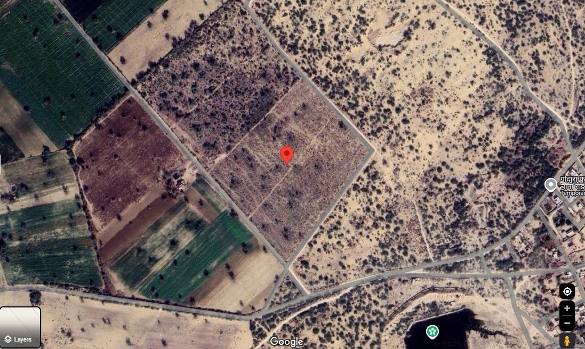
- Demarcation: Demarcation of the land on the Google map is as in the below picture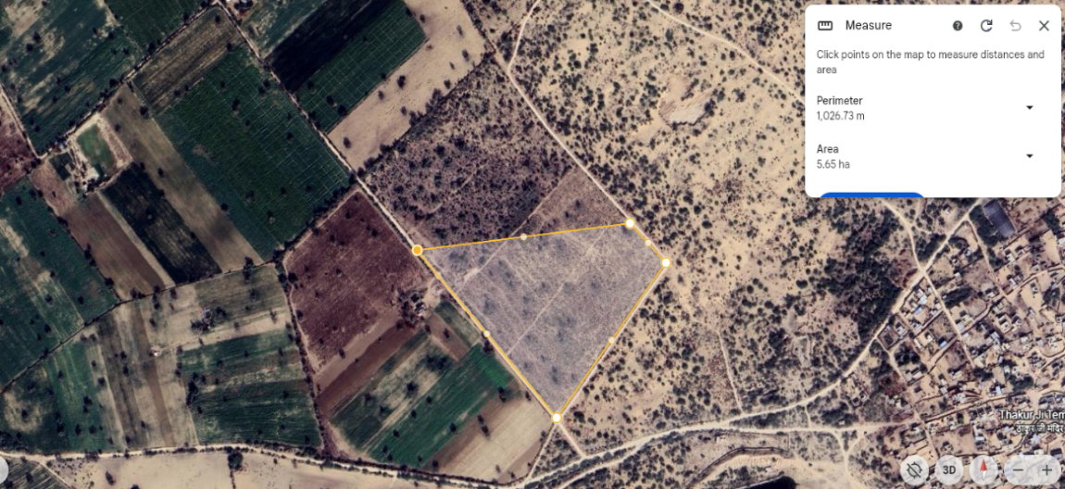
- LAYOUT PLAN:
As per the data/information provided by the client/Company, Proposed Schematic layout plan layout plan is attached below for reference.
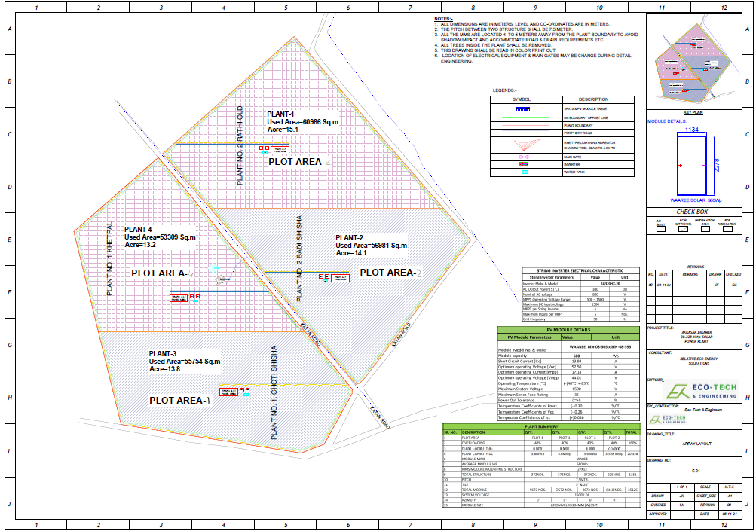
Plant No.2, Badi Shisha is one of the four plants mentioned in the layout plan for the Akkasar, Bikaner solar power project, which has a total capacity of 20.328 MWp. Of this, 5.6 MWp will be allocated for Bikana Renewables 2 Private Limited.
Note: As informed by the client, the schematic layout plan is subject to change as per the actual implementation plan.

- LAND DETAILS:
Bikana Renewables 2 Private Limited (BRPL2) has secured land for its proposed solar power plant through a legally binding lease agreement. The lease deed was executed on December 12, 2024, between Shri Santosh Devi (Lessor) and Bikana Renewables 2 Private Limited (Lessee). The Lessor is the absolute legal owner and holds peaceful possession of the land located in Village Akkasar, Tehsil Kolayat, District Bikaner, Rajasthan. The total landholding under Khasra Nos. 1326/40 and 1328/791 spans 24.0276 hectares, out of which 5.6538 hectares has been leased to BRPL2 for the development, operation, and maintenance of a solar power plant under the Kusum Component C Scheme. As per the information provided by the client, the leased land is strategically positioned to support renewable energy generation and is free from any encumbrances, liens, or disputes.
The lease agreement grants uninterrupted possession of the leased property to BRPL2 for a period of 27 years and 11 months, commencing from the Effective Date (January 1, 2025). During this tenure, BRPL2 will have the exclusive right to use the land for setting up, operating, and maintaining the solar power plant and associated infrastructure. If required, BRPL2 may extend the lease for an additional five years under mutually agreed terms and conditions. To exercise this option, BRPL2 must submit a formal request in writing at least six months before the expiration of the original lease period.
The lease rent is fixed at ₹75,090 per hectare per annum, payable annually by January 10 of the following year. Additionally, the lease rent shall increase by 5% every three years to account for inflation and market variations. BRPL2 is obligated to adhere to these payment terms to maintain compliance with the lease agreement.
This leased land forms part of the 20.328 MWp Akkasar, Bikaner Solar Power Project, which consists of multiple solar plants. Specifically, BRPL2’s project will be housed in Plant No. 3 (Choti Shisha), where 5.6 MWp of solar capacity will be deployed.
The project's location offers seamless connectivity to the Akkasar 1 Substation, facilitating efficient transmission of generated power. The selection of this site is based on technical feasibility studies, availability of essential resources, and accessibility for long-term operations. In summary, the land acquisition through this lease agreement provides a secure foundation for BRPL2’s solar power project.
CLU DETAILS
As per the information provided by the company, the land is classified as agricultural and is being utilized for a solar power plant to generate electricity for sale to DISCOMs. However, the Change of Land Use (CLU) has not been obtained. Based on discussions during the site survey, it was communicated that CLU is generally not required for such projects in Rajasthan.
- SITE PICTURES:
Site pictures were captured during the site survey on 8th March 2025, for reference few of the pictures are attached below:
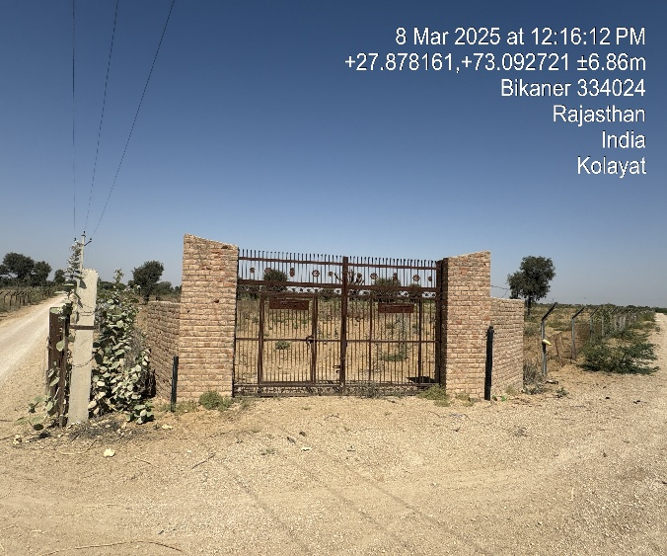 | 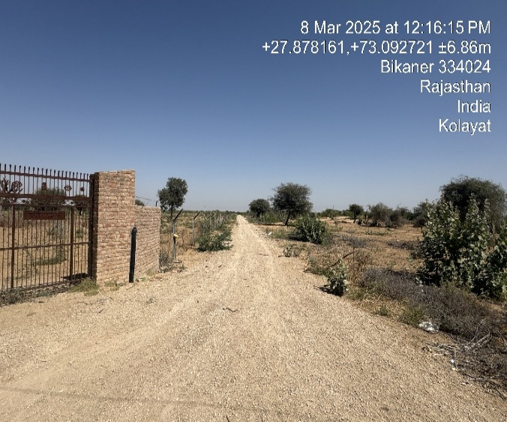
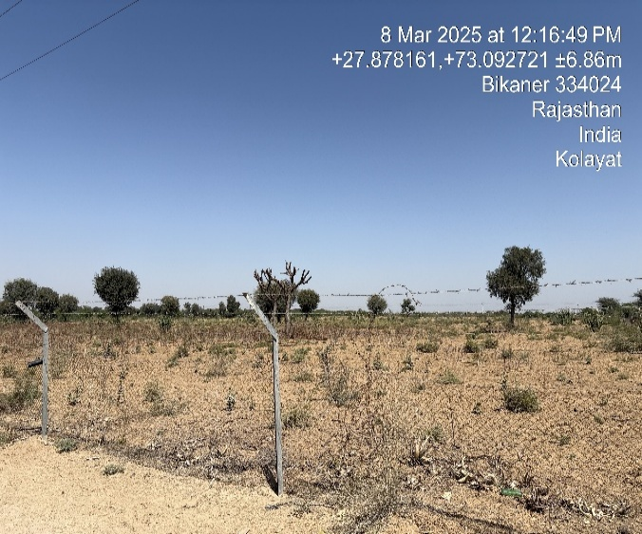 | 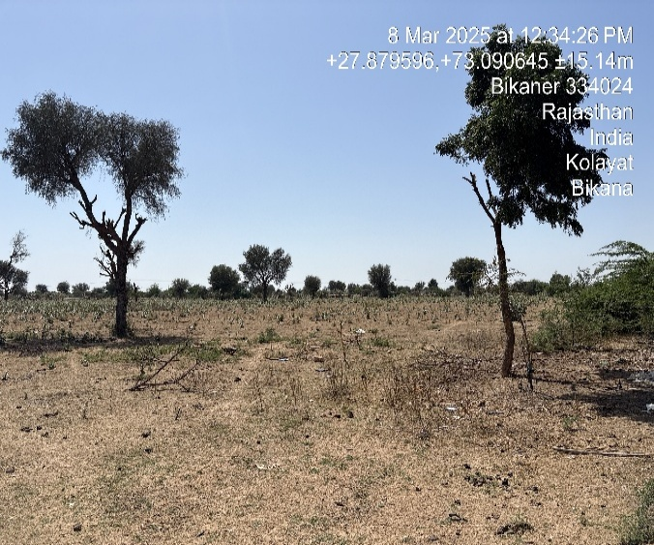
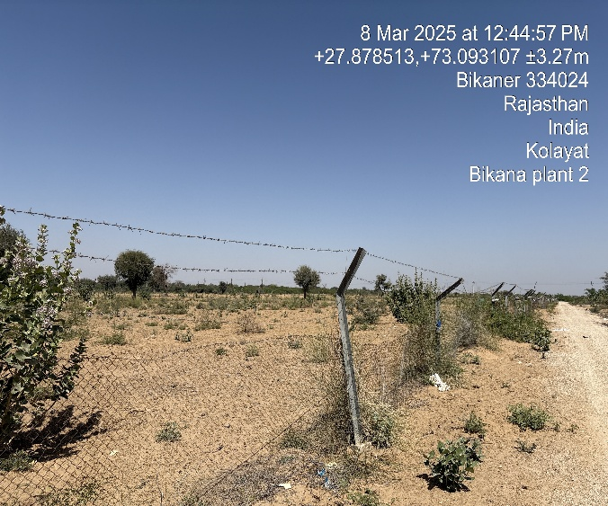 | 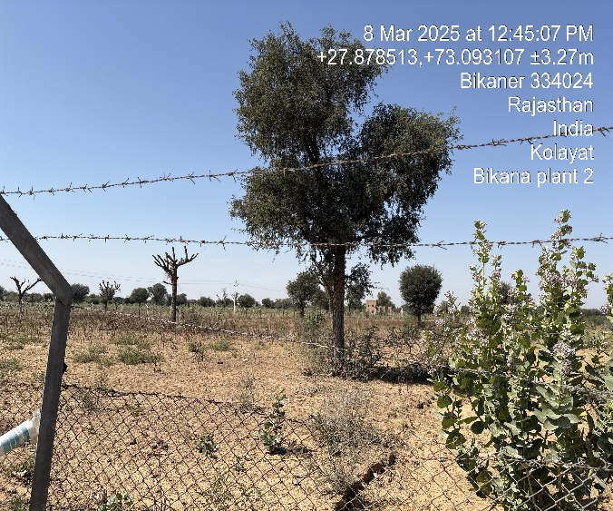
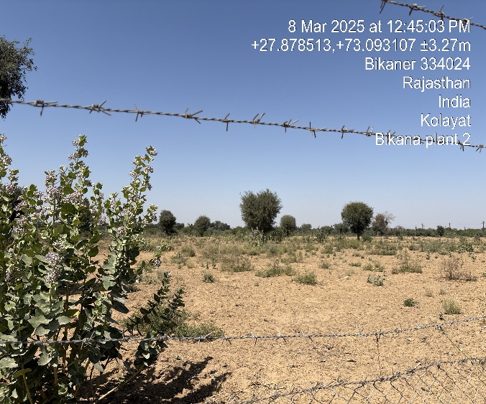 | 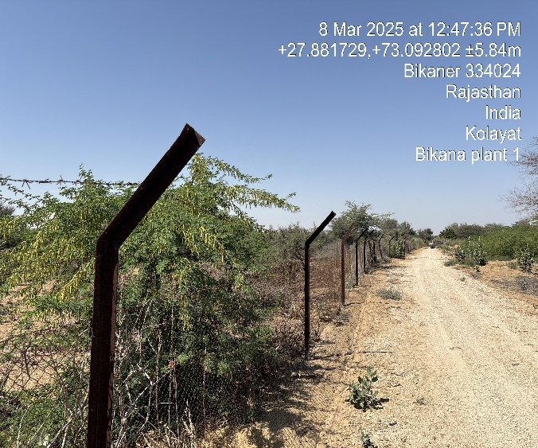

- PLANT & MACHINERY/ EQUIPMENTS DETAILS:
The following table outlines the major materials used in the solar power project.
S. No. | Item | UNIT | SPECIFICATION | MAKE
1. | Module | 5.60 MWp | Elite Series N Topcon Technology Solar PV Modules- 575 & Above Wp Framed Dual Glass AS PER IEC-61215, 61730, 61701, 62716, ULCERTIFIED  1703 | WAAREE N TOPCONE BIFACIAL
2. | Inverter | 15 Nos | STRING INVERTER 300KW @ 50°C, 1500 Vdc, OUTPUT, 3-PHASE 800V, WITH 12MPPT, LVRT, HVRT, REACTIVE POWER COMPATIBLE, SCADA COMMUNICABLE. IEC IEC-61683, IEC 61000, IEEE 519, IEC 60068, IEC 62116, IEC 62109-1 & 2 TYPE TESTED. | 300KW WATTPOWER
3. | STRUCTURE | 5.60MW | HOTDIP 80-100 MICRON ZINC COATING SEASONAL  TILT STRUCTURE As Per Design  - 4.80 MW Ground Mount Solar Structure 1) Column: Hot Dip Structure with 80 Micron  Zinc Coating  2) Rafter/Purline/Bracing: Galulanium (As per Design)  - SS304 NUT BOLT WASHER FOR MODULES & REST OF HDG AND ALL FITTING ASCCESSORIES  Seasonal Tilt with Two Orientation | JINDAL/JSW
4. | DC CABLES | MTR | ANNEALED TINNED FLEXIBLE CU CONDUCTOR ELECTRON BEAM CROSS LINKED XLPE 120 DEG C, SHEATHED AND INSULATED, 4 SQ. MM. 1C, ANTI TERMITE & ANTI RODENT, FRLS- EN 50618 (FOR ARRAY  CONNECTION) | POLYCAB/WAACAB
5. | AC CABLES | MTR | A) 1.9/3.3 KV, 3CX150/185/240/300 SQ.MM, ALUMINUM CONDUCTOR, XLPE INSULATED, PVC OUTER SHEATH, ARMORED -AS PER DESIGN  (FROM STRING INV. TO LT PANEL)  B) 1.9/3.3 KV, 1CX300 SQ.MM, ALUMINUM CONDUCTOR, XLPE INSULATED, PVC OUTER SHEATH, ARMORED  (FROM INV. TRANSFORMER TO LT PANEL) | POLYCAB/HAVELLS
6. | EARTHING BORE AND CHAMBER | NOS | COPPER BONDED EARTHING ELECTRODE WITH 250MICRON COPPER COATING 40MM DIA AND  3-MTR LENGTH AND EARTHING CHEMICAL COMPOUND | TRUE POWER/ JMV/ SABOO
7. | LIGHTENING ARRESTOR | NOS | ESE TYPE LA WITH REDIUS 107 MTR | TRUE POWER
8. | PILING | AS PER CIVIL DRAWING | 1500-2000(DEPTH) *300(DIA)*100(CAPING HEIGHT) MM | AS PER CIVIL DESIGN
9. | MC4 CONNECTOR | PAIR | MAIL AND FEMALE MC4 CONNECTOR | WAAREE/ELMEX
10. | COMBINED SOLAR ACDB | NOS. | INPUT: (13) Nos. of 800V 320 Amp 3-POLE MCCB WITH SPREADER LINK WITH AL BUS BAR: MAKE L&T OUTPUT: (1) Nos. of 800V 3000 Amp 3-POLE ACB WITH SPREADER LINK WITH AL BUS BAR: MAKE L&T MULTI-FUNCTION METER-SECURE 300 WITH 1500/5A CT, IP-55 PROTECTION, R-Y-B INDICTOR WITH CONTROL FUSE AND SURGE PROTECTION DEVICE TYPE-2, DOUBLE EARTHING, EARTH FAULT PROTECTION, EMERGENCY SWITCH OFF SWITCH, GROUND MOUNTED, 16Amp POWER SOCKET WITH SWITCH, DOUBLE COMPRESSION GLAND AND  1.6/2MM METAL SHEET FOR PANEL FABRICATION. | MCCB AND ACB-L&T
11. | TRANSFORMER | NOS | "INVERTER TRANSFORMER (4.25 MVA 33KV/0.8KV), 1 WINDING Dy11 OCTC=+/-5%@ 2.5%  ONAN, Z= 7%  WITH BOTH SIDE CABLE BOX  INDOOR TYPE STEP UP TRANSFORMER CONVERTER DUTY TYPE LOW LOSSES AS PER ECBC OF 4250 KVA, 0.800/33KV, 3 PHASE, 50 HZ, ONAN COOLED OIL IMMERSED  COPPER WOUND INDOOR TYPE STEP UP TRANSFORMER COMPLETE WITH FIRST FILLING OF IS: 335 ISI MARKED FILTERED & DEHYDRATED TRANSFORMER OIL AND OTHER  STANDARD FITTINGS / ACCESSORIES AND 17 POSITION ON LOAD TAP CHANGER (TAPPING RANGE ± 10% IN STEPS OF 1.25% EACH) WITH VECTOR GROUP YND -11 | H.D/ABC/UTTAM
12. | HT PANEL/ ICOG PANEL | NOS | 33KV, 650 AMP, VCB COMPRISING OF  - ASSEMBLY OF 3 INTERUPTERS COMPLETE WITH EPOXY SUPPORT INSULATOR AND SELF ALIGNING FINGER TYPE ISOLATING CONTACTS  - HAND AND MOTOR (220 VOLT AC) CHARGED INDEPENDENT SPRING CLOSING/TRIPPING TRIP FREE OPERATING MECHANISM WITH MANNUAL CLOSING AND TRIPPING PUSH BUTTONS AND MECHANICAL BREAKER CLOSED  /OPEN, SPRING CHARGED/ DISCHARGED INDICATION.  - ELECTRICAL RELEASE COIL 24V DC-01 NO  - MECHANICAL OPERATION COUNTER  - BREAKER OPERATED AUXILLARY SWITCH  - BUS BAR CHAMBER INCLUDING A SET OF 3 PHASE 650 AMP COPPER BUS BAR  - 230 VOLTS AC SINGLE PHASE 80 W RATED STRIP TYPE HEATER -02 NOS WITH INDICATOR COMPLETE.  - VOLTAGE TRANSFORMER (VT) INCORPORATING 3 PHASE 3 LIMB WITH DRAWABLE TYPE VT HAVING RATIO 11 KV/110V AND OUT PUT OF 100 VA PER PHASE WITH ACCURACY CLASS I AS PER IS-3155 COMPLETE WITH HT AND LT HRC FUSED N PRIMARY AND SECONDARY SIDES RESPECTIVELY (CONFIRMING RELATED IS SPECIFICATION) -02 SET FOR INCOMMER VCB'S ONLY  - CURRENT TRANSFORMER (CT) CHAMBER  INCORPORATING 3 SINGLE PHASE RESIN CAST, | REPUTED
DUAL RATIO CT’ OF RATIO – 50/100/1 AMP WITH SUITABLE VA BURDEN AND ACCURACY CLASS.
- REAR CABLE TERMINATION PROVISION FOR TERMINATING 3 CORE 240 SQMM 33KV HT XLPE CABLE.
- AMMETER DUAL RANGE WITH SELECTOR SWITCH SIZE 144 SQMM 0-20/10A
- VOLTMETER WITH SELECTOR SWITCH SIXE 144 SQMM, 0-15 KV
- MICROPROCESSOR BASE PROTECTION SCHEME TO WORK WITH CTS OF SECONDARY CURRENT SUITABLE FOR 24 V DC OPERATED TRIPPING SYSTEM FOR DETECTING, INDICATING AND TRIPPING THE BREAKER ON VARIOUS
FAULTS LIKE
- OVER-CURRENT AND EARTH FAULT WITH MIN. PICKUP OF 10% EACH, SENSITIVE EARTH FAULT WITH MIN PICKUP OF 1 %
- NEGATIVE SEQUENCE DETECTION FOR CONDUCTOR- BREAK FAULTS
- RESIDUAL AND THREE PHASE UNDER VOLTAGE/OVER VOLTAGES
- ADMITTANCE BASED EARTH FAULT PROTECTION TO WORK AT HIGH SYSTEM RESISTANCE
- CIRCUIT BREAKER FAILURE ALARM
13. | EARTHING CABLE |  | 1.1 KV, Flexible Copper Conductor FRLS - 1C X 35 sqmm insulated Unarmored and Unsheathed Cable -  INV EARTHING  1.1 KV, Flexible Copper Conductor FRLS - 1C X 70 sqmm insulated Unarmored and Unsheathed Cable  as per IS 695/IS 1554 - LA EARTHING | POLYCAB/HAVELLS
14. | HDPE CONDUIT PIPE |  | Suitable Size as per supplied (63/50 mm) & (32/25 mm) HDPE DWC Conduit for T and L Joints, Couplers and suitable adhesive and accessories required for laying of these pipes  (As per requirement) | ASTRAL/BERLIA/ REPUTED
15. | Energy Accounting Meters | Nos. | 4 Quadrant ABT Meters Class 0.2s | Secure/ L&T
16. | CT & PT Sets for Energy Meters | Set | - Specification of CT’s  Single Phase, Ratio: 200/5A  Dual Core for Metering Only, Accura Class: 0.2s Burdan: 10VA  - Specification of PT’s  Single Phase, Dual Core for Metering Only, Accura Class: 0.2s Burdan: 30VA, Ratio:33KV/√3/110V / √3 | ALPHA OR DEPARTMENT APRROVED MAKE
17. | DC CABLE CONDUITING | MTR | 20/25/32/40mm HDPE Conduit, Elbow, Tee, Socket and Fitting Accessories | BERLIA/ REPUTED
18. | CABLE TRAY | MTR | GI perforated cable tray with cover and fitting accessories for control cables | REPUTED
19. | 33 Kv 'Jio-Dio, Jiont Kit, Ac Cable and Conductor with Erection And  Installation | LOT | 33 KV Based Jio-Dio with Cable termination and cable jointing Kit and DOG Conductor based wire rope, polymer insulator, circuit breaker, 33KV Tower with accessories | RAYCHEM/ REPUTED
20. | EQUIPMENT FOUNDATION | LOT | ICOG & IDT & LT PANEL & HT PANEL FOUNDATIONS | AS PER CIVIL DRAWINGS
21. | Transmission Line | KM | 9 Mtr PCC Pole with ACSR DOG Conductor. | As per Specification
22. | MISCELLANEOUS ITEM | LOT | - Cable Tie: Nylon type, UV Resistant (200mm, 300mm, 400mm)  - Ferrules, Cable Tags: PVC Type Cable Tags for demarcating equipment & cables (LT Cable, DC Cables)  - Cable Tags: Metallic Type: (For Demarcating of equipment and cables (HT Panel, HT Cables)  - GI Wire: Suitable size GI wire for conduit support and tightening required)  - Electrical Tape HT & LT Both (R/Y/B)  - Anti-Corrosive Coating paint as required on jointing and mounting channel  - Danger Plate, Navigation Plates (Entry, Exit, Assembly and Fire exit, Inverter Numbering, Block Numbering) (150 x 150 mm, 3 mm thick MS Plate with paint).  - PUF sealant Spray Silicon Based for Conduit end to avoid entering of foreign material, particles & Insects.  - M -Seal for Conduit and gland  - First Aid Box  - Tools & Tackles for Testing & Commissioning (Magar, Multimeter, Clamp meter, 1500 Vdc)  - Glands - Double Compression Type As per Applicable Cable Size - For all AC Single Core Cable Non-Metallic Glands to be used Acroleic Paint for Demarcation, Finishing work | LUGS-DOWELLS, GLAND- COMET; OTHER ALL MAKE AS PER IS STANDARD
23. | INSTALLATION & COMMISSIONING | MWp | BY EXPERT TEAM OVER 100MW+ EXPERIENCE | ECO-TECH

Solar Power Plant
Produced Energy | 9242188 kWh/year
Specific production | 1648 kWh/kWp/year
Performance Ratio (PR) | 82.72 %
Solar Module capacity | 580Wp
type | BiN-08-565toBiN-08-600  Bi-facial N-type Dual Glass Bifacial module
Make | Waaree Energies Ltd.
Panels Required | ~9672 qty
Invertor Make | WattPower Systems Pvt.Ltd
Max. PV input voltage | 1500 V
Max. AC Active Power | 330 kWa
Max. efficiency | 99.00 %

As per the EPC agreement, Eco-Tech & Engineering Firm has been appointed as the EPC contractor for the development of a 5.60 MW (DC) ground-mounted seasonal tilt solar PV plant at Village Akkasar, Tehsil Kolayat, District Bikaner, Rajasthan, India. The contract encompasses the supply, erection, and commissioning of essential components, including solar PV modules, inverter systems, module mounting structures (MMS), DC & AC cables, combiner boxes, inverter duty transformers, AC circuit breakers (ACCB), protection panels, lightning and earthing protection systems, pooling point infrastructure, and other balance of system (BOS) components. The total EPC contract price for the project is approx. INR 21.61 crore.
The estimated cost of plant and machinery, as provided by the client in the EPC agreement, has undergone an independent verification by us. Upon evaluation, the cost of major equipment has been found to be reasonable and within acceptable industry standards. However, the final expenditure may vary depending on the specific brand selection and technical specifications of the equipment procured.
Note: It is to be noted here that the cost estimation done by us is just a general assessment for TEV purpose. However, detailed cost vetting is out of scope of this TEV report
The cost of installing a ~5.6 Mw-Dc solar power project in India depends on various factors, including equipment quality, location, and specific project requirements. As per recent estimates, the capital cost for solar installations typically ranges between ₹4 Cr to ₹5 Cr per MW for commercial and industrial projects. Based on this range, the total estimated cost for a proposed solar project would be approximately ₹22.4 Crores to ₹28.00 Crores, which aligns with previous cost assessments for similar projects.
https://waareertl.com/what-is-the-cost-and-roi-of-solar-system-installation-in-india/
https://amplussolar.com/blog/1mw-solar-power-plant/#:~:text=1%20Megawatt%20Solar%20Power%20Plant,which%20comes%20in%20various%20forms.
It's important to note that these figures are indicative and can fluctuate based on market conditions, technological advancements, and specific project parameters. For a precise cost assessment, consulting with experienced solar EPC (Engineering, Procurement, and Construction) contractors and conducting a detailed feasibility study is recommended.
PART E | PROJECT TECHNICAL DETAILS

- CAPACITY OF THE PROPOSED ROOF TOP SOLAR POWER PLANT:
Bikana Renewables 2 Private Limited (BRPL2) plans to develop a Kusum Component C solar project with a capacity of 4 MWac / 5.60 MWdc for the solarization of agricultural feeder substations. The project will be located at Village – Akkasar 1, Tehsil – Kolayat, Plant No.2 Badi Shisha, DD1 Bikaner Division, Substation– Akkasar 1, Bikaner, Rajasthan. The Letter of Award (LOA) for the project was issued on March 23, 2024, and was subsequently converted into a Power Purchase Agreement (PPA) with Jodhpur Vidyut Vitran Nigam Limited (JDVVNL) through Rajasthan Urja Vikas and IT Services Limited on February 5, 2025.
Under the PPA, the finalized levelized tariff is ₹3.38 per unit, ensuring revenue stability. The project is eligible to receive ₹0.78 crore as Central Financial Assistance (CFA) from the Government of India. Additionally, the project has a minimum generation guarantee of 37.24 lakh units, which must be transmitted to the grid.
The project will be executed, covering design, survey, supply, installation, testing, commissioning, operation, and maintenance for a period of 25 years from the commencement of commercial operations. It will function as a grid-connected solar power plant under the RESCO model, with power evacuation through the 33/11 kV transmission network, ensuring seamless integration into the regional power supply infrastructure.
Capacity of the proposed solar power project
Particular | Capacity
Solar Power Plant | ~5.6 MW-DC (~9672 nos. of Solar Panel in proposed location)  580 Wattp, 144 half-cell, N type, Topcon dual glass, bifacial solar module
Source: Data/information provided by the client.
- PROJECT IMPLEMENTATION:
M/s Bikana Renewables 2 Private Limited (BRPL2) has entered into an EPC contract with Eco-Tech & Engineering Firm on February 25, 2025, for the execution of a ~5.6 MW solar power project. The project is proposed to be designed with a Plant Load Factor (PLF) of 18.09% and is expected to be implemented within the next 8 months.

- COMMERCIAL AGREEMENT DETAILS:
Commercial details of EPC agreement are shown in the below table:
S. No. | Particular |  | Price per MW  (In Cr.) | TOTAL PRICE for the Project Capacity of 5.60 MWp
1 | Solar | Supply, Erection and commissioning of Modules, Inverter, MMS, DC Cables, Combines Boxes, AC Cables, Inverter Duty Transformer, ACCB, Protection Panel, lightening & Earthing protection, other BOS & mics, Items, pooling point. | 5.60 | 21.61
 | Total amount for 5.6 MW Solar DC |  | 5.60 | 1,49,30,56,000

- EPC DETAILS:
Eco-Tech & Engineering Firm has established itself as a leading player in the Solar EPC and Electrical EPC sector, showcasing extensive expertise in Distributed Energy and Solar Energy Solutions. The company possesses the technical know-how, infrastructure, and resources necessary to efficiently execute solar power projects with high reliability. Its capabilities span the entire project lifecycle, including design, engineering, procurement, manufacturing, installation, configuration, integration, commissioning, operations, management, and maintenance of solar power systems, ensuring seamless execution with precision and efficiency.
The firm specializes in providing customized solar solutions across various domains, including Grid-Interactive Rooftop Solar Systems, Distributed Renewable Energy Solutions (Mini/Micro Grids), and Standalone Solutions such as Solar Home Systems (SHS) and other customized livelihood solutions. Established on August 21, 2015, and restructured as a partnership firm on October 12, 2018, Eco-Tech & Engineering is currently owned by Shri Kishan Rathi (36 years, son of Rajkumar Rathi) and Shri Babu Lal Joshi (40 years, son of Shri Ram Kumar Joshi). The firm’s previous partners, Shri Manoj Kumar and Shri Pankaj Kumar Mishra, exited the partnership in 2018.
The firm's principal place of business is located at 1-D-58, JNV Colony, Bikaner, Rajasthan - 334003, and it primarily operates in solar energy equipment and engineering solutions. As per the partnership deed, profits are equally divided between the partners, and they are entitled to an interest of 12% per annum on their invested capital. Additionally, each partner has the authority to operate bank accounts and manage financial transactions independently.
Eco-Tech & Engineering initially entered the solar energy sector in 2010 by installing solar pumps for farmers in Rajasthan. However, following the withdrawal of government subsidies for solar pumps, the firm pivoted its focus toward large-scale solar energy parks in Bikaner and other regions of Rajasthan. To expand its capabilities, the company established a manufacturing unit for pre-fabricated boundary walls used in solar farms and entered the EPC business for setting up solar farms. Over time, it built strong industry connections and established itself as a trusted EPC contractor, working with leading solar developers such as Rays Power Experts, Azure Power, ReNew Power, and Avaada Energy.
As part of its professional expansion strategy, Eco-Tech & Engineering opened a corporate office at Spaze IT Park, Sohna Road, Gurgaon, enabling it to manage large-scale projects more efficiently and broaden its market reach. The firm is led by experienced professionals with deep industry expertise. Kuldeep Jain, the Chief Executive Officer (CEO), has 37 years of experience in the power sector, specializing in project management and execution of power plants across diverse sectors, including hydro, fuel-based, gas-based, and solar power plants in India, the Middle East, and Africa. He has held leadership positions in Azure Power, Vikram Solar, Waaree Group, and Wärtsilä.
Sachin Jain, the Chief Operating Officer (COO), is an engineer with 10 years of experience in the power sector. Before co-founding Eco-Tech & Engineering, he worked with Rays Power Experts for three years. His expertise lies in scaling operations and deploying solar power projects, and he has played a key role in expanding the firm's technology portfolio, with over 150 MW of solar power installed to date.
Eco-Tech & Engineering has emerged as a trusted name in the solar industry, leveraging its technical expertise and industry relationships to execute high-quality solar EPC projects. With a proven track record of delivering world-class solar solutions, the firm continues to expand its footprint in the renewable energy sector, contributing to India's clean energy transition
The following table provides an overview of the Scope of Work outlined in the EPC contract entered into with BRPL2.
Scope matrix on Supply, Civil works, Installation & Commissioning, Testing, Transportation, Insurance
S. No. |  | Item | EPC | Client
A |  | LAND REQUIREMENTS
A.1 |  | Arranging clear title land for construction of Project |  | Y
A.2 |  | Right of way for transmission line for power evacuation |  | Y
A.3 |  | Land development of the Project Site |  | Y
A.4 |  | Conduction of geotechnical investigation and topographical  survey, and ERT study | Y
 | B | Supply, Installation, Testing & Commissioning
B.1 |  | Solar PV Modules1 - Mono Crystalline Module (575 Wp & Above  - 1500 V System | Y
B.2 |  | Module Mounting Structure including fasteners for module mounting (wind speed as per IS 875, Column post of HDG, Purlin, rafters and Bracings of Galvalume/ HDG) | Y
B.3 |  | MC4 compatible connectors / Y connectors (male, female and  branch connectors) for creating blocks of strings | Y
B.4 |  | DC cables from each string (Modules) to String Inverter | Y
B.5 |  | AC cable from String Inverter to ACCB | Y
B.6 |  | AC cable from ACCB to Inverter Transformer | Y
B.7 |  | HT AC Cable / 33 kV ACSR conductor from Inverter Transformer  to ICOG Kiosk/ Outdoor Switchyard | Y
B.8 |  | HT AC Cable / 33 kV ACSR conductor from ICOG Kiosk/Outdoor  Switchyard to Project Metering Yard | Y
B.9 |  | String Inverters | Y
B.10 |  | Inverter Duty Transformer | Y
B.11 |  | 33 kV Outdoor ICOG Kiosk/ Outdoor Switchyard | Y
B.12 |  | LT/ HT switchgear | Y
B.13 |  | Internal Lighting for the Project | Y
B.14 |  | Earthing system for PV Array, Inverter, ACCB, Transformer, LA &  Project Switchyard | Y
B.15 |  | Lightning protection for the Project- ESE type Lightning arrestors | Y
B.16 |  | Communication Cable for Project data communication | Y
B.17 |  | Project auxiliary power distribution with distribution box | Y
 |  | Design & Engineering
B.18 |  | Solar resource assessment and generation estimation | Y
B.19 |  | Conceptual design, schematics, Project layouts | Y
B.20 |  | Project System Design up to power pooling station/yard | N.A.
 |  | POWER EVACUATION SYSTEM2
B.21 |  | Underground Transmission Lines from 33 kV common pooling station/ yard (PSS) to the Receiving End Sub Station (GSS) | N.A.
B.22 |  | SITC of Equipment & Material required for Bay at Receiving End Sub-Station | Y
C |  | Logistics
C.1 |  | Facilitation for concession for taxes, if available | Y
C.2 |  | Unloading and shifting of equipment at site | Y
C.3 |  | Storage at site and security for all equipment | Y
D |  | PRECOMMISSIONING & COMMISSIONING
 |  | Pre-commissioning Checks
D.1 |  | Pre-commissioning checks of DC System | Y
D.2 |  | Pre-commissioning checks of AC System | Y
 |  | Commissioning of System
D.3 |  | Commissioning of DC System | Y
D.4 |  | Commissioning of AC System | Y
D.5 |  | Synchronization to grid | Y
E |  | CIVIL WORKS
E.1 |  | Construction of Pile foundation for Module Mounting Structure  as per design specifications/ standards | Y
E.3 |  | Excavation of trenches for cables laying. | Y
E.4 |  | Foundations for major equipment like String Inverter, AC combiner box, Transformers and 11kV switchgear panels/ structures etc. | Y
E.5 |  | Excavation, structure erection, earth-pit construction, Foundations & Fencing for Project switchyard | Y
E.7 |  | Provision shall be provided to avoid water logging in Project area and it shall be drained out through strategic locations as per land Topography | Y
F |  | GOVT APPROVALS / STATUTORY REQUIREMENTS
F.1 |  | Drawing Approval | Y
F.2 |  | Charging Approval | Y
F.3 |  | Drawing Approval for CT, PT and Meter testing | Y
F.4 |  | Material Inspection and Dispatch Clearance | Y
F.5 |  | Bay Testing Clearance | Y
F.6 |  | Pre-commissioning Test reports | Y
F.7 |  | WCC (Work Completion Certificate) for Bays and external Lines | Y
F.8 |  | Charging permission from relevant authority | Y
F.9 |  | Commissioning Certificate | Y
F.10 |  | CEIG / MNRE clearances | Y
F.11 |  | Labor Inspector permission | Y
G |  | INSURANCE AND TAXES; PORT HANDLING, CUSTOMS CLEARANCE
G.1 |  | Insurance for equipment and material supplied by EPC Contractor till commissioning of Project. | Y
G.2 |  | Port handling, customs clearance for EPC Contractor’s scope | N.A.
H |  | FACILITIES AT SITE
H.1 |  | Construction power supply | Y
H.2 |  | Water during construction for construction purposes | Y
I |  | DOCUMENTATION AND HANDOVER
I.1 |  | Documents including:  · Permits and Approvals  ·Test reports  ·Pre-commissioning check reports  As built Drawings and documents and catalogues of Equipment | Y
I.2 |  | Test certificates and routine test certificates, as applicable | Y
I.3 |  | Basic Engineering drawings | Y
I.4 |  | Detailed Engineering drawings and documents | Y

- TECHNICAL SPECIFICATIONS OF THE PROPOSED SOLAR POWER PLANT:
As per the data/information provided by the client, below table shows the technical specification of the proposed Solar Power plant:
GENERAL TECHNICAL SPECIFICATION OF MAJOR COMPONENETS
Solar Panels (Waaree)
The solar power project will utilize Waaree Make ELITE SERIES N-TYPE BIN – 08-565 to BIN – 08-600 Framed Dual Glass Bifacial Modules, ensuring high efficiency and durability. These 144x half-cut cell mono-crystalline PERC Solar PV modules are designed for superior performance and long-term reliability.
Key Features & Specifications:
High Performance & Longevity: The panels come with a 97.3% power output warranty for the first year. From the 2nd to the 30th year, the power degradation is limited to a maximum of 0.7% per year, ensuring 80.5% power retention at the end of the 30-year warranty period.
Durability & Weather Resistance: Equipped with IP68-rated Junction Boxes and 1500 VDC capability, the panels provide excellent protection against environmental factors. They feature highly reliable anti-reflective coated glass, offering strong weather resilience, withstanding windspeeds up to 2400 PA and snow loads up to 5400 PA.
Superior Performance: The modules are Potential Induced Degradation (PID) resistant, ensuring long-term efficiency. Additionally, they offer exceptional performance in low-light conditions, making them suitable for various climatic conditions.
Warranty Coverage: The product warranty covers 12 years, while the performance warranty extends for 30 years, reinforcing confidence in the system’s durability and energy yield over its lifetime.
By integrating these high-quality Waaree solar panels, the project ensures maximum efficiency, reliability, and sustainability, contributing to long-term energy generation with minimal degradation.
Watt Power-Inverter
The Watt Power WP-330KTL-H1 is a smart string inverter designed for high-efficiency solar power generation. With its advanced MPPT technology, robust protection mechanisms, and intelligent monitoring features, it ensures optimal energy conversion and system reliability.
Technological Segment – Inverter Model WP-330KTL-H1
Parameter | Details
Model | WP-330KTL-H1 (Smart String Inverter)
Maximum Efficiency | ≥99.0%
European Efficiency | ≥98.8%
Maximum Input Voltage | 1,500 V
Number of MPPTs | 6
Maximum Current per MPPT | 65 A
Maximum Short-Circuit Current per MPPT | 115 A
MPPT Operating Voltage Range | 500 V – 1,500 V
Start Voltage | 550 V
Nominal AC Active Power | 275,000 W
Maximum AC Apparent Power | 330,000 VA
Maximum AC Active Power (cosφ=1) | 330,000 W
Nominal Output Voltage | 800 V, 3W + PE
Rated AC Grid Frequency | 50 Hz / 60 Hz
Maximum Output Current | 240.3 A
Total Harmonic Distortion (THD) | ≤1%
Protection Features | - Smart String-Level Disconnector (SSLD)  - Anti-islanding Protection  - AC Overcurrent & DC Reverse-Polarity Protection  - PV-Array String Fault Monitoring  - DC & AC Surge Arresters (Type II)  - DC Insulation Resistance Detection  - AC Grounding Fault Protection  - Residual Current Monitoring Unit
Communication & Monitoring | - LED Indicators, WLAN & Mobile App Support  - USB, MBUS, and RS485 Interfaces
Cooling Method | Smart Air Cooling
Environmental Protection | IP66-rated (Suitable for outdoor installation)
Operating Temperature Range | -25°C to 60°C
Maximum Altitude Without Derating | 4,000 meters
Relative Humidity Tolerance | 0 – 100%
The WP-330KTL-H1 inverter’s high efficiency, multi-MPPT tracking, and advanced protection mechanisms make it a reliable choice for grid-connected solar power projects. Its smart monitoring feature allow for remote tracking and real-time performance optimization, ensuring long-term operational efficiency. The inverter's robust surge protection, insulation monitoring, and residual current detection further enhance safety and reliability, making it an ideal choice for high-capacity solar power plants.

- TECHNOLOGICAL ASSESSMENT:
The 5.6 MW (DC) solar power project will utilize Waaree ELITE SERIES N-TYPE BIN – 08-565 to BIN – 08-600 Framed Dual Glass Bifacial Modules and Powerwatt WP-330KTL-H1 smart string inverters to ensure high efficiency and long-term performance.
The Waaree solar panels feature 144x half-cut cell mono-crystalline PERC technology, offering 97.3% power output in the first year, with an annual degradation of 0.7%, ensuring 80.5% efficiency after 30 years. A total of 9,762 panels will be deployed, backed by a 12-year product warranty and 30-year performance warranty.
The Powerwatt WP-330KTL-H1 inverters, manufactured by Watt Power, support DC overloading up to 30% and AC overloading up to 10%, featuring dual MPPT tracking, remote monitoring via Wi-Fi/GPRS, and advanced safety mechanisms. These inverters come with a 5-year standard warranty, extendable up to 20 years.
By integrating high-efficiency solar panels and advanced inverters, the project ensures optimized energy generation, long-term reliability, and smart monitoring capabilities, contributing to sustainable power production.
It seems reasonable to comment that the plant will be running smoothly. Technology & specification of the plant are matching with the need to run the power plant to achieve the economies of scale.

- MANPOWER:
As per the data/information shared by the client/company, BRPL2 will be responsible to operate the plant and there would be no additional manpower required to operate since the cost of manpower is already adjusted in O & M expenses.

PART F | INDUSTRY OVERVIEW

- INTRODUCTION:
India's energy demand is expected to increase more than that of any other country in the coming decades due to its sheer size and enormous potential for growth and development. Therefore, most of this new energy demand must be met by low-carbon, renewable sources. India's announcement India that it intends to achieve net zero carbon emissions by 2070 and to meet 50% of its electricity needs from renewable sources by 2030 marks a historic point in the global effort to combat climate change.
India was ranked fourth in wind power capacity and solar power capacity, and fourth in renewable energy installed capacity, as of 2023. Installed renewable power generation capacity has increased at a fast pace over the past few years, posting a CAGR of 15.4% between FY16 and FY23. India has 125.15 GW of renewable energy capacity in FY23. India is the market with the fastest growth in renewable electricity, and by 2026, new capacity additions are expected to double.
With the increased support of the Government and improved economics, the sector has become attractive from an investor’s perspective. As India looks to meet its energy demand on its own, which is expected to reach 15,820 TWh by 2040, renewable energy is set to play an important role.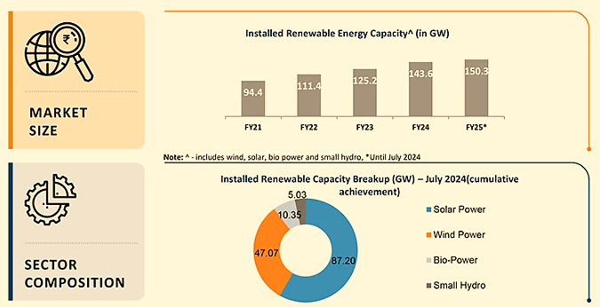
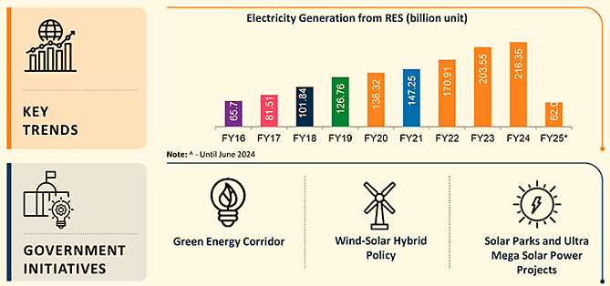
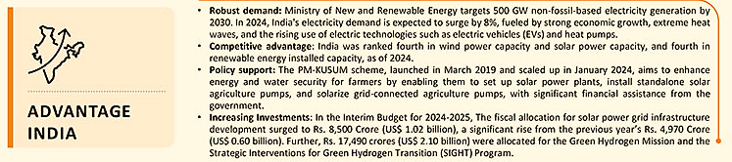

- MARKET SIZE:
- As of July 2024, Renewable energy sources, including biomass, waste to power and waste to energy, have a combined installed capacity of 150.27 GW.
- As of July 2024, 44% of the total power installed capacity is from non-fossil-based sources, which fulfils the target of 40% by the end of 2022.
- India's installed renewable energy capacity is expected to increase to about 170 GW by March 2025 from the level of 135 GW as of December 2023, according to research agency ICRA.
- The country is targeting about 450 Gigawatt (GW) of installed renewable energy capacity by 2030 – about 280 GW (over 60%) is expected from solar.
- The non-hydro renewable energy capacity addition stood at 4.2 GW for the first three months of FY23 against 2.6 GW for the first three months of FY22. According to research by the Council on Energy, Environment and Water's Centre for Energy Finance (CEEW-CEF), India's total installed power generation capacity reached 416 GW in FY23, of which 125 GW (30%) came from renewable energy (RE) and 47 GW (11%) comes from hydro.
- The electricity generation target (Including RE) for the year 2023-24 has been fixed as 1750 Billion Units (BU). i.e., growth of around 7.2% over the actual generation of 1624.158 BU for the previous year (2022-23). The generation during 2022-23 was 1624.158 BU as compared to 1491.859 BU generated during 2021-22, representing a growth of about 8.87%.
- The installed solar energy capacity has increased by 26 times in the last 9 years and stands at 73.32 GW as of December 2023. In 2023, India has added 7.5 GW of solar power capacity.
- During January 2024, the capacity addition from solar energy stood at 9008.47 MW.
- Solar power accounted for 16.9% of the total installed power capacity and 40.1% of the total installed renewable capacity at the end of December 2023. Solar power's share increased by 0.3% from the last quarter, when it accounted for 39.5% of the total renewable capacity.
- India has hydroelectric power projects with a total capacity of 15 GW under construction, which will increase the country's total hydro capacity from 42 GW to 67 GW by 2031-32, supported by IMD's prediction of higher rainfall and the government's proactive stance towards accelerated hydropower development.
- India has generated 75.57 BU of solar power in the first eleven months of FY24.
- Power generation from renewable energy sources (not including hydro) stood at 22.41 billion units (BU) in January 2024, down from 25.79 BU in January 2023.
- India added a record 18.48 GW of renewable energy capacity in 2023-24, a 21% increase over the previous year.
- Power generation from renewable energy sources (not including hydro) stood at 22.27 billion units (BU) in June 2024, up from 21.86 BU in June 2024.
- Power generation from renewable energy sources stood at 62.09 billion units (BU) between April-June 2024, up from 57.94 BU in the same period in the previous year.
- With a potential capacity of 363 GW and with policies focused on the renewable energy sector, Northern India is expected to become the hub for renewable energy in India.
- INVESTMENT:
According to the data released by the Department for Promotion of Industry and Internal Trade (DPIIT), the non-conventional energy space in India has become highly attractive for investors and received an FDI inflow of US$ 15.36 billion between April 2000-September 2023. More than Rs. 5.2 lakh crore (US$ 70 billion) has been invested in India’s renewable energy sector since 2014. Some major investments and developments in the Indian renewable energy sector are as follows:
- India is set to significantly boost its renewable energy investments, with a projected increase of 83% to approximately US$ 16.5 billion in 2024, as part of its strategy to transition to cleaner energy sources and reduce carbon emissions.
- India is set to invest over US$ 360 billion in renewable energy and infrastructure by 2030, with US$ 190 billion to US$ 215 billion needed to achieve 500 GW of renewable capacity. An additional US$ 150 billion to US$ 170 billion will be required for electricity transmission and storage.
- Brookfield Asset Management plans to boost its investments in India’s renewable energy sector to over US$ 10 billion in the next three to four years, also exploring electric vehicles and green hydrogen.
- India's renewable energy sector set to attract over $250 billion in investments, with solar PV projects expecting $15.5 billion and battery manufacturing $2.7 billion.
- The non-conventional energy space in India has become highly attractive for investors and received an FDI inflow of US$ 17.88 billion between April 2000-March 2024.
- According to Moody's, India will require US$ 190 billion-US$ 215 billion of investment over the next seven years to achieve the target of 500 GW of renewable energy capacity by 2030, and another US$ 150 billion-US$ 170 billion for electricity transmission, distribution, and energy storage.
- Radiance Renewables, an Indian renewable energy developer, and the UK's Private Infrastructure Development Group have formed a joint venture called Radiance InfraCo Renewables to develop greenfield solar and wind-solar hybrid projects for commercial and industrial clients in India, leveraging their expertise to support the country's transition towards its net-zero emissions target by 2070.
- Maruti Suzuki India will invest Rs. 450 crore (US$ 54 million) over the next three years in renewable energy projects, including a biogas plant at Manesar and expanding solar capacity. The pilot biogas plant aims to produce 1 lakh cubic meters of biogas in FY 2024-25, offsetting 190 tonnes of CO2 annually. Solar capacity will grow from 43.2 MWp to 78.2 MWp by FY 2025-26, supporting Suzuki's 'Environment Vision 2050.
- NTPC Green Energy Ltd. will invest Rs. 80,000 crore (US$ 9.59 billion) in Maharashtra for green hydrogen, ammonia, and methanol projects, including 2 GW pumped storage and up to 5 GW renewable energy projects, as part of a plan to build 60 GW renewable capacity by 2032.
- On December 4, 2023, Andhra Pradesh announced Rs 6600 crore (US$ 794 million) clean energy and infrastructure expansion plans, including a 750 MW solar project, 100 MW solar plant, substation enhancements, collaborations with HPCL, Avera AI Mobility's electric vehicle expansion, and SECI contract for solar energy.
- On January 4, 2024, Torrent Power signed four initial pacts with the Gujarat government to invest Rs 47,350 crore (US$ 5.70 billion) in renewable energy, green hydrogen, and electricity distribution. These investments are aimed at contributing to the state's development and creating employment opportunities.
- On January 8, 2024, Tata Power announced an Rs 70,000 crore (US$ 8.42 billion) investment to develop 10 GW of solar and wind power capacity in Tamil Nadu over the next 5-7 years. This aligns with its goal of achieving 70% clean energy production by 2030.
- In November 2023, AmpIn Energy Transition announced an investment of Rs. 3,100 crore (US$ 372.6 million) to establish renewable energy projects exceeding 600 MW and an integrated manufacturing facility for solar cells and modules across the Eastern region. The funding will be focused in West Bengal, Bihar, Odisha, Jharkhand, Chhattisgarh, and the Northeastern States.
- Around US$ 2.8 trillion will be invested in energy in 2023 globally. More than US$ 1.7 trillion is going to clean energy, including renewable power, nuclear, grids, storage, low-emission fuels, efficiency improvements and end-use renewables and electrification.
- US$ 2.4 billion National Hydrogen Mission for production of 5 MMT by 2030 and US$ 36 million additional in budget.
- 59 solar parks with an aggregate capacity 40 GW have been approved in India. Solar Parks in Pavagada (2 GW), Kurnool (1 GW) and Bhadla-II (648 MW) are included in the top 5 operational solar parks of 7 GW capacity in the country.
- The world’s largest renewable energy park of 30 GW capacity solar-wind hybrid project is under installation in Gujarat.
- India offers a great opportunity for investments in the RE sector; $196.98 Bn worth of projects are underway in India.
- Wind Energy has an offshore target of 30 GW by 2030 with 3 potential sites identified.

- GOVERNMENT INITIATIVES:
- In the Interim Budget for 2024-2025, The Government of India doubled funding for the National Green Hydrogen Mission, allocating Rs. 600 crores (US$ 72 million). Additionally, Rs. 17,490 crores (US$ 2.10 billion) were allocated for the Green Hydrogen Mission and the Strategic Interventions for Green Hydrogen Transition (SIGHT) Programme, highlighting a commitment to sustainable energy transition.
- In the Interim Budget for 2024-2025, the fiscal allocation for solar power grid infrastructure development surged to Rs. 8,500 Crore (US$ 1.02 billion), a significant rise from the previous year's Rs. 4,970 Crore (US$ 0.60 billion).
- As of January 2, 2024, the Government of India is implementing the Production Linked Incentive (PLI) Scheme for the National Programme on High Efficiency Solar PV Modules, aimed at achieving gigawatt-scale manufacturing capacity. Under Tranche-II, with a budget allocation of Rs 19,500 crore (US$ 2.35 billion), Letters of Award were issued in April 2023 for the establishment of 39,600 MW of fully or partially integrated solar PV module manufacturing units.
- The Ministry of New and Renewable Energy (MNRE) has proposed the establishment of a 13,000 MW renewable energy (RE) capacity along with a 12,000 MWh Battery Energy Storage System (BESS) in Ladakh. On October 18, 2023, the Cabinet Committee on Economic Affairs approved the construction of an Inter-State Transmission System (ISTS) to facilitate the power evacuation and grid integration of these RE projects in Ladakh.
- Proposed solar cities and parks: The Solar Park Scheme launched in December 2014 with a capacity of 20,000 MW was expanded to 40,000 MW by March 2017. As of November 30, 2023, 50 solar parks have been approved, totaling around 37,490 MW capacity across 12 states. Of these, 10,401 MW has been commissioned, including 284 MW in 2023.
- On February 13, 2024, Prime Minister Mr. Narendra Modi launched PM Surya Ghar Muft Bijli Yojana, offering free solar electricity to 1 crore households, backed by subsidies and concessional loans.
- On December 12, 2023, the Union Minister for New & Renewable Energy and Power reported the installation of 140 MW solar power plants and 2.73 lakh standalone solar pumps under PM-KUSUM, aimed at farmer welfare and environmental sustainability.
- In Budget 2023-24, Green Growth was identified as one of the nodes in the SAPTARISHI (7 priorities).
- In Budget 2023-24, pumped storage projects received a push with a detailed framework to be formulated.
- Union Budget 2023-24 envisions to create sustainable cities of tomorrow. To translate this, states and cities will be encouraged to undertake urban planning reforms and actions to transform our cities into 'sustainable cities of tomorrow.’
- The Indian government's commitment to reaching net-zero emissions by 2070 and increasing its renewable energy target to 500 GW by 2030 at the COP26 summit has provided great support to the industry and spurred unprecedented growth.
- In Budget 2023-24, Rs. 8,300 crore central sector support for ISTS infrastructure for 13 GW renewable energy from Ladakh was announced.
- On November 19, Prime Minister Mr. Narendra Modi dedicated the 600 MW Kameng Hydro Power Station in Arunachal Pradesh to the country. The project, which covers more than 80 kilometres and costs about Rs. 8,200 crores, is located in Arunachal Pradesh's West Kameng District.

- CONCLUSION:
India has set a target to reduce the carbon intensity of the nation’s economy by less than 45% by the end of the decade, achieve 50% cumulative electric power installed by 2030 from renewables, and achieve net-zero carbon emissions by 2070. Low-carbon technologies could create a market worth up to $80 billion in India by 2030.
India‘s target is to produce five million tonnes of green hydrogen by 2030. The Green Hydrogen target is set at India’s electrolyser manufacturing capacity is projected to reach 8 GW per year by 2025. The cumulative value of the green hydrogen market in India could reach $8 Bn by 2030 and India will require at least 50 gigawatts (GW) of electrolysers or more to ramp up hydrogen production.
India’s ambitious renewable energy goals are transforming its power sector. The rising population and widespread electrification in rural homes are fuelling the demand for energy to power homes, businesses and communities. Clean energy will reduce pollution levels as villages become self-sustainable with their use of clean energy. In 2022, India's renewable energy sector is expected to boom with a likely investment of US$ 15 billion this year, as the government focuses on electric vehicles, green hydrogen, and the manufacturing of solar equipment.
It is expected that by 2040, around 49% of the total electricity will be generated by renewable energy as more efficient batteries will be used to store electricity, which will further cut the solar energy cost by 66% as compared to the current cost. The use of renewables in place of coal will save India Rs. 54,000 crore (US$ 8.43 billion) annually. Around 15,000 MW of wind-solar hybrid capacity is expected to be added between 2020-25. As per the Central Electricity Authority (CEA) estimates, by 2029-30, the share of renewable energy generation would increase from 18% to 44%, while that of thermal is expected to reduce from 78% to 52%. The CEA also estimates India’s power requirement to grow to reach 817 GW by 2030.

PART G | SWOT ANALYSIS

SWOT ANALYSIS
STRENGTHS | - Strong Promoter: BRPL2 is backed by Eco-Tech & Engineering, a solar EPC firm with 50+ MW of executed projects, and Mukesh Trading Corporation, an infrastructure developer specializing in construction and mechanized earthworks. Their technical expertise, financial strength, and industry experience ensure efficient execution, seamless development, and long-term success.  - Established Industry Network & Strong Client Base: BRPL2’s promoters, Eco-Tech & Engineering, have a strong track record of working with leading solar developers and government agencies, including Azure Power, ReNew Power, Avaada Energy, Rays Power Experts, Noida Metro Rail Corporation, and Nagpur Metro Rail. This industry network enhances BRPL2’s credibility, opening doors for future collaborations and additional project opportunities.  - Strategic Location with High Solar Potential: Located in Bikaner, Rajasthan, the project benefits from high solar irradiance (GHI: 5.5-6.5 kWh/m²/day), ensuring maximum energy yield and efficiency. The dry climate and minimal cloud cover further enhance solar panel performance. Spanning 5.6538 hectares of leased land, the site allows optimal panel placement and future scalability, ensuring higher capacity utilization, improved economics, and long-term sustainability.  - Government Support & Policy Backing: BRPL2’s solar project is part of the Kusum Component C Scheme, a government initiative promoting solarization of agricultural feeders. This provides policy support by aligning with India’s 500 GW renewable energy target by 2030, financial assistance through ₹0.74 crore Central Financial Assistance (CFA), and priority grid integration, ensuring preferential access and tariff stability, minimizing operational risks
WEAKNESSES | - Competitive & Regulatory Risks: The renewable energy sector is highly competitive, with larger players expanding into telecom solarisation, minigrids, and solar. Additionally, fluctuations in government policies, solar tariffs, and subsidies could impact the company’s financial viability and future growth.  - Dependency on Institutional Clients: BRPL2 primarily serves government institutions, making its revenue streams highly dependent on long-term contracts, timely payments, and policy stability. Delays in payments or contract renewals could affect cash flow.  - High Maintenance Costs & Operational Complexity: Maintaining distributed solar infrastructure requires regular inspections, panel cleaning, inverter replacements, and battery upkeep, increasing operational expenses.  - Regulatory & Policy Risks: Changes in government policies, tariffs, or subsidy structures could impact financial projections and project viability
OPPORTUNITIES | - Technological Advancements: Innovations in battery storage and hybrid solar systems can enhance BRPL2’s efficiency and competitiveness.  - Government Incentives: Eligibility for ₹0.74 crore Central Financial Assistance (CFA) and other subsidies reduce financial burden  - Corporate & Industrial Solar Adoption: Increasing demand for captive solar power solutions from industries and commercial users  - Government Renewable Energy Push: Policies mandating renewable energy adoption and incentives such as subsidies, tax benefits, and viability gap funding create significant growth opportunities  - Growing Demand for Renewable Energy: As more businesses and governments commit to renewable energy, Company could benefit from increased demand for its surplus power under open access arrangements.
THREATS | - Regulatory Risks: Changes in government policies or reductions in subsidies could impact the financial viability of the solar project, affecting company’s profitability.  - Market Competition: Increased competition from other renewable energy sources or cheaper conventional energy options might affect the market share and pricing power.  - Technological Risks: Rapid changes in solar technology or issues with the reliability of the installed equipment could pose risks to the project’s performance and financial returns.  - Economic Fluctuations: Economic downturns could affect investment availability and delay project implementation or expansion plans.  - Cybersecurity & Data Risks: As solar projects become more digitized with smart grids and remote monitoring, risks of cyberattacks, data breaches, or system malfunctions increase

PART H | PROJECT COST AND MEANS OF FINANCE
As per data/information shared by the client, the proposed Solar Power Projects are proposed to be commissioned by making an investment of INR 23.99 Crore as shown in the below table along with Means of finance:
Total Project Cost
Particular (INR Crore) | Solar Power Projects
Land Development Cost | 0.00
Building & Civil Works | 0.00
Plant & Machinery | 21.61
Office Equipment & Furniture | 0.00
Interest During Construction (IDC) | 1.09
Preliminary Expenses | 0.86
Contingency @2% | 0.43
Sub Total | 23.99
Source: data/Information provided by the company.
Means of Finance
S. No. | Particular | Weight | Amount (INR Crore)
 | Equity | 30% | 7.20
 | Term Loan from Bank | 70% | 16.79
 | Total |  | 23.99
Source: Data/Information provided by the company.
Notes:
- It is to be noted that the detailed vetting of the project cost is out of scope of this TEV report and we have relied upon the data/information provided by the client regarding Total Project cost in good faith, however as a TEV consultant we have cross verified the cost of the major components of TPC independently wherever required for the purpose of TEV only.
- Proposed Solar Power project will be implemented through appointment of EPC, for which company has signed an agreement with Eco Tech & Engineering. dated 25th February 2025 for design, engineering, supply, installation, testing & commissioning including modules and balance of system items along with all accessories, tools & tackles, in accordance with this Agreement.
- Based on the data and information provided by the client, the total project cost is estimated at INR 23.99 Crore, of which approximately 88% (INR 21.61 Crore) is allocated for plant and machinery for the proposed solar power projects.
- As per the provided details, the applicable Interest During Construction (IDC) is 9.25%. Consequently, the company is required to pay INR 1.09 Crore as IDC for 8 months, covering the period from April 1, 2025, to November 30, 2025, in accordance with the proposed loan repayment schedule.
- The preliminary expenses, including a three-month Debt Service Reserve Account (DSRA) and Processing Fees, have been estimated at INR 0.86 Crore, accounting for 3.58% of the project's total cost, based on the company's projected resource allocation.
- The project is proposed to be funded through a term loan of INR 16.79 Crore, with the promoter's equity contribution of INR 7.20 Crore.

PART I | PROJECT IMPLEMENTETION SCHEDULE

The proposed solar power project is expected to achieve its C.O.D till 30th Nov 2025, as per the proposed implementation schedule shown in the table below:
S. No. | Particulars | Activity | Expected completion date | Status
 | Land | Land Procurement | 12th December 2024  Lease Agreement | Completed
 | Land | Land Development | 30th June 2025 | Scheduled
 | Sanction of Rupee Term Loan | Sanction of Rupee Term Loan | 15th April 2025 | Scheduled
 | Building & Civil Works | Appointment of EPC | 25th February 2025 | Completed
 | Building & Civil Works | Layout Plan Preparation | 10th December 2024 | Completed
 | Building & Civil Works | Building Plan Sanction | NA | -
 | Building & Civil Works | Appointment of Civil contractor/ developer | Under EPC | Scheduled
 | Building & Civil Works | Solar Structure, Building & Civil Works completion | 31st August 2025 | Scheduled
 | Plant & Machinery | Finalization of P&M suppliers | 31st July 2025 | Scheduled
 | Plant & Machinery | Orders to P&M suppliers | 31st July 2025 | Scheduled
 | Plant & Machinery | Arrival of P&M | 15th October 2025 | Scheduled
 | Plant & Machinery | Installation of P&M | 31st October 2025 | Scheduled
 | Plant & Machinery | Utility Installation | 31st October 2025 | Scheduled
 | Statutory Approvals, registrations & NOCs | From the respective authorities | 15th November 2025 | Scheduled
 | Finishing & Trail Run | Informed by client | 15th November 2025 | Scheduled
 | Commercial Operation Date | Informed by client | 1st December 2025 | Scheduled

Notes:
- Schedule has been made as per feasibility to achieve different milestones.
- Achievement of Milestone will depend on sanction of term loan as per proposed timeline.
- For current status of statutory approvals, kindly refer the “Section J” of this report.
- As per this timeline, the expected C.O.D will be 1st December 2025.

PART J | STATUTORY APPROVALS | LICENCES | NOC

As shown in the below table along with current status, following major approvals are required, However the list is not exhaustive and State/District Authorities may be approached for further clearances required (if any):
S. No. | REQUIRED APPROVALS | DATE  REFERENCE NO. | STATUS  (Approved/ Applied For/ Pending)
 | Land conversion to Industrial/Non agriculture | - | Pending
 | Grid Connectivity Approval | - | Pending
 | Electricity Regulatory Compliance | - | Pending
 | Building and civil works Plan Sanction Approval. | - | Pending
 | Pre-establishment fire NOC  Fire and Emergency Services | - | Apply in due course
 | Fire NOC (on completion)  Fire and Emergency Services | - | Will be Applied post C.O.D.

Observation Note:
- Above is the only illustration of the major approvals sought or to be sought by the company. It should not be construed as the exhaustive list and in case any approval is missed to be mentioned then it is the sole responsibility of the company to keep the unit compliant with the necessary statutory approvals/ NOCs.

PART K | PROJECT’S FINANCIAL FEASIBILITY

- PROJECTIONS OF THE PROJECT:
The financial projections of the proposed Solar Power Project is prepared from FY 2025 to FY 2050 based on the expected COD on 1st December 2025 and loan tenure as per the best practice in industry to assess the financial feasibility of the project:
- PROJECTED PROFIT & LOSS ACCOUNT:
(INR Crore)
Year Ending (INR Crore) | 31-Mar-26 | 31-Mar-27 | 31-Mar-28 | 31-Mar-29 | 31-Mar-30 | 31-Mar-31 | 31-Mar-32 | 31-Mar-33 | 31-Mar-34
Year Counter | 1 | 2 | 3 | 4 | 5 | 6 | 7 | 8 | 9
Months Counter | 4 | 12 | 12 | 12 | 12 | 12 | 12 | 12 | 12
Revenue
Revenue | 1.01 | 3.02 | 3.78 | 2.96 | 2.93 | 2.90 | 2.88 | 2.84 | 2.82
Operating Expenses
O & M Expenses | 0.07 | 0.23 | 0.24 | 0.24 | 0.25 | 0.26 | 0.27 | 0.28 | 0.28
Insurance Expenses | 0.02 | 0.02 | 0.02 | 0.02 | 0.02 | 0.02 | 0.01 | 0.01 | 0.01
Depreciation & Amortization | 0.56 | 1.64 | 1.53 | 1.42 | 1.31 | 1.22 | 1.13 | 1.05 | 0.97
Lease Rentals for land | 0.01 | 0.04 | 0.04 | 0.04 | 0.04 | 0.05 | 0.05 | 0.05 | 0.05
Total Expenses | 0.67 | 1.94 | 1.83 | 1.72 | 1.63 | 1.54 | 1.46 | 1.38 | 1.32
EBIT | 0.34 | 1.08 | 1.95 | 1.24 | 1.30 | 1.36 | 1.42 | 1.46 | 1.50
Interest expenses
Interest on term loan | 0.55 | 1.58 | 1.48 | 1.37 | 1.27 | 1.16 | 1.06 | 0.96 | 0.86
Bank Charges | 0.00 | 0.00 | 0.00 | 0.00 | 0.00 | 0.00 | 0.00 | 0.00 | 0.00
Profit before Taxes (PBT) | -0.21 | -0.50 | 0.47 | -0.14 | 0.04 | 0.20 | 0.36 | 0.50 | 0.64
Tax | 0.00 | 0.00 | 0.08 | 0.00 | 0.01 | 0.03 | 0.06 | 0.09 | 0.11
Profit after Taxes (PAT) | -0.21 | -0.50 | 0.39 | -0.14 | 0.03 | 0.16 | 0.30 | 0.42 | 0.53

(Continued)
Year Ending (INR Crore) | 31-Mar-35 | 31-Mar-36 | 31-Mar-37 | 31-Mar-38 | 31-Mar-39 | 31-Mar-40 | 31-Mar-41 | 31-Mar-42 | 31-Mar-43
Year Counter | 10 | 11 | 12 | 13 | 14 | 15 | 16 | 17 | 18
Months Counter | 12 | 12 | 12 | 12 | 12 | 12 | 12 | 12 | 12
Revenue
Revenue | 2.79 | 2.77 | 2.73 | 2.71 | 2.68 | 2.66 | 2.63 | 2.60 | 2.58
Operating Expenses
O & M Expenses | 0.29 | 0.30 | 0.31 | 0.32 | 0.33 | 0.34 | 0.35 | 0.36 | 0.37
Insurance Expenses | 0.01 | 0.01 | 0.01 | 0.01 | 0.01 | 0.01 | 0.01 | 0.01 | 0.01
Depreciation & Amortization | 0.90 | 0.84 | 0.78 | 0.72 | 0.67 | 0.62 | 0.58 | 0.53 | 0.50
Lease Rentals for land | 0.05 | 0.05 | 0.05 | 0.05 | 0.05 | 0.05 | 0.05 | 0.05 | 0.06
Total Expenses | 1.26 | 1.20 | 1.15 | 1.10 | 1.06 | 1.02 | 0.99 | 0.95 | 0.93
EBIT | 1.53 | 1.57 | 1.59 | 1.61 | 1.62 | 1.64 | 1.64 | 1.65 | 1.65
Interest expenses
Interest on term loan | 0.76 | 0.67 | 0.57 | 0.48 | 0.38 | 0.29 | 0.21 | 0.13 | 0.04
Bank Charges | 0.00 | 0.00 | 0.00 | 0.00 | 0.00 | 0.00 | 0.00 | 0.00 | 0.00
Profit before Taxes (PBT) | 0.77 | 0.90 | 1.01 | 1.13 | 1.24 | 1.35 | 1.43 | 1.52 | 1.60
Tax | 0.13 | 0.15 | 0.17 | 0.19 | 0.21 | 0.23 | 0.25 | 0.26 | 0.28
Profit after Taxes (PAT) | 0.64 | 0.75 | 0.84 | 0.94 | 1.03 | 1.12 | 1.19 | 1.26 | 1.33

(Continued)
Year Ending (INR Crore) | 31-Mar-44 | 31-Mar-45 | 31-Mar-46 | 31-Mar-47 | 31-Mar-48 | 31-Mar-49 | 31-Mar-50
Year Counter | 19 | 20 | 21 | 22 | 23 | 24 | 25
Months Counter | 12 | 12 | 12 | 12 | 12 | 12 | 12
Revenue
Revenue | 2.56 | 2.53 | 2.50 | 2.48 | 2.46 | 2.43 | 2.41
Operating Expenses
O & M Expenses | 0.38 | 0.39 | 0.40 | 0.42 | 0.43 | 0.44 | 0.46
Insurance Expenses | 0.01 | 0.01 | 0.01 | 0.00 | 0.00 | 0.00 | 0.00
Depreciation & Amortization | 0.46 | 0.43 | 0.40 | 0.37 | 0.34 | 0.32 | 0.29
Lease Rentals for land | 0.06 | 0.06 | 0.06 | 0.06 | 0.06 | 0.06 | 0.06
Total Expenses | 0.91 | 0.88 | 0.86 | 0.85 | 0.83 | 0.82 | 0.81
EBIT | 1.65 | 1.65 | 1.64 | 1.63 | 1.63 | 1.61 | 1.59
Interest expenses
Interest on term loan | 0.00 | 0.00 | 0.00 | 0.00 | 0.00 | 0.00 | 0.00
Bank Charges | 0.00 | 0.00 | 0.00 | 0.00 | 0.00 | 0.00 | 0.00
Profit before Taxes (PBT) | 1.65 | 1.65 | 1.64 | 1.63 | 1.63 | 1.61 | 1.59
Tax | 0.28 | 0.28 | 0.33 | 0.47 | 0.47 | 0.46 | 0.45
Profit after Taxes (PAT) | 1.37 | 1.36 | 1.31 | 1.16 | 1.16 | 1.15 | 1.14

- PROFORMA BALANCE SHEET:
Below table shows the Projected Balance Sheet of the proposed Solar power project from the period FY 2025 to FY 2050. From 1st April 2025 to 30th November 2025 would be the implementation period of the project:
(INR Crore)
Year Ending (INR Crore) | 30-Nov-25 | 31-Mar-26 | 31-Mar-27 | 31-Mar-28 | 31-Mar-29 | 31-Mar-30 | 31-Mar-31 | 31-Mar-32 | 31-Mar-33
Year Counter | 0 | 1 | 2 | 3 | 4 | 5 | 6 | 7 | 8
Months Counter | 8 | 4 | 12 | 12 | 12 | 12 | 12 | 12 | 12
LIABILITIES
Equity | 7.20 | 7.20 | 7.20 | 7.20 | 7.20 | 7.20 | 7.20 | 7.20 | 7.20
Reserve & Surplus | 0.00 | -0.21 | -0.71 | -0.32 | -0.46 | -0.43 | -0.27 | 0.03 | 0.45
Secured Loan | 16.79 | 15.71 | 14.63 | 13.55 | 12.47 | 11.39 | 10.31 | 9.32 | 8.34
Current Liabilities
Trade Payables | 0.00 | 0.08 | 0.24 | 0.23 | 0.21 | 0.20 | 0.19 | 0.18 | 0.17
Term liabilities payable within one year | 0.00 | 1.08 | 1.08 | 1.08 | 1.08 | 1.08 | 1.08 | 0.99 | 0.99
Other Current Liabilities | 0.00 | 0.00 | 0.00 | 0.00 | 0.00 | 0.00 | 0.00 | 0.00 | 0.00
Total | 23.99 | 23.87 | 22.44 | 21.73 | 20.50 | 19.44 | 18.51 | 17.72 | 17.14
Assets
Land | 0.00 | 0.00 | 0.00 | 0.00 | 0.00 | 0.00 | 0.00 | 0.00 | 0.00
Plant & Machinery | 23.33 | 23.33 | 23.33 | 23.33 | 23.33 | 23.33 | 23.33 | 23.33 | 23.33
Total Gross Block | 23.33 | 23.33 | 23.33 | 23.33 | 23.33 | 23.33 | 23.33 | 23.33 | 23.33
Less: Depreciation | - | 0.56 | 2.20 | 3.73 | 5.15 | 6.46 | 7.68 | 8.81 | 9.86
Net Block | 23.33 | 22.77 | 21.13 | 19.60 | 18.18 | 16.87 | 15.65 | 14.52 | 13.47
Other Non-Current Assets | 0.00 | 0.00 | 0.00 | 0.00 | 0.00 | 0.00 | 0.00 | 0.00 | 0.00
Total Non-Current Assets | 23.33 | 22.77 | 21.13 | 19.60 | 18.18 | 16.87 | 15.65 | 14.52 | 13.47
CURRENT ASSETS
Trade Receivables | 0.00 | 0.05 | 0.16 | 0.16 | 0.16 | 0.16 | 0.16 | 0.15 | 0.15
Cash & Cash Equivalent | 0.00 | 0.38 | 0.49 | 1.31 | 1.50 | 1.75 | 2.04 | 2.39 | 2.86
Other Current Assets | 0.66 | 0.66 | 0.66 | 0.66 | 0.66 | 0.66 | 0.66 | 0.66 | 0.66
Total Current Assets | 0.66 | 1.09 | 1.31 | 2.13 | 2.32 | 2.57 | 2.86 | 3.20 | 3.67
TOTAL | 23.99 | 23.87 | 22.44 | 21.73 | 20.50 | 19.44 | 18.51 | 17.72 | 17.14
(Continued)
Year Ending (INR Crore) | 31-Mar-34 | 31-Mar-35 | 31-Mar-36 | 31-Mar-37 | 31-Mar-38 | 31-Mar-39 | 31-Mar-40 | 31-Mar-41 | 31-Mar-42
Year Counter | 9 | 10 | 11 | 12 | 13 | 14 | 15 | 16 | 17
Months Counter | 12 | 12 | 12 | 12 | 12 | 12 | 12 | 12 | 12
LIABILITIES
Equity | 7.20 | 7.20 | 7.20 | 7.20 | 7.20 | 7.20 | 7.20 | 7.20 | 7.20
Reserve & Surplus | 0.98 | 1.61 | 2.36 | 3.20 | 4.14 | 5.17 | 6.29 | 7.47 | 8.74
Secured Loan | 7.35 | 6.36 | 5.37 | 4.39 | 3.40 | 2.56 | 1.72 | 0.88 | 0.00
Current Liabilities
Trade Payables | 0.16 | 0.15 | 0.15 | 0.14 | 0.14 | 0.13 | 0.13 | 0.12 | 0.12
Term liabilities payable within one year | 0.99 | 0.99 | 0.99 | 0.99 | 0.99 | 0.84 | 0.84 | 0.84 | 0.88
Other Current Liabilities | 0.00 | 0.00 | 0.00 | 0.00 | 0.00 | 0.00 | 0.00 | 0.00 | 0.00
Total | 16.67 | 16.31 | 16.07 | 15.91 | 15.86 | 15.89 | 16.17 | 16.51 | 16.93
Assets
Land | 0.00 | 0.00 | 0.00 | 0.00 | 0.00 | 0.00 | 0.00 | 0.00 | 0.00
Plant & Machinery | 23.33 | 23.33 | 23.33 | 23.33 | 23.33 | 23.33 | 23.33 | 23.33 | 23.33
Total Gross Block | 23.33 | 23.33 | 23.33 | 23.33 | 23.33 | 23.33 | 23.33 | 23.33 | 23.33
Less: Depreciation | 10.83 | 11.74 | 12.57 | 13.35 | 14.07 | 14.74 | 15.36 | 15.94 | 16.47
Net Block | 12.50 | 11.60 | 10.76 | 9.98 | 9.26 | 8.59 | 7.97 | 7.39 | 6.86
Other Non-Current Assets
Total Non-Current Assets | 12.50 | 11.60 | 10.76 | 9.98 | 9.26 | 8.59 | 7.97 | 7.39 | 6.86
CURRENT ASSETS
Trade Receivables | 0.15 | 0.15 | 0.15 | 0.15 | 0.15 | 0.14 | 0.14 | 0.14 | 0.14
Cash & Cash Equivalent | 3.37 | 3.91 | 4.50 | 5.13 | 5.79 | 6.50 | 7.40 | 8.32 | 9.27
Other Current Assets | 0.66 | 0.66 | 0.66 | 0.66 | 0.66 | 0.66 | 0.66 | 0.66 | 0.66
Total Current Assets | 4.17 | 4.72 | 5.31 | 5.93 | 6.60 | 7.30 | 8.20 | 9.12 | 10.07
TOTAL | 16.67 | 16.31 | 16.07 | 15.91 | 15.86 | 15.89 | 16.17 | 16.51 | 16.93
(Continued)
Year Ending (INR Crore) | 31-Mar-43 | 31-Mar-44 | 31-Mar-45 | 31-Mar-46 | 31-Mar-47 | 31-Mar-48 | 31-Mar-49 | 31-Mar-50
Year Counter | 18 | 19 | 20 | 21 | 22 | 23 | 24 | 25
Months Counter | 12 | 12 | 12 | 12 | 12 | 12 | 12 | 12
LIABILITIES
Equity | 7.20 | 7.20 | 7.20 | 7.20 | 7.20 | 7.20 | 7.20 | 7.20
Reserve & Surplus | 10.07 | 11.44 | 12.80 | 14.11 | 15.27 | 16.43 | 17.57 | 18.71
Secured Loan | 0.00 | 0.00 | 0.00 | 0.00 | 0.00 | 0.00 | 0.00 | 0.00
Current Liabilities
Trade Payables | 0.11 | 0.11 | 0.11 | 0.11 | 0.10 | 0.10 | 0.10 | 0.10
Term liabilities payable within one year | 0.00 | 0.00 | 0.00 | 0.00 | 0.00 | 0.00 | 0.00 | 0.00
Other Current Liabilities | 0.00 | 0.00 | 0.00 | 0.00 | 0.00 | 0.00 | 0.00 | 0.00
Total | 17.38 | 18.74 | 20.10 | 21.41 | 22.57 | 23.73 | 24.87 | 26.01
Assets
Land | 0.00 | 0.00 | 0.00 | 0.00 | 0.00 | 0.00 | 0.00 | 0.00
Plant & Machinery | 23.33 | 23.33 | 23.33 | 23.33 | 23.33 | 23.33 | 23.33 | 23.33
Total Gross Block | 23.33 | 23.33 | 23.33 | 23.33 | 23.33 | 23.33 | 23.33 | 23.33
Less: Depreciation | 16.97 | 17.43 | 17.85 | 18.25 | 18.62 | 18.96 | 19.27 | 19.57
Net Block | 6.36 | 5.90 | 5.48 | 5.08 | 4.72 | 4.37 | 4.06 | 3.77
Other Non-Current Assets
Total Non-Current Assets | 6.36 | 5.90 | 5.48 | 5.08 | 4.72 | 4.37 | 4.06 | 3.77
CURRENT ASSETS
Trade Receivables | 0.14 | 0.14 | 0.14 | 0.13 | 0.13 | 0.13 | 0.13 | 0.13
Cash & Cash Equivalent | 10.22 | 12.05 | 13.84 | 15.54 | 17.07 | 18.56 | 20.03 | 21.46
Other Current Assets | 0.66 | 0.66 | 0.66 | 0.66 | 0.66 | 0.66 | 0.66 | 0.66
Total Current Assets | 11.01 | 12.84 | 14.63 | 16.33 | 17.85 | 19.35 | 20.81 | 22.24
TOTAL | 17.38 | 18.74 | 20.10 | 21.41 | 22.57 | 23.73 | 24.87 | 26.01

- PROJECTED CASH FLOW STATEMENT:
(INR Crore)
Year Ending (INR Crore) | 30-Nov-25 | 31-Mar-26 | 31-Mar-27 | 31-Mar-28 | 31-Mar-29 | 31-Mar-30 | 31-Mar-31 | 31-Mar-32 | 31-Mar-33
Year Counter | 0 | 1 | 2 | 3 | 4 | 5 | 6 | 7 | 8
Months Counter | 8 | 4 | 12 | 12 | 12 | 12 | 12 | 12 | 12
A. SOURCE OF FUND
Net Profit | 0.00 | -0.21 | -0.50 | 0.39 | -0.14 | 0.03 | 0.16 | 0.30 | 0.42
Increase in Equity / Share Capital/USL | 7.20 | 0.00 | 0.00 | 0.00 | 0.00 | 0.00 | 0.00 | 0.00 | 0.00
Increase in TL | 16.79 | 0.00 | 0.00 | 0.00 | 0.00 | 0.00 | 0.00 | 0.00 | 0.00
Depreciation | 0.00 | 0.56 | 1.64 | 1.53 | 1.42 | 1.31 | 1.22 | 1.13 | 1.05
Trade payables | - | 0.08 | 0.16 | -0.01 | -0.01 | -0.01 | -0.01 | -0.01 | -0.01
Total | 23.99 | 0.44 | 1.30 | 1.90 | 1.26 | 1.33 | 1.37 | 1.42 | 1.46
B. APPLICATION OF FUNDS
Capital Expenses | 23.33 | 0.00 | 0.00 | 0.00 | 0.00 | 0.00 | 0.00 | 0.00 | 0.00
Decrease in Term Loan | 0.00 | 0.00 | 1.08 | 1.08 | 1.08 | 1.08 | 1.08 | 1.08 | 0.99
Trade Receivable | 0.00 | 0.05 | 0.11 | 0.00 | 0.00 | 0.00 | 0.00 | 0.00 | 0.00
Other Current Assets | 0.00 | 0.00 | 0.00 | 0.00 | 0.00 | 0.00 | 0.00 | 0.00 | 0.00
Other Non-Current Assets | 0.66 | 0.00 | 0.00 | 0.00 | 0.00 | 0.00 | 0.00 | 0.00 | 0.00
Total | 23.99 | 0.05 | 1.19 | 1.08 | 1.08 | 1.08 | 1.08 | 1.08 | 0.99
Opening Balance | 0.00 | 0.00 | 0.38 | 0.49 | 1.31 | 1.50 | 1.75 | 2.04 | 2.39
Net Surplus/ Deficit | 0.00 | 0.38 | 0.11 | 0.82 | 0.19 | 0.25 | 0.29 | 0.34 | 0.47
Cumulative Balance | 0.00 | 0.38 | 0.49 | 1.31 | 1.50 | 1.75 | 2.04 | 2.39 | 2.86
(Continued)
Year Ending (INR Crore) | 31-Mar-34 | 31-Mar-35 | 31-Mar-36 | 31-Mar-37 | 31-Mar-38 | 31-Mar-39 | 31-Mar-40 | 31-Mar-41 | 31-Mar-42
Year Counter | 9 | 10 | 11 | 12 | 13 | 14 | 15 | 16 | 17
Months Counter | 12 | 12 | 12 | 12 | 12 | 12 | 12 | 12 | 12
A. SOURCE OF FUND
Net Profit | 0.53 | 0.64 | 0.75 | 0.84 | 0.94 | 1.03 | 1.12 | 1.19 | 1.26
Increase in Equity/ Share Capital/USL | 0.00 | 0.00 | 0.00 | 0.00 | 0.00 | 0.00 | 0.00 | 0.00 | 0.00
Increase in TL | 0.00 | 0.00 | 0.00 | 0.00 | 0.00 | 0.00 | 0.00 | 0.00 | 0.00
Depreciation | 0.97 | 0.90 | 0.84 | 0.78 | 0.72 | 0.67 | 0.62 | 0.58 | 0.53
Trade payables | -0.01 | -0.01 | -0.01 | -0.01 | -0.01 | -0.01 | 0.00 | 0.00 | 0.00
Total | 1.49 | 1.53 | 1.58 | 1.61 | 1.65 | 1.69 | 1.74 | 1.76 | 1.79
B. APPLICATION OF FUNDS
Capital Expenses | 0.00 | 0.00 | 0.00 | 0.00 | 0.00 | 0.00 | 0.00 | 0.00 | 0.00
Decrease in Term Loan | 0.99 | 0.99 | 0.99 | 0.99 | 0.99 | 0.99 | 0.84 | 0.84 | 0.84
Trade Receivable | 0.00 | 0.00 | 0.00 | 0.00 | 0.00 | 0.00 | 0.00 | 0.00 | 0.00
Other Current Assets | 0.00 | 0.00 | 0.00 | 0.00 | 0.00 | 0.00 | 0.00 | 0.00 | 0.00
Other Non-Current Assets | 0.00 | 0.00 | 0.00 | 0.00 | 0.00 | 0.00 | 0.00 | 0.00 | 0.00
Total | 0.99 | 0.99 | 0.99 | 0.99 | 0.99 | 0.99 | 0.84 | 0.84 | 0.84
Opening Balance | 2.86 | 3.37 | 3.91 | 4.50 | 5.13 | 5.79 | 6.50 | 7.40 | 8.32
Net Surplus/ Deficit | 0.51 | 0.55 | 0.59 | 0.62 | 0.67 | 0.71 | 0.90 | 0.92 | 0.95
Cumulative Balance | 3.37 | 3.91 | 4.50 | 5.13 | 5.79 | 6.50 | 7.40 | 8.32 | 9.27
(Continued)
Year Ending (INR Crore) | 31-Mar-43 | 31-Mar-44 | 31-Mar-45 | 31-Mar-46 | 31-Mar-47 | 31-Mar-48 | 31-Mar-49 | 31-Mar-50
Year Counter | 18 | 19 | 20 | 21 | 22 | 23 | 24 | 25
Months Counter | 12 | 12 | 12 | 12 | 12 | 12 | 12 | 12
A. SOURCE OF FUND
Net Profit | 1.33 | 1.37 | 1.36 | 1.31 | 1.16 | 1.16 | 1.15 | 1.14
Increase in Equity / Share Capital/USL | 0.00 | 0.00 | 0.00 | 0.00 | 0.00 | 0.00 | 0.00 | 0.00
Increase in TL | 0.00 | 0.00 | 0.00 | 0.00 | 0.00 | 0.00 | 0.00 | 0.00
Depreciation | 0.50 | 0.46 | 0.43 | 0.40 | 0.37 | 0.34 | 0.32 | 0.29
Trade payables | 0.00 | 0.00 | 0.00 | 0.00 | 0.00 | 0.00 | 0.00 | 0.00
Total | 1.82 | 1.83 | 1.79 | 1.70 | 1.52 | 1.50 | 1.46 | 1.43
B. APPLICATION OF FUNDS
Capital Expenses | 0.00 | 0.00 | 0.00 | 0.00 | 0.00 | 0.00 | 0.00 | 0.00
Decrease in Term Loan | 0.88 | 0.00 | 0.00 | 0.00 | 0.00 | 0.00 | 0.00 | 0.00
Trade Receivable | 0.00 | 0.00 | 0.00 | 0.00 | 0.00 | 0.00 | 0.00 | 0.00
Other Current Assets | 0.00 | 0.00 | 0.00 | 0.00 | 0.00 | 0.00 | 0.00 | 0.00
Other Non-Current Assets | 0.00 | 0.00 | 0.00 | 0.00 | 0.00 | 0.00 | 0.00 | 0.00
Total | 0.88 | 0.00 | 0.00 | 0.00 | 0.00 | 0.00 | 0.00 | 0.00
Opening Balance | 9.27 | 10.22 | 12.05 | 13.84 | 15.54 | 17.07 | 18.56 | 20.03
Net Surplus/ Deficit | 0.95 | 1.83 | 1.79 | 1.70 | 1.53 | 1.50 | 1.46 | 1.43
Cumulative Balance | 10.22 | 12.05 | 13.84 | 15.54 | 17.07 | 18.56 | 20.03 | 21.46

- KEY FINANCIAL RATIO:
Year Ending (INR Crore) | 31-Mar-26 | 31-Mar-27 | 31-Mar-28 | 31-Mar-29 | 31-Mar-30 | 31-Mar-31 | 31-Mar-32 | 31-Mar-33
Year Counter | 1 | 2 | 3 | 4 | 5 | 6 | 7 | 8
Months Counter | 4 | 12 | 12 | 12 | 12 | 12 | 12 | 12
EBITDA Margin % | 88.97% | 90.25% | 92.01% | 89.61% | 89.30% | 88.90% | 88.58% | 88.20%
EBIT Margin % | 33.71% | 35.78% | 51.50% | 41.79% | 44.50% | 46.92% | 49.24% | 51.35%
PAT Margin % | -20.28% | -16.72% | 10.22% | -4.63% | 1.00% | 5.65% | 10.37% | 14.66%
(Continued)
Year Ending (INR Crore) | 31-Mar-34 | 31-Mar-35 | 31-Mar-36 | 31-Mar-37 | 31-Mar-38 | 31-Mar-39 | 31-Mar-40 | 31-Mar-41 | 31-Mar-42
Year Counter | 9 | 10 | 11 | 12 | 13 | 14 | 15 | 16 | 17
Months Counter | 12 | 12 | 12 | 12 | 12 | 12 | 12 | 12 | 12
EBITDA Margin % | 87.74% | 87.34% | 86.96% | 86.41% | 85.96% | 85.49% | 84.93% | 84.38% | 83.85%
EBIT Margin % | 53.21% | 54.99% | 56.65% | 58.01% | 59.35% | 60.56% | 61.57% | 62.50% | 63.34%
PAT Margin % | 18.76% | 22.85% | 26.93% | 30.73% | 34.61% | 38.44% | 41.97% | 45.21% | 48.45%
(Continued)
Year Ending (INR Crore) | 31-Mar-43 | 31-Mar-44 | 31-Mar-45 | 31-Mar-46 | 31-Mar-47 | 31-Mar-48 | 31-Mar-49 | 31-Mar-50 | Average
Year Counter | 18 | 19 | 20 | 21 | 22 | 23 | 24 | 25 | Average
Months Counter | 12 | 12 | 12 | 12 | 12 | 12 | 12 | 12 | Average
EBITDA Margin % | 83.18% | 82.64% | 81.99% | 81.25% | 80.59% | 79.95% | 79.06% | 78.31% | 85.43%
EBIT Margin % | 63.97% | 64.64% | 65.13% | 65.44% | 65.78% | 66.07% | 66.06% | 66.14% | 56.33%
PAT Margin % | 51.57% | 53.55% | 53.95% | 52.30% | 46.80% | 47.07% | 47.13% | 47.25% | 28.31%

- GRAPHICAL REPRESENTATION OF KEY RATIOS:

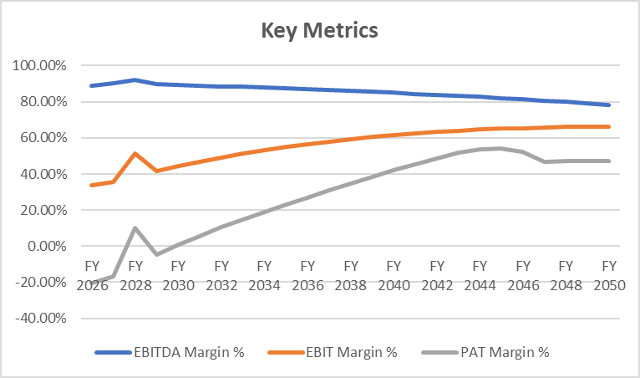

- ESTIMATED KEY FINANCIAL METRICS:
DEBT SERVICE COVERAGE RATIO (D.S.C.R)
(INR Crore except DSCR)
Year Ending (INR Crore) | 31-Mar-26 | 31-Mar-27 | 31-Mar-28 | 31-Mar-29 | 31-Mar-30 | 31-Mar-31 | 31-Mar-32 | 31-Mar-33 | 31-Mar-34 | 31-Mar-35
Year Counter | 1 | 2 | 3 | 4 | 5 | 6 | 7 | 8 | 9 | 10
Months Counter | 4 | 12 | 12 | 12 | 12 | 12 | 12 | 12 | 12 | 12
Cash accrual | 0.35 | 1.14 | 1.92 | 1.28 | 1.34 | 1.38 | 1.43 | 1.47 | 1.50 | 1.54
Interest on term loan | 0.55 | 1.58 | 1.48 | 1.37 | 1.27 | 1.16 | 1.06 | 0.96 | 0.86 | 0.76
Subtotal | 0.90 | 2.72 | 3.39 | 2.65 | 2.61 | 2.55 | 2.49 | 2.42 | 2.36 | 2.30
Interest on term loan | 0.55 | 1.58 | 1.48 | 1.37 | 1.27 | 1.16 | 1.06 | 0.96 | 0.86 | 0.76
Loan Repayment | 0.00 | 1.08 | 1.08 | 1.08 | 1.08 | 1.08 | 1.08 | 0.99 | 0.99 | 0.99
Subtotal | 0.55 | 2.66 | 2.56 | 2.45 | 2.35 | 2.24 | 2.14 | 1.94 | 1.85 | 1.75
DSCR | 1.65 | 1.02 | 1.33 | 1.08 | 1.11 | 1.13 | 1.16 | 1.25 | 1.28 | 1.31

(Continue)
Year Ending (INR Crore) | 31-Mar-36 | 31-Mar-37 | 31-Mar-38 | 31-Mar-39 | 31-Mar-40 | 31-Mar-41 | 31-Mar-42 | 31-Mar-43
Year Counter | 11 | 12 | 13 | 14 | 15 | 9 | 10 | 11
Months Counter | 12 | 12 | 12 | 12 | 12 | 12 | 12 | 12
Cash accrual | 1.59 | 1.62 | 1.66 | 1.70 | 1.74 | 1.76 | 1.80 | 1.82
Interest on term loan | 0.67 | 0.57 | 0.48 | 0.38 | 0.29 | 0.21 | 0.13 | 0.04
Subtotal | 2.25 | 2.19 | 2.13 | 2.08 | 2.03 | 1.97 | 1.92 | 1.87
Interest on term loan | 0.67 | 0.57 | 0.48 | 0.38 | 0.29 | 0.21 | 0.13 | 0.04
Loan Repayment | 0.99 | 0.99 | 0.99 | 0.99 | 0.84 | 0.84 | 0.84 | 0.88
Subtotal | 1.66 | 1.56 | 1.46 | 1.37 | 1.13 | 1.05 | 0.97 | 0.92
DSCR | 1.36 | 1.40 | 1.46 | 1.52 | 1.80 | 1.88 | 1.99 | 2.03
Average D.S.C.R. | 1.33
Max D.S.C.R. | 2.03

Note: D.S.C.R has been calculated for loan repayment period from FY 2026 to FY 2040. The proposed Solar power plant is having a D.S.C.R of more than 1 during the projected loan repayment period.

- NPV AND IRR OF THE PROJECT:
(INR Crore)
Year Ending | 30-Jun-25 | 31-Mar-26 | 31-Mar-27 | 31-Mar-28 | 31-Mar-29 | 31-Mar-30 | 31-Mar-31 | 31-Mar-32 | 31-Mar-33
Year Counter | 1 | 1 | 2 | 3 | 4 | 5 | 6 | 7 | 8
Months Counter | 8 | 4 | 12 | 12 | 12 | 12 | 12 | 12 | 12
EBIT | 0.00 | 0.34 | 1.08 | 1.95 | 1.24 | 1.30 | 1.36 | 1.42 | 1.46
Less: Taxes | 0.00 | 0.09 | 0.27 | 0.49 | 0.31 | 0.33 | 0.34 | 0.36 | 0.37
Add: Dep. & Amortisation | 0.00 | 0.56 | 1.64 | 1.53 | 1.42 | 1.31 | 1.22 | 1.13 | 1.05
NOPAT | 0.00 | 0.81 | 2.45 | 2.99 | 2.34 | 2.29 | 2.24 | 2.19 | 2.14
Capex | 23.33 | 0.00 | 0.00 | 0.00 | 0.00 | 0.00 | 0.00 | 0.00 | 0.00
Change in WC | 0.66 | -0.03 | -0.05 | 0.01 | 0.01 | 0.01 | 0.01 | 0.01 | 0.01
Free Cash Flow to Firm (FCFF) | -23.99 | 0.84 | 2.50 | 2.97 | 2.33 | 2.28 | 2.23 | 2.19 | 2.13

(Continue)
Year Ending | 31-Mar-34 | 31-Mar-35 | 31-Mar-36 | 31-Mar-37 | 31-Mar-38 | 31-Mar-39 | 31-Mar-40 | 31-Mar-41 | 31-Mar-42
Year Counter | 9 | 10 | 11 | 12 | 13 | 14 | 15 | 16 | 17
Months Counter | 12 | 12 | 12 | 12 | 12 | 12 | 12 | 12 | 12
EBIT | 1.50 | 1.53 | 1.57 | 1.59 | 1.61 | 1.62 | 1.64 | 1.64 | 1.65
Less: Taxes | 0.38 | 0.39 | 0.39 | 0.40 | 0.40 | 0.41 | 0.41 | 0.41 | 0.42
Add: Dep. & Amortisation | 0.97 | 0.90 | 0.84 | 0.78 | 0.72 | 0.67 | 0.62 | 0.58 | 0.53
NOPAT | 2.09 | 2.05 | 2.01 | 1.96 | 1.92 | 1.88 | 1.85 | 1.81 | 1.77
Capex | 0.00 | 0.00 | 0.00 | 0.00 | 0.00 | 0.00 | 0.00 | 0.00 | 0.00
Change in WC | 0.01 | 0.01 | 0.01 | 0.00 | 0.00 | 0.00 | 0.00 | 0.00 | 0.00
Free Cash Flow to Firm (FCFF) | 2.09 | 2.04 | 2.01 | 1.96 | 1.92 | 1.88 | 1.85 | 1.80 | 1.77

(Continue)
Year Ending | 31-Mar-43 | 31-Mar-44 | 31-Mar-45 | 31-Mar-46 | 31-Mar-47 | 31-Mar-48 | 31-Mar-49 | 31-Mar-50
Year Counter | 18 | 19 | 20 | 21 | 22 | 23 | 24 | 25
Months Counter | 12 | 12 | 12 | 12 | 12 | 12 | 12 | 12
EBIT | 1.65 | 1.65 | 1.65 | 1.64 | 1.63 | 1.63 | 1.61 | 1.59
Less: Taxes | 0.42 | 0.42 | 0.41 | 0.41 | 0.41 | 0.41 | 0.40 | 0.40
Add: Dep. & Amortisation | 0.50 | 0.46 | 0.43 | 0.40 | 0.37 | 0.34 | 0.32 | 0.29
NOPAT | 1.73 | 1.70 | 1.66 | 1.62 | 1.59 | 1.56 | 1.52 | 1.48
Capex | 0.00 | 0.00 | 0.00 | 0.00 | 0.00 | 0.00 | 0.00 | 0.00
Change in WC | 0.00 | 0.00 | 0.00 | 0.00 | 0.00 | 0.00 | 0.00 | 0.00
Terminal Value | - | - | - | - | - | - | - | 3.77
Free Cash Flow to Firm (FCFF) | 1.73 | 1.70 | 1.66 | 1.62 | 1.59 | 1.56 | 1.52 | 5.25
Thus, the project will be having NPV & IRR of the project is INR 1.11 Crore & 7.56% respectively from C.O.D. to loan repayment period, which indicates worthiness of the project.

- SENSITIVITY ANALYSIS:
Sensitivity analysis of the project with respect to 5% decrease in the revenue, 5% increase in the operating cost and 2% increment in the proposed interest rate has been shown in the below table:

Sensitivity Analysis of D.S.C.R.
S. No. | Particular | Average D.S.C.R. | Max. D.S.C.R.
 | As a base case | 1.33 | 2.03
 | If the projected revenue decreased by 5% | 1.26 | 1.91
 | If the projected Operating and Maintenance cost increased by 5% | 1.32 | 2.01
 | If interest rate is increased by 2% | 1.23 | 2.00
Observation: The proposed project demonstrates greater sensitivity to an increase in interest rates compared to a decline in projected revenue or a rise in operational and maintenance costs. A higher interest rate has a more pronounced impact on the project's debt servicing ability, making it a critical factor in financial planning and risk management.
- OTHER FINANCIAL RATIOS:
Year Ending | 31-Mar-26 | 31-Mar-27 | 31-Mar-28 | 31-Mar-29 | 31-Mar-30 | 31-Mar-31 | 31-Mar-32 | 31-Mar-33
Year Counter | 1 | 2 | 3 | 4 | 5 | 6 | 7 | 8
Months Counter | 4 | 12 | 12 | 12 | 12 | 12 | 12 | 12
Return on Capital Employed (%) | 1.50% | 5.11% | 9.52% | 6.44% | 7.18% | 7.90% | 8.57% | 9.14%
Return on Investment (%) | -2.85% | -7.01% | 5.36% | -1.91% | 0.41% | 2.28% | 4.15% | 5.80%
Return on Net Worth | -2.93% | -7.78% | 5.62% | -2.04% | 0.43% | 2.37% | 4.13% | 5.46%
DSCR | 1.65 | 1.02 | 1.33 | 1.08 | 1.11 | 1.13 | 1.16 | 1.25
ISCR | 1.65 | 1.72 | 2.35 | 1.93 | 2.06 | 2.22 | 2.41 | 2.62
Fixed Asset Coverage Ratio | 1.45 | 1.44 | 1.45 | 1.46 | 1.48 | 1.52 | 1.56 | 1.62
TOL/TNW | 2.44 | 2.46 | 2.16 | 2.04 | 1.87 | 1.67 | 1.45 | 1.24
Debt to Equity Ratio | 2.33 | 2.18 | 2.03 | 1.88 | 1.73 | 1.58 | 1.43 | 1.30

(Continue)
Year Ending | 31-Mar-34 | 31-Mar-35 | 31-Mar-36 | 31-Mar-37 | 31-Mar-38 | 31-Mar-39 | 31-Mar-40 | 31-Mar-41
Year Counter | 9 | 10 | 11 | 12 | 13 | 14 | 15 | 16
Months Counter | 12 | 12 | 12 | 12 | 12 | 12 | 12 | 12
Return on Capital Employed (%) | 9.66% | 10.11% | 10.51% | 10.73% | 10.91% | 10.88% | 10.78% | 10.57%
Return on Investment (%) | 7.34% | 8.86% | 10.37% | 11.68% | 13.03% | 14.32% | 15.53% | 16.52%
Return on Net Worth | 6.47% | 7.23% | 7.81% | 8.08% | 8.27% | 8.34% | 8.29% | 8.10%
DSCR | 1.28 | 1.31 | 1.36 | 1.40 | 1.46 | 1.52 | 1.80 | 1.88
ISCR | 2.87 | 3.19 | 3.60 | 4.13 | 4.89 | 6.04 | 7.79 | 10.65
Fixed Asset Coverage Ratio | 1.70 | 1.82 | 2.00 | 2.28 | 2.73 | 3.36 | 4.64 | 8.43
TOL/TNW | 1.04 | 0.85 | 0.68 | 0.53 | 0.40 | 0.28 | 0.20 | 0.13
Debt to Equity Ratio | 1.16 | 1.02 | 0.88 | 0.75 | 0.61 | 0.47 | 0.36 | 0.24

(Continue)
Year Ending | 31-Mar-42 | 31-Mar-43 | 31-Mar-44 | 31-Mar-45 | 31-Mar-46 | 31-Mar-47 | 31-Mar-48 | 31-Mar-49 | 31-Mar-50
Year Counter | 17 | 18 | 19 | 20 | 21 | 22 | 23 | 24 | 25
Months Counter | 12 | 12 | 12 | 12 | 12 | 12 | 12 | 12 | 12
Return on Capital Employed (%) | 10.35% | 9.55% | 8.88% | 8.23% | 7.69% | 7.26% | 6.88% | 6.48% | 6.14%
Return on Investment (%) | 17.53% | 18.47% | 19.04% | 18.95% | 18.19% | 16.12% | 16.10% | 15.91% | 15.80%
Return on Net Worth | 7.92% | 7.70% | 7.36% | 6.82% | 6.14% | 5.16% | 4.90% | 4.62% | 4.39%
DSCR | 1.99 | 2.03 | 1.33 | - | - | - | - | - | -
ISCR | 17.26 | 48.25 | - | - | - | - | - | - | -
Fixed Asset Coverage Ratio | - | - | - | - | - | - | - | - | -
TOL/TNW | 0.06 | 0.01 | 0.01 | 0.01 | 0.00 | 0.00 | 0.00 | 0.00 | -
Debt to Equity Ratio | 0.12 | - | - | - | - | - | - | - | -

- BREAK-EVEN ANALYSIS:
Year Ending | 31-Mar-26 | 31-Mar-27 | 31-Mar-28 | 31-Mar-29 | 31-Mar-30 | 31-Mar-31 | 31-Mar-32 | 31-Mar-33
Year Counter | 1 | 2 | 3 | 4 | 5 | 6 | 7 | 8
Months Counter | 4 | 12 | 12 | 12 | 12 | 12 | 12 | 12
Sales | 1.01 | 3.02 | 3.78 | 2.96 | 2.93 | 2.90 | 2.88 | 2.84
Variable Expenses | 0.01 | 0.04 | 0.04 | 0.04 | 0.04 | 0.05 | 0.05 | 0.05
Contribution | 1.00 | 2.98 | 3.73 | 2.91 | 2.89 | 2.85 | 2.83 | 2.80
Fixed Expenses | 0.66 | 1.90 | 1.79 | 1.68 | 1.58 | 1.49 | 1.42 | 1.34
Profit / PBT | 0.34 | 1.08 | 1.95 | 1.24 | 1.30 | 1.36 | 1.42 | 1.46
PV RATIO (Contr / Sales) | 98.61% | 98.59% | 98.82% | 98.49% | 98.48% | 98.39% | 98.37% | 98.35%
BEP Sales (Fix Exps / Contr * Sales) | 0.67 | 1.92 | 1.81 | 1.70 | 1.61 | 1.52 | 1.44 | 1.36
BEP% (BEP Sales / sales) | 65.81% | 63.71% | 47.88% | 57.57% | 54.82% | 52.31% | 49.94% | 47.79%

(Continue)
Year Ending | 31-Mar-34 | 31-Mar-35 | 31-Mar-36 | 31-Mar-37 | 31-Mar-38 | 31-Mar-39 | 31-Mar-40 | 31-Mar-41
Year Counter | 9 | 10 | 11 | 12 | 13 | 14 | 15 | 16
Months Counter | 12 | 12 | 12 | 12 | 12 | 12 | 12 | 12
Sales | 2.82 | 2.79 | 2.77 | 2.73 | 2.71 | 2.68 | 2.66 | 2.63
Variable Expenses | 0.05 | 0.05 | 0.05 | 0.05 | 0.05 | 0.05 | 0.05 | 0.05
Contribution | 2.77 | 2.74 | 2.72 | 2.68 | 2.66 | 2.63 | 2.61 | 2.57
Fixed Expenses | 1.27 | 1.21 | 1.15 | 1.10 | 1.05 | 1.01 | 0.97 | 0.93
Profit / PBT | 1.50 | 1.53 | 1.57 | 1.59 | 1.61 | 1.62 | 1.64 | 1.64
PV RATIO (Contr / Sales) | 98.26% | 98.24% | 98.22% | 98.11% | 98.09% | 98.08% | 97.96% | 97.94%
BEP Sales (Fix Exps / Contr * Sales) | 1.29 | 1.23 | 1.17 | 1.12 | 1.07 | 1.03 | 0.99 | 0.95
BEP% (BEP Sales / sales) | 45.85% | 44.02% | 42.33% | 40.87% | 39.50% | 38.26% | 37.15% | 36.19%

(Continue)
Year Ending | 31-Mar-42 | 31-Mar-43 | 31-Mar-44 | 31-Mar-45 | 31-Mar-46 | 31-Mar-47 | 31-Mar-48 | 31-Mar-49 | 31-Mar-50
Year Counter | 17 | 18 | 19 | 20 | 21 | 22 | 23 | 24 | 25
Months Counter | 12 | 12 | 12 | 12 | 12 | 12 | 12 | 12 | 12
Sales | 2.60 | 2.58 | 2.56 | 2.53 | 2.50 | 2.48 | 2.46 | 2.43 | 2.41
Variable Expenses | 0.05 | 0.06 | 0.06 | 0.06 | 0.06 | 0.06 | 0.06 | 0.06 | 0.06
Contribution | 2.55 | 2.52 | 2.50 | 2.47 | 2.44 | 2.42 | 2.40 | 2.37 | 2.34
Fixed Expenses | 0.90 | 0.87 | 0.85 | 0.82 | 0.81 | 0.79 | 0.77 | 0.76 | 0.75
Profit / PBT | 1.65 | 1.65 | 1.65 | 1.65 | 1.64 | 1.63 | 1.63 | 1.61 | 1.59
PV RATIO (Contr / Sales) | 97.92% | 97.79% | 97.77% | 97.75% | 97.61% | 97.59% | 97.57% | 97.42% | 97.39%
BEP Sales (Fix Exps / Contr * Sales) | 0.92 | 0.89 | 0.87 | 0.84 | 0.82 | 0.81 | 0.79 | 0.78 | 0.77
BEP% (BEP Sales / sales) | 35.31% | 34.59% | 33.89% | 33.37% | 32.96% | 32.59% | 32.28% | 32.18% | 32.09%

- TERM LOAN INPUTS:
Term Loan Repayment Inputs
Total loan amount | INR 16.79 Crore
Rate of Interest | 9.75%
Disbursement | April-25
IDC Start & End Month | April-25 to November-25
IDC Period (construction period) | 8 Months
Commencement /Operation Start | 1st December 2025
Moratorium Period | 12 Months
Repayment Start | April-2026
Repayment End | March-2043
Repayment Period | 17 Years

(INR Crore)
Year Ending | 30-Nov-25 | 31-Mar-26 | 31-Mar-27 | 31-Mar-28 | 31-Mar-29 | 31-Mar-30 | 31-Mar-31 | 31-Mar-32 | 31-Mar-33
Year Counter | 0 | 1 | 2 | 3 | 4 | 5 | 6 | 7 | 8
Months Counter | 8 | 4 | 12 | 12 | 12 | 12 | 12 | 12 | 12
Opening Bal | 0.00 | 16.79 | 16.79 | 15.71 | 14.63 | 13.55 | 12.47 | 11.39 | 10.31
Disbursement of loan | 16.79 | 0.00 | 0.00 | 0.00 | 0.00 | 0.00 | 0.00 | 0.00 | 0.00
Repayment | 0.00 | 0.00 | 1.08 | 1.08 | 1.08 | 1.08 | 1.08 | 1.08 | 0.99
Closing Principal O/s | 16.79 | 16.79 | 15.71 | 14.63 | 13.55 | 12.47 | 11.39 | 10.31 | 9.32
Interest | 1.09 | 0.55 | 1.58 | 1.48 | 1.37 | 1.27 | 1.16 | 1.06 | 0.96
IDC | 1.09 | 0.00 | 0.00 | 0.00 | 0.00 | 0.00 | 0.00 | 0.00 | 0.00
TL Interest | 0.00 | 0.55 | 1.58 | 1.48 | 1.37 | 1.27 | 1.16 | 1.06 | 0.96

(Continue)
Year Ending | 31-Mar-34 | 31-Mar-35 | 31-Mar-36 | 31-Mar-37 | 31-Mar-38 | 31-Mar-39 | 31-Mar-40 | 31-Mar-41 | 31-Mar-42 | 31-Mar-43
Year Counter | 9 | 10 | 11 | 12 | 13 | 14 | 15 | 16 | 17 | 18
Months Counter | 12 | 12 | 12 | 12 | 12 | 12 | 12 | 12 | 12 | 12
Opening Bal | 9.32 | 8.34 | 7.35 | 6.36 | 5.37 | 4.39 | 3.40 | 2.56 | 1.72 | 0.88
Disbursement of loan | 0.00 | 0.00 | 0.00 | 0.00 | 0.00 | 0.00 | 0.00 | 0.00 | 0.00 | 0.00
Repayment | 0.99 | 0.99 | 0.99 | 0.99 | 0.99 | 0.99 | 0.84 | 0.84 | 0.84 | 0.88
Closing Principal O/s | 8.34 | 7.35 | 6.36 | 5.37 | 4.39 | 3.40 | 2.56 | 1.72 | 0.88 | 0.00
Interest | 0.86 | 0.76 | 0.67 | 0.57 | 0.48 | 0.38 | 0.29 | 0.21 | 0.13 | 0.04
IDC | 0.00 | 0.00 | 0.00 | 0.00 | 0.00 | 0.00 | 0.00 | 0.00 | 0.00 | 0.00
TL Interest | 0.86 | 0.76 | 0.67 | 0.57 | 0.48 | 0.38 | 0.29 | 0.21 | 0.13 | 0.04

- DEPRECIATION SCHEDULE :
(INR Crore)
Depreciation Schedule as per Company's Act, 2013
Particular | 31-Mar-26 | 31-Mar-27 | 31-Mar-28 | 31-Mar-29 | 31-Mar-30 | 31-Mar-31 | 31-Mar-32 | 31-Mar-33
Building & Civil Works | 0.00 | 0.00 | 0.00 | 0.00 | 0.00 | 0.00 | 0.00 | 0.00
Depreciation Building & Civil Works | 0.00 | 0.00 | 0.00 | 0.00 | 0.00 | 0.00 | 0.00 | 0.00
Plant & Machinery | 23.33 | 22.77 | 21.13 | 19.60 | 18.18 | 16.87 | 15.65 | 14.52
Depreciation Plant & Machinery | 0.56 | 1.64 | 1.53 | 1.42 | 1.31 | 1.22 | 1.13 | 1.05
WDV of Plant & Machinery | 22.77 | 21.13 | 19.60 | 18.18 | 16.87 | 15.65 | 14.52 | 13.47
Office equipment | 0.00 | 0.00 | 0.00 | 0.00 | 0.00 | 0.00 | 0.00 | 0.00
Depreciation Office equipment | 0.00 | 0.00 | 0.00 | 0.00 | 0.00 | 0.00 | 0.00 | 0.00
Total WDV Depreciation | 0.56 | 1.64 | 1.53 | 1.42 | 1.31 | 1.22 | 1.13 | 1.05

(Continue)
Depreciation Schedule as per Company's Act, 2013
Particular | 31-Mar-34 | 31-Mar-35 | 31-Mar-36 | 31-Mar-37 | 31-Mar-38 | 31-Mar-39 | 31-Mar-40 | 31-Mar-41
Building & Civil Works | 0.00 | 0.00 | 0.00 | 0.00 | 0.00 | 0.00 | 0.00 | 0.00
Depreciation Building & Civil Works | 0.00 | 0.00 | 0.00 | 0.00 | 0.00 | 0.00 | 0.00 | 0.00
Plant & Machinery | 13.47 | 12.50 | 11.60 | 10.76 | 9.98 | 9.26 | 8.59 | 7.97
Depreciation Plant & Machinery | 0.97 | 0.90 | 0.84 | 0.78 | 0.72 | 0.67 | 0.62 | 0.58
WDV of Plant & Machinery | 12.50 | 11.60 | 10.76 | 9.98 | 9.26 | 8.59 | 7.97 | 7.39
Office equipment | 0.00 | 0.00 | 0.00 | 0.00 | 0.00 | 0.00 | 0.00 | 0.00
Depreciation Office equipment | 0.00 | 0.00 | 0.00 | 0.00 | 0.00 | 0.00 | 0.00 | 0.00
Total WDV Depreciation | 0.97 | 0.90 | 0.84 | 0.78 | 0.72 | 0.67 | 0.62 | 0.58

(Continue)
Depreciation Schedule as per Company's Act, 2013
Particular | 31-Mar-42 | 31-Mar-43 | 31-Mar-44 | 31-Mar-45 | 31-Mar-46 | 31-Mar-47 | 31-Mar-48 | 31-Mar-49 | 31-Mar-50
Building & Civil Works | 0.00 | 0.00 | 0.00 | 0.00 | 0.00 | 0.00 | 0.00 | 0.00 | 0.00
Depreciation Building & Civil Works | 0.00 | 0.00 | 0.00 | 0.00 | 0.00 | 0.00 | 0.00 | 0.00 | 0.00
Plant & Machinery | 7.39 | 6.86 | 6.36 | 5.90 | 5.48 | 5.08 | 4.72 | 4.37 | 4.06
Depreciation Plant & Machinery | 0.53 | 0.50 | 0.46 | 0.43 | 0.40 | 0.37 | 0.34 | 0.32 | 0.29
WDV of Plant & Machinery | 6.86 | 6.36 | 5.90 | 5.48 | 5.08 | 4.72 | 4.37 | 4.06 | 3.77
Office equipment | 0.00 | 0.00 | 0.00 | 0.00 | 0.00 | 0.00 | 0.00 | 0.00 | 0.00
Depreciation Office equipment | 0.00 | 0.00 | 0.00 | 0.00 | 0.00 | 0.00 | 0.00 | 0.00 | 0.00
Total WDV Depreciation | 0.53 | 0.50 | 0.46 | 0.43 | 0.40 | 0.37 | 0.34 | 0.32 | 0.29

- KEY ASSUMPTIONS & BASIS:
S. No. | Item | Assumptions and Basis
 | General | - The projections of the proposed solar power plant are done for the period from FY 2026 to FY 2050, 25 years, to cover the term loan period as per the industry best practices. It is assumed that the plant will be achieving COD on 1st December 2025.  - We have considered both Revenue & cost-based model (top to bottom approach) while making the future financial projections.  - Revenue modelling has been done based on the net unit generated annually and applicable tariff as defined in the PPA.  - A 0.15% transmission loss was initially considered for the ~5.6 MW-DC solar power plant due to its proximity of ~2 km from the DISCOM substation. This assumption was based on typical energy losses incurred during power transmission over distances.  - The plant is assumed to be operational for 365 days for 24 hours annually.
 | Revenue Build up | - The Plant Load Factor (PLF) for the solar power project is estimated at 18.10%, based on location-specific irradiation levels and simulations conducted through PVSyst at the P90 confidence level. A P90 estimate ensures that there is a 90% probability that the actual energy generation will meet or exceed this level, making it a conservative and bankable projection. The PLF calculation considers site conditions, solar panel efficiency, system losses, and climatic variations, ensuring realistic energy yield expectations for the project.  - Over time, solar PV modules degrade, leading to a reduction in electricity generation. While high-quality panels typically degrade at a rate of 0.3% to 0.7% annually, a conservative assumption of 1% annual degradation has been considered for financial modelling. This accounts for potential performance losses due to environmental exposure, dust accumulation, and general wear and tear over the 25-year operational lifespan. Factoring in this degradation helps in accurately projecting energy generation and financial returns over the project’s lifetime.  - Plant load factor, Transmission loss and degradation factors are considered. After multiplying these factors with installed capacity, No. of units Production (Yearly) can be determined. After adjusted with transmission losses, Net units Exported annually are determined.  - Net units are multiplied by applicable tariff rate as per PPA agreement and Net Revenue is calculated.  - Thus, the company is expected to generate INR 1.01 Crore annual revenue in FY 2026, which is expected to reach up to INR 2.41 Crore till FY 2050.
 | Pricing (Average Price Per Unit) | - Applicable tariff rate is considered as INR 3.38 per unit as per the PPA Agreement.  - No Escalation is considered in applicable tariff rate as informed by client during the projected period.
 | Capacity Utilization | - The proposed Solar Power projects will be installed with a capacity for proposed location ~5.6 MW_{DC} having total solar (~9672 nos. of Solar Panel) 580Wp of Bi-facial N-type Solar module from Waree Energies.  - Plant load factor of 18.10% for Solar and degradation factor of 1.00 % y-o-y basis is taken as per the EPC agreement.
 | Capital Expenditure | - M/s Bikana Renewables 2 Private Limited has entered into an EPC contract with Eco-Tech & Engineering for the installation of a ~5.60 Mw-DC solar power plant, with an estimated Plant Load Factor (PLF) of 18.10%.  - Proposed Power project will be implemented through appointment of Eco-Tech & Engineering, the total project cost is estimated at INR 23.99 Crore, of which approximately 88% (INR 21.61 Crore) is allocated for plant and machinery for the solar power projects.  - As per the provided details, the applicable Interest During Construction (IDC) is 9.75%. Consequently, the company is required to pay INR 1.09 Crore as IDC for eight months, covering the period from April 1, 2025, to November 30, 2025, in accordance with the proposed loan repayment schedule.  - The preliminary expenses, including a three-month Debt Service Reserve Account (DSRA), have been estimated at INR 0.66 Crore, accounting for 3.58% of the project's hard cost, based on the company's projected resource allocation.  - A contingency provision of approximately 2% of the hard costs has been allocated to account for any unforeseen future requirements, ensuring financial flexibility and risk mitigation. This allocation is considered reasonable and prudent to address potential cost variations during project execution.
 | Expenses | - O&M expenses for the solar plant are estimated at ₹ 22 lakhs, with an annual cost of ₹4 lakh per MW. A 3% annual escalation in O&M costs has been factored in for the proposed project.  References of O&M Expenses  https://renewablewatch.in/2024/11/08/optimising-operations-current-practices-and-new-opportunities-in-solar-om/  https://www.mercomindia.com/gerc-sets-levelized-tariff-of-%E2%82%B92-76-kwh-for-solar-projects-below-5-mw  - Insurance expenses are considered as 0.10% of WDV net block y-o-y basis.  - The lease rental for the land is considered as per the lease agreement, which specifies a rate of ₹75,090 per hectare. With a total leased area of approximately 5.6538 hectares, the annual lease rental amounts to ₹4.24 lakhs. Additionally, the lease rent is subject to an escalation of 5% every three years, as per the terms of the agreement.
 | Term Loan | - The project is proposed to be funded through a term loan of INR 16.79 crores and promoter’s margin of INR 7.20 crores.  - Interest rate has been considered as 9.75% on the term loan.  - 12 months moratorium period has been taken during the projections  - Loan repayment period will be for 17 years as per informed by bank/client/financial Institution.

Key Findings:
      - Average DSCR, EBIDTA margin, EBIT margin is 1.33, 85.43%, and 56.33% respectively during the estimated period.
      - D.S.C.R. of the proposed Solar Power Projects is found highly sensitive with respect to any upside fluctuation in the interest rate.
      - The company is having a positive NPV and IRR of INR 1.11 Crore and 7.56% respectively from COD to loan repayment period while it may vary with changes in the assumptions & micro and macro-economic trends considered as on date.
      - Based on the above key financial ratios of the proposed Project during the forecasted period shows that the project appears financially viable if the promoters of the project are able to maintain assumed capacity utilization, revenue and can contain cost as assumed above in the calculation.
PART L | CONCLUSION

Based on the technological, economical and market analysis done above, various assumptions of sectoral trends taken, product pricing to be adopted by the company, the Project appears to be Techno-commercially viable subject to the risks, threats, weaknesses, limitations of the product as detailed previously.
As per financial projections for the estimated period, Average DSCR, EBITDA Margin and EBIT Margin of the project are 1.33, 85.43% and 56.33% respectively, where higher DSCR is the indicator of the project capability to pay out its outstanding debt and EBITDA margin shows the capability of the project to generate the operating profits over the forecasted period.
The proposed Solar Power Plant is having a positive NPV and IRR as INR 1.11 Crore and 7.56% respectively from C.O.D till loan repayment period as the industry is expectedly growing. While it is not avoidable that the future projections may change in the upcoming years due to various factors impacting the operation, managerial, financial efficiency and economies of scale of the project.
While it would be depending on the management’s capability in future that how efficiently company adopts marketing and advertisement strategy, supply chain and carry out inventory & resource management to achieve higher profitability. After considering the foreseen demand of the Power sector domestically and globally, various initiatives taken by the government, financial analysis of the project based on the assumptions taken over the projected period, it appears reasonable to comment that the proposed project is “Technically and Economically” Viable subject to current assumptions considered and occurring the same in the upcoming years same as the forecasted period which is dependent on the sincerity and efforts of the management and various micro and macroeconomic & industry situation.
We have tried our level best to analyse the Project techno-economic feasibility of the Project based on the Industry research, Project information and various futuristic assumption taken within the limitations and challenges came in front of us. However, achieving the financial milestones depends on the ability, sincerity and efforts of the company, promoters and its key management to maintain the projected revenue level Y-o-Y basis keeping the fact in mind that the project is found sensitive with respect to the down side fluctuation in the revenue.

Declaration | - The undersigned does not have any direct/indirect interest in the above property/project/Company.  - The information furnished herein is true and correct to the best of our knowledge, logical and scientific assumptions.  - This TEV Report is carried out by our Financial Analyst team on the request from M/s Bikana Renewables 2 Private Limited.  - Meeting of Financial projections will be subject to the market & economy stability factors, judicious business operations and proper & timely implementation of the project and putting proper plan for achieving high productivity, efficiency and achieving cost saving benefits to increase profitability.  - We have submitted TEV report to the client.
Number of Pages in the Report | 75
Enclosed Documents | Disclaimer & Remarks (72-75)
Place | Noida
Date | 2nd April 2025

FOR ON BEHALF OF
M/S. R.K. ASSOCIATES VALUER & TECHNO ENGINEERING CONSULTANTS PVT. LTD.
SURVEYED BY | PREPARED BY | REVIEWED BY
Anuj Sharma | Mohd Umair | Rachit Gupta

PART M | DISCLAIMER | REMARKS

      - No employee or member of R.K Associates has any direct/ indirect interest in the Project.
      - This report is prepared based on the copies of the documents/ information which the Bank/ Company has provided to us out of the standard checklist of documents sought from them and further based on our assumptions and limiting conditions. The client/owner and its management/representatives warranted to us that the information they supplied was complete, accurate and true and correct to the best of their knowledge. All such information provided to us has been relied upon in good faith and we have assumed that it is true and correct in all respect. I/We shall not be liable for any loss, damages, cost or expenses arising from fraudulent acts, misrepresentations, or wilful default on part of the owner, company, its directors, employee, representative or agents. Verification or cross checking of the documents provided to us from the originals or from any Govt. departments/ Record of Registrar has not been done at our end since this is beyond the scope of our work. If at any time in future, it is found or came to our knowledge that misrepresentation of facts or incomplete or distorted information has been provided to us then this report shall automatically become null & void.
      - Legal aspects for e.g. investigation of title, ownership rights, lien, charge, mortgage, lease, sanctioned maps, verification of documents, etc. have not been done at our end and same has to be taken care by legal expert/ Advocate. It is assumed that the concerned Lender/ Financial Institution has satisfied them with the authenticity of the documents, information given to us and for which the legal verification has been already taken and cleared by the competent Advocate before requesting for this report. I/ We assume no responsibility for the legal matters including, but not limited to, legal or title concerns.
      - This report is a general analysis of the project based on the scope mentioned in the report. This is not an Audit report, Design document, DPR or Techno feasibility study. All the information gathered is based on the facts seen on the site during survey, verbal discussion & documentary evidence provided by the client and is believed that information given by the company is true best of their knowledge.
      - This Techno Economic-Viability study is prepared based on certain futuristic assumption which are intra dependent on economic, market and sectorial growth condition in future and socio-economic, socio-political condition at macro and micro level.
      - Meeting of assumption and financial ratio will entirely depend on the sincerity and efforts of the company, promoters and its key managerial performance.
      - All observations mentioned in the report is only based on the visual observation and the documents/ data/ information provided by the client. No mechanical/ technical tests, measurements or any design review have been performed or carried out from our side during Project assessment.
      - This report has been diligently prepared by our techno-financial team to the best of their ability. However, it's important to note that the recommendations provided in this Total Economic Viability (TEV) assessment do not imply an endorsement, validation, or certification of the accuracy or completeness of the disclosed information by the involved stakeholders. Furthermore, we do not claim or endorse that the opinions presented herein are the sole best course of action for decision-makers to follow. There may exist additional approaches and inputs that have not been covered within this report or fall outside the scope of this report.
      - Bank/FII should ONLY take this report as an Advisory document from the Financial/ Chartered Engineering firm and its specifically advised to the creditor to cross verifies the original documents for the facts mentioned in the report which can be availed from the borrowing company directly.
      - In case of any default in loans or the credit facility extended to the borrowing company, R.K Associates shall not be held responsible for whatsoever reason may be and any request for seeking any explanation from the employee/s of R.K Associates will not be entertained at any instance or situation.
      - The documents, information, data provided to us during the course of this assessment by the client are reviewed only up to the extent required in relation to the scope of the work. No document has been reviewed beyond the scope of the work.
      - This report only contains general assessment & opinion as per the scope of work evaluated as per the information given in the copy of documents, information, data provided to us and/ and confirmed by the owner/ owner representative to us at site which has been relied upon in good faith. It doesn’t contain any other recommendations of any sort including but not limited to express of any opinion on the suitability or otherwise of entering into any transaction with the borrower.
      - We have relied on data from third party, external sources & information available on public domain also to conclude this report. These sources are believed to be reliable and therefore, we assume no liability for the truth or accuracy of any data, opinions or estimates furnished by others that have been used in this analysis. Where we have relied on data, opinions or estimates from external sources, reasonable care has been taken to ensure that such data has been correctly extracted from those sources and /or reproduced in its proper form and context, however still we can’t vouch its authenticity, correctness or accuracy.
      - This Report is prepared by our competent technical team which includes Engineers and financial experts & analysts.
      - This is just an opinion report and doesn’t hold any binding on anyone. It is requested from the concerned Financial Institution which is using this report for taking financial decision on the project that they should consider all the different associated relevant & related factors also before taking any business decision based on the content of this report.
      - All Pages of the report including annexure are signed and stamped from our office. In case any paper in the report is without stamp & signature then this should not be considered a valid paper issued from this office.
      - Though adequate care has been taken while preparing this report as per its scope, but still we can’t rule out typing, human errors, over sightedness of any information or any other mistakes. Therefore, the concerned organization is advised to satisfy themselves that the report is complete & satisfactory in all respect. Intimation regarding any discrepancy shall be brought into our notice immediately. If no intimation is received within 15 (Fifteen) days in writing from the date of issuance of the report, to rectify these timely, then it shall be considered that the report is complete in all respect and has been accepted by the client up to their satisfaction & use and further to which R.K Associates shall not be held responsible in any manner.
      - Defect Liability Period is 15 DAYS. We request the concerned authorized reader of this report to check the contents, data and calculations in the report within this period and intimate us in writing if any corrections are required or in case of any other concern with the contents or opinion mentioned in the report. Corrections only related to typographical, calculation, spelling mistakes, incorrect data/ figures/ statement will be entertained within the defect liability period. Any new changes for any additional information in already approved report will be regarded as additional work for which additional fees may be charged. No request for any illegitimate change in regard to any facts & figures will be entertained.
      - R.K Associates encourages its customers to give feedback or inform concerns over its services through proper channel at valuers@rkassociates.org in writing within 15 days of report delivery. After this period no concern/ complaint/ proceedings in connection with the Techno- Economic Viability Study Services will be entertained due to possible change in situation and condition of the subject Project.
      - Our Data retention policy is of ONE YEAR. After this period, we remove all the concerned records related to the assignment from our repository. No clarification or query can be answered after this period due to unavailability of the data.
      - This Techno Economic Viability Study report is governed by our (1) Internal Policies, Processes & Standard Operating Procedures, (2) Information/ Data/ Inputs given to us by the client and (3) Information/ Data/ Facts given to us by our field/ office technical team. Management of R.K Associates never gives acceptance to any unethical or unprofessional practice which may affect fair, correct & impartial assessment and which is against any prevailing law. In case of any indication of any negligence, default, incorrect, misleading, misrepresentation or distortion of facts in the report then it is the responsibility of the user of this report to immediately or at least within the defect liability period bring all such act into notice of R.K Associates management so that corrective measures can be taken instantly.
      - R.K Associates never releases any report doing alterations or modifications from pen. In case any information/ figure of this report is found altered with pen then this report will automatically become null & void.
      - If this report is prepared for the matter under litigation in any Indian court, no official or employee of R.K Associates will be under any obligation to give in person appearance in the court as a testimony. For any explanation or clarification, only written reply can be submitted on payment of charges by the plaintiff or respondent which will be 10% of the original fees charged where minimum charges will be Rs. 15,000/.

