**CASE NO.:** **VIS(2024-25)-PL815-737-1004 Dated: 04.03.2025**

To,

Chief Manager,

Punjab National Bank

DCM Building, Barakhamba,

New Delhi- 110001,

**SUBJECT: Certificate of estimated rental value of house located at** **Plot no. 28, area measuring 105 sq.yds. (out of plot no. 27 & 28 i.e. total area 200 sq.yds.) out of khasra no. 16/3, situated in the revenue estate of Village- Qutubapur, Delhi State Delhi, Colony known as Qutub Vihar, Phase-I, C-Block, New Delhi-110071.**

# Dear Sir,

As per the observations & documents & photographs provided, the subject property is G+1 upper storey RCC structure residential house situated in above mentioned address. Ground Floor configuration has Drawing Room, Dining Room, 01 Bedroom, Kitchen & Car Parking Space. First Floor configuration has Drawing Room, Dining Room, 02 Bedroom, Kitchen, 02 Bathroom & Balcony. As per our enquiry conducted with the local property dealers, the ongoing monthly rent for independent floor is in the range of Rs. 14,000/- to Rs. 16,000/-. Therefore, for rental value of entire house (G+1) will be approximate Rs. 30,000/- per month.

**For R.K Associates Valuers & Techno Engg. Consultants (P) Ltd.**

**Authorized Signatory**

|  |  |  |  |
| --- | --- | --- | --- |
| **1.** | **DECLARATION** | | |
|  | 1. This rental estimate is done based on the documents/ details/ information provided by the customer. 2. The undersigned does not have any direct/indirect interest in the above property. 3. The information furnished herein is true and correct to the best of our knowledge. 4. We have submitted this certificate directly to the Client. 5. This estimate is carried out by our Engineering team on the request from Punjab National Bank, DCM Building, Barakhamba, New Delhi- 110001. | | |
| **2.** | **Name & Address of Valuer company** | | **Signature of the authorized person** |
| M/s R.K. Associates Valuers & Techno Engineering  Consultants Pvt. Ltd. D-39, Sector-2, Noida, U.P. | |  |
| **3.** | **Enclosed Documents** | 1. Floor Layout. 2. Property Document 3. Rate Reference | |
| **4.** | **Total Number of Pages in the Report with Enclosures** | 06 | |
| **5.** | **Engineering Team worked on the report** | ***SURVEYED BY: NA, as desktop estimation Report*** | |
| ***PREPARED BY: Er.* Abhinav Chaturvedi** | |
| ***REVIEWED BY:* Mrs. Rajani Gupta** | |

**R.K ASSOCIATES IMPORTANT NOTES:**

***DEFECT LIABILITY PERIOD*** *- In case of any query/ issue or escalation you may please contact Incident Manager by writing at* [*valuers@rkassociates.org.*](mailto:valuers@rkassociates.org) *We ensure 100% accuracy in the Calculations done, Rates adopted and various other data points &* information mentioned in the report but still can’t rule out typing, human errors or any other mistakes. In case you find any mistake, variation, discrepancy or inaccuracy in any data point of the report, please help us by bringing all such points into our notice in writing at [valuers@rkassociates.org](mailto:valuers@rkassociates.org)within 30 days of the report delivery, to get these rectified timely, failing which R.K Associates won’t be held responsible for any inaccuracy in any manner. Also if we will not hear back anything from you within 30 days, we will assume that report is correct in all respect and no further claim of any sort will be entertained thereafter. We would welcome and appreciate your feedback & suggestions in order to improve our services.

***COPYRIGHT FORMAT*** *- This report is prepared on the copyright format of R.K Associates to serve our clients in the best possible way. Legally no one can copy or distribute this format without prior approval from R.K Associates. It is meant only for the* Organization as mentioned on the cover page of this report. Distribution or use of this format other than R.K Associates will be seen as unlawful act and necessary legal action can be taken against the defaulters.

***IF REPORT IS USED FOR BANK/ FIs***

**NOTE:** As per IBA Guidelines in case the valuation report submitted by the valuer is not in order, the banks / FIs shall bring the same to the notice of the valuer within 15 days of submission for rectification and resubmission. In case no such communication is received, it shall be presumed that the valuation report has been accepted.

***At our end we have not verified the authenticity of any documents provided to us. Bank is advised to verify the genuineness of the property documents before taking any credit decision.***

***ENCLOSURE***

***Floor Layout***

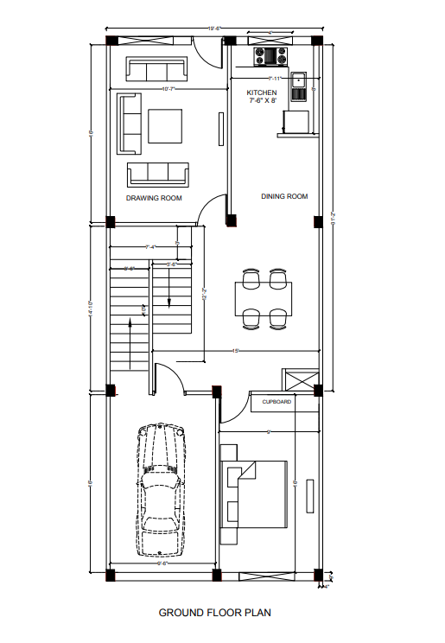

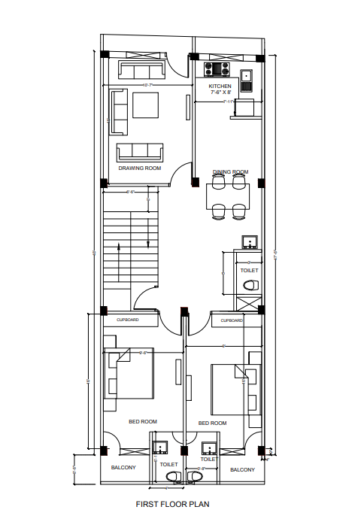

***Property Deed***

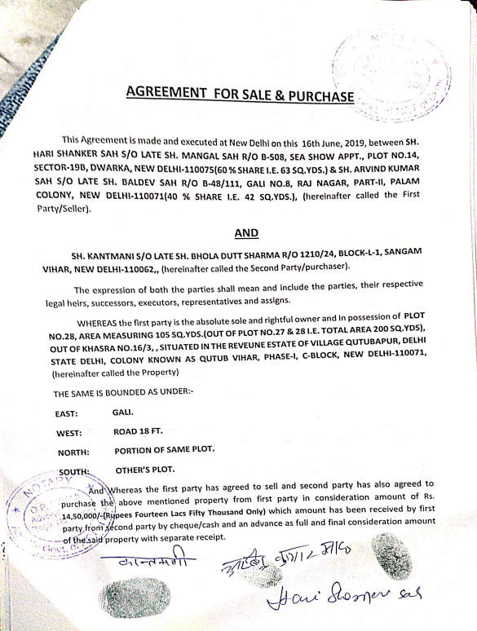

***Property Rate Reference***

