**File No.: VIS(2024-25)-PL864-767-1044 Dated: 03.04.2025**

**VALUATION REPORT**

**OF**

**IMMOVABLE PROPERTY**

**IIDL SUITES**

**SITUATED AT**

**PLOT NO. 4A, MAYUR VIHAR DISTRICT CENTRE, NEW DELHI**

**OWNER/ PROMOTER**

**IFCI INFRASTRUCTURE DEVELOPMENT LIMITED**

**REPORT PREPARED FOR**

**IFCI INFRASTRUCTURE DEVELOPMENT LIMITED**

***\*\*Important - In case of any query/ issue or escalation you may please contact Incident Manager***

***at valuers@rkassociates.org. We will appreciate your feedback in order to improve our services.***

***NOTE: As per IBA Guidelines please provide your feedback on the report within 15 days of its submission after which report will be considered to be correct.***

|  |  |
| --- | --- |
| **PART I** | **BASIC INFORMATION** |

|  |  |  |  |  |  |
| --- | --- | --- | --- | --- | --- |
| **S.NO.** | **CONTENTS** | **DESCRIPTION** | | | |
|  | **VALUATION SNAPSHOT** | | | | |
|  | Z:\Files For Review\Atul Gola\IIDL\site images\IMG-20250422-WA0012.jpg  **IIDLSUITES, PLOT NO. 4A, MAYUR VIHAR DISTRICT CENTRE, DELHI** | | | | |
|  |  | | | | |
|  | Objective of the Study | General Prospective Valuation Assessment of the Property | | | |
|  | Whether valuation was made at the request of the | IFCI Infrastructure Development Limited | | | |
|  | Letter No. & date or Email’s date requesting for undertaking valuation | E-mail dated March 17, 2025. | | | |
|  | Name of persons visiting the site | Mr. Atul & Mr. Anuj Sharma | | | |
|  | Date of visit to the property | 27 March 2025 | | | |
|  | Date on which valuation is made | 3 April 2025 | | | |
|  | Name of the borrower with address of corporate office & head office, telephone nos. & nature of business | M/S. IFCI Infrastructure Development Limited. | | | |
|  | Name, address, telephone no. of the owner/ owner(s) of the property | M/S. IFCI Infrastructure Development Limited. | | | |
|  | Surveyed in presence of | Mr. Mohit Bhatnagar | | | |
|  | Documents provided for perusal | **Documents Requested** | | **Documents Provided** | |
| Total **04** documents requested | | Total **04** documents provided | |
| Ownership Documents | | 2 Nos. Conveyance Deed for 4013.67 sq mtr. land | |
| Approval Plan | | Approved Plan | |
| NOC | | Pollution NOC | |
| FAR | | Fixed Asset Register | |
|  | Identification of the property |  | Cross checked from schedule of the properties mentioned in the deed | | |
|  | Done from the name plate displayed on the property | | |
|  | Identified by the owner/ owner representative | | |
|  | Enquired from local residents/ public | | |
|  | Identification of the property could not be done properly | | |
|  | Survey was not done | | NA |

|  |  |
| --- | --- |
| **PART II** | **VALUATION OF LAND** |

|  |  |  |  |  |
| --- | --- | --- | --- | --- |
|  | **DETAILS OF PROPERTY** | | | |
|  | This valuation report is prepared for the “IIDL Suites” Service Apartments, owned by M/S. IFCI Infrastructure Development Limited.  The property is developed on a land allotted to IFCI by DDA vide two conveyance deed. The cumulative plot area on which the property is constructed is 4013.67 sq mtr. The subject property is located in district Center, Mayur Vihar. It has close proximity with Delhi Noida Link Road.  The building comprises of 3 Basement+Ground+Nine floors. There is a restaurant with the name of “THE EPICURE” and two conference halls are located on Ground floor. The hotel has 92 rooms/suite available in the subject property other amenities as Gym area, Kid Play area and swimming pool are constructed on the ninth floor.  The Salable built-up area of the subject property is 1,05,434 sq ft.    The details of the room are as following:   |  |  |  |  |  | | --- | --- | --- | --- | --- | | S. No | Apartment Type | Number | Size (in sq ft) | Specifications | | 1 | 1 RK Suite | 52 | 475 | 01 Bedroom+ 01 Bathroom+ Kitchen+ Balcony | | 2 | 1 BHK Suite | 26 | 1300 | Living Room+ 01 Bedroom+ 02 Bathroom+ Kitchen+ Balcony | | 3 | 2 BHK Suite | 14 | 1600 | Living Room+ 02 Bedroom+ 02 Bathroom+ Kitchen+ Balcony |   There is no sale comparable/ incident available in market which can be suitable comparable for subject property. The commercial plots available in the market are of small size as compare to the subject property and same goes with the commercial built-up units in the same area. Therefore, we have calculated the Market Value of the subject property in two scenarios.   1. Considering Asset as Land and Building 2. Considering Asset as Built-up Unit. | | | |
|  | **INTRODUCTION / BASIC INFORMATION** | |  | |
|  | Date of acquisition/ purchase of land | | 2009 | |
|  | Value of the property as per regd. Sale/ Lease Deed | | --- | |
|  | Sale deed/ title deed document no. | | 2 Nos. Lease Deed No. 15462 & 15463  Dated: 29.10.2009 | |
|  | Area of land (as per document/ title deed) | | Total Land area taken on is 4013.67 sq mtr./ 4800 sq yards. | |
|  | Area of land (as per record of rights) | | As per 2 nos. Conveyance deed executed between DDA & M/s. IFCI Ltd. The total land area taken on lease as per the Conveyance deeds is 4013.67 sq mtr./ 4,800 sq yards | |
|  | Area of land (as per physical measurement) | | ~4020 sq mtr. | |
|  | Location of the property and postal address | | IIDL Suites, Plot No. 4A, Mayur Vihar District Centre, Delhi | |
| Enclosed with the Report | |
| Google Coordinate: 28°35'38.5"N 77°17'56.7"E | |
|  | Urban/ Semi Urban/ Rural | | Urban | |
|  | Property is situated in | | Commercial/ Service Apartments | |
|  | Classification of locality | | Medium Income Group | |
|  | Type of property | | | |
| 1. Agricultural | | NA | |
| 1. Industrial | | NA | |
| 1. Residential | | NA | |
| 1. Commercial | | Yes, Service Apartment | |
| 1. Institutional | | NA | |
| 1. Others | | NA | |
|  | **BRIEF DESCRIPTION OF THE PROPERTY** | | | |
|  | Address of the property | | IIDL Suites, Plot No. 4A, Mayur Vihar District Centre, Delhi | |
|  | Municipality ward No. | | --- | |
|  | Street No. | | --- | |
|  | Survey / Plot No. | | Plot No 4A | |
|  | Khata No | | --- | |
|  | Mouza | | --- | |
|  | Thana No. | | --- | |
|  | Tehsil No. | | Geeta Colony | |
|  | SRO | | SR-VIII (Geeta Colony) | |
|  | Police Station (P.S) | | Mayur Vihar Phase 1 | |
|  | Village / Town/ City | | --- | |
|  | District | | East | |
|  | State | | Delhi | |
|  | (i) Dimensions of the Site | | | |
|  |  | **As per Document** | | **As per Measurement** |
| 1. East to West | NA | | NA |
| 1. North to south | NA | | NA |
| (ii) Extent of site as per documents: 4013.67 sq mtr./ 4,800 sq yards | | | |
| (iii) Extent of site considered for valuation: 4013.67 sq mtr./ 4,800 sq yards | | | |
| (iv) Boundaries | | | |
| **Direction** | **As per Document** | | **As per Verification** |
| 1. East | Road | | Road |
| 1. West | Plot No 4B | | Plot No 4B |
| 1. North | Road | | Road |
| 1. South | Road | | Road |
| **5.** | **TITLE OF THE PROPERTY- Lease Hold** | | | |
|  | Ownership of the property | | IFCI Infrastructure Development Limited | |
|  | In case of joint ownership, whether share is undivided/ divided. If undivided, share of each owner | | Company Ownership | |
|  | Taxes paid up to | | No such document provided | |
|  | Land revenue | | No such document provided | |
|  | Land /building municipal taxes | | No such document provided | |
|  | Property Tax assessment | | No such document provided | |
| **6.** | **IF LEASE- HOLD** | | | |
|  | Name of the lessor | | NA, Freehold Property | |
|  | Name of the lessee | | NA, Freehold Property | |
|  | Nature of lease | | NA, Freehold Property | |
|  | Date of commencement of lease | | NA, Freehold Property | |
|  | Period of lease | | NA, Freehold Property | |
|  | Terms of renewal | | NA, Freehold Property | |
|  | Lease premium/rent per annum | | NA, Freehold Property | |
|  | Un-expired period of lease | | NA, Freehold Property | |
|  | Initial premium | | NA, Freehold Property | |
|  | Ground rent payable per annum | | NA, Freehold Property | |
|  | Whether lease agreement permits creation of mortgage | | NA, Freehold Property | |
|  | Any term of lease affecting sale of land | | NA, Freehold Property | |
| **7.** | **CHARACTERISTICS OF THE SITE** | | | |
|  | Shape of the land | | Irregular Shape | |
|  | Single land parcel or multiple | | Single Land Parcels | |
|  | Level of land with topographical condition and type of soil | | On Road Level | |
|  | Use to which it can be put | | Any Commercial activity | |
|  | Any encroachments? if so, details | | No | |
|  | If the portion of land is clearly demarcated with compound wall / fencing / boundary stone etc. | | Yes, Property demarcated by boundary walls. | |
|  | Is there any restrictive covenant in regard to use of land? If so, attach a copy of the covenant | | Commercial Use (For Service Apartment use only) | |
|  | Approval letter no. & date of development agencies / municipality etc. authorizing  construction | | File No. F13(120)/08/Bldg dated 23.09.2011 by DDA | |
|  | Whether building use certificate from the development authorities / municipality etc.  has been obtained | | Yes obtained, Completion wide Drawing File No. F13(120)/08/Bldg dated 23.09.2011 by DDA | |
|  | Does the land fall in an area included in any town planning scheme or any development plan of government or any statutory body? If so, give particulars | | No | |
|  | Corner or intermittent plot | | Corner Plot (3 sided open plot) | |
|  | Is plot land locked & its approach | | No, subject property is approachable through Sadbhawna Marg/Club Road | |
|  | Means and proximity to surface communication by which the locality is served | | By Sadbhawna Marg. | |
|  | Road (kind of road and width): | | Around 40 ft wide road leading from the Noida Link road which has got bituminous surface. | |
|  | Location comes under the jurisdiction of Municipal Corporation / Town Panchayat /  Gram Panchayat | | DDA | |
|  | If the property is not within the city/town/municipal limit then state the distance of the property from the | | | |
|  | 1. Municipal Office | | Mayur Vihar | |
|  | 1. Municipal Limits | | Within MCD Limits | |
|  | If the location comes under CRZ | | No | |
|  | Water Potentialities | | Underground/ Delhi Jal Board, both available | |
|  | Possibility of frequent flooding | | No | |
|  | Underground sewerage system availability | | Yes | |
|  | Drainage systems available | | Yes | |
|  | Is Power Supply available at the Site? | | Yes | |
|  | Any restriction on land like land meant for water bodies etc. | | None. | |
|  | Development of surrounding areas | | Well Developed Area | |
|  | Proximity to civic amenities | | | |
| 1. School | | ~2 Km | |
| 1. College | | ~5 Km | |
| 1. Hospital | | ~3 Km | |
| 1. Market | | ~3 Km | |
| 1. Bus Stand | | ~2 Km | |
| 1. Railway Station | | ~8 Km | |
| 1. Any other important place | | NA | |
|  | Any other sentimental / social issue which may affect the value | | No | |
|  | Location Advantages | | Subject property is located on a Three side open plot, On a wide road and well connected to Noida Link Road | |
|  | Location Disadvantages | | None | |
| **8.** | **OTHER ISSUES/POINTS** | | | |
|  | Has the whole or part of the land been notified for acquisition by government or any statutory body? If yes, give date of the notification: | | No such information available in public domain | |
|  | Whether covered under any state/central govt. enactments (e.g. urban land ceiling  act) or notified under agency area/scheduled area/cantonment area | | No such information available in public domain | |
|  | CONSIDIRING ASSET AS BUILTUP UNIT | |  | |
|  | ii. builtup rate adopted in this valuation | | Rs. 13,750/- per sq ft | |
| **9.** | **VALUATION** | | | |
|  | a. Previous valuation details, if any | | Not Available to us, if any. | |
| b. Present valuation details | | Not aware of any other present valuation apart from that being done by us. | |

|  |  |
| --- | --- |
| **PART III** | **BUILDING DETAILS** |

|  |  |  |  |
| --- | --- | --- | --- |
|  | **DETAILS OF BUILDING (LAND DETAILS COVERED IN PART II)** | | |
|  | Type of Building | Service Apartment/ Commercial | |
|  | Year of commencement of construction and year of completion | 2011 | |
|  | Type of construction | RCC structures | |
|  | Estimated future/residual life | 65/53 years | |
|  | Overall condition of the building | Good | |
|  | Compound wall’s height, length and type of construction | RCC compound wall with 8 ft. height | |
|  | What is the floor space index permissible and percentage actually utilized? | Permissible FSI/ FAR= 250%  Consumed FSI/ FAR= 244.04% | |
|  | Approval letter no & date of development authority / municipality / local body authorizing  Construction of the building. | File No. F13(120)/08/Bldg dated 23.09.2011 approved by DDA. | |
|  | Whether the construction has been made as per approved plan? If not, please list the deviations made from the approved plan. | Yes | |
|  | Built Up Area | 16,682.91 sq mtr. | |
| Carpet Area | --- | |
| Saleable Area | --. | |
| Covered Area | Particular | Area (per sq mtr) |
| Basement | 6,888 |
| Typical Floor area | 9,795 |
| **Total** | **16,682.91** |
|  | Is the building owner-occupied / tenanted / both | Owner Occupied | |
|  | If the partly owner – occupied specify portion and extent of area under owners’-  occupation | Fully owner occupied | |
|  | Whether the property is under rent control act | NA | |
|  | Names of tenants / lessees / licenses, etc | NA | |
|  | Portions in their occupation | NA | |
|  | Monthly or annual rent/compensation /license fee, etc. paid by each | NA | |
|  | Gross amount received for the whole property | NA | |
|  | Are any of the occupants related to, or close business associates of the owner | NA | |
|  | Is separate amount being recovered for the use of fixtures like fans, geysers,  refrigerators, cooking ranges built in wardrobes, etc, or for service changes, if any, to be borne by the owner | NA | |
|  | Give details of water and electricity charges, if any, to be borne by the owner | Owner | |
|  | Is any dispute between landlord and tenant regarding rent pending in a court of law | NA | |
|  | Has any standard rent been fixed for the premises under any law relating to the control of rent? | NA | |
|  | Has the tenant to bear the whole of part of the cost of repairs and maintenance? Give  particulars | Owner | |
|  | If a lift is installed, who is to bear the cost of maintenance and operations-owner or  Tenant | Owner | |
|  | If a pump is installed, who is to bear the cost of maintenance and operation-owner or tenant? | Owner | |
|  | Who has to bear the cost of electricity charges for lighting of common space like entrance hall, stairs, passages, compound, etc. owner or tenant? | Owner | |
|  | What is the amount of property tax? Who is to bear it? Give details | Owner | |
|  | Is the building insured? If so give the policy no., amount for which it is insured, risks covered and the annual premium. | Owner | |
|  | Whether upto date statutory dues such as property tax, municipal tax and other outgoings if any, have been paid? | Owner | |

|  |  |  |  |  |
| --- | --- | --- | --- | --- |
|  | **TECHNICAL DETAILS OF THE BUILDING(S)** | | | |
|  | Number of floors & height of each floor including basements, if any | 3B+G+9 | | |
|  | Covered Area floor-wise | Please refer to building valuation sheet | | |
|  | Condition of the building (floor wise) | Good | | |
|  | Type of foundations | Raft foundation | | |
|  | | | | |
|  | **SPECIFICATIONS OF CONSTRUCTION AND OTHER DETAILS** | | | |
|  | **FLOORWISE** | **3 BASEMENTS** | **GROUND FLOOR** | **FIRST TO NINTH FLOOR** |
|  | RCC Works | Complete | Complete | Complete |
|  | Wall Finishing / Plastering | Complete | Complete | Complete |
|  | Flooring, Skirting, Dadoing | Complete | Complete | Complete |
|  | Special Finishing As Marble, Granite,  Wooden Panelling, Drills etc: | Complete | Complete | Complete |
|  | Drainage | Complete | Complete | Complete |
|  | Special Architectural or Decorative  Features, if any | Complete | Complete | Complete |
|  | Internal Wiring | Complete | Complete | Complete |
|  | Class Of Fittings | Complete | Complete | Complete |
|  | **Common to the building** | | | |
|  | No of Lifts, Make And Capacity | Six lifts | | |
|  | Underground Sump – Capacity and  type of Construction | --- | | |
|  | Roads and paving within the  compound, approximate area and  type of paving | Paver block area ~450 Sq.m. | | |
|  | Sewage Disposal – whether connected  to public sewers, if septic tanks  provided no and capacity | Connected to public sewer | | |
|  | Roofing including weather proof  Course | Yes | | |
|  | **VALUATION** | | | |
|  | Previous valuation details, if any | Not available to us. | | |
|  | Present valuation details | NA | | |

|  |  |  |  |  |  |  |  |
| --- | --- | --- | --- | --- | --- | --- | --- |
| **ASSESSMENT FACTORS FOR VALUATION OF BUILT-UP UNIT** | | | | | | | |
|  | Valuation Type | Built-up Unit Value (sold-purchased as a seperate dwelling unit) | | Plant & Machinary | | | |
|  | Scope of the Valuation | Non binding opinion on the assessment of Plain Asset Valuation of the property identified by the owner or through his representative | | | | | |
|  | Property Use factor | Commercial | | | | | |
|  | Legality Aspect Factor  *(Refer clauses 2 & 4 of Part-E)* | Positive as per documents produced to us | | | | | |
|  | Land Physical factors | **Shape** | **Size** | | | **Level** | **Frontage to depth ratio** |
| Irregular, Not Applicable | Large | | | On Road Level | Normal frontage |
|  | Property location category factor | **City Categorization** | **Locality Categorization** | | | **Property location classification** | **Floor Level** |
| Metro City | Good | | | Near to Highway | 3B+G+9 |
| Property within developed comercial zone | | | Corner Plot |
| On wide approach road |
|  | Any New Development in surrounding area | No new development | | |  | | |
|  | Property overall usability Factor | Good | | | | | |
|  | Comment on Property Salability Outlook | Moderate demand as it is has limited use i.e. Hotel/ Service Apartment | | | | | |
|  | Comment on Demand & Supply in the Market | Moderate demand against the good availability. | | | | | |
|  | Methodology/ Basis of Valuation | Comparable Market Sales approach | | | | | |
| *For knowing comparable market sales, significant local enquiries has been made representing ourselves as both buyer and seller of the similar property and thereafter based on this information and various factors of the property, a rate has been judiciously taken seeing the market scenario. Kindly please refer below section to know the name & contact numbers from whom enquiries have been made.* | | | | | |
|  | Adopted Rates Justification | *As there are no direct sale transactions available for service apartment units in the immediate vicinity, we have adopted a comparative approach using two nearby* ***commercial office unit sales*** *as reference benchmarks. Given the differing nature and characteristics of the subject property, appropriate* ***adjustments have been made*** *to account for various factors such as location, usability, and size.*  ***Reference Property Details***   | ***Parameter*** | ***Reference Property A1*** | ***Reference Property A2*** | | --- | --- | --- | | *Property Type* | *Commercial Office Unit* | *Commercial Office Unit* | | *Asking Price (INR)* | *95,00,000* | *1,10,00,000* | | *Built-Up Area (sq. ft.)* | *355* | *390* | | *Rate per sq. ft. (INR)* | *26,760.56* | *28,205.13* |   *Adjustments for Subject Property Comparison* *To align the reference rates with the subject property, adjustments have been made based on the following factors:*   | ***Adjustment Parameter*** | ***Description*** | ***Adjustment – A1*** | ***Adjustment – A2*** | | --- | --- | --- | --- | | ***Location Advantage*** | *Subject property enjoys a three-side open plot, offering better visibility and access.* | *+5%* | *+5%* | | ***Usability*** | *The subject property is designed for only hotel/service apartment use, which differs from the office usage of the comparables.* | *-20%* | *-20%* | | ***Size Differential*** | *Subject property has a significantly larger built-up area compared to the reference properties.* | *-35%* | *-35%* | | ***Total Adjustment*** | *Cumulative effect of above factors* | ***-50%*** | ***-50%*** |   ***Adjusted Rate Calculation:***   | ***Parameter*** | ***A1*** | ***A2*** | | --- | --- | --- | | *Original Rate (INR/sq. ft.)* | *26,760.56* | *28,205.13* | | *Net Adjustment (%)* | *-50%* | *-50%* | | ***Adjusted Rate (INR/sq. ft.)*** | ***13,380.28*** | ***14,102.56*** |  *Final Adopted Rate for Subject Property* *Based on the comparative method of valuation with necessary adjustments for location, usability, and size, the rate comes is in the range of Rs. 13,380 to Rs. 14100/- Sq.ft and* ***final adopted rate*** *for the subject service apartment unit is* ***₹13,750 per sq. ft.*** | | | | | |
|  | **Final adjusted & weighted Rates considered for the subject property** | **Rs. 13,750/- per sq. ft.** | | | | | |

|  |  |  |  |
| --- | --- | --- | --- |
|  | **Particulars** | **Govt. Circle/ Guideline Value** | **Prospective Fair Market Value** |
|  | Prevailing Market Rate range | Rs. 80,640 per sq mtr. | Rs. 13,300/- to Rs. 14,100/- per sq ft. |
|  | Rate adopted considering all characteristics of the property | Rs. 80,640 per sq mtr. | Rs. 13,750/- per sq ft  *(After premium & discounting*) |
|  | Total Development Land Area considered *(documents vs site survey whichever is less)* | 9795.06 sq mtr/ 4,799.55 sq yards | 1,05,434 sq ft/ 9,795.06 sq mtr |
|  | **Total Value of land (A)** | 9795.06 sq mtr x Rs. 80,640 per sq mtr | 1,05,434 sq ft x Rs.13,750/- per sq ft. |
| **Rs. 78,98,73,445/-** | **Rs. 1,44,97,17,500/-** |

|  |  |  |  |  |
| --- | --- | --- | --- | --- |
| **PLANT & MACHINERY VALUATION SUMMARY** | | | | |
| **Particular** | **As per IIDL as**  **on 31-12-2024** | | **As per RKA as**  **on 31-03-2025** | |
| **Gross Block** | **Net Block** | **GCRC** | **Prospective Fair**  **Market Value** |
| C & E | 1,34,27,376 | 12,44,913 | 99,43,200 | 6,93,675 |
| Car | 39,75,586 | 1,98,780 | 51,55,721 | 6,51,464 |
| F&F | 8,78,37,507 | 93,27,578 | 13,92,95,920 | 72,77,088 |
| P&M | 21,82,32,177 | 4,97,04,923 | 25,97,94,720 | 4,20,03,032 |
| Software | 51,49,412 | 28,668 | 51,91,476 | 10,099 |
| **Total** | **32,86,22,059** | 6,05,04,861 | **41,93,81,036** | **5,06,35,357** |

|  |  |  |  |
| --- | --- | --- | --- |
| **CONSOLIDATED VALUE** | | | |
|  | **Particulars** | **Govt. Circle/ Guideline Value** | **Prospective Fair Market Value** |
|  | **Built Up Value (A)** | Rs. 78,98,73,445/- | Rs. 1,44,97,17,500/- |
|  | **Development Charges** **(B)** | --- | Rs. 10,14,80,225/- |
|  | **Basement (C)** | --- | Rs. 91193470/- |
|  | **Boundary Wall (D)** | --- | --- |
|  | **Plant and machinery & Furniture and fixtures** | --- | Rs. 5,06,35,357/- |
|  | **Total Add (A+B)** | **Rs. 78,98,73,445/-** | **Rs. 1,69,30,26,552/-** |
|  | **Rounded Off** | ---- | **Rs. 1,69,30,00,000/-** |
|  | Realizable/ Fetch Value (@ ~15% less) | ---- | Rs. 1,43,90,50,000/- |
|  | Distress/ Forced Sale Value (@~25% less) | ---- | Rs. 1,26,97,50,000/- |
|  | Value for Insurance purpose | NA | Rs. 23,69,83,766/- |

|  |  |  |
| --- | --- | --- |
|  | **Justification for more than 20% difference in Market & Circle Rate** | **More than 20%** |
|  | **Concluding comments if any** |  |

**(Rupees One Hundred Sixty-Nine Crores & Thirty Lakhs Only)**

|  |  |  |
| --- | --- | --- |
| **DECLARATION BY VALUER ORGANIZATION** | | |
| I /We hereby declare that   1. The information furnished above is true to the best of my / our knowledge and belief 2. Neither me/we nor my/our associate have any direct or indirect interest in the advance or assets valued. 3. I/We are neither related to the owner of the property which is being valued nor the officials of the branch from which the borrower proposes to mortgage the property being valued / already mortgaged to the branch. 4. The property was physically inspected by authorised surveyors on 27 March 2025 along with company’s representative Mr. Mohit Bhatnagar. 5. The title deed (s) of the property under valuation is available with IFCI INFRASTRUCTURE DEVELOPMENT LIMITED. 6. The property is identified by Company’s representative Mr. Mohit Bhatnagar. 7. This valuation is prepared without any prejudice or bias to any person or institution. 8. This report is prepared based on available documents during my/our visit to the site and discussions made with the owner of the property. 9. The legal aspects are not considered in this valuation. 10. The value of land is taken into account by making due enquires in the locality and ascertaining the sales value of the properties in the locality. 11. Any additions / alterations made to the property after the date of valuations shall not fall under the scope of this report. 12. I / We are neither the auditors to the owner of the property (ies) and their firms, associates nor are we the statutory auditors to the branch from which the loan is proposed to be availed already availed. 13. I/ We have not been dismissed or removed from govt. service or convicted of an offence connected with any proceedings of income tax act, wealth tax act or gift tax act or have been blacklisted by any bank/ financial institution/ govt. department/ public sector enterprise/ body corporate etc. 14. This valuation report contains 17 pages only. 15. Photographs of the asset valued enclosed. | | |
|  | **ANNEXURES** | |
|  | Details gathered during the primary survey | Attached with report |
|  | Circular of Govt. Rate / Circle Rate | Attached with report |
|  | Document regarding land use | Attached with report |
|  | Industrial estate map / Master plan land use map / Any other map | Attached with report |
|  | Site plan map | Attached with report |
|  | Village Map with Survey Numbers | NA |
|  | Google map and images showing the location of the property with surroundings | Attached with report |
|  | Photographs of site and surroundings | Survey Summary Sheet |
|  | Any other information | Valuers Remarks |

**ENCLOSURE: – VALUER’S REMARKS**

|  |  |
| --- | --- |
|  | **Fair Market Value** suggested by the competent Valuerin his opinionis an prospective estimated amount without any prejudiceafter evaluating all the facts related to the subject propertyat which the subject Asset should be exchanged on the date of Valuation between a willing buyer and willing seller at an arm’s length transaction after proper marketing, wherein the parties, each acted knowledgeably, prudently and without any compulsion. |
|  | **Realizable Value** is the minimum prospective value of the property which it may be able to realize at the time of actual property transaction factoring in potential prospects of deep negotiations carried out between the buyer & seller for ultimately finalizing the transaction. Realizable value may be 10-20% less of the Fair Market Value depending on the salability prospects of the subject property. |
|  | **Forced/ Distress Sale Value** is the value when the property has to be sold due to financial encumbrances or any other constraint or have become a disputed property or as a part of a recovery process. In this type of sale minimum disposable value is assessed which varies from 20-35% less from the Fair Market Value based on the salability prospects of the property. |
|  | Best rates are rationally adopted based on the facts of the case came to our knowledge during the course of the assignment considering many factors like nature of property, location, approach, market situation and trends. |
|  | Construction rates are adopted based on present replacement cost of construction and calculating applicable depreciation & deterioration factor as per its existing condition, specifications based on the visual observation of the structure. No physical tests have been carried out in respect of it. |
|  | No employee or member of R.K Associates has any direct/ indirect interest in the property. |
|  | Sale transaction method of the asset is assumed as free market transaction while assessing Fair Prospective Market Value of the asset. |
|  | Area measurements considered in the Valuation Report pertaining to Land & Building is adopted from relevant approved documents or actual site measurement whichever is less. All area measurements are on approximate basis only. |
|  | This report is having limited scope as per its fields to provide only the general basic idea of the value of the property prevailing in the market based on the documents/ data/ information provided by the client. The suggested value should be considered only if transaction is happened as free market transaction. |
|  | The condition assessment and the estimation of residual economic life of the structure is based on the visual observations and appearance found during the site survey. We have not carried out any structural design or stability study; nor carried out any physical tests to assess structural integrity & strength. |
|  | Secondary/ Tertiary costs related to asset transaction like Stamp Duty, Registration charges, Brokerage, etc. pertaining to the sale/ purchase of this property are not considered while assessing the Market Value. |
|  | This report is prepared based on the copies of the documents/ information which interested organization or customer could provide to us out of the standard checklist of documents sought from them and further based on our assumptions and limiting conditions. All such information provided to us has been relied upon and we have assumed that it is true and correct. Verification or cross checking of the documents provided to us from the originals has not been done at our end. If at any time in future it’s found or came to our knowledge that misrepresentation of facts or incomplete or distorted information has been provided to us then this report will automatically become null & void. |
|  | Investigation of title of the property and its legal right is beyond the scope of this report. If this property is offered as collateral security, the concerned financial institution is requested to verify & satisfy themselves on the ownership & legality of the property shown in this valuation report with respect to the latest legal opinion. |
|  | Value varies with the Purpose/ Date/ Condition of the market. This report should not to be referred if any of these points are different from the one mentioned aforesaid in the Report. |
|  | Analysis and conclusions adopted in the report are limited to the reported assumptions, conditions and information came to our knowledge during the course of the work. |
|  | This report is prepared on the RKA V-L4 (Large) Valuation format as per the client requirement, charges paid and the time allotted. This report is having limited scope as per its fields to provide only the general estimated basic idea of the value of the property prevailing in the market based on the information provided by the client. The Valuation assessed in this Valuation Report should hold good only if transaction is happened as per free market transaction. No detailed analysis or verification of the information is carried upon pertaining to the value of the subject property. No claim for any extra information will be entertained whatsoever be the reason. For any extra work over and above the fields mentioned in the report will have an extra cost which has to be borne by the customer. |
|  | This is just an opinion report and doesn’t hold any binding on anyone. It is requested from the concerned Financial Institution which is using this report for mortgaging the property that they should consider all the different associated relevant & related factors also before taking any business decision based on the content of this report. |
|  | This Valuation report is prepared based on the facts of the property on the date of the survey. However in future property Market may go down, property conditions may change or may go worse, Property reputation may differ, Property vicinity conditions may go down or become worse, Property market may change due to impact of Govt. policies or effect of World economy, Usability prospects of the property may change, etc. Hence before financing, Banker/ FI should take into consideration all such future risk and should loan conservatively to keep the advanced money safe in case of the downward trend of the property value. |
|  | All Pages of the report including annexures are signed and stamped from our office. In case any paper in the report is without stamp & signature then this should not be considered a valid paper issued from this office. |
|  | Defect Liability Period is **30 DAYS**. We request the concerned authorized reader of this report to check the contents, data and calculations in the report within this period and intimate us in writing if any corrections are required or in case of any other concern with the contents or opinion mentioned in the report. Corrections only related to typographical, calculation, spelling mistakes will be entertained within the defect liability period. No request for any illegitimate value revision, date change or any other change will be entertained other than the one mentioned above. |
|  | R.K Associates encourages its customers to give feedback or inform concerns over its services through proper channel at [**valuers@rkassociates.org**](mailto:valuers@rkassociates.org) in writing within 30 days of report delivery. After this period no concern/ complaint/ proceedings in connection with the Valuation Services can be entertained due to possible change in situation and condition of the property. |
|  | Our Data retention policy is of **ONE YEAR**. After this period we remove all the concerned records related to the assignment from our repository. No clarification or query can be answered after this period due to unavailability of the data. |
|  | This Valuation report is governed by our (1) Internal Policies, Processes & Standard Operating Procedures, (2) R.K Associates Quality Policy, (3) Valuation & Survey Best Practices Guidelines formulated by management of R.K Associates, (4) Information input given to us by the customer and (4) Information/ Data/ Facts given to us by our field/ office technical team. Management of R.K Associates never gives acceptance to any unethical or unprofessional practice which may affect fair, correct & impartial assessment and which is against any prevailing law. In case of any indication of any negligence, default, incorrect, misleading, misrepresentation or distortion of facts in the report then it is the responsibility of the user of this report to immediately or atleast within the defect liability period bring all such act into notice of R.K Associates management so that corrective measures can be taken instantly. |
|  | R.K Associates never releases any report doing alterations or modifications from pen. In case any information/ figure of this report is found altered with pen then this report will automatically become null & void. |
|  | If this report is prepared for the matter under litigation in any Indian court, no official or employee of R.K Associates will be under any obligation to give in person appearance in the court as a testimony. For any explanation or clarification, only written reply can be submitted on payment of charges by the plaintiff or respondent which will be 10% of the original fees charged where minimum charges will be Rs.2500/-. |

|  |  |  |  |
| --- | --- | --- | --- |
| **SURVEY & ENGINEERING ANALYST** | **REVIEWER**  **L&B (I)** | **REVIEWER**  **L&B (II)** | **REVIEWER**  **P&M** |
| **Atul** | **Rajani Gupta** | **Anil Kumar** | **Abhinav Chaturvedi** |
|  |  |  |  |

**For**

**R.K. Associates Valuers and Techno Engineering Consultants Pvt. Ltd**

**Place: Noida**

**Date: 20th December 2024**

**ENCLOSURE: – GOOGLE LOCATION MAP**

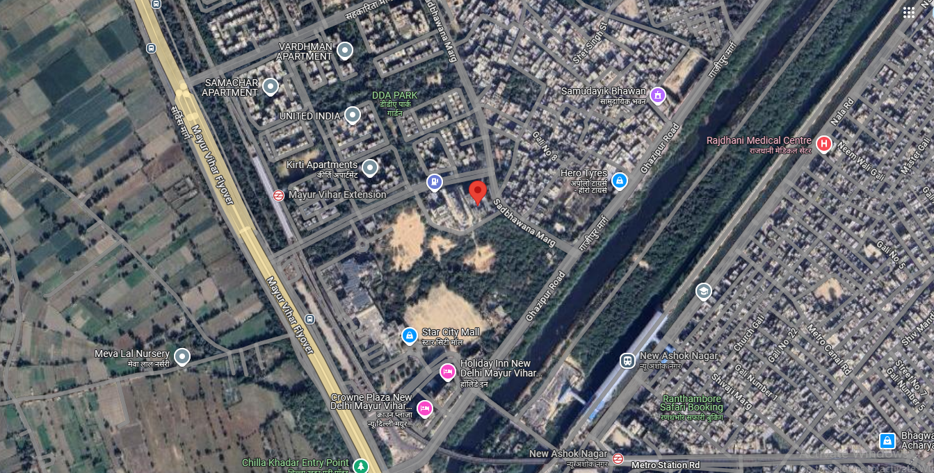

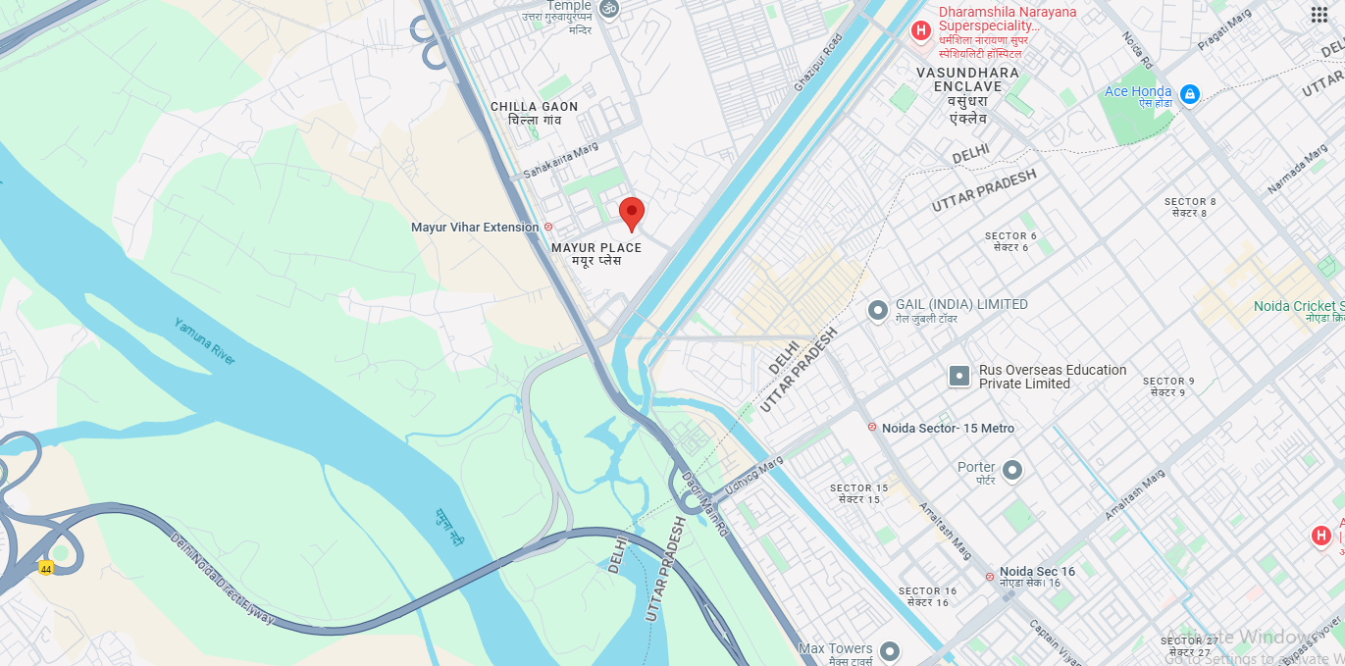

**ENCLOSURE: – APPROVED MAP/SITE PLAN**

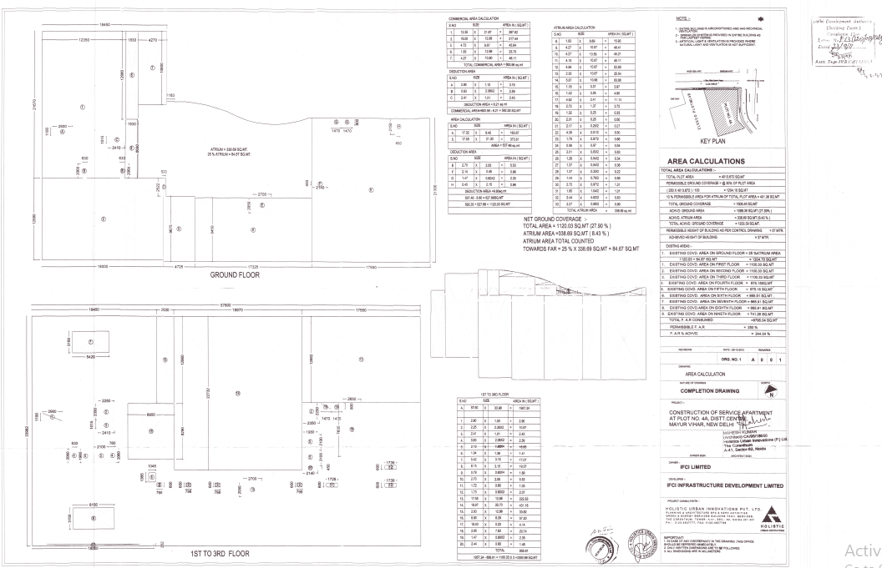

**ENCLOSURE: – CIRCLE RATES**

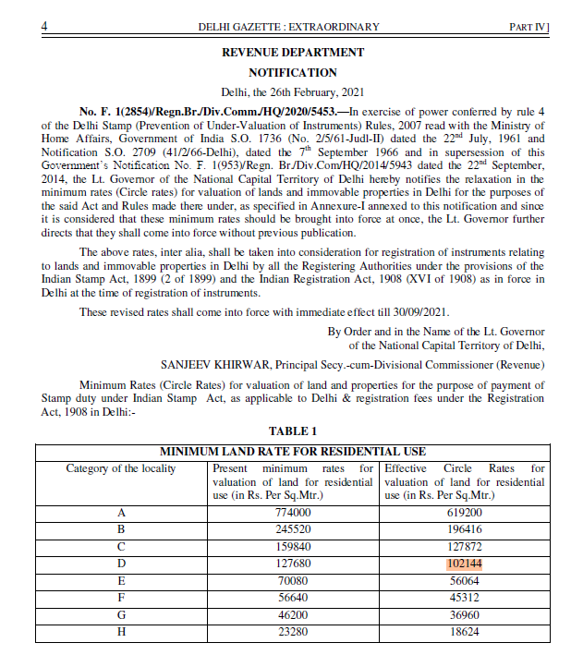

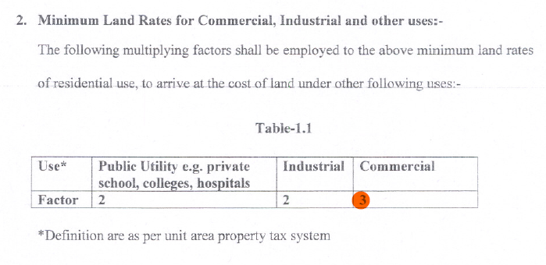

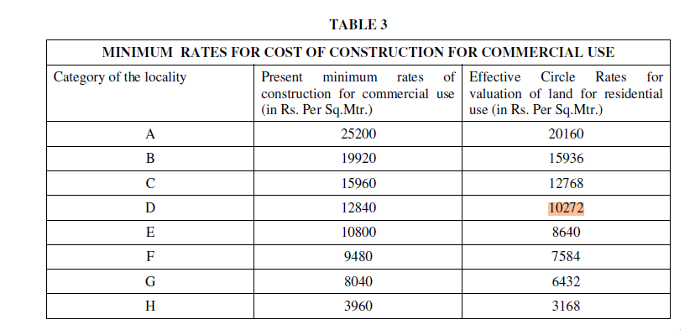

**ENCLOSURE: – SITE IMAGES**

|  |  |
| --- | --- |
|  |  |
|  |  |
|  |  |