**File No.:** **VIS (2024-25)-PL869-772-1051 Dated: 24-03-2025**

**COST VETTING ASSESSMENT**

**OF**

**C FAN ELECTRICALS**

**SITUATED AT**

**SITUATED AT GRAM- LAKESWARI, PARGANA & TEHSIL-BHAGWANPUR, DISTT-HARIDWAR**

**REPORT PREPARED FOR**

**STATE BANK OF INDIA, SME, ROORKEE**

***\*\*Important - In case of any query/ issue or escalation you may please contact Incident Manager***

***at le@rkassociates.org. We will appreciate your feedback in order to improve our services.***

***NOTE: Please provide your feedback on the report within 15 days of its submission after which report will be considered to be correct***

**IMPORTANT NOTICE**

***COPYRIGHT FORMAT:*** *This report is prepared on the copyright format of R.K Associates to serve our clients with the best possible information and analysis to facilitate them to take rational business decisions. Legally no one can copy or distribute this format without prior approval from R.K Associates. It is meant only for the advisory/ reference purpose for the organization/s as mentioned on the cover page of this report. Distribution or use of this format by any organization or individual other than R.K Associates will be seen as an unlawful act and necessary legal action can be taken against the defaulters.*

*This report is intended for the sole use of the intended recipient/s and contains material that is STRICTLY CONFIDENTIAL AND PRIVATE.*

***DEFECT LIABILITY PERIOD:*** *- In case of any query/ issue or escalation you may please contact Incident Manager at le@rkassociates.org. We try to ensure maximum accuracy in the calculations done, rates adopted, assumptions taken and various other data points & information mentioned in the report but even still can’t rule out typing, human errors or any other bonafide mistakes. In case you find any such mistake or inaccuracy in any data point of the report, please help us by bringing all such points into our notice immediately or within 15 days of the r0eport delivery in writing, to rectify these timely failing after which R.K Associates won’t be held responsible for any such inaccuracy in any manner. We would highly appreciate your feedback in order to improve our services.*

|  |  |  |
| --- | --- | --- |
| **TABLE OF CONTENTS** | | |
|  | | |
| **SECTIONS** | **PARTICULARS** | **PAGE NO.** |
| **Part A** | **REPORT SUMMARY** | 04 |
| **Part B** | **COST VETTING ASSESSMENT** | 05 – 10 |
|  | 1. DESCRIPTION | 05 |
| 1. BUILDING & CIVIL WORKS: | 06 – 10 |
| **Part C** | **PHOTOGRAPHS** | 11 |
| **Part D** | **IMPORTANT DOCUMENTS EXHIBIT** | 12 – 15 |
| **Part E** | **DISCLAIMER** | 16 - 17 |

|  |  |
| --- | --- |
| **PART A** | **REPORT SUMMARY** |

* **DOCUMENT NAME:** Cost Vetting Assessment
* **PREPARED FOR:** State Bank of India, SME, ROORKEE
* **BORROWER:** M/s C Fan Electricals
* **ASSET TYPE**: Building Structure & Civil works
* **ADDRESS OF THE ASSET**: Situated At Gram- Lakeswari, Pargana & Tehsil-Bhagwanpur, Distt-Haridwar

|  |  |  |
| --- | --- | --- |
| **S. NO.** | **PARTICULARS** | **DESCRIPTION** |
|  | Date of Work Order | Via Email dated 18-03-2025 |
|  | Date of site survey | Survey has not been carried out, cost vetting has been done on the basis of provided document (on the request of bank) |
|  | Documents provided for perusal | Estimation & Costing (BOQ) of building structure  Structural Drawing |
|  | Project Location | Khata No- 229,22 & 188khasra No- 106, 108 Gha & 107 Kha Situated At Gram- Lakeswari, Pargana & Tehsil-Bhagwanpur , Distt-Haridwar |
|  | Borrowing Company | M/s. C Fan Electricals |
|  | Type of Assessment | Cost vetting. |
|  | Scope of Assessment | Cost Vetting of the Building Structure & civil work |
|  | Nature of Asset | Building Structure |
|  | Total Project Cost as informed by the borrower | **Rs. 1.40 crores** |
|  | Project Cost as assessed by the consultant | **Rs. 1.29 crore** (Including GST) |
|  | Total number of pages with Annexure. | 17 |

|  |  |
| --- | --- |
| **PART B** | **COST VETTING ASSESSMENT** |

1. **DESCRIPTION**

This is a cost vetting document of the building structure proposed to be constructed at the aforesaid address. As per the BOQ provided, the proposed structures planned to be developed is Ground + first floor storied structure & guard room.

No survey has been done for the preparation of this cost vetting report, as per the bank requirement.

1. **BUILDING & CIVIL WORKS:**

The cost involved in the construction of proposed structures and other civil work has been calculated from our analysis and market research. For reference we have considered market rates, CPWD 2023, DSR 2023, and etc.

Details estimate cost of the building construction is as shown below:

|  |  | |  | **Amount by Company** | | **Amount as per cost vetting** | |
| --- | --- | --- | --- | --- | --- | --- | --- |
| **Description of Items** | **Units** | | **Quantity** | **Rate Rs. Per** | **Amount Rupees** | **Rate Rs. Per units** | **Total Amount** |
| excavation of foundation in ordinary soil inclu. Filling of excavated earth in trenches & inclu. Cost of labor T&P etc . | | cu. mt | 78.2784 | 166.4 | 13,025.53 | 200.00 | 15,655.68 |
| P&L 1:6:12 cement concrete foundation with 1 part cement 6 parts coarse sand & 12 parts stone aggregate as base conc. Including cost of material . Labour T&P etc. | | cu.mts | 7.245 | 3478.2 | 25,199.1968 | 4,000.00 | 28,980.00 |
| P&L 1st class brickwork in foundation 1:6 cement mortar , 1 part cement and 6 parts coarse sand inclu. Cost of material labor T&P etc. | | cu.mts | 23.6256 | 4900 | 1,15,765.44 | 5,000.00 | 1,18,128.00 |
| P&L D.P.C. at plinth level with 1:2:4 cement mortar , 1 part cement and 2 part coarse sand & 4 part stone Aggregate with 2% water proof compound complete. | | sq. mts | 5.136 | 263.1 | 1,351.2816 | 250.00 | 1,284.00 |
| P&L first class brick work super structure in 1:6 cement mortar as 1 part cement 6 parts coarse sand inclu. Cost of material shuttring material , labour , T&P etc. required . ( G.F & F.F) | | cu.mts | 204.0675 | 5582.9 | 11,39,278.24 | 6,000.00 | 12,24,405.00 |
| P&L R.C.C at plinth beam & door bend in 1:2:4 as 1 part cement 2 parts coarse sand and 4 parts stone aggregate inclu. Cost of material labour shuttring centering etc . Required but exclu. Cost of reinforcement | | cu.mts | 7.245 | 6215.4 | 45,030.21 | 5,500.00 | 39,847.50 |
| P&F salwood doors & windows chaukhats fixed include simple moulding material labour T&P etc. required for proper completion of job. | | cu.mts | 0 | 42000 | 0 | required specific data is not available to do cost vetting |  |
| S&F 1.5 inch. Thick sheesham wood door shutters with wooden panel or galvanize iron with beading . Wooden cleats , stopper Hings , bolts locks , handles , spring etc . Required for completion of job. | | sq. mts | 0 | 2251 | 0 | required specific data is not available to do cost vetting |  |
| S&F 11/3" thick shutters same as item no.16 but in window & ventilator . | | sq. mts | 50 | 2500 | 1,25,000.00 | 2,000.00 | 1,00,000.00 |
| P&F M.S grill at windows using M.S plate 40 x 6mm. As per design include . Cost of material cutting , welding , sewer & fixingat site . ( P.W.D spec. no. 10.9 (b) ) | | sq. mts | 100 | 2500 | 2,50,000.00 | 600.00 | 60,000.00 |
| P&L SHED in roof with steel column/parlin & tin shed | | qtls | 0 | 8000 | 0 | required specific data is not available to do cost vetting |  |
| P&L R.C.C in roof slab (same as item no. 6 ) | | cu.mts | 595.803 | 3150 | 18,76,779.45 | 5,500.00 | 32,76,916.50 |
| P&L 4 cm . Thick 1:2:4 plain cement concrete flooring with 1 part cement 2 part coarse sand 4 parts 3/4" craded stone balllast with 3mm. Flooring coat of next cement including Base concrete in 1:4:8 as 1 part 4 parts coarse sand & 8 part brick ballast of 4 cm. gauge include. cost of material labour T & P (P.w.D . spec no.- 14.9.1 ) | | sq. mts | 1374.4 | 200 | 2,74,880.00 | 250.00 | 3,43,600.00 |
| P&L granolithic marble chips of 3 mm . Gauge mixed in 4:7 ratio and cutting of floor of include . Finishing by French mansion polish & inclu. 1:5:10 base concrete complete . | | sq. mts |  | 432 | - | required specific data is not available to do cost vetting |  |
| Granolithic marbles dodo same as item no.- 15 (P.W.D. spec. no.- 14.9,1 ) | | sq. mts |  | 256 | 0 | required specific data is not available to do cost vetting |  |
| P&L C.C flooring fixed with 1.2 cement & coarse sand mortar & finished with white cement include cost of cutting & finished with french mansion polish inclu. Cost of 1:5:10 base concrete complete . | | sq. mts | 1374.4 | 1000 | 13,74,400.00 | 350.00 | 4,81,040.00 |
| S&F 6 mm china white glazed tiles 1st class 4" x 4" size with 1:3 cement & coasrse sand mortar finished with white cement slirry jointing & polishing complete | | sq. mts | 0 | 800 | 0 | required specific data is not available to do cost vetting |  |
| P&F glass strips 5 mm . Thick in joint of at the time of lying of floors complete . ( P.W.D. spec. no.- 14. 12.2 ( C ) ) | | r. mts | 0 | 14 | 0 | required specific data is not available to do cost vetting |  |
| P&L mm. th. Cement plaster in 1:3 mortar as 1 part cement 3 parts coarse sand over ceiling and R.C.C. job include supply of all material , labour T&P etc. required (P.W.D. spec. no. 13.5.4 ) | | sq. mts | 0 | 185.2 | 0 | required specific data is not available to do cost vetting |  |
| P&L 12mm. Th. Cement plaster in 1:5 morter at bricks works(same as item no.20 ) (P.W.D spec. no. 13.5.5 ) . | | sq. mts | 3360 | 160.35 | 5,38,776.00 | 200.00 | 6,72,000.00 |
| P&L whitewash 3 coats at walls and ceiling include cost of labour etc. (P.W.D spec. no. 16.1.1 & 16.1.2 ) . | | sq. mts | 0 | 4 | - | required specific data is not available to do cost vetting |  |
| P&L one priming coat & two coat of dry distemper on new work include . Cost of material labour T&P etc. Required for proper completion of job. (P.W.D. spec. no. 16.4.1.& 16.4.2) | | sq. mts | 3360 | 31 | 1,04,160.00 | 70.00 | 2,35,200.00 |
| Painting over new iron / wood work with one cost of priming paint & two cost of ready mixed paint include . Cost of material labour T&P etc.required for proper completion of job. (P.W.D spec . No.15.1.1& 15.1. 2 ) | | sq. mts | 0 | 47 | - | required specific data is not available to do cost vetting |  |
| P&L bricks in 1:3 cement mortar over R.C.C slab of stair cash steps complete . | | each | 212 | 800 | 1,69,600.00 | 3,000.00 | 6,36,000.00 |
| P&L M.S reinforcement as R.C.C work wrought to required shapes as necessary inclu. Cost of material labour T&P required | | qtls | 206.16 | 7500 | 15,46,200.00 | 6,000.00 | 12,36,960.00 |
| P&L one layer of tar felt giving one coat of mastic paints on bottom & top of tar feltinclu. Cost of material , labour , T&P required (P.W.d. spec. no. 549 ). | | sq. mts | 0 | 75 | 0 | required specific data is not available to do cost vetting |  |
| 100 m.m thick mud phaska of damped earth roof laid in slab & fixing of 1st class brick tiles with mud moter finishe din 1:3 cement marter complete job. | | sq. mts | 0 | 426.7 | 0 | required specific data is not available to do cost vetting |  |
| P&F commericial board shutters at wardrobe inclu. Cost of cleats, curtain rod fixing at site complete | | sq. mts | 0 | 2060 | 0 | required specific data is not available to do cost vetting |  |
| P&L F 9" wide palmate of commericial ply including cost of clasts , curraian rod fiixing at site complete job. | | sq. mts | 0 | 1985 | 0 | required specific data is not available to do cost vetting |  |
| SHED ROOF | | kg | 0 | 3000 | 0 | required specific data is not available to do cost vetting |  |
| SIDE SHEET | | kg | 0 | 1500 | 0 | required specific data is not available to do cost vetting |  |
| P&L R.C.C. in Footing same as item | | cu.mts | 250 | 3555 | 8,88,750.00 | 4,000.00 | 10,00,000.00 |
| P&L R.C.C. in column same as item | | cu.mts | 235 | 3555 | 8,35,425.00 | 4,000.00 | 9,40,000.00 |
| P&L R.C.C. in plinth beam same as item | | cu.mts | 280 | 3555 | 9,95,400.00 | 4,000.00 | 11,20,000.00 |
| P&F jet pump / submersible pump with motor & pipe fitting complete job. | |  |  |  | 2,00,000.00 | required specific data is not available to do cost vetting |  |
| Front,Rear & Side open flooring sq. mts 405.07 1100 445577 | | sq .mts | 405.07 | 1100 | 4,45,577.00 | 100.00 | 40,507.00 |
| Front & rear boundary and main gate & paint | |  | lumpsum |  | 500000 | required specific data is not available to do cost vetting |  |
| Anti tremeite treatment | |  | lumpsum |  | 50000 | required specific data is not available to do cost vetting |  |
| septic tank & rain water harvesting tank | |  |  |  | 150000 | required specific data is not available to do cost vetting |  |
| paint in all sheets | |  |  |  | 0 | required specific data is not available to do cost vetting |  |
| Parapet wall | |  |  |  | 0 | required specific data is not available to do cost vetting |  |
| False ceiling work as per the architectural drawings | | sq. mts | 0 | 500 | 0 | required specific data is not available to do cost vetting |  |
| modulur kitchen fittings & Room almira | |  |  |  |  | required specific data is not available to do cost vetting |  |
| Total | |  |  |  | 1,25,60,457.30 |  | 1,15,70,523.68 |
| Add. For Electrification , sanitation & water supply @ 10% of cost of construction | |  | Rs. |  | 12,56,045.73 |  | 11,57,052.37 |
| Add. For contingencies & escalation @2 % | |  | Rs. |  | 2,51,209.15 |  | 2,31,410.47 |
| **TOTAL** | |  |  |  | **1,40,67,712.18** |  | **1,29,58,986.52** |

**REMARKS:**

1. Estimated cost given by the company as per their BOQ is ~1.40 crore and estimated construction cost as per our cost vetting for civil and structure including GST is 1.29 crore.
2. The above details have been provided by the client on the basis of which this cost vetting has been done.
3. Cost difference may be there when labour is deployed through local contractor on daily basis Vs engaging EPC contractor and also difference in using concrete mixer at site Vs using of RMC.

|  |  |
| --- | --- |
| **PART C** | **PHOTOGRAPHS** |

**NA, since no site survey has been conducted**

|  |  |
| --- | --- |
| **PART D** | **IMPORTANT DOCUMENT EXHIBIT** |

**CLIENT’S BOQ:**

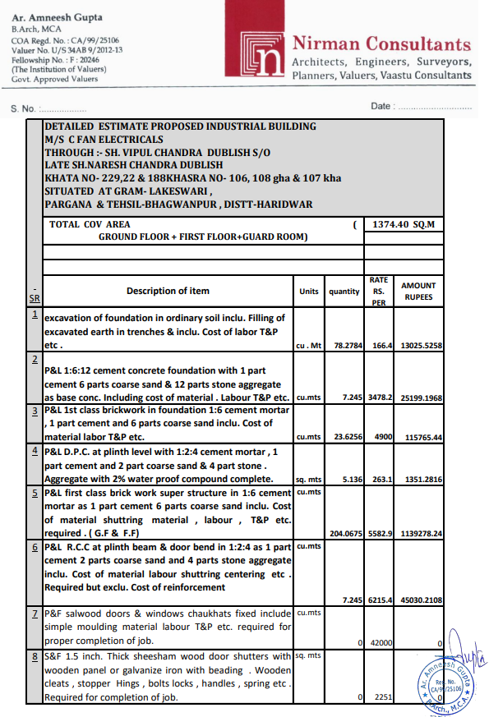

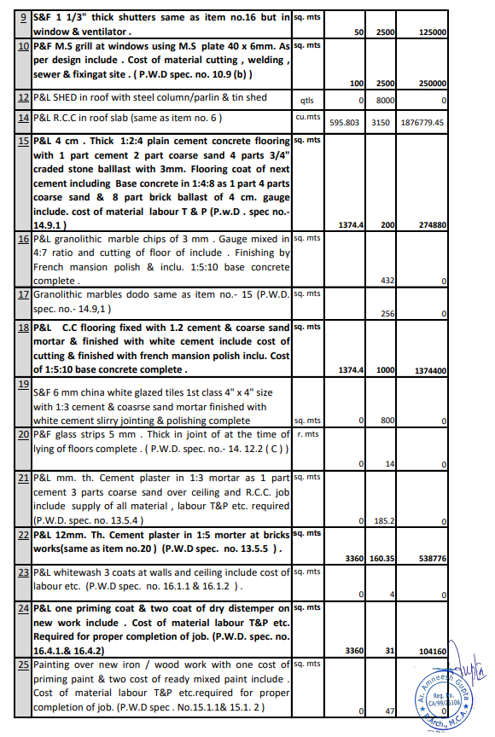

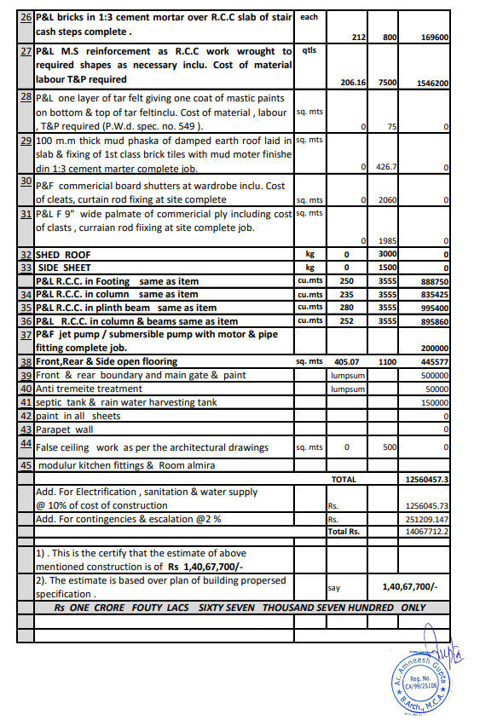

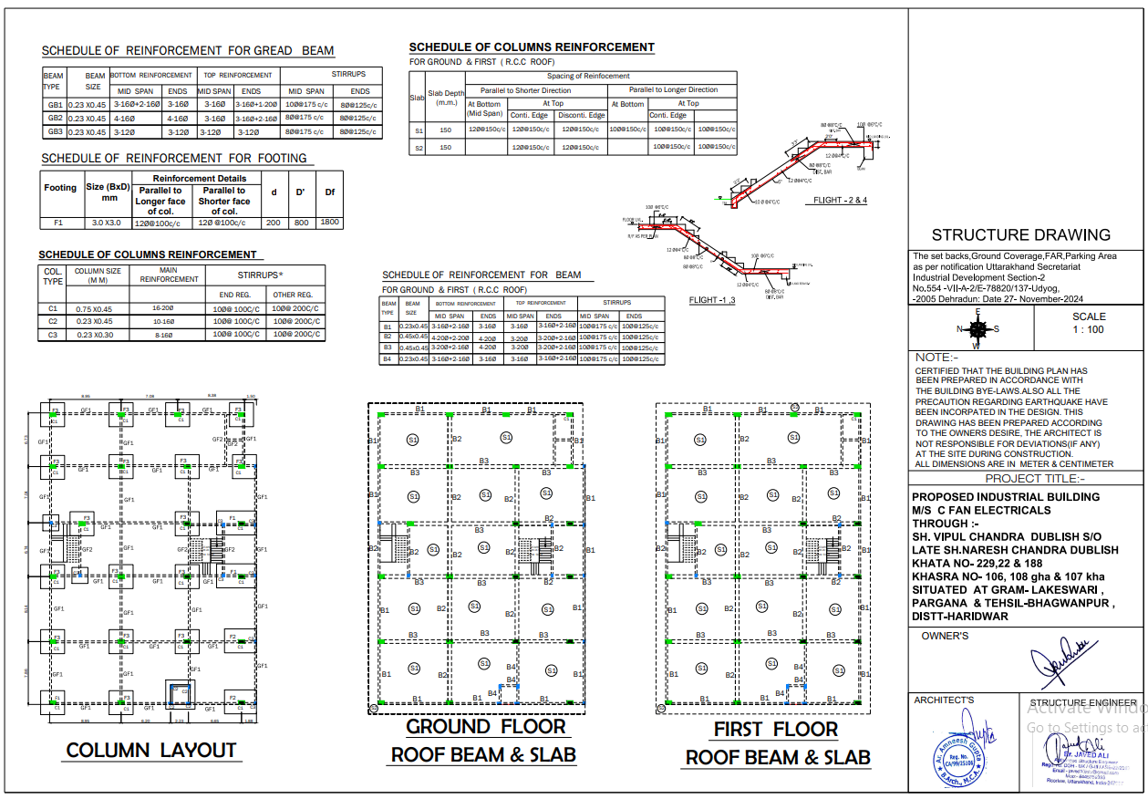`

|  |  |
| --- | --- |
| **PART F** | **DISCLAIMER** |

1. *We have received BOQ for building construction and civil work.*
2. *The client/ owner and its management/ representatives warranted to us that the information they have supplied was complete, accurate and true and correct to the best of their knowledge. All such information provided to us either verbally, in writing or through documents has been relied upon in good faith and we have assumed that it is true & correct without any fabrication or misrepresentation. I/We shall not be held liable for any loss, damages, cost or expenses arising from fraudulent acts, misrepresentations, or willful default on part of the owner, company, its directors, employee, representative or agents.*
3. *Legal aspects for eg. Investigation of title, ownership rights, lien, charge, mortgage, lease, sanctioned maps, and verification of documents provided to us such as title documents, Map, etc. from any concerned Govt. office etc. have to be taken care by legal expert/ Advocate and same is not done at our end. I/ We assume no responsibility for the legal matters including, but not limited to, legal or title concerns.*
4. *Wherever any details are mentioned in the report in relation to any legal aspect of the property such as name of the owner, leases, etc. is only for illustration purpose and should not be construed as a professional opinion. Legal aspects are out of scope of this report. Details mentioned related to legal aspect are only based on the copy of the documents provided to us and whatever we can interpret as a non-legally trained person. This should be cross validated with a legal expert. We do not vouch any responsibility regarding the same.*
5. *We have relied on the data from third party, external sources & information available on public domain to conclude the valuation. These sources are believed to be reliable and therefore, we assume no liability for the truth or accuracy of any data, opinions or estimates furnished by others that have been used in this analysis. Where we have relied on the data, opinions or estimates from external sources, reasonable care has been taken to ensure that such data is extracted from authentic sources, however we still can’t vouch its authenticity, correctness, or accuracy.*
6. *Documents, information, data including provided to us during the course of this assessment by the client is reviewed only upto the extent required in relation to the scope of the work. No document has been reviewed beyond the scope of the work. These are not reviewed in terms of legal rights for which we do not have expertise. Wherever any information mentioned in this report is mentioned from the documents like owner’s name, etc., it is only for illustration purpose and may not necessarily represent accuracy.*
7. *This cost vetting is done only on the basis of market research and BOQ provided to us by the company and we don’t recommend any sort of recommendation in our Document.*
8. *The estimated cost verification of item to item can’t exactly match as per our vetting due to several market consideration. In some of the items it is lower while in some of the item’s price comes to be higher but on an average the price as per list provided to us falls in the range as confirmed by us.*
9. *There can be variation in the estimated price if the specification & make of any items procured is different from the list provided to us during assessment.*
10. *The estimated cost verification is made based on the third-party information which has been replied upon in good faith.*
11. *Ownership and other legal point of view in respect of the asset is not considered in this report as same is out of scope of this document.*
12. *This document is made at the request of the Bank.*

**For R.K Associates Valuers** **& Techno** **FOR INTERNAL USE Engineering Consultants (P) Ltd. *PREPARED BY: Deepak Kumar Singh***  ***REVIEWED BY: Anil Kumar***