

Spunbond Nonwoven Machine (REICOFIL, german Technology)

Site Location:
S.NO.92-93B, KADAIYA, NEAR DALWADA ELE.SUB STATION, NANI DAMAN,(U.T) 396210 (INDIA) Email: fiberweb@vsnl.net Ph: 0091 (22) -2404 4855/2408 2689, fax: 0091(22)- 2404 4853

.Description:

Components for: 3.2 Meters Wide, nominal speed up to 150 m/min, 2 Beam, Spun Bond process Technology, up to 700 kg/hr nominal throughput rate capacity.

Double beam Spunbond Fabric Line 1 (Line Diagram)

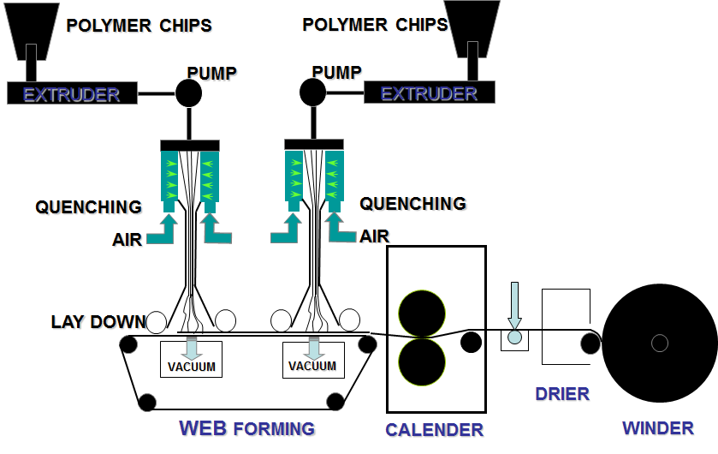
KISS ROLL
SPRAYER SYSTEM

