File No.: VIS (2025-26) - PL012-012-015 Dated: 16.06.2025

TECHNO-ECONOMIC VIABILITY STUDY REPORT
OF

GROUP HOUSING PROJECT “RASIK GREENS”

SETUP BY
M/S RASIK INFRA CONSTRUCTIONS
RASIK TOWER, RAMGHAT ROAD, TALA NAGRI, ALIGARH, UTTAR PRADESH, INDIA, 202001

REPORT PREPARED FOR

PUNJAB NATIONAL BANK, MCC BRANCH (809200),
ALIGARH, 202001

**Important - In case of any query/ issue or escalation you may please contact Incident Manager Valuers@rkassociates.org. We will appreciate your feedback in order to improve our services.

NOTE: As per IBA Guidelines please provide your feedback on the report within 15 days of its submission after which report will be considered to be correct

IMPORTANT NOTICE

COPYRIGHT FORMAT: This report is prepared on the copyright format of R. K. Associates Valuers & Techno Engineering Consultants (P) Ltd. (R. K. Associates) to serve our clients with the best possible information and analysis to facilitate them to take rational business decisions. Legally no one can copy or distribute this format without prior approval from R. K. Associates. It is meant only for the advisory/ reference purpose for the organization/s as mentioned on the cover page of this report. Distribution or use of this format or report or any of its content/ information/ data by any organization or individual other than R.K Associates will be seen as an unlawful act and necessary legal action can be taken against the defaulters.
This report is intended for the sole use of the intended recipient/s and contains material that is STRICTLY CONFIDENTIAL AND PRIVATE.

DEFECT LIABILITY PERIOD: In case of any query/ issue or escalation you may please contact Incident Manager at valuers@rkassociates.org. Though adequate care has been taken while preparing this report as per its scope, but still, we can’t rule out typing, human errors, over sightedness of any information or any other mistakes. Therefore, the concerned organization is advised to satisfy themselves that the report is complete & satisfactory in all respect. Intimation regarding any discrepancy shall be brought into our notice immediately. If no intimation is received within 15 (Fifteen) days in writing from the date of issuance of the report, to rectify these timely, then it will be considered that the report is complete in all respect and has been accepted by the client up to their satisfaction & use and further to which R.K Associates shall not be held responsible in any manner.

Part N: R. K. Associates Important Disclaimer and Remarks are integral part of this report and Feasibility assessment is subject to this section. Reader of the report is advised to read all the points mentioned in these sections carefully.

TABLE OF CONTENTS
SECTIONS | PARTICULARS | PAGE NO.
Part A | Report Summary | 3
Part B | Introduction
Part B | - About the Report | 5
Part B | - Executive summary | 5
Part B | - Purpose of the Report | 9
Part B | - Scope of the Report | 9
Part B | - Methodology/ Model Adopted | 10
Part B | - Data Information received from | 10
Part B | - Documents/ Data Referred | 10
Part C | Partnership Firm’s Profile
Part C | - Firm Overview | 11
Part C | - Profit & Loss Sharing | 11
Part C | - Promoters/Partner’s Profile | 12
Part D | Infrastructure/Technical Details
Part D | - Project Location | 14
Part D | - Location Map | 15
Part D | - Land Details | 16
Part D | - Building & Civil Works | 18
Part D | - Layout Plan | 25
Part D | - Site Pictures | 27
Part D | - Technical Team | 35
Part D | - Utilities | 35
Part D | - Site Visit Observation | 36
Part D | - Conclusion | 37
Part E | Inventory Profile
Part E | - Inventory Overview | 38
Part E | - Inventory Category | 39
Part E | - Pricing Strategy | 40
Part E | - Marketing, Selling & Distribution Plan | 41
Part F | Real Estate Industry Overview | 43
Part G | SWOT Analysis | 48
Part H | Risk Analysis | 50
Part I | Project Cost and Means of Finance | 52
Part J | Project Implementation Schedule | 55
Part K | Statutory Approvals | Licences | NOC | 56
Part L | Project’s Financial Feasibility | 59
Part M | Conclusion | 78
Part N | Disclaimer | Remarks | 80

PART A | REPORT SUMMARY

S. NO. | PARTICULAR | DESCRIPTION
 | Name of the Company: | M/s Rasik Infra Constructions
 | Address of the Company: | Registered Office: Rasik Tower, Ramghat Road, Tala Nagri, Aligarh, Uttar Pradesh, India, 202001
 | Project Name | Rasik Greens (Group Housing Project)
 | Project Location: | Khasra No. 280 Mi, 279/1, 202 Mi, Village: Harduaganj Dehat, Tehsil: Koil & District- Aligarh, Uttar Pradesh - 202125
 | Project Type: | Real Estate Project
 | Project Industry: | Residential Real Estate
 | Product Type / Deliverables: | Group Housing Project
 | Report Prepared for Organization: | Punjab National Bank, MCC Branch, Aligarh, U.P.
 | TEV Consultant Firm: | M/s. R.K Associates Valuers & Techno Engineering Consultants (P) Ltd.
 | Report type: | Techno-Economic Viability Report
 | Purpose of the Report: | To assess Project’s Technical and Economic Viability for the purpose of seeking external financial assistance on the Project.
 | Scope of the Report: | To assess, evaluate & comment on Technical and Economic Viability of the Project as per data information provided by the client, independent Industry research and data/ information available on public domain.
 | Date of Report: | 16th June, 2025
 | Documents referred for the Project: | - PROJECT INITIATION DOCUMENTS:  - Financial Projections of the Project  - Statutory Approval Details  - Partnership Deed  - Proposed/Approved Layout and Site Plan  - Sanctioned FAR  - PROCUREMENT DOCUMENTS:  - Sale Deed for Project Land  - Loan Repayment Chart  - Implementation Schedule  - STATUTORY APPROVALS, LICENCES & NOCs  - Partnership Deed  - RERA Application  - NOC for Environmental Clearance  - GST Registration Certificate  - Supporting of Change of Land Use  - Sanctioned Site Map  - Provisional Fire NOC
 | Means of Finance: | Equity & Debt (Proposed D/E Ratio: 2.23)
 | Key Financial Indicators:
  KEY INDICATORS | VALUE
  Average D.S.C.R | 1.38
  Average EBIT Margin | 86.77%
  Avg. PAT Margin | 8.81%
  NPV | INR 2448.38 Lakhs
  IRR | 26.71%
Note: Above financial indicators are based on the financial projections of the project provided by the firm and assessment and analysis of the same done by us.

PART B | INTRODUCTION

- ABOUT THE REPORT:
Techno-Economic Viability Study Report of the proposed group housing project known as “Rasik Greens” situated at Khasra No. 280Mi, 279/1, 202Mi, Village: Harduaganj Dehat, Tehsil: Koil & District- Aligarh, Uttar Pradesh – 202125 by M/s Rasik Infra Constriction.

- EXECUTIVE SUMMARY:
As per data/information shared by client, Rasik Group is a diversified business conglomerate with interests spanning across real estate, education, FMCG, infrastructure development, and social enterprise. The group has established a strong regional presence in Uttar Pradesh through the following key entities:
Group Structure – Rasik Group
Entity Name | Business Activity
M/s Rasik Refreshment Pvt. Ltd. | Food & beverage operations and packaged product retailing
M/s Rasik Education Foundation | Not-for-profit foundation for education and skill development
M/s Rasik International | Trading and export-oriented business for global outreach
M/s Rasik Infracon Pvt. Ltd. | Infrastructure development – roads, civil works, and utility projects
M/s Mahila Kutir Kendra Pvt. Ltd. | Women-led micro-enterprise and cottage industry initiatives under CSR framework
Source: Data/information shared by client.
The group, led by experienced promoters, has a strong execution track record and diversified revenue streams, thereby ensuring financial stability and operational synergy across its verticals. The proposed Rasik Greens project is a strategic addition to the group’s expanding real estate portfolio under M/s Rasik Infra Constructions.
As per the partnership deed shared by the client, M/s Rasik Infra Constructions is a partnership firm initially incorporated on 01st April 2015 with four partners. However, following a restructuring of the partnership in 2017, two partners retired from the firm. Since then, the business is being managed and operated by the remaining two partners: Mr. Bankey Bihari Bansal and Mr. Rajesh Kumar Mittal.
The primary object of the firm is to undertake and execute a wide range of construction and real estate development activities, which include the construction and development of shops, flats, and residential houses. The firm commenced its business operations from its registered head office located at Rasik Tower, Ramghat Road, Tala Nagri, Aligarh – 202001, Uttar Pradesh. M/s Rasik Infra Constructions has gradually developed a credible reputation in the local real estate and construction sector and continues to expand its presence in the region with a focus on quality execution and timely delivery of residential and commercial real estate projects.
As per data/information provided by the client, since inception, M/s Rasik Infra Constructions has successfully undertaken and completed four residential housing projects within Aligarh City. These projects have primarily focused on the development of affordable and mid-range residential units, including flats and individual houses. The partners had successfully executed multiple real estate development projects in Aligarh under various other entities. The details of their past completed projects are as follows:
S. No. | Project Name | Location | Period of Execution | No. of Units
1 | Rasik Apartment | Ganga Jawahar Colony, Ramghat Road, Aligarh | 2011–2013 | 13 Flats
2 | Vrindavan Dham – I | M-09, Mahavir Park, Marris Road, Aligarh | 2012–2014 | 16 Flats
3 | Rasik Dham | Maharana Pratap Colony, Swarn Jayanti Nagar, Ramghat Road | 2014–2016 | 32 Flats
4 | Vrindavan Dham – II | Mahavir Park, Marris Road, Aligarh | 2015–2016 | 16 Flats
5 | Rasik Tower | Aligarh (Towers A, B, C & D) | Ongoing/Completed | 64 Flats per tower (Total 256 Flats)
Source: Data/information shared by client.
These projects represents the promoter's execution capability, market knowledge, and brand recognition within Aligarh’s real estate landscape. With proven execution skills and market knowledge, the promoters have established M/s Rasik Infra Constructions as a reliable name in Aligarh’s residential real estate.
As per bank proposal sheet shared by client, out of the total inventory developed, a majority of the units have been sold, with only a limited number of flats remaining unsold as on date. Both partners of the firm Mr. Bankey Bihari Bansal and Mr. Rajesh Kumar Mittal are currently enjoying the following credit facilities from the bank: Housing Loan (Individual), Overdraft (OD) Limit (Business), Car Loan. All the accounts are running regular, demonstrating the financial discipline and creditworthiness of the firm and its promoters.
As per data/information provided by the client, the partners of M/s Rasik Infra Constructions, Mr. Bankey Bihari Bansal and Mr. Rajesh Kumar Mittal, are well-established and reputed businessmen in Aligarh. Both have long-standing roots in the local business community and possess extensive experience in the real estate and construction sector, having been actively involved in property development for over a decade.
The proposed project “M/s Rasik Greens” is about development of the group housing development at Khasra No. 280Mi, 279/1, 202Mi, Village: Harduaganj Dehat, Tehsil: Koil & District- Aligarh, Uttar Pradesh – 202125 with total 256 units consisting of 128 units of 3-BHK flats on 16 floors with 8 units per floor in Block-C and 128 units of 4-BHK flats on 16 floors with 8 units per floor in Block-B. The project is to be carried on freehold land besides existing project Rasik Tower having Tower A, B, C and D.
As informed by client, the proposed residential project is planned with modern lifestyle amenities and essential infrastructure to offer a secure and comfortable urban living experience. Key features include 24x7 CCTV surveillance, EPABX system, and fire safety as per norms, an in-premise shopping complex, and a dedicated driver dormitory. Lifestyle amenities comprise a swimming pool, gym, temple, and community hall. Utility highlights include high-speed elevators, 24x7 water supply, ample parking, power backup for common areas, and a modern waste disposal system. The project aims to provide an integrated and self-sustained living environment with all necessary utilities, recreational spaces, and safety measures in place. This comprehensive offering is expected to significantly enhance the quality of life of future occupants and improve the marketability of the property.
As per the land deed shared by the client, M/s Rasik Infra Constructions has acquired a total 26,612 sq. meters land at Khasra No. 280Mi, 279/1, 202Mi, Village: Harduaganj Dehat, Tehsil: Koil & District- Aligarh, Uttar Pradesh – 202125. Out of which, ~50%. Land will be utilised for developed of Tower B & C of the proposed project “Rasik Greens” in phase -1.
As per information furnished by client, vide order dated 18/12/2021 from Sub-Divisional Magistrate, District: Aligarh, Case Number: 23318/2021, ~1.71 Hectare land is converted to non-agricultural. Same is reflected in the kahtauni for the said plots as downloaded from https://upbhulekh.gov.in/. Regarding remaining CLU, the promoters have provided a legal certificate issued by Advocate Pankaj Gupta (Aligarh), confirming that the subject land (Khasra Nos. 202 Minjumla, 280 Minjumla and 279/1, Tehsil Koil, Harduaganj, Aligarh) has already been converted for residential plotted development under Section 80 of the U.P. Revenue Code vide court orders dated 06.01.2023 and 18.12.2021.
As confirmed by the client, the Rasik Greens project has received sanction from the Aligarh Development Authority for a total of four blocks. Currently, only two blocks—Block B (21,292.05 Sq. Mt.) and Block C (16,125.88 Sq. Mt.) are under development in first phase, with the remaining two blocks planned for future phases. Accordingly, the project report and financials considered for this TEV assessment pertain solely to the land area and development scope of these two active blocks.
As per the information provided, the layout plan of the proposed project has been prepared by Architect/Engineer Mr. Pavitra Kumar Singh (Registration No. AM3031185/20022023) and duly approved by the Aligarh Development Authority vide approval no. AGDA/BP/24-25/0267 dated 29th March 2025, which remains valid until 18th May 2030.
As per data/information provided to us, the firm has obtained some of the approvals/NOCs such as Sanctioned layout plan, Environmental clearance, Fire NOC (Provisional), CLU etc. and has applied or will apply in due course for remaining Approvals/NOC’s such RERA, NHAIs & Airport NOC, Ground Water Extraction NOC, Approval from Electricity Department etc. from the respective authorities. (Refer the section Statutory Approval in the later part of the report).
As per the details shared by the client, the total cost of the proposed Group Housing Project (Phase-I) is estimated at INR 11,781.94 lakhs (including land and ADA fees), proposed to be financed through a term loan of INR 7,000.00 lakhs, partners’ contribution of INR 2,581.94 lakhs, unsecured loans of INR 1,200.00 lakhs, and expected customer advances of INR 1,000.00 lakhs. (For Project Cost breakup, refer the section “Project Cost and Means of Finance” in the later part of the report).
During the site visit dated 12th April 2025, it was noted that the proposed land parcel is located at an approximate distance of 400 meters from Ramghat Road. The site adjoins the firm’s existing development “Rasik Tower,” and currently, both Rasik Greens and Rasik Tower share a common entrance, ensuring site accessibility. It was also observed that the project land has been partially demarcated as of date. Also, the promoters have informed that necessary measures for providing a dedicated entry will be undertaken during the development phase, ensuring compliance with planning norms and smooth project accessibility. (Kindly refer the site pictures captured during the survey attached in the later section of the report).
At present, the firm is in discussion with banks/financial institutions to fund the project through a term loan of INR 7,000.00 lakhs. In this regard, Punjab National Bank, MCC Branch, Aligarh has appointed R.K. Associates to assess the Techno-Economic Viability of the proposed project at Khasra No. 280Mi, 279/1, 202Mi, Village: Harduaganj Dehat, Tehsil: Koil & District- Aligarh, Uttar Pradesh, 202125 based on our independent EIC research and information/data provided to us about the project by M/s Rasik Infra Constructions.
- PURPOSE OF THE REPORT:
To assess the Techno-Economic Feasibility of the proposed group housing development project to take project funding decision for the same.

- SCOPE OF THE REPORT:
To assess, evaluate & comment on Techno-Economic Feasibility of the proposed group housing project being developed by M/s Rasik Infra Constructions as per the data/information provided by the client/promoter/stakeholder and our independent EIC research.
NOTES:
- Project status is taken as per the information provided by the client/promoter/stakeholder and independently verified during the site inspection also.
- Scrutiny about the company, background check, credibility, credit worthiness of the company or its promoters is out-of-scope of this report.
- The projections incorporate existing financials as provided by the client, merged with project-specific estimates. However, validation or audit of existing figures is beyond the scope of this assessment. It is recommended that the bank obtain independently audited and validated existing financials directly from the client for due diligence purposes.
- This report is only an opinion in respect to Financial Feasibility of the project as per the future Projections provided by the company and independent analysis done by us and doesn’t contain any recommendations including taking decision on the financial exposure.
- Any verification of the documents/ information from originals/ source is out-of-scope of this report.
- This is not an audit activity of any kind. We have relied upon the data/ information furnished by the firm in good faith that it is true and without any fabrication.
- Any review of the existing business of the promoters is out of scope of this report.
- This is not a Detailed Project Report or Detailed Cost Vetting Report or a detailed design or architecture document. Land and property details mentioned in the report is only for illustration purpose as per the information provided to us by the client. The same doesn’t tantamount for taking any responsibility regarding its legality, ownership and conforming to statutory norms.

- METHODOLOGY/ MODEL ADOPTED:
- Data/Information collection.
- Review of Data/ Information collected related to Techno-Economic Viability study.
- Independent review & assessment of financial projections provided by the company/promoters.
- Review and analysis of the Projections as per the market trends and futuristic growth opportunity of the industry and company.
- Projections of Revenue, P&L, Balance Sheet, Working Capital Schedule, Depreciation Schedule, Loan Schedule as per the inputs given by the company and assessed by us.
- Calculation of key financial indicators and ratio analysis including DSCR, NPV & IRR and payback period of the project.
- Report Compilation and Final Conclusion.
- DATA/ INFORMATION RECEIVED FROM:
All the data/Information has been received from Mr. Rishabh Mittal and the required details about him shown in the below table:
Particulars | Details
Name | Mr. Rishabh Mittal
Company | M/s Rasik Infra Constructions
Email Address | rishabhmittal@rasikgroup.com
- DOCUMENTS / DATA REFFERED:
- Financial Projections of the proposed project up to FY 2029.
- Memorandum of Association of the company.
- Director’s Details & Shareholding Pattern.
- Proposed Total project cost and Means of Finance.
- Few past sample bills/invoices of sold flats.
- Site/Layout Plan.
- Certificates of Statutory approvals/NOCs.
- Survey Report conducted at the site dated 12th April 2025.
- Land Deeds
- Cost Estimations for civil and construction works for Phase-I.
- Data/information available on public domain.

PART C | PARTNERSHIP FIRM’S PROFILE

- FIRM OVERVIEW:
As per the partnership deed shared by the client, M/s Rasik Infra Constructions is a partnership firm initially incorporated on 01st April 2015 with four partners. However, following a restructuring of the partnership in 2017, two partners retired from the firm. Since then, the business is being managed and operated by the remaining two partners: Mr. Bankey Bihari Bansal and Mr. Rajesh Kumar Mittal.
As per the details shared by the client, Main objective of the firm as per the partnership deed is to carry on the business of contractors, Government Contractor and consultants and construction of the road, Building Electrical work, commercial and residential complex, Apartments, Buildings, Offices, builders, developers etc. and to construct ,build design, develop, and buy sell or lease or outright sale acquire and deal in land, shop, flats houses, right in multi-story buildings both commercial & residential and properties of any tenure or therein to erect, construct house building or work of every description and pulls down, rebuilt, enlarge, alter, improve existing houses, flats and building to construct and appropriate such land into and for roads, streets, gardens and other conveniences and to act as builder & contractor:
Details of the Partnership Firm
Particular | Description
Partnership Name | M/s Rasik Infra Constructions
Date of Incorporation | 1st April 2015
Registered Address | Rasik Tower, Ramghat Road, Tala Nagri, Aligarh, Uttar Pradesh, India, 202001
Partners | Mr. Bankey Bihari Bansal and Mr. Rajesh Kumar Mittal with 50% profit & loss sharing.
Source: As per the data shared by the client.

The partnership firm is categorised as micro enterprise with Udyam Registration Number UDYAM-UDYAM-UP-02-0003813 dated 27th April 2024. In this partnership firm, the designated partners have proposed to develop the housing development project “M/s Rasik Greens” at Khasra No. 280Mi, 279/1, 202Mi, Village: Harduaganj Dehat, Tehsil: Koil & District- Aligarh, Uttar Pradesh – 202125 with total 256 units consisting of 128 units of 3-BHK flats on 16 floors with 8 units per floor (Block C) and 128 units of 4-BHK flats on 16 floors with 8 units per floor (Block B).
- PROFIT/LOSS SHARING BY PARNTNERS:
As per the supplementary partnership deed, dated 1st April 2027, the New Profit and Loss Sharing Ratio shall be as under:
The New Profit and Loss Sharing Ratio
Name of Partner | Role | Profits | Losses
Mr. Bankey Bihari Bansal | Party of First Part | 50% | 50%
Mr. Rajesh Mittal | Party of Second Part | 50% | 50%
The project is being undertaken under a partnership structure, wherein Mr. Bankey Bihari Bansal and Mr. Rajesh Mittal are the designated partners, holding equal rights and responsibilities. As per the partnership agreement, both partners shall share profits and losses equally (50:50). This balanced ownership ensures joint accountability and aligned interests towards the successful execution and commercialisation of the project.
- PARTNERS PROFILE:
As per data/information provided by the client, below are the educational & professional experience of the partners of M/s Rasik Infra Constructions:
S. No. | Name | Designation | Qualifications/Experience
1 | Mr. Bankey Bihari Bansal  (+91 9837074800, account@rasikgroup.com) | Designated Partner | - As per data/information shared by client, Mr. Bankey Bihari Bansal, a graduate by qualification, brings over 15 years of extensive experience in the real estate sector, having successfully executed multiple housing and commercial projects.  - His core expertise lies in the development of integrated housing colonies and state-of-the-art buildings. In addition to real estate, he is also engaged in other business ventures, including the wholesale distributorship of ITC products, reflecting his strong entrepreneurial background and financial credibility. He is presently focused on the execution of this project.
2 | Mr. Rajesh Mittal | Designated Partner | - As per data/information shared by client, Mr. Rajesh Kumar Mittal, a graduate by qualification, is a seasoned builder, developer, and manufacturer with over 20 years of experience in real estate development. He has successfully executed several housing colonies and commercial complexes, including four residential projects in collaboration with Mr. Bankey Bihari Bansal.  - In addition to his real estate ventures, he also operates a manufacturing and export unit involved in the production of cotton mats, quilts, and similar textile products, demonstrating diversified business acumen and execution capability.
Source: Data/ Information provided by the company
Below tables shows the information of the companies/LLPs with which each partner is associated with to give a basic background detail of the promoters as found on public domain in general/ tertiary category research.
(MR. BANKEY BIHARI BANSAL DIN: 01860594)
S. No | Company Name  (CIN/FCRN) | Designation | Original Date of Appointment | Date Of Appointment at Current Designation
1 | Tulsi Dairy Products Private Limited  (U15204UP2004PTC028345) | Director | 26/02/2004 | 26/02/2004
2 | Rasik Refreshment Private Limited  (U41000UP2022PTC171108) | Director | 21/09/2022 | 21/09/2022
3 | Rasik Education Foundations  (U80903UP2020NPL138017) | Managing Director | 16/11/2020 | 16/11/2020
4 | Rasik Infracon Private Limited  (U45200DL2012PTC231983) | Director | 24/02/2012 | 24/02/2012
5 | Shri Vaishali Infracon Private Limited  (U45400DL2007PTC170705) | Additional Director | - | 17/02/2012
6 | Oregenal Lite India Private Limited  (U74900DL2007PTC170117) | Director | - | 02/11/2007
7 | Shri Vaishali Infracon Private Limited  (U45400DL2007PTC170705) | Director | - | 21/09/2012
Source: Information extracted from MCA website & public domain.
PART D | INFRASTRUCTURE/TECHNICAL DETAILS

- PROJECT LOCATION:
The proposed residential group housing project Rasik Greens is located at Khasra No. 280Mi, 279/1, and 202Mi, Village Harduaganj Dehat, Tehsil Koil, District Aligarh, Uttar Pradesh 202125, covering a total land area of approximately 26,510.68 square meters. The land parcel lies within the jurisdiction of the Aligarh Development Authority and falls under the designated residential zone as per the applicable master plan.
The location lies in proximity to Ramghat Road (33 ft. wide, approximately 300 meters away), which is one of the key arterial roads in Aligarh, ensuring connectivity to major parts of the city. The site is well-connected to both urban centres and the expanding residential corridors. Additionally, Aligarh has been included under the Smart City Mission, and related infrastructure upgrades are in progress, adding to the overall locational advantage of the project.
The property is having the proximity to the civic amenities such as hospital (~5 km away), school/college (~1.5 km away) and market (~2 km away) from the site location. Table: 1 is showing the details of the adjoining properties of the land for plant’s site location and Table: 2 is showing the Connectivity Details of the Proposed Location:
Table: 1 Adjoining Property Details
Location | Details
East | Rasik Tower (Residential group housing)
West | Residential Colony Talashpur
North | Vacant Agricultural land
South | Vacant Agricultural land

Table: 2 Connectivity Details of the Proposed Location
Connectivity | Details
Rail | Aligarh Junction ~10 km away
Airport | Aligarh Airport ~15 km away (Domestic)
Road | ~33 Ft. Wide Ramghat Road, ~300 mtr. Away.

During our site visit dated 12th April 2025, it was observed that the site is accessible via a 30 ft.-wide private approach road, and the property is East-facing. A prominent local landmark, Golden Stone Resort, is situated approximately 1 km from the project site. The area is in a rapidly urbanizing zone with multiple plotted developments and group housing societies under construction. Furthermore, Aligarh's industrial area, located in the vicinity, is also witnessing expansion, indicating increasing demand for residential spaces in this micro-market.
- LOCATION MAP:
- GOOGLE MAP LOCATION:
The proposed residential group housing project is situated at Khasra No. 280Mi, 279/1, 202Mi, Village Harduaganj Dehat, Tehsil Koil, District Aligarh, Uttar Pradesh – 202125. The site coordinates are approximately 27°56'13.9"N, 78°08'50.1"E, which places the project well within the urban expansion belt of Aligarh city. The location as per the Google map is attached below:
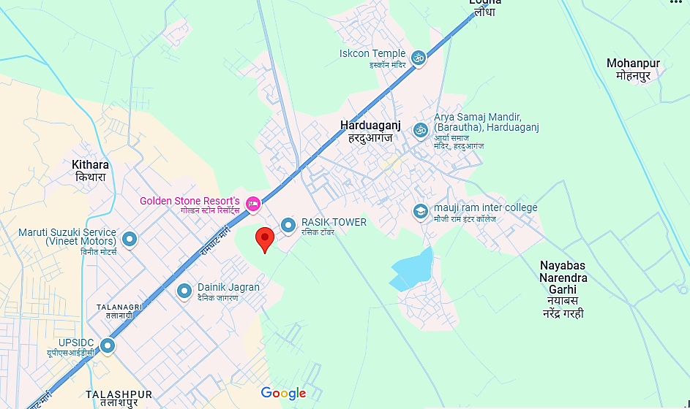
- GOOGLE MAP LAYOUT:
Demarcation of the whole project site with approximate measurement on the Google map are attached below:
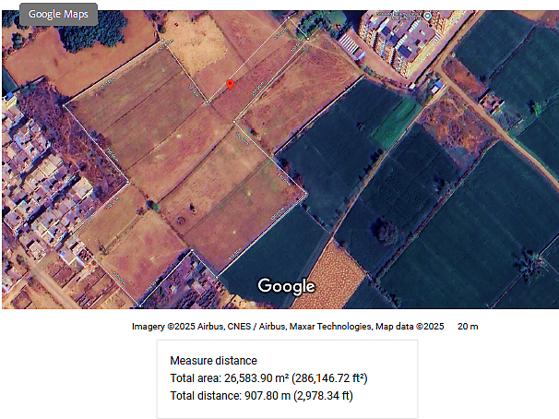
- LAND DETAILS:
As per the land deed shared by the client, M/s Rasik Infra Constructions has acquired a total 26,612 sq. meters (2.6612 Hectare) land at Khasra No. 280Mi, 279/1, 202Mi, Village Harduaganj Dehat, Tehsil: Koil & District- Aligarh, Uttar Pradesh 202125 for development of Tower A, B, C & D of the proposed project “Rasik Greens”. The land details purchased by M/s Rasik Infra Constructions is shown in the table below:
S. No. | Name Of Seller | GATTA NO. | KHATA NO. | TOTAL AREA | DATE OF REGISTRY | AREA (HECTARE) | DETAILS OF REGISTRY | PRICE (Benama+Stamp+1% recipt+advocate fees)
1 | GYAN CHAND JAIN, VINOD KUMAR JAIN, AJAY KUMAR JAIN AND MAHESH CHAND JAIN, VIKAS JAIN | 280Mi | 00304 | 0.8550 | 11-06-2021 | 0.1710 | 01/15649/181-202/6044 | 2,35,72,300
2 |  | 280Mi | 00304 | 0.8550 | 11-06-2021 | 0.1710 | 01/15649/203-226/6045 | 2,35,72,300
3 |  | 280Mi | 00304 | 0.8550 | 11-06-2021 | 0.1710 | 01/15649/227-248/6046 | 2,35,72,300
4 |  | 280Mi | 00304 | 0.8550 | 11-06-2021 | 0.1710 | 01/15649/249-270/6047 | 2,35,72,300
5 |  | 280Mi | 00304 | 0.8550 | 11-06-2021 | 0.1710 | 01/15649/271-292/6048 | 2,35,72,300
6 | GYAN CHAND JAIN | 280Mi | 00302 | 0.8550 | 10-06-2021 | 0.1826 | 01/15647/347-366/6009 | 2,35,72,300
7 | GYAN CHAND JAIN | 280Mi | 00302 | 0.8550 | 10-06-2021 | 0.1826 | 01/15647/367-386/6010 | 2,35,72,300
8 | GYAN CHAND JAIN | 280Mi | 00302 | 0.8550 | 10-06-2021 | 0.1826 | 01/15647/387-406/6011 | 2,35,72,300
 |  |  |  |  |  | 1.4027
9 | SANJEEV KUMAR CHAUHAN | 279/1 | 00355 | 1.9600 | 23-04-2022 | 0.1015 | 01/16181/199-218/4832 | 39,31,050
10 | SANJEEV KUMAR CHAUHAN | 279/1 | 00355 | 1.9600 | 23-04-2022 | 0.1015 | 01/16181/179-198/4831 | 39,31,050
 |  |  |  |  |  | 0.2030
11 | GULAM MOHAMMAD | 202MI | 00858 | 0.6340 | 22-06-2023 | 0.1585 | 01/16928/77-96/6566 | 1,27,60,840
12 | GULAM MOHAMMAD | 202MI | 00858 | 0.6340 | 22-06-2023 | 0.1585 | 01/16928/57-76/6565 | 1,27,60,840
13 | LIYAKAT ALI | 202MI | 00858 | 0.6340 | 22-06-2023 | 0.1585 | 01/16926/313-332/6533 | 1,27,60,840
14 | LIYAKAT ALI | 202MI | 00858 | 0.6340 | 22-06-2023 | 0.1585 | 01/16926/279-298/6531 | 1,27,60,840
 |  |  |  |  |  | 0.6340
15 | DEVENDRA PAL SINGH | 280Mi |  |  | 03-01-2022 | 0.0282 | 01/15992/37-54/57 | 27,22,940
16 | ANITA SINGH | 280Mi |  |  | 03-01-2022 | 0.0263 | 01/15992/17-36/56 | 27,22,940
 |  |  |  |  |  | 0.0546
17 | SM INFRACON BUILDERS AND DEVELOPERS | 202 MI | 00311 | 0.3670 | 19-06-2023 | 0.1223 | 01/16920/1-20/6378 | 73,47,180
18 | SM INFRACON BUILDERS AND DEVELOPERS | 202 MI | 00311 | 0.3670 | 19-06-2023 | 0.1223 | 01/16920/21-40/6379 | 73,47,180
19 | SM INFRACON BUILDERS AND DEVELOPERS | 202 MI | 00311 | 0.3670 | 19-06-2023 | 0.1224 | 01/16920/41-60/6380 | 73,47,180
 |  |  |  |  |  | 0.3670
Total land of Tower A,B,C & D |  |  |  |  |  | 2.6612 |  | INR 5,03,34,310
50% Land use for Tower A & D (Phase -1) |  |  |  |  |  | 1.3306 |  | INR 2,51,67,155

As per data/information shared by the client, out of this, 50%, i.e., 1.3306 hectares (13,306 Sq. Mt.), is proposed to be utilised in Phase 1 for the construction and development of Tower B and Tower C. The phasing has been informed by site planning considerations and development sequencing proposed by the client.
As per registered land deed records and supporting documentation, the total land acquisition cost amounts to INR 5,03,34,310. This includes all associated charges such as the sale deed value (Benama), stamp duty, 1% receipt charges, and advocate fees. Accordingly, INR 2,51,67,155 representing 50% of the total cost has been allocated towards Phase 1 of the project for the development of Tower B and C.
As per information furnished by client, vide order dated 18/12/2021 from Sub-Divisional Magistrate, District: Aligarh, Case Number: 23318/2021, ~1.71 Hectare land is converted to non-agricultural. Same is reflected in the kahtauni for the said plots as downloaded from https://upbhulekh.gov.in/. Regarding remaining CLU, the promoters have provided a legal certificate issued by Advocate Pankaj Gupta (Aligarh), confirming that the subject land (Khasra Nos. 202 Minjumla, 280 Minjumla and 279/1, Tehsil Koil, Harduaganj, Aligarh) has already been converted for residential plotted development under Section 80 of the U.P. Revenue Code vide court orders dated 06.01.2023 and 18.12.2021.
Copy of Revenue Code vide court orders dated 06.01.2023 was not made available to us. Learned advocated has also referred two pronouncement of honble Supreme Court of India (AIR 1998 SC Page No. 473 and AIR 1996 SC Page No.1522) stating as such no further change of land use for the rest area is required. Further, ADA Aligarh has approved the layout map for residential plotted development (File No. AGDA/L.B./24-25/0445, Approval Ref No. 02831/AGDA/24-25/23122024), covering an area of 41,175.51 sq.mtr. Bank is advised to take legal opinion from their empanelled advocate and the validity honble Supreme Court pronouncements in this respect.
- BUILDING & CIVIL WORKS:
As per the data/information provided to us, the firm has engaged Aligarh-based Dev Construction Company for preparation of cost estimates for Phase-I Building & Civil Works of Block B and Block C at Mauza Harduaganj, Pargana & Tehsil Koil, Aligarh (Khasra Nos. 280 MI, 279/1, 202 MI). The estimates, covering detailed civil works, floor-wise quantity analysis and abstract of quantities, have been prepared in line with the UPPWD Schedule of Rates, District Aligarh (effective 20.05.2022) and duly verified by Er. Pavitra Kumar Singh, Chartered Engineer (Regn. No. AM3031185/20022023). Below tables represents the detailed cost estimates of Block B & Block C:
Abstract of Quantities – Rasik Greens Project (Phase-I)
S. No. | Item of Work | Unit | Block B | Block C | Total
1 | Earth Work | CUM | 2093.77 | 2408.84 | 4502.61
2 | Earth Filling | CUM | 1220.84 | 1389.97 | 2610.81
3 | Sand Filling | CUM | 244.17 | 278 | 522.17
4 | PCC Work | CUM | 368.25 | 725.47 | 1093.72
5 | RCC | CUM | 7707.74 | 8491.58 | 16199.32
6 | Reinforcement | QTL | 12101.47 | 15477.93 | 27579.4
7 | B/W in Foundation | CUM | 409.11 | 394.52 | 803.63
8 | B/W in Superstructure | CUM | 5544.36 | 6093.96 | 11638.32
9 | Teak Wood Door Frame | CUM | 77.46 | 77.38 | 154.84
10 | Wooden Door Area | SQM | 8028 | 8000 | 16028
11 | uPVC Window Area | SQM | 2087.73 | 2087.73 | 4175.46
12 | Flooring | SQM | 21877.19 | 22900.97 | 44778.16
13 | 12 mm Plaster | SQM | 18455.92 | 18654.1 | 37110.02
14 | 15 mm Plaster | SQM | 71833.84 | 71783.72 | 143617.6
15 | Internal Paint | SQM | 68718.6 | 68364.48 | 137083.1
16 | MS Door Frames & Grills | KG | 15740 | 16470 | 32210
17 | Outer Façade Tiles | SQM | 25386.14 | 25227.69 | 50613.83

Sources: Cost Estimates shared by client.
Block B – Abstract of Quantities (BOQ)
S. No. | Item of Work | Basement Floor | Stilt Floor | Typical Floor Qty. (1st to 16th) | Total Qty. | Unit
1 | Earth Work | 2093.77 | 0 | 0.00 × 16 = 0.00 | 2093.77 | CUM
2 | Earth Filling | 1220.84 | 0 | 0.00 × 16 = 0.00 | 1220.84 | CUM
3 | Sand Filling | 244.17 | 0 | 0.00 × 16 = 0.00 | 244.17 | CUM
4 | PCC Work | 368.25 | 0 | 0.00 × 16 = 0.00 | 368.25 | CUM
5 | R.C.C | 1718.04 | 405.38 | 349.02 × 16 = 5584.32 | 7707.74 | CUM
6 | Reinforcement | 2697.32 | 636.63 | 547.97 × 16 = 8767.52 | 12101.47 | QTL
7 | B/W in Foundation | 409.11 | 0 | 0.00 × 16 = 0.00 | 409.11 | CUM
8 | B/W in Superstructure | 155.76 | 65.08 | 332.72 × 16 = 5323.52 | 5544.36 | CUM
9 | Teak Wood Door Frame | 0.25 | 0.73 | 4.78 × 16 = 76.48 | 77.46 | CUM
10 | Wooden Door Area | 1.1 | 5.2 | 124.86 × 16 = 1997.76 | 2004.06 | SQM
11 | uPVC Windows Area | 24.53 | 0 | 128.95 × 16 = 2063.20 | 2087.73 | SQM
12 | Flooring | 1633.97 | 1595.54 | 1165.48 × 16 = 18647.68 | 21877.19 | SQM
13 | Plaster 12 mm | 1485.43 | 1450.49 | 970.00 × 16 = 15520.00 | 18455.92 | SQM
14 | Plaster 15 mm | 1408.05 | 577.11 | 4365.48 × 16 = 69847.68 | 71833.84 | SQM
15 | Paint Internal | 2894 | 1796.76 | 4001.74 × 16 = 64027.84 | 68718.6 | SQM
16 | MS Doors, Frames and Grills | 750 | 1150 | 865.00 × 16 = 13840.00 | 15740 | KG
17 | Outer Facade Tiles | 634.07 | 288.55 | 1528.97 × 16 = 24463.52 | 25386.14 | SQM
Sources: Cost Estimates shared by client.
Block B comprises a basement, stilt, and 16 typical floors, with quantities reflecting a high-rise design typology. Major structural components like RCC (7,707.74 CUM) and reinforcement (12,101.47 QTL) indicate a strong structural frame. Finishes such as plastering (12 mm: 18,455.92 SQM; 15 mm: 71,833.84 SQM) and flooring (21,877.19 SQM) show uniformity across levels, supporting modular planning. Substructure work (earthwork, filling, PCC) is basement-focused, while façade and joinery items (tiles: 25,386.14 SQM; windows/doors: ~2,000 SQM each) reflect modern architectural treatment. Overall, the BOQ indicates efficient quantity distribution and repeatability, aiding both cost control and execution.
BOQ Quantity Summary – Block C
S. No. | Item of Work | Basement Floor | Stilt Floor | Typical Floor Qty. (1st to 16th) | Total Qty. | Unit
1 | Earth Work | 2408.84 | 0 | 0.00 × 16 = 0.00 | 2408.84 | CUM
2 | Earth Filling | 1389.97 | 0 | 0.00 × 16 = 0.00 | 1389.97 | CUM
3 | Sand Filling | 278 | 0 | 0.00 × 16 = 0.00 | 278 | CUM
4 | PCC Work | 725.47 | 0 | 0.00 × 16 = 0.00 | 725.47 | CUM
5 | R.C.C | 1761.71 | 424.16 | 349.02 × 16 = 5584.32 | 7770.19 | CUM
6 | Reinforcement | 2765.88 | 665.93 | 547.97 × 16 = 8767.52 | 12199.33 | QTL
7 | B/W in Foundation | 394.52 | 0 | 0.00 × 16 = 0.00 | 394.52 | CUM
8 | B/W in Superstructure | 150.36 | 65.08 | 332.72 × 16 = 5323.52 | 5538.96 | CUM
9 | Teak Wood Door Frame | 0.17 | 0.73 | 4.78 × 16 = 76.48 | 77.38 | CUM
10 | Wooden Door Area | 0.77 | 5.2 | 124.86 × 16 = 1997.76 | 2003.73 | SQM
11 | uPVC Windows Area | 24.53 | 0 | 128.95 × 16 = 2063.20 | 2087.73 | SQM
12 | Flooring | 2057.75 | 1595.54 | 1165.48 × 16 = 18647.68 | 22900.97 | SQM
13 | Plaster 12 mm | 1683.61 | 1450.49 | 970.00 × 16 = 15520.00 | 18654.1 | SQM
14 | Plaster 15 mm | 1358.93 | 577.11 | 4365.48 × 16 = 69847.68 | 71783.72 | SQM
15 | Paint Internal | 2566.88 | 1796.76 | 4001.74 × 16 = 64027.84 | 68364.48 | SQM
16 | MS Doors, Frames & Grills | 750 | 1150 | 865.00 × 16 = 13840.00 | 15740 | KG
17 | Outer Facade Tiles | 475.62 | 288.55 | 1528.97 × 16 = 24463.52 | 25227.69 | SQM

Block C's civil quantities reflect a standard high-rise typology comprising a basement, stilt, and 16 typical floors. Structural core elements like RCC (7,770.19 CUM) and reinforcement steel (12,199.33 QTL) suggest a robust frame design consistent with repetitive vertical modules. Finishing quantities such as plastering (12 mm: 18,654.10 SQM; 15 mm: 71,783.72 SQM) and flooring (22,900.97 SQM) exhibit scale and symmetry across floors. Substructure components including earthwork (2,408.84 CUM), PCC (725.47 CUM), and earth filling (1,389.97 CUM) are concentrated in the basement level. The presence of uPVC windows (2,087.73 SQM), outer façade tiles (25,227.69 SQM), and internal paint (68,364.48 SQM) highlight a modern envelope and finish standard. The BOQ reflects modular planning and efficient material estimation, enabling cost-effective execution and streamlined project scheduling for vertical residential development.
BOQ SUMMARY TABLE
S. No. | Description of Item | Quantity | Unit | Rate (INR) | Amount (INR)
1 | EARTH WORK
1.01 | Excavation in foundation in ordinary soil (including ramming, watering, disposal etc.) | 4502.61 | CUM | 160 | 720417.60
1.02 | Filling with available excavated earth (excluding rock), in layers, ramming & watering | 2601.81 | CUM | 580 | 1509049.80
1.03 | Supplying & filling fine sand in plinth, watering, ramming & dressing complete | 522.17 | CUM | 1150 | 600495.50
1.04 | Anti-termite treatment (vertical surface contact with backfill) | 5250 | SQM | 130 | 682500.00
2 | PLAIN & REINFORCED CEMENT CONCRETE
 | Plain Concrete
2.01 | PCC 1:5:10 (40mm stone aggregate) – All work up to plinth level | 1093.72 | CUM | 5900 | 64,52,948.00
2.02 | Damp-proof course (40 mm thick) with 1:2:4 concrete | 6241 | SQM | 450 | 28,08,450.00
2.03 | Painting DPC with 2 coats of bitumen VG-10 @ 1.70 kg/sqm | 6241 | SQM | 155 | 9,67,355.00
 | Reinforced Cement Concrete
2.04 | RCC 1:1.5:3 (20 mm stone aggregate) – All work up to plinth level | 15477.93 | CUM | 8900 | 13,77,53,577.00
3 | CENTERING & SHUTTERING
3.01 | Foundations, footings, bases of columns, slabs etc. for mass concrete | 7811.75 | SQM | 200 | 15,62,350.00
3.02 | Suspended floors, ramps, roofs, landings, balconies & access platforms | 986 | SQM | 373 | 3,67,778.00
3.03 | Lintels, beams, pinch beams etc. | 5428 | SQM | 314 | 17,04,392.00
3.04 | Columns, pillars, piers, abutments, posts and struts | 4920 | SQM | 438 | 21,54,960.00
4 | STEEL REINFORCEMENT
4.01 | Reinforcement for RCC including cutting, bending, binding (TMT Bars) | 2430080 | KG | 78 | 18,95,46,240.00
5 | STEEL WORKS
5.01 | Steel work in built-up tubular sections (trusses, gates etc.) incl. primer | 32210 | KG | 100 | 32,21,000.00
6 | BRICK WORK
6.01 | Brick work in CM 1:6 in foundations & up to plinth | 803.63 | CUM | 5500 | 44,19,965.00
6.02 | Brick work in CM 1:6 in superstructure (plinth to roof level) | 11083.32 | CUM | 6100 | 6,76,08,252.00
7 | PLASTER WORK
7.01 | 12 mm cement plaster 1:6 on walls (fine sand) | 37110.02 | SQM | 200 | 74,22,004.00
7.02 | 15 mm cement plaster 1:6 (on rough side of walls) | 143617.56 | SQM | 225 | 3,23,13,951.00
8 | FLOORING
8.01 | 20 mm thick White Albeta marble (gang saw cut, polished, with backing & pointing) | 44778.16 | SQM | 2700 | 12,09,01,032.00
9 | WOOD WORK
9.01 | C.P. Teak wood framed & fixed work (Chowkhats, moulding etc.) | 154.84 | CUM | 120000 | 1,85,80,800.00
9.02 | 4 cm thick C.P. Teak wood door/window shutters incl. iron mesh, fittings & painting | 16028 | SQM | 2200 | 3,52,61,600.00
9.03 | Second class teak wood frames for doors, windows, clerestory etc. | 1407.4 | CUM | 2750 | 38,70,350.00
9.04 | 12 mm frameless UPVC windows incl. pivots, spring, fixing, fittings | 4175.46 | CUM | 2400 | 1,00,21,104.00
10 | PAINTING & FINISHING WORK
10.01 | Wall painting (2 coats) with plastic emulsion incl. surface cleaning & prep | 137083.08 | SQM | 100 | 1,37,08,308.00
10.02 | Applying 2 mm thick POP putty on plastered surface for smooth finish | 137083.09 | SQM | 130 | 1,78,20,801.70
10.03 | Bitumen painting on roof tops incl. sand topping & kerosene cleaning | 6296 | SQM | 115 | 7,24,040.00
10.04 | Providing gola 75x75 mm at roof-wall junction with CC & finish | 2270 | RM | 155 | 3,51,850.00
10.05 | Making khuras 45x45 cm with CC 1:2:4 over PVC sheet, incl. plaster & outlet | 2600 | EACH | 195 | 5,07,000.00
10.06 | Providing & fixing outer wall rectified tiles | 50613 | SQM | 350 | 1,77,14,550.00
11 | MODULAR KITCHEN WORK
11.01 | Factory-made kitchen cabinet shutter/partition – 20mm thick rigid foam board | 4756.51 | SQM | 3520 | 1,67,42,915.20
12 | False ceiling work (gypsum/POP as per approved design) | 21760 | SQM | 1614 | 3,51,20,640.00
13 | Swimming pool & open gym area including civil & mechanical works | 3716 | SQM | 3230 | 1,20,02,680.00
14 | Landscape around building incl. fountain & green grass turfing | 5772 | SQM | 2700 | 1,55,84,400.00
15 | Lift (passenger/service, capacity assumed as per design) | 4 | Nos. | 3500000 | 1,40,00,000.00
16 | Fire Fighting System (FHCs, sprinklers, fire pumps etc.) | L.S. | - | - | 2,20,00,000.00
17 | Submersible pumps | 4 | Nos. | 250000 | 10,00,000.00
18 | Septic Tank & STP (civil + mechanical works) | L.S. | - | - | 60,00,000.00
19 | RCC Overhead Tank (10,000 Ltr. capacity each) | 4 | Nos. | 200000 | 8,00,000.00
20 | RCC Underground Tank (10,000 Ltr. capacity each) | 4 | Nos. | 300000 | 12,00,000.00
 | Total |  |  |  | 82,57,27,756
Sources: Cost Estimates shared by client.
Based on the Bill of Quantities (BOQ) provided by the client, the estimated cost for civil, structural, architectural, and MEP-related works amounts to approximately INR 8,257 lakh. The BOQ comprises key elements such as earthwork, RCC, steel reinforcement, brickwork, plastering, flooring, woodwork, painting, plumbing, electrical installations, fire-fighting systems, lifts, STP, landscaping, and other essential built-up infrastructure items.
While the cost framework appears reasonably structured, the same has been taken on good faith as submitted. It is important to note that the actual costs may vary depending on site-specific challenges, execution efficiency, procurement strategy, escalation in input costs, and other external factors. This assessment is based solely on the documentation and details shared by the client, and no independent verification or technical audit of BOQ line items has been undertaken as part of this report.
TOTAL ESTIMATED COST SUMMARY
Description | Amount (INR)
Total Civil Work (As Above) | 825727756
Add: Plumbing @ 7% | 57800942.92
Add: Electrical Work @ 10% | 82572775.6
Add: Contingencies @ 2% | 16514555.12
Grand Total Estimate | INR 98,26,16,029.64
Rounded Total (Say) | INR 98,26,16,000.00
Thus, as per the information shared by the client/company, the estimated cost for the civil construction of Block B and Block C under the “Rasik Greens” project, being developed by M/s Rasik Infra Constructions stands at INR 9826.16 lakhs as per the Detailed Project Cost Estimate prepared in accordance with the UPPWD Schedule of Rates (District Aligarh), effective from 20.05.2022.
Breakup Of Construction Cost Of Civil Work Construction Of Rasik Greens
S. No. | Block Name | Built-up Area Sq. mtr. | Built-up Area in Sq. ft. | Construction Cost Rs. 2200 per Sq. ft. of built-up area | Construction Cost Rs. 2400 per Sq. ft. of built-up area | Construction Cost Rs. 2500 per Sq. ft. of built-up area
1 | B Block | 21,292.05 | 2,29,185 | 50,42,08,093 | 55,00,45,193 | 57,29,63,742
2 | C Block | 16,125.88 | 1,73,577 | 38,18,70,191 | 41,65,85,663 | 43,39,43,399
Total |  | 37,417.93 | 4,02,762 | 88,60,78,000 | 96,66,31,000 | 1,00,69,07,000
Remarks :
1. All the details pertaining to the constructed building area has been taken from the documents provided to us.
2. As per discussion with the company official they will construct only Block - B and Block – C under Phase- I.
3. We have considered the construction cost as per CPWD standard and also as per market standard.
4. The Construction Cost varies from location to location like in rural area the construction cost is lower as compared to a metro city.
5. In Multi-storeys Buildings cost of construction increases with respect to increasing floors due to material handling cost etc.
At INR 2,200/ Sq. Ft., INR 2,400/ Sq. Ft. and INR 2,500/ Sq. Ft. scenarios, total construction cost estimates range from INR 88.60 Cr. to INR 100.69 Cr. falling within ±5% threshold of expected CPWD and market norms.
As a TEV consultant, we have independently verified the estimated building and civil construction cost of the Rasik Greens project, specifically for Block B and Block C being developed under Phase I. As per Delhi Schedule of Rates (DSR) 2021, linked with CPWD Plinth Area Rates 2020 and CPWD Specifications & SOR Guidelines used by CPWD engineers and architect, our assessment, based on built-up areas of 2,29,185.50 Sq. Ft. for Block B and 1,73,577.36 Sq. Ft. for Block C, aligns well with CPWD-derived rates.
Thus, Based on the built-up area of approx. 4,02,762.86 sq. ft. and prevailing CPWD benchmarks, the cumulative construction cost has been assessed at INR 2,439.68 per sq. ft., which is found reasonable and within a permissible variance of ±5%, subject to brand specifications and quality standards. The estimated cost aligns with market trends for similar RCC frame multi-storey developments in non-metro Tier-2 cities like Aligarh.
As per the ADA-approved plan, Block C was sanctioned as 2 BHK units; however, the developer has internally reconfigured them into 3 BHKs to align with market demand as sown in the attached layout. This change is restricted to internal partitioning within the approved built-up area and does not affect FSI, footprint, structure, cost, timelines, or saleable area under this TEV study.
Note: It is to be noted that a detailed item-wise cost vetting or technical audit of the construction budget is beyond the scope of this TEV study. The assessment carried out herein is a general verification based on prevailing market benchmarks, CPWD norms, and inputs provided by the company, solely for the purpose of broad feasibility evaluation and cost reasonability under this TEV analysis.
- LAYOUT PLAN:
As confirmed by the client, the Rasik Greens project has received sanction from the Aligarh Development Authority for a total of four blocks. Currently, only two blocks—Block B (21,292.05 Sq. Mt.) and Block C (16,125.88 Sq. Mt.) are under development in first phase, with the remaining two blocks planned for future phases.
The layout plan of the proposed project has been prepared by Architect/Engineer Mr. Pavitra Kumar Singh (Registration No. AM3031185/20022023) and duly approved by the Aligarh Development Authority vide approval no. AGDA/BP/24-25/0267 dated 29th March 2025, which remains valid until 18th May 2030.
BLOCK B:
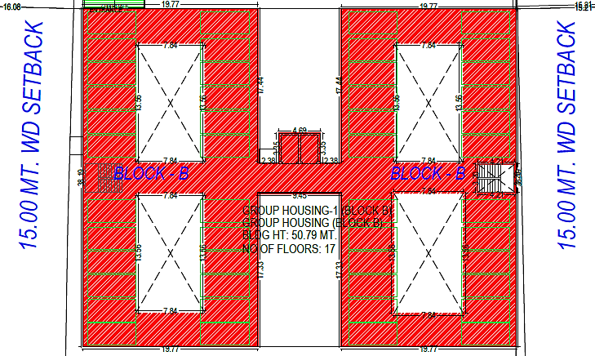
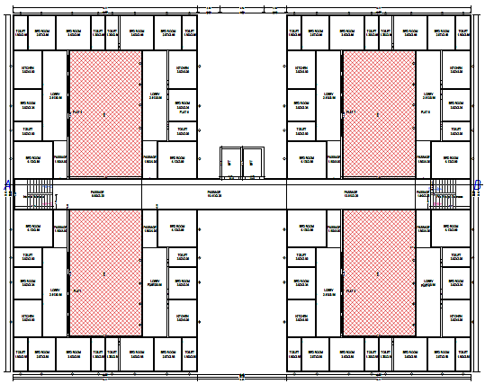
Building : GROUP HOUSING (BLOCK B)
Floor | Gross Built-up Area (Sq.mt.) | Deductions from Gross BUA (Sq.mt.) | OTS (Sq.mt.) | Ramp (Sq.mt.) | Total Built-up Area (Sq.mt.)
Basement Floor | 1949.26 | 0 | 78.61 | 0 | 1870.65
Stilt Floor | 1255.53 | 0 | 0 | 0 | 1255.53
First Floor | 1557.78 | 425.48 | 0 | 0 | 1132.3
Second Floor | 1557.78 | 425.48 | 0 | 0 | 1132.3
Third Floor | 1557.78 | 425.48 | 0 | 0 | 1132.3
Fourth Floor | 1557.78 | 425.48 | 0 | 0 | 1132.3
Fifth Floor | 1557.78 | 425.48 | 0 | 0 | 1132.3
Sixth Floor | 1557.78 | 425.48 | 0 | 0 | 1132.3
Seventh Floor | 1557.78 | 425.48 | 0 | 0 | 1132.3
Eighth Floor | 1557.78 | 425.48 | 0 | 0 | 1132.3
Ninth Floor | 1557.78 | 425.48 | 0 | 0 | 1132.3
Tenth Floor | 1557.78 | 425.48 | 0 | 0 | 1132.3
Eleventh Floor | 1557.78 | 425.48 | 0 | 0 | 1132.3
Twelfth Floor | 1557.78 | 425.48 | 0 | 0 | 1132.3
Thirteenth Floor | 1557.78 | 425.48 | 0 | 0 | 1132.3
Fourteenth Floor | 1557.78 | 425.48 | 0 | 0 | 1132.3
Fifteenth Floor | 1557.78 | 425.48 | 0 | 0 | 1132.3
Sixteenth Floor | 1557.78 | 425.48 | 0 | 0 | 1132.3
Terrace Floor | 49.07 | 0 | 0 | 0 | 49.07
Total | 28178.34 | 6807.68 | 0 | 78.61 | 21292.05
Sources: Approved Map shared by client.
BLOCK C:
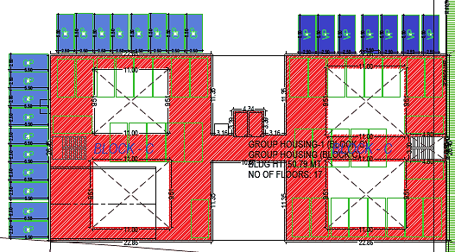
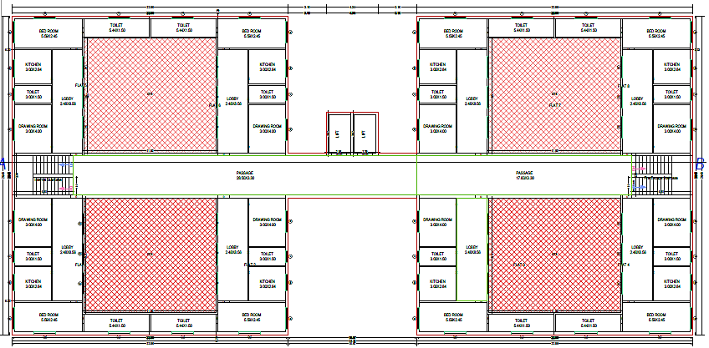
Group Housing (Block C) – Built-Up Area Statement
Floor Name | Gross Built-up Area (Sq.mt.) | Deductions from Gross BUA (Sq.mt.) | Total Built-up Area (Sq.mt.)
Basement Floor | 1568.1 | 76.06 | 1492.04
Stilt Floor | 1118.57 | 76.06 | 1042.51
First Floor | 1264.37 | 418.62 | 845.73
Second Floor | 1264.37 | 418.62 | 845.73
Third Floor | 1264.37 | 418.62 | 845.73
Fourth Floor | 1264.37 | 418.62 | 845.73
Fifth Floor | 1264.37 | 418.62 | 845.73
Sixth Floor | 1264.37 | 418.62 | 845.73
Seventh Floor | 1264.37 | 418.62 | 845.73
Eighth Floor | 1264.37 | 418.62 | 845.73
Ninth Floor | 1264.37 | 418.62 | 845.73
Tenth Floor | 1264.37 | 418.62 | 845.73
Eleventh Floor | 1264.37 | 418.62 | 845.73
Twelfth Floor | 1264.37 | 418.62 | 845.73
Thirteenth Floor | 1264.37 | 418.62 | 845.73
Fourteenth Floor | 1264.37 | 418.62 | 845.73
Fifteenth Floor | 1264.37 | 418.62 | 845.73
Sixteenth Floor | 1264.37 | 418.62 | 845.73
Terrace Floor | 59.65 | 0 | 59.65
Total | 22976.24 | 6850.04 | 16125.88
Sources: Approved Map shared by client.
- SITE PICTURES:
Site pictures were captured during the site survey on 12th April 2025, for reference few of the pictures are attached below:
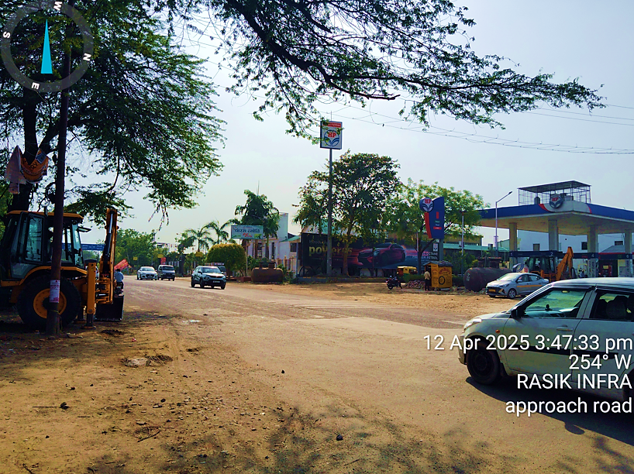
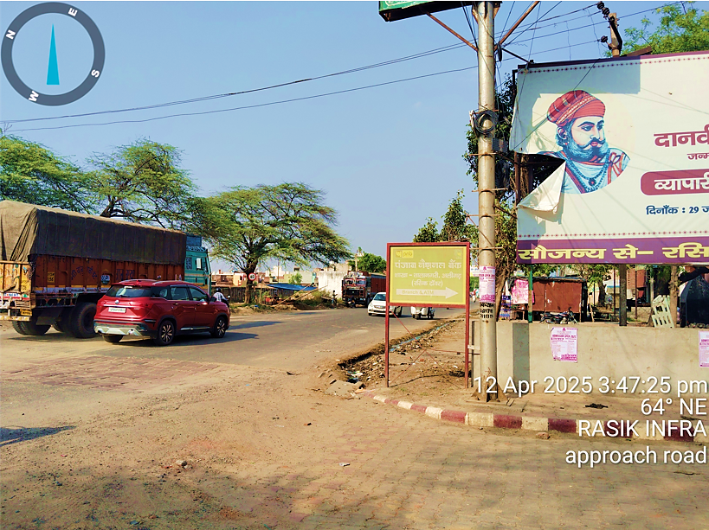
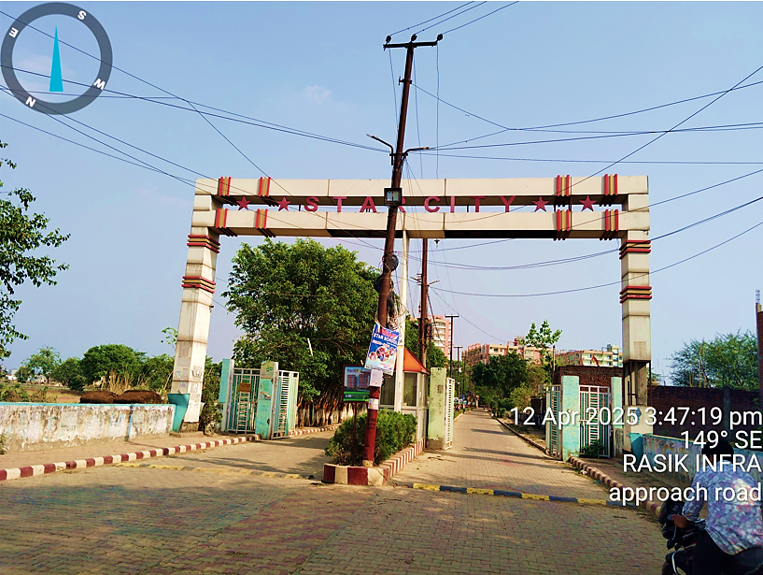
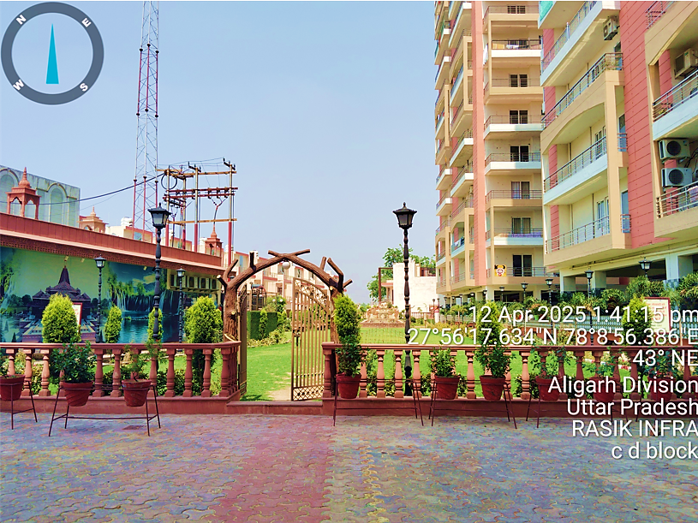
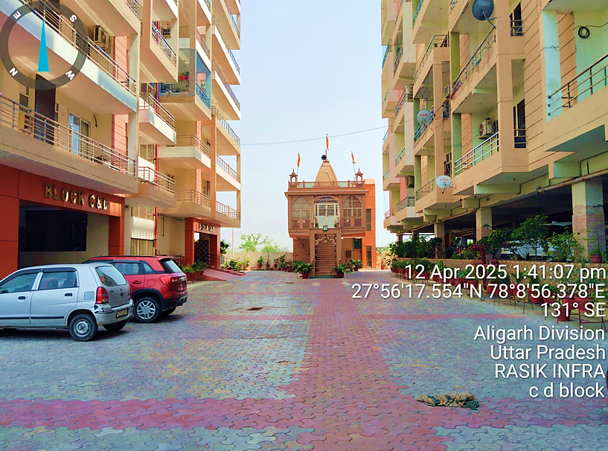
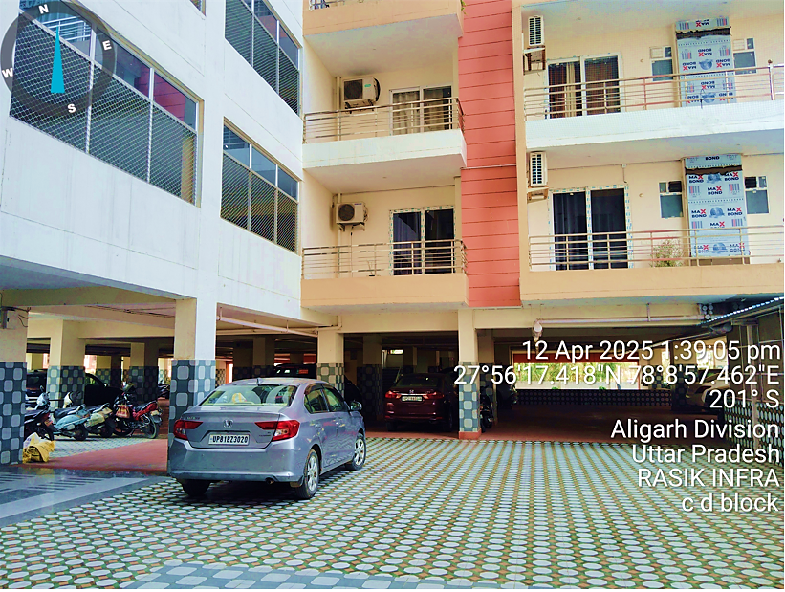
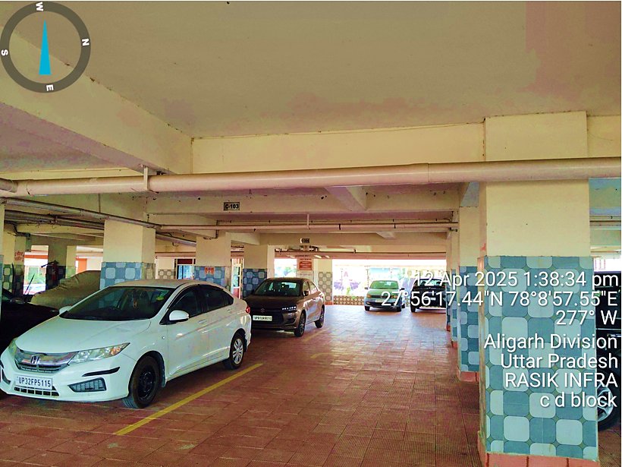
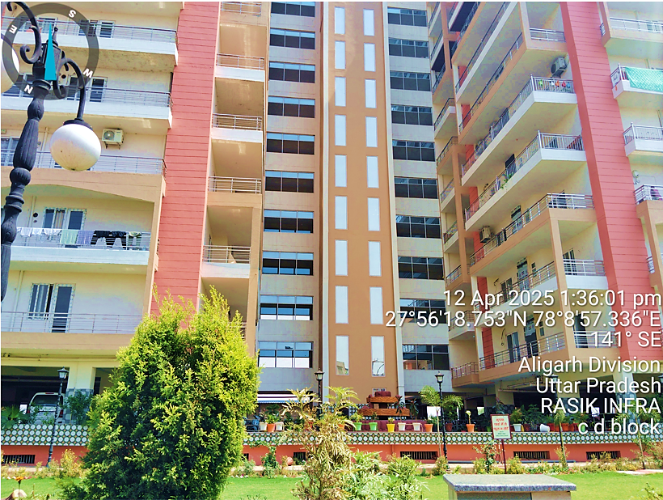
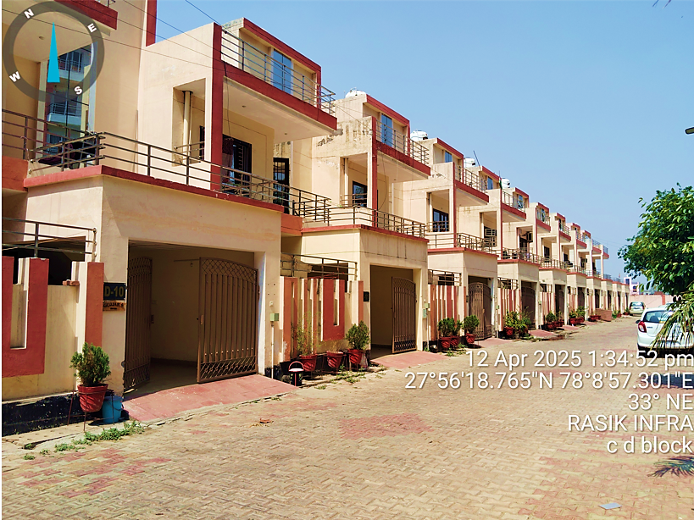
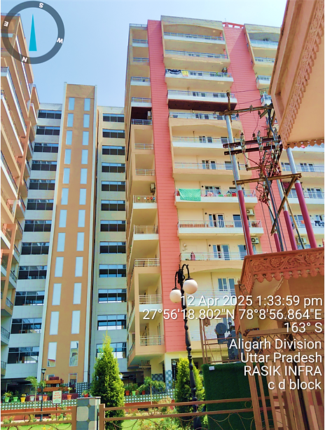
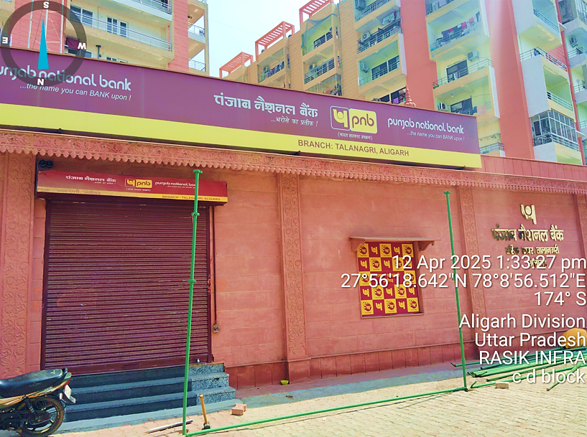
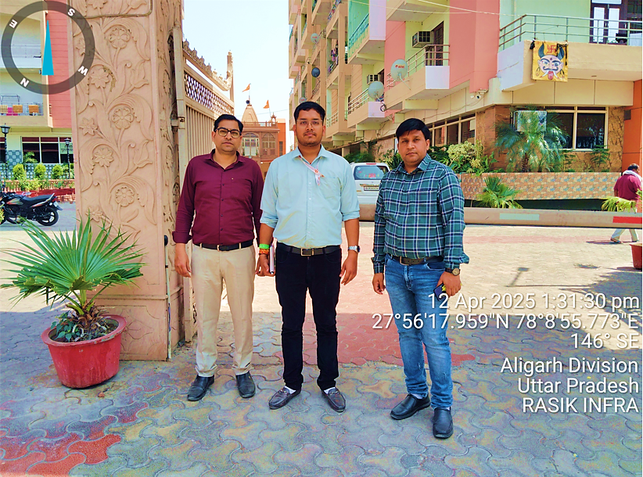
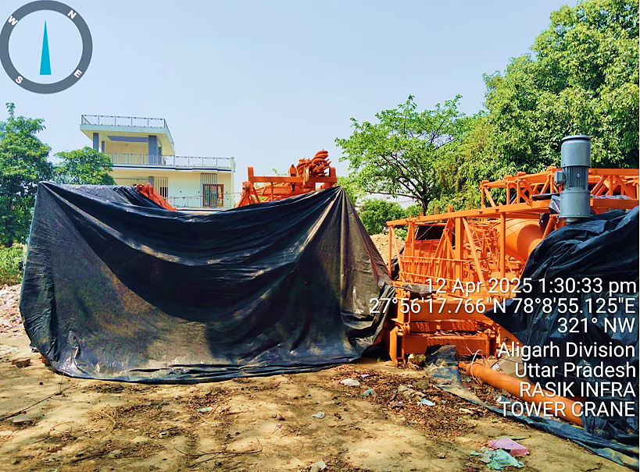
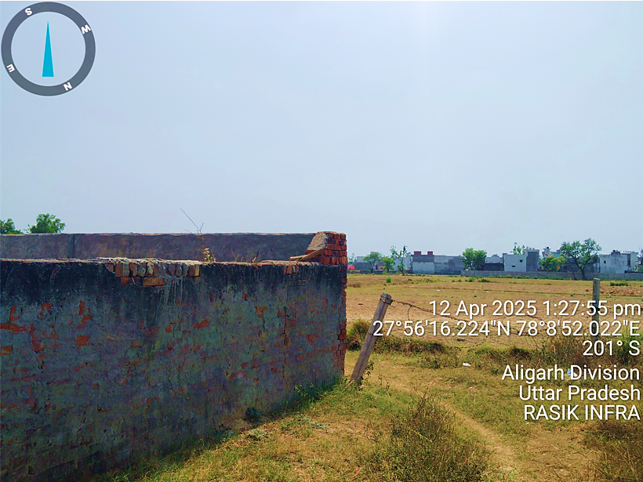
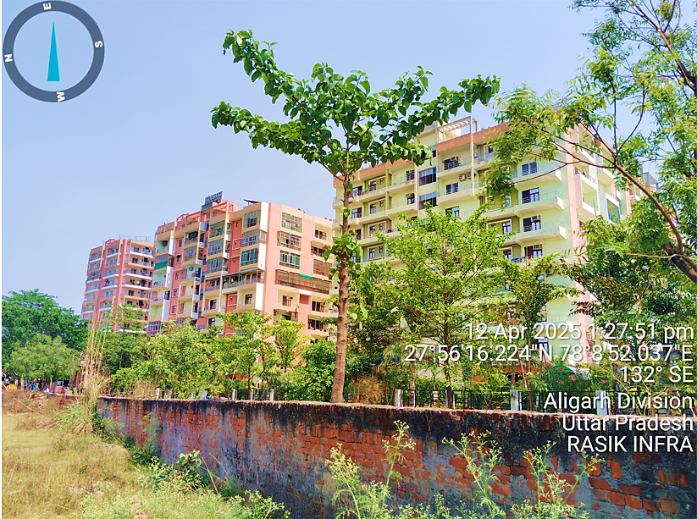
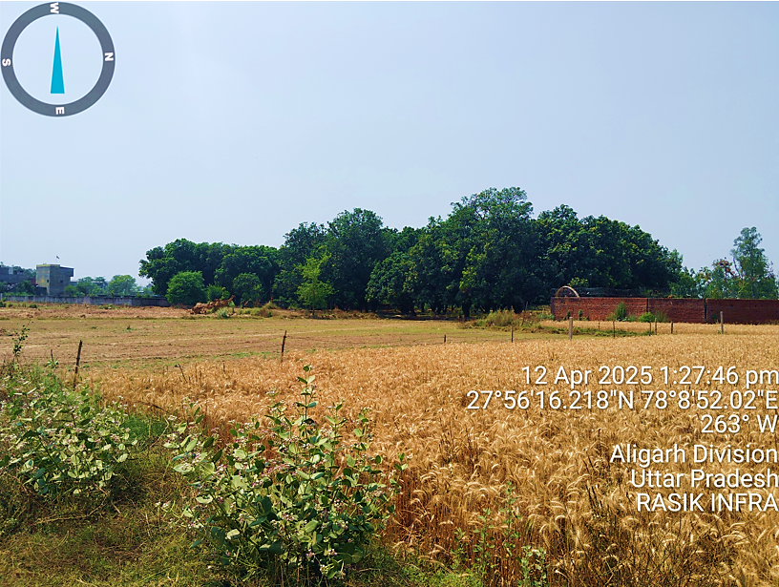
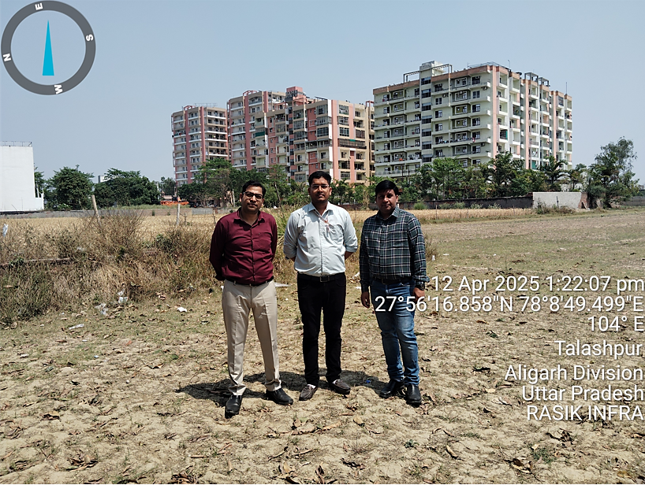
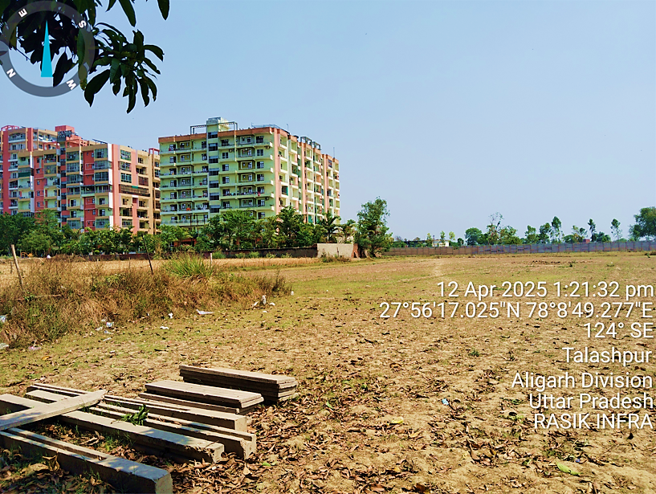
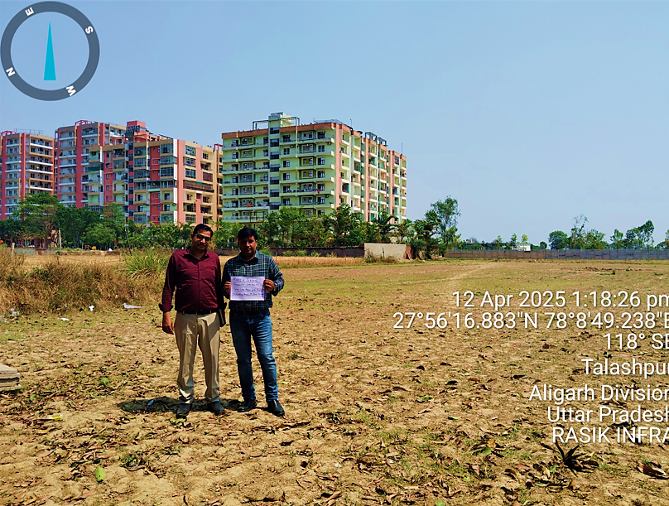
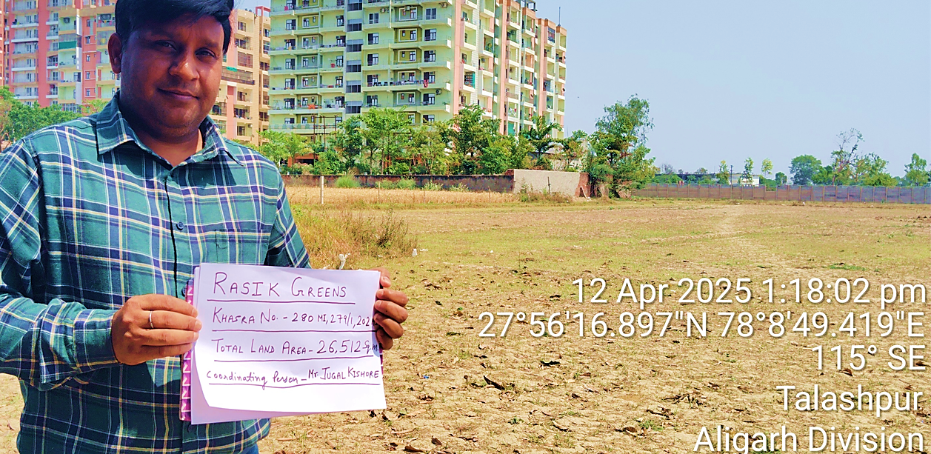
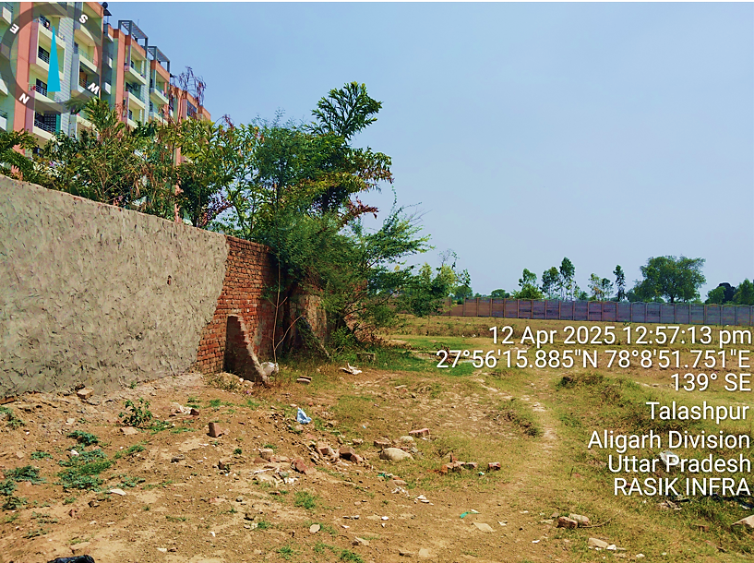
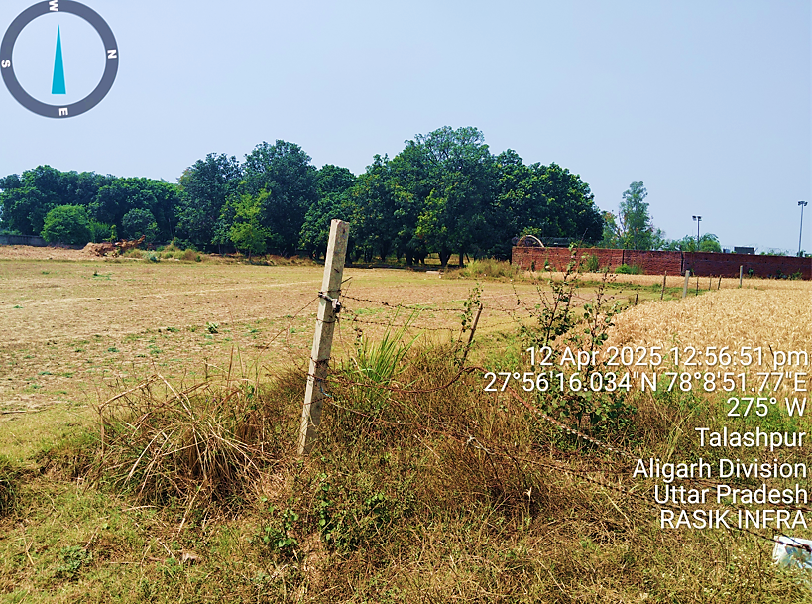
- TECHNICAL TEAM:
As per the information provided by the company, Rasik Infra Constructions has deployed a technically sound and experienced team to oversee the project. This includes B.Tech Civil Engineers with over 15 years of project management experience, supported by a team of 7 Diploma Engineers working as site supervisors. A qualified Chartered Accountant is on the company’s payroll, in addition to reputed CA firms and a Company Secretary engaged to ensure proper financial record-keeping and compliance. Furthermore, a specialized environmental consultancy has been appointed to manage statutory environmental clearances under expert supervision. It is suggested that the lender may directly obtain detailed technical profiles and credentials of the core team from the client for internal evaluation.
- UTILITIES: Details of Water, Electricity and other utilities are describing as below:
- Electricity:
As per the information and technical specifications shared by the client, the projected electrical load requirement for the proposed facility includes a connected load of ~5,230 kW, with a maximum demand of 2,900 kW and an essential load of 2,500 kW. Power is proposed to be sourced from the Uttar Pradesh State Electricity Board (UPSEB) via Transformer No. 03 (1,000 kVA capacity).
In addition, 50% of the street lighting is planned to be solar-powered, aligning with sustainable design goals. To address power continuity during outages, the project proposes backup through 2 diesel generator sets (1 x 120 kVA) positioned 6 metres above rooftop level in accordance with CPCB norms. While this appears to be broadly adequate as per the planning stage, it is important to note that a detailed electrical load assessment and infrastructure verification lies outside the scope of this TEV and should be independently validated prior to execution.
- Water:
As per the data shared by the client, the total domestic water requirement for the proposed project is estimated at approximately 294.91 KLD, comprising 206.44 KLD for net domestic consumption and 88.47 KLD for flushing. The water supply is proposed to be met through two borewells, which are stated to be sufficient for meeting the projected demand.
Additionally, wastewater generation is estimated at 253.62 KLD, with around 202.90 KLD expected to be recycled and reused through an in-house Sewage Treatment Plant (STP) for non-potable uses like flushing, landscaping, and utility purposes. While the planned infrastructure appears aligned with sustainable water management practices, it is to be noted that detailed hydrogeological assessment, yield verification of borewells, and regulatory clearance for groundwater extraction are beyond the scope of this TEV and must be independently verified at the implementation stage.

- SITE VISIT OBSERVATION:
During the site visit dated 12th April 2025, it is found that the proposed project land is partially demarcated, indicating initial steps taken towards site readiness and boundary establishment and site fencing were not yet completed as on the date of inspection.
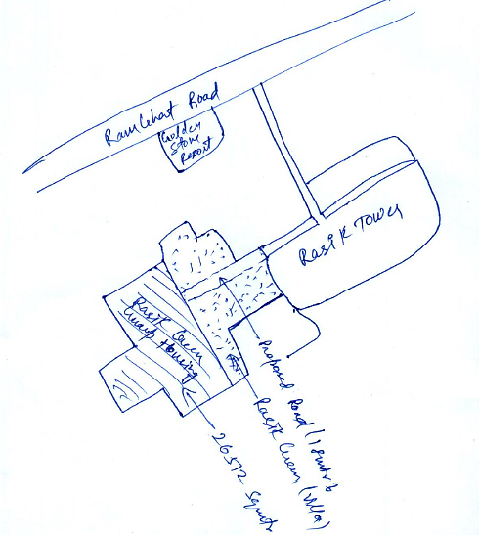
During the site visit dated 12th April 2025, it was noted that the proposed land parcel is located at an approximate distance of 400 meters from Ramghat Road. The site adjoins the firm’s existing development “Rasik Tower,” and currently, both “Rasik Greens” and “Rasik Tower” share a common entrance, ensuring site accessibility. It was also observed that the project land has been partially demarcated as of date. Also, the promoters have informed that necessary measures for providing a dedicated entry will be undertaken during the development phase, ensuring compliance with planning norms and smooth project accessibility. Bank may take separate undertaking from the project proponent to this affect.
- CONCLUSION:
Based on the technical, locational, and cost assessment undertaken by R K Associates including site visit dated 12/04/2025, review of available documentation, interaction with the project team, and general benchmarking the proposed development by Rasik Group appears to be technically feasible and reasonably planned. The estimated cost of construction and finalized capital asset provisioning seems justified considering the specifications and scope shared.
However, the project’s success will remain contingent upon timely procurement of requisite statutory approvals such as RERA approval, Height Clearance from AAI, Ground water NOC etc., clear demarcation and title clarity of land parcels, independent access planning, and adherence to projected timelines and cost controls. Given these factors, the proposed project may be considered technically viable for Phase-I development, subject to the usual risks and dependencies typical of such real estate ventures.
PART E | INVENTORY PROFILE

- INVENTORY OVERVIEW:
The proposed project, "Rasik Greens" by M/s Rasik Infra Constructions, falls under the Commercial Real Estate – Residential Housing (CRE–RH) category and is being developed on freehold land situated adjacent to the existing Rasik Tower (Towers A, B, C & D) at Harduaganj Dehat, Ramghat Road, Aligarh. The project involves construction of a G+16 storied residential complex comprising 256 units, with an equal split of 128 units of 3-BHK and 128 units of 4-BHK apartments, having parking on Ground Floor and 8 units per floor in both blocks.
INVENTORY DETAILS – RASIK GREENS PROJECT
Block Name | No. of Towers | Floors (G+16) | Units per Floor | Total Units | Built-up Area per Unit (approx.)
B - Block | 1 | 16 | 8 | 128 | ~1790 Sq. Ft.
C - Block | 1 | 16 | 8 | 128 | ~1350 Sq. Ft.
Total | 2 | - | - | 256 | -
The project is planned with modern amenities such as CCTV surveillance, EPBX system, firefighting equipment, shopping complex, driver dormitory, gymnasium, swimming pool, temple, community centre, high-speed lifts, submersible pumps, 24x7 water supply, two-wheeler and car parking, and full back up for lighting in parking and common areas — making it a self-sustained and premium residential offering in the micro-market.
The inventory monetization plan is phased across five financial years (FY2025–26 to FY2029–30) and is backed by a defined escalation-linked pricing strategy. The unit pricing is expected to grow year-on-year by 5%–8%, with 3-BHK flats starting at INR 45.00 lakhs and 4-BHK flats at INR 65.00 lakhs in FY2025–26. Cumulative gross revenue from sales is projected at INR 16,084.10 lakhs, with customer advances flowing progressively in sync with the construction schedule. Below is a snapshot of the year-wise unit booking and projected realizations:
Projected Realization
Year | 3-BHK Units Booked | 4-BHK Units Booked | Advance Received (INR Lakhs) | Sales Revenue Recognized (INR Lakhs)
FY2025–26 | 15 | 15 | 550 | 825
FY2026–27 | 20 | 20 | 1705 | 3135
FY2027–28 | 35 | 35 | 5990.05 | 4285.05
FY2028–29 | 35 | 35 | 4585 | 4585
FY2029–30 | 23 | 23 | 3254.04 | 3254.04
Total | 128 | 128 | INR 16,084.10 Lakhs | INR 16,084.10 Lakhs
The entire inventory is expected to be sold out over the five-year cycle, aligning with the construction and handover schedule. The company is following a Percentage of Completion Method (POCM) for revenue recognition, ensuring prudent accounting and clear mapping of unbilled revenue and customer advances in its financial statements. The project is projected to generate a healthy Gross Profit Margin of ~26.75%, indicating strong realizability and pricing power in the target segment.
PROJECT’S HIGHLIGHTS: RASIK GREEN
The proposed project, Rasik Greens, is a ADA-approved and proposed to be RERA-registered residential development on freehold land, offering a well-planned product mix of 256 units comprising 128 units each in 2 Blocks i.e. B - Block and C – Block.. The project includes a premium anchor store at the entry point, ample parking for both two-wheelers and four-wheelers, and 24x7 power backup for common areas and parking. It is equipped with uninterrupted water supply through submersible pumps, comprehensive CCTV surveillance, an EPBX system, and integrated fire safety arrangements. Residents will benefit from premium lifestyle amenities such as a swimming pool, gymnasium, temple, community centre, shopping complex, and a dormitory for drivers. The project also features modern lifts with backup support and an Advanced Integrated Building Management System (IBMS) with controlled access, ensuring safety, convenience, and a high standard of living.
- ADA Approved and RERA Registered residential project on freehold land
- Dedicated anchor store with premium entry frontage to attract high footfall
- Ample covered and open car parking space for residents and visitors
- Advanced Integrated Building Management System (IBMS) with controlled access, CCTV surveillance, and 24x7 security.
- INVENTORY CATEGORY: BLOCK B & C (GROUP HOUSING PROJECT)
As per data/information shared by client, Block B and Block C comprise the saleable residential units forming a significant portion of the revenue-generating assets of the project. The inventory has been categorised based on unit-wise carpet area, BUA, and gross area availability as per proposed plans. All figures considered are as per typical floor layout, and architectural FAR utilization. The categorisation has been provided to highlight sellable floor space and its correlation with unit typology, floor-wise repetition, and construction cost allocation.

Building Use / Sub-Use Details
S. No. | Building Name | Building Use | Sub-Use | Use Group | Building Type | Building Structure | No. of Residential Units
1 | Group Housing (BLOCK B & C) | Residential | Group Housing | High-rise Residential | - | RCC Framed Structure (assumed) | 128 +128

Floor-Wise Usage & FAR Classification
S. No. | Floor Name | Floor Use | Floor Sub-Use | FAR Name | FAR Use | FAR Sub-Use
1 | Basement Floor Plan | Residential + Parking | Group Housing | - | - | -
2 | Stilt Floor Plan | Residential + Parking | Group Housing | - | - | -
3 | Typical Floors (1–16) | Residential | Group Housing | FAR | Residential | Group Housing
4 | Terrace Floor Plan | Residential | Group Housing | - | - | -

- PRICING STRATEGY:
The developer plans to offer 4 BHK units in Block B (~1790 Sq. ft.) at INR 65,00,000 each (approx. INR 3,630/sq. ft.), and 3 BHK units in Block C (~1,356 sq. ft.) at INR 45,00,000 each (approx. INR 3,318/sq. ft.) as shown in the below table:
Proposed selling rates of flats
S. No. | Block Name | Built-up Area in Sq. Mt. | Built-up Area in Sq. ft. | No. of Units | Type of Flats | Area under 1 unit in Sq. Mt. | Area under 1 unit in Sq. Ft. | Rates of Flat  (INR) | Approx. Composite Rates per Sq. Ft. (INR)
1 | B Block | 21,292 | 2,29,185 | 128 | 4 BHK | 166.34 | 1791 | 65,00,000 | 3630
2 | C Block | 16,126 | 1,73,577 | 128 | 3 BHK | 125.98 | 1,356 | 45,00,000 | 3318

Proposed Selling Rates – Rasik Greens vs Market Benchmarks
Block | Unit Type | Size (Sq. ft.) | Proposed Unit Price | Implied Rate/Sq. ft. | Comparable Market Range
B | 4 BHK | 1,791 | INR 65 Lakh | 3630 | INR 2,857–3,650/Sq. ft.
C | 3 BHK | 1,356 | INR 45 Lakh | 3318 | INR 2,991–3,909/Sq. ft.

As a TEV consultant, we have reviewed the proposed selling rates for the Rasik Greens project and benchmarked them against Aligarh’s market trends. 4 BHK resale units listed at INR 3,333–3,650/sq ft in Manjur Garhi & Janakpuri areas. https://www.99acres.com/4-bhk-flats-in-aligarh-ffid
3 BHK flats trading at INR 2,991–3,909/sq ft in ADA Colony, Janakpuri & Gokuleshpuram Colony.
https://housing.com/in/buy/aligarh/3bhk-green_park_colony_gokuleshpuram_colony?

Thus, According to Housing.com, the overall average price in Aligarh is INR 4,577/sq ft, with entry-level properties starting at INR 2,210/sq ft . These pricing assumptions are based on current publicly listed data and may fluctuate depending on final unit specifications, exact carpet vs super-built-up area disclosures, project amenities, RERA certifications, and competitive positioning at launch.
As per data/information available in public domain and market references based on our tertiary research, the 4 BHK at INR 3,630/sq ft is positioned well within the mid-range of current resale and new units (INR 2,857–3,650/sq ft), offering credible premium positioning. The 3 BHK at INR 3,318/sq ft also aligns with average market rates (INR 2,991–3,909/sq ft), balancing affordability and value.
- MARKETING, SELLING & DISTRIBUTION PLAN:
Rasik Infra Constructions is part of the well-established Rasik Group, which holds a strong and diverse presence in Aligarh through entities like Rasik Refreshment Pvt. Ltd., Rasik Education Foundation, Rasik International, Rasik Infracon Pvt. Ltd., and Mahila Kutir Kendra Pvt. Ltd. The group’s credibility in the local market is backed by the successful completion and sale of four residential housing projects in Aligarh city, with only a few residual flats unsold. The promoters bring over 13 years of proven experience in real estate development, construction, and allied services, and enjoy a high reputation within Aligarh’s property and finance circles.
With Aligarh now formally notified as a Smart City, the region is witnessing accelerated infrastructure development, enhanced connectivity, and civic upgrades—improving the micro-market outlook substantially. This urban upliftment is expected to further support the sales and marketing potential of Rasik Group’s new group housing project.
The firm has laid out a phased and structured selling plan over 60 months, targeting 256 units across 3BHK and 4BHK configurations. The marketing approach blends traditional broker channels, on-ground walk-ins, and digital media outreach to ensure diversified lead generation. Average sale velocity is estimated at 4.3 units/month, aligning with comparable absorption rates of mid-premium projects in Aligarh. Detailed sales phasing is as follows:
Projected Selling Plan – Rasik Infra Constructions
Phase | Description | Duration (Months) | Units Planned | % of Inventory | Avg. Monthly Sale Velocity
Phase I | Soft Launch (Brokers & Walk-in Leads) | 0–12 (FY26) | 30 (15+15) | 0.1172 | 2.5 units/month
Phase II | Public Launch (Digital + Offline) | 13–24 (FY27) | 40 (20+20) | 0.1563 | ~3.3 units/month
Phase III | Stabilised Sales Phase | 25–36 (FY28) | 70 (35+35) | 0.2734 | ~5.8 units/month
Phase IV | Final Monetisation Cycle | 37–48 (FY29) | 70 (35+35) | 0.2734 | ~5.8 units/month
Phase V | Residual Inventory Clearance | 49–60 (FY30) | 46 (23+23) | 0.1797 | ~3.8 units/month
Total |  | 60 Months | 256 Units | 1 | Avg.: 4.3 units/month

PART F | REAL ESTATE INDUSTRY OVERVIEW

- INTRODUCTION:
India’s real estate sector is experiencing a robust resurgence, having contributed nearly 7% to GDP in 2024 with residential sales touching INR 3.47 lakh crore a 48% year-on-year increase in FY 2023. The industry is projected to expand to USD 1 trillion by 2030, with estimates soaring up to USD 5.8 trillion by 2047, accounting for roughly 15–15.5% of India’s GDP by mid-century.
Driven by rapid urbanisation, infrastructure rollouts like the National Infrastructure Pipeline, and demand in Tier-2/Tier-3 cities, the sector is aligned with India’s vision of inclusive, technology-driven urban growth. Regulatory reforms such as RERA, PMAY-U, SWAMIH, and enhanced transparency are further strengthening investor confidence and increasing capital flows, especially into residential, office, logistics, and mixed‑use segments
https://www.globenewswire.com/news-release/2024/03/05/2840188/28124/en/India-Real-Estate-Industry-Assessment-2024-Market-Performance-Statistics-Residential-Market-Study-Office-Market-Study-Union-Budget-2022-Outlook-Industry-Speak.html, https://www.hindustantimes.com/business/indian-real-estate-market-size-estimated-to-jump-over-12-fold-to-usd-5-8-trillion-by-2047-report-101692973520848.html, https://www.mordorintelligence.com/industry-reports/residential-real-estate-market-in-india
- MARKET SIZE:
India’s real estate market shows robust growth across sources, with most estimates projecting it to more than double by 2030–2033. Despite variation in size due to methodology, all data confirms strong long-term momentum, validating the sector’s strategic importance and attractiveness for investments in both residential and integrated developments.
India Real Estate Market Size (Residential & Overall)
Year/Period | Market Size (USD Billion) | CAGR | Source & Notes
2024 (Total) | 482 | - | https://www.mordorintelligence.com/industry-reports/real-estate-industry-in-india
2024 (Residential only) | 399 | - | Mordor Intelligence
2024 (Residential only) | 584.1 | - | Grand View Research
2025 (Total) | 385.18 | - | NextMSC via market overview
Forecast 2025–2030 | Residential: 399 → 639.3 | 0.099 | Mordor Intelligence
Forecast 2025–2033 | Total: 482 → 1,184 | 0.105 | IMARC Group
Forecast 2024–2034 | Total: ~300 → 1,300 | - | CREDAI / Press Trust of India
Forecast 2024–2030 | Total: 332.85 → 985.8 | ~24.3% | Mordor Intelligence

- KEY METRICS OF INDUSTRY AND CAGR:
India’s real estate sector typically trades at high valuation multiples compared to other industries: EV/EBITDA has varied between ~17x–22x (22.21x in FY24), reflecting elevated investor expectations and improving profitability across listed developers. The sector’s median P/E ratio stood at ~46.6x in FY24, while P/B multiples reached ~4.8x, indicating strong market premiums over book value.
chrome-extension://efaidnbmnnnibpcajpcglclefindmkaj/https://www.ey.com/content/dam/ey-unified-site/ey-com/en-in/insights/private-equity/documents/ey-private-equity-and-venture-capital-trendbook-2025-v1.pdf,
chrome-extension://efaidnbmnnnibpcajpcglclefindmkaj/https://omnifin.in/publication/Real-Estate-Report-Final.pdf
Operationally, listed real estate firms have delivered robust earnings growth (~25–37% annual) and revenue growth (~25% per annum) over recent years. https://simplywall.st/markets/in/real-estate Forecasted market size expansion, with residential CAGR at ~9.9% (2025–30) and overall sector CAGR at ~10.5% (2024–33), underscores sustained industry momentum. These benchmarks suggest that well-structured, profitable real estate projects such as Rasik Greens would be assessed using similarly strong performance expectations and market multiples.
- REAL ESTATE PROJECTS IN ALIGARH:
Aligarh’s real estate market is currently witnessing a wave of new developments ranging from integrated townships to mid-premium group housing. The following table highlights notable projects that reflect the evolving residential landscape:
REAL ESTATE PROJECTS IN ALIGARH
Project Name | Type | BHK Variant | Price Range | Avg. Rate/Sq. Ft.
Ozone City | Integrated Township | Plot/Flats/  Villa | Not disclosed | Prominent developments; Mint notes moderate pricing and high-quality delivery  https://ozonecity.in/tag/residential-plots-aligarh/  https://www.livemint.com/focus/ozone-city-a-glimpse-into-aligarh-s-evolving-urban-landscape-11752496280651.html?
Kushagra Sky Tower | Group Housing (RERA) | 2–4 BHK | INR 44.41–68.46 Lakh | -
MOSAcles Adobe | Luxury Apartments | 3–4 BHK | Not disclosed | High-end finishes, limited to ~72 units
SMF Aligarh Greens | Group Housing (RERA) | 3–4 BHK | INR 30–38.4 Lakh | -
Prevailing market benchmarks in Aligarh for 3 & 4 BHK flats generally lie between INR 2,500–4,000/Sq. Ft.., with resale transactions reported by MagicBricks in the INR 2,533–3,750/Sq. Ft. Range, 99acres listings at INR 2,750–3,666/Sq. Ft., and Housing.com showing a broader but location-driven band of INR 2,970–7,500/ Sq. Ft. While Housing.com’s citywide trend indicates an average of INR 4,577/Sq. Ft. multiple platforms consistently converge closer to INR 3,500–4,000/Sq. Ft. as the practical operating range.
Further, the area's strategic location near evolving expressways such as NH-334D and enhanced connectivity via the recently commissioned Aligarh Airport are expected to further stimulate demand. Moreover, Aligarh’s inclusion under the Smart City Mission—with completion of 32 out of 37 projects—has initiated significant investment in civic amenities, digital infrastructure, and transit systems. https://www.linkedin.com/posts/aligarh-smart-city-limited_aligarhsmartcity-urbanprogress-smartcitymission-activity-7277202277805735936-A1Xv. These combined factors reinforce a strong medium- to long-term outlook for property appreciation and residential uptake in the region.
- RECENT INVESTMENTS/ DEVELOPMENTS:
RECENT INVESTMENTS / DEVELOPMENTS
Investor / Entity | Deal / Development | Investment Size / Timeline | Key Highlights
Embassy Office Parks REIT | Bond issuance for debt market | INR 2,000 Cr (~$232 mn, Jul ’25) | AAA-rated bonds to institutional investors  https://www.reddit.com/r/Realinsights/comments/1f9fwmv/  https://www.reuters.com/world/india/indias-embassy-reit-tap-debt-market-with-20-billion-rupee-bond-sale-sources-say-2025-07-16/
Property Share (SM REIT) | IPO launch—PropShare Titania | INR 473 Cr (~$57 mn, Jul ’25) | India’s second SM REIT listing
Blackstone | Acquisition of South City Mall (Kolkata and Colombo) | INR 3,250 Cr | Marks Blackstone’s first major east-India retail bet
DLF | Launch of luxury residential project “Westpark,” Mumbai | INR 900 Cr | Entry into Mumbai after a decade; high-end positioning
DDA (Delhi Development Authority) | Premium Housing Scheme (E-auction of flats & garages) | ~250 units across HIG/MIG/LIG categories | Supply-side reform via policy shift
National real estate investments | Annual institutional inflows (Foreign + Domestic) | US$6.5 bn in 2024 | 22% YoY growth; industrial/warehousing-led
Foreign Investments (Q2 2025) | India’s real estate sector inflows | INR 10,226 Cr | Led by US, Japan & Hong Kong; 69% to commercial assets
India’s real estate sector is witnessing robust momentum, with institutional investments hitting an all-time high of $6.5 billion in 2024, driven by commercial and warehousing demand. REIT activity is gaining traction (e.g. Embassy, PropShare), while large players like Blackstone and DLF continue high-value acquisitions. Government-led initiatives such as DDA’s e-auction schemes are enhancing housing supply dynamics. Notably, 100% FDI is permitted under the automatic route for townships, housing, and built-up infrastructure, further accelerating global investor participation. https://www.makeinindia.com/policy/foreign-direct-investment

- GOVERNMENT INITIATIVES:
The Indian government has introduced a series of targeted interventions to boost the real estate sector’s growth and transparency. Initiatives such as the INR 15,000 crore SWAMIH Fund 2.0 aim to fast-track completion of stalled housing projects, while INR 1.5 lakh crore allocation towards urban infrastructure—including smart cities and metros—further bolsters development. With INR 50,000 crore earmarked under PMAY for affordable housing and recent tax relief measures (rebate on income up to INR 12.75 lakh and benefits for two self-occupied homes), demand-side momentum is gaining traction. Additionally, enhanced FDI norms (100% under automatic route for housing and townships) and land use reforms reflect a robust policy push to attract investments. Together, these efforts form a strong policy ecosystem to support real estate growth, especially in Tier‑2 cities like Aligarh.
In the 2024-25 interim Budget, Finance Minister Nirmala Sitharaman announced a boost for India's affordable housing sector by adding 2 crores more houses to the flagship scheme PMAY-U. The Government launched 10 key policies for the real estate sector as Real Estate Regulatory Act (RERA), Benami Transactions Act, Boost to affordable housing construction, Interest subsidy to home buyers, Change in arbitration norms, Service tax exemption, Dividend Distribution Tax (DDT) exemption, Goods and Services Tax (GST) and PR for foreign investors.
- ROAD AHEAD:
The Indian real estate sector remains resilient and growth-bound, with post-Covid recovery marked by strong launches and net inventory absorption across geographies. Lean inventory levels, favourable financing, and rising nuclear families continue to drive demand. With SEBI-approved REITs unlocking a INR 1.25 lakh crore opportunity and developers adopting professionalized operations, the industry is maturing fast. Urban housing shortage (~10 million units) and projected need for 25 million affordable homes by 2030 highlight continued potential. Simultaneously, India’s infrastructure push spanning INR 1.5 lakh crore in smart cities, metros, and roads coupled with Indo-Japan strategic partnerships, positions the sector for robust long-term gains. In markets like Delhi NCR and Tier-2 hubs like Aligarh, rising student and professional influx, job creation, and urbanization form a potent mix for sustained real estate growth and investor returns.
Thus, India’s real estate industry is entering a high-growth phase driven by urbanization, affordable housing demand (~25 million units by 2030), infra push (₹1.5 lakh Cr+), and institutional funding (record $6.5B in 2024). With REITs gaining traction, FDI flowing freely (100% automatic route), and Tier-2 cities emerging as hotspots, the sector shows strong fundamentals, improving transparency, and robust investor appetite all pointing to a structurally sound, long-term growth story.

PART G | SWOT ANALYSIS

SWOT ANALYSIS
STRENGTHS | - Location Advantage: The location lies in proximity to Ramghat Road (33 ft. wide, approximately 300 meters away), which is one of the key arterial roads in Aligarh, ensuring connectivity to major parts of the city. The site is well-connected to both urban centres and the expanding residential corridors. Additionally, Aligarh has been included under the Smart City Mission, and related infrastructure upgrades are in progress, adding to the overall locational advantage of the project. Further, as Aligarh falls within the NCR region and industrial activities are expanding in the vicinity of the proposed site, the location presents a profitable and promising avenue for development.  - Experienced Developers: The promoters of the project bring over 13 years of experience in real estate development, with a strong reputation in the local market for timely execution and quality construction. The borrower has successfully completed multiple residential and commercial projects including Vrindavan Dham-I & II, Rasik Apartment, Rasik Dham, and Rasik Towers (Towers A, B, C & D), all of which were delivered within committed timelines. This track record reflects the group’s execution strength and credibility in the housing segment.  - Strong Network: The Company has built established relationships with key contractors, suppliers, and financial institutions, providing a solid foundation for smooth operations and growth. These strong connections enable better access to resources, timely project execution, and favourable financial terms, giving the business a competitive advantage in the market.  - Investment Potential: Delhi NCR's real estate market offers substantial investment opportunities due to its high returns and potential for appreciation, attracting both domestic and international investors. Ghaziabad is hosting numerous residential societies, financial institutions, educational institutions and industrialists. This economic activity drives demand for both commercial and residential properties.
WEAKNESSES | - Statutory Approvals: The project’s success will remain contingent upon timely procurement of requisite statutory approvals such as RERA approval, Height Clearance from AAI, Ground water NOC etc., clear demarcation and title clarity of land parcels, independent access planning, and adherence to projected timelines and cost controls.  - Timeline Constraints: Project timelines may be vulnerable to delays caused by weather conditions, labour shortages, or logistical challenges which can stall progress and increase carrying costs. Fluctuations in the prices of raw materials, and labour can significantly impact profit margins, especially for companies with limited pricing power.
OPPORTUNITIES | - Market Growth: The real estate market in the area is experiencing growth, presenting an opportunity to capitalize on rising property values and demand.  - Repo Rate: The recent cut in the RBI’s Repo Rate (50 basis points) (0.50%), has improved the borrowing capacity of potential homebuyers, thereby supporting higher demand and sales in the real estate sector.  - Rental Income: As the units are suitable for rental purposes, there may be an opportunity to generate stable rental income in a high-demand rental market.  - Growing Demand for Commercial Space: Increasing population, urbanization trends, or demographic shifts leading to higher demand for commercial properties.  - Smart City: With Aligarh recently being declared a Smart City, the pace of infrastructure development and availability of civic amenities in and around the project location is expected to increase significantly. This urban push is likely to enhance the marketability and long-term value of the proposed project, giving the firm a strategic advantage in attracting potential homebuyers and investors in a fast-developing micro-market.
THREATS | - Increasing Competition: One of the key risks is the presence of competition from other upcoming private real estate developers operating within the city and surrounding regions. However, this risk is mitigated by the fact that the promoters of Rasik Infra Constructions enjoy high market credibility, a proven track record of timely delivery, and are well-recognized for quality construction, which provides them a competitive edge in customer trust and market positioning.  - Economic Downturns: Decline in the economy can influence customers' spending habits, potentially reducing demand for luxury condominiums during an economic recession can impact sales projections and investor returns. It can affect funding availability and project profitability.  - Increased Repo Rate: Any upward revision in the Repo Rate in the near future may reduce the borrowing capacity of potential homebuyers, which may adversely impact demand and lower the expected sales.

PART H | RISK ANALYSIS

Risk | Impact | Description
Time Overrun | Medium | - Although the management is determined to complete the project as per the decided milestones, any delay due to factors not in control of the company/ management can affect the cash flows to that extent.  - Delay in the construction of the project due to the competency of contractors can be mitigated by verifying the organizational capabilities and site organization during the selection process. By supervising and regular follow-up of the level of construction achieved by the project and by day- to-day management of availability and requirements of material land resources.
Cost Overrun | Medium | - It is assumed the total project cost will be to the tune of INR 11,869.44 lakhs including land & ADA fees. Any unwarranted increase due to higher inflation, regulatory requirements, competition etc. may increase the said project costs.  - Risk related to inflation and interest rate fluctuations can be mitigated by adhering to the project timelines.
Operational Risk | Medium | - Risk related to cash flow management of the project will be mitigated by obtaining funding from the Banks/ Financial institutions for the implementation of the project. A suitable Trust and Retention Account (TRA) can also be maintained.  - Significant portion of funds available comes through internal accruals. This risk can be mitigated by early engagement for project awareness amongst the public/prospective buyers which can be seen by the advance booking status of the project.  - The group has developed projects in the region of Aligarh, Uttar Pradesh and do have sufficient experience in the field of real estate development. To mitigate this risk the company has hired local architects, engineers who have experience of this sector in the city as informed by the client. In future, the company can also hire professionals in the future as and when the need arises.
Regulatory Issues | Medium | - Risk of delay in various approvals that are required from various state, local development and municipal agencies can be mitigated by the company by obtaining requisite planning and construction approvals requires extensive liasioning with various Government Authorities. The company is better suited to obtain requisite approvals and clearances to mitigate the delay of approval risk. Therefore, one of the key components of the scope of work of company is to obtain requisite planning and building approvals for the complete land parcel.
Force Majeure | Medium | - The Force Majeure risk has to be borne by all the stakeholders as it is beyond control of them. There would be detailed provisions in the development agreement on the conditions that would be triggering the force majeure clauses by any stakeholder. Suitable insurance cover would be obtained for insurable force majeure events.

PART I | PROJECT COST AND MEANS OF FINANCE

As per data/information provided by the company/client, category wise proposed project cost is shown in the below table:
(INR Lakhs)
Cost Of Project
 | Amount (INR Lakhs)
Freehold Land | 251.67
ADA Fees | 425.29
Building Construction Cost | 9,826.16
Interest on TL ( Up to June 27) | 787.50
Misc. | 491.31
Total Project cost (including Land and ADA fees) | 11,781.94
Total Project cost (excluding Land and ADA fees) | 11,104.97
Means Of Finance
 | Amount (INR Lakhs)
Partners Own Fund (excluding land and ADA fees) | 1,904.97
Partners Own Fund (for Land and ADA fees) | 676.97
Total Partners fund | 2,581.94
Term Loan -( for Building ) | 7,000.00
Unsecured Loan from Friends | 1,200.00
Advance from customer | 1,000.00
Means of Finance (including Land and ADA fees) | 11,781.94
Means of Finance (excluding Land and ADA fees) | 11,104.97
Source: Data/Information provided by the company.
Notes:
- As per data/information shared by the client, the total land parcel acquired for the Rasik Green project measures approximately 26,612 sq. metres. Out of this, 50%, i.e., 1.3306 hectares, is proposed to be utilised in Phase 1 for the construction and development of Tower B and Tower C. The phasing has been informed by site planning considerations and development sequencing proposed by the client. As per registered land deed records and supporting documentation, the total land acquisition cost amounts to INR 5,03,34,310 including sale deed value (Benama), stamp duty, 1% receipt charges, and advocate fees. Accordingly, INR 2,51,67,155 representing 50% of the total cost has been allocated towards Phase 1 of the project for the development of Tower B and C.
- As per the data and information shared by the client, a total amount of INR 8,50,58,827 has been stated as payable/deposited to the Aligarh Development Authority (ADA) under various challans towards statutory approvals and development charges, including INR 14,08,407 (Challan ADA Fees), INR 92,90,316 (Challan ADA), and INR 7,43,60,104 (Challan ADA).
Out of the total, 50% i.e. INR 4,25,29,414 is assumed to be attributable to Phase 1 of the project, which includes the development of Block B & C. However, no documentary evidence such as payment receipts, challan copies, invoices, or supporting bills has been provided to substantiate the said payments. In the absence of documentary validation, the stated fees have been considered as indicative, based solely on the representations made by the client. It is advisable that the client furnish all relevant supporting documents (such as challan copies, receipts, or payment confirmations) to the bank or financial institution to facilitate independent verification and ensure compliance during the final appraisal process.
- As per the information and documents provided, the firm has engaged Aligarh-based Dev Construction Company for preparation of cost estimates for Phase-I Building & Civil Works of Block B and Block C at Mauza Harduaganj, Pargana & Tehsil Koil, Aligarh (Khasra Nos. 280 MI, 279/1, 202 MI). The estimates, covering detailed civil works, floor-wise quantity analysis and abstract of quantities, have been prepared in line with the UPPWD Schedule of Rates, District Aligarh (effective 20.05.2022) and duly verified by Er. Pavitra Kumar Singh, Chartered Engineer (Regn. No. AM3031185/20022023).
Based on the BOQ and cost details provided by the client, the total estimated construction cost for Block B and Block C under the “Rasik Greens” project stands at INR 9,826.16 lakh, prepared as per UPPWD Schedule of Rates (Aligarh, effective 20.05.2022). As TEV consultants, we have cross-checked this against CPWD/DSR 2021 benchmarks and found the estimate at INR 2,439.69 per sq. ft. over ~4,02,762.86 sq. ft. built-up area to be within an acceptable ±5% variance of prevailing norms for similar RCC frame structures in Tier-2 cities. However, no detailed technical audit or item-wise vetting was undertaken, and this assessment is limited to a reasonableness check for TEV purposes only.
- As per the loan repayment schedule, interest during construction (IDC) on the term loan has been projected at INR 787.50 lakh, accruing up to June 2027. This estimate is based on the proposed drawdown timeline and applicable interest rates.
- Miscellaneous capital expenditure has been considered at 5% of the estimated construction cost, in line with industry best practices, professional judgment, and past experience in similar real estate projects. This provision accounts for unforeseen site conditions, minor design changes, inflationary pressures, and cost overruns that may arise during execution.
- Thus, as per the data and inputs provided by the client, the total estimated project cost is INR 11,781.94 lakh, inclusive of land cost (INR 251.67 lakh) and ADA-related statutory fees (INR 425.29 lakh). Excluding land and approval charges, the core project execution cost stands at INR 11,104.97 lakh, comprising INR 9,826.16 lakh for civil construction, INR 787.50 lakh towards interest during construction (IDC) till June 2027, and INR 491.31 lakh under miscellaneous capital provisions.
Based on a cumulative built-up area of approx. 4,02,762.86 sq. ft. for Block B and Block C, the implied average construction cost is approx. INR 2,439.69 per sq. ft., which aligns with CPWD and market-derived benchmarks for RCC frame structures in Tier-2 cities. All cost inputs are indicative, based on client submissions and industry-standard assumptions. No third-party invoices, BoQs, or audit-traceable documentation has been provided for independent verification. Thus, estimates are subject to validation at the appraisal stage by the lending institution.

PART J | PROJECT IMPLEMENTATION SCHEDULE

Below is the tabulated presentation of the proposed implementation schedule for the Group Housing Project, outlining the activity-wise timeline and expected duration as shared by the client:
S. No. | Activity | Start Date | End Date | Current Status
 | Land Procurement | - | 19-06-2023 | Completed
 | Change of Land Use | - | 18.12.2021 | Obtained for ~1.71 Hectare.
 | Land Development & Site Clearance | - | - | Completed
 | Building Layout & Architectural Design | - | 29-03-2025 | Completed
 | Approval From Local Authority (ADA) | - | 29-03-2025 | Completed
 | Financial Closure | 20-08-2025 | 31-08-2025 | Scheduled
 | Excavation & Foundation Work | 01-07-2025 | 31-12-2025 | Scheduled
 | RCC Superstructure (Block B & C) | 01-01-2026 | 30-04-2027 | Scheduled
 | Plumbing, Electrical & Internal Works | 01-01-2027 | 30-05-2027 | Scheduled
 | Brickwork, Plastering & Flooring | 01-02-2027 | 30-06-2027 | Scheduled
 | Painting, Finishing & External Works | 01-03-2027 | 30-07-2027 | Scheduled
 | Occupancy Certificate & Handover | 01-08-2027 | Onwards | Scheduled

Notes:
- Schedule has been made as per feasibility to achieve different milestones.
- Achievement of Milestone will depend on sanction of term loan as per proposed timeline.
- RERA Approval of the project is still pending. Final timeline of the project will depend in the timeline mentioned in RERA.
- Client is expected to achieve the C.O.D from 1st July 2027.

PART K | STATUTORY APPROVALS | LICENCES | NOC
As per the information provided by the client below is the list of Approvals required for the proposed project:
S. No. | Name Of License/ Registration  Issuing Authority | Purpose | Licence No. With Date | Current Status
1. | Certificate of Incorporation | Partnership Firm Formation | - | Obtained
1. | Partnership Deed | Partnership Firm Formation | 1st April 2015 | Obtained
2. | Change of Land Use (CLU) | For Residential Land | Case Number: 23318/2021 | Obtained for 1.71 Hectare.
2. | Uttar Pradesh Pollution Control Board (UPPCB) | For Residential Land | 18.12.2021 | Obtained for 1.71 Hectare.
3. | Approval of Building / Site Plans / Layout Plan | Grant of approval on building plans | AGDA/BP/24-25/0267 | Approved
3. | Aligarh Development Authority (ADA) | Grant of approval on building plans | 29th March 2025 | Approved
4. | RERA Registration | RERA Approval | Letter No.: 1606256/U.P. RERA/Tech. Cell/2025-26 | Applied
4. | Uttar Pradesh Real Estate Regulatory Authority | RERA Approval | 16th June 2025 | Applied
5. | Height Clearance NOC | NOC for Height Clearance | - | Pending
5. | Airports Authority of India | NOC for Height Clearance | - | Pending
6. | NOC for fire-fighting (Prov.) | NOC under firefighting scheme | UPFS/2024/130542/ALG/ALIGARH/2544/DD | Approved
6. | Fire Service, Uttar Pradesh | NOC under firefighting scheme | 7th September 2024 | Approved
7. | Approval for Ground Water Extraction | NOC for Water Extraction | - | Pending
7. | Uttar Pradesh Ground Water Authority (UPGWD) | NOC for Water Extraction | - | Pending
8. | Power load sanction / Electric connection | For Power load sanction | - | Pending
8. | Pashchimanchal Vidyut Vitran Nigam Limited | For Power load sanction |  | Pending
9. | Environmental Clearance | Environmental clearance (EC) certificate for the project | Proposal number  SIA/UP/INFRA2/502293/2024 dated 22/10/2024 | Approved
9. | Ministry of Environment, Forest and Climate Change  (State Environment Impact Assessment Authority (SEIA) | Environmental clearance (EC) certificate for the project | 4th April 2025 | Approved
10. | GST Registration | GST | Registration Number : 09AAUFR2345D1ZZ | Obtained
10. | Goods & Service Tax, CBIC, Government of India | GST | 1st July 2017 | Obtained
11. | Completion Certificate (CC) & Occupancy Certificate (OC) | CC for Building complete as per approved plan.  OC for Building liveable, safe, and ready to occupy. | - | Post Completion
11. | Aligarh Development Authority (ADA) |  | - | Post Completion

Observations & Comments:
- As per information furnished by client, vide order dated 18/12/2021 from Sub-Divisional Magistrate, District: Aligarh, Case Number: 23318/2021, Computerized Case Number: -T202118020223318 ~1.71 Hectare land is converted to non-agricultural. Same is reflected in the kahtauni for the said plots as downloaded from https://upbhulekh.gov.in/. Regarding remaining CLU, the promoters have provided a legal certificate issued by Advocate Pankaj Gupta (Aligarh), confirming that the subject land (Khasra Nos. 202 Minjumla, 280 Minjumla and 279/1, Tehsil Koil, Harduaganj, Aligarh) has already been converted for residential plotted development under Section 80 of the U.P. Revenue Code vide court orders dated 06.01.2023 and 18.12.2021.
Copy of Revenue Code vide court orders dated 06.01.2023 was not made available to us. Learned advocated has also referred two pronouncement of honble Supreme Court of India (AIR 1998 SC Page No. 473 and AIR 1996 SC Page No.1522) stating as such no further change of land use for the rest area is required. Further, ADA Aligarh has approved the layout map for residential plotted development (File No. AGDA/L.B./24-25/0445, Approval Ref No. 02831/AGDA/24-25/23122024), covering an area of 41,175.51 Sq. Mt. Bank is advised to take legal opinion from their empanelled advocate and the validity of honble Supreme Court pronouncements in this respect.
- As per Civil Aviation Requirements (CAR), Section 4, Series ‘B’, Part I issued by DGCA, any high-rise development falling within a 20 km radius of an aerodrome reference point requires prior Height Clearance NOC from the Airports Authority of India (AAI). The developer shall ensure due compliance wherever applicable.
- As per ADA approved map provided to us by the client, the approved layout of Block C reflects units in a 2 BHK configuration. However, the developer, in response to evolving customer preferences and market trends, has proposed an internal reconfiguration of units into a 3 BHK format.
It is important to emphasize that this reconfiguration is limited strictly to internal partitioning and space utilization within the sanctioned built-up area, permissible FSI, and approved building envelope. There is no change in total built-up area, external footprint, structural framework, height, or any other parameter impacting compliance. From a project viability perspective, this variation does not have any material impact on cost estimates, project timelines, or saleable area considered under this TEV study. The change is purely market-driven and remains within the overall sanctioned development parameters.
- Completion Certificate (CC) & Occupancy Certificate (OC) will be applied post completion of construction.
- Above is the only illustration of the major approvals sought or to be sought by the firm. It should not be construed as the exhaustive list and in case any approval is missed to be mentioned then it is the sole responsibility of the firm to keep the construction compliant with the necessary statutory approvals/ NOCs.

PART L | PROJECT’S FINANCIAL FEASIBILITY

- PROJECTIONS OF THE FIRM:
The projections of the proposed project are done from FY 2025-26 to FY 2029-30 based on the revenue generation capacity by selling the 3 & 4 BHK Flats and total expected expenses are shown as below:
- PROJECTED PROFIT & LOSS ACCOUNT:
(INR Lakhs)
Year Ended | 2023-24 |  | 2024-25 |  | 2025-26 | 2026-27 | 2027-28 | 2028-29 | 2029-30
Year Ended | Audited | Prov. |  | Projected
Sale Value | 2,507.58 |  | 1,521.10 |  | 1,649.17 | 4,086.46 | 4,285.05 | 4,585.00 | 3,254.04
Other Incomes (Agriculture And Rental) | 18.74 |  | 48.59 |  | 53.45 | 58.79 | 64.67 | 71.14 | 78.25
Total | 2,526.31 |  | 1,569.68 |  | 1,702.61 | 4,145.26 | 4,349.72 | 4,656.14 | 3,332.29
Cost Of Construction
Cost Of Construction Incurred During The Year | 1,738.34 |  | 1,538.62 |  | 5,948.20 | 5,658.74 | 175.00 | - | -
Add : Op. Stock Of Work In Progress | 2,349.13 |  | 2,028.54 |  | 2,413.55 | 7,089.68 | 9,667.03 | 6,572.56 | 3,350.93
Less: Clo. Stock Of Work In Progress | 2,028.54 |  | 2,413.55 |  | 7,089.68 | 9,667.03 | 6,572.56 | 3,350.93 | 1,233.87
Cost Of Construction | 2,058.93 |  | 1,153.60 |  | 1,272.08 | 3,081.38 | 3,269.47 | 3,221.62 | 2,117.07
Gross Profit | 467.38 |  | 416.08 |  | 430.54 | 1,063.87 | 1,080.25 | 1,434.52 | 1,215.23
GP Ratio | 18.64% |  | 27.35% |  | 26.11% | 26.03% | 25.21% | 31.29% | 37.35%
Expenditure
Admin & Selling Expenses | 200.26 |  | 138.79 |  | 95.65 | 109.48 | 64.28 | 68.78 | 48.81
Finance Costs
Bank Interest | 6.38 |  | 69.47 |  | 25.76 | 18.35 | 465.08 | 382.64 | 119.49
Interest On Unsecured Loan | 64.41 |  | - |  | 110.72 | 82.81 | 75.31 | 66.31 | 57.31
Interest On Partners' Capital | 51.33 |  | 44.07 |  | 48.68 | 54.00 | 51.64 | 51.64 | 51.64
Total Finance Costs | 122.11 |  | 113.54 |  | 185.16 | 155.16 | 592.03 | 500.59 | 228.44
Depreciation | 10.79 |  | 17.95 |  | 40.91 | 34.53 | 29.21 | 24.74 | 20.98
Other Expenses | 27.19 |  | 27.62 |  | 38.63 | 64.77 | 42.85 | 45.85 | 32.54
Total Expenses | 360.34 |  | 297.90 |  | 360.35 | 363.94 | 728.36 | 639.96 | 330.77
Net Profit (Before Partners' Remuneration) | 107.04 |  | 118.18 |  | 70.18 | 699.94 | 351.88 | 794.56 | 884.46
Partners' Remuneration % |  |  |  |  | 7.00% | 7.00% | 7.00% | 7.00% | 7.00%
Partners' Remuneration | 14.00 |  | 24.00 |  | 4.91 | 49.00 | 24.63 | 55.62 | 61.91
Net Profit (After Partners' Remuneration) | 93.04 |  | 94.18 |  | 65.27 | 650.94 | 327.25 | 738.94 | 822.55
Provision For Tax (After Appropriation Of Profit) | 28.30 |  | 26.69 |  | 21.79 | 227.46 | 114.36 | 258.22 | 287.43
Profit After Tax (Transfer To Capital Account) | 64.74 |  | 67.49 |  | 43.48 | 423.48 | 212.90 | 480.73 | 535.12

- PROJECTED BALANCE SHEET:
(INR Lakhs)
Financial Year | 2023-24 |  | 2024-25 |  | 2025-26 | 2026-27 | 2027-28 | 2028-29 | 2029-30
Financial Year | Audited | Prov. |  | Projected
Source Of Fund
Capital Account | 1,496.19 |  | 1,357.43 |  | 2,434.14 | 2,699.91 | 2,581.94 | 2,581.94 | 2,581.94
Reserve & Surplus | - |  | - |  | 43.48 | 466.96 | 679.85 | 1,160.58 | 1,695.69
Secured Loan | 1,328.88 |  | 387.87 |  | 3,144.05 | 5,143.49 | 2,495.14 | 1.46 | (0.00)
Advance From Customer | 38.55 |  | 10.54 |  | - | - | - | - | -
Unsecured Loans | 1,082.83 |  | 2,260.34 |  | 2,860.34 | 3,060.34 | 2,360.34 | 2,060.34 | 1,760.34
Sundry Creditors | 198.39 |  | 88.57 |  | - | - | - | - | -
Other Current Liabilities | 1,013.54 |  | 982.36 |  | 782.18 | 2,491.74 | 2,648.35 | 2,493.69 | 1.46
Total | 5,158.38 |  | 5,087.11 |  | 9,264.19 | 13,862.4 | 10,765.6 | 8,298.00 | 6,039.43
Application Of Fund
Unbilled / Undue Revenue | 473.88 |  | 520.08 |  | 275.00 | 1,705.00 | - | - | -
Fixed Assets And Investments | 1,211.41 |  | 692.12 |  | 689.71 | 1,655.18 | 2,625.97 | 3,601.22 | 4,580.24
Closing Stock | 2,028.54 |  | 2,413.55 |  | 7,089.68 | 9,667.03 | 6,572.56 | 3,350.93 | 1,233.87
Sundry Debtors | 38.19 |  | 47.59 |  | - | - | - | - | -
Other Current Assets | 1,265.99 |  | 1,379.38 |  | 919.59 | 459.79 | - | - | -
Cash And Bank Balance | 140.37 |  | 34.38 |  | 290.22 | 375.44 | 1,567.11 | 1,345.85 | 225.33
Total | 5,158.38 |  | 5,087.11 |  | 9,264.19 | 13,862.4 | 10,765.6 | 8,298.00 | 6,039.43

- PROJECTED FUND FLOW STATEMENT:
(INR Lakhs)
Year Ended | 2025-26 | 2026-27 | 2027-28 | 2028-29 | 2029-30
Year Ended | Provisional | Projected
Sources Of Funds
Profit After Tax | 43.48 | 423.48 | 212.90 | 480.73 | 535.12
Depreciation | 40.91 | 34.53 | 29.21 | 24.74 | 20.98
Increase In Bank Loans | 3,000.00 | 4,000.00 | - | - | -
Increase In Capital | 1,848.20 | 558.73 | 175.00 | - | -
Increase In Unsecured Loan | 600.00 | 600.00 | - | - | -
Decrease In Closing Stock | 575.02 | 604.66 | 3,094.47 | 3,221.62 | 2,117.07
Decrease In Sundry Debtors | 47.59 | - | - | - | -
Decrease In Other Current Assets | 459.79 | 459.79 | 459.79 | - | -
Decrease In Unbilled Revenue | 520.08 | - | 1,705.00 | - | -
Total | 7,135.08 | 6,681.20 | 5,676.38 | 3,727.09 | 2,673.16
Application Of Funds
Decrease In Bank Loans | 243.82 | 50.56 | 1,998.35 | 2,493.69 | 1.46
Decrease In Capital | 771.49 | 292.97 | 292.97 | - | -
Decrease In Unsecured Loan | - | 400.00 | 700.00 | 300.00 | 300.00
Increase In Closing Stock | 5,251.15 | 3,182.02 | - | - | -
Decrease In Sundry Creditors | 88.57 | - | - | - | -
Decrease In Other Current Liabilities | 200.18 | 240.44 | 493.39 | 154.66 | 2,492.23
Increase In Unbilled Revenue | 275.00 | 1,430.00 | - | - | -
Decrease In Advance From Customers | 10.54 | - | - | - | -
Increase In Fixed Assets And Investments | 38.50 | 1,000.00 | 1,000.00 | 1,000.00 | 1,000.00
Total | 6,879.25 | 6,595.99 | 4,484.71 | 3,948.35 | 3,793.69
Opening Balance | 34.38 | 290.22 | 375.44 | 1,567.11 | 1,345.85
Net Surplus/Deficit | 255.84 | 85.22 | 1,191.67 | (221.26) | (1,120.52)
Closing Balance | 290.22 | 375.44 | 1,567.11 | 1,345.85 | 225.33

- ESTIMATED KEY FINANCIAL METRICS: For revenue earning & recognition period:
Year Ended | 2023-24 |  | 2024-25 |  | 2025-26 | 2026-27 | 2027-28 | 2028-29 | 2029-30
Year Ended | Audited | Prov. |  | Projected
EBIT MARGIN % | 54.85% |  | 62.33% |  | 68.28% | 86.46% | 91.35% | 93.48% | 94.26%
PAT MARGIN % | 2.56% |  | 4.30% |  | 2.55% | 10.22% | 4.89% | 10.32% | 16.06%
TIMES INTEREST EARNED | 2.10 |  | 2.28 |  | 1.59 | 5.93 | 1.67 | 2.68 | 5.01

The projections reflect a strong trajectory in operating profitability, with EBIT margins rising from 68.28% in FY 2025–26 to 94.26% by FY 2029–30. PAT margins are also expected to improve gradually, reaching 16.06% by FY 2029–30. Debt servicing capacity strengthens over time, with the Times Interest Earned ratio improving from 1.59x to 5.01x across the projected period.
Note: As required by bank, these projections are inclusive of existing financials shared by client and are based on current assumptions. It is advised that the client submit audited and validated past financials to the bank for formal assessment and alignment of the projections with actual performance. All estimates are subject to changes in execution timelines and external economic factors.

- GRAPHICAL REPRESENTATION:
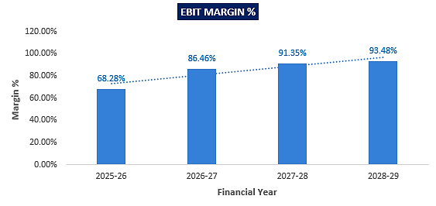
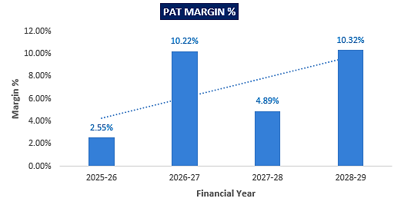
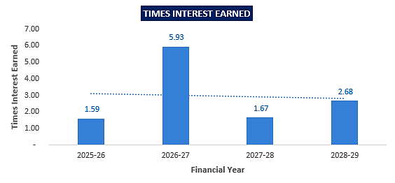
- DEBT SERVICE COVERAGE RATIO (D.S.C.R):
(INR Lakhs except D.S.C.R)
Particulars | 2025-26 | 2026-27 | 2027-28 | 2028-29 | 2029-30
Operating revenue | 1,649.17 | 4,086.46 | 4,285.05 | 4,585.00 | 3,254.04
Operating expenses | 6,087.39 | 5,881.98 | 306.76 | 170.24 | 143.26
Net operating revenue | (4,438.22) | (1,795.51) | 3,978.29 | 4,414.76 | 3,110.78
Debt obligations
Instalment of bank  loans | 198.41 | 45.41 | 2,000.56 | 2,648.35 | 2,493.69
Int. on bank loans | 138.26 | 518.35 | 640.08 | 382.64 | 119.49
Total Outflow | 336.68 | 563.76 | 2,640.63 | 3,030.99 | 2,613.18
DSCR |  |  | 1.51 | 1.46 | 1.19
Average D.S.C.R. | 1.38

- NET PRESENT VALUE (NPV) & INTERNAL RATE OF RETURN (IRR):
Particulars | 2025-26 | 2026-27 | 2027-28 | 2028-29 | 2029-30
Unlevered Income | (4,438.22) | (1,795.51) | 3,978.29 | 4,414.76 | 3,110.78
Discount Rate | 9.86%
Discount Period | 1.00 | 2.00 | 3.00 | 4.00 | 5.00
Discount Factor | 0.91 | 0.83 | 0.75 | 0.69 | 0.63
PV of Cash Flow | (4,040.05) | (1,487.79) | 3,000.74 | 3,031.21 | 1,944.27
NPV | INR 2,448.38 Lakhs
IRR | 26.71%

Calculation of Discount Rate
Component | Amount | Weight | Cost | Weighted Cost
Equity/Quasi Equity  Advance | 4,781.94 | 40.59% | 11.68% | 4.74%
Debt | 7,000.00 | 59.41% | 10.00% | 3.87%
Total | 11,781.94 |  |  | 8.61%
Company Risk Premium |  |  |  | 1.25%
Appropriate Discount Rate |  | 9.86%

Note: The discount rate has been computed using the Weighted Average Cost of Capital (WACC) approach. The cost of equity is taken as 11.68%, based on the 10-year CAGR of the Nifty 50 Index in July 2025, as published by NSE Indices Limited. https://www.niftyindices.com/market-data/return-profile. This reflects long-term market return expectations. The cost of debt has been considered at 10.00%, in line with the applicable interest rate on the sanctioned term loan. After applying capital structure weights and a company-specific risk premium of 1.25%, the appropriate discount rate for the project is arrived at 9.86%.
- SENSITIVITY ANALYSIS:
The proposed project is found comparatively more sensitive with respect to the revenue, than the cost of construction. Sensitivity analysis of the project with respect to 5% decrease in the revenue and 5% increase in the cost of construction has been shown in the below table:
CASE-1 (DSCR AND IRR IF, 5% DECREASE IN SALES):
DSCR | 2025-26 | 2026-27 | 2027-28 | 2028-29 | 2029-30
Net Operating Income | (4,520.68) | (1,999.83) | 3,764.04 | 4,185.51 | 2,948.08
Debt obligations
Instalment of bank loans | 198.41 | 45.41 | 2,000.56 | 2,648.35 | 2,493.69
Int. on bank loans | 138.26 | 518.35 | 640.08 | 382.64 | 119.49
Total Outflow | 336.68 | 563.76 | 2,640.63 | 3,030.99 | 2,613.18
DSCR |  |  | 1.43 | 1.38 | 1.13
Average D.S.C.R. | 1.31
IRR | 22.04%
CASE-2 (DSCR AND IRR IF, 5% INCREASE IN CONSTRUCTION COST):
DSCR | 2025-26 | 2026-27 | 2027-28 | 2028-29 | 2029-30
Net Operating Income | (4,742.59) | (2,089.61) | 3,962.95 | 4,406.25 | 3,103.62
Debt obligations
Instalment of bank loans | 198.41 | 45.41 | 2,000.56 | 2,648.35 | 2,493.69
Int. on bank loans | 138.26 | 518.35 | 640.08 | 382.64 | 119.49
Total Outflow | 336.68 | 563.76 | 2,640.63 | 3,030.99 | 2,613.18
DSCR |  |  | 1.50 | 1.45 | 1.19
Average D.S.C.R. | 1.38
IRR | 22.26%

- CONSTRUCTION PROJECTIONS:
Particulars | Value |  | 2025-26 | 2026-27 | 2027-28 | 2028-29 | 2029-30
 | In Lakhs |  | Construction Period |  | Operating Period
Estimated Cost of Construction Incurred In Financial Year
Value of Land to be utilised in Phase 1 |  | 251.67 | 251.67 | 0.00 | 0.00 | 0.00 | 0.00
ADA Fees |  | 425.29 | 425.29 | 0.00 | 0.00 | 0.00 | 0.00
Interest During Construction |  | 787.50 | 112.50 | 500.00 | 175.00 | 0.00 | 0.00
Percentage of Cost of Construction |  | 100.00% | 50.00% | 50.00% | 0.00% | 0.00% | 0.00%
Construction cost |  | 9,826.16 | 4,913.08 | 4,913.08 | 0.00 | 0.00 | 0.00
Misc. Cost |  | 491.31 | 245.66 | 245.66 | - | - | -
Cost |  | 11,781.94 | 5,948.20 | 5,658.74 | 175.00 | - | -
% Cost |  |  | 50.49% | 48.03% | 1.49% | 0.00% | 0.00%
Disbursement |  |  | 3,000.00 | 4,000.00 | - | - | -
Cumulative cost |  |  | 5,948.20 | 11,606.94 | 11,781.94 | 11,781.94 | 11,781.94
Cumulative disbursement |  |  | 3,000.00 | 7,000.00 | -
Bank Finance to Cost Ratio |  |  | 50% | 60%
The total estimated project cost for Rasik Green stands at INR 11,781.94 lakhs, to be incurred primarily over FY2025–26 and FY2026–27, with a minor balance of IDC in FY2027–28. The cost structure includes land acquisition, ADA fees, construction costs, contingency, and interest during construction. Construction activity is scheduled over two years with a 50:50 phasing of the core construction cost. Bank term loan disbursement of INR 7,000 lakhs is proposed, translating to a bank finance-to-cost ratio of approximately 50% and 60% in FY 2025-26 and FY 2026-27 respectively, which is within acceptable norms for real estate projects of this nature
- REVENUE RECOGNITION:
(INR lakhs)
Year Ending | Mar-2026 | Mar-2027 | Mar-2028 | Mar-2029 | Mar-2030
No Of Flat Booking 3 BHK | 15 | 20 | 35 | 35 | 23
No Of Flat Booking 4 BHK | 15 | 20 | 35 | 35 | 23
Rate per Flat 4 BHK in Lacs | 65.00 | 68.25 | 72.35 | 77.41 | 83.60
Escalation % |  | 5% | 6.00% | 7.00% | 8.00%
Rate per Flat 3 BHK in Lacs | 45.00 | 47.25 | 50.09 | 53.59 | 57.88
Escalation % |  | 5% | 6.00% | 7.00% | 8.00%
Payment schedule for Year 1 booking - 3BHK | 15.00 | 15.00 | 15.00
Payment schedule for Year 2 booking - 3BHK |  | 23.63 | 23.63 | -
Payment schedule for Year 3 booking - 3BHK |  |  | 50.09 | - | -
Payment schedule for Year 4 booking - 3BHK |  |  |  | 53.59 | -
Payment schedule for Year 5 booking - 3BHK |  |  |  |  | 57.88
Payment schedule for Year 1 booking - 4BHK | 21.67 | 21.67 | 21.67
Payment schedule for Year 2 booking - 4BHK |  | 34.13 | 34.13 | -
Payment schedule for Year 3 booking - 4BHK |  |  | 72.35 | - | -
Payment schedule for Year 4 booking - 4BHK |  |  |  | 77.41 | -
Payment schedule for Year 5 booking - 4BHK |  |  |  |  | 83.60
Total amount received unit booked in year 1 | 550.00 | 550.00 | 550.00 | 0.00 | 0.00
Total amount received unit booked in year 2 |  | 1155.00 | 1155.00 | 0.00 | 0.00
Total amount received unit booked in year 3 |  |  | 4285.05 | 0.00 | 0.00
Total amount received unit booked in year 4 |  |  |  | 4585.00 | 0.00
Total amount received unit booked in year 5 |  |  |  |  | 3254.04
Progressive Advance received from Customers | 550.00 | 1,705.00 | 5,990.05 | 4,585.00 | 3,254.04
Percentage of Cost of Construction | 50.00% | 50.00% | 0.00% | 0.00% | 0.00%
Cumulative Sales Value of flats | 825.00 | 3,960.00 | 8,245.05 | 12,830.05 | 16,084.10
Sales value recognised in previous year | - | (825.00) | (3,960.00) | (8,245.05) | (12,830.05)
Sales recognised in profit and loss account | 825.00 | 3,135.00 | 4,285.05 | 4,585.00 | 3,254.04
Cumulative Advance | 550.00 | 2,255.00 | 8,245.05 | 12,830.05 | 16,084.10
Unbilled / (advance from customer) revenue recognised in balance sheet | 275.00 | 1,705.00 | - | - | -
The project’s total projected revenue stands at INR 16,084.10 lakhs over FY2025–26 to FY2029–30, based on phased booking of 128 units each of 3BHK and 4BHK flats with systematic escalation in selling rates. Sales recognition is aligned to construction progress using the percentage of completion method. Customer advances are projected to progressively rise from INR 550 lakhs in FY2025–26 to full recovery by FY2029–30, indicating strong cash flow visibility. Gross Profit (GP) margin for the project is estimated at ~26.75%, reflecting a healthy spread over the total project cost of INR 11,781.94 lakhs. This margin, along with adequate advance-to-cost coverage, demonstrates the project’s financial viability and commercial attractiveness.
- LOAN AMORTIZATION SCHEDULE:
- DETAILS OF TERM LOAN

PARTICULARS | DETAILS
Total loan amount | INR 7,000 lakhs
Rate of Interest Used for Calculation | 10%
1st Disbursement | July-September, 2025
IDC Start & End Month | July-September, 2025 to April-June 2027
IDC Period (construction period) | 24 Months
Moratorium Period | April-June 2027
COD | 1st July 2027
Repayment Start | 1st July 2027
Repayment End | 31st March 2030
Repayment Period | 33 Months
Total Period | 57 Months
- REPAYMENT SCHEDULE:
(INR lakhs)
Year Ending | 31-Mar-26 | 31-Mar-27 | 30-Jun-27 | 31-Mar-28 | 31-Mar-29 | 31-Mar-30
Opening Bal | 0.00 | 3000.00 | 7000.00 | 7000.00 | 5050.00 | 2450.00
Disbursement | 3000.00 | 4000.00 | 0.00 | 0.00 | 0.00 | 0.00
Repayment | 0.00 | 0.00 | 0.00 | 1950.00 | 2600.00 | 2450.00
Closing Principal o/s | 3000.00 | 7000.00 | 7000.00 | 5050.00 | 2450.00 | 0.00
Interest | 112.50 | 500.00 | 175.00 | 451.88 | 375.00 | 116.88
IDC | 112.50 | 500.00 | 175.00 | 0.00 | 0.00 | 0.00
TL Interest | 0.00 | 0.00 | 0.00 | 451.88 | 375.00 | 116.88

- KEY ASSUMPTIONS & BASIS:

S. No. | Item | Assumptions and Basis
 | General | - The financial projections for the “Rasik Green” residential group housing project have been prepared for a 5-year period from FY 2025-26 to FY 2029-30, aligning with the envisaged term loan tenure and planned project exit timeline. The projection horizon captures the complete development lifecycle, including land development, construction, sales, and collections, ensuring realistic cash flow mapping and debt servicing ability.  - As required by the lender, the projections merge existing financials with project-specific estimates. However, assessment or audit of the existing financials remains outside the scope of this engagement. The existing figures have been relied upon as provided by the client, in good faith, without independent verification. We recommend that the bank advise the client to submit validated and audited existing financials directly to the bank for due consideration.  - A revenue and cost recognition-based approach has been adopted for projecting the financials, in line with standard real estate project evaluation practices.
 | Revenue Build up | - The revenue projections of project “Rasik Green”, being developed based on phased sales of a total of 256 residential units (128 units each of 3 BHK and 4 BHK) over a five-year period from FY2025–26 to FY2029–30. Unit pricing is considered as INR 45 lakh for 3 BHK and INR 65 lakh for 4 BHK in FY26, in line with prevailing market trends.  - Customer advances are structured in instalments linked to project progress and milestone achievements, resulting in progressive inflow of INR 550 lakh in FY26 rising to INR 3,254.04 lakh by FY30.  - Revenue recognition follows the cost-to-completion method as per Ind AS 115, with 50% construction progress assumed in FY26 and FY27. Accordingly, sales recognised in the profit and loss account amount to INR 825 lakh in FY26 and peak at INR 4,585 lakh in FY29, aggregating to a cumulative project revenue of INR 16,084.10 lakh by FY30.  - Unbilled revenue/advance balances have been factored in the balance sheet up to FY27. The build-up is strategically phased and firmly aligned with actual demand trends and absorption capacity of the Aligarh housing market, ensuring commercial viability and timely unit off-take.
  Year Ending (INR lakhs) | Mar-2026 | Mar-2027 | Mar-2028 | Mar-2029 | Mar-2030
  No Of Flat Booking 3 BHK | 15 | 20 | 35 | 35 | 23
  No Of Flat Booking 4 BHK | 15 | 20 | 35 | 35 | 23
  Rate per Flat 4 BHK in Lacs | 65.00 | 68.25 | 72.35 | 77.41 | 83.60
  Rate per Flat 3 BHK in Lacs | 45.00 | 47.25 | 50.09 | 53.59 | 57.88
  Escalation % |  | 5% | 6.00% | 7.00% | 8.00%
  Payment schedule for Year 1 booking - 3BHK | 15.00 | 15.00 | 15.00
  Payment schedule for Year 2 booking - 3BHK |  | 23.63 | 23.63 | -
  Payment schedule for Year 3 booking - 3BHK |  |  | 50.09 | - | -
  Payment schedule for Year 4 booking - 3BHK |  |  |  | 53.59 | -
  Payment schedule for Year 5 booking - 3BHK |  |  |  |  | 57.88
  Payment schedule for Year 1 booking - 4BHK | 21.67 | 21.67 | 21.67
  Payment schedule for Year 2 booking - 4BHK |  | 34.13 | 34.13 | -
  Payment schedule for Year 3 booking - 4BHK |  |  | 72.35 | - | -
  Payment schedule for Year 4 booking - 4BHK |  |  |  | 77.41 | -
  Payment schedule for Year 5 booking - 4BHK |  |  |  |  | 83.60
  Total amount received unit booked in year 1 | 550.00 | 550.00 | 550.00 | 0.00 | 0.00
  Total amount received unit booked in year 2 |  | 1155.00 | 1155.00 | 0.00 | 0.00
  Total amount received unit booked in year 3 |  |  | 4285.05 | 0.00 | 0.00
  Total amount received unit booked in year 4 |  |  |  | 4585.00 | 0.00
  Total amount received unit booked in year 5 |  |  |  |  | 3254.04
  Progressive Advance received from Customers | 550.00 | 1,705.0 | 5,990.0 | 4,585.0 | 3,254.0
  Percentage of Cost of Construction | 50.00% | 50.00% | 0.00% | 0.00% | 0.00%
  Cumulative Sales Value of flats | 825.00 | 3,960.00 | 8,245.05 | 12,830.05 | 16,084.10
  Sales value recognised in previous year | - | (825.00) | (3,960.00) | (8,245.05) | (12,830.0)
  Sales recognised in profit and loss account | 825.00 | 3,135.00 | 4,285.05 | 4,585.00 | 3,254.04
  Cumulative Advance | 550.00 | 2,255.00 | 8,245.05 | 12,830.05 | 16,084.10
  Unbilled / (advances) revenue recognised | 275.00 | 1,705.00 | - | - | -
 | Pricing (Average Selling Price per sq. ft.) | - The developer plans to offer 4 BHK units in Block B (~1791 Sq. ft.) at INR 65,00,000 each (approx. INR 3,630/sq. ft.), and 3 BHK units in Block C (~1,356 sq. ft.) at INR 45,00,000 each (approx. INR 3,318/Sq. ft.) as shown in the below table:  - As a TEV consultant, we have reviewed the proposed selling rates for the Rasik Greens project and benchmarked them against Aligarh’s market trends. 4 BHK resale units listed at INR 3,333–3,650/Sq. ft. in Manjur Garhi & Janakpuri areas. https://www.99acres.com/4-bhk-flats-in-aligarh-ffid  - 3 BHK flats trading at INR 2,991–3,909/sq ft in ADA Colony, Janakpuri & Gokuleshpuram Colony. https://housing.com/in/buy/aligarh/3bhk-green_park_colony_gokuleshpuram_colony?  - According to Housing.com, the overall average price in Aligarh is INR 4,577/Sq. ft., with entry-level properties starting at INR 2,210/Sq. Ft. These pricing assumptions are based on current publicly listed data and may fluctuate depending on final unit specifications, exact carpet vs super-built-up area disclosures, project amenities, RERA certifications, and competitive positioning at launch.  - Hence, based on publicly available data and indicative market references through our tertiary-level research, the quoted pricing of INR 3,630/Sq. Ft. for 4 BHK units and INR 3,318/Sq. Ft. for 3 BHK units appears to be reasonably aligned with prevailing market benchmarks (ranging from INR 2,857–3,650/Sq. Ft. for 4 BHK and INR 2,991–3,909/Sq. Ft. for 3 BHK), suggesting that the project is competitively priced within the mid-segment spectrum, with justified premium positioning.
  Proposed Selling Rates – Rasik Greens vs Market Benchmarks
  Block | Unit Type | Size (Sq. ft.) | Unit Price | Implied Rate/Sq. ft. | Comparable Market Range
  B | 4 BHK | 1791 | INR 65 Lakh | 3630 | INR 2,857–3,650/Sq. ft.
  C | 3 BHK | 1356 | INR 45 Lakh | 3318 | INR 2,991–3,909/Sq. ft.
 | Operating Expenses | - The estimated construction cost of INR 9,826.16 lakh is phased equally over FY 2025–26 and FY 2026–27, assuming 50% execution each year. No cost is projected beyond this, aligning with planned completion. Estimates are based on client-shared data and standard civil benchmarks (based on UPPWD schedule of Rates, District- Aligarh Effective From 20-05-2022, subject to market variances.  - Administrative and selling expenses have been assumed at 1.5% of sales during the projection period, in line with the phased construction plan and inputs provided by the client.  - As communicated by the client, interest on unsecured loans (3% p.a.) and partners’ capital (2% p.a.) has been considered in the projections, reflecting the LLP’s internal financing strategy wherein promoters extend support on concessional terms.  - Partner’s remuneration has been considered at 7% of net profit before partner’s remuneration, as per the data and assumptions shared by the client. No independent verification has been undertaken, and this input is considered in good faith for projection purposes.  - Corporate tax rates of 34.94% and 33.38% have been considered for respective years as per prevailing applicable rates under the Income Tax Act. These have been assumed based on standard slab rates for firms/LLPs, without factoring in any special exemptions or incentives. The final tax liability may vary subject to actual assessments and tax planning adopted by the entity.  - Other expenses have been considered at 1% of projected sales, based on inputs provided by the client and indicative historical trends. These are broad estimates and may vary with actual operations and market conditions. Final figures shall depend on actual cost heads incurred during execution.
 | Capital Expenditure | - As per data/information shared by the client, the total land parcel acquired for the Rasik Green project measures approximately 26,612 sq. metres. Out of this, 50%, i.e., 1.3306 hectares, is proposed to be utilised in Phase 1 for the construction and development of Tower B and Tower C. The phasing has been informed by site planning considerations and development sequencing proposed by the client. As per registered land deed records and supporting documentation, the total land acquisition cost amounts to INR 5,03,34,310 including sale deed value (Benama), stamp duty, 1% receipt charges, and advocate fees. Accordingly, INR 2,51,67,155 representing 50% of the total cost has been allocated towards Phase 1 of the project for the development of Tower B and C.  - As per the data and information shared by the client, a total amount of INR 8,50,58,827 has been stated as payable/deposited to the Aligarh Development Authority (ADA) under various challans towards statutory approvals and development charges, including INR 14,08,407 (Challan ADA Fees), INR 92,90,316 (Challan ADA), and INR 7,43,60,104 (Challan ADA). Out of the total, 50% i.e. INR 4,25,29,414 is assumed to be attributable to Phase 1 of the project, which includes the development of Block B & C.  - As per the data/information provided to us, the firm has engaged Aligarh-based “Dev Construction Company” for preparation of cost estimates for Phase-I Building & Civil Works at Mauza Harduaganj, Pargana & Tehsil Koil, Aligarh (Khasra Nos. 280 MI, 279/1, 202 MI). The estimates are prepared in line with the UPPWD Schedule of Rates, District Aligarh (effective 20.05.2022) and duly verified by Er. Pavitra Kumar Singh, Chartered Engineer (Regn. No. AM3031185/20022023).  According to the estimates, total estimated construction cost for Block B and Block C under the “Rasik Greens” project stands at INR 9,826.16 lakh, prepared as per UPPWD Schedule of Rates (Aligarh, effective 20.05.2022).  As TEV consultants, we have cross-checked this against CPWD/DSR 2021 benchmarks and found the estimate at INR 2,439.69 per sq. ft. over ~4,02,763 sq. ft. built-up area to be within an acceptable ±5% variance of prevailing norms for similar RCC frame structures in Tier-2 cities. However, no detailed technical audit or item-wise vetting was undertaken, and this assessment is limited to a reasonableness check for TEV purposes only.  - As per the loan repayment schedule, interest during construction (IDC) on the term loan has been projected at INR 787.50 lakh, accruing up to June 2027 from Q2 of FY 2025-26. This estimate is based on the proposed drawdown timeline and applicable interest rates.  - Miscellaneous capital expenditure has been considered at 5% of the estimated construction cost, in line with industry best practices, professional judgment, and past experience in similar real estate projects. This provision accounts for unforeseen site conditions, minor design changes, inflationary pressures, and cost overruns that may arise during execution.  - Thus, as per the data and inputs provided by the client, the total estimated project cost is INR 11,781.94 lakh, inclusive of land cost (INR 251.67 lakh) and ADA-related statutory fees (INR 425.29 lakh). Excluding land and approval charges, the core project execution cost stands at INR 11,104.97 lakh, comprising INR 9,826.16 lakh for civil construction, INR 787.50 lakh towards interest during construction (IDC) till June 2027, and INR 491.31 lakh under miscellaneous capital provisions.  Based on a cumulative built-up area of approx. 4,02,763 sq. ft. for Block B and Block C, the implied average construction cost is approx. INR 2,439.69 per sq. ft., which aligns with CPWD and market-derived benchmarks for RCC frame structures in Tier-2 cities.
  Particulars | INR Lakhs | 2025-26 | 2026-27 | 2027-28 | 2028-29 | 2029-30
  Estimated Cost of Construction Incurred In Financial Year
  Value of Land to be utilised in Phase 1 | 251.67 | 251.67 | 0.00 | 0.00 | 0.00 | 0.00
  ADA Fees | 425.29 | 425.29 | 0.00 | 0.00 | 0.00 | 0.00
  Interest During Construction | 787.50 | 112.50 | 500.00 | 175.00 | 0.00 | 0.00
  Percentage of Cost of Construction | 100% | 50% | 50% | 0.00% | 0.00% | 0.00%
  Construction cost | 9,826.1 | 4,913.0 | 4,913.0 | 0.00 | 0.00 | 0.00
  Contingency Cost | 491.31 | 245.66 | 245.66 | - | - | -
  Cost | 11,781 | 5,948 | 5,658 | 175 | - | -
  % Cost |  | 50.49% | 48.03% | 1.49% | 0.00% | 0.00%
  Total Estimated Cost Summary
  Description | Amount (INR)
  Total Civil Work (As Above) | 825727756
  Add: Plumbing @ 7% | 57800942.92
  Add: Electrical Work @ 10% | 82572775.6
  Add: Contingencies @ 2% | 16514555.12
  Grand Total Estimate | INR 98,26,16,029.64
  Rounded Total (Say) | INR 98,26,16,000.00
 | Term Loan | - The project is proposed to be funded through INR 2,581.94 lakh of partners’ own capital, INR 7,000.00 lakh in the form of term loan for building construction, INR 1,200.00 lakh as unsecured loans from friends & associates and INR 1000 lakhs of advance from customers.  - Loan repayment commences from 1st July 2027 and continues till 31st March 2030, spanning 33 months, with the overall loan tenure aggregating to 57 months.  - As informed by bank, the applicable rate of interest on the proposed term loan facility is assumed at 10%, subject to final sanction terms and prevailing bank policies at the time of disbursement.

Conclusion:
      - DSCR, EBIT and Net Profit margin are positive in all the projected relevant years. The Project has achieved DSCR of more than 1 during the loan repayment period.
      - Average DSCR, EBIT margin, Net Profit margin is 1.38, 86.77% and 8.81% respectively during the estimated period. The Project is having a positive NPV and IRR of INR 2448.38 Lakhs and 26.71% respectively at the base cases while it may vary with changes in the assumptions & micro and macro-economic trends considered as on date.
      - Based on the above key financial ratios of the project during the forecast period for the proposed project shows that the project looks financially and economically viable if the Project company & promoters are able to maintain sales phasing, revenue and also able to contain cost as assumed above. However, the above-mentioned projections are calculated on the basis of the plan shared by the client/company. If the company differs from the approved plan during the implementation, the projections may differ resulting to altered concluded viability.
PART M | CONCLUSION

Based on the technological, economic and market analysis done above, various Industry assumptions taken, pricing to be adopted by the company, the Project appears to be Techno-commercially viable subject to the risks, threats, weaknesses, limitations of the services and equipment as detailed previously.
As per financial projections for the estimated period, Average DSCR, Average EBIT Margin and Average Net Profit Margin of the project are 1.38 and 86.77% and 8.81% respectively, where higher DSCR is the indicator of the project capability to pay out its outstanding debt and EBITDA margin shows the capability of the project to generate the operating profits over the forecasted period. The proposed facility is having a positive NPV and IRR as INR 2448.38 Lakhs and 26.71% respectively. While it is not avoidable that the future projections may change in the upcoming years due to various factors impacting the operation, managerial, financial efficiency and economies of scale of the project.
It would be depending on the management’s capability in future that how efficiently the company adopts marketing and advertisement strategy, supply chain and carry out inventory & resource management to achieve higher profitability. After considering the demand and supply of the residential units in the region of Aligarh (Smart City) and financial analysis of the project based on the assumptions taken over the projected period, it appears reasonable to comment that the proposed project is ““Technically, Economically & Commercially” viable subject to RERA approval and current assumptions considered and occurring the same in the upcoming years same as the forecasted period which is dependent on the sincerity and efforts of the management and various micro and macroeconomic & industry situation.
We have tried our level best to analyse the Project techno-economic feasibility of the Project based on the industry research, Project information and various futuristic assumption taken within the limitations and challenges came in front of us. However, achieving the financial milestones depends on the ability, sincerity and efforts of the company, promoters and its key management to maintain the projected revenue level Y-o-Y basis keeping the fact in mind that the project is found sensitive with respect to the down side fluctuation in the revenue.
Declaration | - The undersigned does not have any direct/indirect interest in the above property/project/company.  - The information furnished herein is true and correct to the best of our knowledge, logical and scientific assumptions.  - This TEV Report is carried out by our Financial Analyst team on the request from Punjab National Bank, MCC Branch, Aligarh.  - Meeting of Financial projections will be subject to the market & economy stability factors, judicious business operations and proper & timely implementation of the project and putting proper plan for achieving high productivity, efficiency and achieving cost saving benefits to increase profitability.  - We have submitted TEV report to Punjab National Bank, MCC Branch, Aligarh.
Number of Pages in the Repost | 89
Enclosed Documents | Disclaimer & Remarks 80-83
Place | Noida
Date | 16th June 2025

FOR ON BEHALF OF
M/S. R.K. ASSOCIATES VALUER & TECHNO ENGINEERING CONSULTANTS PVT. LTD.
SURVEYED BY | PREPARED BY | REVIEWED BY
Mr. Manmohan | Mr. Gaurav Kumar | H.O.D

PART N | DISCLAIMER | REMARKS

      - No employee or member of R.K Associates has any direct/ indirect interest in the Project.
      - This report is prepared based on the copies of the documents/ information which the Bank/ Company has provided to us out of the standard checklist of documents sought from them and further based on our assumptions and limiting conditions. The client/owner and its management/representatives warranted to us that the information they supplied was complete, accurate and true and correct to the best of their knowledge. All such information provided to us has been relied upon in good faith and we have assumed that it is true and correct in all respect. I/We shall not be liable for any loss, damages, cost or expenses arising from fraudulent acts, misrepresentations, or wilful default on part of the owner, company, its directors, employee, representative or agents. Verification or cross checking of the documents provided to us from the originals or from any Govt. departments/ Record of Registrar has not been done at our end since this is beyond the scope of our work. If at any time in future, it is found or came to our knowledge that misrepresentation of facts or incomplete or distorted information has been provided to us then this report shall automatically become null & void.
      - Legal aspects for e.g., investigation of title, ownership rights, lien, charge, mortgage, lease, sanctioned maps, verification of documents, etc. have not been done at our end and same has to be taken care by legal expert/ Advocate. It is assumed that the concerned Lender/ Financial Institution has satisfied them with the authenticity of the documents, information given to us and for which the legal verification has been already taken and cleared by the competent Advocate before requesting for this report. I/ We assume no responsibility for the legal matters including, but not limited to, legal or title concerns.
      - This report is a general analysis of the project based on the scope mentioned in the report. This is not an Audit report, Design document, DPR or Techno feasibility study. All the information gathered is based on the facts seen on the site during survey, verbal discussion & documentary evidence provided by the client and is believed that information given by the company is true best of their knowledge.
      - This Techno Economic-Viability study is prepared based on certain futuristic assumption which are intra dependent on economic, market and sectorial growth condition in future and socio-economic, socio-political condition at macro and micro level.
      - Meeting of assumption and financial ratio will entirely depend on the sincerity and efforts of the company, promoters and its key managerial performance.
      - All observations mentioned in the report is only based on the visual observation and the documents/ data/ information provided by the client. No mechanical/ technical tests, measurements or any design review have been performed or carried out from our side during Project assessment.
      - This report has been diligently prepared by our techno-financial team to the best of their ability. However, it's important to note that the recommendations provided in this Total Economic Viability (TEV) assessment do not imply an endorsement, validation, or certification of the accuracy or completeness of the disclosed information by the involved stakeholders. Furthermore, we do not claim or endorse that the opinions presented herein are the sole best course of action for decision-makers to follow. There may exist additional approaches and inputs that have not been covered within this report or fall outside the scope of this report.
      - Bank/FII should ONLY take this report as an Advisory document from the Financial/ Chartered Engineering firm and its specifically advised to the creditor to cross verifies the original documents for the facts mentioned in the report which can be availed from the borrowing company directly.
      - In case of any default in loans or the credit facility extended to the borrowing company, R.K Associates shall not be held responsible for whatsoever reason may be and any request for seeking any explanation from the employee/s of R.K Associates will not be entertained at any instance or situation.
      - The documents, information, data provided to us during the course of this assessment by the client are reviewed only up to the extent required in relation to the scope of the work. No document has been reviewed beyond the scope of the work.
      - This report only contains general assessment & opinion as per the scope of work evaluated as per the information given in the copy of documents, information, data provided to us and/ and confirmed by the owner/ owner representative to us at site which has been relied upon in good faith. It doesn’t contain any other recommendations of any sort including but not limited to express of any opinion on the suitability or otherwise of entering into any transaction with the borrower.
      - We have relied on data from third party, external sources & information available on public domain also to conclude this report. These sources are believed to be reliable and therefore, we assume no liability for the truth or accuracy of any data, opinions or estimates furnished by others that have been used in this analysis. Where we have relied on data, opinions or estimates from external sources, reasonable care has been taken to ensure that such data has been correctly extracted from those sources and /or reproduced in its proper form and context, however still we can’t vouch its authenticity, correctness or accuracy.
      - This Report is prepared by our competent technical team which includes Engineers and financial experts & analysts.
      - This is just an opinion report and doesn’t hold any binding on anyone. It is requested from the concerned Financial Institution which is using this report for taking financial decision on the project that they should consider all the different associated relevant & related factors also before taking any business decision based on the content of this report.
      - All Pages of the report including annexure are signed and stamped from our office. In case any paper in the report is without stamp & signature then this should not be considered a valid paper issued from this office.
      - Though adequate care has been taken while preparing this report as per its scope, but still we can’t rule out typing, human errors, over sightedness of any information or any other mistakes. Therefore, the concerned organization is advised to satisfy themselves that the report is complete & satisfactory in all respect. Intimation regarding any discrepancy shall be brought into our notice immediately. If no intimation is received within 15 (Fifteen) days in writing from the date of issuance of the report, to rectify these timely, then it shall be considered that the report is complete in all respect and has been accepted by the client up to their satisfaction & use and further to which R.K Associates shall not be held responsible in any manner.
      - Defect Liability Period is 15 DAYS. We request the concerned authorized reader of this report to check the contents, data and calculations in the report within this period and intimate us in writing if any corrections are required or in case of any other concern with the contents or opinion mentioned in the report. Corrections only related to typographical, calculation, spelling mistakes, incorrect data/ figures/ statement will be entertained within the defect liability period. Any new changes for any additional information in already approved report will be regarded as additional work for which additional fees may be charged. No request for any illegitimate change in regard to any facts & figures will be entertained.
      - R.K Associates encourages its customers to give feedback or inform concerns over its services through proper channel at valuers@rkassociates.org in writing within 15 days of report delivery. After this period no concern/ complaint/ proceedings in connection with the Techno- Economic Viability Study Services will be entertained due to possible change in situation and condition of the subject Project.
      - Our Data retention policy is of ONE YEAR. After this period, we remove all the concerned records related to the assignment from our repository. No clarification or query can be answered after this period due to unavailability of the data.
      - This Techno Economic Viability Study report is governed by our (1) Internal Policies, Processes & Standard Operating Procedures, (2) Information/ Data/ Inputs given to us by the client and (3) Information/ Data/ Facts given to us by our field/ office technical team. Management of R.K Associates never gives acceptance to any unethical or unprofessional practice which may affect fair, correct & impartial assessment and which is against any prevailing law. In case of any indication of any negligence, default, incorrect, misleading, misrepresentation or distortion of facts in the report then it is the responsibility of the user of this report to immediately or at least within the defect liability period bring all such act into notice of R.K Associates management so that corrective measures can be taken instantly.
      - R.K Associates never releases any report doing alterations or modifications from pen. In case any information/ figure of this report is found altered with pen then this report will automatically become null & void.
      - If this report is prepared for the matter under litigation in any Indian court, no official or employee of R.K Associates will be under any obligation to give in person appearance in the court as a testimony. For any explanation or clarification, only written reply can be submitted on payment of charges by the plaintiff or respondent which will be 10% of the original fees charged where minimum charges will be Rs. 15,000/.

EXTRACTS OF IMPORTANT STATUTORY APPROVALS PROVIDED BY THE CLIENT

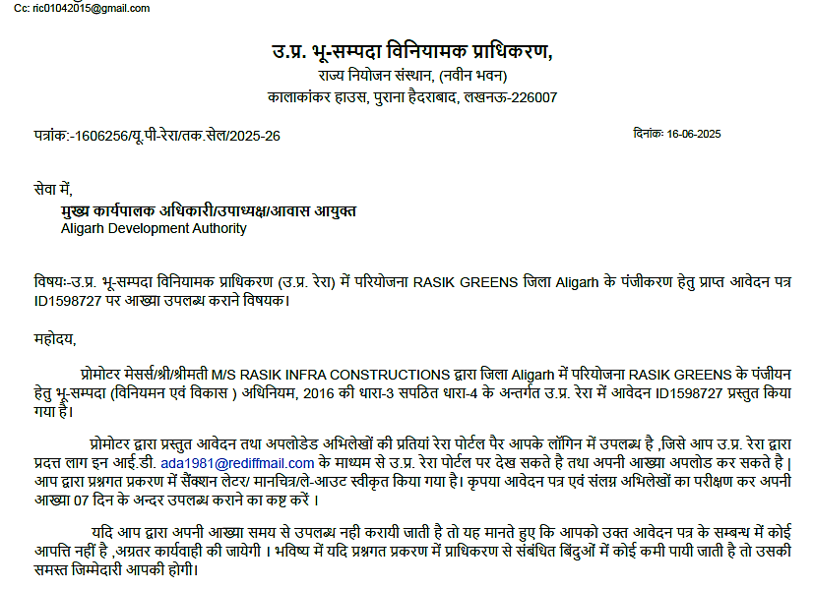
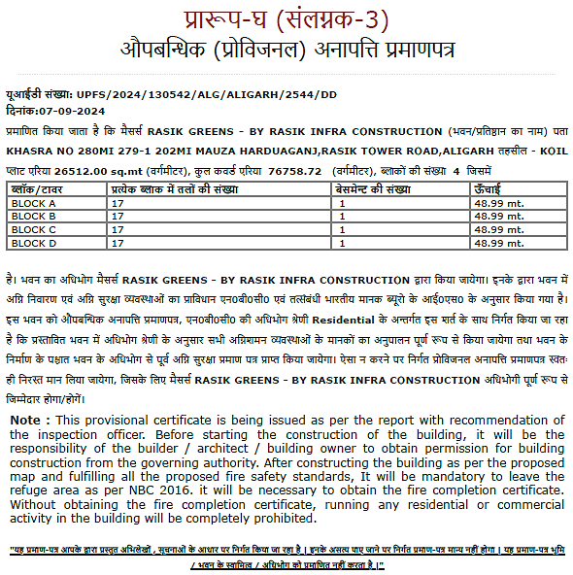

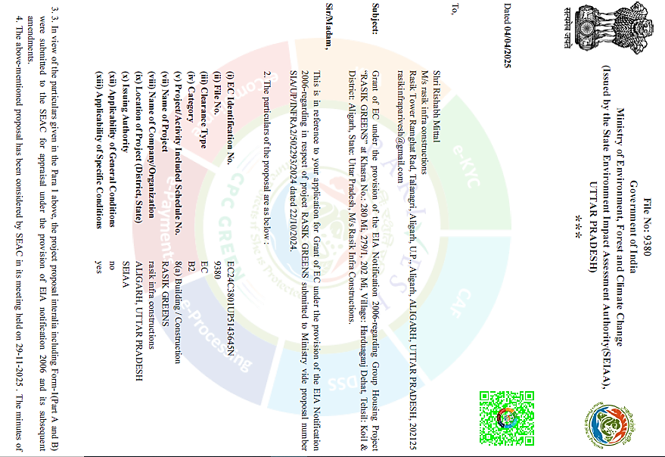

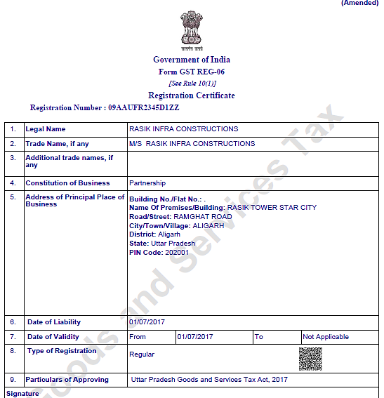
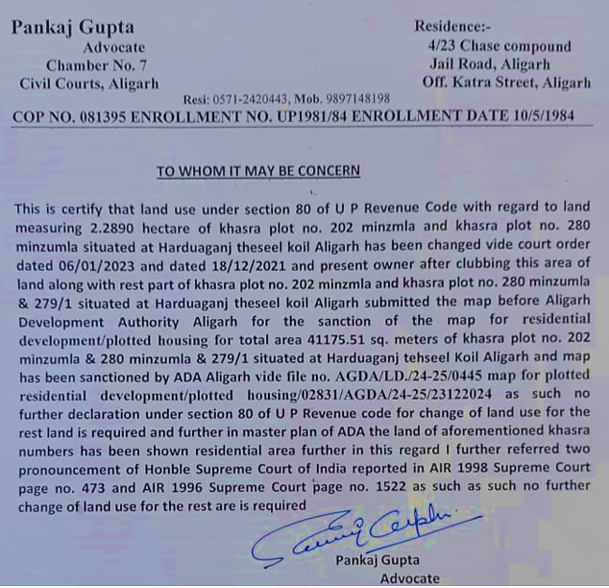
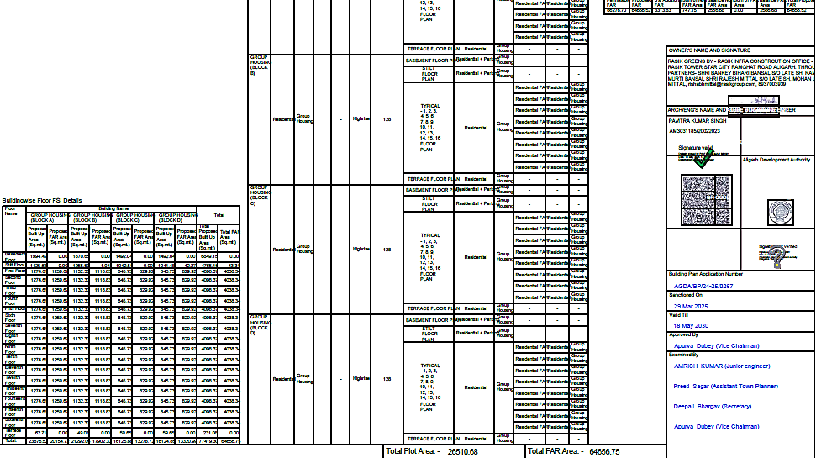
SOURCES & REFERENCES:
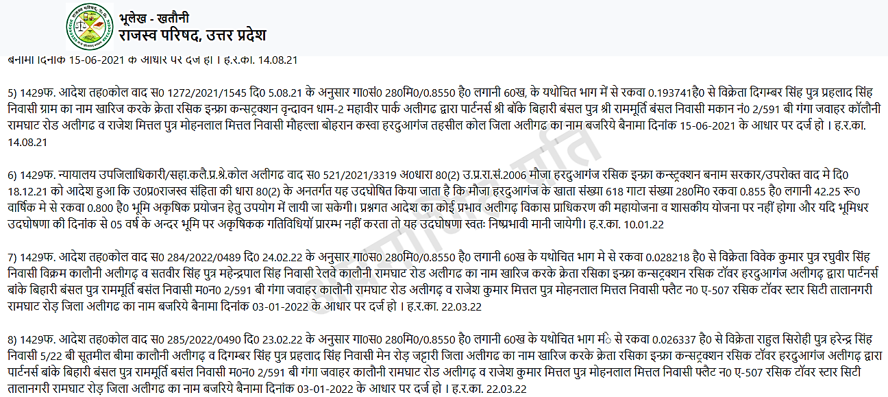
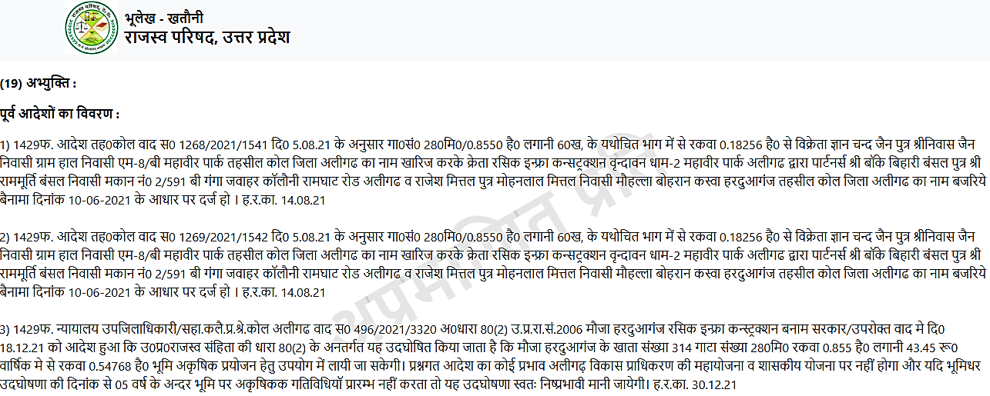
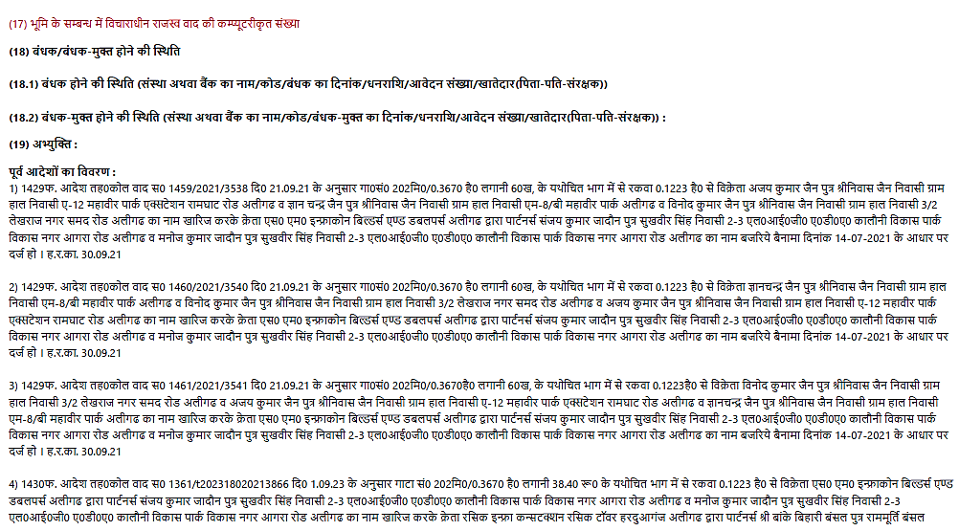
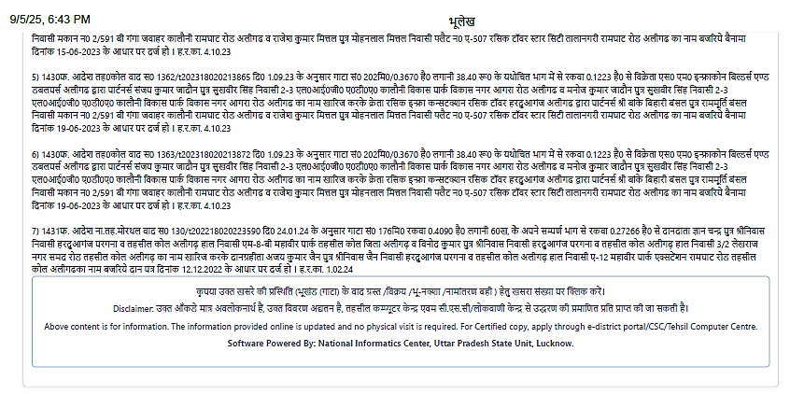
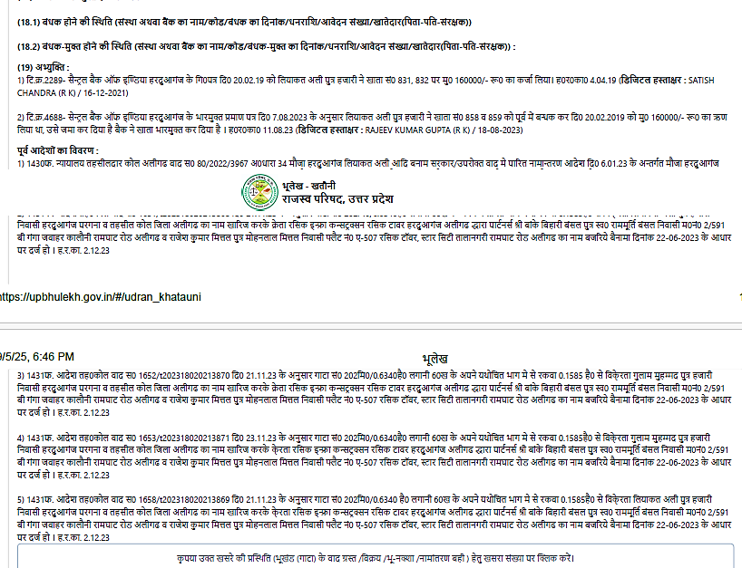
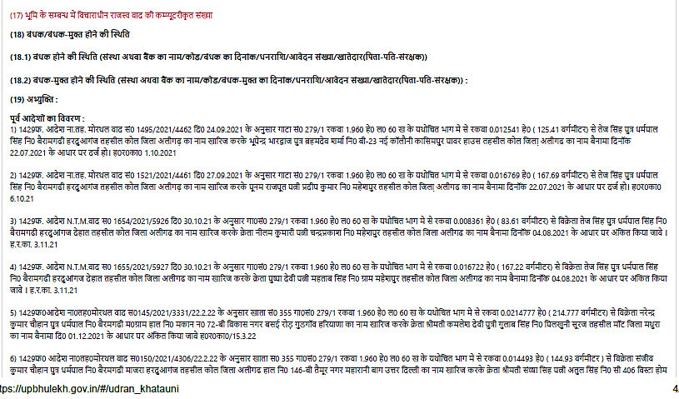
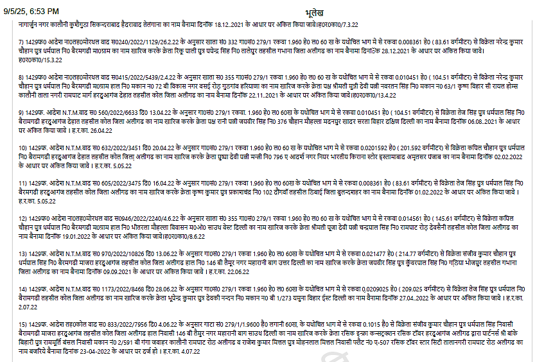
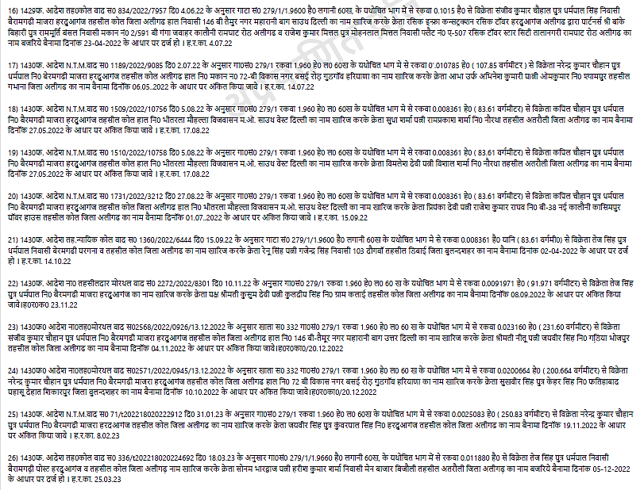
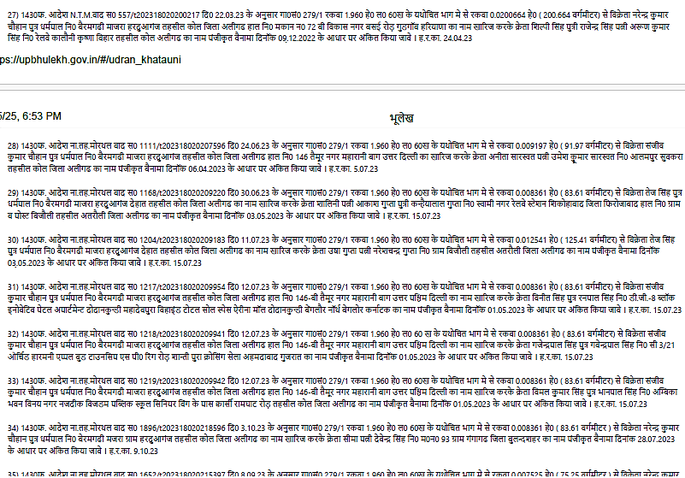

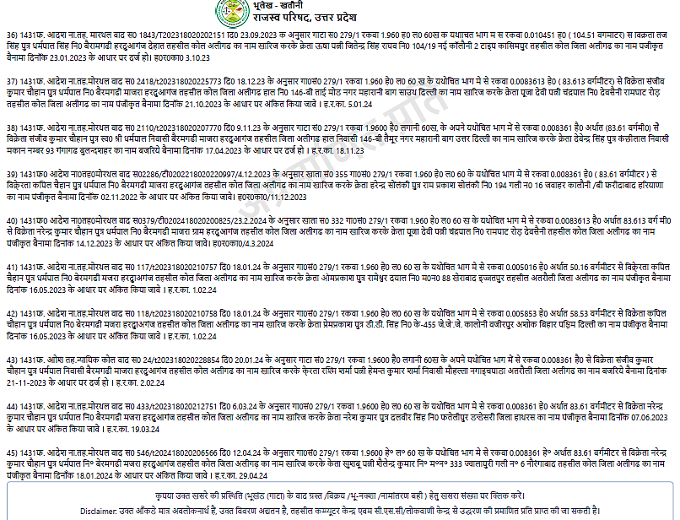

Flat Type | Sample Rates (₹/sq.ft.) | Source(s)
3 BHK | ₹2,533 – ₹3,750 (resale flats) | https://www.magicbricks.com/3-bhk-flats-in-aligarh-for-sale-pppfs?
3 BHK | ₹2,750 – ₹3,666 (new listings on 99acres) | https://www.99acres.com/3-bhk-flats-in-aligarh-ffid?
3 BHK | ₹2,970 – ₹7,500 (housing.com; wide range) | https://housing.com/in/buy/aligarh/3bhk-aligarh?
Avg. Range | ₹2,500 – ₹4,000 (most common) | Multiple sources above
Also Noted | Starting ₹2,210, avg ₹4,577 (all property types) | https://housing.com/price-trends/property-rates-for-buy-in-aligarh_uttar_pradesh-P3nrw9taj0uxjnrbe? trends data Housing

