REPORT FORMAT: V-L1 (Basic) | Version: 4.2_2017

FILE NO.: VIS (2025-26)-PL074-068-086 DATED: 21-05-2025

VALUATION REPORT

OF

PRIVATE VEHICLE

OWNER

MR. MANOJ KUMAR

REPORT PREPARED FOR

BANK OF INDIA, ASSET RECOVERY BRANCH GHAZIABAD, SECTOR - 9, NOIDA, GAUTAM BUDDHA NAGAR, UTTAR PRADESH - 201301

**Important - In case of any query/ issue/ concern or escalation you may please contact Incident Manager @ valuers@rkassociates.org. We will appreciate your feedback in order to improve our services.
NOTE: As per IBA Guidelines please provide your feedback on the report within 15 days of its submission after which report will be considered to be accepted & correct.
Valuation Terms of Services & Valuer’s Important Remarks are available at www.rkassociates.org for reference.

PART A | GENERAL DESCRIPTION

S.NO. | PARTICULARS | DESCRIPTION
 | Valuation prepared for | Chief Manager, Bank of India, Asset Recovery Branch Ghaziabad, Sector - 9, Noida, Gautam Buddha Nagar, Uttar Pradesh - 201301
 | Date of Appointment | Through e-mail dated 01-05-2025
 | Date of Inspection | 13-05-2025
 | Date of Valuation | 21-05-2025
 | Date of Valuation Report | 21-05-2025
 | Car Inspection done at Location | Tasingu, Mahamaya Nagar, U.P.
 | Current Owner | Mr. Manoj Kumar S/o Sh. Devendra Prasad
 | Purpose of Valuation | For Distress Sale of mortgaged assets under NPA a/c
 | Vehicle RC Number | UP-86-V-0100
 | Engine Number | E026671
 | Chassis Number | MEEHSRAW5FB097307
 | Odometer Reading | 1,27,146 km.
 | Manufacturer Name | Renault
 | Model Type | Duster RXS CVT(Manual)
 | Fuel Type | Petrol
 | Vehicle Type | Four Wheeler, 5 Seating Capacity (Including driver)
 | Body Type | Sports Utility Vehicle
 | Color | A. Green (As per RC). But, brown as per site visit.
 | Engine Capacity | 1188 CC
 | Year of Manufacturing | 2016
 | Age of Car | 8 Years 6 months
 | Condition | Good
 | Add on features available | Air-conditioner, Power Steering, Power Windows.
 | Insurance | Insured, upto 06-03-2026
 | Pollution | Not Available
 | Service Record | Details not provided to us
 | Has the car driven for inspection? | No
 | Current production status of the model in market | Renault discontinued Renault Duster RXS CVT production in 2019.

PART B | VALUATION ASSESSMENT OF ASSETS

S.  NO. | PARTICULARS | DESCRIPTION
 | Original Purchase Price | NA, Since no related documents is provided to us.
 | Resale price range for same model | Rs.2,00,000/- to Rs.4,00,000/- (as per information available on public domain, attached below)
 | Depreciation Calculated | Depreciation is considered as per the current condition of the car.
 | Current Market Value of this Car as per current condition | Rs.2,50,000/-
Remarks:
- The vehicle was in running condition at the time of survey, the ignition was also working.
- As per discussion with dealers, Renault doesn’t fetch good value in the resale market, we are considering the value as per the current market conditions of the same model.
- The car is in average condition and running board is rusting and proper maintenance and body work needs to be done as per the observation during the survey.
- The subject model has been discontinued by the manufacturer.
- The odometer reading of the subject vehicle is also more as compared to the references available. And usually vehicle with less odometer reading fetch more value.
- As per references available on public domain car with good condition may fetch good value but as per observations during site survey. We are of the view the same model and based on the condition of the subject car that the reasonable value for the subject vehicle will be Rs.2,50,000/- (Rupees Two Lakh Fifty Thousand Only).

 | Total Number of Pages in the Report with enclosures | 11
 | Engineering Team worked on the report | SURVEYED BY: Kuldeep
 | Engineering Team worked on the report | PREPARED BY: Manmohan
 | Engineering Team worked on the report | REVIEWED BY: Abhinav
 | List of Enclosures | - Reference from Public Domain  - Copy of RC/Important Documents  - Photographs  - Valuer’s Remarks

ENCLOSURE: 1 – REFERENCES AVAILABLE ON PUBLIC DOMAIN

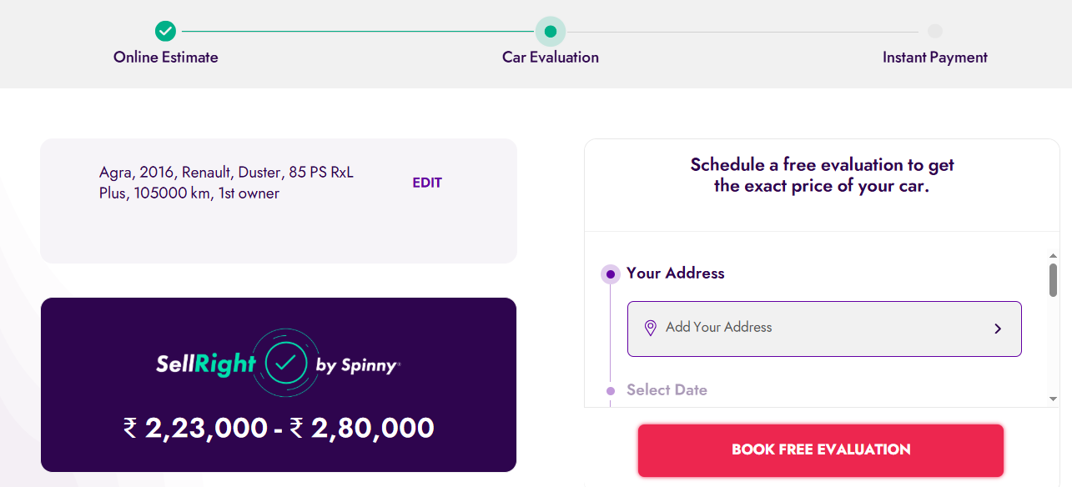
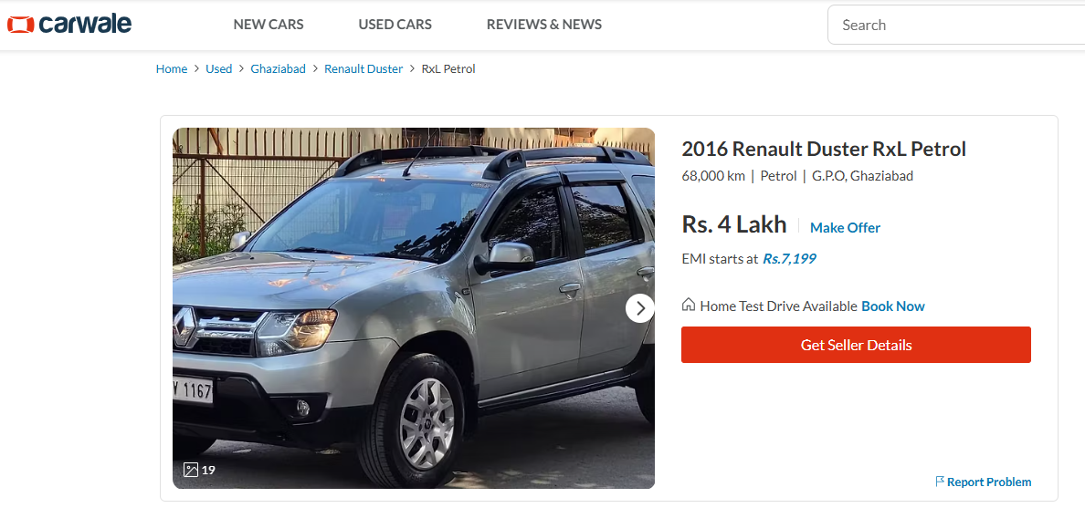

ENCLOSURE: 2 - COPY OF IMPORTANT DOCUMENTS

REGISTRATION CERTIFICATE
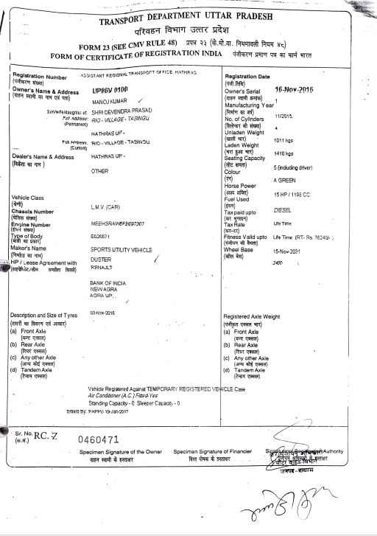
INSURANCE POLICY:
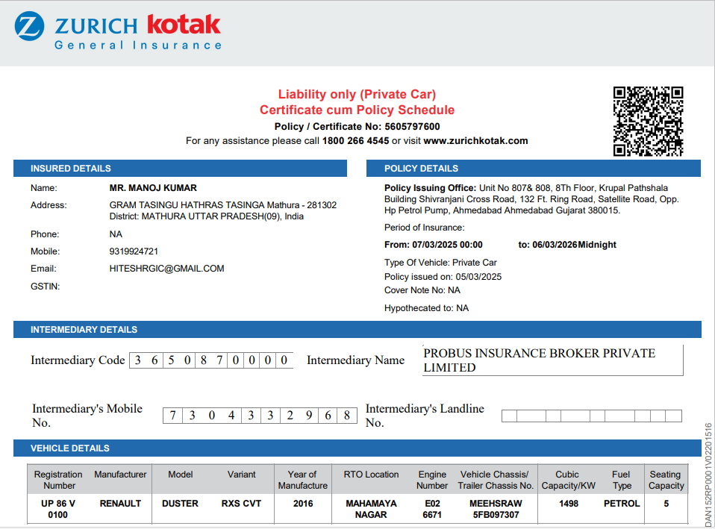
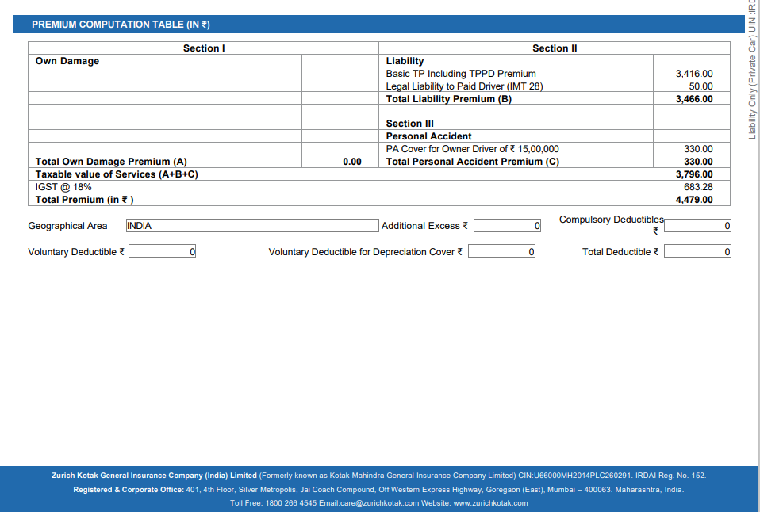

ENCLOSURE: 3 – PHOTOGRAPHS OF THE VEHICLE
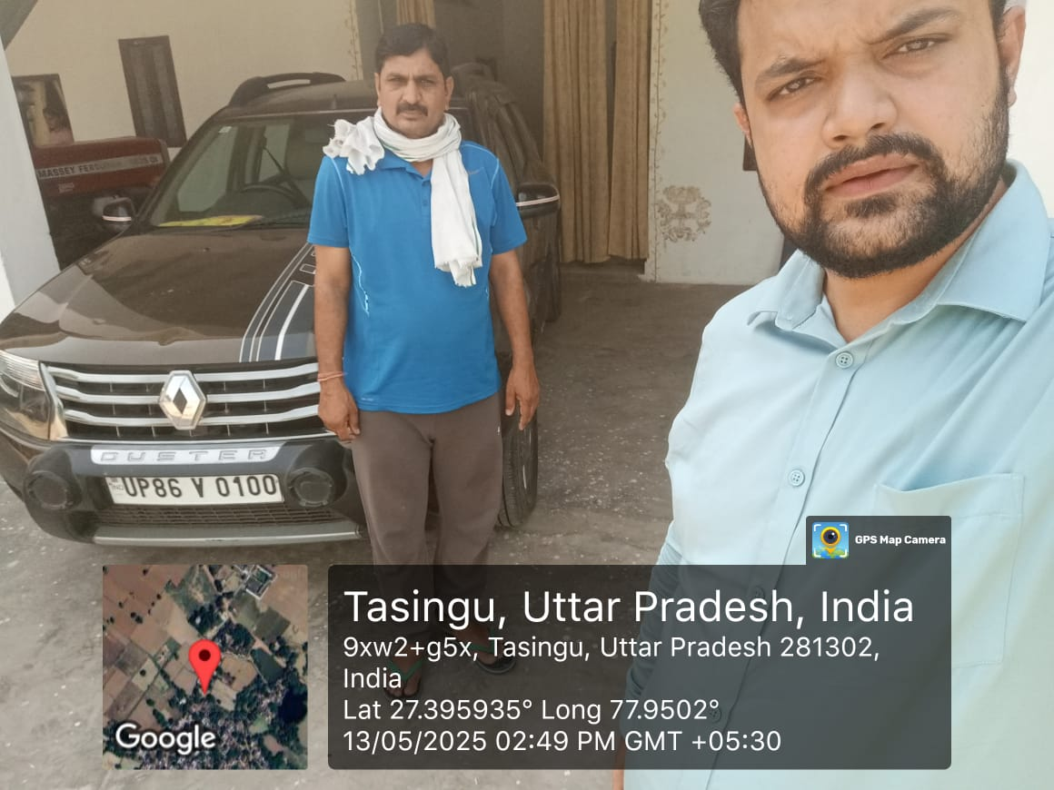 | 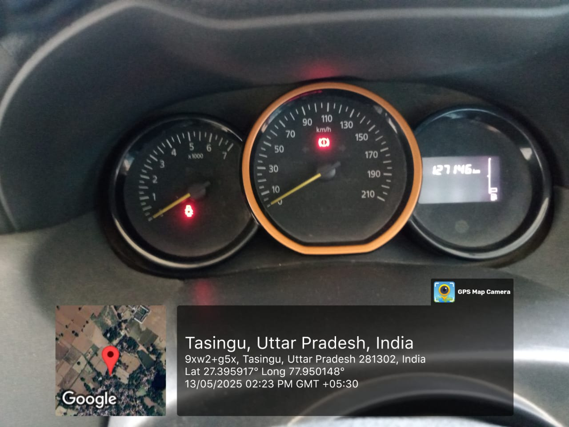
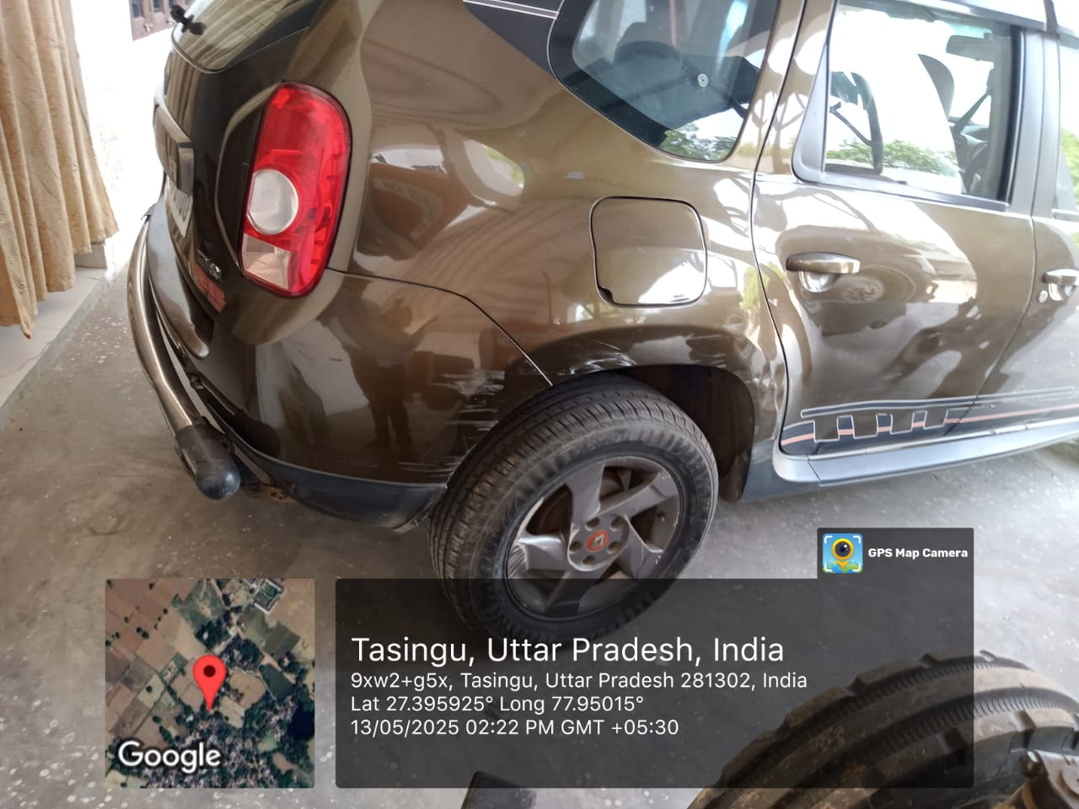 | 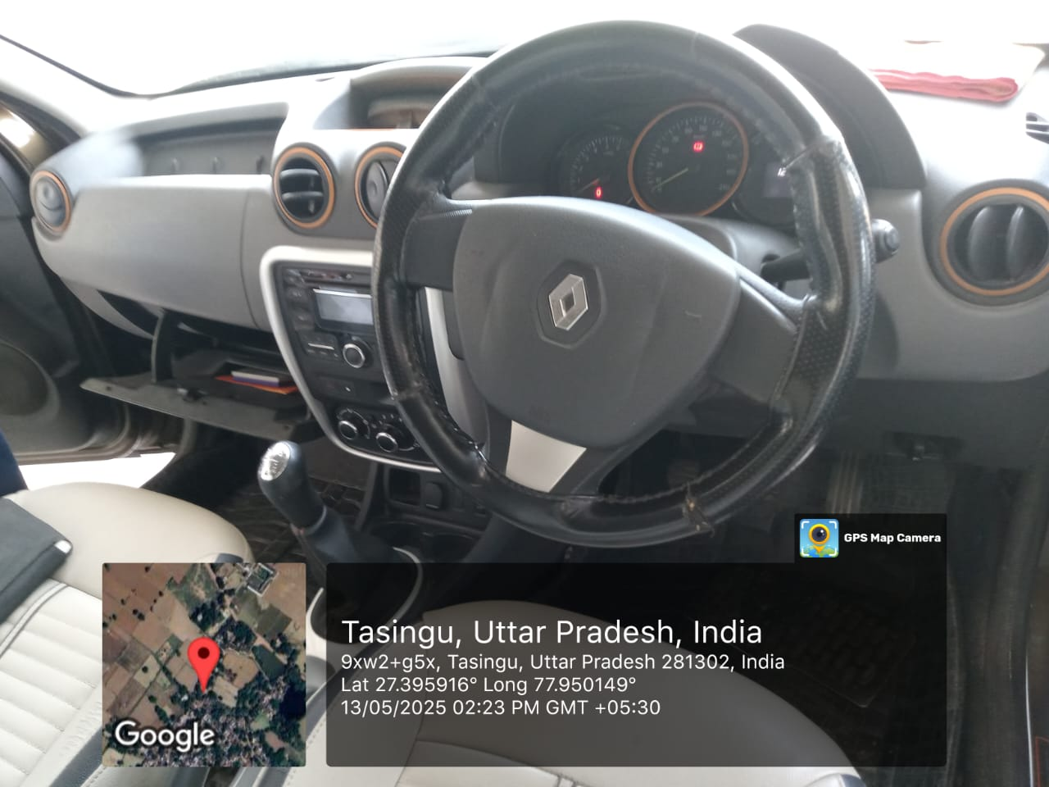
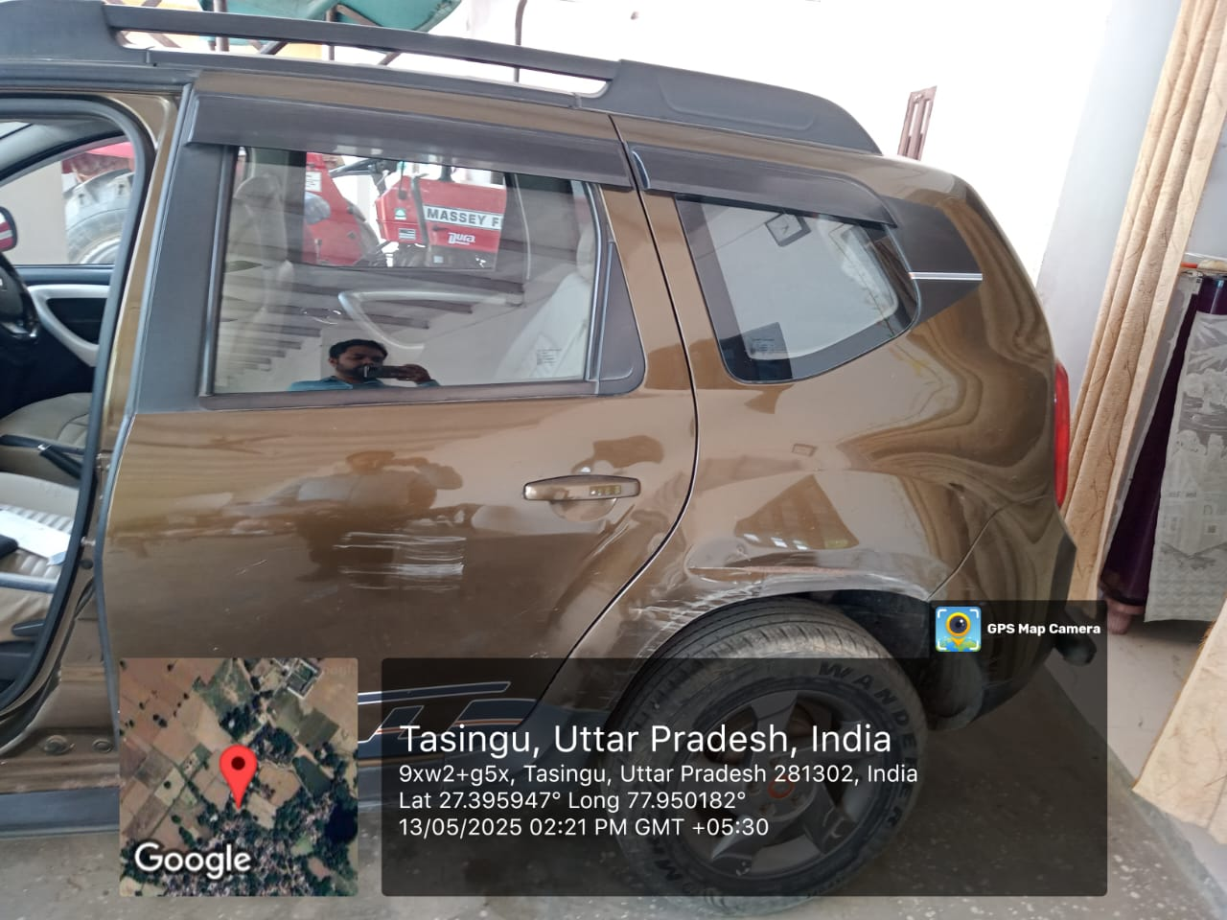 | 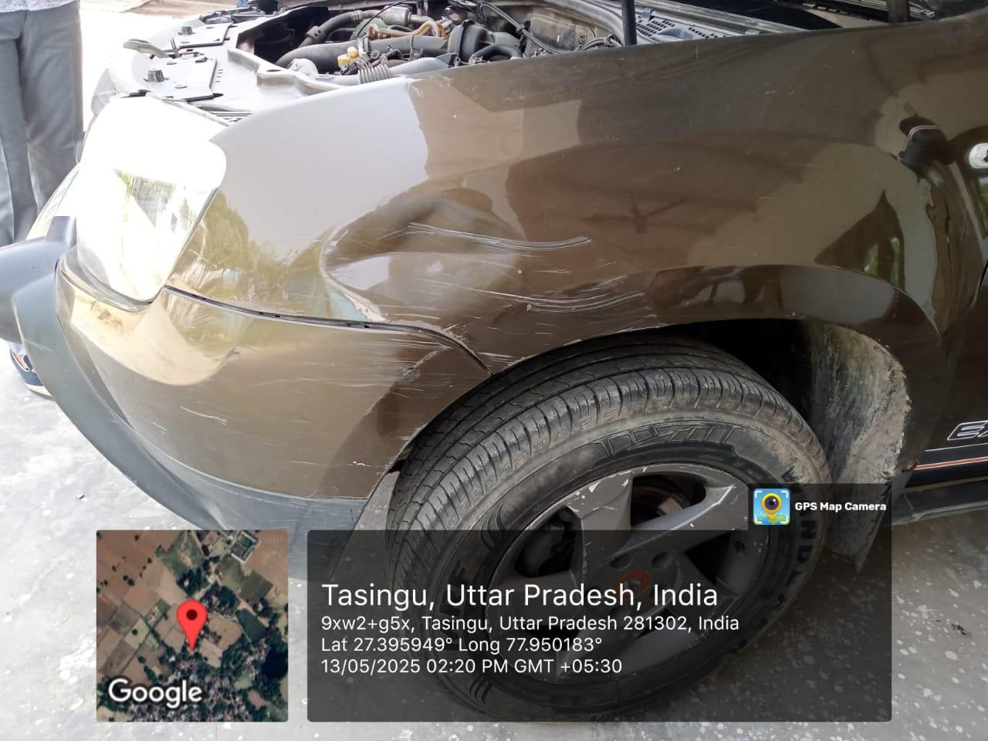

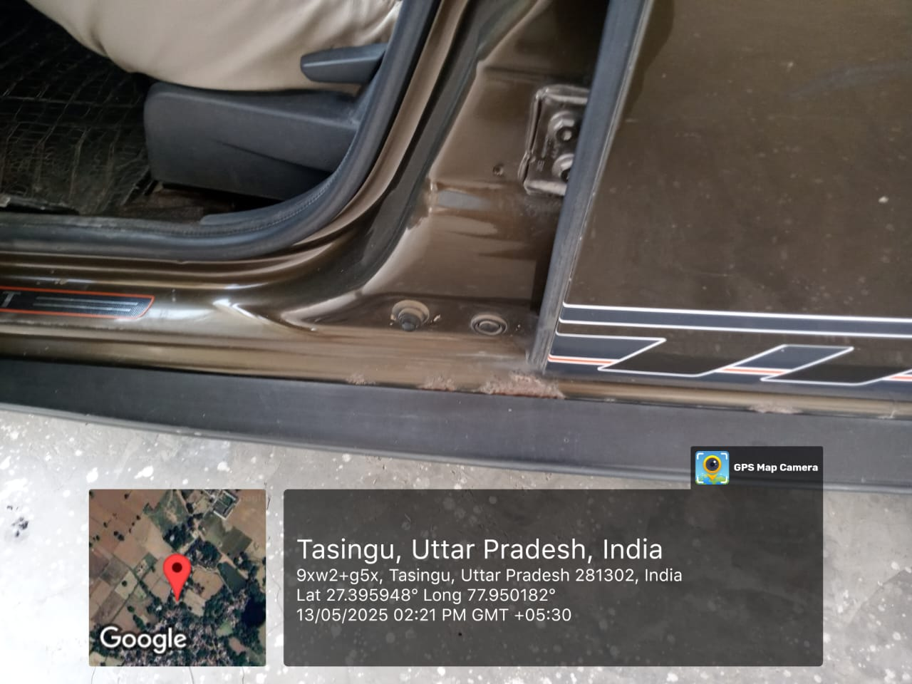 | 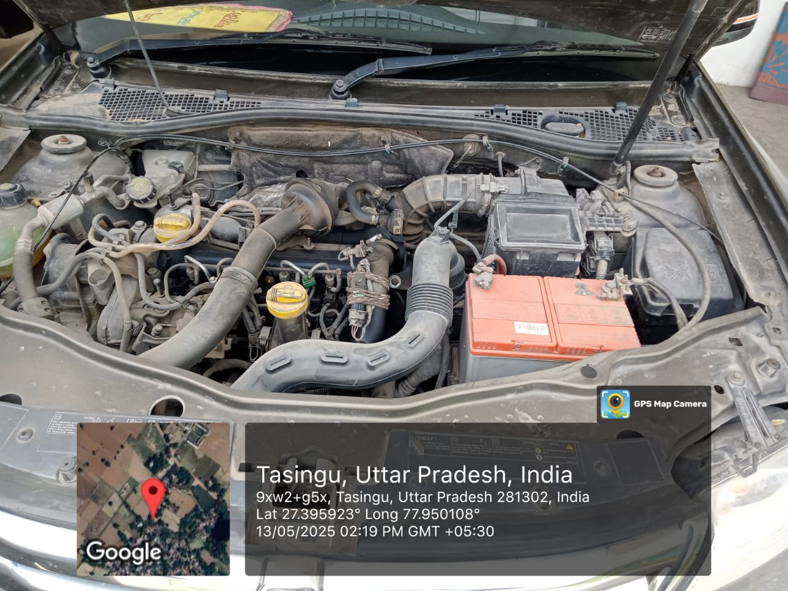
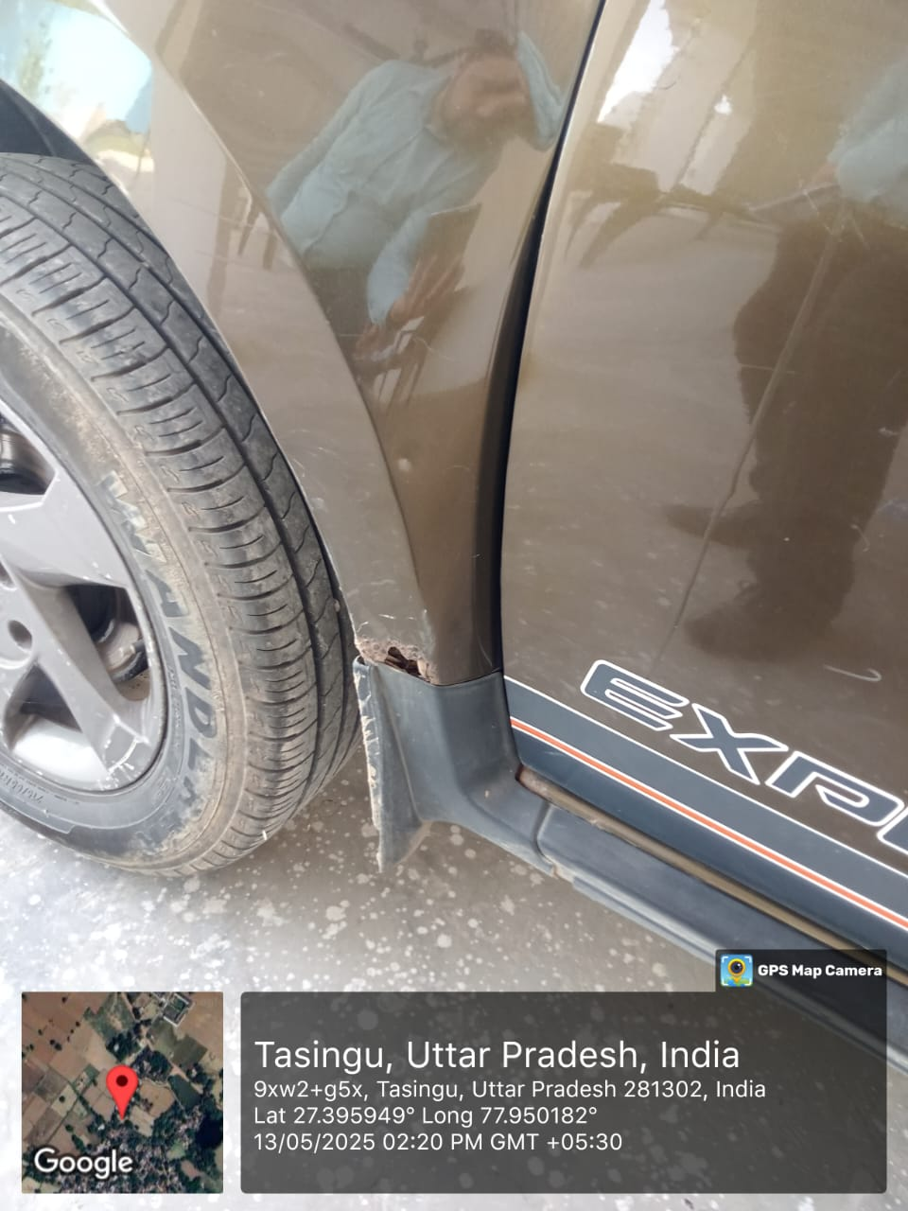 | 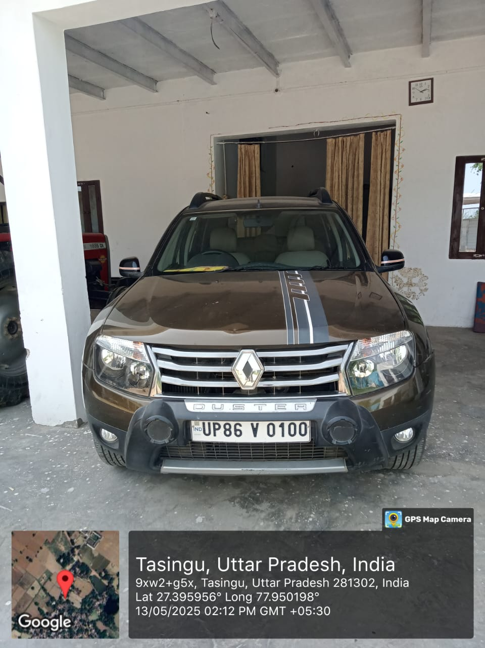

ENCLOSURE: 4 – VALUER’S REMARKS
Valuation is done for the asset found on as-is-where basis which owner/ owner representative/ client/ bank has shown/ identified to us on the site unless otherwise mentioned in the report of which some reference has been taken from the information/ data given in the copy of documents provided to us and informed verbally or in writing out of the standard checklist of documents sought from the client & its customer which they could provide within the reasonable expected time out of the standard checklist of documents sought from them and further based on certain assumptions and limiting conditions. The information, facts, documents, data which has become primary basis of the report has been supplied by the client which has been relied upon in good faith and is not generated by the Valuer.
The client/ owner and its management/ representatives warranted to us that the information they have supplied was complete, accurate and true and correct to the best of their knowledge. All such information provided to us either verbally, in writing or through documents has been relied upon in good faith and we have assumed that it is true & correct without any fabrication or misrepresentation. I/We shall not be held liable for any loss, damages, cost or expenses arising from fraudulent acts, misrepresentations, or willful default on part of the owner, company, its directors, employee, representative or agents.
Legal aspects for eg. Investigation of title, ownership rights, lien, charge, mortgage, lease, sanctioned maps, verification of documents provided to us such as title documents, Map, etc. from any concerned Govt. office etc. have to be taken care by legal expert/ Advocate and same is not done at our end. It is assumed that the concerned Lender/ Financial Institution has asked for the valuation of that property after satisfying the authenticity of the documents given to us for which the legal verification has been already taken and cleared by the competent Advocate before requesting for the Valuation report. I/ We assume no responsibility for the legal matters including, but not limited to, legal or title concerns.
In the course of the valuation, we were provided with both written and verbal information. We have however, evaluated the information provided to us through broad inquiry, analysis and review but have not carried out a due diligence or audit of the information provided for the purpose of this engagement. Our conclusions are based on the assumptions and other information provided to us by the client during the course of the assessment.
Getting cizra map or coordination with revenue officers for site identification is a separate activity and is not part of the Valuation services and same has not been done in this report unless otherwise stated.
We have made certain assumptions in relation to facts, conditions & situations affecting the subject of, or approach to this exercise that has not been verified as part of the engagement rather, treated as “a supposition taken to be true”. If any of these assumptions prove to be incorrect then our estimate on value will need to be reviewed.
This is just an opinion report based on technical & market information having general assessment & opinion on the indicative, estimated Market Value of the property for which Bank has asked to conduct the Valuation. It doesn’t contain any other recommendations of any sort including but not limited to express of any opinion on the suitability or otherwise of entering into any transaction with the borrower.
We have relied on the data from third party, external sources & information available on public domain to conclude the valuation. These sources are believed to be reliable and therefore, we assume no liability for the truth or accuracy of any data, opinions or estimates furnished by others that have been used in this analysis. Where we have relied on the data, opinions or estimates from external sources, reasonable care has been taken to ensure that such data is extracted from authentic sources, however we still can’t vouch its authenticity, correctness, or accuracy.
Analysis and conclusions adopted in the report are limited to the reported assumptions, conditions and information came to our knowledge during the course of the work and based on the Standard Operating Procedures, Best Practices, Caveats, Limitations, Conditions, Remarks, Important Notes, Valuation TOR and definition of different nature of values.
Value varies with the Purpose/ Date/ Asset Condition & situation/ Market condition, demand & supply, asset utility prevailing on a particular date/ Mode of sale. The indicative & estimated prospective Value of the asset given in this report is restricted only for the purpose and other points mentioned above prevailing on a particular date as mentioned in the report. If any of these points are different from the one mentioned aforesaid in the Report then this report should not be referred.
Our report is meant ONLY for the purpose mentioned in the report and should not be used for any other purpose. The Report should not be copied or reproduced for any purpose other than the purpose for which it is prepared for. I/we do not take any responsibility for the unauthorized use of this report.
We owe responsibility only to the authority/client that has appointed us as per the scope of work mentioned in the report. We will not be liable for any losses, claims, damages or liabilities arising out of the actions taken, omissions or advice given by any other person. In no event shall we be liable for any loss, damages, cost or expenses arising in any way from fraudulent acts, misrepresentations or willful default on part of the client or companies, their directors, employees or agents.
This report is having limited scope as per its fields & format to provide only the general basic idea of the value of the property prevailing in the market based on the site inspection and documents/ data/ information provided by the client. The suggested indicative prospective estimated value should be considered only if transaction is happened as free market transaction.
The sale of the subject property is assumed to be on an all cash basis. Financial arrangements would affect the price at which the property may sell for if placed on the market.
The actual realizable value that is likely to be fetched upon sale of the asset under consideration shall entirely depend on the demand and supply of the same in the market at the time of sale.
While our work has involved an analysis & computation of valuation, it does not include detailed estimation, design/ technical/ engineering/ financial/ structural/ environmental/ architectural/ compliance survey/ safety audit & works in accordance with generally accepted standards of audit & other such works. The report in this work in not investigative in nature. It is mere an opinion on the likely estimated valuation based on the facts & details presented to us by the client and third party market information came in front of us within the limited time of this assignment, which may vary from situation to situation.
Where a sketched plan is attached to this report, it does not purport to represent accurate architectural plans. Sketch plans and photographs are provided as general illustrations only.
Documents, information, data including title deeds provided to us during the course of this assessment by the client is reviewed only upto the extent required in relation to the scope of the work. No document has been reviewed beyond the scope of the work. These are not reviewed in terms of legal rights for which we do not have expertise. Wherever any information mentioned in this report is mentioned from the documents like owners name, etc., it is only for illustration purpose and may not necessary represent accuracy.
The report assumes that the borrower/company/business/asset complies fully with relevant laws and regulations applicable in its area of operations and usage unless otherwise stated, and that the companies/business/assets is managed in a competent and responsible manner. Further, as specifically stated to the contrary, this report has given no consideration to matters of a legal nature, including issues of legal title and compliance with relevant laws, and litigations and other contingent liabilities that are not recorded/reflected in the documents/ details/ information/ data provided to us.
This valuation report is not a qualification for accuracy of land boundaries, schedule (in physical terms), dimensions & identification. For this land/ property survey report can be sought from a qualified private or Govt. surveyor.
This Valuation report is prepared based on the facts of the property on the date of the survey. Due to possible changes in market forces, socio-economic conditions, property conditions and circumstances, this valuation report can only be regarded as relevant as at the valuation date. Hence before financing, Banker/ FI should take into consideration all such future risk and should loan conservatively to keep the advanced money safe in case of the downward trend of the property value.
Valuation of the same asset/ property can fetch different values under different circumstances & situations. For eg. Valuation of a running/ operational shop/ hotel/ factory will fetch better value and in case of closed shop/ hotel/ factory it will have considerable lower value. Similarly, an asset sold directly by an owner in the open market through free market transaction then it will fetch better value and if the same asset/ property is sold by any financer due to encumbrance on it, will fetch lower value. Hence before financing, Lender/ FI should take into consideration all such future risks while financing and take decision accordingly.

Valuation is done for the property identified to us by the owner/ owner representative. At our end we have just visually matched the land boundaries, schedule (in physical terms) & dimensions of the property with reference to the documents produced for perusal. Method by which identification of the property is carried out is also mentioned in the report clearly. Responsibility of identifying the correct property to the Valuer/ its authorized surveyor is solely of the client/ owner for which Valuation has to be carried out. It is requested from the Bank to cross check from their own records/ information if this is the same property for which Valuation has to be carried out to ensure that owner has not misled the Valuer company or misrepresented the property due to any vested interest. Where there is a doubt about the precision position of the boundaries, schedule, dimensions of site & structures, it is recommended that a Licensed Surveyor be contacted.
In India more than 70% of the geographical area is lying under rural/ remote/ non municipal/ unplanned area where the subject property is surrounded by vacant lands having no physical demarcation or having any display of property survey or municipal number / name plate on the property clearly. Even in old locations of towns, small cities & districts where property number is either not assigned or not displayed on the properties clearly and also due to the presence of multiple/ parallel departments due to which ownership/ rights/ illegal possession/ encroachment issues are rampant across India and due to these limitations at many occasions it becomes tough to identify the property with 100% surety from the available documents, information & site whereabouts and thus chances of error, misrepresentation by the borrower and margin of chances of error always persists in such cases. To avoid any such chances of error it is advised to the Bank to engage municipal/ revenue department officials to get the confirmation of the property to ensure that the property shown to Valuer/ Banker is the same as for which documents are provided.
If this Valuation Report is prepared for the Flat/ dwelling unit situated in a Group Housing Society or Integrated Township then approvals, maps of the complete group housing society/ township is out of scope of this report and this report will be made for the specific unit based on the assumption that complete Group Housing Society/ Integrated Township and the subject unit must be approved in all respect.
Due to fragmented & frequent change in building/ urban planning laws/ guidelines from time to time, different laws/ guidelines between regions/ states and no strict enforceability of Building Bye-Laws in India specially in non-metro and scale b & c cities & Industrial areas, property owners many times extend or make changes in the covered area/ layout from the approved/ applicable limits. There are also situations where properties are decades old when there was no formal Building Bye-Laws applicable the time when the construction must have been done. Due to such discrete/ unplanned development in many regions sometimes it becomes tough for the Valuer to determine the exact lawful situation on ground. Unless otherwise mentioned in the report, the covered area present on the site as per site survey will be considered in the Valuation.
Area of the large land parcels of more than 2500 sq.mtr or of uneven shape in which there can be practical difficulty in sample measurement, is taken as per property documents which has been relied upon unless otherwise stated.

Drawing Map, design & detailed estimation of the property/ building is out of scope of the Valuation services.
Valuation is a subjective field and opinion may differ from consultant to consultant. To check the right opinion, it is important to evaluate the methodology adopted and various data point/ information/ factors/ assumption considered by the consultant which became the basis for the Valuation report before reaching to any conclusion.
Although every scientific method has been employed in systematically arriving at the value, there is, therefore, no indisputable single value and the estimate of the value is normally expressed as falling within a likely range.
Value analysis of any asset cannot be regarded as an exact science and the conclusions arrived at in many cases will, of necessity, be subjective and dependent on the exercise of individual judgment. Given the same set of facts and using the same assumptions, expert opinions may differ due to the number of separate judgment decisions, which have to be made. Therefore, there can be no standard formula to establish an indisputable exchange ratio. In the event of a transaction, the actual transaction value achieved may be higher or lower than our indicative analysis of value depending upon the circumstances of the transaction. The knowledge, negotiability and motivations of the buyers and sellers, demand & supply prevailing in the market and the applicability of a discount or premium for control will also affect actual price achieved. Accordingly, our indicative analysis of value will not necessarily be the price at which any agreement proceeds. The final transaction price is something on which the parties themselves have to agree. However, our Valuation analysis can definitely help the stakeholders to take informed and wise decision about the Value of the asset and can help in facilitating the arm’s length transaction.
This Valuation is conducted based on the macro analysis of the asset/ property considering it in totality and not based on the micro, component, or item wise analysis. Analysis done is a general assessment and is not investigative in nature.
This report is prepared on the RKA V-L1 (Basic) Valuation format as per the client requirement and scope of work. This report is having limited scope as per its fields & format to provide only the general estimated & indicative basic idea of the value of the property prevailing in the market based on the information provided by the client. No detailed analysis, audit or verification has been carried out of the subject property. There may be matters, other than those noted in this report, which might be relevant in the context of the transaction and which a wider scope might uncover.
This is just an opinion report and doesn’t hold any binding on anyone. It is requested from the concerned Client/ Bank/ Financial Institution which is using this report for mortgaging the property that they should consider all the different associated relevant & related factors & risks before taking any business decision based on the content of this report.
All Pages of the report including annexures are signed and stamped from our office. In case any paper in the report is without stamp & signature then this should not be considered a valid paper issued from this office.
As per IBA Guidelines & Bank Policy, in case the valuation report submitted by the valuer is not in order, the banks / FIs shall bring the same to the notice of the valuer within 15 days of submission for rectification and resubmission. In case no such communication is received, it shall be presumed that the valuation report has been accepted.
Defect Liability Period is 15 DAYS. We request the concerned authorized reader of this report to check the contents, data, information, and calculations in the report within this period and intimate us in writing at valuers@rkassociates.org within 15 days of report delivery, if any corrections are required or in case of any other concern with the contents or opinion mentioned in the report. If no intimation is received within 15 (Fifteen) days in writing from the date of issuance of the report, then it shall be considered that the report is complete in all respect and has been accepted by the client upto their satisfaction & use and further to which R.K Associates shall not be held responsible in any manner. After this period no concern/ complaint/ proceedings in connection with the Valuation Services will be entertained due to possible change in situation and condition of the property.
Though adequate care has been taken while preparing this report as per its scope, but still we can’t rule out typing, human errors, over sightedness of any information or any other mistakes. Therefore, the concerned organization is advised to satisfy themselves that the report is complete & satisfactory in all respect. Intimation regarding any discrepancy shall be brought into our notice immediately. If no intimation is received within 15 (Fifteen) days in writing from the date of issuance of the report, to rectify these timely, then it shall be considered that the report is complete in all respect and has been accepted by the client upto their satisfaction & use and further to which R.K Associates shall not be held responsible in any manner.
Our Data retention policy is of ONE YEAR. After this period we remove all the concerned records related to the assignment from our repository. No clarification or query can be answered after this period due to unavailability of the data.
This Valuation report is governed by our (1) Internal Policies, Processes & Standard Operating Procedures, (2) R.K Associates Quality Policy, (3) Valuation & Survey Best Practices Guidelines formulated by management of R.K Associates, (4) Information input given to us by the customer and (4) Information/ Data/ Facts given to us by our field/ office technical team. Management of R.K Associates never gives acceptance to any unethical or unprofessional practice which may affect fair, correct & impartial assessment and which is against any prevailing law. In case of any indication of any negligence, default, incorrect, misleading, misrepresentation or distortion of facts in the report then we request the user of this report to immediately or atleast within the defect liability period to bring all such act into notice of R.K Associates management so that corrective measures can be taken instantly.
R.K Associates never releases any report doing alterations or modifications by pen. In case any information/ figure of this report is found altered with pen then this report will automatically become null & void.
We are fully aware that based on the opinion of value expressed in this report, we may be required to give testimony or attend court / judicial proceedings with regard to the subject assets, although it is out of scope of the assignment, unless specific arrangements to do so have been made in advance, or as otherwise required by law. In such event, the party seeking our evidence in the proceedings shall bear the cost/professional fee of attending court / judicial proceedings and my / our tendering evidence before such authority shall be under the applicable laws.
The final copy of the report shall be considered valid only if it is in hard copy on the company’s original letter head with proper stamp and sign on it of the authorized official upon payment of the agreed fees. User shall not use the content of the report for the purpose it is prepared for only on draft report, scanned copy, email copy of the report and without payment of the agreed fees. In such a case the report shall be considered as unauthorized and misused.

