File No.: VIS (2025-26)-PL078-072-096 Dated: 19.05.2025

VALUATION REPORT

NATURE OF ASSETS | AIRCRAFT
CATEGORY OF ASSETS | PERSONAL/ INDIVIDUAL
TYPE OF ASSETS | PRIVATE AIRCRAFT

PARKED AT
DR. BABASAHEB AMBEDKAR INTERNATIONAL AIRPORT, NAGPUR- 440005, MAHARASHTRA, INDIA

REPORT PREPARED FOR
IDBI BANK LIMITED, C-WING, 7TH FLOOR, WORLD TRADE CENTRE COMPLEX, CUFFE PARADE, COLABA, MUMBAI – 400005

**Important - In case of any query/ issue/ concern or escalation you may please contact Incident Manager @ valuers@rkassociates.org. We will appreciate your feedback in order to improve our services.
NOTE: Please provide your feedback on the report within 15 days of its submission after which report will be considered to be accepted & correct. Valuation Terms of Services & Valuer’s Important Remarks are available at www.rkassociates.org for reference.

TABLE OF CONTENTS
SECTIONS | PARTICULARS | PAGE NO.
Part A | INTRODUCTION | 2
Part B | PRELIMINARY INFORMATION OF ASSETS | 3
Part B | - About the Report | 3
Part B | - Scope of the report | 3
Part B | - Purpose of the report | 3
Part B | - Methodology adopted | 3
Part C | ASSET TECHNICAL DETAILS | 4
Part D | VALUATION ASSESSMENT | 6
 | Enclosure-I: GOOGLE MAP LOCATION | 13
 | Enclosure-II: PHOTOGRAPHS | 14
 | Enclosure-III: IMPORTANT DOCUMENTS | 18
 | Enclosure-IV: MARKET REFERENCE | 20
Part E | VALUER’S IMPORTANT REMARKS | 22

PART A | INTRODUCTION

S. No. | CONTENTS | DESCRIPTION
 | Name of the Owner | M/s Pathbreaking Projects Limited (erstwhile Abhijeet Projects Ltd.)
 | Registered Office | FE-83, Sector-III, Salt Lake City, Ground Floor, Kolkata, West Bengal
 | Report Prepared for Organization | IDBI Bank Limited, C-Wing, 7th Floor, World Trade Centre Complex, Cuffe Parade, Colaba, Mumbai – 400005
 | Work Order Details | Via letter no. IDBI/NMG/PPL/2025-26/VAL2 dated 08th May 2025 (amended later over the e-mail on 21-05-2025)
 | Date of Inspection | 10th May 2025
 | Date of Valuation | 19th May 2025
 | Date of Valuation Report | 19th May 2025
 | Report Type | Detailed Valuation of Private Aircraft
 | Purpose of the Report | To determine the Market Value of Bombardier Challenger-605
 | Scope of the Report | To determine the Market Value of Bombardier Challenger-605
 | Documents Provided by | Mr. Samir Kumar (IDBI Bank)  Mob. No. +91 83405 02262
 | Documents provided by the company | Aircraft purchase agreement
 | Documents provided by the company | Repair & maintenance quote from Air Works
 | Documents provided by the company | Airworthiness & Noice Certificate
 | Documents provided by the company | Copy of Insurance

PART B | PRELIMINARY INFORMATION

- ABOUT THE REPORT: To determine the Market Value of Private Chartered Aircraft owned by M/s Pathbreaking Projects Limited (erstwhile Abhijeet Projects Ltd.). The aircraft is parked at Dr. Babasaheb Ambedkar International Airport, Nagpur- 440005, Maharashtra.
- SCOPE OF THE REPORT: To determine the Market Value of Private Chartered Aircraft owned by M/s Pathbreaking Projects Limited (erstwhile Abhijeet Projects Ltd.).
- PURPOSE OF THE REPORT: To provide a fair and detailed analysis report based on the “in-scope points” mentioned above.
- METHODOLOGY ADOPTED:
- Data/ information/ documents gathering related to the Aircraft.
- Study of relevant data/ information provided by the bank/company
- To conduct preliminary desktop research about the company & its peer analysis.
- To conduct Market research/analysis of such aircraft.
- Information compilation, analysis, comparison and reporting.
- Mixture of “Depreciated Reproduction Cost Method” under Cost Approach and Market Approach

PART C | TECHNICAL DETAILS

- GENERAL DETAILS OF AIRCRAFT: The Bombardier Challenger 605 is a prominent model in of private and business aviation, offering a refined balance of performance, comfort, and technological sophistication. It was introduced in 2006 as an evolution of the successful Challenger 604, the 605 was designed to meet the growing demands of corporate and high-net-worth travelers seeking long-range capabilities combined with a luxurious in-flight experience. With its spacious cabin, advanced avionics, and impressive range, the Challenger 605 quickly earned a reputation as a reliable and efficient aircraft for both domestic and international travel.
- General Specifications:
- Manufacturer: Bombardier Aerospace (Canada)
- Model: Challenger 605
- Type: Long-range business jet
- First Delivery: 2007
- Production Period: 2006–2015
- Total manufactured: 290
- Maximum Range: Approx. 4,000 nautical miles (7,408 km)
- Cruise Speed: Mach 0.80 (around 870 km/h or 470 knots)
- Maximum Operating Altitude: 41,000 ft
- Engines: 2 × General Electric CF34-3B turbofans
- Take-off Distance: ~5,840 ft (1,780 m)
- Landing Distance: ~2,775 ft (846 m)

- Cabin Features
The Challenger 605 boasts one of the widest cabins in its class, offering superior comfort for long-haul flights.
- Cabin Dimensions:
  - Length: 28.4 ft (8.66 m)
  - Width: 8.2 ft (2.49 m)
  - Height: 6.1 ft (1.85 m)
- Seating Capacity: Typically configured for 10–12 passengers
- Cabin Layout: Includes club seating, divan, conference tables, and a full-service galley
- Lavatory: Full-size aft lavatory
- Baggage Capacity: 115 cu ft (3.26 m³), accessible in-flight
- Cabin Pressurization: Maintains a low cabin altitude for passenger comfort
- Noise Level: Quiet interior environment for business or relaxation

- Avionics and Flight Deck
The aircraft is equipped with the Rockwell Collins Pro Line 21 avionics suite, offering enhanced situational awareness, reliability, and pilot workload reduction.
- Features Include:
  - Four large-screen displays
  - Integrated Flight Information System (IFIS)
  - Enhanced ground proximity warning system (EGPWS)
  - Traffic Collision Avoidance System (TCAS II)
  - Dual Flight Management Systems (FMS)
  - Weather radar with turbulence detection

- Performance and Efficiency:
The Challenger 605 delivers a strong balance of range and fuel efficiency, making it ideal for non-stop transcontinental and intercontinental missions. With its advanced aerodynamics and upgraded systems, it provides improved climb performance and better operating economics compared to its predecessors.

- TECHNICAL DETAILS OF AIRCRAFT UNDER VALUATION CONSIDERATION:
As per the details provided, the aircraft has been grounded at Nagpur International Airport from year 2014. Past details of the aircraft are as follows: -
- Registration: VT-MKJ,MSN-5848
- Year of manufacture: 2010
- Auxiliary Power Unit (APU): Honeywell
- Airframe/Engine Hours: 591.47 hours / 450 cycles
- Airworthiness certificate: Expired on 03-02-2014
- Last fight date: 13-05-2013
- Land Ground run: 13-01-2014
- Insurance: shall expire on December 2025.

PART D | VALUATION ASSESSMENT
- MARKET COMPARABLES: For the valuation of the subject aircraft, a detailed market analysis was conducted for Comparables. As per our market analysis & research conducted, a similar refurbished Challenger-605 ranges from $10,750,000 to $11,000,000. Details of market technical details of market Comparables are as follows: -
Year of Manufacture | Total Flight Time  (In Hours) | Total Landings | Asking Price  (In USD) | Remarks
2010 Bombardier Challenger 605 | 3,300 | --- | 10,750,000 | Please Refer to Annexures
2010 Bombardier Challenger 605 | 4,519 | 3,069 | 11,000,000 | Please Refer to Annexures
2010 Bombardier Challenger 605 | 3,313 | 1,130 | 10,750,000 | Please Refer to Annexures
2011 Bombardier Challenger 605 | 5,746 | 2,926 | 10,750,000 | Please Refer to Annexures
2010 Bombardier Challenger 605 | 4,519 | 3,069 | 11,000,000 | Please Refer to Annexures
Average Asking Price |  |  | 10,850,000

- VALUATION ANALYSIS: To determine the Market Value of the subject aircraft, comparable aircraft are selected from the pool of available aircraft that exhibit similar characteristics. These characteristics may include factors such as total airframe hours, engine cycles, maintenance status, and other relevant technical or operational attributes. Once suitable Comparables are identified, necessary adjustments are made to align their attributes with those of the subject aircraft, allowing for a more accurate valuation.
In contrast, the data related to the comparable aircraft is obtained from third-party sources, including sales brochures, flyers, and brokers. It is important to note that these sources do not typically provide access to official records or documentation that can verify the actual physical condition or operational status of the comparable aircraft. Therefore, for this valuation, it is assumed that all comparable aircraft referenced are in operational condition and represent genuine market examples.
Based on the above information and analysis, Common value adjustments in this approach specific to aircraft include:
- Age: The age of subject and comparable aircraft is same. Hence no, deterioration is taken into consideration while arriving at subject aircraft Market Value.
- Maintenance Status: The available comparable aircraft is at a different stage of its maintenance in comparison to the subject aircraft. Hence, the major maintenance variance is to be adjusted while comparing. The maintenance data provided/recommended is adjusted for the aircraft's variance from that maintenance status. For example, if the subject aircraft had a recent heavy check, the valuer would add the value to the price of available comparable aircraft. Following major maintenance component is taken into consideration;
- Airframe Major Check (C check)
- Engine overhaul,
- APU overhaul,
- Landing Gears overhaul.
- Avionics: As the subject aircraft is non-operational from 2013-14, the status of avionics and its overhauling/ upgradation is to be checked, when power will be made available to the aircraft. Whereas, the comparable aircraft is operational, and we have assumed that the comparable aircraft has a standard/upgraded system. Hence, suitable adjustment consideration is required while arriving at the market value of the subject aircraft.
- External condition of Aircraft (condition of paint) and Internal condition (condition of seating, flooring etc.): Major peeling & chipping was observed in the external surface of the subject aircraft. Significant corrosion has been identified on the door frame and external joints of the aircraft body. This level of deterioration poses a potential risk to structural integrity and must be thoroughly inspected and repaired by approved maintenance procedures before the aircraft is cleared for any flight operations. Hence, suitable adjustments are considered while arriving at the Market Value of the subject aircraft. Similarly, the internal condition of the seat covers of the subject aircraft needs to be cleaned or changed, and hence suitable adjustment is considered while arriving at the Market Value of the subject aircraft.

- MARKET VALUE CALCULATION:

S. No. | Particulars | Values  (In USD) | Remarks
1 | Market price for refurbished Challenger-605 aircraft | 10,850,000 | As per our market research & information available on the public domain.
2 | Economic obsolescence/Negotiation Discount (5%) | 542,500 | An economic obsolescence of negotiation of 10% is considered on the comparable aircraft, as the said model has been discontinued since 2015 and is no longer in production.
3 | C Check for airframe | 500,000 | As per our market research & discussion with the aviation experts, the C-check for the airframe for Challenger-605 varies from $250,000 to $500,000 depending upon the complexity & condition of the aircraft. Since the subject aircraft requires extensive maintenance, we have considered $500,000 for airframe check & maintenance.
4 | Engine | 3,000,000 | As per our market research & discussion with the aviation experts, the subject aircraft overhauling shall require ~$1,500,000 per engine.
5 | APU | 1,500,000 | As per our market research & discussion with the aviation experts, the overhaul cost of APU for Challenger-605 varies from $750,000 to $1,500,000 depending upon APU model & service provider. Since the subject aircraft requires extensive maintenance, we have considered $1,500,000 for APU Overhaul.
6 | Landing Gears | 1,000,000 | Considering the condition of the aircraft & landing gears, it is safe to say that approximately $1,000,000 shall be required for Landing Gears, Avionics, Paint & Interior repair & maintenance.
7 | Avionics | 1,000,000
8 | Paint & Interior | 1,000,000
9 | Total Repair & Maintenance Cost (2+3+4+5+6+7+8) | 6,542,500
Net Market Value of Subject Aircraft (1 – 9) |  | 4,307,500

 | CONSOLIDATED VALUATION ASSESSMENT OF THE ASSET
S. No. | Particulars | Invoice Value | Indicative & Estimated Prospective Market Value
 | Bombardier Challenger-605 Aircraft Value (A) | USD 24,228,577 | USD 4,307,500
 | Total | --- | USD 4,307,500
 | Additional Premium, if any | --- | ---
 | Details/ Justification | --- | ---
 | Dedications charged if any | --- | ---
 | Details/ Justification | --- | ---
 | Total Indicative & Estimated Prospective Market Value | --- | USD 4,307,500
 | Rounded Off | --- | USD 4,300,000
 | Indicative & Estimated Prospective Market Value in words | --- | Four Million and Three Hundred Thousand US Dollars Only/-
 | Concluding Comments/ Disclosures if any
- This is just an asset/aircraft valuation report. Liabilities/dues are not considered in this report.
- The market value of the aircraft, as determined through our analysis, has been further cross-verified using the repair, maintenance, and overhaul (MRO) quotation provided by M/s Air Works India Engineering Pvt. Ltd., dated 14-02-2017. The arrived estimated costs outlined in the MRO quotation closely align with our valuation, thereby supporting the credibility of our assessment. However, to maintain a conservative and prudent approach, the lower of the two values has been taken as the final market value of the aircraft.
- The market value provided herein is an estimate derived from publicly available information, as well as the documents and data made available to us. It is important to note that this is a preliminary valuation and should be treated as indicative in nature. The actual cost of repair, maintenance, and overhaul (MRO) of the aircraft can only be accurately determined after a comprehensive physical inspection is carried out by a reputed and certified organization specializing in MRO services for private aircraft.
- We are independent of client/ company and do not have any direct/ indirect interest in the property.
- This valuation has been conducted by R.K Associates Valuers & Techno Engineering Consultants (P) Ltd. and its team of experts.
- This Valuation is done for the property found on as-is-where basis as shown on the site by the Bank/ customer of which photographs is also attached with the report.
- Reference of the property is also taken from the copies of the documents/ information which interested organization or customer could provide to us out of the standard checklist of documents sought from them and further based on our assumptions and limiting conditions. All such information provided to us has been relied upon in good faith and we have assumed that it is true and correct. However, we do not vouch the absolute correctness of the property identification, exact address, physical conditions, etc. based on the documents provided to us since property shown to us may differ on site Vs as mentioned in the documents or incorrect/ fabricated documents may have been provided to us.
- Legal aspects for eg. Investigation of title, ownership rights, lien, charge, mortgage, lease, verification of documents from originals or from any Govt. department, etc. has to be taken care by legal experts/ Advocates and same has not been done at our end.
- The valuation of an asset is an estimate of the worth of that asset which is arrived at by the Valuer in his expert opinion after factoring in multiple parameters and externalities. This may not be the actual price of that asset and the market may discover a different price for that asset.
- This report only contains opinion based on technical & market information which came to our knowledge during the course of the assignment. It doesn’t contain any recommendations.
- This report is prepared following our Standard Operating Procedures & Best Practices and will be subject to Limitations, Conditions, Valuer’s Remarks, Important Notes, Valuation TOS and basis of computation & working as described above.
- The use of this report will become valid only after payment of full fees as per the Payment Terms. Using this report or any part content created in this report without payment of charges will be seen as misuse and unauthorized use of the report.
 | IMPORTANT KEY DEFINITIONS
Fair Value suggested by the competent Valuer is that prospective estimated amount in his expert & prudent opinion of the subject asset/ property without any prejudice after he has carefully & exhaustively evaluated the facts & information came in front of him or which he could reasonably collect during the course of the assessment related to the subject asset on an as-is, where-is basis in its existing conditions, with all its existing advantages & disadvantages and its potential possibilities which is just & equitable at which the subject asset/ property should be exchanged between a willing buyer and willing seller at an arm’s length transaction in an open & unrestricted market, in an orderly transaction after proper marketing, wherein the parties, each acted knowledgeably, prudently without any compulsion on the date of the Valuation.
Fair Value without using the term “Market” in it describes that the value suggested by the Valuer may not mandatorily follow or may not be in complete consonance to the established Market in his expert opinion. It may or may not follow market dynamics. But if the suggested value by the valuer is not within the prevailing Market range or is assessed for an asset is located in an un-established Market then the valuer will give reasonable justification & reasoning that for what reasons the value suggested by him doesn’t follow the prevailing market dynamics.
Difference between Cost, Price & Value: Generally, these words are used and understood synonymously. However, in reality each of these has a completely different meaning, premise and also having different definitions in professional & legal terms. Therefore, it is our professional responsibility to describe the definitions of these words to avoid ambiguity & confusion in the minds of the user of this report.
The Cost of an asset represents the actual amount spend in the construction/ actual creation of the asset.
The Price is the amount paid for the procurement of the same asset.
The Value is defined as the present worth of future rights in the property/ asset and is a hypothetical or notional price that buyers and sellers are most likely to conclude for a good or service. Value is not a fact, but an estimate of the likely price to be paid for a good or service at a given time in accordance with a particular definition of value.
Therefore, in actual for the same asset/ property, cost, price & value remain different since these terms have different usage & meaning.
Enclosures with the Report:
- Enclosure: I- Google Map
- Enclosure: II- Photographs of the property
- Enclosure: III- Important documents exhibit
- Enclosure: IV- Valuer’s Important Remarks

IMPORTANT NOTES
DEFECT LIABILITY PERIOD - In case of any query/ issue or escalation you may please contact Incident Manager by writing at valuers@rkassociates.org. We try our level best to ensure maximum accuracy in the Calculations done, Rates adopted and various other data points & information mentioned in the report but still can’t rule out typing, human errors, assessment or any other mistakes. In case you find any mistake, variation, discrepancy or inaccuracy in any data point mentioned in the report, please help us by bringing all such points into our notice in writing at valuers@rkassociates.org within 30 days of the report delivery, to get these rectified timely, failing which R.K Associates shouldn’t be held responsible for any inaccuracy in any manner. Also, if we do not hear back anything from you within 30 days, we will assume that the report is correct in all respect and no further claim of any sort will be entertained thereafter. We would welcome and appreciate your feedback & suggestions in order to improve our services.

Our DATA RETENTION POLICY is of ONE YEAR. After this period, we remove all the concerned records related to the assignment from our repository. No clarification or query can be answered after this period due to unavailability of the data.

COPYRIGHT FORMAT - This report is prepared on the copyright format of R.K Associates to serve our clients in the best possible way. Legally no one can copy or distribute this format without prior approval from R.K Associates. It is meant only for the organization as mentioned on the cover page of this report. Distribution or use of this format or any content of this report wholly or partially other than R.K Associates will be seen as unlawful act and necessary legal action can be taken against the defaulters.
IF REPORT IS USED FOR BANK/ FIs
NOTE: As per IBA Guidelines in case the valuation report submitted by the valuer is not in order, the banks / FIs shall bring the same to the notice of the valuer within 15 days of submission for rectification and resubmission. In case no such communication is received, it shall be presumed that the valuation report has been accepted.
At our end we have not verified the authenticity of any documents provided to us. Bank is advised to verify the genuineness of the property documents before taking any credit decision.
Valuation Terms of Services & Valuer’s Important Remarks are available at www.rkassociates.org for reference.

SURVEY ANALYST | VALUATION ENGINEER | L1/ L2 REVIEWER
Abhinav Chaturvedi &  Wing Commander Harish Aggarwal | Abhinav Chaturvedi | Wing Commander Harish Aggarwal

ENCLOSURE: I – GOOGLE MAP LOCATION

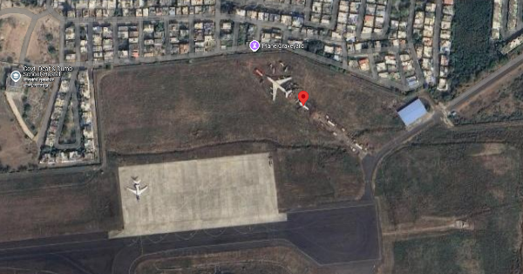
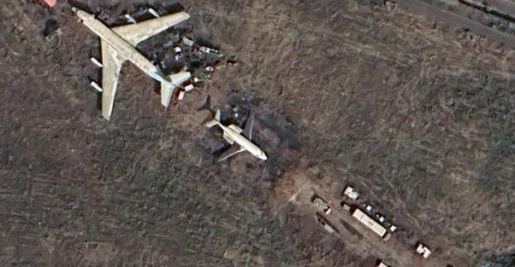

ENCLOSURE: II – PHOTOGRAPHS OF THE PROPERTY

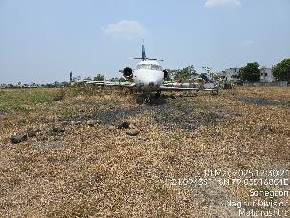 | 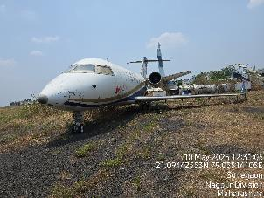
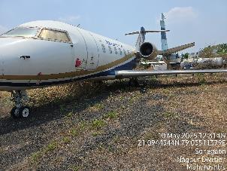 | 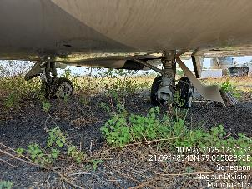
 | 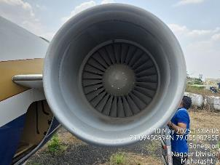

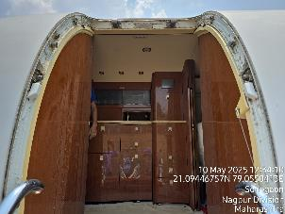 | 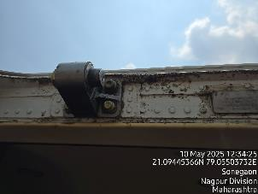
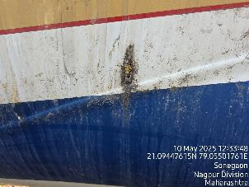 | 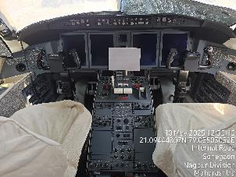
 | 

Door Fame & Body Corrosion
 | 
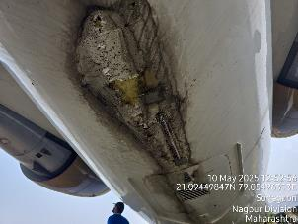 | 
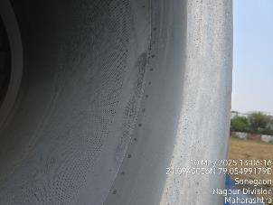 | 

 | 
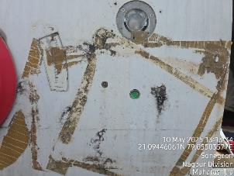 | 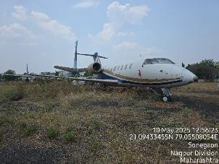
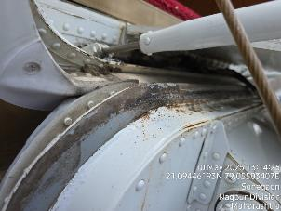 | 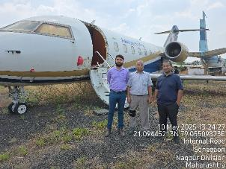

ENCLOSURE: III – IMPORTANT DOCUMENTS

Air Works maintenance quote
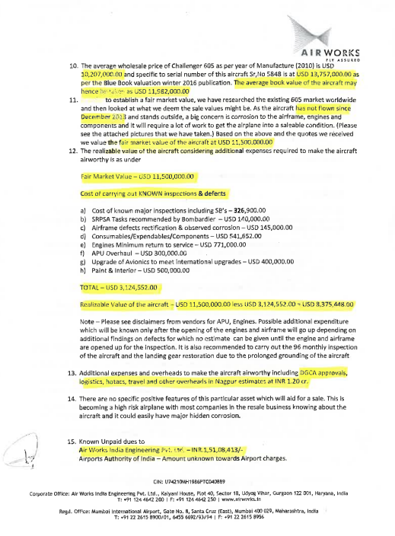

As per the maintenance quote dated 14th February 2017 from Air Works India Engineering Pvt. Ltd., the total maintenance & overhauling cost of the subject aircraft is USD 500,000. Bifurcation of the same is as follows: -
S. No. | Particulars | Values  (In USD)
1 | Cost of known major inspections SB’s | 326,900
2 | SRPSA tasks recommended by Bombardier | 140,000
3 | Airframe defects rectification & observed corrosion | 145,000
4 | Consumables/Expendables/components | 541,652
5 | Engine minimum return to service | 771,000
6 | APU overhaul | 300,000
7 | Upgrade of avionics to meet international upgrades | 400,000
8 | Paint & Interior | 500,000
Total repair & Maintenance cost as of 14-02-2017 |  | 31,24,552
The repair estimate on file was prepared in 2017 and the aircraft has remained inactive ever since, so the figures do not capture nearly a decade of rising labour, parts, and regulatory-compliance costs. Industry data show that maintenance expenses have risen substantially over the last 8–10 years; to reflect this cost inflation, and in the absence of a more recent quotation, we have prudently doubled the 2017 estimate. This 2× uplift is intended to approximate the amount that would have to be spent today to restore the aircraft to an airworthy condition as of the valuation date.  Thus, the repair & maintenance cost as of the date of valuation is - |  | 62,49,104
Market price for refurbished Challenger-605 aircraft |  | 10,850,000
Net Market Value of Subject Aircraft |  | 46,00,896
Or Say (in USD) |  | 4,600,000

Copy of Insurance
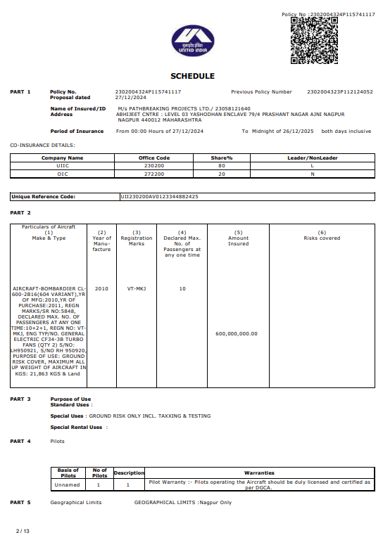

ENCLOSURE: IV – MARKET REFERENCE

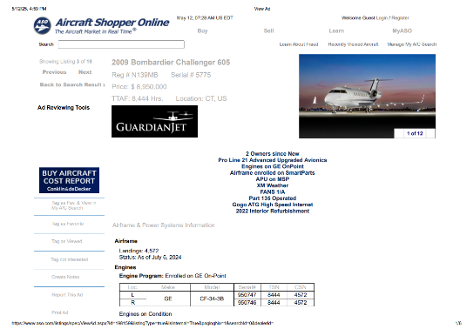
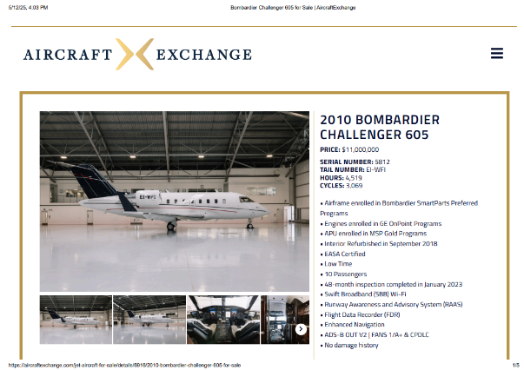

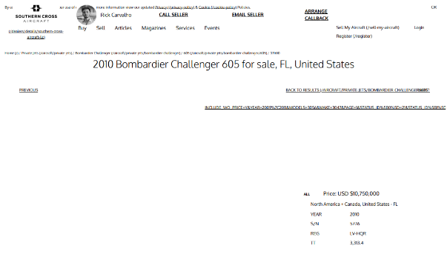
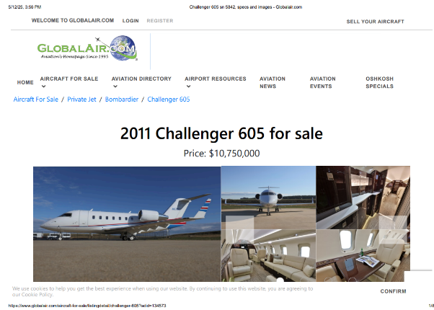

PART E | VALUER’S IMPORTANT REMARKS

Valuation is done for the asset found on as-is-where basis which owner/ owner representative/ client/ bank has shown/ identified to us on the site unless otherwise mentioned in the report of which some reference has been taken from the information/ data given in the copy of documents provided to us and informed verbally or in writing out of the standard checklist of documents sought from the client & its customer which they could provide within the reasonable expected time out of the standard checklist of documents sought from them and further based on certain assumptions and limiting conditions. The information, facts, documents, data which has become primary basis of the report has been supplied by the client which has been relied upon in good faith and is not generated by the Valuer.
The client/ owner and its management/ representatives warranted to us that the information they have supplied was complete, accurate and true and correct to the best of their knowledge. All such information provided to us either verbally, in writing or through documents has been relied upon in good faith and we have assumed that it is true & correct without any fabrication or misrepresentation. I/We shall not be held liable for any loss, damages, cost or expenses arising from fraudulent acts, misrepresentations, or willful default on part of the owner, company, its directors, employee, representative or agents.
Legal aspects for eg. Investigation of title, ownership rights, lien, charge, mortgage, lease, sanctioned maps, verification of documents provided to us such as title documents, Map, etc. from any concerned Govt. office etc. have to be taken care by legal expert/ Advocate and same is not done at our end. It is assumed that the concerned Lender/ Financial Institution has asked for the valuation of that property after satisfying the authenticity of the documents given to us for which the legal verification has been already taken and cleared by the competent Advocate before requesting for the Valuation report. I/ We assume no responsibility for the legal matters including, but not limited to, legal or title concerns.
In the course of the valuation, we were provided with both written and verbal information. We have however, evaluated the information provided to us through broad inquiry, analysis and review but have not carried out a due diligence or audit of the information provided for the purpose of this engagement. Our conclusions are based on the assumptions and other information provided to us by the client during the course of the assessment.
Getting cizra map or coordination with revenue officers for site identification is a separate activity and is not part of the Valuation services and same has not been done in this report unless otherwise stated.
Wherever any details are mentioned in the report in relation to any legal aspect of the property such as name of the owner, leases, etc. is only for illustration purpose and should not be construed as a professional opinion. Legal aspects are out of scope of this report. Details mentioned related to legal aspect are only based on the copy of the documents provided to us and whatever we can interpret as a non-legally trained person. This should be cross validated with a legal expert. We do not vouch any responsibility regarding the same.
We have made certain assumptions in relation to facts, conditions & situations affecting the subject of, or approach to this exercise that has not been verified as part of the engagement rather, treated as “a supposition taken to be true”. If any of these assumptions prove to be incorrect then our estimate on value will need to be reviewed.
This is just an opinion report based on technical & market information having general assessment & opinion on the indicative, estimated Market Value of the property for which Bank has asked to conduct the Valuation. It doesn’t contain any other recommendations of any sort including but not limited to express of any opinion on the suitability or otherwise of entering into any transaction with the borrower.
We have relied on the data from third party, external sources & information available on public domain to conclude the valuation. These sources are believed to be reliable and therefore, we assume no liability for the truth or accuracy of any data, opinions or estimates furnished by others that have been used in this analysis. Where we have relied on the data, opinions or estimates from external sources, reasonable care has been taken to ensure that such data is extracted from authentic sources, however we still can’t vouch its authenticity, correctness, or accuracy.
Analysis and conclusions adopted in the report are limited to the reported assumptions, conditions and information came to our knowledge during the course of the work and based on the Standard Operating Procedures, Best Practices, Caveats, Limitations, Conditions, Remarks, Important Notes, Valuation TOR and definition of different nature of values.
Value varies with the Purpose/ Date/ Asset Condition & situation/ Market condition, demand & supply, asset utility prevailing on a particular date/ Mode of sale. The indicative & estimated prospective Value of the asset given in this report is restricted only for the purpose and other points mentioned above prevailing on a particular date as mentioned in the report. If any of these points are different from the one mentioned aforesaid in the Report then this report should not be referred.
Our report is meant ONLY for the purpose mentioned in the report and should not be used for any other purpose. The Report should not be copied or reproduced for any purpose other than the purpose for which it is prepared for. I/we do not take any responsibility for the unauthorized use of this report.
We owe responsibility only to the authority/client that has appointed us as per the scope of work mentioned in the report. We will not be liable for any losses, claims, damages or liabilities arising out of the actions taken, omissions or advice given by any other person. In no event shall we be liable for any loss, damages, cost or expenses arising in any way from fraudulent acts, misrepresentations or willful default on part of the client or companies, their directors, employees or agents.
This report is having limited scope as per its fields & format to provide only the general basic idea of the value of the property prevailing in the market based on the site inspection and documents/ data/ information provided by the client. The suggested indicative prospective estimated value should be considered only if transaction is happened as free market transaction.
The sale of the subject property is assumed to be on an all-cash basis. Financial arrangements would affect the price at which the property may sell for if placed on the market.
The actual realizable value that is likely to be fetched upon sale of the asset under consideration shall entirely depend on the demand and supply of the same in the market at the time of sale.
While our work has involved an analysis & computation of valuation, it does not include detailed estimation, design/ technical/ engineering/ financial/ structural/ environmental/ architectural/ compliance survey/ safety audit & works in accordance with generally accepted standards of audit & other such works. The report in this work in not investigative in nature. It is mere an opinion on the likely estimated valuation based on the facts & details presented to us by the client and third party market information came in front of us within the limited time of this assignment, which may vary from situation to situation.
Where a sketched plan is attached to this report, it does not purport to represent accurate architectural plans. Sketch plans and photographs are provided as general illustrations only.
Documents, information, data including title deeds provided to us during the course of this assessment by the client is reviewed only upto the extent required in relation to the scope of the work. No document has been reviewed beyond the scope of the work. These are not reviewed in terms of legal rights for which we do not have expertise. Wherever any information mentioned in this report is mentioned from the documents like owners name, etc., it is only for illustration purpose and may not necessary represent accuracy.
The report assumes that the borrower/company/business/asset complies fully with relevant laws and regulations applicable in its area of operations and usage unless otherwise stated, and that the companies/business/assets is managed in a competent and responsible manner. Further, as specifically stated to the contrary, this report has given no consideration to matters of a legal nature, including issues of legal title and compliance with relevant laws, and litigations and other contingent liabilities that are not recorded/reflected in the documents/ details/ information/ data provided to us.
This valuation report is not a qualification for accuracy of land boundaries, schedule (in physical terms), dimensions & identification. For this land/ property survey report can be sought from a qualified private or Govt. surveyor.
This Valuation report is prepared based on the facts of the property on the date of the survey. Due to possible changes in market forces, socio-economic conditions, property conditions and circumstances, this valuation report can only be regarded as relevant as at the valuation date. Hence before financing, Banker/ FI should take into consideration all such future risk and should loan conservatively to keep the advanced money safe in case of the downward trend of the property value.
Valuation of the same asset/ property can fetch different values under different circumstances & situations. For eg. Valuation of a running/ operational shop/ hotel/ factory will fetch better value and in case of closed shop/ hotel/ factory it will have considerable lower value. Similarly, an asset sold directly by an owner in the open market through free market transaction then it will fetch better value and if the same asset/ property is sold by any financer due to encumbrance on it, will fetch lower value. Hence before financing, Lender/ FI should take into consideration all such future risks while financing and take decision accordingly.

Valuation is done for the property identified to us by the owner/ owner representative. At our end we have just visually matched the land boundaries, schedule (in physical terms) & dimensions of the property with reference to the documents produced for perusal. Method by which identification of the property is carried out is also mentioned in the report clearly. Responsibility of identifying the correct property to the Valuer/ its authorized surveyor is solely of the client/ owner for which Valuation has to be carried out. It is requested from the Bank to cross check from their own records/ information if this is the same property for which Valuation has to be carried out to ensure that owner has not misled the Valuer company or misrepresented the property due to any vested interest. Where there is a doubt about the precision position of the boundaries, schedule, dimensions of site & structures, it is recommended that a Licensed Surveyor be contacted.
In India more than 70% of the geographical area is lying under rural/ remote/ non municipal/ unplanned area where the subject property is surrounded by vacant lands having no physical demarcation or having any display of property survey or municipal number / name plate on the property clearly. Even in old locations of towns, small cities & districts where property number is either not assigned or not displayed on the properties clearly and also due to the presence of multiple/ parallel departments due to which ownership/ rights/ illegal possession/ encroachment issues are rampant across India and due to these limitations at many occasions it becomes tough to identify the property with 100% surety from the available documents, information & site whereabouts and thus chances of error, misrepresentation by the borrower and margin of chances of error always persists in such cases. To avoid any such chances of error it is advised to the Bank to engage municipal/ revenue department officials to get the confirmation of the property to ensure that the property shown to Valuer/ Banker is the same as for which documents are provided.
If this Valuation Report is prepared for the Flat/ dwelling unit situated in a Group Housing Society or Integrated Township then approvals, maps of the complete group housing society/ township is out of scope of this report and this report will be made for the specific unit based on the assumption that complete Group Housing Society/ Integrated Township and the subject unit must be approved in all respect.
Due to fragmented & frequent change in building/ urban planning laws/ guidelines from time to time, different laws/ guidelines between regions/ states and no strict enforceability of Building Bye-Laws in India specially in non-metro and scale b & c cities & Industrial areas, property owners many times extend or make changes in the covered area/ layout from the approved/ applicable limits. There are also situations where properties are decades old when there was no formal Building Bye-Laws applicable the time when the construction must have been done. Due to such discrete/ unplanned development in many regions sometimes it becomes tough for the Valuer to determine the exact lawful situation on ground. Unless otherwise mentioned in the report, the covered area present on the site as per site survey will be considered in the Valuation.
Area of the large land parcels of more than 2500 sq.mtr or of uneven shape in which there can be practical difficulty in sample measurement, is taken as per property documents which has been relied upon unless otherwise stated.

Drawing Map, design & detailed estimation of the property/ building is out of scope of the Valuation services.
Valuation is a subjective field and opinion may differ from consultant to consultant. To check the right opinion, it is important to evaluate the methodology adopted and various data point/ information/ factors/ assumption considered by the consultant which became the basis for the Valuation report before reaching to any conclusion.
Although every scientific method has been employed in systematically arriving at the value, there is, therefore, no indisputable single value and the estimate of the value is normally expressed as falling within a likely range.
Value analysis of any asset cannot be regarded as an exact science and the conclusions arrived at in many cases will, of necessity, be subjective and dependent on the exercise of individual judgment. Given the same set of facts and using the same assumptions, expert opinions may differ due to the number of separate judgment decisions, which have to be made. Therefore, there can be no standard formula to establish an indisputable exchange ratio. In the event of a transaction, the actual transaction value achieved may be higher or lower than our indicative analysis of value depending upon the circumstances of the transaction. The knowledge, negotiability and motivations of the buyers and sellers, demand & supply prevailing in the market and the applicability of a discount or premium for control will also affect actual price achieved. Accordingly, our indicative analysis of value will not necessarily be the price at which any agreement proceeds. The final transaction price is something on which the parties themselves have to agree. However, our Valuation analysis can definitely help the stakeholders to take informed and wise decision about the Value of the asset and can help in facilitating the arm’s length transaction.
This Valuation is conducted based on the macro analysis of the asset/ property considering it in totality and not based on the micro, component, or item wise analysis. Analysis done is a general assessment and is not investigative in nature.
This report is prepared on the RKA V-L1 (Basic) Valuation format as per the client requirement and scope of work. This report is having limited scope as per its fields & format to provide only the general estimated & indicative basic idea of the value of the property prevailing in the market based on the information provided by the client. No detailed analysis, audit or verification has been carried out of the subject property. There may be matters, other than those noted in this report, which might be relevant in the context of the transaction and which a wider scope might uncover.
This is just an opinion report and doesn’t hold any binding on anyone. It is requested from the concerned Client/ Bank/ Financial Institution which is using this report for mortgaging the property that they should consider all the different associated relevant & related factors & risks before taking any business decision based on the content of this report.
All Pages of the report including annexures are signed and stamped from our office. In case any paper in the report is without stamp & signature then this should not be considered a valid paper issued from this office.
As per IBA Guidelines & Bank Policy, in case the valuation report submitted by the valuer is not in order, the banks / FIs shall bring the same to the notice of the valuer within 15 days of submission for rectification and resubmission. In case no such communication is received, it shall be presumed that the valuation report has been accepted.
Defect Liability Period is 15 DAYS. We request the concerned authorized reader of this report to check the contents, data, information, and calculations in the report within this period and intimate us in writing at valuers@rkassociates.org within 15 days of report delivery, if any corrections are required or in case of any other concern with the contents or opinion mentioned in the report. If no intimation is received within 15 (Fifteen) days in writing from the date of issuance of the report, then it shall be considered that the report is complete in all respect and has been accepted by the client up to their satisfaction & use and further to which R.K Associates shall not be held responsible in any manner. After this period no concern/ complaint/ proceedings in connection with the Valuation Services will be entertained due to possible change in situation and condition of the property.
Though adequate care has been taken while preparing this report as per its scope, but still we can’t rule out typing, human errors, over sightedness of any information or any other mistakes. Therefore, the concerned organization is advised to satisfy themselves that the report is complete & satisfactory in all respect. Intimation regarding any discrepancy shall be brought into our notice immediately. If no intimation is received within 15 (Fifteen) days in writing from the date of issuance of the report, to rectify these timely, then it shall be considered that the report is complete in all respect and has been accepted by the client upto their satisfaction & use and further to which R.K Associates shall not be held responsible in any manner.
Our Data retention policy is of ONE YEAR. After this period we remove all the concerned records related to the assignment from our repository. No clarification or query can be answered after this period due to unavailability of the data.
This Valuation report is governed by our (1) Internal Policies, Processes & Standard Operating Procedures, (2) R.K Associates Quality Policy, (3) Valuation & Survey Best Practices Guidelines formulated by management of R.K Associates, (4) Information input given to us by the customer and (4) Information/ Data/ Facts given to us by our field/ office technical team. Management of R.K Associates never gives acceptance to any unethical or unprofessional practice which may affect fair, correct & impartial assessment and which is against any prevailing law. In case of any indication of any negligence, default, incorrect, misleading, misrepresentation or distortion of facts in the report then we request the user of this report to immediately or at least within the defect liability period to bring all such act into notice of R.K Associates management so that corrective measures can be taken instantly.
R.K Associates never releases any report doing alterations or modifications by pen. In case any information/ figure of this report is found altered with pen then this report will automatically become null & void.
We are fully aware that based on the opinion of value expressed in this report, we may be required to give testimony or attend court / judicial proceedings with regard to the subject assets, although it is out of scope of the assignment, unless specific arrangements to do so have been made in advance, or as otherwise required by law. In such event, the party seeking our evidence in the proceedings shall bear the cost/professional fee of attending court / judicial proceedings and my / our tendering evidence before such authority shall be under the applicable laws.
The final copy of the report shall be considered valid only if it is in hard copy on the company’s original letter head with proper stamp and sign on it of the authorized official upon payment of the agreed fees. User shall not use the content of the report for the purpose it is prepared for only on draft report, scanned copy, email copy of the report and without payment of the agreed fees. In such a case the report shall be considered as unauthorized and misused.

