**File No.: VIS (2025-26)-PL107-093-121 Dated: 15-05-2025**

**COST VETTING ASSESSMENT**

**OF**

**M/S. SHIVAN AUTO CENTER**

**PROPOSED TO BE AT**

**NH-24, MAYUR VIHAR, PHASE-II, NEW DELHI- 110091**

**REPORT PREPARED FOR**

**STATE BANK OF INDIA, SME BRANCH, SOUTH EXTENSION, PART-I,**

**NEW DELHI- 110024**

***\*\*Important - In case of any query/ issue or escalation you may please contact Incident Manager***

***at le@rkassociates.org. We will appreciate your feedback in order to improve our services.***

***NOTE: Please provide your feedback on the report within 15 days of its submission after which report will be considered to be correct***

**IMPORTANT NOTICE**

***COPYRIGHT FORMAT:*** *This report is prepared on the copyright format of R.K Associates to serve our clients with the best possible information and analysis to facilitate them to take rational business decisions. Legally no one can copy or distribute this format without prior approval from R.K Associates. It is meant only for the advisory/ reference purpose for the organization/s as mentioned on the cover page of this report. Distribution or use of this format by any organization or individual other than R.K Associates will be seen as an unlawful act and necessary legal action can be taken against the defaulters.*

*This report is intended for the sole use of the intended recipient/s and contains material that is STRICTLY CONFIDENTIAL AND PRIVATE.*

***DEFECT LIABILITY PERIOD:*** *- In case of any query/ issue or escalation you may please contact Incident Manager at le@rkassociates.org. We try to ensure maximum accuracy in the calculations done, rates adopted, assumptions taken and various other data points & information mentioned in the report but even still can’t rule out typing, human errors or any other bonafide mistakes. In case you find any such mistake or inaccuracy in any data point of the report, please help us by bringing all such points into our notice immediately or within 15 days of the r0eport delivery in writing, to rectify these timely failing after which R.K Associates won’t be held responsible for any such inaccuracy in any manner. We would highly appreciate your feedback in order to improve our services.*

|  |  |  |
| --- | --- | --- |
| **TABLE OF CONTENTS** | | |
|  | | |
| **SECTIONS** | **PARTICULARS** | **PAGE NO.** |
| **Part A** | **REPORT SUMMARY** | 04 |
| **Part B** | **COST VETTING ASSESSMENT** | 05 - 07 |
|  | 1. DESCRIPTION | 05 |
| 1. CIVIL WORKS | 05 – 07 |
| **Part C** | **PHOTOGRAPHS** | 08 |
| **Part D** | **IMPORTANT DOCUMENTS EXHIBIT** | 09 – 12 |
| **Part E** | **DISCLAIMER** | 13 |

|  |  |
| --- | --- |
| **PART A** | **REPORT SUMMARY** |

* **DOCUMENT NAME:** Cost Estimation Assessment.
* **PREPARED FOR:** State Bank of India, SME Branch, South Extension, Part-I, New Delhi - 110024
* **BORROWER:** M/s Shivan Auto Center.
* **ASSET TYPE**: Civil & Infrastructure development of petrol pump.
* **ADDRESS OF THE ASSET**: M/s Shivan Auto Center, proposed to be setup at NH-24, Mayur Vihar, Phase-II, New Delhi- 110091

|  |  |  |
| --- | --- | --- |
| **S. NO.** | **PARTICULARS** | **DESCRIPTION** |
|  | Date of Work Order | Via Letter dated 08-05-2025 |
|  | Date of site survey | Not Applicable (It is Cost Vetting Assessment) |
|  | Documents provided for perusal | Quotation. |
|  | Project Location | M/s Shivan Auto Center, proposed to be setup at NH-24, Mayur Vihar, Phase-II, New Delhi- 110091 |
|  | Borrowing Company | M/s Shivan Auto Center |
|  | Type of Assessment | Cost vetting. |
|  | Scope of Assessment | Cost Vetting of the Civil & Infrastructure work |
|  | Nature of Asset | Petrol Pump |
|  | Total Project Cost as informed by the borrower | **Rs. 2.79 Crore** (Including GST)  (*Including supply and installation as per the List/ quotations / invoices / Cost Estimate provided by the company.)* |
|  | Total number of pages with Annexure. | 12 |

|  |  |
| --- | --- |
| **PART B** | **COST VETTING ASSESSMENT** |

1. **DESCRIPTION**

This is a cost vetting assessment report Civil & Infrastructure development work of proposed Petrol Pump to be setup at aforesaid address. As per the documents and drawing provided, the client proposed to construct the IOCL Petrol Pump. The subject locality is adjacent to NH-24 Delhi-Meerut Expressway.

This is only a cost vetting report and does not contain any physical progress of the said work.

1. **BUILDING & CIVIL WORKS:**

The cost involved in the construction of proposed structures and other civil work has been calculated from our analysis and market research. For reference we have considered CPWD DSR 2023 and the calculation is mentioned in table below:

|  |  |  |  |
| --- | --- | --- | --- |
| **S.**  **NO.** | **DESCRIPTION** | **Amount**  **(In Rs.)** | **Remarks** |
| **1** | **Site Preparation Work** | 6,22,780 | As per the detailed breakdown of the Civil and Infrastructure work for the petrol pump project of M/s Shivan Auto Center, submitted by M/s Beesebridge Enterprises Private Limited dated 01-06-2024, the proposed total cost for civil and infrastructure works is ₹2,79,39,556/- (inclusive of GST and erection charges).  The quotation has been provided in a comprehensive PDF document spanning 117 pages, which includes an item-wise cost estimation for all construction activities.  We have thoroughly cross-verified the quoted rates for key components of the project such as soil work, cement usage, foundation construction, columns, retaining walls, TMT bars, granite installation, steel works, and structural tubes. These have been compared against the Delhi Schedule of Rates (DSR) 2023.  Based on our assessment, the construction rates quoted in the submitted document are largely consistent with the prevailing DSR-2023 rates. Therefore, it can be reasonably concluded that the quoted cost for the proposed civil and infrastructure work is fair, competitive, and in line with standard market practices. |
|  | Excavation levelling and filling |
|  | Soil compaction and disposal of debris |
| **2** | **Civil Construction** | 1,89,82,763 |
|  | Driveway and driveway curbs |
|  | Office building and sales room |
|  | Canopy foundation and structure |
|  | Toilet block and underground water tank |
|  | Compound wall and security cabin |
| **3** | **Electrical & Lightening** | 12,16,313 |
|  | Electrical wiring and panel installation |
|  | Canopy lighting and area illumination |
|  | Earthing and lighting protection |
| **4** | **Plumbing & Drainage** | 7,46,494 |
|  | Underground piping for water & sewage |
|  | Stormwater drainage |
|  | Pumping system for water supply |
| **5** | **Forecourt Development** | 6,38,440 |
|  | Paver block flooring |
|  | Installation of fuel dispensers (civil foundation only) |
|  | Marking and signage installation |
| **6** | **Miscellaneous** | 5,38,296 |
|  | Firefighting pipeline base work |
|  | Rainwater harvesting providing |
|  | Road signage and barricading |
| **TOTAL** | | **2,27,15,086** |  |
| **GST @ 18%** | | **40,88,715** |  |
| **Commissioning & Erection charges** | | **11,35,754** |  |
| **Grand Total** | | **2,79,39,555** |  |

**REMARKS:**

1. We have verified the cost/rates mentioned in the quotation on sample basis which available Delhi Schedule of Rates (DSR) 2023.
2. Generally, DSR rates have 10-20% cushion concerning Market Rates and accordingly adjustments can be made.
3. Cost difference may be there when labour is deployed through local contractor on daily basis Vs engaging EPC contractor and also difference in using concrete mixer at site Vs using of RMC.

|  |  |
| --- | --- |
| **PART C** | **PHOTOGRAPHS** |

***NO PHOTOGRAPHS ARE AVAILABLE BECAUSE COST VETTING IS DONE PURELY ON THE BASIS OF QUOTATIONS***

|  |  |
| --- | --- |
| **PART D** | **IMPORTANT DOCUMENT EXHIBIT** |

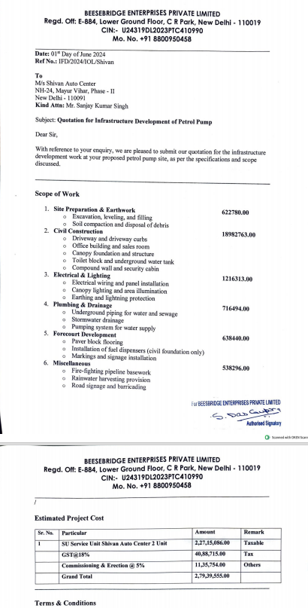

**Layout Plan**

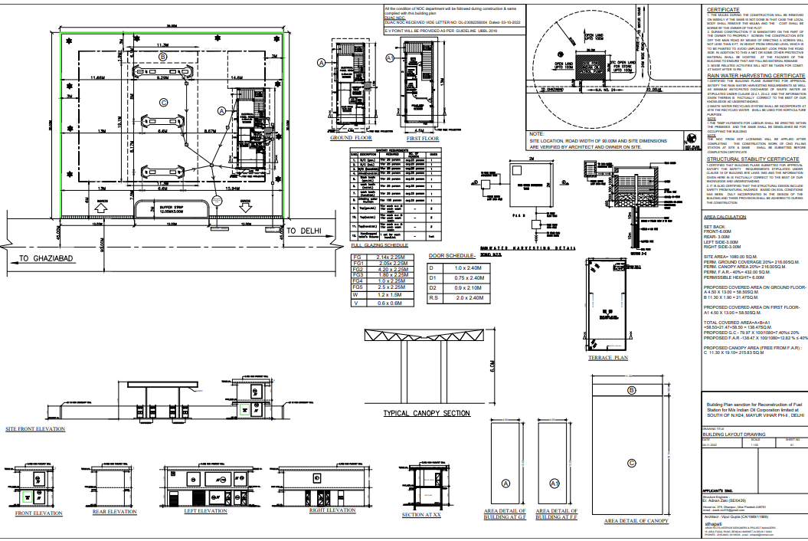

**Detailed Quotation: Sample Page**

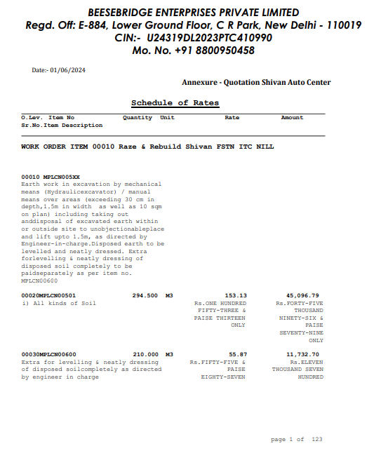

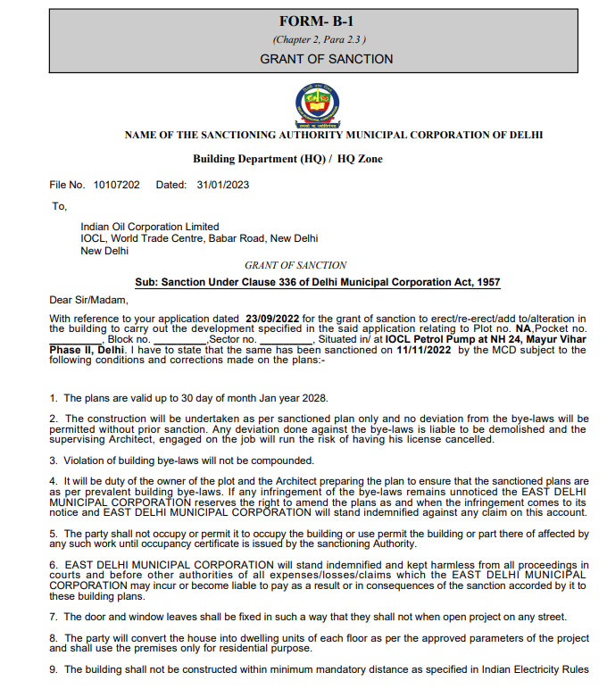

|  |  |
| --- | --- |
| **ART E** | **DISCLAIMER** |

1. *We have only received quotations for construction and civil work and no physical verification has been done.*
2. *The client/ owner and its management/ representatives warranted to us that the information they have supplied was complete, accurate and true and correct to the best of their knowledge. All such information provided to us either verbally, in writing or through documents has been relied upon in good faith and we have assumed that it is true & correct without any fabrication or misrepresentation. I/We shall not be held liable for any loss, damages, cost or expenses arising from fraudulent acts, misrepresentations, or willful default on part of the owner, company, its directors, employee, representative or agents.*
3. *Legal aspects for e.g. Investigation of title, ownership rights, lien, charge, mortgage, lease, sanctioned maps, and verification of documents provided to us such as title documents, Map, etc. from any concerned Govt. office etc. have to be taken care by legal expert/ Advocate and same is not done at our end. I/ We assume no responsibility for the legal matters including, but not limited to, legal or title concerns.*
4. *Wherever any details are mentioned in the report in relation to any legal aspect of the property such as name of the owner, leases, etc. is only for illustration purpose and should not be construed as a professional opinion. Legal aspects are out of scope of this report. Details mentioned related to legal aspect are only based on the copy of the documents provided to us and whatever we can interpret as a non-legally trained person. This should be cross validated with a legal expert. We do not vouch any responsibility regarding the same.*
5. *We have relied on the data from third party, external sources & information available on public domain to conclude the valuation. These sources are believed to be reliable and therefore, we assume no liability for the truth or accuracy of any data, opinions or estimates furnished by others that have been used in this analysis. Where we have relied on the data, opinions or estimates from external sources, reasonable care has been taken to ensure that such data is extracted from authentic sources, however we still can’t vouch its authenticity, correctness, or accuracy.*
6. *Documents, information, data including provided to us during the course of this assessment by the client is reviewed only upto the extent required in relation to the scope of the work. No document has been reviewed beyond the scope of the work. These are not reviewed in terms of legal rights for which we do not have expertise. Wherever any information mentioned in this report is mentioned from the documents like owner’s name, etc., it is only for illustration purpose and may not necessarily represent accuracy.*
7. *This cost vetting is done only on the basis of market research and BOQ provided to us by the company and we don’t recommend any sort of recommendation in our Document.*
8. *The estimated cost verification of item to item can’t exactly match as per our vetting due to several market consideration. In some of the items it is lower while in some of the item’s price comes to be higher but on an average the price as per list provided to us falls in the range as confirmed by us.*
9. *There can be variation in the estimated price if the specification & make of any items procured is different from the list provided to us during assessment.*
10. *The estimated cost verification is made based on the third-party information which has been replied upon in good faith.*
11. *Ownership and other legal point of view in respect of the asset is not considered in this report as same is out of scope of this document.*
12. *This document is made at the request of the Bank.*

**For R.K Associates Valuers** **& Techno** **FOR INTERNAL USE Engineering Consultants (P) Ltd. *PREPARED BY: Manmohan Dubey***  ***REVIEWED BY: Abhinav Chaturvedi***