REPORT FORMAT: CL-1 | Version: 1.0_2018

FILE NO.: VIS (2025-26)-PL148-125-160 Date: 27/05/2025

- CERTIFICATE NAME: Rent Assessment Certificate for a commercial shop situated at Village Atmalpur Bongla, Pargana Jwalapur, Tehsil & District- Haridwar, Pincode- 249402 (Uttarakhand).
- PREPARED FOR: IDBI Bank Ltd, Atmalpur Bongla Branch, Haridwar

- ASSET TYPE: Commercial Unit

- LOCATION OF THE BUILDING: Village Atmalpur Bongla, Pargana Jwalapur, Tehsil & District- Haridwar, Pincode- 249402 (Uttarakhand).

TO WHOM IT MAY CONCERN

S.  NO. | PARTICULARS | DESCRIPTION
1. | Date of Survey | 27/05/2025
2. | Date of Certificate | 27/05/2025
3. | Documents provided  for perusal | Lease Deed (Dated- 03/09/2015)
4. | Location of the Building | Village Atmalpur Bongla, Pargana Jwalapur, Tehsil & District- Haridwar, Pincode- 249402 (Uttarakhand).
5. | Borrower/Lessee | IDBI Bank Ltd, Atmalpur Bongla Branch, Haridwar
6. | Type of Asset | Commercial Unit
7. | Type of Assessment | Rent Assessment
8. | Scope of Assessment | To assess the ongoing market rent of the commercial unit
9. | Nature of Building | Commercial
10. | Year of Construction | 2010
11. | Total Purchase Cost /  Expenses Incurred | No information provided

12. | Total Capet Area of  the property (as per documents provided by bank) | 530 sq.ft / 49.26 sq.mtr
13. | Area Adopted | Area adopted on the basis of the Lease Deed provided to us by the bank.
14. | Current Estimated Market Value | As per the discussion with the property consultant of the subject location we came to know that ongoing rent for the commercial property in the subject vicinity varies within the rate range of Rs.42/- to Rs.46/- per sq. ft./month on carpet area. For ready to move-in properties depending upon the various amenities, floor and location of the property. These rates are for the commercial unit at and around the subject location.

OBSERVATIONS:

- We have been provided with the copy of the Lease Deed and TIR through which we have considered the carpet area of the property.
- During the time of our site visit we have found that presently the property is occupied by IDBI Bank Ltd, Atmalpur Bongla Branch, Haridwar.

- Monthly Rental Income vetted for the subject property is for the commercial unit at the subject location.
- Based on our market research proposed monthly rent of the subject property for above mentioned area of 530 sq.ft / 49.26 sq.mtr works out in the range of Rs.22,000/- to Rs.24,000/- per month

Disclaimer:

  - This certificate is to be referred only for the purpose of the rent assessment of the commercial unit situated at the aforesaid address.
  - This certificate doesn’t include any work related to drawing, design, sketch plan, procurement of the building structure.
  - Ownership and other legal point of view in respect of the asset is not considered in this report as same is out of scope of this certificate.
  - This certificate is made at the request of IDBI Bank Ltd, Atmalpur Bongla Branch, Haridwar.

For R.K Associates Valuers & Techno FOR INTERNAL USE
Engineering Consultants (P) Ltd. TYPED BY: Er. Kuldeep Majumder REVIEWED BY: Er. Anil kumar

ANNEXURE: I-

COPY OF LEASE DEED

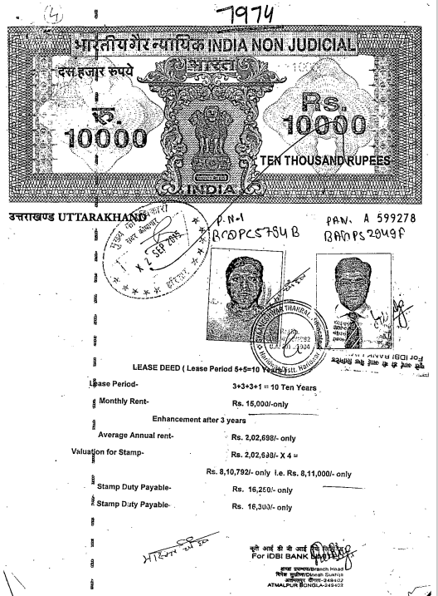

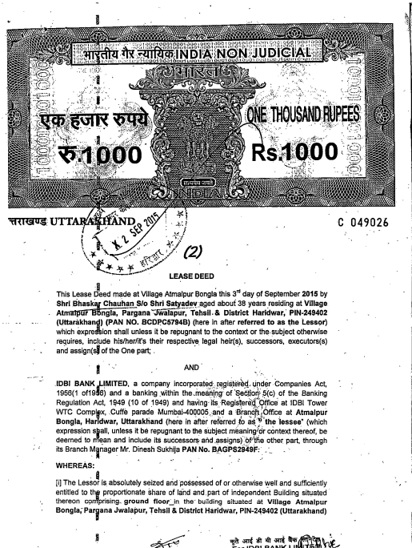

COPY OF TIR

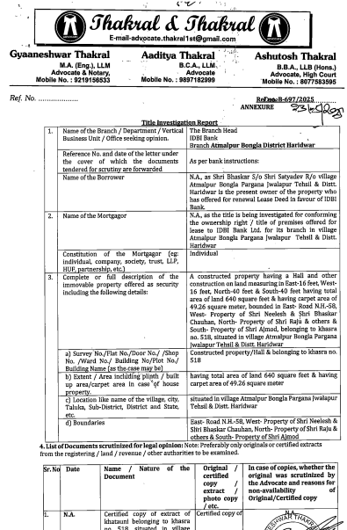
ANNEXURE: II- COPY PHOTOGRAPHS PF PROPERTY
