**REPORT FORMAT:** V-L1 (Basic) | Version: 1.0

# File No.: VIS(2021-22)-PL08-005-005 Dated: 07.04.2021

**GENERAL ASSESSMENT OF RENTAL VALUE IN**

**COMMERCIAL PREMISES**

# SITUATED AT

**SPAZE CORPORATE PARK, SECTOR-69, GURUGRAM**

**REPORT PREPARED FOR**

**STATE BANK OF INDIA, REGION-4, ADMIN OFFICE-4, CRM CAMPUS-II, SECTOR-18, GURUGRAM, HARYANA-122015**

***\*\*Important - In case of any query/ issue or escalation you may please contact Incident Manager***

***at valuers@rkassociates.org. We will appreciate your feedback in order to improve our services.***

***NOTE: As per IBA Guidelines please provide your feedback on the report within 15 days of its submission after which report will be considered to be correct.***

**RENTAL REPORT DESCRIPTION**

|  |  |  |
| --- | --- | --- |
| **S.NO.** | **PARTICULARS** | **DETAILS** |
|  | Report prepared for | Bank |
|  | Purpose of Valuation | Rental Assessment for internal purpose |
|  | Address of the Property | Spaze Corporate Park, Sector-69, Gurugram |
|  | Owner/ Landlord Name | General assessment of prevailing rental in subject premises |
|  | Lessee Name | General assessment of prevailing rental in subject premises |
|  | Type of Property | Commercial Office |
|  | Floor on Rent | NA |
|  | Carpet/ Covered Area | General assessment of prevailing rental in subject premises for an office space having built-up area 1500 sq.ft. |
|  | Total No. of Floors | G+12 Floors |
|  | Total No. of Rooms | Not applicable since this is only general assessment of prevailing rental in subject premises and no internal site survey has been done |
|  | Total No. of W/C | Not applicable since this is only general assessment of prevailing rental in subject premises and no internal site survey has been done |
|  | Type of Flooring | As per the requirement of the lessee |
|  | Quality of Construction | Class A Structure (Very Good) |
|  | Appearance of Structure | Good |
|  | Condition of the Structures | Good |
| External | Good |
| Internal | Good |
|  | Roof | RCC |
|  | Finishing & Beautification | Good |
|  | Approximate Monthly Rent | * **Basic Rate on Built-up Area on Ground Floor-**    + Front Side (road facing shops near Axis Bank)   : Rs.230/- to Rs.250/- per sq.ft.   * + Front Side (not road facing but located on the front)   : Rs.200/- to Rs.220/- per sq.ft.   * + Rear Side: Rs.140/- to Rs.160/- per sq.ft. * **Upper Floors:** Rs.100/- to Rs.120/- per sq.ft. * **CAM Charges on Built-up Area:**   + Rs.30/- to Rs.36/- per sq.ft. |
|  | Security Amount Details | To be decided between the Lessor and the Lessee by mutual negotiations |
|  | Rent Agreement Period | Generally, for a period of 3 yrs. in the subject location. However, no such documentary evidence is provided to us. |

|  |  |  |
| --- | --- | --- |
| CALCULATION | | |
|  | Present Prevailing Market Rental in the Area | * **Basic Rate on Built-up Area on Ground Floor-**    + Front Side (road facing shops near Axis Bank)   : Rs.230/- to Rs.250/- per sq.ft.   * + Front Side (not road facing but located on the front)   : Rs.200/- to Rs.220/- per sq.ft.   * + Rear Side: Rs.140/- to Rs.160/- per sq.ft. * **Upper Floors:** Rs.100/- to Rs.120/- per sq.ft. * **CAM Charges on Built-up Area:**   + Rs.30/- to Rs.36/- per sq.ft. |
|  | Rental Rate adopted after considering the characteristics of the property | Only general assessment of prevailing rental in subject premises. |
|  | Carpet Area of the Premises to be Rented | General assessment of prevailing rental in subject premises for an office space. |
|  | Rental Value by adopting PMR | Only general assessment of prevailing rental in subject premises. |
|  | Rounded off | Only general assessment of prevailing rental in subject premises. |
|  | Source Of Information | 1. **Name**: Mr. Gopal Arora (Property Consultant)   **Contact No.**: +91-9873399733  **Size of the Property**: General Rate Enquiry.  **Rates/ Price informed**: Rs.70/- to Rs.125/- per sq.ft. on super area (Rs.15/- to Rs.18/- PSF- maintenance charges extra) on Ground Floor  **Comment**: As per the discussion held with the above mentioned property dealer we came to know that the rental rates in the concerned area were around Rs.70/- to Rs.125/- per sq.ft. on super area (Rs.15/-to Rs.18/- PSF- maintenance charges extra) on GF. The asking rental rate of the front side shops which are near to axis bank & road facing may vary from Rs.115/- to Rs.125/- PSF & shops which are not road facing but situated on the front are Rs.100/- to Rs.110/- & rental on rear side shops may be Rs.70/- to Rs.80/- PSF. The asking rental rates for the offices situated on Upper Floors may vary from Rs.50/- to Rs.60/- PSF.   1. **Name**: Mr. Jitender Lohia (Property Consultant)   **Contact No.**: +91-9891614600  **Size of the Property**: General Rate Enquiry.  **Rates/ Price informed**: Rs.75/- to Rs.125/- per sq.ft. on super area (Rs.15/- to Rs.18/- PSF- maintenance charges extra) on Ground Floor.  **Comment**: As per the discussion held with the above mentioned property dealer we came to know that the rental rates in the concerned area were around Rs.75/- to Rs.125/- per sq.ft. on super area (Rs.15/- to Rs.18/- PSF- maintenance charges extra) on GF. The asking rental rate of the front side shops which are near to axis bank & road facing may vary from Rs.115/- to Rs.125/- PSF & shops which are not road facing but situated on the front are Rs.100/- to Rs.110/- & rental on rear side shops may be Rs.75/- to Rs.80/- PSF. The asking rental rates for the offices situated on Upper Floors may vary from Rs.50/- to Rs.60/- PSF. |
|  | Adopted Rate Justification | As per the discussion with the above-mentioned property dealers & local people, we came to know following information regarding Spaze Corporate Park:   * Basic Rate on Super Area on Ground Floor-   + Front Side (road facing shop near Axis Bank)   : Rs.115/- to Rs.125/- per sq.ft.   * + Front Side (not road facing but located on the front)   : Rs.100/- to Rs.110/- per sq.ft.   * + Rear Side: Rs.70/- to Rs.80/- per sq.ft. * Upper Floors: Rs.50/- to Rs.60/- per sq.ft. * CAM Charges on Super Area:   Rs.15/- to Rs.18/- per sq.ft.   * The rental are only available on super area and as per the general market survey the carpet/ built-up area is 50% of the super area. i.e. a loading of 100% on built-up area. * In retails shop/offices, the developers offers single halls which do not have any partition walls. So, the carpet area is almost similar to the built-up area.   So, keeping all the above mentioned factors in mind we are of the view that rental rates for front side shops which are road facing located near Axis Bank may vary between Rs.230/- to Rs.250/- and shops which are not road facing but situated on the front may vary between Rs.200/- to Rs.220/- per sq.ft. on built-up area & rear side shops my vary between Rs.140/- to Rs.160/- per sq.ft. on built-up area (Rs.30/- to Rs.36/- per sq.ft. maintenance charges etc.)  For more details & comparable to the subject property, kindly refer to the sheet attached below. |

# 

***Important Notes: -***

1. *This certificate is made for Rental Assessment for internal purpose.*
2. *This certificate doesn’t include map, design and sketch plan in the scope of work.*
3. *We have not provided with any legal documents by the bank and ownership and other legal point of view in respect of the property are not under the scope of this report.*
4. *Legal aspect of the property in terms of ownership and legal rights is not under the scope of this report.*
5. *This certificate is made at the request of State Bank of India, Region-4, Admin Office-4, CRM Campus-II, Sector-18, Gurugram, Haryana-122015*

|  |  |  |  |
| --- | --- | --- | --- |
|  | **DECLARATION** | | |
|  | 1. The property was inspected by our authorized surveyor on 6 April 2021 by name AE Harshit Mayank in the presence of no one. 2. The undersigned does not have any direct/indirect interest in the above property. 3. The information furnished herein is true and correct to the best of our knowledge. 4. We have submitted Valuation report directly to the Bank. 5. This Rental Report is prepared by our Engineering team on the request from **State Bank of India, Region-4, Admin Office-4, CRM Campus-II, Sector-18, Gurugram, Haryana-122015.** | | |
|  | **Name & Address of Valuer company** | **Wealth Tax Registration No.** | **Signature of the authorized person** |
| M/s R.K. Associates Valuers & Techno Engineering Consultants Pvt. Ltd. D-39, 2nd Floor, Sector-02, Noida, U.P |  |  |
|  | **Enclosed Documents** | 1. Valuer’s Remark - Page No.8-9 2. Screenshot of the price trend references of the similar related properties available on public domain – Pages xx 3. Google Map – Pages 01 4. Photographs – Pages 02 5. Copy of Circle Rate – Pages No.x 6. Survey Summary Sheet – Pages x 7. Copy of relevant papers from the property documents referred in the Valuation – Pages No. x | |
|  | **Total Number of Pages in the Report with Enclosures** | 12 | |
|  | **Engineering Team worked on the report** | ***SURVEYED BY:*** *AE Harshit Mayank* | |
| ***PREPARED BY:*** *AE Namrata Rawat* | |
| ***REVIEWED BY: HOD Valuations*** | |

**R.K ASSOCIATES IMPORTANT NOTES:**

1. ***DEFECT LIABILITY PERIOD****- In case of any query/ issue or escalation you may please contact Incident Manager by writing at valuers@rkassociates.org. We ensure 100% accuracy in the Calculations done, Rates adopted and various other data points & information mentioned in the report but still can’t rule out typing, human errors or any other mistakes. In case you find any mistake, variation, discrepancy or inaccuracy in any data point of the report, please help us by bringing all such points into our notice in writing at* [*valuers@rkassociates.org*](mailto:valuers@rkassociates.org)*within 30 days of the report delivery, to get these rectified timely, failing which R.K Associates won’t be held responsible for any inaccuracy in any manner. Also if we will not hear back anything from you within 30 days, we will assume that report is correct in all respect and no further claim of any sort will be entertained thereafter. We would welcome and appreciate your feedback & suggestions in order to improve our services.*
2. ***COPYRIGHT FORMAT*** *- This report is prepared on the copyright format of R.K Associates to serve our clients in the best possible way. Legally no one can copy or distribute this format without prior approval from R.K Associates. It is meant only for the organization as mentioned on the cover page of this report. Distribution or use of this format other than R.K Associates will be seen as unlawful act and necessary legal action can be taken against the defaulters.*

***IF REPORT IS USED FOR BANK/ FIs***

***NOTE:*** *As per IBA Guidelines in case the valuation report submitted by the valuer is not in order, the banks / FIs shall bring the same to the notice of the valuer within 15 days of submission for rectification and resubmission. In case no such communication is received, it shall be presumed that the valuation report has been accepted.*

***At our end we have not verified the authenticity of any documents provided to us. Bank is advised to verify the genuineness of the property documents before taking any credit decision.***

**ENCLOSURE: 1– VALUER’S REMARKS**

|  |  |
| --- | --- |
|  | **Fair Market Value#**suggested by the competent Valueris that prospective estimated amountof the subject asset/ property in his expert & prudent opinionwithout any prejudiceafter he has carefully & exhaustively evaluated all the facts & information related to the subject asset at which the subject asset/ property should be exchanged between a willing buyer and willing seller at an arm’s length transaction after proper marketing, wherein the parties, each acted knowledgeably, prudently and without any compulsion on the date of the Valuation. |
|  | **Realizable Value^** is the minimum prospective value of the property which it may be able to realize at the time of actual property transaction factoring in potential prospects of deep negotiations carried out between the buyer & seller for ultimately finalizing the transaction. Realizable value may be 10-20% less of the Fair Market Value depending on the various salability prospects of the subject property. |
|  | **Forced/ Distress Sale Value\*** is the value when the property has to be sold due to any compulsion or constraint like financial encumbrances, dispute, as a part of a recovery process, any defect in the property, having unclear title or any such sort of condition or situation. In this type of sale minimum disposable value is assessed which varies from 20-35% less from the Fair Market Value based on the nature, size &salability prospects of the property. In this type of sale negotiation power of the buyer is always more than the seller and eagerness of selling the property is more than buying it. Therefore the Forced/ Distress Sale Value always fetches less value. |
|  | Best rates are rationally adopted based on the facts of the case came to our knowledge during the course of the assignment considering many factors like nature of the property, size, location, approach, market situation and trends. |
|  | Construction rates are adopted based on present replacement cost of construction and calculating applicable depreciation & deterioration factor as per its existing condition, specifications based on the visual observation of the structure. No structural, physical tests have been carried out in respect of it. |
|  | This Valuation report is prepared based on the facts of the property on the date of the survey. However in future property Market may go down, property conditions may change or may go worse, Property reputation may differ, Property vicinity conditions may go down or become worse, Property market may change due to impact of Govt. policies or effect of World economy, Usability prospects of the property may change, etc. Hence before financing, Banker/ FI should take into consideration all such future risk and should loan conservatively to keep the advanced money safe in case of the downward trend of the property value. |
|  | Valuation of the same asset/ property can fetch different values in different situations. For eg. Valuation of a running/ operational shop/ hotel/ factory will fetch better value and in case of closed shop/ hotel/ factory it will have considerable lower value. Similarly an asset sold directly by an owner in the market will fetch better value and if the same asset/ property is sold by any financer due to encumbrance on it will fetch lower value. Hence before financing, Banker/ FI should take into consideration all such future risk and should loan conservatively to keep the advanced money safe in case of any such situation. |
|  | No employee or member of R.K Associates has any direct/ indirect interest in the property. |
|  | Sale transaction method of the asset is assumed as free market transaction while assessing Fair Prospective Market Value of the asset. |
|  | Area measurements considered in the Valuation Report pertaining to Land & Building is adopted from relevant approved documents or actual site measurement whichever is less. All area measurements are on approximate basis only. |
|  | This report is having limited scope as per its fields to provide only the general basic idea of the value of the property prevailing in the market based on the documents/ data/ information provided by the client. The suggested value should be considered only if transaction is happened as free market transaction. |
|  | The condition assessment and the estimation of residual economic life of the structure is based on the visual observations and appearance found during the site survey. We have not carried out any structural design or stability study; nor carried out any physical tests to assess structural integrity & strength. |
|  | This report is prepared based on the copies of the documents/ information which interested organization or customer could provide to us out of the standard checklist of documents sought from them and further based on our assumptions and limiting conditions. All such information provided to us has been relied upon and we have assumed that it is true and correct. Verification or cross checking of the documents provided to us from the originalshas not been done at our end. If at any time in future it’s found or came to our knowledge that misrepresentation of facts or incomplete or distorted information has been provided to us then this report will automatically become null & void. |
|  | Investigation of title of the property and its legal right is beyond the scope of this report. If this property is offered as collateral security, then concerned financial institution is requested to verify & satisfy themselves on the ownership & legality of the property shown in this valuation report with respect to the latest legal opinion. |
|  | Value varies with the Purpose/ Date/ Condition of the market. This report should not to be referred if any of these points are different from the one mentioned aforesaid in the Report. The Value indicated in the Valuation Report holds good only upto the period of 3 months from the date of Valuation. |
|  | Analysis and conclusions adopted in the report are limited to the reported assumptions, conditions and information came to our knowledge during the course of the work. |
|  | This report is prepared on the RKA V-L3 (Medium) Valuation format as per the client requirement, charges paid and the time allotted. This report is having limited scope as per its fields to provide only the general estimated basic idea of the value of the property prevailing in the market based on the information provided by the client. The Valuation assessed in this Valuation Report should hold good only if transaction is happened as per free market transaction. No detailed analysis or verification of the information is carried upon pertaining to the value of the subject property. No claim for any extra information will be entertained whatsoever be the reason. For any extra work over and above the fields mentioned in the report will have an extra cost which has to be borne by the customer. |
|  | This is just an opinion report and doesn’t hold any binding on anyone. It is requested from the concerned Client/ Bank/ Financial Institution which is using this report for mortgaging the property that they should consider all the different associated relevant & related factors also before taking any business decision based on the content of this report. |
|  | All Pages of the report including annexures are signed and stamped from our office. In case any paper in the report is without stamp & signature then this should not be considered a valid paper issued from this office. |
|  | Defect Liability Period is **30 DAYS**. We request the concerned authorized reader of this report to check the contents, data and calculations in the report within this period and intimate us in writing if any corrections are required or in case of any other concern with the contents or opinion mentioned in the report. Corrections only related to typographical, calculation, spelling mistakes will be entertained within the defect liability period. No request for any illegitimate value revision, date change or any other change will be entertained other than the one mentioned above. |
|  | R.K Associates encourages its customers to give feedback or inform concerns over its services through proper channel at [**valuers@rkassociates.org**](mailto:valuers@rkassociates.org) in writing within 30 days of report delivery. After this period no concern/ complaint/ proceedings in connection with the Valuation Services can be entertained due to possible change in situation and condition of the property. |
|  | Our Data retention policy is of **ONE YEAR**. After this period we remove all the concerned records related to the assignment from our repository. No clarification or query can be answered after this period due to unavailability of the data. |
|  | This Valuation report is governed by our (1) Internal Policies, Processes & Standard Operating Procedures, (2) R.K Associates Quality Policy, (3) Valuation & Survey Best Practices Guidelines formulated by management of R.K Associates, (4) Information input given to us by the customer and (4) Information/ Data/ Facts given to us by our field/ office technical team. Management of R.K Associates never gives acceptance to any unethical or unprofessional practice which may affect fair, correct & impartial assessment and which is against any prevailing law. In case of any indication of any negligence, default, incorrect, misleading, misrepresentation or distortion of facts in the report then it is the responsibility of the user of this report to immediately or atleast within the defect liability period bring all such act into notice of R.K Associates management so that corrective measures can be taken instantly. |
|  | R.K Associates never releases any report doing alterations or modifications from pen. In case any information/ figure of this report is found altered with pen then this report will automatically become null & void. |
|  | If this report is prepared for the matter under litigation in any Indian court, no official or employee of R.K Associates will be under any obligation to give in person appearance in the court as a testimony. For any explanation or clarification, only written reply can be submitted on payment of charges by the plaintiff or respondent which will be 10% of the original fees charged where minimum charges will be Rs.2500/-. |

**ENCLOSURE: 2 – GOOGLE MAP LOCATION**

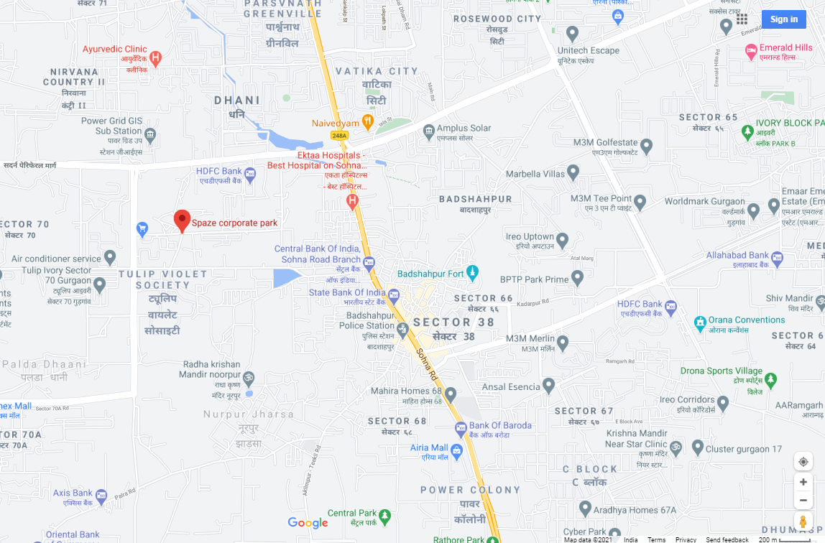

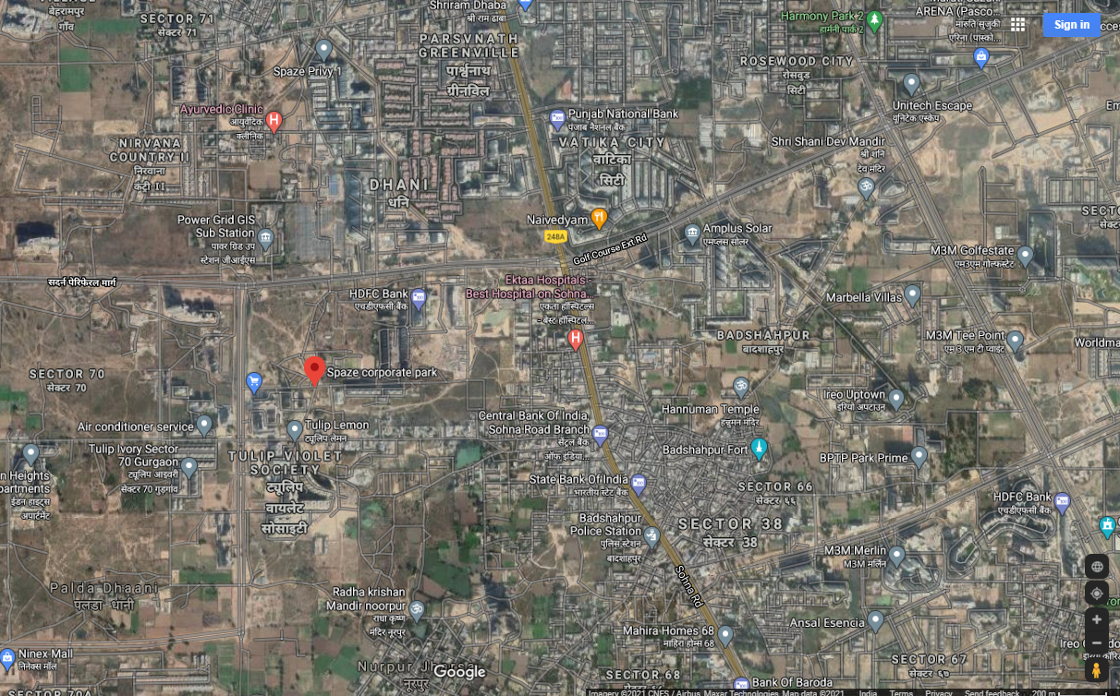

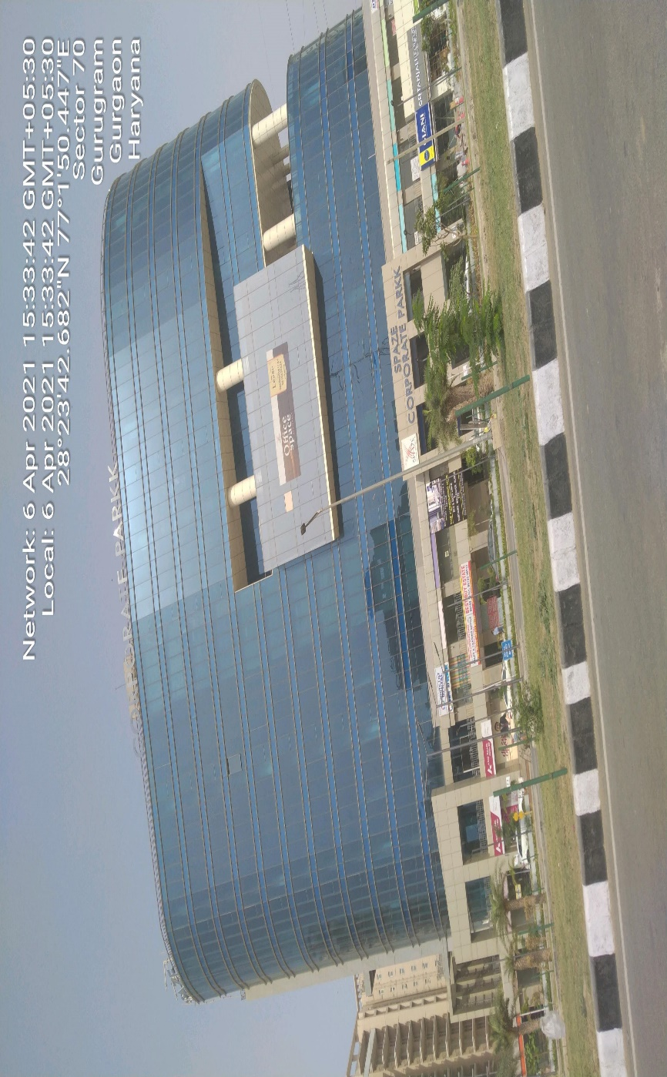**ENCLOSURE: 3 – PHOTOGRAPHS**

