**REPORT FORMAT:** V-L7 | Version: 5.0\_2017

**File No.: VIS(2021-22)-PL22-013-013 Dated: 04.06.2021**

**VALUATION REPORT**

**OF**

**GROUP HOUSING SOCIETY**

**KRISH CITY HEIGHTS**

**SITUATED AT**

**VILLAGE TAPUKARA & DHIRIYAWAS, TEHSIL-TIJARA, DISTRICT ALWAR, RAJASTHAN**

**DEVELOPED & PROMOTED BY**

**M/S. CARNATION DEVELOPERS PVT. LTD.**

**A/C. M/S. CARNATION DEVELOPERS PVT. LTD.**

**REPORT PREPARED FOR**

**STATE BANK OF INDIA, SME BRANCH, GURUGRAM**

***\*\*Important - In case of any query/ issue or escalation you may please contact Incident Manager***

***at valuers@rkassociates.org. We will appreciate your feedback in order to improve our services.***

***NOTE: As per IBA Guidelines please provide your feedback on the report within 15 days of its submission after which report will be considered to be correct.***

|  |  |  |
| --- | --- | --- |
| **TABLE OF CONTENTS** | | |
| **SECTIONS** | **PARTICULARS** | **PAGE NO.** |
| **Part A** | **SUMMARY OF THE VALUATION REPORT** |  |
| 1. General Details of the Project | 03 |
| 1. Brief Description of the Property Under Valuation | 04 |
| 1. Valuation Summary | 13 |
| 1. Enclosures | 13 |
| **Part B** | **SBI FORMAT OF VALUATION REPORT** |  |
| 1. Introduction | 15 |
| 1. Physical Characteristics of the Property | 15 |
| 1. Boundary Schedule of the property | 16 |
| 1. Town Planning/ Zoning Parameters | 16 |
| 1. Document Details And Legal Aspects of the Property | 17 |
| 1. Economic Aspects of the Property | 18 |
| 1. Socio - Cultural Aspects of the Property | 18 |
| 1. Functional And Utilitarian Services, Facilities & Amenities | 19 |
| 1. Infrastructure Availability | 19 |
| 1. Marketability Aspects of the Property | 20 |
| 1. Engineering And Technology Aspects of the Property | 20 |
| 1. Environmental Factors | 21 |
| 1. Architectural And Aesthetic Quality of the Property | 21 |
| 1. Project Details | 21 |
| 1. Valuation | 22 |
| 1. Declaration | 22 |
| 1. Valuation Company Details | 23 |
| 1. Enclosed Documents | 23 |
| **Part C** | **AREA DESCRIPTION OF THE PROPERTY** |  |
|  | 1. Land & Building Area Details | 24 |
| Table – 1: Area for Development of Project | 24 |
| **Part D** | **PROJECT APPROVAL DETAILS** | 25 |
| **Part E** | **VALUATION ASSESSMENT OF THE PROPERTY** | 26 |
|  | Enclosure – 1 : Valuer’s Remarks | 42 |
| Enclosure – 2 : Google Map Location | 44 |
| Enclosure – 3 : Photographs | 45 |
| Enclosure – 4 : Price Trend References | 48 |
| Enclosure – 5 : Circle Rates | 49 |

|  |  |
| --- | --- |
| **PART A** | **SUMMARY OF THE VALUATION REPORT** |

|  |  |  |  |  |  |  |
| --- | --- | --- | --- | --- | --- | --- |
| **S.NO.** | **CONTENTS** | **DESCRIPTION** | | | | |
|  | **GENERAL DETAILS** | | | | | |
|  | Report prepared for | Bank | | | | |
|  | Name & Address of Organization | State Bank of India, SME Branch, Gurugram | | | | |
|  | Name of Borrower unit | M/s. Carnation Developers Pvt. Ltd. | | | | |
|  | Name of Property Owner | M/s. Carnation Developers Pvt. Ltd. & M/s. Narmada Asbestos Pipes Pvt. Ltd. | | | | |
|  | Address & Phone Number of the owner | Registered Address: 203, Caxton House, 2E Jhandewalan Extension, New Delhi | | | | |
|  | Type of the Property | Group Housing Society | | | | |
|  | Type of Loan | Construction Loan as confirmed by the company officials | | | | |
|  | Type of Valuation | Group Housing Society Value of unbooked units | | | | |
|  | Report Type | Plain Asset Valuation | | | | |
|  | Date of Inspection of the Property | 19 April 2021 | | | | |
|  | Date of Valuation Report | 4 June 2021 | | | | |
|  | Surveyed in presence of | Owner's representative | | Mr. Ajit (Sales Office)  🕿 9116007880 | | |
|  | Purpose of the Valuation | Periodic Re-valuation | | | | |
|  | Scope of the Report | Non Binding Opinion on General Prospective Valuation Assessment of the Property identified by Property owner or through its representative | | | | |
|  | Out-of-Scope of Report | 1. Verification of authenticity of documents from originals or cross checking from any Govt. deptt. 2. Legal aspects of the property. 3. Identification of the property is only limited to cross verification from its boundaries at site if mentioned in the provided documents. 4. Getting cizra map or coordination with revenue officers for site identification. 5. Measurement of the property as a whole. 6. Measurement is only limited upto sample random measurement. 7. Drawing Map & design of the property. | | | | |
|  | Documents provided for perusal | **Documents Requested** | | **Documents Provided** | | **Documents Reference No.** |
| Total **04** documents requested. | | Total **08** documents provided. | | **---** |
| Property Title document | | Builder-buyer agreements | | **----** |
| Project Approval Documents | | RERA Registration Certificate | | **---** |
| Approved Map | | Completion Certificate | | **----** |
| Structural Stability Certicate | | Approved Map | | **----** |
| Copy of RERA Registration Certificate | | CA Certificate for cost incurred and estimated project cost | | **----** |
| NA | | Construction Permission | | **----** |
| NA | |  | | **----** |
|  | Identification of the property |  | Cross checked from boundaries of the property mentioned in the deed | | | |
|  | Done from the name plate displayed on the property | | | |
|  | Identified by the Bank representative | | | |
|  | Identified by the Owner/ Owner’s representative | | | |
|  | Enquired from local residents/ public | | | |
|  | Identification of the property could not be done properly | | | |
|  | Survey was not done | | ---- | |

|  |  |
| --- | --- |
|  | **BRIEF DESCRIPTION OF THE PROPERTY UNDER VALUATION** |
|  | **F:\FY2021-22\Files\VIS-PL22\Pics\TimePhoto_20210419_110332.jpg**  ***Snapshot of the Asset/ Property Under Valuation***  **Brief description of the Property under Valuation:** This valuation report is prepared for the Group Housing Project named as “**Krish City Heights**” which is part of much larger integrated group housing project being developed at the aforesaid address on **total** **land area** 35.77 Acres (144760.57 sq.mtr.).  As per the copy of builder buyer agreement, the subject land parcel was leased by Urban Improvement Trust, Bhiwadi in year 2013 in favour of M/s. Carnation Developers Pvt. Ltd. & M/s. Narmada Asbestos Pipes Pvt. Ltd. for the development of this group housing project.    As per the copy of approved map, the complete integrated group housing project comprised of eight residential blocks named as Block-1, 2, 2A, 3, 4, 5, 6 & 6A and one commercial tower. The subject project “Krish City Heights” is a part of this larger integrated group housing project and refereed “Block-1” in the approved map. The developer has developed 420 main residential units in the subject project i.e. “Krish City Heights”. The detailed break-up of type of unit & size in this project is tabulated here under:   |  |  |  |  |  |  | | --- | --- | --- | --- | --- | --- | | **DWELLING UNIT DETAILS | KRISH CITY HEIGHTS | VILLAGE TAPUKARA & DHIRIYAWAS, TEHSIL-TIJARA, ALWAR, RAJASTHAN** | | | | | | | **Tower** | **No. of Floors** | **Type of Units** | **Total Number of dwelling Units** | **No. of Unsold Inventories** | **Stage of Construction** | | Block-1 | S+13 | 1 BHK | 420 | 180 | **Completed & Ready to Move** | | **Total** | | | **420** | **180** |  | | *Important Notes:* | | | | | | | *1. The above mentioned dwelling unit details has been extracted from Approved Site Map & inventory sheet provided to us by the developer.* | | | | | |   **Purpose of Valuation:**  M/s. Carnation Developers Pvt. Ltd. has already mortgaged/ hypothecated the subject project to State Bank of India, SME Branch, Gurugram for obtaining financial assistance and now the bank is required the valuation of the subject project for their internal purpose. As per the details provided by the company, out of the total proposed 420 units, company has already booked 240 dwelling units and rest 180 dwelling units are yet to be sold. As per the purpose of the report and the current status of the Project in this Valuation Report, assessment of the Valuation of unsold units has been done as per current market rates and from which total balance cost to be incurred in the Project to make it complete and other charges for completing the sale of units has been deducted, to arrive at the Fair Market Valuation of the Project and apart from that we have also created cash flow model for booked units receivables as per data/ information provided by the developer.  Booked & unsold units have been taken on the basis of the Inventory Sheet provided to us by the  developer which has been relied upon in good faith. The Financer is advised to legally check the  ownership status of these units. Legal & other ownership rights distribution if any has not been  considered in this report since no such thing has been informed to us by the builder company.  **Statutory Approvals & NOC’s:**  The developer has obtained most of the statutory approvals & NOC’s from competent authorities as completion certificate has been obtained by the developer for the subject project. We have only provided with approved map, RERA certificate and construction permission rest of the statutory apporvals are not provided to us and bank is advised to check the ststus of the same from their end. These NOC’s and Approvals are further described in Part-C **(Statutory Approvals & NOCs Details).**  **Construction Status:**  During our site survey we have observed the subject project is completed and ready to move and the unbooked flats are lying in the raw condition and developer will finish the unsold flats before giving possession as per the buyer’s requirement.  **Project Location:**  The Subject project is located on SH-25 i.e. Alwar-Bhiwadi Road and located at a distance of 12 KM from Bhiwadi. There are few other group housing projects located within a radius of 5 km like Omaxe Panorama City, Trehan City etc. and RIICO industrial also situated nearby. The subject locality is still developing and there are ample of vacant lands located nearby. |

|  |  |
| --- | --- |
|  | **VALUATION METHODOLOGY** |
|  | **Market Value:**  Comparable Market Sales Approach & Residual Method.  **Description:**  The Valuation of the unsold inventory has been carried out on the basis of ‘Comparable Market Sale Approach’ and we believe that all these unsold inventories would be monetized or sold out in micro market in five years. Therefore, for the Valuation purpose we have assumed that based on current market condition and market demand, these unsold inventories can be monetized or sold out over a five years span and accordingly we have calculated the Net Present Value (Discounted Cash Flow Method) of the project by giving discount for the market & business risk. |
| **Market Rate Adopted:**  As per our extensive market research & information available in the public domain, conversations with market participants, we came to know that the market rates of the flats of subject project vary from **Rs.2,250/- to Rs.2,500/- per sq ft on Super Area.** |
| **Flat Inventory Under Valuation:**  The developer of the project has proposed to mortgage/ hypothecate this project to the bank for the financial assistance for the following unsold inventory:   |  |  |  |  |  | | --- | --- | --- | --- | --- | | **UNBOOKED INVENTORY VALUATION | BLOCK-1, KRISH CITY HEIGHTS | VILLAGE TAPUKARA & DHIRIYAWAS, TEHSIL-TIJARA, ALWAR, RAJASTHAN** | | | | | | **S.No.** | **Flat Type** | **Flat No.** | **Floor** | **Super Area** *(sq.ft.)* | | 1 | 1 BHK | A1/101 | First Floor | 485 | | 2 | 1 BHK | A1/102 | First Floor | 485 | | 3 | 1 BHK | A1/120 | First Floor | 485 | | 4 | 1 BHK | A1/121 | First Floor | 485 | | 5 | 1 BHK | A1/123 | First Floor | 485 | | 6 | 1 BHK | A1/124 | First Floor | 485 | | 7 | 1 BHK | A1/130 | First Floor | 485 | | 8 | 1 BHK | A1/201 | Second Floor | 485 | | 9 | 1 BHK | A1/202 | Second Floor | 485 | | 10 | 1 BHK | A1/204 | Second Floor | 485 | | 11 | 1 BHK | A1/206 | Second Floor | 485 | | 12 | 1 BHK | A1/208 | Second Floor | 485 | | 13 | 1 BHK | A1/210 | Second Floor | 485 | | 14 | 1 BHK | A1/211 | Second Floor | 485 | | 15 | 1 BHK | A1/213 | Second Floor | 485 | | 16 | 1 BHK | A1/214 | Second Floor | 485 | | 17 | 1 BHK | A1/219 | Second Floor | 485 | | 18 | 1 BHK | A1/222 | Second Floor | 485 | | 19 | 1 BHK | A1/223 | Second Floor | 485 | | 20 | 1 BHK | A1/225 | Second Floor | 485 | | 21 | 1 BHK | A1/226 | Second Floor | 485 | | 22 | 1 BHK | A1/227 | Second Floor | 485 | | 23 | 1 BHK | A1/228 | Second Floor | 485 | | 24 | 1 BHK | A1/229 | Second Floor | 485 | | 25 | 1 BHK | A1/230 | Second Floor | 485 | | 26 | 1 BHK | A1/301 | Third Floor | 485 | | 27 | 1 BHK | A1/302 | Third Floor | 485 | | 28 | 1 BHK | A1/303 | Third Floor | 485 | | 29 | 1 BHK | A1/305 | Third Floor | 485 | | 30 | 1 BHK | A1/307 | Third Floor | 485 | | 31 | 1 BHK | A1/308 | Third Floor | 485 | | 32 | 1 BHK | A1/310 | Third Floor | 485 | | 33 | 1 BHK | A1/311 | Third Floor | 485 | | 34 | 1 BHK | A1/312 | Third Floor | 485 | | 35 | 1 BHK | A1/313 | Third Floor | 485 | | 36 | 1 BHK | A1/315 | Third Floor | 485 | | 37 | 1 BHK | A1/316 | Third Floor | 485 | | 38 | 1 BHK | A1/317 | Third Floor | 485 | | 39 | 1 BHK | A1/318 | Third Floor | 485 | | 40 | 1 BHK | A1/319 | Third Floor | 485 | | 41 | 1 BHK | A1/320 | Third Floor | 485 | | 42 | 1 BHK | A1/321 | Third Floor | 485 | | 43 | 1 BHK | A1/322 | Third Floor | 485 | | 44 | 1 BHK | A1/323 | Third Floor | 485 | | 45 | 1 BHK | A1/324 | Third Floor | 485 | | 46 | 1 BHK | A1/325 | Third Floor | 485 | | 47 | 1 BHK | A1/326 | Third Floor | 485 | | 48 | 1 BHK | A1/327 | Third Floor | 485 | | 49 | 1 BHK | A1/328 | Third Floor | 485 | | 50 | 1 BHK | A1/329 | Third Floor | 485 | | 51 | 1 BHK | A1/330 | Third Floor | 485 | | 52 | 1 BHK | A1/403 | Fourth Floor | 485 | | 53 | 1 BHK | A1/407 | Fourth Floor | 485 | | 54 | 1 BHK | A1/408 | Fourth Floor | 485 | | 55 | 1 BHK | A1/417 | Fourth Floor | 485 | | 56 | 1 BHK | A1/419 | Fourth Floor | 485 | | 57 | 1 BHK | A1/420 | Fourth Floor | 485 | | 58 | 1 BHK | A1/421 | Fourth Floor | 485 | | 59 | 1 BHK | A1/423 | Fourth Floor | 485 | | 60 | 1 BHK | A1/425 | Fourth Floor | 485 | | 61 | 1 BHK | A1/501 | Fifth Floor | 485 | | 62 | 1 BHK | A1/509 | Fifth Floor | 485 | | 63 | 1 BHK | A1/511 | Fifth Floor | 485 | | 64 | 1 BHK | A1/513 | Fifth Floor | 485 | | 65 | 1 BHK | A1/515 | Fifth Floor | 485 | | 66 | 1 BHK | A1/516 | Fifth Floor | 485 | | 67 | 1 BHK | A1/517 | Fifth Floor | 485 | | 68 | 1 BHK | A1/518 | Fifth Floor | 485 | | 69 | 1 BHK | A1/520 | Fifth Floor | 485 | | 70 | 1 BHK | A1/524 | Fifth Floor | 485 | | 71 | 1 BHK | A1/525 | Fifth Floor | 485 | | 72 | 1 BHK | A1/526 | Fifth Floor | 485 | | 73 | 1 BHK | A1/527 | Fifth Floor | 485 | | 74 | 1 BHK | A1/528 | Fifth Floor | 485 | | 75 | 1 BHK | A1/529 | Fifth Floor | 485 | | 76 | 1 BHK | A1/602 | Sixth Floor | 485 | | 77 | 1 BHK | A1/603 | Sixth Floor | 485 | | 78 | 1 BHK | A1/613 | Sixth Floor | 485 | | 79 | 1 BHK | A1/614 | Sixth Floor | 485 | | 80 | 1 BHK | A1/624 | Sixth Floor | 485 | | 81 | 1 BHK | A1/626 | Sixth Floor | 485 | | 82 | 1 BHK | A1/628 | Sixth Floor | 485 | | 83 | 1 BHK | A1/702 | Seventh Floor | 485 | | 84 | 1 BHK | A1/703 | Seventh Floor | 485 | | 85 | 1 BHK | A1/709 | Seventh Floor | 485 | | 86 | 1 BHK | A1/713 | Seventh Floor | 485 | | 87 | 1 BHK | A1/717 | Seventh Floor | 485 | | 88 | 1 BHK | A1/718 | Seventh Floor | 485 | | 89 | 1 BHK | A1/721 | Seventh Floor | 485 | | 90 | 1 BHK | A1/723 | Seventh Floor | 485 | | 91 | 1 BHK | A1/724 | Seventh Floor | 485 | | 92 | 1 BHK | A1/726 | Seventh Floor | 485 | | 93 | 1 BHK | A1/727 | Seventh Floor | 485 | | 94 | 1 BHK | A1/729 | Seventh Floor | 485 | | 95 | 1 BHK | A1/803 | Eighth Floor | 485 | | 96 | 1 BHK | A1/807 | Eighth Floor | 485 | | 97 | 1 BHK | A1/808 | Eighth Floor | 485 | | 98 | 1 BHK | A1/814 | Eighth Floor | 485 | | 99 | 1 BHK | A1/817 | Eighth Floor | 485 | | 100 | 1 BHK | A1/821 | Eighth Floor | 485 | | 101 | 1 BHK | A1/823 | Eighth Floor | 485 | | 102 | 1 BHK | A1/825 | Eighth Floor | 485 | | 103 | 1 BHK | A1/827 | Eighth Floor | 485 | | 104 | 1 BHK | A1/829 | Eighth Floor | 485 | | 105 | 1 BHK | A1/830 | Eighth Floor | 485 | | 106 | 1 BHK | A1/915 | Ninth Floor | 485 | | 107 | 1 BHK | A1/917 | Ninth Floor | 485 | | 108 | 1 BHK | A1/919 | Ninth Floor | 485 | | 109 | 1 BHK | A1/924 | Ninth Floor | 485 | | 110 | 1 BHK | A1/925 | Ninth Floor | 485 | | 111 | 1 BHK | A1/926 | Ninth Floor | 485 | | 112 | 1 BHK | A1/928 | Ninth Floor | 485 | | 113 | 1 BHK | A1/929 | Ninth Floor | 485 | | 114 | 1 BHK | A1/930 | Ninth Floor | 485 | | 115 | 1 BHK | A1/1001 | Tenth Floor | 485 | | 116 | 1 BHK | A1/1020 | Tenth Floor | 485 | | 117 | 1 BHK | A1/1021 | Tenth Floor | 485 | | 118 | 1 BHK | A1/1102 | Eleventh Floor | 485 | | 119 | 1 BHK | A1/1103 | Eleventh Floor | 485 | | 120 | 1 BHK | A1/1104 | Eleventh Floor | 485 | | 121 | 1 BHK | A1/1105 | Eleventh Floor | 485 | | 122 | 1 BHK | A1/1106 | Eleventh Floor | 485 | | 123 | 1 BHK | A1/1107 | Eleventh Floor | 485 | | 124 | 1 BHK | A1/1109 | Eleventh Floor | 485 | | 125 | 1 BHK | A1/1111 | Eleventh Floor | 485 | | 126 | 1 BHK | A1/1112 | Eleventh Floor | 485 | | 127 | 1 BHK | A1/1113 | Eleventh Floor | 485 | | 128 | 1 BHK | A1/1114 | Eleventh Floor | 485 | | 129 | 1 BHK | A1/1118 | Eleventh Floor | 485 | | 130 | 1 BHK | A1/1121 | Eleventh Floor | 485 | | 131 | 1 BHK | A1/1123 | Eleventh Floor | 485 | | 132 | 1 BHK | A1/1126 | Eleventh Floor | 485 | | 133 | 1 BHK | A1/1127 | Eleventh Floor | 485 | | 134 | 1 BHK | A1/1128 | Eleventh Floor | 485 | | 135 | 1 BHK | A1/1130 | Eleventh Floor | 485 | | 136 | 1 BHK | A1/1201 | Twelfth Floor | 485 | | 137 | 1 BHK | A1/1210 | Twelfth Floor | 485 | | 138 | 1 BHK | A1/1301 | Thirteenth Floor | 485 | | 139 | 1 BHK | A1/1302 | Thirteenth Floor | 485 | | 140 | 1 BHK | A1/1305 | Thirteenth Floor | 485 | | 141 | 1 BHK | A1/1307 | Thirteenth Floor | 485 | | 142 | 1 BHK | A1/1308 | Thirteenth Floor | 485 | | 143 | 1 BHK | A1/1313 | Thirteenth Floor | 485 | | 144 | 1 BHK | A1/1316 | Thirteenth Floor | 485 | | 145 | 1 BHK | A1/1317 | Thirteenth Floor | 485 | | 146 | 1 BHK | A1/1319 | Thirteenth Floor | 485 | | 147 | 1 BHK | A1/1321 | Thirteenth Floor | 485 | | 148 | 1 BHK | A1/1323 | Thirteenth Floor | 485 | | 149 | 1 BHK | A1/1324 | Thirteenth Floor | 485 | | 150 | 1 BHK | A1/1329 | Thirteenth Floor | 485 | | 151 | 1 BHK | A1/1401 | Fourteenth Floor | 485 | | 152 | 1 BHK | A1/1402 | Fourteenth Floor | 485 | | 153 | 1 BHK | A1/1403 | Fourteenth Floor | 485 | | 154 | 1 BHK | A1/1404 | Fourteenth Floor | 485 | | 155 | 1 BHK | A1/1405 | Fourteenth Floor | 485 | | 156 | 1 BHK | A1/1406 | Fourteenth Floor | 485 | | 157 | 1 BHK | A1/1407 | Fourteenth Floor | 485 | | 158 | 1 BHK | A1/1408 | Fourteenth Floor | 485 | | 159 | 1 BHK | A1/1409 | Fourteenth Floor | 485 | | 160 | 1 BHK | A1/1410 | Fourteenth Floor | 485 | | 161 | 1 BHK | A1/1411 | Fourteenth Floor | 485 | | 162 | 1 BHK | A1/1412 | Fourteenth Floor | 485 | | 163 | 1 BHK | A1/1413 | Fourteenth Floor | 485 | | 164 | 1 BHK | A1/1414 | Fourteenth Floor | 485 | | 165 | 1 BHK | A1/1415 | Fourteenth Floor | 485 | | 166 | 1 BHK | A1/1416 | Fourteenth Floor | 485 | | 167 | 1 BHK | A1/1417 | Fourteenth Floor | 485 | | 168 | 1 BHK | A1/1418 | Fourteenth Floor | 485 | | 169 | 1 BHK | A1/1419 | Fourteenth Floor | 485 | | 170 | 1 BHK | A1/1420 | Fourteenth Floor | 485 | | 171 | 1 BHK | A1/1421 | Fourteenth Floor | 485 | | 172 | 1 BHK | A1/1422 | Fourteenth Floor | 485 | | 173 | 1 BHK | A1/1423 | Fourteenth Floor | 485 | | 174 | 1 BHK | A1/1424 | Fourteenth Floor | 485 | | 175 | 1 BHK | A1/1425 | Fourteenth Floor | 485 | | 176 | 1 BHK | A1/1426 | Fourteenth Floor | 485 | | 177 | 1 BHK | A1/1427 | Fourteenth Floor | 485 | | 178 | 1 BHK | A1/1428 | Fourteenth Floor | 485 | | 179 | 1 BHK | A1/1429 | Fourteenth Floor | 485 | | 180 | 1 BHK | A1/1430 | Fourteenth Floor | 485 | | **Total** | | | | |   All the units’ details have been taken on the basis of the Inventory Sheet provided to us by the Developer Company which has been relied upon in good faith. The bank is advised to legally check the status of these units. Legal & other ownership rights distribution *if any* has not been considered in this report since no such thing was informed to us by the developer company. |
| **Inventory Absorptions Rate:**  An absorption rate provides insight on the rate at which unsold inventory will sell. It will depend upon the demand and supply scenario in the micro market. Therefore, after looking at the current real estate market senario, we are of the view that subject unsold inventory should get absorbed in five years time.   |  |  |  |  |  |  |  | | --- | --- | --- | --- | --- | --- | --- | | **ABSORPTION RATE | BLOCK-1, KRISH CITY HEIGHTS | VILLAGE TAPUKARA & DHIRIYAWAS, TEHSIL-TIJARA, ALWAR, RAJASTHAN** | | | | | | | | **Project Details** | **Unsold Inventory Absorption** | | | | | | | **Jun-21** | **Jun-22** | **Jun-23** | **Jun-24** | **Jun-25** | **Total** | | **Jun-22** | **Jun-23** | **Jun-24** | **Jun-25** | **Jun-26** | | Krish City Heights | 18 | 27 | 36 | 50 | 49 | 180 | |
| **Appreciation in sale price:**  To arrive at the expected appreciation in the sale price of unsold inventory we have taken care of the following points:-   * The supply and demand dynamics of a particular location. * The interest rates banks charge for home loans, meaning the cost of borrowing. * Growth in local population, leading to increased demand. * Development of basic infrastructure like School, Hospital, Transportation & Local Market.   In the subject project no flats has been sold since last 5 years and due to the covid-19 disruption in the real estate market and considering all the above factors, we have not consiered any appreciation for first & second year and after 2 years we are of view that the real esate market will show positive growth rate so we have taken 3% appreciation for third & fourth year respectively and 5% appreciation for the fifth year in unsold inventory. |
| **Discount Rate:**  As per the international Valuation Standard hand book, **‘**The rate at which the forecasted cash flow is discounted should reflect not only the time value of money, but also the risks associated with the type of cashflow and the future operations of the asset’.  The discount rate or WACC has been taken as per the discussion with the market participants based on the current real estate markets scenario in India and more importantly based on the current rate of lending by the Indian scheduled banks in real estate sector. The discount rate for the projects depends upon the liquidity factor & Demand and supply gap in the market. Presently real estate is considered to be risky sector due to the large unsold inventory, thus having supply much more than the demand. In Banking also the minimum ROI on real estate Projects is prevailing from minimum 12% to 16% depending upon the Project profile and creditworthiness of the developer company. Therefore we have taken minimum discount rate or RoR as 12% and 16% which any lender would be expecting in present market scenario & condition in order to invest in a realestate project. Therefore we have taken minimum discount rate or RoR as 13.25% which any lender would be expecting in present market scenario & condition in order to invest in a realestate project.  For the calculation of discount rate, we have assumed 50% of capex as debt and 50% of capex as equity  @ 12.50% & 14% interest rate respectively. 14% of equity interest rate is adopted considering the risk factor involved in real estate projects in present scenario. By this WACC arrived is 13.25%. |
| **Balance Cost to be incurred for construction:**  The balance cost of construction of the project has been taken as per the informatiuon provided by the company official, which we have relied upon in good faith.  Due to unavailability of discreet data (bills of quantity/ item wise) from the client we could not do the detailed cost estimation for the project phase and it has been calculated on the basis of cost of finishing of the project. |

|  |  |  |
| --- | --- | --- |
|  | **VALUATION SUMMARY** | |
|  | Total Govt. Guideline Value | **NA** |
|  | Total Prospective Fair Market Value | **Rs.21,00,00,000/-** |
|  | Total Expected Realizable/ Fetch Value | **Rs.17,32,50,000/-** |
|  | Total Expected Distress/ Forced Sale Value | **Rs.15,22,50,000/-** |
|  | Valuation of structure for Insurance purpose | **Rs.15,31,60,480/-** |
|  | **ENCLOSURES** | |
|  | **Part B** | **Valuation Report as per SBI Format Annexure-II** |
|  | **Part C** | **Area description of the Property** |
|  | **Part D** | **Valuation Assessment of the Property** |
|  | Enclosure 1 | Valuer’s Remark - Page No.37-38 |
|  | Enclosure 2 | Screenshot of the price trend references of the similar related properties available on public domain - Page No.46-48 |
|  | Enclosure 3 | Google Map – Page No.39 |
|  | Enclosure 4 | Photographs – Pages 06 |
|  | Enclosure 5 | Copy of Circle Rate – Pages 01 |
|  | Enclosure 6 | Survey Summary Sheet – Pages x |
|  | Enclosure 7 | Copy of relevant papers from the property documents referred in the Valuation – Pages 12 |

|  |  |
| --- | --- |
| **PART B** | **VALUATION REPORT AS PER SBI FORMAT** |

|  |  |
| --- | --- |
| Name & Address of Branch: | State Bank of India, SME Branch, Gurugram |
| Name of Customer (s)/ Borrower Unit | M/s. Carnation Developers Pvt. Ltd. |

|  |  |  |
| --- | --- | --- |
| **S.NO.** | **CONTENTS** | **DESCRIPTION** |
|  | **INTRODUCTION** | |
|  | Name of Property Owner | M/s. Carnation Developers Pvt. Ltd. & M/s. Narmada Asbestos Pipes Pvt. Ltd. |
|  | Address & Phone Number of the Owner | Registered Address: 203, Caxton House, 2E Jhandewalan Extension, New Delhi |
|  | Purpose of the Valuation | Periodic Re-valuation |
|  | Date of Inspection of the Property | 19 April 2021 |
|  | Date of Valuation Report | 4 June 2021 |
|  | Name of the Developer of the Property | M/s. Carnation Developers Pvt. Ltd. |
| Type of Developer | Private developer promoted |

|  |  |  |  |  |  |  |  |
| --- | --- | --- | --- | --- | --- | --- | --- |
|  | **PHYSICAL CHARACTERISTICS OF THE PROPERTY** | | | | | | |
|  | **Location attribute of the property** | | | | | | |
|  | Nearby Landmark | | Itself a land mark | | | | |
|  | Postal Address of the Property | | Krish City Heights, Village Tapukara & Dhiriyawas, Tehsil-Tijara, District Alwar, Rajasthan | | | | |
|  | Area of the Plot/ Land | | For the complete integrated project: 35.77 Acres (144760.57 sq.mtr.) | | | | |
| *Also please refer to Part-B Area description of the property. Area measurements considered in the Valuation Report is adopted from relevant approved documents or actual site measurement whichever is less. Verification of the area measurement of the property is done only based on sample random checking.* | | | | |
|  | Type of Land | | Solid | | | | |
|  | Independent access/ approach to the property | | Clear independent access is available | | | | |
|  | Google Map Location of the Property with a neighborhood layout map | | Enclosed with the Report | | | | |
| Coordinates or URL: 28°05'57.6"N 76°50'06.4"E | | | | |
|  | Details of the roads abutting the property | | | | | | |
|  | * Main Road Name & Width | | SH-25 | | | 60 ft. | |
|  | * Front Road Name & width | | SH-25 | | | 60 ft. | |
|  | * Type of Approach Road | | Bituminous Road | | | | |
|  | * Distance from the Main Road | | On SH-25 | | | | |
|  | Description of adjoining property | | Few group housing projects nearby, village area & vacant lands | | | | |
|  | Plot No./ Survey No. | | --- | | | | |
|  | Village/ Sector | | Village Tapukara & Dhiriyawas | | | NA | |
|  | Sub registrar | | Alwar | | | | |
|  | District | | Alwar, Rajasthan | | | | |
|  | Any other aspect | | | | | | |
|  | * City Categorization | | Village | | | Urban developing | |
|  | * Characteristics of the locality | | Good | | | Within developing Residential zone | |
|  | * Property location classification | | Road Facing | | On Wide Road | | None |
|  | * Property Facing | | West Facing | | | | |
|  | Covered Built-up área description  *(Plinth/ Carpet/ Saleable Area)* | | Please refer building sheet | | | | |
| *Also please refer to Part B - Area description of the property. Area measurements considered in the Valuation Report is adopted from relevant approved documents or actual site measurement whichever is less. Verification of the area measurement of the property is done only based on sample random checking..* | | | | |
|  | **Boundaries schedule of the Property** | | | | | | |
|  | Are Boundaries matched | | Boundaries are not clearly identifiable | | | | |
|  | **Directions** | **As per Sale Deed/TIR** | | **Actual found at Site** | | | |
| East | NA | | Vacant Land | | | |
| West | NA | | Part of the Project/ Highway | | | |
| North | NA | | Vacant Land | | | |
| South | NA | | Vacant Land | | | |

|  |  |  |  |
| --- | --- | --- | --- |
|  | **TOWN PLANNING / ZONING PARAMETERS** | | |
|  | Master Plan provisions related to property in terms of Land use | Residential | |
| 1. Any conversion of land use done | No, since subject land was leased by the concerned authority for the construction of group housing project | |
| 1. Current activity done in the property | Group Housing Society | |
| 1. Is property usage as per applicable zoning | Yes used as residential as per zoning | |
| 1. Any notification on change of zoning regulation | NA | |
| 1. Street Notification | Residential | |
|  | Provision of Building by-laws as applicable | **PERMITTED** | **CONSUMED** |
| 1. FAR/ FSI | Please refer to area chart description | Please refer to area chart description |
| 1. Ground coverage | ----------------do------------- | ----------------do------------- |
| 1. Number of floors | ----------------do------------- | ----------------do------------- |
| 1. Height restrictions | ----------------do------------- | ----------------do------------- |
| 1. Front/ Back/ Side Setback | ----------------do------------- | ----------------do------------- |
|  | Status of Completion/ Occupational certificate | Obtained | Obtained |
|  | Comment on unauthorized construction if any | No, since completion certificate has been obtained by the developer | |
|  | Comment on Transferability of developmental rights | As per regulation of Urban Improvement Trust, Bhiwadi | |
|  | 1. Planning Area/ Zone | Greater Bhiwadi Master Plan | |
| 1. Master Plan currently in force | Greater Bhiwadi Plan-2031 | |
| 1. Municipal limits | Municipal Council Bhiwadi | |
|  | Developmental controls/ Authority | Urban Improvement Trust, Bhiwadi | |
|  | Zoning regulations | Residential | |
|  | Comment on the surrounding land uses & adjoining properties in terms of uses | Most of the land parcels are vacant at present | |
|  | Comment of Demolition proceedings if any | No information available to us | |
|  | Comment on Compounding/ Regularization proceedings | No information available to us | |
|  | Any other aspect | | |
| 1. Any information on encroachment | No | |
| 1. Is the area part of unauthorized area/ colony | No (As per general information available) | |

|  |  |  |  |  |  |  |
| --- | --- | --- | --- | --- | --- | --- |
|  | **DOCUMENT DETAILS AND LEGAL ASPECTS OF THE PROPERTY** | | | | | |
|  | Ownership documents provided | Builder-Buyer Agreements | RERA Certificate | | | Approved Map |
|  | Names of the Legal Owner/s | M/s. Carnation Developers Pvt. Ltd. & M/s. Narmada Asbestos Pipes Pvt. Ltd. | | | | |
|  | Constitution of the Property | Lease hold, Transferable subject to NOC | | | | |
|  | Agreement of easement if any | Not required | | | | |
|  | Notice of acquisition if any and area under acquisition | No, as per general information available in the public domain | | | | |
|  | Notification of road widening if any and area under acquisition | No, as per general information available in the public domain | | | | |
|  | Heritage restrictions, if any | No | | | | |
|  | Comment on Transferability of the property ownership | Lease hold, have to take NOC in order to transfer | | | | |
|  | Comment on existing mortgages/ charges/ encumbrances on the property, if any | No Information available to us. Bank to obtain details from the Developer | | | ---- | |
|  | Comment on whether the owners of the property have issued any guarantee *(personal or corporate)* as the case may be | No Information available to us. Bank to obtain details from the Developer | | | ---- | |
|  | **Building plan sanction:** | | | | | |
| 1. Authority approving the plan | Urban Improvement Trust, Bhiwadi | | | | |
| 1. Name of the office of the Authority | Urban Improvement Trust, Bhiwadi | | | | |
| 1. Any violation from the approved Building Plan | As per our visual observation, the construction of project is as per the approved building plan moreover completion certificate has been issued by the concerned authority | | | | |
|  | Whether Property is Agricultural Land if yes, any conversion is contemplated | No not an agricultural property | | | | |
|  | Whether the property SARFAESI complaint | Yes | | | | |
|  | 1. Information regarding municipal taxes *(property tax, water tax, electricity bill)* | Tax name | | NA | | |
| Receipt number | | NA | | |
| Receipt in the name of | | NA | | |
| Tax amount | | NA | | |
| 1. Observation on Dispute or Dues if any in payment of bills/ taxes | Not Known to us | | | | |
| 1. Is property tax been paid for this property | NA | | | | |
| 1. Property or Tax Id No. | NA | | | | |
|  | Whether entire piece of land on which the unit is set up / property is situated has been mortgaged or to be mortgaged | No information available to us | | | | |
|  | Qualification in TIR/Mitigation suggested if any | Cannot comment since copy of TIR is not available to us | | | | |
|  | Any other aspect | | | | | |
| 1. Since how long owners owing the Property | Around 8-years | | | | |
| 1. Year of Acquisition/ Purchase | Year-2013 | | | | |
| 1. Property presently occupied/ possessed by | Developer | | | | |
| 1. Title verification | To be done by the competent Advocate | | | | |
| 1. Details of leases if any | NA | | | | |

|  |  |  |
| --- | --- | --- |
|  | **ECONOMIC ASPECTS OF THE PROPERTY** | |
|  | Reasonable letting value/ Expected market monthly rental | NA |
|  | Is property presently on rent | No |
| 1. Number of tenants | NA |
| 1. Since how long lease is in place | NA |
| 1. Status of tenancy right | NA |
| 1. Amount of monthly rent received | NA |
|  | Taxes and other outgoing | Developer/Owner to provide this information |
|  | Property Insurance details | Developer/Owner to provide this information |
|  | Monthly maintenance charges payable | Developer/Owner to provide this information |
|  | Security charges, etc. | Developer/Owner to provide this information |
|  | Any other aspect | NA |

|  |  |  |
| --- | --- | --- |
|  | **SOCIO - CULTURAL ASPECTS OF THE PROPERTY** | |
|  | Descriptive account of the location of the property in terms of Social structure of the area in terms of population, social stratification, regional origin, age groups, economic levels, location of slums/ squatter settlements nearby, etc. | Urban Developing area |
|  | Whether property belongs to social infrastructure like hospital, school, old age homes etc. | No |

|  |  |  |  |  |  |  |  |
| --- | --- | --- | --- | --- | --- | --- | --- |
|  | **FUNCTIONAL AND UTILITARIAN SERVICES, FACILITIES & AMENITIES** | | | | | | |
|  | Description of the functionality & utility of the property in terms of : | | | | | | |
|  | 1. Space allocation | | | | Yes | | |
| 1. Storage spaces | | | | Yes | | |
| 1. Utility of spaces provided within the building | | | | Yes | | |
| 1. Car parking facilities | | | | Yes | | |
| 1. Balconies | | | | Yes | | |
|  | Any other aspect | | | | | | |
|  | 1. Drainage arrangements | | | | Yes | | |
| 1. Water Treatment Plant | | | | No such information provided to us | | |
| 1. Power Supply arrangements | | Permanent | | Will be obtained by individual flat owners as per sanctioned load | | |
| Auxiliary | | Yes proposed | | |
| 1. HVAC system | | | | No | | |
| 1. Security provisions | | | | Yes/ Private security guards | | |
| 1. Lift/ Elevators | | | | Yes | | |
| 1. Compound wall/ Main Gate | | | | Yes | | |
| 1. Whether gated society | | | | Yes | | |
| 1. Internal development | | | | | | |
| Garden/ Park/ Land scraping | Water bodies | | Internal roads | | Pavements | Boundary Wall |
| Yes, proposed | Yes, proposed | | Yes | | Yes | Yes |

|  |  |  |  |  |  |  |  |  |
| --- | --- | --- | --- | --- | --- | --- | --- | --- |
|  | **INFRASTRUCTURE AVAILABILITY** | | | | | | | |
|  | Description of Aqua Infrastructure availability in terms of: | | | | | | | |
|  | 1. Water Supply | | | | Yes | | | |
| 1. Sewerage/ sanitation system | | | | Underground | | | |
| 1. Storm water drainage | | | | Yes | | | |
|  | Description of other Physical Infrastructure facilities in terms of: | | | | | | | |
|  | 1. Solid waste management | | | | Yes | | | |
| 1. Electricity | | | | Yes | | | |
| 1. Road and Public Transport connectivity | | | | Yes | | | |
| 1. Availability of other public utilities nearby | | | | Transport, Market, Hospital etc. available at some distance | | | |
|  | Proximity & availability of civic amenities & social infrastructure | | | | | | | |
|  | School | Hospital | Market | Bus Stop | | Railway Station | Metro | Airport |
| 3.5 Km | 5 Km | 3.5 Km | NA | | 30 Km | NA | 70 Km |
|  | Availability of recreation facilities (parks, open spaces etc.) | | | It is a developing area and recreational facilities are planned to be developed nearby | | | | |

|  |  |  |  |
| --- | --- | --- | --- |
|  | **MARKETABILITY ASPECTS OF THE PROPERTY:** | | |
|  | Marketability of the property in terms of | | |
|  | 1. Location attribute of the subject property | Good | |
| 1. Scarcity | Similar kind of properties are easily available on demand. | |
| 1. Market condition related to demand and supply of the kind of the subject property in the area | Normal demand for such properties in the market | |
| 1. Comparable Sale Prices in the locality | Please refer to Part C: Valuation Assessment of the Property. | |
|  | Any other aspect which has relevance on the value or marketability of the property | No | |
|  | 1. Any New Development in surrounding area | None | NA |
| 1. Any negativity/ defect/ disadvantages in the property/ location | No | NA |

|  |  |  |  |  |
| --- | --- | --- | --- | --- |
|  | **ENGINEERING AND TECHNOLOGY ASPECTS OF THE PROPERTY:** | | | |
|  | Type of construction & design | RCC framed pillar beam column structure on RCC slab | | |
|  | Method of construction | Construction done using professional contractor workmanship based on architect plan | | |
|  | Specifications | | | |
| 1. Class of construction | Class B construction | | |
| 1. Appearance/ Condition of structures | Internal – Good | | |
| External – Good | | |
| 1. Roof | **Floors/ Blocks** | | **Type of Roof** |
| High-Rise towers | | RCC |
| 1. Floor height | 10 ft. for each floors | | |
| 1. Type of flooring | Vitrified tiles, Ceramic Tiles, Anti-Skid Tiles | | |
| 1. Doors/ Windows | Wooden frame with glass panel windows | | |
| 1. Interior Finishing | Neatly plastered and putty coated walls | | |
| 1. Exterior Finishing | Simple plastered walls | | |
| 1. Interior decoration/ Special architectural or decorative feature | Simple plain looking structure. | | |
| 1. Class of electrical fittings | Internal/ Normal quality fittings | | |
| 1. Class of sanitary & water supply fittings | Internal/ Normal[ quality fittings | | |
|  | Maintenance issues | No maintenance issue, structure is maintained properly | | |
|  | Age of building/ Year of construction | 02 Years | 2019 | |
|  | Total life of the structure/ Remaining life expected | Approx. 60-65 years | Approx. 60-65 years | |
|  | Extent of deterioration in the structure | NA | | |
|  | Structural safety | Appears to be structurally stable | | |
|  | Protection against natural disasters viz. earthquakes etc. | Structure built on RCC technique so should be able to withstand moderate intensity earthquakes | | |
|  | Visible damage in the building if any | No | | |
|  | System of air conditioning | No | | |
|  | Provision of firefighting | Yes | | |
|  | Status of Building Plans/ Maps | Building plans are approved by the concerned authority | | |
|  | 1. Is Building as per approved Map | Yes, since completion certificate has been obtained by the developer | | |
| 1. Details of alterations/ deviations/ illegal construction/ encroachment noticed in the structure from the original approved plan | Permissible Alterations | | NA |
| Not permitted alteration | | NA |
| 1. Is this being regularized | No information provided | | |

|  |  |  |
| --- | --- | --- |
|  | **ENVIRONMENTAL FACTORS:** | |
|  | Use of environment friendly building materials like fly ash brick, other Green building techniques if any | No information available to us |
|  | Provision of rainwater harvesting | Yes |
|  | Use of solar heating and lighting systems, etc. | No such information provided on site |
|  | Presence of environmental pollution in the vicinity of the property in terms of industries, heavy traffic, etc. if any | Yes, normal vehicular pollution are present in the atmosphere |

|  |  |  |
| --- | --- | --- |
|  | **ARCHITECTURAL AND AESTHETIC QUALITY OF THE PROPERTY:** | |
|  | Descriptive account on whether the building is modern, old fashioned, etc., plain looking or with decorative elements, heritage value if applicable, presence of landscape elements,  etc. | Modern structure |

|  |  |  |
| --- | --- | --- |
|  | **PROJECT DETAILS:** | |
|  | Name of the Developer | M/s. Carnation Developers Pvt. Ltd. |
|  | Name of the Architect | M/s. Shilpkaar Architects Pvt. Ltd. |
|  | Developer market reputation | New small scale builder with no track record of any past Project. Entered into market with few residential projects. |
|  | Proposed completion date of the Project | Project is completed and ready to move |
|  | Progress of the Project | Project is completed and ready to move |
|  | Other Salient Features of the Project | High end modern apartment,  Ordinary Apartments,  Affordable housing,  Club,  Swimming Pool,  Play Area,  Walking Trails,  Gymnasium,  Convenient Shopping,  Parks,  Multiple Parks,  Kids Play Area, |

|  |  |  |
| --- | --- | --- |
|  | **VALUATION:** | |
|  | Methodology of Valuation – Procedures adopted for arriving at the Valuation | Please refer to ***Point 1 (K, L & M) of the Part D: Valuation Assessment Factors*** of the report. |
|  | Prevailing Market Rate/ Price trend of the Property in the locality/ city from property search sites | Please refer to the Point ***‘L’ of the Part D: Valuation Assessment Factors*** of the report and the screenshot annexure in the report. |
|  | Guideline Rate obtained from Registrar’s office/ State Govt. gazette/ Income Tax Notification | Please refer to the Point ***‘K’ of the Part D: Valuation Assessment Factors*** of the report and the screenshot annexure in the report. |
|  | **Summary of Valuation** | For detailed Valuation calculation please refer to ***Point 2, 3 & 4 of the Part D: Valuation Assessment Factors*** of the report. |
| 1. **Guideline Value** | NA |
| * **Land** | NA |
| * **Building** | NA |
| **BY USING PROJECT RESIDUAL METHOD.** | |
| 1. **Prospective Fair Market Value of unsold units** | **Rs.21,00,00,000/-** |
| 1. **Expected Realizable Value** | **Rs.17,32,50,000/-** |
| 1. **Expected Forced/ Distress Sale Value** | **Rs.15,22,50,000/-** |
| 1. **Valuation of structure for Insurance purpose** | **Rs.15,31,60,480/-** |
|  | 1. Justification for more than 20% difference in Market & Circle Rate | Circle rates are determined by the District administration as per their own theoritical internal policy and Market rates are adopted based on Discounted Cash Flow Method. |
| 1. Details of last two transactions in the locality/ area to be provided, if available | No authentic last two transactions details could be known. However prospective transaction details as per information available on public domain and gathered during site survey mentioned in Point L of the Part C: Valuation Assessment Factors of the report and the screenshot annexure in the report can be referred. |

|  |  |  |
| --- | --- | --- |
|  | **Declaration**  *(Also see Enclosure: 1 Valuer’s Remarks)* | 1. The information provided is true and correct to the best of my knowledge and belief. 2. The analysis and conclusions are limited by the reported assumptions, conditions and the information came to knowledge during the course of the work. 3. I/ firm have read the Handbook on Policy, Standards and Procedures for Real Estate Valuation by Banks and HFIs in India, 2011 issued by IBA and NHB, fully understood the provisions of the same and followed the provisions of the same to the best of my ability and this report is in conformity to the Standards of Reporting enshrined in the above Handbook. 4. No employee or member of R.K Associates has any direct/ indirect interest in the property. 5. Our authorized surveyor by name of AE Harshit Mayank has visited the subject property on 19 April 2021 in the presence of the owner’s representative. 6. I am a registered Valuer under Section 34 AB of Wealth Tax Act, 1957. 7. I/ firm is an approved Valuer under SARFAESI Act – 2002 and approved by the Bank. 8. We have submitted Valuation report directly to the Bank. 9. This valuation work is carried out by our Engineering team on the request from **State Bank of India, SME Branch, Gurugram** |

|  |  |  |  |
| --- | --- | --- | --- |
|  | **Name & Address of Valuer company** | **Wealth Tax Registration No.** | **Signature of the authorized person** |
|  | M/s R.K. Associates Valuers & Techno Engineering Consultants Pvt. Ltd.  D-39, Sector-2, Noida | 2303/ 1988 |  |
|  | **Total Number of Pages in the Report with enclosures** | 49 | |
|  | **Engineering Team worked on the report** | ***SURVEYED BY: AE Harshit Mayank*** | |
| ***PREPARED BY: SE Jitender Sharma*** | |
| ***REVIEWED BY: HOD Valuations*** | |

|  |  |  |
| --- | --- | --- |
|  | **Enclosed Documents**  *(All enclosures & annexures to remain integral part & parcel of the main report)* | 1. **Part C: Area Description of the Property** 2. **Part D: Valuation Assessment of the Property** 3. Assumption & Remarks 4. Valuer’s Remark - Page No.41-42 5. Google Map – Page No.43 6. Photographs – Pages 03 7. Copy of Circle Rate – Pages 01 8. Survey Summary Sheet – Pages x 9. Copy of relevant papers from the property documents referred in the Valuation – Pages 06 |

|  |  |
| --- | --- |
| **PART C** | **AREA DESCRIPTION OF THE PROPERTY** |

|  |  |  |  |  |
| --- | --- | --- | --- | --- |
|  | Land Area of complete integrated project | | 35.77 Acres (144760.57 sq.mtr.) | |
| Note :- We have not provided with any data/ information regarding the total land area under the subject project i.e. Krish City Heights. | | | |
| Area adopted on the basis of | Property documents only since site measurement couldn't be carried out | | |
|  | Ground Coverage Area | Permissible  (x% of Plot area) | | 50666.20 (35%) |
| Proposed (x%) | | 29060.92 m2 (20.08%) |
| Area adopted on the basis of | Approved Building Plan | | |
|  | FAR for residential | Permissible | | 210835.54 m2 (1.46) |
| Proposed (x%) | | 203664.57 m2 (1.41) |
| Under Krish City Heights | | 14906.28 m2 |
|  | Constructed Area considered for Valuation  (As per IS 3861-1966) | Covered area *as per approved map under Krish City Heights* | | 17786.36 m2hbkjb |
| Remarks | NA | | |
| Area adopted on the basis of | Property documents only since site measurement couldn't be carried out | | |

***Table No. 01- Area for development of project***

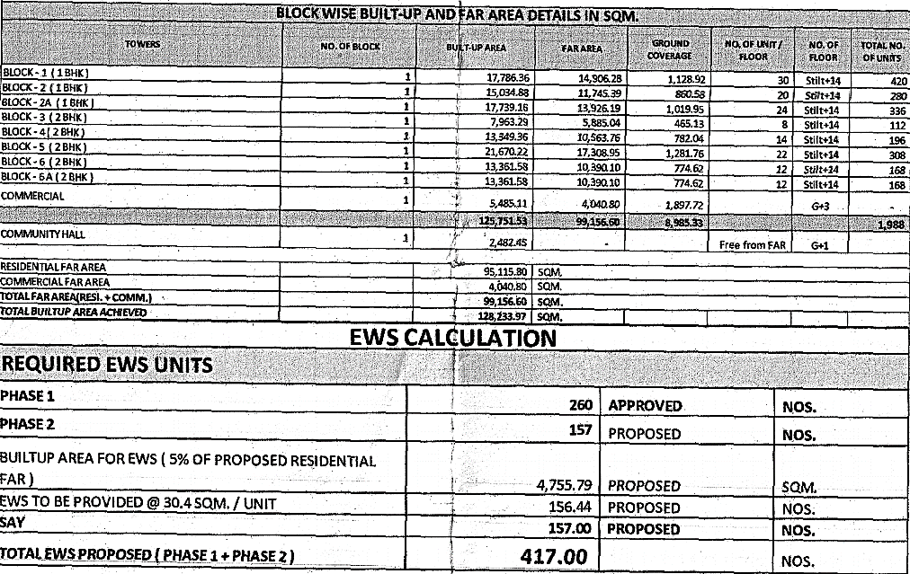

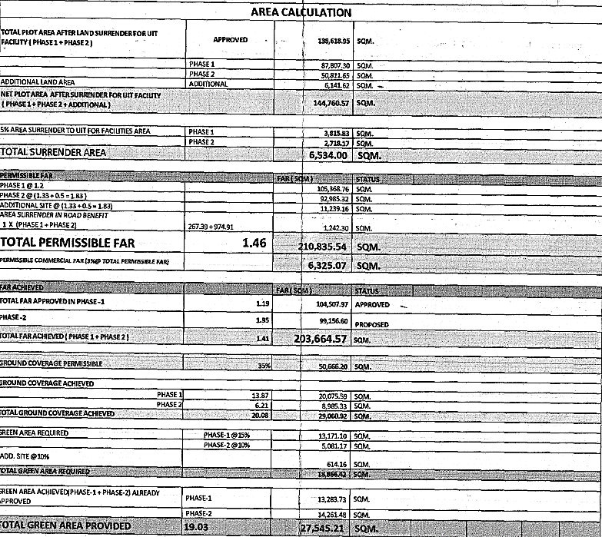

|  |  |
| --- | --- |
| **PART D** | **PROJECT APPROVAL DETAILS** |

|  |  |  |  |
| --- | --- | --- | --- |
| **S.No.** | **REQUIRED APPROVALS** | **REFERENCE NO./ DATE** | **STATUS**  (Approved/ Applied For/ Pending) |
|  | Revised Building Plans from UIT, Bhiwadi | Letter No. 5407.08  Dated: 01/09/2017 | Approved |
|  | Lease Deed for the development of group housing project | --- | Obtained as per builder buyer agreement |
|  | NOC for Height Clearance from Airport Authority of India | --- | Not Provided |
|  | Environmental clearance NOC from SEIAA | --- | Not Provided |
|  | NOC from Pollution Control Board | --- | Not Provided |
|  | Final NOC from Fire Authority | --- | Not Provided |
|  | Completion Certificate | --- | Obtained |
|  | RERA Registration Certificate issued from RRERA | Registration No. RAJ/P/2018/761  Dated: 22/06/2018 | Approved |
|  | Structural Stability Certificate | ---- | NA |

***OBSERVATIONS:*** *Project meets most of the preliminary necessary compliance statutory approvals since completion certificate has been obtained by the developer. However we have not provided with all the approvals and NOCs and bank is advised to take the same from the developer.*

|  |  |
| --- | --- |
| **PART E** | **VALUATION ASSESSMENT OF THE PROPERTY** |

|  |  |  |  |  |  |  |  |  |  |
| --- | --- | --- | --- | --- | --- | --- | --- | --- | --- |
|  | **ASSESSMENT FACTORS** | | | | | | | | |
|  | Valuation Type | | Project Valuation | | | | | Group Housing Society Value | |
|  | Scope of the Valuation | | Non Binding Opinion on General Prospective Valuation Assessment of the Property identified by Property owner or through its representative | | | | | | |
|  | Property Use factor | | Group Housing Society Project | | | | | | |
|  | Legality Aspect Factor  *(Refer clauses 2 & 4 of Part-E)* | | Positive as per documents produced to us | | | | | | |
|  | Land Physical factors | | **Shape** | | **Size** | | **Level** | | **Frontage to depth ratio** |
| Irregular | | Large | | On Road Level | | Normal frontage |
|  | Property location category factor | | **City Categorization** | | **Locality Categorization** | | **Property location classification** | | **Floor Level** |
| Rural | | Good | | On wide approach road | | NA |
| Property within developing Residential zone | | NA | |
| NA | |
|  | Any New Development in surrounding area | | None | | | NA | | | |
|  | Property overall usability Factor | | Good | | | | | | |
|  | Comment on Property Salability Outlook | | Easily sellable | | | | | | |
|  | Comment on Demand & Supply in the Market | | Normal demand of such properties in the market | | | | | | |
|  | Methodology/ Basis of Valuation | | **Residual Method** | | | | | | |
| *As per the current status of the Project this Project Valuation report is assessed assuming that in the eventuality for the need of sale of this Project the interested buyer would be any developer only who will be interested in operating this Project taking over from the current developer.*  *This report is prepared for the purpose of creating equitable mortgage to the financer and this whole Project is put as mortgage for it.*  *Since this is a licensed land for the purpose of development of Group Housing Society where some units have been sold and some are still unsold. Ultimately in the eventuality of sale or recovery financer would be able to sell unsold units only and no other part of the Project like Land or sold units will remain sellable.*  *Hence this Valuation is assessed by calculating the Valuation of unsold units as per current market rates and deduct the total balance cost to be put in the Project to make it complete plus profit margin of any prospective investor (buyer), to arrive at the Fair Market Valuation of the Project.*  *Sold & unsold units have been taken on the basis of the Inventory Sheet provided to us by the developer which has been relied upon in good faith. Financer is advised to legally check the status of these units through Title Investigation Report. Legal & other ownership rights distribution if any has not been considered in this report since no such thing informed to us by the builder company.* | | | | | | |
| *Valuation of the asset is done as found on as-is-where basis.*  *Valuation is done based on the Valuation best practices, standard operating procedures and definitions prescribed by various organizations like IVSC, Income Tax of India, etc. as defined under.*  *For knowing comparable market rates, significant discreet local enquiries have been made from our side representing ourselves as both buyer and seller for the similar properties in the subject area and thereafter based on this information and various factors of the property, a rate has been judiciously taken considering the market scenario.*  *References regarding the prevailing market rates are based on the verbal/ informal/ secondary/ tertiary information collected during market survey in the subject area from the local people, property consultants, recent deals, demand-supply, internet postings which are relied upon. No written record is generally available for such market information and only the verbal information has to be relied upon.*  *Market Rates are rationally adopted based on the facts of the property that came to our knowledge during the course of the assignment considering many factors like nature of the property, size, location, approach, market situation and trends.*  *The indicative value has been suggested based on the prevailing market rates that came to our knowledge during secondary & tertiary market researches and does not split into formal & informal payment components.*  *Secondary/ Tertiary costs related to asset transaction like Stamp Duty, Registration charges, Brokerage, Bank interest, selling cost, marketing cost, etc. pertaining to the sale/ purchase of this property are not considered while assessing the indicative estimated Market Value.*  *This report includes both, Govt. Guideline Value and Indicative Estimated Prospective Fair Market Value. As per the current market practice, in most of the cases, formal transaction takes place for an amount less than the actual transaction amount and rest of the payment is normally done informally.*  *Construction rates are adopted based on the present market replacement cost of construction and calculating applicable depreciation & deterioration factor as per its existing condition & specifications based on only visual observation of the structure. No structural, physical tests have been carried out in respect of it.*  *Construction rates are adopted based on the plinth area rates prevailing in the market for the structure as a whole and not based on item wise estimation or Bills of Quantity method.*  *The condition assessment and the estimation of the residual economic life of the structure is only based on the visual observations and appearance found during the site survey. We have not carried out any structural design or stability study; nor carried out any physical tests to assess structural integrity & strength.*  *Sale transaction method of the asset is assumed as free market transaction while assessing Indicative & Estimated Fair Prospective Market Value of the asset.*  *Any kind of unpaid statutory, utilities, lease, interest or any other pecuniary dues on the asset has not been factored in the Valuation.*  *This Valuation is conducted based on the macro analysis of the asset/ property considering it in totality and not based on the micro, component or item wise analysis. Analysis done is a general assessment and is not investigative in nature*  ***Fair Market Value#*** *suggested by the competent Valuer is that prospective estimated amount in his expert & prudent opinion of the subject asset/ property without any prejudice after he has carefully & exhaustively evaluated the facts & information came in front of him related to the subject asset at which the subject asset/ property should be exchanged between a willing buyer and willing seller at an arm’s length transaction in an open & unrestricted market, after proper marketing, wherein the parties, each acted knowledgeably, prudently and without any compulsion on the date of the Valuation.*  *Forced, under compulsion & constraint, obligatory sales transactions data doesn’t indicate the Fair Market Value.*  ***Realizable Value^*** *is the minimum prospective estimated value of the property which it may be able to realize at the time of actual property transaction factoring in the potential prospects of deep negotiations carried out between the buyer & seller for ultimately finalizing the transaction across the table. Realizable value may be 10-20% less than the Fair Market Value depending on the various salability prospects of the subject property and the needs of the buyer & the seller.*  ***Forced/ Distress Sale Value\**** *is the value when the property has to be sold due to any compulsion or constraint like financial encumbrances, dispute, as a part of a recovery process, any defect in the property, legal issues or any such condition or situation. In this type of sale, minimum fetch value is assessed which can be 25-40% less than the estimated Fair Market Value based on the nature, size & salability prospects of the property. In this type of sale, negotiation power of the buyer is always more than the seller and eagerness & pressure of selling the property is more than buying it. Therefore the Forced/ Distress Sale Value will always fetch significantly less value compare to the estimated Fair Market Value.*  ***Liquidation Value*** *is the amount that would be realized when an asset or group of assets are sold on a piecemeal basis that is without consideration of benefits (or detriments) associated with a going-concern business. Liquidation value can be either in an orderly transaction with a typical marketing period or in a forced transaction with a shortened marketing period.*  ***Difference between Cost, Price & Value:*** *Generally these words are used and understood synonymously. However in reality each of these has a completely different meaning, premise and also having different definitions in the professional & legal terms. Therefore to avoid confusion, it is our professional responsibility to describe the definitions of these words to avoid ambiguity & confusion in the minds of the user of this report.*  *The* ***Cost*** *of an asset represents the actual amount spend in the construction/ actual creation of the asset.*  *The* ***Price*** *is the amount paid for the procurement of the same asset.*  *The* ***Value*** *is defined as the present worth of future rights in the property/ asset and depends to a great extent on combination of various factors such as demand and supply, market situation, purpose, situation & needs of the buyer & seller, saleability outlook, usability factor, market perception & reputation. needs of the buyer & seller, saleability outlook, usability factor, market perception & reputation.*  *Therefore in actual for the same asset/ property, cost, price & value remain different since these terms have different usage & meaning.* | | | | | | |
|  | Details of the sources from where the information is gathered on prevailing market Rate/ Price trend of the property *(from property search sites & local information)* | | | | | | | | |
| 1. Name: Farha Tyagi   Contact No.: 9560714446 | | | *As per our telephonic conversation, we came to know that flats are available for resale & direct booking from the developer.*  *Further we came to know that the prevailing market rates for flats in the subject society is between Rs.13,00,000/- to Rs.14,50,000/- for 1 BHK flat in Krish heights City depending on location, size of the flat, floor level etc.*  *As per the data provided by the developer no flats have been sold from past five and due to the low demand of flats and project location the flats are not being selling at their current price list therefore we have assumed that flats can be available at discounted price in the subject project.* | | | | | |
|  | Adopted Rates Justification | Rates taken as per market survey. | | | | | | | |
|  | **Inventory Absorptions Rate:** | An absorption rate provides insight on the rate at which unsold inventory are selling. It will depend upon the demand and supply gap in micro market. Therefore, for Krish City Heights Project, after looking the current realestate market senario, we are on the view that subject unsold inventory will be absorbed in five years time. | | | | | | | |
|  | **Appreciation in Sale Price** | For arriving at the appreciation in sale price of unsold inventory we have taking care following points:-   * The supply and demand dynamics of a particular location. * The interest rates banks charge for home loans, meaning the cost of borrowing. * Growth in local population, leading to increased demand * Development of basic infrastructure like School, Hospital, Transportation & Local Market.   In the subject project no flats has been sold since last 5 years and due to the covid-19 disruption in the real estate market and considering all the above factors, we have not consiered any appreciation for first & second year and after 2 years we are of view that the real esate market will show positive growth rate so we have taken 3% appreciation for third & fourth year respectively and 5% appreciation for the fifth year in unsold inventory. | | | | | | | |
|  | **Balance cost to be incurred for construction** | The balance cost of construction of the project has been taken as per the information provided by the company official, which we have relied upon in good faith.  Due to unavailability of discreet data (bills of quantity/ item wise) from the client we could not do the detailed cost estimation for the project phase and it has been calculated on the basis of cost yet to to be incurred in finishing of the project. | | | | | | | |
|  | **Discount Rate** | As per the international Valuation Standard hand book, **‘**The rate at which the forecasted cash flow is discounted should reflect not only the time value of money, but also the risks associated with the type of cashflow and the future operations of the asset’.  The discount rate or WACC has been taken as per the discussion with the market participants based on the current real estate markets scenario in India and more importantly based on the current rate of lending by the Indian scheduled banks in real estate sector. The discount rate for the projects depends upon the liquidity factor & Demand and supply gap in the market. Presently real estate is considered to be risky sector due to the large unsold inventory, thus having supply much more than the demand. In Banking also the minimum ROI on real estate Projects is prevailing from minimum 12% to 16% depending upon the Project profile and creditworthiness of the developer company. Therefore we have taken minimum discount rate or RoR as 12% and 16% which any lender would be expecting in present market scenario & condition in order to invest in a realestate project. Therefore we have taken minimum discount rate or RoR as 13.25% which any lender would be expecting in present market scenario & condition in order to invest in a realestate project.  For the calculation of discount rate we have assumed 50% of capex as debt and 50% of capex as equity  @ 12.50% & 14% interest rate. 14% of equity interest rate is adopted considering the risk factor involvedin real estate projects in present scenario. By this WACC arrived is 13.25%. | | | | | | | |

* **PROJECT INFLOW MODEL:**

1. **Receivables of Sold Flats**

As per the data provided to us by the company the total receivables of 157 booked flats as on date is Rs.11,25,57,690/- which will be received within 5 years.

*Note: - As per the data provided by the developer, the total receivables of 157 booked units is Rs.20,14,26,405/- which include of principal amount and late payment interest. Since the interest on the subject these units is subject to litigation and being on conservative side we have only considered the receivables excluding the late payment interest. Since at present the demand of units in this society is not good due to its location and size of the unit. Therefore, considering all the facts i.e. ongoing litigation between developer and buyer, no demand, location we have taken only principal amount of the receivables.*

1. **Market Sale Value:**

The current Market rates of the property have been taken after several discussions with market participants & secondary market researches on public domain and came to the following conclusion: -

1. Secondary market for the subject project is developed and the flats are available on both resale and fresh booking. As per the market feedback we came to know that the prevailing market rates for flats in subject project is between Rs.13,00,000/- to Rs.14,50,000/- which is calculated to be Rs.2,680/- to Rs.2,980/- per sq. ft. on super area.
2. The subject project is completed and read to move and as per the data provided by the developer no flats has been sold since 2016 and their most of the flats are sold from year 2012 to 2014. Due to the steep pricing of the project, growth of affordable housing under Deen Dayal Awas Yojna in the proximity of the subject project, weak location of the project & declination of real estate market after demonetization. The developer is not able to sold the balance flats in the market from past 5 years.
3. Due to above mentioned reason we are of view that the developer will not be able to sell the subject flats under the current pricing scheme and the developer should sell the subject flats at lower pricing and should be comparative to the pricing of other affordable group housing projects.
4. Therefore, based on these facts rates per floor have been adopted judiciously.

Therefore for the Valuation purpose for flats of this project we have taken market rate range of Rs.2,250/- to Rs.2,500/- per sq.ft. on Super Area (Including other charges like PLC, Parking, Club Charges, EDC & IDC) and these rates depends upon the characteristics of the unsold dwelling units.

|  |  |  |  |  |  |  |
| --- | --- | --- | --- | --- | --- | --- |
| **UNBOOKED INVENTORY VALUATION | BLOCK-1, KRISH CITY HEIGHTS | VILLAGE TAPUKARA & DHIRIYAWAS, TEHSIL-TIJARA, ALWAR, RAJASTHAN** | | | | | | |
| **S.No.** | **Flat Type** | **Flat No.** | **Floor** | **Super Area** *(sq.ft.)* | **Adopted Market Rates** *(per sq.ft.)* | **Market Value** |
| 1 | 1 BHK | A1/101 | First Floor | 485 | 2500 | ₹ 12,12,500.00 |
| 2 | 1 BHK | A1/102 | First Floor | 485 | 2500 | ₹ 12,12,500.00 |
| 3 | 1 BHK | A1/120 | First Floor | 485 | 2500 | ₹ 12,12,500.00 |
| 4 | 1 BHK | A1/121 | First Floor | 485 | 2500 | ₹ 12,12,500.00 |
| 5 | 1 BHK | A1/123 | First Floor | 485 | 2500 | ₹ 12,12,500.00 |
| 6 | 1 BHK | A1/124 | First Floor | 485 | 2500 | ₹ 12,12,500.00 |
| 7 | 1 BHK | A1/130 | First Floor | 485 | 2500 | ₹ 12,12,500.00 |
| 8 | 1 BHK | A1/201 | Second Floor | 485 | 2450 | ₹ 11,88,250.00 |
| 9 | 1 BHK | A1/202 | Second Floor | 485 | 2450 | ₹ 11,88,250.00 |
| 10 | 1 BHK | A1/204 | Second Floor | 485 | 2450 | ₹ 11,88,250.00 |
| 11 | 1 BHK | A1/206 | Second Floor | 485 | 2450 | ₹ 11,88,250.00 |
| 12 | 1 BHK | A1/208 | Second Floor | 485 | 2450 | ₹ 11,88,250.00 |
| 13 | 1 BHK | A1/210 | Second Floor | 485 | 2450 | ₹ 11,88,250.00 |
| 14 | 1 BHK | A1/211 | Second Floor | 485 | 2450 | ₹ 11,88,250.00 |
| 15 | 1 BHK | A1/213 | Second Floor | 485 | 2450 | ₹ 11,88,250.00 |
| 16 | 1 BHK | A1/214 | Second Floor | 485 | 2450 | ₹ 11,88,250.00 |
| 17 | 1 BHK | A1/219 | Second Floor | 485 | 2450 | ₹ 11,88,250.00 |
| 18 | 1 BHK | A1/222 | Second Floor | 485 | 2450 | ₹ 11,88,250.00 |
| 19 | 1 BHK | A1/223 | Second Floor | 485 | 2450 | ₹ 11,88,250.00 |
| 20 | 1 BHK | A1/225 | Second Floor | 485 | 2450 | ₹ 11,88,250.00 |
| 21 | 1 BHK | A1/226 | Second Floor | 485 | 2450 | ₹ 11,88,250.00 |
| 22 | 1 BHK | A1/227 | Second Floor | 485 | 2450 | ₹ 11,88,250.00 |
| 23 | 1 BHK | A1/228 | Second Floor | 485 | 2450 | ₹ 11,88,250.00 |
| 24 | 1 BHK | A1/229 | Second Floor | 485 | 2450 | ₹ 11,88,250.00 |
| 25 | 1 BHK | A1/230 | Second Floor | 485 | 2450 | ₹ 11,88,250.00 |
| 26 | 1 BHK | A1/301 | Third Floor | 485 | 2400 | ₹ 11,64,000.00 |
| 27 | 1 BHK | A1/302 | Third Floor | 485 | 2400 | ₹ 11,64,000.00 |
| 28 | 1 BHK | A1/303 | Third Floor | 485 | 2400 | ₹ 11,64,000.00 |
| 29 | 1 BHK | A1/305 | Third Floor | 485 | 2400 | ₹ 11,64,000.00 |
| 30 | 1 BHK | A1/307 | Third Floor | 485 | 2400 | ₹ 11,64,000.00 |
| 31 | 1 BHK | A1/308 | Third Floor | 485 | 2400 | ₹ 11,64,000.00 |
| 32 | 1 BHK | A1/310 | Third Floor | 485 | 2400 | ₹ 11,64,000.00 |
| 33 | 1 BHK | A1/311 | Third Floor | 485 | 2400 | ₹ 11,64,000.00 |
| 34 | 1 BHK | A1/312 | Third Floor | 485 | 2400 | ₹ 11,64,000.00 |
| 35 | 1 BHK | A1/313 | Third Floor | 485 | 2400 | ₹ 11,64,000.00 |
| 36 | 1 BHK | A1/315 | Third Floor | 485 | 2400 | ₹ 11,64,000.00 |
| 37 | 1 BHK | A1/316 | Third Floor | 485 | 2400 | ₹ 11,64,000.00 |
| 38 | 1 BHK | A1/317 | Third Floor | 485 | 2400 | ₹ 11,64,000.00 |
| 39 | 1 BHK | A1/318 | Third Floor | 485 | 2400 | ₹ 11,64,000.00 |
| 40 | 1 BHK | A1/319 | Third Floor | 485 | 2400 | ₹ 11,64,000.00 |
| 41 | 1 BHK | A1/320 | Third Floor | 485 | 2400 | ₹ 11,64,000.00 |
| 42 | 1 BHK | A1/321 | Third Floor | 485 | 2400 | ₹ 11,64,000.00 |
| 43 | 1 BHK | A1/322 | Third Floor | 485 | 2400 | ₹ 11,64,000.00 |
| 44 | 1 BHK | A1/323 | Third Floor | 485 | 2400 | ₹ 11,64,000.00 |
| 45 | 1 BHK | A1/324 | Third Floor | 485 | 2400 | ₹ 11,64,000.00 |
| 46 | 1 BHK | A1/325 | Third Floor | 485 | 2400 | ₹ 11,64,000.00 |
| 47 | 1 BHK | A1/326 | Third Floor | 485 | 2400 | ₹ 11,64,000.00 |
| 48 | 1 BHK | A1/327 | Third Floor | 485 | 2400 | ₹ 11,64,000.00 |
| 49 | 1 BHK | A1/328 | Third Floor | 485 | 2400 | ₹ 11,64,000.00 |
| 50 | 1 BHK | A1/329 | Third Floor | 485 | 2400 | ₹ 11,64,000.00 |
| 51 | 1 BHK | A1/330 | Third Floor | 485 | 2400 | ₹ 11,64,000.00 |
| 52 | 1 BHK | A1/403 | Fourth Floor | 485 | 2400 | ₹ 11,64,000.00 |
| 53 | 1 BHK | A1/407 | Fourth Floor | 485 | 2400 | ₹ 11,64,000.00 |
| 54 | 1 BHK | A1/408 | Fourth Floor | 485 | 2400 | ₹ 11,64,000.00 |
| 55 | 1 BHK | A1/417 | Fourth Floor | 485 | 2400 | ₹ 11,64,000.00 |
| 56 | 1 BHK | A1/419 | Fourth Floor | 485 | 2400 | ₹ 11,64,000.00 |
| 57 | 1 BHK | A1/420 | Fourth Floor | 485 | 2400 | ₹ 11,64,000.00 |
| 58 | 1 BHK | A1/421 | Fourth Floor | 485 | 2400 | ₹ 11,64,000.00 |
| 59 | 1 BHK | A1/423 | Fourth Floor | 485 | 2400 | ₹ 11,64,000.00 |
| 60 | 1 BHK | A1/425 | Fourth Floor | 485 | 2400 | ₹ 11,64,000.00 |
| 61 | 1 BHK | A1/501 | Fifth Floor | 485 | 2400 | ₹ 11,64,000.00 |
| 62 | 1 BHK | A1/509 | Fifth Floor | 485 | 2400 | ₹ 11,64,000.00 |
| 63 | 1 BHK | A1/511 | Fifth Floor | 485 | 2400 | ₹ 11,64,000.00 |
| 64 | 1 BHK | A1/513 | Fifth Floor | 485 | 2400 | ₹ 11,64,000.00 |
| 65 | 1 BHK | A1/515 | Fifth Floor | 485 | 2400 | ₹ 11,64,000.00 |
| 66 | 1 BHK | A1/516 | Fifth Floor | 485 | 2400 | ₹ 11,64,000.00 |
| 67 | 1 BHK | A1/517 | Fifth Floor | 485 | 2400 | ₹ 11,64,000.00 |
| 68 | 1 BHK | A1/518 | Fifth Floor | 485 | 2400 | ₹ 11,64,000.00 |
| 69 | 1 BHK | A1/520 | Fifth Floor | 485 | 2400 | ₹ 11,64,000.00 |
| 70 | 1 BHK | A1/524 | Fifth Floor | 485 | 2400 | ₹ 11,64,000.00 |
| 71 | 1 BHK | A1/525 | Fifth Floor | 485 | 2400 | ₹ 11,64,000.00 |
| 72 | 1 BHK | A1/526 | Fifth Floor | 485 | 2400 | ₹ 11,64,000.00 |
| 73 | 1 BHK | A1/527 | Fifth Floor | 485 | 2400 | ₹ 11,64,000.00 |
| 74 | 1 BHK | A1/528 | Fifth Floor | 485 | 2400 | ₹ 11,64,000.00 |
| 75 | 1 BHK | A1/529 | Fifth Floor | 485 | 2400 | ₹ 11,64,000.00 |
| 76 | 1 BHK | A1/602 | Sixth Floor | 485 | 2350 | ₹ 11,39,750.00 |
| 77 | 1 BHK | A1/603 | Sixth Floor | 485 | 2350 | ₹ 11,39,750.00 |
| 78 | 1 BHK | A1/613 | Sixth Floor | 485 | 2350 | ₹ 11,39,750.00 |
| 79 | 1 BHK | A1/614 | Sixth Floor | 485 | 2350 | ₹ 11,39,750.00 |
| 80 | 1 BHK | A1/624 | Sixth Floor | 485 | 2350 | ₹ 11,39,750.00 |
| 81 | 1 BHK | A1/626 | Sixth Floor | 485 | 2350 | ₹ 11,39,750.00 |
| 82 | 1 BHK | A1/628 | Sixth Floor | 485 | 2350 | ₹ 11,39,750.00 |
| 83 | 1 BHK | A1/702 | Seventh Floor | 485 | 2350 | ₹ 11,39,750.00 |
| 84 | 1 BHK | A1/703 | Seventh Floor | 485 | 2350 | ₹ 11,39,750.00 |
| 85 | 1 BHK | A1/709 | Seventh Floor | 485 | 2350 | ₹ 11,39,750.00 |
| 86 | 1 BHK | A1/713 | Seventh Floor | 485 | 2350 | ₹ 11,39,750.00 |
| 87 | 1 BHK | A1/717 | Seventh Floor | 485 | 2350 | ₹ 11,39,750.00 |
| 88 | 1 BHK | A1/718 | Seventh Floor | 485 | 2350 | ₹ 11,39,750.00 |
| 89 | 1 BHK | A1/721 | Seventh Floor | 485 | 2350 | ₹ 11,39,750.00 |
| 90 | 1 BHK | A1/723 | Seventh Floor | 485 | 2350 | ₹ 11,39,750.00 |
| 91 | 1 BHK | A1/724 | Seventh Floor | 485 | 2350 | ₹ 11,39,750.00 |
| 92 | 1 BHK | A1/726 | Seventh Floor | 485 | 2350 | ₹ 11,39,750.00 |
| 93 | 1 BHK | A1/727 | Seventh Floor | 485 | 2350 | ₹ 11,39,750.00 |
| 94 | 1 BHK | A1/729 | Seventh Floor | 485 | 2350 | ₹ 11,39,750.00 |
| 95 | 1 BHK | A1/803 | Eighth Floor | 485 | 2350 | ₹ 11,39,750.00 |
| 96 | 1 BHK | A1/807 | Eighth Floor | 485 | 2350 | ₹ 11,39,750.00 |
| 97 | 1 BHK | A1/808 | Eighth Floor | 485 | 2350 | ₹ 11,39,750.00 |
| 98 | 1 BHK | A1/814 | Eighth Floor | 485 | 2350 | ₹ 11,39,750.00 |
| 99 | 1 BHK | A1/817 | Eighth Floor | 485 | 2350 | ₹ 11,39,750.00 |
| 100 | 1 BHK | A1/821 | Eighth Floor | 485 | 2350 | ₹ 11,39,750.00 |
| 101 | 1 BHK | A1/823 | Eighth Floor | 485 | 2350 | ₹ 11,39,750.00 |
| 102 | 1 BHK | A1/825 | Eighth Floor | 485 | 2350 | ₹ 11,39,750.00 |
| 103 | 1 BHK | A1/827 | Eighth Floor | 485 | 2350 | ₹ 11,39,750.00 |
| 104 | 1 BHK | A1/829 | Eighth Floor | 485 | 2350 | ₹ 11,39,750.00 |
| 105 | 1 BHK | A1/830 | Eighth Floor | 485 | 2350 | ₹ 11,39,750.00 |
| 106 | 1 BHK | A1/915 | Ninth Floor | 485 | 2350 | ₹ 11,39,750.00 |
| 107 | 1 BHK | A1/917 | Ninth Floor | 485 | 2350 | ₹ 11,39,750.00 |
| 108 | 1 BHK | A1/919 | Ninth Floor | 485 | 2350 | ₹ 11,39,750.00 |
| 109 | 1 BHK | A1/924 | Ninth Floor | 485 | 2350 | ₹ 11,39,750.00 |
| 110 | 1 BHK | A1/925 | Ninth Floor | 485 | 2350 | ₹ 11,39,750.00 |
| 111 | 1 BHK | A1/926 | Ninth Floor | 485 | 2350 | ₹ 11,39,750.00 |
| 112 | 1 BHK | A1/928 | Ninth Floor | 485 | 2350 | ₹ 11,39,750.00 |
| 113 | 1 BHK | A1/929 | Ninth Floor | 485 | 2350 | ₹ 11,39,750.00 |
| 114 | 1 BHK | A1/930 | Ninth Floor | 485 | 2350 | ₹ 11,39,750.00 |
| 115 | 1 BHK | A1/1001 | Tenth Floor | 485 | 2350 | ₹ 11,39,750.00 |
| 116 | 1 BHK | A1/1020 | Tenth Floor | 485 | 2350 | ₹ 11,39,750.00 |
| 117 | 1 BHK | A1/1021 | Tenth Floor | 485 | 2350 | ₹ 11,39,750.00 |
| 118 | 1 BHK | A1/1102 | Eleventh Floor | 485 | 2300 | ₹ 11,15,500.00 |
| 119 | 1 BHK | A1/1103 | Eleventh Floor | 485 | 2300 | ₹ 11,15,500.00 |
| 120 | 1 BHK | A1/1104 | Eleventh Floor | 485 | 2300 | ₹ 11,15,500.00 |
| 121 | 1 BHK | A1/1105 | Eleventh Floor | 485 | 2300 | ₹ 11,15,500.00 |
| 122 | 1 BHK | A1/1106 | Eleventh Floor | 485 | 2300 | ₹ 11,15,500.00 |
| 123 | 1 BHK | A1/1107 | Eleventh Floor | 485 | 2300 | ₹ 11,15,500.00 |
| 124 | 1 BHK | A1/1109 | Eleventh Floor | 485 | 2300 | ₹ 11,15,500.00 |
| 125 | 1 BHK | A1/1111 | Eleventh Floor | 485 | 2300 | ₹ 11,15,500.00 |
| 126 | 1 BHK | A1/1112 | Eleventh Floor | 485 | 2300 | ₹ 11,15,500.00 |
| 127 | 1 BHK | A1/1113 | Eleventh Floor | 485 | 2300 | ₹ 11,15,500.00 |
| 128 | 1 BHK | A1/1114 | Eleventh Floor | 485 | 2300 | ₹ 11,15,500.00 |
| 129 | 1 BHK | A1/1118 | Eleventh Floor | 485 | 2300 | ₹ 11,15,500.00 |
| 130 | 1 BHK | A1/1121 | Eleventh Floor | 485 | 2300 | ₹ 11,15,500.00 |
| 131 | 1 BHK | A1/1123 | Eleventh Floor | 485 | 2300 | ₹ 11,15,500.00 |
| 132 | 1 BHK | A1/1126 | Eleventh Floor | 485 | 2300 | ₹ 11,15,500.00 |
| 133 | 1 BHK | A1/1127 | Eleventh Floor | 485 | 2300 | ₹ 11,15,500.00 |
| 134 | 1 BHK | A1/1128 | Eleventh Floor | 485 | 2300 | ₹ 11,15,500.00 |
| 135 | 1 BHK | A1/1130 | Eleventh Floor | 485 | 2300 | ₹ 11,15,500.00 |
| 136 | 1 BHK | A1/1201 | Twelfth Floor | 485 | 2300 | ₹ 11,15,500.00 |
| 137 | 1 BHK | A1/1210 | Twelfth Floor | 485 | 2300 | ₹ 11,15,500.00 |
| 138 | 1 BHK | A1/1301 | Thirteenth Floor | 485 | 2250 | ₹ 10,91,250.00 |
| 139 | 1 BHK | A1/1302 | Thirteenth Floor | 485 | 2250 | ₹ 10,91,250.00 |
| 140 | 1 BHK | A1/1305 | Thirteenth Floor | 485 | 2250 | ₹ 10,91,250.00 |
| 141 | 1 BHK | A1/1307 | Thirteenth Floor | 485 | 2250 | ₹ 10,91,250.00 |
| 142 | 1 BHK | A1/1308 | Thirteenth Floor | 485 | 2250 | ₹ 10,91,250.00 |
| 143 | 1 BHK | A1/1313 | Thirteenth Floor | 485 | 2250 | ₹ 10,91,250.00 |
| 144 | 1 BHK | A1/1316 | Thirteenth Floor | 485 | 2250 | ₹ 10,91,250.00 |
| 145 | 1 BHK | A1/1317 | Thirteenth Floor | 485 | 2250 | ₹ 10,91,250.00 |
| 146 | 1 BHK | A1/1319 | Thirteenth Floor | 485 | 2250 | ₹ 10,91,250.00 |
| 147 | 1 BHK | A1/1321 | Thirteenth Floor | 485 | 2250 | ₹ 10,91,250.00 |
| 148 | 1 BHK | A1/1323 | Thirteenth Floor | 485 | 2250 | ₹ 10,91,250.00 |
| 149 | 1 BHK | A1/1324 | Thirteenth Floor | 485 | 2250 | ₹ 10,91,250.00 |
| 150 | 1 BHK | A1/1329 | Thirteenth Floor | 485 | 2250 | ₹ 10,91,250.00 |
| 151 | 1 BHK | A1/1401 | Fourteenth Floor | 485 | 2250 | ₹ 10,91,250.00 |
| 152 | 1 BHK | A1/1402 | Fourteenth Floor | 485 | 2250 | ₹ 10,91,250.00 |
| 153 | 1 BHK | A1/1403 | Fourteenth Floor | 485 | 2250 | ₹ 10,91,250.00 |
| 154 | 1 BHK | A1/1404 | Fourteenth Floor | 485 | 2250 | ₹ 10,91,250.00 |
| 155 | 1 BHK | A1/1405 | Fourteenth Floor | 485 | 2250 | ₹ 10,91,250.00 |
| 156 | 1 BHK | A1/1406 | Fourteenth Floor | 485 | 2250 | ₹ 10,91,250.00 |
| 157 | 1 BHK | A1/1407 | Fourteenth Floor | 485 | 2250 | ₹ 10,91,250.00 |
| 158 | 1 BHK | A1/1408 | Fourteenth Floor | 485 | 2250 | ₹ 10,91,250.00 |
| 159 | 1 BHK | A1/1409 | Fourteenth Floor | 485 | 2250 | ₹ 10,91,250.00 |
| 160 | 1 BHK | A1/1410 | Fourteenth Floor | 485 | 2250 | ₹ 10,91,250.00 |
| 161 | 1 BHK | A1/1411 | Fourteenth Floor | 485 | 2250 | ₹ 10,91,250.00 |
| 162 | 1 BHK | A1/1412 | Fourteenth Floor | 485 | 2250 | ₹ 10,91,250.00 |
| 163 | 1 BHK | A1/1413 | Fourteenth Floor | 485 | 2250 | ₹ 10,91,250.00 |
| 164 | 1 BHK | A1/1414 | Fourteenth Floor | 485 | 2250 | ₹ 10,91,250.00 |
| 165 | 1 BHK | A1/1415 | Fourteenth Floor | 485 | 2250 | ₹ 10,91,250.00 |
| 166 | 1 BHK | A1/1416 | Fourteenth Floor | 485 | 2250 | ₹ 10,91,250.00 |
| 167 | 1 BHK | A1/1417 | Fourteenth Floor | 485 | 2250 | ₹ 10,91,250.00 |
| 168 | 1 BHK | A1/1418 | Fourteenth Floor | 485 | 2250 | ₹ 10,91,250.00 |
| 169 | 1 BHK | A1/1419 | Fourteenth Floor | 485 | 2250 | ₹ 10,91,250.00 |
| 170 | 1 BHK | A1/1420 | Fourteenth Floor | 485 | 2250 | ₹ 10,91,250.00 |
| 171 | 1 BHK | A1/1421 | Fourteenth Floor | 485 | 2250 | ₹ 10,91,250.00 |
| 172 | 1 BHK | A1/1422 | Fourteenth Floor | 485 | 2250 | ₹ 10,91,250.00 |
| 173 | 1 BHK | A1/1423 | Fourteenth Floor | 485 | 2250 | ₹ 10,91,250.00 |
| 174 | 1 BHK | A1/1424 | Fourteenth Floor | 485 | 2250 | ₹ 10,91,250.00 |
| 175 | 1 BHK | A1/1425 | Fourteenth Floor | 485 | 2250 | ₹ 10,91,250.00 |
| 176 | 1 BHK | A1/1426 | Fourteenth Floor | 485 | 2250 | ₹ 10,91,250.00 |
| 177 | 1 BHK | A1/1427 | Fourteenth Floor | 485 | 2250 | ₹ 10,91,250.00 |
| 178 | 1 BHK | A1/1428 | Fourteenth Floor | 485 | 2250 | ₹ 10,91,250.00 |
| 179 | 1 BHK | A1/1429 | Fourteenth Floor | 485 | 2250 | ₹ 10,91,250.00 |
| 180 | 1 BHK | A1/1430 | Fourteenth Floor | 485 | 2250 | ₹ 10,91,250.00 |
| **Total** | | | | | **423050** | **₹ 20,51,79,250.00** |

1. **KRISH CITY HEIGHTS INFLOW MODEL:**



* **PROJECT OUT FLOW:**

1. **CAPEX (Capital Expenditure):**

**CONSTRUCTION COST YET TO BE INCURRED:** The construction cost of the project includes the balance final finishing cost of the unsold flats which the developer will do before giving possession as per the demand of the buyer. The final finishing work is calculated by assuming Rs.200/- per sq.ft. on built-up area of the unsold units. Which comes out to be Rs.1.42 Cr.

1. **OPEX (Operational Expenditure):**

**BROKERGE:** Brokerage charges have taken as 1% of the income by selling the remaining unsold units of the project.

**ADMINISTRATIVE EXPENSES:** The administrative charges have taken as 5% of the income by selling the remaining unsold units of the project.

**INTEREST REPAYMENT:** the project interest repayment has been taken on the basis of information provided by the company and we have relied upon in good faith.

* **PROJECT NET PRESENT VALUE (NPV):**





**(Rupees Twenty-One Crores Only)**



|  |  |  |
| --- | --- | --- |
|  | **Concluding comments if any** | As per the scope of the assignment,Value assessment is subject to R.K Associates Important Notes and Valuer’s Remarks *(Enclosure: 1)* & other enclosed documents with the Report which will remain part & parcel of the report. |

|  |  |
| --- | --- |
|  | **ASSUMPTIONS/ REMARKS** |
|  | Information of the average market rates is taken based on the verbal market survey in the subject area from the local people, property agents, recent deals, demand-supply, internet postings which has been relied upon. No written record is generally available for such market information. |
|  | Sale transaction method of the asset is assumed as free market transaction while assessing Prospective Fair Market Value of the asset. |
|  | All area measurements are on approximate basis. Verification of the area measurement of the property is done only based on sample random checking and not based on full scale measurement. Area of the large land parcels of more than 2500 sq.mtr or of uneven shape, is taken as per property documents which has been relied upon. |
|  | Legal aspects are not considered in this report. It is assumed and taken into account that the concerned Bank/ Financial Institution has first got the legal verification cleared by the competent Advocate before requesting for the Valuation report. |
|  | This report is prepared based on the copies of the documents/ information which interested organization or customer could provide to us out of the standard checklist of documents sought from them and further based on our assumptions and limiting conditions. All such information provided to us has been relied upon and we have assumed that it is true and correct. Verification or cross checking of the documents provided to us from the originals has not been done at our end. If at any time in future it’s found or came to our knowledge that misrepresentation of facts or incomplete or distorted information has been provided to us then this report will automatically become null & void. |
|  | Valuation is done for the property identified to us by the owner/ owner representative. Responsibility of identifying the correct property to the Valuer/ its authorized surveyor is solely of the client/ owner for which Valuation has to be carried out. At our end we can just cross verify the identification of the property with reference to the documents produced for perusal. Method by which identification of the property is carried out is also mentioned in the report clearly. It is requested from the Bank to cross check from their own records/ information if this is the same property for which Valuation has to be carried out to ensure that owner has not misled the Valuer company or misrepresented the property due to any vested interest. |
|  | In India more than 70% of the geographical area is lying under rural/ remote/ non municipal/ unplanned area where the subject property is surrounded by vacant lands having no physical demarcation or having any display of property survey or municipal number / name plate on the property clearly. Even in old areas of towns, small cities & districts where property number is not assigned clearly and not displayed on the properties, also due to the presence of multiple/ parallel departments (errors for in property registration) it becomes tough to identify the property with 100% surety from the available documents, information & site whereabouts and chances of error & misrepresentation by the borrower and margin & chances of error always persists in such cases. To avoid any such chances of error it is advised to the Bank to engage municipal/ revenue department officials to get the confirmation of the property to ensure that the property shown to Valuer/ Banker is the same as for which documents are provided. |
|  | If this Valuation Report is prepared for the Flat/ dwelling unit situated in a Group Housing Society or Integrated Township then it is assumed that the Banker or the concerned organization has satisfied themselves with the approval of the Group Housing Society/ particular floor & building before allotting the Valuation case to the Valuer company. |
|  | Due to fragmented & frequent change in building/ urban planning laws/ guidelines from time to time, different laws/ guidelines between regions/ states and no strict enforceability of Building Bye-Laws in India specially in non-metro and scale b & c cities & Industrial areas, property owners many times extend or make changes in the covered area/ layout out of approved/ applicable limits or the properties are decades old for which no formal Building Bye-Laws were applicable. Due to such discrete/ unplanned development in many regions sometimes it becomes tough to determine the exact lawful situation on ground for the Valuer. In case nothing specific is noted on the covered built-up area considered in the Valuation Report, the covered area present on the site as per site survey will be considered in the Valuation. |
|  | Valuation is a subjective field and opinion may differ from consultant to consultant. To check the right opinion, it is important to evaluate the methodology adopted and various factors/ basis considered during the course of assessment before reaching to any conclusion. |
|  | At the outset, it is to be noted that Value analysis of any asset cannot be regarded as an exact science and the conclusions arrived at in many cases will, of necessity, be subjective and dependent on the exercise of individual judgment. Given the same set of facts and using the same assumptions, expert opinions may differ due to the number of separate judgment decisions, which have to be made. Therefore, there can be no standard formulae to establish an indisputable exchange ratio. In the event of a transaction, the actual transaction value achieved may be higher or lower than our indicative analysis of value depending upon the circumstances of the transaction. The knowledge, negotiability and motivations of the buyers and sellers and the applicability of a discount or premium for control will also affect actual price achieved. Accordingly, our indicative analysis of value will not necessarily be the price at which any agreement proceeds. The final transaction price is something on which the parties themselves have to agree. However our Valuation analysis can definitely help the stakeholders to make them informed and wise decision about the Value of the asset and can help in facilitating the arm’s length transaction. |

**ENCLOSURE 1 – VALUER’S REMARKS**

|  |  |
| --- | --- |
|  | **Fair Market Value** suggested by the competent Valuerin his opinionis an prospective estimated amount without any prejudiceafter evaluating all the facts related to the subject propertyat which the subject Asset should be exchanged on the date of Valuation between a willing buyer and willing seller at an arm’s length transaction after proper marketing, wherein the parties, each acted knowledgeably, prudently and without any compulsion. |
|  | **Realizable Value** is the minimum prospective value of the property which it may be able to realize at the time of actual property transaction factoring in potential prospects of deep negotiations carried out between the buyer & seller for ultimately finalizing the transaction. Realizable value may be 10-20% less of the Fair Market Value depending on the salability prospects of the subject property. |
|  | **Forced/ Distress Sale Value** is the value when the property has to be sold due to financial encumbrances or any other constraint or have become a disputed property or as a part of a recovery process. In this type of sale minimum disposable value is assessed which varies from 20-35% less from the Fair Market Value based on the salability prospects of the property. |
|  | Best rates are rationally adopted based on the facts of the case came to our knowledge during the course of the assignment considering many factors like nature of property, location, approach, market situation and trends. |
|  | Construction rates are adopted based on present replacement cost of construction and calculating applicable depreciation & deterioration factor as per its existing condition, specifications based on the visual observation of the structure. No physical tests have been carried out in respect of it. |
|  | No employee or member of R.K Associates has any direct/ indirect interest in the property. |
|  | Sale transaction method of the asset is assumed as free market transaction while assessing Fair Prospective Market Value of the asset. |
|  | Area measurements considered in the Valuation Report pertaining to Land & Building is adopted from relevant approved documents or actual site measurement whichever is less. All area measurements are on approximate basis only. |
|  | This report is having limited scope as per its fields to provide only the general basic idea of the value of the property prevailing in the market based on the documents/ data/ information provided by the client. The suggested value should be considered only if transaction is happened as free market transaction. |
|  | The condition assessment and the estimation of residual economic life of the structure is based on the visual observations and appearance found during the site survey. We have not carried out any structural design or stability study; nor carried out any physical tests to assess structural integrity & strength. |
|  | Secondary/ Tertiary costs related to asset transaction like Stamp Duty, Registration charges, Brokerage, etc. pertaining to the sale/ purchase of this property are not considered while assessing the Market Value. |
|  | This report is prepared based on the copies of the documents/ information which interested organization or customer could provide to us out of the standard checklist of documents sought from them and further based on our assumptions and limiting conditions. All such information provided to us has been relied upon and we have assumed that it is true and correct. Verification or cross checking of the documents provided to us from the originals has not been done at our end. If at any time in future it’s found or came to our knowledge that misrepresentation of facts or incomplete or distorted information has been provided to us then this report will automatically become null & void. |
|  | Investigation of title of the property and its legal right is beyond the scope of this report. If this property is offered as collateral security, the concerned financial institution is requested to verify & satisfy themselves on the ownership & legality of the property shown in this valuation report with respect to the latest legal opinion. |
|  | Value varies with the Purpose/ Date/ Condition of the market. This report should not to be referred if any of these points are different from the one mentioned aforesaid in the Report. The Value indicated in the Valuation Report holds good only upto the period of 3 months from the date of Valuation. |
|  | Analysis and conclusions adopted in the report are limited to the reported assumptions, conditions and information came to our knowledge during the course of the work. |
|  | This report is prepared on the RKA V-L3 (Medium) Valuation format as per the client requirement, charges paid and the time allotted. This report is having limited scope as per its fields to provide only the general estimated basic idea of the value of the property prevailing in the market based on the information provided by the client. The Valuation assessed in this Valuation Report should hold good only if transaction is happened as per free market transaction. No detailed analysis or verification of the information is carried upon pertaining to the value of the subject property. No claim for any extra information will be entertained whatsoever be the reason. For any extra work over and above the fields mentioned in the report will have an extra cost which has to be borne by the customer. |
|  | This is just an opinion report and doesn’t hold any binding on anyone. It is requested from the concerned Financial Institution which is using this report for mortgaging the property that they should consider all the different associated relevant & related factors also before taking any business decision based on the content of this report. |
|  | This Valuation report is prepared based on the facts of the property on the date of the survey. However in future property Market may go down, property conditions may change or may go worse, Property reputation may differ, Property vicinity conditions may go down or become worse, Property market may change due to impact of Govt. policies or effect of World economy, Usability prospects of the property may change, etc. Hence before financing, Banker/ FI should take into consideration all such future risk and should loan conservatively to keep the advanced money safe in case of the downward trend of the property value. |
|  | All Pages of the report including annexures are signed and stamped from our office. In case any paper in the report is without stamp & signature then this should not be considered a valid paper issued from this office. |
|  | Defect Liability Period is **30 DAYS**. We request the concerned authorized reader of this report to check the contents, data and calculations in the report within this period and intimate us in writing if any corrections are required or in case of any other concern with the contents or opinion mentioned in the report. Corrections only related to typographical, calculation, spelling mistakes will be entertained within the defect liability period. No request for any illegitimate value revision, date change or any other change will be entertained other than the one mentioned above. |
|  | R.K Associates encourages its customers to give feedback or inform concerns over its services through proper channel at [**valuers@rkassociates.org**](mailto:valuers@rkassociates.org) in writing within 30 days of report delivery. After this period no concern/ complaint/ proceedings in connection with the Valuation Services can be entertained due to possible change in situation and condition of the property. |
|  | Our Data retention policy is of **ONE YEAR**. After this period we remove all the concerned records related to the assignment from our repository. No clarification or query can be answered after this period due to unavailability of the data. |
|  | This Valuation report is governed by our (1) Internal Policies, Processes & Standard Operating Procedures, (2) R.K Associates Quality Policy, (3) Valuation & Survey Best Practices Guidelines formulated by management of R.K Associates, (4) Information input given to us by the customer and (4) Information/ Data/ Facts given to us by our field/ office technical team. Management of R.K Associates never gives acceptance to any unethical or unprofessional practice which may affect fair, correct & impartial assessment and which is against any prevailing law. In case of any indication of any negligence, default, incorrect, misleading, misrepresentation or distortion of facts in the report then it is the responsibility of the user of this report to immediately or atleast within the defect liability period bring all such act into notice of R.K Associates management so that corrective measures can be taken instantly. |
|  | R.K Associates never releases any report doing alterations or modifications from pen. In case any information/ figure of this report is found altered with pen then this report will automatically become null & void. |
|  | If this report is prepared for the matter under litigation in any Indian court, no official or employee of R.K Associates will be under any obligation to give in person appearance in the court as a testimony. For any explanation or clarification, only written reply can be submitted on payment of charges by the plaintiff or respondent which will be 10% of the original fees charged where minimum charges will be Rs.2500/-. |

**ENCLOSURE 2 – GOOGLE MAP LOCATION**

**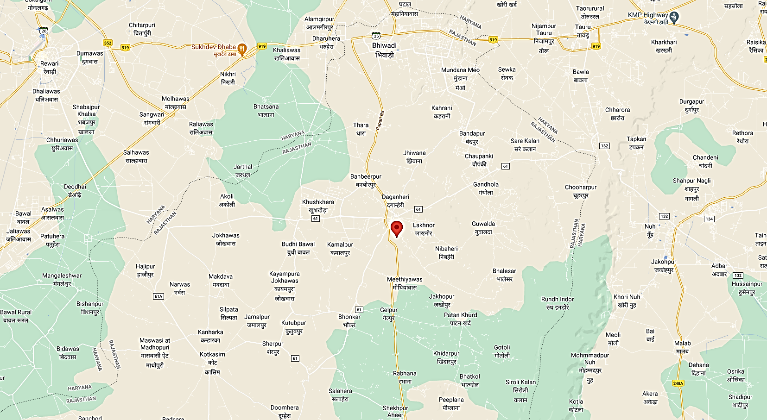**

**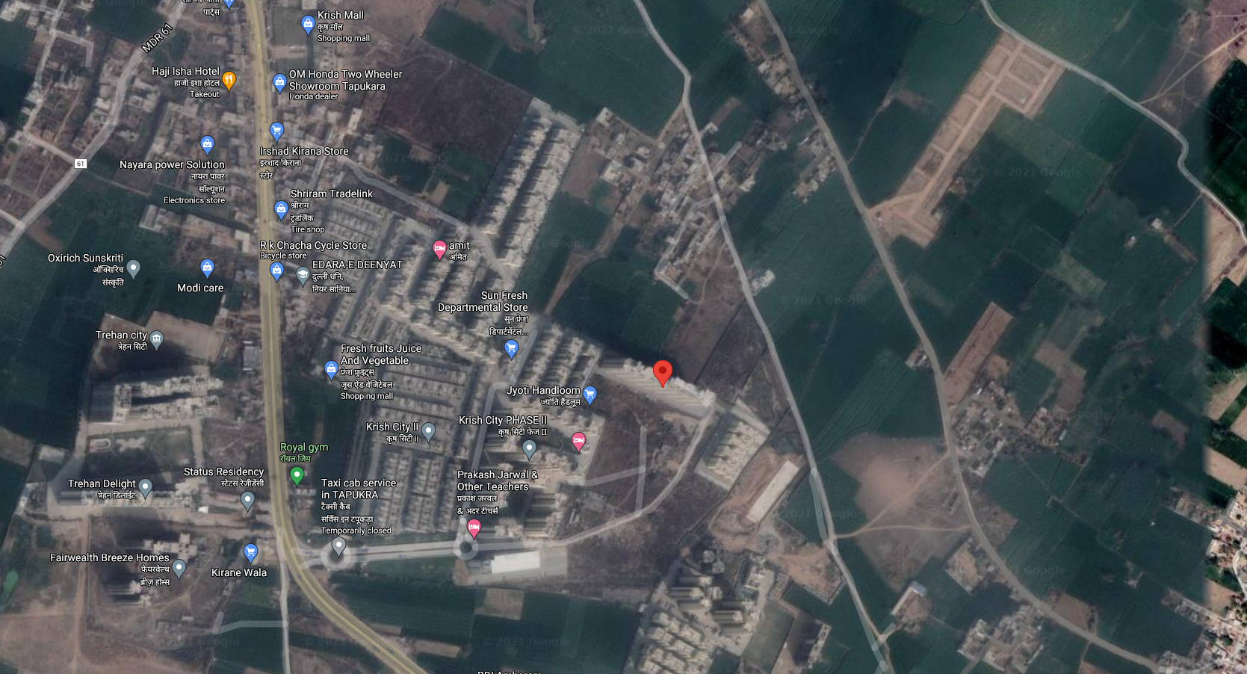**

**ENCLOSURE 3 – PHOTOGRAPHS**

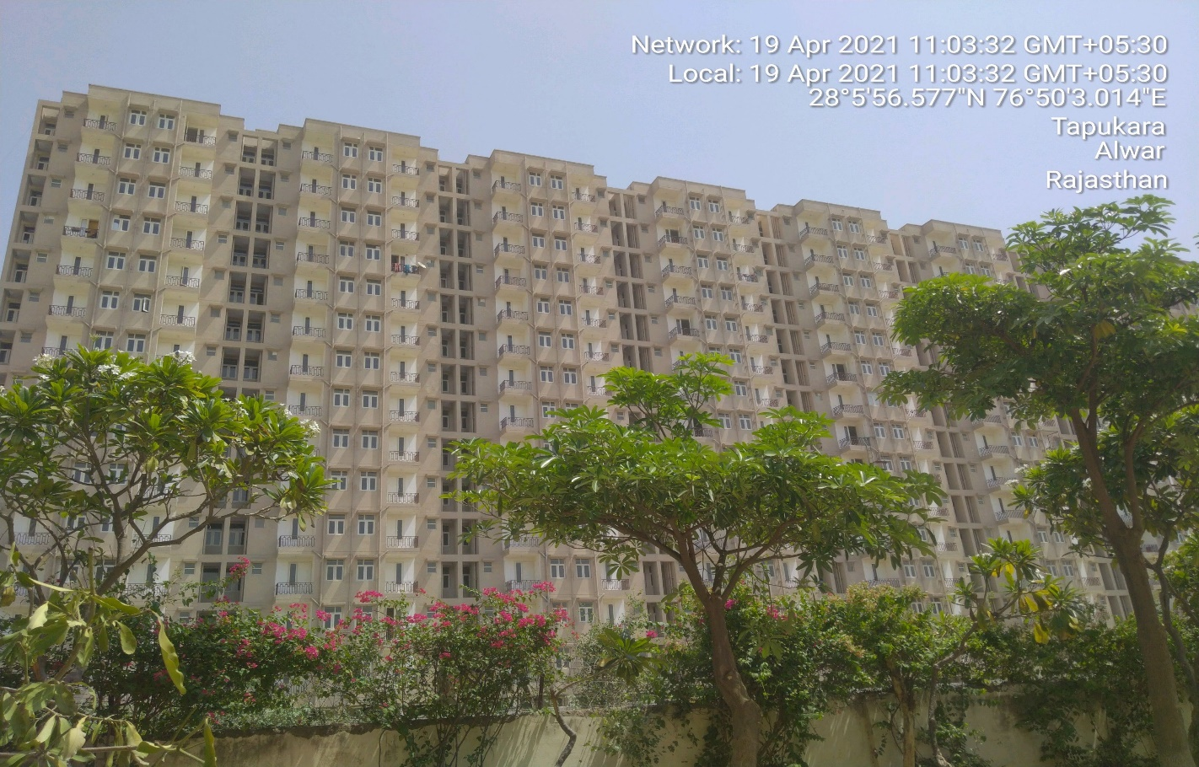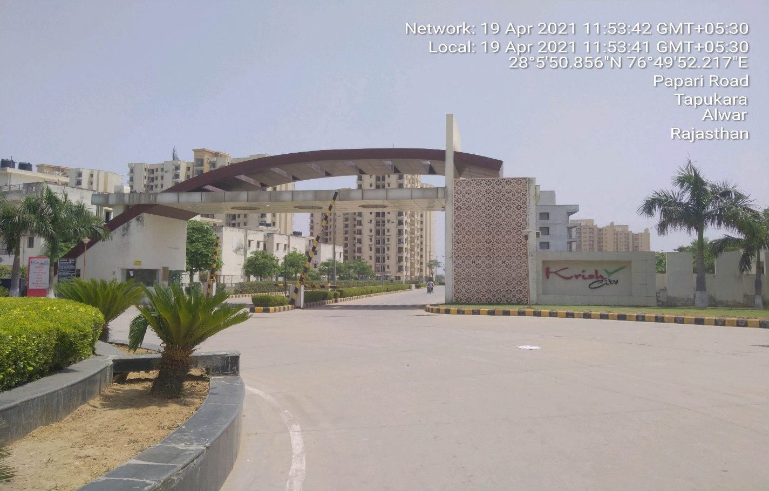

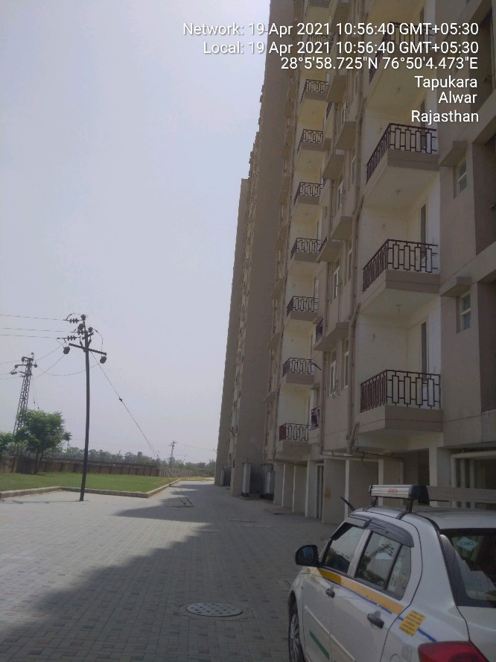 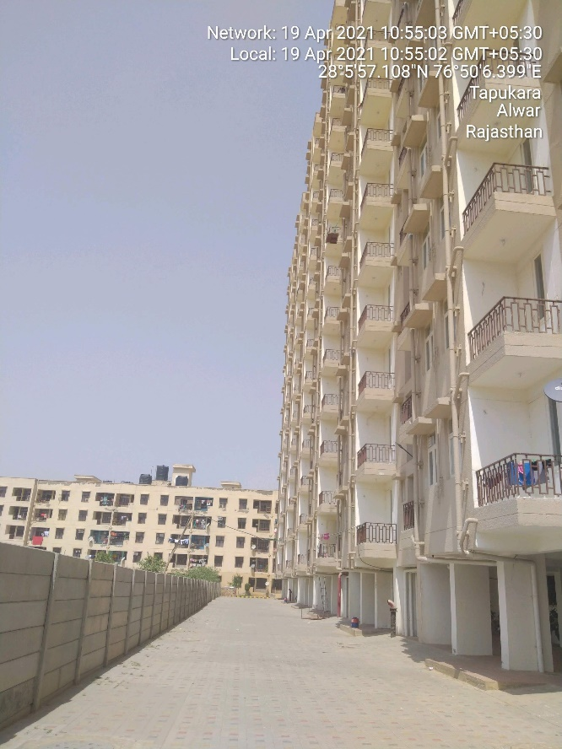 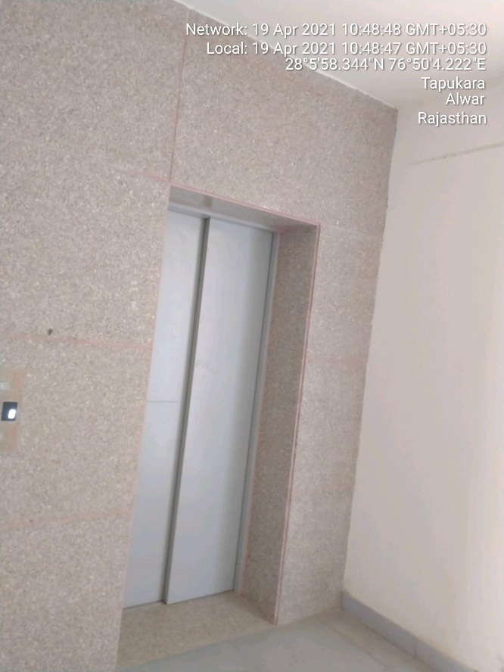 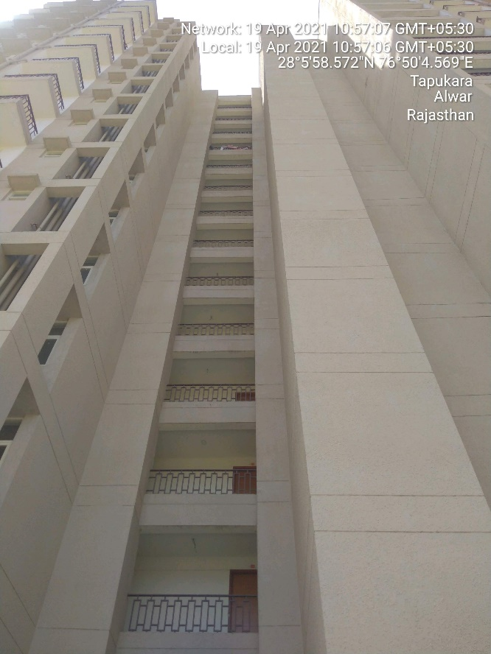

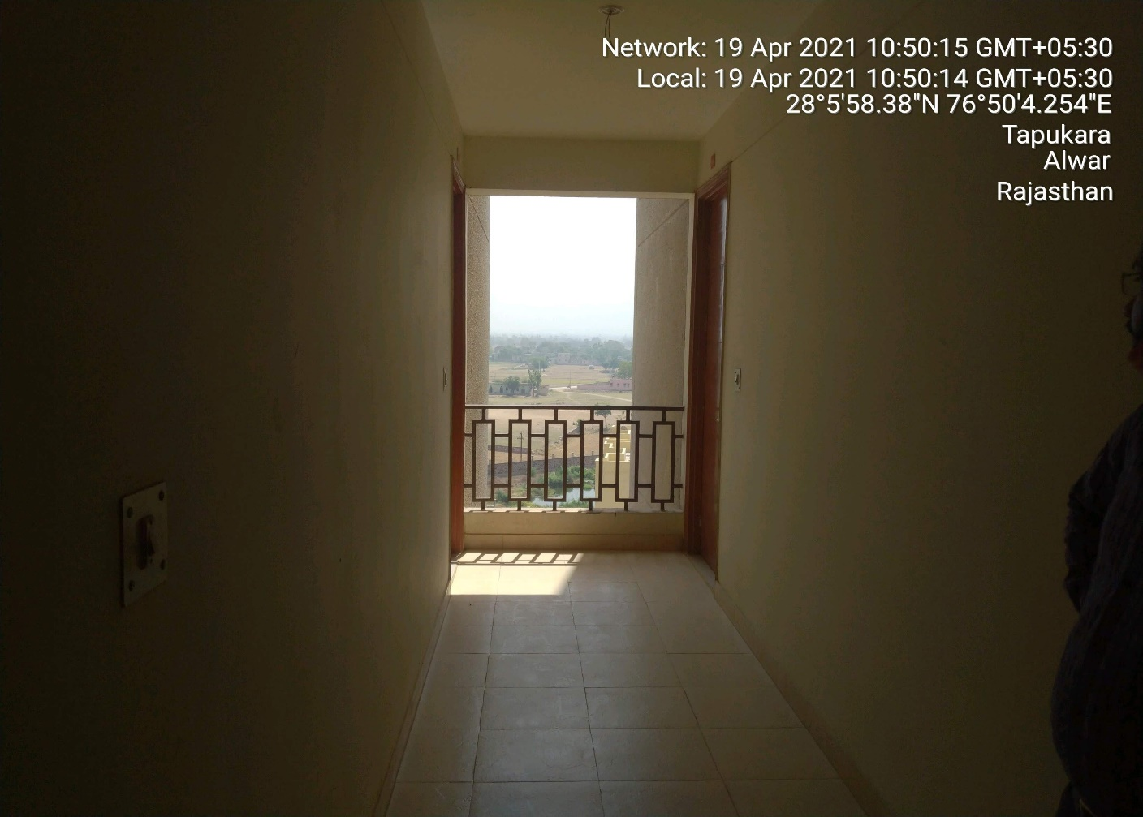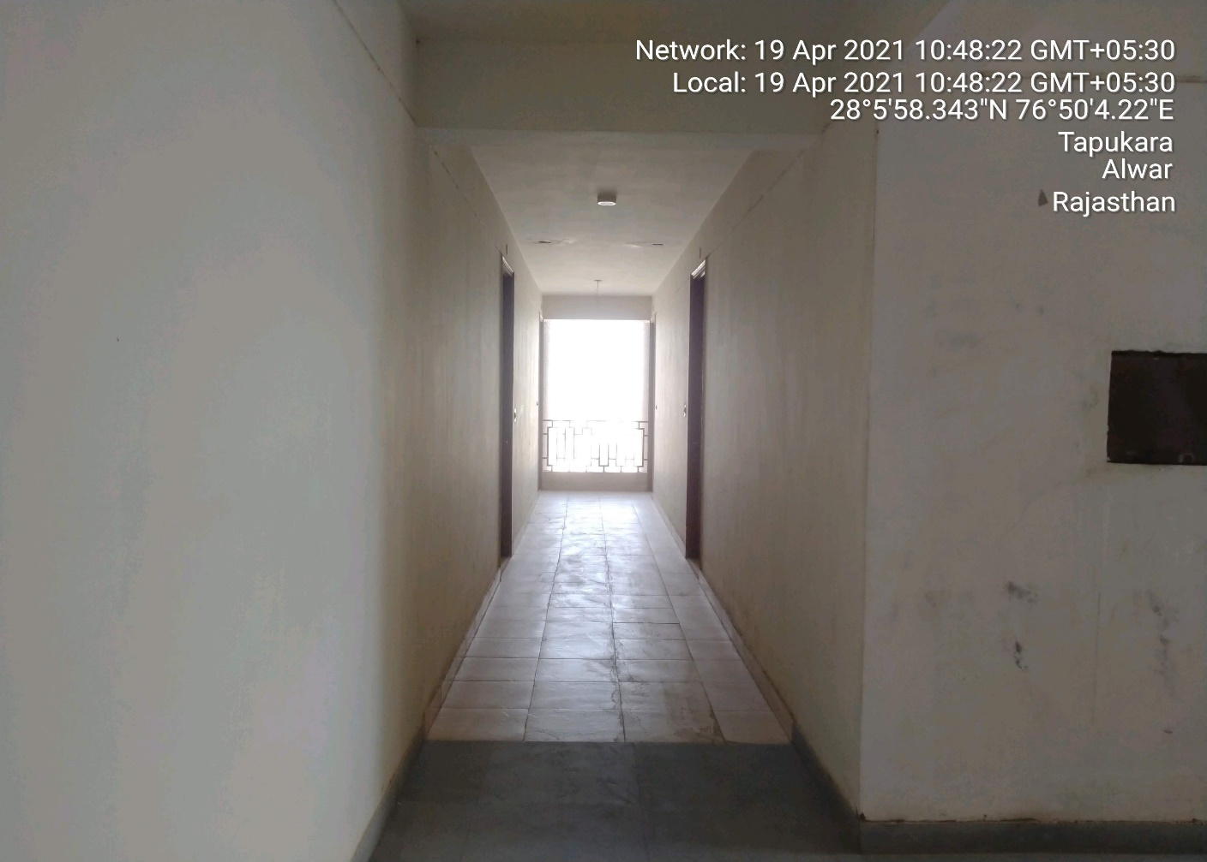

**ENCLOSURE 4 – PRICE TREND REFRENCES**

(No projects with similar specification is present in the proximity of the subject project so not comparative in the subject locality is found on the public domain.)

**ENCLOSURE 5 – CIRCLE RATES**

(Circle rates for the subject project is not applicable since valuation is done using discount rate cash flow method)